Topic name: battery-health-data

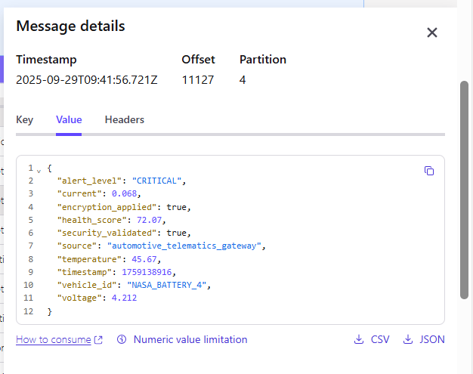

Application logs:  
Producer logs:

Consumer logs:

Database details:  
