**Introduction**

Freecode charts and d3 wrapper is a free (Apache Licence 2.0) open-source library to draw charts or even any pictures dynamically using the modern powerful technologies of HTML5 SVG. This library is very easy to use, well-documented, gives you the full capability of modern browsers to draw any charts, pictures and images dynamically.

It works in all modern browsers from desktop computers to Android and iOS smartphones, including Firefox, Chrome, Opera, Safari, Internet Explorer 9 and above.

It is based on another free open-source library called d3 (www.d3js.org), which is under BSD licence. This library provides a way to directly execute d3 commands and so you can use it as a d3 wrapper with or without the chart functionality (you can disable the chart functionality and it becomes just a d3 wrapper).

There are 2 versions of this library: for Vaadin 6 and Vaadin 7. Both versions have the same functionality and the same user interface (so, if you write it for Vaadin6, you do not need to change any your code when writing the same for Vaadin7, just recompile with a new library).

As for the chart functionality, now the supported curve presentations are a line, single points, vertical bars and areas. In the further it is expected to add horizontal bars, pies, donuts.

The line, single points and areas can be shown with markers having the shape of a circle, square, triangles (upward, downward, leftward, rightward), rectangle, ring and any custom marker that you can design by yourself (you can use up to 240 own custom markers using the SVG path description).

The library supports multiple axes with labels, title, ticks, meshing, optionally shows the legend at any position of the chart.

You can also enable the values shown above the points and a pop-up value indicator which can move along the chart following the movements of the mouse.

You can set up any custom format for the message shown by the pop-up value indicator.

The colors are highly customizable: you can either set a unique color for each series or set different colors for ascending and descending parts of each series or even set a specific color to each piece of line or point, you can design various color schemes and apply different or the same schemes to different charts, and you can also change the color schemes dynamically in the code.

The library supports multiple axes: up to 16 axes at the top, up to 16 axes at the bottom, up to 16 axes at the left and up to 16 axes at the right. All series can belong to any couple of a horizontal axis and vertical axis, the number of series is unlimited.

This library is the beginning to provide the best charts available for today.

It is highly customizable and even if now it lacks something, you can complete it using the power of executing commands of d3 library.

Below are some examples produced by this library:

1. The chart shows 4 series, the axes, the legend. In this chart we used the composition of lines, vertical bars and areas.

The first series is blue vertical bars.

The second series is green vertical bars.

The third series is yellow line with the thickness of 2. We provided the data of this series which goes beyond the y range [0, 1000], so not all lines are connected.

The fourth series is area.

All colors can be customized in the fchart.css file.

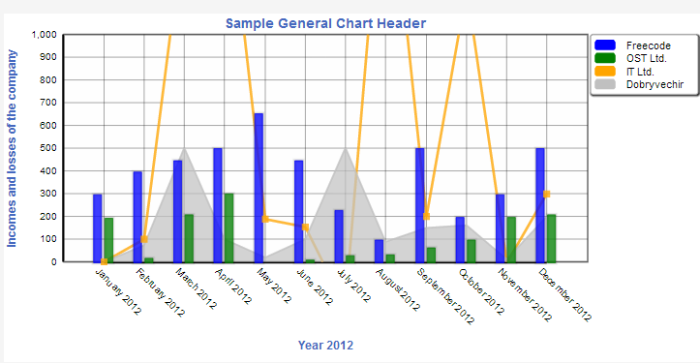

1. Below is the same chart with popup value indicator which moves along the chart following your mouse movement.

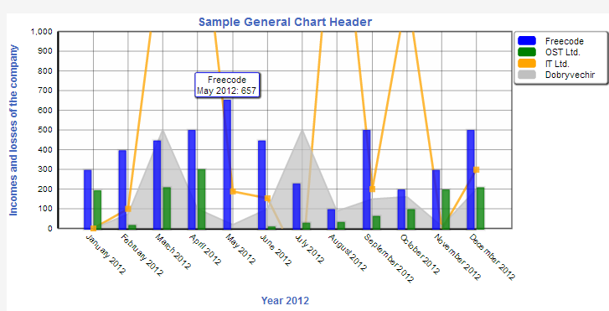

The popup value indicator shows the name from the legend (Freecode) in the first row, the X value of the current item (May 2012) and the Y value (657). The format of the popup value indicator is easily customizable. The border color of the indicator is changed to the color of the current series while it moves along the chart.

1. Below is the same chart with enabled all value showing, that is, the values for each point are shown immediately above the point.

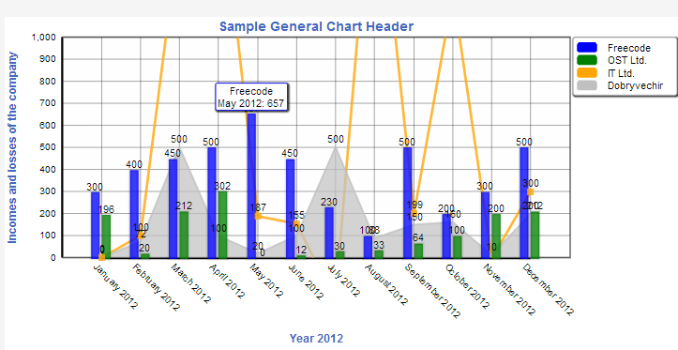

1. Below is the same chart with different colors for ascending and descending parts. In this example we provided different colors for all 4 series. It is easily done in fchart.css file.

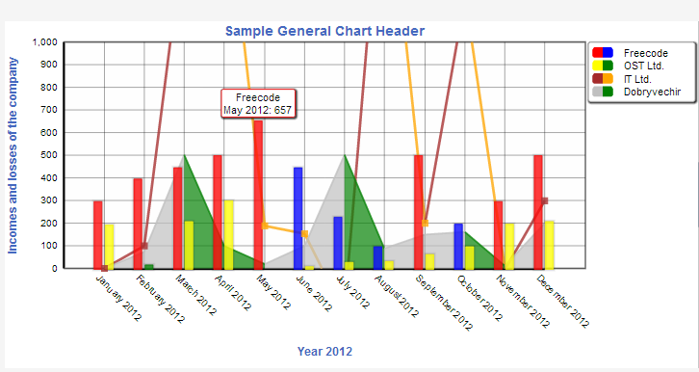

The sample source code for this chart is provided together with the library which you downloaded (see folders sample1ForVaadin6 for Vaadin6 and sample1ForVaadin7 for Vaadin7).

The next picture was produced with this library using the direct execution of d3 commands.

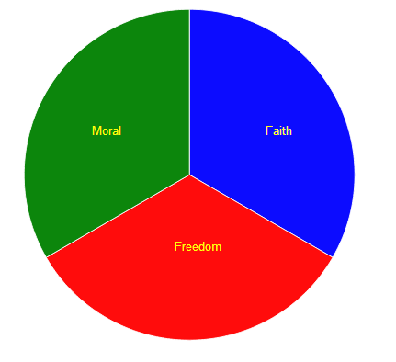

The sample source code for this chart is provided together with the library which you downloaded (see folders sample2ForVaadin6 for Vaadin6 and sample2ForVaadin7 for Vaadin7).