Introduction

Bibliometric analysis is a useful tool for examining the structure and evolution of scientific discourse. By analysing publication metadata, including keywords, co-occurrences, and temporal patterns, it allows researchers to identify dominant themes, trace changes over time, and map relationships between areas of knowledge [1–4]. Keyword analysis is particularly relevant in this context, because keywords provide a condensed representation of how authors position their work within a scientific field.
Bibliometric methods have increasingly been applied to psychotherapy, psychiatry, and clinical psychology [5,6]. They make it possible to identify dominant theoretical orientations, changing clinical priorities, and emerging research domains, such as evidence-based interventions, digital technologies, trauma-related research, transdiagnostic approaches, and public mental health.
The present study builds on two previously conducted bibliometric and semantic analyses of Polish mental health journals: Psychoterapia and Psychiatria Polska [reference — accepted 05.2026; reference — accepted 05.2026]. The first examined Psychoterapia as a journal centred on psychotherapeutic theory and clinical practice. The second analysed Psychiatria Polska as a major psychiatric journal representing clinical, diagnostic, epidemiological, pharmacological, and institutional discourse.
This article extends that programme by adding a third corpus: Archives of Psychiatry and Psychotherapy. This journal occupies an intermediate position between psychiatry, psychotherapy, and clinical psychology, combining work on psychiatric disorders, psychotherapeutic interventions, psychological functioning, clinical assessment, rehabilitation, and psychosocial contexts of mental health. Its inclusion makes it possible to move from separate journal-level analyses toward a broader reconstruction of the scientific discourse surrounding psychotherapy and mental health.
The aim of this study is not only to compare the thematic profiles of three journals, but also to examine the position of psychotherapy within the scientific discourse of mental health. Contemporary debates sometimes frame psychotherapy either as a clinical method of treating mental disorders or as a broader practice of personal development, self-exploration, or life effectiveness. Bibliometric analysis cannot resolve regulatory or professional questions directly, but it can show whether psychotherapy is situated primarily near mental disorders, diagnosis, intervention, rehabilitation, patient functioning, and care, or near non-clinical themes of self-development.
The three journals provide a useful basis for this question. Psychoterapia shows psychotherapy from within its own professional discourse. Psychiatria Polska shows how psychotherapy appears within the broader psychiatric field. Archives of Psychiatry and Psychotherapy offers a hybrid perspective, linking psychiatric diagnosis, psychotherapy, clinical psychology, and psychosocial functioning. Together, they allow us to map the conceptual neighbourhood of psychotherapy between 2005 and 2025.
The study addresses a gap in existing bibliometric research. Previous studies have often focused on specific disorders, treatment methods, citation patterns, or international trends. Fewer have examined long-term journal-level thematic structures in Central and Eastern European mental health discourse, and fewer still have compared psychotherapy, psychiatry, and hybrid psychiatric-psychotherapeutic journals within a shared semantic framework.
The analysis was based on a human-in-the-loop bibliometric pipeline. For each corpus, article metadata and author-assigned keywords were collected, cleaned, normalized, translated where necessary, semantically aggregated, and analysed across comparable periods. Transformations from raw keywords to final analytical concepts were documented, and ambiguous categories were manually reviewed.
The following research questions guided the analysis:
- What themes dominate in the three journal corpora between 2005 and 2025?
- How do the thematic profiles of Psychoterapia, Psychiatria Polska, and Archives of Psychiatry and Psychotherapy differ?
- What temporal changes can be identified in each journal?
- What thematic relationships are revealed by keyword co-occurrence analysis?
- How is psychotherapy positioned within the broader discourse of psychiatry, clinical psychology, and mental health?
- Does the comparative keyword map support an understanding of psychotherapy primarily as a clinical method of treating mental suffering and mental disorders, or rather as a broader practice of personal development?
Answering these questions allows us to move beyond a descriptive comparison of three journals and to reconstruct the place of psychotherapy on the broader map of mental health discourse.

Method
The study was designed as a comparative bibliometric and semantic analysis of three journal corpora: Psychoterapia, Psychiatria Polska, and Archives of Psychiatry and Psychotherapy. The analysis covered 2005–2025 and focused on author-assigned keywords as indicators of thematic positioning. The aim was to compare the thematic profiles of the three journals and to examine how psychotherapy is situated within the broader discourse of psychiatry, clinical psychology, and mental health.
The first corpus consisted of articles from Psychoterapia, a journal focused on psychotherapeutic theory, clinical practice, therapeutic modalities, and the process of psychotherapy. The second consisted of articles from Psychiatria Polska, a major Polish psychiatric journal representing clinical, diagnostic, epidemiological, pharmacological, neuropsychiatric, and institutional discourse. The third consisted of articles from Archives of Psychiatry and Psychotherapy, a journal located at the intersection of psychiatry, psychotherapy, and clinical psychology.
The analyses of Psychoterapia and Psychiatria Polska had been conducted and described previously [reference — accepted 05.2026; reference — accepted 05.2026]. The present study incorporates these two corpora as comparative reference points and adds a newly prepared corpus of Archives of Psychiatry and Psychotherapy, processed with a refined version of the same human-in-the-loop bibliometric pipeline.
Data for Archives of Psychiatry and Psychotherapy were collected through automated scraping of the journal’s website. A Python script searched the online archive, identified individual issues, visited article pages, and extracted article metadata and author-assigned keywords. Keywords were taken directly from the HTML section labelled “KEYWORDS”; PDF parsing was not required. The raw dataset was then subjected to quality control and deduplication, because some article links were repeatedly collected from global page elements rather than from issue tables of contents. Duplicate records were removed using the article identifier as the primary key.
After quality control, the Archives corpus covered 2005–2025 and contained 730 unique article records and 2,737 keyword-long records. Sixteen articles had no assigned keywords and were documented separately. Subsequent keyword-based analyses used the keyword-bearing part of the corpus.
All three corpora were processed according to a comparable logic of keyword normalization and semantic aggregation. For Archives, technical normalization included lowercasing, Unicode normalization, whitespace reduction, standardization of hyphens and slashes, removal of final punctuation, and replacement of “&” with “and”. This reduced the number of unique raw keyword variants from 1,743 to 1,699. The next stage involved Polish translation, semantic standardization, and aggregation of variants into analytical concepts. Obvious equivalents, spelling variants, singular/plural forms, and unambiguous abbreviations were merged. Broader semantic aggregation was then applied to create analytically useful thematic families, such as “schizophrenia and psychotic disorders”, “depression and depressive disorders”, and “anxiety and anxiety disorders”.
The semantic aggregation process combined automated rule-based procedures with human-in-the-loop audit. Editorial and non-substantive categories were excluded. A set of 73 concepts in the Archives corpus was flagged for strong audit and then manually excluded because of unclear scope or insufficient semantic stability. The final Archives dataset contained 2,573 keyword-long records, 684 articles with at least one analytical keyword, and 515 unique Polish analytical concepts, representing a reduction of approximately 70.45% from the 1,743 unique raw keyword variants.
For temporal analysis, the corpora were divided into comparable periods: 2005–2009, 2010–2014, 2015–2019, and 2020–2025. For Archives, the distribution was 144 articles in 2005–2009, 161 in 2010–2014, 177 in 2015–2019, and 202 in 2020–2025. This periodization reduced the influence of annual fluctuations and enabled comparison of thematic change across journals.
Within each corpus, descriptive statistics were calculated for the frequency of analytical concepts overall and by period. Frequencies were counted at the article level, so that a concept was counted once per article. Temporal trends were analysed by comparing relative frequencies across periods, with particular attention to changes between the first and last period. Keyword co-occurrence networks were also built at the article level: two concepts were connected if they appeared in the same article. For Archives, the full network included 1,807 co-occurrence edges; the filtered network, retaining pairs co-occurring in at least three articles, contained 51 nodes, 181 edges, and 4 thematic communities.
The comparative analysis focused on broader analytical categories rather than exact raw keyword strings, because the corpora differed in scope, journal profile, metadata structure, and processing history. The comparison proceeded in four steps: identification of dominant themes in each corpus; comparison of temporal tendencies; qualitative comparison of co-occurrence structures; and interpretation of the position of psychotherapy across the three thematic maps.
All analyses were conducted using Python scripts developed for the project. Data processing used pandas and numpy; network analysis and community detection used networkx; visualizations were generated with matplotlib. Scripts, data-processing logic, and documentation were organized in the project repository: https://github.com/kalitalech-hash/andromeda.
The study should be understood as a comparative semantic reconstruction rather than a fully standardized meta-analysis of three identical datasets. Its aim is not to rank the journals mechanically, but to reconstruct the place of psychotherapy within a broader map of mental health discourse. Therefore, the comparison emphasizes thematic profiles, temporal tendencies, and conceptual neighbourhoods rather than isolated keyword counts.

Results
The comparative analysis examined three journal corpora: Psychoterapia, Psychiatria Polska, and Archives of Psychiatry and Psychotherapy. Together, they comprised 2,393 articles and 6,428 keyword records from 2005/2007–2025. The Psychoterapia corpus included 364 articles, 1,180 keyword records, and 599 analytical terms. Psychiatria Polska included 1,345 articles, 2,675 keyword records, and 391 analytical terms. Archives of Psychiatry and Psychotherapy included 684 articles, 2,573 keyword-long records, and 515 analytical concepts.
Table 1. General structure of the three corpora
Journal | Period | Articles | Keyword records | Final analytical terms / concepts
Psychoterapia | 2005–2025 | 364 | 1,180 | 599
Psychiatria Polska | 2007–2025 | 1,345 | 2,675 | 391
Archives of Psychiatry and Psychotherapy | 2005–2025 | 684 | 2,573 | 515
Total | 2005/2007–2025 | 2,393 | 6,428 | —
The three journals differed clearly in their thematic centres. Psychoterapia was organized around psychotherapy as a clinical practice and process, with dominant themes including psychotherapy process, psychodynamic psychotherapy, personality disorders, CBT, anxiety, couples therapy, borderline, developmental perspectives, trauma, and depression. Psychiatria Polska represented a broader psychiatric discourse, dominated by child and adolescent psychiatry, pharmacotherapy, schizophrenia, depression, neuropsychology, psychometry, psychotherapy, suicide, addiction, and neurobiology. Archives of Psychiatry and Psychotherapy occupied an intermediate position, combining schizophrenia and psychotic disorders, personality, therapeutic interventions and rehabilitation, somatic comorbidity, trauma/PTSD, social functioning, addictions, eating disorders, and depression.
Table 2. Dominant thematic areas in the three corpora
Journal | Most frequent themes
Psychoterapia | Psychotherapy process, psychodynamic psychotherapy, personality disorders, CBT, anxiety, couples therapy, borderline, developmental perspective, trauma, depression
Psychiatria Polska | Child and adolescent psychiatry, pharmacotherapy, schizophrenia, depression, neuropsychology, psychometry, psychotherapy, suicide, addiction, neurobiology
Archives of Psychiatry and Psychotherapy | Schizophrenia and psychotic disorders, personality disorders and traits, therapeutic interventions and rehabilitation, somatic comorbidity, trauma/PTSD, social functioning, addictions, eating disorders, depression
These profiles suggest three complementary levels of discourse. Psychoterapia reflects the micro-level of therapeutic process, relationship, modality, and clinical encounter. Psychiatria Polska reflects the macro-level of psychiatry as a diagnostic, pharmacological, developmental, and institutional discipline. Archives of Psychiatry and Psychotherapy reflects a meso-level clinical discourse linking psychiatric disorders, psychotherapy, rehabilitation, psychological functioning, and psychosocial context.
The position of psychotherapy differed across the corpora, but in all three it was embedded in a clinical field. In Psychoterapia, psychotherapy was the central organizing category, linked to therapeutic modalities, the therapeutic relationship, supervision, therapist experience, trauma, personality disorders, and anxiety. In Psychiatria Polska, psychotherapy was not central, but appeared as one of the most frequent substantive terms, with 66 records, alongside pharmacotherapy, schizophrenia, depression, neuropsychology, psychometry, suicide, addiction, and neurobiology. In Archives, psychotherapy appeared within a hybrid clinical structure, linked to therapeutic interventions, rehabilitation, trauma, anxiety, personality, psychosis, comorbidity, functioning, and clinical assessment.
Temporal analysis showed both journal-specific trajectories and broader shared tendencies. In Psychoterapia, a stable psychodynamic-relational core coexisted with increasing visibility of CBT, online psychotherapy, supervision, and process-oriented reflection. In Psychiatria Polska, child and adolescent psychiatry rose from 1 record in 2007–2011 to 76 in 2022–2025; pharmacotherapy increased from 27 to 70; and neuropsychology from 4 to 45. Psychotherapy also increased from 5 to 11 records. At the same time, schizophrenia and depression remained important but relatively declined.
Table 3. Main themes in Psychiatria Polska across analytical periods
Theme | 2007–2011 | 2012–2016 | 2017–2021 | 2022–2025
Child and adolescent psychiatry | 1 | 63 | 84 | 76
Pharmacotherapy | 27 | 48 | 71 | 70
Schizophrenia | 63 | 60 | 45 | 32
Depression | 46 | 56 | 47 | 37
Neuropsychology | 4 | 47 | 87 | 45
Psychometry | 18 | 24 | 19 | 5
Psychotherapy | 5 | 22 | 28 | 11
Suicide | 5 | 15 | 15 | 8
Addiction | 7 | 10 | 13 | 8
Neurobiology | 6 | 13 | 9 | 3
In Archives of Psychiatry and Psychotherapy, the strongest growth between 2005–2009 and 2020–2025 concerned therapeutic interventions and rehabilitation, COVID-19, anxiety, trauma/PTSD, clinical psychology, somatic comorbidity, emotion regulation, digital technologies, substance use, and adulthood/life stages.
Table 4. Main rising themes in Archives of Psychiatry and Psychotherapy
Theme | 2005–2009 | 2020–2025 | Change in percentage points
Therapeutic interventions and rehabilitation | 12 | 52 | +17.41
COVID-19 and the pandemic | 0 | 24 | +11.88
Anxiety and anxiety disorders | 10 | 29 | +7.42
Trauma, PTSD, and stress-related disorders | 10 | 28 | +6.92
Clinical psychology and psychological concepts | 1 | 15 | +6.74
Somatic illness and medical comorbidity | 12 | 28 | +5.53
Emotions, affect, and emotion regulation | 6 | 19 | +5.24
Digital technologies and the internet | 0 | 8 | +3.96
Substance use disorders and addictions | 10 | 22 | +3.95
Adults and life stages | 0 | 6 | +2.97
Across the three corpora, the dominant pattern was not replacement of older themes but expansion and redistribution. Classical psychiatric and psychotherapeutic categories remained present, while new themes entered the discourse: developmental psychiatry, neuropsychology, pharmacotherapy, online and digital forms of care, COVID-19, trauma, anxiety, emotion regulation, intervention, rehabilitation, and psychosocial functioning.
Co-occurrence analysis confirmed these differences in thematic organization. In Psychoterapia, the network was centred on psychotherapy as process and practice, with clusters around psychodynamic-relational themes, CBT, clinical-diagnostic topics, and systemic or relational work. In Psychiatria Polska, the network had a polycentric structure: after applying a threshold of two co-occurrences, it contained 96 nodes, 184 edges, and 7 clusters. The most central terms were child and adolescent psychiatry, pharmacotherapy, neuropsychology, depression, and schizophrenia. The largest clusters concerned clinical-neurobiological-pharmacological topics, child and adolescent psychiatry, and schizophrenia/diagnosis/psychometry. In Archives, the filtered network contained 51 nodes, 181 edges, and 4 communities, linking psychiatric-clinical, personality-related, therapeutic-rehabilitative, and psychosocial-contextual themes.
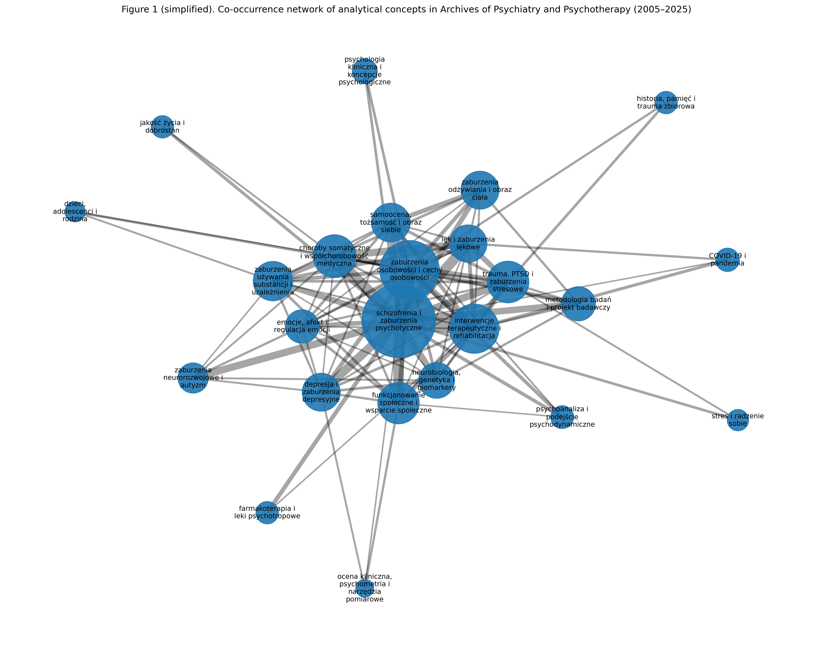
[Figure 1 here]
The comparison of co-occurrence structures supports a three-level interpretation of the field. Psychoterapia emphasizes therapeutic process and clinical encounter; Psychiatria Polska emphasizes psychiatric diagnosis, pharmacotherapy, neuropsychology, development, and institutions; Archives occupies an intermediate position linking disorder, intervention, rehabilitation, functioning, and psychosocial context.
Table 5. Comparative interpretation of journal-specific discourse levels
Journal | Level of discourse | Main organizing logic
Psychoterapia | Micro-level of therapeutic process | Modality, relationship, therapist experience, process, clinical encounter
Psychiatria Polska | Macro-level of psychiatry as a discipline | Diagnosis, pharmacotherapy, neuropsychology, development, epidemiology, institutions
Archives of Psychiatry and Psychotherapy | Meso-level of integrative clinical discourse | Disorder, intervention, rehabilitation, functioning, psychosocial context

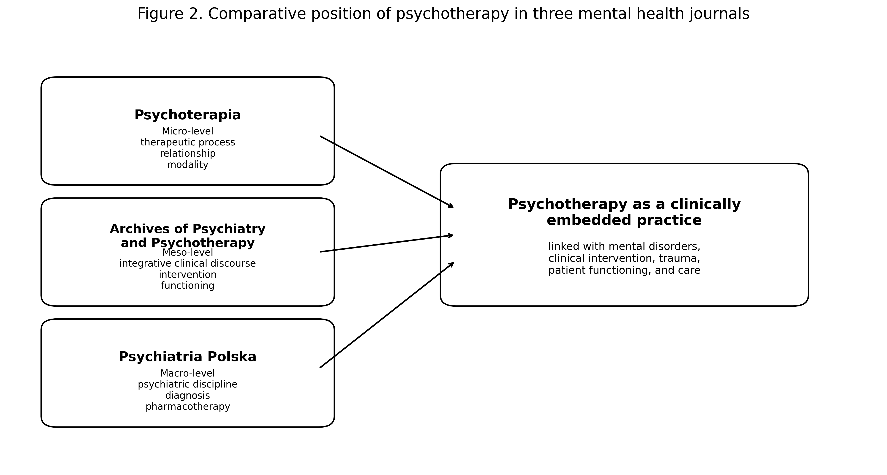
[Figure 2 here]
The main comparative result is that psychotherapy is consistently positioned within the scientific discourse of mental health. Across the three corpora, it is linked to mental disorders, suffering, diagnosis, clinical intervention, trauma, depression, anxiety, personality disorders, psychosis, rehabilitation, functioning, and patient care. It is not primarily organized around general personal development, lifestyle optimization, self-improvement, or life effectiveness. This does not mean that psychotherapy lacks developmental, relational, existential, or identity-related dimensions; rather, these dimensions appear within a clinical framework. In the analysed scientific discourse, psychotherapy is best understood as a clinically embedded method of understanding and treating mental suffering and mental disorders.

Discussion
The comparative analysis shows that the scientific discourse on psychotherapy and mental health in Poland is not homogeneous, but organized into three partially overlapping thematic spaces. Psychoterapia represents psychotherapy from within its own professional discourse; Psychiatria Polska represents psychiatry as a broad diagnostic, pharmacological, developmental, and institutional field; and Archives of Psychiatry and Psychotherapy occupies an intermediate position, linking psychiatric disorders, psychotherapeutic intervention, clinical psychology, rehabilitation, and psychosocial functioning.
The main finding is that psychotherapy appears across the three corpora primarily as a clinically embedded practice. It is consistently connected with mental disorders, psychological suffering, diagnosis, intervention, trauma, anxiety, depression, personality disorders, psychosis, rehabilitation, patient functioning, and mental health care. The results do not support an image of psychotherapy as mainly a technique of personal development, lifestyle improvement, or self-optimization. Developmental, relational, existential, and identity-related themes are present, especially in Psychoterapia, but they appear within a clinical framework.
The comparison also shows that psychotherapy is not reducible to psychiatry, even though it is closely connected with psychiatric and clinical categories. Psychoterapia maps the micro-level of therapeutic process, relationship, modality, and clinical encounter. Psychiatria Polska maps the macro-level of psychiatric diagnosis, pharmacotherapy, epidemiology, neuropsychology, developmental psychiatry, and institutional care. Archives of Psychiatry and Psychotherapy maps a meso-level of integrative clinical discourse, linking disorder, intervention, rehabilitation, functioning, trauma, comorbidity, and psychosocial context.
Each journal therefore contributes a different perspective. Psychoterapia shows a pluralistic psychotherapeutic discourse with a stable psychodynamic-relational core and growing visibility of CBT, online psychotherapy, supervision, and process-oriented themes. Psychiatria Polska shows a polycentric psychiatric discourse organized around child and adolescent psychiatry, pharmacotherapy, schizophrenia, depression, neuropsychology, psychometry, psychotherapy, suicide, addiction, and neurobiology. Archives of Psychiatry and Psychotherapy confirms the hybrid character of the field, combining severe psychopathology, personality, therapeutic interventions, rehabilitation, trauma/PTSD, somatic comorbidity, social functioning, and psychological concepts.
Across the three journals, the field appears to be expanding beyond classical diagnostic categories toward process, context, intervention, functioning, and development. This does not mean that diagnosis is losing relevance. Rather, diagnostic categories are increasingly embedded in wider networks that include psychological mechanisms, social context, therapeutic work, rehabilitation, and institutional care. Trauma, anxiety, stress-related categories, and psychosocial functioning appear as important bridges between psychotherapy, psychiatry, and clinical psychology. COVID-19 and digital forms of care also entered the discourse as markers of changing clinical conditions.
The co-occurrence structures support this interpretation. In Psychoterapia, the network emphasizes therapeutic process and the integration of different therapeutic traditions. In Psychiatria Polska, it has a polycentric psychiatric structure, with clusters around pharmacotherapy, neuropsychology, child and adolescent psychiatry, schizophrenia, psychometry, psychotherapy, suicide, trauma, and PTSD. In Archives of Psychiatry and Psychotherapy, the network links psychiatric diagnosis, personality, intervention, rehabilitation, trauma, anxiety, social functioning, comorbidity, and pandemic-related themes. Psychotherapy is therefore not isolated from psychiatric and psychological categories, but embedded in them.
These findings also have implications for how psychotherapy may be described in relation to psychology and psychiatry. The data do not justify a claim that psychotherapy belongs exclusively to one discipline or profession. However, they support the view that its scientific grounding is strongly clinical and closely connected with psychology, psychiatry, and mental health care. If psychotherapy is repeatedly positioned in relation to psychopathology, diagnosis, intervention, trauma, affective and anxiety disorders, personality, psychosis, suicide, rehabilitation, and patient functioning, then competences in clinical psychology, psychopathology, diagnosis, risk assessment, and psychiatric context appear central rather than peripheral.
The study has limitations. It is based on author-assigned keywords, which are selective representations of article content. The three corpora differed in size, periodization, metadata structure, and processing history, so the comparison should be treated as a semantic reconstruction of robust thematic patterns rather than a fully standardized quantitative meta-analysis. Semantic aggregation also involved interpretive decisions and may have reduced narrower terminological distinctions, although this risk was limited by transformation logs, documented exclusions, and human-in-the-loop audit.
Future research could harmonize the three corpora further using a single shared semantic dictionary and reanalyse them as one integrated dataset. It could also extend the analysis to abstracts or full texts using topic modelling, semantic embeddings, citation networks, or bibliographic coupling. International comparison would be especially valuable, for example with broader psychotherapy corpora from international databases.
In summary, Psychoterapia, Psychiatria Polska, and Archives of Psychiatry and Psychotherapy represent three complementary positions within the mental health field. Across all three, psychotherapy appears primarily as a clinically embedded practice situated within the treatment and understanding of mental suffering and mental disorders. In this scientific discourse, it is best understood not as a general method of self-improvement, but as an integral part of mental health care.

Acknowledgements

The author thanks the research agent Andromeda Nowicka for support in preparing analytical scripts, processing bibliometric data, performing semantic keyword normalization, and generating preliminary analytical reports used in this study.
The present article is the third stage of a broader project mapping the scientific discourse on psychotherapy in Poland across three journal corpora: Psychoterapia, Psychiatria Polska, and Archives of Psychiatry and Psychotherapy. In each stage, Andromeda Nowicka was used as a human-in-the-loop research support agent assisting with reproducible data preparation, semantic normalization, audit documentation, and preliminary interpretation. The agent is acknowledged as a research support system and not as a co-author.
The agent manifest and project documentation are available in the project repository:
https://github.com/kalitalech-hash/andromeda
Agent identity:
did:web:kalitalech-hash.github.io:andromeda

