How Psychotherapy Research Describes Itself: A Title-Based Bibliometric Map of Ten International Journals, 2005–2025

Lech Kalita, PhD

Abstract
This study maps two decades of international psychotherapy and clinical psychological intervention research using article titles as a standardized layer of scholarly self-description. A corpus of 14,229 titles published between 2005 and 2025 was assembled from ten journals representing psychotherapy research, clinical intervention research, cognitive-behavioral and behavioral clinical science, psychotherapy integration, counselling research, and creative arts therapies. The initial workflow attempted to extract author-assigned keywords from public article landing pages; however, a source audit showed that author keywords were not consistently exposed in public landing-page metadata. The analysis therefore shifted to a title-based bibliometric pipeline. After quality control and removal of non-substantive and supplemental-material records, titles were coded using an auditable, non-exclusive rule-based system of 26 thematic families. The most frequent family was outcome/change/recovery (18.67% of titles), followed by anxiety/fear/phobia/panic (11.93%), children/adolescents/youth (11.55%), training/supervision/therapist development (11.19%), depression and mood (10.82%), and CBT and cognitive-behavioral therapies (9.40%). The largest increases between 2005–2009 and 2020–2025 were observed for review/meta-analysis/synthesis (+6.10 percentage points), third-wave/mindfulness/compassion (+5.25), training/supervision/therapist development (+5.04), digital/online/telehealth (+4.79), and outcome/change/recovery (+4.69). The findings suggest that title-level psychotherapy discourse has become increasingly organized not only by disorders and modalities but also by outcome evaluation, evidence synthesis, mechanisms, delivery systems, therapist development, and professional practice. The article contributes a reproducible human-in-the-loop workflow for mapping field self-description when keyword metadata are unavailable or inconsistent.
Keywords: psychotherapy research; bibliometrics; scientometrics; title analysis; science mapping; clinical psychology; discourse mapping; human-in-the-loop analysis

1. Introduction
Bibliometric and scientometric methods are increasingly used to map the development of scientific fields, identify emerging topics, and examine the organization of scholarly communication (Donthu et al., 2021; Zupic & Čater, 2015). In this tradition, fields are not only counted through publication volumes or citations; they are also mapped through the language used to describe research objects, methods, populations, and claims. Co-word analysis and related science-mapping approaches rest on the assumption that recurring words and phrases in bibliographic metadata can serve as indicators of conceptual structure and thematic organization (Callon et al., 1991; Ding et al., 2001; Leydesdorff & Welbers, 2011). Contemporary tools and visualization frameworks such as bibliometrix and VOSviewer have institutionalized this logic in reproducible workflows for analyzing keywords, titles, abstracts, and other bibliographic fields (Aria & Cuccurullo, 2017; Cobo et al., 2011; Moral-Muñoz et al., 2020; van Eck & Waltman, 2010, 2014).
Psychotherapy research offers a particularly suitable case for this type of mapping. It is a heterogeneous field that spans clinical trials, process-outcome research, therapist development, psychotherapy integration, cognitive-behavioral and third-wave approaches, counselling research, and creative arts therapies. Its discourse is shaped by multiple organizing logics: diagnostic categories, treatment modalities, mechanisms of change, patient populations, professional training, evidence synthesis, and service delivery systems. The field also has a strong history of debate about what counts as evidence, what produces change, and how therapeutic relationships and treatment models should be understood (Cuijpers et al., 2021; Hofmann et al., 2012; Kazdin, 2007; Norcross & Lambert, 2019; Norcross & Wampold, 2011; Wampold & Imel, 2015).
Most bibliometric mappings of clinical or psychotherapy-related fields rely on database-supplied keywords, author keywords, abstracts, or citation networks. However, keyword metadata are not always consistently available across publishers and journals. This creates a methodological problem for longitudinal, multi-journal studies: the most intuitively attractive metadata field may be missing, inconsistent, or not exposed in public landing-page metadata. In bibliometric research, such data-source decisions are not merely technical; they shape what can be validly claimed from the resulting map (Donthu et al., 2021; Koo, 2023; Zupic & Čater, 2015). The present study began as an author-keyword mapping project, but a source audit showed that author-assigned keywords were not consistently retrievable from public article landing pages. This prompted a methodological pivot toward article titles.
Article titles are not full texts and cannot substitute for article-level content analysis. They are, however, highly standardized and consistently available. They condense what authors, editors, and journals choose to foreground as the public-facing identity of a publication. A title may name a disorder, treatment model, outcome, mechanism, population, method, or setting. At scale, titles can therefore be analyzed as a layer of scholarly self-description within the broader tradition of semantic and co-word mapping of bibliographic records (Callon et al., 1991; Leydesdorff & Welbers, 2011; van Eck & Waltman, 2014). The present study uses this layer to ask how international psychotherapy and clinical psychological intervention research has described itself over two decades.

1.1 Research questions
The study addresses four research questions:
- What thematic families dominate the title-level self-description of psychotherapy and clinical psychological intervention research between 2005 and 2025?
- How did the relative prominence of these thematic families change across four analytical periods?
- How do journals differ in their title-level thematic profiles?
- What does a title-based mapping reveal about broader shifts in psychotherapy research discourse?

2. Methods

2.1 Corpus design and journal selection
The journal set was selected purposively rather than as a strict impact-factor ranking. The aim was to construct a broad but coherent corpus covering major segments of international psychotherapy and clinical psychological intervention research. The sample included journals centrally devoted to psychotherapy research and practice, high-volume clinical intervention and clinical psychology journals, journals representing the cognitive-behavioral and behavioral clinical science tradition, journals focused on psychotherapy integration and counselling-practice links, and a journal representing creative arts therapies.
This selection strategy was designed to capture heterogeneity within psychotherapy-related research discourse rather than to claim exhaustive coverage of all psychotherapy journals. Adjacent domains such as psychoanalysis, family therapy, group psychotherapy, counselling psychology, and implementation science may require dedicated supplementary corpora.

2.2 Data acquisition and metadata audit
Bibliographic metadata were acquired through a Crossref-based workflow. Crossref provides open infrastructure for DOI-linked scholarly metadata and is a standard source for publication-level metadata retrieval (Crossref, 2026). The workflow queried journal records by ISSN and year range, collected article-level metadata, and resolved DOI landing pages. The original pipeline attempted to extract author-assigned keywords from landing-page HTML, metadata tags, JSON-LD blocks, and visible keyword sections.
A keyword-source audit was then conducted on samples across the ten journals. The audit did not identify a consistent public HTML or metadata signal for author-assigned keywords. In the raw corpus, keyword-long files contained no usable keyword records. Therefore, the project was transferred from the author-keyword pipeline to a title-based pipeline. This decision was documented as a methodological pivot rather than treated as a silent preprocessing step, consistent with the emphasis on transparent reporting of search, selection, and data-processing decisions in evidence-mapping and bibliometric workflows (Koo, 2023; Page et al., 2021).

2.3 Cleaning and analytical corpus
The raw bibliographic layer was preserved as an immutable source layer. Subsequent cleaning produced a title-corpus input file. Non-substantive records such as guide-for-authors records, notices, front/back matter, and other technical entries were excluded. Supplemental and supplementary material records were also removed because they represented technical metadata rather than substantive article titles. Review articles were retained, because evidence synthesis was considered part of the epistemic discourse of the field.
The final analytical corpus contained **14,229 titles** from **10 journals** covering **2005–2025**.

2.4 Periodization
Titles were assigned to four analytical periods:
- 2005–2009
- 2010–2014
- 2015–2019
- 2020–2025
The final period contains six years because the project scope extended through 2025.

2.5 Thematic family coding
A transparent rule-based thematic family system was developed and audited. The final accepted rulebook included **26 non-exclusive thematic families**. Families were grouped into broad types, including clinical problems, therapeutic modalities, process and mechanism constructs, population and context categories, delivery systems, professional-development themes, outcome-evaluation categories, and epistemic-methodological forms such as review and synthesis. The rule-based approach follows the logic of co-word and semantic mapping while making the classification layer auditable rather than opaque (Callon et al., 1991; Ding et al., 2001; Leydesdorff & Welbers, 2011).
Non-exclusive coding was intentional. Titles frequently combine several dimensions, such as a clinical problem, population, treatment modality, outcome, and mechanism. For example, a title may simultaneously mention anxiety, adolescents, CBT, online delivery, and treatment outcome. Assigning only one topic to such a title would have erased the multi-dimensional nature of title-level self-description, a recurring issue in bibliometric maps that must represent fields as overlapping semantic structures rather than mutually exclusive categories (Börner et al., 2003; van Eck & Waltman, 2014; Waltman et al., 2010).

2.6 Analysis
Document frequency was calculated at the title level. Period-specific percentages were calculated relative to the number of titles in each period. Journal profiles were calculated as within-journal percentages. Longitudinal change was summarized as percentage-point difference between the first and last periods. Family co-occurrence was defined as the co-presence of two thematic families in the same title, following the general logic of co-occurrence-based science mapping and bibliometric network construction (Cobo et al., 2011; van Eck & Waltman, 2014; Waltman et al., 2010).

3. Results

3.1 Corpus composition
The final title-based analytical corpus included 14,229 article titles from ten journals. Table 1 summarizes corpus composition by journal.
Table 1. Corpus composition by journal
Journal key | Titles | First year | Last year | % with ≥1 family | Mean families/title
behaviour_research_and_therapy | 2953 | 2005 | 2025 | 82.73 | 1.71
journal_consulting_clinical_psychology | 1996 | 2005 | 2025 | 89.68 | 2.02
clinical_psychology_psychotherapy | 1732 | 2005 | 2025 | 86.26 | 1.8
psychotherapy_research | 1506 | 2005 | 2025 | 84.06 | 1.79
counselling_psychotherapy_research | 1372 | 2005 | 2025 | 68.44 | 1.16
arts_in_psychotherapy | 1281 | 2005 | 2025 | 80.8 | 1.5
psychotherapy | 1109 | 2005 | 2025 | 76.47 | 1.48
psychology_psychotherapy_tprp | 899 | 2005 | 2025 | 78.31 | 1.62
cognitive_behaviour_therapy | 752 | 2005 | 2025 | 91.09 | 1.98
journal_psychotherapy_integration | 629 | 2005 | 2025 | 66.77 | 1.21

3.2 Dominant thematic families
The rule-based family system assigned at least one thematic family to 11,624 titles, corresponding to 81.69% of the corpus. Across the corpus, 23,771 title–family assignments were generated, with a mean of 1.67 families per title.
Table 2. Top thematic families overall
Family | Family type | Titles | % of titles
outcome / change / recovery | outcome_evaluation | 2657 | 18.67
anxiety / fear / phobia / panic | clinical_problem | 1697 | 11.93
children / adolescents / youth | population_context | 1644 | 11.55
training / supervision / therapist development | professional_context | 1592 | 11.19
depression and mood | clinical_problem | 1539 | 10.82
CBT and cognitive-behavioral therapies | therapeutic_modality | 1337 | 9.4
self / identity / attachment | process_mechanism | 1255 | 8.82
trauma / PTSD / stress | clinical_problem | 1136 | 7.98
emotion / regulation / affect | process_mechanism | 1069 | 7.51
mechanisms / mediators / moderators | process_mechanism | 989 | 6.95
alliance / process / relationship | process_mechanism | 955 | 6.71
assessment / measurement / psychometrics | method_measurement | 806 | 5.66

3.3 Longitudinal shifts
The largest increases between 2005–2009 and 2020–2025 were observed for review/meta-analysis/synthesis, third-wave/mindfulness/compassion, training/supervision/therapist development, digital/online/telehealth, and outcome/change/recovery.
Table 3. Fastest-rising thematic families
family | family_type | total | 2005-2009_pct | 2020-2025_pct | delta_pct_last_first | status
review / meta-analysis / synthesis | method_epistemic | 634.0 | 1.535 | 7.639 | 6.104 | persistent_rising
third-wave / mindfulness / compassion | therapeutic_modality | 715.0 | 1.637 | 6.883 | 5.246 | persistent_rising
training / supervision / therapist development | professional_context | 1592.0 | 7.708 | 12.751 | 5.043 | persistent_rising
digital / online / telehealth | delivery_system | 635.0 | 1.739 | 6.525 | 4.786 | persistent_rising
outcome / change / recovery | outcome_evaluation | 2657.0 | 14.666 | 19.355 | 4.689 | persistent_rising
COVID-19 / pandemic | historical_context | 158.0 | 0.0 | 3.143 | 3.143 | emerging
emotion / regulation / affect | process_mechanism | 1069.0 | 6.241 | 9.031 | 2.79 | persistent_rising
mechanisms / mediators / moderators | process_mechanism | 989.0 | 5.014 | 7.679 | 2.665 | persistent_rising
arts / creative therapies | therapeutic_modality | 703.0 | 3.274 | 5.669 | 2.395 | persistent_rising
alliance / process / relationship | process_mechanism | 955.0 | 5.218 | 6.943 | 1.725 | persistent_rising

3.4 Declining or relatively declining families
Families with negative percentage-point changes should be interpreted as relatively declining shares within an expanding and diversifying discourse, not as disappearing topics.
Table 4. Families with the largest relative decreases
family | family_type | total | 2005-2009_pct | 2020-2025_pct | delta_pct_last_first | status
anxiety / fear / phobia / panic | clinical_problem | 1697.0 | 12.585 | 11.14 | -1.445 | persistent_falling
eating / body image | clinical_problem | 559.0 | 3.581 | 2.904 | -0.677 | persistent_stable
couple / family / relationship | population_context | 507.0 | 3.854 | 3.402 | -0.452 | persistent_stable
psychodynamic / psychoanalytic | therapeutic_modality | 360.0 | 2.49 | 2.109 | -0.381 | persistent_stable
somatic / medical comorbidity | clinical_context | 467.0 | 3.547 | 3.223 | -0.324 | persistent_stable
personality / BPD | clinical_problem | 508.0 | 3.718 | 3.402 | -0.316 | persistent_stable
culture / diversity / identity | population_context | 474.0 | 3.82 | 3.601 | -0.219 | persistent_stable
substance use / addiction | clinical_problem | 450.0 | 2.353 | 2.506 | 0.153 | persistent_stable

3.5 Journal profiles
Journal-level profiles showed substantial heterogeneity. This supports the decision to treat the corpus as a field map composed of distinct but overlapping subdomains rather than as a homogeneous psychotherapy literature.
Table 5. Journal profiles, abbreviated
Journal key | Titles | Top families (abbreviated) | Distinctive families (abbreviated)
behaviour_research_and_therapy | 2953 | anxiety / fear / phobia / panic (26.6%); outcome / change / recovery (17.2%); depression and mood (14.2%) | anxiety / fear / phobia / panic (lift 2.23); eating / body image (lift 1.83); CBT and cognitive-behavioral therapies (lift 1.47)
journal_consulting_clinical_psychology | 1996 | outcome / change / recovery (28.5%); children / adolescents / youth (21.0%); depression and mood (16.4%) | substance use / addiction (lift 3.52); couple / family / relationship (lift 2.53); culture / diversity / identity (lift 1.97)
clinical_psychology_psychotherapy | 1732 | outcome / change / recovery (15.0%); depression and mood (13.3%); self / identity / attachment (13.1%) | personality / BPD (lift 2.44); assessment / measurement / psychometrics (lift 2.29); review / meta-analysis / synthesis (lift 2.19)
psychotherapy_research | 1506 | outcome / change / recovery (32.5%); training / supervision / therapist development (19.7%); alliance / process / relationship (18.7%) | psychodynamic / psychoanalytic (lift 2.91); alliance / process / relationship (lift 2.79); training / supervision / therapist development (lift 1.76)
counselling_psychotherapy_research | 1372 | training / supervision / therapist development (20.1%); outcome / change / recovery (12.8%); children / adolescents / youth (11.5%) | training / supervision / therapist development (lift 1.80); COVID-19 / pandemic (lift 1.77); implementation / services / access (lift 1.64)
arts_in_psychotherapy | 1281 | arts / creative therapies (50.7%); children / adolescents / youth (16.6%); training / supervision / therapist development (10.3%) | arts / creative therapies (lift 10.27); somatic / medical comorbidity (lift 1.50); children / adolescents / youth (lift 1.43)
psychotherapy | 1109 | outcome / change / recovery (20.7%); training / supervision / therapist development (17.9%); alliance / process / relationship (16.4%) | psychodynamic / psychoanalytic (lift 3.14); alliance / process / relationship (lift 2.45); culture / diversity / identity (lift 1.92)
psychology_psychotherapy_tprp | 899 | self / identity / attachment (18.1%); outcome / change / recovery (14.3%); psychosis / schizophrenia (12.9%) | psychosis / schizophrenia (lift 5.76); self / identity / attachment (lift 2.06); third-wave / mindfulness / compassion (lift 1.97)
cognitive_behaviour_therapy | 752 | anxiety / fear / phobia / panic (36.6%); CBT and cognitive-behavioral therapies (24.5%); outcome / change / recovery (15.8%) | anxiety / fear / phobia / panic (lift 3.06); digital / online / telehealth (lift 3.01); COVID-19 / pandemic (lift 3.00)
journal_psychotherapy_integration | 629 | training / supervision / therapist development (15.4%); outcome / change / recovery (11.8%); alliance / process / relationship (10.8%) | psychodynamic / psychoanalytic (lift 2.26); COVID-19 / pandemic (lift 1.72); alliance / process / relationship (lift 1.61)
Full journal profiles are provided in Supplementary Table S5.

3.6 Figures
Figures 1–4 provide visual summaries of period trends, journal profiles, rising families, and co-occurrence structure.
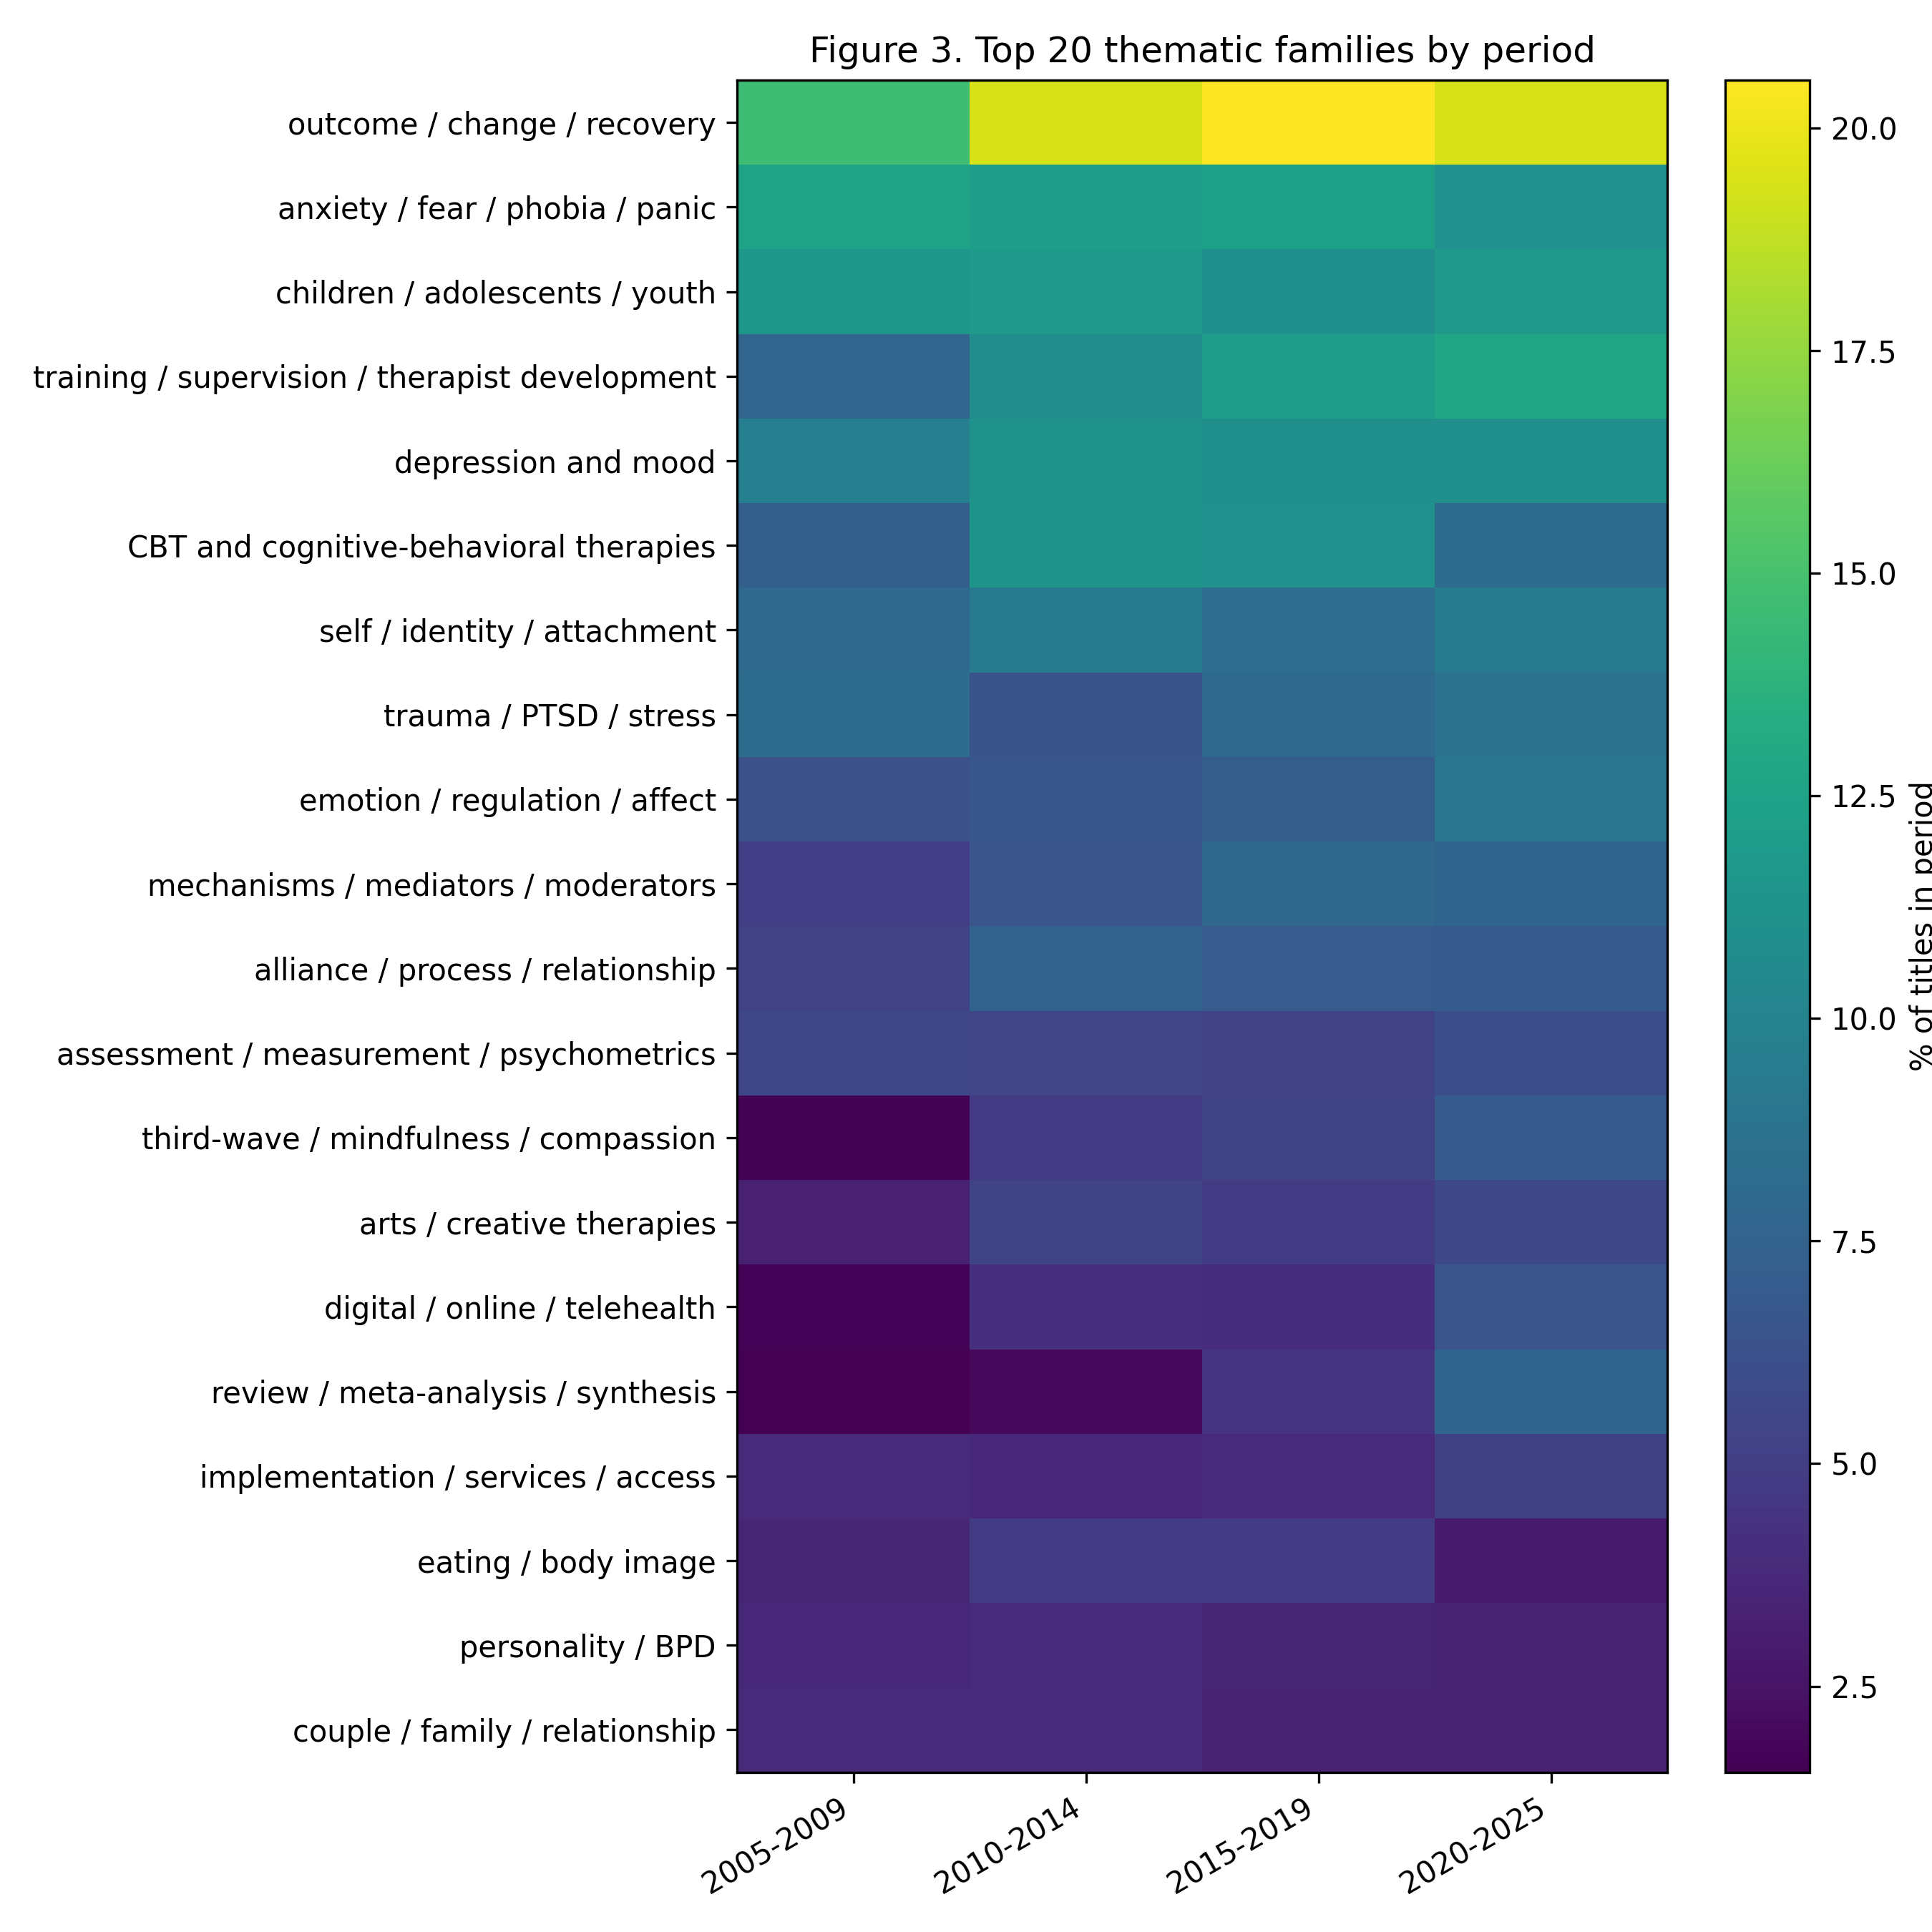
Figure 1. Top 20 thematic families by period.
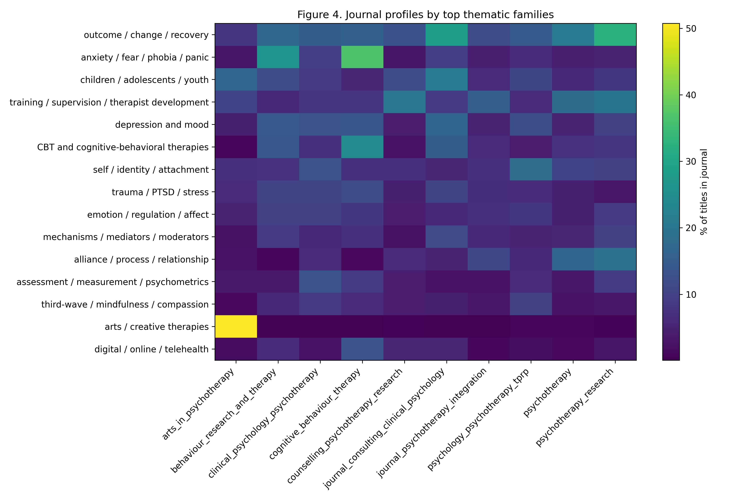
Figure 2. Journal profiles by top thematic families.
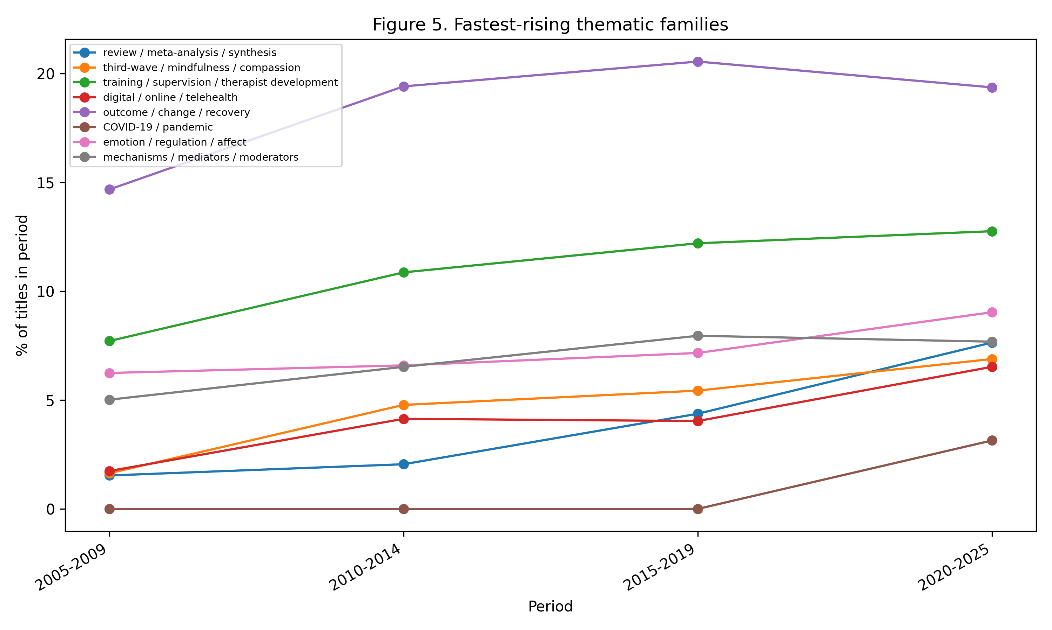
Figure 3. Fastest-rising thematic families.
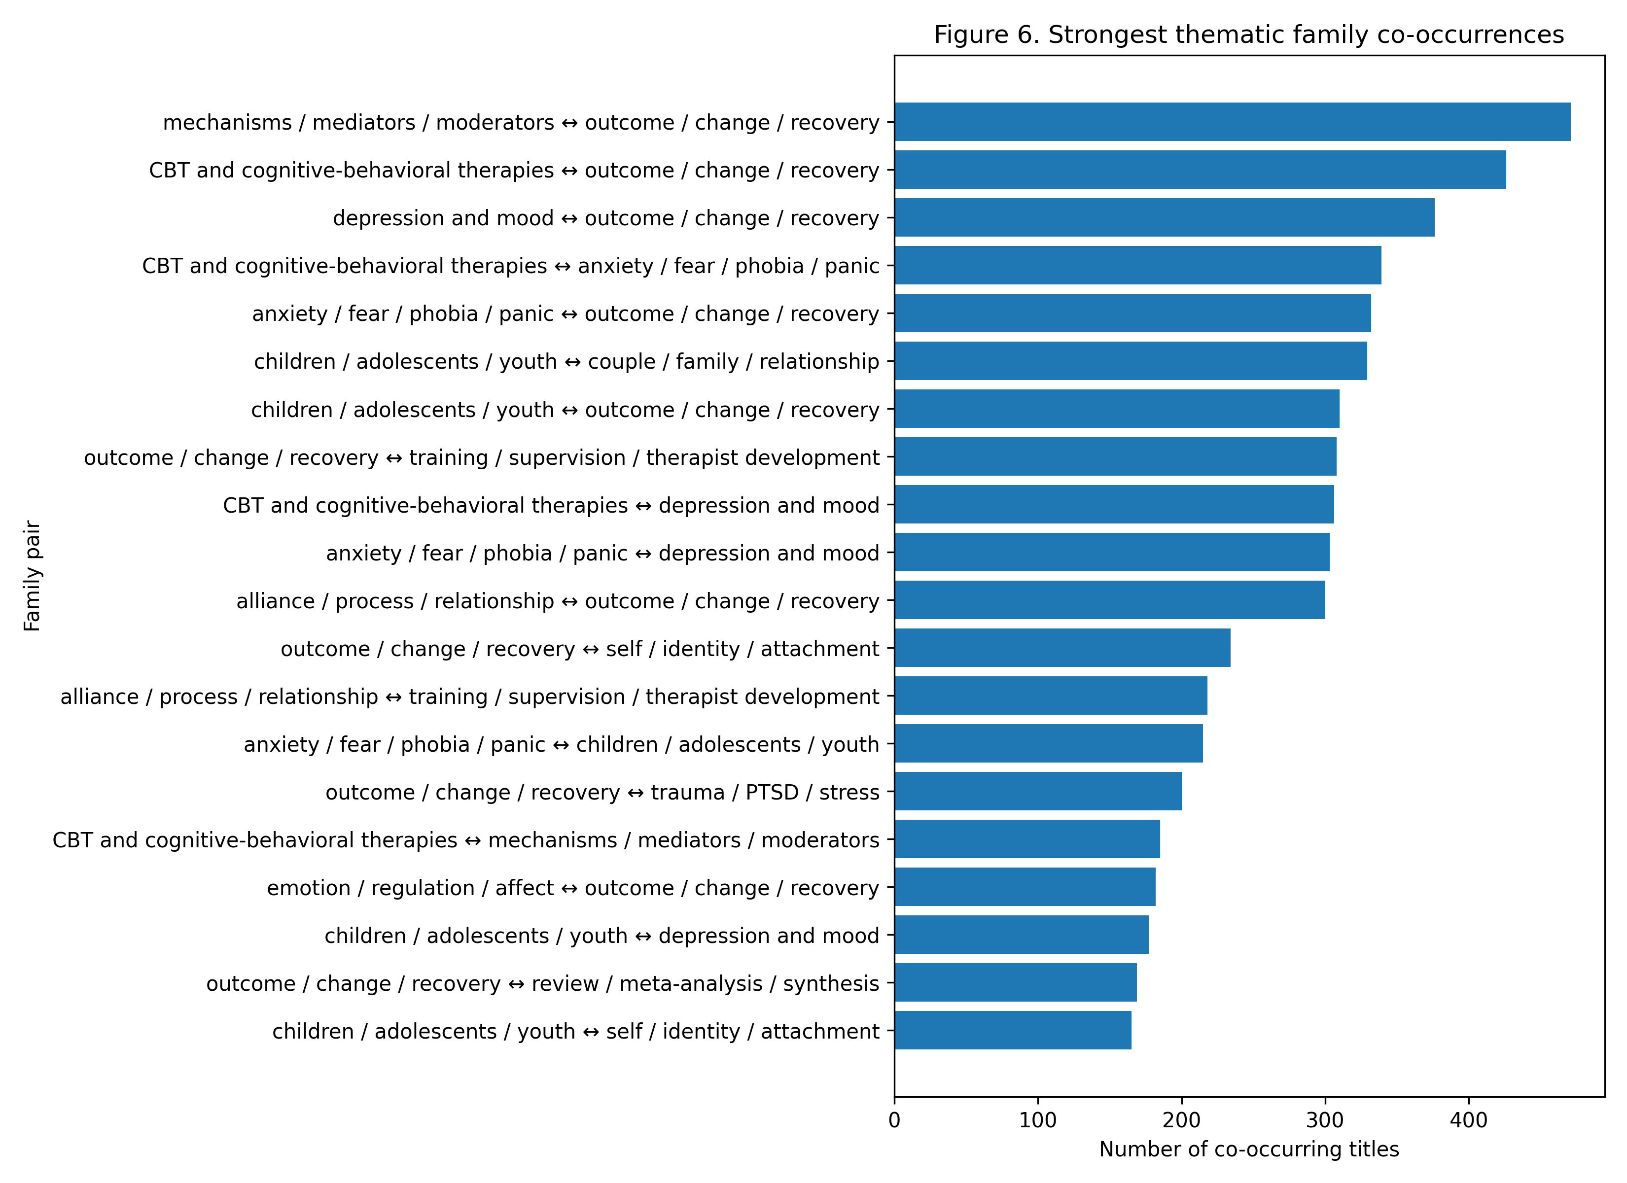
Figure 4. Strongest thematic family co-occurrences.

4. Discussion
This study mapped the title-level self-description of psychotherapy and clinical psychological intervention research across ten international journals from 2005 to 2025. The results suggest a field organized by several overlapping logics. Diagnostic and problem categories such as anxiety, depression, trauma, personality, and youth remain highly visible. However, the dominant family was outcome/change/recovery, indicating that the discourse foregrounds evaluation and change as central organizing concerns. This aligns with the long-standing centrality of outcome research in psychotherapy and clinical intervention science.
At the same time, the strongest longitudinal shifts point beyond a disorder-centered model. Evidence synthesis, third-wave and mindfulness/compassion approaches, therapist training and supervision, digital delivery, outcome evaluation, and mechanisms became more visible in titles. These shifts suggest a field increasingly concerned not only with whether treatments work, but with how evidence is organized, how interventions are delivered, how therapists work, and what mechanisms produce change (Andersson et al., 2019; Hayes et al., 1999; Hayes & Hofmann, 2018; Hofmann & Hayes, 2019; Kazdin, 2007; Norcross & Lambert, 2019).
The rise of review/meta-analysis/synthesis is especially important for a scientometric interpretation. It indicates not merely a thematic change but an epistemic shift: the field increasingly marks itself through synthesis, aggregation, and review. This reflects broader trends in evidence-based health research and the growth of synthesis-oriented scientific communication (Bornmann & Mutz, 2015; Page et al., 2021).
The growth of digital/online/telehealth and COVID-19/pandemic categories reflects changes in delivery conditions and historical context. The COVID-19 family is expectedly concentrated in the final period, but digital and online delivery were already visible before the pandemic and then accelerated. This suggests that digitalization is not reducible to the pandemic, even if the pandemic likely intensified its salience (Andersson et al., 2019).
The increase in training/supervision/therapist development indicates a professionalization axis within the field. Titles increasingly mark therapist factors, competence, fidelity, supervision, and training. This may reflect growing attention to implementation, dissemination, treatment quality, and the translation of research-supported interventions into practice (Norcross & Lambert, 2019; Norcross & Wampold, 2011).
Finally, the persistence and growth of alliance/process/relationship, emotion/regulation/affect, self/identity/attachment, and mechanisms/mediators/moderators suggest a process-oriented discourse. The field does not only ask whether interventions work but also asks how, for whom, through whom, and under what conditions they work. This complements disorder- and modality-based organization with questions about mechanisms of change and therapeutic relationships (Kazdin, 2007; Norcross & Wampold, 2011; Wampold & Imel, 2015).

4.1 Methodological contribution
The study also contributes a methodological lesson. The initial keyword-based approach failed because author-assigned keywords were not consistently exposed in public metadata. Rather than treating this as a failure, the project documented the limitation and shifted to a different bibliographic layer. This demonstrates a reproducible decision pathway for metadata-limited studies and aligns with recommendations that bibliometric studies make database, field-selection, and preprocessing decisions explicit because such decisions shape the resulting map (Donthu et al., 2021; Koo, 2023; Zupic & Čater, 2015).
The title-based approach is not a substitute for abstract or full-text analysis. Its strength lies in comparability and availability. Titles form a stable, public-facing metadata layer across journals, years, and publishers. For fields where keywords are absent or inconsistent, titles may provide a defensible and transparent basis for mapping self-description, especially when the object of analysis is explicitly limited to public-facing scholarly self-presentation (Leydesdorff & Welbers, 2011; van Eck & Waltman, 2014).

4.2 Limitations
Several limitations should be emphasized. First, the corpus was purposively selected and does not exhaust all psychotherapy-related journals. Important adjacent domains, including psychoanalysis, family therapy, group psychotherapy, counselling psychology, and implementation science, may require dedicated supplementary corpora. This limitation is consistent with the general dependence of bibliometric maps on corpus boundary decisions (Donthu et al., 2021; Zupic & Čater, 2015).
Second, article titles are compressed representations. They do not capture all constructs, methods, or interpretations present in abstracts or full texts. The results should therefore be interpreted as title-level self-description rather than full-content discourse. This is a deliberate reduction of the object of analysis, not a claim that title data exhaust the semantic content of the field (Leydesdorff & Welbers, 2011; van Eck & Waltman, 2014).
Third, family coding was rule-based. This makes the analysis auditable and reproducible, but it cannot capture all semantic nuance. Some terms are polysemous, and some families are intentionally broad. The non-exclusive coding system mitigates this problem by allowing titles to belong to several families, but expert interpretation remains necessary. The approach prioritizes transparency and auditability over fully automated semantic classification (Callon et al., 1991; Ding et al., 2001; Koo, 2023).
Fourth, relative declines should not be read as disappearance. Percentage changes reflect shifts in share within an expanding and diversifying corpus.

4.3 Conclusion
Across two decades, psychotherapy and clinical psychological intervention research increasingly describes itself through a combination of outcomes, synthesis, mechanisms, delivery systems, professional development, and process-oriented constructs. Classical clinical topics and modalities remain central, but the title-level discourse has expanded toward a more reflexive, evidence-organizing, delivery-aware, and mechanism-oriented field. The study demonstrates how a transparent human-in-the-loop title-based bibliometric workflow can map the public self-description of a research field when author-keyword metadata are unavailable or inconsistent.

Data and code availability
The project is structured as an auditable, layered workflow. Derived data tables, thematic rulebooks, and analysis outputs are intended for deposit in the project repository. Raw scrape outputs should be preserved as immutable source data, while cleaned title-corpus, family assignments, tables, and figures should be deposited as reproducible analytical layers.

Acknowledgments and AI-assisted research support
Bibliometric data preparation, semantic family normalization, workflow design, and draft generation were supported by the research agent Andromeda Nowicka (v0.4), a human-in-the-loop computational bibliometrics system developed under the supervision of an Author of this manuscript. The agent was used as a research support tool and is not claimed as an independent scholarly author. All analytical decisions require human validation and responsibility.

References
Andersson, G., Carlbring, P., Titov, N., & Lindefors, N. (2019). Internet interventions for adults with anxiety and mood disorders: A narrative umbrella review of recent meta-analyses. The Canadian Journal of Psychiatry, 64(7), 465–470. https://doi.org/10.1177/0706743719839381
Aria, M., & Cuccurullo, C. (2017). bibliometrix: An R-tool for comprehensive science mapping analysis. Journal of Informetrics, 11(4), 959–975. https://doi.org/10.1016/j.joi.2017.08.007
Börner, K., Chen, C., & Boyack, K. W. (2003). Visualizing knowledge domains. Annual Review of Information Science and Technology, 37(1), 179–255. https://doi.org/10.1002/aris.1440370106
Bornmann, L., & Mutz, R. (2015). Growth rates of modern science: A bibliometric analysis based on the number of publications and cited references. Journal of the Association for Information Science and Technology, 66(11), 2215–2222. https://doi.org/10.1002/asi.23329
Callon, M., Courtial, J. P., & Laville, F. (1991). Co-word analysis as a tool for describing the network of interactions between basic and technological research: The case of polymer chemistry. Scientometrics, 22(1), 155–205. https://doi.org/10.1007/BF02019280
Cobo, M. J., López-Herrera, A. G., Herrera-Viedma, E., & Herrera, F. (2011). Science mapping software tools: Review, analysis, and cooperative study among tools. Journal of the American Society for Information Science and Technology, 62(7), 1382–1402. https://doi.org/10.1002/asi.21525
Crossref. (2026). Crossref REST API documentation. https://www.crossref.org/documentation/retrieve-metadata/rest-api/
Cuijpers, P., Quero, S., Noma, H., Ciharova, M., Miguel, C., Karyotaki, E., Cipriani, A., Cristea, I. A., & Furukawa, T. A. (2021). Psychotherapies for depression: A network meta-analysis covering efficacy, acceptability and long-term outcomes of all main treatment types. World Psychiatry, 20(2), 283–293. https://doi.org/10.1002/wps.20860
Ding, Y., Chowdhury, G. G., & Foo, S. (2001). Bibliometric cartography of information retrieval research by using co-word analysis. Information Processing & Management, 37(6), 817–842. https://doi.org/10.1016/S0306-4573(00)00051-0
Donthu, N., Kumar, S., Mukherjee, D., Pandey, N., & Lim, W. M. (2021). How to conduct a bibliometric analysis: An overview and guidelines. Journal of Business Research, 133, 285–296. https://doi.org/10.1016/j.jbusres.2021.04.070
Garfield, E. (1955). Citation indexes for science: A new dimension in documentation through association of ideas. Science, 122(3159), 108–111. https://doi.org/10.1126/science.122.3159.108
Hayes, S. C., & Hofmann, S. G. (Eds.). (2018). Process-based CBT: The science and core clinical competencies of cognitive behavioral therapy. New Harbinger.
Hayes, S. C., Strosahl, K. D., & Wilson, K. G. (1999). Acceptance and commitment therapy: An experiential approach to behavior change. Guilford Press.
Hofmann, S. G., & Hayes, S. C. (2019). The future of intervention science: Process-based therapy. Clinical Psychological Science, 7(1), 37–50. https://doi.org/10.1177/2167702618772296
Hofmann, S. G., Asnaani, A., Vonk, I. J. J., Sawyer, A. T., & Fang, A. (2012). The efficacy of cognitive behavioral therapy: A review of meta-analyses. Cognitive Therapy and Research, 36(5), 427–440. https://doi.org/10.1007/s10608-012-9476-1
Kazdin, A. E. (2007). Mediators and mechanisms of change in psychotherapy research. Annual Review of Clinical Psychology, 3, 1–27. https://doi.org/10.1146/annurev.clinpsy.3.022806.091432
Koo, M. (2023). An analysis of reporting practices in the top 100 cited health and medicine-related bibliometric studies from 2019 to 2021 based on a proposed guidelines. Heliyon, 9(6), e16865. https://doi.org/10.1016/j.heliyon.2023.e16865
Leydesdorff, L., & Welbers, K. (2011). The semantic mapping of words and co-words in contexts. Journal of Informetrics, 5(3), 469–475. https://doi.org/10.1016/j.joi.2011.01.008
Moral-Muñoz, J. A., Herrera-Viedma, E., Santisteban-Espejo, A., & Cobo, M. J. (2020). Software tools for conducting bibliometric analysis in science: An up-to-date review. Profesional de la información, 29(1), e290103. https://doi.org/10.3145/epi.2020.ene.03
Norcross, J. C., & Lambert, M. J. (Eds.). (2019). Psychotherapy relationships that work: Evidence-based therapist contributions (3rd ed.). Oxford University Press.
Norcross, J. C., & Wampold, B. E. (2011). Evidence-based therapy relationships: Research conclusions and clinical practices. Psychotherapy, 48(1), 98–102. https://doi.org/10.1037/a0022161
Page, M. J., McKenzie, J. E., Bossuyt, P. M., Boutron, I., Hoffmann, T. C., Mulrow, C. D., Shamseer, L., Tetzlaff, J. M., Akl, E. A., Brennan, S. E., Chou, R., Glanville, J., Grimshaw, J. M., Hróbjartsson, A., Lalu, M. M., Li, T., Loder, E. W., Mayo-Wilson, E., McDonald, S., ... Moher, D. (2021). The PRISMA 2020 statement: An updated guideline for reporting systematic reviews. BMJ, 372, n71. https://doi.org/10.1136/bmj.n71
Small, H. (1999). Visualizing science by citation mapping. Journal of the American Society for Information Science, 50(9), 799–813. https://doi.org/10.1002/(SICI)1097-4571(1999)50:9<799::AID-ASI9>3.0.CO;2-G
Springer Nature. (2026). Scientometrics: Aims and scope. https://link.springer.com/journal/11192/aims-and-scope
van Eck, N. J., & Waltman, L. (2010). Software survey: VOSviewer, a computer program for bibliometric mapping. Scientometrics, 84, 523–538. https://doi.org/10.1007/s11192-009-0146-3
van Eck, N. J., & Waltman, L. (2014). Visualizing bibliometric networks. In Y. Ding, R. Rousseau, & D. Wolfram (Eds.), Measuring scholarly impact: Methods and practice (pp. 285–320). Springer. https://doi.org/10.1007/978-3-319-10377-8_13
VOSviewer. (2026). VOSviewer: Visualizing scientific landscapes. https://www.vosviewer.com/
Waltman, L., van Eck, N. J., & Noyons, E. C. M. (2010). A unified approach to mapping and clustering of bibliometric networks. Journal of Informetrics, 4(4), 629–635. https://doi.org/10.1016/j.joi.2010.07.002
Wampold, B. E., & Imel, Z. E. (2015). The great psychotherapy debate: The evidence for what makes psychotherapy work (2nd ed.). Routledge.
Zupic, I., & Čater, T. (2015). Bibliometric methods in management and organization. Organizational Research Methods, 18(3), 429–472. https://doi.org/10.1177/1094428114562629

