VELLORE INSTITUTE OF TECHNOLOGY, VELLORE
School of Computer Science and Engineering

DATABASE MANAGEMENT SYSTEMS
Review 2

Smart Movie Experience & Booking System
A full-stack movie discovery, booking, and demand-based dynamic pricing platform
Frontend, Business Logic and Database Connectivity

Submitted by
Name | Registration No. | Role
Kalivarapu Prabhas | 24BCE2279 | Team Member
Shanmukha Abhinav | 24BAI0238 | Team Member

Faculty Guide: Navamani T M
Slot: L33 + L34 | Course Code: BCSE302P
Report prepared: 22 October 2026

Contents
1. Scope and architecture
2. Technology stack
3. Frontend
4. Backend REST API
5. Business logic
6. Database connectivity
7. Security
8. Project structure
Appendix - key source excerpts

1. Scope and architecture
Review 2 covers the working application built on the Review-1 database: a single-page frontend, a Flask REST backend containing all business logic, and the database connectivity layer. The application runs end to end: every screen described here was exercised in a real browser (results in Review 3).
Browser (HTML/CSS/JS SPA, hash router)
| fetch() JSON over HTTP, session cookie (HttpOnly, SameSite=Lax)
Flask app (backend/app.py) -- validation, RBAC, booking transaction, notifications
|-- backend/pricing.py : dynamic pricing engine (+ 15-minute scheduler thread)
|-- backend/db.py : connection factory, schema + seed bootstrap
SQLite database (same 20-table relational model as the Oracle scripts)

Database note: the Oracle scripts remain the lab deliverable (Review 1). The running website connects to SQLite because no Oracle server was available in the build environment and SQLite lets the site run and deploy anywhere. The business rules are enforced by the same constraints in both. Section 6.4 shows how the connection layer would be swapped to Oracle (python-oracledb); that swap was not implemented or tested.

2. Technology stack
Layer | Technology | Why
Frontend | HTML5, CSS3 (custom properties, grid, flex, dark/light via prefers-color-scheme), vanilla JavaScript ES2020 | no build step, no dependencies, easy to demonstrate
Backend | Python 3.12, Flask 3.1, Werkzeug | small, readable REST layer; password hashing and sessions built in
Database | SQLite 3 (running app) / Oracle 11g+ (lab scripts) | same schema; ACID transactions
Server | gunicorn (production), Flask dev server (local) | WSGI
Testing | unittest, Flask test client, Playwright + Chromium | API, DB and real-browser tests

3. Frontend
A single-page application (frontend/index.html, style.css, app.js - about 450 lines of JavaScript). Hash routing (#/movie/3, #/show/25) means deep links work without server configuration. All dynamic text is HTML-escaped by a tagged-template helper before insertion, which neutralises stored XSS in reviews and captions. The layout is responsive (verified at 390 px width) and follows the OS light/dark preference.
Route | Screen | Backend calls
#/ | Home: hero, search box, genre / language / rating filters, movie grid with live 'from' price | GET /api/movies, /api/genres
#/movie/:id | Details, shows grouped by date and theatre with live price and seats left, watchlist toggle, reviews and review form | GET /api/movies/:id, /shows, /reviews; POST /reviews; /watchlist
#/show/:id | Interactive seat map, smart recommendation, live price + demand meter, payment selection, booking | GET /api/shows/:id, /recommend; POST /api/bookings
#/bookings | Booking history, cancel, add memory, link to review | GET /api/bookings; POST /cancel; POST /memories
#/memories, #/watchlist, #/notifications, #/preferences | Memory gallery, watchlist, alerts with unread badge, genre preferences | /api/memories, /watchlist, /notifications, /preferences
#/login, #/register, #/admin-login | Authentication forms with server-side validation messages | /api/auth/*, /api/admin/login
#/admin | Dashboard (overview, shows, movies, theatres & screens, pricing engine, users) | /api/admin/*

3.1 Interactive seat booking
- Seats are rendered row by row (A, B, ...), premium seats outlined, booked seats disabled and struck through, selected seats green, recommended seats dashed.
- The page polls the server every 12 seconds: availability and the live price update without reloading, and a seat someone else just took is automatically deselected.
- Smart recommendation: choose 1-6 seats; the server returns the best block of adjacent free seats (rows around 60% of the depth, centred columns, premium preferred) or the best individual seats when no block exists.
- If two people click Confirm for the same seat, the loser receives a clear message and the seat map refreshes (demonstrated in Review 3, screenshot 09).
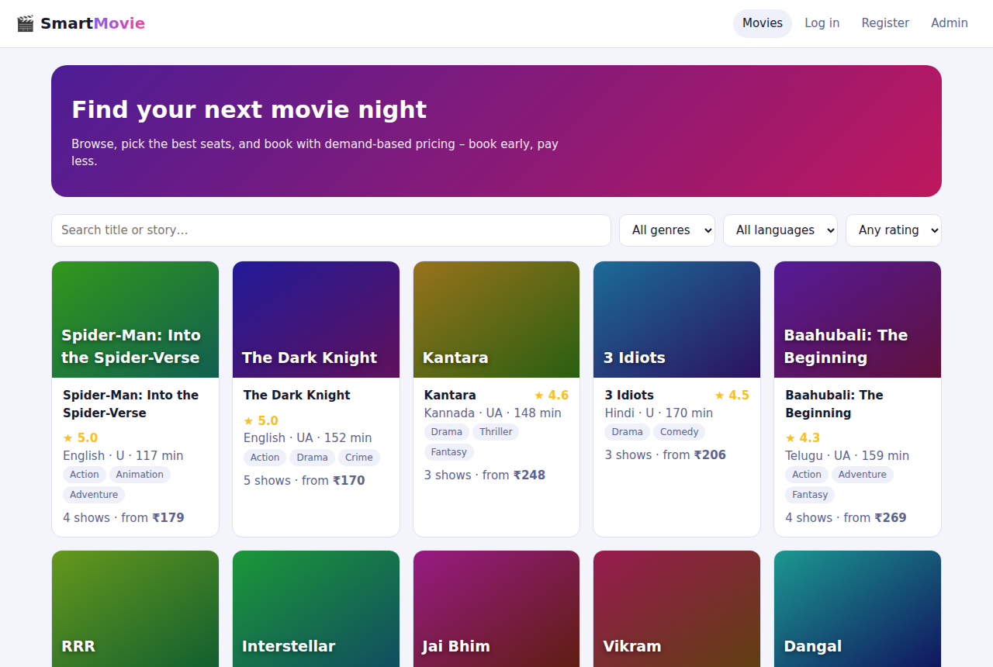
Figure 1 - Home page with search and filters
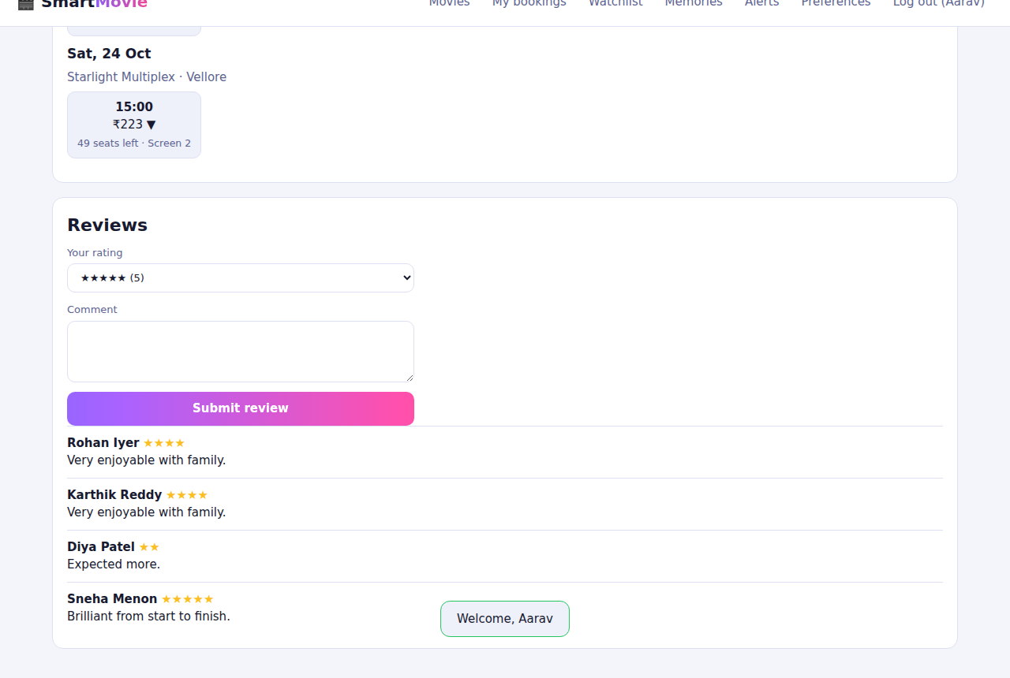
Figure 2 - Movie detail: shows with live dynamic prices (arrows show price above/below base)
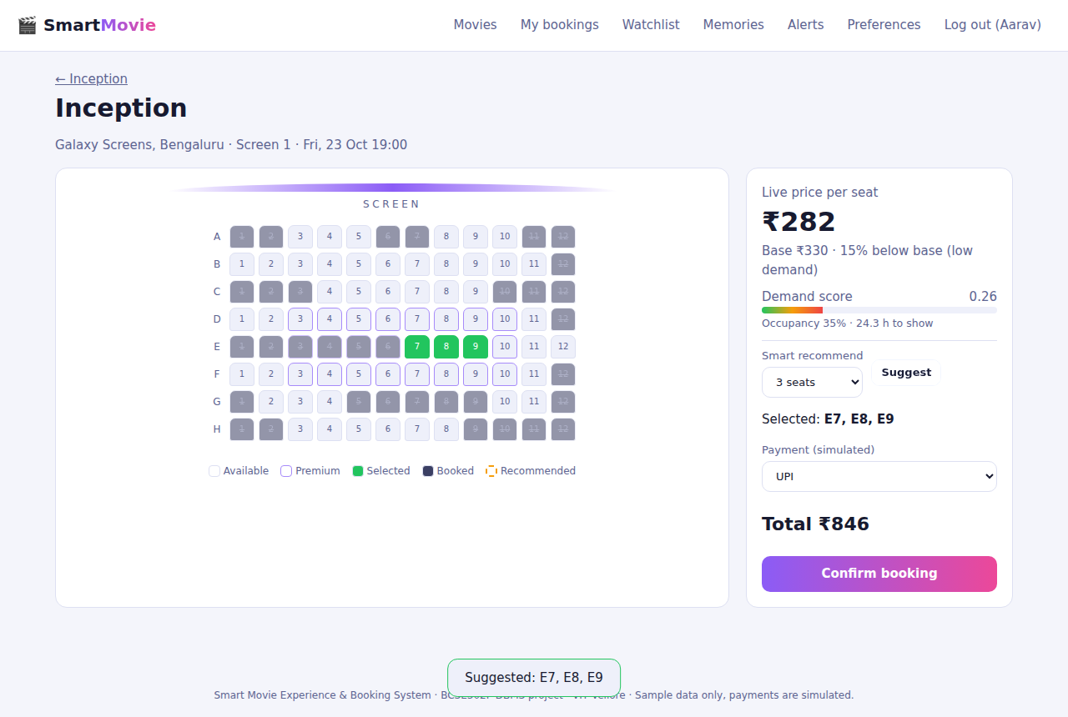
Figure 3 - Seat map with recommended seats, demand meter and live price
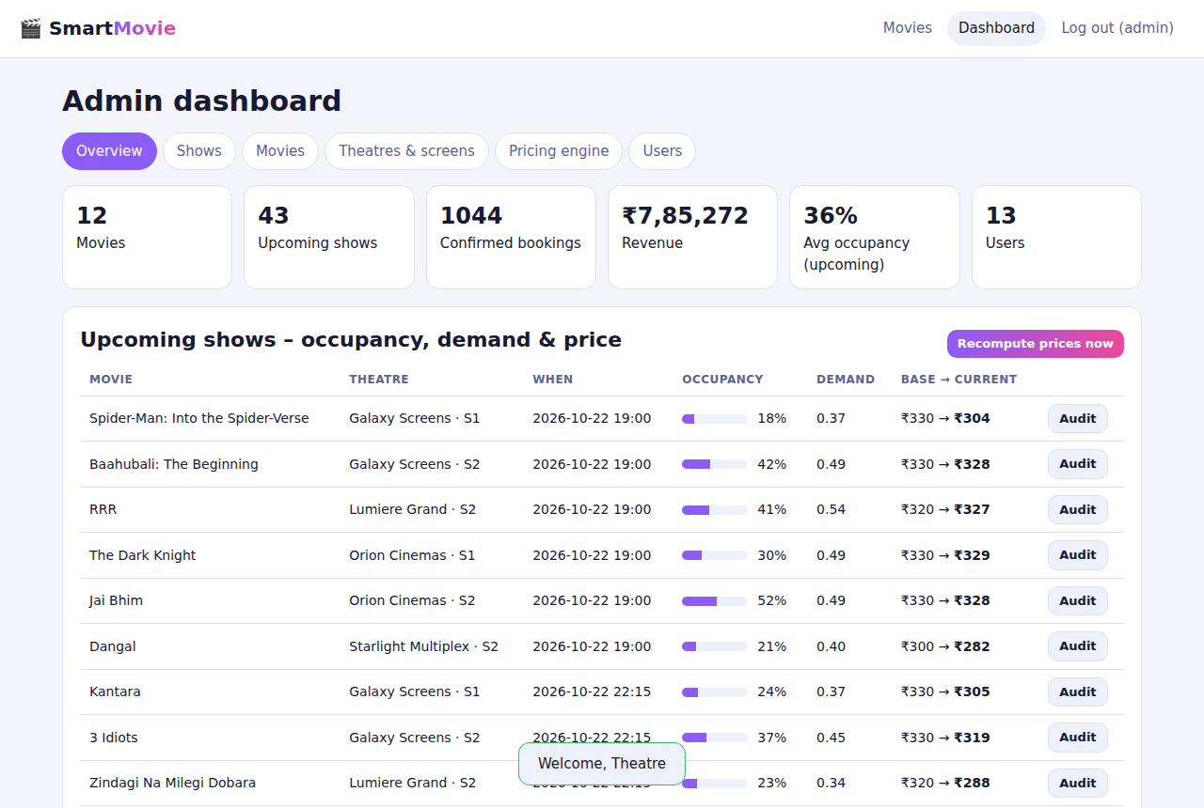
Figure 4 - Admin dashboard: totals, occupancy, demand and price per show
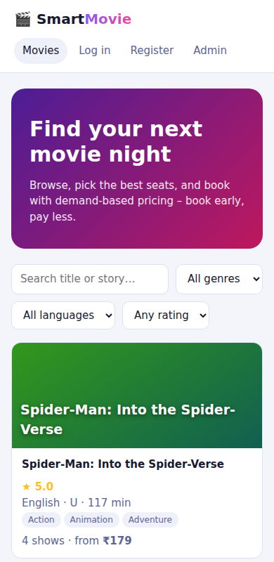
Figure 5 - Mobile layout (390 px)

4. Backend REST API
All endpoints return JSON; errors use {"error": message} with meaningful status codes (400 validation, 401 not logged in, 403 forbidden, 404, 409 conflict, 429 throttled).
Method and path | Role | Purpose
POST /api/auth/register, /login, /logout; GET /api/auth/me | public | accounts, session
POST /api/admin/login | public | separate admin authentication
GET /api/movies?q&genre&language&min_rating; /api/movies/:id; /api/genres | public | catalogue
GET /api/movies/:id/shows, /reviews | public | shows with live price, reviews
GET /api/shows/:id; /api/shows/:id/recommend?count=n | public | seat map + demand snapshot; seat recommendation
POST /api/bookings; GET /api/bookings; POST /api/bookings/:id/cancel | user | atomic booking, history, cancellation
POST /api/movies/:id/reviews | user | review (after attending)
POST /api/bookings/:id/memories; GET/DELETE /api/memories | user | movie memories (media upload)
GET/POST/DELETE /api/watchlist; GET/PUT /api/preferences; GET /api/notifications; POST /api/notifications/read | user | personalisation
GET /api/admin/dashboard; GET /api/admin/shows/:id/pricing | admin | KPIs; demand and price audit
POST /api/admin/pricing/run; GET/PUT /api/admin/pricing-config | admin | run engine; tune weights (history kept)
POST/PUT/DELETE /api/admin/movies, /shows; GET/POST /api/admin/theatres; POST /api/admin/screens | admin | catalogue, schedule and screen/seat management
GET /api/admin/users; POST /api/admin/admins | admin | account management
GET /api/health | public | deployment health check

5. Business logic

5.1 Booking transaction (double-booking prevention)
BEGIN IMMEDIATE -- takes the write lock: bookings are serialised
load show; refuse if show has started
verify all seat_ids belong to the show's screen
INSERT booking (price = shows.current_price * n_seats)
INSERT booking_seat for each seat -- UNIQUE(show_id, seat_id) is the last line of defence
on constraint violation -> ROLLBACK, HTTP 409 'seats just booked by someone else'
INSERT payment (SUCCESS, simulated), INSERT notification
recompute_show(show) -- occupancy changed, so reprice and log
COMMIT

Defence in depth: (1) the UI hides booked seats, (2) the server checks inside a write-locked transaction, (3) the database UNIQUE constraint rejects duplicates even if the application had a bug. The price per seat is read inside the transaction, so the customer pays the price that was current at confirmation. Cancellation deletes the Booking_Seat rows (seats become free), marks Booking CANCELLED and Payment REFUNDED, notifies the user and reprices.

5.2 Dynamic pricing engine (backend/pricing.py)
Implements Review-0 section 5 exactly (formulas in Review 1, section 9). It runs (a) immediately after every booking and cancellation, (b) when an admin saves new pricing weights, creates a show or presses Recompute, and (c) every 15 minutes from a scheduler thread. Each run inserts one Demand_Analysis row per show; a Price_History row is inserted only when the price changes, with reason demand_recalculation, suffixed '(clamped to max)' or '(clamped to min)' when the admin band was binding. The pure function compute_price(O, S, P, U, config, base, min, max) is unit-tested against the Review-0 worked example.

from datetime import datetime, timedelta
import math

SPEED_FLOOR = 5
WATCHLIST_FLOOR = 5

def now_str(dt=None):
return (dt or datetime.now()).strftime("%Y-%m-%d %H:%M:%S")

def compute_price(o, s, p, u, cfg, base, pmin, pmax):
"""Pure function: signals -> (score, multiplier, raw_price, final_price). Used by tests and the engine."""
score = cfg["w_occupancy"] * o + cfg["w_booking_speed"] * s + cfg["w_popularity"] * p + cfg["w_urgency"] * u
score = min(1.0, max(0.0, score))
mult = round(1 + cfg["elasticity_k"] * (score - 0.5), 3)
raw = math.floor(base * mult + 0.5)
return score, mult, raw, min(pmax, max(pmin, raw))

5.3 Other rules
- Reviews: only users who hold a confirmed booking for a show of that movie that has already started; one review per user per movie (later submissions update it); the movie's average rating is kept in sync by a database trigger.
- Movie memories: uploads (png/jpg/gif/webp/mp4/webm, max 8 MB) only for confirmed bookings whose show has started; stored under a random file name; linked to booking, user and movie.
- Notifications: booking confirmation / cancellation, 3-hour show reminders (scheduler), new-release alerts to users who follow a genre of a newly added movie, watchlist alerts when a show is scheduled for a watchlisted movie.
- Seat recommendation: adjacent block nearest the ideal row (60% depth) and centre columns, premium preferred; falls back to best single seats.
- Admin: movies with shows and shows with bookings cannot be deleted; show times validated (HH:MM), min <= base <= max; a duplicate screen/date/time slot is rejected; pricing weights must sum to 1.

6. Database connectivity

6.1 Connection layer (backend/db.py)
"""SQLite connection helpers + database bootstrap (schema + sample data)."""
import os, sqlite3, sys
from datetime import datetime

ROOT = os.path.dirname(os.path.dirname(os.path.abspath(__file__)))
sys.path.insert(0, os.path.join(ROOT, "database"))
SCHEMA = os.path.join(ROOT, "database", "sqlite", "schema.sql")

def connect(path):
conn = sqlite3.connect(path, timeout=30, isolation_level=None) # autocommit; we manage transactions explicitly
conn.row_factory = sqlite3.Row
conn.execute("PRAGMA foreign_keys = ON")
conn.execute("PRAGMA journal_mode = WAL")
return conn

- One connection per request (flask.g), closed in the teardown hook; no global shared connection.
- PRAGMA foreign_keys=ON so referential integrity is enforced; WAL journal for concurrent readers during a write.
- isolation_level=None with explicit BEGIN IMMEDIATE ... COMMIT/ROLLBACK in a Tx context manager, so every multi-statement operation is atomic.
- All SQL uses bound parameters (?), never string concatenation of user input (injection test in Review 3). Only column-name fragments chosen by the program itself are formatted into SQL.

6.2 Transaction helper and a query example
class Tx:
"""BEGIN IMMEDIATE ... COMMIT/ROLLBACK -- serialises writers so seat checks are race-free."""
def __enter__(self): conn().execute("BEGIN IMMEDIATE"); return conn()
def __exit__(self, et, ev, tb):
conn().execute("ROLLBACK" if et else "COMMIT")
return False

# seat map: LEFT JOIN marks seats already present in booking_seat for this show
SELECT st.seat_id, st.seat_number, st.seat_type, st.seat_location,
CASE WHEN bs.seat_id IS NULL THEN 0 ELSE 1 END AS booked
FROM seat st LEFT JOIN booking_seat bs ON bs.seat_id = st.seat_id AND bs.show_id = ?
WHERE st.screen_id = ?

6.3 Bootstrap
On first start the app creates the database file, runs database/sqlite/schema.sql, loads the sample data produced by database/seed_data.py and runs a first pricing pass. The same generator writes the Oracle INSERT script, so both databases hold the same sample data.

6.4 Connecting to Oracle instead (not implemented, not tested)
If the lab requires the website itself to talk to Oracle, replace db.py with python-oracledb and port the few SQLite-specific functions. Sketch:
import oracledb
pool = oracledb.create_pool(user=os.environ['ORA_USER'], password=os.environ['ORA_PASS'],
dsn=os.environ['ORA_DSN'], min=1, max=4) # e.g. localhost/XEPDB1
with pool.acquire() as conn, conn.cursor() as cur:
out = cur.var(int)
cur.callproc('book_seats', [user_id, show_id, oracledb.DB_TYPE_..., 'UPI', out]) # PL/SQL unit from 02_plsql.sql
booking_id = out.getvalue()
# Port list: datetime('now') -> SYSTIMESTAMP, GROUP_CONCAT -> LISTAGG, LIMIT n -> FETCH FIRST n ROWS ONLY,
# INSERT OR IGNORE -> MERGE, '?' placeholders -> ':1' / named binds, lastrowid -> RETURNING ... INTO

7. Security
Concern | Measure
Password storage | Werkzeug scrypt salted hashes; test proves identical passwords produce different hashes
Roles | customers and admins in separate tables, separate login endpoints; admin API returns 403 to customers (tested)
Brute force | login throttling: 10 attempts per 5 minutes per IP and email, HTTP 429
SQL injection | bound parameters everywhere; injection strings in login and search tested
XSS | all rendered text HTML-escaped in the frontend; API serves JSON only
CSRF | SameSite=Lax HttpOnly session cookie; state-changing calls need JSON bodies (cross-site form posts cannot set JSON content type)
Uploads | extension allow-list, 8 MB limit, random server-side names; files served from a dedicated folder
Secrets | SECRET_KEY from the environment (must be set in production); no secrets in the repository

Not covered (out of scope for a lab project): CSRF tokens, email verification, password reset, real payment gateway, rate limiting beyond login, content scanning of uploads.

8. Project structure
smart-movie-booking/
backend/ app.py pricing.py db.py
frontend/ index.html style.css app.js sample/
database/ oracle/{01_schema,02_plsql,03_seed}.sql sqlite/schema.sql seed_data.py queries.sql
tests/ test_all.py scripts/ e2e_browser.py build_reports.py
docs/ SETUP.md diagrams/ screenshots/ evidence/ reports/
wsgi.py manage.py requirements.txt Procfile Dockerfile render.yaml README.md

Appendix - key source excerpts

A. Booking endpoint (backend/app.py)
@app.post("/api/bookings")
@login_required
def create_booking():
d = body(); sid = num(d, "show_id", integer=True)
seat_ids = d.get("seat_ids")
if not isinstance(seat_ids, list) or not seat_ids: raise ApiError("Select at least one seat")
try: seat_ids = sorted({int(x) for x in seat_ids})
except (TypeError, ValueError): raise ApiError("Invalid seat ids")
if len(seat_ids) > MAX_SEATS: raise ApiError(f"At most {MAX_SEATS} seats per booking")
method = (d.get("payment_method") or "UPI").upper()
if method not in METHODS: raise ApiError("Invalid payment method")
with Tx() as c:
s = c.execute("""SELECT s.*, m.title FROM shows s JOIN movie m ON m.movie_id=s.movie_id WHERE s.show_id=?""", (sid,)).fetchone()
if not s: raise ApiError("Show not found", 404)
if pricing.show_start(s) <= datetime.now(): raise ApiError("This show has already started", 409)
ok = c.execute(f"SELECT COUNT(*) FROM seat WHERE screen_id=? AND seat_id IN ({','.join('?' * len(seat_ids))})",
[s["screen_id"], *seat_ids]).fetchone()[0]
if ok != len(seat_ids): raise ApiError("Some seats do not belong to this show's screen")
price = s["current_price"]; total = price * len(seat_ids)
cur = c.execute("INSERT INTO booking (user_id,show_id,booking_time,total_amount,booking_status) VALUES (?,?,?,?,?)",
(uid(), sid, now_s(), total, "CONFIRMED"))
bid = cur.lastrowid
try:
for seat in seat_ids: c.execute("INSERT INTO booking_seat (booking_id,seat_id,show_id) VALUES (?,?,?)", (bid, seat, sid))
except sqlite3.IntegrityError as e:
if "UNIQUE" in str(e): raise ApiError("One or more selected seats were just booked by someone else. Please pick again.", 409)
raise
c.execute("INSERT INTO payment (booking_id,amount,payment_date,payment_method,payment_status) VALUES (?,?,?,?,'SUCCESS')",
(bid, total, now_s(), method))
c.execute("INSERT INTO notification (user_id,message,notif_type,sent_date) VALUES (?,?,?,?)",
(uid(), f"Booking #{bid} confirmed for {s['title']} on {s['show_date']} at {s['show_time']}.", "BOOKING", now_s()))
pricing.recompute_show(c, sid)
return jsonify(booking_id=bid, total_amount=total, price_per_seat=price, seats=len(seat_ids)), 201

B. Seat recommendation
@app.get("/api/shows/<int:sid>/recommend")
def recommend(sid):
s = show_info(sid)
n = max(1, min(int(request.args.get("count", 1) or 1), 6))
seats = sorted(seat_map(sid, s["screen_id"]), key=seat_sort_key)
rows = {}
for st in seats: rows.setdefault(st["seat_number"][0], []).append(st)
letters = sorted(rows); ideal_row = 0.6 * (len(letters) - 1)
def score(st, ri, ncols):
col = int(st["seat_number"][1:]); center = (ncols + 1) / 2
return -abs(ri - ideal_row) - 0.5 * abs(col - center) / (ncols / 2) * 2 + (0.5 if st["seat_type"] == "PREMIUM" else 0)
best = None
for ri, L in enumerate(letters):
row = rows[L]; ncols = len(row)
for i in range(0, ncols - n + 1):
grp = row[i:i + n]
if any(x["booked"] for x in grp): continue
sc = sum(score(x, ri, ncols) for x in grp) / n
if best is None or sc > best[0]: best = (sc, grp)
if best is None: # no contiguous block: best individual free seats
free = [(score(st, letters.index(st["seat_number"][0]), len(rows[st["seat_number"][0]])), st) for st in seats if not st["booked"]]
free.sort(key=lambda x: -x[0])
if len(free) < n: raise ApiError("Not enough free seats", 409)
return jsonify(seat_ids=[x[1]["seat_id"] for x in free[:n]], seats=[x[1]["seat_number"] for x in free[:n]], contiguous=False)
return jsonify(seat_ids=[x["seat_id"] for x in best[1]], seats=[x["seat_number"] for x in best[1]], contiguous=True)

C. Frontend seat selection (frontend/app.js)
async function pageShow(id) {
if (!needUser()) return;
let sel = new Set(), rec = new Set(), data;
const draw = () => {
const { show: s, seats, demand } = data;
const pay0 = document.getElementById("pay")?.value, n0 = document.getElementById("rec-n")?.value;
const rows = {}; seats.forEach(x => (rows[x.seat_number[0]] ||= []).push(x));
const total = sel.size * s.current_price;
const diff = Math.round((s.current_price / s.base_price - 1) * 100);
render(html`<a href="#/movie/${s.movie_id}" class="muted">← ${s.title}</a>
<h1>${s.title}</h1><p class="muted">${s.theatre_name}, ${s.city} · Screen ${s.screen_number} · ${fmtDate(s.show_date)} ${s.show_time}</p>
<div class="seat-layout"><div class="panel"><div class="screen-bar"></div><div class="screen-label">SCREEN</div>
<div class="seats" id="seats">${Object.entries(rows).map(([L, list]) => html`<div class="seat-row"><span class="rl">${L}</span>${list.map(x => html`<button class="seat ${x.seat_type === "PREMIUM" ? "premium" : ""} ${sel.has(x.seat_id) ? "sel" : ""} ${rec.has(x.seat_id) && !sel.has(x.seat_id) ? "rec" : ""}" data-act="seat" data-id="${x.seat_id}" ${x.booked ? "disabled" : ""} title="${x.seat_number} · ${x.seat_type} · ${x.seat_location}" aria-label="Seat ${x.seat_number} ${x.booked ? "booked" : "available"}">${x.seat_number.slice(1)}</button>`)}</div>`)}</div>
<div class="legend"><span><i></i>Available</span><span><i style="border-color:#a78bfa"></i>Premium</span><span><i style="background:var(--ok)"></i>Selected</span><span><i style="background:#3b3f63"></i>Booked</span><span><i style="border:2px dashed var(--warn)"></i>Recommended</span></div></div>
<aside class="panel"><div class="muted">Live price per seat</div><div class="price-big">${money(s.current_price)}</div>
<div class="muted">Base ${money(s.base_price)} · ${diff === 0 ? "at base price" : diff > 0 ? `${diff}% above base (high demand)` : `${-diff}% below base (low demand)`}</div>
${demand ? html`<div style="margin:10px 0"><div class="row between muted"><span>Demand score</span><span>${demand.demand_score.toFixed(2)}</span></div><div class="meter"><i style="width:${demand.demand_score * 100}%"></i></div>
<small class="muted">Occupancy ${(demand.occupancy_rate * 100).toFixed(0)}% · ${demand.time_remaining.toFixed(1)} h to show</small></div>` : ""}
<hr style="border:0;border-top:1px solid var(--line)">
<div class="row"><label>Smart recommend<select id="rec-n">${[1, 2, 3, 4, 5, 6].map(n => html`<option value="${n}">${n} seat${n > 1 ? "s" : ""}</option>`)}</select></label><button class="btn ghost sm" data-act="recommend">Suggest</button></div>
<p>Selected: <b>${[...sel].map(i => seats.find(x => x.seat_id === i).seat_number).join(", ") || "none"}</b></p>
<label>Payment (simulated)<select id="pay"><option>UPI</option><option>CARD</option><option>NETBANKING</option><option>WALLET</option></select></label>
<p class="price-big" style="font-size:22px">Total ${money(total)}</p>
<button class="btn" style="width:100%" data-act="book" ${sel.size && !s.started ? "" : "disabled"}>${s.started ? "Show started" : "Confirm booking"}</button></aside></div>`);
if (pay0) document.getElementById("pay").value = pay0;
if (n0) document.getElementById("rec-n").value = n0;
};
const load = async keep => {
data = await api("/shows/" + id);
const free = new Set(data.seats.filter(x => !x.booked).map(x => x.seat_id));
sel = new Set([...sel].filter(x => free.has(x))); if (!keep) rec = new Set(); draw();
};
await load();
page.ctx = { sel: () => sel, toggle: i => { sel.has(i) ? sel.delete(i) : sel.add(i); rec.delete(i); draw(); },
recommend: async () => { const n = document.getElementById("rec-n").value; try { const r = await api(`/shows/${id}/recommend?count=${n}`); rec = new Set(r.seat_ids); sel = new Set(r.seat_ids); draw(); toast("Suggested: " + r.seats.join(", ") + (r.contiguous ? "" : " (not adjacent)")); } catch (e) { toast(e.message, "err"); } },
book: async () => {
try { const r = await api("/bookings", { json: { show_id: id, seat_ids: [...sel], payment_method: document.getElementById("pay").value } });
toast(`Booked! ${r.seats} seat(s), ${money(r.total_amount)}`); await refreshUser(); go("#/bookings");
} catch (e) { toast(e.message, "err"); await load(true); }
} };
state.timer = setInterval(() => { if (document.hidden) return; load(true).catch(() => { }); }, 12000); // live availability + price
}

