VELLORE INSTITUTE OF TECHNOLOGY, VELLORE
School of Computer Science and Engineering

DATABASE MANAGEMENT SYSTEMS
Review 3 (Final)

Smart Movie Experience & Booking System
A full-stack movie discovery, booking, and demand-based dynamic pricing platform
Testing, Validation, Screenshots, Demonstration and Final Documentation

Submitted by
Name | Registration No. | Role
Kalivarapu Prabhas | 24BCE2279 | Team Member
Shanmukha Abhinav | 24BAI0238 | Team Member

Faculty Guide: Navamani T M
Slot: L33 + L34 | Course Code: BCSE302P
Report prepared: 22 October 2026

Contents
1. Summary of the project
2. Test strategy and environment
3. Automated unit / database / API tests (29)
4. Real-browser end-to-end tests (18)
5. Validation of key requirements
6. Screenshots
7. Demonstration script
8. Software documentation and installation
9. Repository and deployment status
10. Limitations and future work
11. Conclusion

1. Summary of the project
The Smart Movie Experience & Booking System is a database-driven web platform: customers browse movies, choose a theatre and show, pick seats on an interactive map with smart recommendation, and book with guaranteed protection against double-booking; they review movies, keep a watchlist, set genre preferences, receive notifications and attach memories to bookings. Administrators run a demand-analysis pipeline that drives dynamic ticket pricing bounded by configurable limits, and manage the catalogue from a dashboard. The project delivers a 3NF schema of 20 tables, Oracle DDL/PL/SQL/DML scripts, a Flask + SQLite web application and an automated test suite.
Deliverable | Where | Verified here?
Normalization, DDL, DML (Oracle) | database/oracle/*.sql, Review 1 | Oracle scripts NOT executed (no Oracle server); same model executed on SQLite
Website: frontend + backend + real database | frontend/, backend/, SQLite file | Yes - 29 API/DB tests and 18/18 browser checks passed
Dynamic pricing algorithm | backend/pricing.py, pkg_dynamic_pricing | Python version tested incl. Review-0 worked example; PL/SQL not executed
Word reports | Review_1/2/3 .docx | Generated from the real files and test evidence
GitHub repository | local git repository with commits | NOT published - requires your GitHub authorisation
Online deployment | render.yaml, Procfile, Dockerfile | NOT deployed - requires your hosting account; configs untested

2. Test strategy and environment
- Levels: formula tests (pure functions), database constraint tests, API tests through Flask's test client, concurrency test with 8 threads, real-browser tests with Playwright/Chromium.
- Isolation: every test class builds a fresh temporary SQLite database seeded with the sample data; nothing touches a shared database.
- Environment: Ubuntu 24 sandbox, Python 3.12.3, Flask 3.1.3, SQLite 3.45.1, Playwright 1.56 (Chromium headless). No network access, no Oracle server.
- Evidence: raw outputs are stored in docs/evidence/ (unit_test_output.txt, e2e_results.json, query_outputs.txt). The tables below are copied from those files, not written by hand.

3. Automated unit / database / API tests
Command: python -m unittest discover -s tests -v | Result: Ran 29 tests in 7.358 s - OK
# | Test | Group | What it proves | Result
1 | test_admin_crud_pricing_config_and_notifications | test_admin_crud_pricing_config_and_notifications | admin movie/show CRUD, new-release + watchlist alerts, config history | PASS
2 | test_admin_screen_generates_seats | test_admin_screen_generates_seats | adding a 4x6 screen creates 24 seats | PASS
3 | test_auth_required_and_rbac | test_auth_required_and_rbac | anonymous 401; customer cannot reach admin API (403) | PASS
4 | test_booking_flow_double_booking_and_cancel | test_booking_flow_double_booking_and_cancel | overlapping booking rejected atomically; cancel frees seats; no double cancel | PASS
5 | test_cannot_book_started_show | test_cannot_book_started_show | booking a show that has started is refused | PASS
6 | test_concurrent_booking_same_seat_only_one_wins | test_concurrent_booking_same_seat_only_one_wins | 8 simultaneous requests for one seat: exactly 1 succeeds, 7 get 409 | PASS
7 | test_dashboard_numbers_consistent_with_database | test_dashboard_numbers_consistent_with_database | dashboard totals equal direct SQL aggregates | PASS
8 | test_invalid_booking_inputs | test_invalid_booking_inputs | empty seats, bad payment method, foreign-screen seat, unknown show | PASS
9 | test_memory_upload | test_memory_upload | image upload linked to booking; .exe rejected; upload before show refused | PASS
10 | test_passwords_are_salted_hashes | test_passwords_are_salted_hashes | same password stored with different salted hashes, no plain text | PASS
11 | test_recommendation_returns_free_adjacent_seats | test_recommendation_returns_free_adjacent_seats | recommended seats are free and adjacent | PASS
12 | test_register_validation_and_login | test_register_validation_and_login | email/password validation, duplicate email 409, wrong password 401 | PASS
13 | test_review_rules_and_rating_update | test_review_rules_and_rating_update | review only after attending; upsert; rating range | PASS
14 | test_search_and_filters | test_search_and_filters | title search, language, rating and genre filters | PASS
15 | test_sql_injection_attempt_is_inert | test_sql_injection_attempt_is_inert | SQL injection strings in login/search have no effect | PASS
16 | test_watchlist_and_preferences_and_notifications | test_watchlist_and_preferences_and_notifications | watchlist add/remove, genre preferences, mark-read | PASS
17 | test_xss_payload_stored_verbatim_not_executable_server_side | test_xss_payload_stored_verbatim_not_executable_server_side | HTML in reviews served only as JSON (UI escapes on render) | PASS
18 | test_all_prices_inside_bounds_and_logged | test_all_prices_inside_bounds_and_logged | after recompute_all every price is in band; demand + price history logged | PASS
19 | test_booking_raises_occupancy_signal | test_booking_raises_occupancy_signal | booking 6 seats raises occupancy in the next demand snapshot | PASS
20 | test_extremes_and_clamping | test_extremes_and_clamping | multiplier bounds 0.70/1.30; raw price clamped to admin min/max | PASS
21 | test_neutral_demand_keeps_base | test_neutral_demand_keeps_base | demand 0.5 leaves price at base | PASS
22 | test_report_worked_example | test_report_worked_example | Review-0 worked example: demand 0.696, multiplier 1.118, price Rs.280 | PASS
23 | test_double_booking_blocked_by_unique_constraint | test_double_booking_blocked_by_unique_constraint | UNIQUE(show_id, seat_id) rejects a duplicate seat for a show | PASS
24 | test_one_payment_per_booking | test_one_payment_per_booking | UNIQUE(booking_id) on Payment (1:1) | PASS
25 | test_price_band_check | test_price_band_check | CHECK(min<=current<=max) rejects out-of-band price | PASS
26 | test_rating_trigger | test_rating_trigger | avg_rating maintained by trigger on review insert/delete | PASS
27 | test_seat_must_belong_to_show_screen | test_seat_must_belong_to_show_screen | trigger rejects a seat from another screen | PASS
28 | test_twenty_tables | test_twenty_tables | schema has exactly 20 tables | PASS
29 | test_weights_must_sum_to_one | test_weights_must_sum_to_one | CHECK rejects pricing weights not summing to 1 | PASS

3.1 Concurrency (double-booking) result
test_concurrent_booking_same_seat_only_one_wins starts eight logged-in customers at a barrier so they all POST a booking for the same seat of the same show at the same instant. Assertion: exactly one HTTP 201 and seven HTTP 409, and exactly one booking_seat row for that (show, seat). The test passed. This exercises both the write-locked transaction and the UNIQUE constraint.

4. Real-browser end-to-end tests
Command: python scripts/e2e_browser.py | Result: 18 passed, 0 failed. The script starts the server on a temporary database, drives Chromium through the UI and saves the screenshots of section 6.
# | Scenario | Result | Note
1 | Home page lists 12 movies | PASS
2 | Search and language filter | PASS
3 | Register new user | PASS
4 | Logout, bad login rejected, good login | PASS
5 | Movie detail with shows and live prices | PASS
6 | Add movie to watchlist | PASS
7 | Seat map renders and recommendation selects 3 seats | PASS
8 | Double booking prevented in UI (seat taken by another user) | PASS
9 | Confirm booking of remaining seats | PASS
10 | Cancel booking | PASS
11 | Upload movie memory for a watched booking | PASS
12 | Post review after attending a show | PASS
13 | Notifications and genre preferences | PASS
14 | Customer redirected away from admin dashboard | PASS
15 | Admin login, dashboard, repricing and audit | PASS
16 | Admin: pricing config, show scheduling, add movie, users | PASS
17 | Responsive layout at 390px (no horizontal overflow) | PASS
18 | No JavaScript errors in console | PASS

During development the first browser run failed 8 of 18 checks. Causes were found and fixed: (1) a test assumed the seeded user did not already follow the movie; (2) a race in the test between logout navigation and the next page load; (3) a real defect: a debounced search callback could run after navigating away and throw 'Cannot set properties of null' - fixed with a guard in the application. The deliberate 401/409 responses of the negative tests are excluded from the 'no console errors' check.

5. Validation of key requirements
Requirement (Review 0) | How validated | Result
No two bookings claim the same seat for a show | UNIQUE constraint test; overlapping-booking API test; 8-way race; browser test with second session; SQL audit query Q5 returns 0 rows | Pass
Failed booking leaves no partial data | Overlapping booking rejected; the non-conflicting seat of that request stays free | Pass
Price always within admin bounds | CHECK constraint test; after recompute_all no show violates the band; clamp tests | Pass
Pricing follows the documented algorithm | Worked example reproduced: 0.696 / 1.118 / Rs.280 | Pass
Every price decision is traceable | Demand_Analysis row per recompute, Price_History row per change; admin audit view in UI | Pass
Passwords stored as salted hashes; separate admin/customer auth | Hash-uniqueness test; RBAC tests | Pass
Search/filter movies | API filter tests and browser test (title, language) | Pass
Reviews only after watching; ratings update | Review rules test + trigger test + browser test | Pass
Memories linked to booking | Upload test, bad-extension rejection, pre-show rejection, browser upload | Pass
Watchlist, preferences, notifications | API and browser tests | Pass
Admin dashboard figures correct | Dashboard totals compared with direct SQL aggregates | Pass
Responsive UI | 390 px viewport shows no horizontal overflow | Pass

5.1 Not validated
- Oracle 01/02/03 scripts (no Oracle server) - run them in the lab and record outcomes.
- gunicorn, Dockerfile and render.yaml (no network/Docker in the build environment).
- Public deployment, HTTPS cookie behaviour, load/performance testing, multi-browser testing (only Chromium), accessibility audit beyond basic labels.
- The scheduler thread's 15-minute cycle (the same function was run on demand in tests, but a 15-minute wait was not observed).

6. Screenshots
All screenshots were captured by the automated browser run against the real application (sample data, light theme).
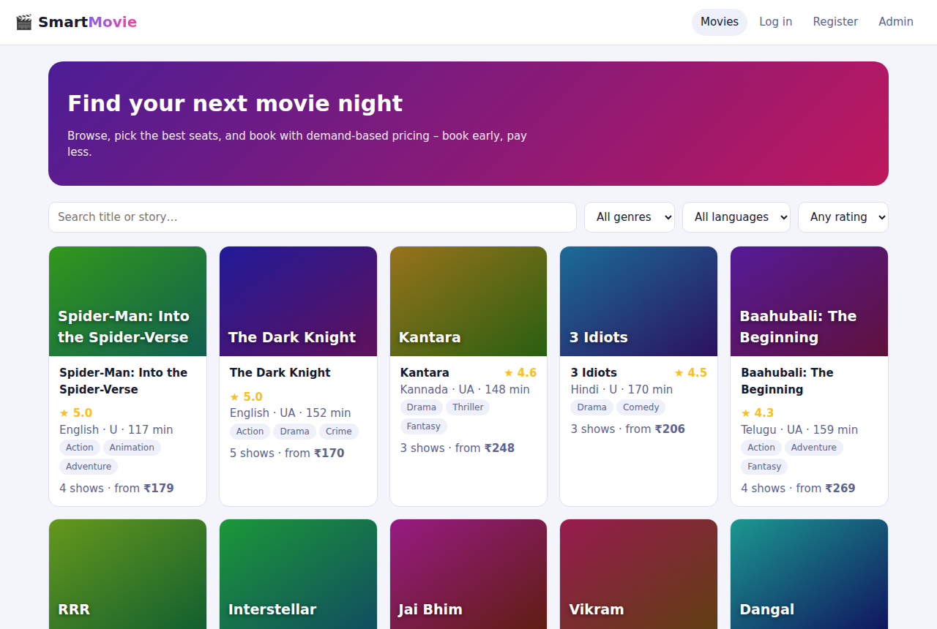
Figure 1 - Home - 12 movies with search and filters
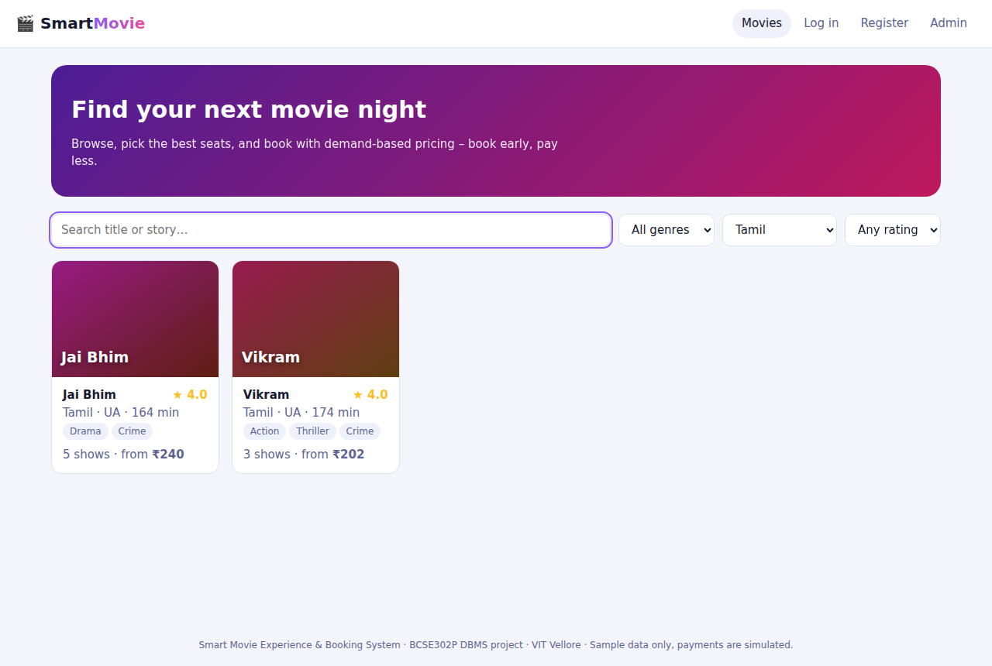
Figure 2 - Filter: language = Tamil (2 results)
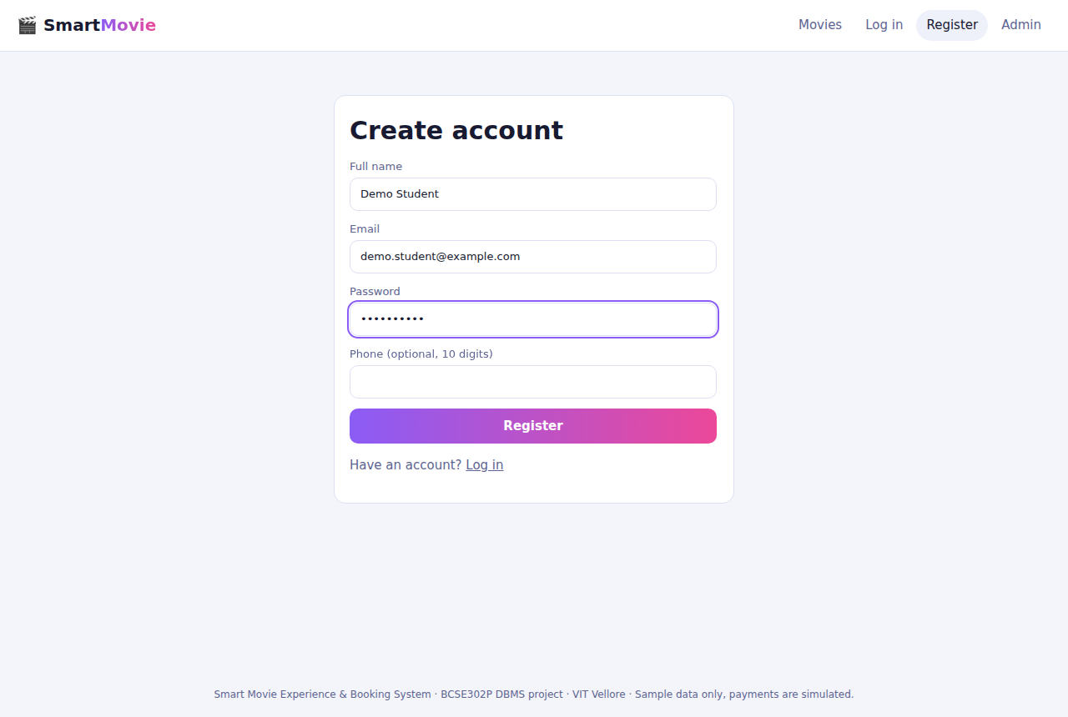
Figure 3 - Registration form
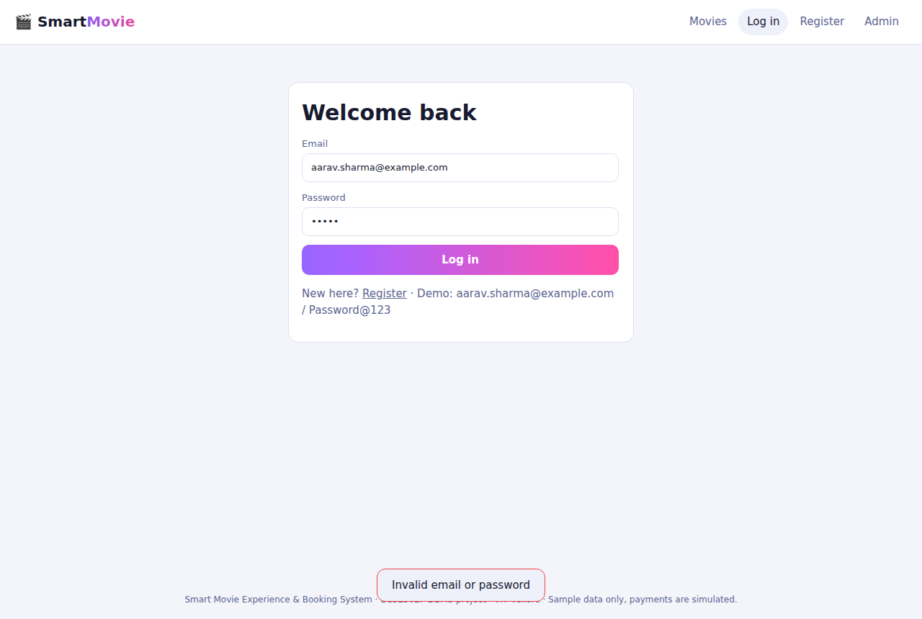
Figure 4 - Wrong password rejected
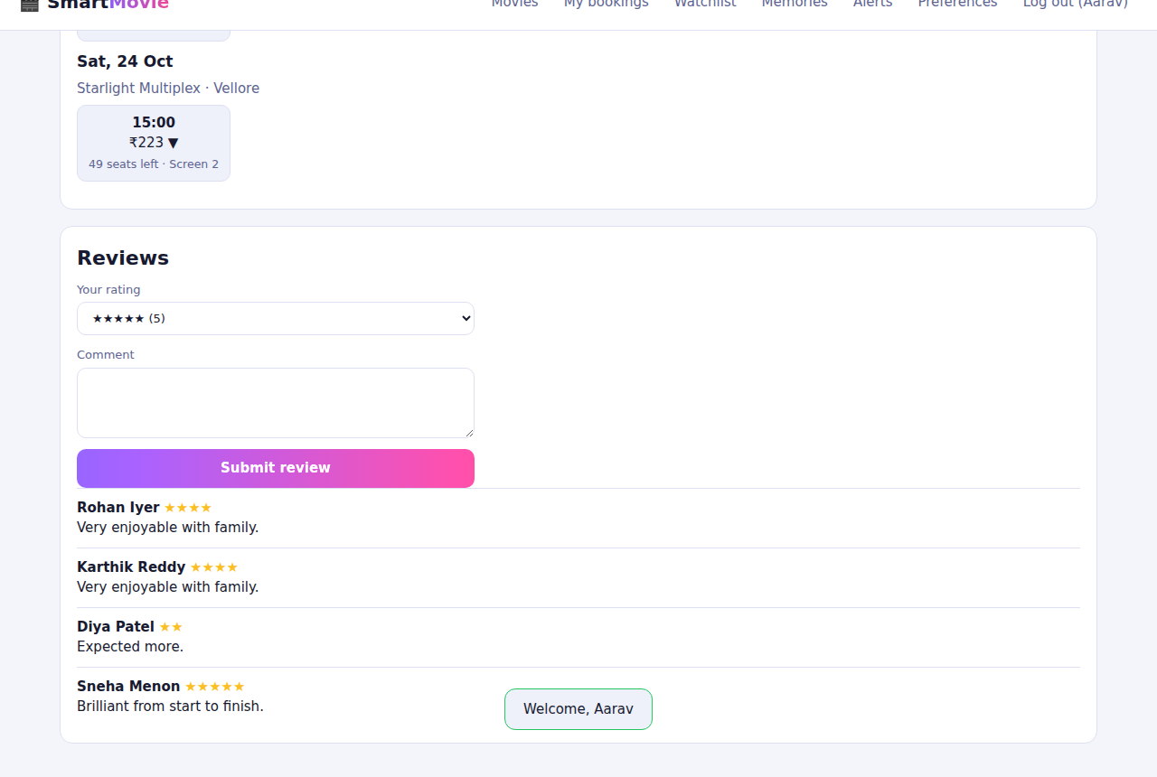
Figure 5 - Movie detail with shows and live prices
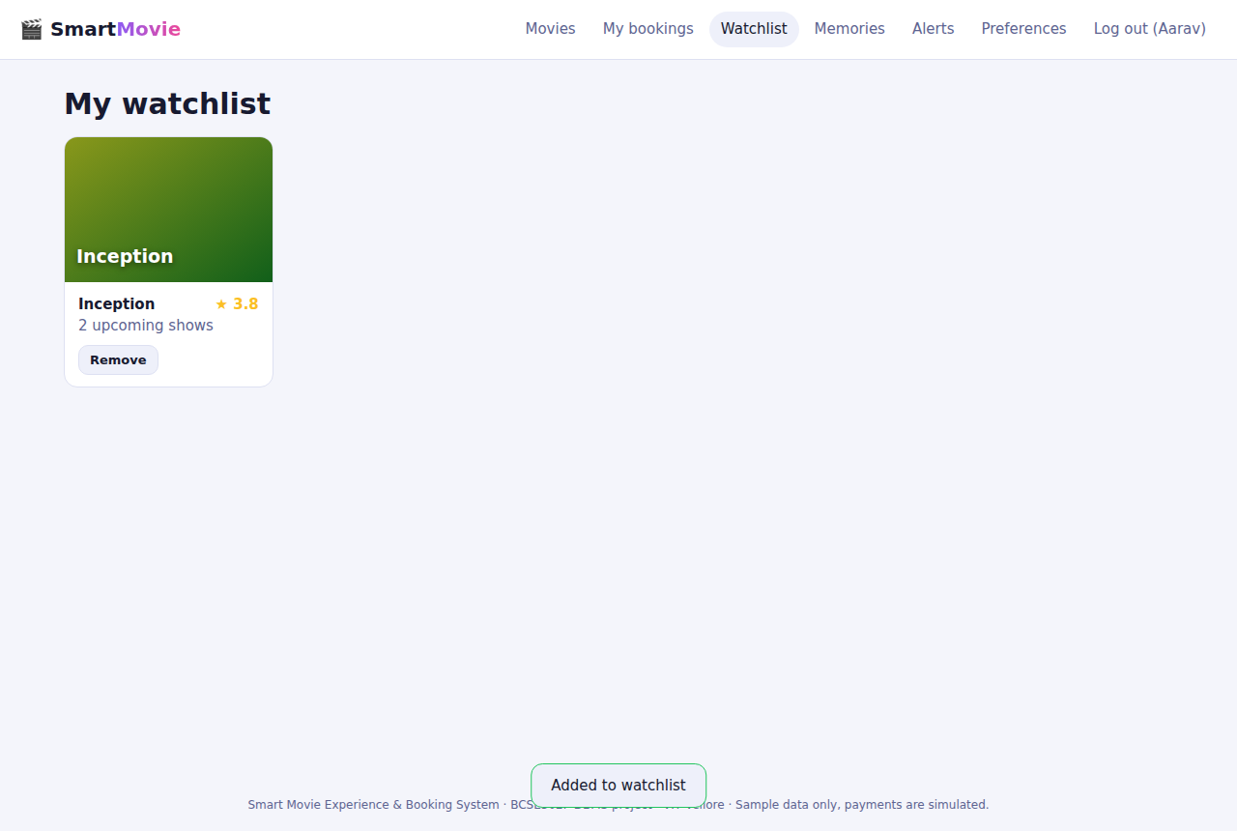
Figure 6 - Watchlist
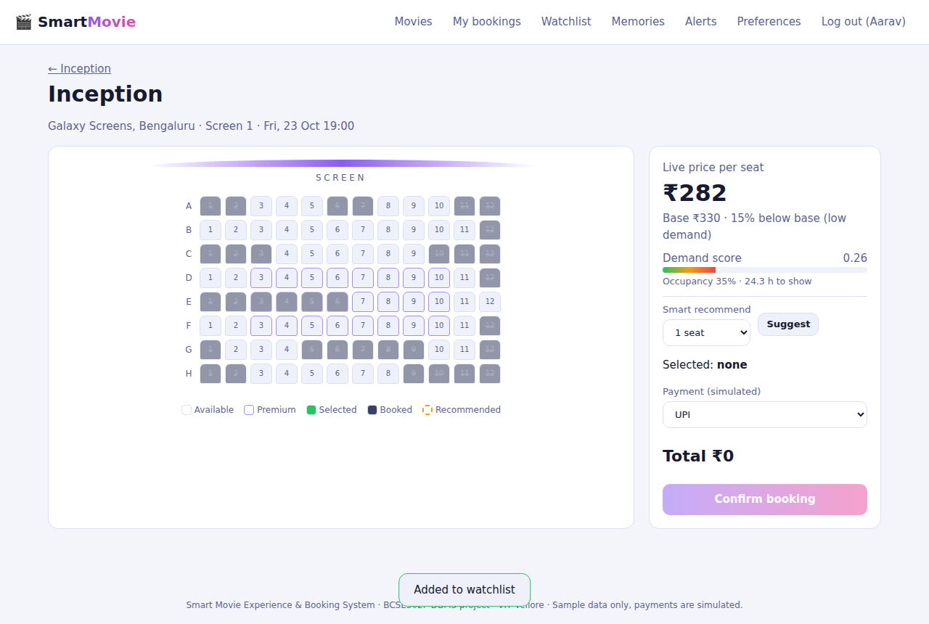
Figure 7 - Seat map
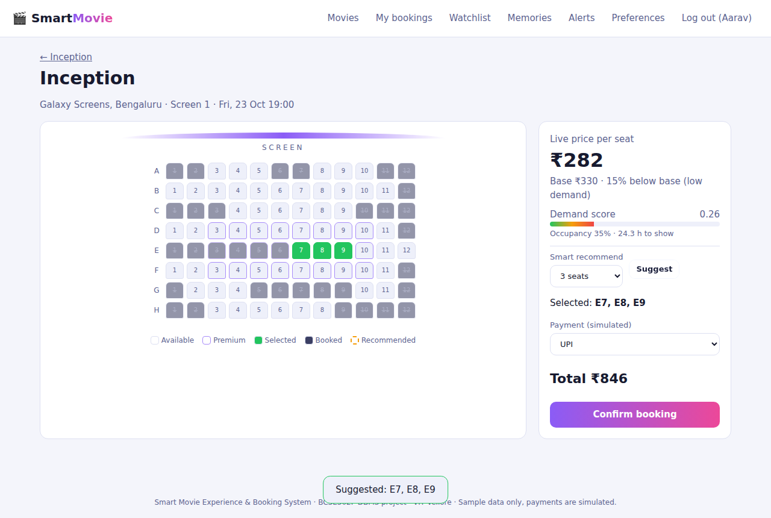
Figure 8 - Smart seat recommendation (3 adjacent seats)
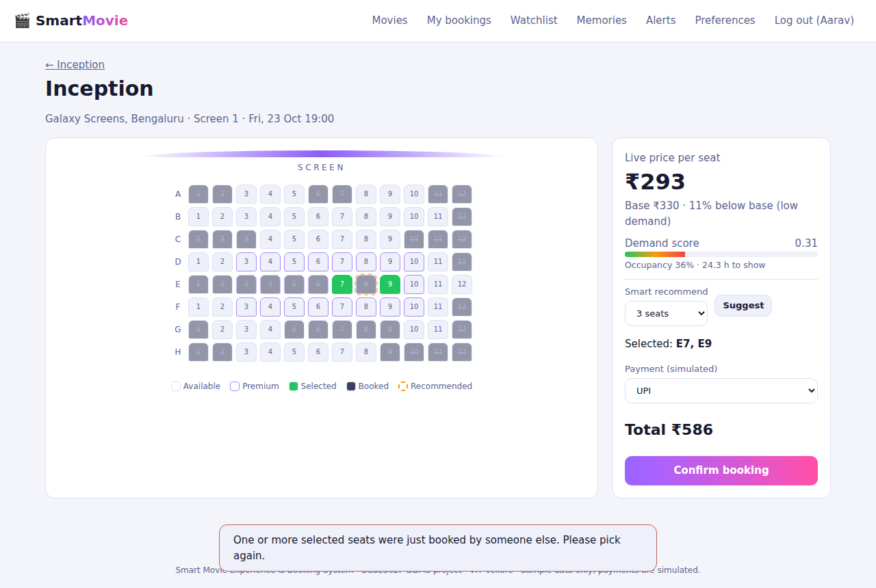
Figure 9 - Double booking blocked: seat taken by another session
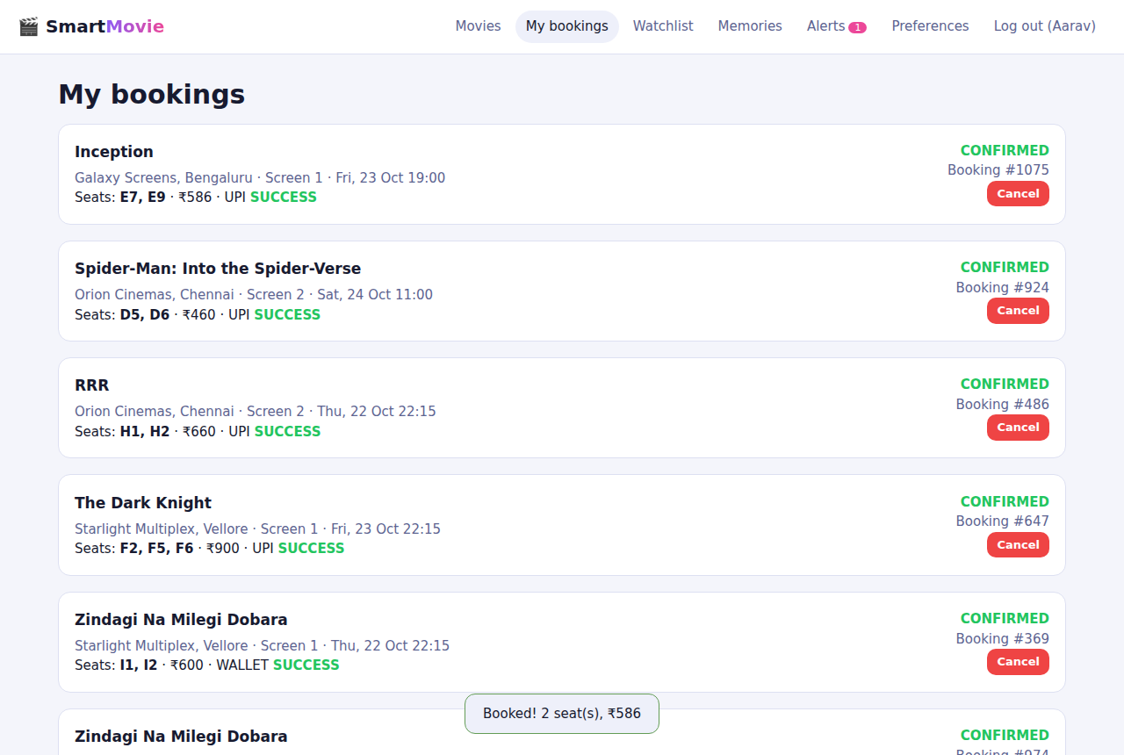
Figure 10 - My bookings after confirmation
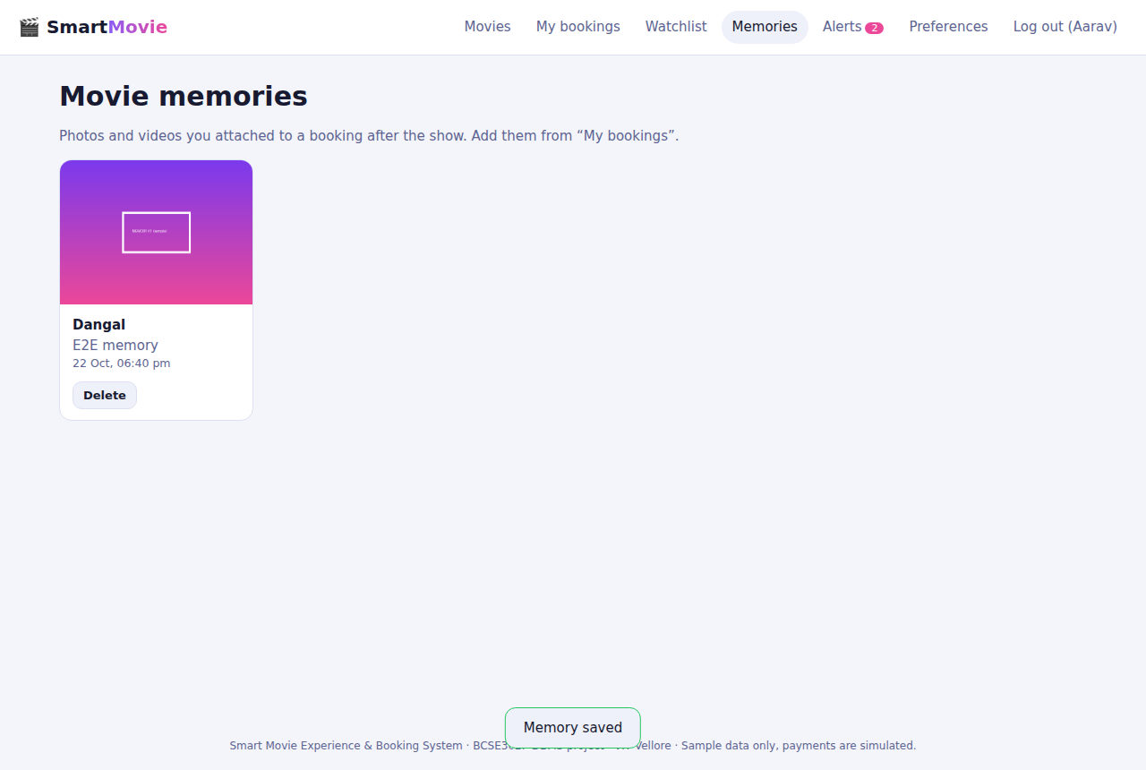
Figure 11 - Movie memories gallery
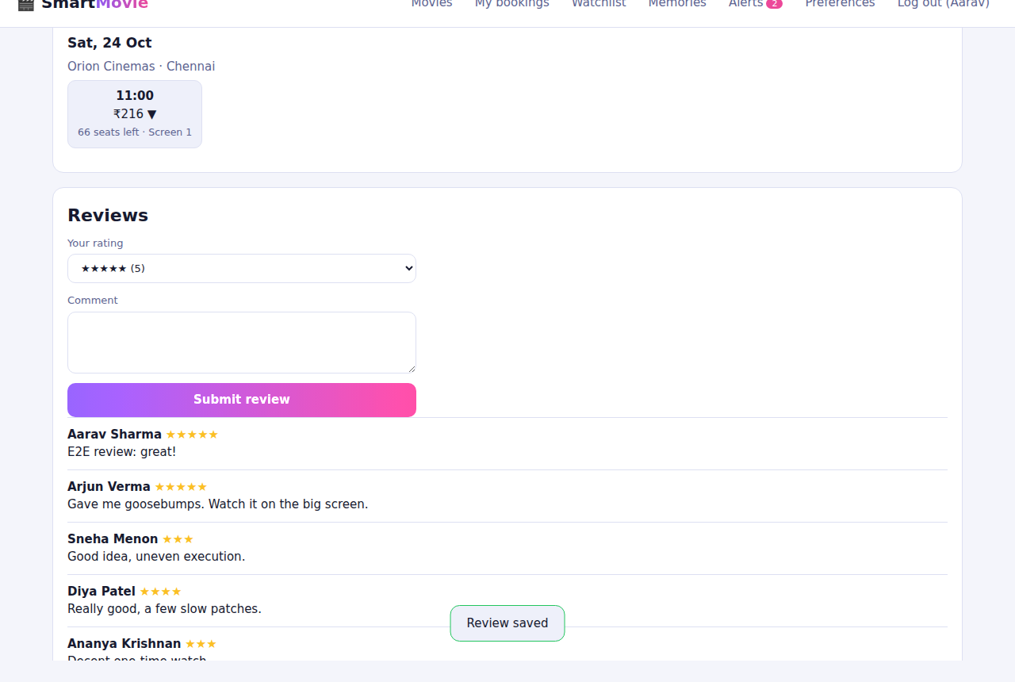
Figure 12 - Review posted after attending
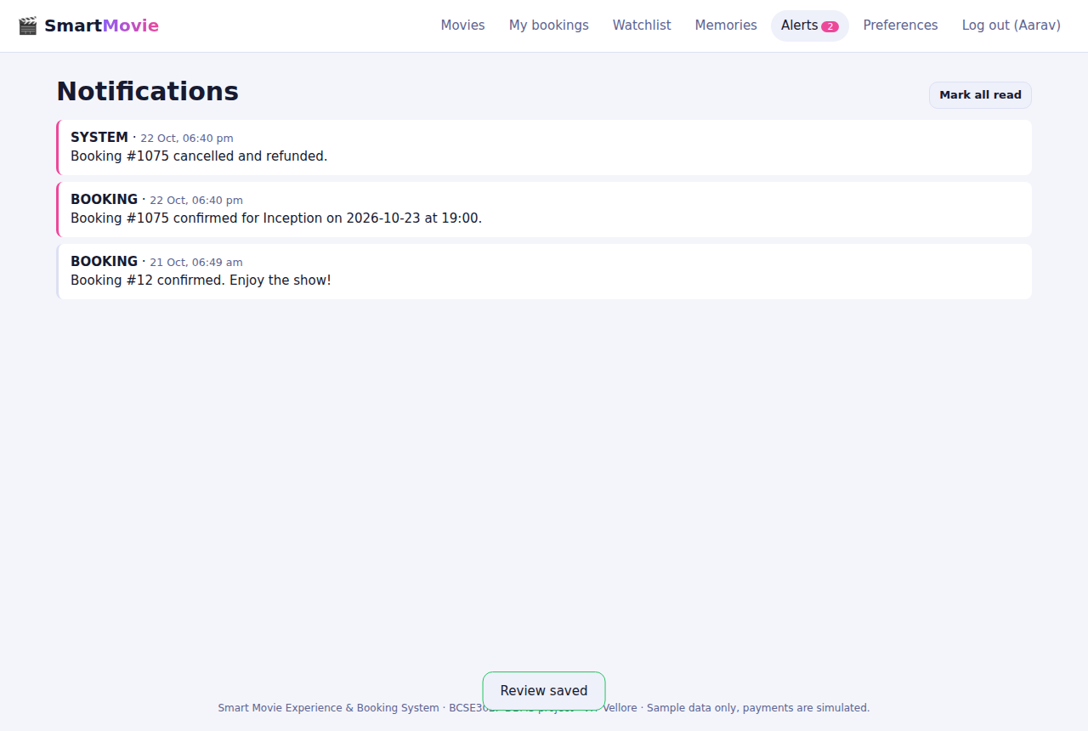
Figure 13 - Notifications
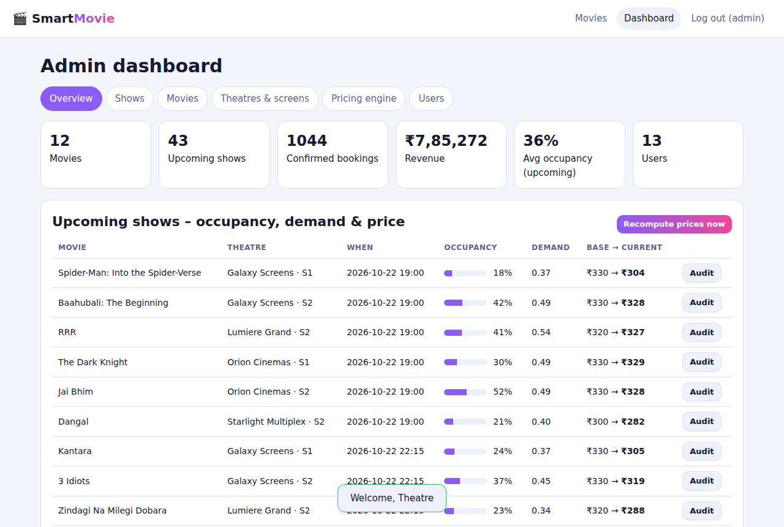
Figure 14 - Admin dashboard overview
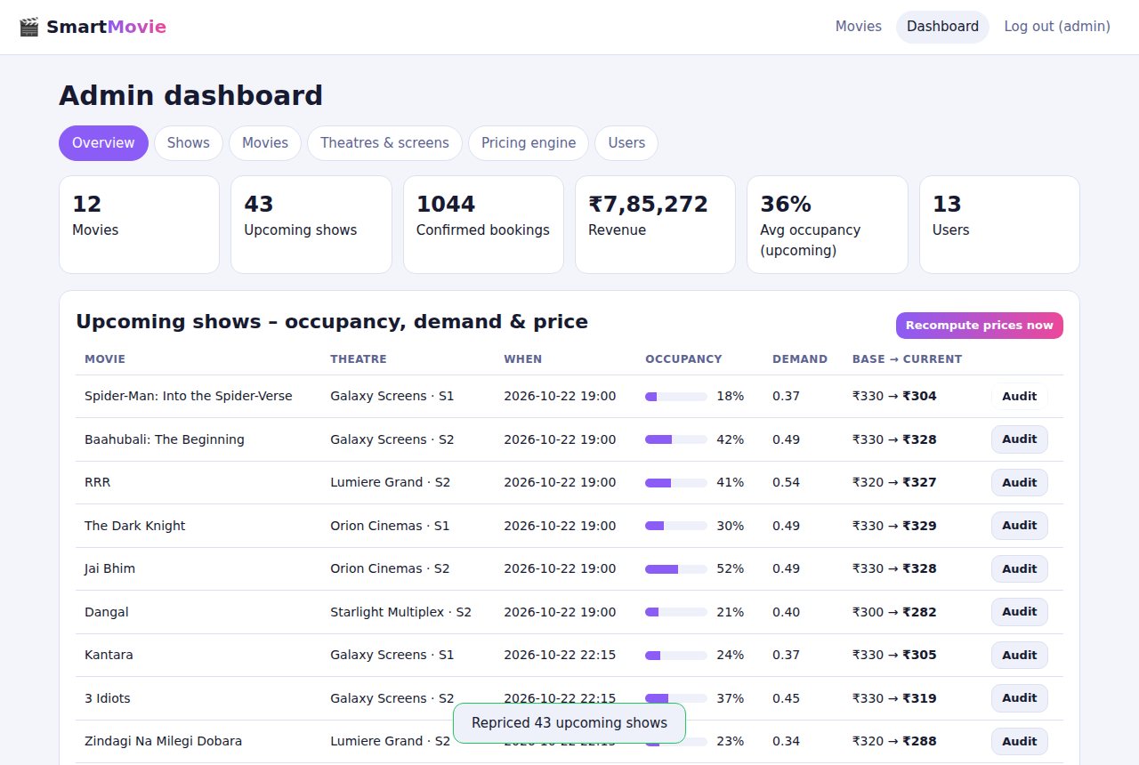
Figure 15 - Admin: demand and price audit of one show
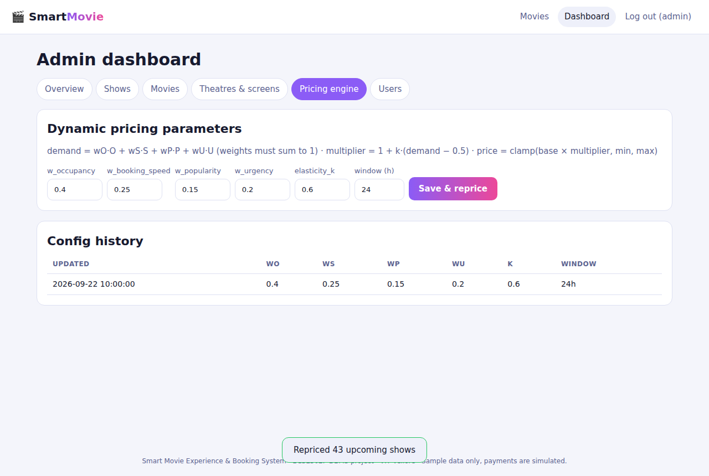
Figure 16 - Admin: pricing-engine configuration
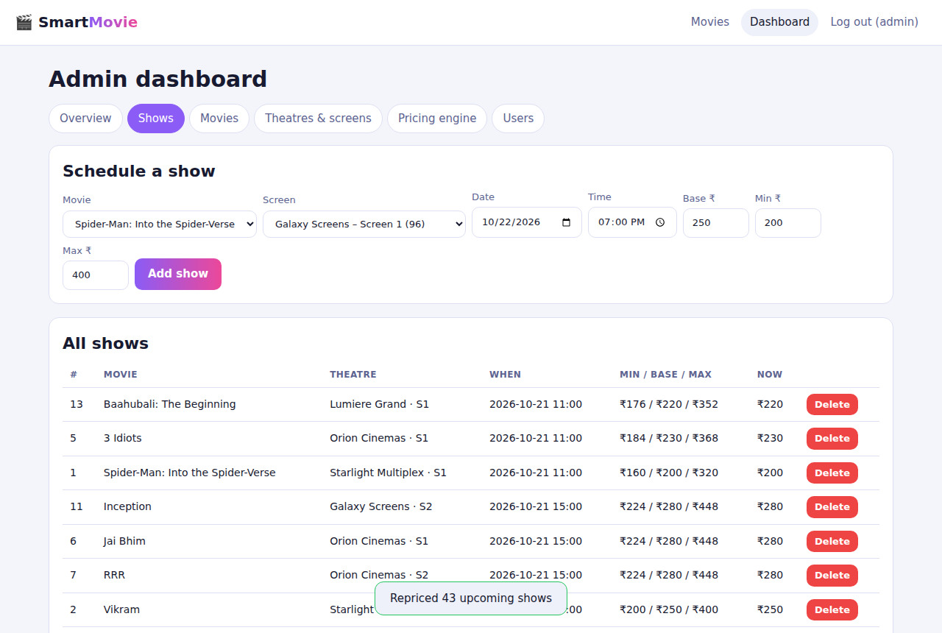
Figure 17 - Admin: schedule a show
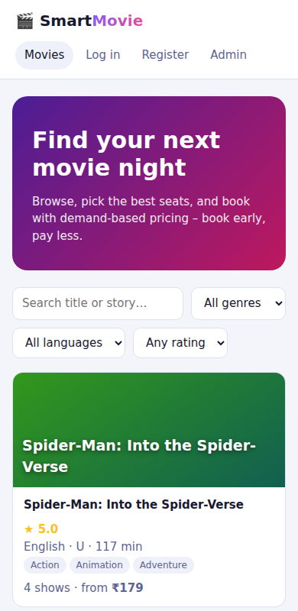
Figure 18 - Mobile layout (390 px)

7. Demonstration script (10 minutes)
- Start: python backend/app.py, open http://localhost:5000 (or the deployed URL once you deploy it).
- Browse: search 'inception', filter language Tamil, open a movie - point out the live price and the up/down arrow next to it.
- Register a new account, then log in; add a movie to the watchlist; set genre preferences.
- Open a show: ask for a 3-seat recommendation, show the demand meter and 'x% above/below base' text, pay (simulated) and confirm.
- Double booking: in a private window log in as diya.patel@example.com and book one of the same seats first; then press Confirm in the first window - the booking is refused and the map refreshes.
- My bookings: cancel a booking and show that its seats are free again and the price reacted; upload a memory for a past booking; review the movie.
- Admin (admin@smartmovie.local / Admin@123): dashboard KPIs, Audit a show (Demand_Analysis + Price_History), change pricing weights and watch prices recompute, schedule a new show for a watchlisted movie and show the user's alert.
- Database: run database/queries.sql (Q5 returns no rows = no double-booking), show the CHECK/UNIQUE constraints and, in the lab, the Oracle package pkg_dynamic_pricing.

8. Software documentation and installation

8.1 Technologies
Technology | Version used | Role
Oracle Database SQL/PL-SQL | scripts for 11g+ (not executed here) | Lab DDL, DML, triggers, pricing package, scheduler job
SQLite | 3.45.1 | Database of the running website (same relational model)
Python | 3.12.3 | Backend language
Flask / Werkzeug | 3.1.3 / 3.1.7 | REST API, sessions, password hashing
gunicorn | 23.0.0 (pinned, not run here) | Production WSGI server
HTML5 / CSS3 / JavaScript | ES2020 | Single-page frontend, no frameworks
Playwright + Chromium | 1.56 | Browser tests and screenshots
Graphviz | dot/neato | ER diagram
python-docx | 1.2.0 | Report generation
Git | - | Version control

8.2 Installation and execution
- Install Python 3.10+ and Git.
- git clone <repository-url>; cd smart-movie-booking
- python -m venv .venv; activate it (Windows: .venv\Scripts\activate; others: source .venv/bin/activate)
- pip install -r requirements.txt
- python backend/app.py -> open http://localhost:5000 (database created and seeded automatically)
- Logins: customer aarav.sharma@example.com / Password@123, admin admin@smartmovie.local / Admin@123
- Run tests: python manage.py test; browser tests: pip install playwright; playwright install chromium; python scripts/e2e_browser.py
- Oracle lab: in SQL*Plus run @database/oracle/01_schema.sql, @02_plsql.sql, @03_seed.sql, @database/queries.sql
- Reset demo data: python manage.py reseed
Full instructions including deployment and environment variables: docs/SETUP.md in the repository.

9. Repository and deployment status
GitHub: NOT published. The build environment has no network access or GitHub credentials. A local git repository with commits is included. To publish: create an empty repository on github.com, then run 'git remote add origin <url>', 'git branch -M main', 'git push -u origin main' (authenticate with a personal access token or gh auth login).
Deployment: NOT done. render.yaml, Procfile and Dockerfile are provided (untested). To deploy on Render: New > Blueprint > select the repository; verify /api/health after the build.
Repository URL: ______________________ Live website URL: ______________________ (fill in after you publish and verify)

10. Limitations and future work
- Payments are simulated; no email/SMS delivery.
- SQLite serialises writers: adequate for a lab, not for a large cinema chain (use Oracle/PostgreSQL with row-level locking).
- Free hosting tiers have ephemeral disks: users, bookings and uploads reset on restart unless a disk or external database is attached.
- Possible extensions: temporary seat holds with expiry, QR e-tickets, per-seat-type pricing, personalised recommendations from watch history, real payment gateway, Oracle connection layer (python-oracledb).

11. Conclusion
The Review-0 design was implemented completely: the normalised 20-table model, the double-booking guarantee at database level, the bounded and fully audited dynamic-pricing algorithm, and the customer and admin journeys. The parts that remain for the team are the ones that need external accounts or servers: running the Oracle scripts in the lab, pushing to GitHub and deploying to a host.

