KWEKWE POLYTECHNIC
ND3 INFORMATION TECHNOLOGY – JANUARY 2023
NEIGHBOURHOOD WATCH ZIMBABWE
A Web and Mobile System for Community Safety, Incident Reporting and Emergency Alerts
PROJECT DOCUMENTATION
Student name: ……………………………………
Registration number: ……………………………
Supervisor: ………………………………………
Date: October 2026

Table of Contents
Table of Contents
1. Project Identification
1.1 Executive Summary
1.2 Description of the Current System
1.3 Scope
1.4 Objectives (SMART)
1.5 Description of the Proposed System
2. Feasibility Study
2.1 Technical Feasibility
2.2 Economic Feasibility
2.3 Operational Feasibility
2.4 Schedule Feasibility
2.5 Legal and Ethical Feasibility
2.6 Feasibility Conclusion
3. Requirement Analysis
3.1 Fact Finding and Recording Tools
3.2 Analysis Tools
4. Design
4.1 System Architecture
4.2 Input, Output and Process Design
4.3 Database Design and File Design
4.4 User Interface Design
4.5 Design of System Controls
4.6 Data Flow Diagrams (up to Level 2)
4.7 UML Diagrams
5. Coding and Testing
5.1 Technologies Used
5.2 Project Structure
5.3 Programming Practice
5.4 Program Quality (User Friendliness)
5.5 Program Resilience (Robustness)
5.6 Testing
5.7 Code Samples from the System
6. Implementation and Post-Implementation Plan
6.1 Pre-Presentation
6.2 Documentation
6.3 Conversion Plans
7. Conclusion
7.1 Challenges
7.2 Future Plans
Appendix: Glossary

1. Project Identification

1.1 Executive Summary
Topic: Neighbourhood Watch Zimbabwe is a computer system that helps people in a neighbourhood report crime and send emergency alerts. It has a website, a mobile phone app and a central server.
Why: In many Zimbabwean suburbs, crime reports are shared by word of mouth, WhatsApp groups or paper books. Information is slow, gets lost, and cannot be checked. Police and community leaders do not have one clear picture of what is happening. Residents also have no fast way to call for help when they are in danger.
How: Residents register and are verified by a local coordinator. A verified resident can report an incident with a description, a place on the map, and photos, video or audio as proof. Coordinators check the report and assign it to a responder, such as a police officer or a block captain. In an emergency, a resident presses an SOS button. The system saves the phone location, sends an SMS to the resident’s emergency contacts, and shows the alert to coordinators, police officers and administrators. All actions are saved in an audit log so that nothing can be changed in secret.
The system is built with Python (Django) for the server, React for the website, and Flutter for the Android/iOS app. It uses a PostgreSQL database in production and SQLite for development.

1.2 Description of the Current System

Company / community background
A neighbourhood watch is a group of residents who look after the safety of their area. They work with the Zimbabwe Republic Police (ZRP), block captains and ward or residents’ association coordinators. The groups are voluntary and usually have little money and few tools.

How it works now
- A resident sees a crime or something suspicious.
- The resident tells a neighbour, calls a block captain, or posts in a WhatsApp group.
- The block captain may write the report in a paper book or tell the police by phone.
- The police may visit the area, but there is often no written record or follow-up for the resident.
- In an emergency, people shout, blow whistles or make phone calls one by one.

Problems with the current system
No. | Problem | Effect
1 | Reports are verbal or on paper | Records are lost, damaged or forgotten
2 | No exact location of incidents | Police waste time finding the place
3 | No way to check if a report is true | Rumours and false alarms spread in groups
4 | No proof such as photos or audio is kept safely | Hard to use as evidence
5 | No quick emergency alert with location | Help arrives late
6 | No statistics or crime patterns | Leaders cannot plan patrols
7 | No tracking of who handled a report | No accountability; residents get no feedback
8 | Poor network in some areas | Reports cannot be sent when there is no data

1.3 Scope

What is IN scope
- User registration with a one-time password (OTP) and login using secure tokens (JWT).
- Five user roles: Resident, Block Captain, Coordinator, Police Officer and System Administrator.
- Resident verification by a coordinator.
- Incident reporting with category, severity, location and media (photo, video, audio).
- Incident steps: Pending → Verified → Investigating → Resolved → Closed. Assigning an incident to an officer.
- SOS emergency alert with live location updates.
- Notifications (in-app, with push and SMS channels prepared).
- Neighbourhood management and map view.
- Audit log of important actions.
- Offline saving on the mobile app and later sync.
- Daily analytics summaries.
- Web app (React) and mobile app (Flutter).

What is OUT of scope
Out of scope | Reason
Direct link to the ZRP computer systems | Needs official approval and is outside student control
Real payment features | The system is free and not needed
Real SMS and push sending (Twilio, Firebase) in the tested version | These need paid accounts. The code is ready but sending is simulated for now
CCTV or camera integration | Needs special hardware
Face recognition or any automatic spying | Privacy and legal risk
Courts or legal case management | Not part of neighbourhood watch work

1.4 Objectives (SMART)
No. | Objective | S/M/A/R/T check
1 | Build a secure registration and login system with OTP and 5 roles by the end of the coding phase. | Measurable by passing authentication tests.
2 | Allow a verified resident to submit an incident report with location and up to 100 MB of media in less than 3 minutes. | Timed test with users.
3 | Save an SOS alert with GPS location, queue SMS alerts to the resident’s emergency contacts, and show the alert to coordinators, police and administrators within 10 seconds on a working network. | Measured in testing.
4 | Keep a full audit trail: 100% of status changes and verifications saved with who, when and what changed. | Check database after tests.
5 | Let the mobile app save reports offline and send them when the network returns, without duplicates. | Test with the phone in flight mode.
6 | Reach at least 90% of planned test cases passing before final presentation. | Test report.
7 | Give coordinators a daily summary of incidents per neighbourhood. | Daily analytics job runs and shows data.

1.5 Description of the Proposed System
The proposed system is a central server with an API. The website and the mobile app both talk to this API. The major processes are:
- Registration and verification – a person registers, confirms the OTP, then asks for verification. A coordinator approves or rejects the request.
- Login and access control – the system checks the email and password, then gives tokens. What the user can do depends on the role.
- Incident reporting – a resident fills in the form, picks the place on the map, adds media and submits.
- Incident handling – a coordinator verifies the incident, assigns it to a responder (for example a police officer or block captain), and moves the status forward until it is closed.
- SOS alert – a resident presses SOS. The system records the location, keeps updating it, sends an SMS to the resident’s emergency contacts, and lists the alert for coordinators, police officers and administrators.
- Notifications – the system tells users about new incidents, status changes and SOS alerts. Users choose their channels.
- Offline sync – the app queues work on the phone and sends it later.
- Auditing and analytics – every important action is saved, and daily reports are produced.

Date: …………………. Sign: Supervisor……………………... Student ……………………

2. Feasibility Study
A feasibility study checks if the project is possible and worth doing. Five techniques are used: technical, economic, operational, schedule and legal feasibility.

2.1 Technical Feasibility
This checks if the technology exists and if the team can use it.
Need | Tool chosen | Available?
Server code | Python 3.10+, Django 5.2, Django REST Framework | Yes, free
Database | PostgreSQL (production), SQLite (development) | Yes, free
Website | React 18, Vite, Tailwind CSS, Leaflet maps | Yes, free
Mobile app | Flutter (Dart) | Yes, free
Background jobs | Celery with Redis | Yes, free
File storage | MinIO (S3 compatible) | Yes, free
Deployment | Docker, Docker Compose, Kubernetes files, Nginx | Yes, free
Computer | Windows 11 laptop | Already owned

Result: The project is technically feasible. The tools are free, widely used, and the main parts are already working in the prototype.

2.2 Economic Feasibility
The costs below are estimates in US dollars for a small pilot in one neighbourhood.
Item | Cost (USD) | Note
Software and tools | 0 | All open source
Cloud server (small VPS) per year | 120 | For testing and first users
Domain name per year | 15 | Optional
SMS provider credit (starting) | 30 | For OTP and alerts
Internet and data during development | 120 | Estimate
Printing and presentation | 30 | Estimate
Total estimated cost | 315

Benefits: faster response to crime, less lost information, better evidence, and better planning of patrols. These benefits are social, so they are hard to put in money. Because the cost is low and all software is free, the project is economically feasible.

2.3 Operational Feasibility
This checks if people will accept and use the system.
- Most residents already own smartphones and use WhatsApp, so the app idea is familiar.
- The screens are simple and use clear words.
- Coordinators and block captains already do these jobs; the system only makes them easier.
- Risk: some users have little data or poor network. The offline mode helps with this.
- Risk: some people may fear being identified. Reports can only be seen by allowed roles.
Result: The system is operationally feasible if training is given (see Chapter 6).

2.4 Schedule Feasibility
Phase | Work | Status
1 | Foundation: models, roles, Docker | Done
2 | Authentication, OTP, verification | Done
3 | Incident reporting and media | Done
4–5 | Maps, geospatial, notifications | Done / mostly done
6–8 | Real-time, hardening, mobile app | In progress
Final | Testing, documentation, presentation | Planned

Result: Most of the work is complete, so the remaining work can be finished before the deadline.

2.5 Legal and Ethical Feasibility
- Personal data (national ID, phone, location) must be protected. The system hashes passwords, uses tokens and limits who can see data.
- Evidence files are only served to logged-in, allowed users.
- Zimbabwe’s Cyber and Data Protection Act applies. Users must agree to how their data is used.
- The system must not accuse people. Reports stay “Pending” until a coordinator verifies them.
- Open source libraries used all have licences that allow this use.
Result: The project is legally feasible if data protection rules are followed.

2.6 Feasibility Conclusion
The project is technically, economically, operationally, in schedule, and legally feasible. It is recommended to continue.

Date: …………………. Sign: Supervisor……………………... Student ……………………

3. Requirement Analysis

3.1 Fact Finding and Recording Tools
Technique | How it is used in this project | How facts are recorded
Interviews | Talk to block captains, coordinators and police officers about how reports are handled today | Written notes, a table of answers
Questionnaires | Short forms for residents: how they report, what phone they have, what they fear | Summary tables and charts
Observation | Watch how a WhatsApp group or paper book is used during an incident | Observation notes
Document review | Read paper registers, community rules and the Data Protection Act | Checklist of rules
Review of similar systems | Look at other community safety and crime-report apps | Comparison table

The problems described in section 1.2 and the requirements in this chapter are based on these fact-finding methods. The complete forms are in the separate document “Fact-Finding Instruments”: two questionnaires (residents; block captains and watch members) and four interview guides (coordinator, police officer, block captain, and a resident who reported a crime), with summary sheets for recording the results.

3.2 Analysis Tools

Functional requirements
ID | Requirement
FR1 | The system shall let a user register with email, phone and national ID and confirm an OTP.
FR2 | The system shall let a user log in, log out and reset a password.
FR3 | The system shall let a coordinator approve or reject resident verification requests.
FR4 | The system shall let verified users create, view and update incidents based on their role.
FR5 | The system shall accept photo, video and audio evidence and check file type and size (max 100 MB).
FR6 | The system shall move incidents through the allowed statuses only.
FR7 | The system shall let a coordinator assign an incident to a responder.
FR8 | The system shall let a resident start, update and end an SOS alert with location.
FR9 | The system shall send notifications and let users set their preferences.
FR10 | The system shall save an audit log of key actions.
FR11 | The system shall show incidents and neighbourhoods on a map.
FR12 | The mobile app shall queue actions offline and sync later.

Non-functional requirements
Type | Requirement
Security | Passwords hashed; JWT tokens expire; rate limits on login and OTP; evidence files protected.
Performance | Normal pages respond in under 3 seconds on a normal connection.
Usability | Simple English, clear buttons, works on small screens.
Reliability | The system should not crash on bad input; health check endpoint available.
Portability | Runs on Windows, Linux and Docker. Mobile app runs on Android and iOS.
Maintainability | Clean code, comments, automated tests and CI workflows.

User roles and permissions
Role | Main powers
Resident | Report incidents, send SOS, view own and neighbourhood incidents
Block Captain | Everything a resident can, plus see block incidents and handle assigned cases
Coordinator | Verify residents, verify and assign incidents, see neighbourhood dashboard
Police Officer | View incidents in own neighbourhood and incidents assigned to them; view active SOS alerts
System Administrator | Manage users, roles, neighbourhoods and system settings

Incident status rules
Current status | Allowed next status | Who can do it
Pending | Verified or Closed | Coordinator / System Administrator
Verified | Investigating or Closed | Coordinator / System Administrator
Investigating | Resolved or Closed | Coordinator / System Administrator
Resolved | Closed | Coordinator / System Administrator
Closed | No further change | —
Any other jump (for example Pending to Resolved) | Rejected with an error | —

Date: …………………. Sign: Supervisor……………………... Student ……………………

4. Design

4.1 System Architecture
[ React Website ] [ Flutter Mobile App ]
\ /
\ /
[ Nginx reverse proxy ]
|
[ Django REST API (Gunicorn / Daphne) ]
| | | |
PostgreSQL Redis MinIO Celery workers
(data) (cache, (files: (OTP, alerts,
queue) evidence) daily reports)

4.2 Input, Output and Process Design

Inputs
Input | Fields | Checks
Registration form | Full name, email, phone, national ID, address, password | Unique email, phone, ID; strong password; phone format
Login form | Email, password | Both required; locked after many failures
OTP form | Code | Code correct and not expired
Incident form | Title, description, category, severity, date/time, location, media | Required fields; category from list; file type and size
SOS request | Location, optional audio | Verified user; valid coordinates
Verification review | Decision, reason | Coordinator only

Outputs
Output | Content | User
Incident list and detail | Title, status, severity, place, media, history | All allowed roles
Map view | Pins for incidents and neighbourhood areas | All logged-in users
Notifications inbox | Alerts and status updates | All users
Coordinator queue | Pending verification requests | Coordinator
Analytics summary | Counts of incidents by type and period | Coordinator, Admin
API responses | JSON with clear error messages | Apps

Main processes
Process | Steps
Report incident | 1 Check login and role → 2 Validate form → 3 Save incident as Pending → 4 Save media → 5 Write audit log → 6 Notify coordinator
Verify incident | 1 Coordinator opens report → 2 Checks details → 3 Changes status to Verified → 4 Audit log → 5 Notify reporter
SOS | 1 Resident presses SOS → 2 Save alert and location → 3 Queue SMS to emergency contacts → 4 Send location pings → 5 Resident resolves or cancels → 6 Coordinators, police and admins see it in the active list
Offline sync | 1 App saves action in queue → 2 Network returns → 3 App sends queue with unique key → 4 Server skips duplicates → 5 Result returned

4.3 Database Design and File Design
All main tables use a UUID as primary key, and they have created_at, updated_at and deleted_at fields. Deleting a record only sets deleted_at (soft delete), so history is kept.

Entity relationship diagram (part 1: users, neighbourhoods, incidents)
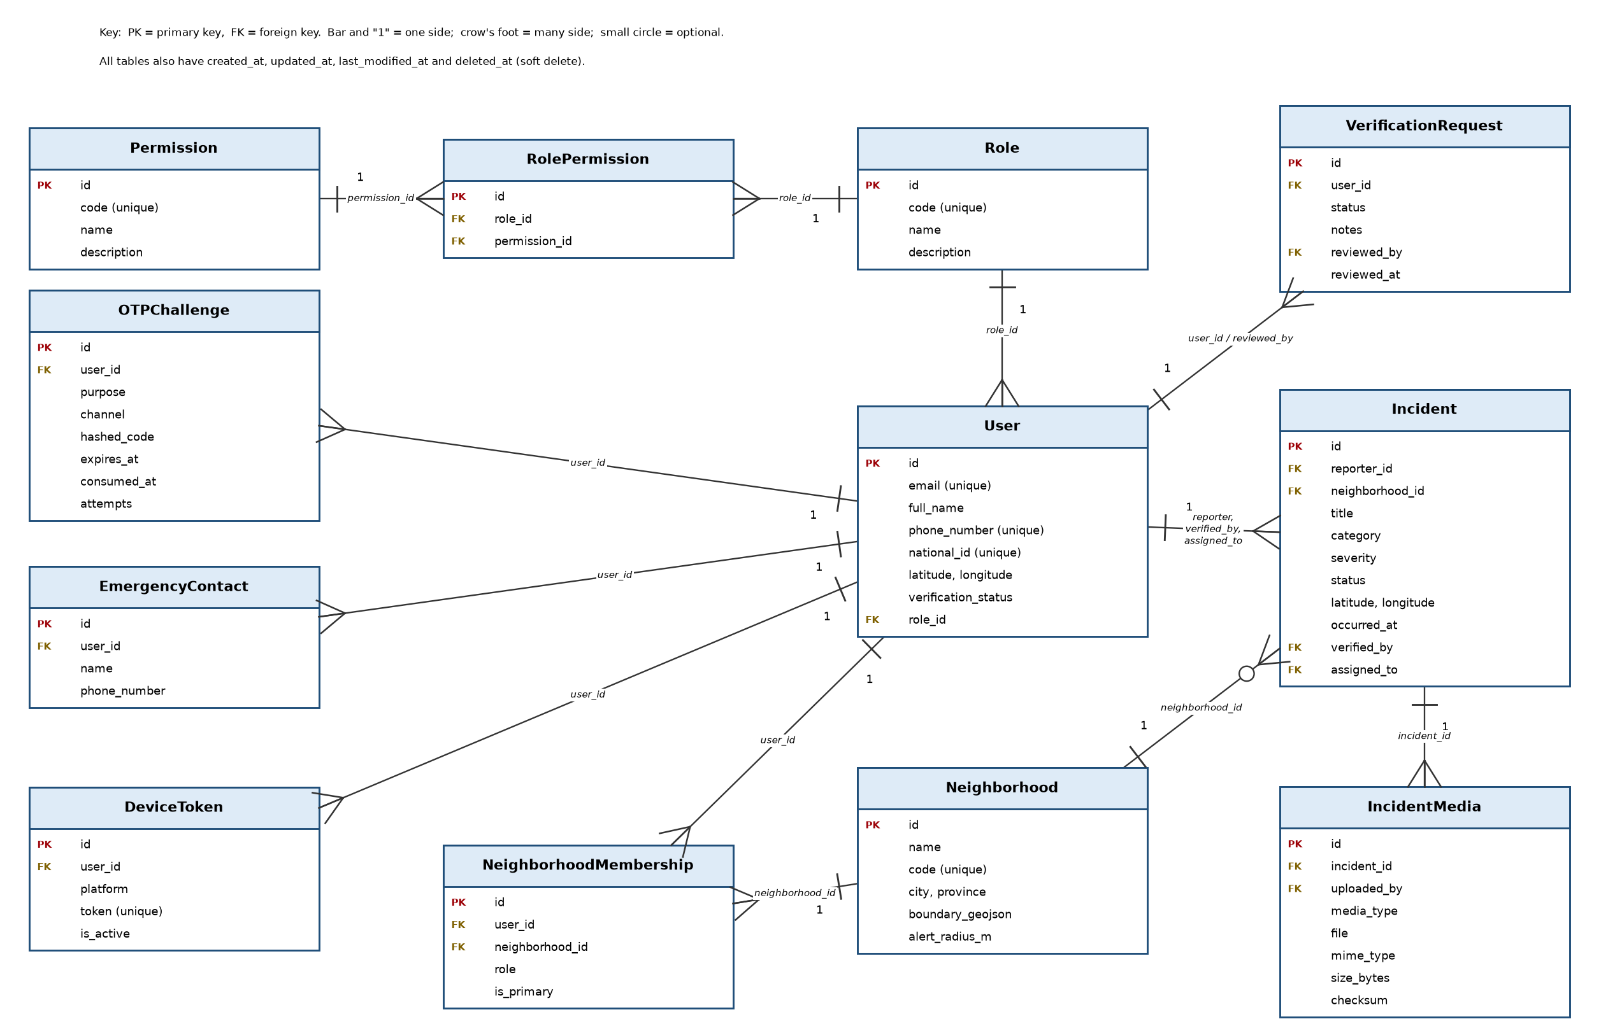
Figure 4.1: ERD part 1 – users, roles, neighbourhoods and incidents

Entity relationship diagram (part 2: SOS, notifications, audit, sync, analytics)
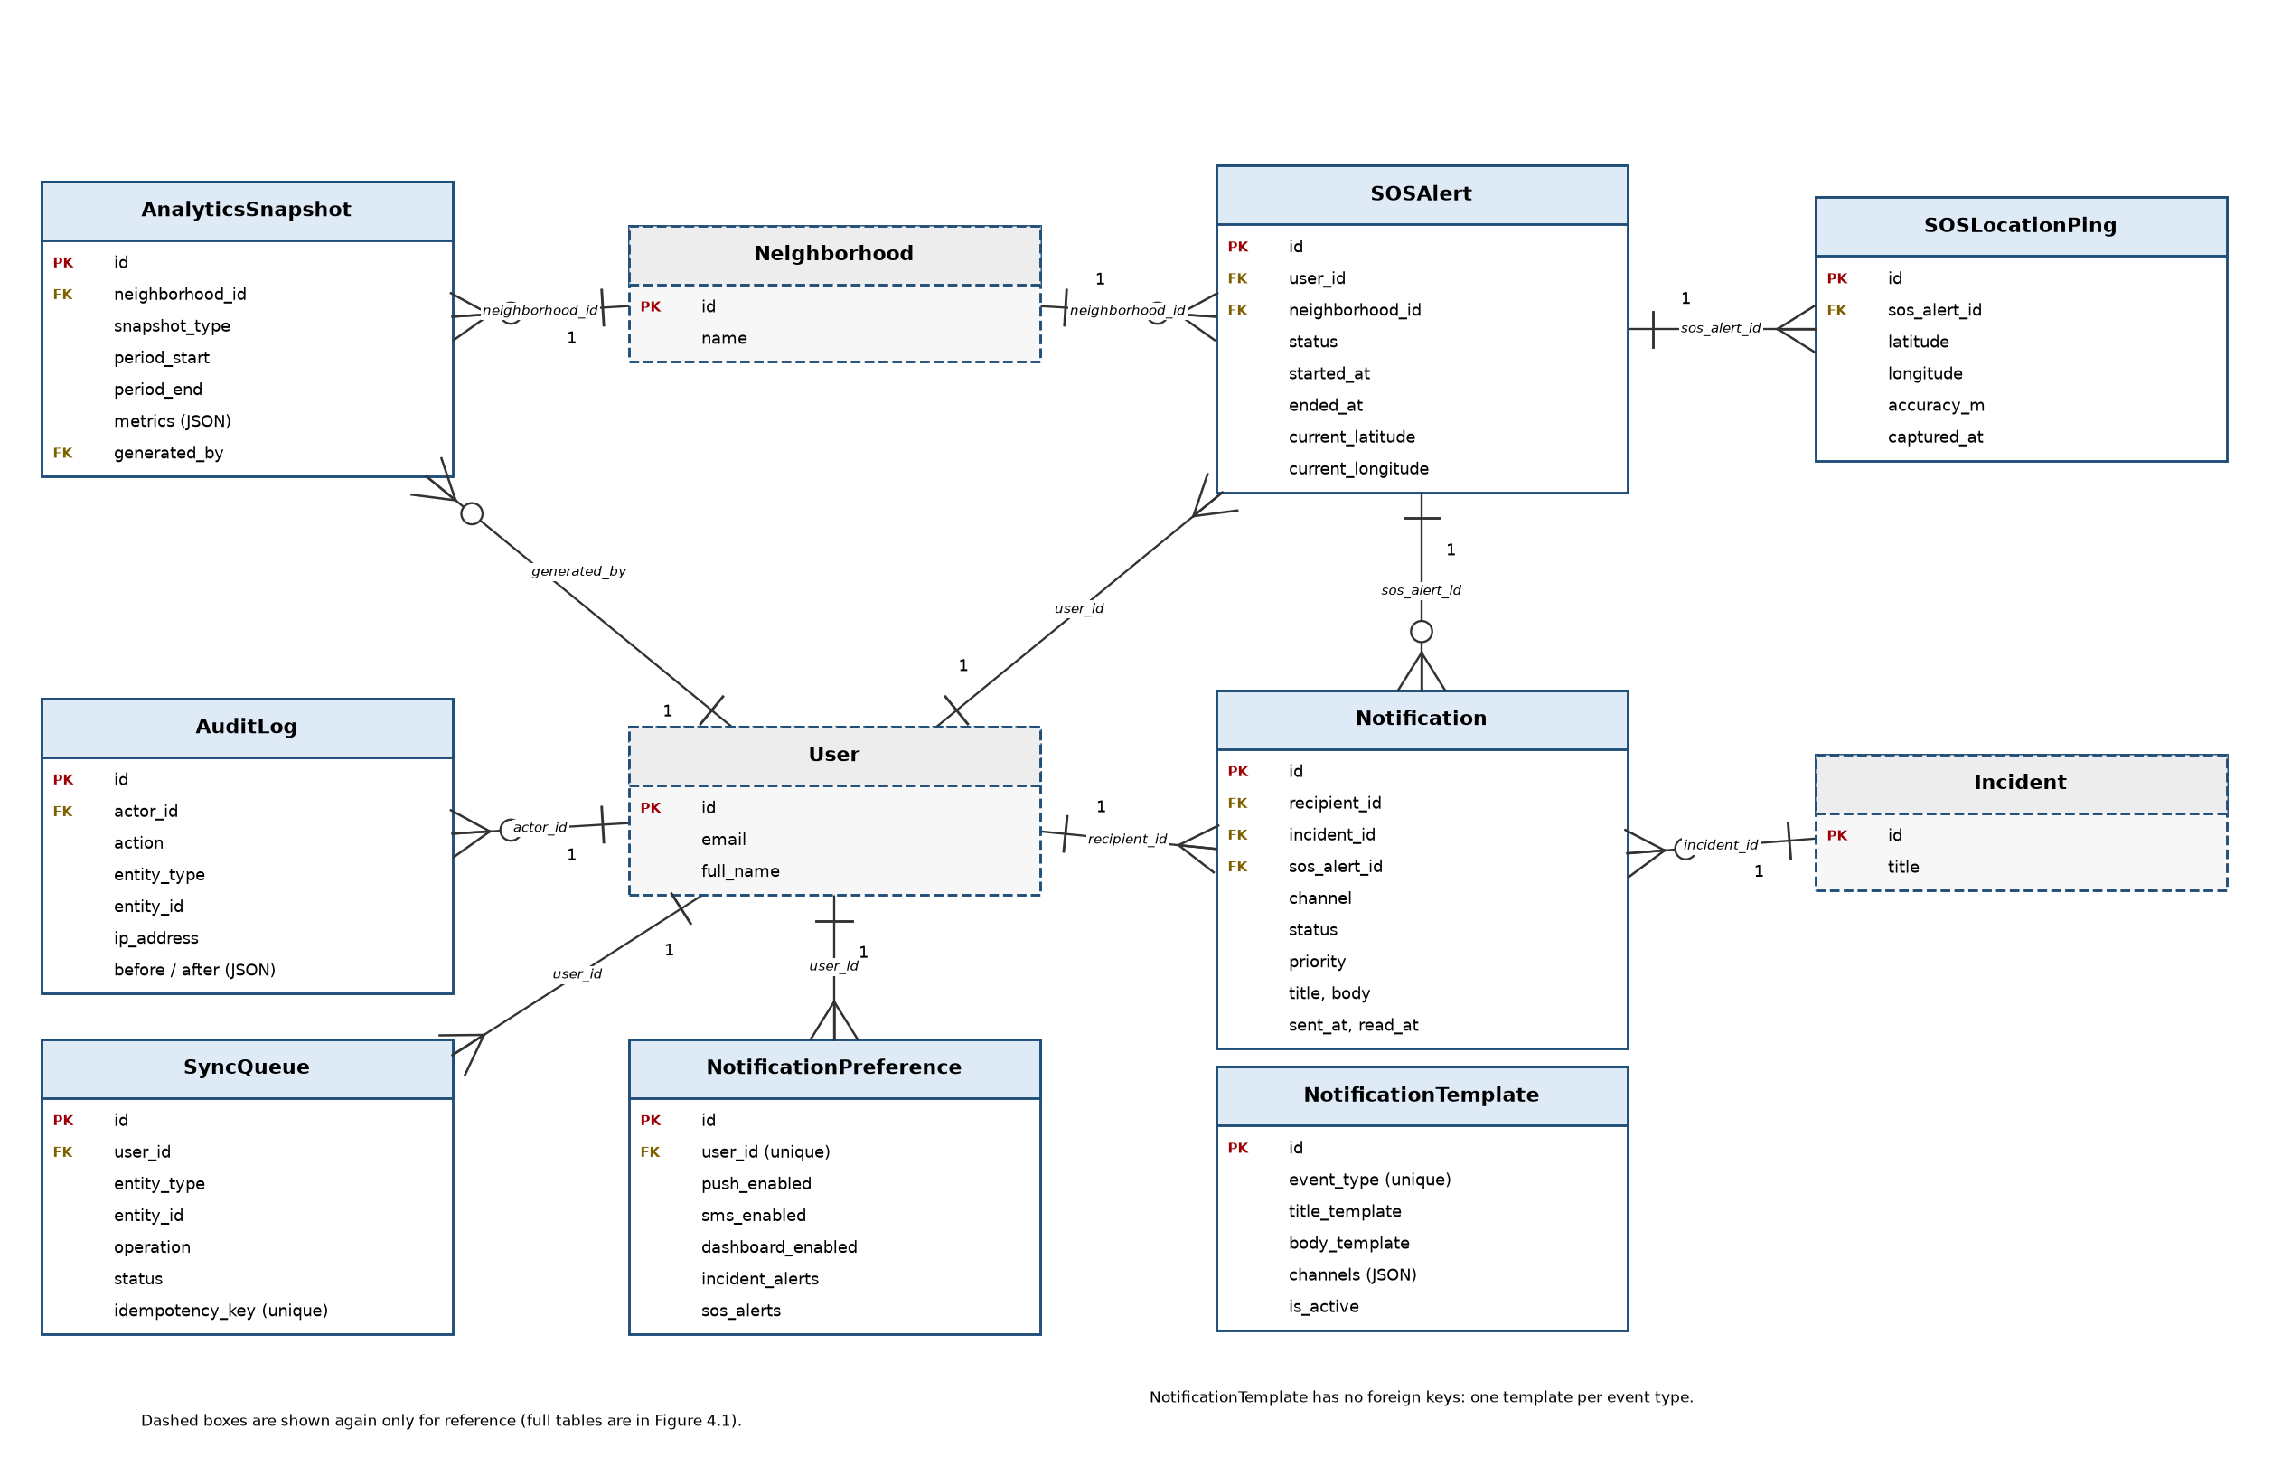
Figure 4.2: ERD part 2 – SOS, notifications, audit, sync and analytics

File design
File type | Location | Rule
Profile photos | profiles/ | Image only
Incident evidence | incident-evidence/YEAR/MONTH/ | Image, video or audio; max 100 MB; checksum saved; served only to allowed users
SOS audio | sos-audio/YEAR/MONTH/ | Audio only
Log files | debug.log and server logs | No passwords saved

4.4 User Interface Design
Design rules: simple English, large buttons, same colours and layout on all pages, works on phones first.
Severity colours: Red = Critical, Yellow = Important, Blue = Average, Green = Normal.

Screenshots of the implemented interface
The screenshots below were taken from the running website with demo data. The names, phone numbers and addresses in them are made up for testing. They show the same design rules: simple words, large buttons, the same menu on every page, and colour badges together with text for severity and status.
Screenshot 1: Home page
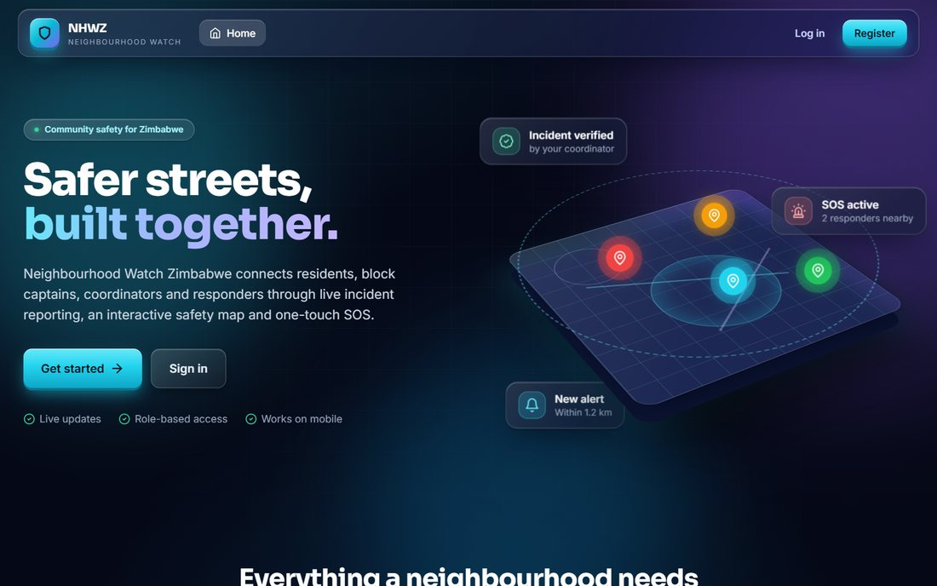
Visitors see the purpose of the system, with Log in and Register buttons.
Screenshot 2: Incident list
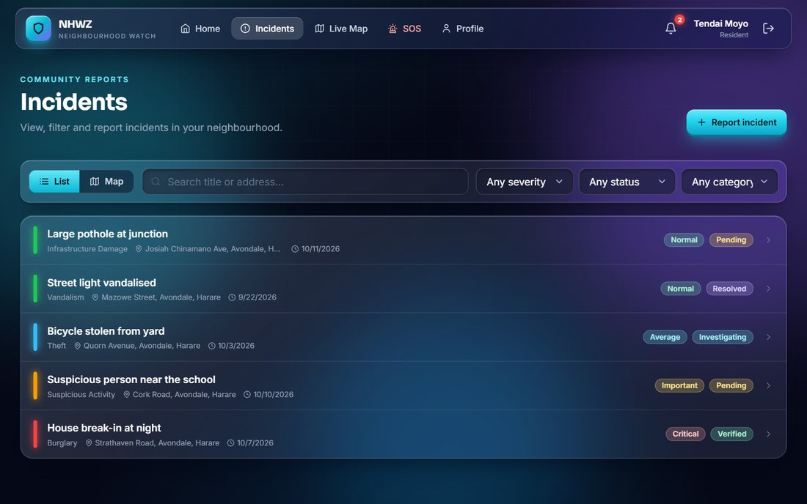
Incidents with search, filters, and colour badges for severity and status. The Report incident button is at the top right.
Screenshot 3: Report an incident form
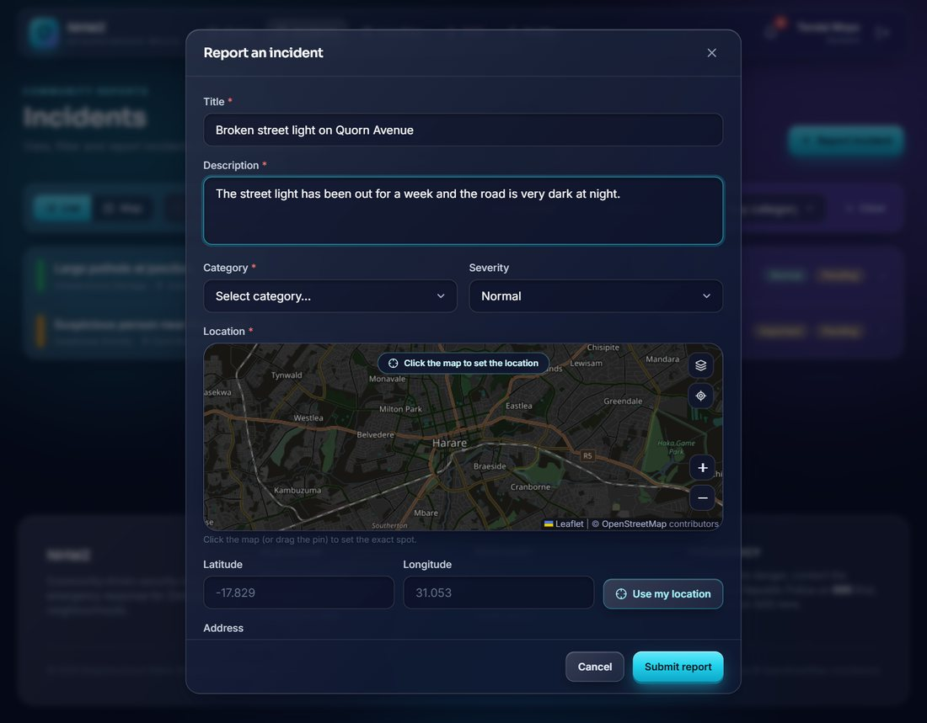
The form asks for a title, description, category, severity and a location chosen on the map. Evidence can be added afterwards.
Screenshot 4: Incident details (coordinator view)
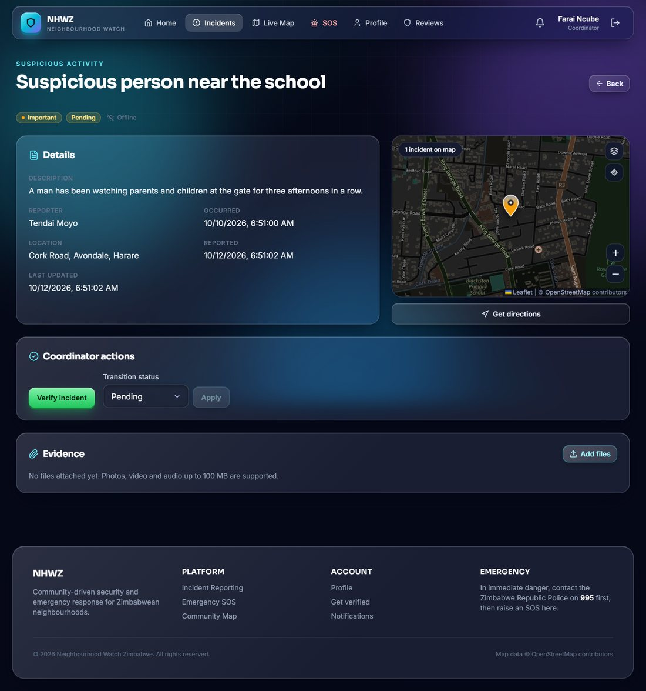
Details, map, evidence area, and the Coordinator actions panel with Verify incident and status change.
Screenshot 5: Live map
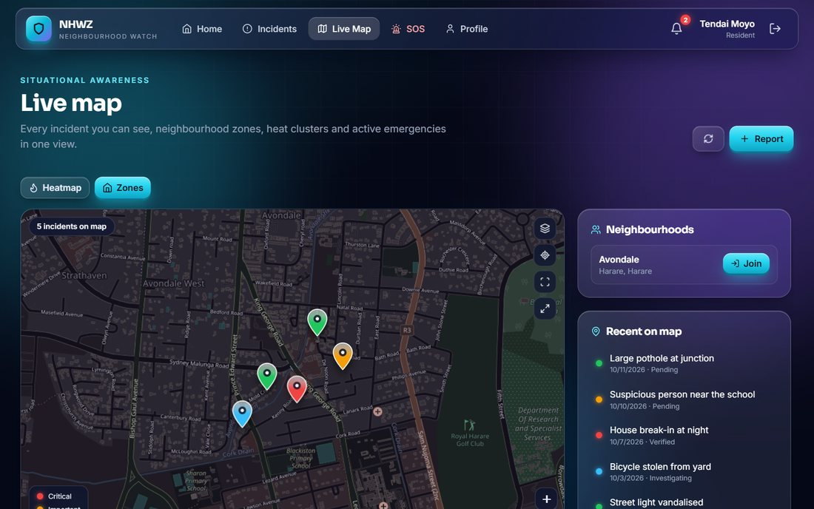
Incidents appear as coloured pins on the map. Neighbourhoods are listed on the right and a resident can join one.
Screenshot 6: SOS page (alert active)
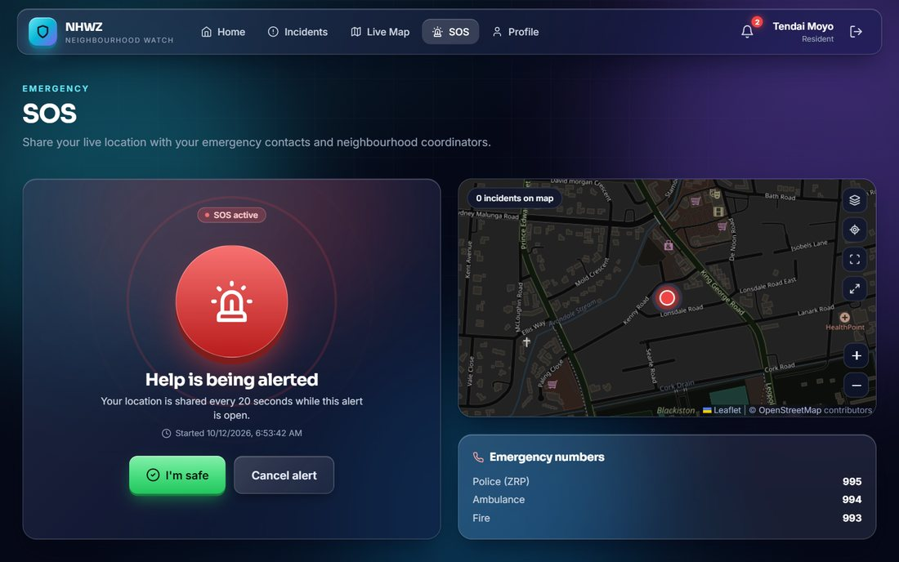
After the alert is sent the page shows that it is active, shares the location every 20 seconds, and offers I am safe and Cancel alert.
Screenshot 7: Verification queue (coordinator view)
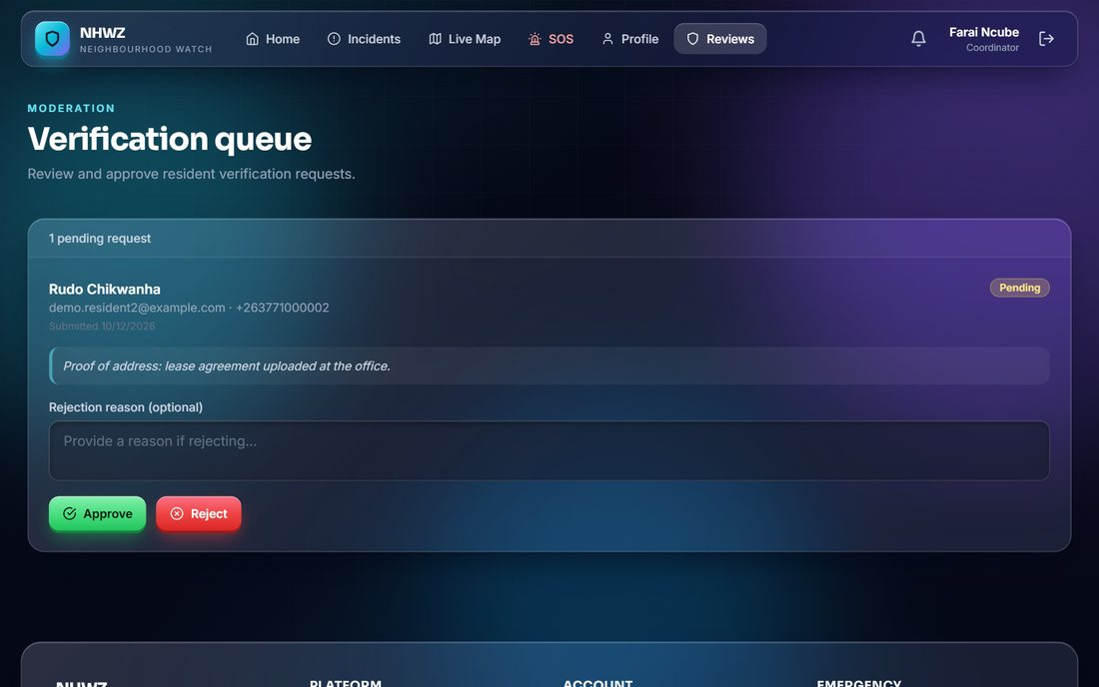
Coordinators approve or reject resident requests and can write a reason when rejecting.
Screenshot 8: Phone-size screens
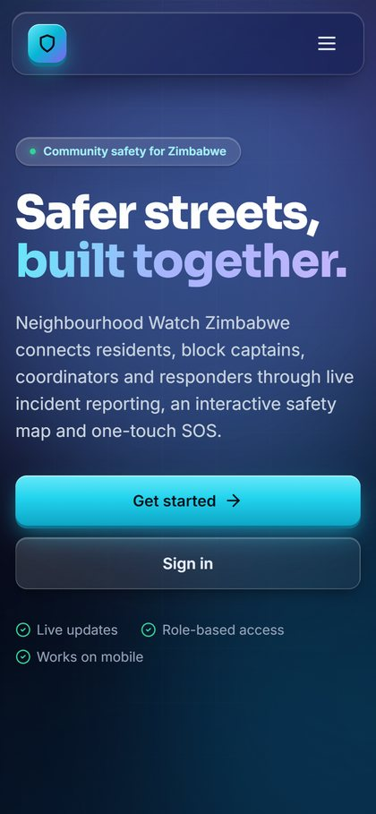 | 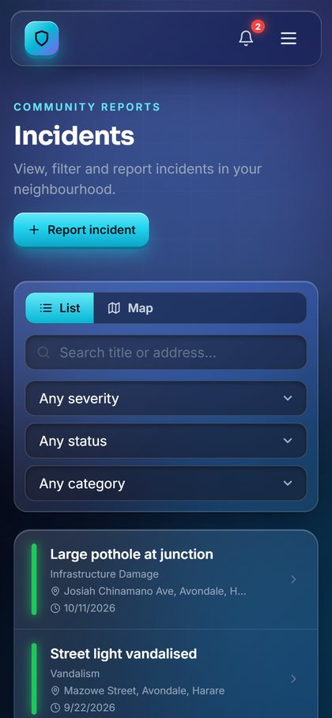 | 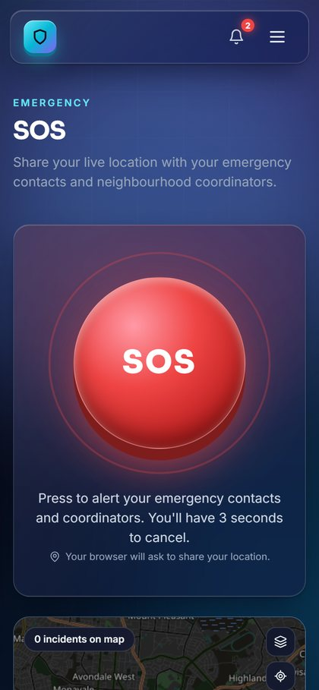
The website adapts to small screens: home page, incident list and SOS page on a phone.
The Flutter mobile app follows the same flows (login, incidents, map, alerts, alarm and profile). Its screens are not included here.

4.5 Design of System Controls
Control type | What is done
Input controls | Field checks, format checks (phone, email), list choices, file type and size checks
Access controls | Login with JWT; role checks on every request; users see only allowed data
Password and OTP controls | Passwords hashed (PBKDF2); OTP expires; rate limits on login, OTP and reset
Processing controls | Only valid status changes allowed; offline sync uses unique keys to stop duplicates
Audit controls | Audit log keeps actor, time, IP, before and after values
Data controls | Soft delete; database backups; evidence checksums
Security controls | CORS and CSRF protection; protected media; HTTPS in production; secrets in environment variables
Error controls | Clear error messages; health check endpoint; logging; Sentry for errors

4.6 Data Flow Diagrams (up to Level 2)
Symbols: yellow rectangle = external entity (a person or outside service); blue rounded box = process; green open box = data store (D1, D2 …); arrow = data flow.

Context diagram (Level 0)
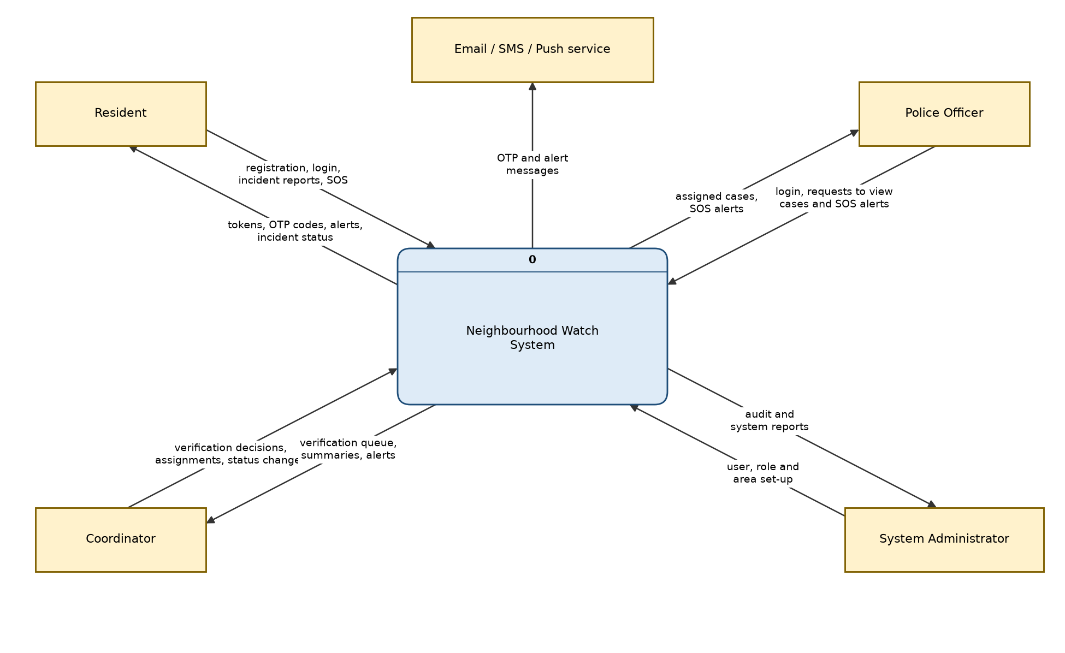
Figure 4.3: Context diagram of the Neighbourhood Watch system

Level 1 DFD
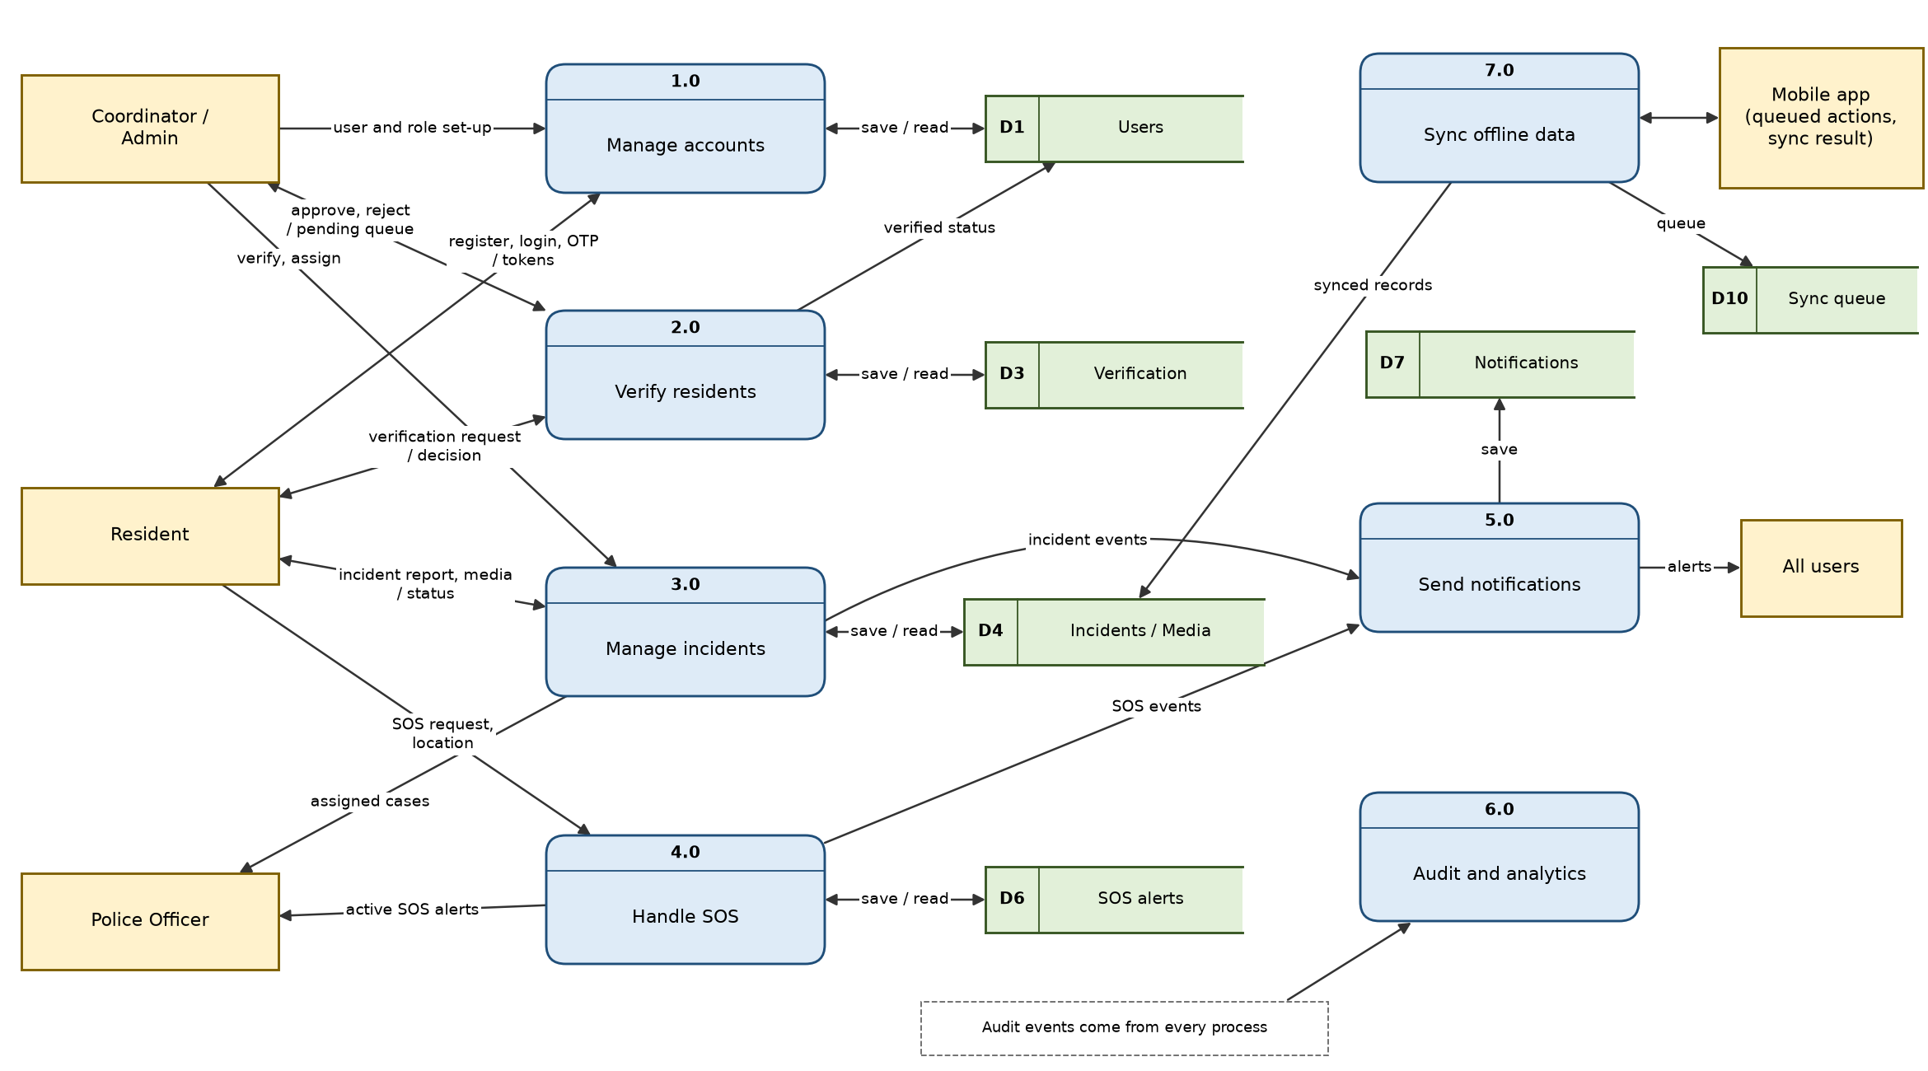
Figure 4.4: Level 1 data flow diagram
Process | Inputs | Outputs | Data stores
1.0 Manage accounts | Registration, login, OTP | Tokens, OTP messages | D1 Users
2.0 Verify residents | Verification request, decision | Updated status | D1 Users, D3 Verification
3.0 Manage incidents | Incident forms, media, status changes | Incident lists, updates | D4 Incidents / Media
4.0 Handle SOS | SOS start, location pings | Alerts, location trail | D6 SOS alerts
5.0 Send notifications | Events from 3.0 and 4.0 | In-app, push, SMS messages | D7 Notifications
6.0 Audit and analytics | Events from all processes | Logs, daily summaries | D8 Audit, D9 Analytics
7.0 Sync offline data | Queued actions from the mobile app | Sync results | D10 Sync queue, D4

Level 2 DFD – Process 3.0 Manage incidents
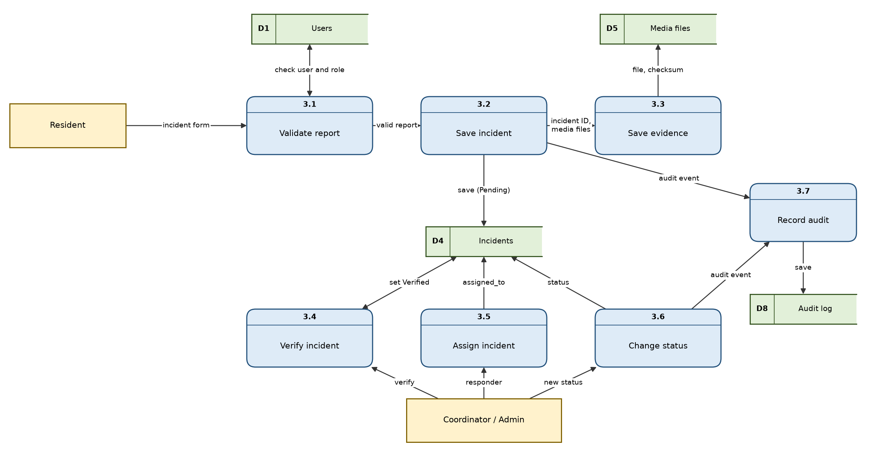
Figure 4.5: Level 2 DFD for process 3.0

4.7 UML Diagrams

Use case diagram
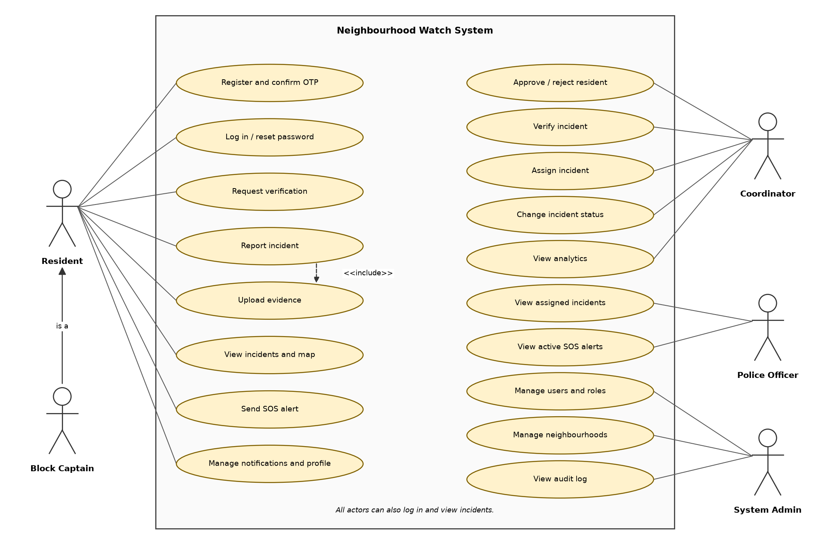
Figure 4.6: Use case diagram

Class diagram (main classes)
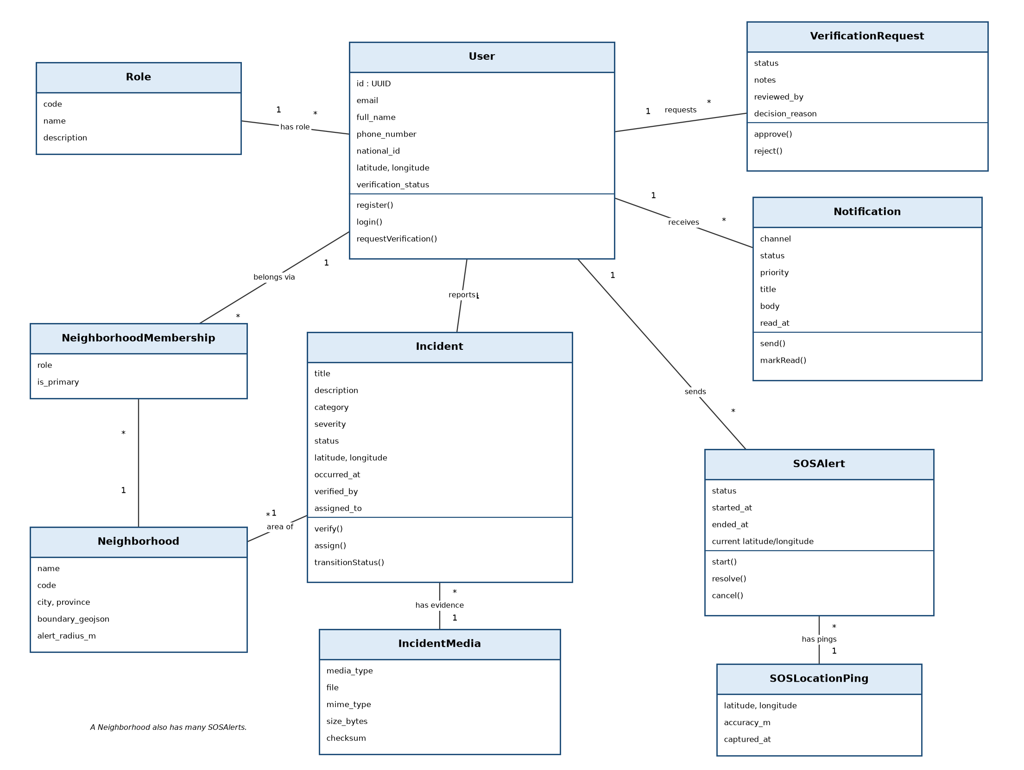
Figure 4.7: Class diagram

Sequence diagram: Report an incident
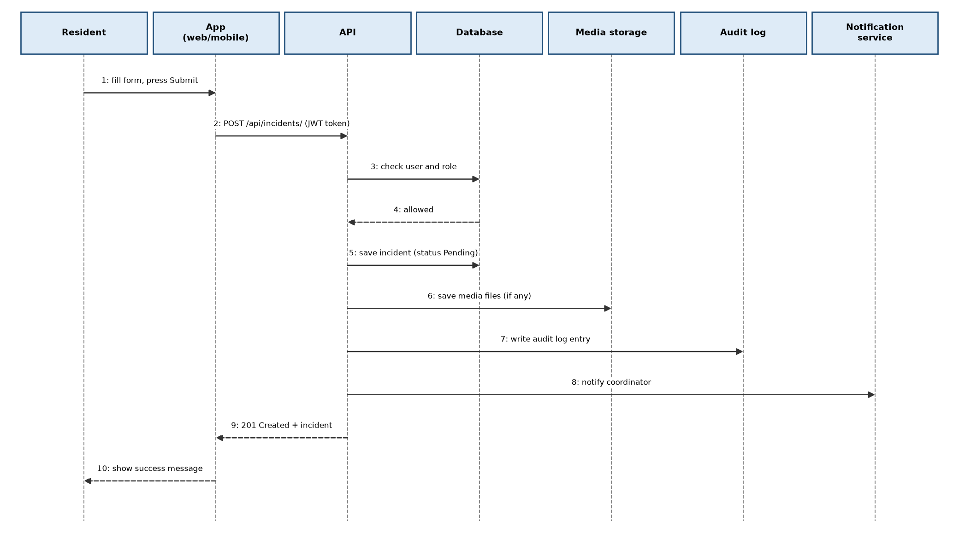
Figure 4.8: Sequence diagram for reporting an incident

State diagram: Incident
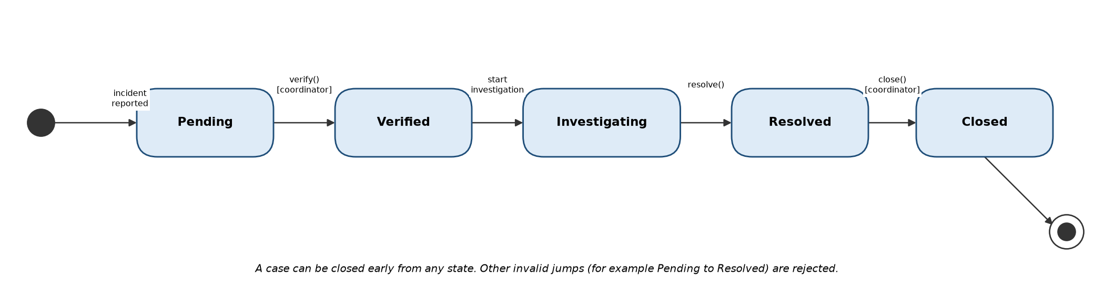
Figure 4.9: States of an incident

Date: …………………. Sign: Supervisor……………………... Student ……………………

5. Coding and Testing

5.1 Technologies Used
This project uses Python (Django) for the server and JavaScript (React) and Dart (Flutter) for the clients. These were chosen because Django gives built-in security, an admin site and a strong REST framework.
Part | Technology
Server | Python, Django 5.2, Django REST Framework, SimpleJWT, Celery, Channels
Website | React 18, React Router, Tailwind CSS, Axios, Leaflet, Vite
Mobile app | Flutter and Dart with geolocator, secure storage, Firebase messaging
Database | PostgreSQL with PostGIS (production), SQLite (development and tests)
DevOps | Docker Compose, Nginx, Kubernetes manifests, GitHub Actions

5.2 Project Structure
Neighbourhood Watch/
backend/apps/ accounts, incidents, neighborhoods, sos,
notifications, audit, analytics, sync, core
backend/config/ settings (base, local, test, production), urls
frontend/src/ pages, components, hooks, api.js, App.jsx
mobile/lib/ features (auth, incidents, alarm, map, alerts, profile)
infra/, k8s/ Docker and Kubernetes files
docs/ phase plans and guides

5.3 Programming Practice
- Indentation: 4 spaces in Python, 2 spaces in JavaScript. Checked with flake8.
- Names: clear names such as IncidentViewSet and verification_status. Classes use CapitalWords, variables use snake_case.
- Comments: each module and complex function has a short docstring that explains why it exists.
- Small functions and separate files: models, serializers, views, urls, services, tasks.
- Settings and secrets are in environment variables, not in code (.env.example is provided).
- Version control with Git and CI workflows that run tests and builds.
- Reusable base model (UUID, timestamps, soft delete) to avoid repeated code.
Real examples of this practice are shown in section 5.7.

5.4 Program Quality (User Friendliness)
- Clear forms with labels and helpful error messages next to the field.
- Loading spinners and success / error alerts.
- Mobile-first responsive layout.
- Colour badges for severity and status, with text as well as colour.
- Consistent buttons, cards and modals from one component library.
- Short simple wording, no technical terms.
- Redirect to login when the session ends.

5.5 Program Resilience (Robustness)
- All input is validated in the serializers before it reaches the database.
- Invalid status jumps return a clear error, not a crash.
- File uploads are checked for type and size.
- Rate limiting and account lockout (django-axes) protect against guessing attacks.
- Retries for failed notifications and emails with Celery.
- Offline queue with idempotency keys stops duplicate records.
- Health check endpoint and logs help find faults quickly.
- Soft delete protects against accidental data loss.

5.6 Testing

Types of testing
Type | What is tested | Tool
Unit tests | Models, soft delete, services | Django test / pytest
API tests | Auth, profile, verification, incidents, permissions | Django REST test client
Integration tests | Infrastructure, consumers (real-time), hardening | pytest
Mobile tests | Alarm rules | Flutter test
System / user acceptance | Full user flows with real users | Manual checklist

The backend has about 300 automated test cases. A test run on 9 October 2026 gave these results:
App | Tests run | Result
accounts (login, OTP, profile, verification) | 56 | All passed
neighborhoods | 14 | All passed
sos | 22 | All passed
notifications | 44 | All passed
sync (offline queue) | 17 | All passed
core (health, real-time, hardening) | 44 | All passed
analytics and audit | 0 | No tests yet
Total | 197 | 197 passed, 0 failed

The incidents tests did not finish inside the 5 minute limit used for this run (they wait for the background task service), so they are not counted in the table.
python manage.py test apps --settings=config.settings.test

Sample test cases
ID | Test | Expected result | How tested
T1 | Register with valid data | User created; OTP sent | Automated – passed
T4 | Resident tries to verify an incident | Error 403 (not allowed) | Automated (incidents)
T5 | Coordinator verifies a Pending incident | Status Verified; audit log saved | Automated (incidents)
T6 | Change Pending directly to Resolved | Error: invalid transition | Automated (incidents)
T7 | Upload a 150 MB video | Rejected: too large | Automated (incidents)
T9 | Start SOS with location | Alert created; notifications queued | Automated – passed
T10 | Send same offline item twice | Only one record saved | Automated – passed

Known gaps found in the project review
- Push and SMS providers are simulated (no real sending yet).
- Fine-grained permission table is created but not yet used by views.
- The analytics and audit apps have no automated tests and audit logs have no read API.
- The website has no automated test suite.

5.7 Code Samples from the System
The listings below are copied from the project source files. The file path and line numbers are given so that each sample can be found in the project. Long lines and unrelated code are left out and shown as "...".

Database and data protection
Listing 5.1: Base model with UUID, timestamps and soft delete
backend/apps/core/models.py (lines 33–55)
class UUIDTimeStampedModel(models.Model):
id = models.UUIDField(primary_key=True, default=uuid.uuid4, editable=False)
created_at = models.DateTimeField(auto_now_add=True, db_index=True)
updated_at = models.DateTimeField(auto_now=True)
last_modified_at = models.DateTimeField(auto_now=True, db_index=True)
deleted_at = models.DateTimeField(null=True, blank=True, db_index=True)

objects = SoftDeleteManager()
all_objects = AllObjectsManager()

class Meta:
abstract = True
ordering = ("-created_at",)

def delete(self, using=None, keep_parents=False):
now = timezone.now()
self.deleted_at = now
self.updated_at = now
self.last_modified_at = now
self.save(
using=using,
update_fields=["deleted_at", "updated_at", "last_modified_at"],
)
Every main table inherits this model. It gives a random UUID key and time stamps. The delete() method does not remove the row. It only sets deleted_at, so records and their history are kept.
Listing 5.2: One-time password: generate and check
backend/apps/accounts/services/otp_service.py (lines 28–42, 54–78)
def generate(self, *, user, purpose, channel, destination) -> OTPDelivery:
code = self._generate_code()
expires_at = timezone.now() + timedelta(minutes=self.ttl_minutes)
challenge = OTPChallenge.objects.create(
user=user,
purpose=purpose,
channel=channel,
destination=destination,
hashed_code=make_password(code),
expires_at=expires_at,
)
if channel == OTPChallenge.Channel.EMAIL:
from apps.accounts.tasks import send_otp_email
send_otp_email.delay(destination, code, purpose, expires_at.isoformat())
return OTPDelivery(challenge=challenge, code=code, expires_at=expires_at)
# ...
if challenge is None:
raise ValidationError("No active OTP challenge was found.")

now = timezone.now()
if challenge.expires_at <= now:
raise ValidationError("OTP code has expired.")

if challenge.attempts >= self.max_attempts:
raise ValidationError("Maximum OTP verification attempts exceeded.")

challenge.attempts += 1
if not check_password(code, challenge.hashed_code):
challenge.save(update_fields=["attempts", "updated_at", "last_modified_at"])
raise ValidationError("Invalid OTP code.")

challenge.consumed_at = now
challenge.save(
update_fields=[
"attempts",
"consumed_at",
"updated_at",
"last_modified_at",
]
)
return challenge
The code is stored hashed (make_password), so a database leak does not show codes. The check rejects missing, expired or over-used codes, counts each attempt, and marks a correct code as used so it cannot be used again.

Business rules
Listing 5.3: Incident status rules
backend/apps/incidents/services.py (lines 224–250)
VALID_TRANSITIONS = {
Incident.Status.PENDING: [Incident.Status.VERIFIED, Incident.Status.CLOSED],
Incident.Status.VERIFIED: [
Incident.Status.INVESTIGATING,
Incident.Status.CLOSED,
],
Incident.Status.INVESTIGATING: [
Incident.Status.RESOLVED,
Incident.Status.CLOSED,
],
Incident.Status.RESOLVED: [Incident.Status.CLOSED],
Incident.Status.CLOSED: [],
}

@classmethod
def can_transition(cls, current_status: str, new_status: str) -> bool:
"""Check if transition is valid."""
return new_status in cls.VALID_TRANSITIONS.get(current_status, [])

@classmethod
def transition(cls, incident: Incident, new_status: str, actor, request=None) -> bool:
"""
Attempt status transition with validation and audit logging.
Returns True if successful, False if invalid transition.
"""
if not cls.can_transition(incident.status, new_status):
return False
The allowed status changes are kept in one table. Any change not in the table, for example Pending to Resolved, returns False and the API answers with an error. This stops wrong status jumps and makes the rule easy to test.
Listing 5.4: Reusable role check for views
backend/apps/accounts/permissions.py (lines 28–43)
class HasAnyRole(BasePermission):
"""Allows access to users with one of the view's required role codes."""

def has_permission(self, request, view):
if not request.user or not request.user.is_authenticated:
return False
if request.user.is_superuser:
return True

required_role_codes = set(getattr(view, "required_role_codes", ()))
if not required_role_codes:
return True
if not request.user.role_id:
return False

return request.user.role.code in required_role_codes
A view lists the roles it allows. This class checks the logged-in user against that list, so the same rule is not repeated in every view.

Validation and robustness
Listing 5.5: Evidence file checks
backend/apps/incidents/serializers.py (lines 224–246)
}

def validate_file(self, value):
if value.size > 100 * 1024 * 1024:
raise serializers.ValidationError("File size cannot exceed 100MB.")
return value

def validate(self, attrs):
attrs = super().validate(attrs)
file_obj = attrs.get("file")
media_type = attrs.get("media_type")
if file_obj and media_type:
try:
import magic
header = file_obj.read(2048)
file_obj.seek(0)
detected_mime = magic.from_buffer(header, mime=True)
allowed_prefixes = self._ALLOWED_MIME_PREFIXES.get(media_type, ())
if not any(detected_mime.startswith(p) for p in allowed_prefixes):
raise serializers.ValidationError(
{"file": f"File content does not match media type '{media_type}' (detected: {detected_mime})."}
)
except ImportError:
Files over 100 MB are refused. The file content is read (not just the name) to find its real type, and it must match the type the user chose (image, video or audio). This blocks files of the wrong type.
Listing 5.6: Safe offline sync (no duplicates)
backend/apps/sync/services.py (lines 36–45)
def _apply_one(cls, user, item: dict) -> dict:
key = item["idempotency_key"]
existing = SyncQueue.objects.filter(idempotency_key=key).first()
if existing and existing.status == SyncQueue.Status.SYNCED:
return {
"idempotency_key": key,
"status": "already_synced",
"entity_id": str(item["entity_id"]),
"error": None,
}
Each item from the mobile app has a unique idempotency key. If the key was already synced, the server skips it and replies "already_synced", so a retry after a bad network never creates a duplicate record.

Accountability
Listing 5.7: Audit log helper
backend/apps/audit/services.py (lines 30–54)
def create_audit_log(
*,
action,
actor=None,
entity=None,
request=None,
before=None,
after=None,
metadata=None,
):
entity_type = entity.__class__.__name__ if entity is not None else ""
entity_id = getattr(entity, "id", None)
user = actor if getattr(actor, "is_authenticated", False) else None

return AuditLog.objects.create(
actor=user,
action=action,
entity_type=entity_type,
entity_id=entity_id,
ip_address=_request_ip(request),
user_agent=_request_user_agent(request),
before=before,
after=after,
metadata=metadata or {},
)
Important actions call this function. It saves who did it, what changed (before and after), the IP address and the browser or device.

Date: …………………. Sign: Supervisor……………………... Student ……………………

6. Implementation and Post-Implementation Plan

6.1 Pre-Presentation
- Run all backend tests and record the results.
- Build the website and mobile app, and check that they connect to the server.
- Load demo data: roles, one neighbourhood, and test accounts for each role.
- Prepare a live demonstration: register → verify → report incident → verify → assign → SOS.
- Prepare backup slides and screenshots in case the network fails.
- Print this documentation and have it signed by the supervisor.
- Practise a 10-minute presentation.

6.2 Documentation
Document | Purpose | Audience
This project documentation | Full record of the project | Supervisor, examiners
README.md and QUICKSTART.md | Setup and running | Developers
API examples and OpenAPI schema (/api/schema/) | How to use the API | Developers
DEPLOYMENT_GUIDE.md | Putting the system online | Administrators
CONTRIBUTING.md | Coding rules | Developers
User manual (below) | How to use the system | End users

User manual

How to report an incident
- Log in and press Incidents, then Report incident.
- Write a title and describe what happened.
- Choose the category and how serious it is.
- Pick the place on the map.
- Add photos, video or audio if you have them (max 100 MB each).
- Press Submit. You can follow the status in the incident list.

How to send an SOS
- Open the SOS page or press the SOS button.
- Confirm. Your emergency contacts are told by SMS, and coordinators and police can see your alert and location.
- Keep the app open so your location updates.
- Press Resolve when you are safe, or Cancel for a false alarm.

For coordinators
- Open the Coordinator queue to approve or reject resident requests. Always give a reason when rejecting.
- Open Pending incidents, check details, and press Verify.
- Assign to a responder and update the status until closed.

6.3 Conversion Plans
There is no old computer system, so the change is from paper and WhatsApp to the new system.
Chosen plan: Pilot with parallel running. One neighbourhood uses the new system for about two months while keeping WhatsApp and paper. After problems are fixed, other neighbourhoods are added.

Conversion steps
- Install the server (Docker) and set secrets, HTTPS and backups.
- Create the neighbourhood and system administrator.
- Create coordinator accounts and train coordinators first.
- Register block captains and residents; coordinators verify them.
- Enter important old records, if the community wants them kept.
- Run in parallel; compare old and new records weekly.
- Switch fully when results are good.

Training plan
Group | Topics | Time
Coordinators and administrators | Verification, incident handling, assigning, reports, user management | 3 hours + practice
Police officers and block captains | View assigned cases, see active SOS alerts | 2 hours
Residents | Register, report, SOS, notification settings | 1 hour community meeting + printed guide

Post-implementation plan
- Collect feedback with a short form after one month.
- Review problems and fix bugs in monthly updates.
- Check performance, backups and security every month.
- Check if objectives were met (Chapter 1.4) and report to the community.
- Keep a helpdesk contact (phone or email) for users.

Date: …………………. Sign: Supervisor……………………... Student ……………………

7. Conclusion
Neighbourhood Watch Zimbabwe gives communities a single, safe place to report incidents, keep evidence, and ask for help. It replaces slow, unclear, verbal reporting with a clear process: report, verify, assign, resolve and close, with every step recorded.
The project has a working server, a website and a mobile app, with authentication, role-based access, incident handling, SOS alerts, notifications, offline sync, audit logging, and Docker/Kubernetes deployment files. The feasibility study shows low cost and good chance of success. Remaining gaps are clear and small, and are listed in Chapter 5.

7.1 Challenges
- Poor internet and data cost in some areas.
- Protecting private data and the identity of reporters.
- Getting the trust and cooperation of the police and the community.
- Paid services (SMS, push) are needed to send real alerts.

7.2 Future Plans
- Connect real SMS (Twilio or a local provider) and Firebase push notifications.
- Use the fine-grained permission system in all views.
- Add an audit log viewer for administrators and tests for analytics and audit.
- Add automated tests for the website.
- Crime heat maps and patrol planning using analytics.
- Languages: Shona and Ndebele.
- USSD or SMS reporting for phones without data.
- Official link with the ZRP, with approval.
- Patrol scheduling and community notice board.
- Performance tests and a security review before wide launch.

Date: …………………. Sign: Supervisor……………………... Student ……………………

Appendix: Glossary
Term | Meaning
API | A way for programs to talk to the server
JWT | A secure token that proves you are logged in
OTP | One-time password: a code sent to you once
RBAC | Role-based access control: what you can do depends on your role
SOS | Emergency call for help
Soft delete | Mark data as deleted but keep it in the database
Audit log | A record of who did what and when
DFD | Data Flow Diagram

