KWEKWE POLYTECHNIC
National Diploma in Information Technology (ND3 IT)
Project Documentation
CHAPTER 4
Design
CyberShield Hub
An Enterprise Cybersecurity Awareness and Incident Response Platform
Student name: [Insert student name]
Registration number: [Insert registration number]
Supervisor: [Insert supervisor name]
Academic session: ND3 IT, January 2023 intake

4.1 Introduction
The design converts the requirements of Chapter 3 into a blueprint for construction. It covers input, output and process design, database and file design, user-interface design, system controls, data flow diagrams to level 2 and UML diagrams.

4.2 Input, Output and Process Design

4.2.1 Input design
Inputs are captured through validated forms in the web and mobile clients and re-validated on the server. Principles: capture each item once, use controlled lists (drop-downs) wherever possible, give immediate field-level messages, and never trust the client.
Input | Fields | Validation
Registration | first name, last name, e-mail, password, confirm password, organisation, department | E-mail unique and valid; password strength checker and Django password validators; passwords must match
Login | e-mail, password | Required; account must be active; failed attempts recorded; throttled to 10 per minute
Incident report | title, category, severity, description, affected system, date/time occurred, evidence files, draft flag | Title and description required; category from list; severity from list; file extension and size check
Quiz answers | attempt id, list of question id + answer id | Question and answer must belong to the quiz; attempt limit enforced
Phishing classification | simulation id, classification (safe / suspicious), inspected URLs, selected red flags | Classification from fixed list; flags from scenario list
Alert | title, body, priority, type, audience role, start, expiry | Title and body required; expiry after start
Lesson / quiz / simulation authoring | title, slug, content, category, difficulty, tags, questions and answers, red flags | Slug unique; at least one correct answer per question; required fields
Status change / assignment | incident id, new status or officer id, note | Officer role required; assignee must be an officer

4.2.2 Output design
Output | Content | Recipient | Medium
Personal dashboard | Security score, lesson progress, quiz and phishing results, open incidents, alerts | Every user | Screen, charts
Quiz result | Score, pass/fail, correct answers, explanations, weak topics, recommended lessons | Learner | Screen
Phishing feedback | Score, expected classification, red flags found and missed, training tip | Learner | Screen
Incident confirmation and timeline | Reference number, status history, assignee | Reporter | Screen
SOC queue and heat map | Incidents grouped by status; severity × status counts | Officer, admin | Kanban board, heat map
Organisation analytics | Training, quiz, phishing, incident and risk indicators | Officer, admin | Charts (bar, line, doughnut, radar)
Notification centre | Unread and read alerts | Users | Screen, badge count
Audit report | Who did what, when, from which IP | Officer, admin | Screen and CSV file
API documentation | All endpoints and schemas | Developers | Swagger page

4.2.3 Process design
Business rules live in the service layer so they are shared by both clients and are testable.

Quiz grading (grade_quiz_attempt)
FOR each question in the quiz
total_points += question.points
selected = answer chosen by user for this question (if any)
correct = selected exists AND selected.is_correct
earned_points += question.points IF correct
store QuizAttemptAnswer(selected, correct, points)
update weakness[competency] (correct / total)
score = earned_points / total_points * 100
passed = score >= quiz.pass_score
recommendations = explanations of wrongly answered questions

Incident priority
severity_weight = {low: 25, medium: 50, high: 75, critical: 95}
status_weight = {open: +5, investigating: +10, escalated: +15, resolved: -20, closed: -30}
priority_score = clamp(severity_weight + status_weight, 0, 100)
reference = 'INC-' + yyyymmdd + '-' + 6 random hex characters (generated once)

Phishing scoring
The score is the sum of classification points (correct safe/suspicious decision) and red-flag points (proportion of the scenario's red flags the user selected), capped at 100. A safe e-mail correctly classified earns full credit without needing flags.

Incident life cycle
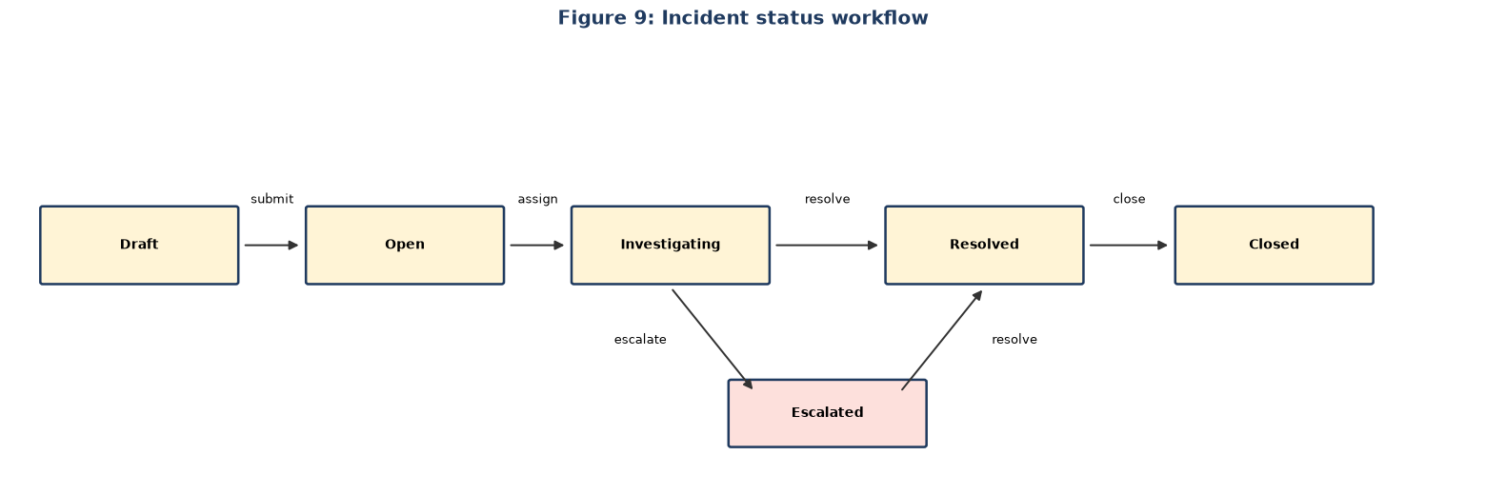
Figure 9: Incident status workflow

4.3 Database Design and File Design

4.3.1 Database approach
A relational database is used because the data is highly structured with clear ownership relationships. SQLite is the default for development and MySQL 8 (InnoDB, utf8mb4) for production. The schema is created by Django migrations; docs/database_schema.sql documents the production tables. Design rules applied: every table has a surrogate primary key and created/updated timestamps; relationships use foreign keys; frequently searched columns are indexed; JSON columns hold small variable lists (tags, red flags); tables are normalised to third normal form (answers are separate from questions, attempts from attempt answers).
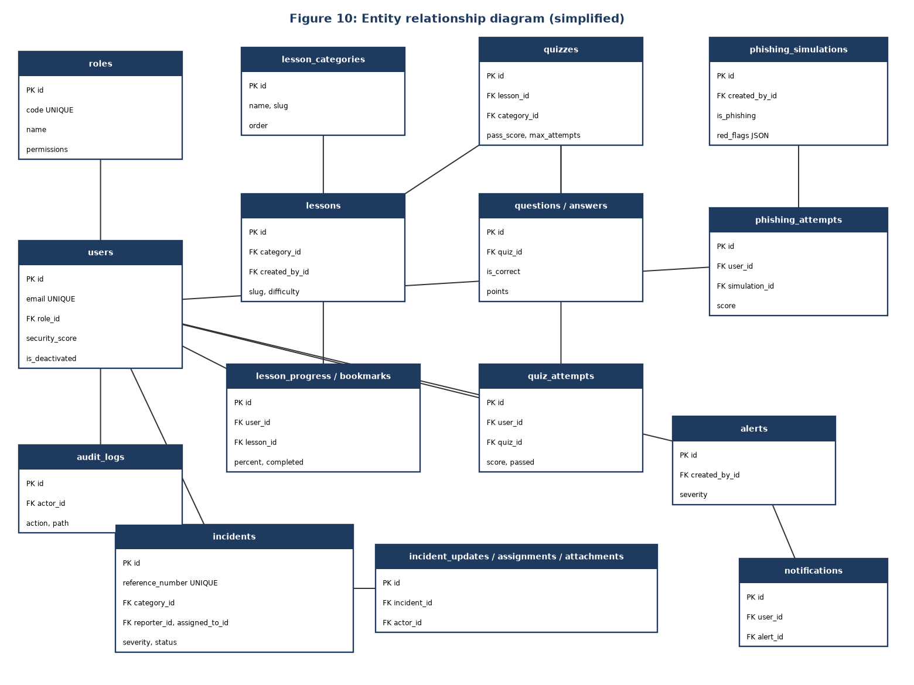
Figure 10: Entity relationship diagram (simplified)

4.3.2 Table list
Table | Purpose | Key relationships
roles | Role definitions and permissions | 1 role : many users
users | Accounts, profile, security data | FK role
lesson_categories | Training categories | 1 : many lessons
lessons | Training content | FK category, created_by
lesson_progress, lesson_bookmarks | Per-user progress and bookmarks | FK user, lesson
quizzes, questions, answers | Assessment content | quiz 1 : many questions 1 : many answers
quiz_attempts, quiz_attempt_answers | Results and given answers | FK user, quiz, question, answer
phishing_simulations, phishing_attempts | Scenarios and results | FK user, simulation
incident_categories, incidents | Incident types and cases | incident FK category, reporter, assigned_to
incident_attachments, incident_updates, incident_assignments | Evidence, timeline, assignment history | FK incident, user
alerts, notifications | Advisories and per-user delivery | notification FK user, alert (unique pair)
audit_logs | Request audit trail | FK actor

4.3.3 Data structures for key tables

users
Column | Type | Constraint
id | BIGINT | Primary key, auto increment
email | VARCHAR(254) | Unique, not null
username, first_name, last_name | VARCHAR(150) | Not null (username unique)
password | VARCHAR(128) | Hashed
role_id | BIGINT | FK → roles.id
organization, department, phone | VARCHAR | Optional
is_active, is_deactivated, is_email_verified | BOOLEAN | Account state
failed_login_attempts, last_failed_login, last_login_ip | INT, DATETIME, CHAR(39) | Login tracking
security_score | INT | Default 72

incidents
Column | Type | Constraint
id | BIGINT | Primary key
reference_number | VARCHAR(32) | Unique, generated
title | VARCHAR(220) | Not null
category_id | BIGINT | FK → incident_categories.id (protect)
severity | VARCHAR(24) | low/medium/high/critical, indexed
description | LONGTEXT | Not null
affected_system | VARCHAR(180) | Optional
occurred_at | DATETIME | Not null
reporter_id | BIGINT | FK → users.id
assigned_to_id | BIGINT | FK → users.id, null allowed
status | VARCHAR(24) | open … closed, indexed
priority_score | INT | 0–100
is_draft, submitted_at, resolved_at, closed_at | BOOLEAN / DATETIME | Life-cycle fields

quizzes and quiz_attempts
Table.column | Type | Notes
quizzes.title, slug | VARCHAR(220/240) | slug unique
quizzes.time_limit_minutes | INT | Default 10
quizzes.pass_score | INT | Default 80
quizzes.max_attempts | INT | 0 = unlimited
quizzes.randomize_questions, is_active | BOOLEAN | Behaviour switches
quiz_attempts.user_id, quiz_id | BIGINT | FKs; indexed together with created_at
quiz_attempts.score, total_points, earned_points | DECIMAL(5,2), INT, INT | Result
quiz_attempts.passed, started_at, completed_at, duration_seconds | BOOLEAN, DATETIME, INT | Result and timing
quiz_attempts.weakness_map, recommendations | JSON | Per-competency analysis

4.3.4 File design
File / store | Content | Rules
media/incident-evidence/<reference>/… | Evidence attached to incidents (png, jpg, jpeg, pdf, txt, log, eml, msg) | Maximum 10 MB; extension allow-list; path generated by the system; files never executed; deleted with parent incident record
media/avatars/… | Optional profile pictures | Image types only
staticfiles/ | Compiled static assets served by WhiteNoise | Rebuilt on deployment
.env | Configuration: secret key, debug flag, database engine, allowed hosts, CORS origins, token lifetimes | Not committed to version control; .env.example supplied
docs/database_schema.sql, docs/api_endpoints.md | Reference documentation | Maintained with the code
Secure storage on phone | Mobile access/refresh tokens | Held in the platform's encrypted store (flutter_secure_storage)

4.4 User Interface Design

4.4.1 Design principles
- Consistency: the same layout, buttons, badges and messages across all modules.
- Role-aware navigation: menus show only what the signed-in role may use.
- Feedback: loading skeletons, toast messages, empty states and clear error panels.
- Safety: confirmation dialogs for destructive actions; warning on leaving forms with unsaved changes.
- Accessibility and responsiveness: readable contrast, keyboard-usable controls, layouts that adapt from desktop to phone.
- Visual identity: a cybersecurity theme with shield imagery, cards, glass-style panels and subtle 3D accents (web and mobile).

4.4.2 Navigation structure
Group | Pages (web route) | Visible to
Public | Login /login, Register /register, Forgot/Reset password, Verify e-mail | Anyone
Home | Dashboard / | All
Learn | Training /training, Lesson /training/:slug, Quizzes /quizzes, Take quiz, Results, Phishing lab /phishing | All
Respond | My incidents /incidents, Report /incidents/new, Incident detail, Alerts /alerts | All
Respond (staff) | SOC queue /soc, Analytics /analytics | Officer, admin
Administer | Users /admin/users, Content library (lessons, quizzes, simulations, categories), Quiz settings, Audit log /admin/audit | Admin (audit also officer)
Account | Profile and password /account | All

4.4.3 Screen layouts
All authenticated screens share an application shell: a left sidebar with the grouped navigation, a top bar with the notification bell and user menu, and a content area with a page header.
Screen | Layout description
Login / Register | Centred card over an animated shield background; fields with inline validation; password strength meter on registration; links to reset password.
Dashboard | Row of metric cards (security score, lessons completed, quiz average, phishing accuracy); progress bars; trend and radar charts; recent incidents and alerts.
Training | Search box and filters (category, difficulty); grid of lesson cards with progress and bookmark icon; lesson page with formatted content, completion button and related quiz.
Quiz | List with attempts used/remaining; quiz page with timer, one question block at a time, progress indicator; result page with score ring, answer review and recommendations.
Phishing lab | Simulated mail client: message list, message view with sender details; inspect-URL action; red-flag checklist; Safe / Suspicious buttons; feedback panel.
Report incident | Single form: title, affected system, category, severity, date and time (cannot be in the future), description, evidence upload list with removable files; Save draft and Submit buttons.
Incident detail | Summary header with reference, severity and status badges; description; evidence list; timeline; officer management panel (assign, change status, add note).
SOC queue | Kanban board with columns Open, Investigating, Escalated, Resolved, Closed; cards sorted by priority; severity/status heat map.
Analytics | Bar, line, doughnut and radar charts for training, quizzes, phishing, incidents and risk.
Admin content | Tabs for lessons, quizzes, simulations and categories; editor pages with unsaved-change protection; list tables with edit and delete.
Audit log | Filterable table (actor, action, date), search box and Export CSV button.

The mobile application follows the same structure with a bottom navigation bar (Home, Learn, Incidents, Alerts, Account) and full-screen flows for quizzes and phishing practice.

4.4.4 Colour and typography
A dark navy background with cyan and mint accents and amber and red warning colours. Severity and status are always shown as coloured badges with text labels. Because every badge carries text, colour is never the only signal.

4.5 Design of System Controls
Control type | Control | Where implemented
Authentication | JWT access (20 min) and rotating refresh (7 days) tokens; old refresh tokens blacklisted; logout revokes session | users app, Simple JWT settings
Authorisation | Role checks (IsSystemAdmin, IsCyberOfficer, IsAdminOrReadOnly, IsOwnerOrOfficer) on every view; users cannot change their own role | common/permissions.py
Input controls | Server-side serializer validation, strong-password validators, unique constraints, choice fields | serializers, models
File upload controls | Extension allow-list, 10 MB limit, generated storage path | common/validators.py
Brute-force protection | Login attempt counter, deactivated-account refusal, 10/min throttle on authentication endpoints, 60/min anonymous throttle | users views, DRF throttling
Processing controls | Attempt limits enforced at start and submit; scores computed only on the server; status workflow validated; reference numbers generated once | quizzes and incidents services/models
Audit controls | Middleware logs every authenticated mutating request; audit model cannot be edited via the API | audit app
Transport and browser controls | HTTPS in production; CORS limited to configured origins; allowed hosts list | settings
Information privacy | Users see only their own incidents, attempts and notifications; unknown e-mail on password reset does not reveal whether the account exists | view querysets
Error handling | Custom exception handler returns uniform JSON errors without stack traces | common/exceptions.py
Backup and recovery | Scheduled database dump and media backup; Git version control for code; migrations to rebuild the schema | Operations procedure (Chapter 6)
Environment control | Secrets in .env, never committed; debug off in production | Configuration

4.6 Data Flow Diagrams up to Level 2
Notation: rectangles are external entities, ellipses are processes, open-ended bars are data stores and arrows are data flows.

4.6.1 Level 0 (context diagram)
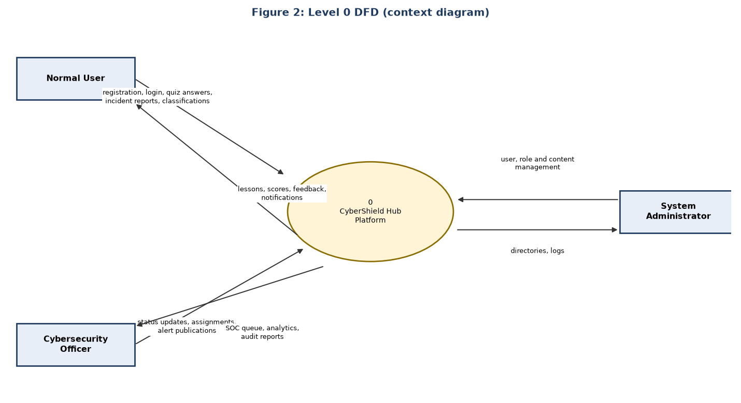
Figure 2: Level 0 DFD (context diagram)

4.6.2 Level 1
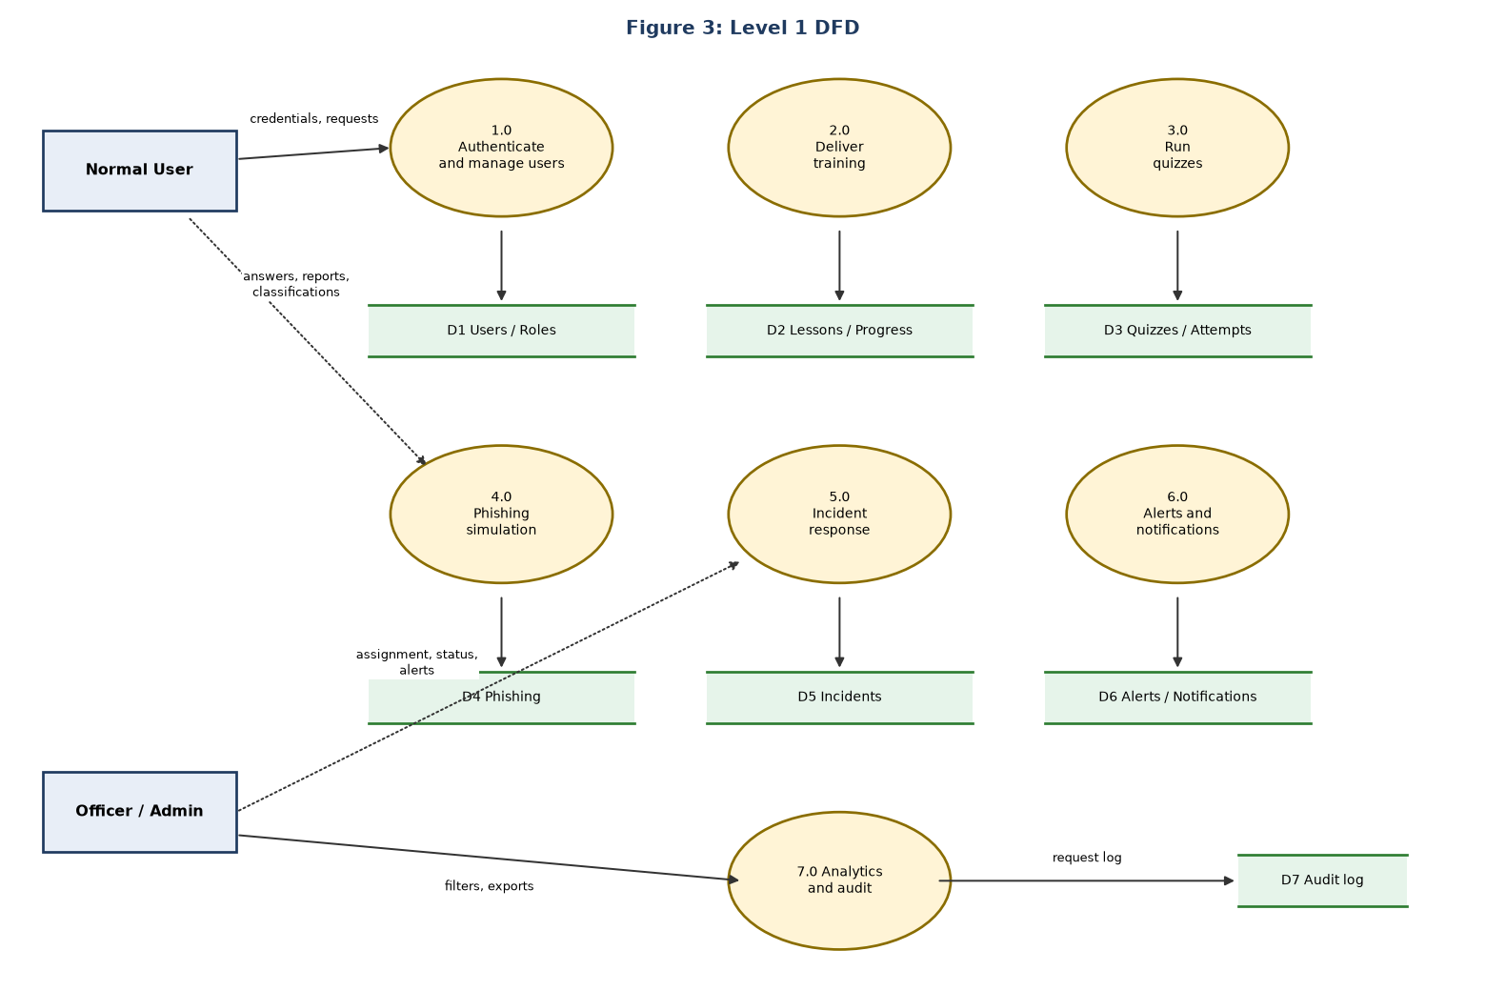
Figure 3: Level 1 DFD

4.6.3 Level 2: Incident response (process 5.0)
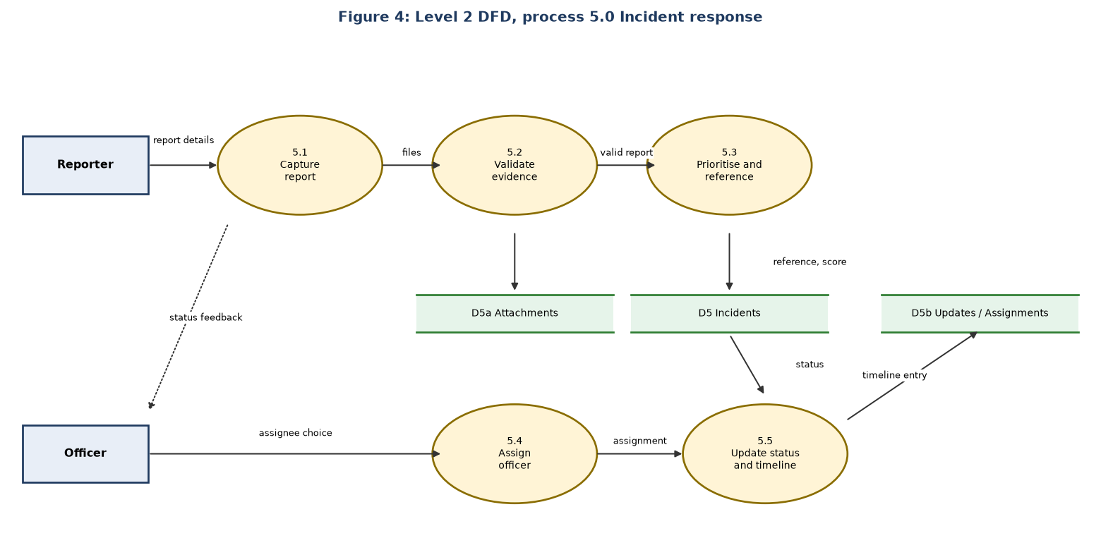
Figure 4: Level 2 DFD, process 5.0 Incident response

4.6.4 Level 2: Quizzes (process 3.0)
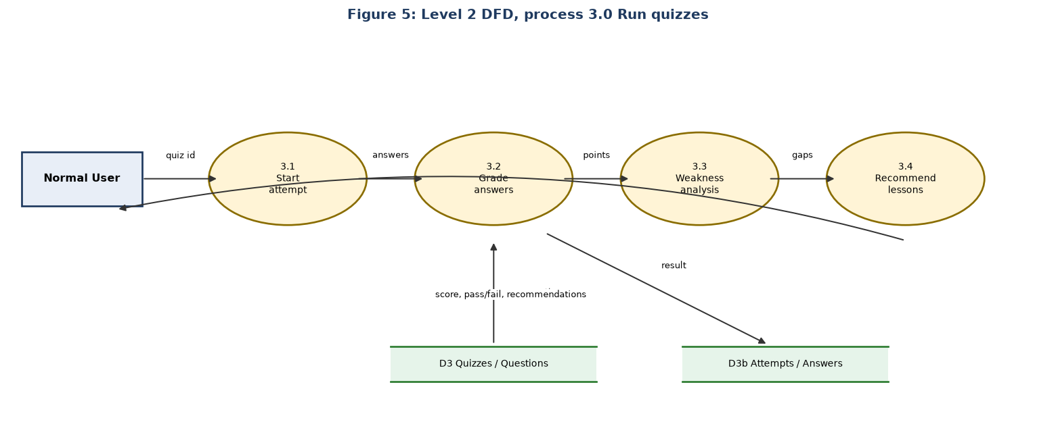
Figure 5: Level 2 DFD, process 3.0 Run quizzes

4.7 UML Diagrams

4.7.1 Use case diagram
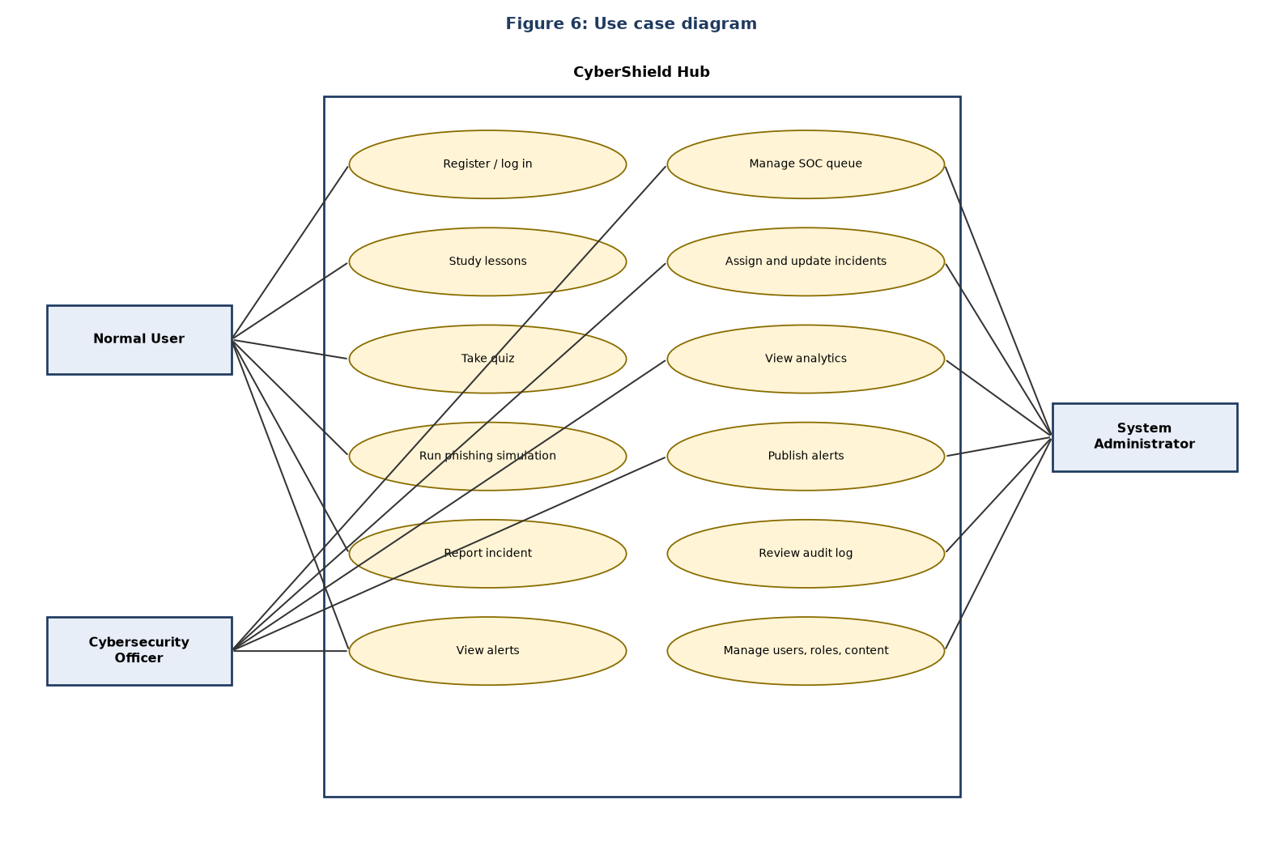
Figure 6: Use case diagram

4.7.2 Class diagram
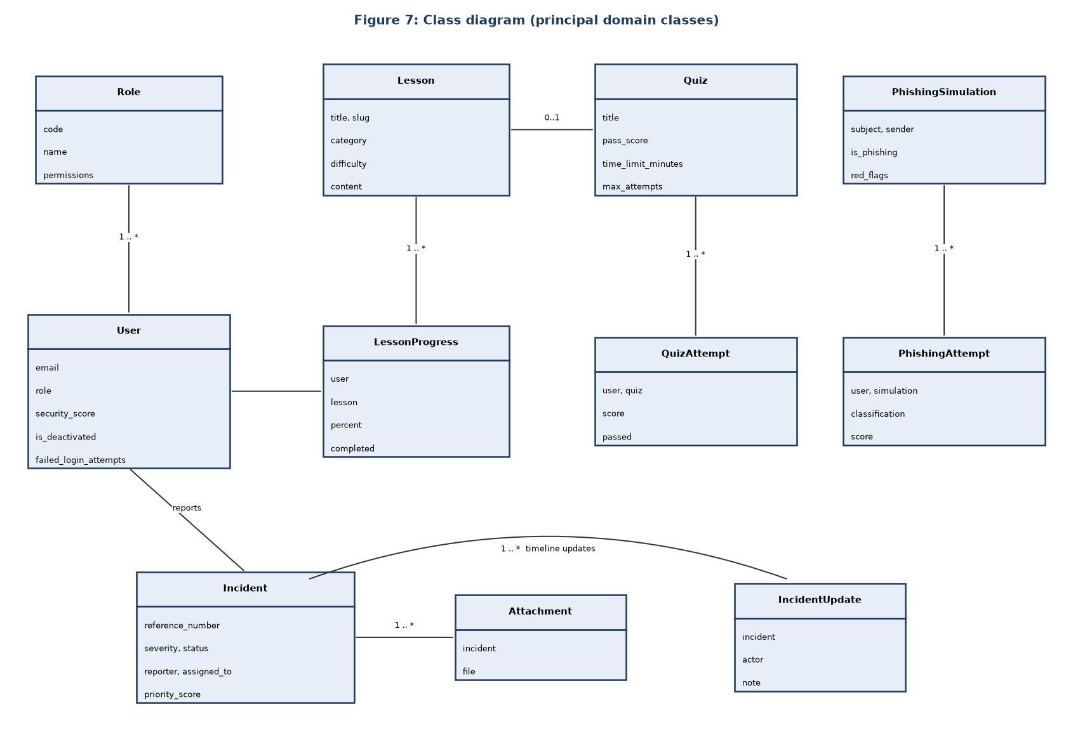
Figure 7: Class diagram (principal domain classes)

4.7.3 Sequence diagram
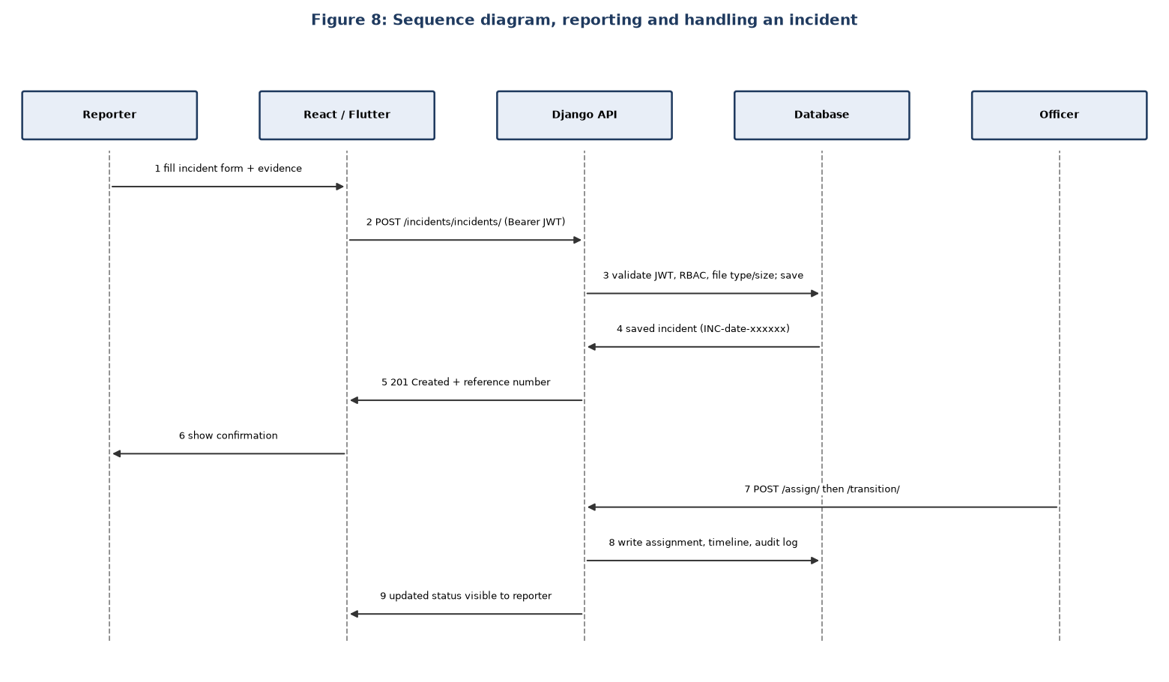
Figure 8: Sequence diagram, reporting and handling an incident

4.7.4 System architecture
The deployment and layer view is shown in Chapter 1, Figure 1. Request flow: client → JWT authentication → RBAC permission check → service/ORM → database → audit write → JSON response.

Date: ………………………. Sign: Supervisor ………………………. Student ……………………….

