KWEKWE POLYTECHNIC
National Diploma in Information Technology (ND3 IT)
Project Documentation
CHAPTER 1
Project Identification
CyberShield Hub
A Cybersecurity Awareness and Incident Response Platform
Student name: [Insert student name]
Registration number: [Insert registration number]
Supervisor: [Insert supervisor name]
Academic session: ND3 IT, January 2023

1.1 Executive Summary
Topic. CyberShield Hub is a web and mobile system for cybersecurity awareness and incident response. It puts security training, quizzes, phishing practice, incident reporting and incident handling in one safe place.
Why. Most security problems start with a human action. A worker may click a bad link, use a weak password or forget to report a strange event. Many organisations use separate tools for these tasks, such as talks, posters, e-mail and spreadsheets. These tools do not work together. Nobody can tell what staff have learned or how risky the organisation is. Incidents are reported late, with missing facts, and are often never closed.
How. The project builds one system with three types of user: normal user, cybersecurity officer and system administrator. Normal users study lessons, take timed quizzes and practise on a simulated phishing inbox. They also report incidents and attach evidence. Officers see each report in a board of columns (a Kanban board). They assign it to a person, change its status and record each step. Administrators manage users, lessons, quizzes and alerts, and they can check an audit log. Dashboards turn all this activity into scores that managers can read.
The server uses Python and Django with a REST API. The web app uses React. The mobile app uses Flutter. The database is SQLite for development and MySQL for real use.
Expected result. Staff become more aware of threats. Incidents are reported faster and with better detail. The organisation has a clear record of training and response.

1.2 Description of the Current System

1.2.1 Company background
CyberShield Hub is made for small and medium organisations, such as companies, schools, colleges and clinics. These organisations depend on computers, e-mail and shared networks. Most of them have no tool for security awareness. They usually have a small IT team of two to five people. The team also looks after computers, networks and user support. Security is only one of their many jobs. For this reason the new system must be easy for a small team to run, and it must also grow if the organisation grows.

1.2.2 How the current system works
In a typical organisation today:
- Training is an occasional talk, a poster or a PDF sent by e-mail. A paper list may record who attended, but nobody checks if staff understood.
- Testing is missing, or it is done once on paper and marked by hand.
- Phishing awareness comes from warning e-mails sent by IT. Staff never practise on safe examples.
- Incident reporting is a phone call, a chat message, an e-mail or a hand-written form. There is no standard format, no reference number and no way to keep evidence.
- Incident tracking uses a spreadsheet or the memory of one IT officer. There is no record of who is working on a case, and no fixed steps.
- Reports to management are written by hand when someone asks for them.
- Control is weak. Nobody can show who changed or approved anything.

1.2.3 Problems in the current system
Table 1.1: Problems in the current system
No. | Problem | Effect on the organisation
1 | Training happens once and is passive | Staff forget it and behaviour does not change
2 | Knowledge and behaviour are not measured | Management cannot see who is at risk
3 | No safe place to practise phishing detection | Staff meet phishing for the first time in a real attack
4 | Incidents are reported late and in an informal way | Attackers have more time and evidence is lost
5 | No reference number, severity or priority | Serious incidents wait behind small ones
6 | No record of assignment or status | Work is repeated, cases are forgotten and not closed
7 | Evidence arrives in many forms and places | It is hard to investigate and to prove what happened
8 | Reports are made by hand | They are slow, have errors and are out of date
9 | No audit trail or access control | Wrong changes and rule breaches go unseen
10 | No single place for security warnings | Staff miss news about active threats

1.2.4 Problem statement
The organisation has no single, safe and measurable way to teach staff about cyber threats and to handle security incidents. As a result, staff make avoidable mistakes and incidents are handled slowly and without proof.

1.2.5 Stakeholders
Table 1.2: Stakeholders
Stakeholder | Interest in the system
Staff (normal users) | Learn about threats, test themselves and report problems easily
Cybersecurity officers | Receive clear reports and manage them to closure
System administrators | Manage accounts, content and alerts; keep the system safe
Management | See measurable results and reduced risk
Supervisor and examiners | Judge the quality of the project

1.3 Scope
The scope says what the project will do and what it will not do, and gives a reason for each.

1.3.1 What is in scope
Table 1.3: Items in scope
Item | Reason it is included
Registration, login and logout with tokens (JWT), password reset, e-mail verification, session control | All other features need to know who the user is
Three roles: normal user, cybersecurity officer, system administrator | People need different powers; each person should have only the power they need
Training library with categories, lessons, difficulty levels, tags, progress, bookmarks and recommendations | This is the main learning content
Quiz engine: timed multiple-choice quizzes, scoring, pass mark, attempt limits, weak-topic analysis | It measures if learning happened
Phishing simulator: inbox scenarios, link inspection, red-flag choice, scored feedback | It builds real skill in a safe way
Incident reporting with evidence upload, drafts and reference numbers | It fixes informal reporting
SOC queue: Kanban board, assignment, escalation, status flow and timeline | It fixes tracking and accountability
Alerts and a notification centre | It sends urgent warnings to the right people
Analytics dashboards for one user and for the whole organisation | It gives management clear numbers
Audit log with filters and CSV export | It gives accountability
Admin tools for lessons, quizzes, simulations, categories, quiz settings and users | The organisation can update content without a programmer
Web app (React) and mobile app (Flutter) for learners and incident reporters | Staff use both computers and phones

1.3.2 What is out of scope
Table 1.4: Items out of scope
Item | Reason it is left out
Live network monitoring, intrusion detection and SIEM log collection | It needs special equipment. This project deals with people and process, not network sensors
Sending real phishing e-mails to staff | It has legal and ethical risks. The simulator is an inbox inside the app
Automatic malware analysis of uploaded files | It needs special skills and more time. Files are stored but never run
Single sign-on with HR or directory systems | Not needed for a first version; accounts are managed inside the system
Payments or product licensing | The system is for use inside one organisation
Desktop programs and an iPhone store release | The web and Android cover most users in the time available

1.4 Objectives (SMART)
Each objective is Specific, Measurable, Achievable, Relevant and Time-bound. The time shown is the week of the project term (about 14 weeks) when the objective is due.
Table 1.5: SMART objectives
No. | Objective | How success is measured | Due
O1 | Give secure login to three roles using JWT tokens and role-based access control | Every protected endpoint refuses anonymous users and wrong roles (checked by automatic tests) | Week 4
O2 | Provide a training library with progress and bookmarks | At least 5 categories and 20 lessons loaded; progress saved for each user | Week 6
O3 | Build a quiz engine that marks automatically | Quiz is marked in under 2 seconds; pass or fail and weak topics are shown | Week 7
O4 | Build a phishing simulator with scored feedback | Each scenario gets a score from 0 to 100 | Week 8
O5 | Let users report incidents with evidence | Each report gets a unique reference number; only allowed file types up to 10 MB are accepted | Week 9
O6 | Give officers a queue with assignment and status flow | Every status change and assignment is written to a timeline | Week 10
O7 | Provide analytics and alerts | Personal and organisation dashboards work; an alert reaches all active users of its audience | Week 11
O8 | Record every data-changing request in an audit log | An audit entry exists for every signed-in POST, PUT, PATCH and DELETE request; CSV export works | Week 11
O9 | Prove quality with automatic tests | At least 300 automatic tests pass with no failures | Week 12
O10 | Deliver the mobile app and user documents | The Flutter app covers login, learning, quizzes, phishing and incidents; the user manual is finished | Week 13

1.5 Description of the Proposed System
CyberShield Hub replaces the manual and separate practices with one connected system. Each user has a role. The main processes are shown below.
Table 1.6: Main processes of the proposed system
Process | What it does | Main users
1. Sign-in and user management | Register; log in with JWT tokens (access token 20 minutes, refresh token 7 days); reset password; verify e-mail; count failed logins; deactivate accounts; end sessions; manage roles. | All users; admins manage
2. Security training | Browse lessons by category; read rich content; track progress; bookmark; get suggestions. Admins write and edit lessons and categories. | Normal users; admins write
3. Quizzes | Start a timed quiz and submit answers. The system marks the quiz, saves the attempt, enforces the attempt limit, shows correct answers with reasons and suggests lessons for weak topics. | Normal users; admins write
4. Phishing simulation | Open a simulated e-mail, check the sender and links, choose safe or suspicious, tick red flags and get a score and a tip. | Normal users; admins write
5. Incident response | Report an incident with evidence, or save a draft. The system makes a reference (INC-date-code) and a priority. Officers sort the reports on a board, assign them, escalate them and move them through Open, Investigating, Escalated, Resolved and Closed. A timeline keeps every step. | Reporters; officers
6. Alerts and notifications | Administrators publish alerts for an audience. Each eligible user gets a notification and can mark it as read. | All users; admins publish
7. Analytics | A personal dashboard (security score, progress, quiz and phishing results) and organisation reports for officers and administrators. | All users; officers see the organisation
8. Audit | A middleware records each data-changing request. Officers and administrators search, filter and export the log. | Officers, admins

How the parts fit together. The React web app and the Flutter mobile app send requests to a versioned REST API (/api/v1). Each request carries a token. The Django server checks the token and the role, checks the data, runs the business rules and then reads or writes the database. A middleware writes the audit trail. Evidence files are stored on the file system, and only allowed file types are accepted.
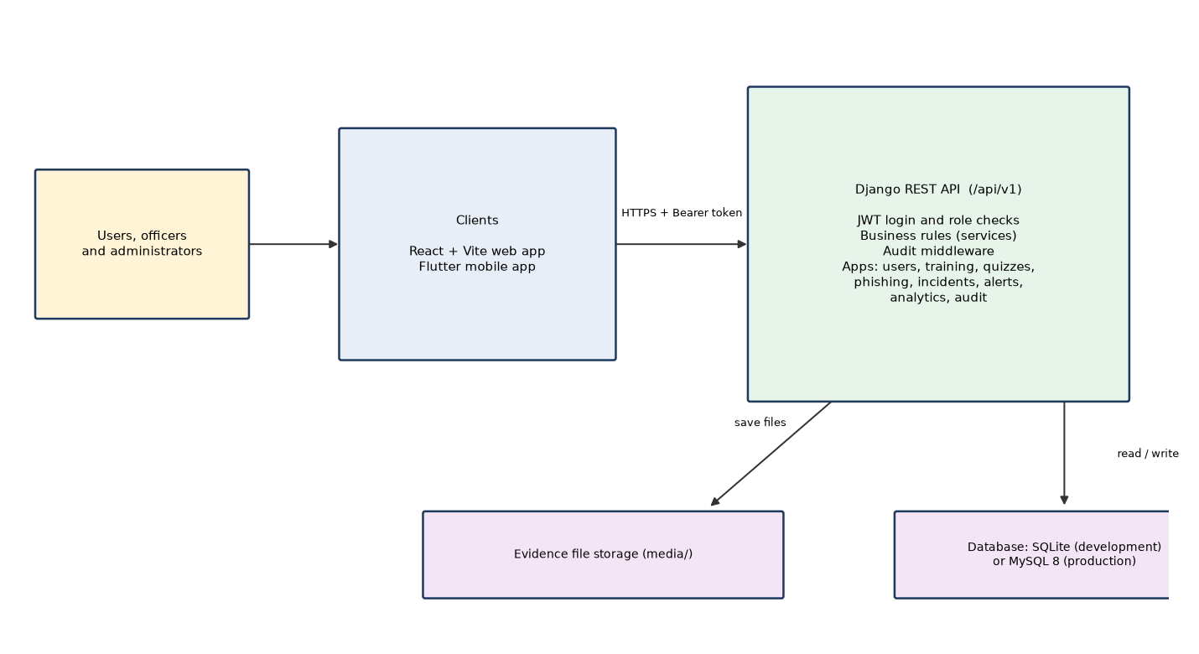
Figure 1.1: System architecture of CyberShield Hub
Benefits. Training is continuous instead of once a year. Knowledge and behaviour can be measured. Incident reports follow one format and include evidence. The response is traceable. Managers can see the risk. The cost is low because every part of the stack is free and open source.

1.5.1 Project deliverables
- Web application (React) and API server (Django).
- Mobile application (Flutter).
- Database design and sample data (seed_demo command).
- 348 automatic back-end tests.
- Project documentation: seven chapters, this combined document and the user manual.

Date: ………………… Supervisor sign: ………………… Student sign: …………………

