KWEKWE POLYTECHNIC
National Diploma in Information Technology (ND3 IT)
Project Documentation
CHAPTER 2
Feasibility Study
CyberShield Hub
A Cybersecurity Awareness and Incident Response Platform
Student name: [Insert student name]
Registration number: [Insert registration number]
Supervisor: [Insert supervisor name]
Academic session: ND3 IT, January 2023

2.1 Introduction
A feasibility study checks if a project is worth building before much effort is spent. This chapter uses five techniques: technical, economic, operational, schedule, and legal and ethical feasibility. It then compares three possible solutions and gives a recommendation.
The three options are:
- Option A: keep the manual process (posters, talks, e-mail and spreadsheets).
- Option B: buy a ready-made commercial product (separate products for training and phishing tests, and for incident tickets).
- Option C: build CyberShield Hub, a custom system made from open-source tools.

2.2 Technique 1: Technical Feasibility
Technical feasibility asks three questions. Does the technology exist? Is it proven? Can the available people use it?
Table 2.1: Technical feasibility
Need | Technology chosen | Assessment
Server language and framework | Python 3.12, Django 5, Django REST Framework | Proven, free and well documented. It has an ORM, migrations, an admin site and built-in security
Login | Simple JWT with refresh rotation and a blacklist | Standard method that works for web and mobile
Database | SQLite (development), MySQL 8 (real use) | SQLite needs no set-up; MySQL is common and scales well
Web front end | React 18, Vite, Tailwind CSS, Chart.js, Framer Motion | Components suit the many screens; Chart.js draws the dashboards
Mobile app | Flutter (Dart) with provider, http and secure storage | One code base; tokens can be stored safely
API documents | drf-spectacular (OpenAPI / Swagger) | Creates the documents automatically
Testing | pytest, pytest-django, GitHub Actions | Free automatic testing
Hardware | Any PC or small server with 4 GB RAM; users need a browser or an Android phone | Most organisations already have this

Skills. The developer knows Python, JavaScript and databases. All the tools have free guides. The main risk is the time needed to learn React and Flutter. To reduce this risk, the API was built first and both apps use it.
Conclusion: the project is technically feasible. A working version of every module has been built and checked with automatic tests.

2.3 Technique 2: Economic Feasibility
Economic feasibility compares costs and benefits. The amounts below are estimates in US dollars for an organisation with 50 users. They should be replaced with local prices.

2.3.1 Costs
Table 2.2: Estimated costs
Cost item | Option A (manual) | Option B (commercial) | Option C (CyberShield Hub)
Software licences | 0 | About 2,500 a year (50 users, two products) | 0 (open source)
Development | 0 | 0 | Student project time (no cash cost)
Hosting | 0 | Included | About 240 a year (or an existing server)
Set-up | 0 | About 800 | About 100 (domain name and certificate)
Staff training | About 300 a year | About 200 | About 200 (internal sessions)
Support | Staff time | Included in the subscription | About 15 hours of IT time each month
First-year cash cost | About 300 | About 3,500 | About 540

2.3.2 Benefits
- Measurable: about 4 hours saved each month on reports; fewer repeat incidents; one avoided phishing loss can cost more than the whole system.
- Hard to measure: a better security culture; faster response; proof for auditors and insurers; one set of data owned by the organisation.

2.3.3 Result
In the first year, Option C costs about 85% less than Option B. It also joins training, phishing practice and incident response, which Option B sells as separate products. Option A is cheapest on paper but gives none of the benefits. Option C should pay for itself in under one year if it prevents even one medium-size incident.
Conclusion: the project is economically feasible.

2.4 Technique 3: Operational Feasibility
Operational feasibility asks if people will use the system and if it fits the way the organisation works.
Table 2.3: Operational feasibility
Question | Finding
Will users accept it? | The screens use familiar patterns such as a dashboard, cards and forms. Lessons and quizzes are short. The mobile app lets staff learn on their phones.
Does it solve the problems? | Each problem in Chapter 1 has a matching module. Problems 4 to 7 are solved by the incident module. Problems 1 to 3 are solved by training, quizzes and the simulator.
Will management support it? | Dashboards and audit reports give managers the facts they need.
Who will run it? | A small IT team. Admin screens let people who are not programmers manage users, lessons, quizzes and alerts.
Will staff resist the change? | Short training, demonstrations and a pilot group reduce this risk (see the conversion plan in Chapter 6).
Is privacy respected? | Role-based access means users see only their own incidents and results.

Conclusion: the project is operationally feasible if users get short training and management supports it.

2.5 Technique 4: Schedule Feasibility
Schedule feasibility checks that the project can finish in the time allowed. The term is about 14 weeks.
Table 2.4: Project phases
Phase | Weeks | Result
Project identification and feasibility | 1 to 2 | Chapters 1 and 2
Requirement analysis | 2 to 3 | Requirement list and fact-finding records
Design | 3 to 4 | DFDs, UML, database and screen designs
Back end: login, training, quizzes | 4 to 7 | Working API for the learning modules
Back end: phishing, incidents, alerts, audit | 7 to 11 | Complete API with audit
Web front end | 6 to 12 | React app for all roles
Mobile app | 11 to 13 | Flutter app for learners and reporters
Testing and fixes | 10 to 13 | Automatic and manual test results
Documents, presentation and hand-over | 13 to 14 | Chapters 6 and 7, user manual, presentation

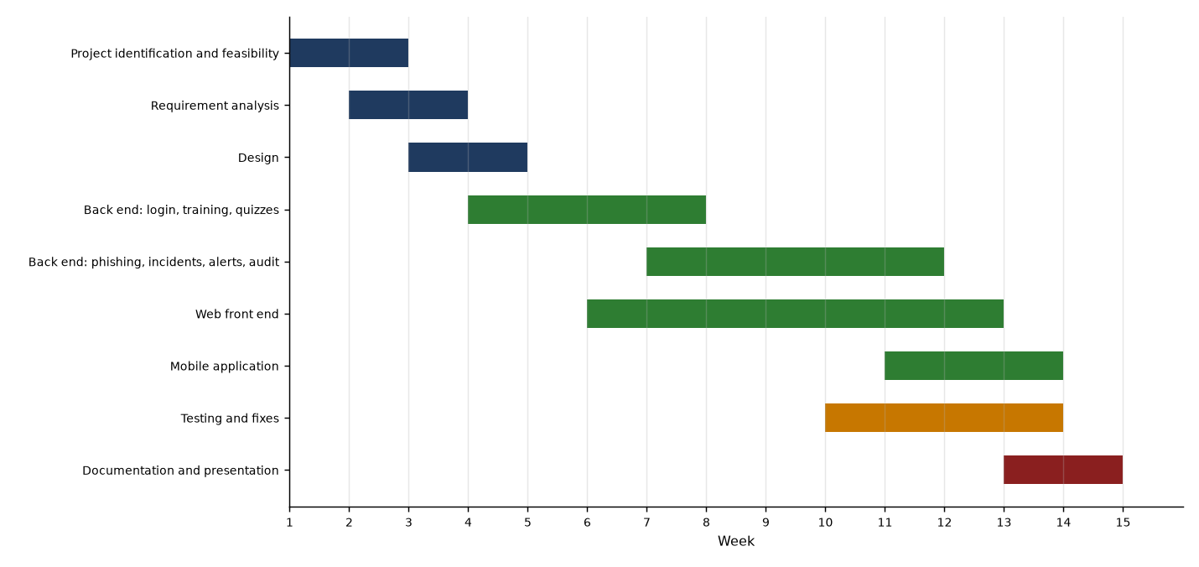
Figure 2.1: Project schedule (Gantt chart)
The API and the web app are built in parallel, and testing starts as soon as each module exists. The back end is the critical path. To manage risks such as illness or computer failure, work is saved to Git every day. One week of the testing phase is kept as spare time.
Conclusion: the project is feasible within the schedule. The finished system shows that the plan could be met.

2.6 Technique 5: Legal and Ethical Feasibility
Table 2.5: Legal and ethical feasibility
Area | Issue | How the project deals with it
Data protection and privacy | The system keeps names, e-mail addresses, scores and incident reports. Zimbabwe's Cyber and Data Protection Act asks for lawful, limited and secure use of personal data. | Collect only what is needed; role-based access; users see only their own data; passwords are hashed; accounts can be deactivated; changes are logged.
Software licences | All libraries must be legal to use. | Django, React, Flutter, Chart.js and the other tools are open source with permissive licences.
Ethics of phishing tests | Tricking staff with real fake e-mails can upset people or cause legal problems. | The simulations stay inside the app, are clearly exercises and teach instead of blame.
Evidence handling | Uploaded files may hold malware or private data. | Only png, jpg, jpeg, pdf, txt, log, eml and msg files up to 10 MB are accepted. Files are stored and never run. Access depends on role.
Copyright | Training content must not copy other people's work. | The lesson text is original and written for this platform.
Accountability | Administrator actions must be traceable. | Every data-changing request is logged with who, when and what.

Conclusion: the project is legally and ethically feasible if these controls are kept and the organisation publishes an acceptable-use and privacy notice.

2.7 Risk Analysis
Table 2.6: Project risks
Risk | Chance | Effect | Plan to reduce it
Learning React and Flutter takes too long | Medium | Delay | Build and test the API first; reuse the same API for both apps
Computer or disk failure | Low | Loss of work | Daily Git commits to GitHub
Scope grows during development | Medium | Delay | Keep to the scope in Chapter 1; list new ideas as future work
Staff do not use the system | Medium | Low benefit | Management support, short training, pilot group
Security weakness in the system | Low | Data loss | Role checks, input checks, throttling, audit log and tests

2.8 Comparison of the Options
Each criterion is scored from 1 (poor) to 5 (excellent) and multiplied by its weight.
Table 2.7: Comparison of options
Criterion | Weight | A: Manual | B: Commercial | C: CyberShield Hub
Technical fit with the needs | 20% | 1 | 4 | 5
Cost | 20% | 4 | 2 | 5
Fit with daily work and joined-up features | 20% | 1 | 3 | 5
Time to deliver | 10% | 5 | 4 | 3
Legal position and data ownership | 15% | 3 | 3 | 5
Measurable benefit | 15% | 1 | 4 | 5
Weighted total (out of 5) | 100% | 2.35 | 3.25 | 4.80

Working: A = 0.2×1 + 0.2×4 + 0.2×1 + 0.1×5 + 0.15×3 + 0.15×1 = 2.35. B = 0.8 + 0.4 + 0.6 + 0.4 + 0.45 + 0.6 = 3.25. C = 1.0 + 1.0 + 1.0 + 0.3 + 0.75 + 0.75 = 4.80.

2.9 Recommendation
All five techniques give a positive result, and Option C has the highest score. CyberShield Hub should be developed and put into use.

Date: ………………… Supervisor sign: ………………… Student sign: …………………

