KWEKWE POLYTECHNIC
National Diploma in Information Technology (ND3 IT)
Project Documentation
CyberShield Hub
An Enterprise Cybersecurity Awareness and Incident Response Platform
Student name: [Insert student name]
Registration number: [Insert registration number]
Supervisor: [Insert supervisor name]
Academic session: ND3 IT, January 2023 intake

Contents

Chapter 1: Project Identification

1.1 Executive Summary
Topic. CyberShield Hub is an enterprise cybersecurity awareness and incident response platform. It is a web application (with a companion mobile app) that brings security training, knowledge testing, phishing simulation, incident reporting and security-team case management into one secured system.
Why. Most security breaches in organisations begin with a human action: a staff member clicking a phishing link, reusing a weak password, or failing to report a suspicious event quickly. Organisations usually respond with disconnected tools: slide-based induction talks, email threads, paper forms and spreadsheets. Nothing links what an employee has learned to how they behave, and nobody can see the organisation's real risk level at a glance. Incidents are reported late, by word of mouth, with missing detail, and are rarely tracked to closure.
How. The project delivers a single platform with three user roles (normal user, cybersecurity officer, system administrator). Normal users learn through categorised lessons, test themselves with timed quizzes and practise spotting phishing emails in a simulated inbox. They report incidents with evidence files through a guided form. Officers receive these reports in a Kanban-style queue, assign and escalate them and keep a timeline until closure. Administrators manage users, roles, content and alerts, and audit every change. Dashboards turn the activity into measurable security scores. The system is built on Python/Django with a REST API, a React web front end and a Flutter mobile app, using SQLite for development and MySQL for production.
Expected outcome. A measurable improvement in security awareness, faster and better-documented incident reporting, and an auditable record of training and response activity.

1.2 Description of the Current System

1.2.1 Company background
The system is designed for medium-sized organisations (companies, schools, colleges, clinics and government offices) that depend on computers, email and shared networks but have no dedicated security-awareness product. Typically such an organisation has a small IT section of two to five people who also look after hardware, networks and user support. Security is only one of their many duties. The platform is therefore built to be run by a small team and to scale to a larger Security Operations Centre (SOC) function as the organisation grows.

1.2.2 Description of the current (manual) system
In the typical current arrangement:
- Awareness training is an occasional talk, a poster or a PDF e-mailed to staff. Attendance may be recorded on paper, but understanding is never measured.
- Testing is absent or done once on paper, marked by hand.
- Phishing awareness relies on warning e-mails from IT. Staff never practise recognising a phishing message in a safe setting.
- Incident reporting is a phone call, a WhatsApp message, an e-mail or a handwritten form to the IT office. There is no standard format, no reference number and no evidence handling.
- Incident tracking uses a spreadsheet or the memory of the IT officer. There is no assignment history, no status workflow and no escalation rule.
- Reporting to management is compiled by hand when requested. There is no live view of risk.
- Accountability is weak: nobody can show who changed or approved what.

1.2.3 Problems with the current system
No. | Problem | Effect on the organisation
1 | Training is one-off and passive | Staff forget material; behaviour does not change
2 | No measurement of knowledge or behaviour | Management cannot tell who is at risk
3 | No safe phishing practice | Staff first meet phishing in a real attack
4 | Incidents reported informally and late | Attackers have more time; evidence is lost
5 | No reference numbers, severity or priority | Serious incidents wait behind minor ones
6 | No assignment or status history | Duplicated effort, forgotten cases, no closure
7 | Evidence arrives in many formats and places | Hard to investigate and to prove what happened
8 | Reports compiled manually | Slow, error-prone, out of date when read
9 | No audit trail or access control | Data tampering and policy breaches go unnoticed
10 | No central place for security advisories | Staff miss warnings about active threats

1.3 Scope
The scope states what the project will and will not deliver, and why.

1.3.1 In scope
Item | Reason it is included
User registration, JWT login/logout, password reset, email verification, session revocation | Every other feature depends on knowing who the user is
Three-role access control (normal user, cybersecurity officer, system administrator) | Different people need different powers; least-privilege is a core security principle
Training library: categories, lessons, difficulty, tags, progress, bookmarks, recommendations | Delivers the awareness content, which is the main purpose
Quiz engine: timed multiple-choice, scoring, pass mark, attempt limits, weakness analysis | Measures whether learning happened
Phishing simulator: inbox scenarios, URL inspection, red-flag selection, scored feedback | Builds practical detection skill safely
Incident reporting with evidence upload, drafts, reference numbers and tracking | Fixes the informal reporting problem
SOC queue: Kanban board, assignment, escalation, status workflow and timeline | Fixes the tracking and accountability problem
Alerts and notification centre | Gets urgent advisories to the right audience
Analytics dashboards (personal and organisation-wide) | Gives measurable evidence for management
Audit log with filtering and CSV export | Provides accountability
Admin content management (lessons, quizzes, simulations, categories, quiz settings, users) | Lets the organisation keep content current without a developer
Web application (React) and mobile application (Flutter) for learners and incident reporters | Staff use both desktops and phones

1.3.2 Out of scope
Item | Reason it is excluded
Real-time network monitoring, intrusion detection, SIEM log ingestion | Needs specialised infrastructure; this project addresses people and process, not network sensors
Sending real phishing e-mails to staff | Raises legal and ethical issues; the simulator is an in-app inbox
Automatic malware analysis or forensics of uploaded files | Beyond the time and skill scope; evidence is stored, not executed
Integration with payroll, HR or active-directory single sign-on | Not needed for a first release; accounts are managed inside the platform
Payment processing or commercial licensing | The system is for internal organisational use
Native desktop applications and an iOS store release | Web and Android cover the target users within the time available

1.4 Objectives (SMART)
Each objective is Specific, Measurable, Achievable, Relevant and Time-bound, relative to the project timetable (one academic term for development and testing).
No. | Objective | Measure of success | Time
O1 | Provide secure login for three roles with JWT tokens and role-based access control | 100% of protected endpoints reject anonymous or wrong-role requests (verified by automated RBAC tests) | Week 4
O2 | Deliver a training library with progress tracking and bookmarks | At least 5 categories and 20 lessons seeded; progress saved per user | Week 6
O3 | Implement a quiz engine that grades automatically | Quiz graded and result returned in under 2 seconds; pass/fail and per-topic weakness shown | Week 7
O4 | Provide a phishing simulator with scored feedback | Scenarios scored 0–100 for classification and red flags identified | Week 8
O5 | Let users report incidents with evidence | Each report receives a unique reference number; only allowed file types up to 10 MB accepted | Week 9
O6 | Give officers an incident queue with assignment and status workflow | Every status change and assignment written to a timeline | Week 10
O7 | Provide analytics and alerts | Personal and organisation dashboards; alert delivered to all active users of the target audience | Week 11
O8 | Record every data-changing request in an audit log | Audit entry exists for 100% of authenticated POST/PUT/PATCH/DELETE calls; CSV export available | Week 11
O9 | Verify quality through automated testing | At least 300 automated tests passing with no failures | Week 12
O10 | Deliver mobile app and user documentation | Flutter app covers login, learning, quizzes, phishing and incidents; user manual completed | Week 13

1.5 Description of the Proposed System
CyberShield Hub replaces the manual and disconnected practices with one integrated, role-based platform. The major processes are:
Process | Description | Main users
1. Authentication and user management | Register, log in with JWT (20-minute access token, 7-day rotating refresh token), reset password, verify e-mail, track failed logins, deactivate accounts, revoke sessions, manage roles. | All; admins manage
2. Security training | Browse categorised lessons, read rich content, track progress, bookmark, receive role-aware recommendations. Admins create and edit lessons and categories. | Normal users; admins author
3. Quizzes | Start a timed quiz, answer questions, submit; the system grades, records the attempt, enforces attempt limits, shows correct answers with explanations and recommends lessons for weak topics. | Normal users; admins author
4. Phishing simulation | Open a simulated e-mail, inspect the sender and URL, classify safe or suspicious, tick red flags, and receive a score and a training tip. | Normal users; admins author
5. Incident response | Report an incident with evidence (or save a draft); system generates a reference (INC-date-code) and priority; officers triage on a Kanban queue, assign, escalate, and move the incident through Open, Investigating, Escalated, Resolved and Closed with a timeline. | Reporters; officers
6. Alerts and notifications | Admins/officers publish alerts to an audience; each eligible user receives a notification and can mark it read. | All
7. Analytics | Personal dashboard (security score, progress, quiz and phishing performance) and organisation-wide reporting (training, quiz, phishing, incident and risk data). | All; officers see organisation
8. Audit | Middleware records every data-changing API request; officers and admins search, filter and export the log. | Officers, admins

Architecture summary. Clients (React web, Flutter mobile) call a versioned REST API (/api/v1) over HTTPS with a Bearer JWT. The Django back end performs authentication, role checks, validation and business logic, then reads or writes the database. A middleware writes the audit trail. Evidence files are stored on the file system with allow-listed types.
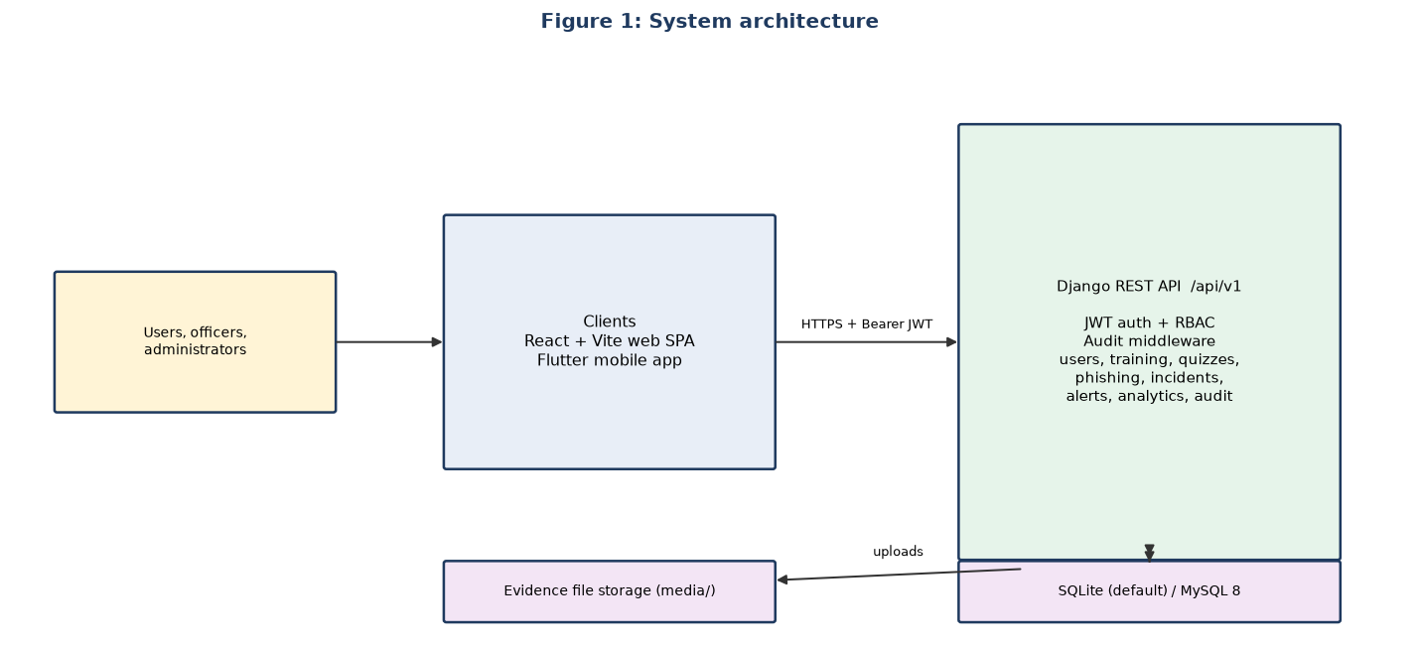
Figure 1: Proposed system architecture
Benefits. Continuous rather than one-off training; measurable knowledge and behaviour; standardised, evidence-backed incident reports; accountable response workflow; management visibility; low cost because all components are open source.

Date: ………………………. Sign: Supervisor ………………………. Student ……………………….

Chapter 2: Feasibility Study

2.1 Introduction
A feasibility study decides whether a proposed project is worth building before large effort is spent. This chapter applies five standard techniques: technical, economic, operational, schedule and legal/ethical feasibility. It then compares three alternative solutions and recommends one.
Three alternatives were considered:
- Option A: Continue the manual process (posters, talks, e-mail, spreadsheets).
- Option B: Buy an off-the-shelf commercial awareness and ticketing suite (separate subscriptions for training/phishing simulation and for incident ticketing).
- Option C: Build CyberShield Hub, a custom integrated platform using open-source technology.

2.2 Technique 1: Technical Feasibility
Technical feasibility asks whether the required technology exists, is mature and can be operated with the skills available.
Requirement | Technology chosen | Assessment
Server-side language and framework | Python 3.12, Django 5, Django REST Framework | Mature, well documented, free; includes ORM, migrations, admin and security protections
Authentication | Simple JWT with refresh rotation and blacklist | Standard, stateless, works for web and mobile
Database | SQLite (development), MySQL 8 (production) | Zero set-up for development; MySQL is widely supported and scalable
Web front end | React 18, Vite, Tailwind CSS, Chart.js, Framer Motion | Component model suits the many screens; Chart.js gives dashboards
Mobile client | Flutter (Dart) with provider, http, secure storage | One code base for Android/iOS; secure token storage available
API documentation | drf-spectacular (OpenAPI/Swagger) | Generates documentation automatically
Testing and CI | pytest, pytest-django, GitHub Actions workflow | Automated regression testing is available at no cost
Hardware | Any PC or small server with 4 GB RAM; clients need only a browser or Android phone | Already available in most organisations

Skills. The developer has working knowledge of Python, JavaScript and databases. All frameworks have extensive free documentation. Risk: learning curve for React and Flutter. This was reduced by building the API first and reusing its service layer for both clients.
Conclusion: technically feasible. A working prototype of every module has been built and verified by automated tests.

2.3 Technique 2: Economic Feasibility
Economic feasibility compares costs with benefits. Figures are planning estimates in US dollars for a 50-user organisation and should be replaced with local quotations.

2.3.1 Costs
Cost item | Option A (manual) | Option B (commercial) | Option C (CyberShield Hub)
Software licences | 0 | ≈ 2,500 per year (50 users, two products) | 0 (open-source stack)
Development | 0 | 0 | Student project time (no cash cost)
Hosting server / VPS | 0 | Included | ≈ 240 per year (or existing server)
Set-up and integration | 0 | ≈ 800 | ≈ 100 (domain, TLS certificate)
Training of staff | ≈ 300 per year (facilitator, printing) | ≈ 200 | ≈ 200 (internal sessions)
Maintenance and support | Staff time | Included in subscription | ≈ 15 hours per month of IT time
Estimated first-year cash cost | ≈ 300 | ≈ 3,500 | ≈ 540

2.3.2 Benefits
- Tangible: time saved compiling reports (estimated 4 hours per month); fewer repeat incidents; reduced cost of a single phishing-related loss, which for a small organisation can exceed the entire system cost.
- Intangible: improved security culture; faster incident response; evidence for audits and insurers; one data set owned by the organisation.

2.3.3 Cost-benefit result
Option C has a first-year cost roughly 85% lower than Option B while providing the integration between training, phishing practice and incident response that Option B sells as separate products. Option A is cheapest on paper but delivers none of the measurable benefits. The pay-back period for Option C is expected to be under one year if it prevents even one moderate incident.
Conclusion: economically feasible.

2.4 Technique 3: Operational Feasibility
Operational feasibility asks whether people will use the system and whether it fits the way the organisation works.
Question | Finding
Will users accept it? | The interface follows familiar patterns (dashboard, cards, forms). Short lessons and quizzes can be done in minutes; the mobile app lets staff learn on their phones.
Does it solve the problems found? | Each problem in Chapter 1 (Section 1.2.3) maps to a module: for example problems 4–7 are solved by the incident module and problems 1–3 by training, quizzes and the simulator.
Is management support likely? | Dashboards and audit exports give managers the evidence they need, which encourages sponsorship.
Who will operate it? | A small IT team. Admin screens let non-programmers manage users, lessons, quizzes and alerts.
Will staff resist change? | Resistance is reduced by short training, demonstrations and a pilot group (see Chapter 6 conversion plan).
Security and privacy acceptance? | Role-based access ensures users only see their own incidents and results.

Conclusion: operationally feasible, provided users receive brief training and management endorses use.

2.5 Technique 4: Schedule Feasibility
Schedule feasibility checks that the project can be completed within the time allowed (one term of about 14 weeks).
Phase | Weeks | Deliverable
Project identification and feasibility | 1–2 | Chapters 1 and 2
Requirement analysis | 2–3 | Requirement specification, fact-finding records
Design | 3–4 | DFDs, UML, database and interface designs
Back end development (authentication, training, quizzes) | 4–7 | Working API for core learning modules
Back end development (phishing, incidents, alerts, analytics, audit) | 7–11 | Complete API with audit
Web front end | 6–12 | React application for all roles
Mobile application | 11–13 | Flutter app for learners and reporters
Testing and fixes | 10–13 | Automated and manual test results
Documentation, presentation and hand-over | 13–14 | Chapters 6 and 7, user manual, presentation

Because the API and web client are developed in parallel and testing begins as soon as each module exists, the critical path is the back end. Risks (illness, hardware failure) are managed by committing work to Git daily. A buffer of one week is kept inside the testing phase.
Conclusion: schedule feasible. The implemented system already demonstrates that the timetable was achievable.

2.6 Technique 5: Legal and Ethical Feasibility
Area | Consideration | How the project addresses it
Data protection and privacy | The system stores names, e-mail addresses, scores and incident reports (personal data). Zimbabwe's Cyber and Data Protection Act requires lawful, limited and secure processing. | Collect only what is needed; role-based access; users see only their own data; password hashing; deactivation of accounts; audit log of access to changes.
Software licensing | All libraries must be legally usable. | Django, React, Flutter, Chart.js and others are open source with permissive licences.
Phishing simulation ethics | Deceiving staff with real fake e-mails can cause distress or legal exposure. | Simulations are in-app, clearly an exercise, and provide educational feedback rather than blame.
Evidence handling | Uploaded files could contain malware or sensitive information. | Only allow-listed types (png, jpg, jpeg, pdf, txt, log, eml, msg) up to 10 MB; files are stored, never executed; access limited by role.
Intellectual property | Training content must not infringe copyright. | Lesson content is original and written for the platform.
Accountability | Administrative actions must be traceable. | Every mutating request is logged with actor, time and path.

Conclusion: legally and ethically feasible when the controls above are kept and the organisation publishes an acceptable-use and privacy notice.

2.7 Comparison of Alternatives
Each criterion is scored from 1 (poor) to 5 (excellent) and multiplied by a weight.
Criterion | Weight | A: Manual | B: Commercial | C: CyberShield Hub
Technical fit with needs | 20% | 1 | 4 | 5
Cost | 20% | 4 | 2 | 5
Operational fit / integration | 20% | 1 | 3 | 5
Time to deliver | 10% | 5 | 4 | 3
Legal / data ownership | 15% | 3 | 3 | 5
Measurable benefit | 15% | 1 | 4 | 5
Weighted total (out of 5) | 100% | 2.35 | 3.25 | 4.80

Workings: A = 0.2×1 + 0.2×4 + 0.2×1 + 0.1×5 + 0.15×3 + 0.15×1 = 2.35; B = 0.8 + 0.4 + 0.6 + 0.4 + 0.45 + 0.6 = 3.25; C = 1.0 + 1.0 + 1.0 + 0.3 + 0.75 + 0.75 = 4.80.

2.8 Recommendation
All five feasibility techniques give a positive result and Option C scores highest. It is recommended that CyberShield Hub be developed and implemented.

Date: ………………………. Sign: Supervisor ………………………. Student ……………………….

Chapter 3: Requirement Analysis

3.1 Introduction
Requirement analysis establishes exactly what the system must do and the constraints it must respect. This chapter describes the fact-finding tools used to gather information about the existing process and the analysis tools used to turn that information into clear, testable requirements.

3.2 Fact-Finding and Recording Tools
Five fact-finding techniques were selected so that each weakness of one technique is covered by another.
Technique | Who / what | Why it was used | How it was recorded
Interviews | IT officer, a department head, a sample of ordinary staff | Obtain detailed, open answers about how incidents and training are handled today | Interview guide with written notes; summary sheet per interview
Questionnaires | Staff across departments | Reach many people cheaply and collect comparable answers | Printed/online form; responses tabulated
Observation | Watching how an incident is reported to the IT office | See actual practice rather than described practice | Observation checklist with time stamps
Document review | Existing security policy, induction slides, incident e-mails, spreadsheet logs | Identify the data items and rules already in use | Document inventory; extracted field list
Review of similar systems | Open-source and commercial awareness and ticketing tools | Learn good practice and avoid known pitfalls | Comparison table of features

3.2.1 Interview guide
Questions asked of the IT officer and department heads:
- How are new staff introduced to information-security rules, and how often is the topic revisited?
- How do you know whether a staff member has understood the training?
- What happens when a staff member receives a suspicious e-mail? Whom do they tell and how?
- What details do you need to start investigating an incident, and how often are they missing?
- How do you record who is working on an incident and what progress has been made?
- What reports does management ask for, and how long do they take to prepare?
- Who should be allowed to see incident reports and staff test results?
- What would make you trust and use a new system?

3.2.2 Questionnaire (extract)
No. | Question | Response options
1 | How often have you received information-security training? | Never / once / yearly / more often
2 | Could you recognise a phishing e-mail? | Yes / not sure / no
3 | Have you ever clicked a link you later suspected was malicious? | Yes / no / not sure
4 | Did you report it? How? | Phone / e-mail / in person / did not report
5 | Would you use a phone or computer application to learn and report incidents? | Yes / no / maybe
6 | Which device do you use most at work? | Desktop / laptop / smartphone
7 | What would stop you from reporting an incident? | Free text

3.2.3 Observation checklist
- Channel used to report (phone, e-mail, walk-in, messaging app).
- Time between discovering and reporting the event.
- Information supplied on first contact (what, when, which system, evidence).
- Where the report is written down.
- Follow-up made to the reporter.

3.2.4 Findings summary
The findings below are the problems documented in Chapter 1 (Section 1.2.3). Replace or extend this table with the figures from your own questionnaires and interviews before submission.
Finding | Source
Training is occasional and unmeasured | Interviews, document review
Incident reports are informal, incomplete and unnumbered | Observation, interviews
Incident status is held in a spreadsheet or in memory | Document review
Management reports are produced by hand | Interviews
Staff use smartphones heavily and would prefer a mobile option | Questionnaire
Staff want to know that their reports are confidential | Interviews

3.3 Analysis Tools

3.3.1 PIECES framework
PIECES classifies weaknesses of the current system into Performance, Information, Economics, Control, Efficiency and Service.
Category | Current weakness | Proposed improvement
Performance | Reports take days to reach the right person | Immediate submission with automatic reference and priority
Information | Incomplete, inconsistent, no evidence | Structured form with mandatory fields and evidence upload
Economics | Staff time wasted compiling reports; incident losses | Dashboards generated automatically; faster response
Control | No access control, no audit trail | RBAC, JWT, audit log, attempt limits, login tracking
Efficiency | Duplicated effort, forgotten cases | Assignment history, Kanban queue, status workflow
Service | Reporters get no feedback; training is generic | Timeline visible to reporter; recommendations from quiz results

3.3.2 Actors and use cases
Three actors interact with the system. Their use cases are shown in the use case diagram in Chapter 4 (Figure 6) and listed here.
Actor | Main use cases
Normal user | Register, log in, reset password, view dashboard, study lessons, bookmark, take quizzes, run phishing simulations, report incident, track own incidents, read alerts, update profile and password
Cybersecurity officer | All normal-user cases plus: view SOC queue and heat map, assign and escalate incidents, change status, add timeline updates, view organisation analytics, publish alerts, view and export audit log
System administrator | All officer cases plus: manage users (activate/deactivate, change role), manage roles, create/edit lessons, categories, quizzes (including settings), phishing simulations

3.3.3 Functional requirements
ID | Requirement | Priority
FR1 | The system shall let a visitor register an account with e-mail, name and a password that passes strength rules; new accounts receive the normal-user role. | High
FR2 | The system shall authenticate users with e-mail and password and issue an access token and a rotating refresh token. | High
FR3 | The system shall record failed login attempts and refuse login for deactivated accounts. | High
FR4 | The system shall allow password reset by token and e-mail verification by token. | Medium
FR5 | The system shall allow users to log out, which revokes the session and blacklists the refresh token. | High
FR6 | The system shall restrict every function according to the three roles. | High
FR7 | The system shall display published lessons by category with search, difficulty and tag filters. | High
FR8 | The system shall record lesson progress, completion and bookmarks per user and recommend lessons by role. | Medium
FR9 | The system shall let administrators create, edit, publish and delete lessons and categories. | High
FR10 | The system shall run timed quizzes, enforce attempt limits, grade automatically and store each attempt. | High
FR11 | The system shall show correct answers, explanations, pass/fail, weak competencies and lesson recommendations after grading. | High
FR12 | The system shall let administrators author quizzes and configure pass score, time limit, attempts and question randomisation. | High
FR13 | The system shall present phishing scenarios, let the user inspect URLs and select red flags, classify, and return a score and feedback. | High
FR14 | The system shall let administrators author phishing simulations. | Medium
FR15 | The system shall let users submit an incident (or save a draft) with category, severity, description, affected system, time and evidence files. | High
FR16 | The system shall generate a unique reference number and a priority score for each incident. | High
FR17 | The system shall reject evidence files whose type is not allowed or whose size exceeds 10 MB. | High
FR18 | The system shall let officers view the queue grouped by status, assign incidents, change status and add timeline updates. | High
FR19 | The system shall let reporters see only their own incidents and their timelines. | High
FR20 | The system shall let officers and administrators publish alerts to an audience; each eligible user shall receive a notification and be able to mark it read. | Medium
FR21 | The system shall show a personal dashboard and, for officers/administrators, organisation analytics and charts. | Medium
FR22 | The system shall log every data-changing request and let authorised users search and export the log as CSV. | High
FR23 | The system shall provide a mobile application with login, dashboard, learning, quizzes, phishing practice, incident reporting and alerts. | Medium

3.3.4 Non-functional requirements
ID | Category | Requirement
NFR1 | Security | Passwords stored hashed; all API calls (except registration, login, reset) require a valid token; tokens expire (access 20 min, refresh 7 days); request throttling (anonymous 60/min, users 600/min, authentication 10/min).
NFR2 | Performance | Typical API responses under 2 seconds on a 4 GB server for 50 concurrent users; list endpoints paginated (20 per page).
NFR3 | Usability | Consistent navigation grouped as Learn / Respond / Administer; clear error messages; responsive layout for phone and desktop.
NFR4 | Reliability | Input validated on the server; failures return a standard JSON error; no unhandled crashes for invalid input.
NFR5 | Maintainability | Modular Django apps per domain; automated tests; API documented with OpenAPI.
NFR6 | Portability | Runs on Windows, Linux and macOS; database selectable by configuration (SQLite or MySQL).
NFR7 | Auditability | Audit records are immutable through the application.
NFR8 | Compatibility | Current versions of Chrome, Edge, Firefox; Android phones for the mobile app.

3.3.5 Data dictionary (principal items)
Data element | Type / size | Rule
email | Text, max 254 | Unique, valid format; used to log in
role.code | Text, max 40 | One of normal_user, cybersecurity_officer, system_admin
security_score | Integer ≥ 0 | Starts at 72; updated from activity
lesson.difficulty | Text | Beginner, intermediate or advanced
quiz.pass_score | Integer 0–100 | Default 80
quiz.max_attempts | Integer ≥ 0 | 0 means unlimited
incident.reference_number | Text, max 32 | Format INC-YYYYMMDD-XXXXXX; unique, generated once
incident.severity | Text | low, medium, high or critical
incident.status | Text | open, investigating, escalated, resolved or closed
incident.priority_score | Integer 0–100 | Severity weight (25/50/75/95) plus status weight (+5/+10/+15/−20/−30), limited to 0–100
attachment.file | File ≤ 10 MB | png, jpg, jpeg, pdf, txt, log, eml, msg only
phishing.score | Integer 0–100 | Classification points plus red-flag points, capped at 100

3.3.6 Decision table: incident status change
A decision table captures the rules that decide whether a status change request is accepted.
Condition / action | R1 | R2 | R3 | R4
User is authenticated | Y | Y | Y | N
User role is officer or administrator | Y | Y | N | –
Incident exists and is not a draft | Y | N | Y | –
Requested status is valid | Y | – | – | –
Action: apply change, add timeline entry, write audit log | X
Action: reject (404 / validation error) |  | X
Action: reject (403 forbidden) |  |  | X
Action: reject (401 unauthorised) |  |  |  | X

3.3.7 Requirement traceability
Objective (Ch. 1) | Functional requirements | Verified by
O1 secure login, RBAC | FR1–FR6 | test_auth, test_rbac, test_permissions
O2 training library | FR7–FR9 | test_training, test_content, authoring tests
O3 quiz engine | FR10–FR12 | quiz test modules
O4 phishing simulator | FR13–FR14 | test_phishing, test_simulation_authoring
O5 incident reporting | FR15–FR17, FR19 | test_incidents, test_models
O6 incident queue and workflow | FR18 | test_incidents, test_internal_updates
O7 analytics and alerts | FR20–FR21 | test_analytics, test_alerts
O8 audit | FR22 | test_audit
O10 mobile app | FR23 | mobile/test (Flutter tests)

3.3.8 Constraints and assumptions
- The project must be completed within one academic term by one developer.
- The system must use free or open-source tools.
- Users have either a modern browser or an Android phone and a network connection to the server.
- E-mail delivery of reset and verification links depends on an SMTP service being configured. In development the tokens are returned for testing.

Date: ………………………. Sign: Supervisor ………………………. Student ……………………….

Chapter 4: Design

4.1 Introduction
The design converts the requirements of Chapter 3 into a blueprint for construction. It covers input, output and process design, database and file design, user-interface design, system controls, data flow diagrams to level 2 and UML diagrams.

4.2 Input, Output and Process Design

4.2.1 Input design
Inputs are captured through validated forms in the web and mobile clients and re-validated on the server. Principles: capture each item once, use controlled lists (drop-downs) wherever possible, give immediate field-level messages, and never trust the client.
Input | Fields | Validation
Registration | first name, last name, e-mail, password, confirm password, organisation, department | E-mail unique and valid; password strength checker and Django password validators; passwords must match
Login | e-mail, password | Required; account must be active; failed attempts recorded; throttled to 10 per minute
Incident report | title, category, severity, description, affected system, date/time occurred, evidence files, draft flag | Title and description required; category from list; severity from list; file extension and size check
Quiz answers | attempt id, list of question id + answer id | Question and answer must belong to the quiz; attempt limit enforced
Phishing classification | simulation id, classification (safe / suspicious), inspected URLs, selected red flags | Classification from fixed list; flags from scenario list
Alert | title, body, priority, type, audience role, start, expiry | Title and body required; expiry after start
Lesson / quiz / simulation authoring | title, slug, content, category, difficulty, tags, questions and answers, red flags | Slug unique; at least one correct answer per question; required fields
Status change / assignment | incident id, new status or officer id, note | Officer role required; assignee must be an officer

4.2.2 Output design
Output | Content | Recipient | Medium
Personal dashboard | Security score, lesson progress, quiz and phishing results, open incidents, alerts | Every user | Screen, charts
Quiz result | Score, pass/fail, correct answers, explanations, weak topics, recommended lessons | Learner | Screen
Phishing feedback | Score, expected classification, red flags found and missed, training tip | Learner | Screen
Incident confirmation and timeline | Reference number, status history, assignee | Reporter | Screen
SOC queue and heat map | Incidents grouped by status; severity × status counts | Officer, admin | Kanban board, heat map
Organisation analytics | Training, quiz, phishing, incident and risk indicators | Officer, admin | Charts (bar, line, doughnut, radar)
Notification centre | Unread and read alerts | Users | Screen, badge count
Audit report | Who did what, when, from which IP | Officer, admin | Screen and CSV file
API documentation | All endpoints and schemas | Developers | Swagger page

4.2.3 Process design
Business rules live in the service layer so they are shared by both clients and are testable.

Quiz grading (grade_quiz_attempt)
FOR each question in the quiz
total_points += question.points
selected = answer chosen by user for this question (if any)
correct = selected exists AND selected.is_correct
earned_points += question.points IF correct
store QuizAttemptAnswer(selected, correct, points)
update weakness[competency] (correct / total)
score = earned_points / total_points * 100
passed = score >= quiz.pass_score
recommendations = explanations of wrongly answered questions

Incident priority
severity_weight = {low: 25, medium: 50, high: 75, critical: 95}
status_weight = {open: +5, investigating: +10, escalated: +15, resolved: -20, closed: -30}
priority_score = clamp(severity_weight + status_weight, 0, 100)
reference = 'INC-' + yyyymmdd + '-' + 6 random hex characters (generated once)

Phishing scoring
The score is the sum of classification points (correct safe/suspicious decision) and red-flag points (proportion of the scenario's red flags the user selected), capped at 100. A safe e-mail correctly classified earns full credit without needing flags.

Incident life cycle
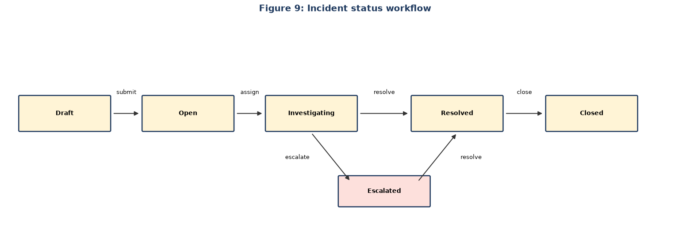
Figure 9: Incident status workflow

4.3 Database Design and File Design

4.3.1 Database approach
A relational database is used because the data is highly structured with clear ownership relationships. SQLite is the default for development and MySQL 8 (InnoDB, utf8mb4) for production. The schema is created by Django migrations; docs/database_schema.sql documents the production tables. Design rules applied: every table has a surrogate primary key and created/updated timestamps; relationships use foreign keys; frequently searched columns are indexed; JSON columns hold small variable lists (tags, red flags); tables are normalised to third normal form (answers are separate from questions, attempts from attempt answers).
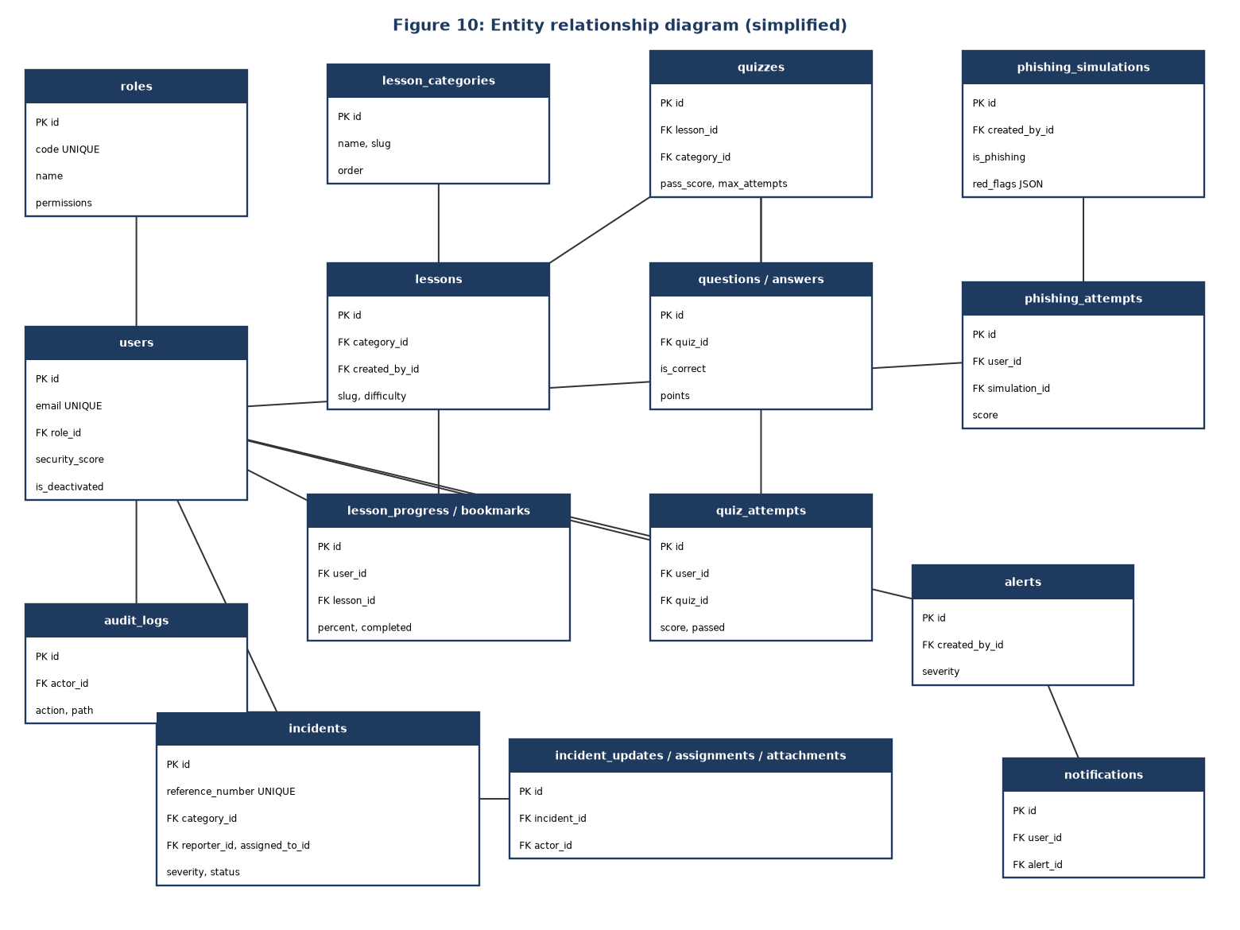
Figure 10: Entity relationship diagram (simplified)

4.3.2 Table list
Table | Purpose | Key relationships
roles | Role definitions and permissions | 1 role : many users
users | Accounts, profile, security data | FK role
lesson_categories | Training categories | 1 : many lessons
lessons | Training content | FK category, created_by
lesson_progress, lesson_bookmarks | Per-user progress and bookmarks | FK user, lesson
quizzes, questions, answers | Assessment content | quiz 1 : many questions 1 : many answers
quiz_attempts, quiz_attempt_answers | Results and given answers | FK user, quiz, question, answer
phishing_simulations, phishing_attempts | Scenarios and results | FK user, simulation
incident_categories, incidents | Incident types and cases | incident FK category, reporter, assigned_to
incident_attachments, incident_updates, incident_assignments | Evidence, timeline, assignment history | FK incident, user
alerts, notifications | Advisories and per-user delivery | notification FK user, alert (unique pair)
audit_logs | Request audit trail | FK actor

4.3.3 Data structures for key tables

users
Column | Type | Constraint
id | BIGINT | Primary key, auto increment
email | VARCHAR(254) | Unique, not null
username, first_name, last_name | VARCHAR(150) | Not null (username unique)
password | VARCHAR(128) | Hashed
role_id | BIGINT | FK → roles.id
organization, department, phone | VARCHAR | Optional
is_active, is_deactivated, is_email_verified | BOOLEAN | Account state
failed_login_attempts, last_failed_login, last_login_ip | INT, DATETIME, CHAR(39) | Login tracking
security_score | INT | Default 72

incidents
Column | Type | Constraint
id | BIGINT | Primary key
reference_number | VARCHAR(32) | Unique, generated
title | VARCHAR(220) | Not null
category_id | BIGINT | FK → incident_categories.id (protect)
severity | VARCHAR(24) | low/medium/high/critical, indexed
description | LONGTEXT | Not null
affected_system | VARCHAR(180) | Optional
occurred_at | DATETIME | Not null
reporter_id | BIGINT | FK → users.id
assigned_to_id | BIGINT | FK → users.id, null allowed
status | VARCHAR(24) | open … closed, indexed
priority_score | INT | 0–100
is_draft, submitted_at, resolved_at, closed_at | BOOLEAN / DATETIME | Life-cycle fields

quizzes and quiz_attempts
Table.column | Type | Notes
quizzes.title, slug | VARCHAR(220/240) | slug unique
quizzes.time_limit_minutes | INT | Default 10
quizzes.pass_score | INT | Default 80
quizzes.max_attempts | INT | 0 = unlimited
quizzes.randomize_questions, is_active | BOOLEAN | Behaviour switches
quiz_attempts.user_id, quiz_id | BIGINT | FKs; indexed together with created_at
quiz_attempts.score, total_points, earned_points | DECIMAL(5,2), INT, INT | Result
quiz_attempts.passed, started_at, completed_at, duration_seconds | BOOLEAN, DATETIME, INT | Result and timing
quiz_attempts.weakness_map, recommendations | JSON | Per-competency analysis

4.3.4 File design
File / store | Content | Rules
media/incident-evidence/<reference>/… | Evidence attached to incidents (png, jpg, jpeg, pdf, txt, log, eml, msg) | Maximum 10 MB; extension allow-list; path generated by the system; files never executed; deleted with parent incident record
media/avatars/… | Optional profile pictures | Image types only
staticfiles/ | Compiled static assets served by WhiteNoise | Rebuilt on deployment
.env | Configuration: secret key, debug flag, database engine, allowed hosts, CORS origins, token lifetimes | Not committed to version control; .env.example supplied
docs/database_schema.sql, docs/api_endpoints.md | Reference documentation | Maintained with the code
Secure storage on phone | Mobile access/refresh tokens | Held in the platform's encrypted store (flutter_secure_storage)

4.4 User Interface Design

4.4.1 Design principles
- Consistency: the same layout, buttons, badges and messages across all modules.
- Role-aware navigation: menus show only what the signed-in role may use.
- Feedback: loading skeletons, toast messages, empty states and clear error panels.
- Safety: confirmation dialogs for destructive actions; warning on leaving forms with unsaved changes.
- Accessibility and responsiveness: readable contrast, keyboard-usable controls, layouts that adapt from desktop to phone.
- Visual identity: a cybersecurity theme with shield imagery, cards, glass-style panels and subtle 3D accents (web and mobile).

4.4.2 Navigation structure
Group | Pages (web route) | Visible to
Public | Login /login, Register /register, Forgot/Reset password, Verify e-mail | Anyone
Home | Dashboard / | All
Learn | Training /training, Lesson /training/:slug, Quizzes /quizzes, Take quiz, Results, Phishing lab /phishing | All
Respond | My incidents /incidents, Report /incidents/new, Incident detail, Alerts /alerts | All
Respond (staff) | SOC queue /soc, Analytics /analytics | Officer, admin
Administer | Users /admin/users, Content library (lessons, quizzes, simulations, categories), Quiz settings, Audit log /admin/audit | Admin (audit also officer)
Account | Profile and password /account | All

4.4.3 Screen layouts
All authenticated screens share an application shell: a left sidebar with the grouped navigation, a top bar with the notification bell and user menu, and a content area with a page header.
Screen | Layout description
Login / Register | Centred card over an animated shield background; fields with inline validation; password strength meter on registration; links to reset password.
Dashboard | Row of metric cards (security score, lessons completed, quiz average, phishing accuracy); progress bars; trend and radar charts; recent incidents and alerts.
Training | Search box and filters (category, difficulty); grid of lesson cards with progress and bookmark icon; lesson page with formatted content, completion button and related quiz.
Quiz | List with attempts used/remaining; quiz page with timer, one question block at a time, progress indicator; result page with score ring, answer review and recommendations.
Phishing lab | Simulated mail client: message list, message view with sender details; inspect-URL action; red-flag checklist; Safe / Suspicious buttons; feedback panel.
Report incident | Single form: title, affected system, category, severity, date and time (cannot be in the future), description, evidence upload list with removable files; Save draft and Submit buttons.
Incident detail | Summary header with reference, severity and status badges; description; evidence list; timeline; officer management panel (assign, change status, add note).
SOC queue | Kanban board with columns Open, Investigating, Escalated, Resolved, Closed; cards sorted by priority; severity/status heat map.
Analytics | Bar, line, doughnut and radar charts for training, quizzes, phishing, incidents and risk.
Admin content | Tabs for lessons, quizzes, simulations and categories; editor pages with unsaved-change protection; list tables with edit and delete.
Audit log | Filterable table (actor, action, date), search box and Export CSV button.

The mobile application follows the same structure with a bottom navigation bar (Home, Learn, Incidents, Alerts, Account) and full-screen flows for quizzes and phishing practice.

4.4.4 Colour and typography
A dark navy background with cyan and mint accents and amber and red warning colours. Severity and status are always shown as coloured badges with text labels. Because every badge carries text, colour is never the only signal.

4.5 Design of System Controls
Control type | Control | Where implemented
Authentication | JWT access (20 min) and rotating refresh (7 days) tokens; old refresh tokens blacklisted; logout revokes session | users app, Simple JWT settings
Authorisation | Role checks (IsSystemAdmin, IsCyberOfficer, IsAdminOrReadOnly, IsOwnerOrOfficer) on every view; users cannot change their own role | common/permissions.py
Input controls | Server-side serializer validation, strong-password validators, unique constraints, choice fields | serializers, models
File upload controls | Extension allow-list, 10 MB limit, generated storage path | common/validators.py
Brute-force protection | Login attempt counter, deactivated-account refusal, 10/min throttle on authentication endpoints, 60/min anonymous throttle | users views, DRF throttling
Processing controls | Attempt limits enforced at start and submit; scores computed only on the server; status workflow validated; reference numbers generated once | quizzes and incidents services/models
Audit controls | Middleware logs every authenticated mutating request; audit model cannot be edited via the API | audit app
Transport and browser controls | HTTPS in production; CORS limited to configured origins; allowed hosts list | settings
Information privacy | Users see only their own incidents, attempts and notifications; unknown e-mail on password reset does not reveal whether the account exists | view querysets
Error handling | Custom exception handler returns uniform JSON errors without stack traces | common/exceptions.py
Backup and recovery | Scheduled database dump and media backup; Git version control for code; migrations to rebuild the schema | Operations procedure (Chapter 6)
Environment control | Secrets in .env, never committed; debug off in production | Configuration

4.6 Data Flow Diagrams up to Level 2
Notation: rectangles are external entities, ellipses are processes, open-ended bars are data stores and arrows are data flows.

4.6.1 Level 0 (context diagram)
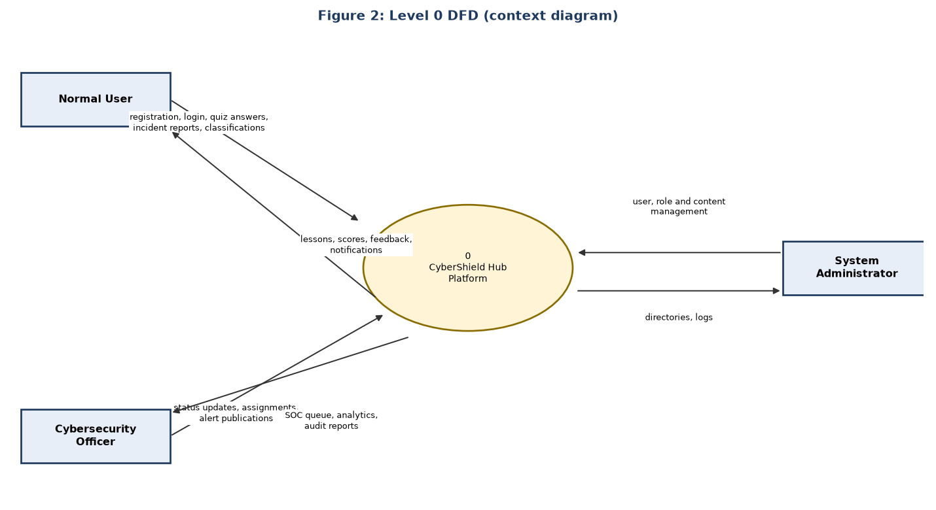
Figure 2: Level 0 DFD (context diagram)

4.6.2 Level 1
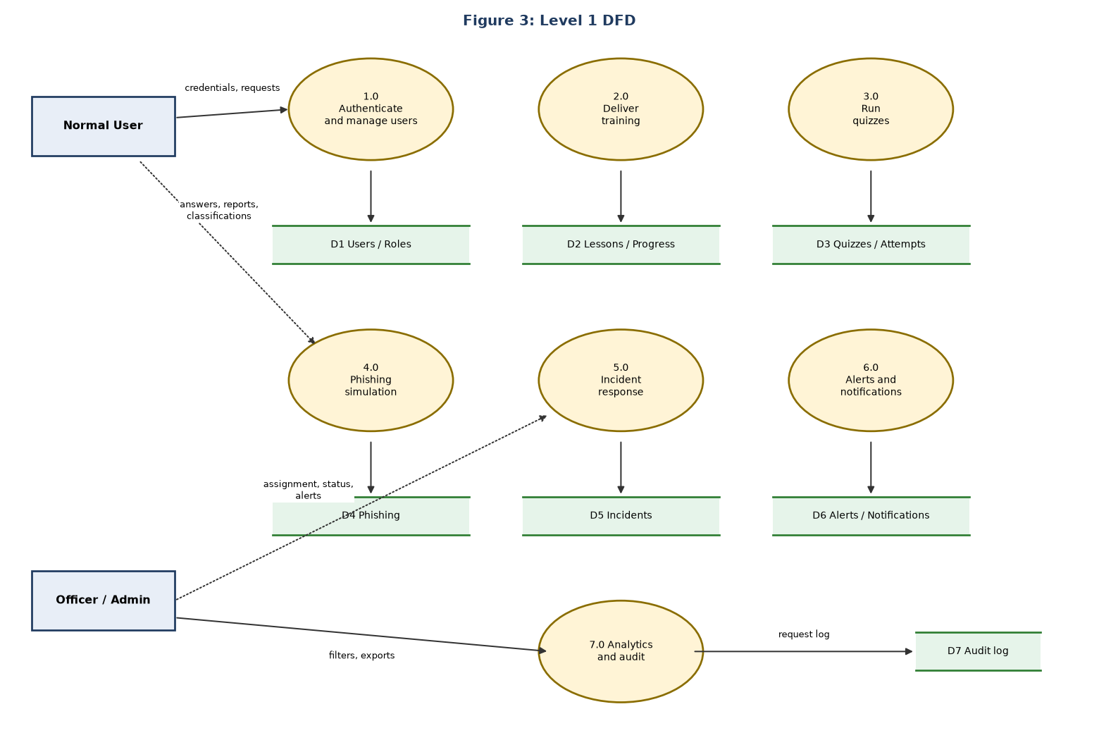
Figure 3: Level 1 DFD

4.6.3 Level 2: Incident response (process 5.0)
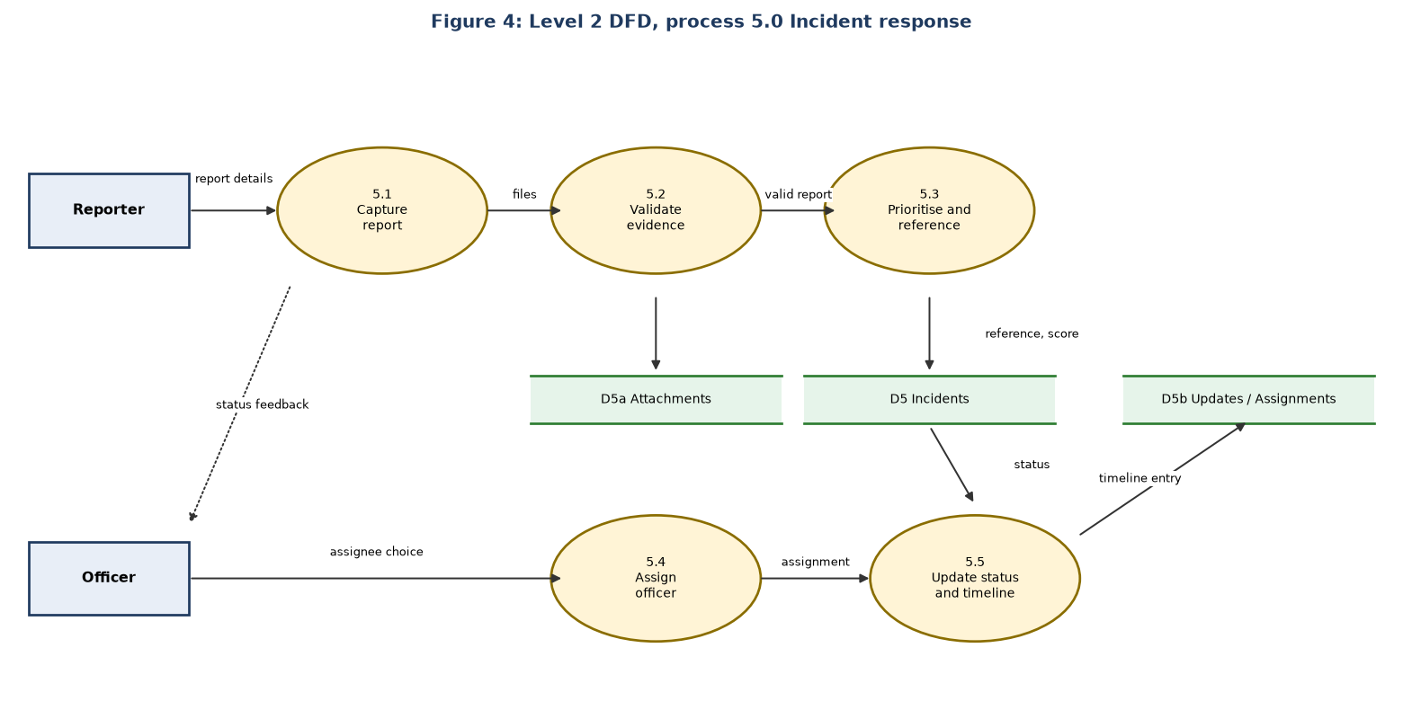
Figure 4: Level 2 DFD, process 5.0 Incident response

4.6.4 Level 2: Quizzes (process 3.0)
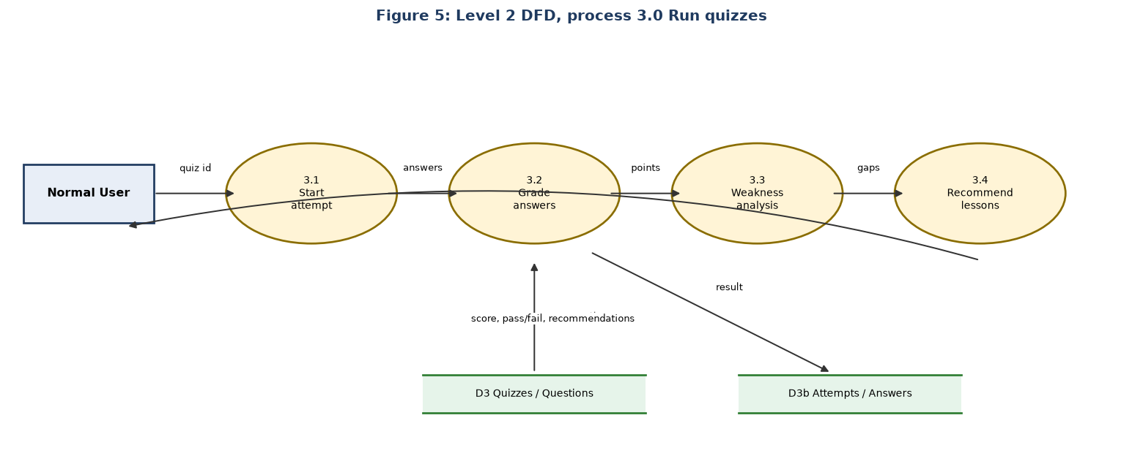
Figure 5: Level 2 DFD, process 3.0 Run quizzes

4.7 UML Diagrams

4.7.1 Use case diagram
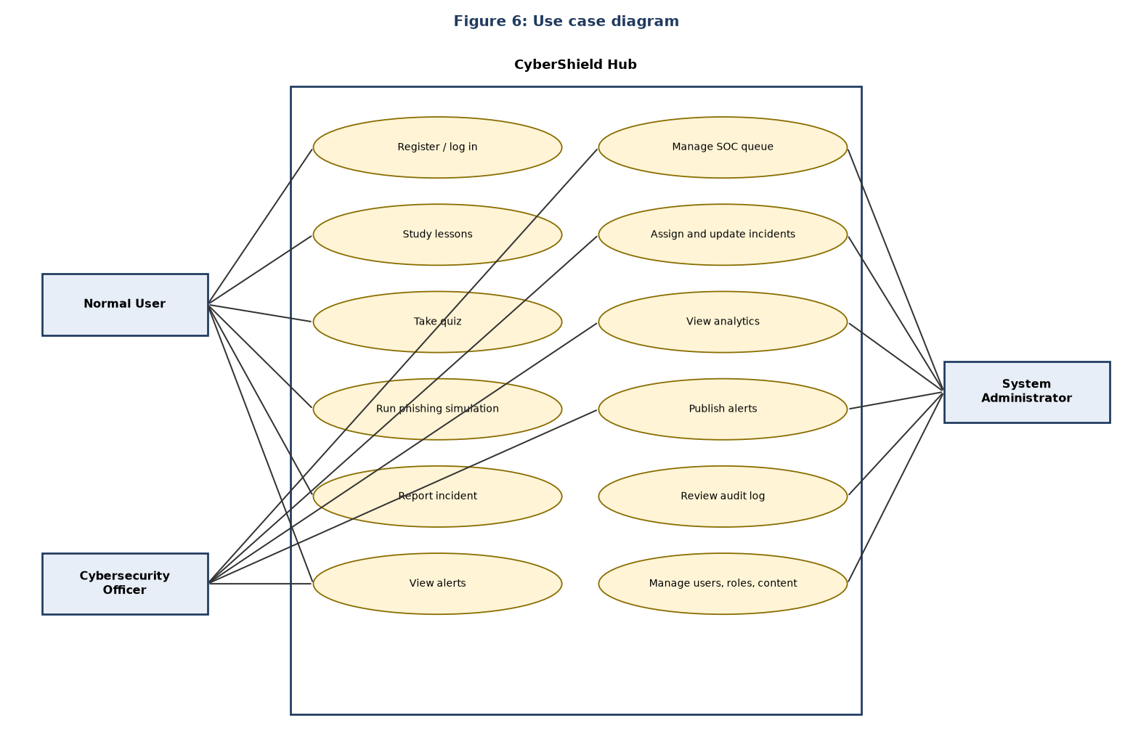
Figure 6: Use case diagram

4.7.2 Class diagram
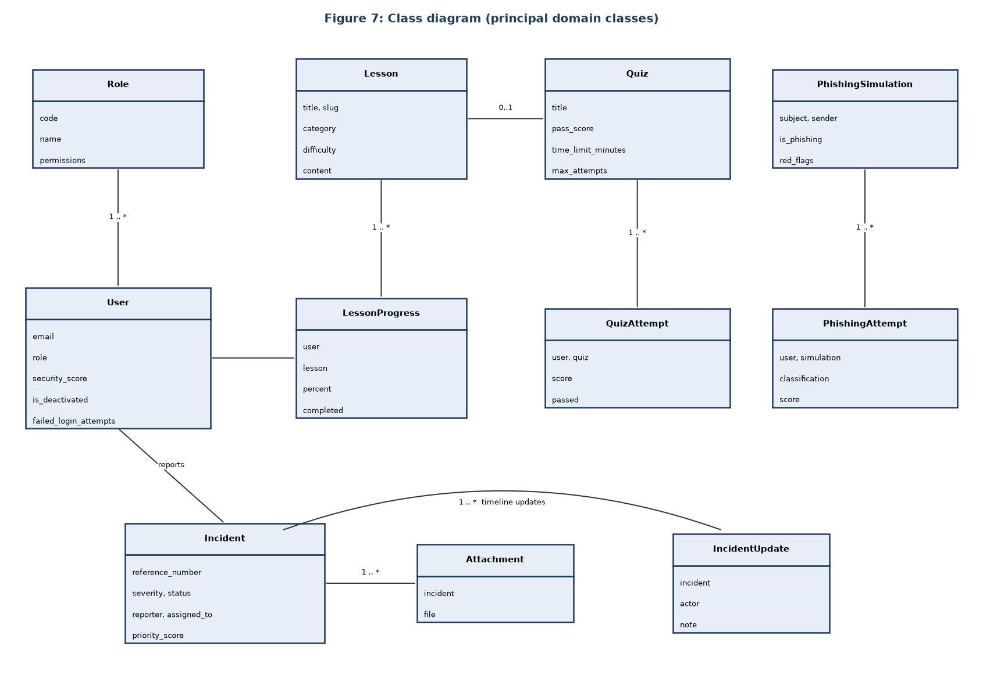
Figure 7: Class diagram (principal domain classes)

4.7.3 Sequence diagram
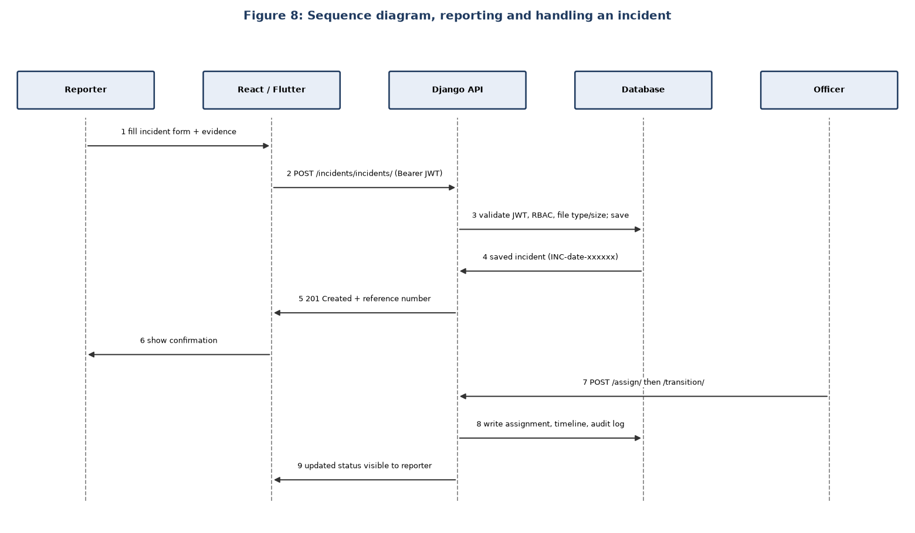
Figure 8: Sequence diagram, reporting and handling an incident

4.7.4 System architecture
The deployment and layer view is shown in Chapter 1, Figure 1. Request flow: client → JWT authentication → RBAC permission check → service/ORM → database → audit write → JSON response.

Date: ………………………. Sign: Supervisor ………………………. Student ……………………….

Chapter 5: Coding and Testing

5.1 Introduction
This chapter describes how the design was turned into working code, the programming practices followed, the quality and robustness of the programs, and how the system was tested. The guidelines list VB.NET, PHP and Java as example languages; the project uses Python (Django REST Framework) for the server, JavaScript (React) for the web client and Dart (Flutter) for the mobile client. The same principles of structure, commenting, usability and robustness apply.

5.2 Development Environment and Code Structure
Layer | Technology | Location
API server | Python 3.12, Django 5, Django REST Framework, Simple JWT, django-filter, drf-spectacular, WhiteNoise | backend/
Web client | React 18, Vite, Tailwind CSS, Framer Motion, Chart.js, Axios, React Router | frontend/
Mobile client | Flutter / Dart, provider, http, flutter_secure_storage, intl | mobile/
Database | SQLite (development), MySQL 8 (production) | configured by .env
Tools | Git and GitHub, GitHub Actions CI, pytest, VS Code | repository root

The back end is divided into Django apps, one per domain: users, training, quizzes, phishing, incidents, alerts, analytics, audit and a shared common app. Each app contains models.py, serializers.py, views.py, urls.py and a tests/ folder; business logic that is more than simple CRUD sits in services.py. The web client is organised into pages, components, contexts, hooks, services and api; the mobile client into screens, widgets, state, api and models.

5.3 Programming Practice

5.3.1 Indentation and layout
Python code uses four-space indentation as required by the language and PEP 8 naming (snake_case functions, CamelCase classes, upper-case constants). JavaScript and Dart code use two-space indentation, consistent formatting and one component or class per file. Related imports are grouped and unused imports are removed.

5.3.2 Commenting
Comments explain why, not what. Docstrings are used where behaviour is not obvious, for example the attempt-limit helper:
def attempts_remaining(user, quiz):
"""Attempts the user has left on ``quiz``; ``None`` when the quiz is unlimited.

Only completed attempts count, so opening a quiz and leaving does not burn one.
"""
if not quiz.max_attempts:
return None
used = QuizAttempt.objects.filter(user=user, quiz=quiz, completed_at__isnull=False).count()
return max(0, quiz.max_attempts - used)

5.3.3 Naming and modularity
- Names describe purpose: grade_quiz_attempt, validate_evidence_upload, calculate_priority, IsCyberOfficer.
- Small functions with a single responsibility; shared rules live in one place (common/permissions.py, common/validators.py) and are reused.
- Constants instead of magic numbers: MAX_UPLOAD_SIZE = 10 * 1024 * 1024, ALLOWED_UPLOAD_EXTENSIONS.
- Configuration comes from environment variables (.env), not from the code.

5.3.4 Representative code

Evidence validation (common/validators.py)
ALLOWED_UPLOAD_EXTENSIONS = {".png", ".jpg", ".jpeg", ".pdf", ".txt", ".log", ".eml", ".msg"}
MAX_UPLOAD_SIZE = 10 * 1024 * 1024

def validate_evidence_upload(file_obj):
ext = os.path.splitext(file_obj.name)[1].lower()
if ext not in ALLOWED_UPLOAD_EXTENSIONS:
raise ValidationError("Unsupported evidence file type.")
if file_obj.size > MAX_UPLOAD_SIZE:
raise ValidationError("Evidence file exceeds the 10 MB limit.")

def evidence_upload_path(instance, filename):
ext = os.path.splitext(filename)[1].lower()
safe_name = f"{uuid.uuid4().hex}{ext}" # user-supplied name is never used
return f"incident-evidence/{instance.incident.reference_number}/{safe_name}"

Priority calculation (incidents/models.py)
def calculate_priority(self):
severity_weight = {self.LOW: 25, self.MEDIUM: 50, self.HIGH: 75, self.CRITICAL: 95}
status_weight = {self.OPEN: 5, self.INVESTIGATING: 10, self.ESCALATED: 15,
self.RESOLVED: -20, self.CLOSED: -30}
return max(0, min(100, severity_weight.get(self.severity, 50)
+ status_weight.get(self.status, 0)))

Quiz grading (quizzes/services.py)
@transaction.atomic
def grade_quiz_attempt(attempt, submitted_answers):
answer_map = {int(i["question_id"]): int(i["answer_id"]) for i in submitted_answers}
questions = attempt.quiz.questions.prefetch_related("answers").all()
...
for question in questions:
total_points += question.points
selected = AnswerOption.objects.filter(id=selected_id, question=question).first()
correct = bool(selected and selected.is_correct)
earned_points += question.points if correct else 0
QuizAttemptAnswer.objects.update_or_create(attempt=attempt, question=question, ...)
@transaction.atomic ensures a grading failure cannot leave a half-saved attempt, and the answer lookup is restricted to the question so a user cannot score points with an answer from a different question.

5.4 Program Quality (User Friendliness)
Quality aspect | How it is achieved
Clear navigation | Sidebar grouped Learn / Respond / Administer on the web; five-item bottom navigation (Home, Learn, Incidents, Alerts, Account) on mobile.
Helpful messages | Field-level validation text, toasts for success, error panels with a retry option, empty-state messages that say what to do next.
Guidance | Password strength meter, hint text on forms (for example the example affected systems), file-type and size hints on upload, timer on quizzes.
Efficiency | Drafts for incident reports, bookmarks and progress for lessons, search and filters, paginated lists, loading skeletons instead of blank screens.
Protection against mistakes | Confirmation dialogs for deletion; warning when leaving a form with unsaved changes; dates cannot be set in the future on incident reports.
Consistency | Reusable components (Card, Button, Dialog, StatusBadge, Toast) ensure the same behaviour everywhere.
Responsiveness | Layouts adapt from desktop to tablet and phone; the Flutter app gives a native mobile experience.
Feedback to the learner | Quiz results explain each answer and recommend lessons; phishing results show which red flags were missed.

5.5 Program Resilience (Robustness)
A robust program does not crash or corrupt data when given bad input or when something fails. The following measures are used.
Risk | Protection
Invalid or missing input | Serializer validation on every endpoint; uniform JSON errors from custom_exception_handler (success flag, error code, message, details) instead of stack traces.
Malicious files | Extension allow-list, 10 MB limit, randomised stored file name, files are never executed.
Unauthorised access | Authentication and role checks on every view; owner-or-officer object permissions; tests confirm 401/403 responses.
Brute-force and flooding | Failed-login counter, throttling (anonymous 60/min, user 600/min, authentication 10/min).
Stolen or old tokens | Short-lived access tokens; refresh rotation with blacklist; logout revokes the session.
Partial updates | Database transactions around grading and multi-step writes.
Quiz abuse | Attempt limits enforced at both start and submit; abandoned attempts do not use up an attempt; counts only completed attempts.
Network failure on clients | Axios interceptors refresh tokens or return to login; error and retry states on pages; development-only fallback data is not used in production.
Data inconsistency | Foreign keys, unique constraints (reference numbers, notification per user and alert) and protected deletes for categories that are in use.
Mistakes by administrators | Audit log records who changed what; delete confirmations.

5.6 Testing

5.6.1 Test strategy
Level | Purpose | Tool
Unit testing | Verify single functions and model methods (priority score, reference number, grading, validators) | pytest, pytest-django
Integration / API testing | Verify complete request flows through authentication, permissions, serializers, services and database | pytest with DRF API client
Security / role testing | Verify that each role can only do what it should | pytest (RBAC and permission tests)
Static and build checks | Check migrations are in step with models; Django deployment checks; production build of the web client; mobile analysis and tests | GitHub Actions CI (makemigrations --check, check --deploy, npm run build, Flutter job)
User acceptance testing | Confirm the system meets the requirements with real users | Manual test script (section 5.6.4)

5.6.2 Automated test suite
The automated suite was executed on the back end. Result: 345 tests passed, 0 failed (run time about 2 minutes on a development PC, SQLite test database). The distribution is:
Module | Tests | What is covered
users | 37 | Registration, login, refresh rotation, logout, password reset/change, e-mail verification, RBAC, deactivation
training | 137 | Lesson and category authoring, content library integrity, progress, bookmarks, recommendations
quizzes | 95 | Attempt lifecycle, scoring, results, attempt limits, quiz settings and authoring
phishing | 14 | Scoring, partial credit, feedback, visibility, authoring
incidents | 23 | Reporting, drafts, priority, reference numbers, assignment, transitions, queue, heat map, timeline
alerts | 11 | Publishing, audience fan-out, expiry, notifications, read/read-all, back-fill for new users
analytics | 10 | User and organisation metrics
audit | 7 | Logging of mutating requests, immutability, permissions, CSV export
common and config | 11 | Permission classes, smoke tests
Total | 345

5.6.3 Representative test cases
ID | Test (module) | Input / action | Expected result | Result
T01 | Register user (users) | Valid registration data | Account created with normal-user role and verification token | Pass
T02 | Duplicate e-mail (users) | Register with existing e-mail | Rejected with validation error | Pass
T03 | Mismatched passwords (users) | Password and confirmation differ | Rejected | Pass
T04 | Valid login (users) | Correct credentials | Access and refresh tokens returned | Pass
T05 | Wrong password (users) | Incorrect password | Login refused; failed attempt recorded | Pass
T06 | Deactivated account (users) | Login with deactivated user | Login refused | Pass
T07 | Token rotation (users) | Use refresh token | New tokens issued; old refresh token blacklisted | Pass
T08 | Role escalation (users) | User PATCHes own profile with role_id | Role unchanged | Pass
T09 | Reset for unknown e-mail (users) | Request reset for address that does not exist | Same response; existence not leaked | Pass
T10 | Admin-only user list (users) | Normal user, officer, anonymous request user list | 403 / 401; admin receives list | Pass
T11 | Report incident (incidents) | Authenticated user submits incident | Created with reference number and initial timeline entry | Pass
T12 | Draft incident (incidents) | Save as draft | No submitted_at time set | Pass
T13 | Priority (incidents) | Different severities and statuses | Score = severity weight + status weight, within 0–100 | Pass
T14 | Visibility (incidents) | Reporter and officer list incidents | Reporter sees own only; officer sees all | Pass
T15 | Assignment (incidents) | Officer assigns; normal user tries; assign to non-officer | Officer succeeds; others rejected | Pass
T16 | Status change (incidents) | Officer and normal user transition | Officer succeeds; normal user refused | Pass
T17 | Queue and heat map (incidents) | Officer requests queue / heat map | Grouped by status; severity × status counts | Pass
T18 | All correct quiz (quizzes) | Submit every correct answer | Score 100, passed | Pass
T19 | Wrong answer (quizzes) | Submit wrong answer | Fail with recommendation | Pass
T20 | Attempt limit (quizzes) | Exceed max attempts | Start and submit blocked; last allowed attempt works | Pass
T21 | Result privacy (quizzes) | Other user opens someone's result | Refused | Pass
T22 | Phishing scoring (phishing) | Correct classification with all flags; wrong classification; partial flags | 100; lower; partial credit | Pass
T23 | Alert fan-out (alerts) | Admin creates alert | Notifications created for active users of the audience | Pass
T24 | Expired alert (alerts) | Normal user views expired alert | Hidden | Pass
T25 | Audit logging (audit) | Mutating request / read-only request / anonymous | Logged / not logged / not logged | Pass
T26 | Audit export (audit) | Officer exports | CSV returned; normal user refused | Pass

5.6.4 Manual and user acceptance test script
Items below are performed on the web and mobile clients with the demo accounts created by python manage.py seed_demo. Record the outcome in the last column when the tests are run.
No. | Step | Expected | Pass / Fail
M1 | Register a new account, then log in | Dashboard shows; user has normal role
M2 | Open a lesson, mark progress, bookmark it | Progress saved and persists after logout/login
M3 | Take a quiz and submit | Score, pass/fail, explanations and recommendations shown
M4 | Use the phishing lab on a safe and a suspicious message | Scores and tips appear for both
M5 | Report an incident with a .pdf, then try a .exe | .pdf accepted; .exe rejected with message
M6 | Log in as officer, open SOC queue, assign and change status | Card moves column; timeline entry added; reporter sees update
M7 | Publish an alert as officer/admin | Bell badge increases for users; can mark read
M8 | As normal user open /soc and /admin/users | Access denied or redirected
M9 | As admin deactivate a user, then try to log in as that user | Login refused
M10 | Open audit log, filter, export CSV | Entries for steps above appear; CSV downloads
M11 | Repeat M1–M5 on the Flutter app (Android) | Same results as web
M12 | Enter wrong password 10+ times quickly | Requests throttled

5.6.5 Defects found and fixed during development
The suite contains regression tests for subtle problems of the kind that testing exposes: attempt counts must not be inflated by database joins; an open attempt created before a limit change must not be submittable past the limit; refresh rotation must keep the stored session pointed at the new token; unanswered questions must still show the correct answer in results; and attempt detail must not issue a database query per answer.

5.6.6 Conclusion on testing
All 345 automated tests passed, giving strong evidence for requirements FR1–FR22 on the server side. Manual acceptance testing (section 5.6.4) completes verification of the user interfaces.

Date: ………………………. Sign: Supervisor ………………………. Student ……………………….

Chapter 6: Implementation and Post-Implementation Plan

6.1 Introduction
This chapter explains how CyberShield Hub will be introduced into an organisation and supported afterwards. It contains the pre-presentation plan, the documentation including the user manual, and the conversion and training plans.

6.2 Pre-Presentation
The pre-presentation is a rehearsal for the supervisor and, later, for management and staff.

6.2.1 Presentation outline (about 15 minutes)
Slide / segment | Content | Minutes
1. Title and problem | Why human error and informal incident handling are risks | 2
2. Objectives and scope | SMART objectives and what is in and out of scope | 2
3. Solution overview | Architecture (Figure 1) and the three roles | 2
4. Live demonstration | Follow the script in 6.2.2 | 6
5. Quality evidence | 345 automated tests passing; controls (JWT, RBAC, audit, upload checks) | 1
6. Implementation and benefits | Conversion plan, training, expected benefits | 1
7. Conclusion and questions | Future plans; invite questions | 1

6.2.2 Demonstration script
- Log in as a normal user: show the dashboard (security score and progress).
- Open a lesson, bookmark it, then take its quiz and show the result and recommendations.
- Open the phishing lab, inspect a link, select red flags and show the feedback.
- Report an incident with an evidence file; show the generated reference number.
- Log in as an officer: open the SOC queue, assign the incident, move it to Investigating and add an update.
- Switch back to the reporter: show the timeline update. Publish an alert and show the notification.
- Log in as administrator: manage a user and edit a lesson; show the audit log and CSV export.
- Show the mobile app performing a login, quiz and incident report.

6.2.3 Preparation checklist
- Backend started with demo data (python manage.py migrate, python manage.py seed_demo, python manage.py runserver) as in LaunchMe.md.
- Web client started with npm run dev (or built and served); mobile app installed on a phone or emulator.
- Three browser profiles ready (user, officer, admin) to avoid repeated log-ins.
- Sample evidence files (a screenshot and a PDF) saved on the desktop.
- Backup plan: screenshots or a short screen recording if the network or server fails.

6.3 Documentation
Document | Audience | Location
Project chapters 1–7 (this series) | Supervisor, examiners | docs/project-documentation/
README and LaunchMe (installation and run guide) | Administrators, developers | README.md, LaunchMe.md
Architecture and diagrams | Developers | docs/architecture.md
API endpoint map and live Swagger documentation | Developers, integrators | docs/api_endpoints.md, /api/v1/docs/
Database schema reference | Database administrators | docs/database_schema.sql
Mobile README | Mobile developers | mobile/README.md
User manual | End users and officers | Section 6.3.1 below
Administrator guide | System administrators | Section 6.3.2 below

6.3.1 User manual

A. Getting started (all users)
- Open the CyberShield Hub address in your browser (or open the mobile app).
- Select Register, enter your name, e-mail and a strong password (the strength meter must show an acceptable level), and submit.
- Sign in with your e-mail and password. If you forget your password choose Forgot password and follow the link sent to you.
- The Dashboard shows your security score, learning progress, quiz and phishing results, incidents and alerts.
- Use Account to update your profile or change your password. Always choose Log out on shared computers.

B. Learn
Task | Steps
Find a lesson | Training → type in the search box or filter by category and difficulty → select a card.
Read and track progress | Open the lesson, read the content; progress is saved. Select Mark complete at the end.
Bookmark | Select the bookmark icon on a lesson; find it later in your bookmarks.
Take a quiz | Quizzes → choose a quiz (check attempts remaining) → Start → answer all questions before the timer ends → Submit.
Read your result | The result page shows score, pass/fail, the correct answers with explanations and lessons recommended for weak topics.
Practise phishing detection | Phishing lab → open a message → inspect the sender and links → tick the red flags you see → choose Safe or Suspicious → read the feedback.

C. Report and track an incident
- Open Incidents → Report incident.
- Enter a clear title, the affected system, category, severity, when it happened and a description of what you saw.
- Attach evidence (screenshots, e-mails, logs). Allowed types: png, jpg, jpeg, pdf, txt, log, eml, msg; maximum 10 MB each.
- Choose Save draft to finish later or Submit. Note the reference number (INC-date-code).
- Follow progress in Incidents: open the incident to see its status and timeline.
Tip: Report early. Do not delete the suspicious message and do not click links in it.

D. Alerts
The bell icon shows the number of unread alerts. Open Alerts to read advisories, mark one as read or choose Mark all read.

E. Cybersecurity officer tasks
Task | Steps
Review the queue | SOC queue → incidents appear in columns by status, highest priority first; use the heat map to see severity against status.
Assign | Open an incident → Manage panel → choose an officer → Assign.
Change status | Manage panel → select the new status (Investigating, Escalated, Resolved, Closed) and add a note; the timeline is updated automatically.
Publish an alert | Alerts → Publish → enter title, message, priority, audience and expiry → Publish.
View analytics | Analytics → review training, quiz, phishing, incident and risk charts.
Audit | Audit log → filter or search → Export CSV.

F. Administrator tasks
Task | Steps
Manage users | Admin → Users → activate, deactivate, change role, reset failed-login counter.
Manage content | Admin → Content library → Lessons / Quizzes / Simulations / Categories → New or Edit → Save.
Quiz settings | Admin → Quiz settings → set pass score, time limit, attempts and randomisation.

G. Troubleshooting
Problem | What to do
Cannot log in | Check the e-mail and password; after many failures wait a minute (throttling); ask an administrator if your account is deactivated.
Session ended | Sessions expire for security; log in again.
File rejected | Check the type (png, jpg, jpeg, pdf, txt, log, eml, msg) and size (under 10 MB).
Quiz says no attempts left | Ask an administrator to raise the attempt limit.
Page will not load | Check your network connection and try again; contact IT if it continues.

6.3.2 Administrator guide (installation summary)
- Install Python 3.12+ and Node.js 20+ (Flutter only for the mobile app).
- Copy .env.example to .env and set DJANGO_SECRET_KEY, DJANGO_DEBUG=False, DJANGO_ALLOWED_HOSTS, CORS_ALLOWED_ORIGINS and the database settings (DB_ENGINE=mysql for production).
- In backend/: create a virtual environment, pip install -r requirements.txt, python manage.py migrate, then create the first administrator with python manage.py createsuperuser.
- Start the API behind a production web server with HTTPS; build the web client with npm run build and serve the output.
- Verify the health check (/health/) and Swagger page (/api/v1/docs/).
- Do not run seed_demo on a production system except for a training environment: it creates sample accounts with a known password.

6.4 Conversion Plans

6.4.1 Choice of conversion method
Method | Description | Advantage | Risk
Direct (big bang) | Stop the old way and start the new system on one day | Fast | High risk if something fails
Parallel | Run old and new together for a period | Safe; results can be compared | Double work for staff
Pilot | Start with one department | Problems found on a small scale | Slower overall
Phased | Introduce modules one by one | Spreads training load | Longer period of mixed systems

Recommended: pilot followed by phased roll-out, with the old incident spreadsheet kept in parallel for the first month. Because training and quizzes are new activities, nothing needs to be replaced; only incident reporting changes an existing process, and for that the parallel period gives a safety net.

6.4.2 Conversion schedule
Stage | Activities | Duration
1. Preparation | Provision server, install, configure HTTPS, create administrator and officer accounts, load or write lessons, quizzes and simulations, back-up procedure tested | 1 week
2. Data conversion | Create staff accounts (administrators create them, or staff self-register and the administrator checks them); enter open incidents from the spreadsheet through the incident form, recording the original date in the description; assign categories | 1 week
3. Pilot | One department (about 10 users) uses all modules; collect feedback and fix issues | 2 weeks
4. Roll-out phase 1 | All staff: training and quizzes, alerts | 2 weeks
5. Roll-out phase 2 | All staff: phishing lab and incident reporting; old spreadsheet continues in parallel | 4 weeks
6. Cut-over | Spreadsheet frozen and archived; CyberShield Hub is the official record | 1 day

6.4.3 Data conversion
- Existing open incident records are re-entered through the incident form; the system generates new reference numbers, and the old identifiers and original dates are recorded in the description.
- Staff lists come from HR; accounts are created by administrators or by self-registration, and users set their own passwords.
- Historic training attendance may be recorded as a note, but scores start fresh.

6.4.4 Training plan
Group | Content | Method | Duration
All staff | Registering, dashboard, lessons, quizzes, phishing lab, reporting an incident, alerts | Live demonstration plus hands-on session; user manual and short video | 1 hour
Cybersecurity officers | SOC queue, assignment, status workflow, timeline notes, alerts, analytics, audit log | Workshop with practice incidents | 3 hours
System administrators | Installation, configuration, users and roles, content authoring, backup and restore, monitoring | Technical workshop | 1 day
Management | Dashboards and what the figures mean | Short briefing | 30 minutes

6.4.5 Risks and contingency
Risk | Contingency
Server failure during roll-out | Daily database and media backups; restore procedure tested; paper/e-mail reporting continues until restored
Staff reluctance | Management sponsorship, short sessions, emphasise no-blame reporting
Low connectivity | Mobile-friendly pages and the mobile app; lightweight pages
Wrong role assigned | Administrator corrects role; audit log records the change

6.5 Post-Implementation Plan
Activity | Frequency | Responsible
Database and media backups (and restore test) | Daily backup; restore test quarterly | System administrator
Apply security updates to Python, Django, Node packages and the operating system | Monthly, urgent updates at once | System administrator
Review audit log for unusual activity | Weekly | Cybersecurity officer
Add and refresh lessons, quizzes and phishing scenarios | Monthly | Administrator / officer
Publish alerts about current threats | As needed | Cybersecurity officer
Post-implementation review: objectives met, user satisfaction survey, incident response times, quiz and phishing trends | 3 months and 12 months after go-live | Project owner and supervisor
Change requests and enhancements logged and prioritised | Ongoing | Administrator
Run automated tests before every change is deployed | Each change | Developer

Success measures for the review: percentage of staff who completed lessons; average quiz score and pass rate; phishing detection accuracy trend; number of incidents reported and the average time from report to first assignment and to closure; user satisfaction rating.

Date: ………………………. Sign: Supervisor ………………………. Student ……………………….

Chapter 7: Conclusion

7.1 Summary
The project set out to replace the informal, disconnected and unmeasured approach to security awareness and incident handling with one integrated platform. CyberShield Hub was analysed, designed, built and tested as a role-based system with a Django REST API, a React web application and a Flutter mobile application. It provides secure authentication, a training library, a quiz engine, a phishing simulator, incident reporting with evidence, a SOC-style incident queue, alerts and notifications, analytics and an audit trail.

7.2 Achievement of Objectives
Objective | Outcome
O1 Secure login and RBAC | Achieved: JWT with refresh rotation and blacklist; three roles enforced on every endpoint; tests confirm refusal for wrong roles.
O2 Training library | Achieved: categorised lessons, progress, bookmarks, recommendations and admin authoring.
O3 Quiz engine | Achieved: automatic grading, pass/fail, attempt limits, weakness analysis and recommendations.
O4 Phishing simulator | Achieved: scenario inbox, URL inspection, red flags, scored feedback and admin authoring.
O5 Incident reporting | Achieved: unique reference numbers, drafts and validated evidence upload (allow-listed types, 10 MB).
O6 Incident queue and workflow | Achieved: Kanban queue, assignment, status transitions and timeline.
O7 Analytics and alerts | Achieved: personal and organisation dashboards, alert publication and per-user notifications.
O8 Audit | Achieved: every authenticated data-changing request logged; filter and CSV export.
O9 Automated testing | Achieved: 345 automated back-end tests passing.
O10 Mobile app and documentation | Achieved: Flutter app covering the learner and reporter flows; this documentation set and the user manual.

7.3 Strengths
- One integrated system instead of several disconnected tools.
- Security built in: least-privilege roles, token handling, throttling, upload controls and audit.
- Modular architecture that is easy to extend and test.
- Low cost: open-source stack and flexible database (SQLite or MySQL).
- Works on desktop and phone.

7.4 Limitations
- E-mail delivery of reset and verification links depends on a configured SMTP service; no real mail server is bundled.
- Phishing simulation is in-app only; it does not send simulated e-mails to real inboxes.
- Evidence files are stored but not scanned for malware.
- No integration with directory services (single sign-on) or external SIEM tools.
- The mobile app targets learners and incident reporters; officer and administrator functions are web-only.
- Front-end and mobile automated tests are fewer than the back-end tests, so user-interface testing relies partly on manual scripts.

7.5 Lessons Learned
- Writing business rules in a service layer made them reusable by both clients and easy to test.
- Writing tests alongside features found real defects early (attempt counting, token rotation, query efficiency).
- Early fact-finding with users keeps the scope realistic.
- Regular commits and a CI workflow make changes safer.

7.6 Future Plans
Enhancement | Benefit
Single sign-on (Active Directory / Azure AD / Google) and multi-factor authentication | Stronger and easier log-in
Real e-mail integration and scheduled phishing campaigns with click tracking | Realistic measurement of behaviour
Antivirus scanning of uploaded evidence and secure object storage | Safer evidence handling
SIEM and log-source integration for automatic incident creation | Faster detection
Push notifications and offline mode on mobile; iOS release | Better reach and engagement
Officer and administrator screens on mobile | Respond from anywhere
Gamification: badges, leaderboards, streaks, certificates | Higher engagement
Multi-tenant support and multi-language content (including Shona and Ndebele) | Wider adoption
Advanced analytics: trend forecasting, per-department risk scores, scheduled PDF reports | Better management decisions
Playbooks and SLA timers for incident response | Consistent, timely response
Container deployment (Docker) and automated backups | Easier operation

7.7 Final Remarks
CyberShield Hub shows that a small team can deliver a secure, measurable and user-friendly security awareness and incident response platform using open-source tools. By combining continuous learning with an accountable response process, it helps an organisation move from reacting to incidents to preventing them.

References and Resources
- Django Software Foundation. Django documentation. https://docs.djangoproject.com
- Encode. Django REST Framework documentation. https://www.django-rest-framework.org
- Simple JWT documentation. https://django-rest-framework-simplejwt.readthedocs.io
- React documentation. https://react.dev
- Flutter documentation. https://docs.flutter.dev
- OWASP. Top Ten Web Application Security Risks. https://owasp.org
- Republic of Zimbabwe. Cyber and Data Protection Act (2021).

Date: ………………………. Sign: Supervisor ………………………. Student ……………………….

