# Identification of Aircraft

## Khalid Aliweh

### CSCI E-89 Deep Learning

### **Harvard University Extension School**

Prof. Zoran B. Djordjević

Problem Statement:

Aircraft manufacturer Identification given the aircraft image.

Dataset:

The dataset was extracted from the Fine-Grained Visual Classification of Aircraft **(FGVC-Aircraft)** project.

Project Website: <http://www.robots.ox.ac.uk/~vgg/data/fgvc-aircraft/>

Dataset Description:

The dataset contains 10000 images of aircraft. The Aircraft models are organized in a four-levels hierarchy. The four levels, from finer to coarser, are: Model, e.g. Boeing 737-76J. Variant, e.g. Boeing 737-700. Family, e.g. Boeing 737. The dataset comprises 70 different families and Manufacturer, e.g. Boeing. The dataset comprises 41 different manufacturers.

Approach:

Utilize Keras/Tensorflow backend to build a Sequential Convolutional Neural Network (CNN) model that can classify the aircraft manufacturer. The model was designed and trained to differentiate between two different classes [*Boeing* and *Airbus*]

Challenges:

Aircrafts are nearly visually indistinguishable and requires a large neural network and computational resources to capture the aircraft features.

Solution:

Utilize image augmentation techniques to increase the classification accuracy.

Results:

The average validation accuracy for the last 5 training epochs of 50 epochs was 80.08%.

Links:

Two minute (short): <https://youtu.be/nMAg5-aPYaY>

15 minutes (long): <https://youtu.be/XIISTZKJPHg>

Project GitHub URL: <https://github.com/kaliweh/identificationofaircraft>

#### Software Libraries used and hardware description:

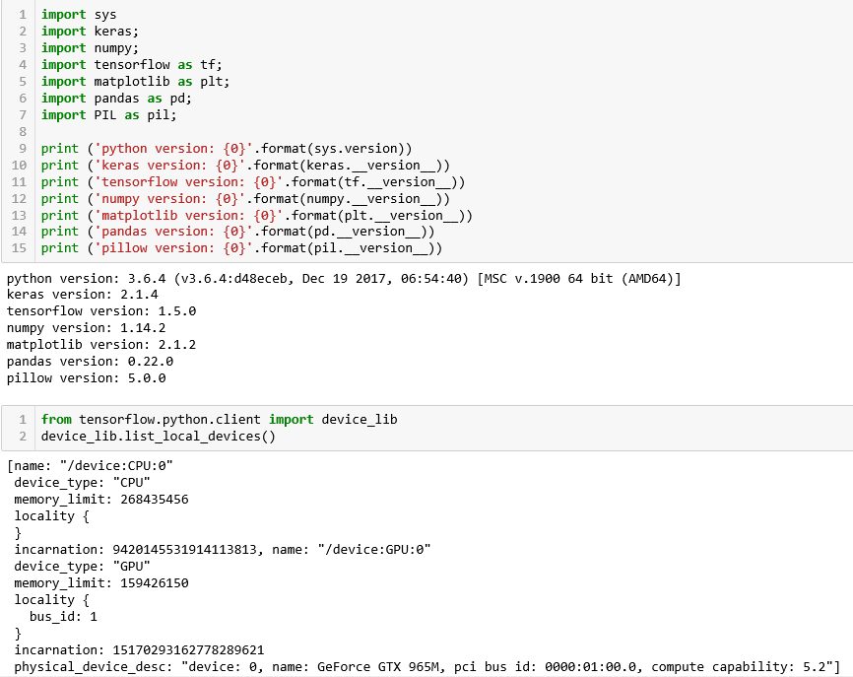

#### Software installation instructions:

1. Python: <https://www.ics.uci.edu/~pattis/common/handouts/pythoneclipsejava/python.html>
2. Keras: <https://keras.io/#installation>
3. Tensoflow: <https://www.tensorflow.org/install/>
4. Numpy: <https://docs.scipy.org/doc/numpy/user/install.html>
5. Matplotlib: <https://matplotlib.org/faq/installing_faq.html>
6. Pandas: <https://pandas.pydata.org/pandas-docs/stable/install.html>
7. Pillow: <https://pillow.readthedocs.io/en/5.0.0/installation.html>

#### Extracting, Inspecting and Cleaning the data:

After downloading the dataset from the project site (<http://www.robots.ox.ac.uk/~vgg/data/fgvc-aircraft/>) Extract the fgvc-aircraft-2013b.tar.gz file locally and Move the extracted data directory to your processing directory.

The dataset size is 2.75 GB

The data folder contains 'images' folder that contains all the labeled images. The data folder also contains the labels files labeled by classification type. (i.e. classification by Aircraft families, manufacturers and variants)

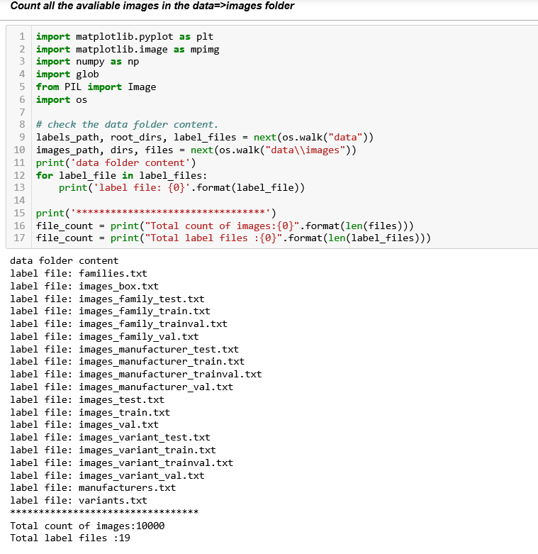

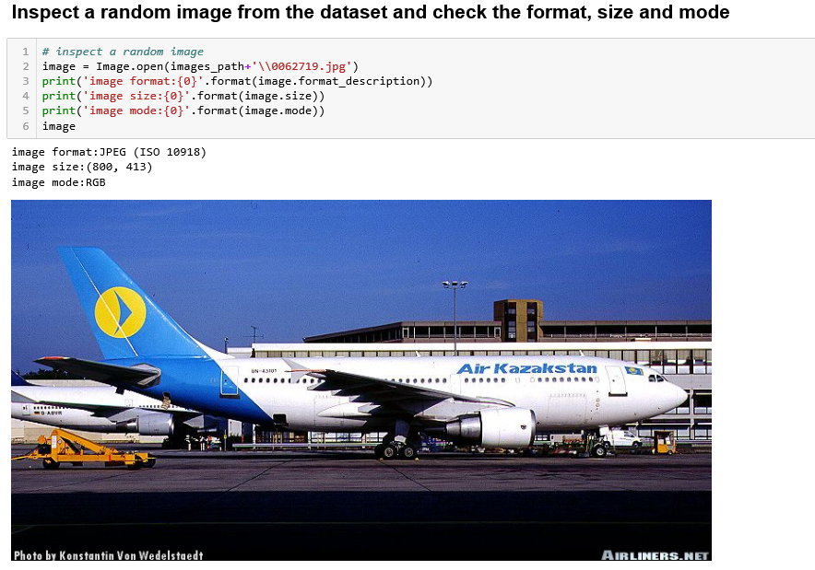

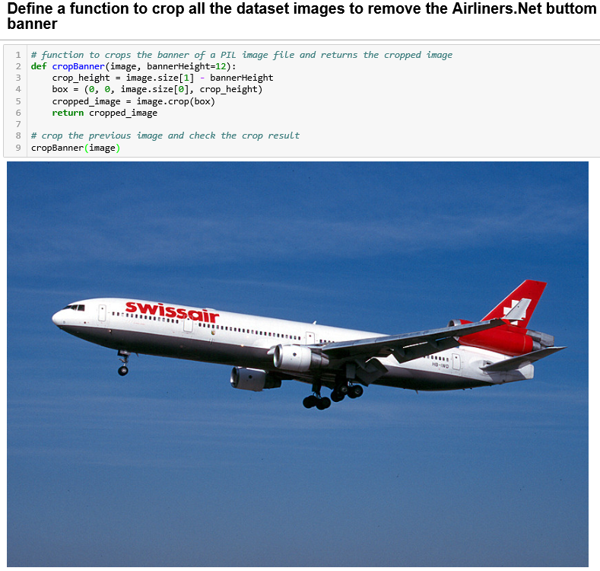

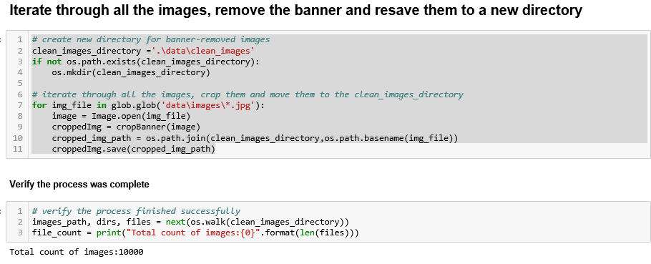

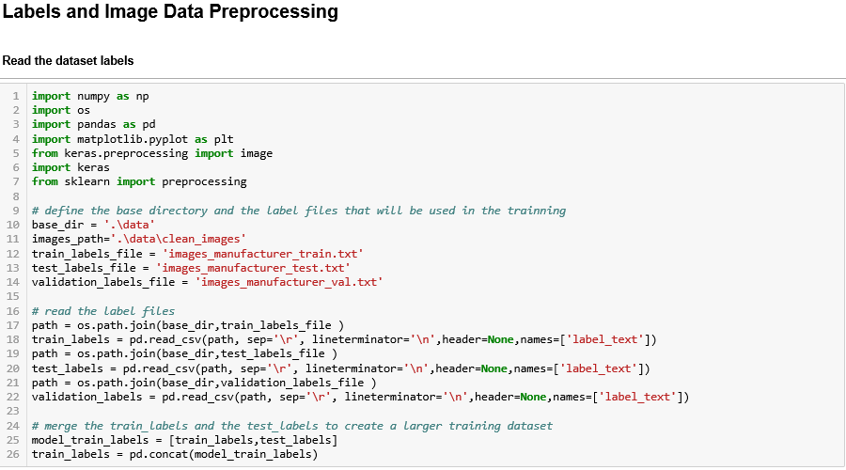

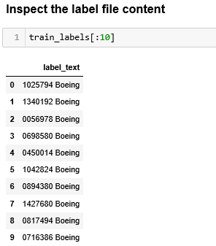

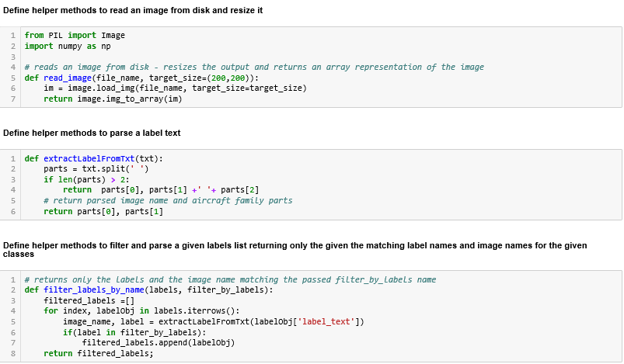

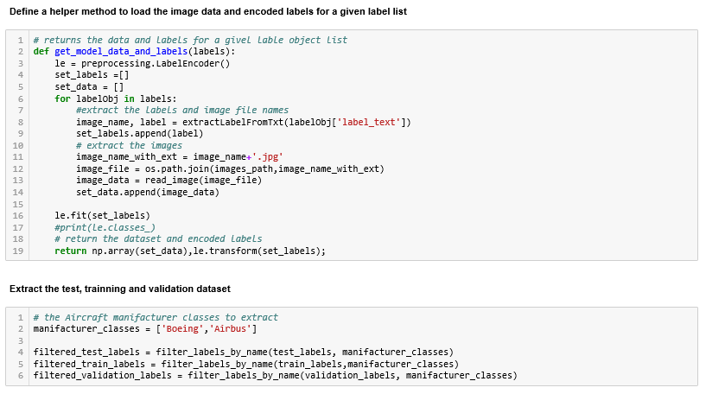

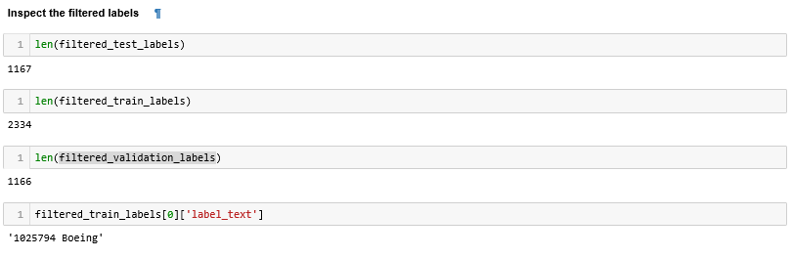

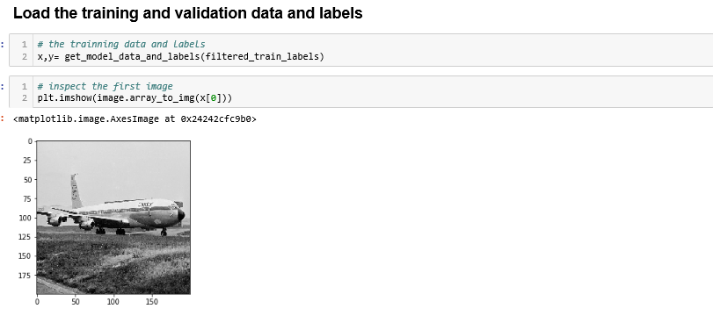

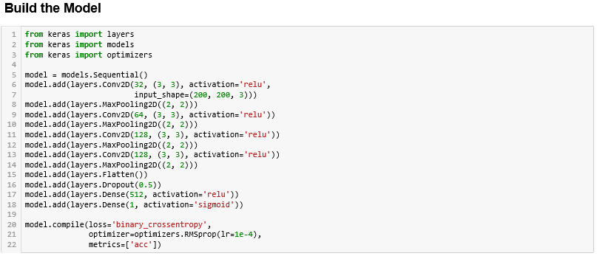

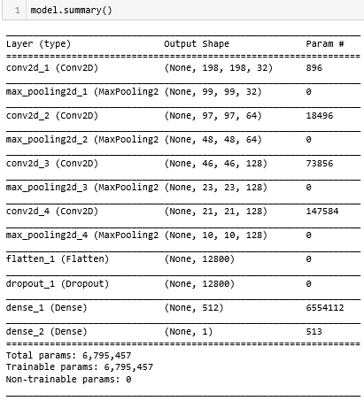

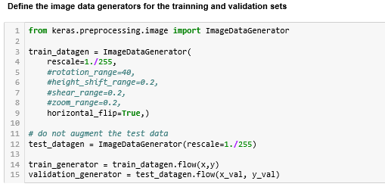

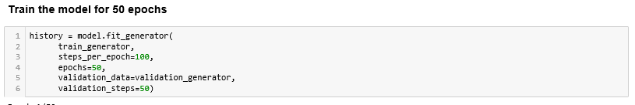

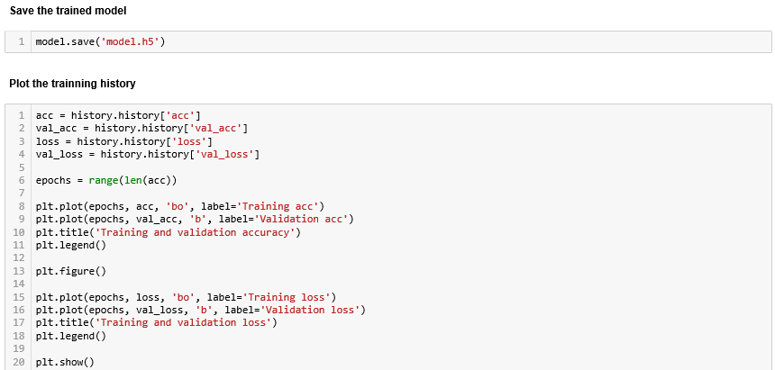

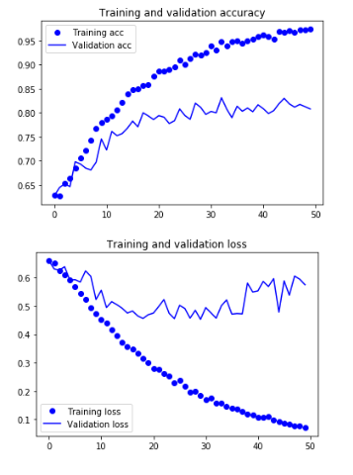

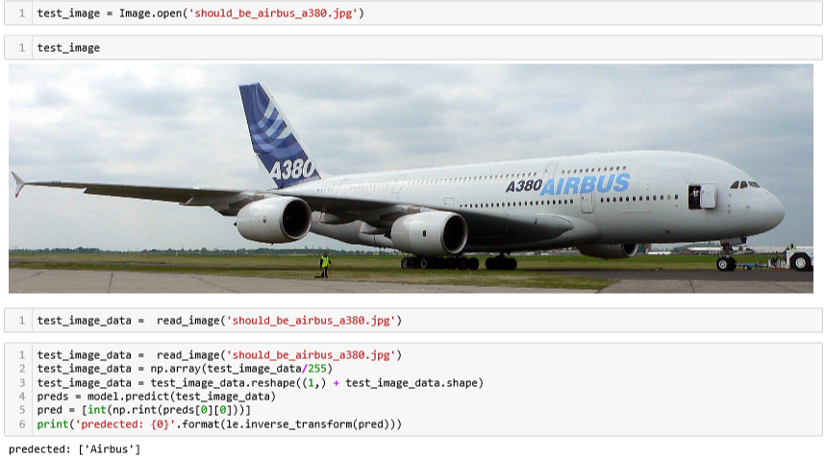

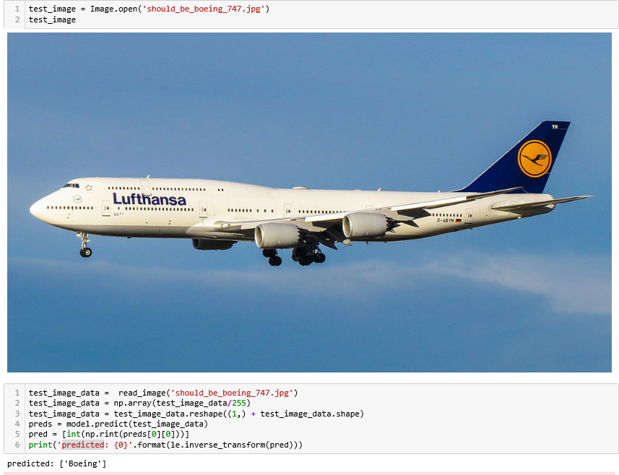

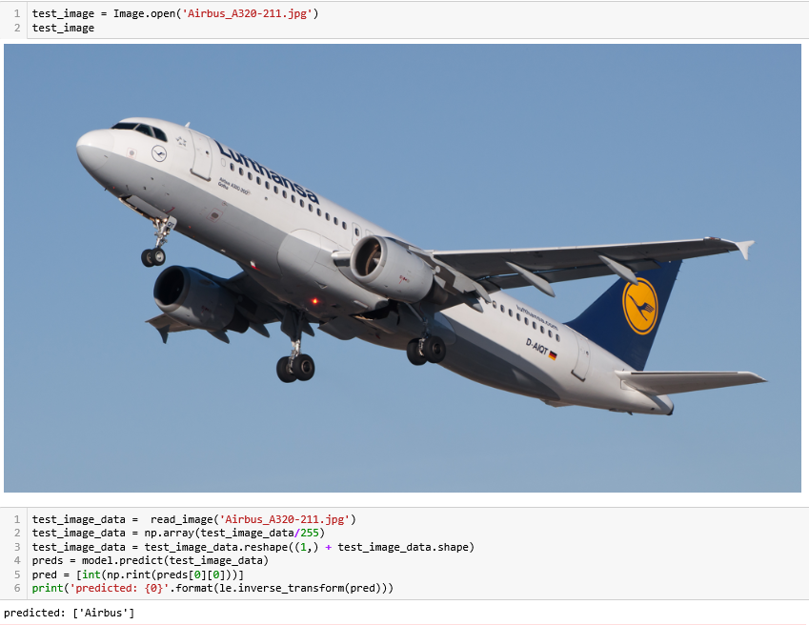

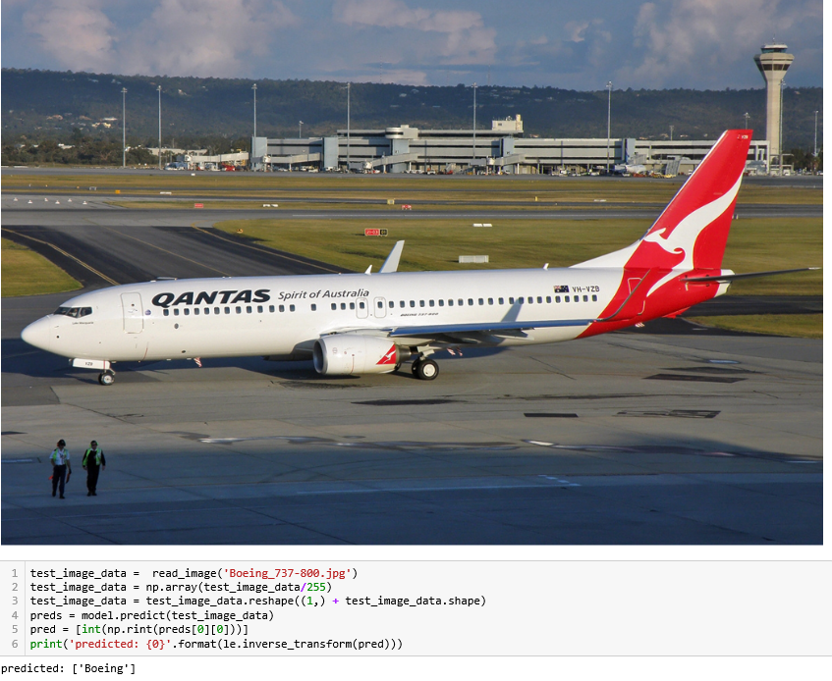

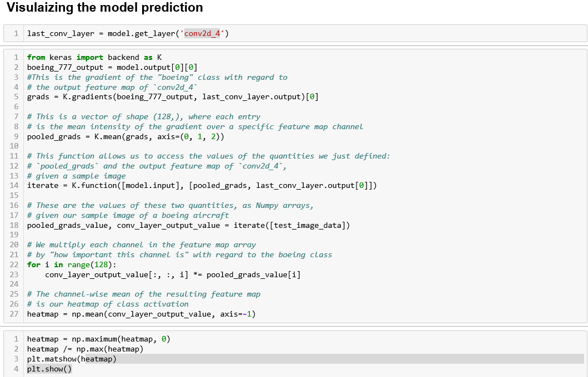

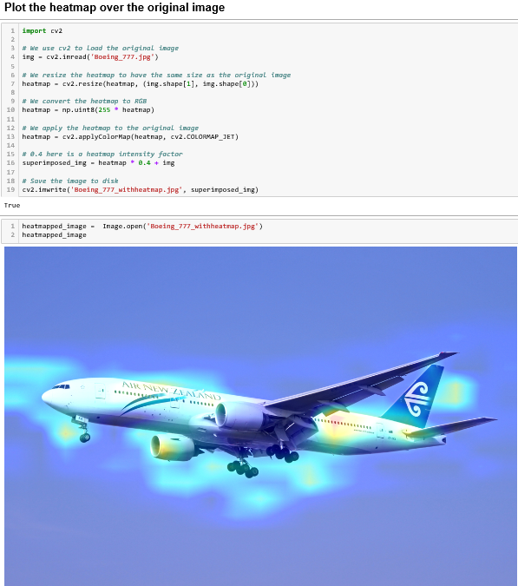

Challenges:

* Couldn’t increase the image array size more than 200*200 nor increase the first layer size to increase the accuracy due to hardware limitations. (I get OOM errors due to extra-large array sizes).
* Couldn’t create a large enough network that captures the variant to classify the aircraft model variant dataset due to the hardware limitations as well.

Lessons learned:

* Hard image processing problems are made possible with the existing deep learning techniques

YouTube URLs:

* Two minute (short): <https://youtu.be/nMAg5-aPYaY>
* 15 minutes (long): <https://youtu.be/XIISTZKJPHg>
* Project GitHub URL: <https://github.com/kaliweh/identificationofaircraft>