Aim: Write a C program to check whether a given string belongs to the language defined by a Context Free Grammar (CFG).

S → 0A1 A → 0A | 1A | ε

Algorithm:

1. User Input: Prompt the user to enter a string.

2. Check Validity: Iterate through each character in the string. If any character is not '0' or '1', set the flag to 0 (invalid).

3. Output Result: If the flag is not 1, print "String is Not Valid." If the flag is 1, check if the first character is '0' and the last character is '1'. If true, print "String is accepted," otherwise print "String is Not accepted."

4. End of Program.

Program:

#include<stdio.h>

#include<string.h>

int main(){

char s[100];

int i,flag;

int l;

printf("enter a string to check:");

scanf("%s",s);

l=strlen(s);

flag=1;

for(i=0;i<l;i++)

{

if(s[i]!='0' && s[i]!='1')

{

flag=0;

}

}

if(flag!=1)

printf("string is Not Valid\n");

if(flag==1)

{

if (s[0]=='0'&&s[l-1]=='1')

printf("string is accepted\n");

else

printf("string is Not accepted\n");

}

}

Output:

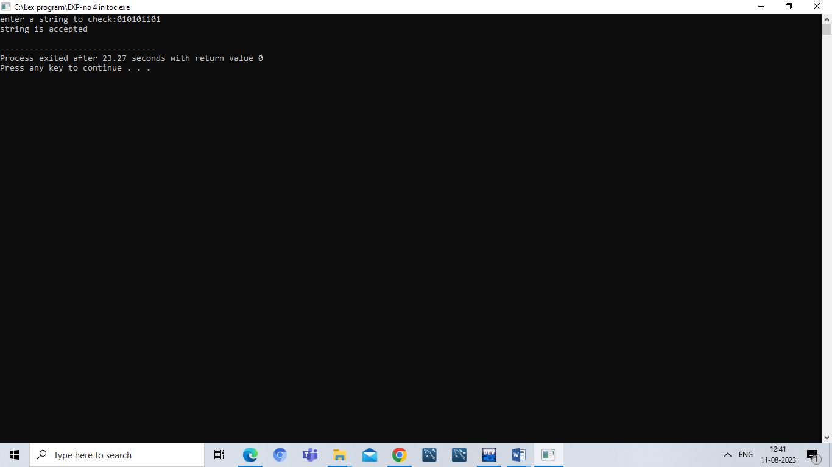

Result:

Hence ,we successfully compiled the c program for CFG.