Aim: Write a C program to check whether a given string belongs to the language defined by a Context Free Grammar (CFG)

S → 0S1 | ε

Algorithm:

Certainly! Here's a concise algorithm for the provided C code:

1. Input

- Declare a character array `s` to store the input string.

- Declare variables `i`, `flag`, `flag1`, `flag2`, and `l`.

2. User Input:

- Prompt the user to enter a string.

- Read the string using `scanf`.

3. Check Validity:

- Iterate through each character of the string:

- If a character is not '0' or '1', set `flag` to 0.

- If `flag` is 0, print "string is Not Valid" and exit.

4. Check Conditions 0n1n:

- Check if the length of the string is odd (`l % 2 != 0`):

- If true, print "The string does not satisfy the condition 0n1n" and "String Not Accepted" and exit.

- Initialize `flag1` to 1 and `flag2` to 1.

- Iterate through the first half of the string:

- If a character is not '0', set `flag1` to 0.

- Iterate through the second half of the string:

- If a character is not '1', set `flag2` to 0.

- Check conditions:

- If `flag1` is 1 and `flag2` is 1, print "The string satisfies the condition 0n1n" and "String Accepted."

- If either `flag1` or `flag2` is 0, print "The string does not satisfy the condition 0n1n" and "String Not Accepted."

5. Output:

- Print the appropriate messages based on the conditions.

This short algorithm covers the key steps of the provided C code in a more compact form.

Program:

#include<stdio.h>

#include<string.h>

int main()

{

char s[100];

int i,flag,flag1,flag2;

int l;

printf("enter a string to check:");

scanf("%s",s);

l=strlen(s);

flag=1;

for(i=0;i<l;i++)

{

if(s[i]!='0' && s[i]!='1')

{

flag=0;

}

}

if(flag!=1)

printf("string is Not Valid\n");

if(flag==1)

{

if(l%2!=0) // If string length is odd

{

printf("The string does not satisfy the condition 0n1n\n");

printf("String Not Accepted\n");

}

else

{

// To check first half contains 0s

flag1=1;

for(i=0;i<(l/2);i++)

{

if(s[i]!='0')

{

flag1=0;

}

}

// To check second half contains 1s

flag2=1;

for(i=l/2;i<l;i++)

{

if(s[i]!='1')

{

flag2=0;

}

}

if(flag1==1 && flag2==1)

{

printf("The string satisfies the condition 0n1n\n");

printf("String Accepted\n");

}

else

{

printf("The string does not satisfy the condition 0n1n\n");

printf("String Not Accepted\n");

}

}

}

return 0;

}

Output 1:

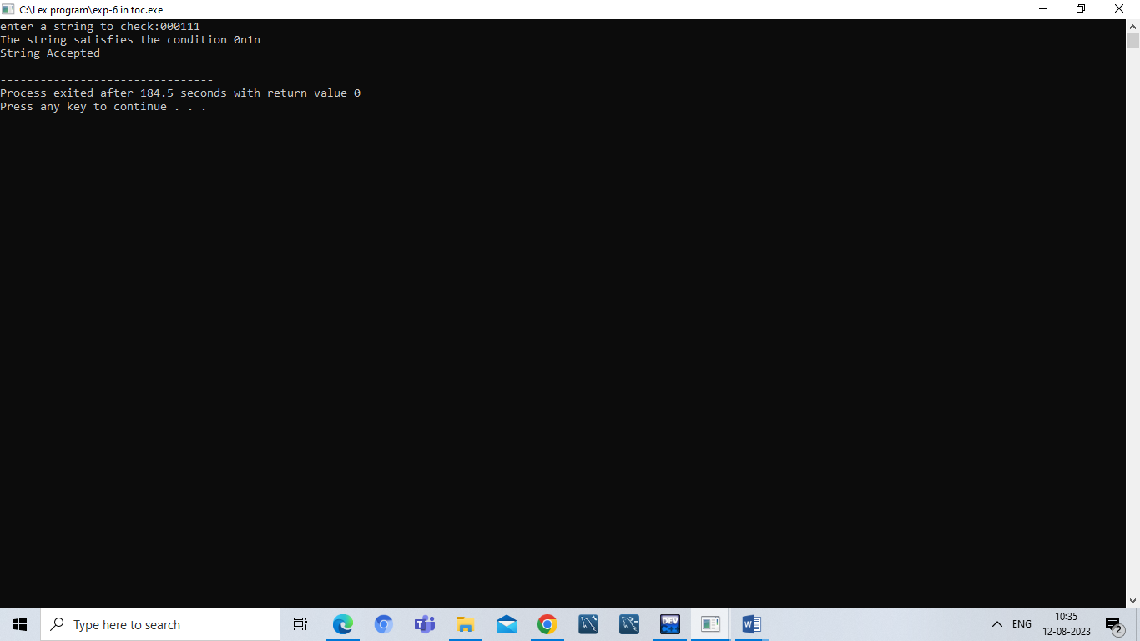

Output 2:

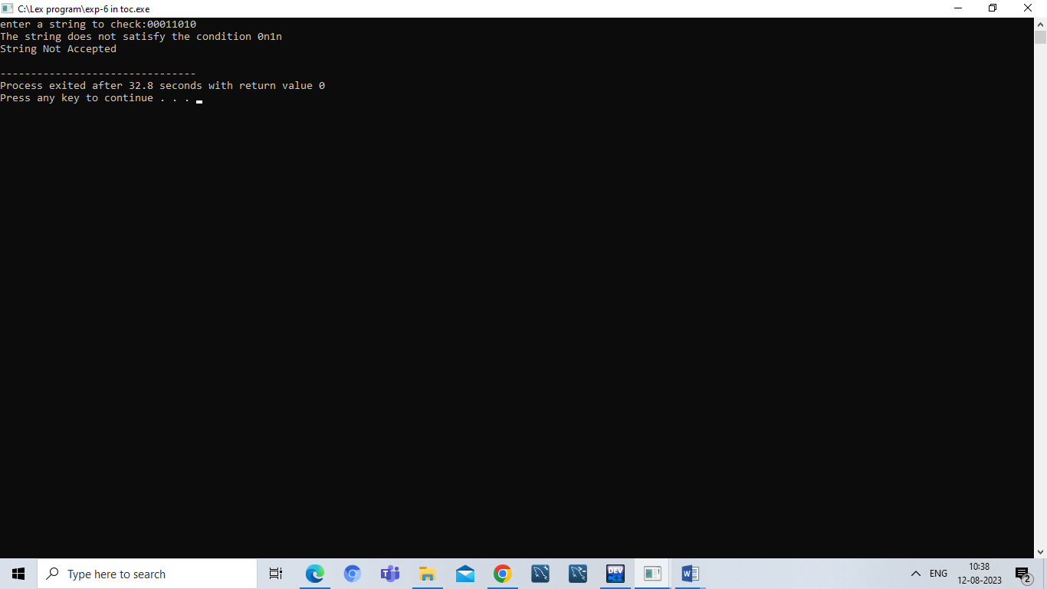

Result:

Hence ,we successfully compiled the c program for CFG.