Capstone Project:

1.Open the browser- <https://www.saucedemo.com/>

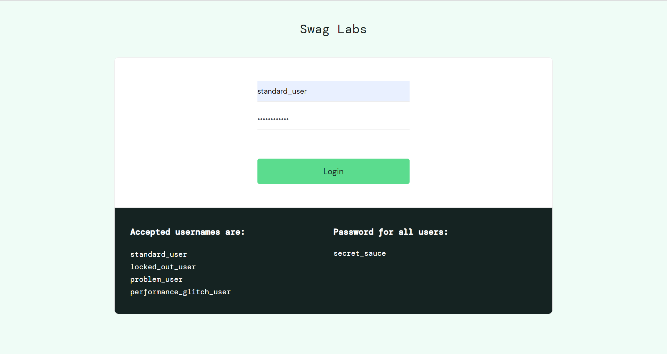

2.Login into it

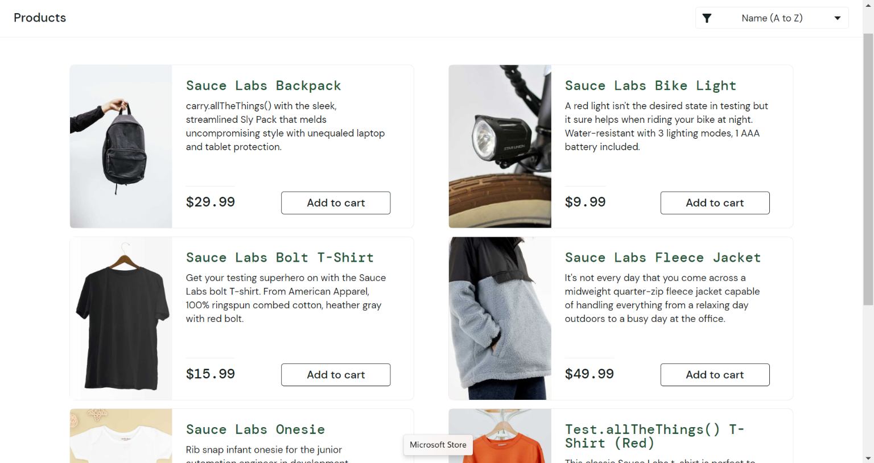

3.Add item to the cart

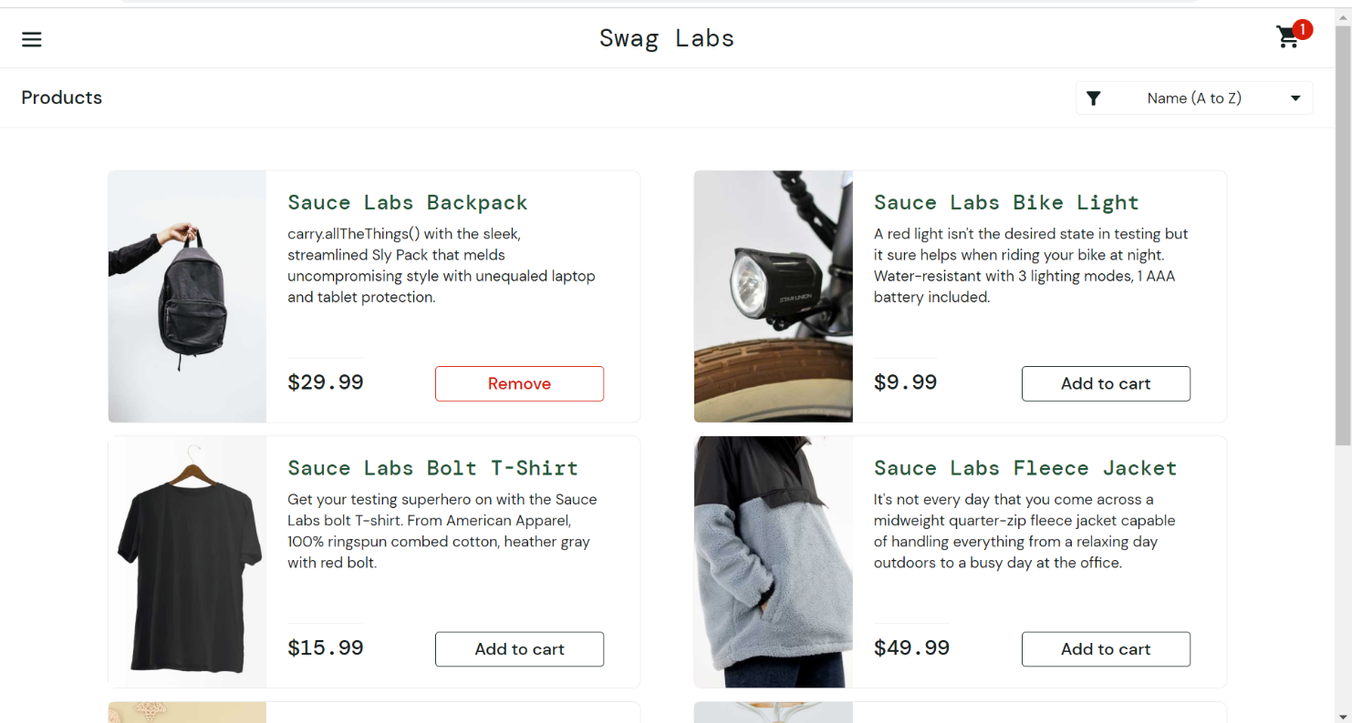

4.Go to the cart

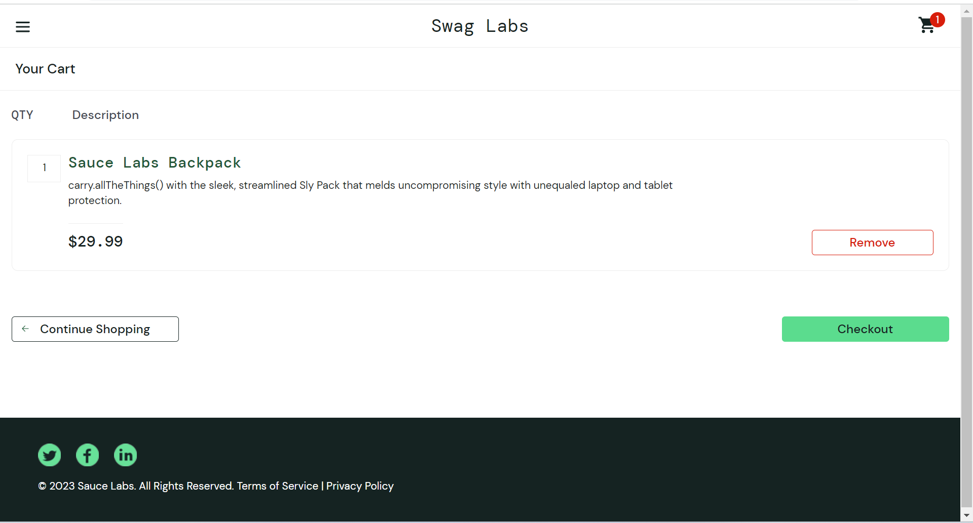

5. Enter the details

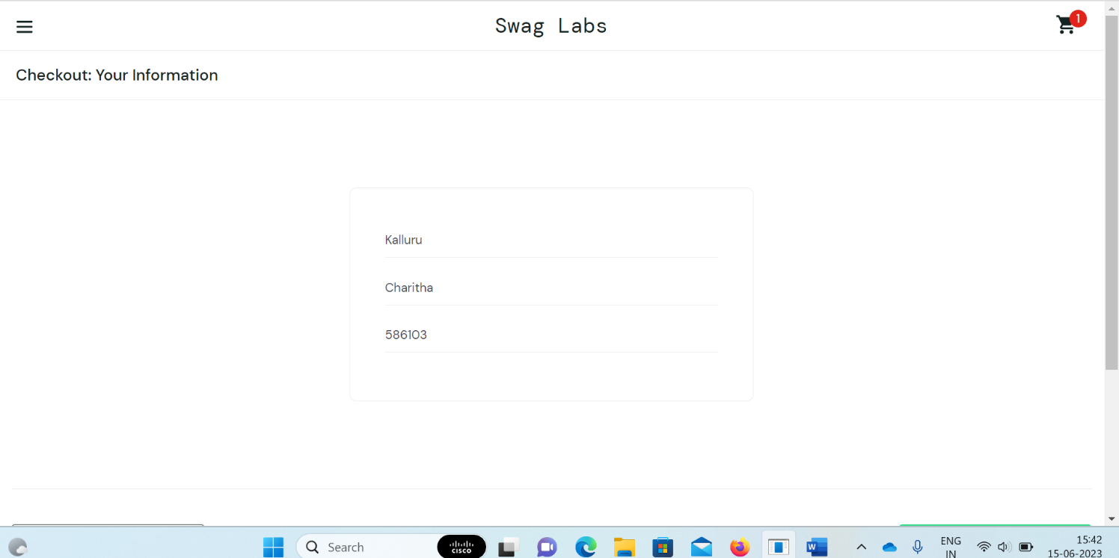

6. Checkout the product



