Do the below programs in anonymous function and IIFE

* Print odd numbers in an array

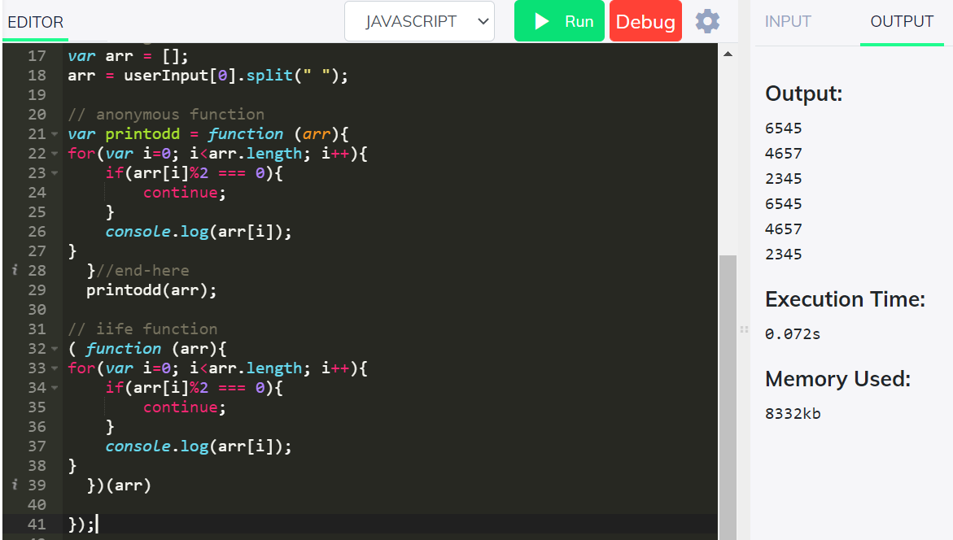

* Convert all the strings to title caps in a string array

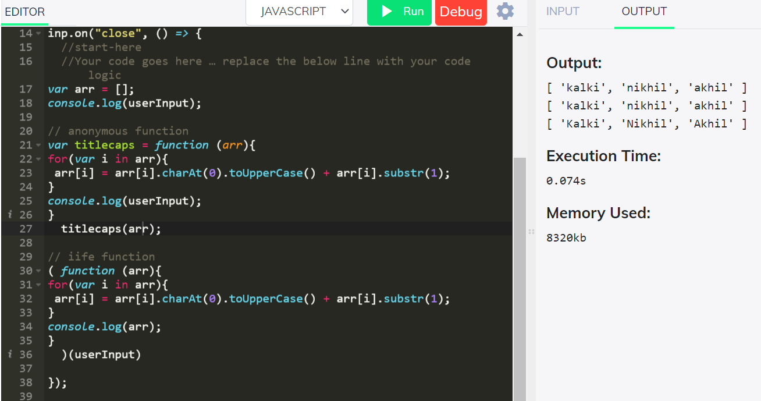

* Sum of all numbers in an array

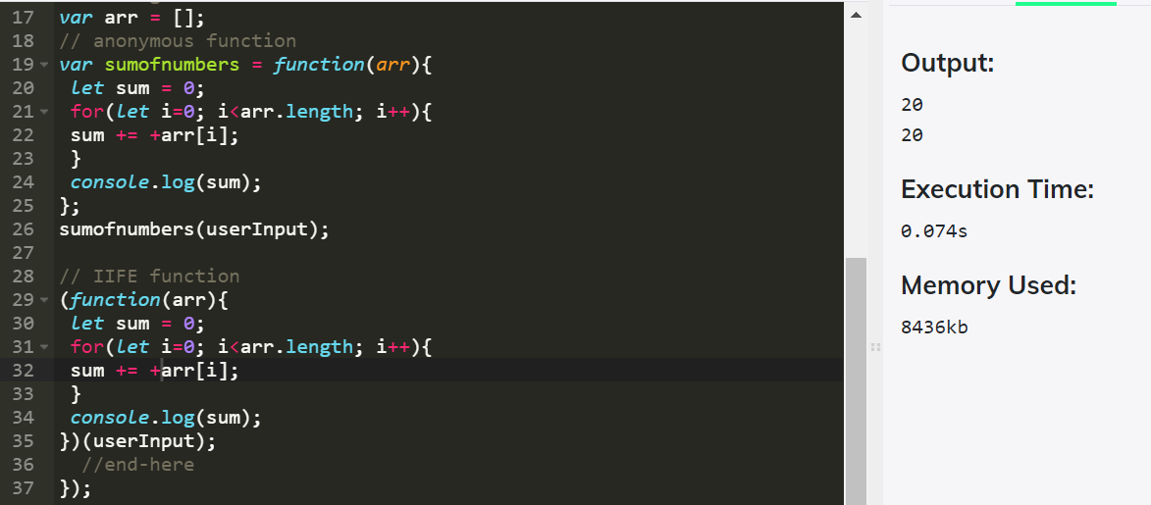

* Return all the palindromes in an array

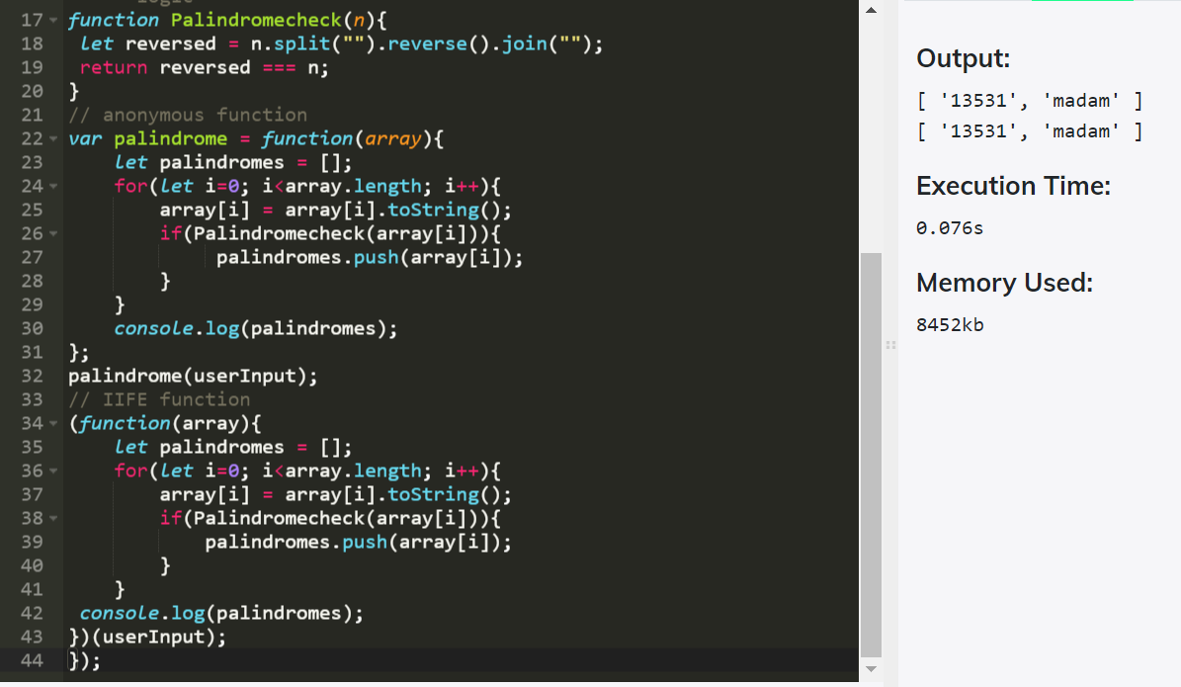

* Return median of two sorted arrays of same size

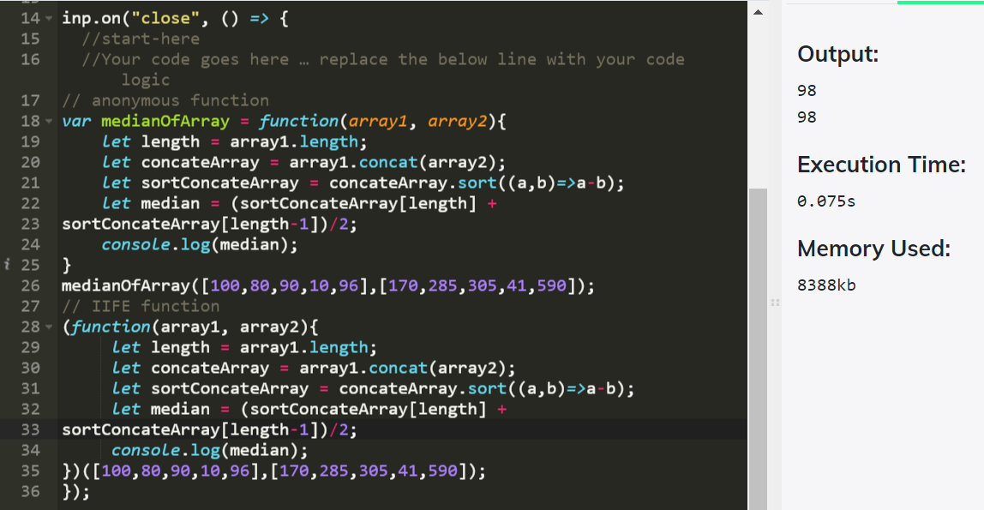

* Remove duplicates from an array

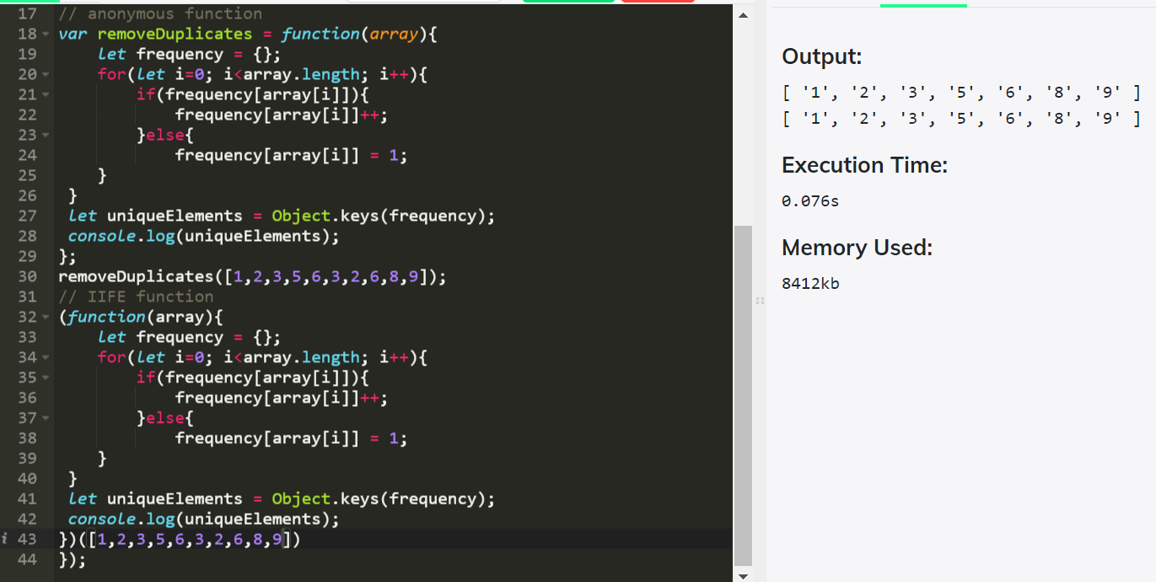

* Rotate an array by k times and return the rotated array

