Solving problems using array functions on rest countries data.

1. Get all the countries from Asia continent / “region” using the Filter function

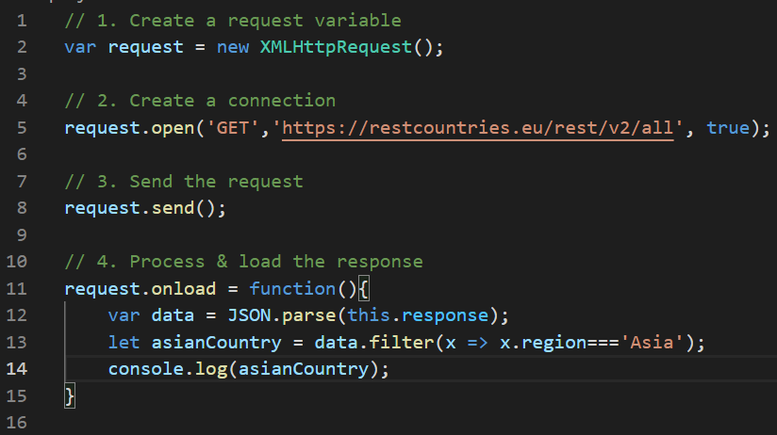

2. Get all the countries with a population of less than 2 lacs using Filter function

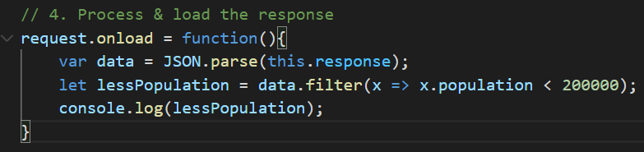

3. Print the following details name, capital, flag using forEach function

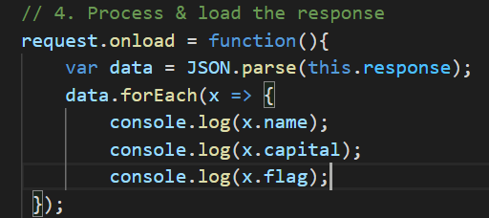

4. Print the total population of countries using reduce function.

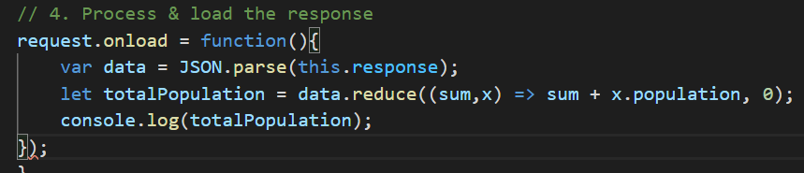

5. Print the country which uses US Dollars as currency

