Q.1) html and script.js file and run a for loop on the data and print all the country names in the console.

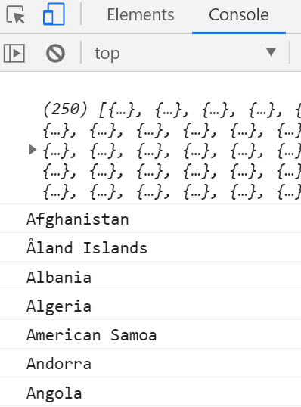

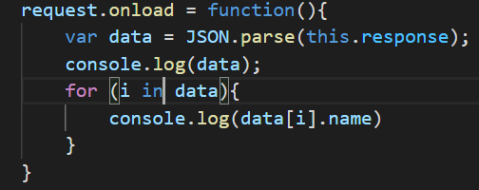

Q.2) Write a write up on Difference between copy by value and copy by reference.

**Copy by value:**

In a primitive data-type when a variable is assigned a value, we can imagine that a box is created in the memory. This box has a sticker attached to it i.e., the variable name. Inside the box the value assigned to the variable is stored.

Values are assigned to x & y (numbers or strings). further these x & y were copied to a & b (a = x; b =y).

Even though ‘x’ and ‘a’ as well as ‘y’ and ‘b’ contains the same value they are not connected to each other. It is so because the values are directly copied into the new variables.

Changes taking place in one does not affect the other.

**Copy by reference:**

In case of a non-primitive data-type the values are not directly copied. When a non-primitive data-type is assigned a value, a box is created with a sticker of the name of the data-type.

However, the values it is assigned is not stored directly in the box. It itself assigns a different memory location to store the data. The address of this memory location is stored in the box created.

Values are assigned to ‘user’ (arrays/objects). further this user was copied to ‘admin’ (admin = user).

Here both ‘user’ and ‘admin’ are storing the address of the memory location. And when one changes the values in the allocated memory it is reflected in the other as well.

To elaborate, copy by reference is like having two keys of the same room shared between ‘admin’ and ‘user’. If one of them alters the arrangement of the room the other would experience it as well.

Q.3) How to copy by value a composite data type (array+objects).

1. Using the spread ( ... ) operator.

Changes in first array not to affect second array. We can use the concept of SPREAD OPERATOR ( … ).

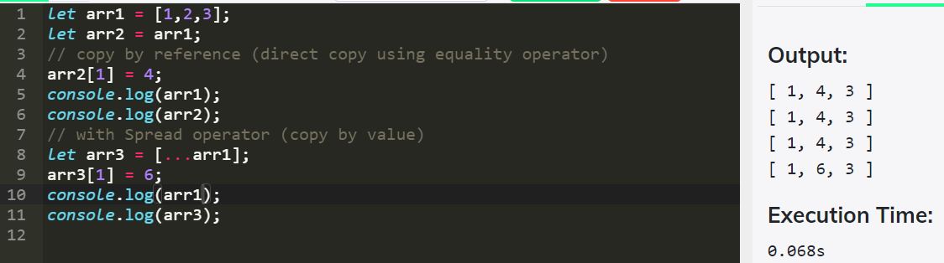

1. Using the Object.assign() method.

The method copies all each and each own properties from source objects to a target object. It returns the target object. This will be a shallow copy.

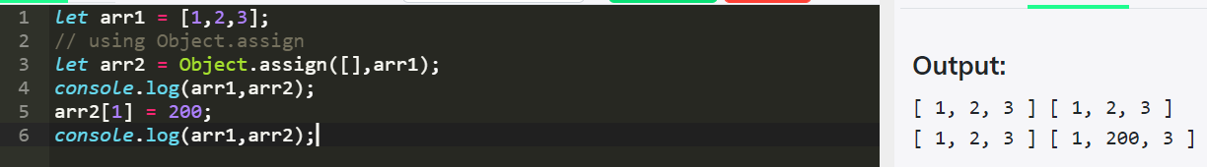

1. Using the JSON.stringify() and JSON.parse() methods.

JSON.parse() takes a JSON string and transforms it into a JavaScript object. JSON.stringify() takes a JavaScript object and transforms it into a JSON string. Using JSON.parse() and JSON.stringify() for copy performs deep copy .

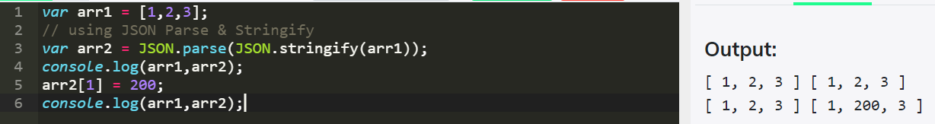

Q.4) JSON task <https://medium.com/@reach2arunprakash/guvi-zen-code-sprint-javascript-practice-problems-in-json-objects-and-list-49ac3356a8a5>

**Problem 0. Playing with JSON object’s Values:**

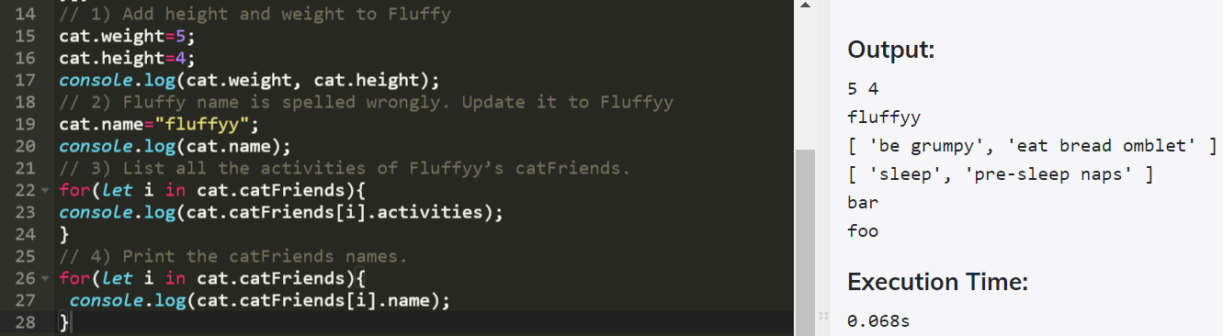

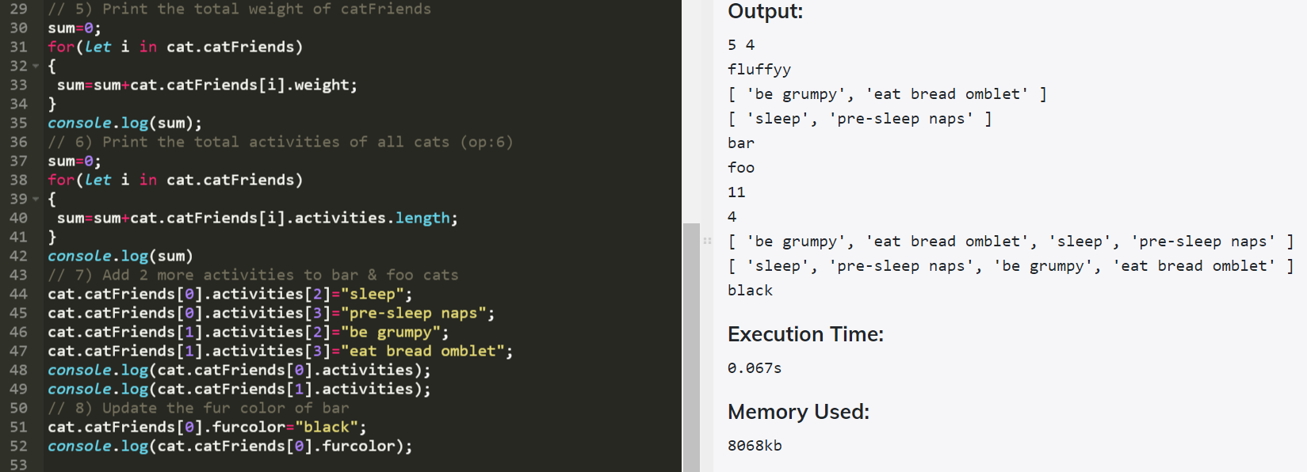

**Problem 0 (b): Iterating with JSON object’s Values**

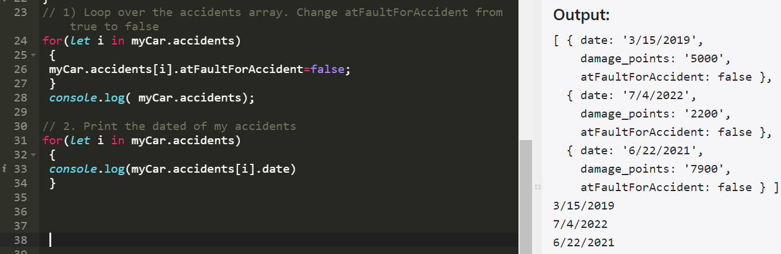

**Problem 1. Parsing an JSON object’s Values** -> Write a function called “printAllValues” which returns an newArray of all the input object’s values

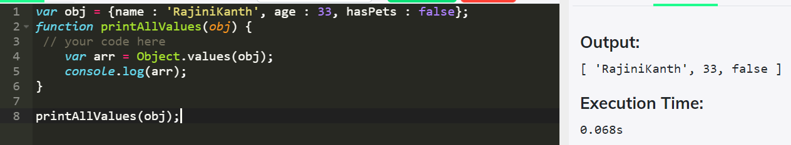

**Problem 2. Parsing an JSON object’s Keys:** -> Write a function called “printAllKeys” which returns an newArray of all the input object’s keys.

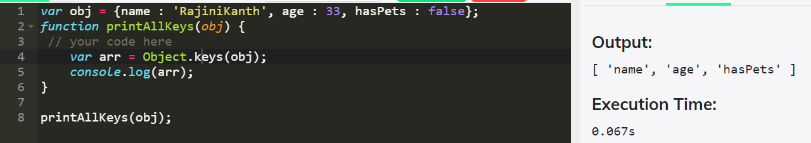

**Problem 3. Parsing an JSON object and convert it to a list:**

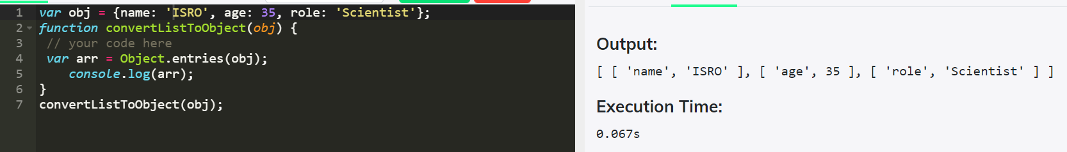

**Problem 4. Parsing a list and transform the first and last elements of it ->** Write a function ‘transformFirstAndLast’ that takes in an array, and returns an object with:

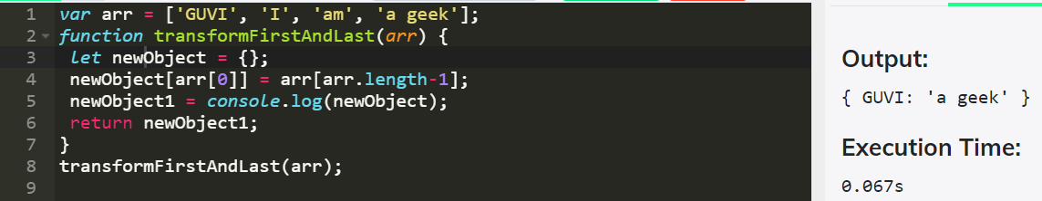

**Problem 5. Parsing a list of lists and convert into a JSON object:**

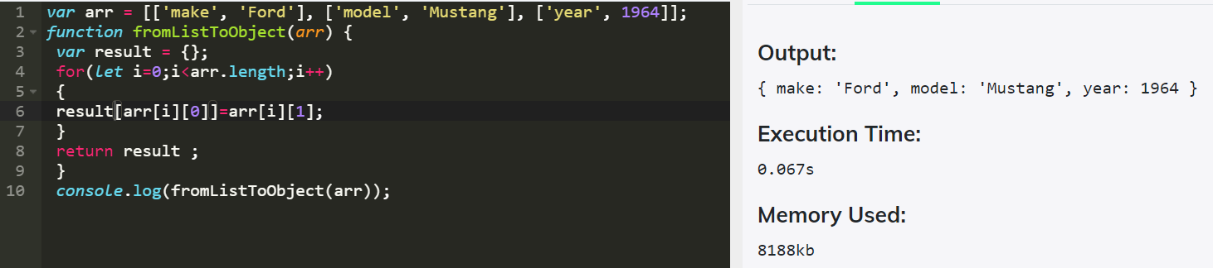

**Problem 6. Parsing a list of lists and convert into a JSON object ->** Write a function called “transformGeekData” that transforms some set of data from one format to another.

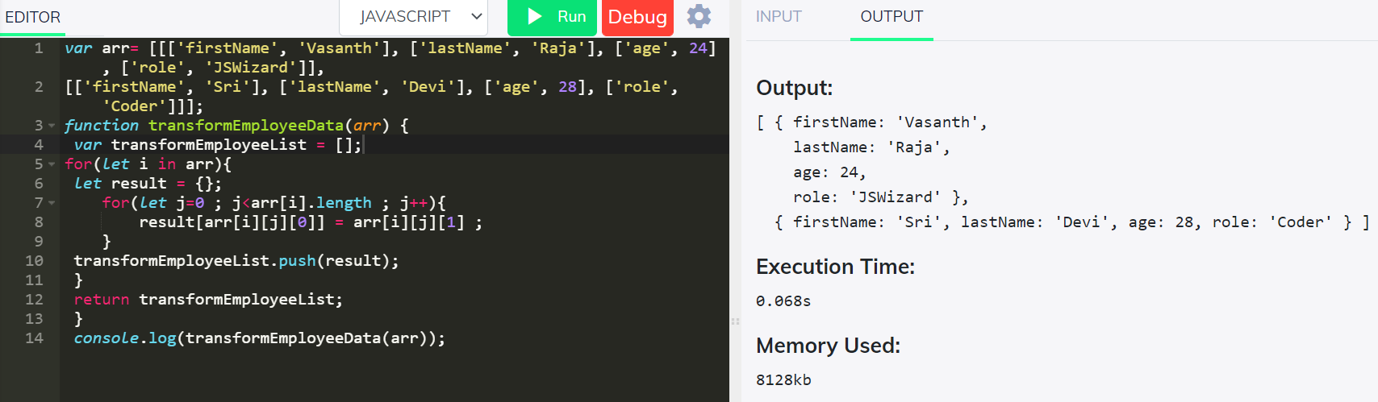

**Problem 7. Parsing two JSON objects and Compare ->** Write an “assertObjectsEqual” function from scratch.  
Assume that the objects in question contain only scalar values (i.e., simple values like strings or numbers).  
It is OK to use JSON.stringify().

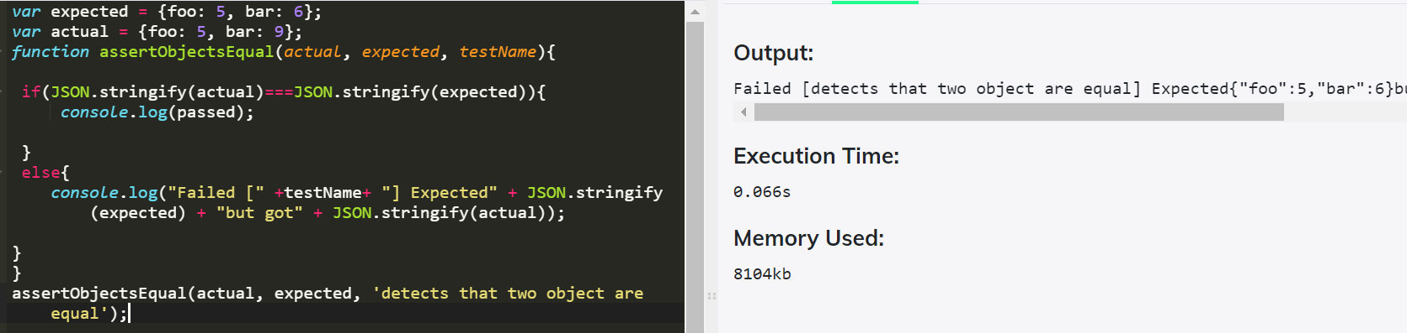

**Problem 8. Parsing JSON objects and Compare ->** I have a mock data of security Questions and Answers. You function should take the object and a pair of strings and should return if the quest is present and if its valid answer

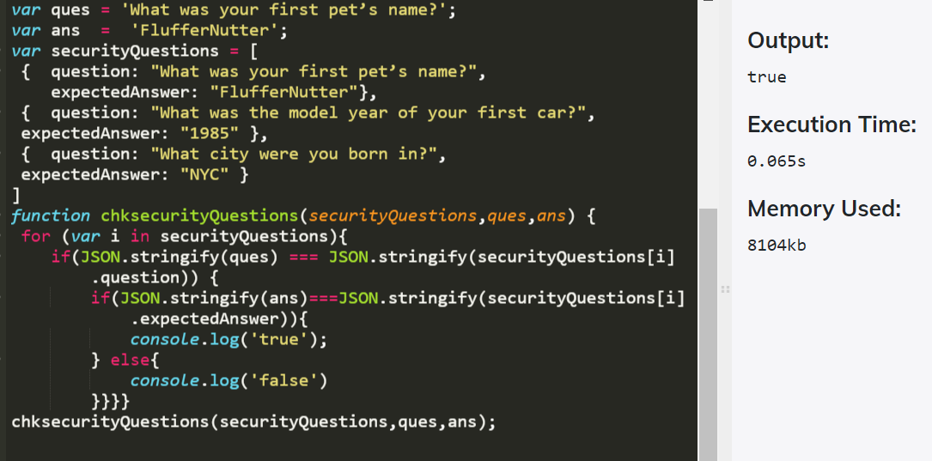

**Problem 9. Parsing JSON objects and Compare ->** Write a function to return the list of characters below 20 age

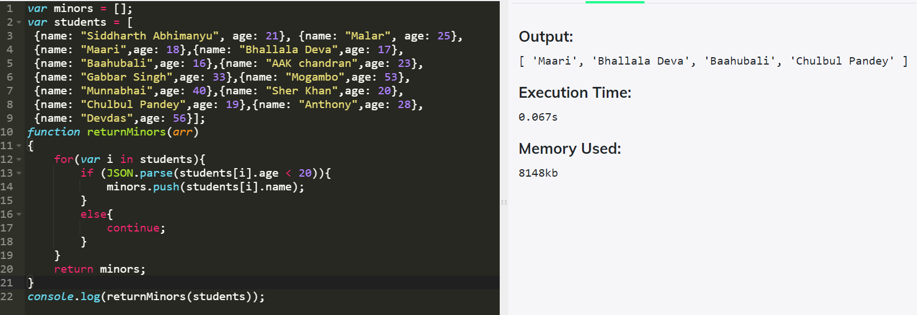

Q.5) Try the rest countries api. Extract and print the total population of all the countries in the console. use the html template. <https://restcountries.eu/rest/v2/all>

