BROKEN ACCESS CONTROL
Unauthenticated Admin-Level Course Management API
CVSS v3.1 Score: 9.8 — CRITICAL

Report ID | CVE-2026-DATAVALLEY-001
Reporter | Kalla Gowtham
Date | 30 March 2026
Severity | CRITICAL — CVSS v3.1: 9.8 (AV:N/AC:L/PR:N/UI:N/S:U/C:N/I:H/A:H)
Category | Broken Access Control (OWASP Top 10 – A01:2021)
CWE | CWE-285 – Improper Authorization
Affected Product | Learning Management System (LMS) – ████████████
Affected Endpoint | https://██████████████████████████████/api/admin/courses/69a7d79fc0ded3e576805d3a
Status | UNPATCHED — LIVE & EXPLOITABLE

1. Executive Summary
A critical broken access control vulnerability was identified in the Learning Management System (LMS) backend API of ████████████. The administrative endpoint responsible for modifying course content accepts PUT requests with no proper authentication or authorization mechanism. An attacker can send a crafted HTTP request using only the trivial header “Authorization: admin” — no valid JWT, Bearer token, session cookie, or API key is required — and successfully update any course on the live platform.

Changes made via this endpoint are immediately reflected across the platform for all enrolled users. This vulnerability completely bypasses the intended authentication and role-based access control (RBAC) system, exposing the entire course catalog to unauthenticated tampering by any individual with basic knowledge of HTTP requests.

2. Detailed Vulnerability Description
The API endpoint below accepts PUT requests to modify core course attributes including title, headline, banner image, description, and batch assignments:

https://██████████████████████████████/api/admin/courses/69a7d79fc0ded3e576805d3a

Authentication Mechanism Observed
Factor | Observation
Authorization Header Used | Authorization: admin
JWT / Bearer Token Required? | NO — Not validated
Session Cookie / API Key? | NO — Not required
Server Role Validation? | NO — Server does not verify requester identity or privileges

This violates the fundamental security principle of least privilege and allows any unauthenticated user to act as a full administrator for all course content on the platform.

3. Proof of Concept (PoC)
3.1 Attack Request (cURL)
curl -X PUT https://██████████████████████████████/api/admin/courses/69a7d79fc0ded3e576805d3a \
-H "Authorization: admin" \
-F "title=TCS NQT Preparation" \
-F "headline=BATCH B21" \
-F "courseId=course_1772607389841_d1cf88jr7" \
-F "banner=@/path/to/image.png"

3.2 Server Response (HTTP 200 OK)
{
"message": "Course updated successfully",
"course": {
"_id": "69a7d79fc0ded3e576805d3a",
"title": "TCS NQT Preparation",
"headline": "BATCH B21",
"banner": "course_1772607389841_d1cf88jr7/img.png",
...
}
}

3.3 Live Platform Impact — Visual Proof
The screenshot below confirms that the unauthorized course modification was immediately applied and is now visible to all enrolled students on the live platform:

Figure 1 — Live Platform Screenshot: Enrolled Courses Showing Tampered Content
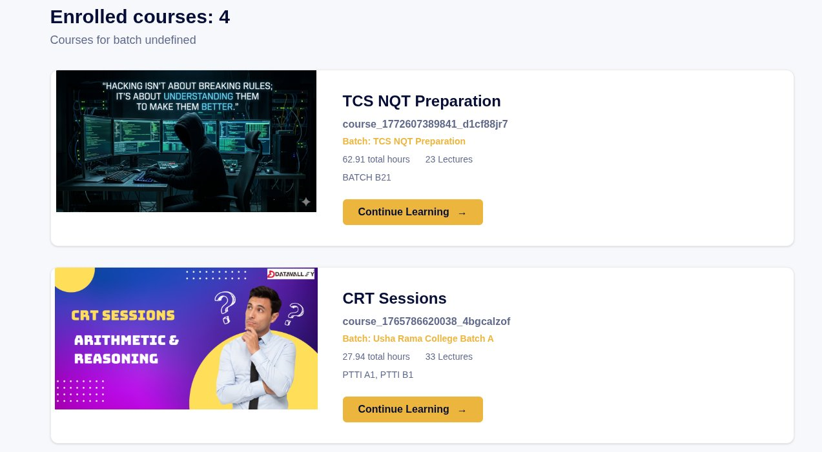
Confirmed: Course title changed to "TCS NQT Preparation" with headline "BATCH B21" is visible on the enrolled courses page for all active students. The banner image has been replaced with an attacker-supplied image.

4. Business & Security Impact
Because this vulnerability requires zero valid credentials, it is trivially exploitable. Any individual with basic knowledge of cURL or Postman can carry out the following attacks:

- Course defacement & sabotage — Modify titles, descriptions, or banners to offensive, misleading, or malicious content visible to all enrolled students.
- Corruption of learning material — Replace video links, upload inappropriate banners, or structurally alter course content.
- Targeting enrolled students — Changes appear instantly on enrolled users’ dashboards, affecting thousands of learners simultaneously.
- Financial damage — Alteration of premium/paid courses can trigger mass refund requests, chargebacks, and direct revenue loss.
- Reputation destruction — Injection of fake courses, harmful imagery, or offensive batch names under the official brand causes lasting reputational harm.
- Automated mass attack — A simple script can modify hundreds of courses in seconds with no rate limiting in place.
- Chained exploitation — Phishing links can be embedded in course content, or this vulnerability can serve as a stepping stone for further privilege escalation.

⚠ Real-World Risk Level: EXTREMELY HIGH
No authentication is needed. Only basic knowledge of cURL or Postman is sufficient to exploit this vulnerability. The platform is live and publicly accessible.

5. Recommended Remediation
The following actions should be taken immediately given the critical severity. Timeline recommendation: fix within 24–48 hours.

- Enforce proper JWT-based authentication — Require a valid cryptographically-signed JWT Bearer token with an admin role claim on all /api/admin/* endpoints. Reject any request without a verifiable token.
- Remove the weak Authorization header logic — Immediately remove any server-side code that accepts the plain string "admin" as a valid authorization value.
- Implement server-side RBAC authorization checks — Verify user.role === "admin" (or equivalent claim) before processing any course modification request.
- Apply rate limiting and audit logging — Introduce request rate limiting on all admin API endpoints to mitigate automated attack scripts. Log all admin actions with user identity, IP, and timestamp.
- Full security audit of all /api/admin/* routes — Conduct a comprehensive review of all administrative endpoints for similar broken access control vulnerabilities, as this pattern may extend beyond course management.
- Penetration test post-remediation — After applying fixes, conduct a formal penetration test to verify that all admin endpoints are properly secured.

6. Additional Notes & Disclosure
Data Accessed | No user data was accessed or exfiltrated during testing.
Discovery Method | Identified during routine security research / responsible disclosure.
Platform Status | LIVE and publicly accessible — vulnerability is currently unpatched.
Reporter Availability | Available to provide exact test payloads and assist with post-fix verification upon request.

This report is submitted in good faith for responsible disclosure purposes. — Reporter: Kalla Gowtham — Date: 30 March 2026

