COMP 3133 – Full Stack Development II
Lab 08 – Angular Data Binding & Directives

Topics:
- Angular Data Binding & Directives
- Building Custom Pipes & Directives

Developer Note:
When working on your exercises, please use the same Angular project from previous labs. This way you way you won’t have to re-generate a new Angular application every lab.
Only submit the files components, typescript files that you have created and not the entire application.
Exercise #1 – Directives and Data Binding
* If you have not previously completed part one of Angular Tutorial, complete it first.
https://angular.dev/tutorials/learn-angular
- Complete Part Two of Angular Tour of Hero’s Tutorial on Structural Directives and Data Binding.
https://angular.io/tutorial/toh-pt2

Exercise #2 – Creating a Custom Pipe with Angular CLI
Reference: https://www.digitalocean.com/community/tutorials/angular-custom-pipes-angular

- Use the following Angular CLI command to generate a Custom Pipe named remove-spaces
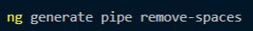
- Review the generated boiler plate code and navigate to the app.module.ts file and review the updated import statements and @NgModule declarations for the generated remove-spaces Pipe.
- Update the mock.heros.ts file from Exercise #1. Add the following list items to the array of Heros
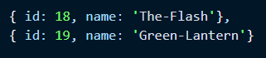
- Write the code in the Custom Pipe to replace any occurrence of a dash ‘-‘ with an empty spaces.
- Once completed apply it the hero name in the file heros.component.html to filter out the dashes in names
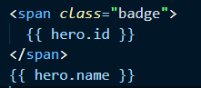
Exercise #3 – Creating a Custom Directive with Angular CLI
Reference: https://angular.dev/guide/directives
https://medium.com/@krishsurya1249/angular-13-directives-and-custom-directives-86a226cbc26e
https://adrianmejia.com/creating-custom-angularjs-directives-for-beginners/

- Use the following Angular CLI command to generate a Custom Directive named inputFormat
- Create a textbox input element in the HTML markup that has the input-format Directive as an attribute.
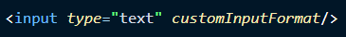
- In the generated input-format.directive.ts file implement the HostListener interface and ElementRef class
- Implement the HostListener interface and add logic such that when the User clicks away from the textbox (OnBlur event) the textbox text will be converted to UpperCase text.
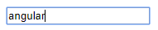
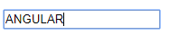
Homework: Nested Components

- Complete Part Three of Angular Tour of Hero’s Tutorial on Nested Child Components.
https://angular.io/tutorial/toh-pt3

Submission
  - Screenshot(s) of appropriate output. You may add all the screenshots in word document and upload it. [Do not put screenshots in project/zip file].
  - Create a zip file of your entire project folder and submit.
  - Your GitHub project link.

