COMP 3133
Lab Exercise 6

Arkadii Akopian
ID: 101513972
CRN: 50581

March 14, 2026

Table of contents
1. Exercise 1 3
2. Exercise 2 4
3. Exercise 3 4
4. Exercise 4 5
5. GitHub link 5

Exercise 1
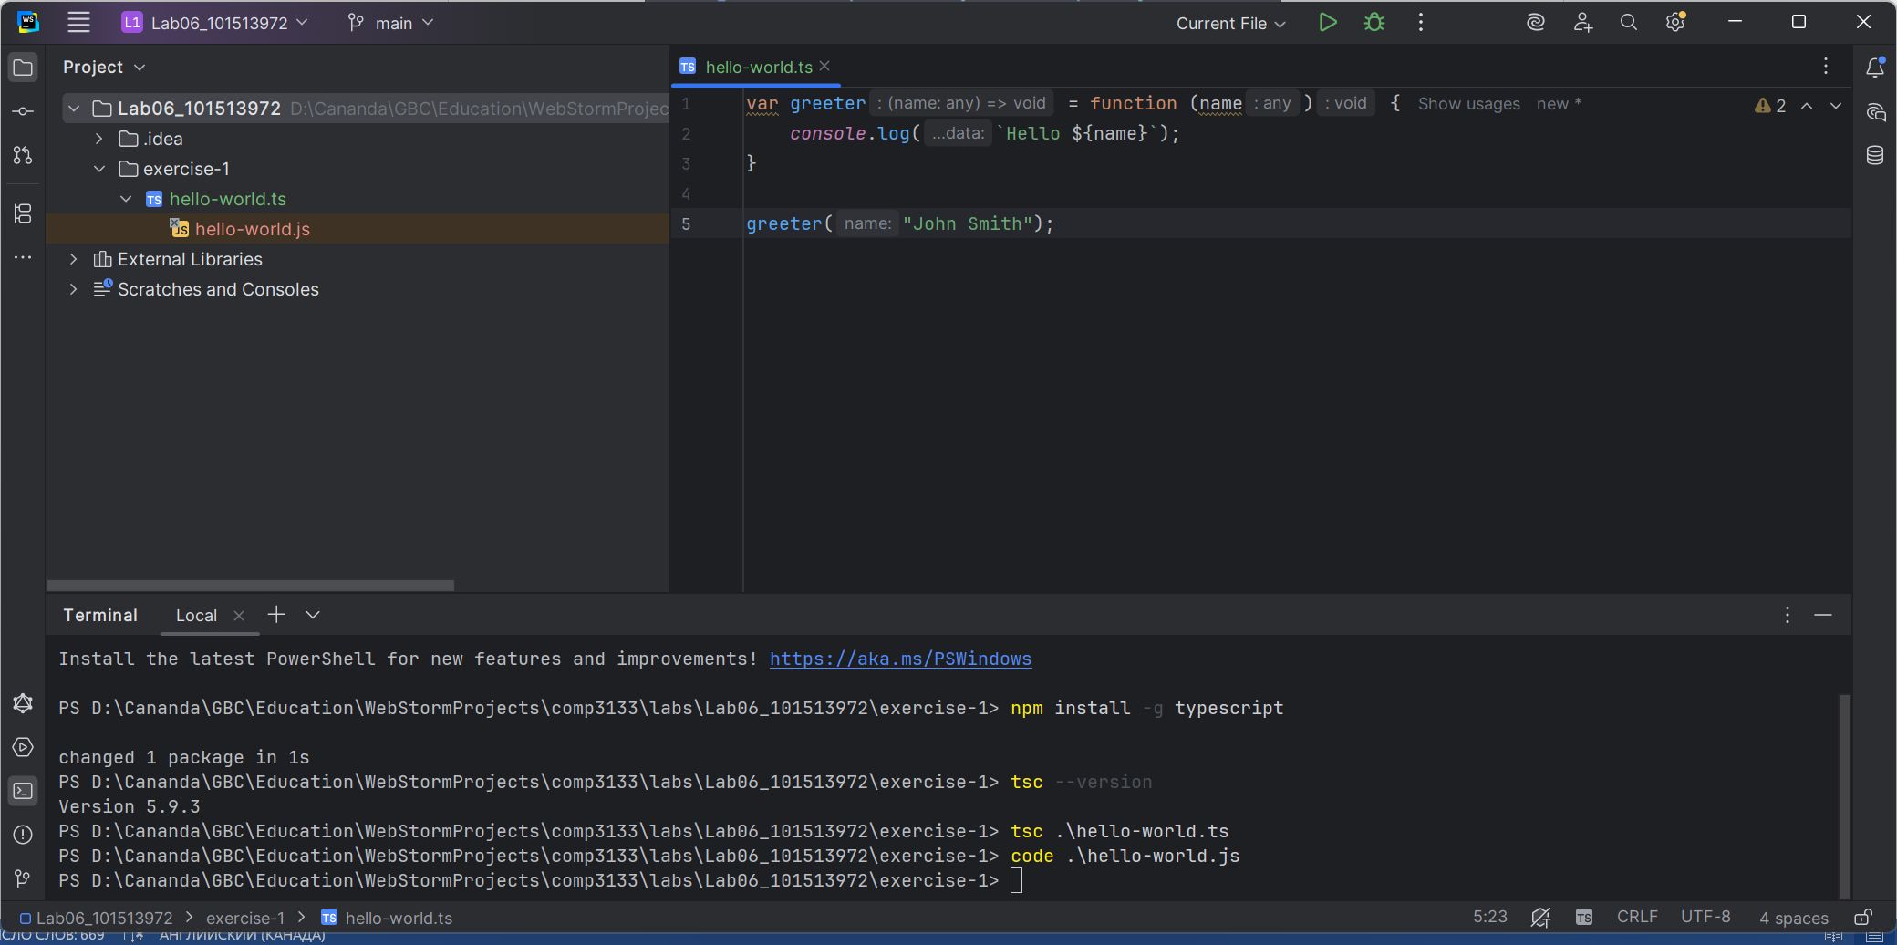

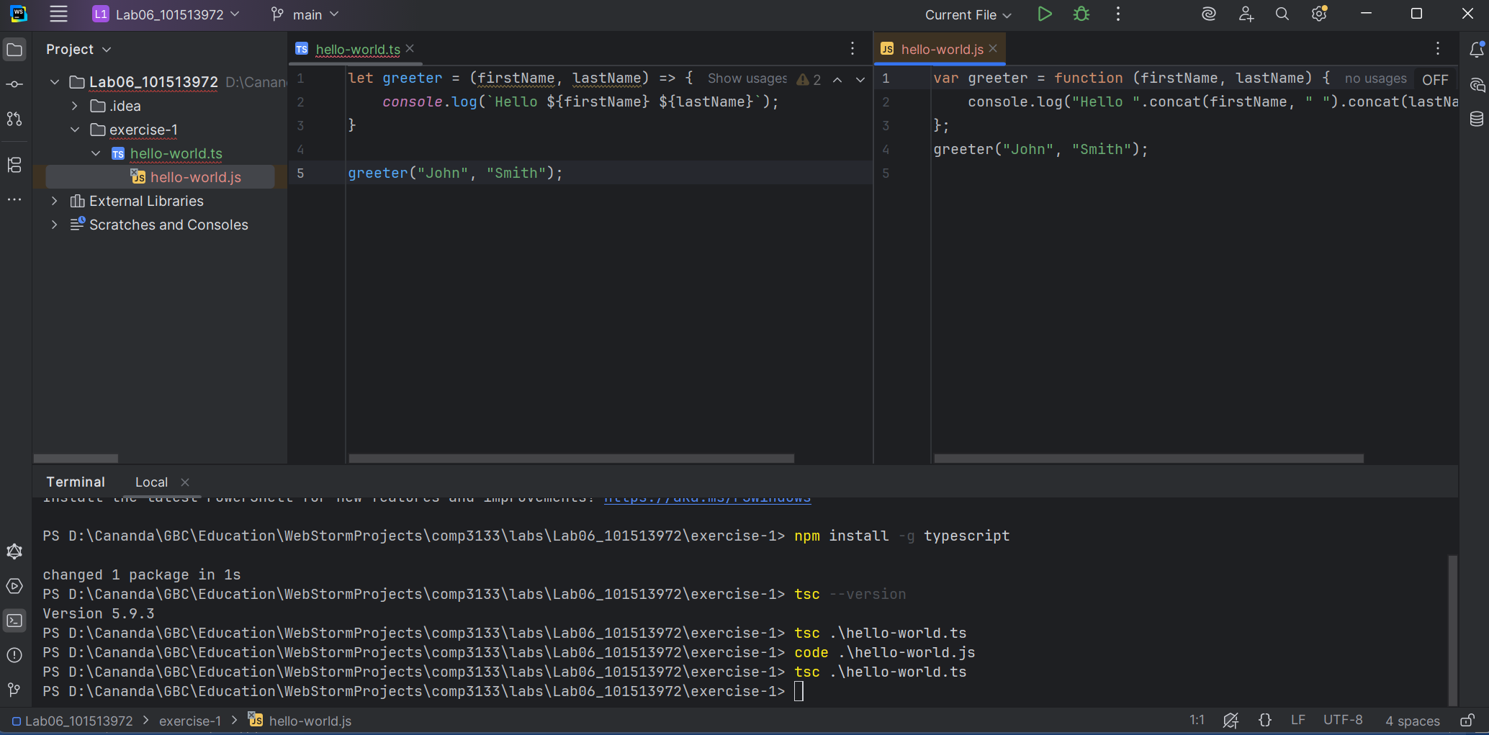

Exercise 2
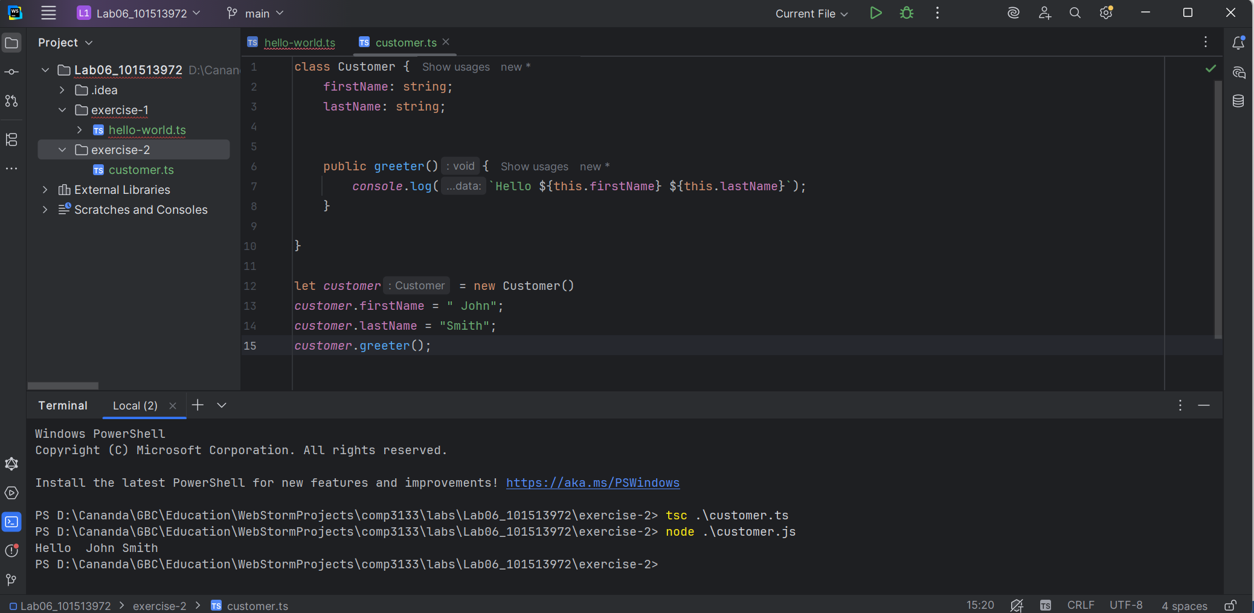

Exercise 3
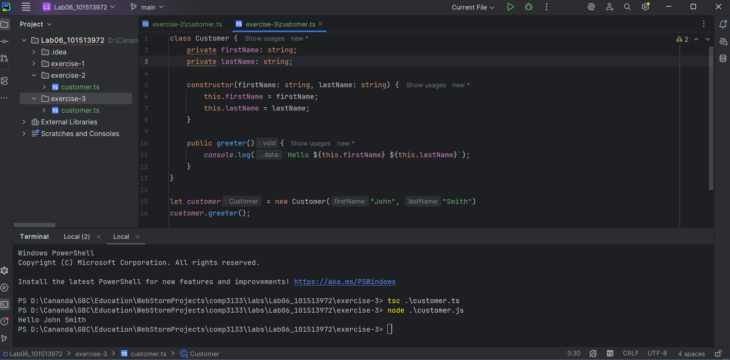

Exercise 4
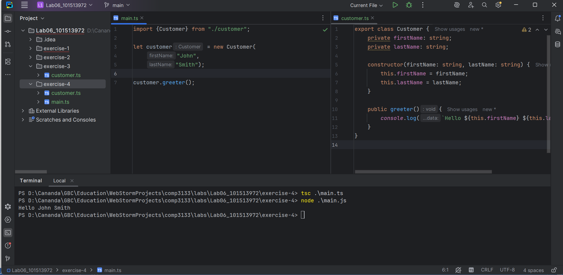

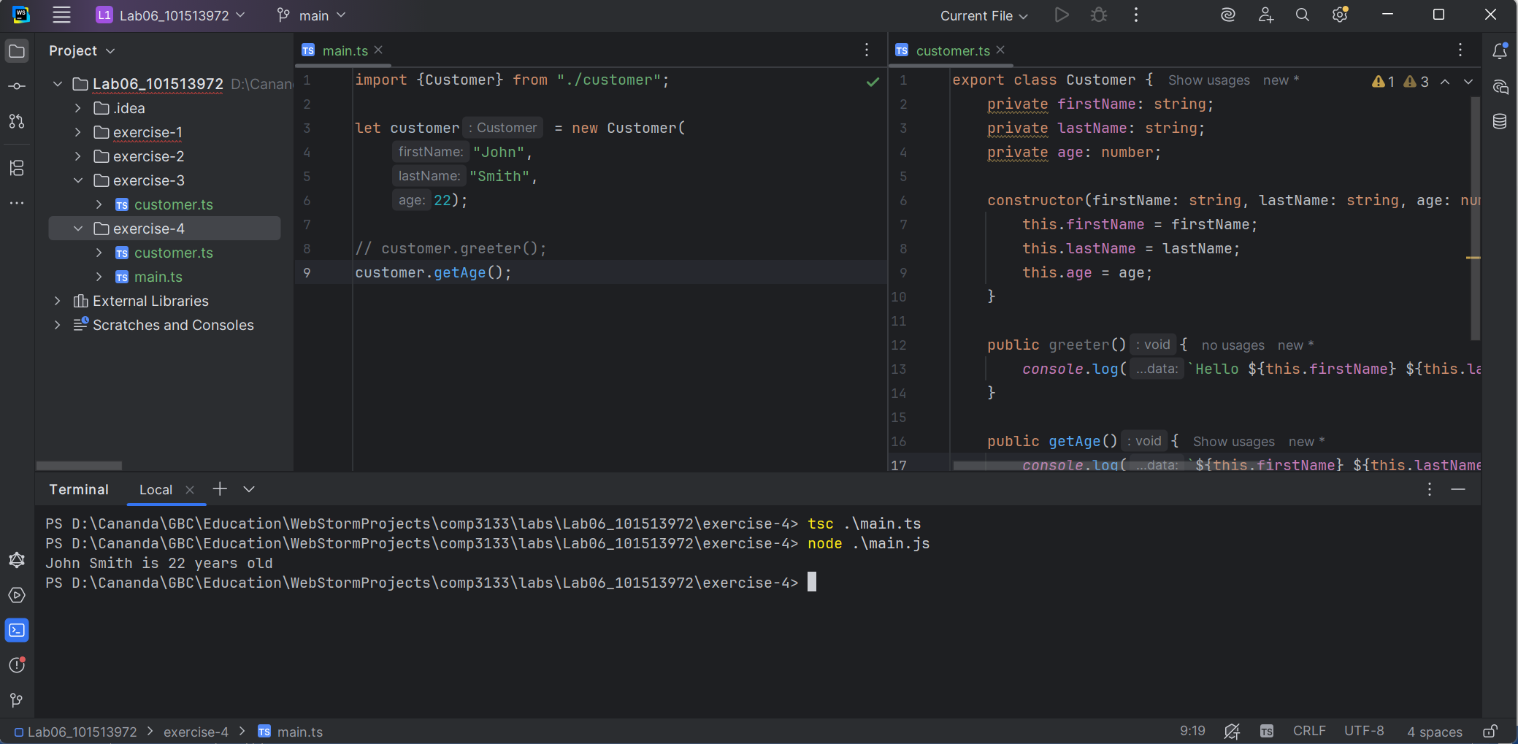

GitHub link
https://github.com/kalllak17/comp3133/tree/main/Lab06_101513972

