COMP 3133
Lab Exercise 7

Arkadii Akopian
ID: 101513972
CRN: 50581

March 18, 2026

Table of contents
1. Exercise 1 3
2. Exercise 2 5
3. Exercise 3 6
4. GitHub link 7

Exercise 1
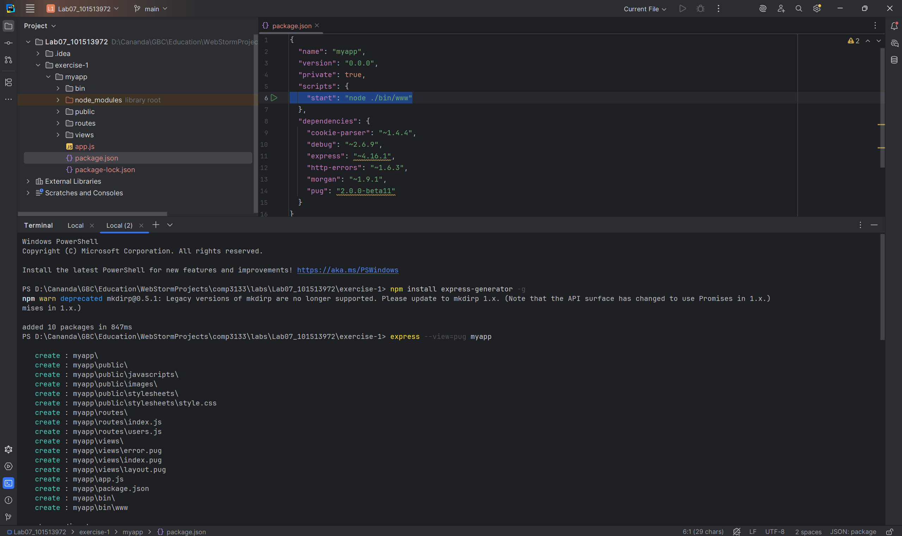
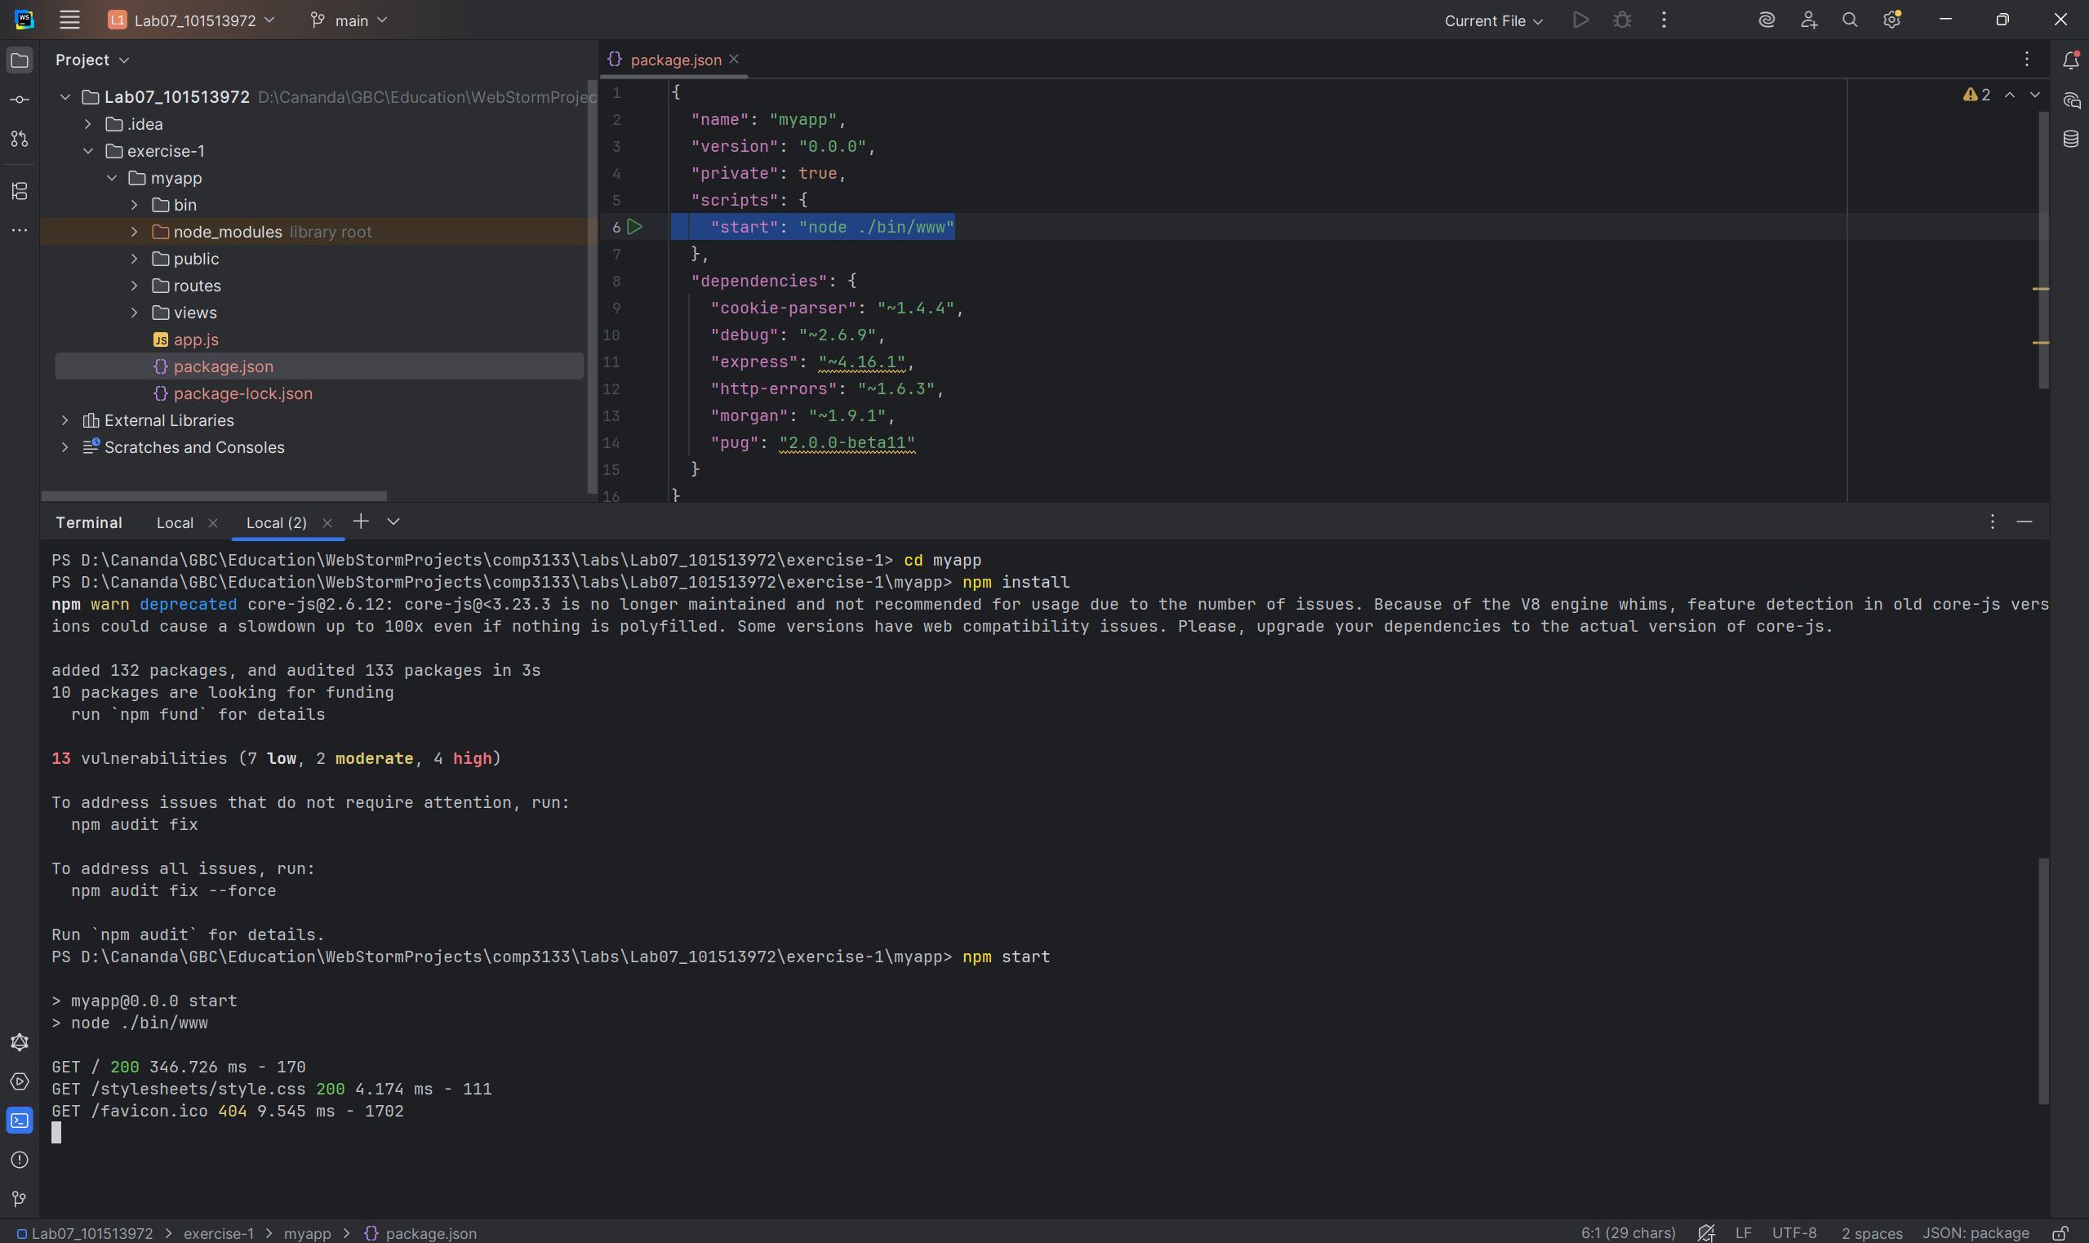
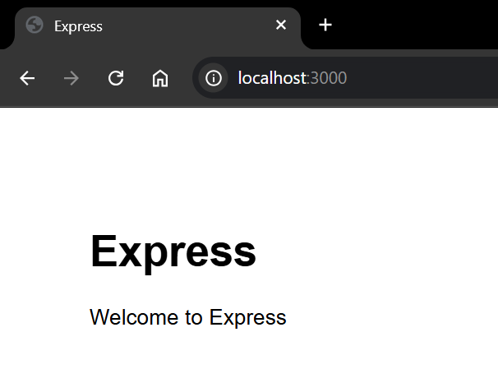

Exercise 2
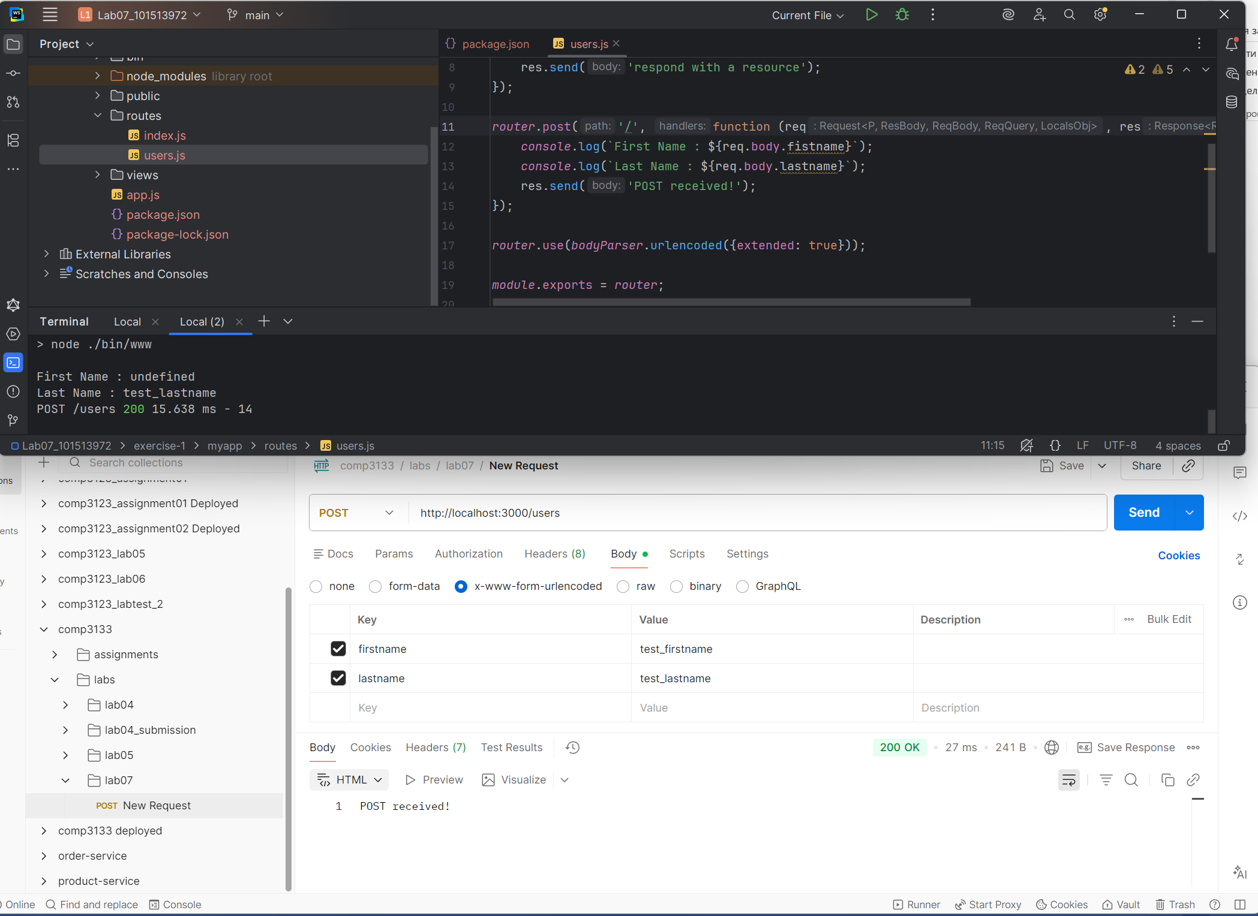

Exercise 3
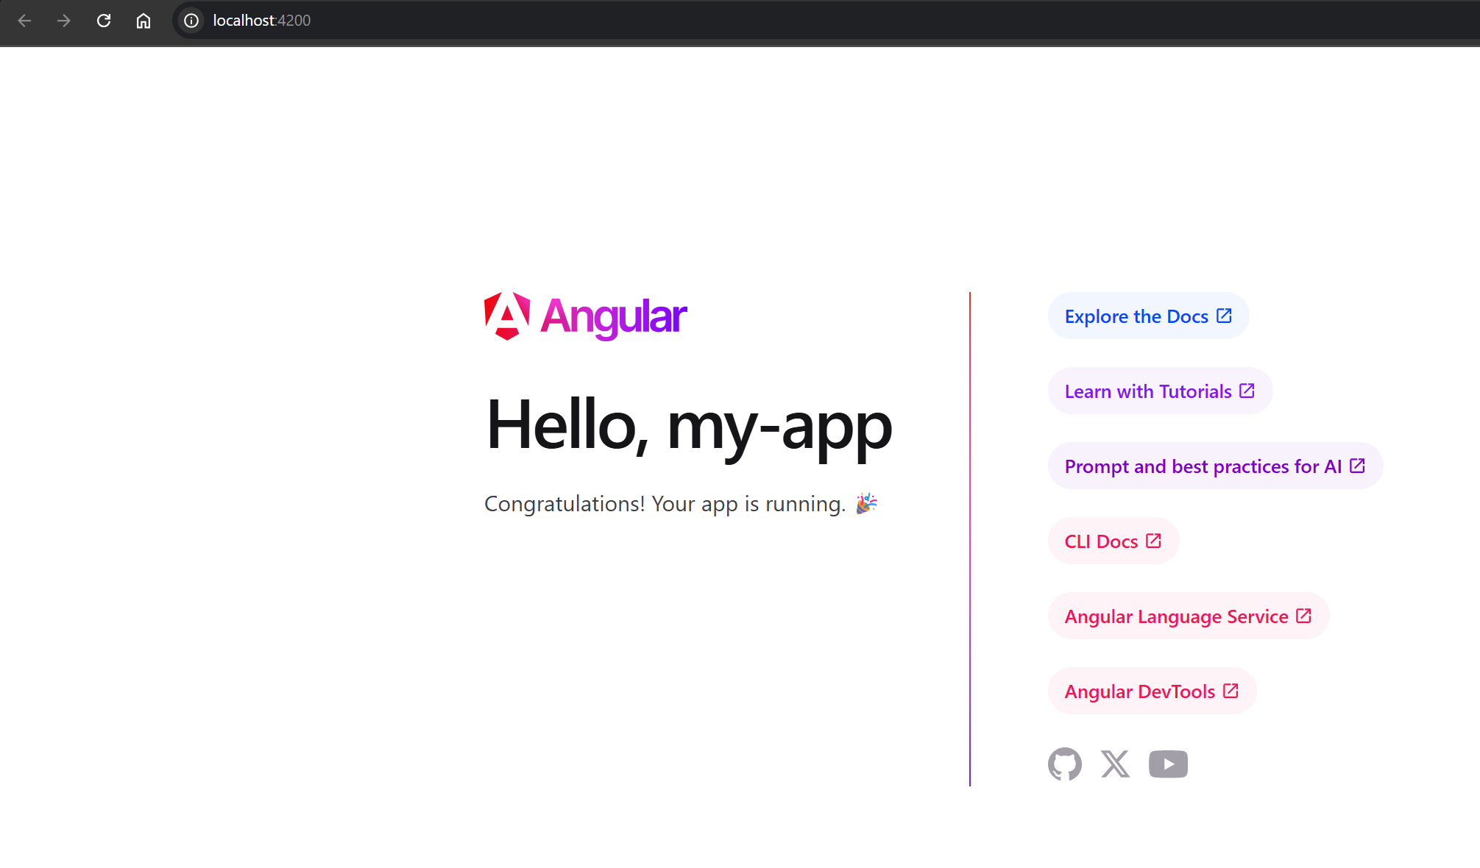

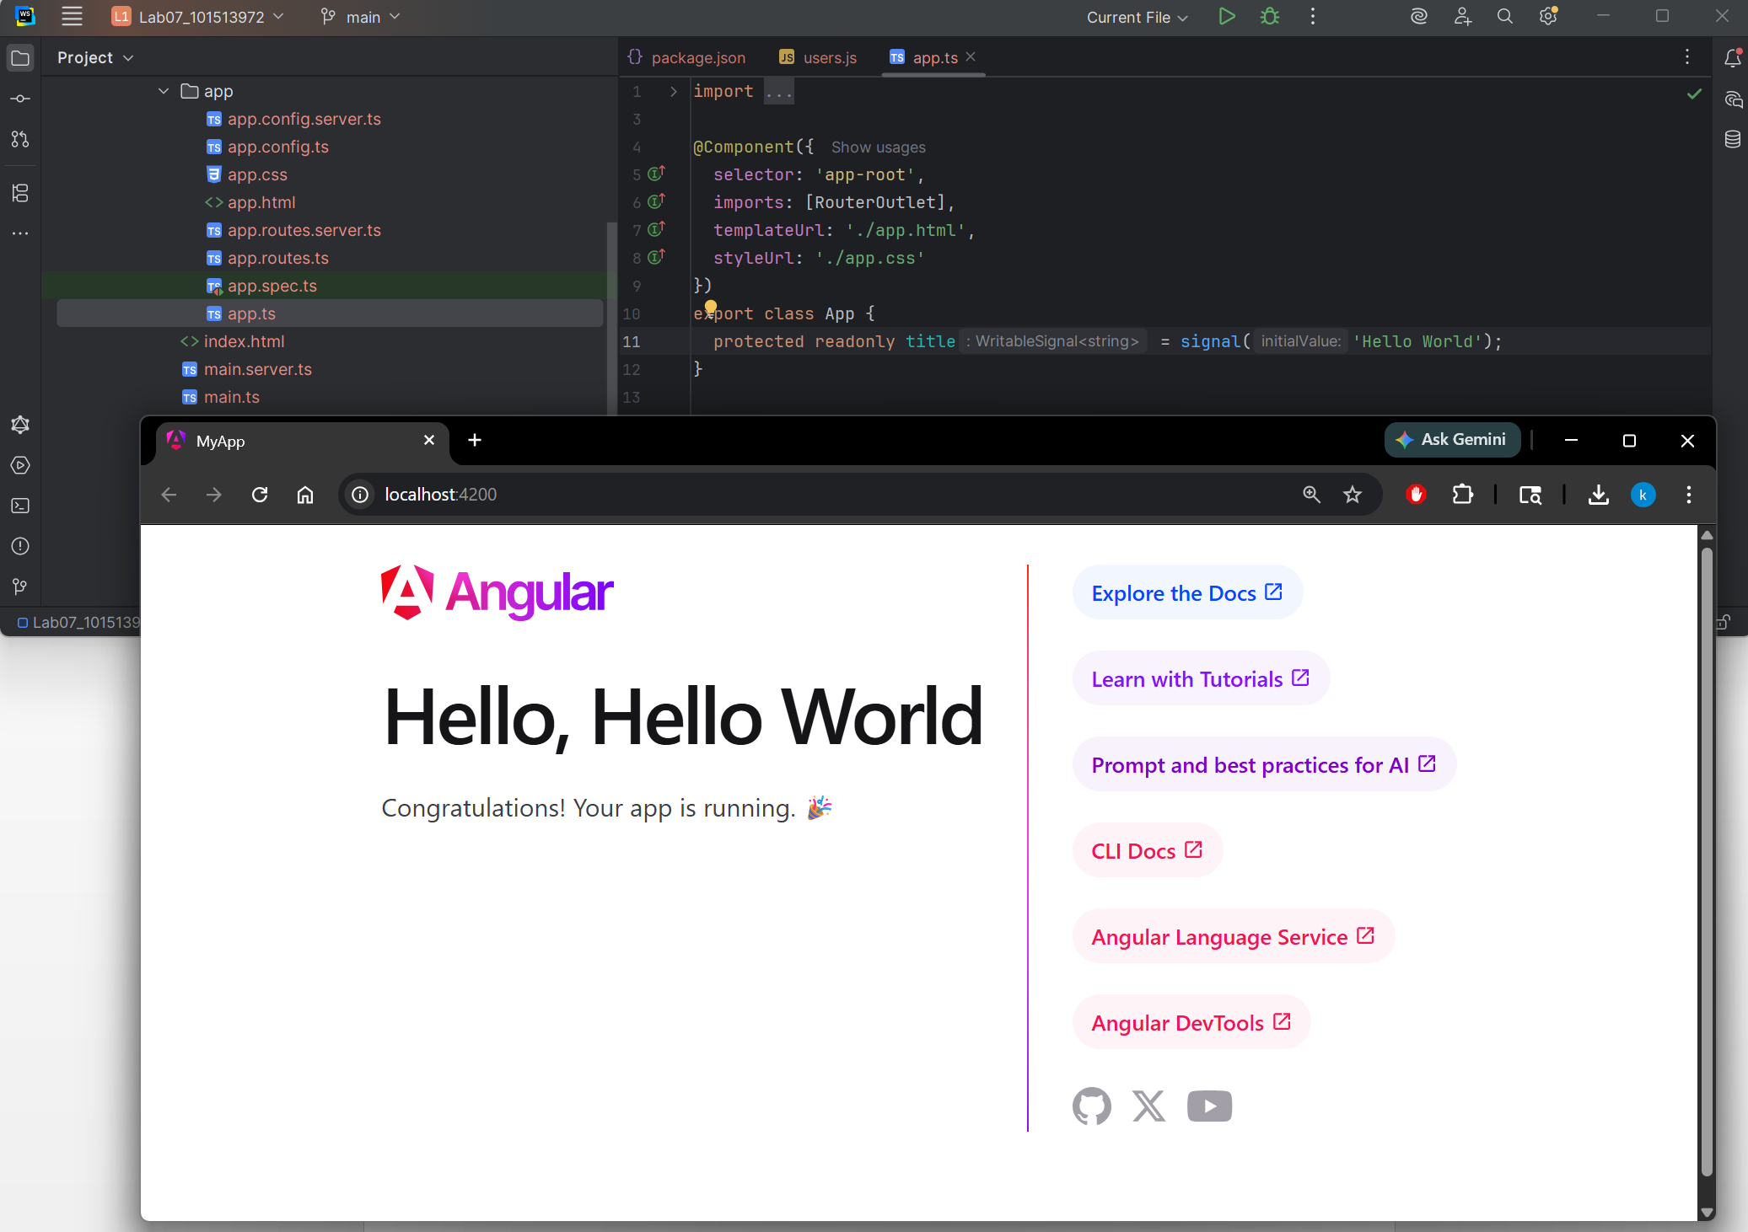

GitHub link
https://github.com/kalllak17/comp3133/tree/main/Lab07_101513972

