COMP 3133
Lab Exercise 5

Arkadii Akopian
ID: 101513972
CRN: 50581

February 18, 2026

Table of contents
1. POST /insert successful Ошибка! Закладка не определена.
2. POST /insert failed due validation Ошибка! Закладка не определена.
3. GET /users successful Ошибка! Закладка не определена.
4. GitHub link 6

Get all movies
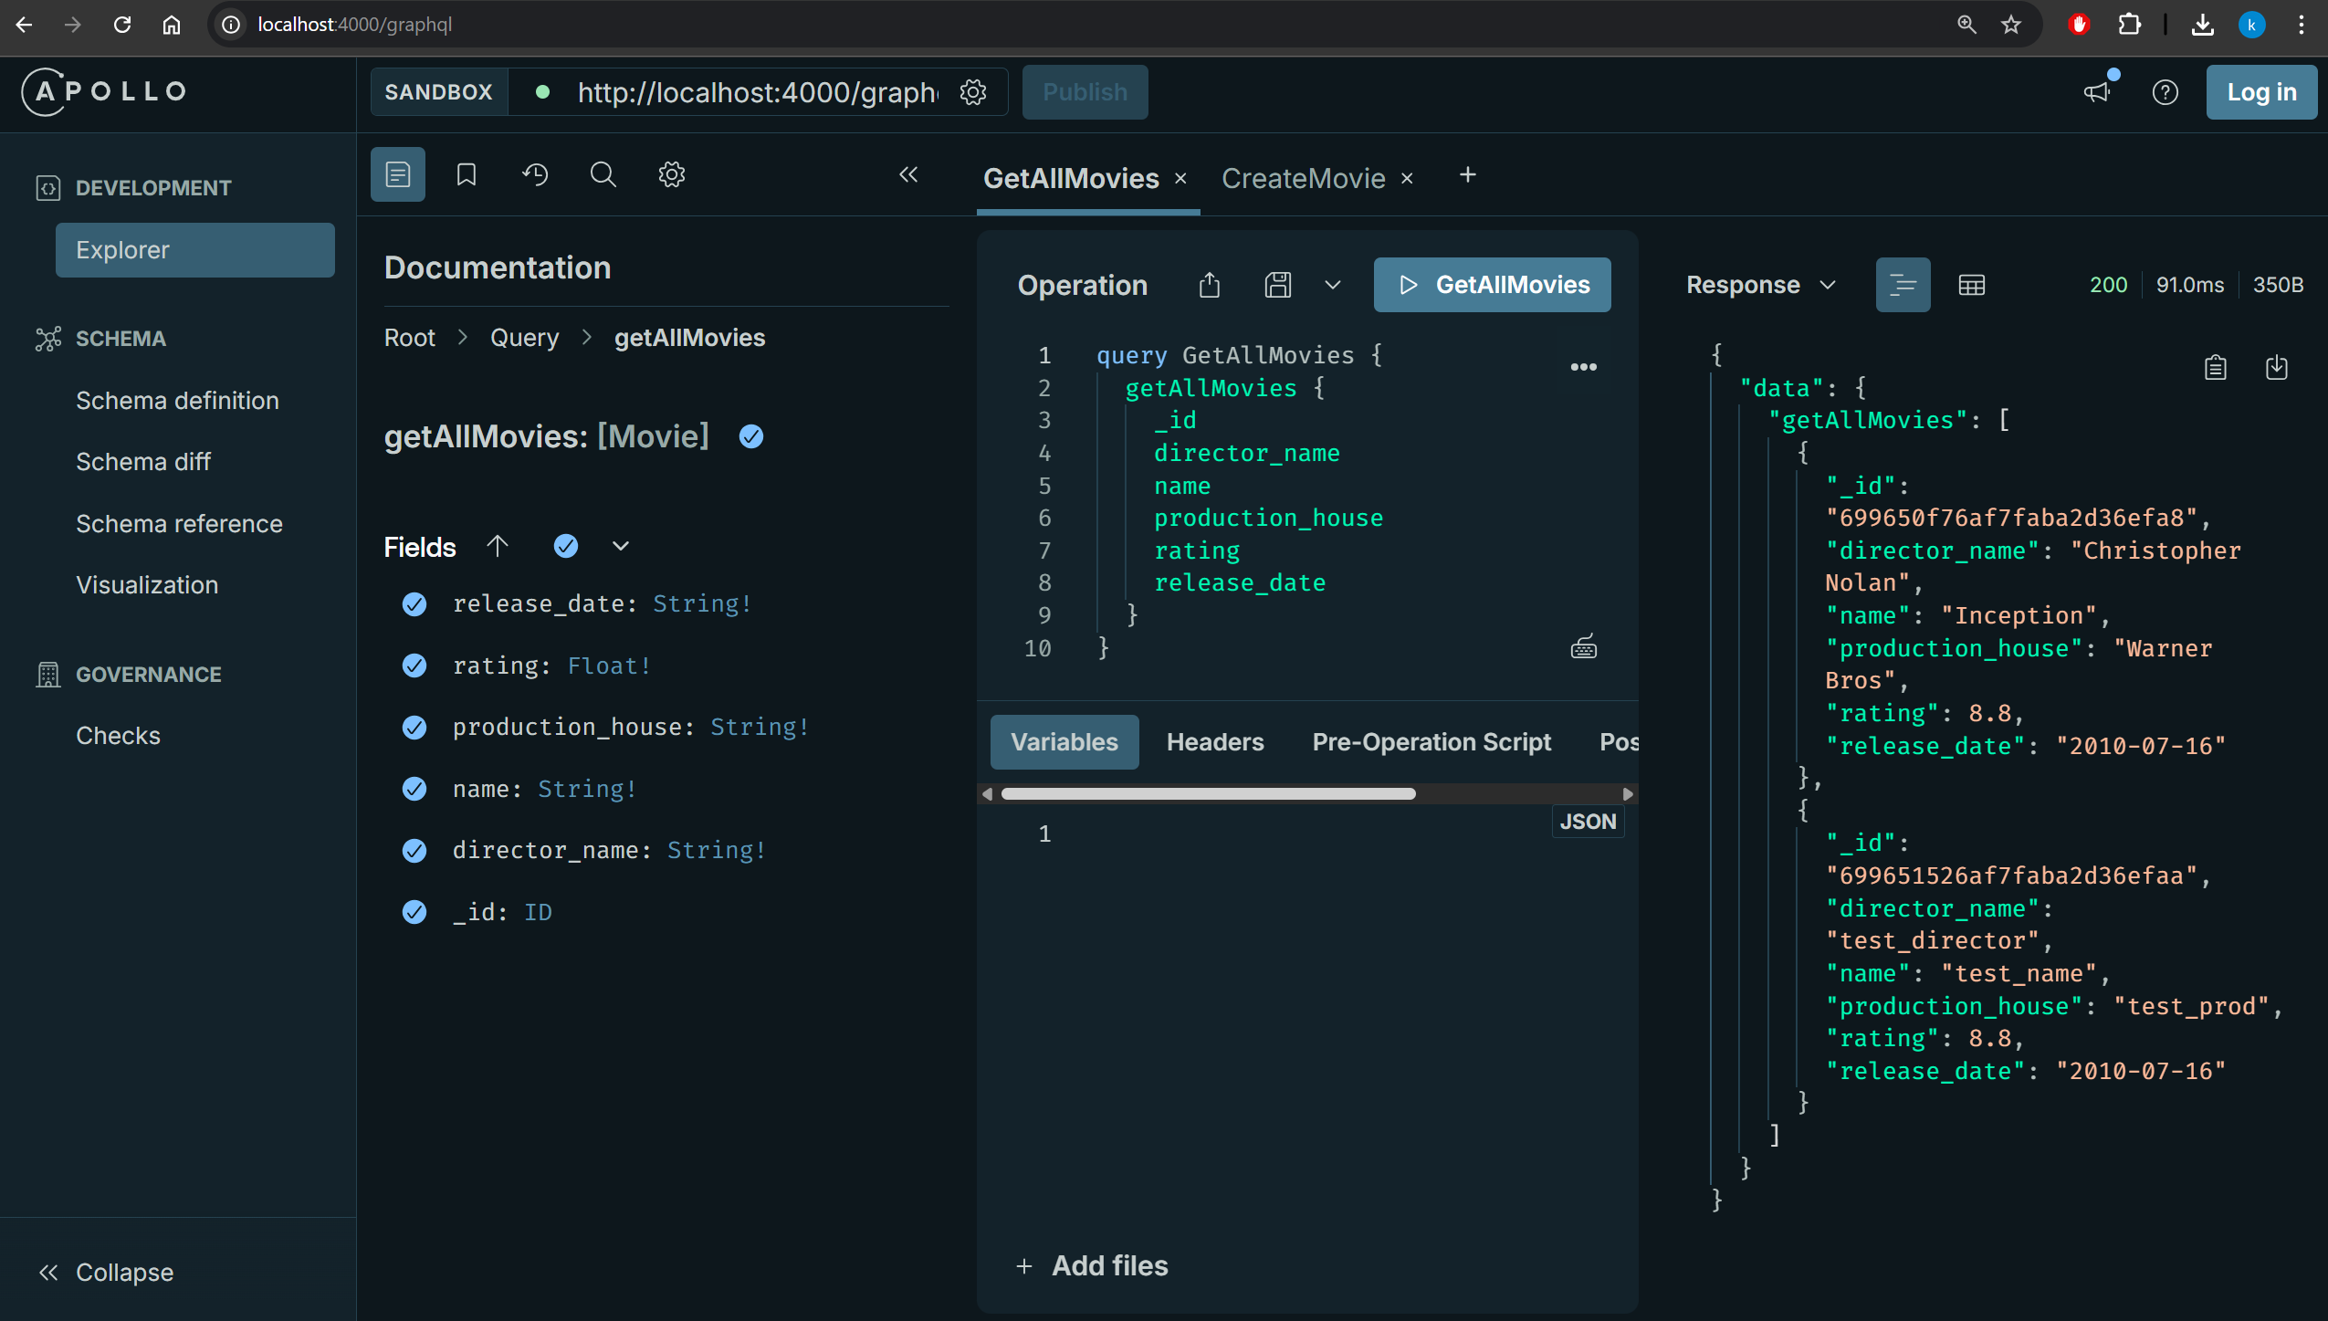

Get movie by ID
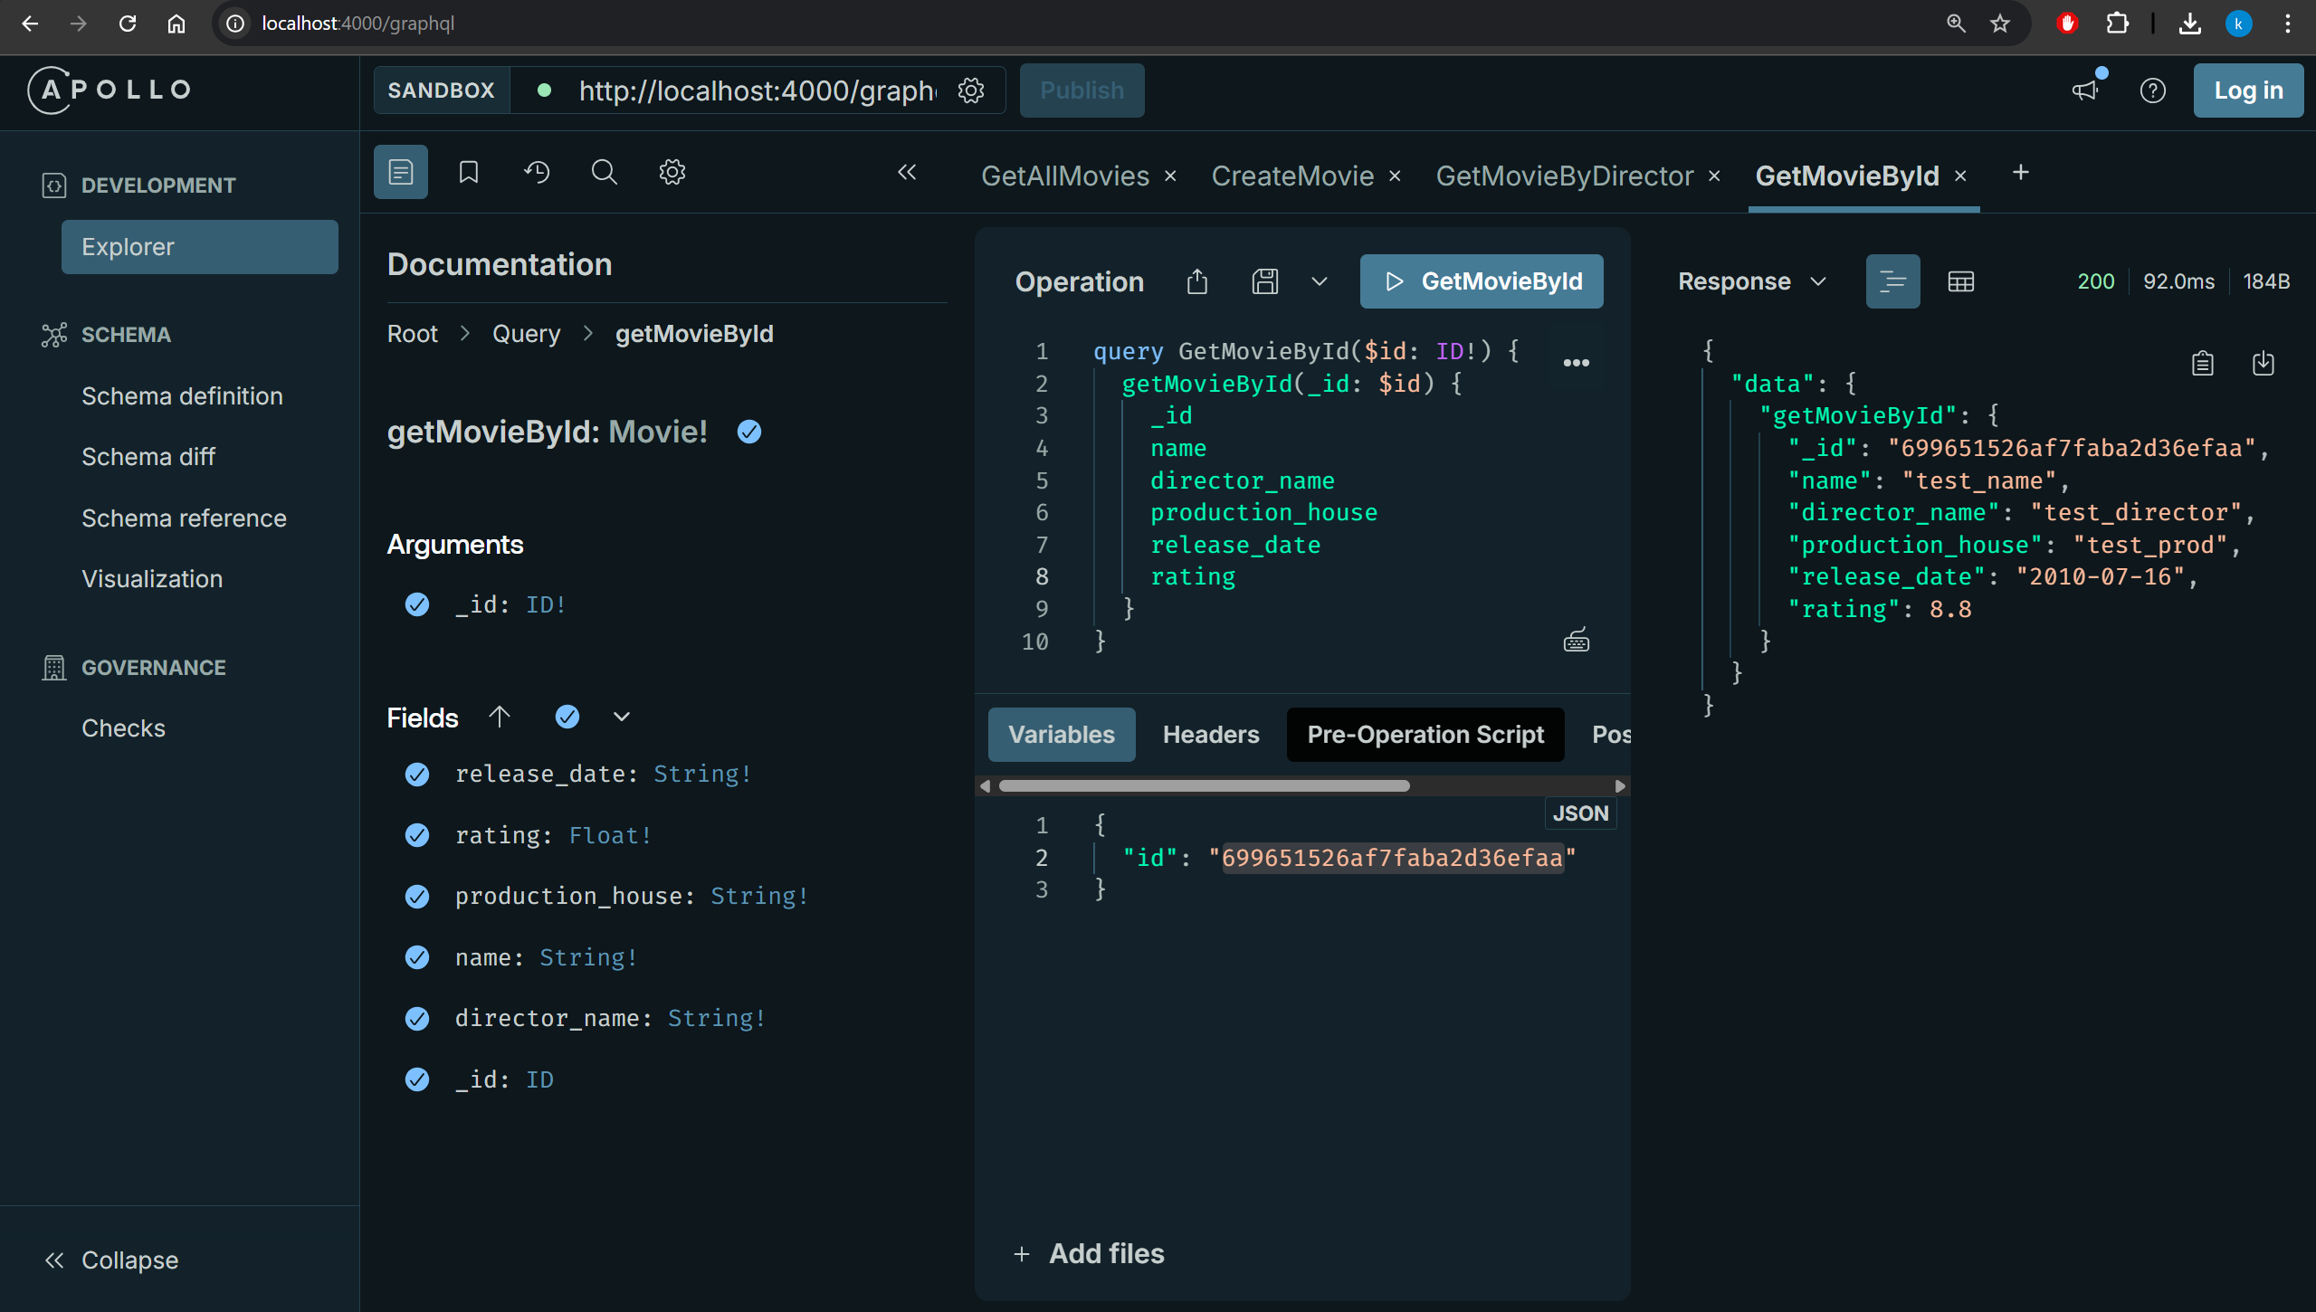

Get movies by Director name using static methods
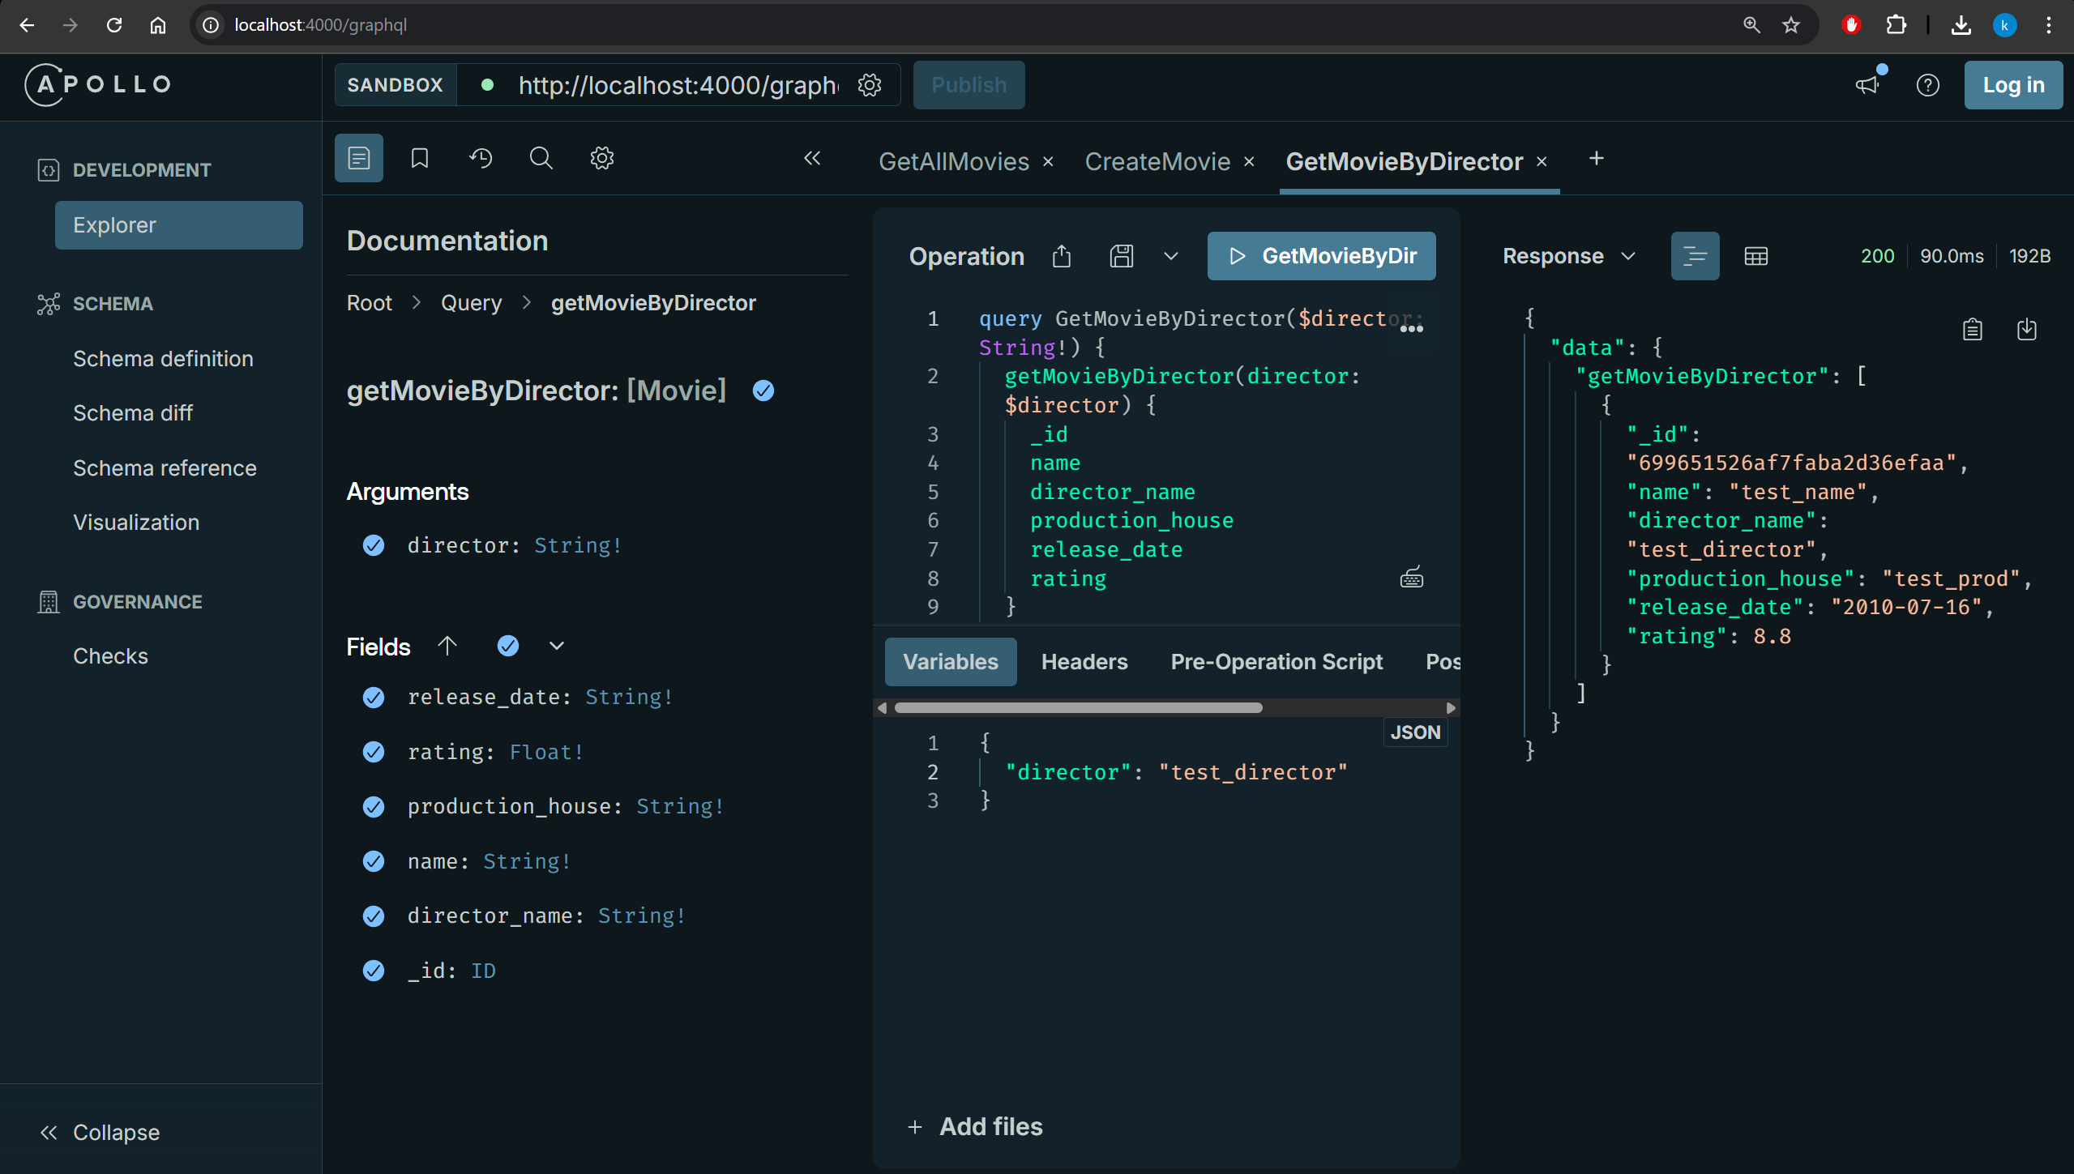

Insert new movie
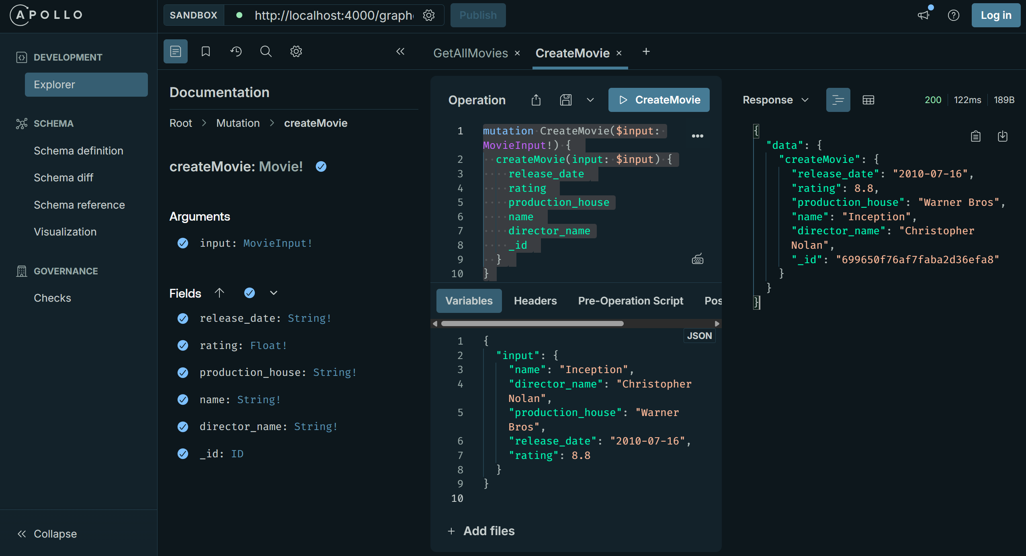

Update movie
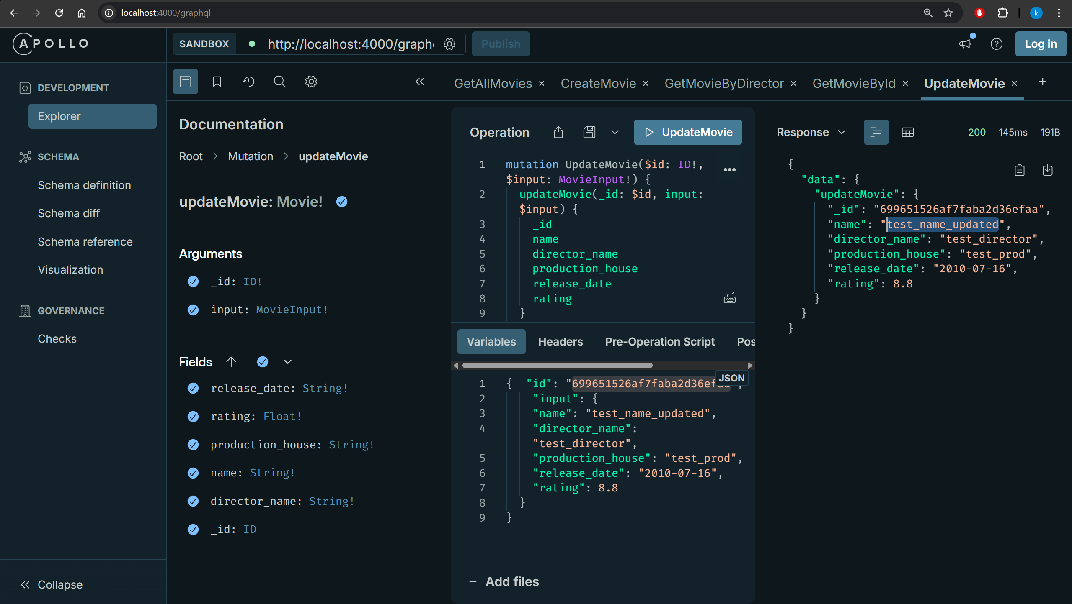

Delete movie By ID
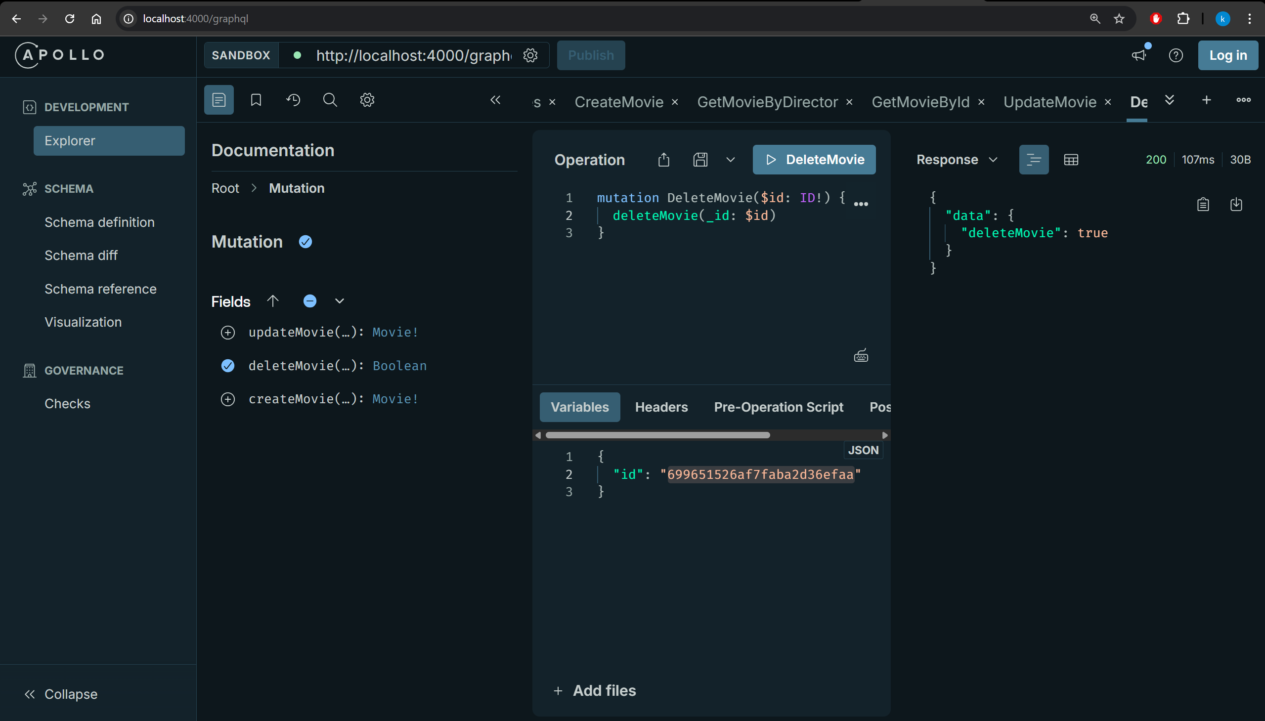

GitHub link
https://github.com/kalllak17/comp3133/tree/main/Lab5_graph_ql

