COMP 3133
Lab Exercise 2

Arkadii Akopian
ID: 101513972
CRN: 50581

January 28, 2026

Table of contents
1. Source code 3
2. General otput 4
3. add() function output 4
4. mul() function output 5
5. div() function output 5
6. sub() function output 6
7. GitHub link 6

Source code
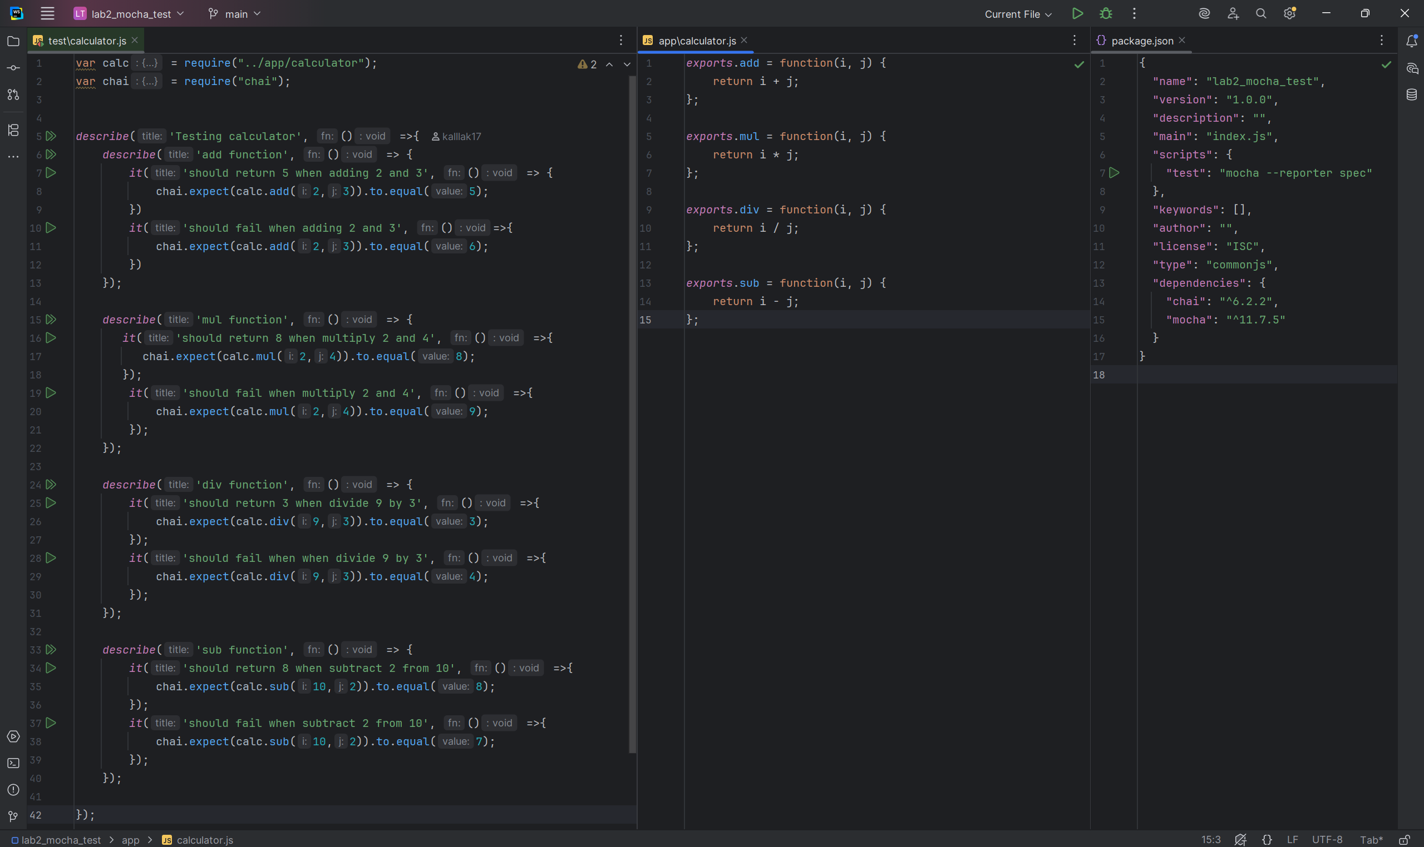

General otput
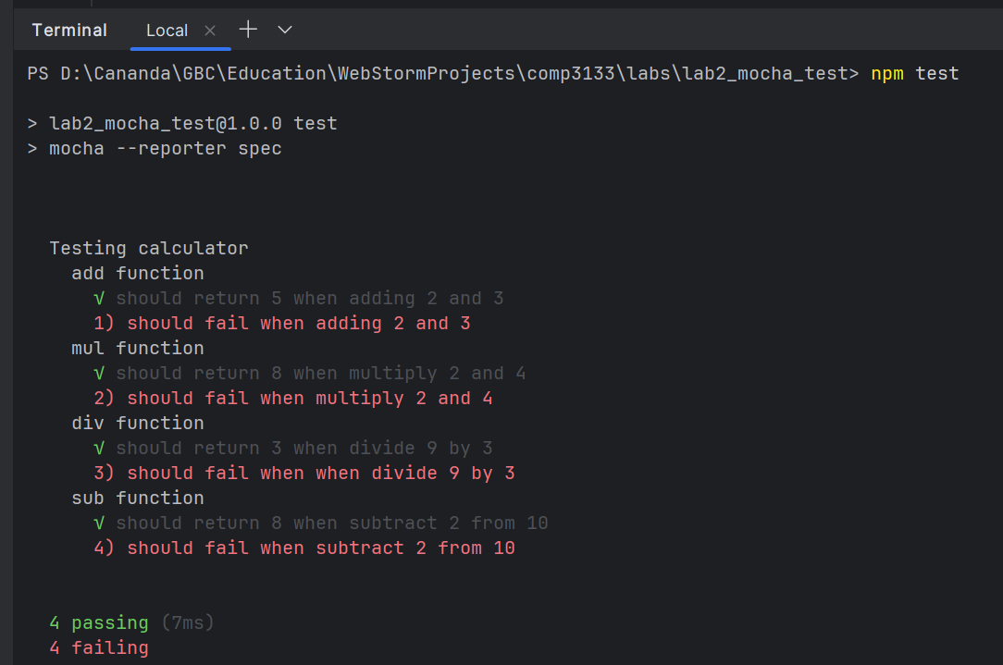

add() function output
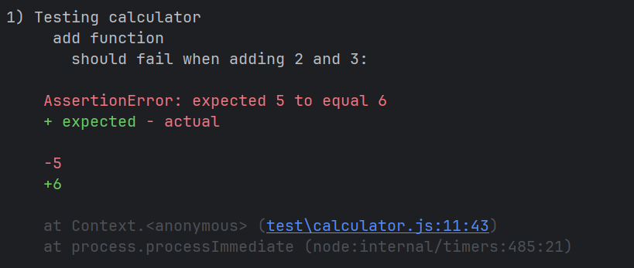

mul() function output
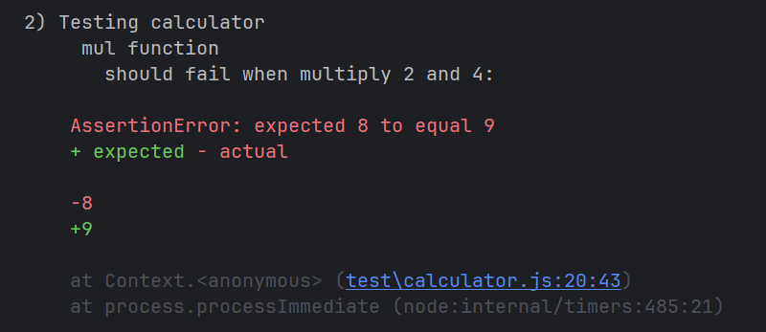

div() function output
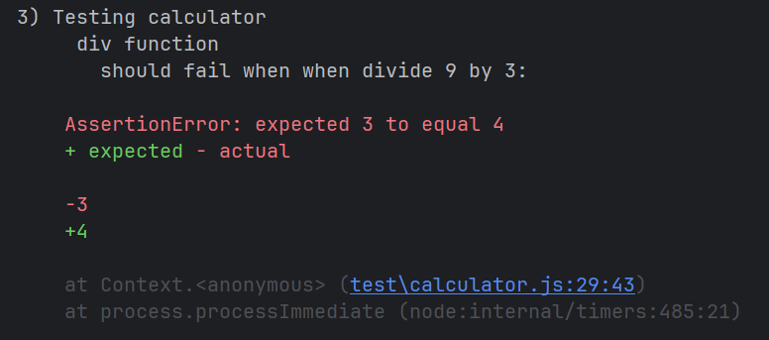

sub() function output
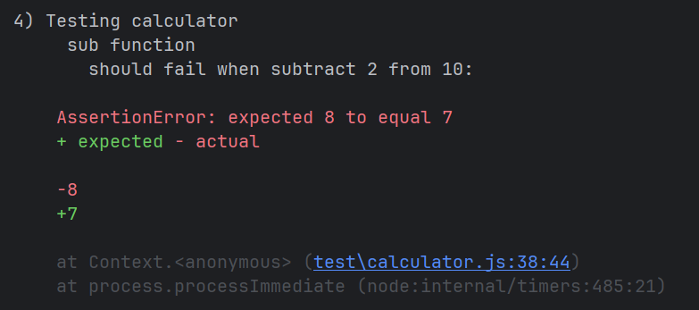

GitHub link
https://github.com/kalllak17/comp3133/tree/main/lab2_mocha_test

