COMP 3133
Lab Exercise 4

Arkadii Akopian
ID: 101513972
CRN: 50581

February 10, 2026

Table of contents
1. POST /insert successful 3
2. POST /insert failed due validation 3
3. GET /users successful 4
4. GitHub link 4

POST /insert successful
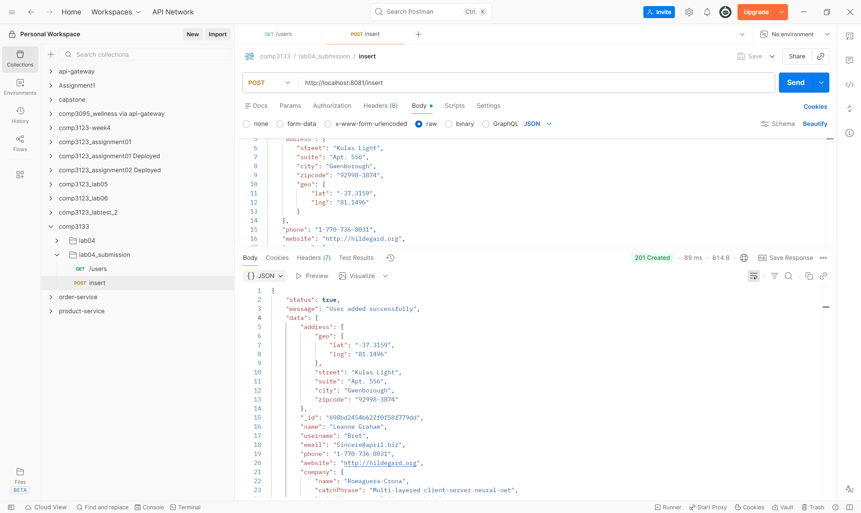

POST /insert failed due validation
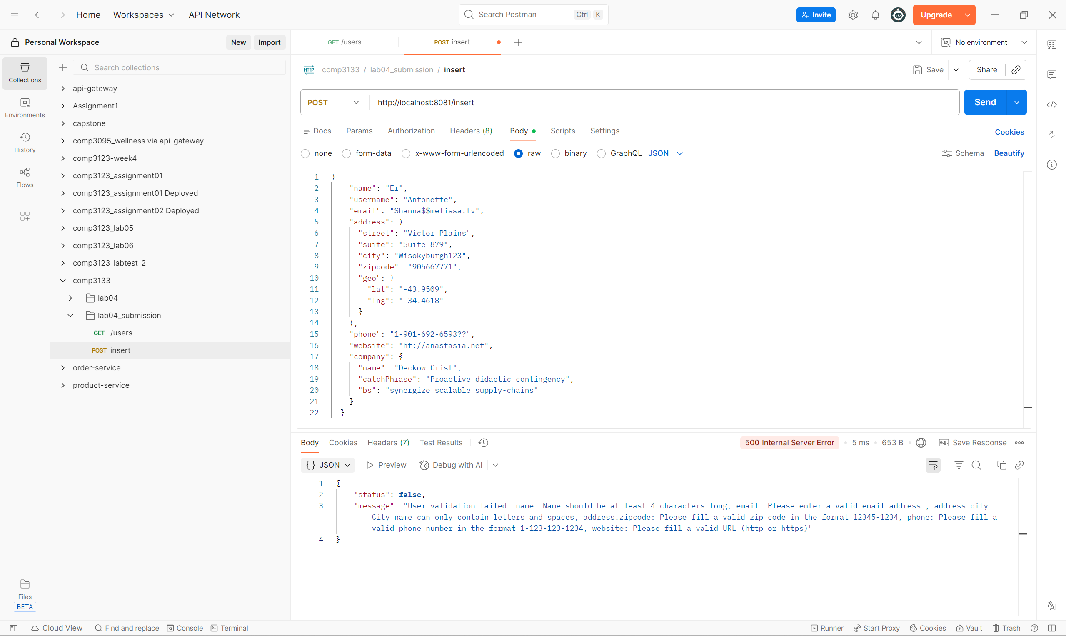

GET /users successful
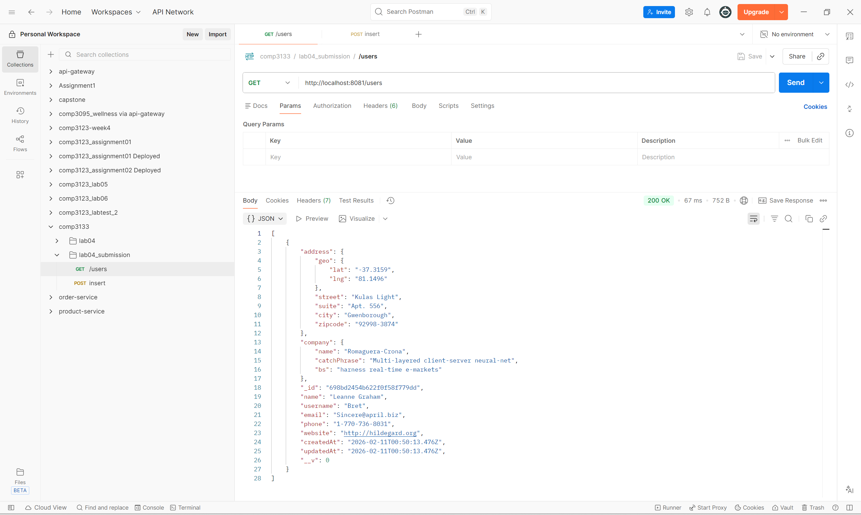

GitHub link
https://github.com/kalllak17/comp3133/tree/main/lab4_users_database

