1. Find out if the given number is an Armstrong number.

Logic: if 153 is the Supplied value, then1+5+3= 1+125+27= 153

This is the same as supplied value hence it is an Armstrong number.

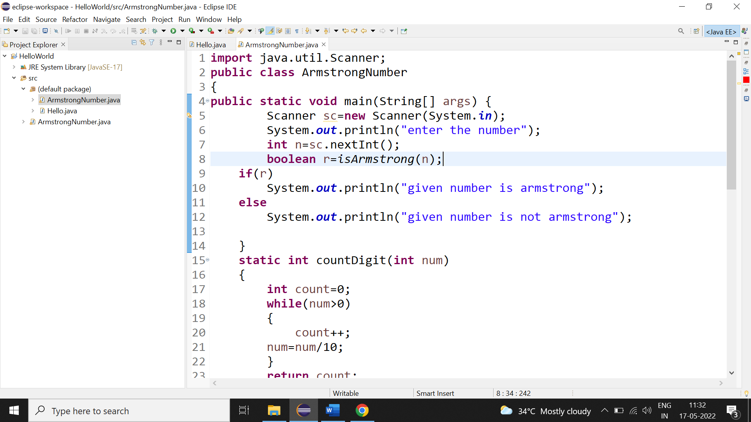

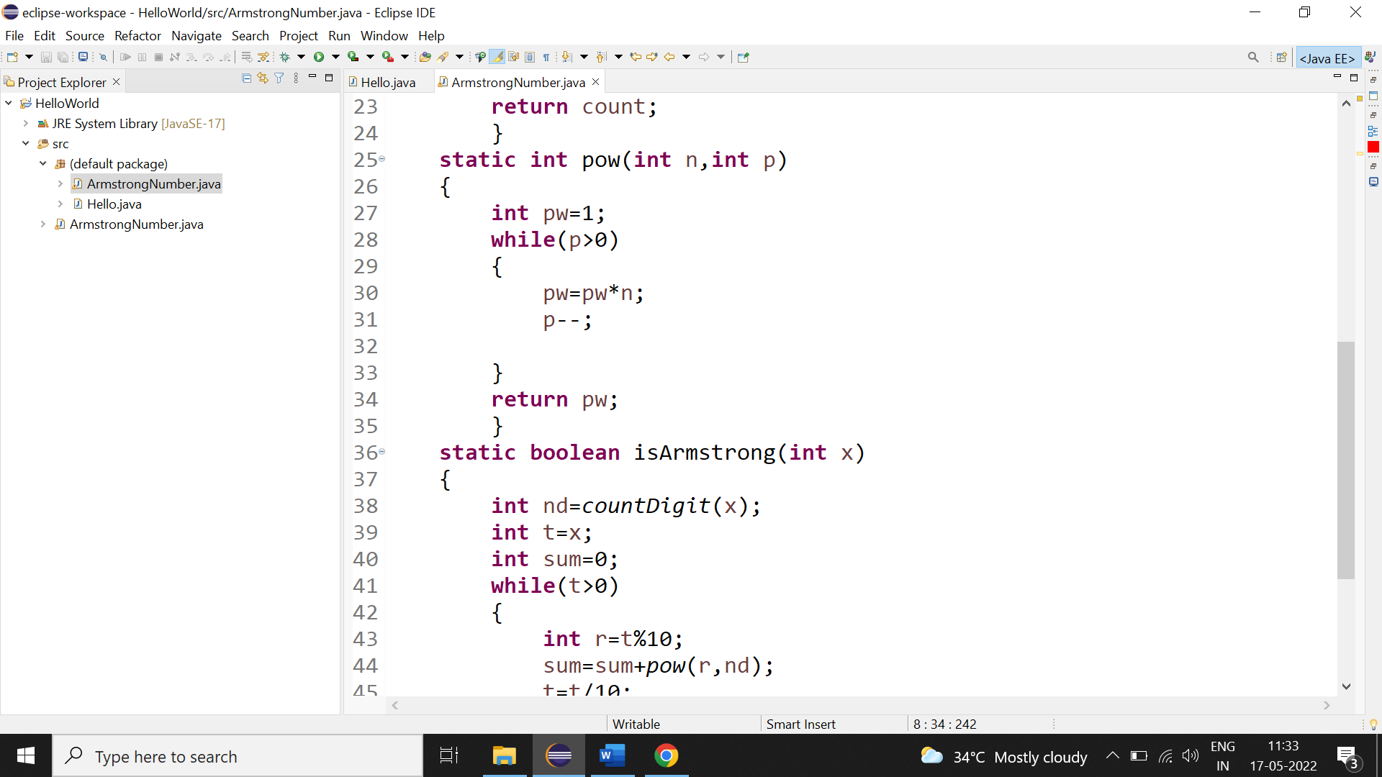

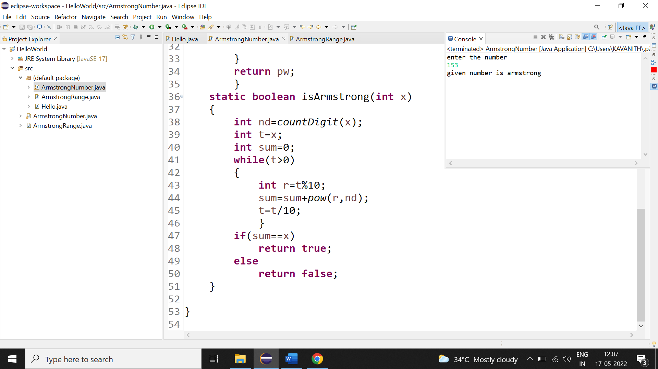

2.Find out all the Armstrong numbers falling in the range of 100-999 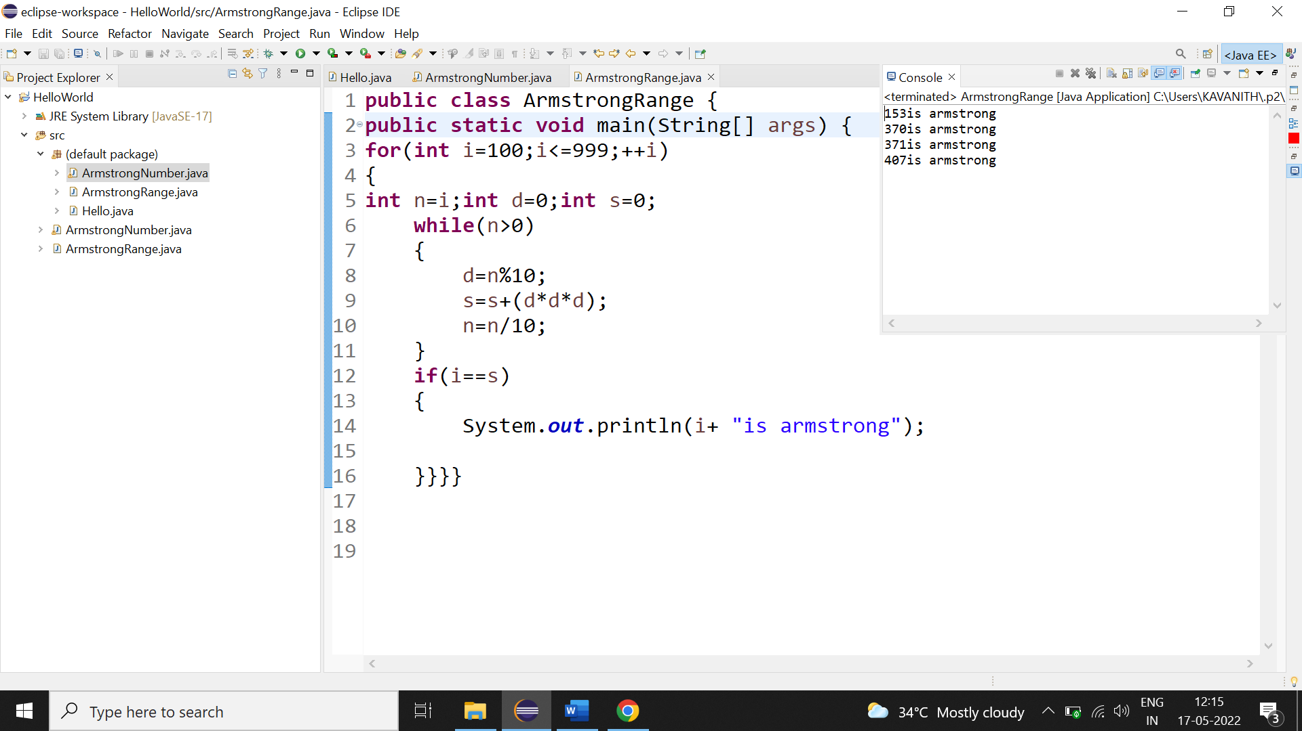

3.Find out the simple as well as the compound interest of supplied value 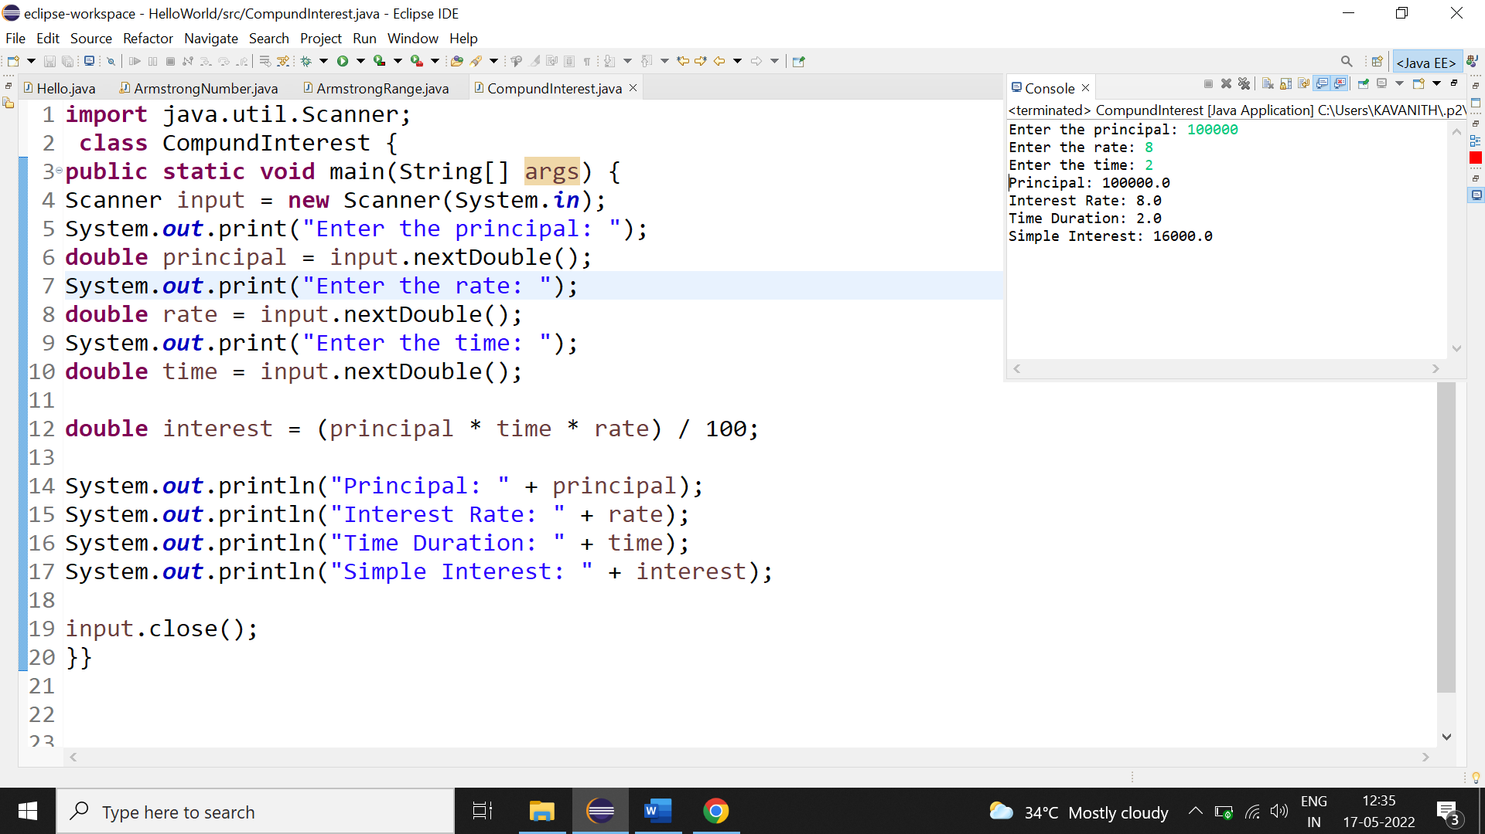

4. marks of three subject and declare the result, result declaration is based on below conditions

Condition 1: -All subjects marks is greater than 60 is Passed

Condition 2: -Any two subjects marks are greater than 60 is Promoted

Condition 3: -Any one subject mark is greater than 60 or all subjects' marks less than 60 is failed.

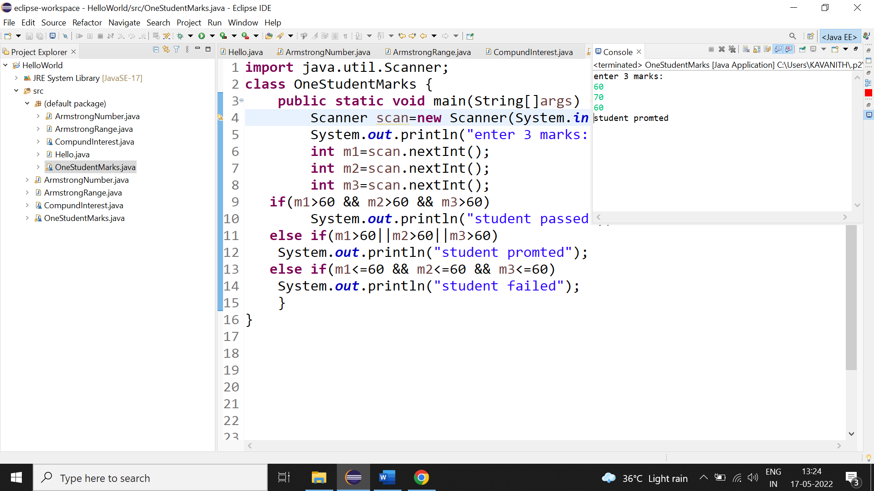

**6.Consider a CUl based application, where you are asking a user to enter his Login name and password, after entering the valid user-id and password it will print the message "Welcome" along with user name. As per the validation is concerned, the program should keep a track of login attempts. After three attempts a message should be flashed saying "Contact Admin" and the program should terminate**.

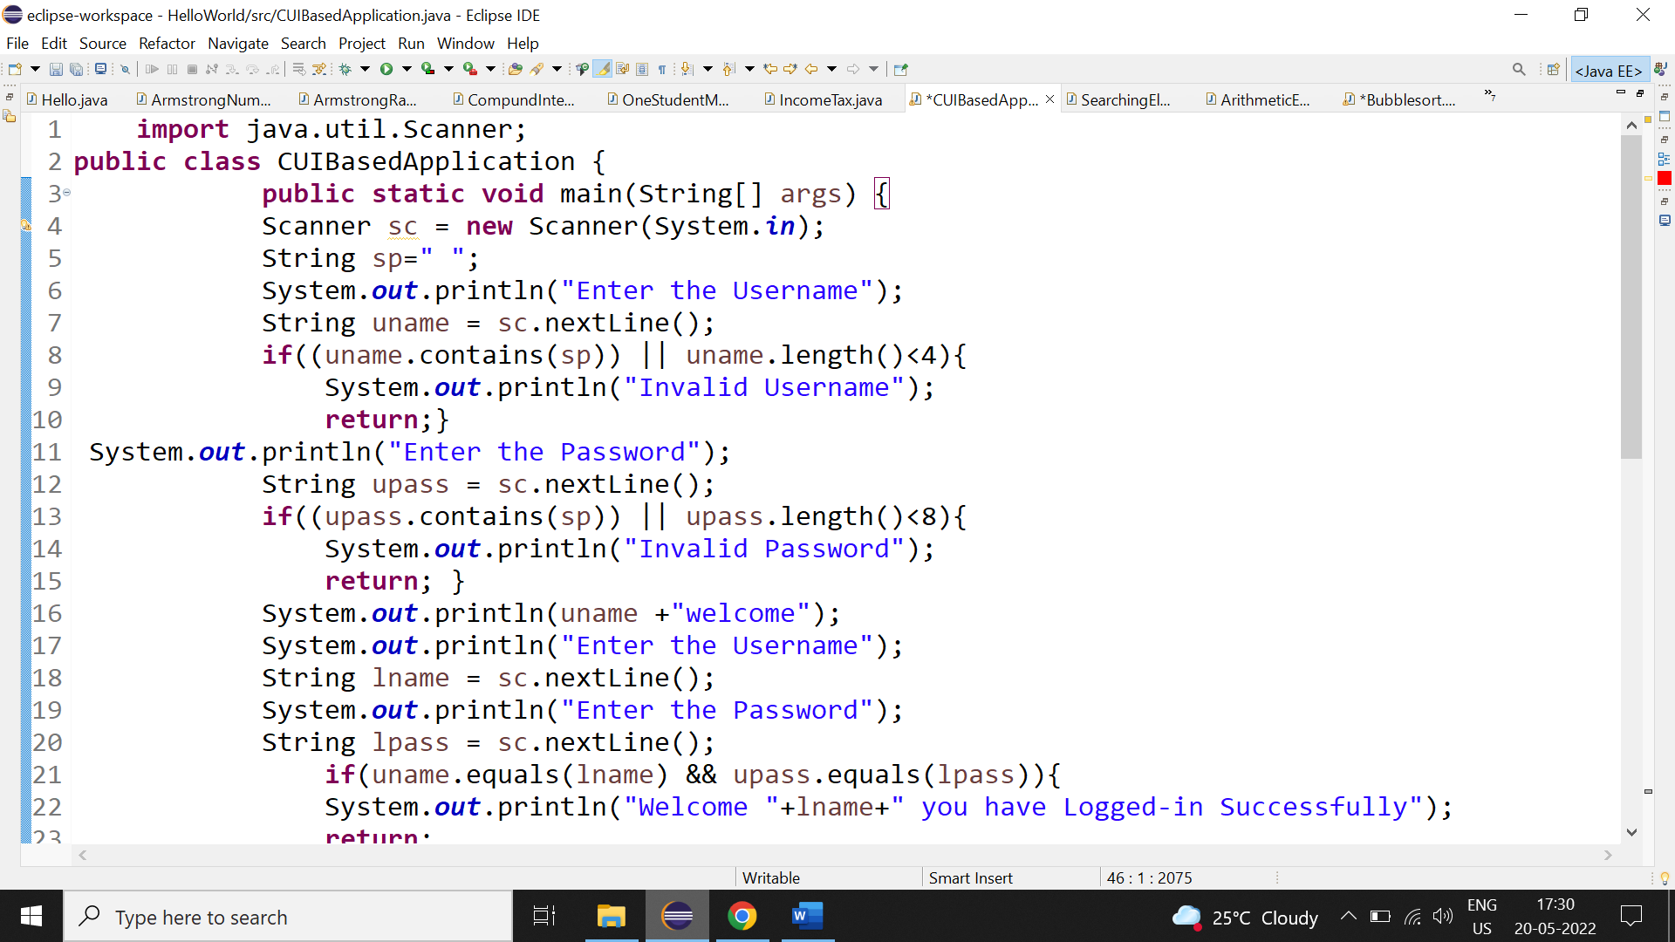

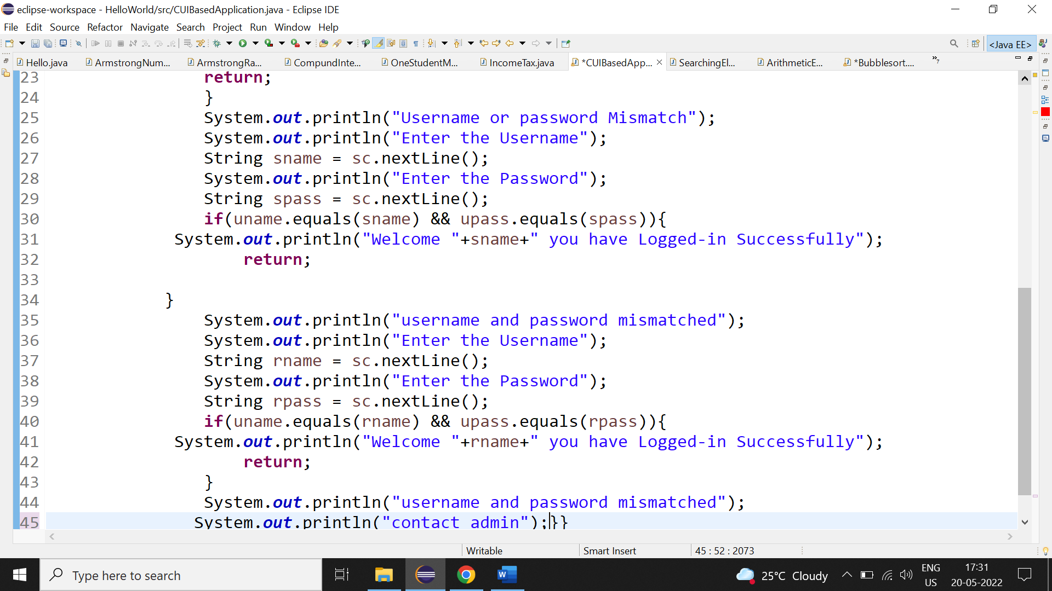

Output: 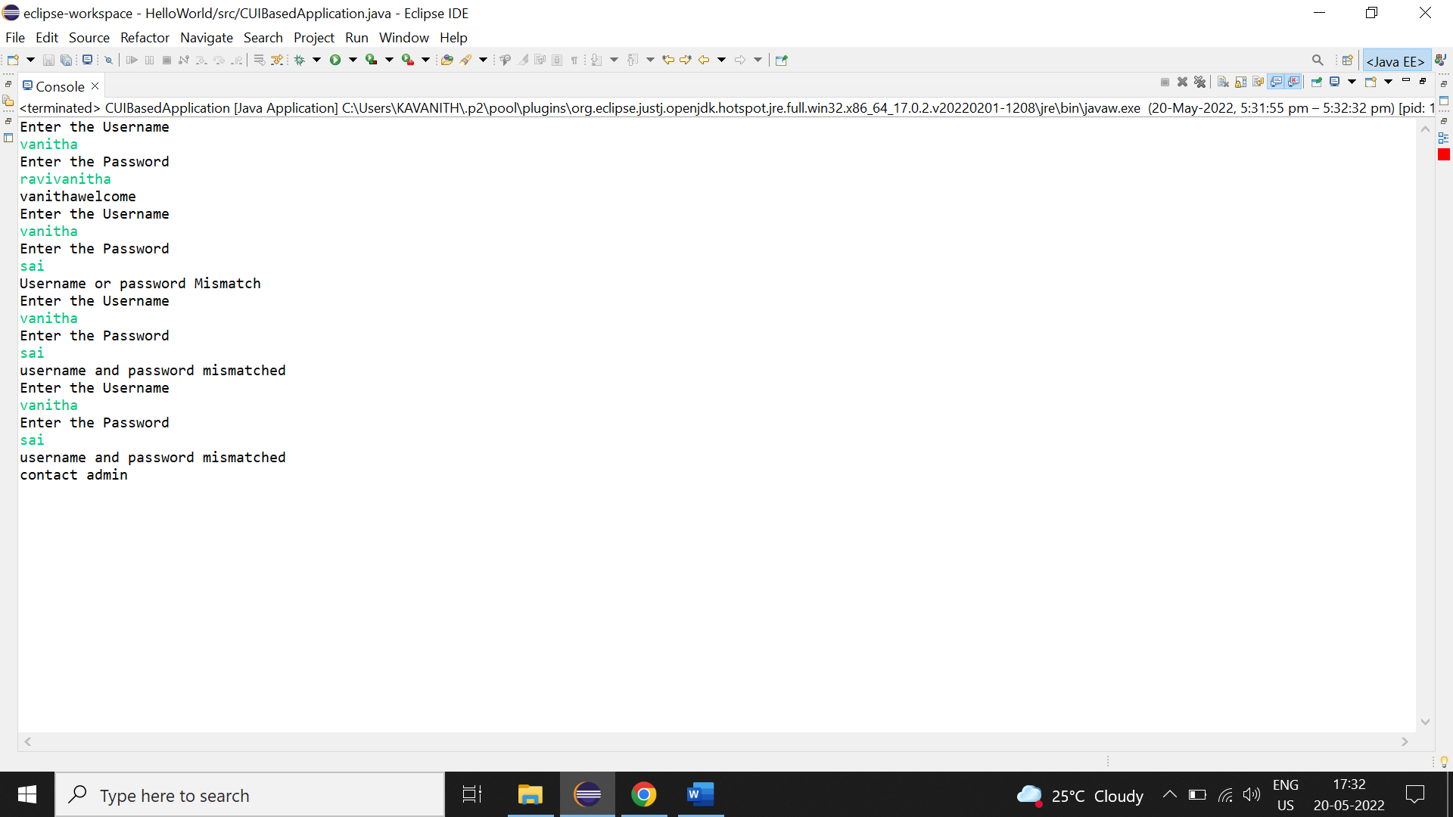

7.There is an Array which is of the size 15, whrch may or may not be sorted. You should write a program to accept a number and search if it in contained in the array.

Examples :[5,12,14,6,78,19,1,23,26,35,37,7,52,86,47]

Value to be search is 19.

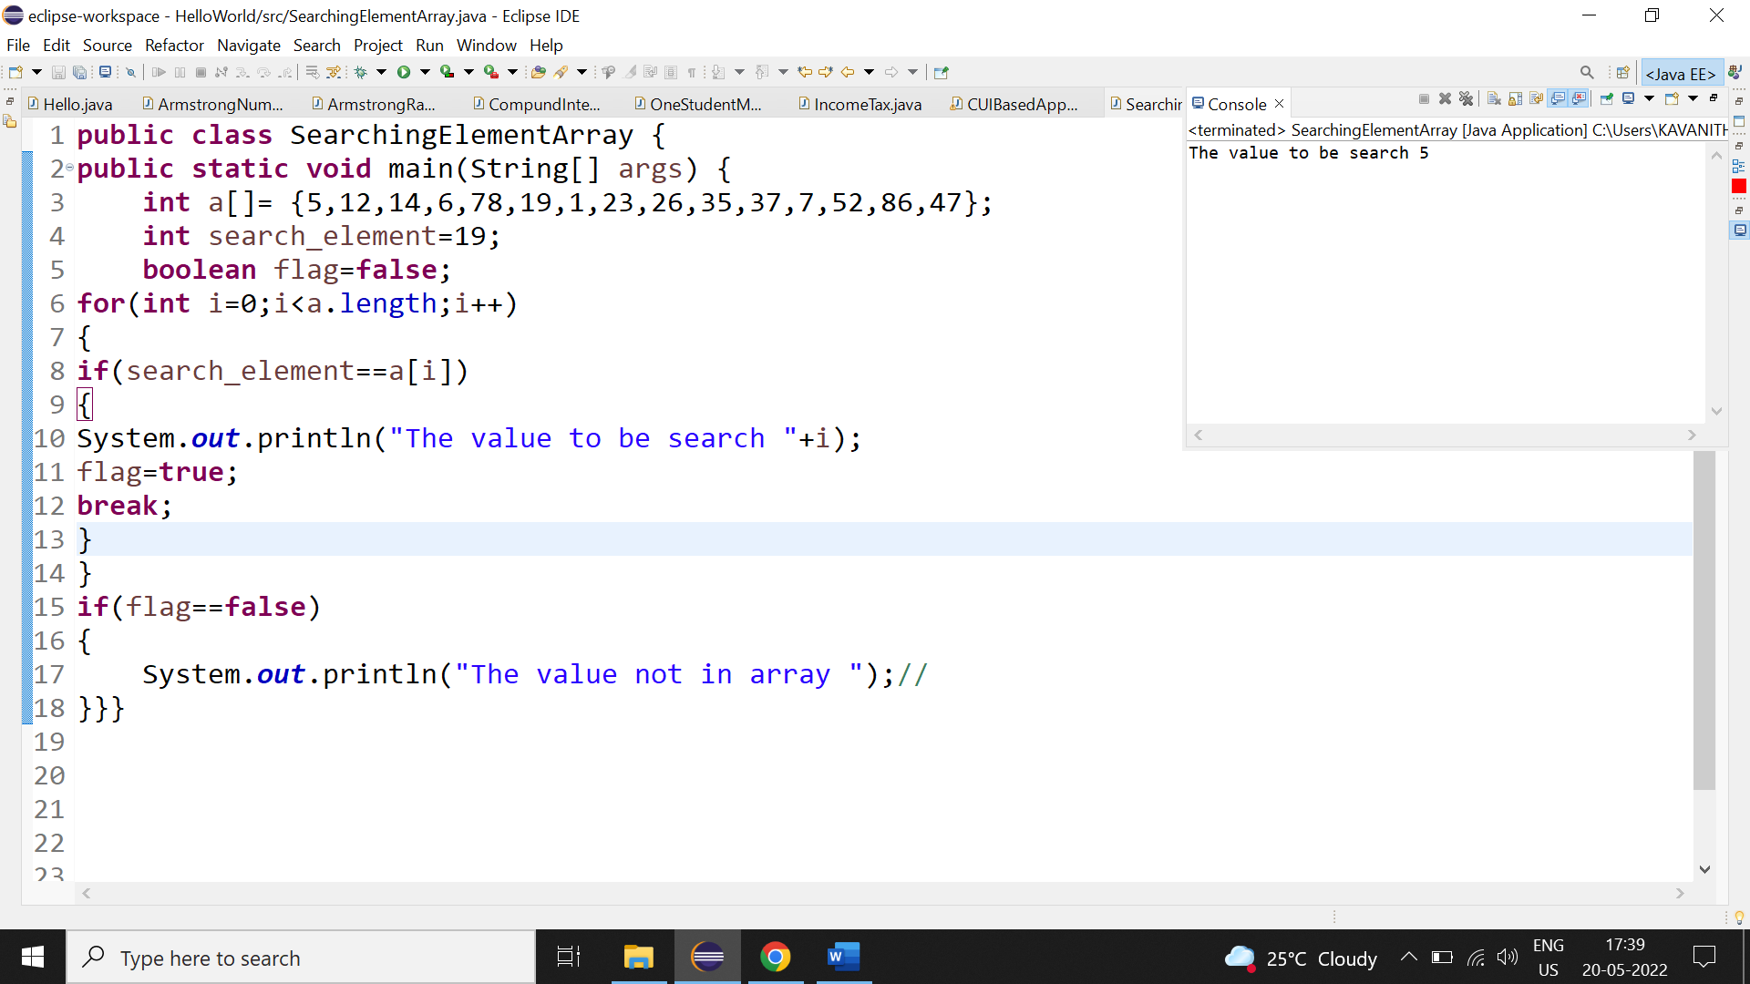

8. Using the above table write method apply sorting using Bubble Sort.

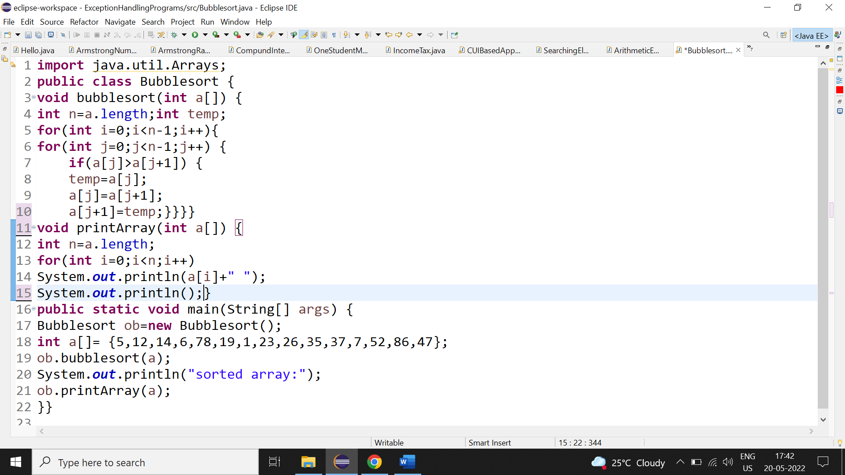

Output: 