“Database Client-Server Management System using C and Linux”
A Project Report Submitted in the partial fulfillment of the requirements for the award of the degree of

BACHELOR OF TECHNOLOGY
In

DEPARTMENT OF COMPUTER SCIENCE ENGINNERING

By

HASINI REDDY 2520030116

K. SHRESTA 2520030127

P. DEVISREE 2520030594

Under the Esteemed Guidance of

Kolla Hema
Assistant Professor
Department of Computer Science and Engineering




K L (Deemed to be) University DEPARTMENT OF COMPUTER SCIENCE ENGINEERING
&

DEPARTMENT OF COMPUTER SCIENCE AND INFORMATION TECHNOL

Declaration

The Project Report entitled “Database Client-Server Management System using C and Linux” is a record of Bonafide work of HASINI REDDY - 2520030116, K. SHRESTA - 2520030127, P. DEVISREE - 2520030594 submitted in
partial fulfillment for the award of B. Tech in Computer Science and Engineering (or) Computer Science and Information Technology to the K L University. The results embodied in this report have not been copied from any other departments/University/Institute.

HASINI REDDY 2520030116

K. SHRESTA 2520030127

P. DEVISREE 2520030594

K L (Deemed to be) University

DEPARTMENT OF COMPUTER SCIENCE ENGINEERING

CERTIFICATE

This is certify that the mini project based report entitled“Database Client-Server Management System using C and Linux” is a bonafide work done and submitted by HASINI REDDY - 2520030116, K. SHRESTA - 2520030127, P. DEVISREE - 2520030594,
in partial fulfillment of the requirements for the award of the degree of BACHELOR OF TECHNOLOGY in Department of Computer Science Engineering, K L (Deemed to be University), during the academic year 2025-2026.

Signature of the Guide

Signature of the Course Coordinator Signature of the HOD

ACKNOWLEDGEMENT
The success in this project would not have been possible but for the timely help and guidance rendered by many people. Our wish to express my sincere thanks to all those who has assisted us in one way or the other for the completion of my project.

Our greatest appreciation to my Course Coordinator Kolla Hema, and my guide Kolla Hema, Department of Computer Science which cannot be expressed in words for his/her tremendous support, encouragement and guidance for this project.

We express our gratitude to Dr. P Venkateshwara Roa (CSE), Head of the Department for Computer Science Engineering for providing us with adequate facilities, ways and means by which we are able to complete this project-based Lab.

We thank all the members of teaching and non-teaching staff members, and also who have assisted me directly or indirectly for successful completion of this project. Finally, I sincerely thank my parents, friends and classmates for their kind help and cooperation during my work.

HASINI REDDY 2520030116

K. SHRESTA 2520030127

P. DEVISREE 2520030594
Abstract

The Database Client-Server Management System is a Linux-based application developed in C to demonstrate concurrent client-server communication and database management. The system provides a centralized server that accepts requests from multiple clients over TCP sockets and processes them using POSIX worker threads. A shared request/response queue coordinates concurrent work, while mutexes and semaphores synchronize access to queues, database structures and other shared resources.

Student records, including marks, attendance and course data, can be inserted, searched, updated and deleted. Memory mapping (mmap) is used for efficient access to frequently used database data while the database file preserves the records on disk. Transaction and server activity logs provide traceability, while POSIX signals support configuration reload (SIGHUP) and controlled shutdown (SIGINT/SIGTERM).

The server also monitors active connections and resource usage, demonstrating practical operating-system concepts in a real-world database service. In summary, the project shows how TCP sockets, POSIX threads, mutexes, semaphores, queues, signals and mmap() can be combined to build a reliable, concurrent and manageable networked database service.

Index

S. No. | Chapter | Topics / Subtopics | Page No.
 | Acknowledgement |  | i
 | Abstract |  | ii
1 | Introduction |  | 8–10
 |  | 1.1 Background of the Project
 |  | 1.2 Problem Statement
 |  | 1.3 Scope of the Project
 |  | 1.4 Objectives of the Project
 |  | 1.5 Importance of the Application
 |  | 1.6 Target Users / Audience
2 | OS Concepts and Background Study |  | 11–13
 |  | 2.1 Operating System Concepts Related to the Project
 |  | 2.2 Existing Methods / Algorithms
 |  | 2.3 Proposed Approach
 |  | 2.4 Advantages of the Proposed Approach
3 | System Requirements |  | 14–15
 |  | 3.1 Hardware Requirements
 |  | 3.2 Software Requirements
 |  | 3.3 Operating System Environment – Ubuntu / WSL
 |  | 3.4 Development Tools and Compilers
4 | Technology and Tools Used |  | 16–17
 |  | 4.1 C / C++ Programming
 |  | 4.2 GCC Compiler
 |  | 4.3 Linux System Calls
 |  | 4.4 POSIX Threads / Synchronization
 |  | 4.5 Linux Commands and Utilities
 |  | 4.6 Other Tools / Libraries Used
5 | System Architecture and Design |  | 18–21
 |  | 5.1 Overall System Architecture
 |  | 5.2System Workflow
 |  | 5.3 Flowchart / Data Flow
 |  | 5.4 Module Description
 |  | 5.5 Input and Output Design
6 | Implementation |  | 22–27
 |  | 6.1 Module-wise Implementation
 |  | 6.2 Algorithm / Pseudocode
 |  | 6.3 Core C / C++ Implementation
 |  | 6.4 Linux System Calls / APIs Used
 |  | 6.5 Process / Thread Implementation
 |  | 6.6 IPC / Synchronization Implementation
 |  | 6.7 Memory Management Implementation
 |  | 6.8 Optional User Interface Implementation
7 | Execution and Demonstration |  | 28–29
 |  | 7.1 Compilation in Ubuntu
 |  | 7.2 Execution Commands
 |  | 7.3 Sample Inputs and Outputs
 |  | 7.4 Screenshots of Execution
 |  | 7.5 Demonstration of OS Concepts
8 | Conclusion |  | 30–31
 |  | 8.1 Summary of the Project
 |  | 8.2 Objectives Achieved
 |  | 8.3 Results Achieved
 |  | 8.4 Skills and Learning Outcomes
9 | References |  | 32
 |  | 9.1 Books
 |  | 9.2 Research Papers
 |  | 9.3 Linux / GNU Documentation
 |  | 9.4 Online Resources

CHAPTER -1 INTRODUCTION

1.1 Background of the Project
In every university, student information such as personal details, marks, attendance and course records is created, read and modified many times a day by faculty members and administrative staff. When this information is kept in separate files or on individual computers, it becomes difficult to keep it consistent, secure and available to everyone who needs it. A centralized database service solves this problem by storing all records in one place and letting authorised users reach them through the network.
A centralized service, however, introduces a new challenge: many clients may ask for the same data at the same moment. If the server handles requests carelessly, two updates to the same record can overwrite each other, a record can be read while it is half-written, or shared data structures can be corrupted. Operating-system concepts such as threads, mutexes, semaphores, queues, signals and memory mapping provide the tools needed to handle this safely.
The Database Client-Server Management System is a Linux-based application written in C that combines these concepts into a working, practical service. A multi-threaded server accepts requests from several clients over TCP sockets, places them in a shared queue, and processes them with a pool of POSIX worker threads that operate on a memory-mapped student database.

1.2 Problem Statement
A university database may be accessed simultaneously by many faculty members and administrators. Uncontrolled concurrent access can cause inconsistent updates, lost data, duplicate operations or corrupted shared structures. The system must therefore accept concurrent client requests while maintaining data integrity, coordinating shared resources, monitoring connections, and allowing the server to be safely reconfigured or shut down.
The main issues addressed by this project are summarised below.
Issue | Description
Concurrent Requests | Several clients may access the same records at once.
Race Conditions | Unsynchronized updates can overwrite or corrupt shared data.
Resource Sharing | Queues, database memory and logs are shared by threads.
Reliability | The server needs controlled shutdown, logging and monitoring.
Table 1.1: Key problems in a centralized student database

1.3 Scope of the Project
The scope of the project covers the design and implementation of a concurrent student database server and its client program on Linux using the C language and POSIX interfaces. The project includes:
- A TCP server that accepts multiple client connections at the same time.
- A shared request queue and response queue that coordinate work between network handlers and database workers.
- A pool of worker threads that process requests concurrently instead of creating a new process for every request.
- Database operations INSERT, SEARCH, UPDATE and DELETE on student records, including marks, attendance and course data.
- A memory-mapped database file (mmap) that gives fast access to records while preserving data on disk.
- Mutexes and semaphores to protect queues, database memory and logs.
- Activity logging, connection and resource monitoring, and signal-based configuration reload and controlled shutdown.
Features such as authentication, role-based access control, encryption, backup and recovery, and a graphical client are outside the present scope and are listed as future enhancements.

1.4 Objectives of the Project
The objectives of the project are:
- Concurrent client handling: accept and serve multiple clients simultaneously using TCP sockets and worker threads.
- Safe synchronization: use mutexes and semaphores to avoid race conditions and coordinate access to shared resources.
- Database operations: support INSERT, SEARCH, UPDATE and DELETE operations on student records.
- Efficient data access: use mmap() to map the database file into memory for efficient record access.
- Server management: maintain activity logs, monitor connections and resources, and support controlled shutdown.
- Signal-based control: use signals such as SIGHUP for configuration reload and SIGINT/SIGTERM for shutdown.

1.5 Importance of the Application
The application is important both as a practical service and as a learning vehicle. As a service, it shows how a university can provide a single, reliable source of student information to many staff members at once. As a learning vehicle, it brings together a large number of operating-system concepts in one real-world design, so each concept is seen in the context in which it is actually needed rather than in isolation.
- It prevents lost updates and corrupted records through proper synchronization.
- It improves responsiveness because a fixed pool of threads is reused for every request.
- It makes administration practical through logging, monitoring and signal handling.
- It demonstrates how TCP sockets, POSIX threads, semaphores, mutexes, signals and mmap() work together in a networked service.

1.6 Target Users / Audience
- Faculty members who need to search and update marks, attendance and course records.
- Administrative staff who insert new student records and delete outdated ones.
- System administrators who monitor the server, read the activity log, reload the configuration and shut the server down safely.
- Students and teachers of Operating Systems who want a worked example of concurrency, synchronization and inter-process communication on Linux.

CHAPTER -2 OS CONCEPTS AND BACKGROUND STUDY

2.1 Operating System Concepts Related to the Project
The project is built directly on the following operating-system concepts. Each concept is used for a specific purpose in the server.
OS Concept | Purpose in the Project | Linux / POSIX Interface
Sockets (TCP/IP) | Communication between clients and the server over the network | socket, bind, listen, accept, recv, send
Threads | Concurrent processing of requests without a new process per request | pthread_create, pthread_join, pthread_detach
Mutex | Mutual exclusion on queues, database and log file | pthread_mutex_lock / unlock
Semaphore | Counting free and filled queue slots; blocking workers when idle | sem_init, sem_wait, sem_post
Queues | Coordination between network handlers and database workers | Bounded circular buffer in shared memory
Signals | Configuration reload and controlled shutdown | sigaction: SIGHUP, SIGINT, SIGTERM
Memory mapping | Efficient access to frequently used records, persistence on disk | open, ftruncate, mmap, msync, munmap
File I/O | Activity and transaction logging | fopen, fprintf, fflush
Table 2.1: Operating-system concepts used in the project
Threads and Concurrency
A thread is a unit of execution inside a process. All threads of the server share the same address space, so they can share the request queue and the database directly, without the cost of inter-process communication. Using a pool of worker threads means that the cost of creating execution contexts is paid once, at start-up, rather than for every request.
Mutual Exclusion and Race Conditions
A race condition occurs when the result of a computation depends on the timing of threads. For example, if two workers update the same record at the same time, one update may be lost. A mutex allows only one thread at a time to enter a critical section, which removes the race.
Semaphores and the Producer-Consumer Problem
The request queue is an instance of the classic bounded-buffer (producer-consumer) problem. Client-handler threads produce requests, and worker threads consume them. Two counting semaphores track the number of free slots and the number of filled slots, so producers block when the queue is full and consumers block when it is empty, without busy waiting. A mutex protects the queue indices while a slot is being added or removed.
Signals
A signal is an asynchronous notification sent to a process. The server installs handlers so that SIGHUP requests a configuration reload, while SIGINT and SIGTERM request an orderly shutdown. The handlers only set flags of type volatile sig_atomic_t; the real work is done in normal code, which is the safe way to use signals.
Memory-Mapped Files
mmap() maps a file into the virtual address space of the process. The database file can then be accessed like an ordinary array in memory, and the kernel takes care of loading pages on demand and writing modified pages back to disk. This avoids repeated read() and write() calls for every record and keeps the data persistent.

2.2 Existing Methods / Algorithms
Several approaches are commonly used to build servers that handle multiple clients. Each has strengths and weaknesses.
Method | How it Works | Limitation
Iterative (single-threaded) server | Serves one client at a time, in order | Other clients wait; one slow client blocks everyone
Process-per-request (fork) | A new process is created for every connection | High creation cost; sharing data needs explicit IPC
Thread-per-request | A new thread is created for every request | Unbounded thread count under heavy load
Event-driven (select / poll / epoll) | One thread multiplexes many sockets | More complex programming model; one long operation can block all clients
Plain file-based storage | Each request opens, reads and writes the file | No concurrency control; slow due to repeated I/O
Table 2.2: Existing server and storage approaches

2.3 Proposed Approach
The proposed system uses a hybrid of the above techniques to obtain their benefits while avoiding their limitations. A TCP listener accepts connections; lightweight client-handler threads read requests and place them into a bounded request queue; a fixed pool of worker threads takes requests from the queue and executes the database operation; and the result is placed in a response queue and returned to the client.
- Network handling is separated from database processing by the shared queues.
- A fixed-size worker pool limits resource usage and avoids creating a process for every request.
- Mutexes and semaphores protect every shared structure: queues, database memory and the log.
- The database file is memory mapped for fast access and persistence.
- Activity logging, monitoring and signals provide traceability and controlled administration.

2.4 Advantages of the Proposed Approach
- Concurrent and responsive: many clients can be served at once and work is distributed among worker threads.
- Safe shared access: mutexes and semaphores coordinate access to queues, database structures and resources, reducing the risk of race conditions.
- Efficient: memory mapping avoids repeated system calls for record access.
- Manageable: logging, monitoring and signal handling give practical server administration.
- Scalable design: the number of worker threads and the queue size are configurable.
- Educational value: every major OS concept appears in a realistic context.

CHAPTER -3 SYSTEM REQUIREMENTS

3.1 Hardware Requirements
Component | Minimum | Recommended
Processor | Dual-core, 1.6 GHz | Quad-core, 2.4 GHz or higher
RAM | 2 GB | 4 GB or more
Storage | 500 MB free disk space | 2 GB free disk space
Network | Loopback / LAN interface | 100 Mbps Ethernet or Wi-Fi
Display / Input | Standard monitor, keyboard | Standard monitor, keyboard
Table 3.1: Hardware requirements

3.2 Software Requirements
Software | Details
Operating System | Ubuntu 22.04 LTS (or later), or Windows 10/11 with WSL2 running Ubuntu
Language | C (C99 / GNU11)
Compiler | GCC (GNU Compiler Collection)
Libraries | POSIX Threads (pthread), POSIX semaphores, Berkeley sockets (glibc)
Build Tool | GNU Make
Editor / IDE | VS Code, Vim or Nano
Debugging Tools | GDB, Valgrind (optional)
Network Test Tools | netcat (nc), telnet (optional)
Table 3.2: Software requirements

3.3 Operating System Environment – Ubuntu / WSL
The project targets Linux because all the required interfaces (POSIX threads, POSIX semaphores, sigaction, mmap and BSD sockets) are available natively. Development and testing were carried out on Ubuntu. Students who use Windows can run the same code unchanged inside Windows Subsystem for Linux (WSL2) with an Ubuntu distribution, because WSL2 runs a real Linux kernel.
The environment can be prepared with the following commands:
sudo apt update
sudo apt install build-essential gdb valgrind netcat-openbsd
gcc --version

3.4 Development Tools and Compilers
- GCC: compiles the C source files with warnings enabled (-Wall -Wextra) and links with -pthread.
- GNU Make: automates compilation of server and client with a Makefile.
- GDB: used to debug crashes and inspect thread states.
- Valgrind (Helgrind / DRD): used to detect data races and memory errors.
- netcat: used to send raw test commands to the server from the terminal.

CHAPTER -4 TECHNOLOGY AND TOOLS USED

4.1 C / C++ Programming
The system is written in the C programming language. C gives direct access to the operating-system interfaces used in this project: system calls, pointers into memory-mapped regions, fixed-size structures and manual resource management. The same code can be compiled as C++, but plain C is used so that the operating-system behaviour is visible and not hidden behind library abstractions.

4.2 GCC Compiler
GCC is used to translate the source code to an executable. Important flags are -Wall -Wextra (enable warnings), -g (debug symbols), -O2 (optimization) and -pthread (enable POSIX threads and link the pthread library).
gcc -Wall -Wextra -g -O2 -pthread -o server server.c db.c queue.c log.c
gcc -Wall -Wextra -g -O2 -o client client.c

4.3 Linux System Calls
System calls are the interface between a user program and the Linux kernel. The server relies on the following groups of system calls:
- Networking: socket(), setsockopt(), bind(), listen(), accept(), recv(), send(), close().
- File and memory: open(), ftruncate(), mmap(), msync(), munmap().
- Signals: sigaction(), sigemptyset().
- Time: time() / clock_gettime() for log time stamps.

4.4 POSIX Threads / Synchronization
POSIX Threads (pthreads) provide thread creation and synchronization. The project uses pthread_create() and pthread_detach() for threads, pthread_mutex_t for mutual exclusion and sem_t (from <semaphore.h>) for counting semaphores. Together they implement the bounded request queue and protect the shared database.

4.5 Linux Commands and Utilities
Command | Use
make | Build the server and client
./server, ./client | Run the programs
nc / telnet | Send test requests to the server
ps -T, top -H | Inspect threads of the running server
ss -tnp, netstat | Check listening socket and active connections
kill -HUP / -TERM <pid> | Send signals to reload configuration or stop the server
tail -f server.log | Watch the activity log live
ls -l students.db | Check persistent database file
Table 4.1: Linux commands and utilities used

4.6 Other Tools / Libraries Used
- Standard C library (glibc): string handling, formatted I/O and time functions.
- POSIX semaphores (semaphore.h) and pthreads (pthread.h).
- BSD sockets headers: sys/socket.h, netinet/in.h, arpa/inet.h.
- sys/mman.h for memory mapping and signal.h for signal handling.
- Git for version control among the three team members.

CHAPTER -5 SYSTEM ARCHITECTURE AND DESIGN

5.1 Overall System Architecture
The system follows a client-server architecture. Faculty, administrator and other clients send requests to a multi-threaded database server. Inside the server, a TCP socket listener accepts connections, a client handler and request queue receive the requests, a worker thread pool executes them using mutex and semaphore synchronization, and the database layer performs INSERT, SEARCH, UPDATE and DELETE operations on the memory-mapped database. The result is placed in the response queue and sent back to the client. The activity log, signal handling and monitoring components support administration.
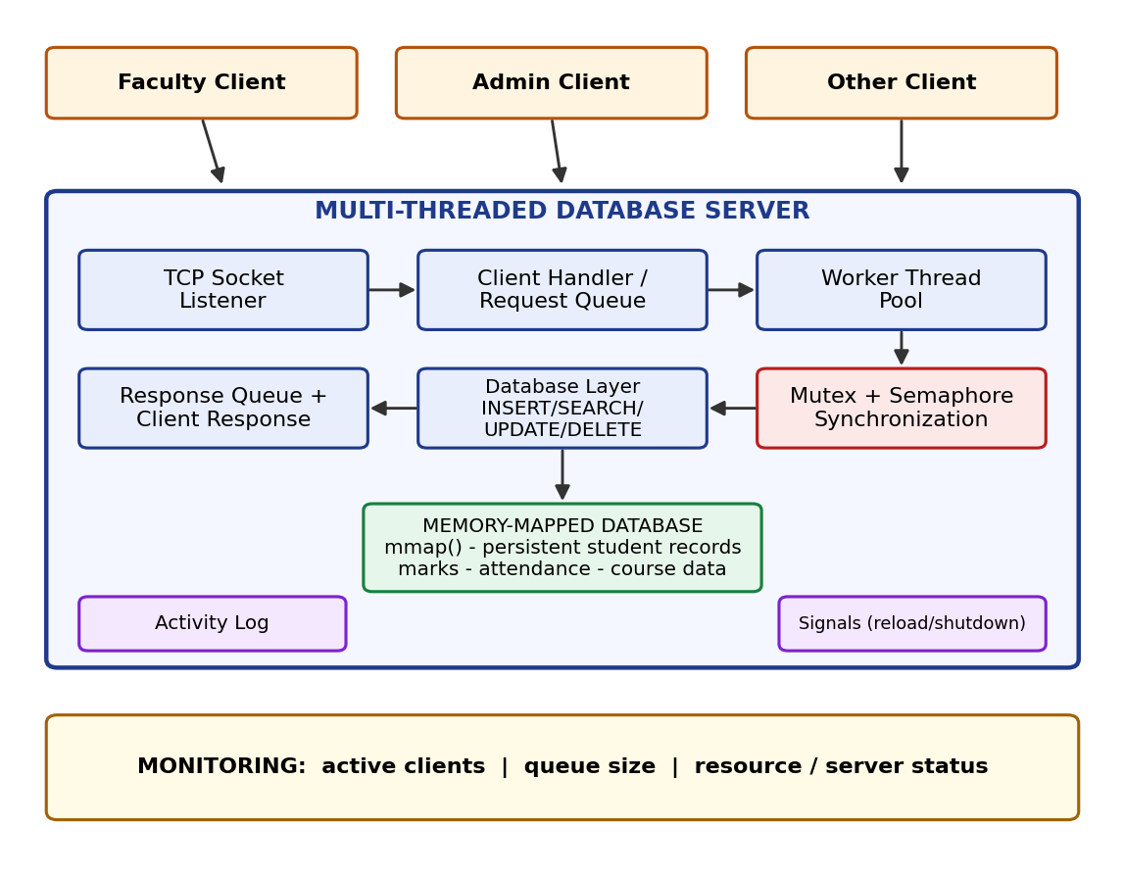
Figure 5.1: System architecture of the Database Client-Server Management System

5.2 System Workflow
The workflow of one request, from start-up to response, is as follows:
- The server starts, reads its configuration, opens the database file and maps it into memory with mmap().
- The server creates a TCP socket and calls bind() and listen() on the configured port.
- accept() returns when a client connects; a client-handler thread is created for that connection.
- The handler reads a request line from the client and pushes it into the request queue (sem_wait on free slots, sem_post on filled slots).
- An idle worker thread wakes up, removes the request from the queue and locks the database mutex.
- The worker performs the INSERT, SEARCH, UPDATE or DELETE operation, then unlocks the mutex.
- The worker writes a log entry and places the result into the response queue.
- The responder sends the result to the client over the TCP connection.
- On SIGHUP the configuration is reloaded; on SIGINT or SIGTERM the server shuts down in a controlled manner.

5.3 Flowchart / Data Flow
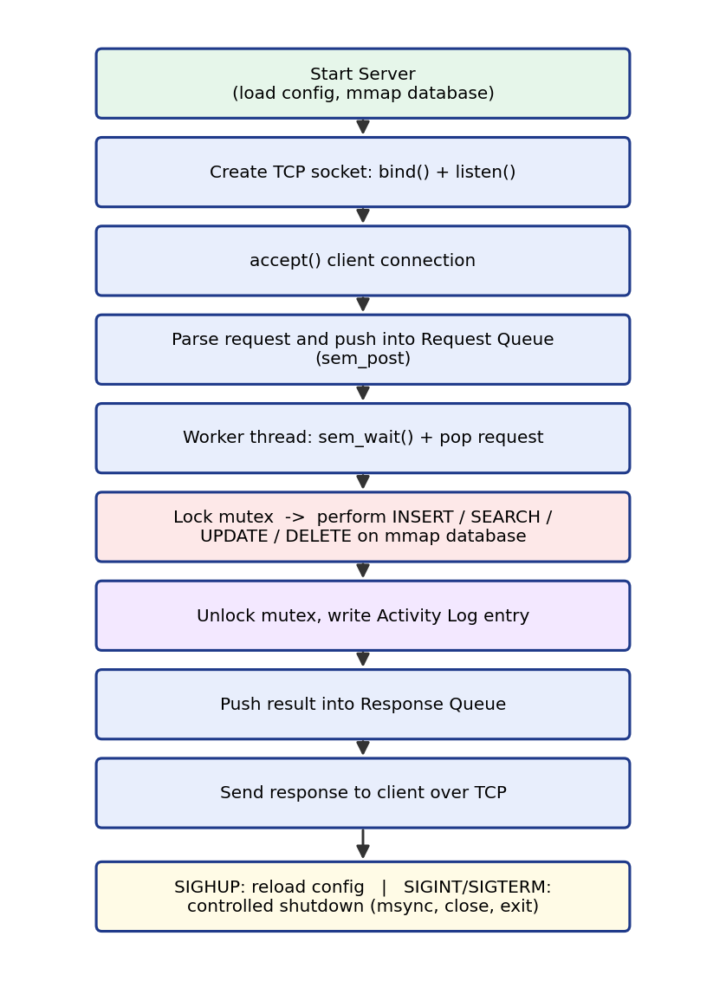
Figure 5.2: Flowchart of request processing in the server
The data flow between the main components is summarised below.
From | To | Data
Client | Socket Listener / Client Handler | Request text (command and fields)
Client Handler | Request Queue | Request record (client id, command)
Request Queue | Worker Thread | Next pending request
Worker Thread | Database Layer (under mutex) | Student record or key
Database Layer | Worker Thread | Result code and record data
Worker Thread | Response Queue | Response text
Response Queue | Client | Response over TCP
Worker Thread | Activity Log | Transaction entry
Table 5.1: Data flow between components

5.4 Module Description
Module | Description
TCP Listener | Creates the listening socket, accepts client connections and starts a handler for each.
Client Handler | Reads requests from one client, validates them and pushes them to the request queue.
Request / Response Queues | Bounded circular buffers protected by a mutex and two semaphores.
Worker Thread Pool | Fixed set of threads that take requests, run database operations and produce responses.
Database Layer | Implements INSERT, SEARCH, UPDATE and DELETE on records stored in the memory-mapped file.
Synchronization | Mutexes and semaphores that protect shared queues, database memory and the log.
Activity Logger | Writes time-stamped transactions and server events to a log file.
Signal Handler | Handles SIGHUP (reload configuration) and SIGINT/SIGTERM (controlled shutdown).
Monitor | Reports active clients, queue size and resource / server status.
Client Program | Menu-driven program that connects to the server and sends commands.
Table 5.2: Module description

5.5 Input and Output Design
Clients and the server communicate using simple text commands, one per line. The server replies with one line that starts with OK or ERR.
Operation | Input Format | Sample Output
INSERT | INSERT <roll> <name> <course> <marks> <attendance> | OK INSERTED 2520030001
SEARCH | SEARCH <roll> | OK 2520030001 Anil CSE 78.5 91.0
UPDATE | UPDATE <roll> <marks> <attendance> | OK UPDATED 2520030001
DELETE | DELETE <roll> | OK DELETED 2520030001
STATUS | STATUS | OK clients=3 queue=0 records=12
Invalid / missing | Any other text, or unknown roll number | ERR NOT FOUND or ERR BAD COMMAND
Table 5.3: Input and output formats
Each student record contains the roll number, name, course, marks and attendance percentage. Roll numbers are unique, so an INSERT for an existing roll number is rejected.

CHAPTER -6 IMPLEMENTATION

6.1 Module-wise Implementation
The source code is divided into small modules so that each OS concept is implemented in one place.
File | Responsibility
common.h | Constants, Student, Database and Request structures
queue.c / queue.h | Bounded queue using a mutex and two semaphores
db.c / db.h | mmap-based database and the four operations
log.c / log.h | Mutex-protected activity log
server.c | Listener, client handlers, workers, responder, signals, main()
client.c | Menu-driven client program
Makefile | Builds server and client
Table 6.1: Source files

6.2 Algorithm / Pseudocode
Worker thread
loop forever:
request = queue_pop(request_queue) // blocks on semaphore
if request is shutdown marker: exit
parse command from request
lock(db_mutex)
result = execute INSERT / SEARCH / UPDATE / DELETE on mapped database
unlock(db_mutex)
write log entry
queue_push(response_queue, result)
Bounded queue (producer-consumer)
push(item): pop():
wait(free_slots) wait(filled_slots)
lock(queue_mutex) lock(queue_mutex)
buffer[tail] = item item = buffer[head]
tail = (tail + 1) mod N head = (head + 1) mod N
unlock(queue_mutex) unlock(queue_mutex)
post(filled_slots) post(free_slots)
Server main
load configuration; open and mmap database; init queues and log
install signal handlers (SIGHUP, SIGINT, SIGTERM); ignore SIGPIPE
start worker threads, responder thread and monitor thread
create socket; bind; listen
while running:
if reload flag set: reload configuration
client = accept()
start detached client-handler thread for client
on exit: stop workers, msync + munmap database, close log and sockets

6.3 Core C / C++ Implementation
The following listings show the core of the implementation. They are shortened for readability; error handling is kept where it matters for correctness.
common.h – data structures
#define MAX_RECORDS 1000
#define QUEUE_SIZE 64
#define NUM_WORKERS 4
#define BUF_SIZE 256

typedef struct {
char roll[16];
char name[48];
char course[16];
float marks;
float attendance;
int used;
} Student;

typedef struct {
int count;
Student rec[MAX_RECORDS];
} Database;

typedef struct {
int client_fd;
char text[BUF_SIZE];
} Request;
queue.c – bounded queue
typedef struct {
Request items[QUEUE_SIZE];
int head, tail;
pthread_mutex_t lock;
sem_t free_slots, filled;
} Queue;

void q_init(Queue *q) {
q->head = q->tail = 0;
pthread_mutex_init(&q->lock, NULL);
sem_init(&q->free_slots, 0, QUEUE_SIZE);
sem_init(&q->filled, 0, 0);
}

void q_push(Queue *q, const Request *r) {
sem_wait(&q->free_slots);
pthread_mutex_lock(&q->lock);
q->items[q->tail] = *r;
q->tail = (q->tail + 1) % QUEUE_SIZE;
pthread_mutex_unlock(&q->lock);
sem_post(&q->filled);
}

void q_pop(Queue *q, Request *r) {
sem_wait(&q->filled);
pthread_mutex_lock(&q->lock);
*r = q->items[q->head];
q->head = (q->head + 1) % QUEUE_SIZE;
pthread_mutex_unlock(&q->lock);
sem_post(&q->free_slots);
}
db.c – memory-mapped database
static Database *db;
static pthread_mutex_t db_lock = PTHREAD_MUTEX_INITIALIZER;

int db_open(const char *path) {
int fd = open(path, O_RDWR | O_CREAT, 0644);
if (fd < 0) return -1;
if (ftruncate(fd, sizeof(Database)) < 0) { close(fd); return -1; }
db = mmap(NULL, sizeof(Database), PROT_READ | PROT_WRITE, MAP_SHARED, fd, 0);
close(fd); /* mapping stays valid */
return (db == MAP_FAILED) ? -1 : 0;
}

static int find(const char *roll) { /* caller holds db_lock */
for (int i = 0; i < MAX_RECORDS; i++)
if (db->rec[i].used && strcmp(db->rec[i].roll, roll) == 0) return i;
return -1;
}

int db_insert(const Student *s) {
int rc = -1;
pthread_mutex_lock(&db_lock);
if (find(s->roll) < 0) {
for (int i = 0; i < MAX_RECORDS; i++)
if (!db->rec[i].used) {
db->rec[i] = *s; db->rec[i].used = 1;
db->count++; rc = 0; break;
}
}
pthread_mutex_unlock(&db_lock);
return rc;
}

int db_delete(const char *roll) {
int rc = -1;
pthread_mutex_lock(&db_lock);
int i = find(roll);
if (i >= 0) { db->rec[i].used = 0; db->count--; rc = 0; }
pthread_mutex_unlock(&db_lock);
return rc;
}

void db_close(void) {
msync(db, sizeof(Database), MS_SYNC); /* flush to disk */
munmap(db, sizeof(Database));
}
server.c – worker thread and signal handling
static Queue req_q, resp_q;
static volatile sig_atomic_t running = 1, reload = 0;

static void on_term(int sig) { running = 0; }
static void on_hup(int sig) { reload = 1; }

static void *worker(void *arg) {
Request rq, rs;
for (;;) {
q_pop(&req_q, &rq);
if (rq.client_fd < 0) break; /* shutdown marker */
execute(rq.text, rs.text); /* INSERT/SEARCH/... */
rs.client_fd = rq.client_fd;
q_push(&resp_q, &rs);
log_event("fd=%d cmd=%s", rq.client_fd, rq.text);
}
return NULL;
}

int main(void) {
struct sigaction sa = {0};
sigemptyset(&sa.sa_mask);
sa.sa_handler = on_term;
sigaction(SIGINT, &sa, NULL); sigaction(SIGTERM, &sa, NULL);
sa.sa_handler = on_hup;
sigaction(SIGHUP, &sa, NULL);
signal(SIGPIPE, SIG_IGN);
...
while (running) {
if (reload) { load_config(); reload = 0; }
int cfd = accept(lfd, NULL, NULL);
if (cfd < 0) { if (errno == EINTR) continue; break; }
pthread_t t;
pthread_create(&t, NULL, client_handler, (void *)(long)cfd);
pthread_detach(t);
}
shutdown_server(); /* stop workers, db_close() */
return 0;
}

6.4 Linux System Calls / APIs Used
System Call / API | Purpose
socket(), setsockopt() | Create the TCP socket; enable address reuse (SO_REUSEADDR)
bind(), listen(), accept() | Attach to a port, wait for and accept connections
recv(), send(), close() | Exchange data with clients and end connections
open(), ftruncate() | Open the database file and set its size
mmap(), msync(), munmap() | Map the database into memory, flush changes, release the mapping
pthread_create(), pthread_detach() | Create worker, responder, monitor and handler threads
pthread_mutex_lock() / unlock() | Mutual exclusion on queues, database and log
sem_init(), sem_wait(), sem_post() | Counting semaphores for the bounded queues
sigaction() | Install handlers for SIGHUP, SIGINT and SIGTERM
time(), localtime_r() | Time stamps for log entries
Table 6.2: System calls and APIs used

6.5 Process / Thread Implementation
The server is a single process containing several kinds of threads. A fixed pool of worker threads is created at start-up and reused for the lifetime of the server, so no new process is created for any request.
Thread | Count | Role
Main / listener | 1 | Accepts connections, checks the reload flag, coordinates shutdown
Client handler | 1 per client | Reads request lines and pushes them to the request queue
Worker | NUM_WORKERS (4) | Pops requests, executes database operations, pushes responses
Responder | 1 | Pops responses and sends them to the correct client
Monitor | 1 | Periodically records active clients, queue size and record count
Table 6.3: Threads in the server
Client-handler threads are detached because nothing needs to wait for them. At shutdown the main thread pushes one shutdown marker per worker into the request queue so that every blocked worker wakes up, exits its loop and can be joined.

6.6 IPC / Synchronization Implementation
Because the threads share memory, communication between them is done through shared queues and synchronization is done with mutexes and semaphores.
Shared Resource | Protection | Reason
Request queue | Mutex + 2 semaphores | Producer-consumer between handlers and workers
Response queue | Mutex + 2 semaphores | Producer-consumer between workers and responder
Database (mapped region) | db mutex | Prevent lost updates and half-written records
Activity log file | log mutex | Prevent interleaved log lines
Active-client counter | Mutex | Correct count while clients connect and disconnect
Reload / running flags | volatile sig_atomic_t | Safe communication from signal handlers
Table 6.4: Synchronization of shared resources
The semaphores free_slots and filled make threads sleep instead of polling: a worker with no work blocks in sem_wait() and consumes no CPU, and a handler that finds the queue full blocks until a worker frees a slot. The mutex is held only for the few instructions that move a queue index or update a record, which keeps contention low. Locks are always taken in the same order (queue lock before database lock is never nested), so deadlock cannot occur.

6.7 Memory Management Implementation
The database is a fixed-size structure (a count and an array of Student records) stored in the file students.db. The file is created and sized with open() and ftruncate(), and mapped with mmap(PROT_READ | PROT_WRITE, MAP_SHARED). Because the mapping is shared, any modification made through the pointer is carried back to the file by the kernel; msync() is called at shutdown to force the data to disk.
- Records are accessed as array elements, so no read() or write() call is needed per record.
- The kernel loads pages on demand and keeps frequently used pages in memory.
- The file descriptor can be closed right after mmap(); the mapping remains valid.
- Queues are fixed-size arrays inside the process, so no dynamic allocation occurs on the request path and memory leaks are avoided.
- At shutdown munmap() releases the mapping.

6.8 Optional User Interface Implementation
A simple menu-driven command-line client (client.c) is provided. It connects to the server with socket() and connect(), shows a menu, builds the text command for the chosen operation, sends it and prints the server response.
===== STUDENT DATABASE CLIENT =====
1. Insert student
2. Search student
3. Update marks / attendance
4. Delete student
5. Server status
6. Exit
Enter choice:
Any other tool that can send text over TCP, such as netcat, can also act as a client.

CHAPTER -7 EXECUTION AND DEMONSTRATION

7.1 Compilation in Ubuntu
Open a terminal in the project folder and run make, or compile manually with GCC:
$ make
gcc -Wall -Wextra -g -O2 -pthread -o server server.c db.c queue.c log.c
gcc -Wall -Wextra -g -O2 -o client client.c

$ ls
client server students.conf Makefile *.c *.h

7.2 Execution Commands
# Terminal 1 - start the server
$ ./server

# Terminals 2, 3 ... - start one or more clients
$ ./client 127.0.0.1 8080

# Test with netcat
$ echo "STATUS" | nc 127.0.0.1 8080

# Administration
$ kill -HUP $(pidof server) # reload configuration
$ kill -TERM $(pidof server) # controlled shutdown (or press Ctrl+C)
$ tail -f server.log # watch the activity log
The port number, number of workers and the database file name are read from the configuration file students.conf.

7.3 Sample Inputs and Outputs
Client session
$ ./client 127.0.0.1 8080
Connected to database server.
Enter choice: 1
Roll: 2520030001
Name: Anil
Course: CSE
Marks: 78.5
Attendance: 91.0
Server: OK INSERTED 2520030001

Enter choice: 2
Roll: 2520030001
Server: OK 2520030001 Anil CSE 78.5 91.0

Enter choice: 3
Roll: 2520030001 New marks: 82.0 New attendance: 93.5
Server: OK UPDATED 2520030001

Enter choice: 4
Roll: 2520030001
Server: OK DELETED 2520030001

Enter choice: 2
Roll: 2520030001
Server: ERR NOT FOUND
Server activity log
[10:15:02] Server started on port 8080 (workers=4, db=students.db)
[10:15:20] Client connected: fd=4 (active=1)
[10:15:24] Client connected: fd=5 (active=2)
[10:15:31] fd=4 INSERT 2520030001 Anil CSE 78.5 91.0 -> OK
[10:15:35] fd=5 SEARCH 2520030001 -> OK
[10:15:48] fd=4 UPDATE 2520030001 82.0 93.5 -> OK
[10:16:02] fd=5 DELETE 2520030001 -> OK
[10:16:40] SIGHUP received: configuration reloaded
[10:21:07] SIGTERM received: shutting down (workers stopped, db synced)

7.4 Screenshots of Execution
[Insert screenshot 1: Compilation of the project using make]
[Insert screenshot 2: Server started and listening on the port]
[Insert screenshot 3: Two or more clients connected at the same time]
[Insert screenshot 4: INSERT, SEARCH, UPDATE and DELETE operations from a client]
[Insert screenshot 5: Activity log and STATUS output]
[Insert screenshot 6: SIGHUP reload and controlled shutdown using SIGTERM / Ctrl+C]

7.5 Demonstration of OS Concepts
OS Concept | How it is Demonstrated
Sockets | Several clients connect to one server port at the same time
Threads | ps -T -p $(pidof server) shows the worker, responder and monitor threads
Mutex | Concurrent updates to the same roll number never corrupt the record
Semaphore | Idle workers block without using CPU; a full queue blocks producers
Queues | STATUS shows queue size rising under load and returning to 0
mmap() | Records persist in students.db after the server is restarted
Signals | kill -HUP reloads configuration; kill -TERM / Ctrl+C stops the server cleanly
Logging / monitoring | server.log records every transaction; STATUS reports active clients
Table 7.1: Demonstration of OS concepts

CHAPTER -8 CONCLUSION

8.1 Summary of the Project
The Database Client-Server Management System demonstrates how operating-system concepts can be combined to build a practical networked database service. The server accepts requests from multiple clients over TCP sockets and distributes the work among POSIX worker threads. Mutexes and semaphores coordinate access to shared queues, database structures and resources, and a memory-mapped file provides efficient, persistent storage of student records. Logging, monitoring and signal handling make the service observable and controllable.

8.2 Objectives Achieved
Objective | Status | How it was Achieved
Concurrent client handling | Achieved | TCP sockets with client-handler and worker threads
Safe synchronization | Achieved | Mutexes and semaphores on queues, database and log
Database operations | Achieved | INSERT, SEARCH, UPDATE and DELETE implemented
Efficient data access | Achieved | Database file mapped into memory with mmap()
Server management | Achieved | Activity log, monitoring and controlled shutdown
Signal-based control | Achieved | SIGHUP reload; SIGINT / SIGTERM shutdown
Table 8.1: Objectives achieved

8.3 Results Achieved
- The server accepts requests from multiple clients and distributes work among worker threads, improving responsiveness under concurrent access.
- Shared access to queues, database structures and resources is coordinated, reducing the risk of race conditions.
- Memory mapping, activity logging, monitoring and signal handling provide efficient storage access and practical server administration.
- Records are preserved on disk and available again after a restart.
- The server can be reconfigured and shut down without losing data.

8.4 Skills and Learning Outcomes
- Network programming with TCP sockets on Linux.
- Multi-threaded programming with POSIX threads.
- Solving the producer-consumer problem with semaphores and mutexes.
- Using mmap() for persistent, efficient data access.
- Handling signals safely for reload and shutdown.
- Debugging concurrent programs with GDB and Valgrind, building with Make, and working as a team with Git.
Future Enhancements
- Authentication and role-based access control for faculty and administrators.
- Richer queries such as search by name, course or marks range.
- Backup and recovery of the database file.
- Encrypted communication (TLS) between client and server.
- A graphical or web-based client.

CHAPTER -9 REFERENCES

9.1 Books
[1] W. Richard Stevens, Bill Fenner and Andrew M. Rudoff, UNIX Network Programming, Volume 1: The Sockets Networking API, 3rd Edition, Addison-Wesley.
[2] Michael Kerrisk, The Linux Programming Interface, No Starch Press, 2010.
[3] Abraham Silberschatz, Peter B. Galvin and Greg Gagne, Operating System Concepts, 10th Edition, Wiley.
[4] David R. Butenhof, Programming with POSIX Threads, Addison-Wesley, 1997.
[5] Brian W. Kernighan and Dennis M. Ritchie, The C Programming Language, 2nd Edition, Prentice Hall.

9.2 Research Papers
[1] E. W. Dijkstra, "Cooperating Sequential Processes", Technical Report EWD-123, Technische Hogeschool Eindhoven, 1965.
[2] B. W. Lampson and D. D. Redell, "Experience with Processes and Monitors in Mesa", Communications of the ACM, 23(2), 1980.
[3] M. Welsh, D. Culler and E. Brewer, "SEDA: An Architecture for Well-Conditioned, Scalable Internet Services", Proc. 18th ACM Symposium on Operating Systems Principles (SOSP), 2001.

9.3 Linux / GNU Documentation
[1] Linux manual pages: pthreads(7), sem_overview(7), mmap(2), msync(2), signal(7), sigaction(2), socket(7), tcp(7). https://man7.org/linux/man-pages/
[2] The GNU C Library Reference Manual. https://www.gnu.org/software/libc/manual/
[3] GCC, the GNU Compiler Collection – Online Documentation. https://gcc.gnu.org/onlinedocs/
[4] GNU Make Manual. https://www.gnu.org/software/make/manual/

9.4 Online Resources
[1] Linux Kernel documentation. https://www.kernel.org/doc/
[2] Ubuntu Documentation. https://help.ubuntu.com/
[3] Microsoft Docs: Install Linux on Windows with WSL. https://learn.microsoft.com/windows/wsl/
[4] Beej's Guide to Network Programming. https://beej.us/guide/bgnet/

