Fashion Web Application Report

1. Main purpose of the application
The main purpose of the website is to provide users with a fashion magazine with the latest design trends. It will serve as a platform for well-known brands that want to advertise their products, with each brand having its own subpage.

2. Target Audience
The website is aimed at all age groups, but the main focus is on the female audience.

3. Basic functionalities
- Stylish and modern look
- Categories and filters (men, women, clothing type, jewellery)
- Ability to add advertising from brands
- Option to link to designers’ websites
- Division by type of clothing
- DropDown Menus

4. Website Type
The website will be more of a fashion magazine with the ability to link to designers’ shopping sites.
.

5. Design preference
- Clean and modern interface
- Filters to find content more easily
- Sections for different types of clothing and accessories
- Specific AI-based stylish recommendations

6. Technologies used
- Programming language: Python
- Framework: Flask (for backend and templating)
- Database: MongoDB (using PyMongo)
- Authentication: Flask-Login (or Firebase Auth, optional)
- Frontend: HTML, CSS, JavaScript (for interactivity)
- Analytics : Google Analytics (via script embed)

7. Software Architecture - Three-Tier Web Architecture
- Presentation Layer (Front-End)
This layer handles the user interface and interaction.
It is responsible for displaying pages and communicating with the back-end via API requests.
Technologies:
- HTML, CSS, JavaScript
- React.js – for building dynamic and interactive pages
- Tailwind CSS or Bootstrap – for responsive and stylish design
Main Components:
- Home Page: User can register or sign in using Email, Google, Facebook, or Instagram.
- Category Page: Shows categories such as Women, Men, Animals, Accessories, etc.
- Brand Page: Displays brands like Giang Donna, Gucci, Prada, Armani, etc.
- External Links Page: Provides links to official websites of selected brands.

- Application Layer (Back-End)
This is the logic and control layer that manages all operations and connects the front-end with the database.
Technologies:
- Node.js with Express or Python Django
Main Functions:
- Handles user registration and login
- Provides product and category data to the front-end
- Sends brand and external link information
- Manages user sessions and authentication

- Data Layer (Database)
This layer stores all website data, including users, categories, brands, and links to official brand websites.
Technologies:
- MongoDB – for flexible NoSQL data
- or PostgreSQL – for relational structure
Data Stored:
- Users (email, name, password)
- Categories (Women, Men, Animals, etc.)
- Brands (name, description, image)
- External Links (official clothing websites)

- Authentication & Security
- The system uses JWT (JSON Web Token) for secure login and registration.
- User passwords are encrypted before being stored in the database.
- All communication between the client and server is protected via HTTPS.
- Input validation and request filtering are applied to prevent attacks such as SQL Injection and Cross-Site Scripting (XSS).

8. Inspiration from existing apps
- Vogue
- Cosmopolitan
- Designer Fashion Websites (e.g Harper’s Bazaar, Elle, Tatler, Farfetch)

9. Main Content
- Designer clothes, shoes and accessories
- Animal fashion

10. Budget
Total budget: €35,000
- Taxes and external costs: €5,000
- Team salary: 7,500 euros per person (approximately)

11. Monetization
- Deals with big brands
- Affiliate Links (Pay per Click)
- In-app banner ads

12. Team Distribution
- Product owner & UI designer: Mira Poryzova
- Team Leader & Frontend Developer: Andzhelina Kaneva
- Scrum Master & Backend Developer: Kaloyan Stoyanov
- QA, Marketing & Business Analyst: Viktoria Kartalova

13. Schedule:
The project was carried out over a three-month period (01.01.2025 – 01.03.2025), divided into three main phases: Planning & Design, Development, and Testing & Launch.
Each team member contributed according to their role to ensure efficient collaboration, timely delivery and high-quality outcomes.

Month 1: Planning & Design (January 1 – January 31, 2025)
Week 1: Project Kick-off & Research
- Mira – conducted competitor analysis and created the initial product vision and feature list.
- Viktoria – researched target audience and market trends in fashion e-commerce.
- Kaloyan – set up the GitHub repository, created basic backend structure planning. ▪ Andzhelina – prepared initial technical stack proposal and frontend framework.
Week 2: Requirements & Planning
- Mira – created low-fidelity wireframes for homepage , product catalogue and user profile.
- Viktoria – documented business requirements and helped refine the user journey.
- Kaloyan – defined API endpoints and database schema draft.
- Andzhelina – structured the fronted project skeleton and configured routing.
Week 3: UI Design & System Architecture
- Mira – finalized UI mock-ups using Figma, including color palette and typography. ▪ Viktoria – reviewed the design from a user perspective, providing accessibility suggestions ▪ Kaloyan – implemented database setup (MongoDB) and initial API framework.
- Andzhelina – created frontend components for navigation and landing page layout.
Week 4: Sprint Review & Adjustments
- Kaloyan – led a meeting to review progress.
- Mira – updated design based on feedback.
- Andzhelina – integrated the final Figma assets.
- Viktoria – drafted the marketing strategy outline and started preparing test cases.

Month 2: Development phase (February 1 – February 29, 2025)
Week 5-6: Core Functionality Development
- Mira – reviewed UI alignment and ensured brand consistency.
- Viktoria – began test plan documentation.
- Kaloyan – developed user authentication and RESTful API endpoints.
- Andzhelina – implemented frontend for login/signup and product listing.
Week 7-8: Feature Expansion
- Mira – adjusted visuals based on feedback, adding hover effects and refining icons.
- Viktoria – executed first round of QA testing, reported minor UI bugs.
- Kaloyan – worked on shopping cart and order management system.
- Andzhelina – developed responsive product details and filter/sort funstionality.

Month 3: Testing, Marketing & Launch (March 1 – March 31, 2025)
Week 9-10: Integration & Testing
- Mira – created promotional visuals for launch.
- Viktoria – conducted comprehensive QA testing (usability, security, performance)
- Kaloyan – integrated frontend and backend and fixed API inconsistencies
- Andzhelina- optimized performance and ensured cross-browser compatibility
Week 11: Pre-Launch & Marketing
- Mira – designed email newsletter templates and social media banners
- Viktoria – led the marketing campaign, managed social media content and launch countdown.
- Kaloyan – deployed the staging environment for final checks.
- Andzhelina – handled UI polish and fixed final bugs.
Week 12: Launch & Retrospective
- Kaloyan – documented technical maintenance plan.
- Mira & Andzhelina – presented the final project showcase.
- Team launched the application successfully on March 28, 2025.
- Kaloyan - led a scrum retrospective; team discussed lessons learned and improvements for next project
- Viktoria – gathered user feedback and summarized analytics for the first week.

15. Schedule of working hours:
Project Duration: January 1 – March 31 (3 months)
Total Duration : 12 weeks
Total estimated hours per team member: ~180-200 hours

Role | Team Member | Avg.  Weekly  Hours | Total  Hours (3  Months) | % of Total Work
Product Owner & UI Designer | Mira Poryazova | 15 hrs/week | ~180 hrs | 22%
Team Leader & Frontend Developer | Andzhelina Kaneva | 20 hrs/week | ~240 hrs | 31%
Scrum Master & Backend Developer | Kaloyan Stoyanov | 18 hrs/week | ~216 hrs | 27%
QA, Marketing & Business Analyst | Viktoria Kartalova | 15 hrs/week | ~180 hrs | 20%

15.03-21.03
01.03-14.03
15.04-29.04
01.02-14.02
22.01-31.01
15.01-21.01
08.01-14.01
01.01-07.01
22.03-31.03
Mira
Viktoria
Andzhelina
Kaloyan
*Gantt Chart, according to work

16. Salary distribution
Team member | Responsibility level & Workload | Salary (approximately)
Mira Poryazova | Medium, ~22% | €9,000
Viktoria Kartalova | Medium, ~20% | €8,100
Andzhelina Kaneva | High, ~31% | €6,900
Kaloyan Stoyanov | High, ~27% | €6,000

17. UML Diagram (Web Application Function)
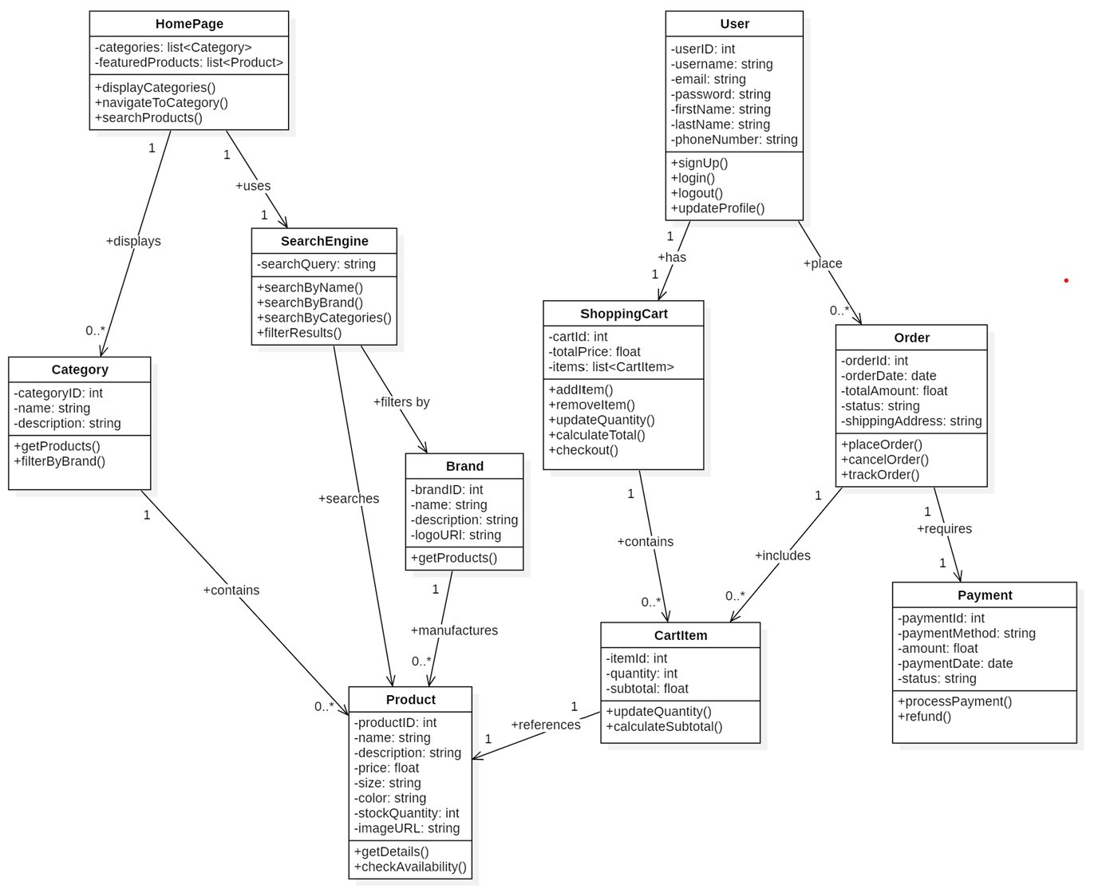

18. USE CASE Diagram
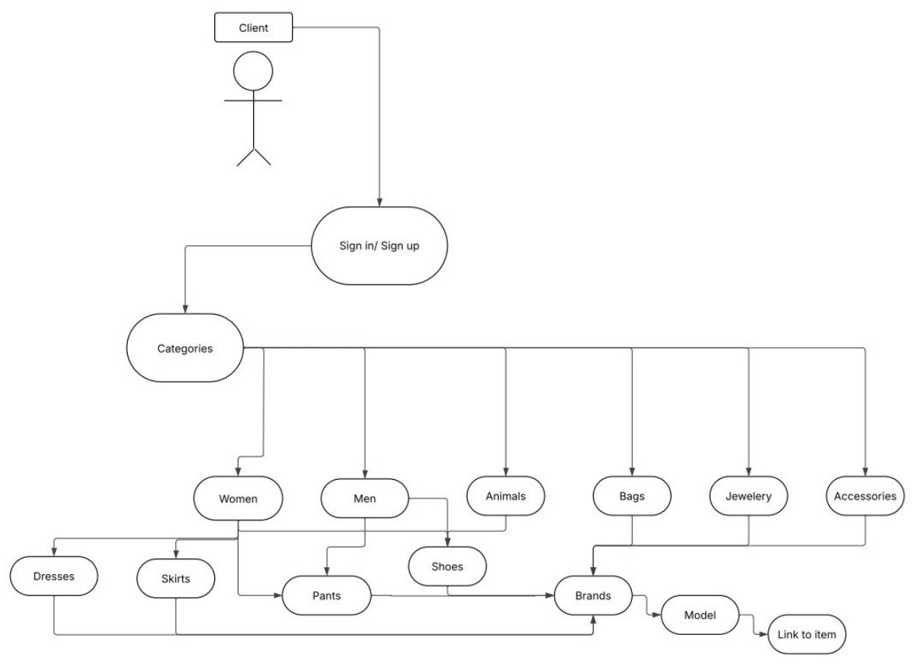

19. Class Diagram
