Page layouts and images
Three sections test portrait and landscape orientation, header variants, page numbering, columns and image placement.

Portrait A4 with inline image
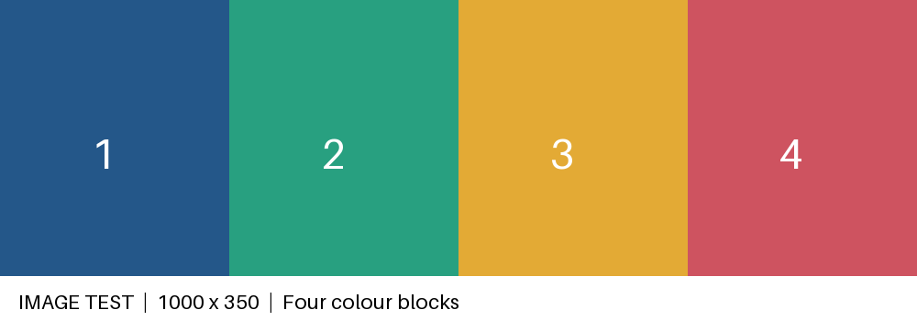
Figure 1. Inline image with alternative text
Expected: The image preserves its aspect ratio and stays in the text flow. This page has its own first-page header and footer.

Landscape A4 and wide table
Region | Jan | Feb | Mar | Apr | May | Jun
North | 10 | 20 | 30 | 40 | 50 | 60
South | 60 | 50 | 40 | 30 | 20 | 10
A floating image is anchored to the next paragraph. Text should wrap beside the image without covering it.
Wrapping sample. Wrapping sample. Wrapping sample. Wrapping sample. Wrapping sample. Wrapping sample. Wrapping sample. Wrapping sample. Wrapping sample. Wrapping sample. Wrapping sample. Wrapping sample. Wrapping sample. Wrapping sample. Wrapping sample. Wrapping sample. Wrapping sample. Wrapping sample. Wrapping sample. Wrapping sample. Wrapping sample. Wrapping sample. Wrapping sample. Wrapping sample. Wrapping sample. Wrapping sample. Wrapping sample. Wrapping sample. Wrapping sample. Wrapping sample. Wrapping sample. Wrapping sample. Wrapping sample. Wrapping sample. Wrapping sample. Wrapping sample. Wrapping sample. Wrapping sample. Wrapping sample. Wrapping sample. Wrapping sample. Wrapping sample. Wrapping sample. Wrapping sample. Wrapping sample.

Letter paper and columns
Left column. Left column. Left column. Left column. Left column. Left column. Left column. Left column. Left column. Left column. Left column. Left column. Left column. Left column. Left column. Left column. Left column. Left column. Left column. Left column. Left column. Left column. Left column. Left column. Left column. Left column. Left column. Left column. Left column. Left column. Left column. Left column. Left column. Left column. Left column. Left column. Left column. Left column. Left column. Left column. Left column. Left column. Left column. Left column. Left column. Left column. Left column. Left column. Left column. Left column. Left column. Left column. Left column. Left column. Left column.

Right column
Right column. Right column. Right column. Right column. Right column. Right column. Right column. Right column. Right column. Right column. Right column. Right column. Right column. Right column. Right column. Right column. Right column. Right column. Right column. Right column. Right column. Right column. Right column. Right column. Right column. Right column. Right column. Right column. Right column. Right column. Right column. Right column. Right column. Right column. Right column. Right column. Right column. Right column. Right column. Right column. Right column. Right column. Right column. Right column. Right column. Right column. Right column. Right column. Right column. Right column. Right column. Right column. Right column. Right column. Right column.
Expected: This section is US Letter portrait, has two columns with a separator, and restarts page numbering in Roman numerals.

