Document editor acceptance report
A compact report combines headings, prose, tables, a figure and pagination. All results below are synthetic and do not describe your application.

Executive summary
This sample report supplies a realistic editing surface. Change the title, insert a row, replace the image and export the result. Compare the saved file with the original to identify lost formatting or content.

Test outcomes
Test area | Sample result | Next action
Text editing | Pass | Check undo and redo
Table editing | Review | Insert and remove a row
Image replacement | Pending | Replace the figure
Export | Pending | Compare page breaks

Sample figure
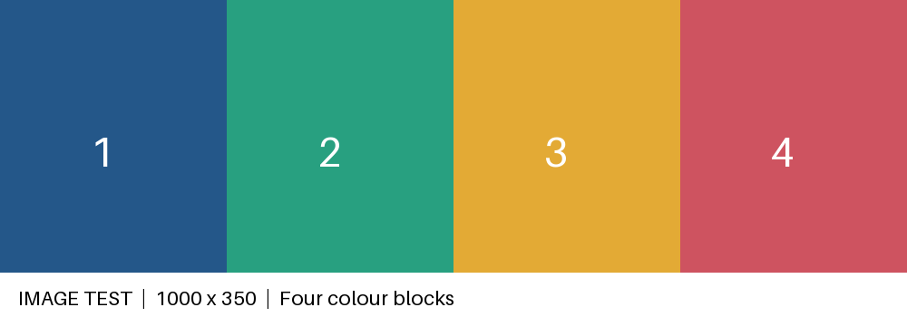
Figure 1. Synthetic colour blocks

Acceptance checklist
- Open the original without a repair warning.
- Edit Greek and English text and undo the change.
- Apply a paragraph style and preserve direct formatting.
- Insert and delete a table row; retain merged cells.
- Replace the image while preserving its aspect ratio.
- Save a new copy, close it, and reopen it.
- Verify that comments, revisions and fields survive.
- Print or export and compare orientation and page breaks.

Results to record
Operation | Expected result | Actual result
Open | No loss or repair
Save and reopen | Content and features retained
Export | Readable layout
Record the application version, platform, fonts and reference editor alongside each result. A fixture cannot by itself prove support for a feature.

