Greenhouse Planning and Approach

Table of Contents
1. Waterfall approach 2
2. Weekly milestones 2
3. What depends on what 3
4. How I will handle delays 3
5. Detailed schedule 4

1. Waterfall approach
I will work through five phases, checking components early and updating earlier decisions when a problem requires it.
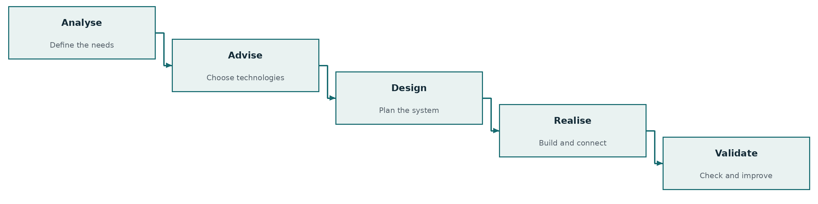

2. Weekly milestones
Week 1 | Week 2 | Week 3 | Week 4
Requirements and technology choices defined. | Design ready and individual components checked. | Local control, storage and dashboard connected. | Final checks complete; fixes retested and work submitted.
At each week’s end, I will compare the working result with the milestone and update the remaining plan.

3. What depends on what
These links show which work must come together before the complete system can be evaluated.
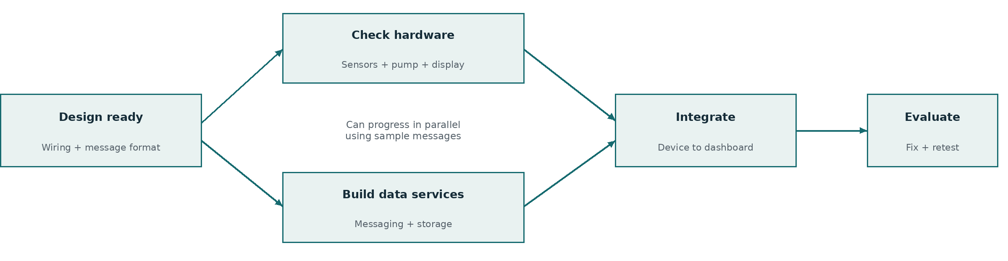
If parts are delayed, I can continue the data services with sample readings. Actual hardware integration still needs the real components.

4. How I will handle delays
If this happens | My response
A component does not work as expected | Check compatibility early; revise the choice or wiring before integration.
Connecting the software takes longer | Complete one path first: device → stored reading → dashboard. Expand after it works.
There is not enough time for every feature | Postpone “Could Have” requirements first, then “Should Have” if needed.
I will update the schedule when tasks slip and record the reason for each change.

5. Detailed schedule
The Gantt chart will show task durations, overlaps, dependencies and milestones across the four weeks.

