Greenhouse Project
Gibbs Reflection
Kaloyan Milev | Fontys | Submission reflection

Table of Contents
Summary of the document: 1
1 Description 2
2 Feelings and thoughts 2
3 Evaluation 3
4 Analysis 3
5 Conclusion 4
6 Action plan 5

Summary of the document:
- Description: I built an ESP32 greenhouse system that waters a plant, displays sensor readings locally and sends data through MQTT to a database and dashboard.
- Feelings: I understood individual lines of code but struggled to understand the “why?” behind some of the code and architecutre.
- Evaluation: The system worked within my planned schedule, although networking and repeated sensor calibration took more effort than expected.
- Analysis: Choosing a demanding implementation added learning time because I needed to understand connection behaviour and turn raw sensor readings into useful watering decisions.
- Conclusion: My biggest learning was understanding why the code needed its structure, and I realised that deeper technical analysis would help me choose a suitable working methodology.
- Action plan: In my next project, I will investigate unfamiliar concepts before estimating the work, define each function’s purpose, allow time for repeated tests and continue using a project plan and Gantt chart.

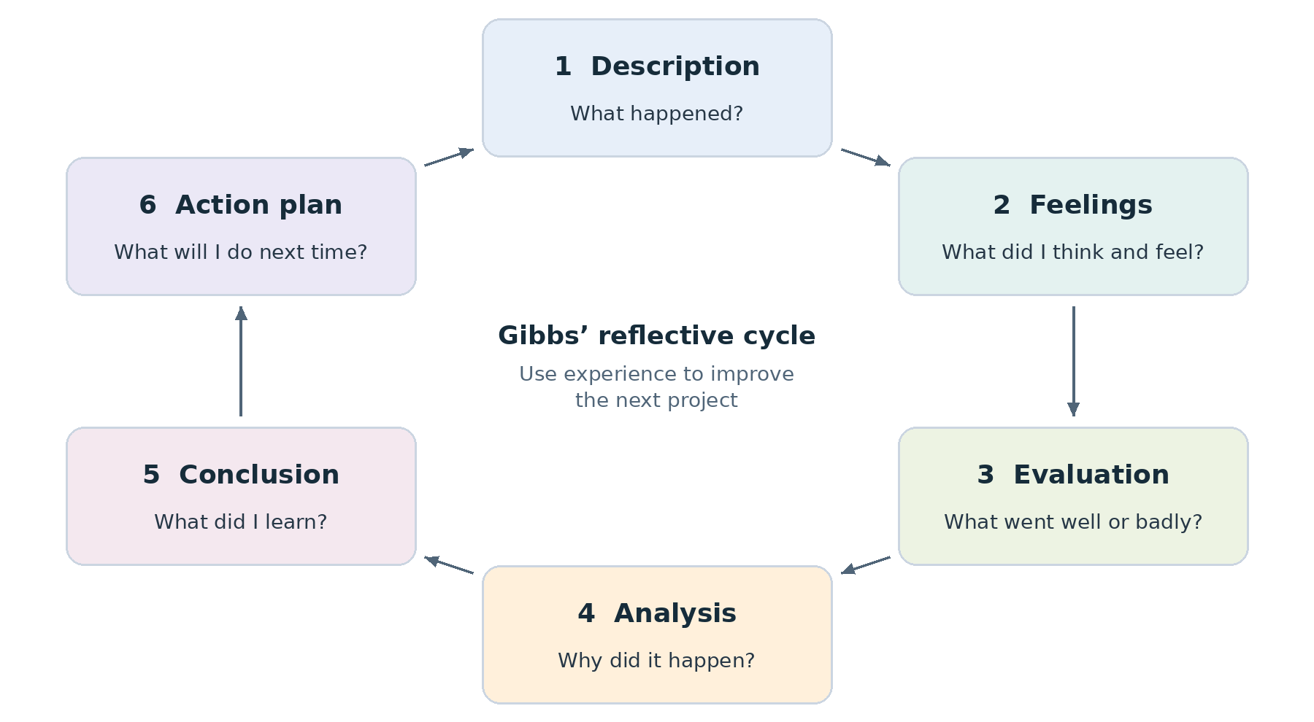
Figure 1 Gibbs’ reflective cycle

1 Description
I built a one-plant greenhouse prototype within a four-week project scope. The work covered analysis, hardware and software design, implementation, testing and documentation.
- At the plant, an ESP32 controller reads sensors, controls watering and shows readings and warnings on an OLED screen.
- On the computer, a backend saves data in PostgreSQL, and Grafana shows current readings and watering history.
During analysis, I chose to challenge myself by writing the application functions for Wi-Fi and MQTT using ESP-IDF. I used the existing networking libraries; I did not implement the Wi-Fi or MQTT protocols from scratch.

2 Feelings and thoughts

I understood the code but questioned its purpose
Writing network.c and mqtt.c was the hardest part. Event handlers, event groups, void and generic pointers were new to me. I could understand what the code did, but I kept struggling with the question: “Why am I writing this?”
For example, I would not initially have thought of writing a separate function just to initialise Wi-Fi. The difficulty was deciding which functions were needed and how they should work together, rather than only learning the syntax.
I used sources ranging from Wikipedia and datasheets to AI explanations. I used AI to understand the concepts and the reasons behind the code, while trying to write as much of the code myself as possible.

3 Evaluation

What worked by submission
- The complete system worked. I saw the pump water the plant, readings appear on the dashboard and the device reconnect after losing Wi-Fi. These did not all work on the first attempt.
- The schedule was sufficient. Realization took slightly longer than I expected, but I still had enough time for the work and followed my project plan and Gantt chart.
- The harder route supported my learning. Writing the connection functions made me work through concepts I had not used before, including events and shared connection status.

What took more effort than expected
- Wi-Fi and MQTT structure. I had not initially expected how much application code I would need around the libraries. During analysis, I chose that route to push myself.
- Sensor calibration. The moisture and water-level sensors needed several attempts before they worked as intended. Receiving a sensor value was only the first step; the controller also needed useful thresholds for watering.
My assessment: I achieved a working prototype within the plan. The main weakness was how little I initially understood about the work behind the connection functions.

4 Analysis

What the unfamiliar concepts were doing
The networking code needed to react to things that happened after setup, such as receiving an IP address or losing the connection. That explains why one initialisation function was not enough.
- Initialisation sets up the network interface, Wi-Fi driver, configuration and event handlers. In my code, networkInit() keeps this setup separate from the main sensor and watering loop.
- An event handler runs when a registered event occurs. My handler sets the network-ready flag when an IP address arrives. If Wi-Fi disconnects, it clears that flag and schedules another connection attempt after three seconds.
- An event group holds status flags that different parts of the program can check. NETWORK_READY_BIT represents whether an IP address has been obtained. This gives connection status a clear meaning.
- void and void * mean different things. A void function returns no value. A void * parameter can pass data without specifying its type in the function signature. My callbacks include such parameters because the library expects them; some are unused.
These details explain why the structure mattered. The functions had separate jobs: configure the connection, react to changes and report its state. Understanding those jobs was harder for me than reading the individual lines.

Why calibration needed repeated attempts
The program needed to turn raw sensor readings into decisions: whether the soil was dry and whether the reservoir contained enough water. Those decisions depended on calibration. My attempts with the actual sensors were therefore part of making the control logic useful, not just checking whether the sensors returned numbers.

Why realization took longer
During analysis, I deliberately chose a more demanding implementation. That added learning time for the connection code. My schedule still accommodated it, so the lesson is to investigate unfamiliar work earlier, rather than assume that the whole plan was wrong.

5 Conclusion
I finished with a system that watered, displayed readings remotely and reconnected after a Wi-Fi loss. I also understood the code I had written more clearly. The largest learning step was understanding why event-based networking needs several functions with different responsibilities.
For the next project, I would spend more time investigating the technical work during analysis. I would choose the working methodology after that investigation, when I could better judge how much was known and how much needed experimentation.

6 Action plan

What I will carry into an unknown next project
I do not know the subject of my next project yet. These actions address the difficulties I experienced here without assuming that the next assignment uses sensors, Wi-Fi or MQTT.
When | My action | Evidence of progress
During analysis | List the concepts and tools I have not used. Try a small example of the hardest part before estimating the implementation work. | I can explain what I must build myself and what an existing library provides.
Before choosing a method | Use what I learned in analysis to decide how to organise the project. Consider clear phases for known work and short experiments for uncertain parts. | A reason for the chosen methodology based on the actual project.
Before writing a module | Write down each proposed function’s job, what triggers it and what information it needs. | I can answer “Why does this function exist?” before writing its body.
When using outside help | Use documentation and AI to explain unfamiliar concepts. Check the relevant API documentation, then write and explain my own implementation. | I can explain the code without relying on the explanation I was given.
When planning tests | Reserve time for repeated trials where results depend on real inputs or conditions. Record the input, result and adjustment. | Decisions are based on observed behaviour, as with sensor calibration in this project.
During the project | Continue using a project plan and Gantt chart. Check whether new learning changes the time needed for the remaining work. | The schedule includes learning and retries, not only writing the final code.

The main change: Investigate deeper, then choose the methodology and estimate the work. Keep the planning discipline that already worked for me.

