MoodPulse Project Plan
Group 4 | Six weeks | Two three-week sprints

Table of Contents
1 Scrumban approach 1
2 Sprint goals 2
3 Weekly milestones 2
4 GitHub workflow 3
5 Domain responsibilities 4
6 Managing delays and scope changes 5
7 Final acceptance and delivery 5
Delivery package 6

1 Scrumban approach
We will combine Scrum sprint goals, planning, reviews and retrospectives with a Kanban workflow on GitHub. Analysis, design, implementation and testing repeat within both sprints. We will integrate early, limit work in progress and adjust the backlog when feedback or technical findings require a change.

The product defined in MoodPulse Analysis will be delivered through two working increments. Sprint 1 establishes the bracelet-to-website flow, accounts and basic journaling. Sprint 2 completes trends, AI summaries and final validation. Individual tasks and assignments are managed on the GitHub issue board.

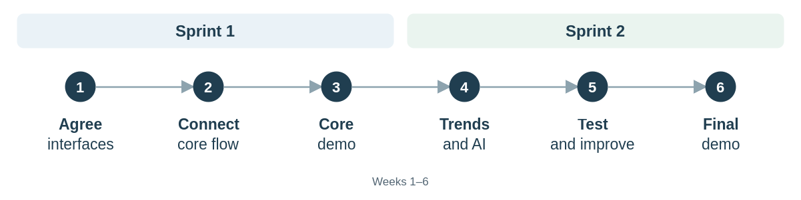

2 Sprint goals
Sprint | Goal and review evidence
Sprint 1  Weeks 1–3 | Demonstrate real heart-rate and movement readings travelling over Bluetooth into the correct user’s stored history and website view. Users can log in, log out, and save and reopen an optional journal entry. Check invalid readings, user isolation and basic connection-loss recovery.
Sprint 2  Weeks 4–6 | Demonstrate history and trends, AI summaries with non-medical suggestions, and journal editing and deletion with updated analysis. Complete all shared Must Have checks, including recovery and failure cases. Deliver setup instructions, test evidence and known limitations.

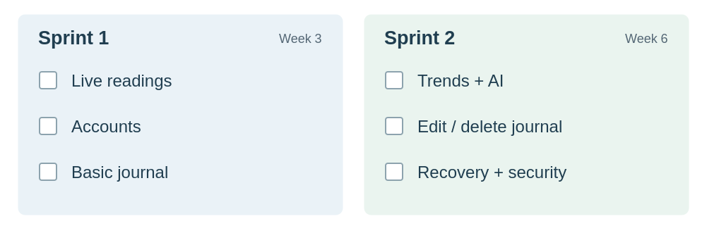

3 Weekly milestones
Week | Expected outcome
1 | Confirm the shared requirements, supported Bluetooth route and record format. Set up the board and deployment environment; check sensors and prototype AI access using sample data.
2 | Connect real bracelet readings to backend storage and the website. Add accounts, access checks and basic journal storage. Begin buffering and replay tests.
3 | Demonstrate the Sprint 1 user journey and fix integration issues. Review results, record feedback and plan Sprint 2.
4 | Add selected-period history, trends and AI summaries. Complete journal editing and deletion, including updates to affected analysis.
5 | Test missing data, Bluetooth recovery, AI failure, user isolation and privacy controls. Complete remaining Must Haves; add Should Haves only if core delivery is on track.
6 | Retest fixes and verify all shared Must Haves. Finalise deployment instructions and test evidence; demonstrate the product and record the final review.

Weekly milestones guide the work; the board holds the current task order. Testing and documentation continue throughout both sprints.

4 GitHub workflow
We will use the GitHub issue board to organise tasks through four stages: To do → In progress → Review → Done. During sprint planning, we will select tasks that support the sprint goal and assign their priority, domain and responsible team member. Each issue will describe the expected result.
Team members will move issues as work progresses and record blockers directly on the issue. We will focus on finishing active tasks before starting new ones. Work moves to Review when it is ready for another team member to check.

When an issue is done
An issue moves to Done when its acceptance checks pass, another team member has reviewed the result, and relevant changes are integrated. The complete user journey will also be tested to confirm that the components work together.
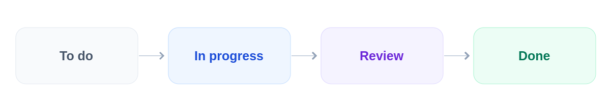

5 Domain responsibilities
Domain | Main responsibility
Embedded systems | Heart rate and movement sensing, quality flags, timestamps, buffering, Bluetooth transfer and wearable checks.
Software engineering | Website, accounts, application backend, journal features, data retrieval and presentation of history and AI results.
Network and cloud | Hosting, deployment, service connectivity, access configuration and recovery setup.
Data analytics | Validate readings, calculate trends and summaries, and prepare user-specific data for AI interpretation.
AI integration | Generate non-medical overviews and suggestions; handle missing data, service failure and optional face analysis.
Security | Coordinate access, device association, privacy and deletion checks with every domain.

Assign people to issues on GitHub. For work crossing domains, choose one accountable assignee and identify the contributors. Integration, reviews and final acceptance are shared team responsibilities.

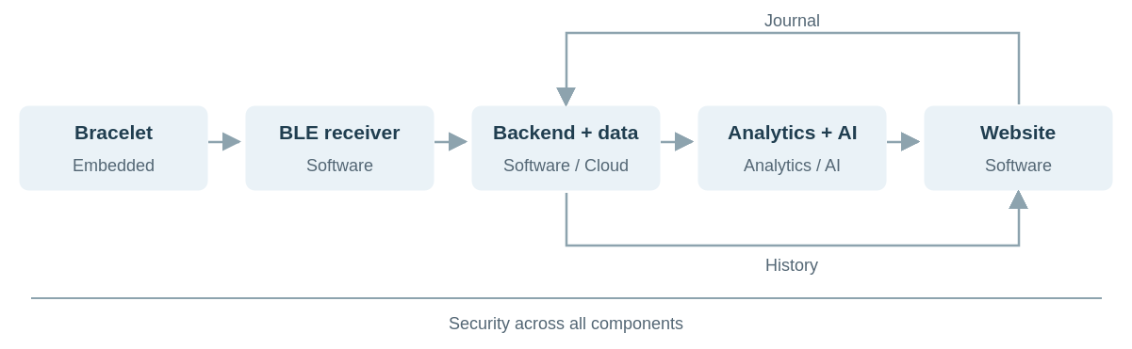

6 Managing delays and scope changes
If this happens | Our response
Hardware or Bluetooth is delayed | Test the smallest working connection first. Continue backend and interface work with sample records; keep real-device integration visibly outstanding.
An interface or data format changes | Update the shared contract and affected GitHub issues before dependent work continues. Retest both ends of the connection.
AI access or output is unreliable | Investigate early, keep history usable during AI failure and review outputs against the non-medical requirements. Resolve core AI issues before optional face analysis.
There is insufficient time | Postpone Could Haves first, then Should Haves. Protect the core user journey and final validation. Record any proposed change to a Must Have in the analysis and backlog.
A privacy or access check fails | Block the affected feature from acceptance, fix the issue and repeat the test before using personal data in that flow.

Face analysis and battery reporting are Should Haves. Personal reference values and restart-persistent buffering are Could Haves. A phone application remains a later decision and must not displace completion of the website-based core.

7 Final acceptance and delivery
Use the shared requirements in section 4 of MoodPulse Analysis as the acceptance baseline. Section 5 module requirements are marked for team review; resolve conflicts against the shared baseline during planning.
Check | Required evidence
Core user journey  FR-01–FR-10, FR-13 | Real bracelet → Bluetooth → stored history → website → trends → AI overview. Demonstrate optional journaling, editing and deletion with updated analysis; repeat without a journal entry.
Invalid data and failures  FR-05–FR-06, FR-08, FR-11–FR-12 | Invalid and stale readings are visible; replay preserves acquisition times without duplicates. Demonstrate insufficient-data handling, connection loss and AI failure.
Quality and security  NFR-01–NFR-04, NFR-06–NFR-09 | Verify account isolation, protected data handling, device association, privacy notice and deletion process. Check units, usability, reproducible setup and wearable assembly.

Record expected and actual results against each requirement ID. Completed optional features must also pass their applicable checks, including face-capture controls and image handling. Unfinished work remains visible on the board.

Delivery package
At the end of Week 6, we will deliver the working MoodPulse app and bracelet prototype, supported by the source code and configuration in GitHub. The delivery will include the instructions for using the system. We will demonstrate the complete user journey and record known limitations and unfinished features so that the product can be assessed, reproduced and continued after the project.

