SpaceGame

Design

1. Inspiration

Asteroids (video game) – Wikipedia
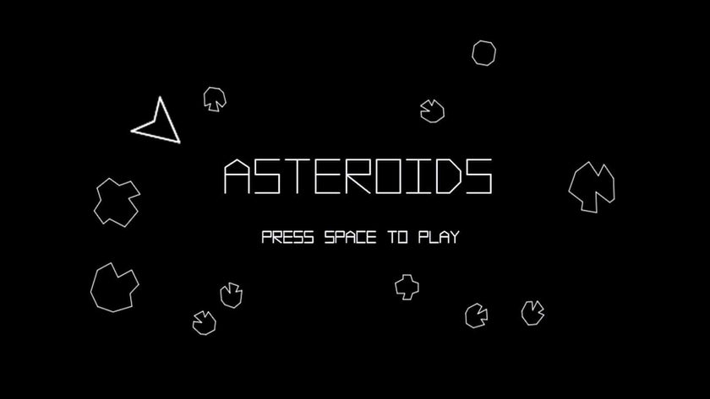

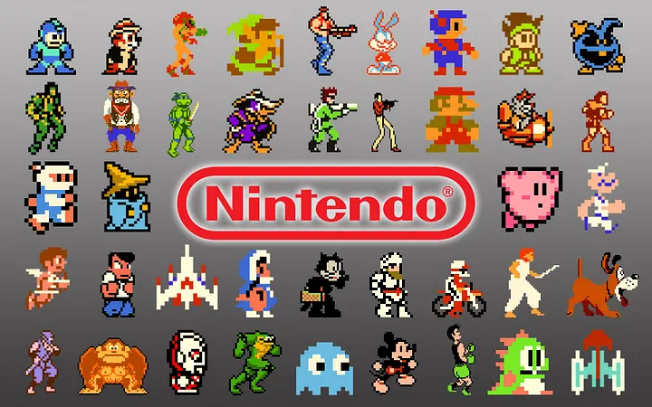
Third generation of video game consoles – Wikipedia

2. Design Sketch

