Europe's Exposure to a Natural Gas Shock (Dutch TTF)
Author: Kaloyan (@ktsvv_) | Date: February 1, 2026 | Asset: Dutch TTF Natural Gas Futures

1. Summary
When a U.S.-Iran crisis breaks out, the usual reaction is to buy gold and silver before Monday's open. I think that is the wrong hedge this time. Gold had already reached a cycle top, with three regression channels meeting at $5,400–$5,600 and record leverage behind it. The exposure the market is missing is European natural gas, priced at the Dutch TTF hub.
"Buying gold and silver right now is not the best option to hedge against the U.S. - Iran war. Both have been on a remarkable run and are attracting investors to buy in on Monday open. However, the analysis I have conducted says otherwise. We are in for an energy crisis that the markets did not fully price in. A thread on why I looked elsewhere for a hedge:"
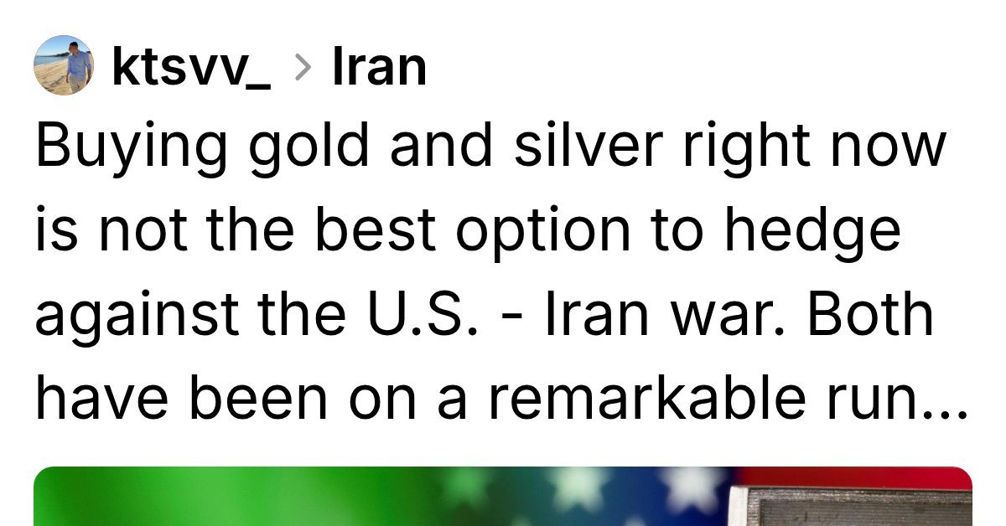
Figure 1: Thread posted on Threads (@ktsvv_), comparing stretched precious metals with the risk to European natural gas.

2. The Strait of Hormuz
Qatar supplies about 20% of the world's seaborne LNG, and all of it passes through the Strait of Hormuz, with no pipeline route around it. Iran would not need to close the strait: the threat of strikes or mines is enough for war-risk insurers to pull cover and for tankers to stop. Unlike oil, there are no strategic reserves of gas to release.

3. Why Europe Is Exposed
After 2022, Europe replaced Russian pipeline gas (over 40% of supply) mainly with seaborne LNG, which is now 40–50% of its imports. North Sea fields are declining and Groningen is shut. That makes Europe a spot buyer with little domestic cushion, so any supply drop shows up quickly in TTF.

4. Competition with Asia and Shipping
About 70–80% of Qatar's LNG goes to Asia. If it stops, Asian buyers will bid for Atlantic cargoes from the U.S., West Africa and Norway, and Europe will have to outbid them, with TTF trading above the Asian benchmark (JKM). Red Sea disruption has already added 10–14 days to voyages around the Cape, so fewer ships are available.

5. Storage
High storage in early 2026 made Europe look well supplied, but storage covers only 25–30% of annual demand. The EU requires it to be refilled to 90% between April and October, so a disruption at the start of refilling season would force utilities to buy at any price.

6. Gold versus TTF
Gold sat about two standard deviations above its 28-year trend, with record leverage and near-universal bullishness: limited upside, high risk of a forced sell-off. TTF had spent months near its post-crisis lows with little geopolitical risk priced in: limited downside, large upside in an energy crunch. I would rather own the asset in the path of the crisis that has not moved yet.

7. What to Watch
- Shipping through Hormuz and changes from war-risk insurers.
- The TTF–JKM spread: wider Asian premiums pull cargoes away from Europe.
- European forward curves: summer 2026 contracts above spot would signal urgent buying for storage.
I may be wrong on timing, but I think energy is a better hedge than metals for this particular risk.

