Reading the XAUUSD Cycle Top Through Converging Regression Channels
Author: Kaloyan (@ktsvv_) | Published on Threads: January 29, 2026 | Asset: Gold Spot / U.S. Dollar (XAUUSD)

1. Background
From late 2025 into January 2026 gold went almost straight up, clearing every previous high and pushing through $5,500. Calling the end of a move like that on instinct is usually expensive, so I combined three things: statistical channels, leverage data and market sentiment. I posted the call on Threads on January 29, 2026, while gold was still near the high.

2. The Three Regression Channels
A linear regression channel fits a best-fit line through every close in a period and adds bands two standard deviations above and below it. Price at the upper band is stretched well ahead of its own trend, and tends to revert towards the middle.
I drew three channels on the monthly chart:
- Long-term, from 1998 (gold near $251.70): almost 30 years of the bull market.
- Cycle, from 2021: the inflation, central-bank buying and safe-haven cycle.
- Short-term, from early 2025: the near-vertical final year.
Any one of these can give a false signal. What mattered was that all three upper bands met in the same zone, $5,400 to $5,600.

3. The Call
I posted it before the monthly close, with a clear trigger: "A candle close below $5,400 and that is it for the Gold run on this cycle. Finally at the top. Officially calling it now."
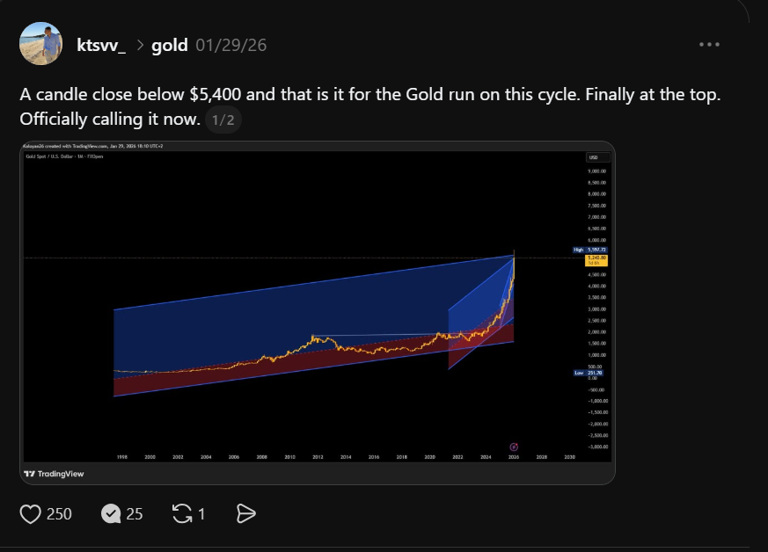
Figure 1: Analysis posted on Threads on January 29, 2026, showing the three converging regression channels on the monthly XAUUSD chart.

4. Leverage and Sentiment
Leverage was at record levels in the final leg: record margin balances, heavy micro-futures and call-option buying, record speculative longs on COMEX and gold ETFs trading above their net asset value. When a rally runs on borrowed money, a small stall triggers margin calls and forced selling, so a reversal from the top of the channels was likely to be fast.
Sentiment was one-way. Gold was on front pages, social media was full of $7,000–$10,000 targets, and first-time buyers were opening accounts at the highs. Once nearly everyone who wants to own an asset already owns it, few buyers are left.

5. Conclusion
The call rested on three things lining up: the 28-year, 5-year and 1-year channels meeting at $5,400–$5,600, record leverage that left the market fragile, and euphoric sentiment. Publishing it before the outcome was known is how I try to approach every analysis.

6. From Analysis to Indicator
Reading several regression channels at once and looking for where their bands meet led me to build the Dynamic Regression Channels indicator. It fits channels over four horizons, sizes each band by the real scatter around its trend, and marks the zones where several horizons agree.

