HOW I ANALYSED THE EXACT TOP OF XAUUSD
Author: Kaloyan (@ktsvv_) | Date of Public Analysis: January 29, 2026 | Asset: Gold Spot / U.S. Dollar (XAUUSD)
1. Overview and Context
In late 2025 and January 2026, Gold (XAUUSD) experienced one of the most explosive, parabolic rallies in modern market history. The metal broke every historical price ceiling and pushed aggressively through the $5,500 milestone. Pinpointing the exact top of an aggressive, historic trend is notoriously difficult. Attempting to guess turning points based on gut feeling usually leads to heavy losses. My analysis was not based on guesswork, but on a disciplined confluence of quantitative statistical tools, structural leverage data, and market psychology.
By aligning three distinct linear regression channels across three completely different time horizons (spanning decades, years, and months), I identified the exact mathematical exhaustion zone where price could no longer sustain its momentum. To remove all hindsight bias and validate the framework in real time, I published my exact analysis publicly on Threads on January 29, 2026, calling the definitive cycle top right as the market traded at its peak.
2. Understanding Linear Regression Channels
A linear regression channel is an objective statistical charting tool used to measure trends and detect extreme price deviations. Unlike traditional manual trendlines, which rely heavily on individual trader discretion and arbitrary anchor points, linear regression is calculated mathematically using the method of least squares.
The channel consists of three primary components:
- Center Line (The Mean): This represents the line of best fit through every single closing price point within the chosen timeframe. It reflects the statistical average, or fair value, of the asset over that period.
- Upper and Lower Standard Deviation Bands: Parallel lines placed above and below the center line at a set statistical distance, typically two standard deviations away. Statistically, in a normal distribution, approximately 95% of all price action stays within these boundaries.
When an asset trades within its channel, the price action is considered normal and statistically sustainable. However, when price accelerates dramatically and touches or penetrates the upper boundary, it signals that the asset is stretched far beyond its historical growth trajectory. While strong momentum can temporarily push prices near the upper band, an asset cannot remain two standard deviations away from its mean indefinitely. Mathematical gravity eventually takes over, resulting in a sharp reversion toward the mean.
3. The Three Regression Channels Used to Pinpoint the Top
Rather than relying on a single timeframe, my analysis utilized three independent linear regression channels on the monthly chart. Each channel was anchored to a fundamental structural milestone in gold's modern trading history:
1. The Secular Macro Channel (Beginning of Digital Price History): Anchored from the dawn of reliable electronic gold spot data around 1998, when gold traded near its secular low of roughly $251.70 per ounce. Spanning nearly three decades, this channel outlines the absolute outer boundaries of the secular gold bull market. Reaching the upper band of this channel represents a once-in-a-generation statistical extreme.
2. The Intermediate Cycle Channel (From 2021 to 2026): Anchored from the post-2020 consolidation bottom in 2021 through 2026. This channel framed the multi-year inflationary cycle, capturing the structural shift driven by global inflation, central bank de-dollarization, and geopolitical safe-haven demand.
3. The Parabolic Micro-Cycle Channel (One Year Leading to the Analysis): Anchored approximately one year prior to January 2026. This short-term channel tracked the sharp, near-vertical acceleration phase where speculative momentum went into overdrive and retail FOMO reached historic levels.
In trading, a single technical indicator or individual channel can frequently give false signals. The core breakthrough of this analysis was the confluence of all three channels. The upper extreme resistance boundaries of the 28-year channel, the 5-year channel, and the 1-year channel all converged at the exact same price zone: between $5,400 and $5,600. When three completely independent statistical periods all signal maximum overextension at the very same price coordinate, the probability of an immediate trend reversal reaches its highest possible level.
4. Publicly Cementing the Call on Threads
Anyone can claim they saw a market top after the price has already crashed. The true test of an analytical framework is putting your reputation on the line before the reversal happens. To establish an unalterable, time-stamped public record and eliminate any personal hesitation, I published my exact findings on Threads (account @ktsvv_) on January 29, 2026.
The post was intentionally clear, objective, and definitive. I wrote: 'A candle close below $5,400 and that is it for the Gold run on this cycle. Finally at the top. Officially calling it now.' By stating this publicly before the monthly candle closed, I established a clear validation and invalidation parameter for the entire market to see.
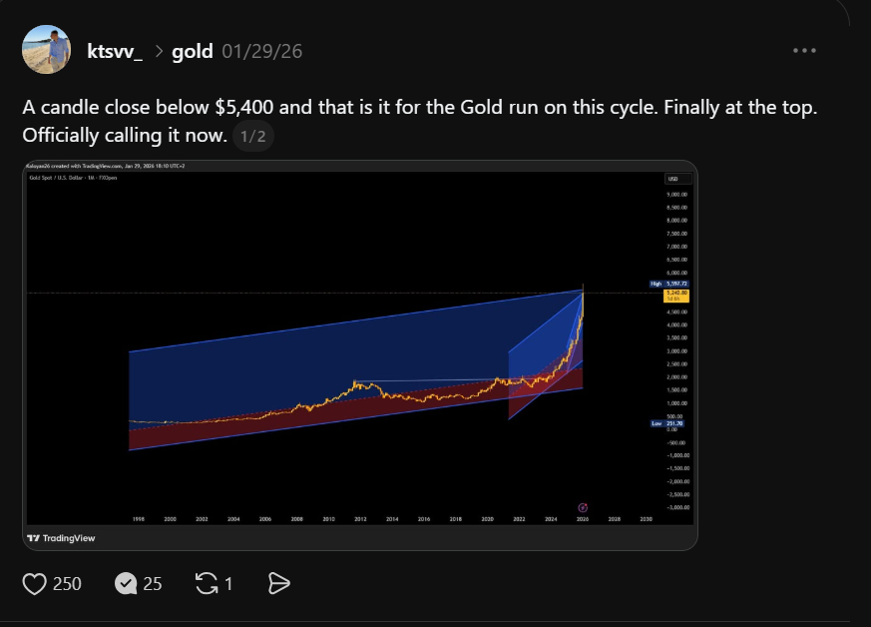
Figure 1: Real-time analysis published on Threads on January 29, 2026, displaying the three converging regression channels on the monthly XAUUSD chart and identifying the cycle peak.
5. Market Structure: The Surge in Unsustainable Leverage
A technical pattern alone is never complete without understanding the underlying market structure. During the final vertical push into late January 2026, market data revealed that speculative leverage had surged to unprecedented, dangerous extremes.
Financial media reporting and market research—including analyses published across Bloomberg, Reuters, and reports highlighted by the Bank for International Settlements (BIS)—documented an explosive expansion in speculative borrowing. Major brokers reported record margin debt balances as retail and speculative accounts rushed into leveraged gold derivatives, micro-futures, and high-delta call options to capitalize on every dollar increase. Speculative net long positioning on COMEX futures reached historic highs, while gold-backed exchange-traded funds (ETFs) traded at persistent premiums over their net asset value due to one-sided retail demand.
Leverage acts as an accelerant on the way up, but it becomes lethal at the turning point. When an asset is driven higher primarily by borrowed money, the market becomes structurally fragile. Even a minor stall in price momentum forces clearinghouses and brokers to raise margin requirements to protect against volatility. The moment the market fails to make fresh highs, leveraged traders who are overextended face immediate margin calls. This initiates an automatic chain reaction: forced liquidations trigger stop-loss orders, which push prices down further, sparking more margin calls. Understanding this structural leverage trap confirmed that once gold hit the ceiling of the three regression channels, the ensuing sell-off would be swift and decisive.
6. Market Psychology: Exploiting Peak Euphoria
The final piece of the analysis was market psychology. Financial markets are driven by human emotion, and no major market cycle ever tops out in an atmosphere of caution. Market tops occur when optimism turns into blind euphoria.
In January 2026, the sentiment surrounding gold was overwhelmingly one-sided. Mainstream news outlets that rarely cover commodities were running sensational headlines about the metal. Social media was flooded with newly minted market commentators declaring that gold would easily reach $7,000, $8,000, or even $10,000 without any pullback. Casual observers and retail investors who had never traded physical bullion or futures were actively opening brokerage accounts to buy at the very highs out of intense Fear Of Missing Out (FOMO).
Whenever any analyst or trader suggested taking profits or hedging downside risk, they were met with ridicule. In behavioral finance, this is known as the late-stage euphoria phase. When everyone who wants to buy is already fully invested—and when they have maxed out their available leverage to do so—there is literally no one left to buy the next tick higher. True market tops occur when the last retail buyer enters the trade. Recognizing this extreme emotional peak provided the exact psychological confirmation needed to take a firm, contrarian stance against the crowd.
7. Conclusion
Successfully calling the exact top of XAUUSD on January 29, 2026, was not the result of guesswork. It was the product of a clear, disciplined framework combining three distinct pillars:
1. Statistical Confluence: The simultaneous alignment of the upper boundary lines of the 28-year secular channel, the 5-year cycle channel, and the 1-year momentum channel between $5,400 and $5,600.
2. Structural Market Fragility: Documented by record broker margin debt, extreme futures open interest, and aggressive call option speculation that left the market vulnerable to cascading liquidations.
3. Behavioral Psychology: Classic contrarian sentiment signals, characterized by widespread euphoria, retail FOMO, and unanimous expectations of higher prices.
By synthesizing quantitative statistical tools with real-world leverage data and human psychology, and by publicly committing to the analysis in real time on Threads, this framework demonstrated how rigorous market analysis can successfully identify major macroeconomic turning points.

