**Veer Narmad South Gujarat University, Surat.**

**M.Sc. (Information Technology) Programme**



# Project Report

**8th Semester**

**M.Sc. (Information Technology)**

**5 Year Integrated Course**

**Year 2020 – 2021**

## **“Photography Website”**

|  |  |
| --- | --- |
| **Guide By:** | **Submitted By :** Kalp Kansara(021) |

### 

### 

**Veer Narmad South Gujarat University, Surat.**

**M.Sc. (Information Technology) Programme**

**Project Report**

**7th Semester**

**M.Sc. (Information Technology)**

**5 Year Integrated Course**

**Year 2020 – 2021**

## **“Photography Website”**

|  |  |
| --- | --- |
| **Guide By:** | **Submitted By :** Kalp Kansara(021) |

**Veer Narmad South Gujarat University, Surat.**

**M.Sc. (Information Technology) Programme**

##### Certificate

This is to certify that **Mr. Kalp Rajeshkumar Kansara** Exam Seat Number : **021** has satisfactorily completed his project work entitled **PHOTOGRAPHY WEBSITE(DOW)** as a partial fulfilment of the requirements for 7th ***Semester - M.Sc.(Information Technology) [5 Year course]***, during the academic Year 2019-2020.

Date:

**Course Co-ordinator**

Place: Surat **M.Sc. (I.T.) Programme.**

**Department of I.C.T.**

**Veer Narmad** **South Gujarat**

**University, Surat**

### **ACKNOWLEDGEMENT**

### It was an educational phase while studying at the Bachelor of Science in Information Technology (M.Sc. (I.T)) working with highly devoted computer teacher’s community and will probably remain the most memorable experience of our life. Hence, this acknowledgement is a humble attempt to earnestly thank all those who were directly or indirectly involved in our project work and were of immense help to us.

### With immense pleasure, we present this report on the project assignment title **“HRMS”** developed at **Elite Techno Crats**.

### We owe a debt of gratitude to **Mr. Naitik Shah** **Elite Techno Crats**, Surat for bestowing their faith in us and giving us the privilege of working, which will be the building step for our bright future.

### The invaluable guidance and time rendered by our internal project guide Prof. **Dr. Payal Joshi**, was the inevitable part of the journey to success. We sincerely thank him for the perseverance, patience and helpfulness they have shown through the hard and easy times during the project.

### We take a rather special privilege of thanking our Respected **Course Coordinator Prof. Pushpal Desai & All the Faculties** for making the resources available within the institute for the project work.

### The encouragement and help received from **our family members, friends and colleagues** cannot be expressed in terms of words. Without their moral support, the work would have been left unfinished.

Kalp R. Kansara

Index

|  |  |  |
| --- | --- | --- |
| Sr No. | Particular | Page No. |
| 1. | Introduction  1.1 Company Profile | 2 |
| 2. | Proposed System  2.1 Scope  2.2 Objective  2.4 Advantages  2.5 Limitation | 4  4  4  4 |
| 3. | Environment Specification  3.1 H/W & S/W Configuration  3.2 Development Description | 6  7 |
| 4. | System Planning  4.1 Feasibility Study  4.2 Software Engineering Model  4.3 Risk Analysis  4.4 Project Schedule  4.4.1 Task Dependency  4.4.2 Timeline Chart  4.4.3 Project Table | 9  11  12  13  14  15 |
| 5. | System Analysis  5.1 Software requirement specification (In Detail)   * 1. UML Diagram * Use Case Diagram * CRC Diagram * Class Diagram * Activity Diagram * Sequence Diagram * Database Diagram   5.3 Entity Relationship Diagram | 28  30  32  33  34  36  39  40 |
| 6. | Software Design  6.1 Database Design  6.2 Interface Design | 42  60 |
| 7. | Testing  7.1 Unit Testing  7.2 Integration Testing | 71  86 |
| 8. | Future Enhancement | 89 |
| 9. | Reference | 91 |

1. INTRODUCTION
   1. **Company Profile**

**1.1 Company Profile:**

* Elite Technocrats is pioneer in IT outsourcing and the offshore software development business. We have helped customers balance their cost-performance parameters for IT projects via sustainable, long term relationships with Elite. Our hybrid engagement model is designed to leverage the best of US and India so that our customers are the ultimate beneficiaries. We work with the same care and diligence to make each of our engagement a success, one at a time, small or large.

|  |  |
| --- | --- |
| **Company Name :** | Elite Techno Crats |
|  |  |
| **Address :** | 302, Sundaram Sky, Athugar Street, Nanpura, Surat-395001 |
|  |  |
| **Proprietor :** | Naitik Shah |
|  |  |
| **Business Type :** | Software Developing |
|  |  |
| **Year Of Establish :** | 2010 |
|  |  |
| **Contact No :** | +91-9825479004 |
|  |  |
| **Email Id :** | [naitik@elitetechnocrats.com](mailto:naitik@elitetechnocrats.com) |

1. Proposed System
   1. **Scope**
   2. **Objective**
   3. **Advantages**
   4. **Limitation**

**2.1 Scope:**

This project is all about the Photography related. The project contains photo download/upload, contest, photography tips, photographer of the week. Additionally, the Contest management module is based on voting based then count the total votes of each photograph of uploaded by participants. Also, Photography website in download and upload your photographs like social media.

**2.2 Objective:**

* Manage Users
* Admin/Users manage photos
* Admin can see User’s Photographs, can Approve or Reject those photograph it wants to show in website.
* Manage Tips
* Manage Contest
* Admin/User can see Voting of contest
* Manage Image of the week

**2.3 Advantages:**

* Calculate Voting
* Learn Basic Photography
* Know about Users

**2.4 Limitation:**

* If User proves that it is his photo but not actually his, then it has to be approved and his photo has to be shown.

1. Environment Specification

**3.1 H/W & S/W Requirements**

**3.2 Development Description**

**3.1 Hardware and Software Requirements**

* **Hardware Configuration:**

|  |  |
| --- | --- |
| Processor: | 2.5 GHz |
| Hard Disk: | 1 TB |
| RAM: | 8 GB |
| Networking: | Lan Card (Must be internet connection) or modem |

* **Software Configuration:**
* Apache NetBeans IDE 11.2
* Xampp Server
* Mozilla Firefox, Google Chrome
* **Server Configuration**

|  |  |
| --- | --- |
| Operating System: | Windows Server 2010 |
| Web Server: | Payara Server |
| Front End: | JSF, Prime faces, Html |
| Back End: | Payara server, MySql |

**3.2 Development Description**

HRMS is developed using the integration of **Primefaces, JSF** and **JAVA EE** and **MySql**:

1. Admin Development Description:

* Manage Users
* Manage Tips
* Manage Photographer of the week
* Manage Contest
* Check Voting
* Manage Photos of Users (Admin can decide the photograph request can approve or can reject)

1. User Development Description:

* Users can apply for the contest and contest is based on voting system
* User upload his photos on website and others can see and download his photos
* User learn the basic photography and develop the basic skills

1. System Planning
   1. **Feasibility Study**
   2. **Software Engineering Model**
   3. **Risk Analysis**
   4. **Project Schedule**
      * + - **Task Dependency**
          - **Timeline Chart**
          - **Project Table**

**4.1 Feasibility Study**

Feasibility study involves research relating to different aspects that go into developing software. Feasibility study of the problem definition or requirement was done to determine if the requirement can be solved effectively given the budgetary, operational & technical and scheduled constraints in place. The aim of feasibility study is to identify the best solution under the circumstances by identifying the effects of this solution on the organization.

The feasibility of our project has been judged on the basis of time, technology, resources available, behavioral feasibility & cost of development.

* **Duration Feasibility**

Project initiated with pre-stated deadlines. The duration is allotted keeping in mind the entire task & is practically feasible.

* **Implementation Feasibility**

A proper implementation is essential to provide a reliable system to meet requirements of the organization. Implementation is the stage in the project where the theoretical design is turned into a working system. The most critical stage in achieving a new successful system is to improve the performance of the existing system and to deliver system effective application.

* **Operational Feasibility**

It will help in time saving and fast processing and dispersal. From the Admin perspective our application requires basic knowledge about policies of Cyber World.

* **Technical Feasibility**

Minimum system required for admin, user and visitor is computer connected with internet with compatible browser. The system is suitable for multi user operations. With the available resources robust system with data security can be developed. It uses PHP which has been tested & approved to be sufficiently robust, scalable & efficient to develop such an application. Hence technically there is no limitation for development of the system.

* **Behavioral Feasibility**

Benefits of proposed system were assessed. Having realized the benefit of new system the users’ response was studied before the inception of system development. They reacted positively towards the proposal. Since all the users involved in project development are familiar with internet no explicit training will be required to learn the usage of new system. Simple guidance would suffice

* **Economic Feasibility**

The cost of software and hardware required for system including storage of bulk of data server. No budgetary constraints were imposed on the system. More importantly since all free software were used only hardware, usage & internet costs were to be considered. These were quite limited & well within feasibility.

Based on above study it can be stated that designing & developing this system is certainly feasible if executed well within stated guidelines. So based on these positive results, the new system was approved for development

**4.2 Software Engineering Model**

**Development** of a **HRMS** can be approached using **waterfall model**. Often considered the classic **approach** to the **systems development** life cycle, the **waterfall model** describes a **development method** that is linear and sequential. **Waterfall development** has distinct goals for each phase of **development**.

* **Waterfall Model:**

1. **Requirements:**

For our project, requirements are book an appointment online .and if patient book appointment then mail goes to that patient.

1. **Design:**

Firstly, Design the database as per the above requirement.

1. **Implement:**

After the above two steps, implement your system well, also implement its feasibility. Implement modules that are require for your project.

Like, create slot, booking appointment and mail transfer.

1. **Maintenance:**

Whenever the tools we have used in your system, after some time its need to update. So maintainability is necessary for the system.

**4.3 Risk Analysis**

Risk Management Information system (RMIS) is a computerized system used for data collection and processing, information analysis and generation of statistical trend reports for the identification and monitoring of events, claims and finances.

Key Concepts in Risk Management Risk management for Hospital Patient Queue entities can be defined as an organized effort to identify, assess, and reduce, where appropriate, risk to patients, visitors, staff and organizational assets. Risk management in its best form may be to use it in a pro-active manner in identifying and managing the risks. However, in case an incident has happened; after the event handling, it should still be tackled in line with the risk

**[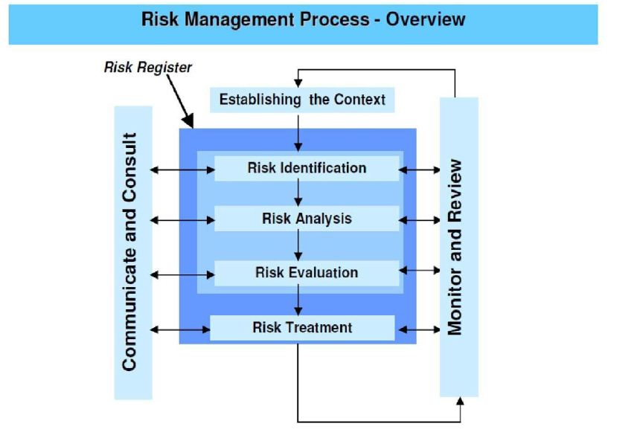](https://www.elynsgroup.com/assets/kcfinder/upload/files/Risk%20Management%20Figure%201H.JPG)**management principles as outlined here. This review provides a concise material in risk management for system professionals to quickly grasp the key concepts in risk management and implement them in the healthcare organizations where they work.

**4.4 Project Schedule**

* **Task Dependency:**

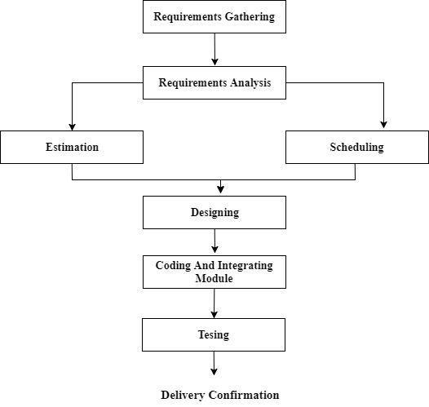

* In Photography system, “UserUploadPhoto” is depending on “Users”
* “ContestXUser” is depending on “User”.
* “PaymentXUser” is depending on “User”.
* “Contest” is depending on “ContestXUser” and “vottingXContest”.
* “Payment” is depending on “PaymentXUser”.
* “PhotoCategory” is depending on “UserUploadPhoto”,
* “TipsType” is depending on “PhotographyTips”

**4.4 Project Schedule**

* **Time Line Chart**

|  |  |  |  |  |  |  |  |  |  |  |  |  |  |  |  |
| --- | --- | --- | --- | --- | --- | --- | --- | --- | --- | --- | --- | --- | --- | --- | --- |
| **Task Name** | W  1 | W  2 | W | W | W | W | W | W | W | W | W | W | W | W | W |
| 3 | 4 | 5 | 6 | 7 | 8 | 9 | 10 | 11 | 12 | 13 | 14 | 15 |
| **1) Requirement Analysis** |  |  |  |  |  |  |  |  |  |  |  |  |  |  |  |
| Collected requirement from our guide |  |  |  |  |  |  |  |  |  |  |  |  |  |  |  |
| Analysis gathered information |  |  |  |  |  |  |  |  |  |  |  |  |  |  |  |
| Determine different modules |  |  |  |  |  |  |  |  |  |  |  |  |  |  |  |
| **2) Planning & Risk Analysis** |  |  |  |  |  |  |  |  |  |  |  |  |  |  |  |
| Analysis data for possible risk |  |  |  |  |  |  |  |  |  |  |  |  |  |  |  |
| Identify technical risk |  |  |  |  |  |  |  |  |  |  |  |  |  |  |  |
| Determine different modules |  |  |  |  |  |  |  |  |  |  |  |  |  |  |  |
| **3) Designing** |  |  |  |  |  |  |  |  |  |  |  |  |  |  |  |
| Design basic interface of the site |  |  |  |  |  |  |  |  |  |  |  |  |  |  |  |
| Design database tables |  |  |  |  |  |  |  |  |  |  |  |  |  |  |  |
| Design web form for module |  |  |  |  |  |  |  |  |  |  |  |  |  |  |  |
| **4) Coding and integrating modules** |  |  |  |  |  |  |  |  |  |  |  |  |  |  |  |
| Implement logic for different modules |  |  |  |  |  |  |  |  |  |  |  |  |  |  |  |
| Implement database connectivity |  |  |  |  |  |  |  |  |  |  |  |  |  |  |  |
| Implement report |  |  |  |  |  |  |  |  |  |  |  |  |  |  |  |
| Integrate different modules |  |  |  |  |  |  |  |  |  |  |  |  |  |  |  |
| **5) Testing** |  |  |  |  |  |  |  |  |  |  |  |  |  |  |  |
| Validate input control and check accuracy of Reports |  |  |  |  |  |  |  |  |  |  |  |  |  |  |  |

**4.4 Project Schedule**

* **Project Table**

1. **Users:**

|  |  |  |
| --- | --- | --- |
|  | **Field** | **Datatype** |
|  | | |
| Primary key | UserId | int |
|  | FirstName | Varchar(50) |
|  | MiddleName | Varchar(50) |
|  | LastName | Varchar(50) |
|  | EmailId | Varchar(50) |
|  | Password | Text |
|  | ProfilePhoto | Text |
|  | SocialProfileURL | Varchar(100) |
|  | IsDisable | Boolean |

1. **Roles:**

|  |  |  |
| --- | --- | --- |
|  | **Field** | **Datatype** |
|  | | |
| Primary key | RoleId | int |
|  | RoleName | Varchar(50) |
|  | Description | Varchar(50) |

1. **UserRoles:**

|  |  |  |
| --- | --- | --- |
|  | **Field** | **Datatype** |
|  | | |
| Primary key | UserRolesId | Int |
| Foreign key | UserId | Int |
| Foreign key | RoleId | Int |

1. **PhotoCategory:**

|  |  |  |
| --- | --- | --- |
|  | **Field** | **Datatype** |
|  | | |
| Primary key | CategoryId | int |
|  | CategoryName | Varchar(50) |
|  | Description | Varchar(50) |
|  | CategoryPhotoPath | Text |

1. **UserUploadPhoto:**

|  |  |  |
| --- | --- | --- |
|  | **Field** | **Datatype** |
|  | | |
| Primary key | UserUploadPhotoId | int |
| Foreign key | UserId | int |
| Foreign key | CategoryId | int |
|  | PhotoDescription | Varchar(50) |
|  | IsApprove | Boolean |
|  | PhotoPath | text |

1. **Payment:**

|  |  |  |
| --- | --- | --- |
|  | **Field** | **Datatype** |
|  | | |
| Primary Key | PaymentTypeId | int |
|  | PaymentTypeName | Varchar(50) |
|  | PaymentTypeDescription | Varchar(50) |

1. **PaymentXUser:**

|  |  |  |
| --- | --- | --- |
|  | **Field** | **Datatype** |
|  | | |
| Primary Key | PaymentXUserId | int |
| Foreign Key | PaymentTypeId | int |
| Foreign Key | UserId | int |
|  | PayFor | Varchar(50) |
|  | PaymentAmount | Float |
|  | PaymentDateTime | Varchar(50) |

1. **Contest:**

|  |  |  |
| --- | --- | --- |
|  | **Field** | **Datatype** |
|  | | |
| Primary Key | ContestId | Int |
|  | ContestName | Varchar(50) |
|  | ContestType | Varchar(50) |
|  | StartDate | Varchar(50) |
|  | EndDate | Varchar(50) |
|  | ContestDescription | Text |
|  | ContestStatus | Varchar(50) |
|  | ContestPhotoPath | Text |

1. **ContestXUser:**

|  |  |  |
| --- | --- | --- |
|  | **Field** | **Datatype** |
|  | | |
| Primary Key | ContestXUserId | int |
| Foreign Key | UserId | int |
| Foreign Key | ContestId | int |
|  | ContestImagePath | Varchar(200) |
|  | UploadDateTime | DateTime |
|  | SocialProfileUrl | Varchar(200) |

1. **VotingXContest:**

|  |  |  |
| --- | --- | --- |
|  | **Field** | **Datatype** |
|  | | |
| primary Key | VottingXContestId | int |
| Foreign Key | ContestId | int |
| Foreign Key | UserId | int |
| Foreign Key | CotestXUserId | Int |
|  | VottingCount | int |

1. **Winner:**

|  |  |  |
| --- | --- | --- |
|  | **Field** | **Datatype** |
|  | | |
| primary Key | WinnerId | int |
| Foreign Key | ContestId | int |
| Foreign Key | UserId | int |
| Foreign Key | ContestXUserId | Int |
|  | Description | Text |

1. **ImageOfWeek:**

|  |  |  |
| --- | --- | --- |
|  | **Field** | **Datatype** |
|  | | |
| Primary Key | ImageOfWeekId | int |
|  | ImageOfWeekPhotoPath | Varchar(200) |
|  | SocialProfileUrl | Varchar(100) |
|  | SocialPhotoUrl | Varchar(100) |
|  | DeclarationDate | Varchar(50) |
|  | ImageDescription | Varchar(500) |

1. **Tips:**

|  |  |  |
| --- | --- | --- |
|  | **Field** | **Datatype** |
|  | | |
| primary key | TipsTypeId | int |
|  | TipsTypeName | Varchar(50) |
|  | TipsTypeDescription | Varchar(50) |
|  | TipsTypePhotoPath | Varchar(100) |

1. **PhotographyTips:**

|  |  |  |
| --- | --- | --- |
|  | **Field** | **datatype** |
|  | | |
| Primary Key | PhotographyTipsId | int |
| Foreign Key | TipsTypeId | Int |
|  | PhotographyTipsPhotoPath | Varchar(100) |
|  | PhotographyTipsDescription | text |

1. SYSTEM ANALYSIS
   1. **Software Requirement Specification (In detail)**
   2. **UML Diagram**
      * + **Use case Diagram**
        + **CRC Diagram**
        + **Class Diagram**
        + **Activity Diagram**
        + **Sequence Diagram**
        + **Database Diagram**

**5.3 Entity Relationship Diagram**

* 1. **System Requirement Specification Details**

1. Manage User
2. Manage Photocategory
3. Manage UserUploadPhoto
4. Manage Contest
5. Tips
6. ImageofTheWeek
7. **Manage User:**

* In this module, Admin can manage User details and enable or disable users.

1. **Manage Photocategory:**

* Admin can add photocategory and users can select the category and shows the image of each category.
* Admin can also remove photocategory and modify existing photocategory.

1. **Manage UserUploadPhoto:**

* User can upload photos.
* Admin can Approve those photos request
* **Constraints:** User can upload some other photos.
* **Validation:** Admin can approve or reject the photos who upload some other photos

1. **Manage Contest:**

* Admin can create contest and user take part in it.
* Admin can also cancel the contest or modify existing contest.

1. **Tips:**

* Admin can add Photography tips and user learn the basic photography.
* Admin can modify and remove existing photography tips.

1. **Leaves:**

* Admin can add photographer of week / ImageofWeek.
* Admin can remove or modify existing imageof week / photographerofweek.

**5.2 UML Diagram**

* **Use case Diagram (Admin)**

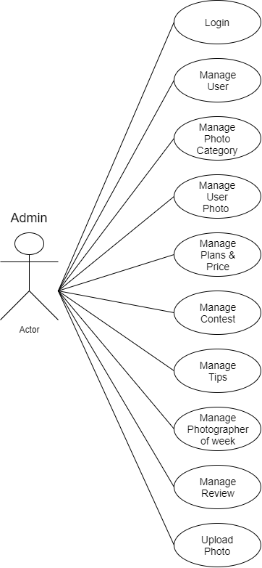

* **Use case Diagram (User)**

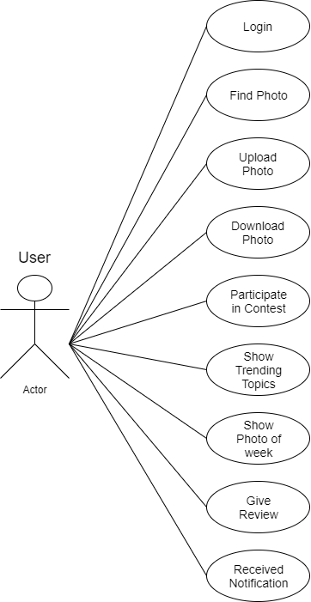

**5.2 UML Diagram**

* **CRC Diagram**

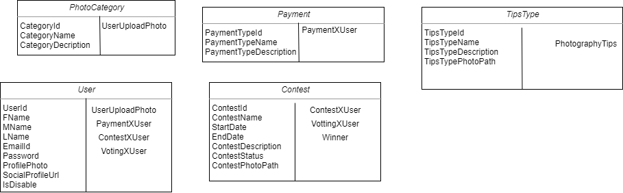

**5.2 UML Diagram**

* **Class Diagram**

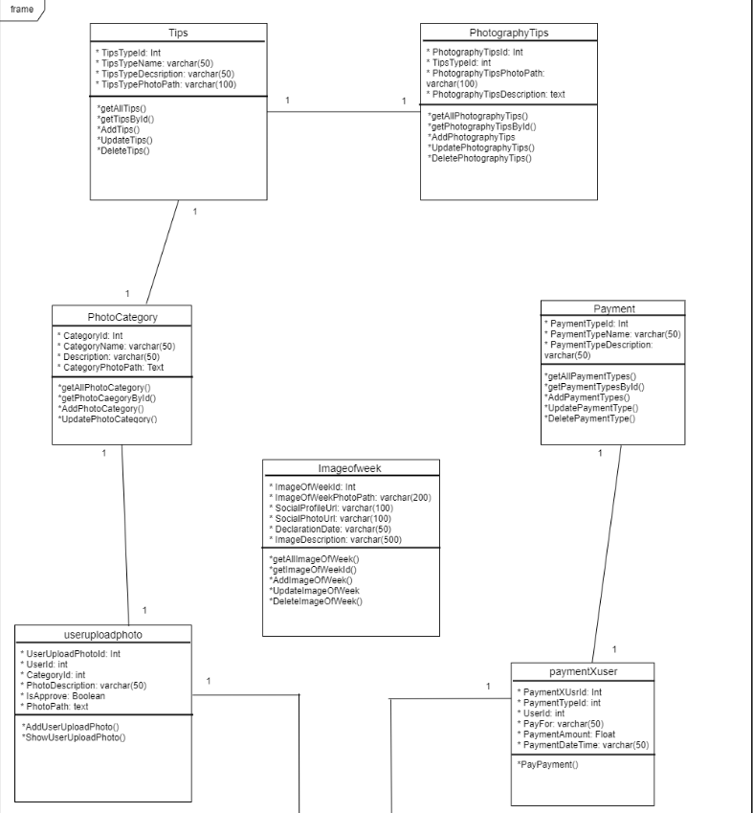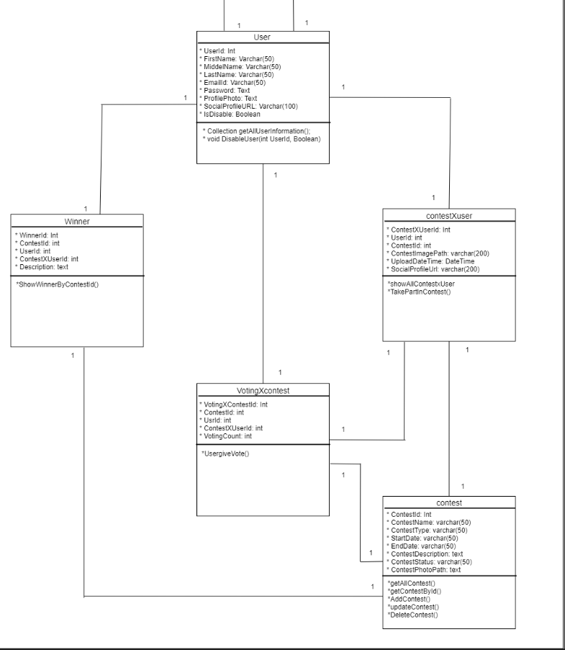

**5.2 UML Diagram**

* **Activity Diagram (Admin)**

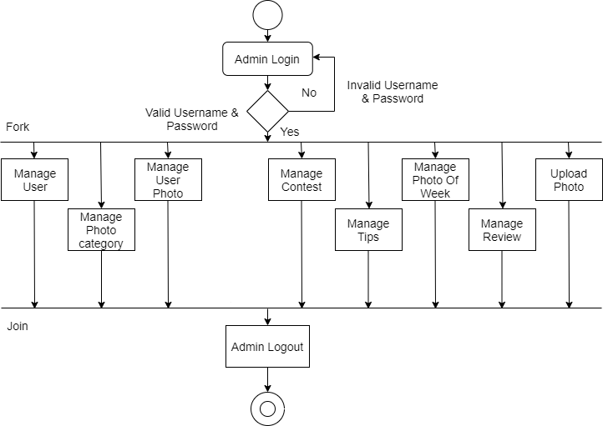

**5.2 UML Diagram**

* **Activity Diagram (User)**

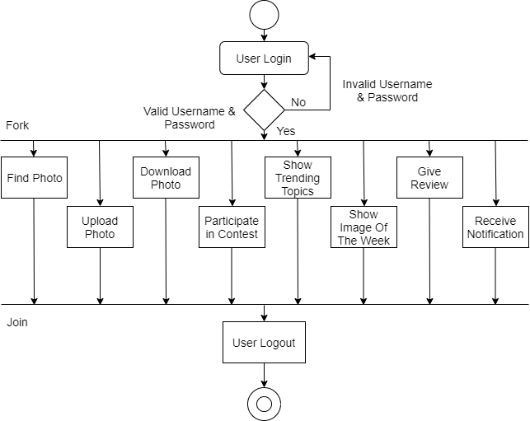

**5.2 UML Diagram**

* **Sequence Diagram (Admin)**

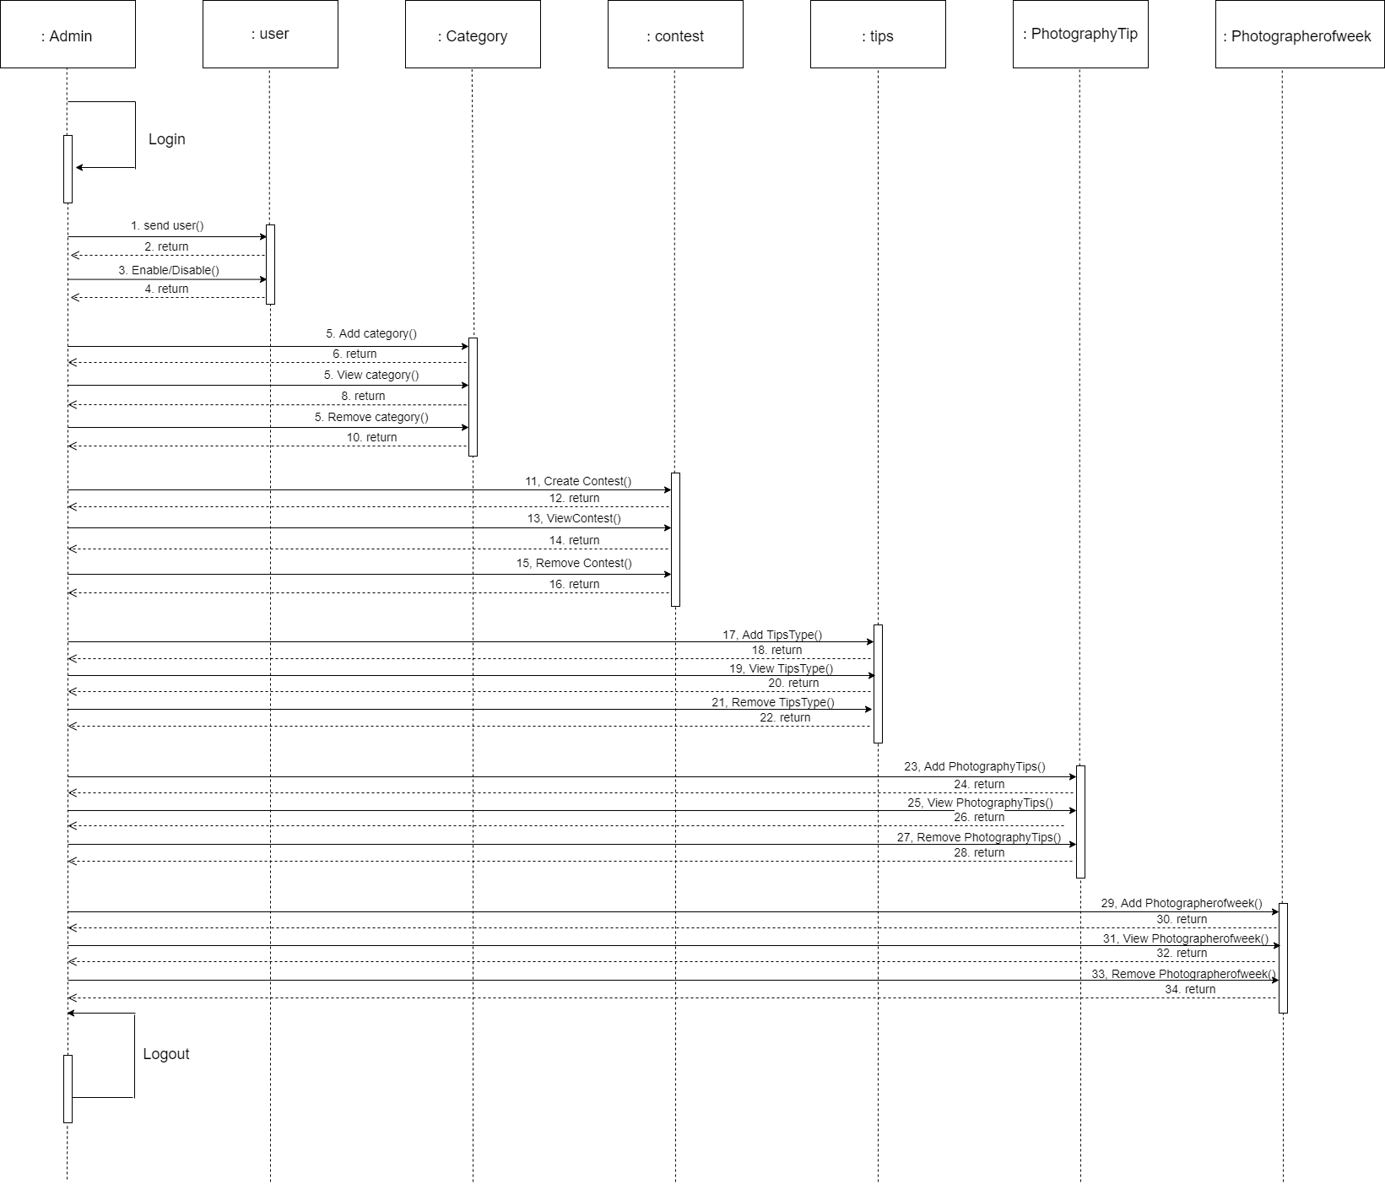

**5.2 UML Diagram**

* **Sequence Diagram (User)**

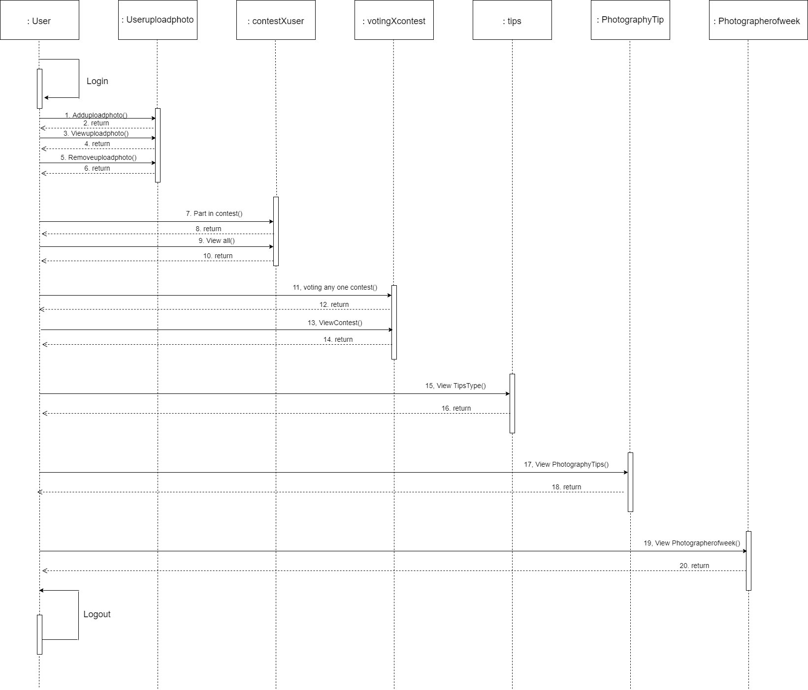

**5.2 UML Diagram**

* **Database Diagram**

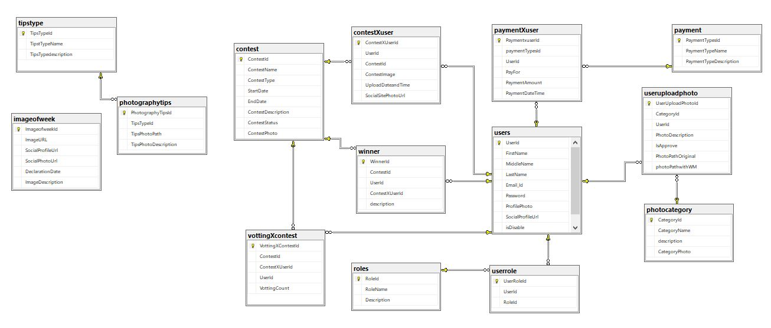

* 1. **Entity Relationship Diagram**

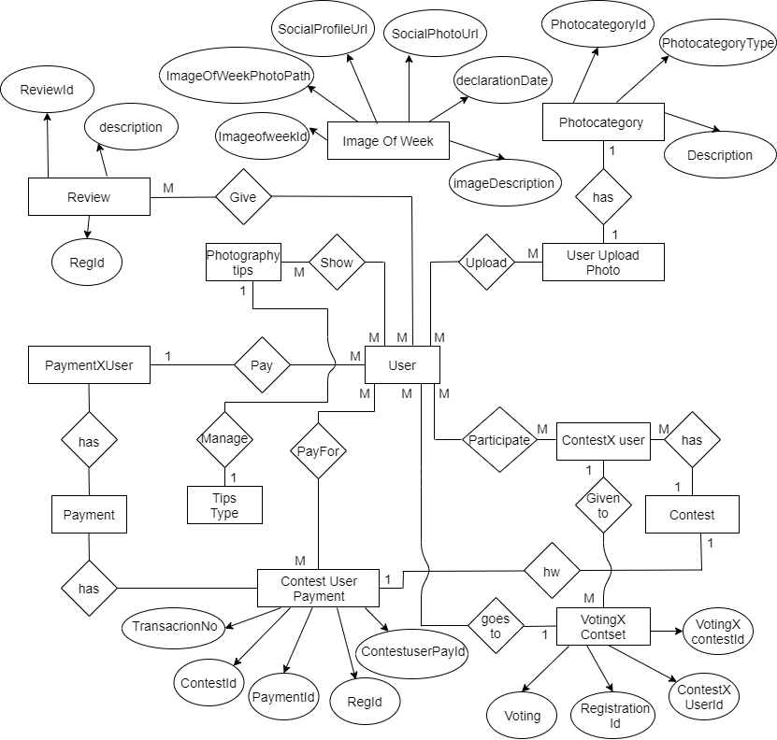

1. DESIGNING

**6.1 Database Design**

**6.2 Interface Design**

**6.1 Database Design**

|  |  |  |
| --- | --- | --- |
| 1. | Table Name : | Employee |
|  | Description : | Constraints the Information about Employee |
|  | Primary Key : | EmployeeId |
|  | Foreign Key : | DesignnationId, DepartmentId |

|  |  |  |  |  |  |
| --- | --- | --- | --- | --- | --- |
|  | **Column Name** | **Data Type** | **Size** | **Constraint** | **Description** |
| 1 | EmployeeId | INT | 11 | Primary Key | Unique **Employee** id |
| 2 | EmployeeCode | INT | 11 |  | Unique identify to **Employee** |
| 3 | FirstName | VARCHAR | 20 |  | Description For Employee’s First name |
| 4 | MiddleName | VARCHAR | 20 |  | Description For Employee’s Middle name |
| 5 | LastName | VARCHAR | 20 |  | Description For Employee’s Last name |
| 6 | Gender | VARCHAR | 10 |  | Description For Employee’s Gender |
| 7 | DesignationId | INT | 11 | Foreign Key | Unique Designation Id |
| 8 | DepartmentId | INT | 11 | Foreign Key | Unique Department Id |
| 9 | DateOfBirth | DATE | - |  | Description For Employee’s Birthdate |
| 10 | MobileNo1 | VARCHAR | 15 |  | Description For Employee’s MobileNo1 |
| 11 | MobileNo2 | VARCHAR | 15 |  | Description For Employee’s MobileNo2 |
| 12 | Address1 | VARCHAR | 50 |  | Description For Employee’s Address1 |
| 13 | Address2 | VARCHAR | 50 |  | Description For Employee’s Address2 |
| 14 | Address3 | VARCHAR | 50 |  | Description For Employee’s Address3 |
| 15 | Area | VARCHAR | 30 |  | Description For Employee Leave Area |
| 16 | City | VARCHAR | 50 |  | Description For Employee Leave City |
| 17 | State | VARCHAR | 50 |  | Description For Employee leave State |
| 18 | Pincode | NUMERIC | 18,0 |  | Description For Employee Address Pincode |
| 19 | EmailId | VARCHAR | 50 |  | Description for Employee Email Id |
| 20 | DateOfJoin | DATE | - |  | Description For Employee Date of Join |
| 21 | MaritalStatus | BIT | - |  | Description For Employee Marital Status |
| 22 | EmployeeImage | TEXT | - |  | Description For Employee Image |
| 23 | ResignDate | DATE | - |  | Description For Employee Resign Date |
| 24 | LeaveDate | DATE | - |  | Description For Employee Leave Date |
| 25 | Remark | VARCHAR | 50 |  | Description For Employee |

|  |  |  |
| --- | --- | --- |
| 2. | Table Name : | EmployeeExperience |
|  | Description : | Constraints the Information about Employee Experience |
|  | Primary Key : | ExperienceId |
|  | Foreign Key: | EmployeeId |

|  |  |  |  |  |  |
| --- | --- | --- | --- | --- | --- |
|  | **Column Name** | **Data Type** | **Size** | **Constraint** | **Description** |
| 1 | ExperienceId | INT | 11 | Primary Key | Unique **Experience** id |
| 2 | EmployeeId | INT | 11 | Foreign Key | Unique **Employee** id |
| 3 | Designation | VARCHAR | 25 |  | Employee’s Designation |
| 4 | CompanyName | VARCHAR | 25 |  | Employee’s Company name |
| 5 | FromDate | DATE | - |  | Starting date of Experience |
| 6 | ToDate | DATE | - |  | Ending date of Experience |
| 7 | LastSalary | NUMERIC | 18,0 |  | Last salary of Employee |
| 8 | LastWorkDuration | VARCHAR | 10 |  | Last Duration of Employee |

|  |  |  |
| --- | --- | --- |
| 3. | Table Name : | EmployeeQualification |
|  | Description : | Constraints the Information about Employee Qualification |
|  | Primary Key : | QualificationId |
|  | Foreign Key: | EmployeeId |

|  |  |  |  |  |  |
| --- | --- | --- | --- | --- | --- |
|  | **Column Name** | **Data Type** | **Size** | **Constraint** | **Description** |
| 1 | QualificationId | INT | 11 | Primary Key | Unique Qualification id |
| 2 | EmployeeId | INT | 11 | Foreign Key | Unique Employee id |
| 3 | QualificationName | VARCHAR | 50 |  | Name of Qualification |
| 4 | PassingYear | INT | 11 |  | Passing Year of Employee Qualification |
| 5 | CGPA | FLOAT | 8 |  | Employee’s CGPA |
| 6 | University | VARCHAR | 50 |  | Description For University of Employee |
| 7 | Collage | VARCHAR | 50 |  | Description For College of Employee |

|  |  |  |
| --- | --- | --- |
| 4. | Table Name : | Shift |
|  | Description : | Constraints the Information about Employee Shift |
|  | Primary Key : | ShiftId |
|  | Foreign Key : | - |

|  |  |  |  |  |  |
| --- | --- | --- | --- | --- | --- |
|  | **Column Name** | **Data Type** | **Size** | **Constraint** | **Description** |
| 1 | ShiftId | INT | 11 | Primary Key | Unique Shift Id |
| 2 | ShiftCode | INT | 11 |  | Unique Shift Code |
| 3 | StartTime | TIME | - |  | Starting time of shift |
| 4 | EndTime | TIME | - |  | Ending time of shift |
| 5 | BreakMinutes | INT | 11 |  | Minutes of break time |
| 6 | Description | TEXT | - |  | Description of shift |

|  |  |  |
| --- | --- | --- |
| 5. | Table Name : | EmployeeShift |
|  | Description : | Constraints the Information about Employee Shift |
|  | Primary Key : | EmployeeShiftId |
|  | Foreign Key : | EmployeeId,ShiftId |

|  |  |  |  |  |  |
| --- | --- | --- | --- | --- | --- |
|  | **Column Name** | **Data Type** | **Size** | **Constraint** | **Description** |
| 1 | EmployeeShiftId | INT | 11 | Primary Key | Unique **Employee Shift** id |
| 2 | EmployeeId | INT | 11 | Foreign Key | **Unique Employee id** |
| 3 | ShiftId | INT | 11 | Foreign Key | **Shift id** |
| 4 | FromDate | DATE | - |  | Starting date of shift |

|  |  |  |
| --- | --- | --- |
| 6. | Table Name : | Attendance |
|  | Description : | Constraints the Information about Employee Attendance |
|  | Primary Key : | AttendanceId |
|  | Foreign Key : | EmployeeId |

|  |  |  |  |  |  |
| --- | --- | --- | --- | --- | --- |
|  | **Column Name** | **Data Type** | **Size** | **Constraint** | **Description** |
| 1 | AttendanceId | INT | 11 | Primary Key | Unique Attendance id |
| 2 | AttendanceDate | DATE | - |  | Date of Attendance |
| 3 | AttendanceTime | TIME | - |  | Description For Time of Attendance |
| 4 | AttendanceStatus | VARCHAR | 3 |  | Description For Status of Attendance |
| 5 | EmployeeId | INT | 11 | Foreign Key | Employee Unique id |
| 6 | EntryType | VARCHAR | 10 |  | Description For Type for Entry |
| 7 | Remark | VARCHAR | 50 |  | Remark of Attendance |
| 8 | EntryInsertBy | INT | 11 |  | Description of Entry Insert By |

|  |  |  |
| --- | --- | --- |
| 7. | Table Name : | Leaves |
|  | Description : | Constraints the Information about Employee Take Leaves |
|  | Primary Key : | LeavesId |
|  | Foreign Key : | EmployeeId |

|  |  |  |  |  |  |
| --- | --- | --- | --- | --- | --- |
|  | **Column Name** | **Data Type** | **Size** | **Constraint** | **Description** |
| 1 | LeavesId | INT | 11 | Primary Key | Unique LeavesId |
| 2 | EmployeeId | INT | 11 | Foreign Key | Unique EmployeeId |
| 3 | Resion | TEXT | - |  | Description For Reason for leave |
| 4 | LeaveFromDate | DATE | - |  | Starting date of leave |
| 5 | LeaveToDate | DATE | - |  | Ending date of leave |
| 6 | Remark | VARCHAR | 70 |  | Remark of Leaves |
| 7 | StatusBy | INT | 11 |  | Description For Assign Leave Status |

|  |  |  |
| --- | --- | --- |
| 8. | Table Name : | LeaveAssign |
|  | Description : | Constraints the Information about Employee Leave Assign |
|  | Primary Key : | LeaveAssign |
|  | Foreign Key: | EmployeeId |

|  |  |  |  |  |  |
| --- | --- | --- | --- | --- | --- |
|  | **Column Name** | **Data Type** | **Size** | **Constraint** | **Description** |
| 1 | LeaveAssignId | INT | 11 | Primary Key | Unique **LeaveAssignI**d |
| 2 | EmployeeId | INT | 11 | Foreign Key | **Unique EmployeeId** |
| 3 | NumberOfLeave | INT | 11 |  | **Number of leave** |
| 4 | AssignDate | DATE | - |  | Leave assign date |
| 5 | Year | INT | 11 |  | Year of leave assign |

|  |  |  |
| --- | --- | --- |
| 9. | Table Name : | LeaveTransaction |
|  | Description : | Constraints the Information about Employee Leave Transaction |
|  | Primary Key : | LeaveTransactionId |
|  | Foreign Key : | LeaveId, EmployeeId |

|  |  |  |  |  |  |
| --- | --- | --- | --- | --- | --- |
|  | **Column Name** | **Data Type** | **Size** | **Constraint** | **Description** |
| 1 | LeaveTransactionId | INT | 11 | Primary Key | Unique Leave Transaction Id |
| 2 | LeaveId | INT | 11 | Foreign Key | Unique Leave Id |
| 3 | EmployeeId | INT | 11 | Foreign Key | Unique EmployeeId |
| 4 | LeaveDate | VARCHAR | 500 |  | Description For Date of leave |
| 5 | TransactionType | VARCHAR | 2 |  | Description For Transaction Type |
| 6 | Status | VARCHAR | 3 |  | Description For leaves transaction |
| 7 | Year | INT | 11 |  | Description For Leave Year |
| 8 | Remark | VARCHAR | 50 |  | Description For Remark of Leave |
| 9 | LeaveAssignId | INT | 11 | Foreign Key | Unique LeaveId |

|  |  |  |
| --- | --- | --- |
| 10. | Table Name : | Holiday |
|  | Description : | Constraints the Information about Public Holiday |
|  | Primary Key : | HolidayId |
|  | Foreign Key : | - |

|  |  |  |  |  |  |
| --- | --- | --- | --- | --- | --- |
|  | **Column Name** | **Data Type** | **Size** | **Constraint** | **Description** |
| 1 | HolidayId | INT | 11 | Primary Key | Unique **HolidayDetail** id |
| 2 | HolidayName | VARCHAR | 25 |  | **Name of holiday** |

|  |  |  |
| --- | --- | --- |
| 11. | Table Name : | HolidayDetail |
|  | Description : | Constraints the Information about Employee Holiday |
|  | Primary Key : | HolidayDetailId |
|  | Foreign Key : | HolidayId |

|  |  |  |  |  |  |
| --- | --- | --- | --- | --- | --- |
|  | **Column Name** | **Data Type** | **Size** | **Constraint** | **Description** |
| 1 | HolidayDetailId | INT | 11 | Primary Key | Unique **HolidayDetail** id |
| 2 | DateOfHoliday | VARCHAR | 50 |  | **Date for holiday** |
| 3 | YearOfHoliday | INT | 11 |  | **Year for holiday** |
| 4 | HolidayId | INT | 11 | Foreign Key | Unique **Holiday** id |

|  |  |  |
| --- | --- | --- |
| 12. | Table Name : | WorkingHour |
|  | Description : | Constraints the Information about Employee Working Hours |
|  | Primary Key : | DesignationId |
|  | Foreign Key : | - |

|  |  |  |  |  |  |
| --- | --- | --- | --- | --- | --- |
|  | **Column Name** | **Data Type** | **Size** | **Constraint** | **Description** |
| 1 | WorkingHourId | INT | 11 | Primary Key | Unique **workingHour Id** |
| 2 | WorkingHours | FLOAT | 8 |  | Hours of working |
| 3 | EmployeeId | INT | 11 | Foreign Key | Unique Employee Id |
| 4 | WorkDate | Date | - |  | Description For Work Date |

|  |  |  |
| --- | --- | --- |
| 13. | Table Name : | Recruitment |
|  | Description : | Constraints the Information about Recruitment |
|  | Primary Key : | RecruitmentId |
|  | Foreign Key : | - |

|  |  |  |  |  |  |
| --- | --- | --- | --- | --- | --- |
|  | **Column Name** | **Data Type** | **Size** | **Constraint** | **Description** |
| 1 | RecruitmentId | INT | 11 | Primary Key | Unique **RecruitmentId** |
| 2 | ApplicantName | VARCHAR | 50 |  | Name of applicant |
| 3 | Address | TEXT | - |  | Address of applicant |
| 4 | EmailId | VARCHAR | 50 |  | Emailid of applicant |
| 5 | MobileNumber1 | VARCHAR | 11 |  | MobileNumber1 of applicant |
| 6 | MobileNumber2 | VARCHAR | 11 |  | MobileNumber2 of applicant |
| 7 | Gender | VARCHAR | 10 |  | Description For Gender of applicant |
| 8 | City | VARCHAR | 50 |  | Description For City of applicant |
| 9 | State | VARCHAR | 50 |  | Description For State of applicant |
| 10 | ApplyFor | VARCHAR | 50 |  | Apply reason of applicant |
| 11 | NoticePeirod | INT | 11 |  | Notice Period of applicant |
| 12 | InterviewDateTime | DATETIME | - |  | Interview Date Time of applicant |
| 13 | Interviewed | BIT | - |  | Description For Interviewed |
| 14 | Rating | VARCHAR | 25 |  | Rating of applicant |
| 15 | Remark | TEXT | - |  | Remark of applicant |

|  |  |  |
| --- | --- | --- |
| 14. | Table Name : | RecruitmentExperience |
|  | Description : | Constraints the Information about Recruitment Experience |
|  | Primary Key : | RecruitmentExperienceId |
|  | Foreign Key : | Recruitmentid |

|  |  |  |  |  |  |
| --- | --- | --- | --- | --- | --- |
|  | **Column Name** | **Data Type** | **Size** | **Constraint** | **Description** |
| 1 | RecruitmentExperienceId | INT | 11 | Primary Key | Unique **Recruitment Experience Id** |
| 2 | RecruitmentId | INT | 11 | Foreign Key | Unique Recruitment Id |
| 3 | CompanyName | VARCHAR | 50 |  | Description For of Company |
| 4 | JoinDate | DATE | - |  | Description For Joining Date |
| 5 | LeaveDate | DATE | - |  | Description For Leave date |
| 6 | IsCurrentJob | BIT | - |  | Description For current job or not |
| 7 | ExperienceMonth | INT | 11 |  | Description For experienced month |
| 8 | ExperienceYear | INT | 11 |  | Description For experienced year |

|  |  |  |
| --- | --- | --- |
| 15. | Table Name : | RecruitmentQualification |
|  | Description : | Constraints the Information about Recruitment Qualification |
|  | Primary Key : | RecruitmentQualificationId |
|  | Foreign Key : | RecruitmentId |

|  |  |  |  |  |  |
| --- | --- | --- | --- | --- | --- |
|  | **Column Name** | **Data Type** | **Size** | **Constraint** | **Description** |
| 1 | RecruitmentQualificationId | INT | 11 | Primary Key | Unique **Recruitment Qualification Id** |
| 2 | RecruitmentId | INT | 11 | Foreign Key | Unique Recruitment Id |
| 3 | SSCPercentage | FLOAT | 8 |  | Percentage of SSC exam |
| 4 | SSCPassingYear | INT | 11 |  | Passing Year of SSC exam |
| 5 | HSCPercentage | FLOAT | 8 |  | Percentage of HSC exam |
| 6 | HSCPassingYear | INT | 11 |  | Passing Year of HSC exam |
| 7 | QualificationName | VARCHAR | 25 |  | Name of Qualification |
| 8 | PassingYear | INT | 11 |  | Year of passing |
| 9 | CGPA | FLOAT | 8 |  | CGPA of exam |
| 10 | University | VARCHAR | 50 |  | Description For University |
| 11 | Collage | VARCHAR | 50 |  | Description For of Collage |

|  |  |  |
| --- | --- | --- |
| 16. | Table Name : | Department |
|  | Description : | Constraints the Information about Employee Depatment |
|  | Primary Key : | DepartmentId |
|  | Foreign Key : | - |

|  |  |  |  |  |  |
| --- | --- | --- | --- | --- | --- |
|  | **Column Name** | **Data Type** | **Size** | **Constraint** | **Description** |
| 1 | DepartmentId | INT | 11 | Primary Key | Unique Department id |
| 2 | DepartmentCode | INT | 11 |  | Description For Department |
| 3 | DepartmentName | VARCHAR | 50 |  | Description For Department |

|  |  |  |
| --- | --- | --- |
| 17. | Table Name : | Designation |
|  | Description : | Constraints the Information about Employee Designation |
|  | Primary Key : | DesignationId |
|  | Foreign Key : | - |

|  |  |  |  |  |  |
| --- | --- | --- | --- | --- | --- |
|  | **Column Name** | **Data Type** | **Size** | **Constraint** | **Description** |
| 1 | DesignationId | INT | 11 | Primary Key | Unique **Designation** id |
| 2 | DesignationCode | INT | 11 |  | Description For **Designation** |
| 3 | DesignationName | VARCHAR | 50 |  | Description For **Designation** |

|  |  |  |
| --- | --- | --- |
| 19. | Table Name : | Users |
|  | Description : | Constraints the Information about Users |
|  | Primary Key : | UserId |
|  | Foreign Key: | - |

|  |  |  |  |  |  |
| --- | --- | --- | --- | --- | --- |
|  | **Column Name** | **Data Type** | **Size** | **Constraint** | **Description** |
| 1 | UserId | INT | 11 | Primary Key | Unique **UserId** |
| 2 | Email | VARCHAR | 50 |  | Description for user Email Id |
| 3 | Password | VARCHAR | MAX |  | Description for user Password |

|  |  |  |
| --- | --- | --- |
| 20. | Table Name : | Roles |
|  | Description : | Constraints the Information about |
|  | Primary Key : | RoleId |
|  | Foreign Key: | - |

|  |  |  |  |  |  |
| --- | --- | --- | --- | --- | --- |
|  | **Column Name** | **Data Type** | **Size** | **Constraint** | **Description** |
| 1 | RoleId | INT | 11 | Primary Key | Unique **RoleId** |
| 2 | Name | VARCHAR | 50 |  | Description for Role Name |
| 3 | Description | VARCHAR | MAX |  | Description for Role Description |

|  |  |  |
| --- | --- | --- |
| 19. | Table Name : | Permission |
|  | Description : | Constraints the Information about |
|  | Primary Key : | Permission |
|  | Foreign Key: | - |

|  |  |  |  |  |  |
| --- | --- | --- | --- | --- | --- |
|  | **Column Name** | **Data Type** | **Size** | **Constraint** | **Description** |
| 1 | PermissionId | INT | 11 | Primary Key | Unique **PermissionId** |
| 2 | PermissionGroup | VARCHAR | 50 |  | Description for Permission PermissionGroup |
| 3 | PermissionGroup2 | VARCHAR | 50 |  | Description for Permission PermissionGroup2 |
| 4 | PermissionName | VARCHAR | MAX |  | Description for Permission PermissionName |
| 5 | Description | VARCHAR | MAX |  | Description for Permission Description |

|  |  |  |
| --- | --- | --- |
| 20. | Table Name : | RolePermission |
|  | Description : | Constraints the Information about RolePermssion |
|  | Primary Key : | RolePermissionId |
|  | Foreign Key: | RoleId, PermissionId |

|  |  |  |  |  |  |
| --- | --- | --- | --- | --- | --- |
|  | **Column Name** | **Data Type** | **Size** | **Constraint** | **Description** |
| 1 | RolePermissionId | INT | 11 | Primary Key | Unique **RolePermissionId** |
| 2 | RoleId | INT | 11 | Foreign Key | Unique RoleId |
| 3 | PermissionId | INT | 11 | Foreign Key | Unique PermissionId |

|  |  |  |
| --- | --- | --- |
| 21. | Table Name : | UserRole |
|  | Description : | Constraints the Information about UserRole |
|  | Primary Key : | UserRole |
|  | Foreign Key: | RoleId, UserId |

|  |  |  |  |  |  |
| --- | --- | --- | --- | --- | --- |
|  | **Column Name** | **Data Type** | **Size** | **Constraint** | **Description** |
| 1 | UserRole | INT | 11 | Primary Key | Unique **UserRoleId** |
| 2 | RoleId | INT | 11 | Foreign Key | Unique RoleId |
| 3 | UserId | INT | 11 | Foreign Key | Unique UserId |

**6.2 Interface Design**

* **Login**

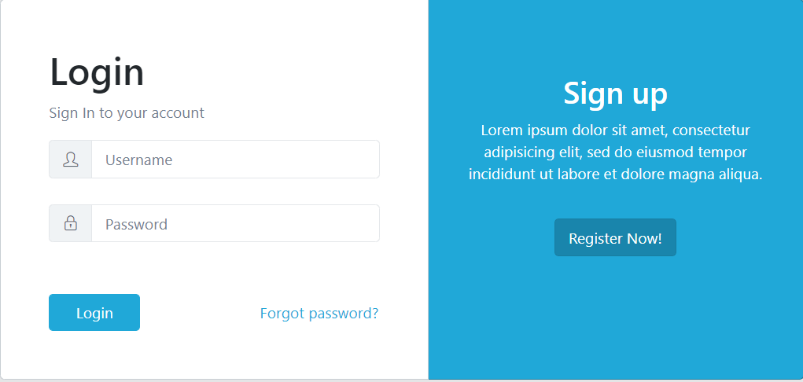

* **Admin Side**
* **Display Employee**

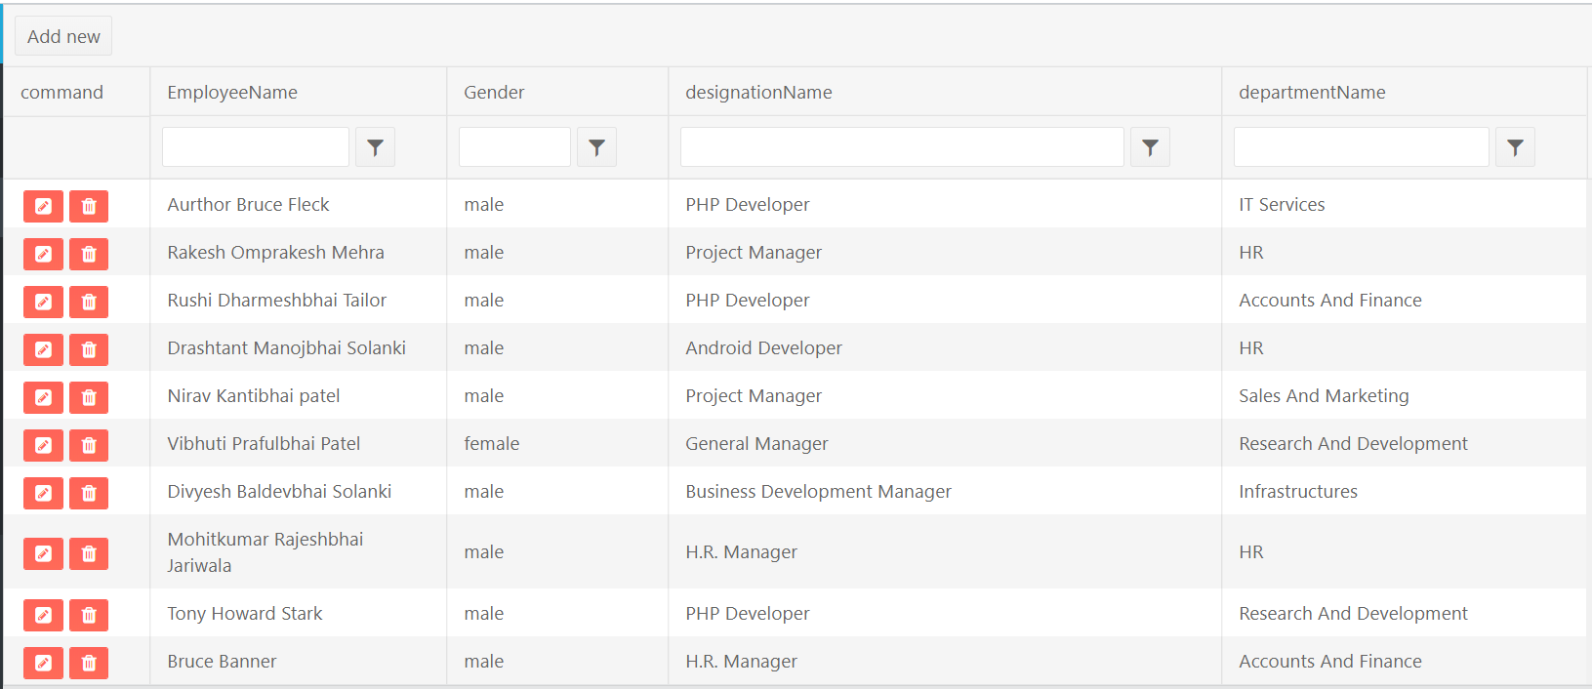

* **Add Employee**

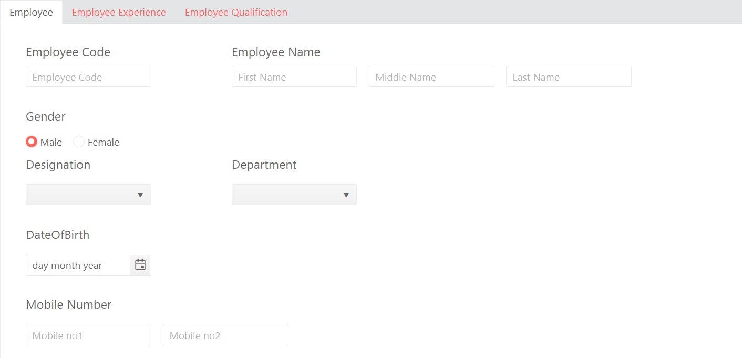

* **Add EmployeeQualification**

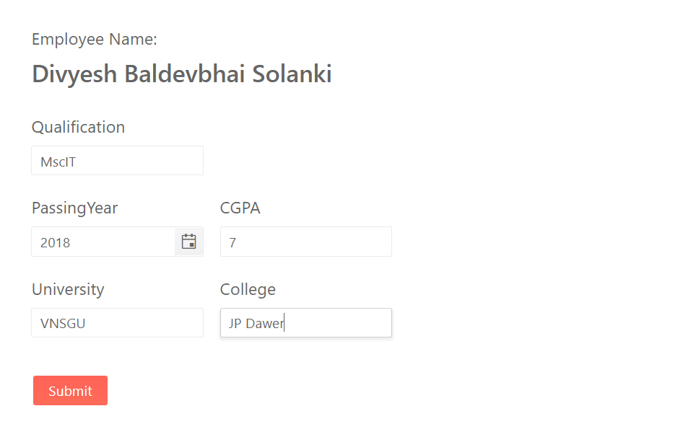

* **Add More EmployeeQualification**

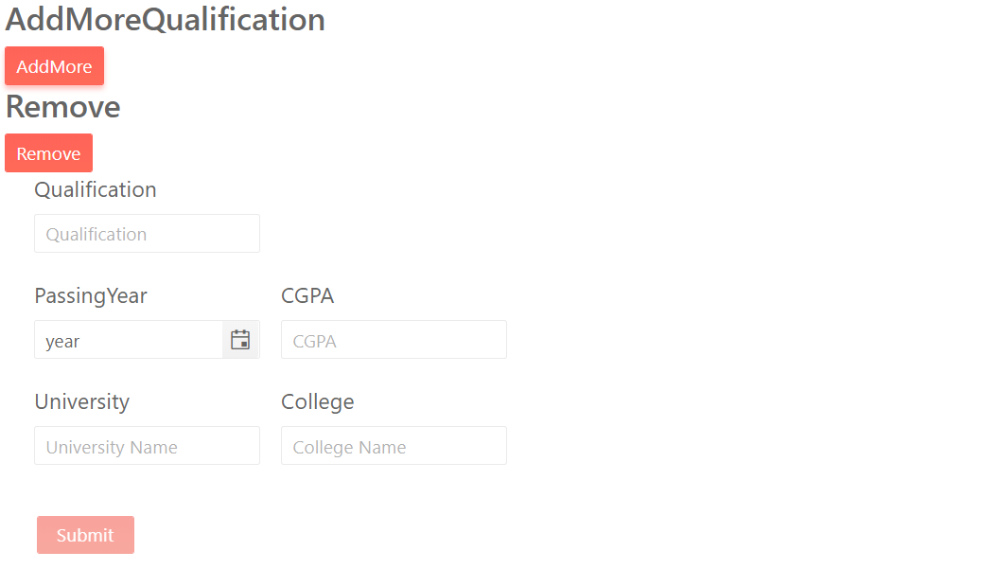

* **Add EmployeeExperience**

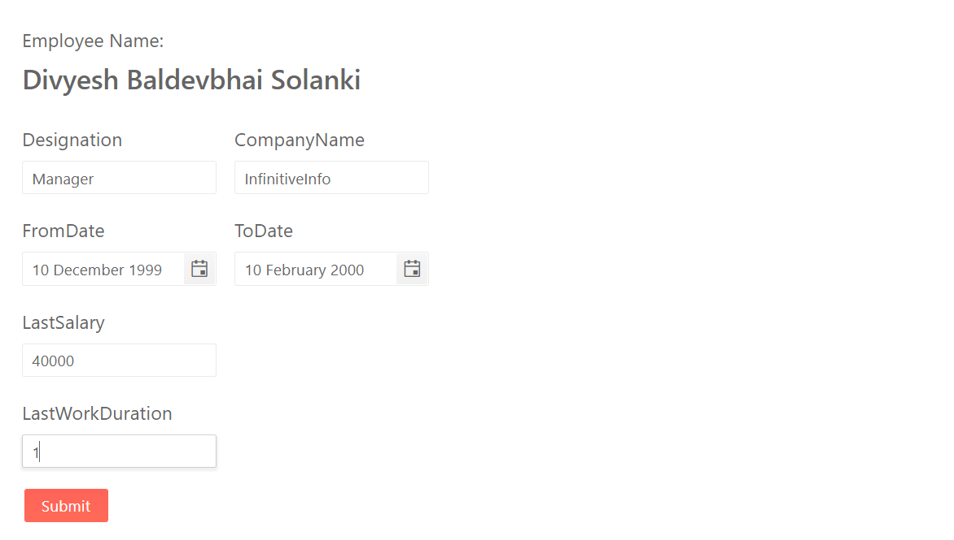

* **Add More EmployeeExperience**

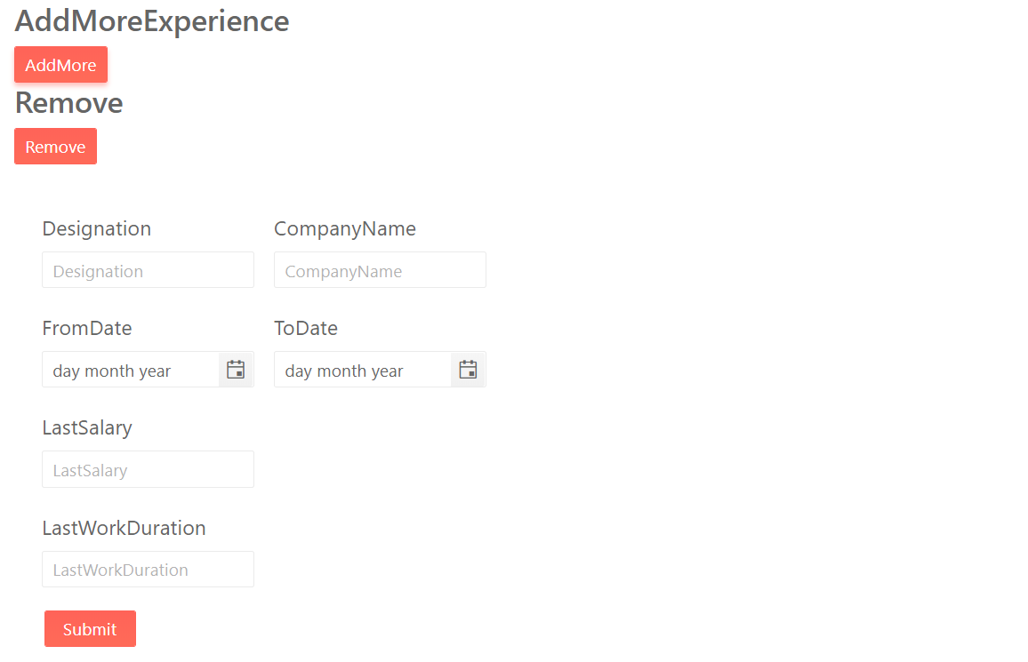

* **Leaves Display**

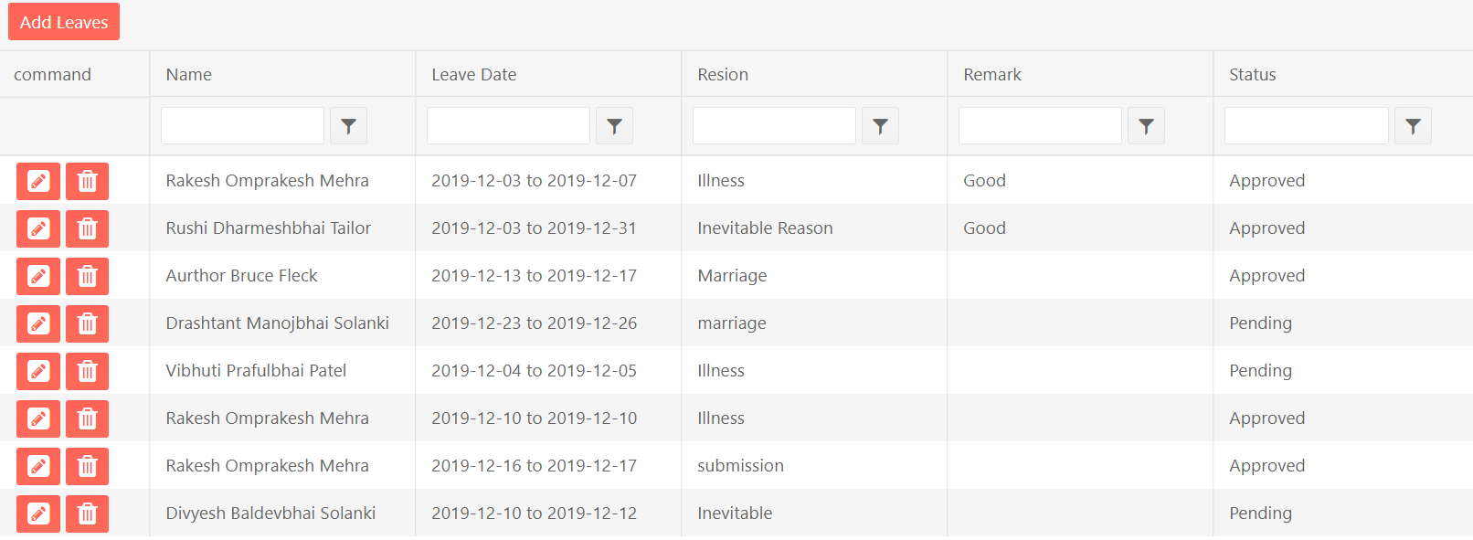

* **Add Leaves**

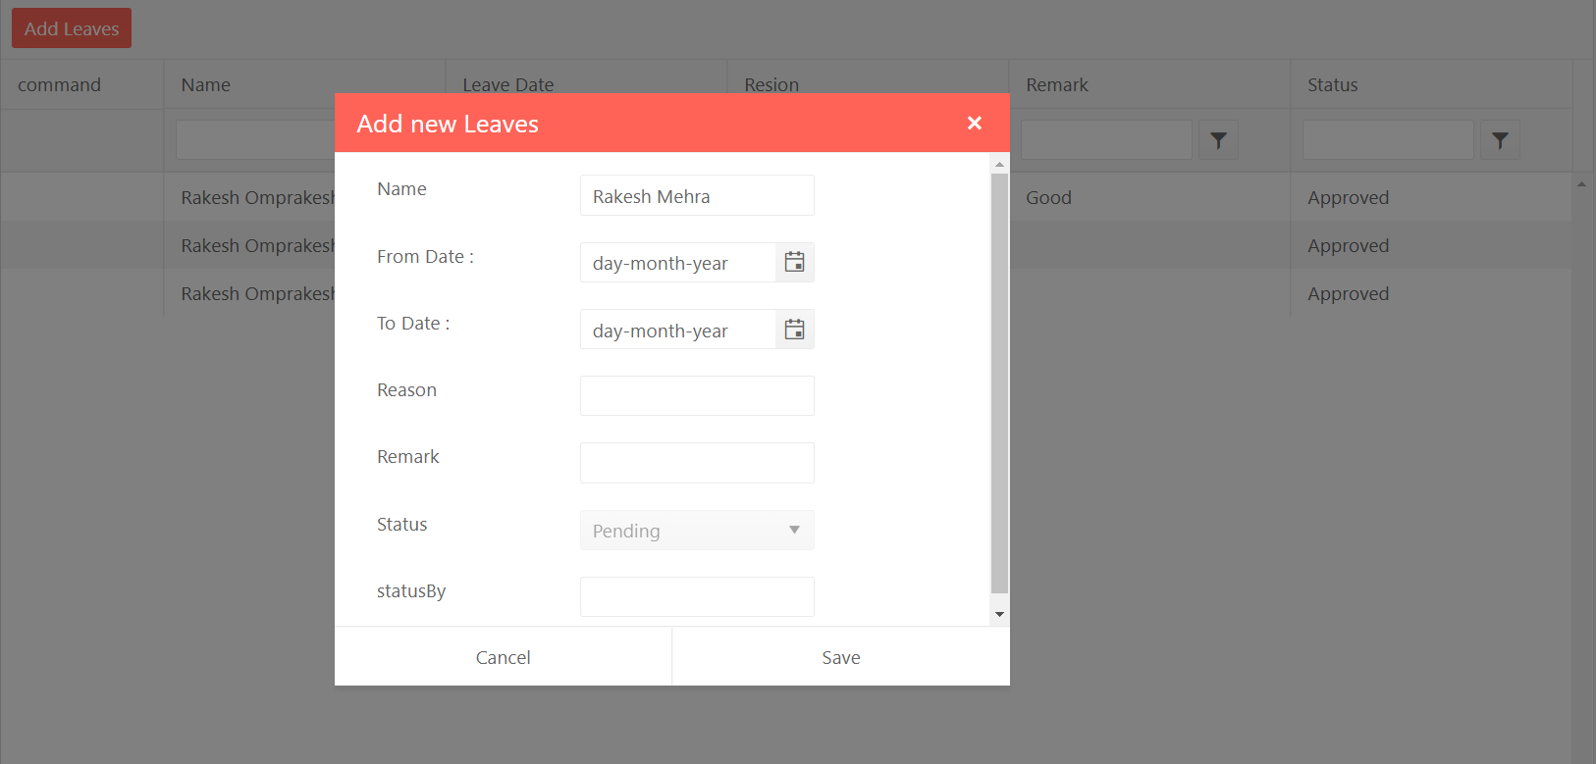

* **Display LeaveTransaction**

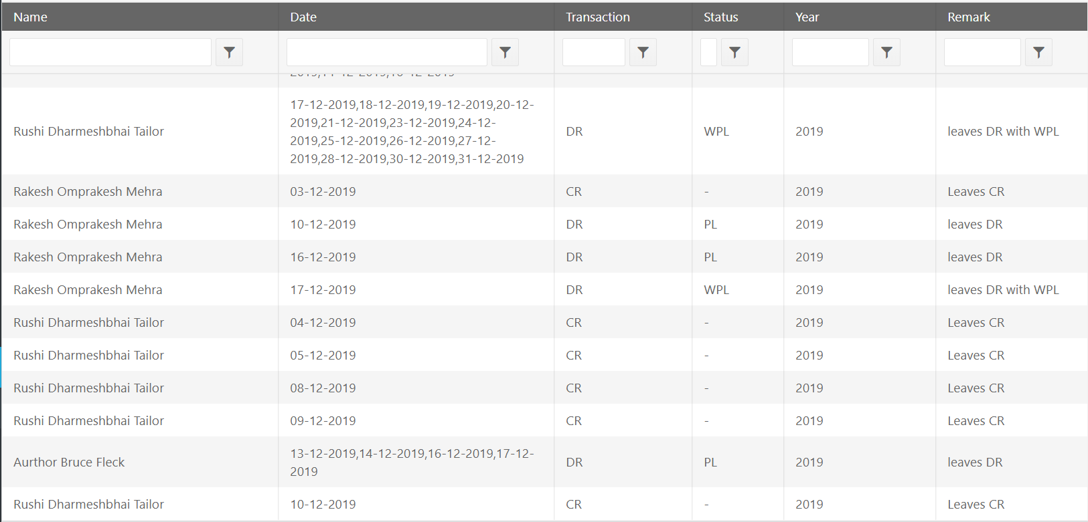

* **Display Attendance**

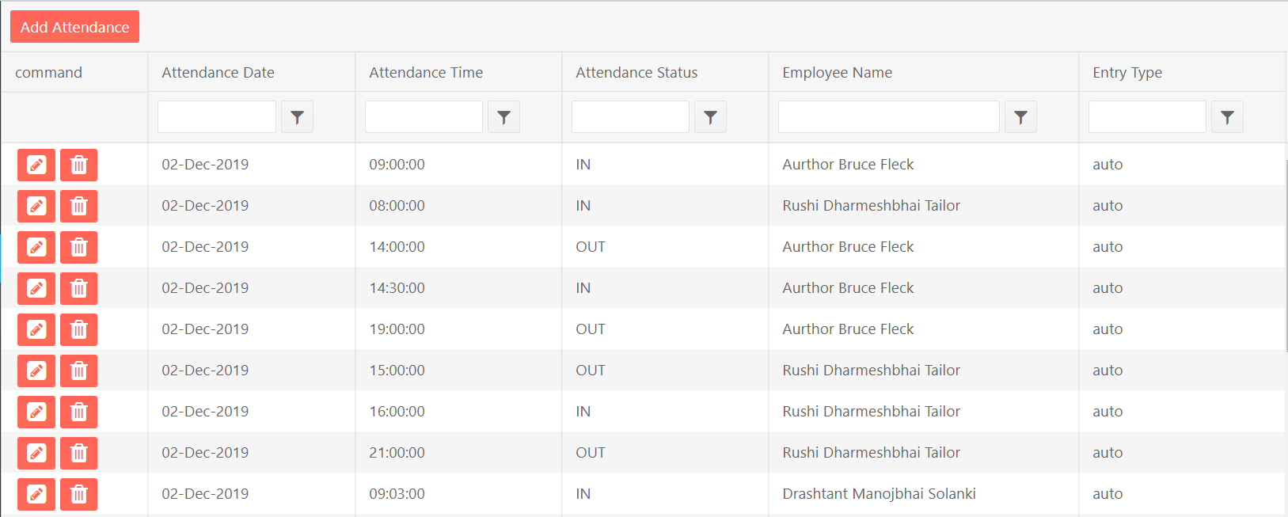

* **Add Attendance**

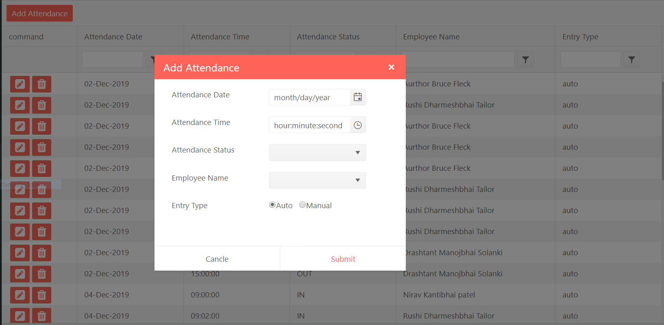

* **Display WorkingHours**

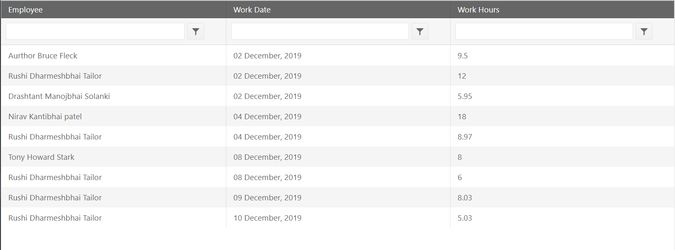

* **Sorting**

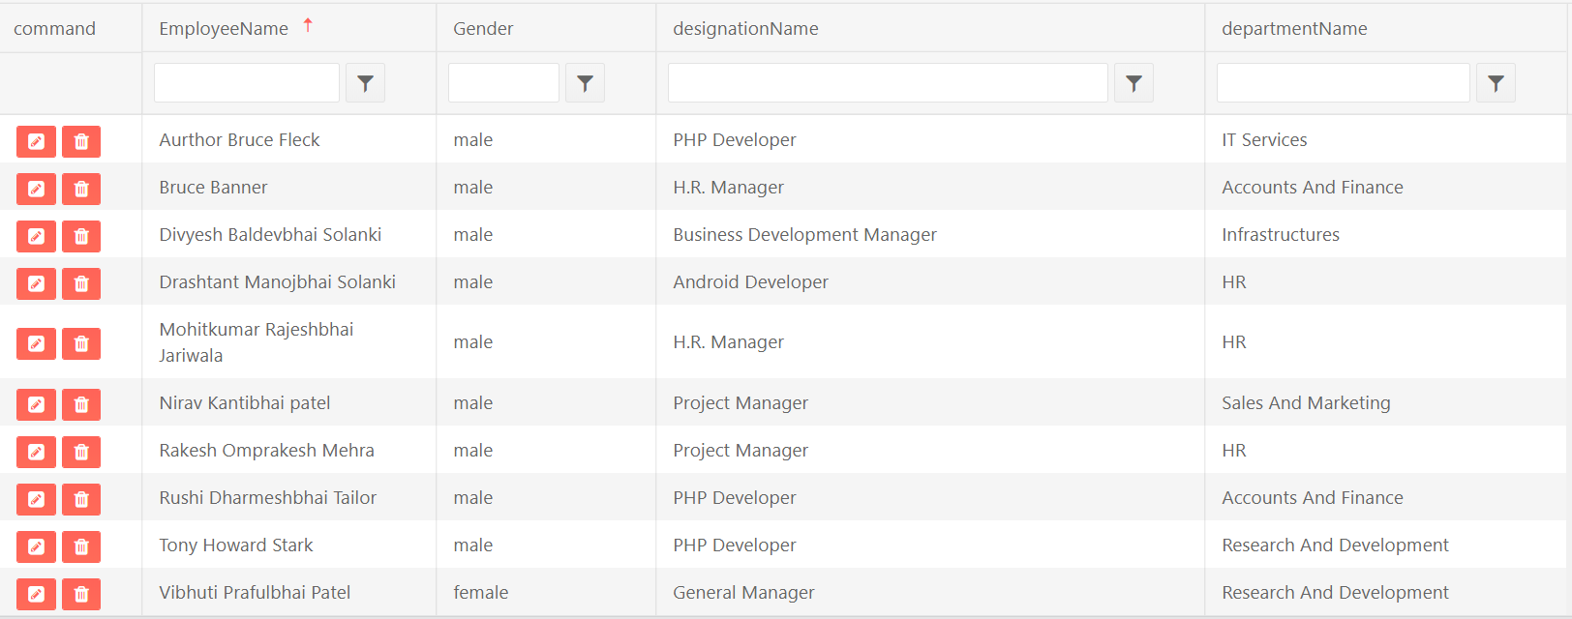

* **Filtering**

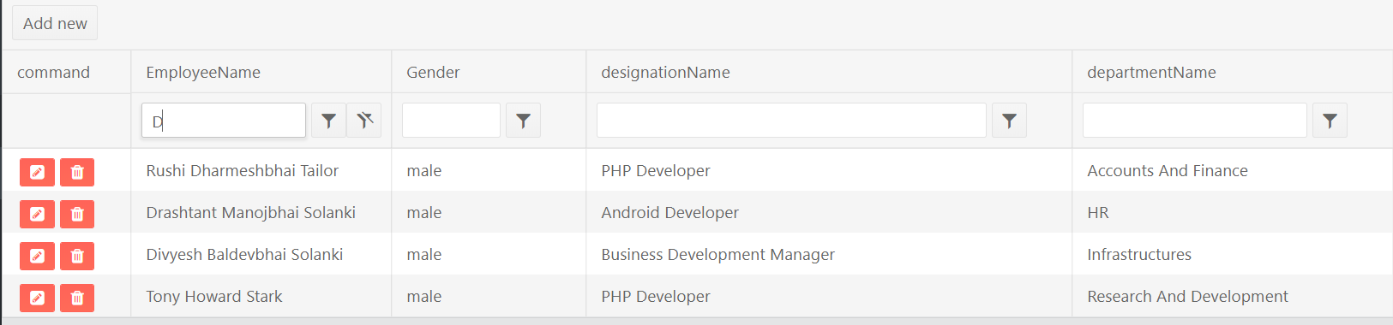

* **User Side**
* **Display Attendance**

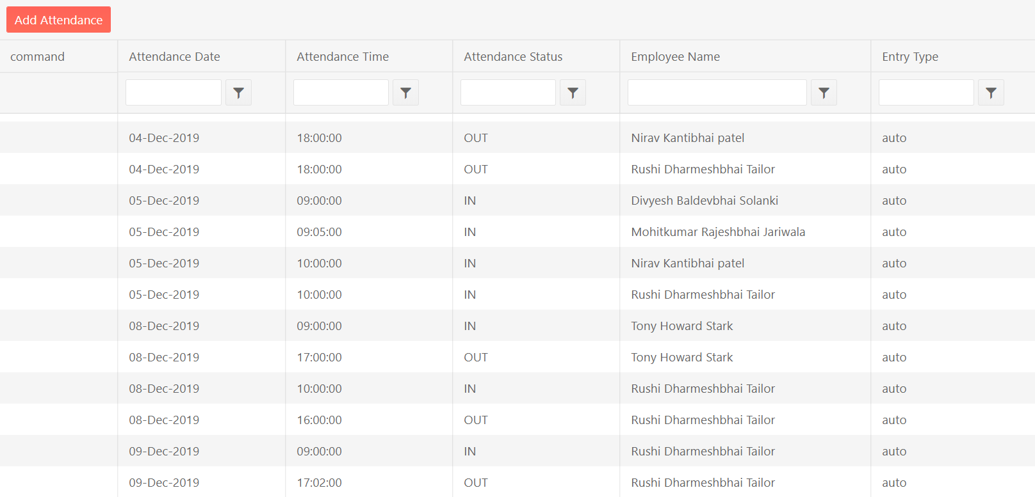

* **Add Attendance**

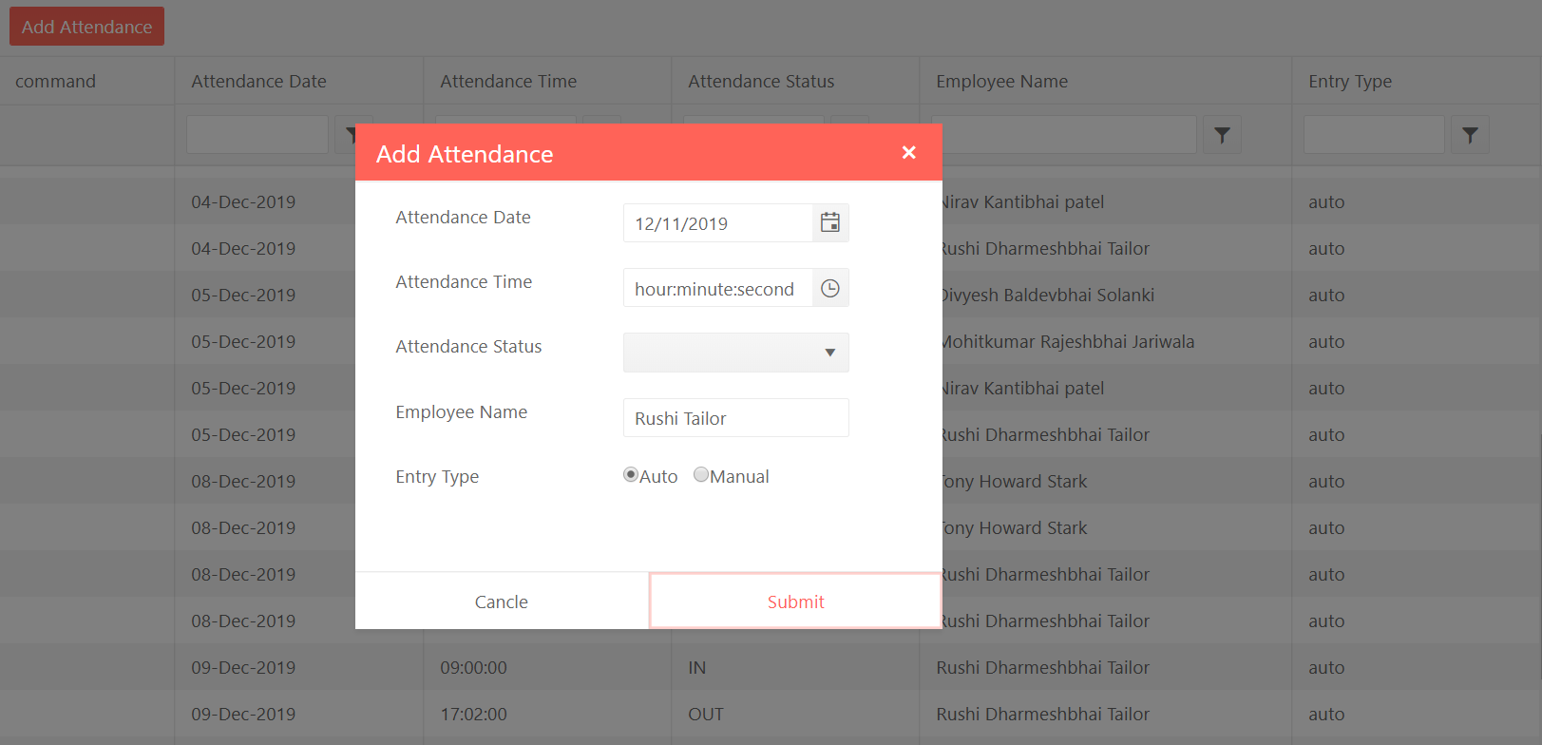

* **Display Leaves**

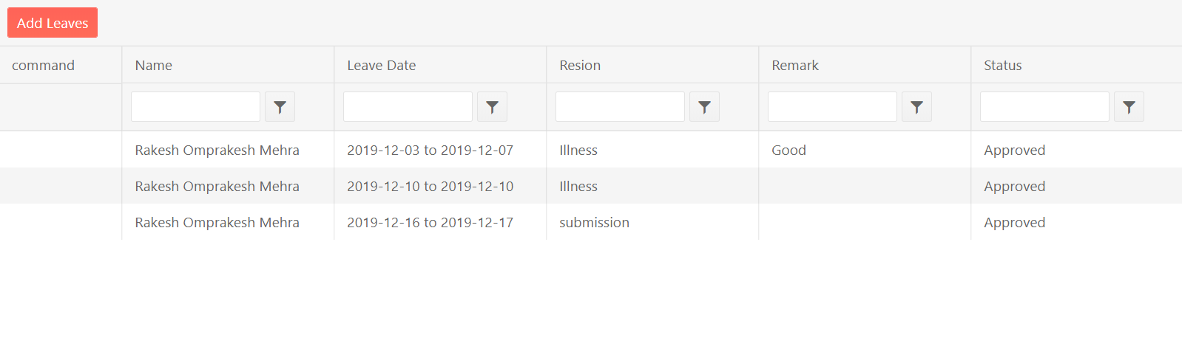

* **Add Leaves**



1. TESTING
   1. **Unit Testing**
   2. **Integration Testing**

**7.1 Unit Testing**

* **Add/Edit Employee:**

|  |  |  |  |  |
| --- | --- | --- | --- | --- |
| **Sr. no** | **Field Name / Constraint** | **Input Value** | **Valid /Invalid** | **Error Message** |
| 1. | EmployeeCode | Numeric | Valid: any input Numeric Value  Invalid: null Numeric Field | EmpCode is required  Invalid EmpCode |
| 2. | FirstName | String | Valid: any input String  Invalid: null String | FirstName is required  Invalid FirstName |
| 3. | MiddleName | String | - | - |
| 4. | LastName | String | - | - |
| 5. | Gender | String | By Default Male is select | - |
| 7. | DesignationId | Int | Valid: Select any one option in combo box  Invalid: not Select any one | Please select Designation |
| 8. | DepartmentId | Int | Valid: Select any one option in combo box  Invalid: not Select any one | Please select Department |
| 9. | DateOfBirth | Date | Valid: select any date  Invalid: not select any date | Date is Required |
| 10. | MobileNo1 | String | Valid: any input Numeric Value  Invalid: null Numeric Field | MobileNo is Required |
| 11. | MobileNo2 | String | - | - |
| 12. | Address1 | String | Valid: any input String  Invalid: null String | Address is Required |
| 13. | Address2 | String | - | - |
| 14. | Address3 | String | - | - |
| 15. | Area | String | Valid: any input String  Invalid: null String | Area is required  Invalid Area |
| 16. | City | String | Valid: any input String  Invalid: null String | City is required  Invalid City |
| 17. | State | String | Valid: any input String  Invalid: null String | State is Required  Invalid State |
| 18. | Pincode | String | - | - |
| 19. | EmailId | String | Valid: any input String  Invalid: null String | EmailId is Required  Invalid EmailId |
| 20. | DateOfJoin | Date | Valid: select any date  Invalid: not select any date | Date is Required |
| 21. | MaritalStatus | String | - | - |
| 22. | EmployeeImage | String | - | - |
| 23. | ResignDate | Date | Valid: Select any date  Invalid: not select any date | ResignDate is Required |
| 24. | LeaveDate | Date | Valid: select any date  Invalid: not select any date | LeaveDate is Required |
| 25. | Remark | String | - | - |

* **Add/Edit EmployeeQualification:**

|  |  |  |  |  |
| --- | --- | --- | --- | --- |
| **Sr. no** | **Field Name / Constraint** | **Input Value** | **Valid /Invalid** | **Error Message** |
| 1. | EmployeeId | Int | - | - |
| 2. | QualificationName | String | Valid: any input String  Invalid: null String | QualificationName is required  Invalid QualificationName |
| 3. | PassingYear | Int | Valid: any input Integer value  Invalid: null Integer value | PassYear Is Required |
| 4. | CGPA | Float | Valid: any input Float value  Invalid: null Float value | CGPA is Required  Invalid CGPA |
| 5. | University | String | Valid: Any input string  Invalid: null input string | University Name is required  Invalid University Name |
| 6. | Collage | String | Valid: any input String  Invalid: null String | Collage Name is required  Invalid Collage Name |

* **Add/Edit EmployeeExperience:**

|  |  |  |  |  |
| --- | --- | --- | --- | --- |
| **Sr. no** | **Field Name / Constraint** | **Input Value** | **Valid /Invalid** | **Error Message** |
| 1. | EmployeeId | Int | - | - |
| 2. | Designation | String | Valid: any input String  Invalid: null String | Designation is required  Invalid Designation Name |
| 3. | CompanyName | String | Valid: any input Integer value  Invalid: null Integer value | Company Name is required  Invalid Company Name |
| 4. | FromDate | Date | Valid: Select any date  Invalid: not select any date | From Date is Required |
| 5. | ToDate | Date | Valid: Select any date  Invalid: not select any date | ToDate is Required |
| 6. | LastSalary | Numeric | Valid: any input numeric value  Invalid: null String | Salary is Required  Invalid Salary |
| 7. | LastWorkDuration | String | Valid: any input String  Invalid: null String | Duration is required  Invalid Duration |

* **Add/Edit Recruitment:**

|  |  |  |  |  |
| --- | --- | --- | --- | --- |
| **Sr. no** | **Field Name / Constraint** | **Input Value** | **Valid /Invalid** | **Error Message** |
| 1. | ApplicantName | String | Valid: any input String  Invalid: null String | ApplicantName is required  Invalid ApplicantName |
| 2. | Address | String | Valid: any input Integer value  Invalid: null Integer value | Address is Required |
| 3. | EmailId | String | Valid: Select any date  Invalid: not select any date | EmailId Is Required  Invalid EmailId |
| 4. | MobileNumber1 | String | Valid: Select any date  Invalid: not select any date | MobileNo Is required  Invalid MobileNo |
| 5. | MobileNumber2 | String | - | - |
| 6. | Gender | String | By default Male Is Select | - |
| 7. | City | String | Valid: any input String  Invalid: null String | City is required  Invalid City |
| 8. | State | String | Valid: any input String  Invalid: null String | State is required  Invalid State |
| 9. | ApplyFor | String | Valid: any input String  Invalid: null String | ApplyFor is required |
| 10. | NoticePeirod | Int | Valid: any input Integer value  Invalid: null Integer value | NoticePeriod is Required  Invalid NoticePeriod |
| 11. | InterviewDateTime | Datetime | Valid: Select any date and time  Invalid: not select any date and time | InterviewDateTime is Required |
| 12. | Interviewed | Bit | By default yes selected | - |
| 13. | Rating | String | Valid: any input String  Invalid: null String | Rating is required |
| 14. | Remark | String | - | - |

* **Add/Edit RecruitmentExperience:**

|  |  |  |  |  |
| --- | --- | --- | --- | --- |
| **Sr. no** | **Field Name / Constraint** | **Input Value** | **Valid /Invalid** | **Error Message** |
| 1. | CompanyName | String | Valid: any input String  Invalid: null String | Company Name Is Required  Invalid Company Name |
| 2. | JoinDate | Date | Valid: Select any date  Invalid: not select any date | Join Date Is required |
| 3. | LeaveDate | Date | Valid: Select any date  Invalid: not select any date | LeaveDate Is Required |
| 4. | IsCurrentJob | Bit | Valid: Select True or false  Invalid: not select True or false | CurrentJob Is Required |
| 5. | ExperienceMonth | Int | - | - |
| 6. | ExperienceYear | Int | - | - |

* **Add/Edit RecruitmentQualification:**

|  |  |  |  |  |
| --- | --- | --- | --- | --- |
| **Sr. no** | **Field Name / Constraint** | **Input Value** | **Valid /Invalid** | **Error Message** |
| 1. | SSCPercentage | Float | Valid: any input Float value  Invalid: null Float value | SSCPercentage Is Required  Invalid SSCPercentage |
| 2. | SSCPassingYear | Int | Valid: any input Integer value  Invalid: null Integer value | SSCPassingYear Is Required  Invalid SSCPassingYear |
| 3. | HSCPercentage | Float | Valid: any input Float value  Invalid: null Float value | HSCPercentage Is Required  Invalid HSCPercentage |
| 4. | HSCPassingYear | Int | Valid: any input Integer value  Invalid: null Integer value | HSCPassingYear Is Required  Invalid HSCPassingYear |
| 5. | QualificationName | String | Valid: any input String  Invalid: null String | QualificationName Is Required  Invalid QualificationName |
| 6. | PassingYear | Int | Valid: any input Integer value  Invalid: null Integer value | PassingYear Is Required  Invalid PassingYear |
| 7. | CGPA | Float | Valid: any input Float value  Invalid: null Float value | CGPA is Reqiored  Invalid CGPA |
| 8. | University | String | Valid: any input String  Invalid: null String | University Is Required  Invalid University |
| 9. | Collage | String | Valid: any input String  Invalid: null String | Collage is Required  Invalid Collage |

* **Add/Edit Designation:**

|  |  |  |  |  |
| --- | --- | --- | --- | --- |
| **Sr. no** | **Field Name / Constraint** | **Input Value** | **Valid /Invalid** | **Error Message** |
| 1. | DesignationCode | Int | Valid: any input Integer value  Invalid: null Integer value | DesignationCode Is Required  Invalid DesignationCode |
| 2. | DesignationName | String | Valid: any input String  Invalid: null String | DesignationName Is Required  Invalid DesignationName |

* **Add/Edit Department:**

|  |  |  |  |  |
| --- | --- | --- | --- | --- |
| **Sr. no** | **Field Name / Constraint** | **Input Value** | **Valid /Invalid** | **Error Message** |
| 1. | DepartmentCode | Int | Valid: any input Integer value  Invalid: null Integer value | DepartmentCode Is Required  Invalid DepartmentCode |
| 2. | DepartmentName | String | Valid: any input String  Invalid: null String | DepartmentName Is Required  Invalid DepartmentName |

* **Add/Edit HolidayDetail:**

|  |  |  |  |  |
| --- | --- | --- | --- | --- |
| **Sr. no** | **Field Name / Constraint** | **Input Value** | **Valid /Invalid** | **Error Message** |
| 1. | DateOfHoliday | Date | Valid: Select any date  Invalid: not select any date | DateOfHoliday Is Required |
| 2. | YearOfHoliday | Int | Valid: any input Integer value  Invalid: null Integer value | YearOfHoliday Is Required |
| 3. | HolidayId | Int | Valid: any input Integer value  Invalid: null Integer value | Holiday Is Required |

* **Add/Edit Leaves:**

|  |  |  |  |  |
| --- | --- | --- | --- | --- |
| **Sr. no** | **Field Name / Constraint** | **Input Value** | **Valid /Invalid** | **Error Message** |
| 1. | EmployeeId | Int | Valid: Select any option  Invalid:not select any option | Employee Is Required |
| 2. | Resion | String | Valid: any input String  Invalid: null String | Resion Is Required  Invalid Resion |
| 3. | LeaveFromDate | Date | Valid: Select any date  Invalid: not select any date | LeaveFromDate Is Required |
| 4. | LeaveToDate | Date | Valid: Select any date  Invalid: not select any date | LeaveToDate Is Required |
| 5. | Remark | String | - | - |

* **Add/Edit LeaveAssign:**

|  |  |  |  |  |
| --- | --- | --- | --- | --- |
| **Sr. no** | **Field Name / Constraint** | **Input Value** | **Valid /Invalid** | **Error Message** |
| 1. | EmployeeId | Int | Valid: Select any option  Invalid:not select any option | EmployeeName Is Required |
| 2. | NumberOfLeave | Int | Valid: any input Integer Value  Invalid: null String | Assign Number Of Leave |
| 3. | AssignDate | Date | Valid: Select any date  Invalid: not select any date | Enter Date |
| 4. | Year | Int | Valid: any input Integer Value  Invalid: null String | Year Is Required |

* **Add/Edit Shift:**

|  |  |  |  |  |
| --- | --- | --- | --- | --- |
| **Sr. no** | **Field Name / Constraint** | **Input Value** | **Valid /Invalid** | **Error Message** |
| 1. | ShiftCode | Int | Valid: any input Integer value  Invalid: null Integer value | ShiftCode Is Required  Invalid ShiftCode |
| 2. | StartTime | Time | Valid: Select Time value  Invalid: not select Time value | StartTime Is Required |
| 3. | EndTime | Time | Valid: Select Time value  Invalid: not select Time value | EndTime Is Required |
| 4. | BreakMinutes | Int | Valid: any input Integer value  Invalid: null Integer value | BreakMinutes Is Required |
| 5. | Description | String | - | - |

* **Add/Edit EmployeeShift:**

|  |  |  |  |  |
| --- | --- | --- | --- | --- |
| **Sr. no** | **Field Name / Constraint** | **Input Value** | **Valid /Invalid** | **Error Message** |
| 1. | EmployeeId | Int | Valid: Select any option  Invalid:not select any option | Employee Is Required |
| 2. | ShiftId | Int | Valid: any input Integer value  Invalid: null Integer value | Shift Is Required |
| 3. | FromDate | Date | Valid: Select any date  Invalid: not select any date | FromDate Is Required |

**7.2 Integration Testing**

* **Admin Side**

|  |  |
| --- | --- |
| Test Case | 1 |
| Description | Login |
| Pre-Condition | Admin should know username and password both field should not be empty. |
| Test action | Allow access or deny access |
| Error message | Invalid Username and password |

|  |  |
| --- | --- |
| Test Case | 2 |
| Description | Add data |
| Pre-Condition | Admin should be logged in.  Field should not be empty and should be of database datatype. |
| Test action | Add data |
| Error message | Enter correct data |

|  |  |
| --- | --- |
| Test Case | 3 |
| Description | Edit data |
| Pre-Condition | Admin should be logged in.  Field should not be empty and should be of database datatype. |
| Test action | Edit data |
| Error message | Enter correct data |

|  |  |
| --- | --- |
| Test Case | 4 |
| Description | Photo upload |
| Pre-Condition | Admin should be logged in.  Field should not be empty |
| Test action | Photo Upload |
| Error message | Choose any photo |

* **User Side**

|  |  |
| --- | --- |
| Test Case | 1 |
| Description | Login |
| Pre-Condition | User should know username and password both field should not be empty. |
| Test action | Allow access or deny access |
| Error message | Invalid Username and password |

|  |  |
| --- | --- |
| Test Case | 2 |
| Description | Add data |
| Pre-Condition | User should be logged in.  Field should not be empty and should be of database datatype. |
| Test action | Add data |
| Error message | Enter correct data |

1. Future Enhancement

* Project Management
* Role Management
* If Employee apply for leave and owner don’t take action on it and Leave date has passed out then those leave considered as reject

1. Reference

* <https://www.telerik.com/kendo-angular-ui/components/>
* <https://stackoverflow.com>
* <https://v7.angular.io/docs>
* <https://github.com/>