Software Requirements Specification

For

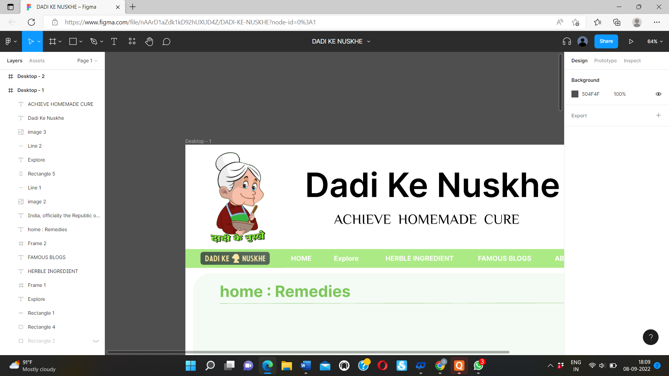

“ Dadi k Nuske”

Guided by : Sneha Padhiyar

**Prepared by 20CE074, 20CE081,21CE082,21CE084**

Date : 9/9/2022

**Table of Contents**

**1*.* Introduction*………………………………………………………………………………******.*1**

1.1 Objective………………………………………………………………………………….1

1.2 Project Scope …………………………………………………………………………….1

1.3 References………………………………………………………………………………..1

**2. Overall Description……………………………………………………………………….2**

2.1 Project Perspective ……………………………………………………………………….2

2.2 Features……………………………………………………………………………………2

2.3 Operating Environment……………………………………………………………...……2

2.4 Design Constraints …..…………………………………………………………………...2

2.5 User Documentation ……………………………………………………………………..3

2.6 Assumptions and Dependencies………………………………………………………….3

**3. External Interface Requirements……………………………………………….…….....3**

3.1 User interface …………………………………………………………………………….3

3.2 Software interface ………………………………………………………………………..4

3.3 Communications Interface……………………………………………………………..…4

**4. Other Nonfunctional Requirements……………………………………………………..4**

4.1 Performance Requirements ………………………………………………………………4

4.2 Software Quality Attributes ……………………………………………………………...4

**5.Other Requirements………………………………………………………………………5**

Appendix : Glossary………………………………………………………………………….5

**1. Introduction**

* 1. Objective:
* The objective of this project is to Solve The Problem Of people by using this Website to cure their illness .Users can find information about natural herbs User can cure their selves in low cost .User can now know our old culture how the rushimunis cure with natural herbs.
  1. Project Scope:
* After pandemic all people are approaching towards “ayurvedic” cures , so people will go on internet for finding details about herbal ingredient. we are thinking for adding user feedback which make our website user flexible.
  1. References:

Refference for gathering information of different cures :

* + <https://www.adityabirlacapital.com/healthinsurance/active-together/2017/06/09/family-home-remedies-for-minor-ailments/#:~:text=Boil%2020%20basil%20leaves%20in,and%20fight%20the%20viral%20flu>
  + https://www.healthline.com/

**2. Overall Description**

* 1. Project Perspective :
* The basic moto of this project is to give the Information about different disease Symptoms of different disease , Cure of disease by following our dadi’s guideline ,Knowledge about herbal ingredient ,Herbal ingredient like tulsi, aswagandha, turmeric etc , Some famous blogs of cure by herbals ingredient.

2.2 Features :

* Home page
* Login page
* At low cost disease treatment
* Explore page
* Herbal ingredient
* Famous blogs

2.3 Operating Environment:

The operating environment for our website is as listed below.

* Client/server system
* Operating system: Windows, MacOs.
* Platform: HTML/CSS

## 2.4 Design and Implementation Constraints:

Describe any items or issues that will limit the options available to the developers. These might include corporate or regulatory policies; hardware limitations (timing requirements, memory requirements); interfaces to other applications; parallel operations; language requirements; communications protocols; design conventions or programming standards.

## 2.5 User Documentation :

In the About Us section of the project, there will be a brief description of the Website.

## 2.6 Assumptions and Dependencies :

The main assumption of this project is that the user will be provided with ample Ayurvedic cures regarding their disease . and also if they can give us any suggestion or comment on our cures if they want .

**3. External Interface Requirements**

* 1. User interface:

Front-end Software: Figma , Vs code

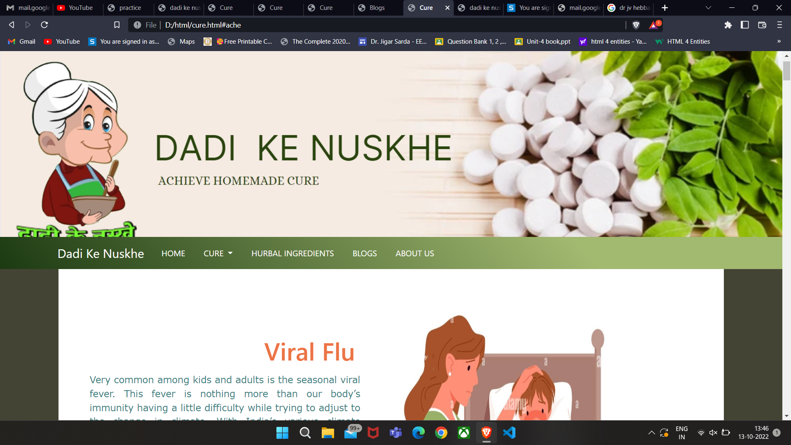

Figure 3.1

3.2 Software interface:

|  |  |
| --- | --- |
| **Software used** | **Description** |
| Figma | a browser-based application that supports editing in any browser that supports WebGL. Users can also view designs in desktop browsers. Figma also offers desktop applications for Windows, Mac OS X, and Linux operating systems. |
| Visual studio code | To implement the project we have chosen HTML, CSS language for its more interactive support. |

3.3 Communications Interface:

* This project supports all types of web browsers.

**4. Other Nonfunctional Requirements**

4.1 Performance Requirements :

* The system must be interactive and the delays involved must be less

4.2 Software Quality Attributes :

* Availability:
* Usability:
* Maintainability:

**5.Other Requirements**

Appendix : Glossary

HyperText Markup Language (HTML) The standard markup language for creating

web pages and web applications by ISO/IEC 15445 and W3C HTML5.

Cascading Style Sheets(CSS): used for styling and laying out webpages. It can be used to adjust the content size, spacing, color, and font or add decorative features, such as animations or split content into columns.