Computer Vision Workshop on Robotics : Snake Game by using Teachable machine and p5.js

Procedures

A. Create FIVE gestures image samples to control the snake movement
A1. Connect PC webcam to the computer or follow the instructions from MobileWebcam.docx to use your smart phone as the webcam.
A2. Visit the link https://teachablemachine.withgoogle.com/ using the Chrome browser.

A3. Click the Get Started button to create the new project

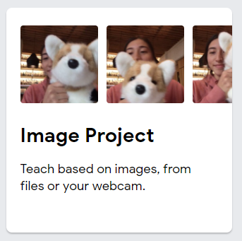
A4. Click “Image Project” to create a new image project.

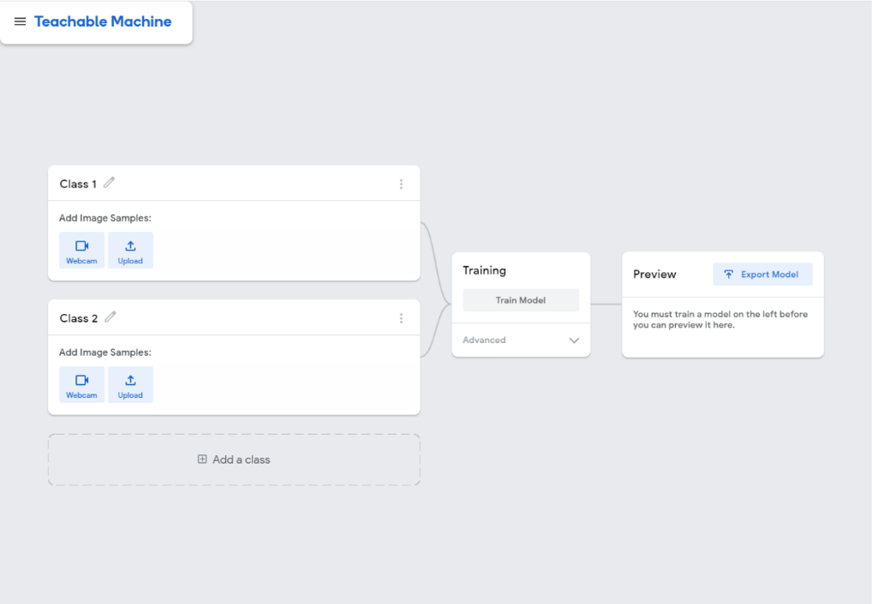
A5. The web browser will open a page for you to create a model.

A6. Change Class 1 to Left in the Image Set Column.
Before | After
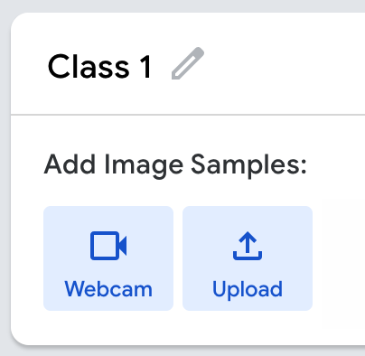 | 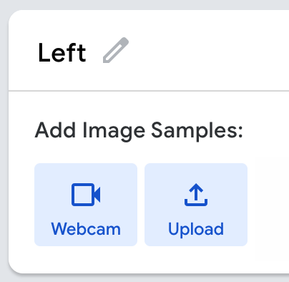

A7. Click Settings Icon and change the setting as below.
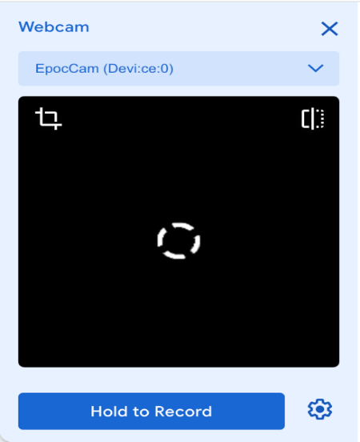 | FPS: 24  Hold to Record: OFF  Delay: 2 seconds  Duration: 15 seconds

A8. Click Save Settings at the bottom.

A9. Click “Record 15 Seconds” to record a gesture for controlling the snake to the left as below.
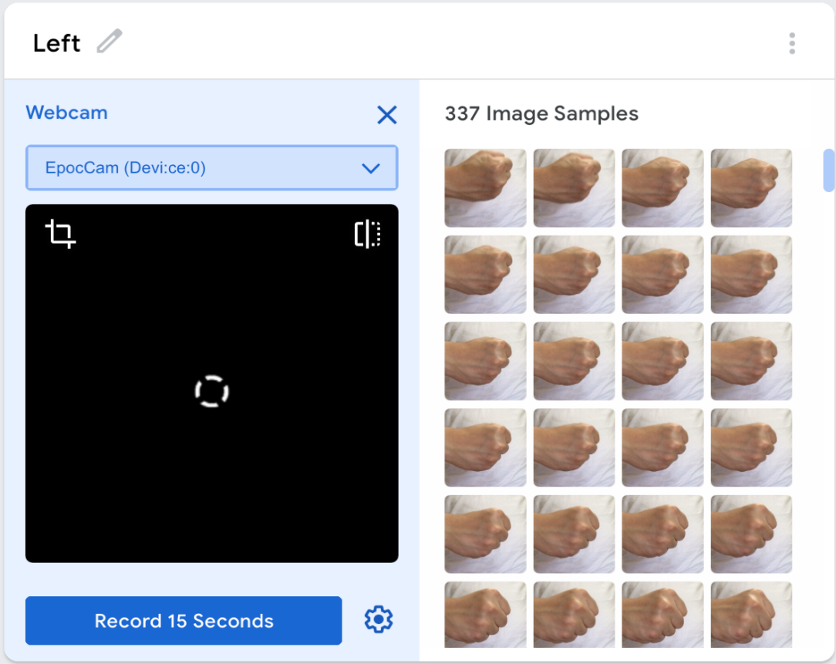
Tips: Try to move your hand in different positions/orientations, it helps to improve the robustness the AI model.

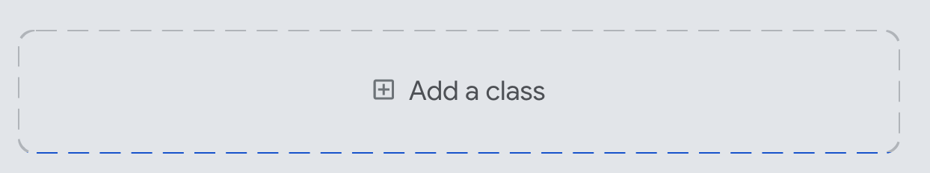
A10. Click “Add a class” to create another 4 image sets to control the snake movement. (Order is NOT important.)

Right | Up
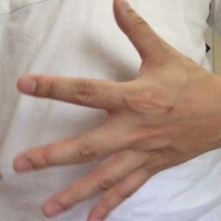 | 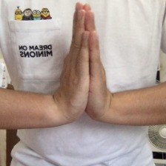
Down | Nothing
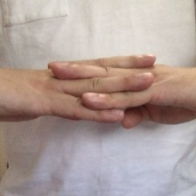 | 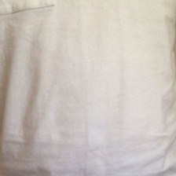

B Train your model and testing
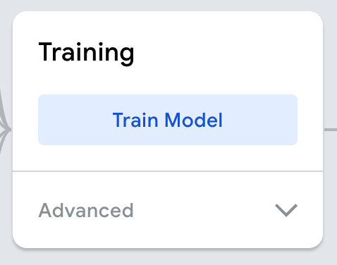
B1 Now you can train your model by clicking the Train Model button.

It may need a while… so you can take a break.
But remember don't switch tab or close the browser, you must leave the page open to train your model.

B2 Capture and paste the whole screenshot below.
Any one of the Gesture (Left / Right / Up / Down / Nothing)

C Start to create a basic Snake game
C1. Go to the link https://editor.p5js.org/ to create a new p5js project.

C2. Create an account (optional – if you want to save your project.)

C3. Open the source codes sketch.js from the resources folder using Notepad++, copy the source codes sketch.js and replace the existing one (sketch.js).

C4. Create a new file snake.js
- Click the buttons below.
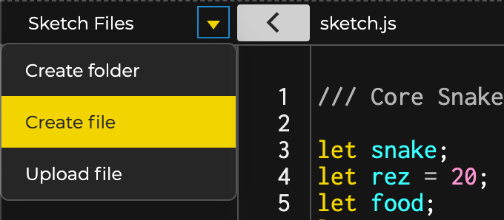
1
2
3

- Name it as snake.js
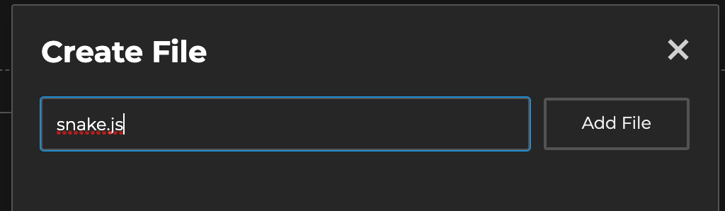

C5. Open the source codes snake.js from the resources folder using Notepad++, copy the source codes snake.js and replace the existing one (snake.js).

C6. Open the index.html from Sketch Files. Copy the following code and add it at (line 12) as below. It aims to load the JavaScript “snake.js” into the index page.
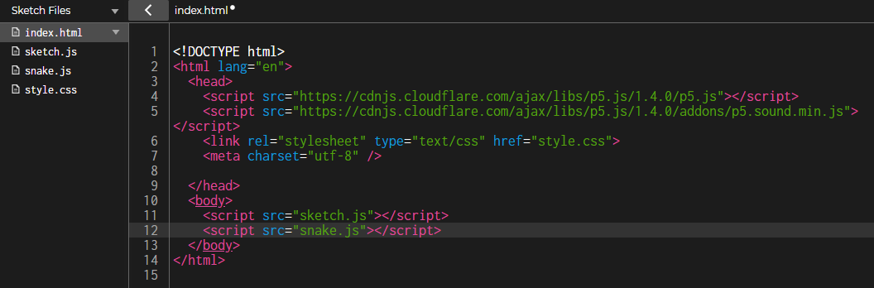
<script src="snake.js"></script>
C7. Copy the following code and add it at (line 6) in the index.html file as below.
<script src="https://unpkg.com/ml5@0.4.3/dist/ml5.min.js"></script>
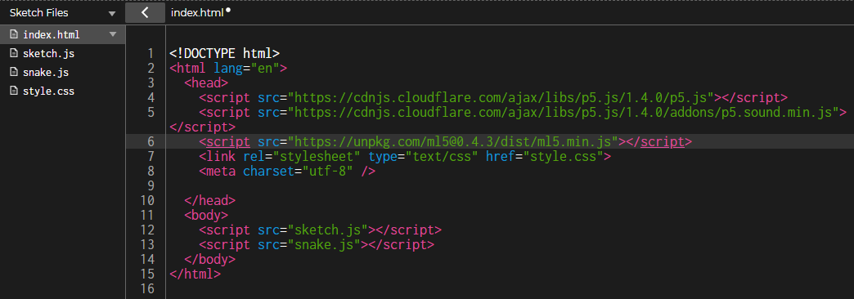

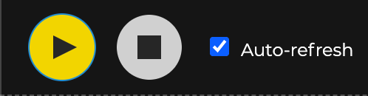
C8. Check the Auto-refresh and click Play button. You can click the Preview screen and use the four arrows ↑ ↓ ← → to control the snake movement.

C9. Capture and paste the Preview below.

D Integrate the hand gestures into the snake game
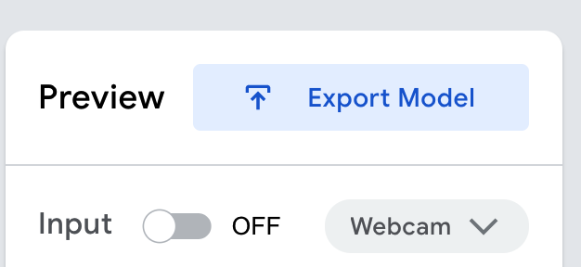
D1. Goto the page Teachable Machine and click “Export Model”.

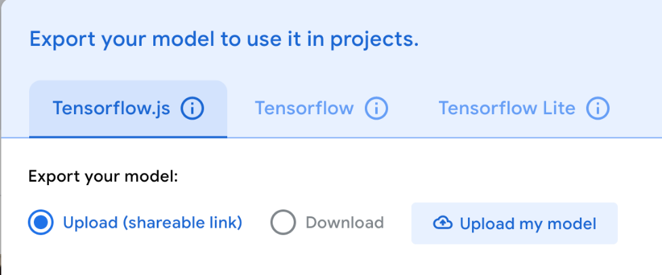
D2. Choose Tensorflow.js and click Upload my model.

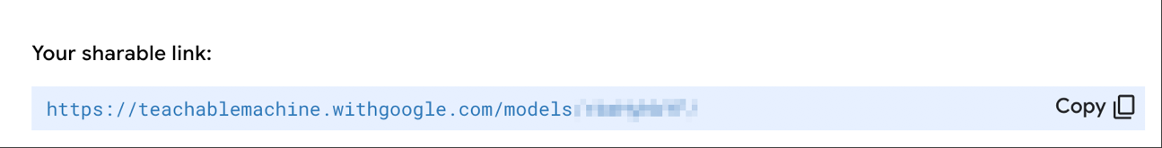
D3. Copy “Your sharable link”.

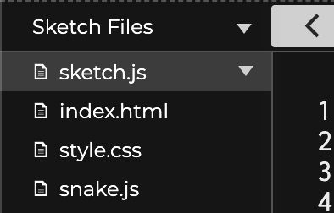
D4. Select "sketch.js" file from the Sketch file.
D5. Paste the copied link as below. This is going to apply the classifier that you trained into your snake game.
*Note: Remember to keep "/model.json" at the end of the link.

E Control the snake with gestures
E1. Find and change the function name "keyPressed" to "controlSnake".

E2. Change LEFT_ARROW, RIGHT_ARROW, DOWN_ARROW, UP_ARROW to "Left", "Right", "Down" and "Up" respectively. You may copy the code below and paste into the (line 53 to 64)
// Step E2: Change this function from "keyPressed" to "controlSnake" and the keyCode to label

function controlSnake() {
if (label == "Left") {
snake.setDir(-1, 0);
} else if (label == "Right") {
snake.setDir(1, 0);
} else if (label == "Down") {
snake.setDir(0, 1);
} else if (label == "Up") {
snake.setDir(0, -1);
}
}
HINT

The text inside quotation (e.g "Left") should same as the Image Set name in Teachable Machine.
Remember in programming world, all texts are usually case-sensitive.

Before | After
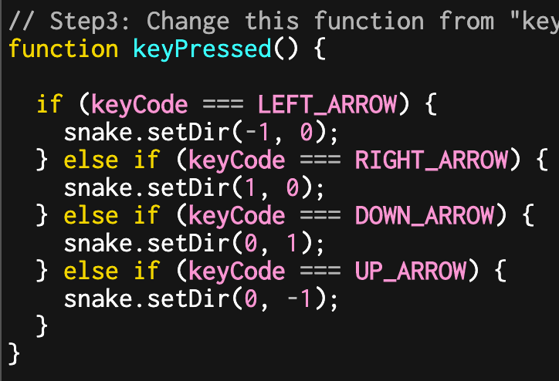 | 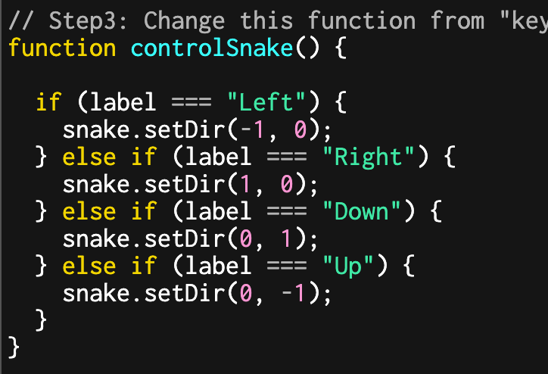

E3. Now, goto function "gotResults", add a call function " controlSnake(); " in line 42.
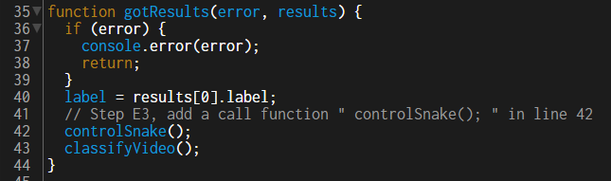

E4. Try to play your game with the gesture that you trained in Teachable Machine. Capture the whole browser in the below box

*Note: If you want to see display your cam in the output, you can add “//” to disable the command video.hide();in line 20. END -

