A PROJECT REPORT
on
DISTRICT-LEVEL RICE YIELD PREDICTION IN ODISHA
USING TIME-AWARE MACHINE LEARNING REGRESSION
Submitted to
KIIT Deemed to be University
In Partial Fulfilment of the Requirement for the Award of
BACHELOR’S DEGREE IN
COMPUTER SCIENCE & ENGINEERING
BY

KALPANA PAL | Roll No.: 23052398
RIDHIMA | Roll No.: 23052415
MAYANK SINGH | Roll No.: 23052401
NAMAN KUMAR | Roll No.: 23053221
MIHIR SINHA | Roll No.: 23052977
SHAURYAN PATTNAIK | Roll No.: 23052426
UNDER THE GUIDANCE OF
GUIDE NAME: Dr. Dipti Dash



SCHOOL OF COMPUTER SCIENCE AND ENGINEERING
KALINGA INSTITUTE OF INDUSTRIAL TECHNOLOGY
BHUBANESWAR, ODISHA – 751024
November 2026

KIIT DEEMED TO BE UNIVERSITY
School of Computer Science and Engineering
Bhubaneswar, Odisha – 751024
CERTIFICATE
This is to certify that the project entitled “District-Level Rice Yield Prediction in Odisha Using Time-Aware Machine Learning Regression”, submitted by the following students:
• KALPANA PAL (23052398)
• RIDHIMA (23052415)
• MAYANK SINGH (23052401)
• NAMAN KUMAR (23053221)
• MIHIR SINHA (23052977)
• SHAURYAN PATTNAIK (23052426)
is a record of bona fide work carried out by them in partial fulfilment of the requirements for the award of the Bachelor’s Degree in Computer Science & Engineering at KIIT Deemed to be University, Bhubaneswar. The work was carried out during the academic year 2026 under our guidance.
Date: 06 / 11 / 2026

Dr. Dipti Dash
Guide Name
Project Guide

ACKNOWLEDGEMENTS
We express our sincere gratitude to our project guide, [Guide Name], School of Computer Science and Engineering, KIIT Deemed to be University, for the guidance, suggestions, and encouragement provided during the development of this project.
We also thank the faculty members and the School of Computer Science and Engineering for providing the academic environment and resources required to complete this work. We acknowledge the public data sources used to assemble the Odisha district-level agricultural, climate, soil, nutrient, and irrigation dataset, as well as the open-source Python and machine-learning libraries that supported the implementation.
Finally, we thank our teammates and families for their cooperation and support throughout the project.
Signature of KALPANA PAL: __________________________________
Signature of RIDHIMA: __________________________________
Signature of MAYANK SINGH: __________________________________
Signature of NAMAN KUMAR: __________________________________
Signature of MIHIR SINHA: __________________________________
Signature of SHAURYAN PATTNAIK: __________________________________

ABSTRACT
Accurate district-level rice-yield prediction can support agricultural planning, resource allocation, and food-security assessment. This project develops a time-aware machine-learning regression pipeline for estimating rice yield (kg/ha) across districts of Odisha using integrated agricultural, climate, soil, nutrient, and irrigation data from 2014 to 2024. The final dataset contains 839 observations from 30 districts. To represent a genuine future-year forecasting setting, observations from 2014–2021 (665 records) are used for model development and 2022–2024 (174 records) are reserved as a chronological test set. Four regression algorithms are compared using leakage-safe preprocessing and year-aware forward cross-validation. The tuned Random Forest model is selected with a cross-validation RMSE of 639.40 kg/ha and obtains a test RMSE of 541.77 kg/ha, MAE of 435.91 kg/ha, and R² of 0.4165. Model behaviour is examined using feature importance, SHAP, LIME, residual analysis, and robustness checks. A Streamlit dashboard is deployed to provide overview, district analysis, prediction, explainability, and performance views using the saved model pipeline. The work is intended as an academic research prototype rather than a production agricultural advisory system.
Keywords: Rice yield prediction, Odisha, machine learning, Random Forest, time-aware validation, SHAP, LIME, Streamlit, explainable AI.

CONTENTS
Certificate i
Acknowledgements ii
Abstract iii
List of Figures iv
List of Tables v
Chapter 1 – Introduction 1
Chapter 2 – Basic Concepts / Literature Review 3
Chapter 3 – Problem Statement / Requirement Specifications 6
Chapter 4 – Implementation 9
Chapter 5 – Standards Adopted 15
Chapter 6 – Conclusion and Future Scope 17
References 18
Individual Contribution Reports 19
Plagiarism Report Appendix

LIST OF FIGURES
Figure 3.1 Overall project workflow
Figure 3.2 Chronological training and test split
Figure 3.3 Data integration and target preparation
Figure 4.1 Model predictors grouped by data type
Figure 4.2 Preprocessing and prediction pipeline
Figure 4.3 Final model error metrics
Figure 4.4 SHAP global feature ranking
Figure 4.5 LIME local fidelity
Figure 4.6 Streamlit dashboard sections
Figure 4.7 Deployed dashboard screenshot

LIST OF TABLES
Table 3.1 Dataset summary
Table 3.2 Functional requirements
Table 4.1 Model performance
Table 4.2 Verification and test cases
Table 5.1 Software and tools used
Table 5.2 Cost analysis

Chapter 1
Introduction

Rice is a major crop in Odisha and an important component of the state’s agricultural economy. Yield varies across districts and years because of differences in cultivated area, rainfall, temperature, humidity, soil conditions, nutrient availability, irrigation coverage, and seasonal conditions. Reliable yield estimates can help researchers and planners understand regional patterns and assess how agricultural outcomes change over time.
Traditional estimates and simple trend-based methods may not capture non-linear relationships among these variables. Machine-learning regression provides a way to learn patterns from historical observations. However, a model intended to forecast future years must be evaluated carefully. A random train/test split can place observations from later years in the training data while earlier years appear in validation, which does not match the real forecasting use case.
This project addresses that evaluation gap by using a chronological split. Data from 2014–2021 are used for training and model selection, while 2022–2024 are held out for final testing. The study integrates district-level agricultural statistics with climate and agricultural covariates and evaluates four regression algorithms. The final model is further studied using explainability and robustness techniques.
The project also provides a deployed Streamlit dashboard so that the dataset, district-level patterns, model predictions, explainability outputs, and performance metrics can be explored through a user interface. The dashboard loads the already trained pipeline; it does not retrain the model or improve its predictive accuracy.
The remainder of this report is organized as follows. Chapter 2 introduces the basic concepts and related literature. Chapter 3 defines the problem, requirements, planning, constraints, and system architecture. Chapter 4 describes implementation, verification, and results. Chapter 5 lists the standards and practices adopted. Chapter 6 presents the conclusion and future scope.

Chapter 2
Basic Concepts / Literature Review

2.1 Machine Learning Regression
Regression is a supervised-learning task in which a model learns a mapping from input variables to a continuous numerical target. In this project, the target is rice yield in kilograms per hectare (kg/ha). The input variables describe district, season, year, cultivated area, weather, soil, nutrients, and irrigation.

2.2 Random Forest Regression
Random Forest is an ensemble learning method that combines predictions from multiple decision trees. Each tree is trained using a bootstrap sample and considers a subset of features when splitting nodes. For regression, the predictions of the trees are averaged. This approach can model non-linear relationships and interactions while reducing the variance of a single decision tree.

2.3 Gradient Boosting and Decision Trees
A Decision Tree Regressor predicts a numerical value by recursively partitioning the feature space into regions. Gradient Boosting builds an ensemble sequentially, with each new learner attempting to reduce errors made by the current ensemble. Linear Regression is included as a baseline to assess whether a linear relationship is sufficient for the task.

2.4 Data Preprocessing and Leakage Prevention
Numerical and categorical inputs require different preprocessing. Numerical variables are standardized using StandardScaler, while categorical variables are converted into indicator columns using OneHotEncoder. A ColumnTransformer and estimator are kept together in a scikit-learn Pipeline so that preprocessing parameters are learned only from the training portion of each fold. This reduces information leakage during cross-validation.

2.5 Time-Aware Validation
In chronological forecasting, the model must be trained on past observations and evaluated on later observations. Year-aware forward validation preserves this order within the training period. The final test period is not used for model selection or hyperparameter tuning, providing a more realistic estimate of future-year performance.

2.6 Explainable Artificial Intelligence
SHAP estimates feature contributions to an individual prediction using a Shapley-value framework. Aggregating absolute SHAP values provides a global view of model reliance. LIME explains an individual prediction by fitting a simpler local surrogate around the selected observation. Both methods describe model behaviour and should not be interpreted as proof that a feature causes changes in rice yield.

2.7 Related Work
Prior work has applied machine learning to crop recommendation and yield prediction using soil, weather, remote-sensing, and agricultural statistics. Badshah et al. [1] studied crop classification and yield prediction using machine-learning pipelines. De Clercq and Mahdi [2] investigated district-level rice-yield prediction in India using climate reanalysis data and SHAP-based attribution. Paidipati et al. [3] evaluated Support Vector Regression kernels for Indian rice-yield series. Sahoo et al. [4] compared machine-learning techniques for rice yield-gap prediction in eastern India under climate uncertainty. Sah et al. [5] integrated optical and SAR remote-sensing data with biophysical parameters.
The present project emphasizes a strict chronological holdout for Odisha district-level records and documents the season-label distribution shift found between the training and test periods. Its purpose is not to claim superiority over studies with different datasets and validation designs, but to build and document a reproducible time-aware workflow.

Chapter 3
Problem Statement / Requirement Specifications

3.1 Problem Statement
The problem addressed is the estimation of district-level rice yield in Odisha from historical agricultural, climate, soil, nutrient, and irrigation variables. The dataset contains temporal and categorical structure, and the intended use case is prediction for years later than those used for model training. The project therefore requires a model-development and evaluation process that respects chronological order, avoids target leakage, and exposes the limitations of the available data.

3.2 Objectives
- Integrate district-, season-, and crop-wise agricultural records with environmental and agricultural covariates.
- Prepare a validated dataset for rice-yield regression at district level.
- Explore temporal, district, seasonal, and feature-level patterns through EDA.
- Compare Linear Regression, Decision Tree, Random Forest, and Gradient Boosting.
- Use chronological training/testing and year-aware forward cross-validation.
- Interpret model behaviour using feature importance, SHAP, and LIME, and perform robustness checks.
- Deploy a Streamlit dashboard that uses the saved model pipeline.

3.3 Dataset Summary
Attribute | Description
Study area | Odisha, India
Temporal coverage | 2014–2024
District coverage | 30 districts
Observations | 839 records after target cleaning
Training period | 2014–2021; 665 observations
Final test period | 2022–2024; 174 observations
Target | yield_kg_ha (kg/ha)
Raw predictors | 12: 10 numerical and 2 categorical
Transformed features | 43 after one-hot encoding

3.4 Functional Requirements
ID | Requirement
FR-01 | The system shall accept validated district-level rice-yield input records.
FR-02 | The training pipeline shall preprocess numerical and categorical predictors.
FR-03 | The evaluation process shall preserve chronological order.
FR-04 | The system shall compare four regression algorithms and select using training-period validation.
FR-05 | The saved pipeline shall generate predictions for dashboard inputs.
FR-06 | The dashboard shall provide overview, district analysis, prediction, explainability, and performance views.

3.5 Non-Functional Requirements
- Reproducibility: preprocessing and model inference are packaged in a saved pipeline.
- Usability: the dashboard presents results through clearly separated views.
- Reliability: unseen categorical values should not cause the encoder to fail at inference.
- Transparency: limitations, metrics, and explanation caveats must be reported.
- Maintainability: source code, artifacts, and documentation are maintained in the GitHub repository.

3.6 Project Planning
The project was carried out in stages: (1) understand the prediction problem and identify data sources; (2) merge and validate records; (3) perform EDA and feature engineering; (4) construct leakage-safe preprocessing; (5) train and compare candidate regressors; (6) tune the selected ensemble using time-aware validation; (7) evaluate once on the chronological holdout; (8) perform explainability and robustness analysis; (9) build and deploy the dashboard; and (10) prepare project documentation and the research paper.

3.7 Design Constraints
The available dataset is relatively small, containing 839 observations across 11 years and 30 districts. Several potentially important variables, such as crop variety, pest and disease incidence, precise sowing and harvest dates, and detailed farm-level soil properties, are not included. The training period contains Autumn, Summer, and Winter season labels, while the test period also contains Kharif. OneHotEncoder(handle_unknown='ignore') allows inference to continue for an unseen category, but it cannot learn a season-specific effect for Kharif without training examples.
The implementation uses Python, pandas, NumPy, scikit-learn, SHAP, LIME, joblib, and Streamlit. The dashboard is hosted on Streamlit Community Cloud and loads the saved model artifact. Exact hardware specifications and individual team member roles were not supplied in the project materials and should be completed by the team if required by the department.
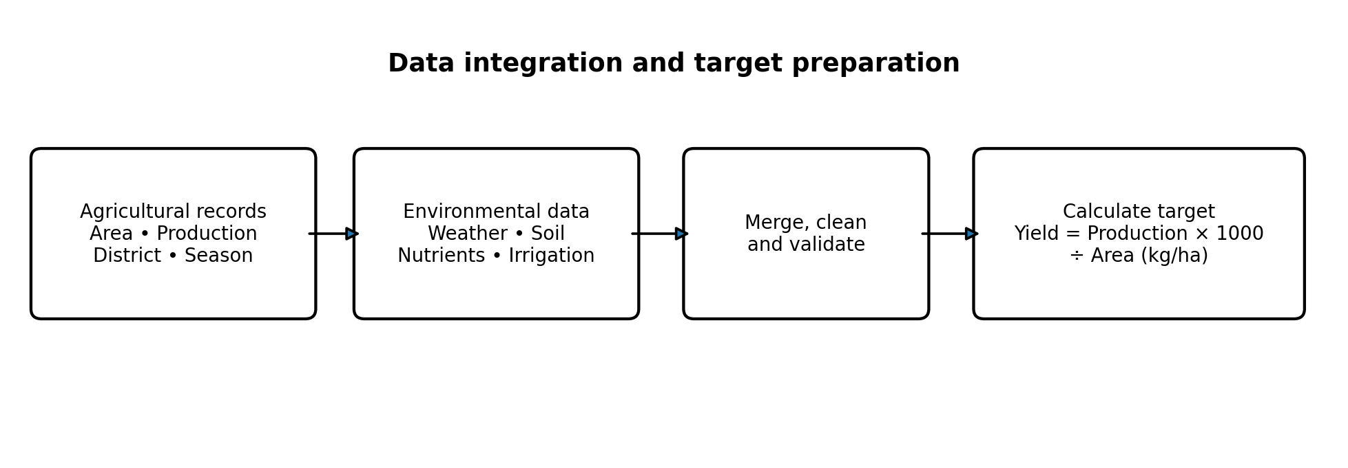
Figure 3.3: Integration of agricultural and environmental data and calculation of the target yield.

3.8 System Architecture / Block Diagram
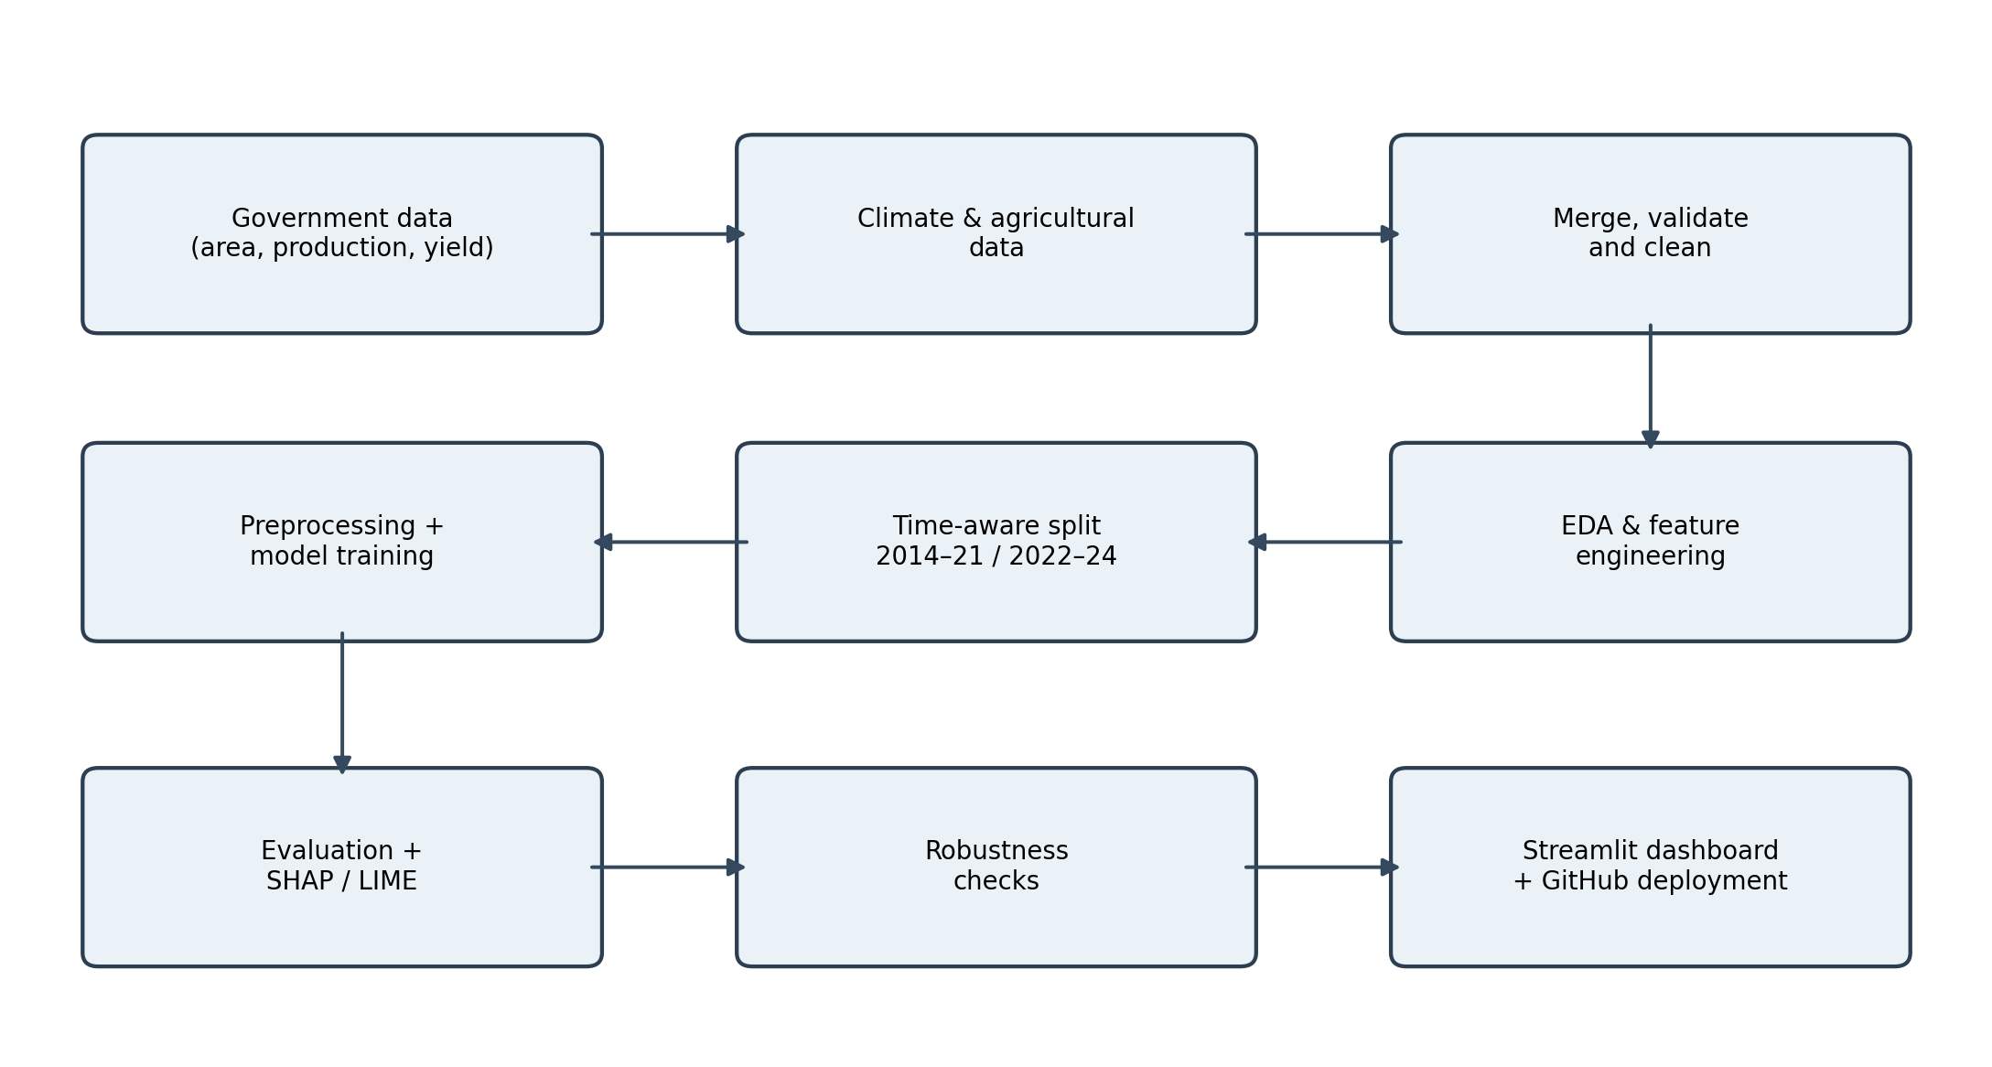
Figure 3.1: Overall workflow of the rice-yield prediction project.
The workflow begins with two data sources: district-level agricultural statistics and environmental/agricultural covariates. The data are merged and validated, followed by EDA and feature engineering. A chronological split separates model-development years from the final holdout. Preprocessing and model training are followed by evaluation, explainability, robustness checks, and dashboard deployment.
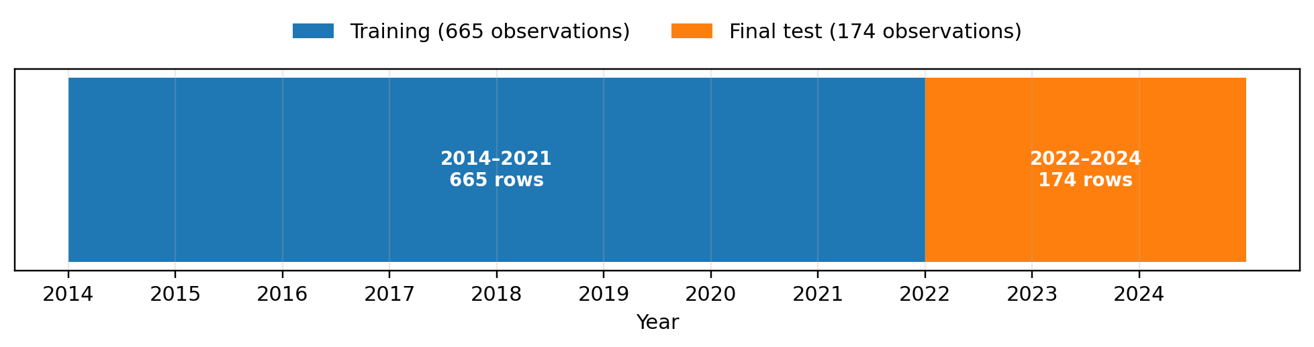
Figure 3.2: Chronological training and final test split.

Chapter 4
Implementation

4.1 Methodology

4.1.1 Data Integration and Target Preparation
Two district-, season-, and crop-wise sources were integrated using fiscal year, district LGD code, crop, and season. Only rice observations were retained and state-total aggregate rows were removed. The merge produced 869 matched district-level observations. After removing records with missing target values, 839 observations remained. The target yield_kg_ha was computed as production (tonnes) multiplied by 1000 and divided by area (hectares), avoiding inconsistent unit reporting in the raw yield field.
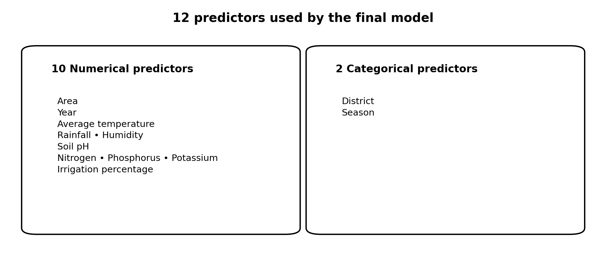
Figure 4.1: The 12 model predictors grouped by data type.

4.1.2 Feature Set and Preprocessing
The 12 predictors consist of ten numerical variables—area, year, average temperature, rainfall, humidity, soil pH, nitrogen, phosphorus, potassium, and irrigation percentage—and two categorical variables: district and season. Target-derived or redundant fields, including the target itself, production, reported_crop_yield, district_lgd_code, district_source, and fiscal_year, are excluded. Numerical inputs are standardized and categorical inputs are one-hot encoded. The transformed feature space contains 43 features.
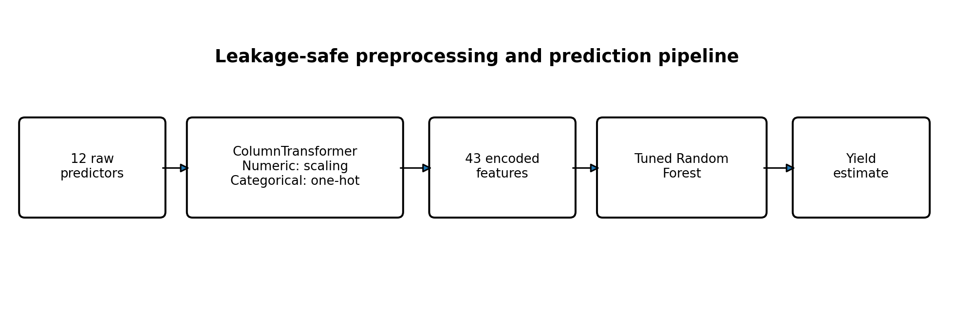
Figure 4.2: Leakage-safe preprocessing and prediction pipeline used by the final model.

4.1.3 Chronological Model Development
The dataset is split by year: 2014–2021 (665 observations) for training and model selection, and 2022–2024 (174 observations) for final testing. Five year-aware forward validation folds are used within the training period. RandomizedSearchCV is applied to Random Forest and Gradient Boosting using only the training period. The final holdout is kept separate from tuning and model selection.

4.1.4 Candidate Models
Four regression algorithms are compared: Linear Regression, Decision Tree Regressor, Random Forest Regressor, and Gradient Boosting Regressor. The tuned Random Forest is selected based on the lowest mean time-aware cross-validation RMSE.

4.1.5 Explainability and Robustness
The Tree-Path-Dependent SHAP formulation is used as the primary SHAP method. Global rankings are compared between training and test data and between grouped original inputs and encoded features. LIME is used for four representative test observations, with quartile discretization, 5,000 perturbation samples, 12 displayed features, and random_state=42. Sensitivity checks vary the LIME seed, sample count, and kernel width. SHAP/LIME directional agreement is calculated only across eligible feature comparisons.

4.1.6 Dashboard Development
A Streamlit application is implemented with five views: Overview, District Analysis, Yield Prediction, Model Explainability, and Model Performance. It loads the serialized preprocessing-and-model pipeline from the project artifacts and uses that fitted pipeline for inference. The dashboard does not retrain the estimator on application launch. The project source and documentation are available at https://github.com/kalpana-sketch/Rice_Yield_Prediction and the deployed dashboard is available at https://riceyieldprediction-wgowxbc5trijckm4fai95q.streamlit.app/.

4.2 Testing / Verification Plan
Verification focuses on data integrity, chronological separation, preprocessing behaviour, prediction consistency, explanation calculations, and dashboard availability. The following table summarizes checks documented during the project. Tests that depend on the live deployment should be repeated before final submission.
Test ID | Test case | Condition / action | Expected or verified outcome
T01 | Dataset size | Check cleaned modelling dataset | 839 observations retained after target cleaning
T02 | Chronological split | Separate by year | 665 training rows (2014–2021); 174 test rows (2022–2024)
T03 | Feature leakage | Inspect selected predictors | Target and listed redundant/target-derived fields excluded
T04 | Unknown category | Pass unseen Kharif season through encoder | Pipeline runs due to handle_unknown='ignore'; no learned Kharif-specific signal
T05 | Saved pipeline | Load final_model_rf.joblib for inference | Dashboard uses saved pipeline; no retraining on app launch
T06 | SHAP additivity | Compare SHAP decomposition with model output | Maximum gaps: 7.28e-12 train and 4.55e-12 test
T07 | SHAP ranking stability | Compare train/test top-five features | 5/5 overlap; Spearman rank correlation 0.9161
T08 | SHAP/LIME robustness | Run predefined Phase 4 checks | 10 out of 10 verification checks passed
T09 | LIME wrapper | Compare wrapper predictions with final pipeline | Exact prediction match on train and test
T10 | Dashboard views | Inspect application sections | Five views implemented: Overview, District Analysis, Yield Prediction, Model Explainability, Model Performance

4.3 Result Analysis
Model / metric | Reported result
Selected model | Tuned Random Forest Regressor
Selection CV RMSE | 639.40 kg/ha
Test RMSE | 541.77 kg/ha
Test MAE | 435.91 kg/ha
Test R² | 0.4165

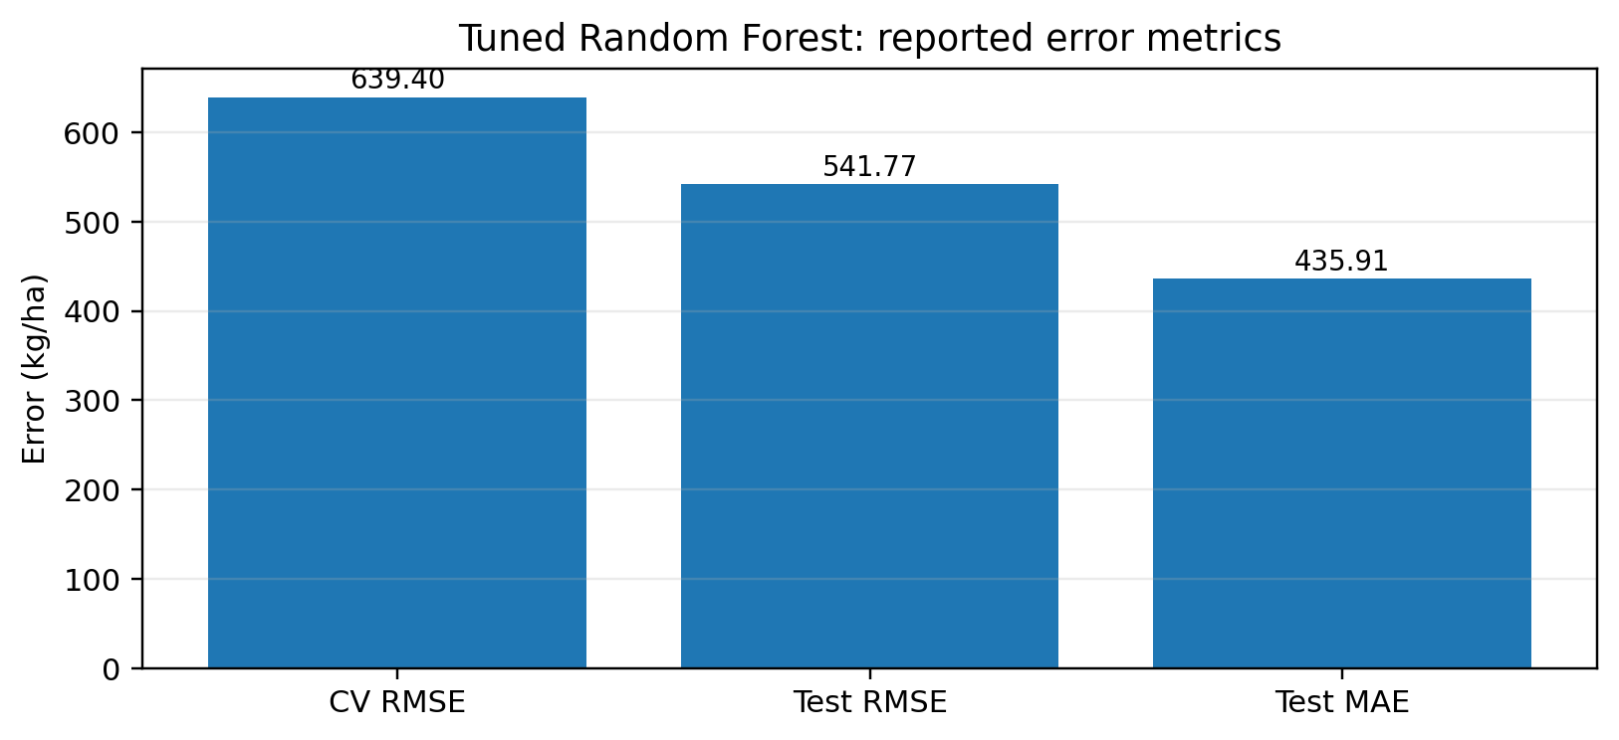
Figure 4.3: Reported cross-validation and test error metrics for the selected Random Forest.
The final model obtains a test RMSE of 541.77 kg/ha and a test MAE of 435.91 kg/ha. The test R² of 0.4165 indicates that a substantial share of the variation in the holdout remains unexplained. These results should be interpreted in the context of the relatively small dataset and strict future-year evaluation protocol.
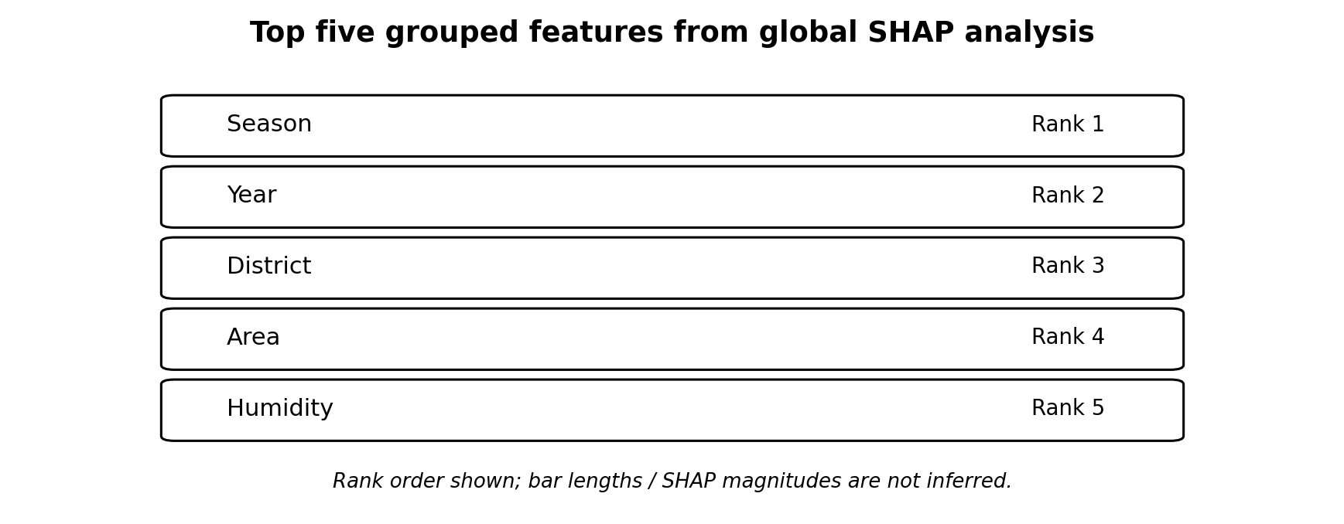
Figure 4.4: Global SHAP top-five feature ranking; rank order is shown without implying numerical magnitude.

4.3.1 SHAP Results
The primary Tree-Path-Dependent SHAP expected value is 2177.2042. SHAP arrays have dimensions 665 × 43 for training and 174 × 43 for testing. The maximum additivity gaps are approximately 7.28 × 10⁻¹² for training and 4.55 × 10⁻¹² for testing. The leading grouped features are season, year, district, area, and humidity. The train/test top-five overlap is 5/5 and the Spearman rank correlation is 0.9161. Grouped-input and encoded-feature rankings also have a 5/5 top-five overlap and a rank correlation of approximately 0.993. Interventional SHAP was not selected as the primary method because its additivity gap was materially larger.
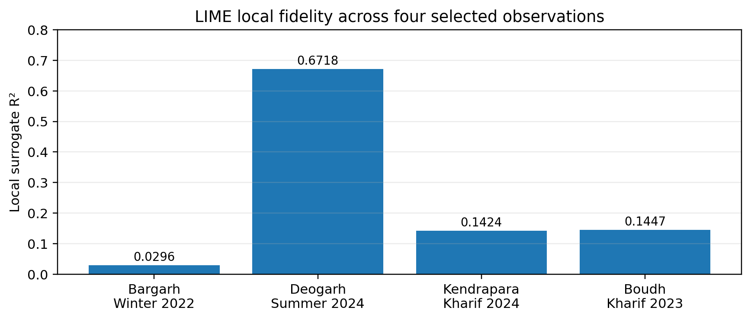
Figure 4.5: LIME local surrogate R² for the four selected test observations.

4.3.2 LIME and Robustness Results
Four representative observations were explained using LIME: Bargarh Winter 2022 (underprediction; local R² 0.0296), Deogarh Summer 2024 (overprediction; local R² 0.6718), Kendrapara Kharif 2024 (local R² 0.1424), and Boudh Kharif 2023 (local R² 0.1447). The variation in local R² shows that surrogate fidelity differs by case and can be weak. SHAP/LIME feature-direction agreement was 82.6% across 46 eligible comparisons. Top-five feature overlap for the four local cases ranged from 2/5 to 4/5. Therefore, the global SHAP ranking is more stable than every individual local explanation.

4.3.3 Dashboard Output
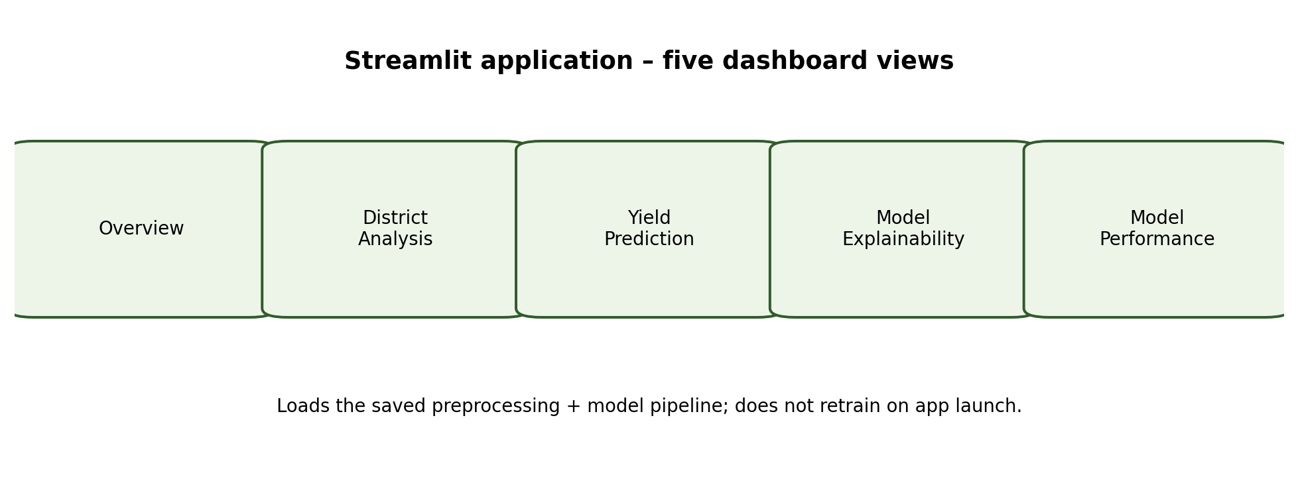
Figure 4.6: Five sections of the deployed Streamlit dashboard.
The dashboard provides a user-facing interface for exploring project information, district patterns, model predictions, explanation outputs, and evaluation metrics. The dashboard is an implementation and dissemination component; it does not increase the predictive performance of the trained model. Actual screenshots from the deployed application may be inserted in this section before final submission.

4.4 Quality Assurance
Quality assurance is addressed through a leakage-safe scikit-learn Pipeline, chronological holdout separation, training-only hyperparameter tuning, consistent saved-artifact inference, SHAP additivity checks, comparison of feature rankings, LIME wrapper equivalence checks, and Phase 4 robustness verification. Ten out of ten predefined Phase 4 verification checks passed. The project also records the unseen Kharif category and the moderate test R² as limitations rather than hiding them.
The project is a research and academic prototype. It has not been established as a production-grade agricultural advisory system, and predictions should not be used as the sole basis for operational farming or policy decisions.

Chapter 5
Standards Adopted

5.1 Design Standards
The project follows a modular machine-learning workflow: data ingestion, validation, preprocessing, training, evaluation, explainability, and deployment are separated into understandable stages. The chronological split is documented explicitly. The scikit-learn Pipeline and ColumnTransformer are used to keep preprocessing attached to the estimator and to reduce leakage risk. Figures and tables are numbered and titled consistently in this report.

5.2 Coding Standards
- Use descriptive variable, function, and file names.
- Keep data preparation, model training, evaluation, explainability, and dashboard code logically separated.
- Use consistent indentation and formatting.
- Avoid unnecessary duplication by reusing the saved preprocessing-and-model pipeline.
- Set random seeds where reproducibility is required.
- Keep credentials and secret API keys out of public source control.
- Document assumptions, input fields, output metrics, and known limitations.

5.3 Testing Standards
Testing is organized around explicit verification criteria and reproducibility. The project uses chronological validation rather than random splitting for the forecasting task. Model selection is performed using training-period cross-validation, and the final holdout is reserved for final evaluation. Numerical checks are used for SHAP additivity and LIME wrapper equivalence. No formal ISO/IEC or IEEE certification is claimed for this academic project.

5.4 Cost Analysis
The implementation primarily uses open-source software and public data. Python, pandas, NumPy, scikit-learn, SHAP, LIME, joblib, and Streamlit are available without a paid software licence for the usage described. GitHub provides repository hosting, and Streamlit Community Cloud was used for dashboard deployment. No dedicated paid cloud infrastructure or specialized hardware cost has been reported. Internet access and personal computing resources are assumed to be available; any institution-specific or optional service charges should be added by the team if applicable.
Component | Tool / service | Cost basis
Programming | Python and open-source libraries | No licence cost reported
Data processing | pandas, NumPy, scikit-learn | Open source
Explainability | SHAP and LIME | Open source
Version control | Git and GitHub | Public repository; no paid plan cost reported
Dashboard | Streamlit Community Cloud | Deployed using available community tier
Hardware | Personal computer | Existing resource; cost not separately measured

Chapter 6
Conclusion and Future Scope

6.1 Conclusion
This project developed a district-level rice-yield prediction workflow for Odisha using integrated agricultural, climate, soil, nutrient, and irrigation data from 2014–2024. After cleaning, 839 observations across 30 districts were retained. A strict chronological split used 665 observations from 2014–2021 for model development and 174 observations from 2022–2024 for final testing. Four regression models were compared through leakage-safe preprocessing and year-aware forward cross-validation.
The tuned Random Forest Regressor was selected with a mean selection CV RMSE of 639.40 kg/ha and achieved a test RMSE of 541.77 kg/ha, MAE of 435.91 kg/ha, and R² of 0.4165. SHAP analysis showed consistent global feature rankings across the training and test partitions, while LIME results varied in local fidelity. Robustness checks recorded 82.6% SHAP/LIME directional agreement across 46 eligible comparisons and passed 10 of 10 predefined verification checks.
A Streamlit dashboard was implemented and deployed with five sections and uses the saved model pipeline for inference. The project documents important limitations, particularly the unseen Kharif season label in the test period, limited sample size, district-level aggregation, and moderate explanatory power. The model should therefore be treated as an academic research prototype.

6.2 Future Scope
- Extend the temporal range beyond 2024 and include more historical observations where reliable records are available.
- Resolve season-label drift through agronomically validated mapping or a date-based representation of growing seasons.
- Use finer spatial data, such as block- or farm-level observations, where available.
- Add crop variety, sowing and harvest dates, pest and disease incidence, and richer soil characteristics.
- Conduct external validation on independently collected datasets and additional future years.
- Improve the dashboard with validated data sources, clearer uncertainty communication, and feedback from intended users.

REFERENCES
[1] A. Badshah, B. Y. Alkazemi, F. Din, K. Z. Zamli, and M. Haris, “Crop Classification and Yield Prediction Using Robust Machine Learning Models for Agricultural Sustainability,” IEEE Access, vol. 12, pp. 162799–162813, 2024, doi: 10.1109/ACCESS.2024.3486653.
[2] D. De Clercq and A. Mahdi, “Feasibility of machine learning-based rice yield prediction in India at the district level using climate reanalysis data,” arXiv preprint, Mar. 2024.
[3] K. K. Paidipati, C. Chesneau, B. M. Nayana, K. R. Kumar, K. Polisetty, and C. Kurangi, “Prediction of Rice Cultivation in India—Support Vector Regression Approach with Various Kernels for Non-Linear Patterns,” AgriEngineering, vol. 3, no. 2, pp. 182–198, 2021, doi: 10.3390/agriengineering3020012.
[4] S. Sahoo, C. Singha, and A. Govind, “Advanced prediction of rice yield gaps under climate uncertainty using machine learning techniques in Eastern India,” 2024.
[5] S. Sah, D. Haldar, R. N. Singh, B. Das, and A. S. Nain, “Rice yield prediction through integration of biophysical parameters with SAR and optical remote sensing data using machine learning models,” Scientific Reports, vol. 14, no. 1, Art. no. 21674, Sep. 2024.
[6] K. Pal, Ridhima, Mayank, Naman, Mihir, and Shauryan, “Odisha Rice Yield Prediction,” GitHub repository, 2026. [Online]. Available: https://github.com/kalpana-sketch/Rice_Yield_Prediction.
[7] F. Pedregosa et al., “Scikit-learn: Machine Learning in Python,” Journal of Machine Learning Research, vol. 12, pp. 2825–2830, 2011.

INDIVIDUAL CONTRIBUTION REPORT
DISTRICT-LEVEL RICE YIELD PREDICTION IN ODISHA

Abstract: This project develops a time-aware machine-learning regression workflow to predict district-level rice yield in Odisha using historical agricultural, climate, soil, nutrient, and irrigation data. It compares regression models, evaluates the selected model on future years, studies model explanations, and provides a deployed Streamlit dashboard.

Roll Number: Kalpana Pal (23052398)

- Coordinated the end-to-end project workflow and maintained alignment between the modelling work, explainability analysis, dashboard, and final documentation.
- Worked on the integrated machine-learning pipeline, including chronological model development and use of the saved preprocessing-and-model artifact.
- Led or coordinated the Streamlit dashboard integration and deployment, including the Overview, District Analysis, Yield Prediction, Model Explainability, and Model Performance views.
- Contributed to interpreting the final metrics and preparing the research paper and project report.
contribution allocation : Project coordination, dataset integration oversight, model pipeline implementation, and dashboard integration.

Roll Number: Ridhima (23052415)

- Reviewed the agricultural and environmental datasets and helped understand their fields, units, keys, and coverage.
- Contributed to data validation and exploratory analysis of year-wise, district-wise, and season-wise patterns.
- Helped document the dataset characteristics, missing-value handling, target calculation, and the season-label distribution issue.
- Contributed to writing the dataset, EDA, and data-quality portions of the project documentation.
contribution allocation : Dataset understanding, data cleaning, exploratory data analysis, and data-quality documentation.

Roll Number: Mayank Singh (23052401)

- Contributed to defining the numerical and categorical predictor set and identifying target-derived or redundant fields that should be excluded.
- Worked on preprocessing choices, including numerical standardization and categorical one-hot encoding in a leakage-safe pipeline.
- Contributed to the comparison of Linear Regression, Decision Tree, Random Forest, and Gradient Boosting models.
- Helped document the feature engineering and model-preparation methodology.
contribution allocation : Feature engineering, preprocessing design, and regression model experimentation.

Roll Number: Naman Kumar (23053221)

- Contributed to the chronological training and final-test split and the year-aware forward validation strategy.
- Worked on model-selection logic and training-period hyperparameter tuning while keeping the final test period separate.
- Helped analyse RMSE, MAE, and R-squared results and compare training/validation behaviour.
- Contributed to documenting the evaluation protocol, performance table, and interpretation of model results.
contribution allocation : Time-aware validation, hyperparameter tuning, and model-performance evaluation.

Roll Number: Mihir Sinha (23052977)

- Contributed to applying SHAP to the fitted tree-based model and examining feature contributions in the transformed feature space.
- Helped compare global feature rankings across the training and chronological test partitions.
- Contributed to grouping encoded feature contributions back to original input variables and checking explanation additivity.
- Helped document the global explainability findings and the distinction between model reliance and causal effects.
contribution allocation : Explainable-AI analysis using SHAP and global feature interpretation.

Roll Number: Shauryan Pattnaik (23052426)

- Contributed to preparing representative local explanation cases using LIME and reviewing the local surrogate-fidelity results.
- Helped examine explanation sensitivity and SHAP/LIME directional agreement as part of the robustness checks.
- Contributed to verification of saved-model inference and dashboard functionality, and to recording known limitations.
- Helped prepare result summaries, figures, testing records, and final project documentation.
contribution allocation: LIME explanations, robustness verification, testing, and final documentation support.

PLAGIARISM REPORT


Dashboard Screenshot – Overview Page
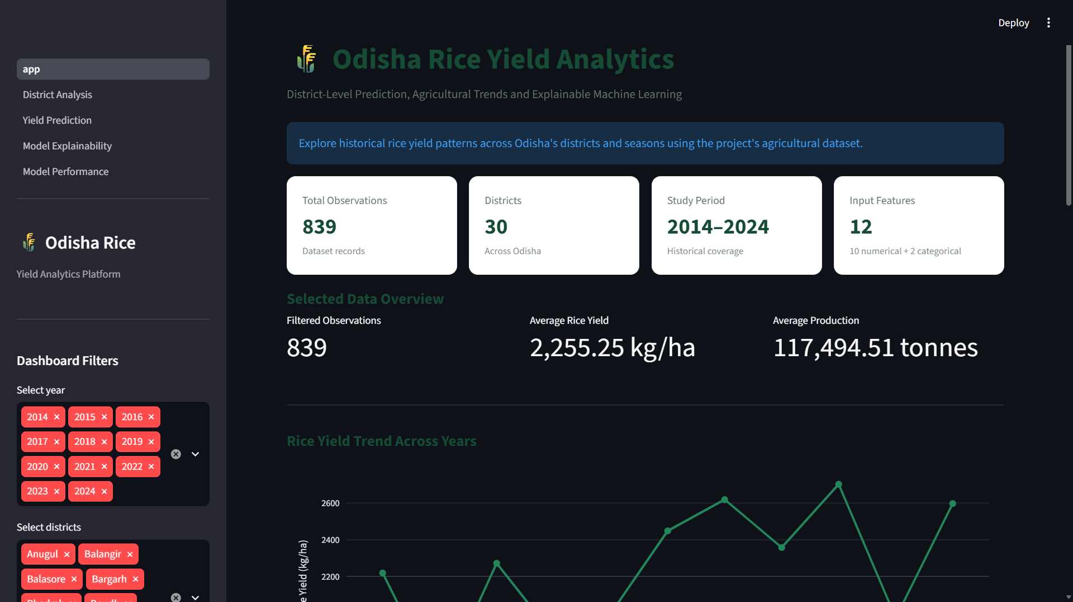
Figure 4.7: Screenshot of the deployed Odisha Rice Yield Analytics dashboard showing dataset summary, filters, average yield, and year-wise rice-yield trend.

