**Creating an RDS Instance in AWS**

This document provides a step-by-step guide to creating an RDS instance in AWS.

## Prerequisites

Before you begin, ensure that you have the following:

An AWS account with appropriate permissions to create RDS instances.

Access to the AWS Management Console.

## Steps

Open the AWS Management Console and navigate to the RDS service.

The prerequisite for rds creation is subnet group

1.Create subnet group

Goto rds service and goto subnet group and click on create db subnet group in the left side of the navigation pane

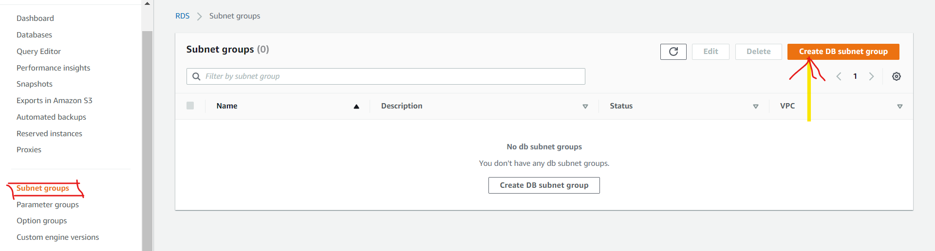

Give name for subnet group and select the custom vpc

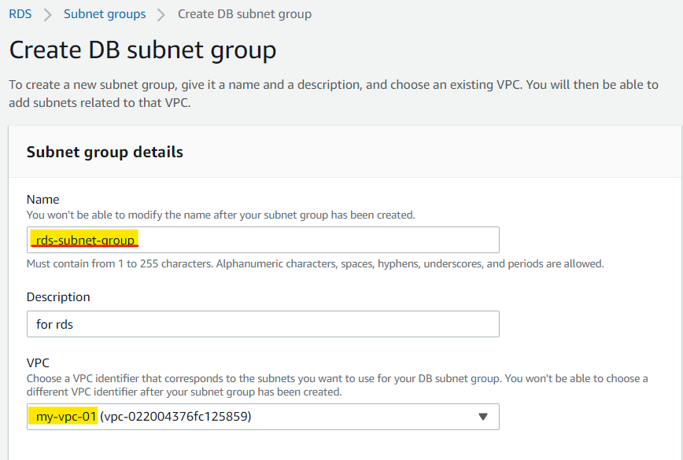

Select the az and data subnets and then click on create

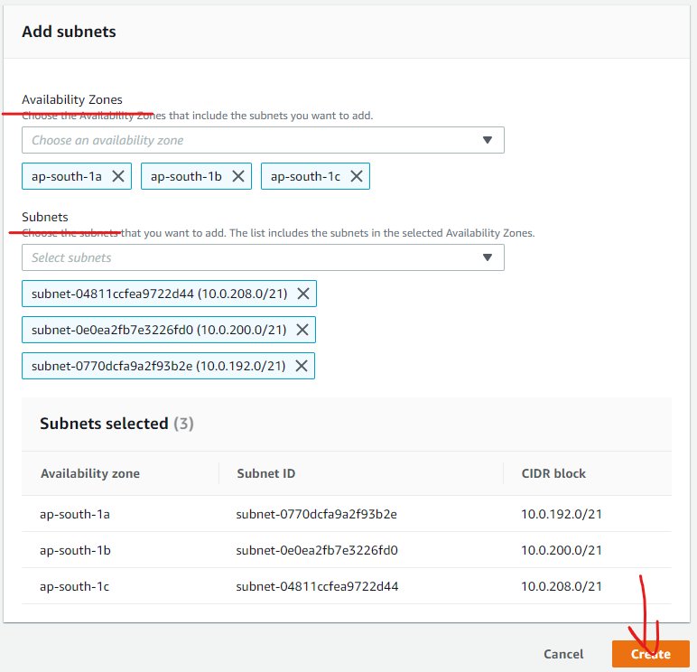

Click on "Create database" to start creating a new RDS instance.

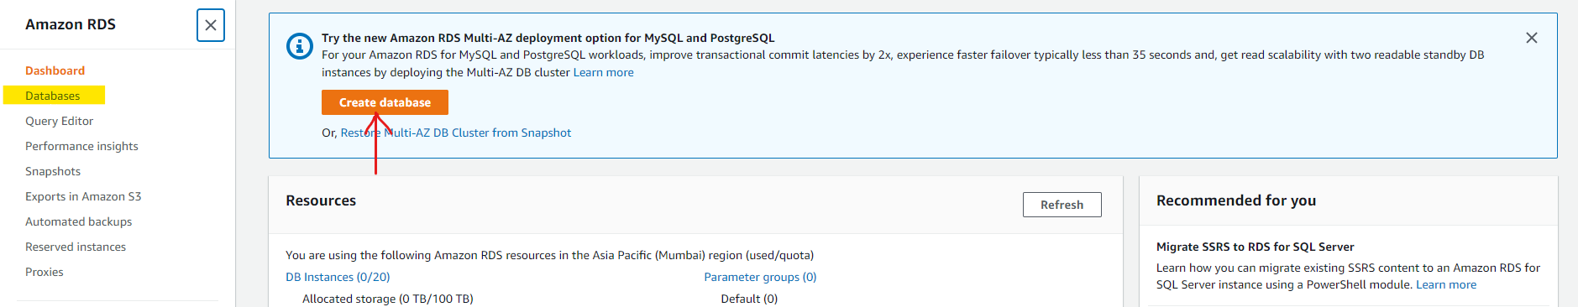

Choose the database creation method:

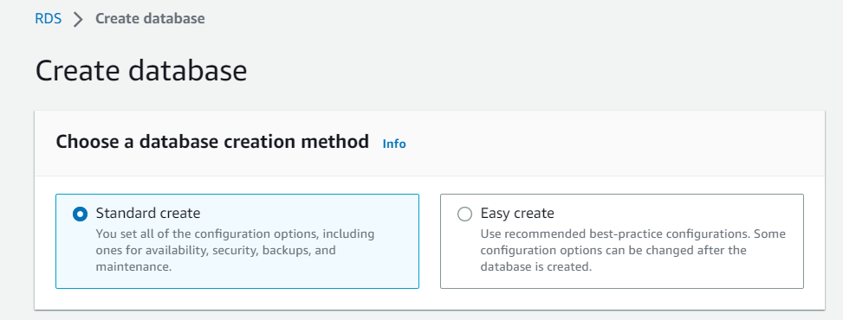

Standard Create: Provides options for commonly used database engines such as MySQL, PostgreSQL, Oracle, etc.

Easy Create: Offers simplified options for creating a database.

Select the appropriate method based on your requirements.

Select the database engine you want to use (e.g., MySQL, PostgreSQL, etc.) and the version.

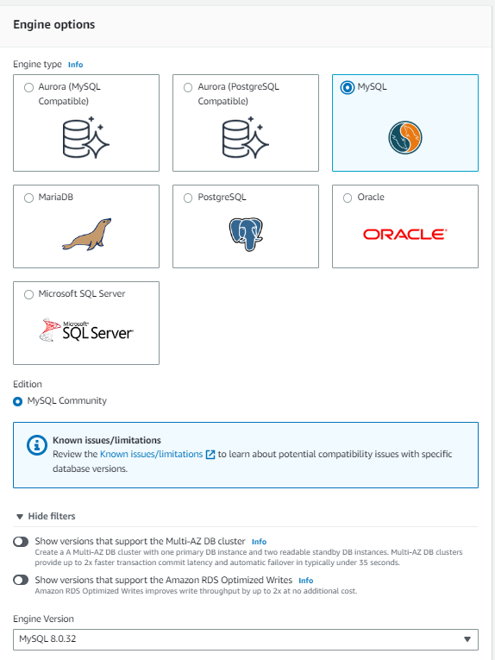

Choose the deployment type:

If you go with the Free tier ,, Availability and durability will disabled by default

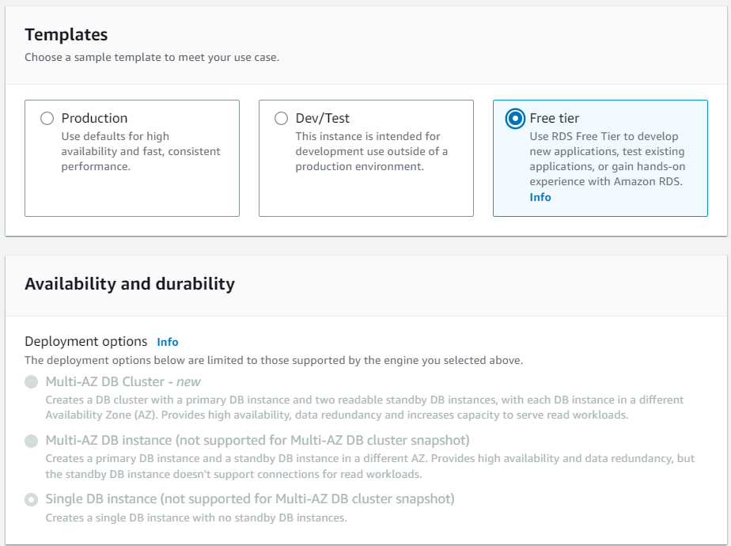

If you choose production or dev/stage it will allow you for to choose availability and durability

Standard: Provides a single Availability Zone (AZ) deployment.

Multi-AZ: Offers high availability with synchronous replication across multiple AZs.

Select the appropriate deployment type based on your availability and durability needs.

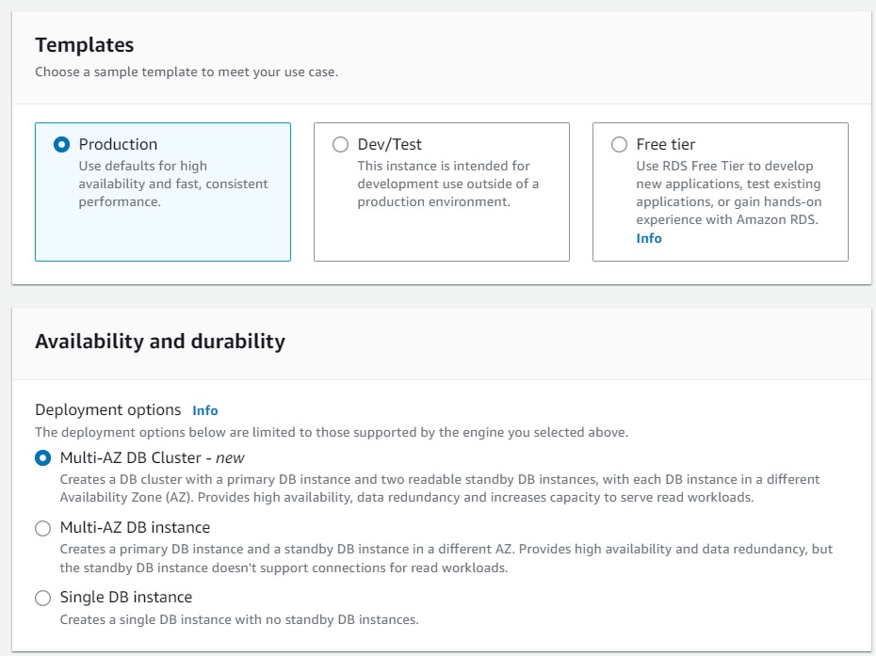

Configure the instance details:

DB instance identifier: Enter a unique name for your RDS instance.

Auto generate password will generates password and shows you after completion of rds creation

Master username: Set the username for the master database user.

Master password: Set a strong password for the master database user.

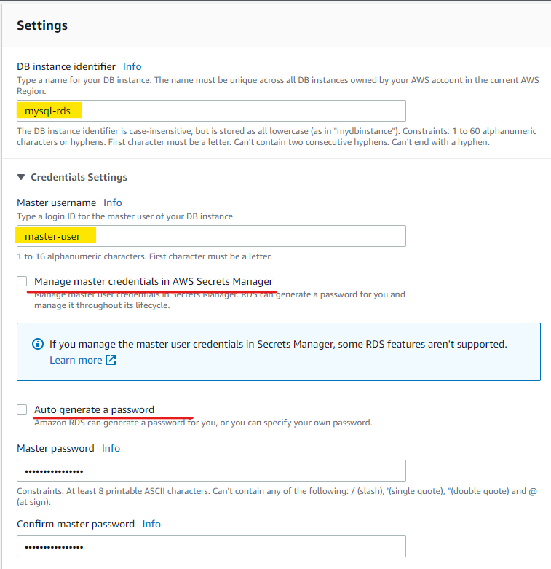

Specify the database size and performance options:

DB instance class: Choose the appropriate instance type based on your performance requirements and budget.

Allocated storage: Set the storage size for the database.

Adjust other settings such as storage type, storage autoscaling, etc., as per your needs.

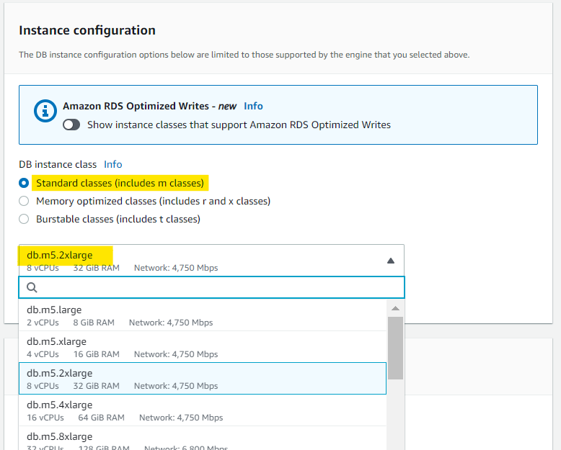

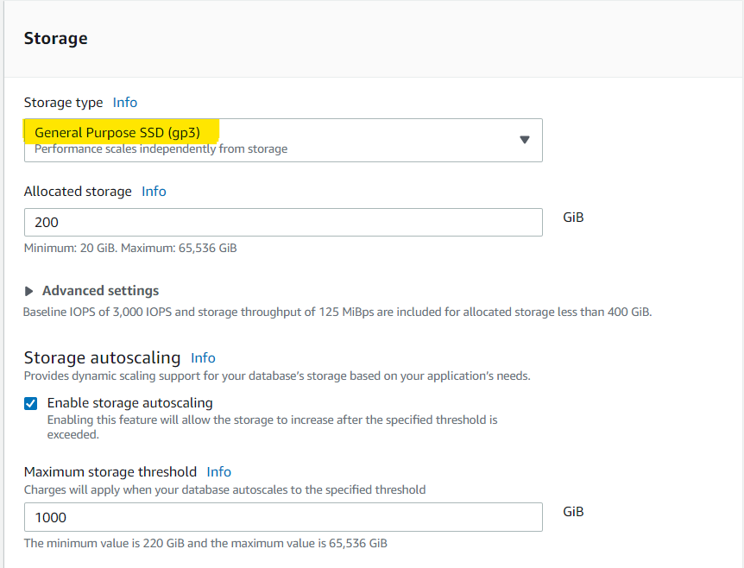

Configure the connectivity options:

Virtual Private Cloud (VPC): Select the VPC where the RDS instance will be deployed.

Subnet group: Choose the appropriate subnet group for the instance.

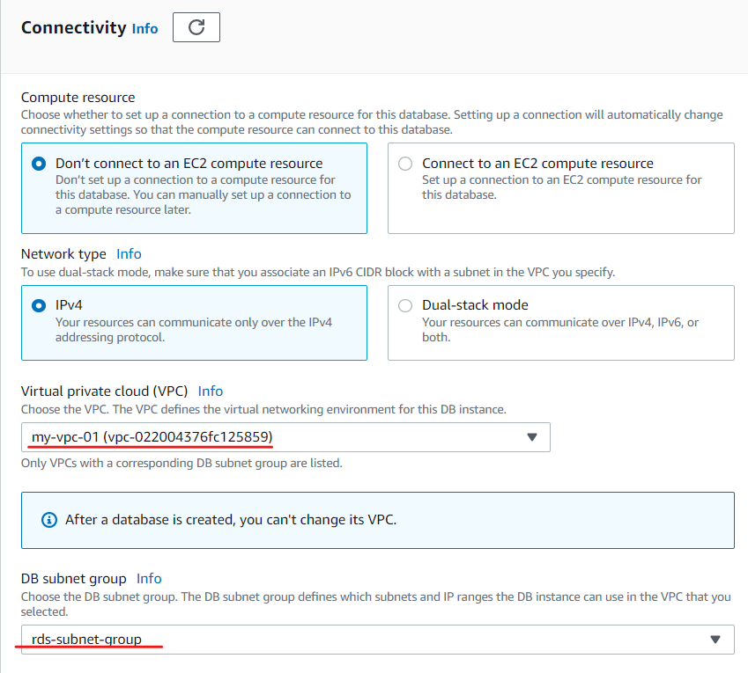

Public accessibility: Set whether the RDS instance should have a public IP address.

Adjust the remaining settings such as VPC security groups, database port, etc., according to your network requirements.

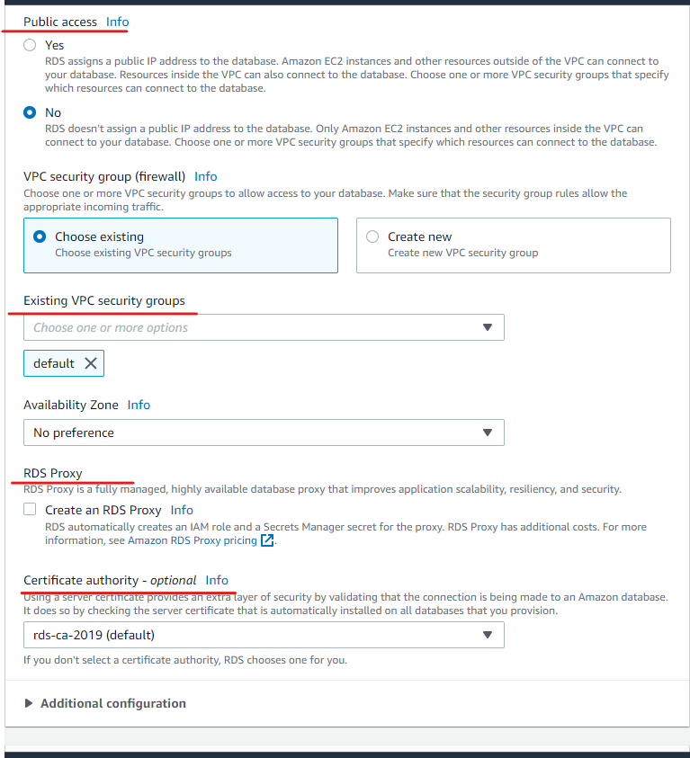

Set up the database authentication:

Database authentication: Choose the authentication method for your RDS instance (password-based or AWS Identity and Access Management (IAM)-based).

Configure other options such as encryption, advanced settings, etc., based on your security and compliance needs.

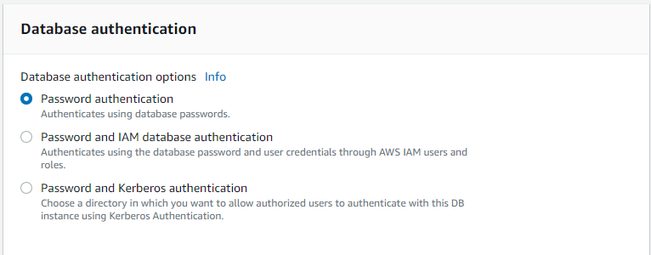

Monitoring ….in the retention period always go with the maximum one

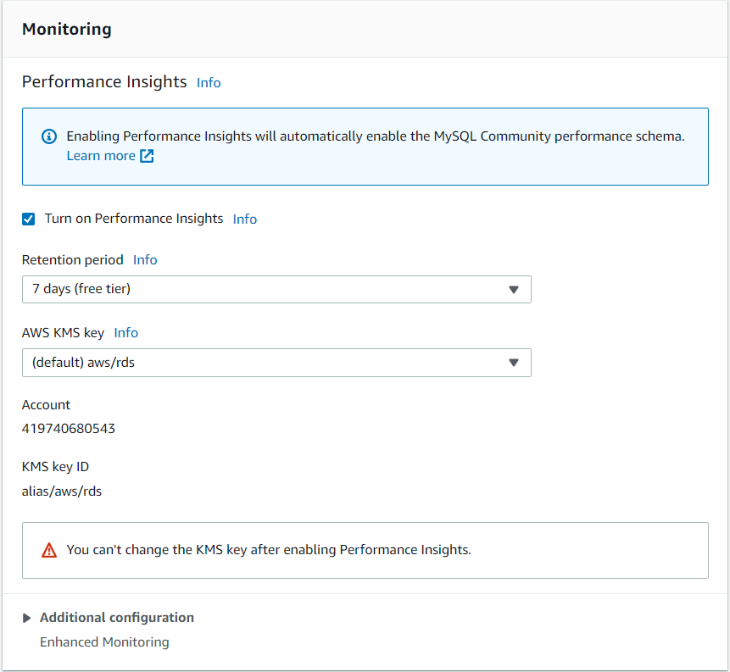

In the additional configuration give name for the database

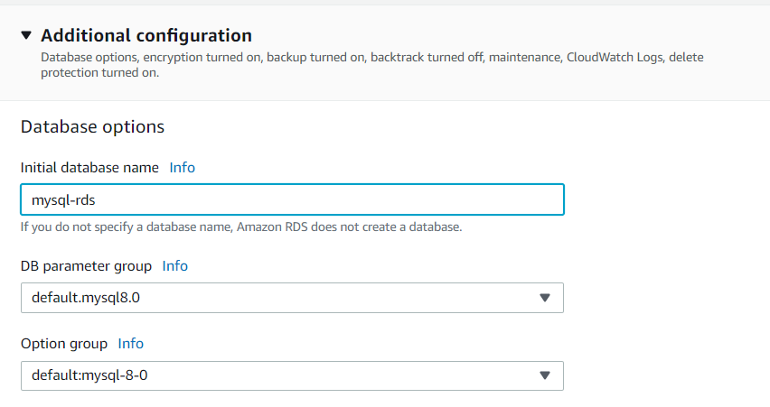

Backup settings set work off timings

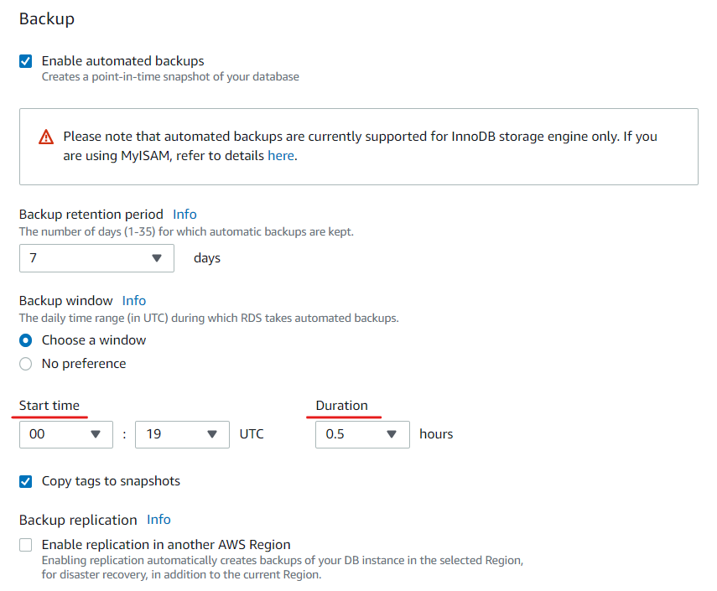

Encryption

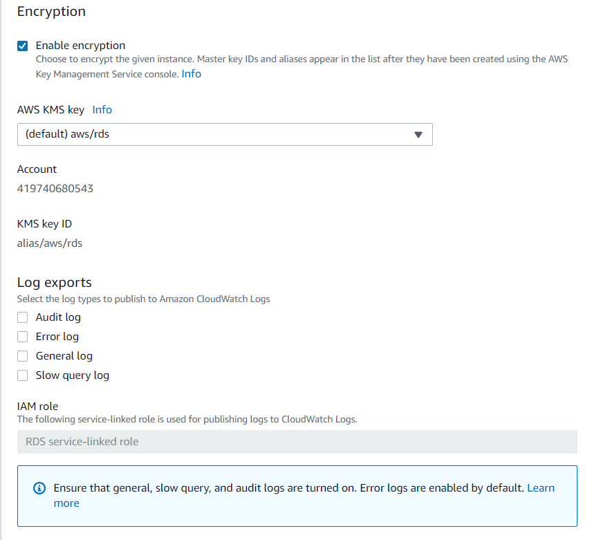

Set as default for practicing purpose not a problem

Review the configuration settings and click on "Create database" to start the creation process.

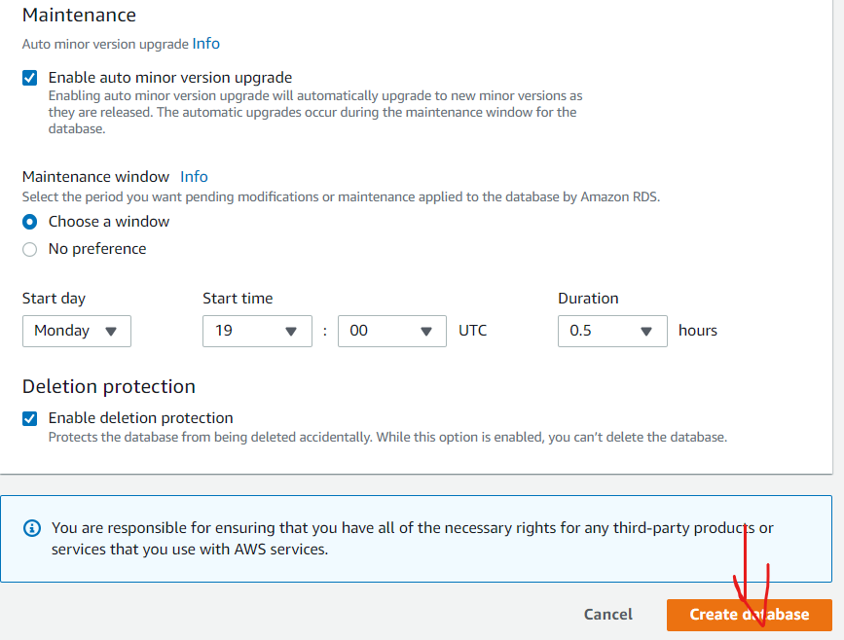

Wait for the RDS instance to be created. The process may take several minutes.

Once the RDS instance is created, you can access it using the endpoint provided in the AWS Management Console.