**AWS Secret Manager**

To create secrets in AWS Secrets Manager manually using the AWS Management Console, follow these steps:

**1.Open the AWS Management Console**: Go to the AWS Management Console (https://console.aws.amazon.com) and sign in to your AWS account.

Navigate to AWS Secrets Manager: Use the search bar at the top of the console or locate the "Security, Identity & Compliance" category and click on "Secrets Manager".

Click on "Store a new secret": On the Secrets Manager dashboard, click on the "Store a new secret" button.

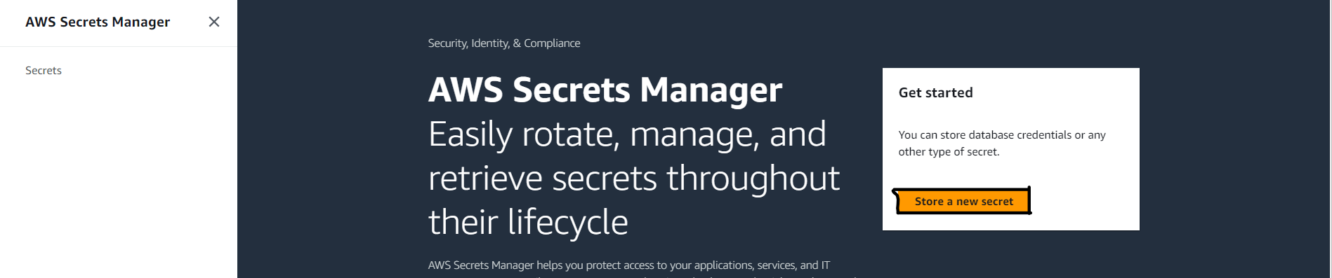

**2.Choose the type of secret:** Select the type of secret you want to create. You can choose between "Credentials for RDS database", "Credentials for Redshift database", "Credentials for DocumentDB database", "Credentials for MySQL database", "Other type of secrets (e.g., API key, SSH key)", and "Plaintext".

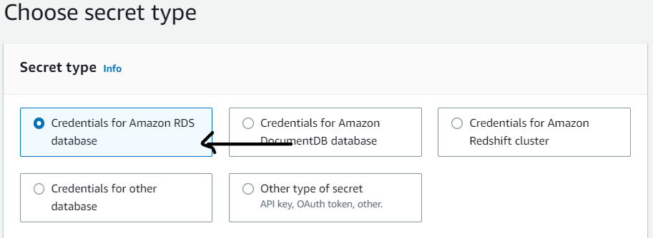

**3.Enter the secret details:** Fill in the necessary information based on the type of secret you selected. The required information may vary depending on the secret type. For example, if you choose "Plaintext", you will only need to enter the secret value. If you choose a database-specific secret, you will need to provide the connection details and credentials.

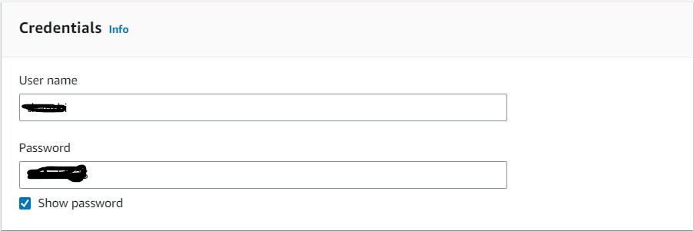

For database you have to choose database for which you want to store the credentials and then click on next

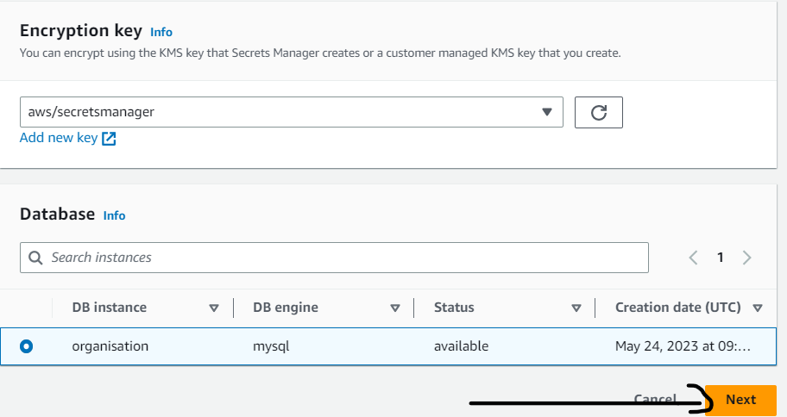

**4.Configure the secret:** Give the name for the secret and remaining all are optional and then click on next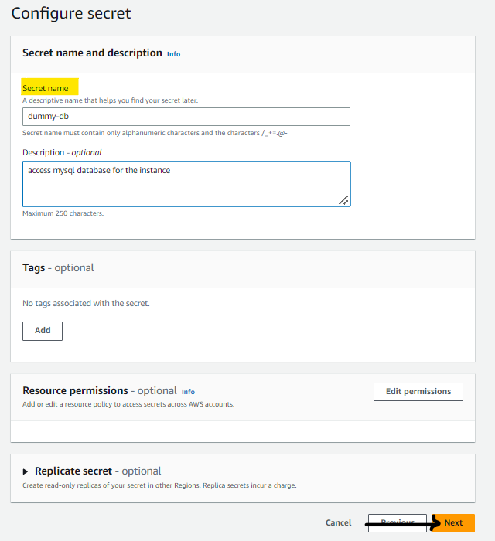

**5.Review and create the secret:** Verify the information you provided and click on the "Next" button. Review the settings once more on the next screen, and if everything is correct, click on the "Store" button to create the secret.

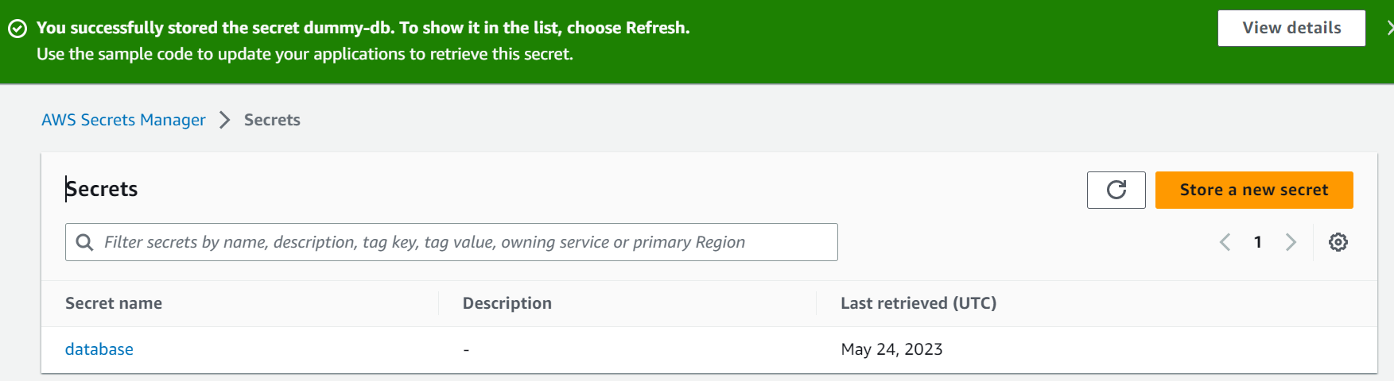

**6.Verify the secret creation:** Once the secret is created, you will be redirected to the secret details page. Here, you can view the secret ARN, version history, and other relevant information.

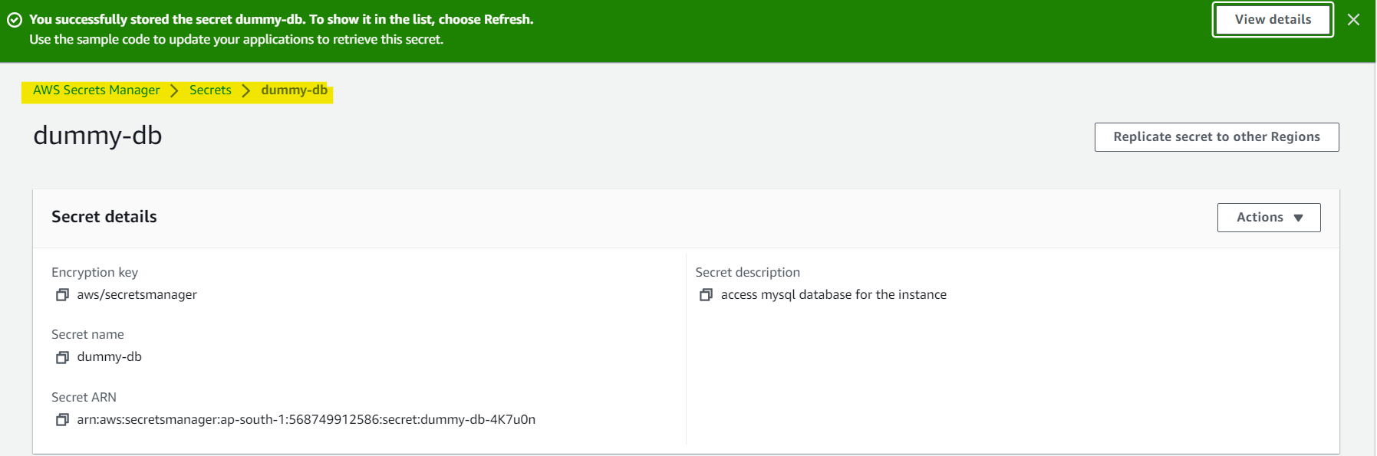

That's it! You have now manually created a secret in AWS Secrets Manager using the AWS Management Console. You can access and manage the secret from the console or retrieve its value programmatically using its ARN or alias and also it will give some programs to retrieve the data.