**OUTPUT**

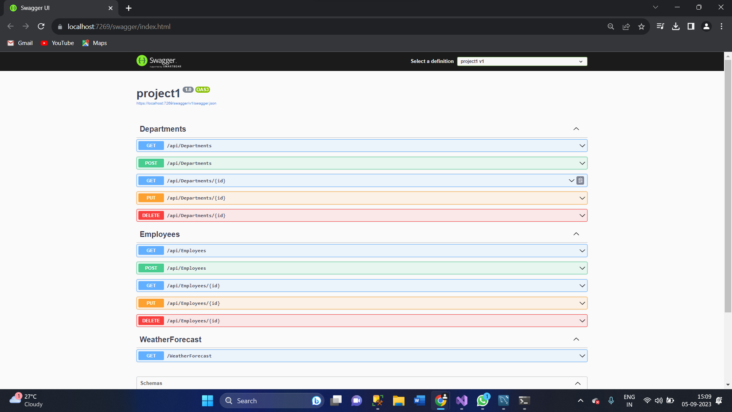

**POST-Operation 🡺 in Employees**

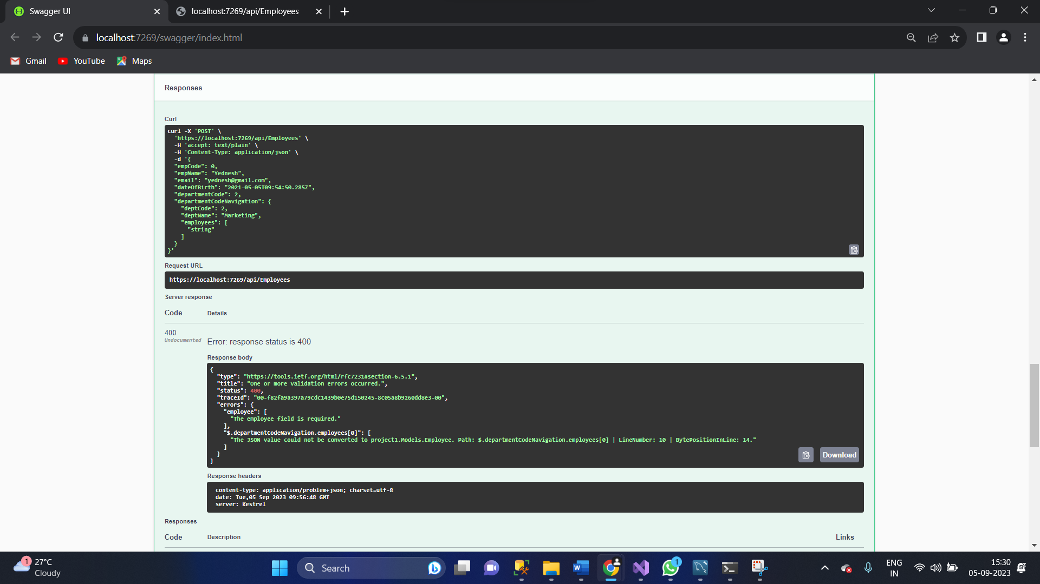

**GET_Operation 🡺 in Employees**

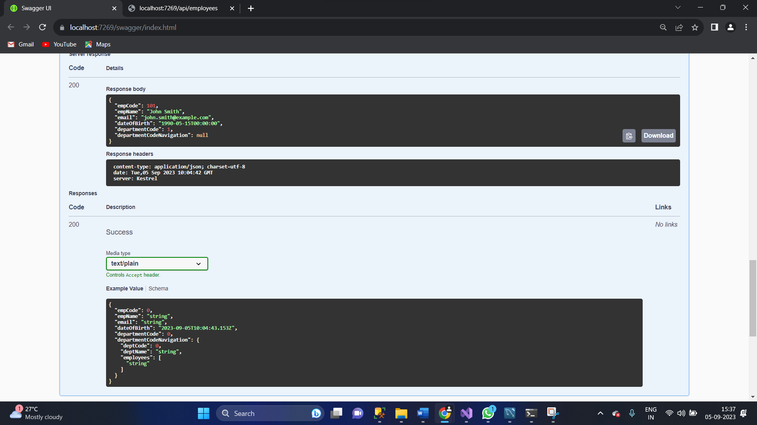

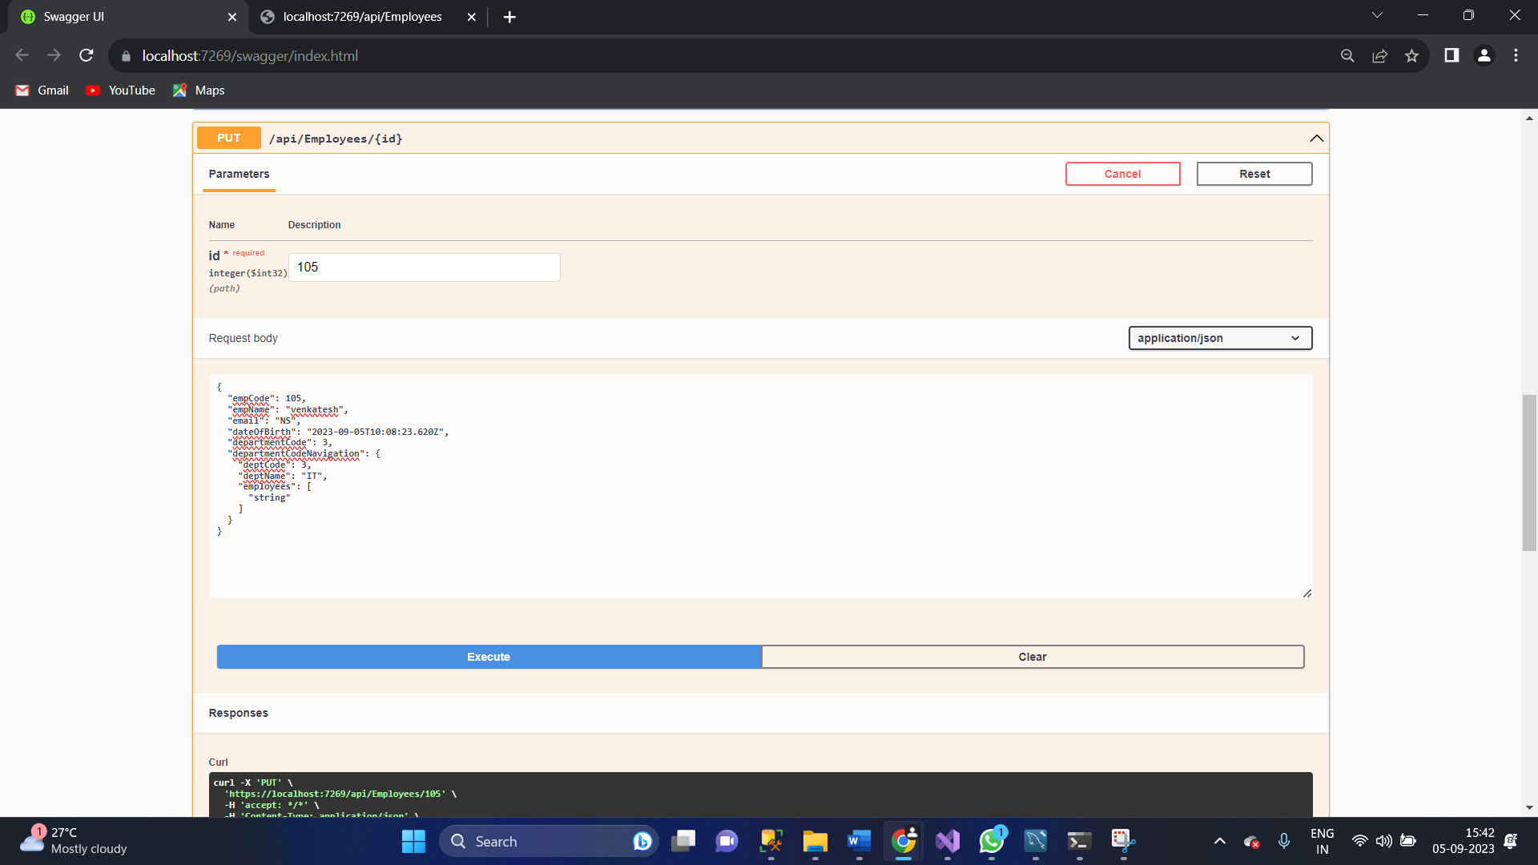**PUT-Operation 🡺 in Employees**

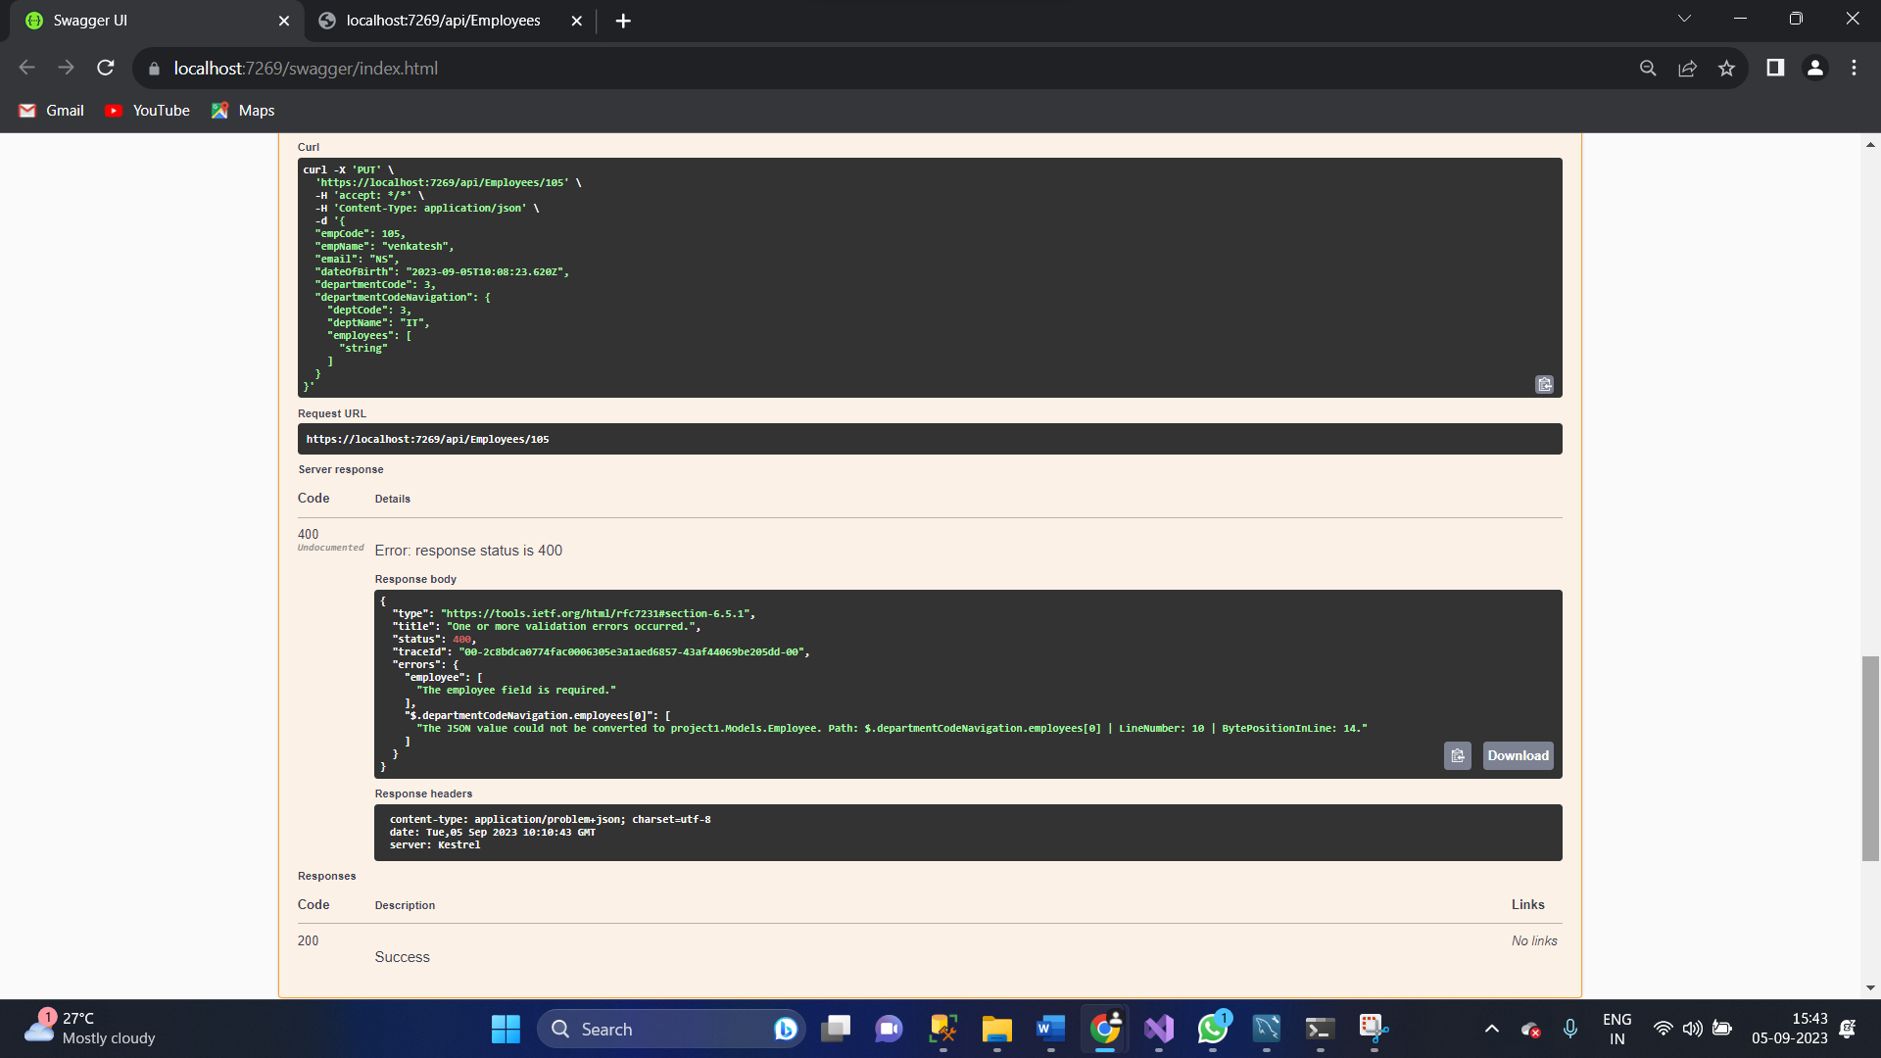

**DELETE-Operation**

**Overall Result**

