**BANK LOAN ANALYSIS**

SELECT * FROM financial_loan

1. TOTAL LOAN APPLICATIONS

SELECT COUNT(ID) FROM financial_loan

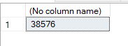

2.MTD TOTAL LOAN APPLICATIONS

SELECT COUNT(ID) AS MTD_TOTAL_LOAN_APPLICATIONS FROM financial_loan

WHERE MONTH(ISSUE_DATE) =12 AND YEAR(ISSUE_DATE)=2021

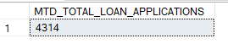

3.PMTD TOTAL LOAN APPLICATIONS

SELECT COUNT(ID) AS PMTD_TOTAL_LOAN_APPLICATIONS FROM financial_loan

WHERE MONTH(ISSUE_DATE) =11 AND YEAR(ISSUE_DATE)=2021



4. TOTAL FUNDED AMOUNT

SELECT SUM(LOAN_AMOUNT) AS TOAL_FUNDED_AMOUNT FROM financial_loan

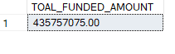

5. MTD_TOTAL FUNDED AMOUNT

SELECT SUM(LOAN_AMOUNT) AS MTD_TOAL_FUNDED_AMOUNT FROM financial_loan

WHERE MONTH(ISSUE_DATE) =12 AND YEAR(ISSUE_DATE)=2021

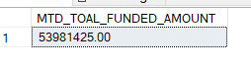

6. PMTD_TOTAL FUNDED AMOUNT

SELECT SUM(LOAN_AMOUNT) AS PMTD_TOAL_FUNDED_AMOUNT FROM financial_loan

WHERE MONTH(ISSUE_DATE) =11 AND YEAR(ISSUE_DATE)=2021



7.TOTAL AMOUNT RECEIVED

SELECT SUM(TOTAL_PAYMENT) AS TOTAL_AMOUNT_RECEIVED FROM financial_loan



---8.MTD TOTAL AMOUNT RECEIVED

SELECT SUM(TOTAL_PAYMENT) AS MTD_TOTAL_AMOUNT_RECEIVED FROM financial_loan

WHERE MONTH(ISSUE_DATE) =12 AND YEAR(ISSUE_DATE)=2021

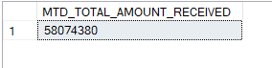

---9. AVG INTEREST RATE

SELECT ROUND(AVG(INT_RATE),4)*100 AS AVG_INTEREST_RATE FROM financial_loan

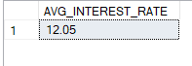

---10. AVG DTI

SELECT ROUND(AVG(DTI),4)*100 AS AVG_DTI FROM financial_loan



--- GOOD LOAN PERCENTAGE

SELECT(COUNT(CASE WHEN LOAN_STATUS = 'Fully Paid' OR LOAN_STATUS = 'Current' THEN ID END)*100)/

COUNT(ID) AS GOOD_LOAN_STATUS

FROM financial_loan

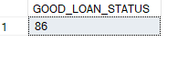

-- GOOD LOAN APPLICATIONS

SELECT COUNT(ID) AS GOOD_LOAN_APPLICATIONS FROM financial_loan

WHERE LOAN_STATUS = 'Fully Paid' OR LOAN_STATUS = 'CURRENT'

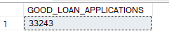

---GOOD LOAN FUNDED AMOUNT

SELECT SUM(loan_amount) AS GOOD_LOAN_FUNDED_AMOUNT FROM financial_loan

WHERE LOAN_STATUS = 'Fully Paid' OR LOAN_STATUS = 'CURRENT' 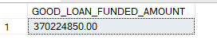

---GOOD LOAN TOTAL AMOUNT RECEIVED

SELECT SUM(total_payment) AS GOOD_LOAN_AMOUNT_RECEIVED FROM financial_loan

WHERE LOAN_STATUS = 'Fully Paid' OR LOAN_STATUS = 'CURRENT'

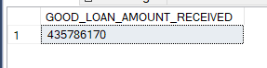

- BAD LOAN PERCENTAGE

SELECT(COUNT(CASE WHEN LOAN_STATUS = 'Charged Off' THEN ID END)*100)/

COUNT(ID) AS BAD_LOAN_PERCENTAGE

FROM financial_loan



-- BAD LOAN APPLICATIONS

SELECT COUNT(ID) AS BAD_LOAN_APPLICATIONS FROM financial_loan

WHERE LOAN_STATUS = 'Charged Off'

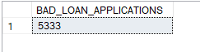

---BAD LOAN FUNDED AMOUNT

SELECT SUM(loan_amount) AS BAD_LOAN_FUNDED_AMOUNT FROM financial_loan

WHERE LOAN_STATUS = 'Charged Off'

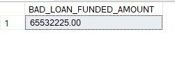

---BAD LOAN TOTAL AMOUNT RECEIVED

SELECT SUM(total_payment) AS BAD_LOAN_AMOUNT_RECEIVED FROM financial_loan

WHERE LOAN_STATUS = 'Charged Off'



---LOAN STATUS

SELECT

loan_status,

COUNT(id) AS TOTAL_LOAN_APPLICATIONS,

SUM(loan_amount) AS TOTAL_AMOUNT_RECEIVED,

SUM(TOTAL_PAYMENT) AS TOTAL_FUNDED_AMOUNT,

AVG(INT_RATE*100)AS INTEREST_RATE,

SUM(DTI*100) AS DTI

FROM financial_loan

GROUP BY LOAN_STATUS

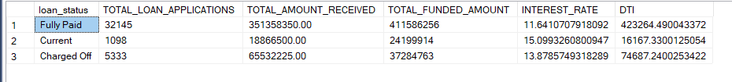

---MONTHLY TREND BY ISSUE_DATE

SELECT

MONTH(ISSUE_DATE) AS MONTH_NUMBER,

DATENAME(MONTH, ISSUE_DATE) AS MONTH_NAME,

COUNT(ID) AS TOTAL_LOAN_APPLICATIONS,

SUM(LOAN_AMOUNT) AS TOTAL_AMOUNT_RECEIVED,

SUM(TOTAL_PAYMENT) AS TOTAL_FUNDED_AMOUNT

FROM financial_loan

GROUP BY MONTH(ISSUE_DATE),DATENAME(MONTH, ISSUE_DATE)

ORDER BY MONTH(ISSUE_DATE)

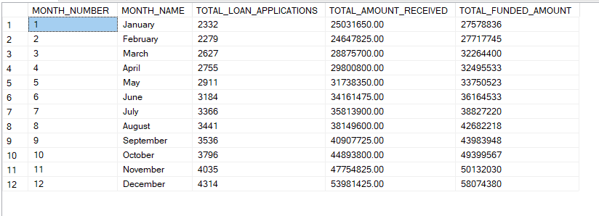

---REGIONAL ANALYSIS BY STATE

SELECT

ADDRESS_STATE,

COUNT(ID) AS TOTAL_LOAN_APPLICATIONS,

SUM(LOAN_AMOUNT) AS TOTAL_AMOUNT_RECEIVED,

SUM(TOTAL_PAYMENT) AS TOTAL_FUNDED_AMOUNT

FROM financial_loan

GROUP BY ADDRESS_STATE

ORDER BY COUNT(ID) DESC;

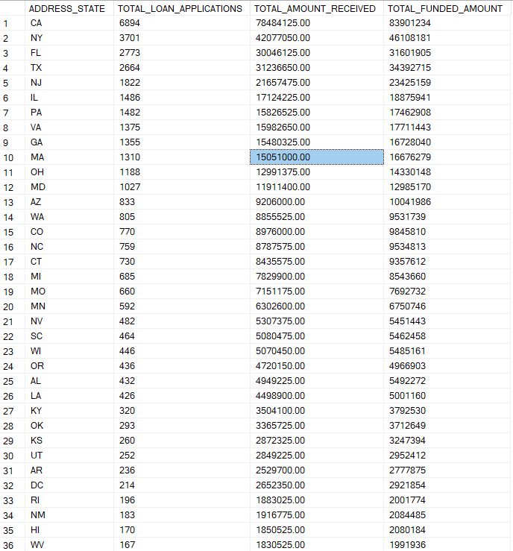

---LOAN TERM ANALYSIS

SELECT

TERM,

COUNT(ID) AS TOTAL_LOAN_APPLICATIONS,

SUM(LOAN_AMOUNT) AS TOTAL_AMOUNT_RECEIVED,

SUM(TOTAL_PAYMENT) AS TOTAL_FUNDED_AMOUNT

FROM financial_loan

GROUP BY TERM

ORDER BY TERM;

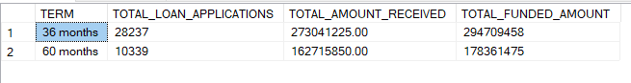

----EMP_LENGTH ANALYSIS

SELECT

emp_length,

COUNT(ID) AS TOTAL_LOAN_APPLICATIONS,

SUM(LOAN_AMOUNT) AS TOTAL_AMOUNT_RECEIVED,

SUM(TOTAL_PAYMENT) AS TOTAL_FUNDED_AMOUNT

FROM financial_loan

GROUP BY emp_length

ORDER BY emp_length;

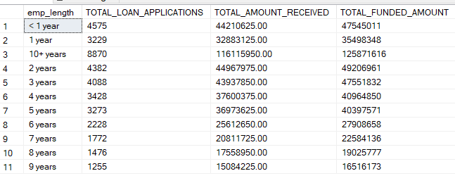

---LOAN PURPOSE BREAKDOWN

SELECT

Purpose,

COUNT(ID) AS TOTAL_LOAN_APPLICATIONS,

SUM(LOAN_AMOUNT) AS TOTAL_AMOUNT_RECEIVED,

SUM(TOTAL_PAYMENT) AS TOTAL_FUNDED_AMOUNT

FROM financial_loan

GROUP BY purpose

ORDER BY count(ID);

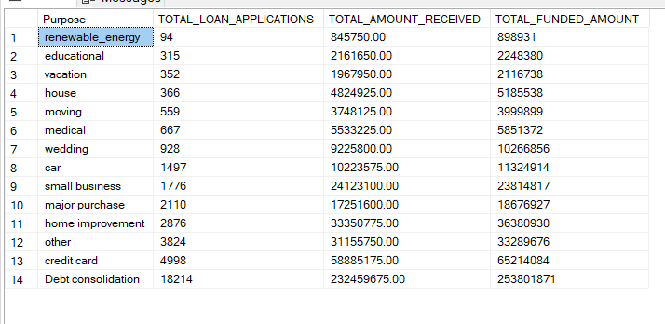

---HOME OWNERSHIP BREAKDOWN

SELECT

home_ownership,

COUNT(ID) AS TOTAL_LOAN_APPLICATIONS,

SUM(LOAN_AMOUNT) AS TOTAL_AMOUNT_RECEIVED,

SUM(TOTAL_PAYMENT) AS TOTAL_FUNDED_AMOUNT

FROM financial_loan

GROUP BY home_ownership

ORDER BY count(ID);

