FuelSphere
Airline Fuel Lifecycle Management Solution

Data Model & Entity Relationship Diagram
Foundation Document

Document ID: FS-FND-002
Version: 1.0
Date: January 2025

Prepared by: Diligent Global
Platform: SAP Business Technology Platform

Table of Contents
Table of Contents 2
1. Document Semantics 4
1.1 Document Properties 4
1.2 Amendment History 4
1.3 RACI Matrix 4
2. Executive Summary 5
2.1 Purpose 5
2.2 Scope 5
2.3 Data Model Summary 5
3. Data Architecture Overview 6
3.1 Architecture Principles 6
3.2 Technology Stack 6
3.3 Data Flow Architecture 6
4. Master Data Entities 7
4.1 Country (Countries) 7
Field Specifications 7
4.2 Currency (Currencies) 7
Field Specifications 7
4.3 Unit of Measure (UnitsOfMeasure) 8
Field Specifications 8
4.4 Manufacturer (Manufacturers) 9
Field Specifications 9
Sample Data 9
4.5 Aircraft (Aircraft) 9
Field Specifications 9
4.6 Airport (Airports) 11
Field Specifications 11
Associations 11
4.7 Supplier (Suppliers) 11
Field Specifications 12
4.8 Product (Products) 13
Field Specifications 13
4.9 Contract (Contracts) 13
Field Specifications 13
4.10 Route (Routes) 15
Field Specifications 15
Validation Rules 15
5. Transactional Entities 16
5.1 Flight (Flights) 16
Field Specifications 16
5.2 Fuel Order (FuelOrders) 16
Field Specifications 17
5.3 Fuel Delivery / ePOD (FuelDeliveries) 18
Field Specifications 18
5.4 Fuel Ticket (FuelTickets) 18
Field Specifications 18
5.5 Fuel Burn (FuelBurns) 20
Field Specifications 20
5.6 ROB Ledger (ROBLedger) 20
Field Specifications 20
6. Financial Entities 22
6.1 Invoice (Invoices) 22
Field Specifications 22
6.2 Cost Allocation (CostAllocations) 22
Field Specifications 22
7. Entity Relationship Diagram 24
7.1 Complete ERD Overview 24
Master Data Domain 24
Transactional Domain 24
8. S/4HANA Integration Mapping 25
8.1 Master Data Mapping 25
8.2 Transactional Mapping 25
8.3 Key Field Mapping 25
9. Indexes and Performance 26
9.1 Recommended Indexes 26
9.2 Performance Guidelines 26
10. Validation Rules Summary 27
11. Appendix 28
11.1 Entity Count by Module 28
11.2 Glossary 28
11.3 References 28

1. Document Semantics

1.1 Document Properties
Property | Value
Document ID | FS-FND-002
Document Title | FuelSphere Data Model & Entity Relationship Diagram
Document Type | Foundation Document
Version | 1.0
Status | Draft
Prepared By | Data Modeler Agent (FSA-DATA-001)
Reviewed By | Solution Architect, Integration Specialist
Approved By | [Pending]

1.2 Amendment History
Version | Date | Author | Changes
1.0 | Jan 2025 | Data Modeler Agent | Initial release - Complete data model for all 13 modules

1.3 RACI Matrix
Role | Responsibility
Data Modeler | R/A - Responsible & Accountable
Solution Architect | C - Consulted
Business Analyst | C - Consulted
Integration Specialist | C - Consulted
Security Architect | C - Consulted
Technical Writer | I - Informed
UX/UI Designer | I - Informed
QA Lead | I - Informed

2. Executive Summary

2.1 Purpose
This document defines the complete data model for FuelSphere, the Airline Fuel Lifecycle Management Solution. It serves as the foundational reference for all entity definitions, relationships, and data structures across all 13 functional modules.
The data model is designed for implementation on SAP HANA Cloud using the SAP Cloud Application Programming Model (CAP) with Core Data Services (CDS). It includes comprehensive mappings to SAP S/4HANA for enterprise integration.

2.2 Scope
This document covers:
• Complete entity definitions for all 13 FuelSphere modules
• Entity Relationship Diagrams (ERD) showing all associations
• S/4HANA integration entity mappings
• Data dictionary with field specifications
• Validation rules and constraints
• Performance optimization guidelines
• Data governance and quality standards

2.3 Data Model Summary
Category | Entity Count | System of Record
Master Data Entities | 15 | FuelSphere + S/4HANA
Transactional Entities | 12 | FuelSphere
Financial Entities | 8 | FuelSphere + S/4HANA
Integration Entities | 6 | FuelSphere
Security & Audit Entities | 5 | FuelSphere
Configuration Entities | 4 | FuelSphere
TOTAL | 50 | -

3. Data Architecture Overview

3.1 Architecture Principles
1. Hybrid Data Architecture: FuelSphere maintains aviation-specific data locally while integrating with S/4HANA for enterprise master data.
2. CAP-Native Design: All entities designed for SAP Cloud Application Programming Model using CDS.
3. UUID Primary Keys: All FuelSphere entities use UUID for primary keys ensuring global uniqueness.
4. Managed Aspect: All entities include audit fields (createdAt, createdBy, modifiedAt, modifiedBy).
5. Soft Delete: Records are deactivated (isActive=false) rather than physically deleted.
6. Referential Integrity: Foreign key constraints enforced at application and database level.

3.2 Technology Stack
Component | Technology
Database | SAP HANA Cloud
Data Modeling | Core Data Services (CDS)
Application Framework | SAP CAP (Node.js runtime)
API Protocol | OData V4
ERP Integration | SAP S/4HANA via SAP Integration Suite

3.3 Data Flow Architecture
The FuelSphere data architecture follows a hub-and-spoke pattern with the following data flows:

Inbound from S/4HANA: Business Partner, Material, Plant, Currency, UoM, Tax Codes
Outbound to S/4HANA: Purchase Orders, Goods Receipts, Journal Entries, Invoice Documents
External Inbound: Flight schedules (SSIM), ACARS fuel burn data, EFB inputs, CPE pricing
External Outbound: Fuel orders to suppliers (Shell Skypad), ePOD confirmations

4. Master Data Entities
Master data entities represent the foundational reference data used across all FuelSphere modules. These entities are relatively static and serve as lookup references for transactional data.

4.1 Country (Countries)
Property | Value
Entity Name | Countries
CDS Table | fuelsphere.db.Countries
System of Record | S/4HANA (T005)
Expected Volume | ~250 records
Description | ISO country codes with currency mapping

Field Specifications
Field | Type | Required | Key | Description
code | String(3) | Yes | PK | ISO 3166-1 alpha-3 country code
name | String(100) | Yes | - | Country name
isoCode2 | String(2) | Yes | UK | ISO 3166-1 alpha-2 code
currency | Association | No | FK | Default currency for country
region | String(50) | No | - | Geographic region (APAC, EMEA, etc.)
isEmbargoed | Boolean | No | - | Embargo/sanction flag
isActive | Boolean | No | - | Active status (default: true)

4.2 Currency (Currencies)
Property | Value
Entity Name | Currencies
CDS Table | fuelsphere.db.Currencies
System of Record | S/4HANA (TCURC)
Expected Volume | ~180 records

Field Specifications
Field | Type | Required | Key | Description
code | String(3) | Yes | PK | ISO 4217 currency code
name | String(100) | Yes | - | Currency name
symbol | String(5) | No | - | Currency symbol ($, €, etc.)
decimalPlaces | Integer | No | - | Decimal places (default: 2)
isActive | Boolean | No | - | Active status

4.3 Unit of Measure (UnitsOfMeasure)
Property | Value
Entity Name | UnitsOfMeasure
CDS Table | fuelsphere.db.UnitsOfMeasure
System of Record | S/4HANA (T006)
Expected Volume | ~50 records

Field Specifications
Field | Type | Required | Key | Description
code | String(3) | Yes | PK | UoM code (KG, LTR, GAL)
name | String(50) | Yes | - | UoM name
dimension | String(20) | No | - | Mass, Volume, Length
baseUom | Association | No | FK | Base UoM for conversion
conversionFactor | Decimal(15,6) | No | - | Conversion to base UoM

4.4 Manufacturer (Manufacturers)
Property | Value
Entity Name | Manufacturers
CDS Table | fuelsphere.db.Manufacturers
System of Record | FuelSphere
Expected Volume | ~20 records

Field Specifications
Field | Type | Required | Key | Description
ID | UUID | Yes | PK | System-generated UUID
code | String(10) | Yes | UK | Manufacturer code (AB, BO, EM)
name | String(100) | Yes | - | Manufacturer name
country | Association | No | FK | Country of origin
isActive | Boolean | No | - | Active status

Sample Data
Code | Name | Country
AB | Airbus S.A.S. | FRA
BO | The Boeing Company | USA
EM | Embraer S.A. | BRA
BOM | Bombardier Inc. | CAN
ATR | ATR (Aerei da Trasporto Regionale) | FRA

4.5 Aircraft (Aircraft)
Property | Value
Entity Name | Aircraft
CDS Table | fuelsphere.db.Aircraft
System of Record | FuelSphere
Expected Volume | ~500 records
Description | Aircraft type master with fuel specifications

Field Specifications
Field | Type | Req | Key | Description
ID | UUID | Yes | PK | System-generated UUID
typeCode | String(10) | Yes | UK | Aircraft type code (A320, B738)
model | String(50) | Yes | - | Full model name
manufacturer | Association | Yes | FK | Link to Manufacturers
icaoCode | String(4) | No | - | ICAO aircraft type designator
fuelCapacityKg | Decimal(12,2) | Yes | - | Maximum fuel capacity in KG
fuelCapacityLtr | Decimal(12,2) | No | - | Fuel capacity in liters
cruiseBurnKgph | Decimal(10,2) | Yes | - | Cruise fuel burn (kg/hour)
taxiBurnKg | Decimal(10,2) | No | - | Taxi fuel burn (kg)
mtow | Decimal(12,2) | No | - | Max takeoff weight (kg)
maxRange | Integer | No | - | Maximum range (km)
engineCount | Integer | No | - | Number of engines
status | String(20) | Yes | - | Active, Inactive, Retired

4.6 Airport (Airports)
Property | Value
Entity Name | Airports
CDS Table | fuelsphere.db.Airports
System of Record | FuelSphere (with S/4HANA Plant mapping)
Expected Volume | ~1,000 records

Field Specifications
Field | Type | Req | Key | Description
ID | UUID | Yes | PK | System-generated UUID
iataCode | String(3) | Yes | UK | IATA 3-letter airport code
icaoCode | String(4) | Yes | UK | ICAO 4-letter airport code
name | String(100) | Yes | - | Airport name
city | String(50) | Yes | - | City name
country | Association | Yes | FK | Link to Countries
timezone | String(50) | No | - | IANA timezone identifier
latitude | Decimal(10,6) | No | - | Geographic latitude
longitude | Decimal(10,6) | No | - | Geographic longitude
elevation | Integer | No | - | Elevation in feet
s4PlantCode | String(4) | No | - | S/4HANA Plant (WERKS)
s4StorageLocation | String(4) | No | - | S/4HANA Storage Location
isActive | Boolean | No | - | Active status (default: true)

Associations
Association | Target Entity | Cardinality | Type
country | Countries | N:1 | Managed
suppliers | AirportSuppliers | 1:N | Association
routes | Routes | 1:N | Association

4.7 Supplier (Suppliers)
Property | Value
Entity Name | Suppliers
CDS Table | fuelsphere.db.Suppliers
System of Record | FuelSphere + S/4HANA (Business Partner)
Expected Volume | ~200 records

Field Specifications
Field | Type | Req | Key | Description
ID | UUID | Yes | PK | System-generated UUID
supplierCode | String(20) | Yes | UK | FuelSphere supplier code
name | String(100) | Yes | - | Supplier legal name
supplierType | String(20) | Yes | - | External, IntoPlane, Consortium
country | Association | Yes | FK | Link to Countries
paymentTerms | String(20) | No | - | Payment terms code
s4VendorNo | String(10) | No | - | S/4HANA Vendor (LIFNR)
s4BusinessPartner | String(10) | No | - | S/4HANA Business Partner
contactName | String(100) | No | - | Primary contact name
contactEmail | String(100) | No | - | Contact email
contactPhone | String(20) | No | - | Contact phone
isActive | Boolean | No | - | Active status

4.8 Product (Products)
Property | Value
Entity Name | Products
CDS Table | fuelsphere.db.Products
System of Record | FuelSphere + S/4HANA (Material)
Expected Volume | ~50 records
Description | Fuel types, grades, and specifications

Field Specifications
Field | Type | Req | Key | Description
ID | UUID | Yes | PK | System-generated UUID
productCode | String(20) | Yes | UK | Product code (JETA1, AVGAS)
name | String(100) | Yes | - | Product name
productType | String(20) | Yes | - | JetFuel, AvGas, BioFuel, Additive
specification | String(50) | No | - | ASTM D1655, DEF STAN 91-91
uom | Association | Yes | FK | Base unit of measure
density15C | Decimal(8,4) | No | - | Standard density at 15°C (kg/L)
s4MaterialNo | String(18) | No | - | S/4HANA Material (MATNR)
isActive | Boolean | No | - | Active status

4.9 Contract (Contracts)
Property | Value
Entity Name | Contracts
CDS Table | fuelsphere.db.Contracts
System of Record | FuelSphere + S/4HANA (Purchase Contract)
Expected Volume | ~500 records

Field Specifications
Field | Type | Req | Key | Description
ID | UUID | Yes | PK | System-generated UUID
contractNumber | String(20) | Yes | UK | Contract reference number
name | String(100) | Yes | - | Contract name/description
supplier | Association | Yes | FK | Link to Suppliers
contractType | String(20) | Yes | - | Supply, Framework, Spot
priceType | String(20) | Yes | - | CPE, Fixed, Index
validFrom | Date | Yes | - | Contract start date
validTo | Date | Yes | - | Contract end date
currency | Association | Yes | FK | Contract currency
minVolume | Decimal(15,2) | No | - | Minimum volume commitment
maxVolume | Decimal(15,2) | No | - | Maximum volume limit
s4ContractNo | String(10) | No | - | S/4HANA Contract (EBELN)
status | String(20) | Yes | - | Draft, Active, Expired, Terminated

4.10 Route (Routes)
Property | Value
Entity Name | Routes
CDS Table | fuelsphere.db.Routes
System of Record | FuelSphere
Expected Volume | ~5,000 records

Field Specifications
Field | Type | Req | Key | Description
ID | UUID | Yes | PK | System-generated UUID
routeCode | String(20) | Yes | UK | Route code (MNL-CEB)
originAirport | Association | Yes | FK | Origin airport
destinationAirport | Association | Yes | FK | Destination airport
distanceKm | Decimal(10,2) | Yes | - | Great circle distance (km)
avgFlightTime | String(10) | No | - | Average flight time (HH:MM)
fuelRequiredKg | Decimal(12,2) | No | - | Standard fuel requirement
alternateCount | Integer | No | - | Number of alternates
status | String(20) | Yes | - | Active, Inactive, Seasonal

Validation Rules
Rule ID | Field(s) | Rule | Error Code
VAL-RT-001 | originAirport, destinationAirport | Origin ≠ Destination | MD410
VAL-RT-002 | distanceKm | Must be > 0 | MD411
VAL-RT-003 | routeCode | Format: XXX-XXX | MD412

5. Transactional Entities
Transactional entities capture the business operations and events that occur within FuelSphere. These entities have higher data volumes and are the primary focus of operational processing.

5.1 Flight (Flights)
Property | Value
Entity Name | Flights
CDS Table | fuelsphere.db.Flights
System of Record | FuelSphere (from Flight Schedule)
Expected Volume | ~500,000 records/year

Field Specifications
Field | Type | Req | Key | Description
ID | UUID | Yes | PK | System-generated UUID
flightNumber | String(10) | Yes | - | Flight number (PR123)
flightDate | Date | Yes | - | Flight date
route | Association | Yes | FK | Link to Routes
aircraft | Association | Yes | FK | Link to Aircraft
tailNumber | String(10) | No | - | Aircraft registration
scheduledDeparture | Time | Yes | - | Scheduled departure time
scheduledArrival | Time | Yes | - | Scheduled arrival time
actualDeparture | Time | No | - | Actual departure time
actualArrival | Time | No | - | Actual arrival time
plannedFuelKg | Decimal(12,2) | No | - | Planned fuel load
status | String(20) | Yes | - | Scheduled, Departed, Arrived, Cancelled

5.2 Fuel Order (FuelOrders)
Property | Value
Entity Name | FuelOrders
CDS Table | fuelsphere.db.FuelOrders
System of Record | FuelSphere
Expected Volume | ~300,000 records/year
Description | Core fuel order management entity

Field Specifications
Field | Type | Req | Key | Description
ID | UUID | Yes | PK | System-generated UUID
orderNumber | String(20) | Yes | UK | FuelSphere order number
flight | Association | Yes | FK | Link to Flights
airport | Association | Yes | FK | Delivery airport
supplier | Association | Yes | FK | Link to Suppliers
contract | Association | No | FK | Link to Contracts
product | Association | Yes | FK | Link to Products
orderedQuantity | Decimal(12,2) | Yes | - | Ordered fuel quantity
uom | Association | Yes | FK | Unit of measure
requestedTime | Timestamp | Yes | - | Requested delivery time
s4PONumber | String(10) | No | - | S/4HANA PO Number
status | String(20) | Yes | - | Draft, Submitted, Confirmed, InProgress, Delivered, Cancelled

5.3 Fuel Delivery / ePOD (FuelDeliveries)
Property | Value
Entity Name | FuelDeliveries
CDS Table | fuelsphere.db.FuelDeliveries
System of Record | FuelSphere
Expected Volume | ~300,000 records/year
Description | Electronic Proof of Delivery - triggers PO/GR creation

Field Specifications
Field | Type | Req | Key | Description
ID | UUID | Yes | PK | System-generated UUID
order | Association | Yes | FK | Link to FuelOrders
deliveryNumber | String(20) | Yes | UK | ePOD reference number
deliveryDate | Date | Yes | - | Delivery date
deliveryTime | Time | Yes | - | Delivery time
deliveredQuantity | Decimal(12,2) | Yes | - | Actual delivered quantity
temperature | Decimal(5,2) | No | - | Fuel temperature (°C)
density | Decimal(8,4) | No | - | Measured density (kg/L)
temperatureCorrectedQty | Decimal(12,2) | No | - | Temp-corrected quantity
vehicleId | String(20) | No | - | Delivery vehicle ID
driverName | String(100) | No | - | Driver name
pilotSignature | LargeBinary | No | - | Pilot signature image
groundCrewSignature | LargeBinary | No | - | Ground crew signature
signatureTimestamp | Timestamp | No | - | Signature capture time
s4GRNumber | String(10) | No | - | S/4HANA Material Doc
status | String(20) | Yes | - | Pending, Verified, Posted, Disputed

5.4 Fuel Ticket (FuelTickets)

Field Specifications
Field | Type | Req | Key | Description
ID | UUID | Yes | PK | System-generated UUID
delivery | Association | Yes | FK | Link to FuelDeliveries
ticketNumber | String(30) | Yes | UK | Supplier ticket number
ticketDate | Date | Yes | - | Ticket date
quantity | Decimal(12,2) | Yes | - | Ticket quantity
meterStart | Decimal(12,2) | No | - | Meter start reading
meterEnd | Decimal(12,2) | No | - | Meter end reading
sealNumbers | String(100) | No | - | Seal numbers (comma-separated)
pdfUrl | String(500) | No | - | PDF storage URL

5.5 Fuel Burn (FuelBurns)
Property | Value
Entity Name | FuelBurns
CDS Table | fuelsphere.db.FuelBurns
System of Record | FuelSphere (from ACARS/EFB)
Expected Volume | ~500,000 records/year

Field Specifications
Field | Type | Req | Key | Description
ID | UUID | Yes | PK | System-generated UUID
flight | Association | Yes | FK | Link to Flights
aircraft | Association | Yes | FK | Link to Aircraft
tailNumber | String(10) | Yes | - | Aircraft registration
burnDate | Date | Yes | - | Burn record date
plannedBurnKg | Decimal(12,2) | No | - | Planned fuel burn
actualBurnKg | Decimal(12,2) | Yes | - | Actual fuel burn
varianceKg | Decimal(12,2) | No | - | Variance (calculated)
variancePct | Decimal(5,2) | No | - | Variance % (calculated)
dataSource | String(20) | Yes | - | ACARS, EFB, Manual, Jefferson
status | String(20) | Yes | - | Preliminary, Confirmed, Adjusted

5.6 ROB Ledger (ROBLedger)
The ROB (Remaining on Board) Ledger tracks fuel inventory per aircraft tail number using the formula: ROB_current = ROB_previous + Uplift - Burn

Field Specifications
Field | Type | Req | Key | Description
ID | UUID | Yes | PK | System-generated UUID
aircraft | Association | Yes | FK | Link to Aircraft
tailNumber | String(10) | Yes | - | Aircraft registration
recordDate | Date | Yes | - | Record date
recordTime | Time | Yes | - | Record time
airport | Association | Yes | FK | Location airport
flight | Association | No | FK | Associated flight
openingROBKg | Decimal(12,2) | Yes | - | Opening ROB
upliftKg | Decimal(12,2) | No | - | Fuel uplift
burnKg | Decimal(12,2) | No | - | Fuel burn
adjustmentKg | Decimal(12,2) | No | - | Manual adjustment
closingROBKg | Decimal(12,2) | Yes | - | Closing ROB (calculated)

6. Financial Entities
Financial entities support invoice processing, cost allocation, and integration with SAP S/4HANA Finance (FI/CO) modules.

6.1 Invoice (Invoices)
Property | Value
Entity Name | Invoices
CDS Table | fuelsphere.db.Invoices
System of Record | FuelSphere + S/4HANA (BKPF/BSEG)
Expected Volume | ~50,000 records/year

Field Specifications
Field | Type | Req | Key | Description
ID | UUID | Yes | PK | System-generated UUID
invoiceNumber | String(20) | Yes | UK | Supplier invoice number
supplier | Association | Yes | FK | Link to Suppliers
invoiceDate | Date | Yes | - | Invoice date
postingDate | Date | No | - | Posting date
dueDate | Date | Yes | - | Payment due date
currency | Association | Yes | FK | Invoice currency
netAmount | Decimal(15,2) | Yes | - | Net invoice amount
taxAmount | Decimal(15,2) | No | - | Tax amount
grossAmount | Decimal(15,2) | Yes | - | Gross amount (calculated)
matchedQuantity | Decimal(12,2) | No | - | Matched delivery qty
matchStatus | String(20) | Yes | - | Matched, PartialMatch, Unmatched
varianceAmount | Decimal(15,2) | No | - | Price variance amount
approvalStatus | String(20) | Yes | - | Pending, Approved, Rejected
s4DocumentNo | String(10) | No | - | S/4HANA FI Document
status | String(20) | Yes | - | Draft, Verified, Posted, Paid

6.2 Cost Allocation (CostAllocations)

Field Specifications
Field | Type | Req | Key | Description
ID | UUID | Yes | PK | System-generated UUID
flight | Association | Yes | FK | Link to Flights
invoice | Association | No | FK | Link to Invoices
allocationDate | Date | Yes | - | Allocation posting date
costCenter | String(10) | No | - | S/4HANA Cost Center
internalOrder | String(12) | No | - | S/4HANA Internal Order
profitCenter | String(10) | No | - | S/4HANA Profit Center
allocatedAmount | Decimal(15,2) | Yes | - | Allocated cost amount
currency | Association | Yes | FK | Cost currency
allocationType | String(20) | Yes | - | Actual, Accrual, Reversal
status | String(20) | Yes | - | Draft, Posted, Reversed

7. Entity Relationship Diagram

7.1 Complete ERD Overview
The following diagram shows the complete entity relationships across all FuelSphere modules. Entities are grouped by functional domain with relationships indicated by cardinality.
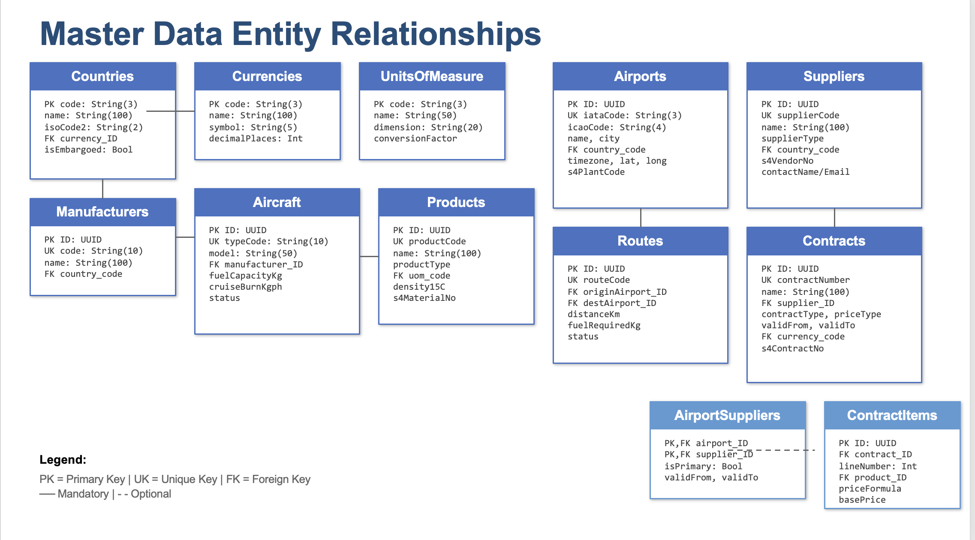
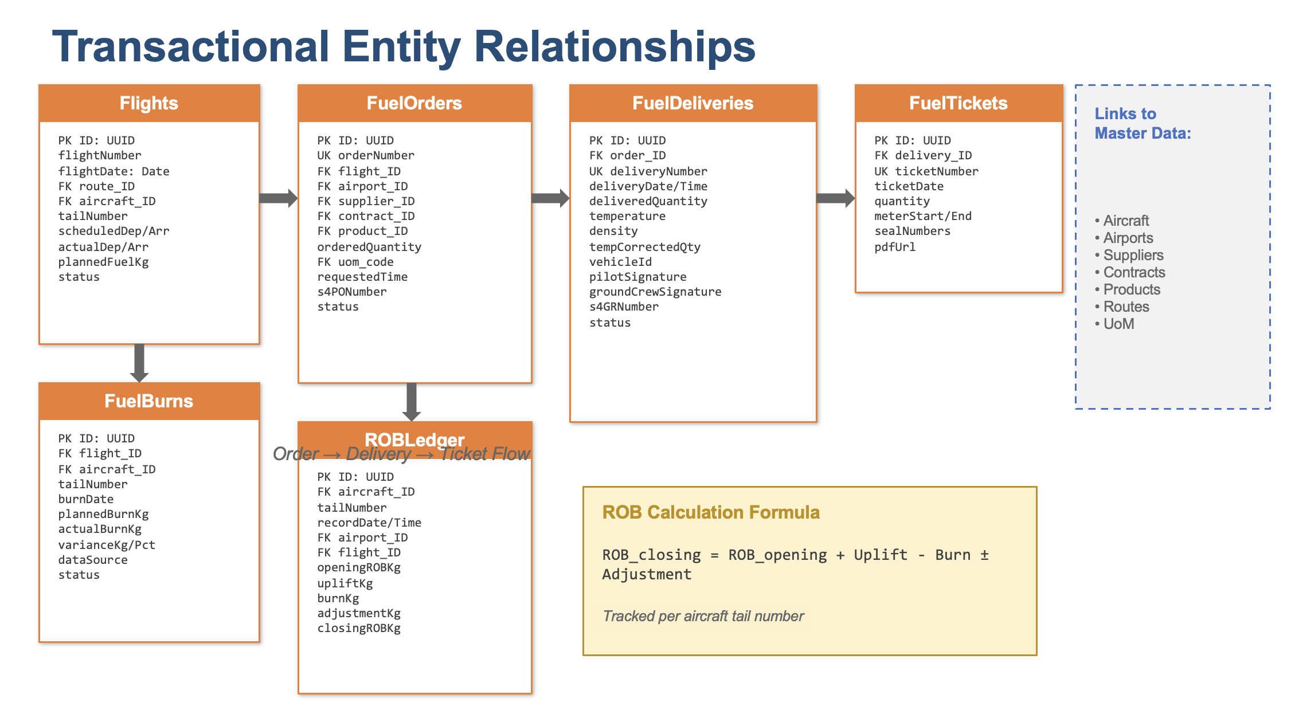
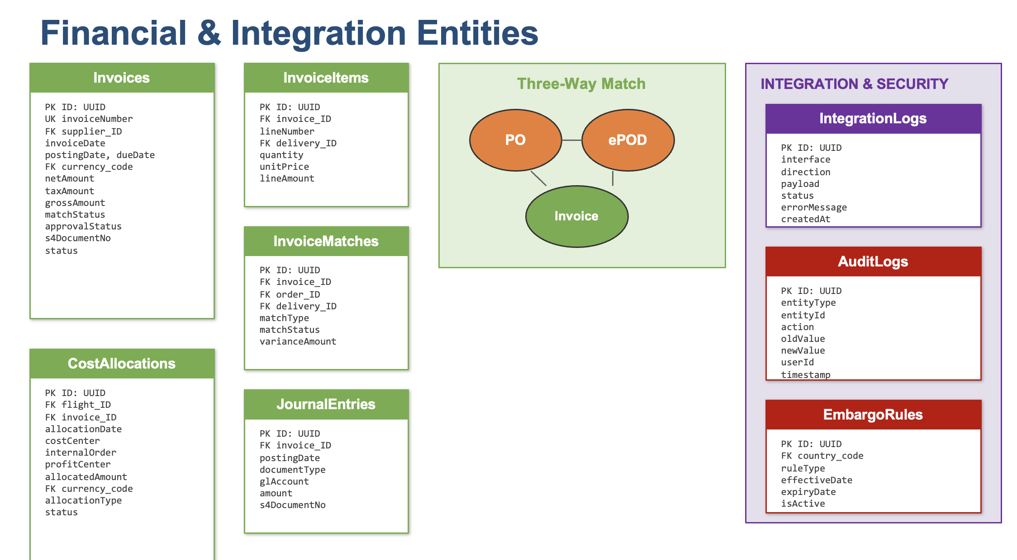

All foreign key relationships across FuelSphere entities
Source Entity | Target Entity | Cardinality | Type | FK Field | Description
Countries | Currencies | 1:1 | Association | currency_code | Default currency for country
Countries | Airports | 1:N | Association | country_code | Country contains airports
Countries | Suppliers | 1:N | Association | country_code | Supplier home country
Countries | Manufacturers | 1:N | Association | country_code | Manufacturer origin country
Manufacturers | Aircraft | 1:N | Association | manufacturer_ID | Manufacturer produces aircraft types
Airports | Routes (origin) | 1:N | Association | originAirport_ID | Route origin airport
Airports | Routes (dest) | 1:N | Association | destAirport_ID | Route destination airport
Airports | AirportSuppliers | 1:N | Composition | airport_ID | Airport-supplier junction (N:M)
Suppliers | AirportSuppliers | 1:N | Composition | supplier_ID | Supplier serves airports (N:M)
Suppliers | Contracts | 1:N | Association | supplier_ID | Supplier has contracts
Contracts | Currencies | N:1 | Association | currency_code | Contract currency
Contracts | ContractItems | 1:N | Composition | contract_ID | Contract line items
Contracts | ContractAirports | 1:N | Composition | contract_ID | Contract covers airports (N:M)
ContractItems | Products | N:1 | Association | product_ID | Contract item product
Products | UnitsOfMeasure | N:1 | Association | uom_code | Product base UoM
Routes | Flights | 1:N | Association | route_ID | Route has flights
Aircraft | Flights | 1:N | Association | aircraft_ID | Aircraft assigned to flights
Flights | FuelOrders | 1:N | Association | flight_ID | Flight creates fuel orders
FuelOrders | Airports | N:1 | Association | airport_ID | Order delivery airport
FuelOrders | Suppliers | N:1 | Association | supplier_ID | Order supplier
FuelOrders | Contracts | N:1 | Association | contract_ID | Order under contract
FuelOrders | Products | N:1 | Association | product_ID | Ordered product
FuelOrders | FuelDeliveries | 1:N | Composition | order_ID | Order receives deliveries
FuelDeliveries | FuelTickets | 1:N | Composition | delivery_ID | Delivery has tickets
Flights | FuelBurns | 1:N | Association | flight_ID | Flight records fuel burn
Aircraft | FuelBurns | 1:N | Association | aircraft_ID | Aircraft burn records
Aircraft | ROBLedger | 1:N | Association | aircraft_ID | Aircraft ROB tracking
Airports | ROBLedger | 1:N | Association | airport_ID | ROB record location
Flights | ROBLedger | 1:N | Association | flight_ID | ROB linked to flight
Suppliers | Invoices | 1:N | Association | supplier_ID | Supplier sends invoices
Invoices | Currencies | N:1 | Association | currency_code | Invoice currency
Invoices | InvoiceItems | 1:N | Composition | invoice_ID | Invoice line items
InvoiceItems | FuelDeliveries | N:1 | Association | delivery_ID | Item matches delivery
Invoices | InvoiceMatches | 1:N | Composition | invoice_ID | Three-way match records
Flights | CostAllocations | 1:N | Association | flight_ID | Flight cost allocation
Invoices | CostAllocations | 1:N | Association | invoice_ID | Invoice cost allocation

Mapping between FuelSphere entities and SAP S/4HANA structures
FuelSphere Entity | S/4HANA Table | S/4HANA API | Key Field Mapping | Direction | Sync Type
Countries | T005 | Standard OData | code ↔ LAND1 | Inbound | Real-time
Currencies | TCURC | Standard OData | code ↔ WAERS | Inbound | Real-time
UnitsOfMeasure | T006 | Standard OData | code ↔ MSEHI | Inbound | Real-time
Suppliers | BUT000 / LFA1 | API_BUSINESS_PARTNER | s4VendorNo ↔ LIFNR | Inbound | Real-time
Products | MARA / MARC | API_PRODUCT_SRV | s4MaterialNo ↔ MATNR | Inbound | Real-time
Airports (Plant) | T001W | ZAPI_PLANT_SRV | s4PlantCode ↔ WERKS | Inbound | Real-time
Storage Locations | T001L | ZAPI_STLOC_SRV | s4StorageLoc ↔ LGORT | Inbound | Real-time
Contracts | EKKO / EKPO | API_PURCHASECONTRACT | s4ContractNo ↔ EBELN | Bidirectional | Real-time
FuelOrders → PO | EKKO / EKPO | API_PURCHASEORDER_PROCESS | s4PONumber ↔ EBELN | Outbound | Event-driven
FuelDeliveries → GR | MKPF / MSEG | API_MATERIAL_DOCUMENT | s4GRNumber ↔ MBLNR | Outbound | Event-driven
Invoices → FI Doc | BKPF / BSEG | API_JOURNALENTRY_SRV | s4DocumentNo ↔ BELNR | Outbound | Event-driven
CostAllocations | ACDOCA | API_JOURNALENTRY_SRV | costCenter ↔ KOSTL | Outbound | Batch
CPE Formulas | CPE Tables | ZAPI_CPEFORMULA_SRV | formulaId ↔ FORMULA_ID | Inbound | Cached (TTL)

Cardinality Reference
Notation | Name | Description
1:1 | One-to-One | Each record in source matches exactly one record in target
1:N | One-to-Many | One source record relates to multiple target records
N:1 | Many-to-One | Multiple source records relate to one target record
N:M | Many-to-Many | Requires junction table (e.g., AirportSuppliers, ContractAirports)

Association Types (CDS)
Type | Description
Association | Unmanaged relationship - FK exists but target can exist independently. Used for lookups and references.
Composition | Managed relationship - child cannot exist without parent. Cascade delete applies. Used for header-item patterns.

Entity Category Color Legend
Category | Description
Master Data | Reference data: Countries, Currencies, Aircraft, Airports, Suppliers, Products, Contracts, Routes (15 entities)
Transactional | Operational data: Flights, FuelOrders, FuelDeliveries, FuelTickets, FuelBurns, ROBLedger (12 entities)
Financial | Financial data: Invoices, InvoiceItems, CostAllocations, JournalEntries, Accruals (8 entities)
Integration/Security | System data: IntegrationLogs, ErrorLogs, Users, Roles, AuditLogs, EmbargoRules (15 entities)

8. S/4HANA Integration Mapping
This section documents the mapping between FuelSphere entities and SAP S/4HANA structures for integration via SAP Integration Suite.

8.1 Master Data Mapping
FuelSphere Entity | S/4HANA Table | API | Direction
Suppliers | BUT000 / LFA1 | API_BUSINESS_PARTNER | Inbound
Products | MARA / MARC | API_PRODUCT_SRV | Inbound
Airports (Plant) | T001W | ZAPI_PLANT_SRV | Inbound
Countries | T005 | Standard OData | Inbound
Currencies | TCURC | Standard OData | Inbound
UnitsOfMeasure | T006 | Standard OData | Inbound
Contracts | EKKO/EKPO | API_PURCHASECONTRACT | Bidirectional

8.2 Transactional Mapping
FuelSphere Entity | S/4HANA Table | API | Direction
FuelOrders (PO) | EKKO/EKPO | API_PURCHASEORDER | Outbound
FuelDeliveries (GR) | MKPF/MSEG | API_MATERIAL_DOCUMENT | Outbound
Invoices | BKPF/BSEG | API_JOURNALENTRY | Outbound
CostAllocations | ACDOCA | API_JOURNALENTRY | Outbound

8.3 Key Field Mapping
FuelSphere Field | S/4HANA Field | Table | Notes
Supplier.s4VendorNo | LIFNR | LFA1 | 10-char vendor number
Product.s4MaterialNo | MATNR | MARA | 18-char material number
Airport.s4PlantCode | WERKS | T001W | 4-char plant code
Contract.s4ContractNo | EBELN | EKKO | 10-char PO number
FuelOrder.s4PONumber | EBELN | EKKO | Created via API
FuelDelivery.s4GRNumber | MBLNR | MKPF | Material document
Invoice.s4DocumentNo | BELNR | BKPF | FI document number

9. Indexes and Performance

9.1 Recommended Indexes
Index Name | Entity | Fields | Purpose
idx_aircraft_type | Aircraft | typeCode | Type code lookups
idx_airport_iata | Airports | iataCode | IATA code searches
idx_route_airports | Routes | origin, destination | Route lookups
idx_flight_date | Flights | flightDate, status | Daily flight queries
idx_order_status | FuelOrders | status, airport | Order dashboard
idx_delivery_date | FuelDeliveries | deliveryDate | Delivery reports
idx_invoice_status | Invoices | status, supplier | Invoice processing
idx_rob_aircraft | ROBLedger | tailNumber, date | ROB queries

9.2 Performance Guidelines
1. Partitioning Strategy: Partition transactional tables (Flights, FuelOrders, FuelDeliveries) by date for improved query performance and data lifecycle management.
2. Data Archiving: Implement archiving for records older than 3 years to maintain optimal performance.
3. Query Optimization: Use CDS views with appropriate projections to limit data transfer.
4. Caching: Implement TTL-based caching for master data (15-30 minutes) and CPE formulas.

10. Validation Rules Summary
Error Code | Entity | Rule Description | Severity
MD401 | Aircraft | typeCode must be unique | Error
MD402 | Aircraft | fuelCapacityKg must be > 0 | Error
MD403 | Airport | iataCode must be 3 characters | Error
MD404 | Airport | icaoCode must be 4 characters | Error
MD405 | Supplier | supplierCode must be unique | Error
MD406 | Contract | validFrom must be < validTo | Error
MD407 | Contract | minVolume must be <= maxVolume | Error
MD408 | Product | density15C must be between 0.7 and 0.9 | Warning
MD409 | Aircraft | Duplicate type code not allowed | Error
MD410 | Route | Origin airport must differ from destination | Error
ORD401 | FuelOrder | orderedQuantity must be > 0 | Error
ORD402 | FuelOrder | requestedTime must be future | Warning
EPD401 | FuelDelivery | deliveredQuantity must be > 0 | Error
EPD402 | FuelDelivery | Signature required for completion | Error
INV401 | Invoice | Invoice number must be unique per supplier | Error
INV402 | Invoice | Variance > 5% requires approval | Warning
FB401 | FuelBurn | actualBurnKg must be > 0 | Error
FB402 | ROBLedger | closingROBKg cannot be negative | Error

11. Appendix

11.1 Entity Count by Module
Module | Module Name | Entity Count | Key Entities
FDD-01 | Master Data | 15 | Core masters
FDD-02 | Annual Planning & Forecasting | 4 | Budgets, Plans
FDD-03 | Contracts & CPE Integration | 4 | Contracts, Prices
FDD-04 | Fuel Orders & Milestones | 3 | FuelOrders
FDD-05 | Fuel Ticket & ePOD | 3 | Deliveries, Tickets
FDD-06 | Invoice Verification | 4 | Invoices, Items
FDD-07 | Embargo & Compliance | 3 | Embargo rules
FDD-08 | Fuel Burn & ROB Tracking | 3 | Burns, ROB
FDD-09 | Cost Allocation | 2 | Allocations
FDD-10 | Finance Integration | 3 | Postings
FDD-11 | Integration Monitoring | 4 | Logs, Errors
FDD-12 | Reporting & Analytics | 2 | Views
FDD-13 | Security Management | 3 | Users, Roles

11.2 Glossary
Term | Definition
CAP | SAP Cloud Application Programming Model
CDS | Core Data Services - SAP's data modeling language
CPE | Commodity Pricing Engine - SAP's pricing solution
ePOD | Electronic Proof of Delivery
IATA | International Air Transport Association
ICAO | International Civil Aviation Organization
ROB | Remaining on Board - fuel inventory on aircraft
UUID | Universally Unique Identifier

11.3 References
• FS-HLD-001: FuelSphere Overall Solution HLD
• FDD-01-HLD: Master Data Module HLD
• SAP CAP Documentation: https://cap.cloud.sap/docs/
• SAP HANA Cloud: https://help.sap.com/hana-cloud
• SAP API Business Hub: https://api.sap.com

--- End of Document ---

