INTERNSHIP REPORT

*A report submitted in partial fulfilment of the requirements for the Award of Degree of*

## BACHELOR OF ENGINEERING

**in**

## COMPUTER ENGINEERING

**BY**

**Kalpesh Baviskar**

**University PRN:72292428D**

**Under Supervision of Mr. G.S Pole (Academic Guide)**

## (Duration:6 weeks)



**DEPARTMENT OF COMPUTER ENGINEERING**

Modern Education Society’s Wadia College of Engineering, Pune Approved by AICTE,

Affiliated to SPPU, Pune

## Maharashtra

## DEPARTMENT OF COMPUTER ENGINEERING MODERN EDUCATION SOCIETY’S WADIA

## COLLEGE OF ENGINEERING,

## PUNE



**CERTIFICATE**

This is to certify that the “**Internship report”** submitted by **Kalpesh Baviskar (University PRN:72292428D)** is work done by him and submitted during 2023-24 academic year, in partial fulfilment of the requirements for the award of the degree of **BACHELOR OF ENGINEERING in COMPUTER ENGINEERING,** at **MESWCOE.**

**Department  
Coordinator**

**Head of Department  
Department of Computer**

**College Internship   
Coordinator**

# ACKNOWLEDGEMENT

We would like to express my heartfelt gratitude to Mr. G. S. Pole, our college professor, whose unwavering support and guidance have been instrumental throughout my internship journey in web technology. His expertise, mentorship, and valuable insights have significantly enriched my learning experience, shaping me into a more proficient and confident professional.

We are also immensely grateful to the Departmental Student Club (ACE) for providing us with the invaluable opportunity to work on a real-world project in web development. This hands-on experience has not only honed our practical skills but also deepened my understanding of the field, thanks to the collaborative environment fostered by the club.

Lastly, I would like to express my deepest gratitude to my friends for their unwavering support, encouragement, and understanding throughout this enriching experience. Their constant encouragement has been a source of strength, motivating me to strive for excellence every step of the way.

Shreyas Rane 72292681C

Kalpesh Baviskar 72292428D

Shubham Chitampalle72292464L

Aryan Chogale 72292408K

# ABSTRACT

**Company Information**: Modern Education Society’s Wadia College of Engineering, Pune.

**Programs and opportunities**: The internship at the ACE club website development project, involved utilizing a range of technologies including HTML, CSS, JavaScript, SQL, JSP, and related tools.

**Methodologies**: Collaboration was integral to the project, as we worked as a team to develop a user-friendly website. Project planning, requirement gathering, designing and development, testing and quality assurance (QA) are the main steps in the internship methodology.

**Key parts of the report:** The internship report documents the project description, learning outcomes, acknowledgements and conclusions focusing on technical skills gained, teamwork experiences, and personal development. Using report one can also easily understand the problem that we tried to solve during the internship.

**Benefits of the Company/Institution through our report:** This report serves to showcase all the important insights about the ACE website including its features, methodologies and all risk factors. Using our report the institution can manage the ACE website more efficiently by knowing all pros and cons. Our report will also help institute for further development of the website.

**INDEX**

# S.no CONTENTS Page no

1. Introduction 1
2. Problem Statement and Objective 2

2.1 Problem Statement

2.2 Objective

2.3 Motivation /Scope and Rationale of the Study:

1. System Analysis 3

3.1 Existing System

3.2 Proposed System

1. Software Requirement Analysis 4
2. Methodological Details 5

5.1 Project Planning

5.2 Design Phase

5.3 Development Phase

5.4 Testing and Quality Assurance

5.5 Deployment and Maintenance

5.6 Documentation and Reporting

1. Result/ Analysis / Inferences 7
2. Conclusions 14
3. Bibliography 15

# 

## WEEKLY OVERVIEW OF INTERNSHIP ACTIVITIES

|  |  |  |  |
| --- | --- | --- | --- |
| **FIRST WEEK** | **DATE** | **DAY** | **NAME OF THE TOPIC/MODULE COMPLETED** |
| 12/2/24 | Monday | Discussion on various Domains |
| 13/2/24 | Tuesday | Domain Decided |
| 14/2/24 | Wednesday | Discussion on topics related to domain |
| 15/2/24 | Thursday | Discussion on Topics related to real life |
| 16/2/24 | Friday | Discussion with Guide |
| 17/2/24 | Saturday | Topic Decided |

|  |  |  |  |
| --- | --- | --- | --- |
| **SECOND WEEK** | **DATE** | **DAY** | **NAME OF THE TOPIC/MODULE COMPLETED** |
| 19/2/24 | Monday | Scheduling and Planning |
| 20/2/24 | Tuesday | Requirement gathering |
| 21/2/24 | Wednesday | Meeting with ACE coordinators |
| 22/2/24 | Thursday | Data Gathering |
| 23/2/24 | Friday | Data Gathering |
| 24/2/24 | Saturday | Data Sorting |

|  |  |  |  |
| --- | --- | --- | --- |
| **THIRD WEEK** | **DATE** | **DAY** | **NAME OF THE TOPIC/MODULE COMPLETED** |
| 26/2/24 | Monday | Starting the Implementation |
| 27/2/24 | Tuesday | Frontend Development |
| 28/2/24 | Wednesday | Frontend Development |
| 29/2/24 | Thursday | Frontend Development |
| 01/3/24 | Friday | Frontend Development |
| 02/3/24 | Saturday | Reviewing Frontend with Guide |

|  |  |  |  |
| --- | --- | --- | --- |
| **FOURTH WEEK** | **DATE** | **DAY** | **NAME OF THE TOPIC/MODULE COMPLETED** |
| 04/3/24 | Monday | Working on Backend |
| 05/3/24 | Tuesday | Backend Development |
| 06/3/24 | Wednesday | Backend Development |
| 07/3/24 | Thursday | Backend Development |
| 08/3/24 | Friday | Backend Development |
| 09/3/24 | Saturday | Backend Development |

|  |  |  |  |
| --- | --- | --- | --- |
| **FIFTHWEEK** | **DATE** | **DAY** | **NAME OF THE TOPIC/MODULE COMPLETED** |
| 11/3/24 | Monday | Registration form creation |
| 12/3/24 | Tuesday | Frontend backend linking |
| 13/3/24 | Wednesday | Frontend backend linking |
| 14/3/24 | Thursday | Testing and Quality Assurance |
| 15/3/24 | Friday | Testing and Quality Assurance |
| 16/3/24 | Saturday | Presenting the Website to Guide |

# 

|  |  |  |  |
| --- | --- | --- | --- |
| **Last WEEK** | **DATE** | **DAY** | **NAME OF THE TOPIC/MODULE COMPLETED** |
| 18/3/24 | Monday | Working on changes suggested by guide |
| 19/3/24 | Tuesday | Working on changes |
| 20/3/24 | Wednesday | Final Presentation to guide |
| 21/3/24 | Thursday | Documentation |
| 22/3/24 | Friday | Documentation |
| 23/3/24 | Saturday | Documentation |

**1.INTRODUCTION**

During your web technology internship, you worked on developing a website for the ACE club under the guidance of your college professor Mrs. G.S.Pole. The project involved using HTML, CSS, JavaScript, SQL, JSP and related technologies. Collaboration was a key aspect, with you working alongside a group of four students to achieve the project goals and enhance the club's online presence.

The ACE club website aimed to provide information about the club, an events calendar, membership registration, and interactive features. Technologies like HTML for structure, CSS for styling, JavaScript for interactivity, and JSP & SQL for dynamic components were used to create a user-friendly and engaging website.

our internship report serves to document this experience, covering aspects such as the project description, collaboration process, learning outcomes, acknowledgements, and conclusions. It's structured to reflect on the technical skills gained, teamwork experiences, and personal development throughout the internship.

We will express gratitude to your college professor, the ACE club, technical support providers, and your family and friends for their support and guidance during the internship. The learning outcomes will highlight improvements in technical proficiency, teamwork skills, and personal growth in problem-solving and time management related to web development practices.

**2.PROBLEM STATEMENT**

**AND OBJECTIVES**

**Problem Statement:**

1. Lack of an effective online platform for the ACE club to communicate with members and share information.
2. Outdated or static website design that does not engage users or provide interactive features.
3. Difficulty in managing club events, registrations, and member communications manually.

**Objectives:**

1. Develop a dynamic website for the ACE club with interactive features for event management, member registration, and information dissemination.
2. Implement responsive design principles to ensure the website is accessible and user-friendly across different devices.
3. Integrate a content management system (CMS) to facilitate easy updates and maintenance of website content by club administrators.
4. Enhance user engagement through features such as discussion forums, social media integration, and personalized member profiles.

**Motivation/Scope and Rationale of the Study:**

1. The increasing importance of online presence for organizations like the ACE club in engaging with members and promoting events.
2. The potential benefits of a dynamic website in improving user experience, increasing membership, and streamlining club operations.

The opportunity to apply and demonstrate knowledge of web development technologies in a real-world context, contributing to personal and professional growth.

# 3.SYSTEM ANALYSIS

**Requirement Analysis - Existing System:**

"The existing ACE club website lacks interactive features for event management, member registration, and content updates. The design is static and not optimized for mobile devices, leading to a subpar user experience. Manual processes for event coordination, membership management, and content publishing are time-consuming and prone to errors.

The requirements for the new system include:

1. A dynamic website with responsive design to ensure accessibility across devices.

2. User-friendly interfaces for event creation, registration, and management.

3. Integration of a content management system (CMS) for easy content updates by club administrators.

4. Member registration and profile management functionalities.

5. Social media integration and interactive features to enhance user engagement.

6. Security measures to protect user data and prevent unauthorized access."

**Proposed System:**

"The proposed system aims to overcome the limitations of the existing ACE club website by introducing a dynamic and user-centric platform. Key features of the proposed system include:

1. Responsive design using HTML, CSS, and Bootstrap framework to ensure compatibility across devices.

2. Implementation of React.js for dynamic user interfaces and seamless interactions.

3. Integration of a CMS, such as WordPress or Joomla, for easy content management and updates.

4. Event management module with features for event creation, registration, RSVPs, and reminders.

5. Membership registration and profile management functionalities with secure login mechanisms.

6. Social media integration to enable sharing of club activities and engagement with members.

7. Discussion forums and interactive elements to encourage community participation and collaboration.

8. Implementation of security protocols, including HTTPS encryption and user authentication measures to safeguard user data.

The proposed system aims to provide a modern and interactive platform for the ACE club, improving user experience, streamlining operations, and enhancing member engagement."

By outlining the existing system's analysis and proposing a detailed solution, you'll provide a comprehensive overview of the project's requirements and objectives.

# 4. SOFTWARE REQUIREMENTS

# SPECIFICATIONS

**System Configurations:**

The system configurations refer to the software environment required for the development and deployment of the ACE club website. These configurations include:

Operating System: The recommended operating system for hosting and development purposes.

Coding Language: The primary programming language(s) used for backend development.

Front-End: The front-end technologies and frameworks used for designing the user interface.

Database The database management system used for storing and retrieving website data.

**Software Requirements:**

- Operating System: Linux/Unix-based operating systems (e.g., Ubuntu, CentOS) for hosting the website. Windows or macOS for development environments.

- Front-End: HTML, CSS, JavaScript.

- Back-End: Java, JSP.

- Database: SQL for the database management system to store website data.

- Server: Apache Tomcat

**Hardware Requirements:**

**-**The hardware requirements refer to the specifications of the system used for development and testing purposes. These requirements include:

- System: Desktop or laptop computer with adequate processing power and memory.

- Hard Disk: Minimum 250GB of storage space for development environment and project files.

- RAM: Minimum 4GB RAM for smooth development experience and running development tools and servers.

# 5. METHODOLOGICAL DETAIL

The development process of the ACE club website followed a systematic and iterative approach to ensure efficient project management, design excellence, robust development, thorough testing, seamless deployment, and ongoing maintenance. This methodology was crucial in achieving the project's objectives and delivering a high-quality website to meet the needs of the ACE club and its members.

**1. Project Planning:**

The project planning phase was instrumental in laying the groundwork for the entire development process. This phase involved comprehensive requirements gathering through discussions with stakeholders, including club members and administrators. The project scope was carefully defined, outlining the features, functionalities, and goals of the website. A project roadmap was created, breaking down tasks into manageable units, setting realistic timelines, allocating resources effectively, and establishing milestones for progress tracking.

**2. Design Phase:**

The design phase focused on creating an intuitive, visually appealing, and user-centric interface for the ACE club website. This phase began with conceptualization, where wireframes and mock-ups were developed to visualize the layout, structure, and navigation of the website. During the website's design phase, we took inspiration from similar college club websites to inform our own design choices.

**3. Development Phase:**

The development phase involved the implementation of frontend and backend functionalities using a combination of HTML, CSS, JavaScript, JSP and SQL. The frontend development focused on creating responsive, mobile-friendly layouts, implementing interactive elements, and optimizing performance for fast loading times. SQL was used to store and retrieve data efficiently.

**4. Testing and Quality Assurance:**

Thorough testing and quality assurance (QA) were integral parts of the development process to ensure the functionality, performance, security, and compatibility of the ACE club website. Integration testing ensured seamless interaction between frontend and backend systems. User acceptance testing (UAT) involved real users testing the website's features and providing feedback. Performance testing tools like Google Lighthouse were used to assess speed, accessibility, and best practices adherence.

**5. Deployment and Maintenance:**

The deployment phase involved setting up the website on a secure hosting environment, configuring servers, domains and implementing security protocols. Continuous integration and deployment (CI/CD) pipelines, using tools like GitHub Actions, automated the deployment process, ensuring consistency and reliability.

**6. Documentation and Reporting:**

-Comprehensive documentation was prepared to capture all aspects of the development process. This documentation included:

- Code documentation: Comments within the codebase explaining functions, variables, and logic.

- User manuals: Guides for administrators on managing the website, updating content, and handling member interactions.

- Technical specifications: Details on system architecture, database schema, APIs, and third-party integrations.

- Project reports: Progress reports, milestone achievements, challenges faced, lessons learned, and future recommendations.

By following this methodological approach, the ACE club website was successfully developed, tested, deployed, and maintained, meeting the requirements and expectations of stakeholders and users alike. The structured methodology ensured efficiency, quality, collaboration, and continuous improvement throughout the project lifecycle.

**6. RESULTS / ANALYSIS /INFERENCES**

# 1. Website Performance Analysis:

# Evaluate the performance metrics of the ACE club website, including speed, responsiveness, accessibility, and overall user experience.

# Use tools like Google Analytics, Lighthouse, and performance monitoring tools to gather data and analyse website performance.

# Discuss any improvements made during the development process to optimize performance.

# 

# 2. User Feedback and Satisfaction:

# Summarize user feedback received during testing phases, user acceptance testing (UAT), and post-launch feedback.

# Highlight positive feedback regarding usability, design, functionality, and content.

# Address any negative feedback or areas for improvement identified by users.

# 

# 3. Functionality Testing and Bug Resolution:

# Report on functionality testing results, including the identification and resolution of bugs, errors, and issues.

# Discuss the effectiveness of bug tracking and resolution processes implemented during development.

# Highlight any critical issues encountered and how they were addressed.

# 

# 4. Comparison with Initial Objectives:

# Compare the final outcomes of the project with the initial objectives and goals set during the planning phase.

# Discuss achievements, areas where objectives were fully met, and areas that may require further improvement.

# 

# 5. Challenges and Solutions:

# Identify and discuss challenges faced during the development process, such as technical constraints, time constraints, resource limitations, or unforeseen issues.

# Describe the solutions implemented to overcome these challenges and ensure project success.

# 

# 6. Lessons Learned:

# Reflect on key lessons learned from the project, including technical insights, best practices, and project management experiences.

Discuss how these lessons can be applied to future projects or similar initiatives.

# 7. Future Recommendations:

# Provide recommendations for future enhancements or updates to the ACE club website.

# Suggest areas for further development, such as additional features, improved user engagement strategies, or performance optimization.

# Consider feedback received from users, stakeholders, and team members in formulating recommendations.

# 

By including these elements in the "Results/Analysis/Inferences" section, you'll provide a comprehensive evaluation of the project outcomes, insights gained, and recommendations for continuous improvement and future development.

# Home Page: -

# 

# 

# Events Page: -

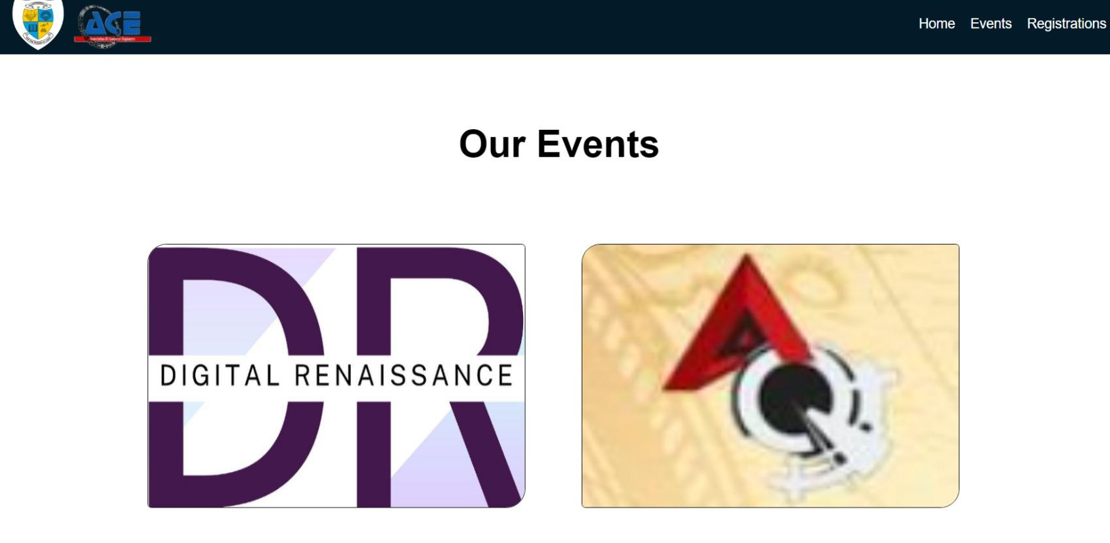

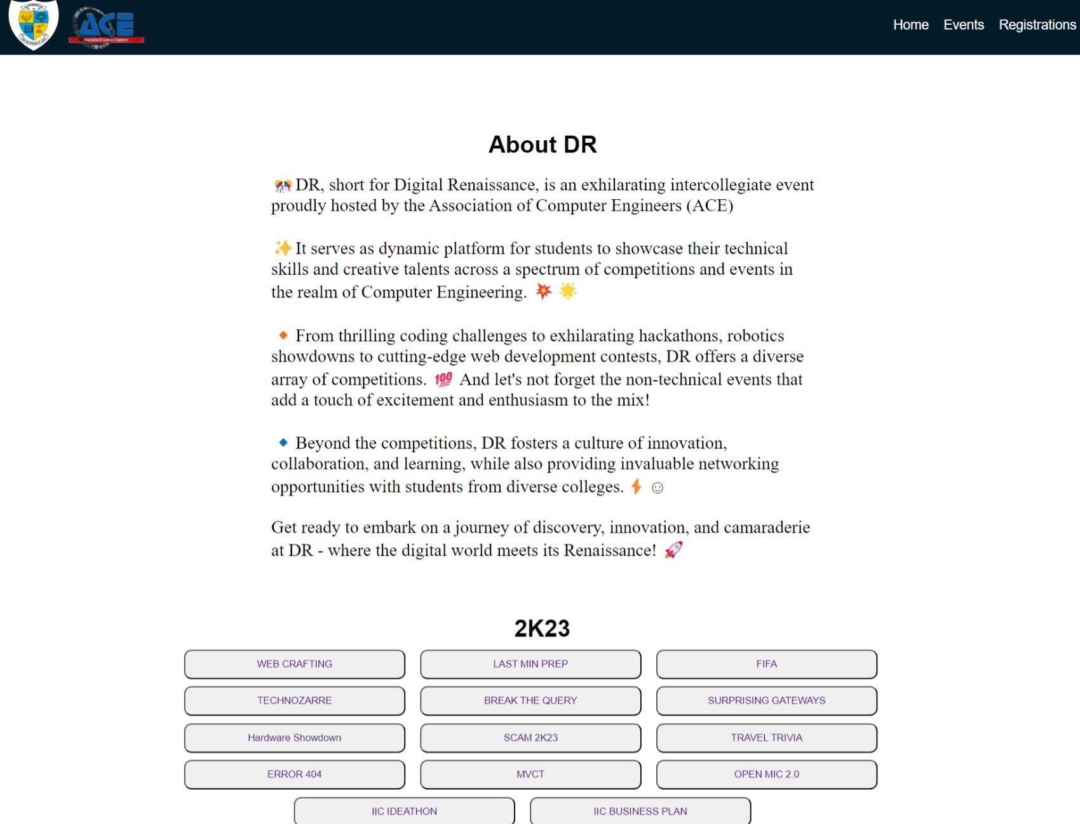

# 

# Registrations Page: -

# 

# 

# 

# 

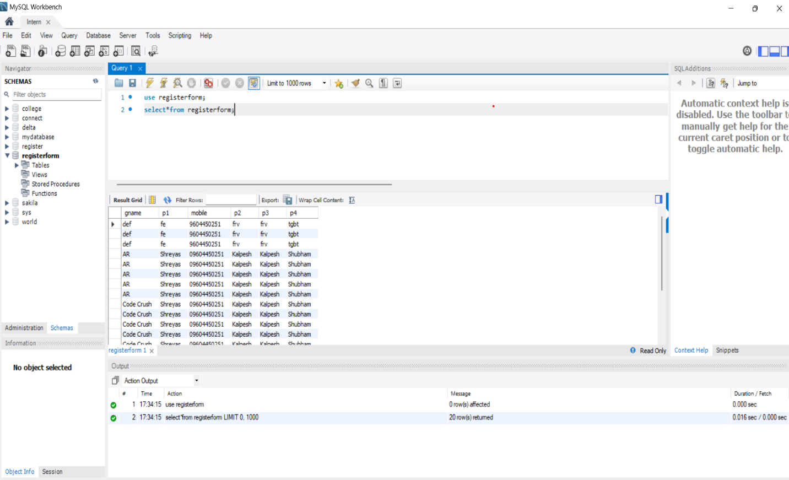

# 7. CONCLUSION

# 

# The internship experience in web technology, specifically the development of the ACE club website, has been a transformative journey filled with learning, challenges, and achievements. Through the application of HTML, CSS, JavaScript,JSP,SQL and collaborative teamwork, we successfully crafted a dynamic and user-centric platform for the ACE club. This project not only met its objectives of enhancing the club's online presence but also provided valuable insights into agile project management, UI/UX design principles, and effective communication within a development team.

# 

# One of the most significant achievements of this project was the positive impact it had on the ACE club and its members. The website's functionalities, such as event management, membership registration, and interactive features, significantly improved user engagement and streamlined club operations. User feedback during testing phases and post-launch validation indicated a high level of satisfaction with the website's design, functionality, and ease of use.

# 

# However, the journey was not without its challenges. Technical complexities, time constraints, and unforeseen issues required adaptive problem-solving and collaborative efforts. Through perseverance and teamwork, we successfully navigated these challenges, demonstrating resilience, adaptability, and a commitment to delivering quality results.

# 

# Looking ahead, there are opportunities for further enhancements and continuous improvement. Future iterations of the ACE club website could explore additional features, accessibility enhancements, performance optimization, and integration with emerging technologies to stay relevant and meet evolving user needs.

# 

# In conclusion, the internship experience has been a valuable steppingstone in my journey of professional growth and development. I am grateful for the guidance of my college professor, the collaboration of my team members, and the support of the ACE club and technical resources. This experience has equipped me with valuable skills, insights, and a deeper appreciation for the intricacies of web development and project management, laying a strong foundation for future endeavours in the field.

# 9.BIBLIOGRAPHY

## Links:

## 1) https://csi-fcrt.netlify.app

## 2) [Servlet Example : Steps to create a servlet example - javatpoint](https://www.javatpoint.com/steps-to-create-a-servlet-using-tomcat-server)

## 3) [Top Engineering College in Pune | MES Wadia College of Engineering in Pune (mespune.org)](https://mescoe.mespune.org/)

## 4)<https://ieeexplore.ieee.org/document/10334208/references#references>

## 5)Ibrahim Mohd, Kasim Shahreen, Hassan Rohayanti, Mahdin Hairulnizam, Ramli Ts, Azizul Azhar, et al., "INFORMATION TECHNOLOGY CLUB MANAGEMENT SYSTEM", *Acta Electronica Malaysia*, vol. 1, pp. 01-05, 2018.

## 6)A. Rahmat and N. A. M. Hanifiah, "Usability Testing in Kanban Agile Process for Club Management System", *2020 6th International Conference on Interactive Digital Media (ICIDM)*, pp. 1-6, 2020.

## 7)R. Khatipov, A. Negimatzhanov, I. Zamaleev, A. Zakirov, M. Mazzara and V. Rivera, "Hikester - The Event Management Application", *2018 32nd International Conference on Advanced Information Networking and Applications Workshops (WAINA)*, pp. 462-468, 2018.

## 8)R. Vidya Pradosh, R. Saran and S. Vasanth, "Cricket Club Management System", *International Journal of Recent Advances in Multidisciplinary Topics*, vol. 2, no. 4, pp. 2582-7839, April 2021.

# 9)P. J. A. Reusch and P. Reusch, "Event management - A special kind of project

## management", *2013 IEEE 7th International Conference on Intelligent Data Acquisition and Advanced Computing Systems (IDAACS)*, pp. 555-559, 2013.

## 10)P. Afsar, M. Faizudheen, M. Jasim Anikkadan, P. Mohammed Rashad and U. Mohammed Shabeer, "Intelligent Event Finder and Management System", *2021 Fifth International Conference on I-SMAC (IoT in Social Mobile Analytics and Cloud) (I-SMAC)*, pp. 1191-1195, 2021.

## 11)Sindhu Madhukar and G Suhas, "Club Management System using Laravel Framework", *International Journal of Trend in Scientific Research and Development (ijtsrd)*, vol. 2, no. 3, pp. 2647-2651, April 2018, ISBN 2456–6470.

## 12)Y. S. Noh et al., "Development of sports health care system suitable to the fitness club environment", *2010 IEEE EMBS Conference on Biomedical Engineering and Sciences (IECBES)*, pp. 93-96, 2010.

## 13)S. Kornilova and N. Sizykh, "Algorithm for Assessing and Managing key Financial Performance Indicators of a Sports Club", *2019 Twelfth International Conference “Management of large-scale system development” (MLSD)*, pp. 1-3, 2019.

## 14)S. Palanisamy and P. SuvithaVani, "A survey on RDBMS and NoSQL Databases SQL vs MongoDB", *2020 International Conference on Computer Communication and Informatics (ICCCI)*, pp. 1-7, 2020.

## 15)W. Hu, T. Chen, Q. Shi, J. Wang and N. Bao, "Promoting Embedded Education by Student Technology Club", *2009 First International Workshop on Education Technology and Computer Science*, pp. 143-147, 2009.