
Loan Origination System
Business Requirement Document

Contents
Contents 2
1. Introduction 10
2. Version History 11
3. Terms of Reference (ToR) 12
4. Login Screen 13
5. Dashboard 15
6. Product Line Covered 21
7. KFIC Loan Process Flow 22
8. User Role 45
9. Stage Role Mapping 46
10. Stagewise Action 47
11. Application Creation 48
11.1 Loan Simulator 48
11.2 Application List 72
11.3 New Application 75
11.3.1 New Application – Individual Customer 77
11.3.2 New Application – Corporate Customer 84
11.3.3 New Application (Credit Limit Creation) 90
11.3.4 New Application (Credit Limit Utilization) 95
11.3.5 New Application – Loan Renewal 100
11.3.6 New Application - Loan Reschedule 101
11.3.7 New Application – Loan Rearrangement 102
11.3.8 New Application – Loan Transfer 103
11.3.9 New Application – Staff Loan – KFIC Finance 105
11.4 Customer Dedupe Search 106
11.5 View Exposure (Customer 360) 111
11.5.1 Summary Details 111
11.5.2 Customer Details 114
11.5.3 Account Details 122
11.5.5 Loan Details 126
11.5.6 Transaction Details 135
11.5.7 Repayment Details 140
11.5.8 Charges Details 143
11.5.9 Service Request details 145
12. Initiating Loan Origination 148
12.1 Overview 151
12.2 Progress of Application 155
12.3 Team Inbox 156
13. Detail Data Entry Stage 158
13.1 Access Right Metrics 158
13.2 Business Logic 160
13.2.1 Application Summary 161
13.2.2 KYC 180
13.2.3 Collateral & Loan Details 267
13.2.4 Income & Expense 341
13.2.5 Document 373
13.2.6 Financials – Corporate Customer 381
13.2.7 Policy Review 422
13.3 Stage Completion Rules 433
13.4 Interface Touchpoints 433
13.5 Required Documents 433
14. Collection Review 434
14.1 Access Rights 434
14.2 Business Logic 436
14.2.1 Collection Review 437
14.3 Stage Completion Rules 439
14.4 Interface Touchpoints 439
14.5 Required Documents 439
15. Verification 440
15.1 Access Right Metrics 440
15.2 Business Logic 442
15.2.1 Verification 443
15.3 Stage Completion Rules 445
15.4 Interface Touchpoints 446
15.5 Required Documents 446
16. Legal Review 447
16.1 Access Right Metrics 447
16.2 Business Logic 450
16.2.1 Legal Opinion Checklist 450
16.3 Stage Completion Rules 454
16.4 Interface Touchpoints 454
16.5 Required Documents 454
17. Credit Control Review 455
17.1 Access Right Metrics 455
17.2 Business Logic 457
17.3 Stage Completion Rules 457
17.4 Interface Touchpoints 457
17.5 Required Documents 457
18. Credit Concentration Check 458
18.1 Access Right Metrics 458
18.2 Business Logic 460
18.2.1 Credit Concentration Review 460
18.3 Stage Completion Rules 464
18.4 Interface Touchpoints 464
18.5 Required Documents 464
19. AML Screening & Approval 465
19.1 Access Right Metrics 465
19.2 Business Logic 467
19.2.1 Risk Assessment Checklist 467
19.2.2 Customer Risk Rating 472
19.1 Stage Completion Rules 476
19.2 Interface Touchpoints 476
19.3 Required Documents 476
20. Risk Opinion 476
20.1 Access Right Metrics 477
20.2 Business Logic 479
20.3 Stage Completion Rules 484
20.4 Interface Touchpoints 484
20.5 Required Documents 484
21. Credit Approval 485
21.1 Access Right Metrics 485
21.2 Business Logic 487
21.1 Stage Completion Rules 503
21.2 Interface Touchpoints 503
21.3 Required Documents 503
22. Credit Administration (Post Approval - Applicable for Retails Loans)) 504
22.1 Access Right Metrics 504
22.2 Business Logic 506
22.3 Stage Completion Rules 506
22.4 Interface Touchpoints 506
22.5 Required Documents 506
23. Legal Review & MOJ process 507
23.1 Access Right Metrics 507
23.2 Business Logic 509
23.3 Stage Completion Rules 509
23.4 Interface Touchpoints 510
23.5 Required Documents 510
24. Deal Printing and Offer Acceptance 510
24.1 Access Right Metrics 510
24.2 Business Logic 512
24.1 Stage Completion Rules 513
24.2 Interface Touchpoints 513
24.3 Required Documents 513
25. Final Check Credit Control 513
25.1 Access Right Metrics 513
25.2 Business Logic 515
25.3 Stage Completion Rules 516
25.4 Interface Touchpoints 516
25.5 Required Documents 516
26. Purchase Order Generation 517
26.1 Access Right Metrics 517
26.2 Business Logic 519
26.1 Stage Completion Rules 519
26.2 Interface Touchpoints 519
26.3 Required Documents 519
27. Loan Activation 520
27.1 Access Right Metrics 520
27.2 Business Logic 522
27.3 Stage Completion Rules 526
27.4 Interface Touchpoints 526
27.5 Required Documents 526
28. Post Loan Activation 527
28.1 Access Right Metrics 527
28.2 Business Logic 529
28.3 Stage Completion Rules 533
28.4 Interface Touchpoints 533
28.5 Required Documents 533
29. Document Archive 534
29.1 Access Right Metrics 534
29.2 Business Logic 536
29.3 Stage Completion Rules 540
29.4 Interface Touchpoints 540
29.5 Required Documents 540
30. Miscellaneous 541
30.1 Loan Transfer 541
30.2 Loan Rearrangement 547
30.3 Loan Renewal 553
30.4 Loan Reschedule 559
30.5 Credit Limit Creation 565
30.6 Credit Limit Utilization 567
30.7 Staff Loan – KFIC Finance 570
30.8 Rejection Queue 579
30.9 Manual Reallocation 583
30.10 Charges Wavier Approval 587
30.11 Master & Configuration - Requirements 588
31. Permission Grid 591
31.1 Approved 593
31.2 Decline 593
31.3 Comments and Notes 596
31.4 KIV 599
31.5 Appeal 601
31.6 Return 603
31.7 Pull Back 605
31.8 Move To Next 606
32. Reports 609
33. Charges 609
34. Required Document Checklist 609
35. Stage Completion Rules 609
36. Interface Touchpoints 610
37. Lookups & Master 610

Introduction
This is the Scope document prepared for Implementation of Kiya.ai’s Loan Origination Solution at KFIC. The document is prepared based on the available functionalities in Kiya.ai’s Loan Origination Solution and process understanding availed from the business & IT users of KFIC.
For Kiya.ai
Prepared By | Reviewed By | Approved By
Mr. Umer Bhikan | Mr. Manish B. Thapar | Mr. Manish B. Thapar

For KFIC
Name | Designation | Signature

We have reviewed this document and agree that the same is in line with what has been demonstrated, discussed, and finalized between Kiya.ai’s Team and KFIC’s IT and Business Teams. We agree that this document overrides any other documents that have been shared previously.
Please note that the final screens developed may differ slightly from the screen layouts outlined in the BRD, depending on technical feasibility.

Version History

Version No. | Date | Created By | Reviewed By | Comments/Changes
V1.0 | 8th November 2024 | Mr. Umer Bhikan | Mr. Manish B. Thapar
V1.1 | 20th January 2024 | Mr. Umer Bhikan | Mr. Manish B. Thapar | Updated as per the feedback received from KFIC
V1.2 | 30th January 2024 | Mr. Umer Bhikan | Mr. Manish B. Thapar | Updated as per the feedback received from KFIC

Terms of Reference (ToR)
No. | Term | Abbreviation | Definition
1 | Detail Data Entry | DDE
2 | Bahrain Credit Bureau –  Credit Information Network Company | Ci-Net
3 | Purchase Order | PO
4 | Post Date Cheque | PDC
5 | Hire Purchase | HP
6 | Kuwaiti Dinar | KD
7 | Net Disposable Income | NDI
8 | Company Registration No | CR No | For Corporate
9 | National ID for an individual | Civil ID No | For Individuals
10 | Repayment Ratio | RR
11
12

Login Screen
Following Screen will be visible to each User of the System. Post Login with valid credentials, the User will be displayed different Modules/Sub Modules based on their profile in the System.

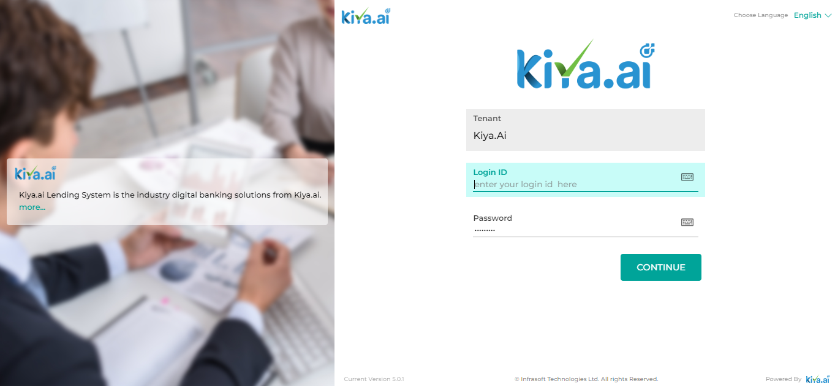

Below are the details specific to the information being displayed above.
Field Name | Field Type | Data Type / Length | Mandatory | Look-Up Key/ Master Name | Possible Value | Field Description
 |  |  |  |  |  | Validations/Remarks
Login ID | Text Box | NVARCHAR | Yes | NA | NA | The User will enter their login credentials.
Password | Text Box | NVARCHAR | Yes | NA | NA | The User will enter the password set by them to access the system.
Action Buttons
Continue | Button | Button | NA | NA | NA | The User will click on this button to log into the system.

Dashboard

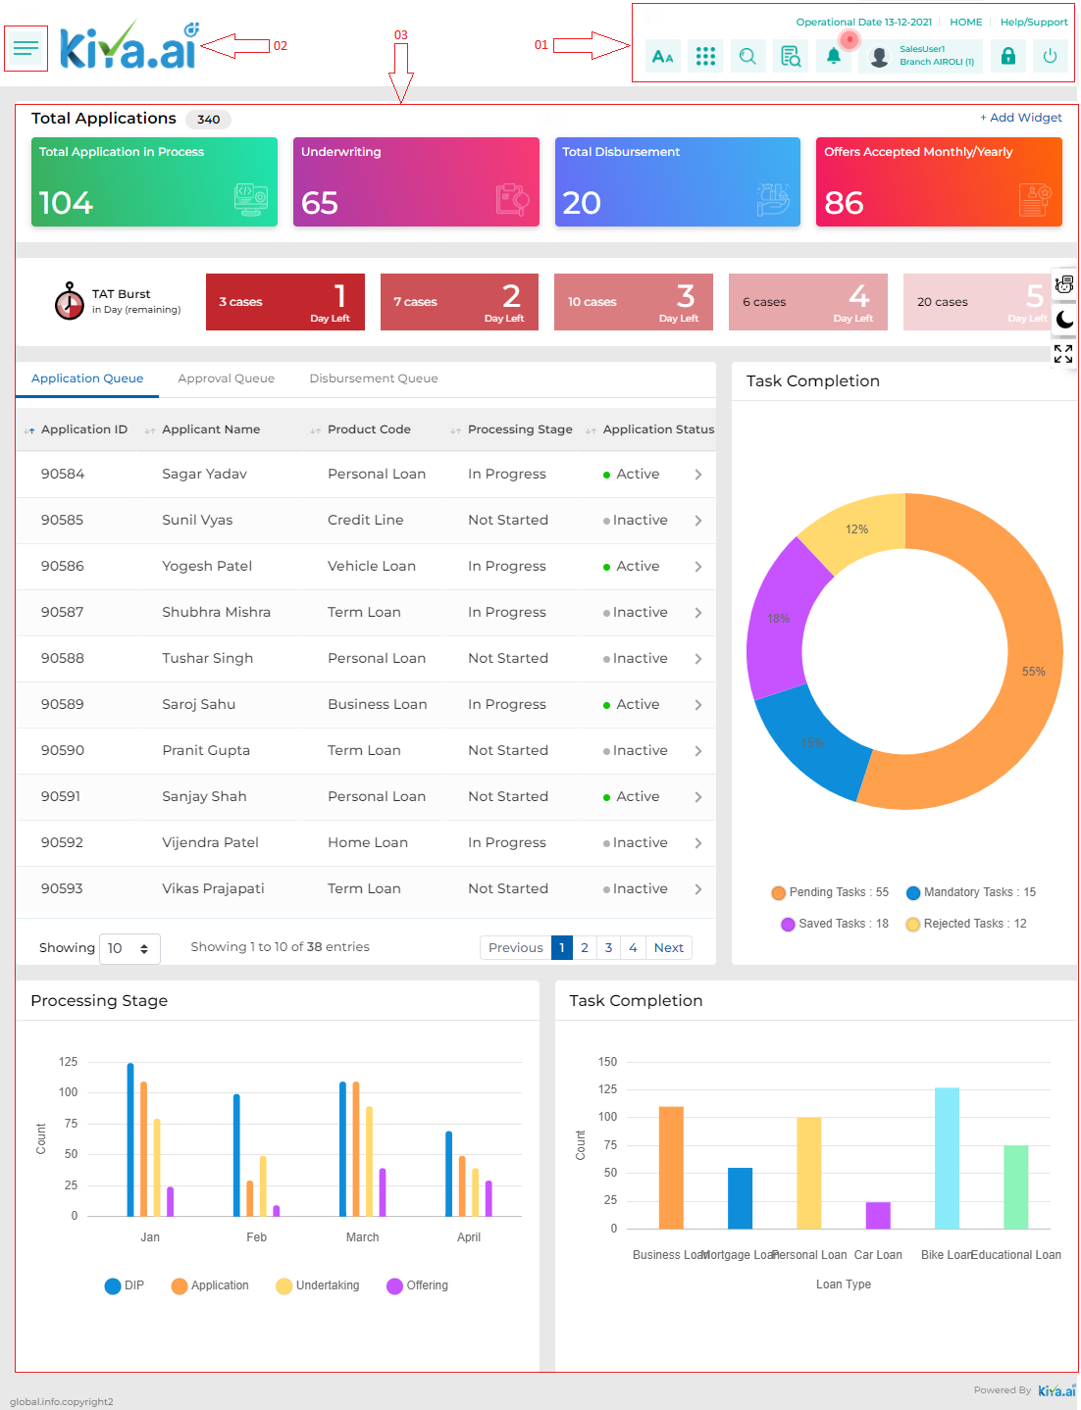

Field | Description
Application Queue | The Application Queue feature displays the list of Application with their Id, Name of the applicant, Product Code, Processing Stage and Application Status.
Approval Queue | The Approval Queue feature displays all the list of application which are pending at the credit approval stage.
Disbursement Queue | The Disbursement Queue feature displays all the applications which are pending at the disbursement stage.
 | Following widget showcase the count of total application which are currently under the queue of the user and are still under process.
 | Following widget showcase the count of application processed by the user and currently pending at the credit approval stage.
 | Following widget showcase the count of application processed by the user and currently pending at the disbursement stage.
 | Following widget showcase the count of application processed by the user and customer has accepted the offer.
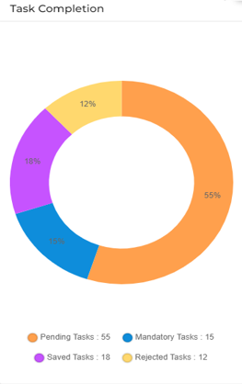 | This Task Completion matrix will depict the Pending Tasks, Mandatory Tasks, Saved Tasks and Rejected Tasks in a pictorial representation. Which provide an overview of the workload to the user.
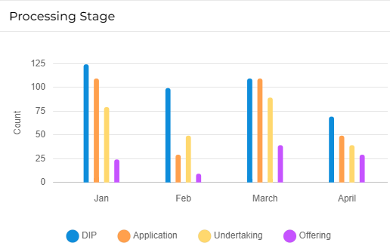 | This Processing Stage matrix depict the month wise count of the total loan at various stages such as Application, Undertaking and Offering in a pictorial representation
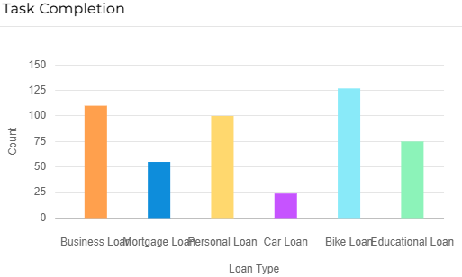 | The Task Completion widget provides the user with the total count of loan processed for the different product line.

Product Line Covered

- Retail Loans
Sr No | Products | Sub Products
1 | Vehicle Loan | New Car
2 | Vehicle Loan | Used Car (Agency)
3 | Vehicle Loan | Used Car (Others)
4 | Housing Loan | Housing Loan
5 | Consumer Loan | Cash Loan

- Commercial Loans
Sr No | Products | Sub Products
1 | Vehicle Loan | New Car
2 | Vehicle Loan | Used Car
3 | Cash Loan | Real estate Loan
4 | Cash Loan | Shares Loan

- Other Loans
Sr No | Products | Sub Products
1 | Staff Loan | Advance Salary
2 | Staff Loan | Interest Free Loan

KFIC Loan Process Flow

- Retail – Vehicle Loan
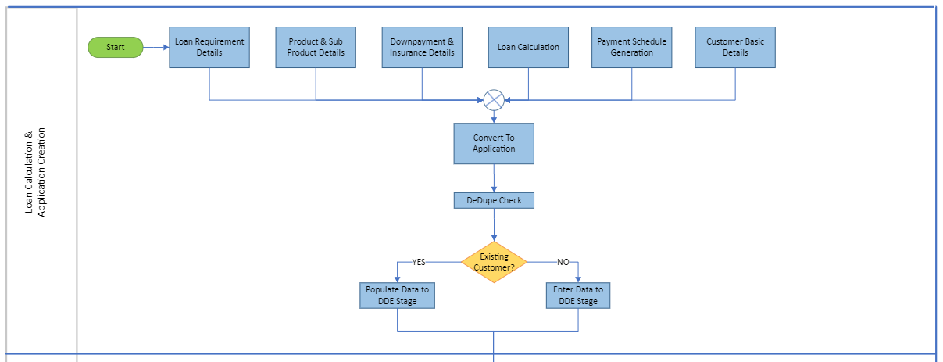
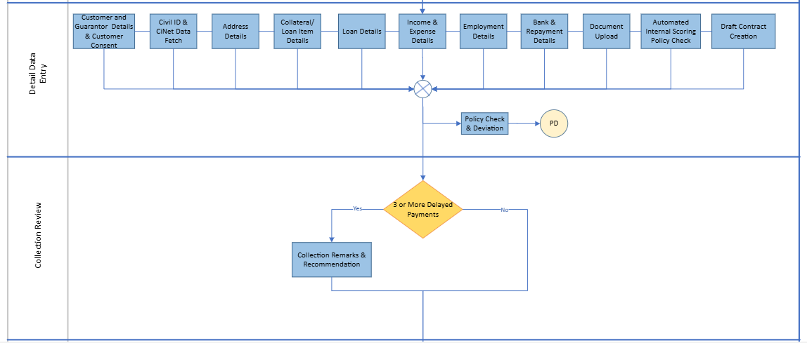
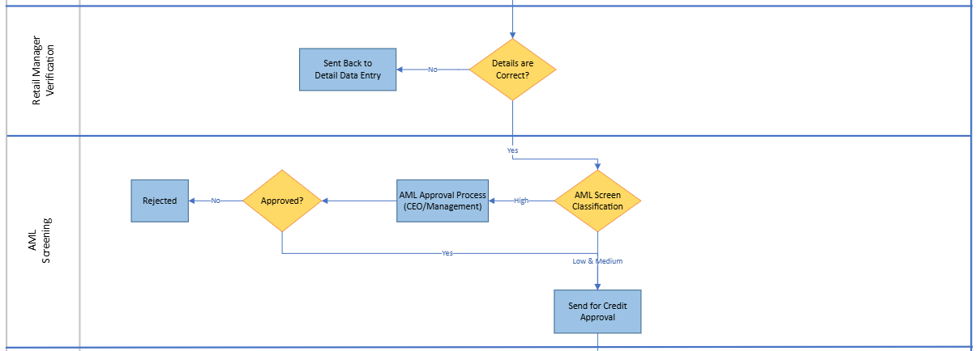
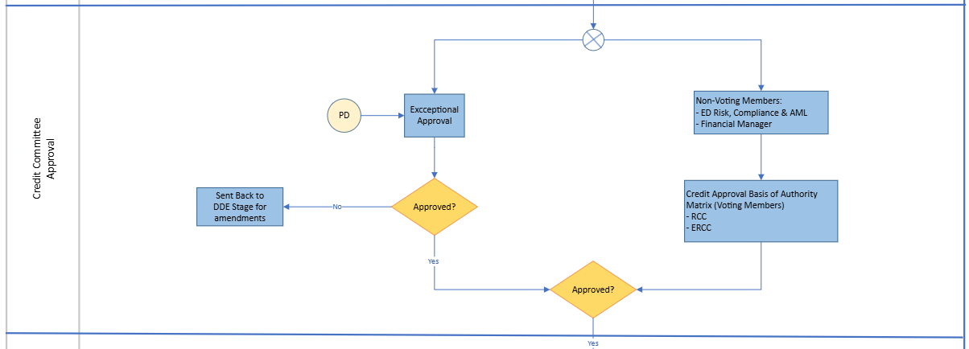
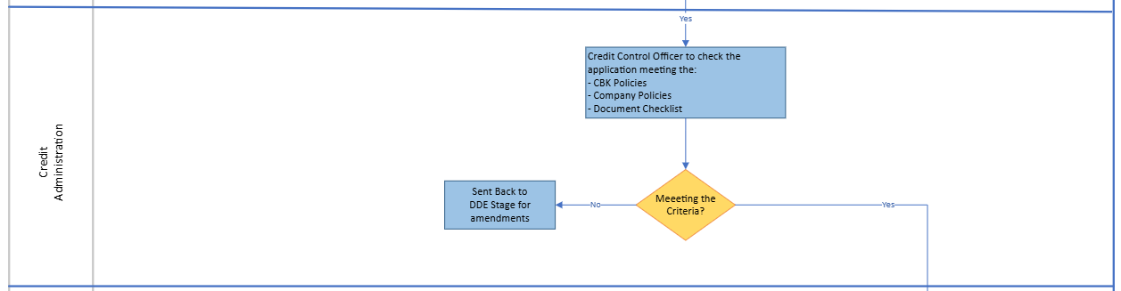

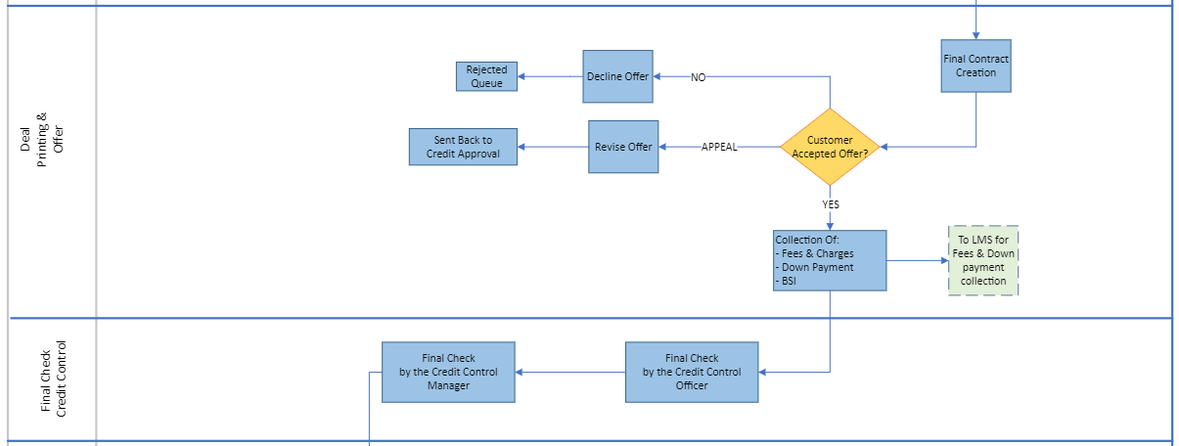
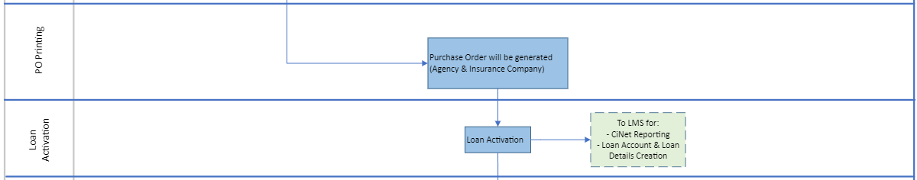

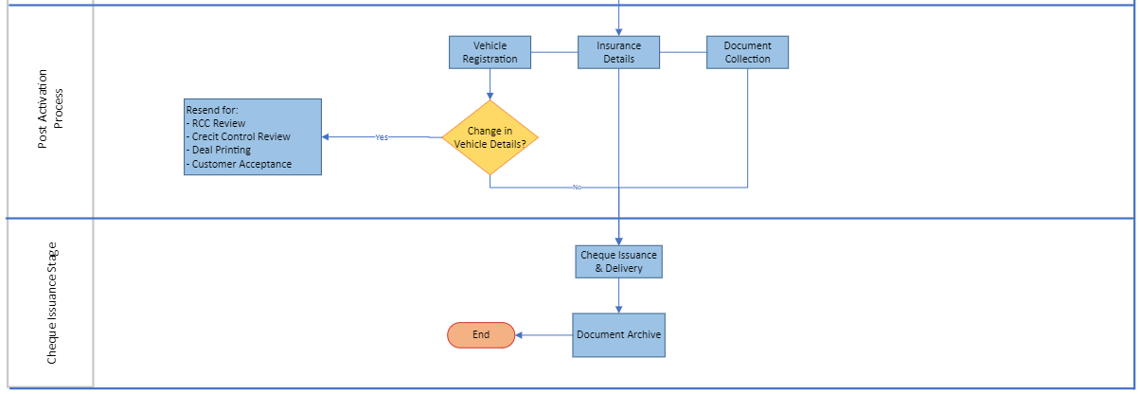

- Retail – Consumer & Housing Loan
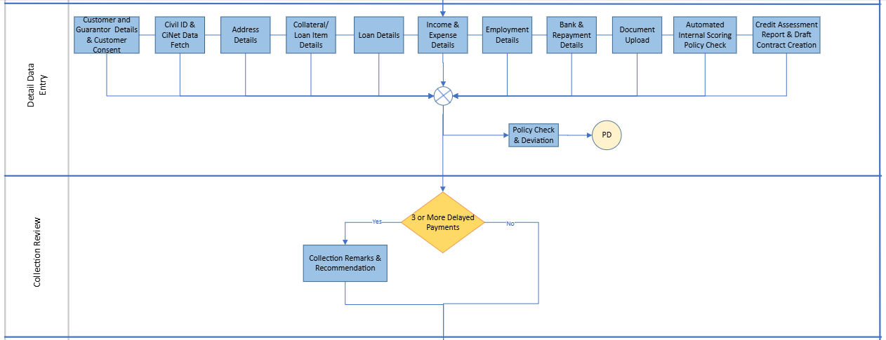
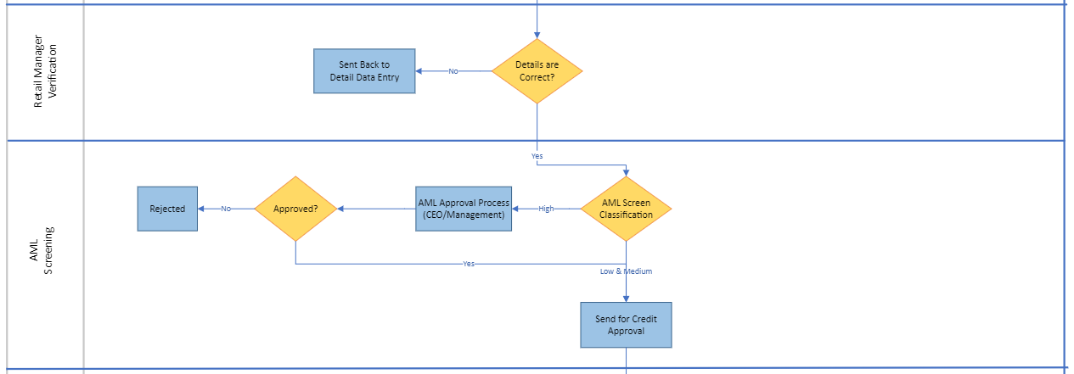
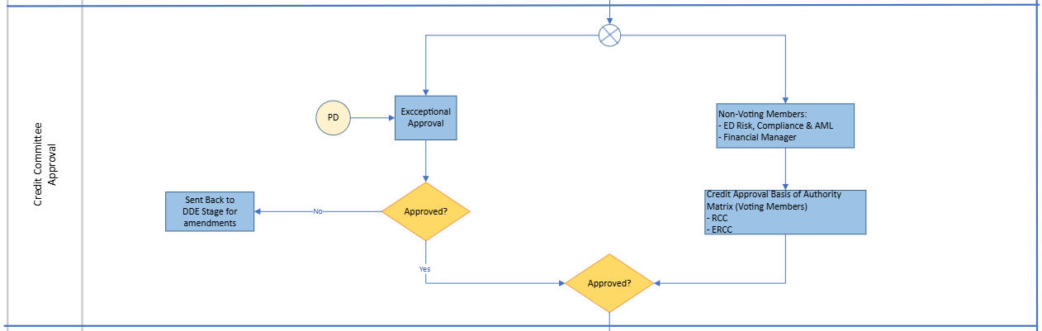
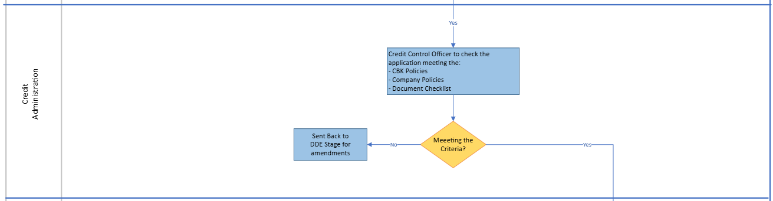
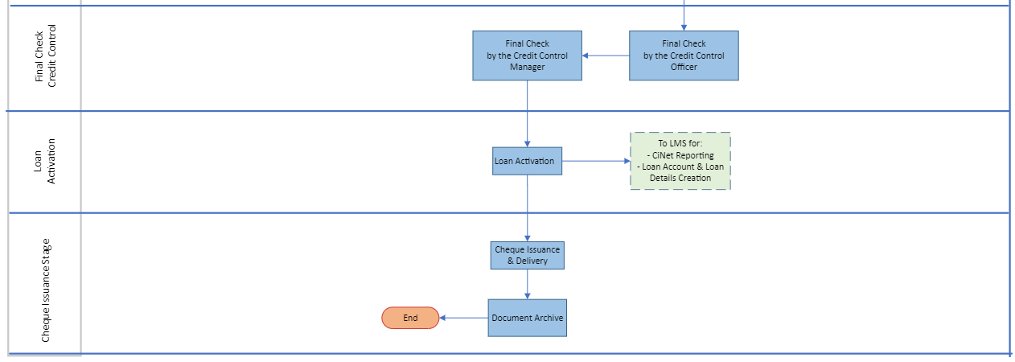

- Commercial – Vehicle Loan
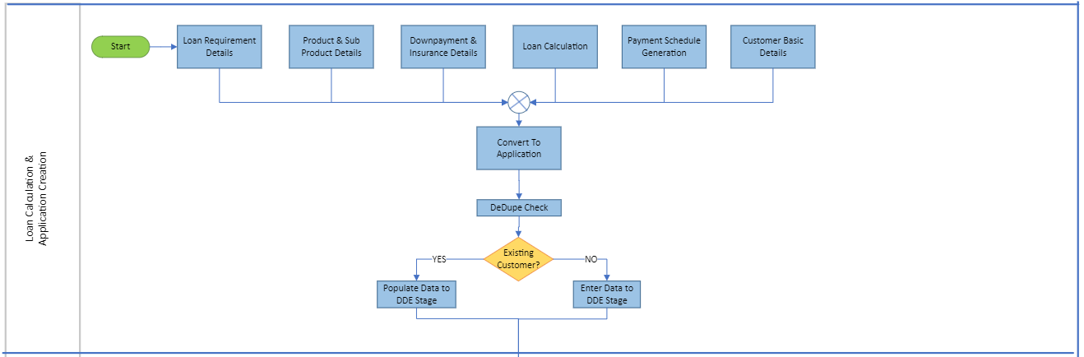
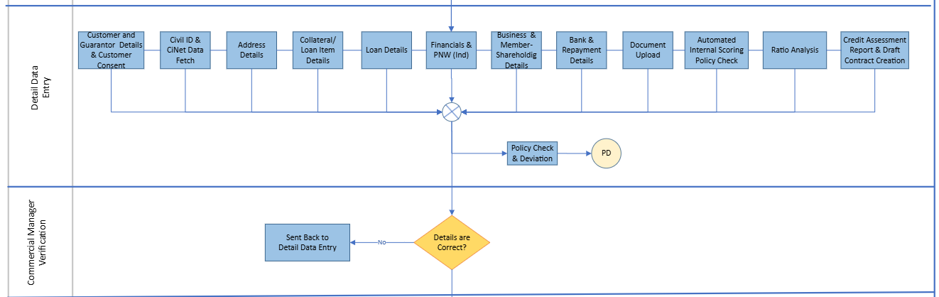

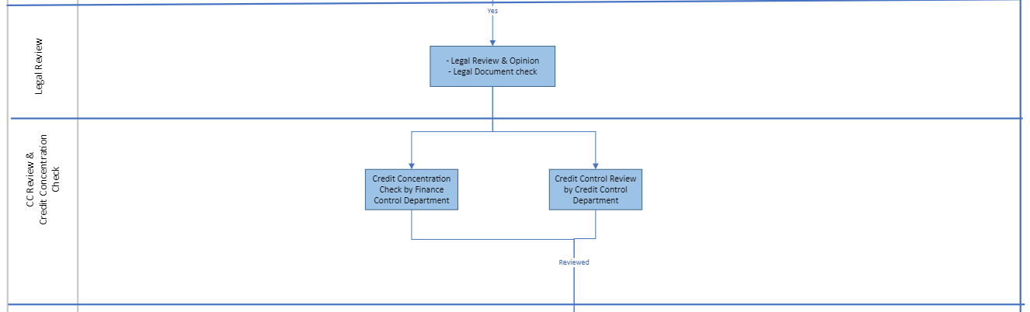
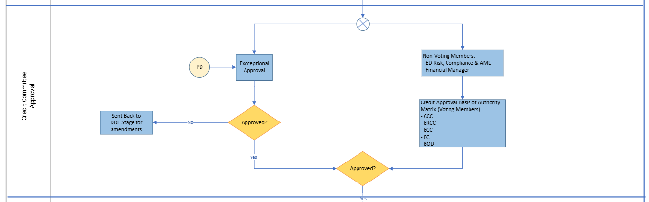
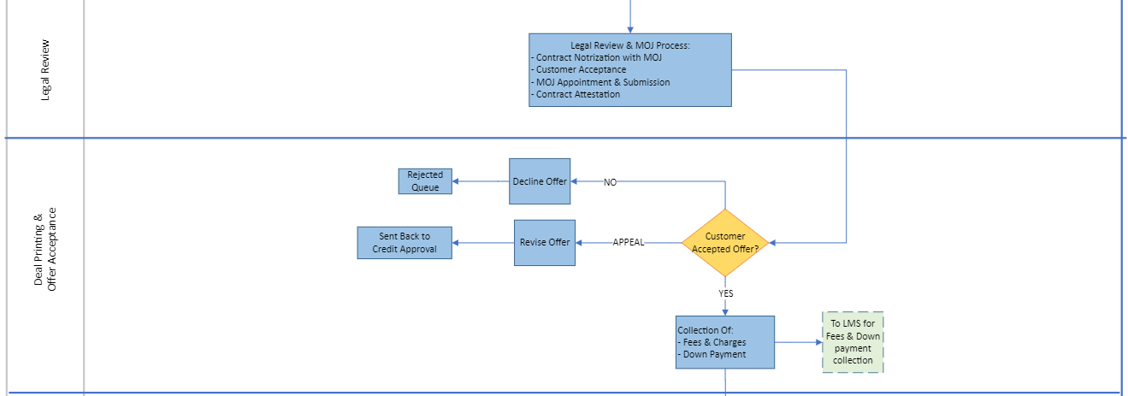

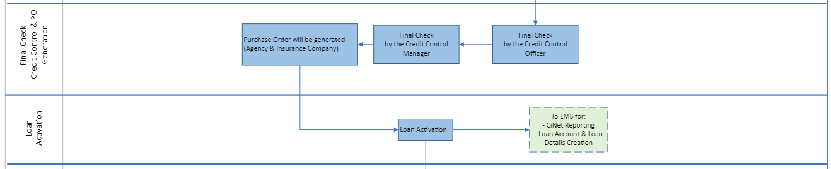
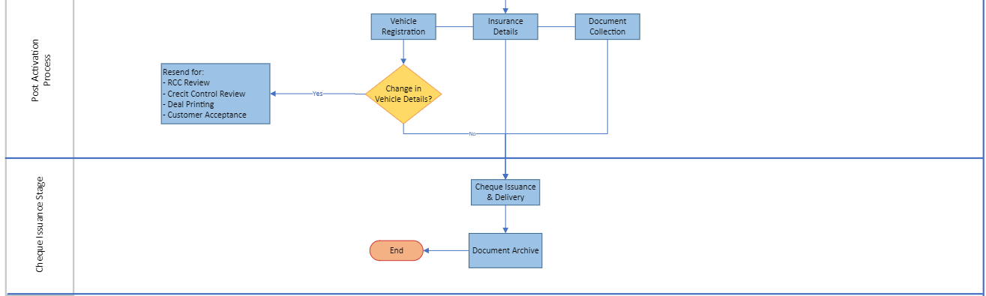
- Commercial – Shares & Real Estate Loan
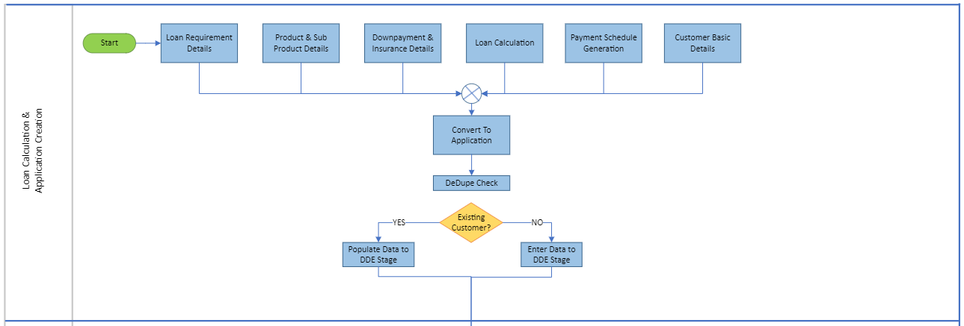
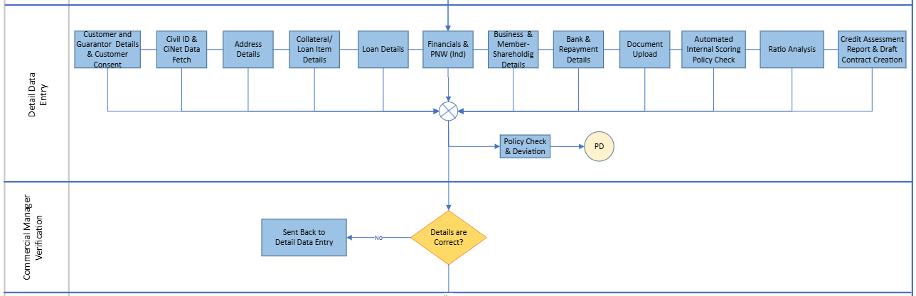

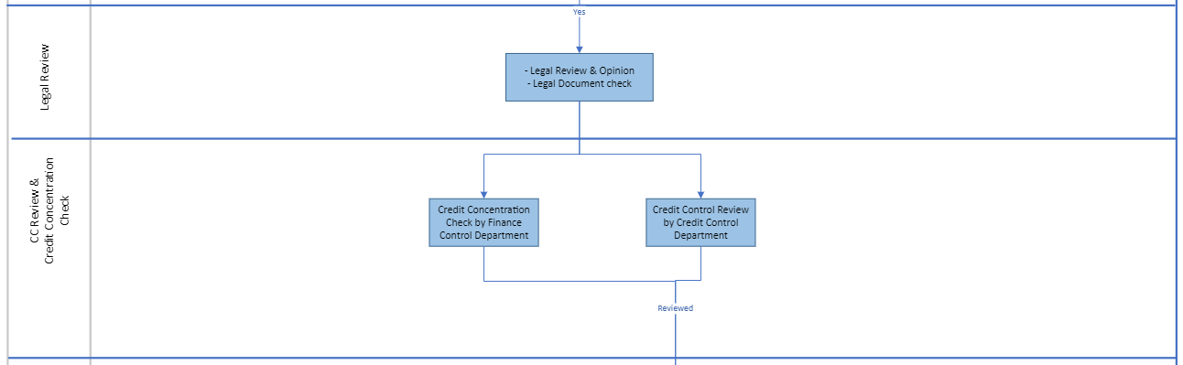
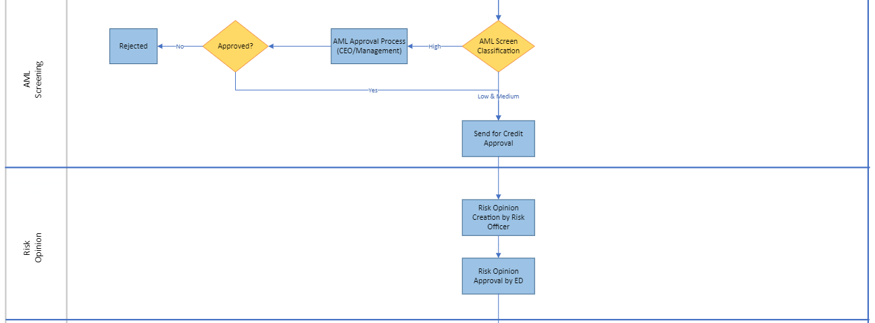
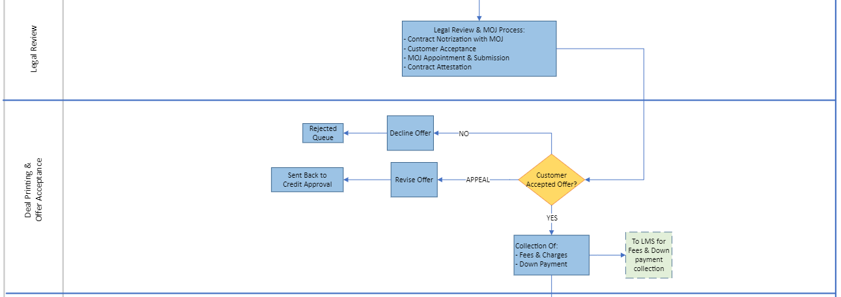

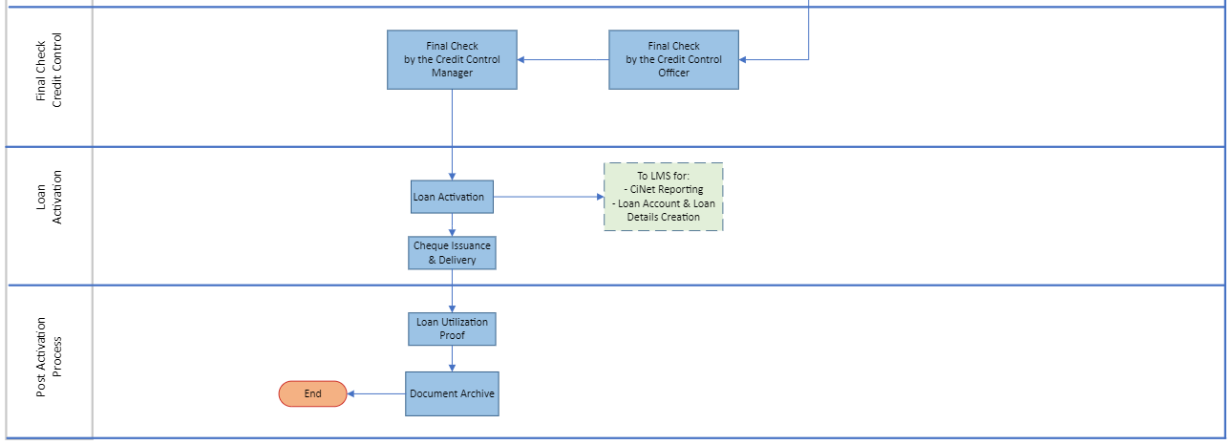

- Staff Loan – KFIC Finance
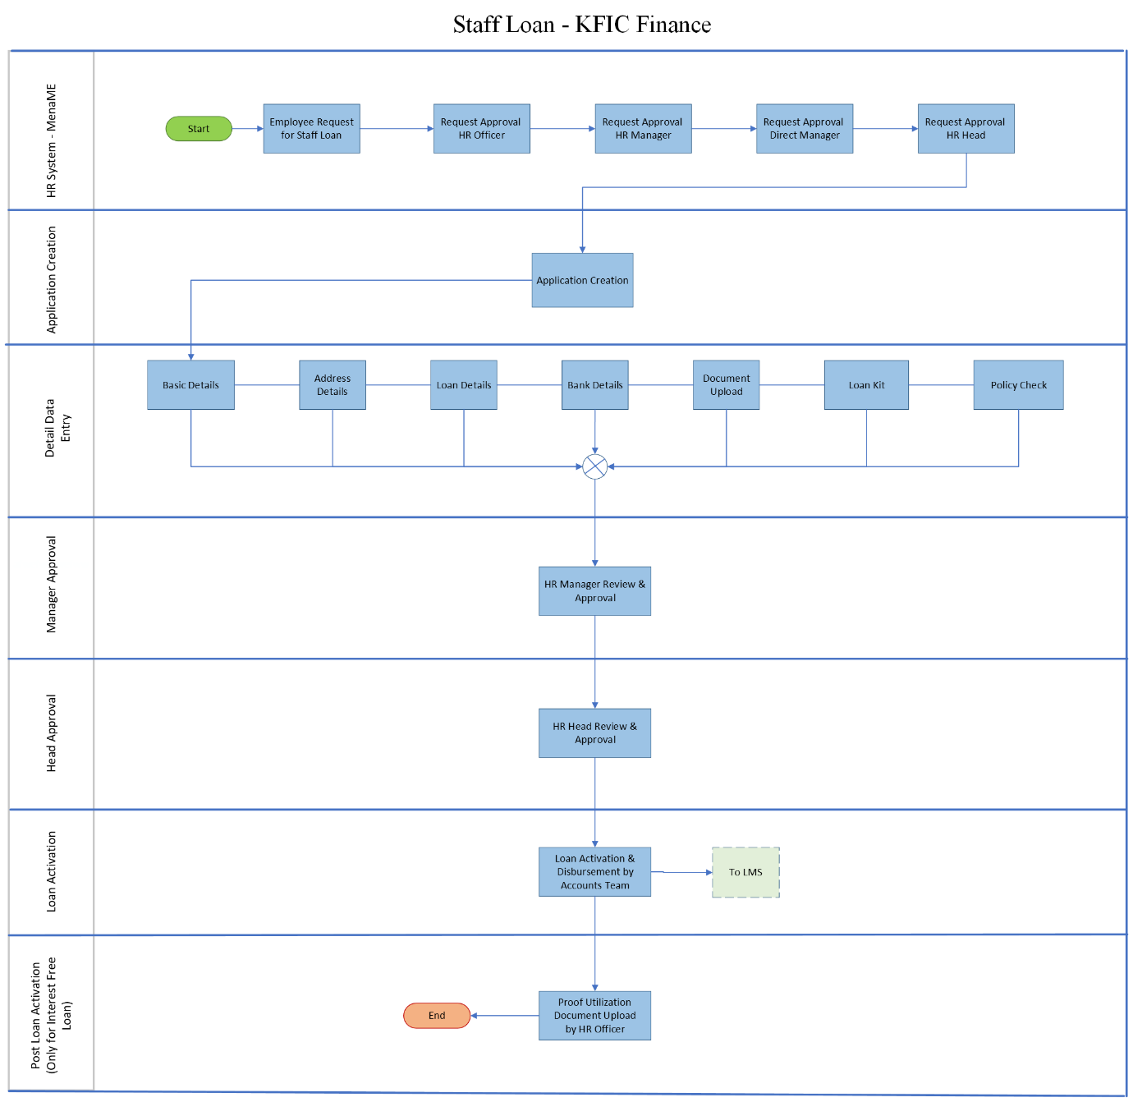

User Role
User role across the KFIC:
Role Name | Description
Retail Sales Officer | Onboard the retail customer and initiate the loan application process
Commercial Sales Officer | Onboard the commercial customer and initiate the loan application process
Retail Sales Manger | Verifying the data captured by the retail sales officer and proceed it ahead for further loan processing
Commercial Sales Manager | Verifying the data captured by the commercial sales officer and proceed it ahead for further loan processing
Credit Control Officer | Responsible for reviewing the loan application processed is as per the CBK guidelines & company policies
Credit Control Manager | Credit Control manager perform the other level of review for the loan application which was sanitized at first level by the Credit Control Officer
Legal Officer | Involved in providing the legal opinion during the loan processing and looks after the contract getting signed and attested in case of commercial loan
Risk, Compliance & AML Officer | Responsible for performing the AML screening of the customer
Risk, Compliance & AML Manager | Reviewing the AML screening done by the AML officer
Associate Director Risk, Compliance & AML | Participate in the loan approval process as per the approval authority matrix
Executive Director Risk, Compliance & AML | Participate in the loan approval process as per the approval authority matrix
Financial Officer | Responsible for performing the financial check of the customer and looks after the loan activation process
Financial Manager | Review the financial check done by the financial officer
CEO | Participate in the loan approval process as per the approval authority matrix
Chairman of Executive Committee | Participate in the loan approval process as per the approval authority matrix
Board Members | Participate in the loan approval process as per the approval authority matrix
Chairman Board of Directors | Participate in the loan approval process as per the approval authority matrix
HR Officer | Capture the required details & documents for an employee requested the staff loan
HR Manager | Participate in the staff loan approval process
HR Head | Participate in the staff loan approval process

Stage Role Mapping

Stagewise Action

Stages | Action
Stages | Approve | Decline | Move To Next | Show Remarks | Comments & Notes | Appeal | Return | Keep In View | Pull Back
Detail Data Entry |  |  | ü | ü | ü
Collection Review | ü | ü | ü | ü | ü |  | ü | ü | ü
Verification |  |  | ü | ü | ü |  | ü | ü | ü
Legal Review |  |  | ü | ü | ü |  | ü | ü | ü
Credit Control Review |  |  | ü | ü | ü |  | ü | ü | ü
Credit Concentration Check |  |  | ü | ü | ü |  | ü | ü | ü
AML Screening & Approval | ü | ü | ü | ü | ü |  | ü | ü | ü
Risk Opinion Checklist & Approval |  |  | ü | ü | ü |  | ü | ü | ü
Credit Approval | ü | ü |  | ü | ü |  | ü | ü | ü
Credit Administration |  |  | ü | ü | ü | ü | ü | ü | ü
Legal Review & MOJ Process |  |  | ü | ü | ü | ü | ü | ü | ü
Deal Printing & Offer Acceptance |  |  | ü | ü | ü | ü | ü | ü | ü
Final Check Credit Control |  |  | ü | ü | ü | ü | ü | ü | ü
Purchase Order Generation |  |  | ü | ü | ü | ü | ü | ü | ü
Loan Activation |  |  | ü | ü | ü | ü | ü | ü | ü
Post Loan Activation |  |  | ü | ü | ü | ü | ü | ü | ü
Document Archive |  |  | ü | ü | ü |  | ü | ü | ü

Application Creation
This feature enables users to create an application by capturing essential customer details. It also facilitates the conversion of prospective customers into applications from various channels, such as branch walk-ins, mobile applications, and websites. This functionality encompasses loan calculation, application creation, conversion, allocation, and processing, serving as the initial phase of the loan origination process.

Loan Simulator
The Loan Simulator feature enables users to calculate instalments by capturing essential details from the prospect. It displays the repayment schedule, including a breakdown of various components such as principal, interest, instalments, insurance, and corresponding outstanding amounts. Additionally, users have the option to print the details and repayment schedule for customer reference.
The user will enter the Product and Sub Product as per customer’s request, after which the associated interest rates will be displayed. Next, the user will input the loan amount required, and the down payment provided by the customer basis of which the finance amount will be computed. The user will also select the loan tenure and repayment frequency, as well as enter any applicable insurance amount and the date of the request. Once all the necessary information is entered, the user will click the Calculate button to perform the computation.
After the calculations are complete, the system will display the simulated parameters, including the instalment amount, total interest payable, start and maturity dates, instalment amount including insurance, and a detailed repayment schedule. Additionally, the user will have the option to print the computation details, which can be shared with the customer for their reference.
Scenario 1:
- The user enters the required details, excluding customer-specific information like Name and Mobile Number.
- The user clicks the "Calculate EMI" button.
- The system computes the simulated details and generates the repayment schedule.
Scenario 2:
- If the user wishes to print and share the simulated details with the prospective customer, they will click the "Print" button.
- The system will prompt the user to enter the Customer Name and Mobile Number before printing the template.
- After the user inputs the customer’s Name and Mobile Number and clicks "Print," the system will download a predefined template with both the simulated details and customer information, which can then be shared with the prospective customer.
- Once the template is generated, the user will click the "Save" button, creating a lead with the customer's name. This lead will then appear in the Application List.
- The user will navigate to the Application List, search for the customer, enter the Customer ID, and perform a customer search. The user can then convert the prospective customer into a loan application.

Navigation:
To validate the record of newly converted lead into application
The following screen will be displayed once the User clicks on Simulator menu.

- Loan Simulator (Secured Loans): Following screen will be displayed in case of collateral backed Product & Sub Product is selected.
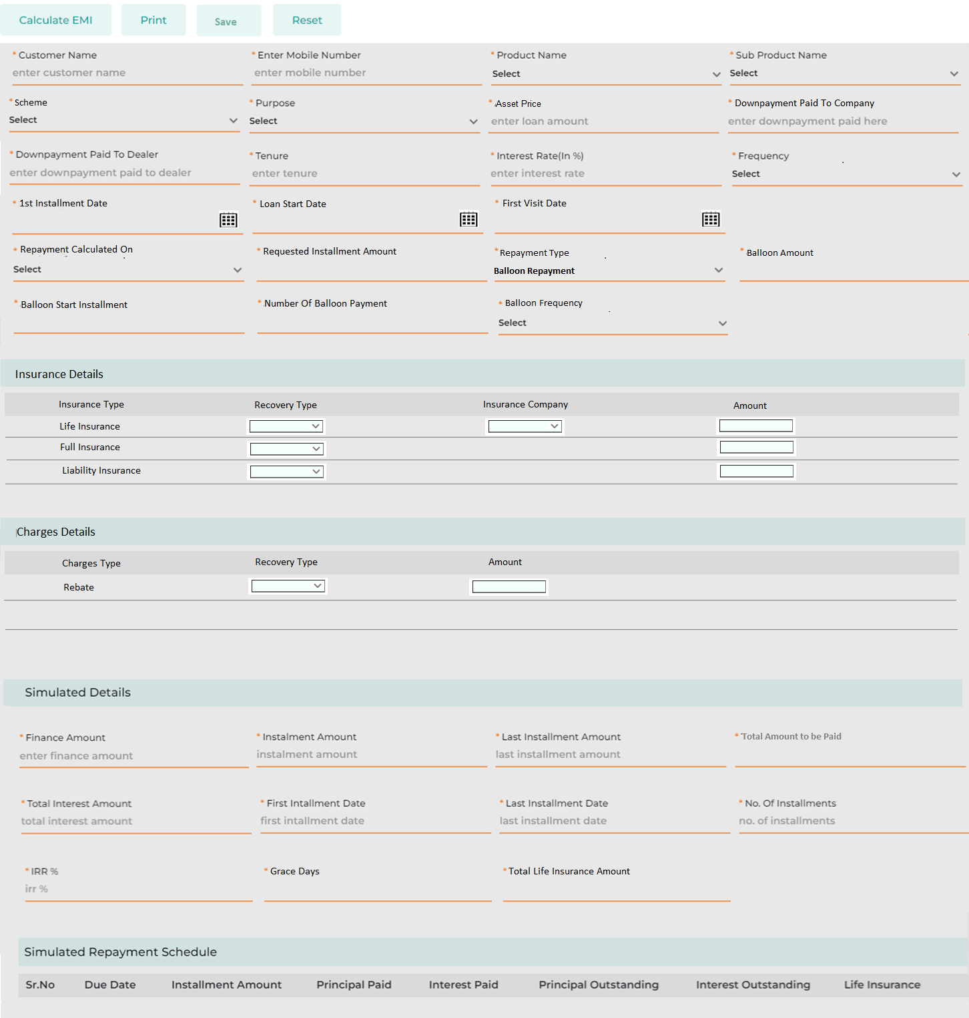
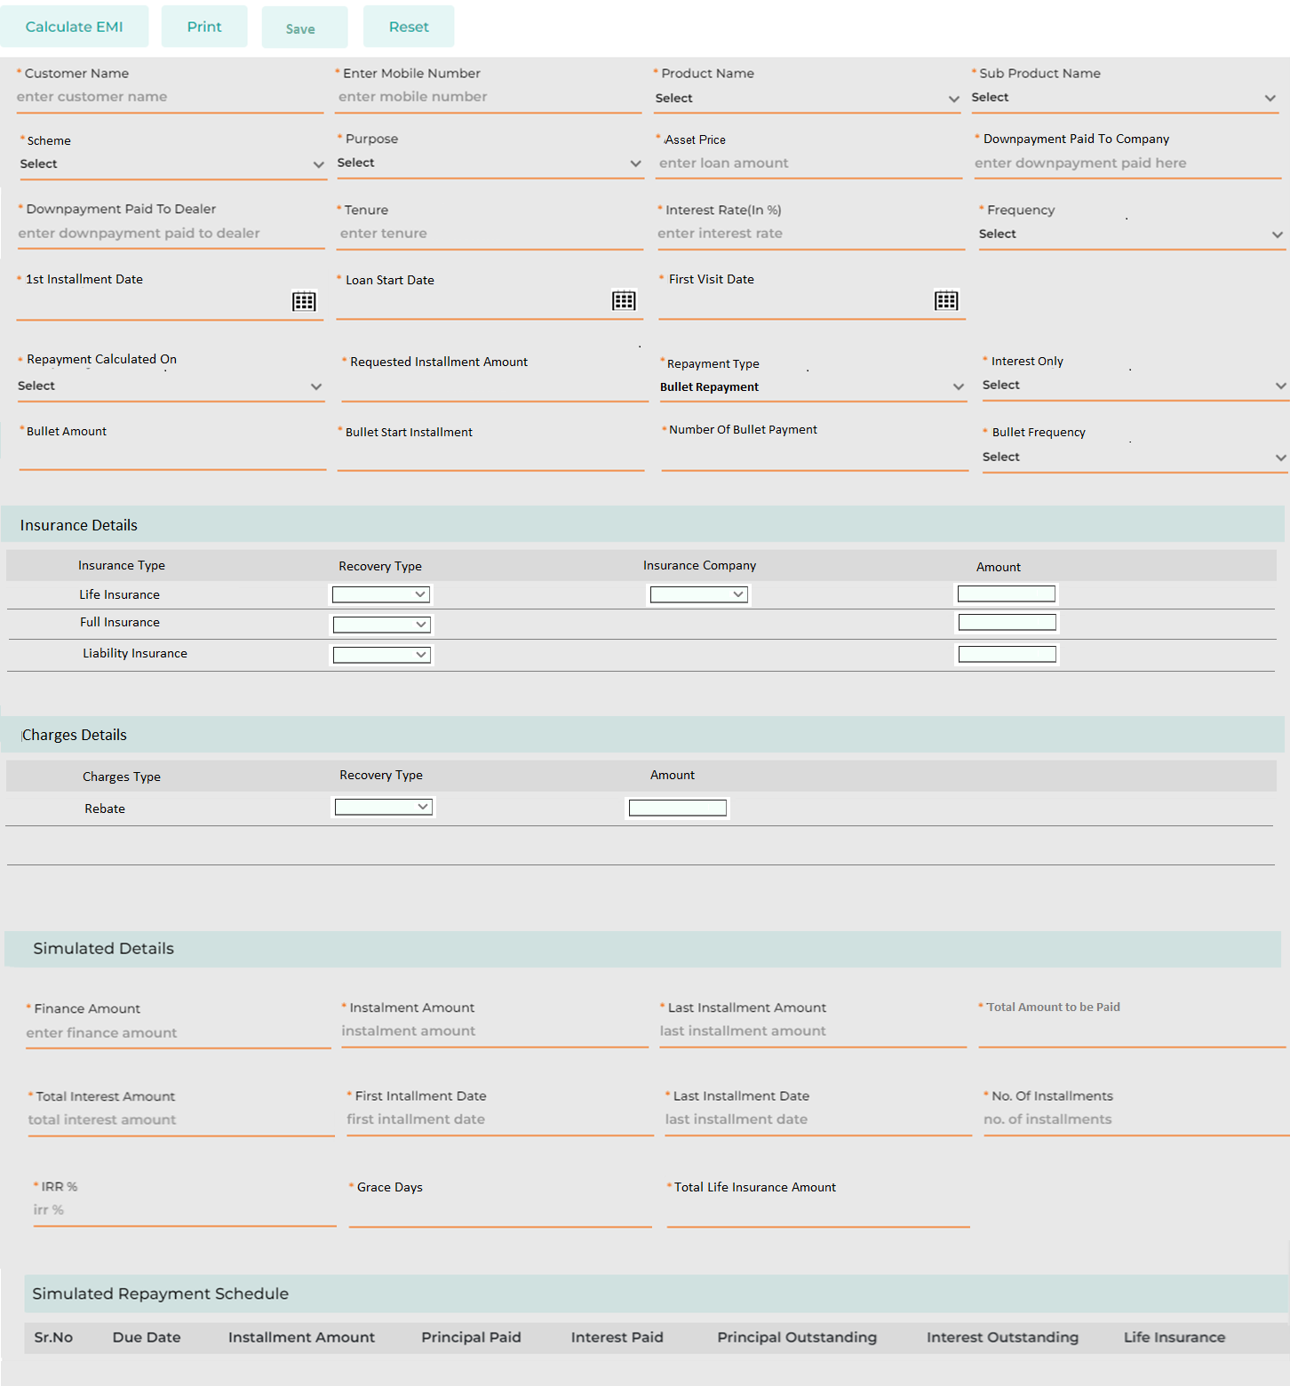
Below are the details specific to the information being displayed above.
Field Name | Field Type | Data Type / Length | Mandatory (Yes/No) | Lookup Key/Master Name | Possible Value | Field Description
 |  |  |  |  |  | Remarks / Validation
Customer Name | Text Box | Varchar | Yes | NA | ShamS Al Kilab | The user will enter Customer name.
Mobile Number | Text Box | Int | No | NA | +965 85635489 | The user will enter customer's mobile number.  Mobile Number pattern will be as follow:  Code +965  Followed by 8 digits
Product Name | Master Dropdown | Varchar | Yes | Facility Master | Retail Vehicle Loan | The user will select the product requested by the customer
Sub-Product | Master Dropdown | Varchar | Yes | Sub-Facility Master | Vehicle Loan New | The user will select the sub-product requested by the customer
Scheme | Master Dropdown | Varchar | Yes | Scheme Master | MotoCorp Dealer Campaign | The user will select the scheme
Purpose | LOV Dropdown | Varchar | Yes |  | Vehicle | The user will select the purpose of loan
Asset Price | Text Box | Float | Yes | NA | 5000 | The user will enter the total price of the asset.
Downpayment Paid To Company | Text Box | Float | Yes | NA | 300 | The user will enter the downpayment to be paid by the customer to KFIC
Downpayment Paid to Dealer | Text Box | Float | Yes | NA | 0 | The user will enter the downpayment to be paid by the customer to the dealer
Tenure | Text Box | Int | Yes | NA | 36 | The user will enter the loan tenure requested by the customer else if configured will be displayed automatically
Interest Rate % | Textbox | Float | Yes | NA | 3.5 | Automatically fetched as per the configuration done in the product master
Frequency | Dropdown |  | Yes |  | - Monthly | The user will need to select the frequency applicable, default monthly
- Quarterly
- Yearly
1st Installment Date | Calendar | Date | Yes |  | 01-10-2024 | The user will enter the 1st Installment date
Loan Start Date | Calendar | Date | Yes |  | 01-10-2024 | The user will enter the date from when the loan is expected to be started.
First Visit Date | Calendar | Date | Yes |  | 01-10-2024 | Will be auto populated as current date
Repayment Calculated On | Dropdown | VARCHAR | Yes |  | 1. Tenure  2. Installment | By defaul Tenure, if selected Installment then field “Requested Installment Amount” to be appeared for the user to enter the requested Installment  In the following scenario, if the system computes the installment amount as KD 180 based on the tenure and frequency, but the customer indicates they can only pay a maximum of KD 160, the user can select “Repayment Calculated” by “Installment.” This action will generate a new repayment schedule based on the customer's requested installment amount.
Requested Installment Amount | Textbox | VARCHAR | Yes | NA |  | Applicable only if the user has selected “Repayment Calculated’ as Installment.  User will enter the requested installment amount
Repayment Type | LOV Dropdown | VARCHAR | Yes | NA | - Balloon Repayment  - Bullet Repayment | The user will select the Repayment Type, whether Balloon or Bullet Repayment type
Dependent fields for Repayment Type - Balloon
Balloon Amount | Textbox | VARCHAR | Yes | NA | 200000 | Applicable only if repayment type selected as Balloon, The user will enter the amount to be considered in each Balloon installment.
Balloon Start Installment | Textbox | VARCHAR | Yes | NA | 3rd | Applicable only if repayment type selected as Balloon.  The user will select the installment number from when the balloon installment will be applicable.
Number Of Balloon Payment | Textbox | VARCHAR | Yes | NA | 2 | The user will enter the number of balloon payment installment across the repayment tenure.
Balloon Frquency | LOV Dropdown | VARCHAR | Yes | NA | - Monthly  - Quarterly  - Yearly | Applicable only if repayment type selected as Balloon.  The user will select the frequency application of the Balloon Installment
Dependent fields for Repayment Type - Bullet
Interest Only | LOV Dropdown | VARCHAR | Yes | NA | - Yes  - No | Applicable only if repayment type selected as Bullet, where the user will select wether Interest is to be considered in monthly installment or both Principal and Interest to be considered.
Bullet Amount | Textbox | VARCHAR | Yes | NA | 200000 | Applicable only if repayment type selected as Bullet, The user will enter the amount to be considered in each Bullet installment.
Bullet Start Installment | Textbox | VARCHAR | Yes | NA | 12th | Applicable only if repayment type selected as Bullet.  The user will select the installment number from when the Bullet installment will be applicable.
Number Of Bullet Payment | Textbox | VARCHAR | Yes | NA | 3 | The user will enter the number/s of Bullet payment installment across the repayment tenure.
Bullet Frquency | LOV Dropdown | VARCHAR | Yes | NA | - Monthly  - Quarterly  - Yearly | Applicable only if repayment type selected as Bullet.  The user will select the frequency application of the Bullet Installment
Insurance Details
Insurance Type | List View | VARCHAR | NA | NA | - Liability Insurance  - Full Insurance  - Life Insurance | The List of Insurance Type configured at the Product & Sub Product will appear in the list.  Insurance Type will be configurable and will be linked to Product & Sub Product.  If the “Insurance Type” is Life Insurance, the user also need to enter the Insurance Company Name. Based on the selected insurance company, the corresponding amount will automatically populate in the 'Amount' field.  Whereas for other Insurance Type, the user will enter the amount.
Recovery Type | LOV Dropdown | VARCHAR |  |  | - Finance  - Upfront | The user will select, whether the amount will be part of Finance or will be paid upfront by the customer.
Insurance Company | Master Dropdown | VARCHAR |  |  | - AXA Insurance  - National Insurance Company | Dependent field basis if the Insurance Type is selected as Life Insurance, the user will select the insurance Company from the dropdown.
Amount | Text Box | VARCHAR | NA | NA | NA | If the “Insurance Type” is Life Insurance, the user also need to enter the Insurance Company Name. Based on the selected insurance company, the corresponding amount will automatically populate in the 'Amount' field.  Whereas for other Insurance Type, the user will enter the amount.
Charges Details
Charges Type | LOV Dropdown | VARCHAR | NA | NA | - Rebate | The List of Charges Type configured at the Product & Sub Product will appear in the list.
Recovery Type | LOV Dropdown | VARCHAR |  |  | - Finance  - Upfront  - Cash Back | The user will select, whether the amount will be part of Finance or will be paid upfront by the customer.  If charges type is Rebate, by default the recovery type will be cash back. The treatment of the cashback will be as included in finance.
Amount | Text Box | VARCHAR | NA | NA | NA | The user will enter the amount
Simulated Details
Finance Amount | Text Box | Float | Yes | NA | 4850 | Total amount to be financed  Computed as follows:  Amount - Total Downpayment + Insurance & Charges where the Recovery Type is selected as “Finance”
Installment Amount | Read Only | Float | Yes | NA | 142 | Displays the simulated instalment amount after computation.
Last Installment Amount | Read Only | Float | Yes | NA | 160 | Displays the simulated last instalment amount after computation.
Total Amount to be Paid | Read Only | Float | Yes | NA | 5300 | Displays the simulated Total amount paid after computation.
Total Interest Amount | Read Only | Float | Yes | NA | 450 | Displays the total Interest amount across the loan tenure.
First Instalment Date | Read Only | Date | Yes | NA | 01-10-2024 | Displays the start date of the loan.
Last Installment Date | Read Only | Date | Yes | NA | 01-10-2027 | Displays the maturity date of the loan on basis of the tenure defined.
No. of Instalments | Read Only | Int | Yes | NA | 36 | Displays the number of instalments on basis of the tenure and frequency defined.
IRR % | Read Only | Int | Yes | NA | 9 | Displays the profitability from the loan computed
Grace Days | Read Only | Int | Yes | NA | 9 | Computed as the difference between the Loan Start Date & the 1st Installment Date in days.
Total Life Insurance Amount | Read Only | Int | Yes | NA | 350 | Summation of the Life Insurance component from the repayment schedule.
Simulated Repayment Schedule
Sr. No. | List View | NA | Yes | NA |  | Repayment schedule generated should have breakage for each 5-year tenure reflecting the interest rate change
Due Date | List View | NA | Yes | NA
Installment Amount | List View | NA | Yes | NA
Principal Paid | List View | NA | Yes | NA
Interest Paid | List View | NA | Yes | NA
Principal Outstanding | List View | NA | Yes | NA
Interest Outstanding | List View | NA | Yes | NA
Life Insurance | List View | NA | Yes | NA
Action Button
Calculate EMI | Button | Button | Button | NA |  | Calculate EMI button lets the user compute the instalments on basis of the details entered  Customer Name & Mobile Number is non-mandatory to perform the simulation.
Print | Button | Button | Button | NA |  | Print button allows the user to generate a template highlighting the customer’s name, loan amount requested along with the computation & repayment schedule  The “Print” button will only be enabled after the user has performed the computation by clicking on “Calculate EMI” and entered both the Customer Name and Mobile Number.
Save | Button | Button | Button | NA |  | Allows the user to Save the customer details as a Lead in the Application List  The “Save” button will only be enabled after the user has performed the computation by clicking on “Calculate EMI” and entered both the Customer Name and Mobile Number.
Reset | Button | Button | Button | NA |  | Reset button allows the User to reset all the field details entered allowing to re-enter the details again.

- Loan Simulator (Un-Secured Loans): Following screen will be displayed in case of non-collateral Product & Sub Product is selected.
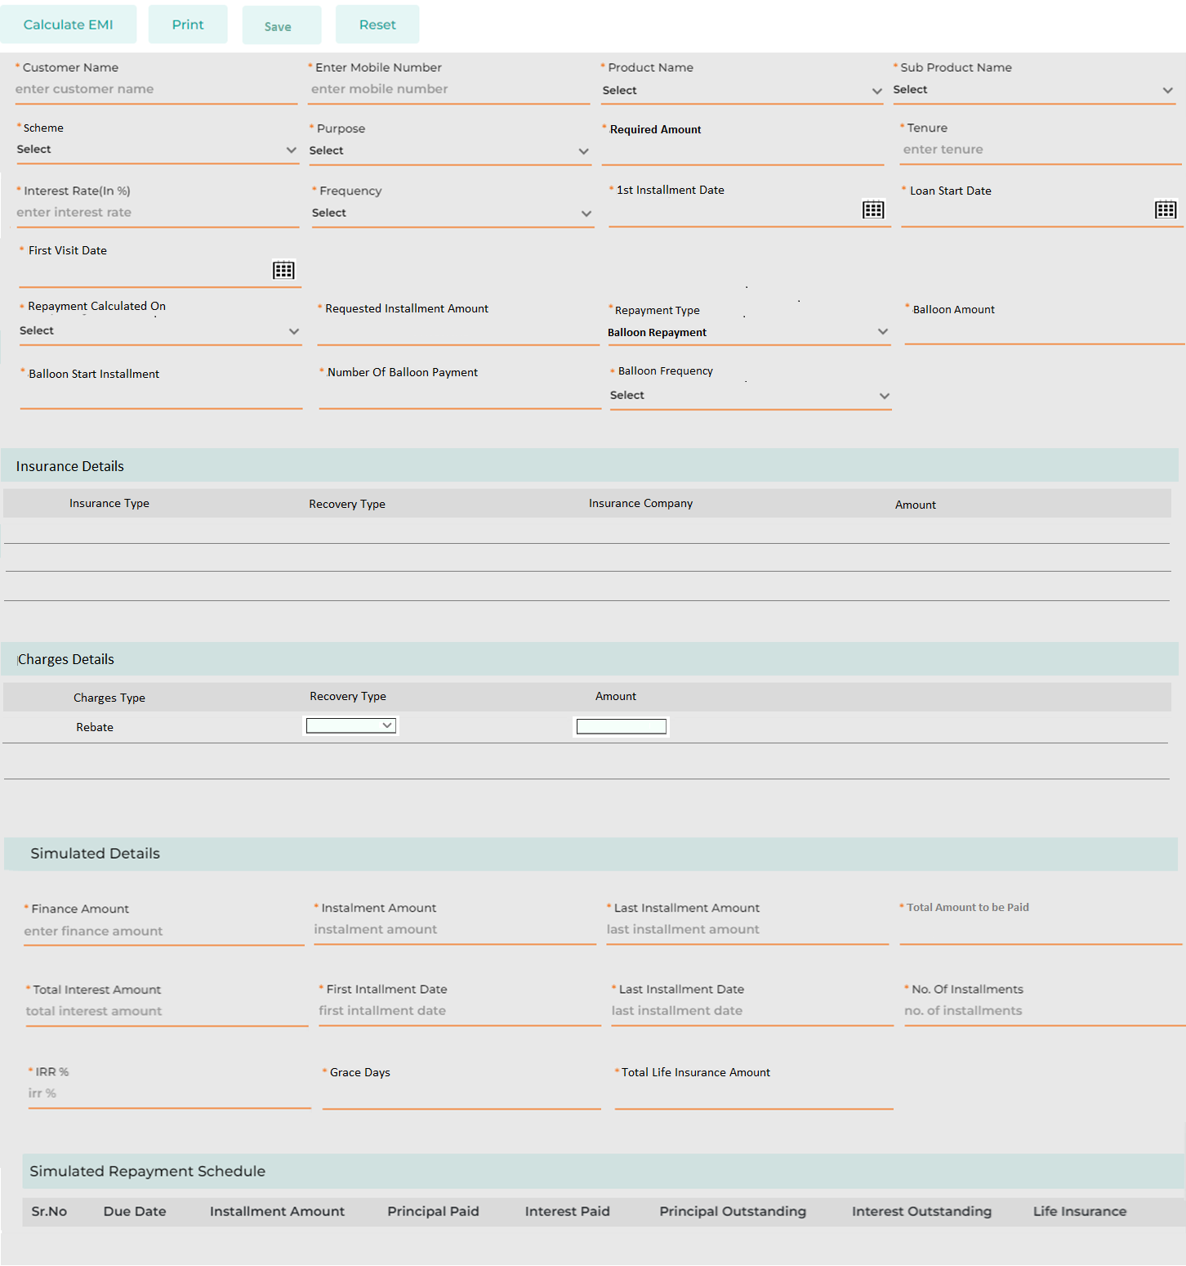
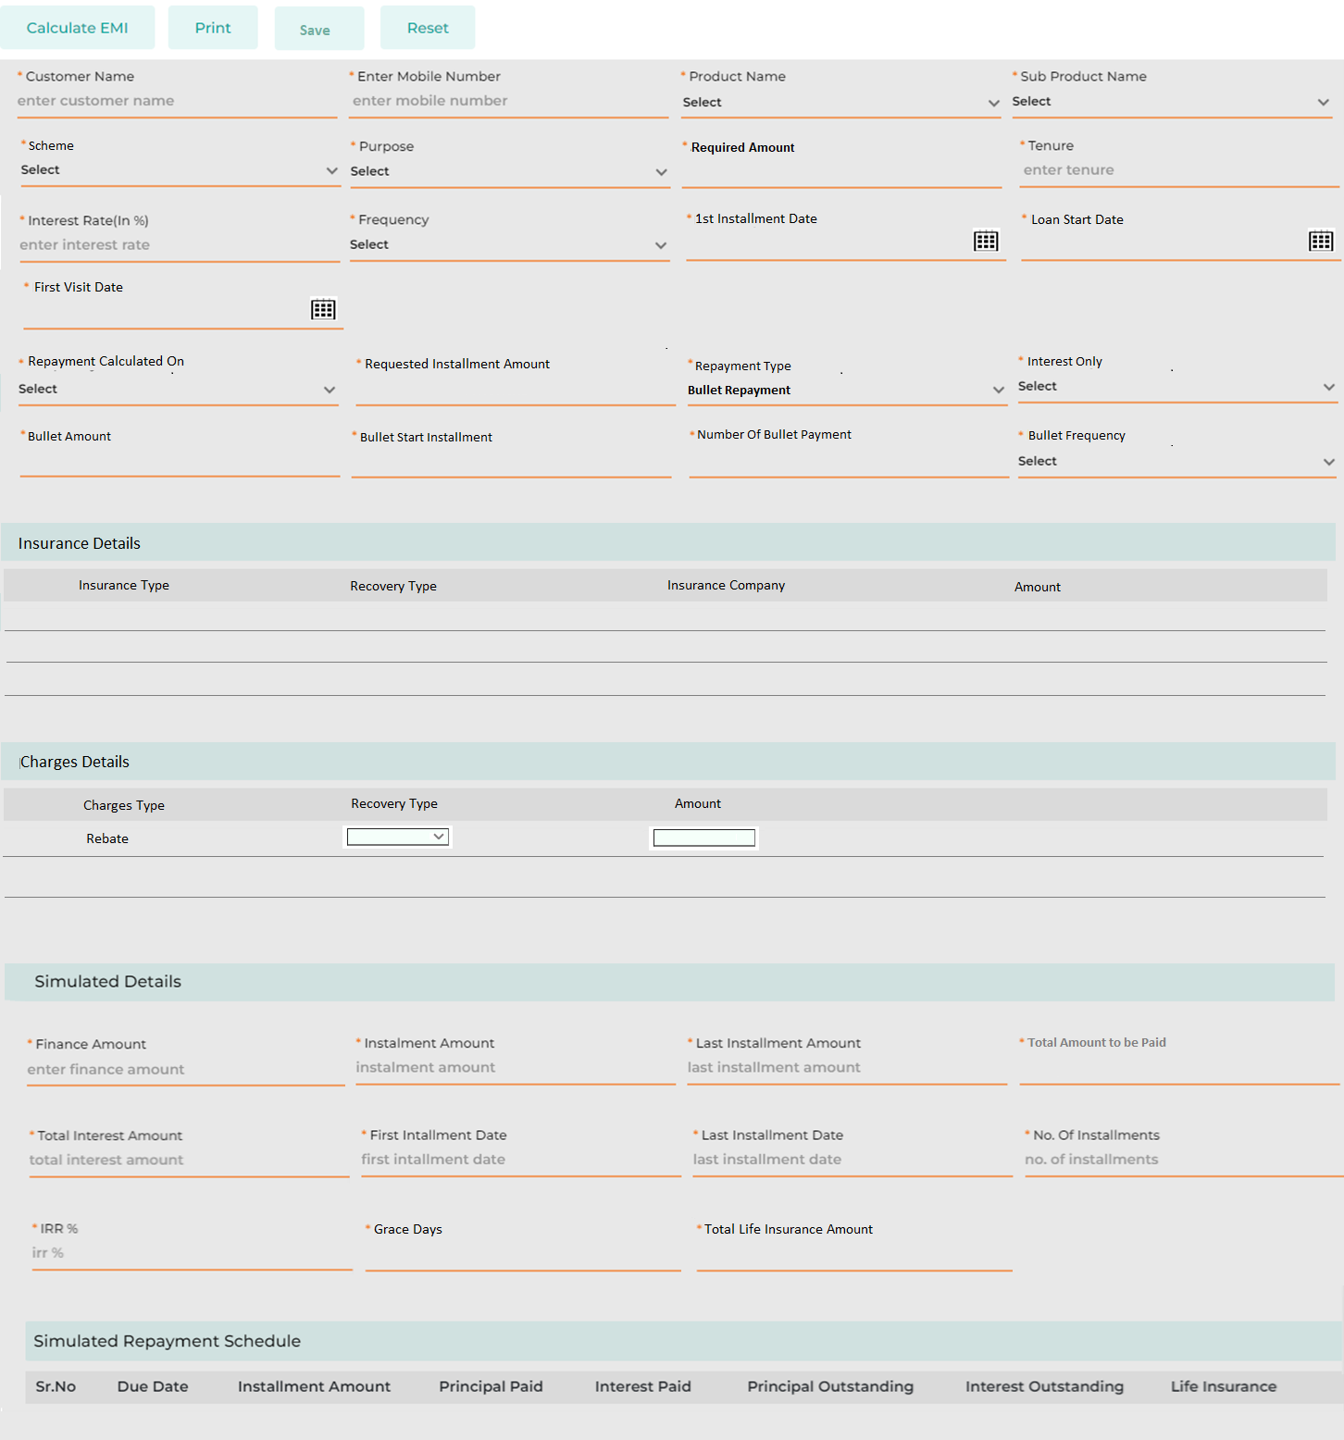
Field Name | Field Type | Data Type / Length | Mandatory (Yes/No) | Lookup Key/Master Name | Possible Value | Field Description
 |  |  |  |  |  | Remarks / Validation
Customer Name | Text Box | Varchar | Yes | NA | ShamS Al Kilab | The user will enter Customer name.
Mobile Number | Text Box | Int | No | NA | +965 8563548 | The user will enter customer's mobile number.  Mobile Number pattern will be as follow:  Code +965  Followed by 8 digits
Product Name | Master Dropdown | Varchar | Yes | Facility Master | Retail Vehicle Loan | The user will select the product requested by the customer
Sub-Product | Master Dropdown | Varchar | Yes | Sub-Facility Master | Vehicle Loan New | The user will select the sub-product requested by the customer
Scheme | Master Dropdown | Varchar | Yes | Scheme Master | MotoCorp Dealer Campaign | The user will select the scheme
Purpose | LOV Dropdown | Varchar | Yes |  | Vehicle | The user will select the purpose of loan
Required Amount | Text Box | Float | Yes | NA | 5000 | The user will enter the amount requested by the customer
Tenure | Text Box | Int | Yes | NA | 36 | The user will enter the loan tenure requested by the customer else if configured will be displayed automatically
Interest Rate % | Textbox | Float | Yes | NA | 3.5 | Automatically fetched as per the configuration done in the product master
Frequency | Dropdown |  | Yes |  | - Monthly | The user will need to select the frequency applicable, default monthly
 |  |  |  |  | - Quarterly
 |  |  |  |  | - Half Yearly
 |  |  |  |  | - Yearly
1st Installment Date | Calendar | Date | Yes |  | 01-10-2024 | The user will enter the 1st Instalment date
Loan Start Date | Calendar | Date | Yes |  | 01-10-2024 | The user will enter the date from when the loan is expected to be started.
First Visit Date | Calendar | Date | Yes |  | 01-10-2024 | Will be auto populated as current date
Repayment Calculated On | Dropdown | VARCHAR | Yes |  | 1. Tenure  2. Installment | By defaul Tenure, if selected Installment then field “Requested Installment Amount” to be appeared for the user to enter the requested Installment  In the following scenario, if the system computes the installment amount as KD 180 based on the tenure and frequency, but the customer indicates they can only pay a maximum of KD 160, the user can select “Repayment Calculated” by “Installment.” This action will generate a new repayment schedule based on the customer's requested installment amount.
Requested Installment Amount | Textbox | VARCHAR | Yes | NA | NA | Applicable only if the user has selected “Repayment Calculated’ as Installment.  User will enter the requested installment amount
Repayment Type | LOV Dropdown | VARCHAR | Yes | NA | - Balloon Repayment  Bullet Repayment | The user will select the Repayment Type, whether Balloon or Bullet Repayment type
Dependent fields for Repayment Type - Balloon
Balloon Amount | Textbox | VARCHAR | Yes | NA | 200000 | Applicable only if repayment type selected as Balloon, The user will enter the amount to be considered in each Balloon installment.
Balloon Start Installment | Textbox | VARCHAR | Yes | NA | 3rd | Applicable only if repayment type selected as Balloon.  The user will select the installment number from when the balloon installment will be applicable.
Number Of Balloon Payment | Textbox | VARCHAR | Yes | NA | 2 | The user will enter the number of balloon payment installment across the repayment tenure.
Balloon Frquency | LOV Dropdown | VARCHAR | Yes | NA | - Monthly  - Quarterly  Yearly | Applicable only if repayment type selected as Balloon.  The user will select the frequency application of the Balloon Installment
Dependent fields for Repayment Type - Bullet
Interest Only | LOV Dropdown | VARCHAR | Yes | NA | - Yes  No | Applicable only if repayment type selected as Bullet, where the user will select wether Interest is to be considered in monthly installment or both Principal and Interest to be considered.
Bullet Amount | Textbox | VARCHAR | Yes | NA | 200000 | Applicable only if repayment type selected as Bullet, The user will enter the amount to be considered in each Bullet installment.
Bullet Start Installment | Textbox | VARCHAR | Yes | NA | 12th | Applicable only if repayment type selected as Bullet.  The user will select the installment number from when the Bullet installment will be applicable.
Number Of Bullet Payment | Textbox | VARCHAR | Yes | NA | 3 | The user will enter the number/s of Bullet payment installment across the repayment tenure.
Bullet Frquency | LOV Dropdown | VARCHAR | Yes | NA | - Monthly  - Quarterly  Yearly | Applicable only if repayment type selected as Bullet.  The user will select the frequency application of the Bullet Installment
Insurance Details
Insurance Type | List View | VARCHAR | NA | NA | - Liability Insurance  - Full Insurance  - Life Insurance | The List of Insurance Type configured at the Product & Sub Product will appear in the list.  Insurance Type will be configurable and will be linked to Product & Sub Product.  If the “Insurance Type” is Life Insurance, the user also need to enter the Insurance Company Name. Based on the selected insurance company, the corresponding amount will automatically populate in the 'Amount' field.  Whereas for other Insurance Type, the user will enter the amount.
Recovery Type | LOV Dropdown | VARCHAR |  |  | - Finance  - Upfront | The user will select, whether the amount will be part of Finance or will be paid upfront by the customer.
Insurance Company | Master Dropdown | VARCHAR |  |  | - AXA Insurance  - National Insurance Company | Dependent field basis if the Insurance Type is selected as Life Insurance, the user will select the insurance Company from the dropdown.
Amount | Text Box | VARCHAR | NA | NA | NA | If the “Insurance Type” is Life Insurance, the user also need to enter the Insurance Company Name. Based on the selected insurance company, the corresponding amount will automatically populate in the 'Amount' field.  Whereas for other Insurance Type, the user will enter the amount.
Charges Details
Charges Type | LOV Dropdown | VARCHAR | NA | NA | Rebate | The List of Charges Type configured at the Product & Sub Product will appear in the list.
Recovery Type | LOV Dropdown | VARCHAR |  |  | - Finance  - Upfront | The user will select, whether the amount will be part of Finance or will be paid upfront by the customer.
Amount | Text Box | VARCHAR | NA | NA | NA | The user will enter the amount
Simulated Details
Finance Amount | Text Box | Float | Yes | NA | 5150 | Total amount to be financed  Computed as follows:  Amount - Total Downpayment + Insurance & Charges where the Recovery Type is selected as “Finance”
Installment Amount | Read Only | Float | Yes | NA | 142 | Displays the simulated instalment amount after computation.
Last Installment Amount | Read Only | Float | Yes | NA | 160 | Displays the simulated last instalment amount after computation.
Total Amount to be Paid | Read Only | Float | Yes | NA | 5300 | Displays the simulated Total amount paid after computation.
Total Interest Amount | Read Only | Float | Yes | NA | 450 | Displays the total Interest amount across the loan tenure.
First Instalment Date | Read Only | Date | Yes | NA | 01-10-2024 | Displays the start date of the loan.
Last Installment Date | Read Only | Date | Yes | NA | 01-10-2027 | Displays the maturity date of the loan on basis of the tenure defined.
No. of Instalments | Read Only | Int | Yes | NA | 36 | Displays the number of instalments on basis of the tenure and frequency defined.
IRR % | Read Only | Int | Yes | NA | 9 | Displays the profitability from the loan computed
Simulated Repayment Schedule
Sr. No. | List View | NA | Yes | NA
Due Date | List View | NA | Yes | NA
Installment Amount | List View | NA | Yes | NA
Principal Paid | List View | NA | Yes | NA
Interest Paid | List View | NA | Yes | NA
Principal Outstanding | List View | NA | Yes | NA
Interest Outstanding | List View | NA | Yes | NA
Life Insurance | List View | NA | Yes | NA
Action Button
Calculate EMI | Button | Button | Button | NA |  | Calculate EMI button lets the user compute the instalments on basis of the details entered  Customer Name & Mobile Number is non-mandatory to perform the simulation.
Print | Button | Button | Button | NA |  | Print button allows the user to generate a template highlighting the customer’s name, loan amount requested along with the computation & repayment schedule  The “Print” button will only be enabled after the user has performed the computation by clicking on “Calculate EMI” and entered both the Customer Name and Mobile Number.
Save | Button | Button | Button | NA |  | Allows the user to Save the customer details as a Lead in the Application List  The “Save” button will only be enabled after the user has performed the computation by clicking on “Calculate EMI” and entered both the Customer Name and Mobile Number.
Reset | Button | Button | Button | NA |  | Reset button allows the User to reset all the field details entered allowing to re-enter the details again.

Application List
The Application List serves as a queue displaying all leads converted by retail and commercial sales users that are still pending application conversion. It also allows users to create new applications directly. Leads generated from various channels will appear in this queue, enabling users to perform loan calculations, capture essential details, conduct duplicate checks, and review existing customer exposure before converting a lead into a loan application.

Navigation:
Hamburger Menu à Sales à Application à Application List
The following screen will be displayed once the User clicks on Application List.
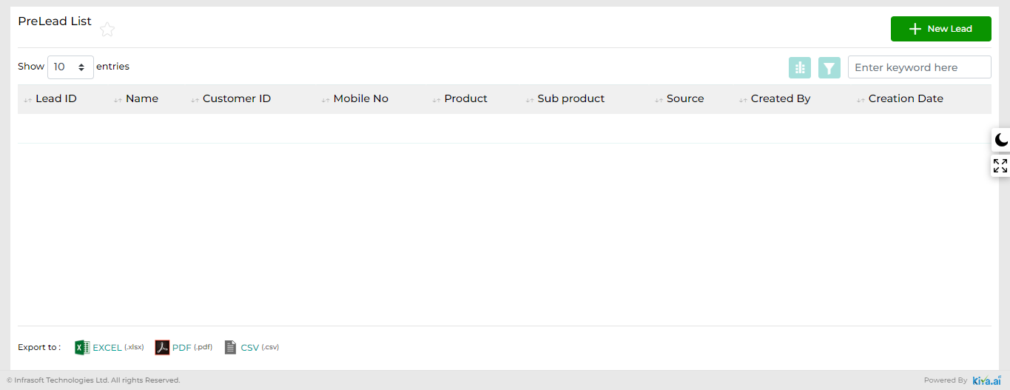

Below are the details specific to the information being displayed above.
Field Name | Field Type | Data Type / Length | Mandatory (Yes/No) | Look Up Value/ Master Name | Possible Value | Field Description
 |  |  |  |  |  | Remarks / Validation
Lead Id | List View | VARCHAR | Yes | NA | NA | Fetched as per the lead created via various channels
 |  |  |  |  |  | Clicking on the Lead Id (Hyperlink), New Application form will be open with auto-populated values such as Name, Mobile Number, Product, & Sub Product which were saved earlier and did not convert to an application.
Name | List View | VARCHAR | Yes | NA | NA | Name of the prospect
Customer ID | List View | VARCHAR | Yes | NA | NA | Customer identification number
Mobile No | List View | VARCHAR | Yes |  | NA | Mobile Number to be displayed as captured at the time of lead capturing.
Product | List View | VARCHAR | Yes | NA | NA | Product I which the prospect is interested to apply for
Sub Product | List View | VARCHAR | Yes | NA | NA | Product I which the prospect is interested to apply for
Source | List View | VARCHAR | Yes | NA | NA | Source name will be auto populated as “Face to Face” in case the application was created by the branch user or in case created via the digital channel it will be mentioned as “Digital Channel”
Created By | List View | VARCHAR | Yes | NA | NA | Auto-populated as per the username who had created the lead.
Creation Date | List View | VARCHAR | Yes | NA | NA | Auto-populated by the system.
Action Button
New Application | Button | NA | NA | NA | NA | Users will click on the New Application button, in order to proceed with creating the new application.

New Application
The New Application feature enables retail and commercial sales users to create leads by capturing essential prospect customer details for initial lead generation. Users can then perform CIF searches within the system to retrieve customer information, distinguishing between existing and new customers. The system utilizes various parameters to match and display results.
The screen will be configured for KFIC's business unit, such as Retail and Commercial, allowing the respective sales teams to initiate loan processes for both types. The user will select the Application type as “New Application”, and the Customer Category will be either Individual or Company based as per the user’s business unit who will be proceeding with the application. For the Retail business unit, the customer category will be set to "Individual" by default. However, for the Commercial business unit, the user will have the option to select the customer category as either "Individual" or "Company." The user will first select the nationality (Kuwaiti or Non-Kuwaiti), then choose the ID type and enter the ID number. If the ID type is selected as Civil ID and the nationality is Kuwaiti, the system will allow the user to retrieve customer details from the Civil ID interface by clicking the "Scan Civil ID" button. After that, the user can click the "Search" button to initiate the customer search.
Once a prospective customer is identified as new, they can be seamlessly converted to an application by capturing more detailed information. If the customer is identified as existing, the system will display their current exposure and streamline data entry by populating data from the customer file (CIF) data into the new application with a simple click of the “Convert To App” button. Furthermore, the system allows users to make amendments at this initial stage of loan processing during the detailed data entry phase.
The following data points to be fetched from the Civil Id interface on the click of Fetch button and will be stored and utilized during the detail data entry stage.
- Name - English and Arabic
- Civil ID Number
- Gender - English and Arabic
- Nationality - English and Arabic
- Birth Date - YYYY-MM-DD
- Issue Date - YYYY-MM-DD
- Expiry Date - YYYY-MM-DD
- District
- Block
- Street
- Building No
- Unit Type
- Unit No
- Floor
- Blood Type

Navigation:
Hamburger Menu à Sales à Application à New Application

11.3.1 New Application – Individual Customer
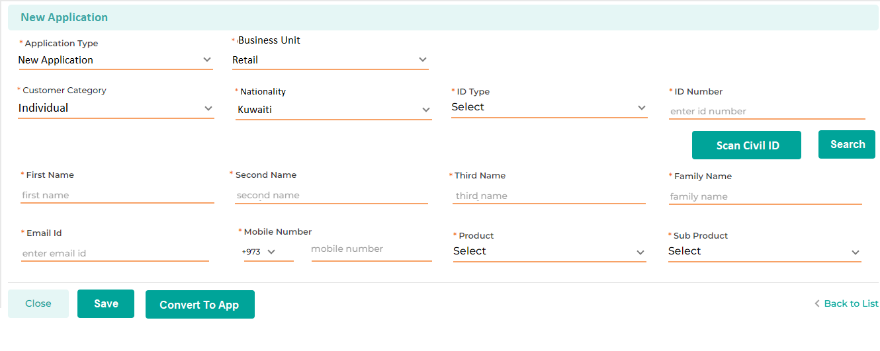
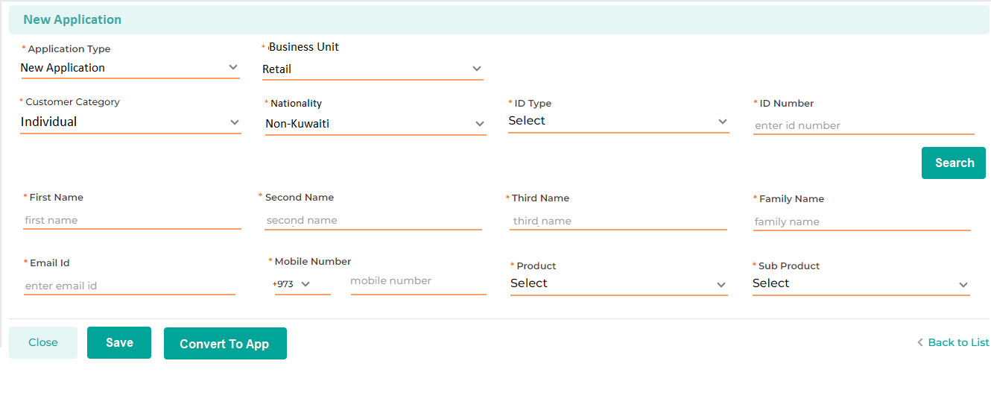
Below are the details specific to the information being displayed above.
Field Name | Field Type | Data Type / Length | Mandatory | Look-Up Key/ Master Name | Possible Value | Field Description
 |  |  |  |  |  | Remarks / Validation
Application Type | LOV Dropdown | VARCHAR | Yes | NA | - New Application  - Loan Transfer  - Loan Renewal  - Loan Reschedule  - Loan Rearrangement  - Credit Limit Creation  - Credit Limit Utilization | The user will select the application type for which the customer onboarding is to be initiated as per customer’s request.
Business Unit | Read Only | VARCHAR | Yes | NA | - Retail  - Commercial | Business Unit will be auto populated as the Business unit defined for the specific user role who will be initiating the application.
Customer Category | Dropdown | Varchar | Yes | CUSTTYPE | Individual | Will be dependent on the Business Unit
 |  |  |  |  | Company | For the Retail business unit, the customer category will be set to "Individual" by default. However, for the Commercial business unit, the user will have the option to select the customer category as either "Individual" or "Company."  Based on the Customer Category, the following related fields, and lists of values (LOVs) should be displayed to capture the details of the prospective customer:
Nationality | Master Dropdown | VARCHAR | Yes | Country Master | - Kuwaiti  - KSA  - UAE  - Egypt  - India | The user will select the Nationality from the list of country
ID Type | Master Dropdown | VARCHAR | Yes | IDTYPEs | Civil ID | The user will select the ID Type from the dropdown values such as Civil ID
 |  |  |  |  | Passport | As the customer category is Individual, the dropdown values for the ID type linked to the Customer category should be displayed as mentioned.
ID Number | Text Box | NVARCHAR | Yes | NA | NA | This will let the User enter the applicant’s ID number.
 |  |  |  |  |  | Allows the user to enter only 12-digit number if ID type selected as Civil Id
Scan Civil ID | Button | Button | Button | NA | NA | The user will Click on the button to fetch the detail via the Civil ID interface.  If the Nationality is selected as “Kuwait” the “Scan Civil Id” button will be enabled allowing the user to fetch the details from the Civil ID interface. Whereas if selected other than Kuwait the “Scan Civil Id” button will be disabled not allowing the user to trigger the interface and the user will capture the details manually.
Search | Button | Button | Button | NA | NA | Allow the user to do the Dedupe customer search basis of the data entered and will let the user know whether the prospect customer is a new or existing to KFIC  Will only enabled once the required data points (ID type & ID Number) are captured for performing the dedupe search
First Name | Text box | VARCHAR | Yes | NA | NA | User will enter the customer’s first name in English  Will be populated automatically if fetched via the Civil ID interface.
Second Name | Text box | VARCHAR | Yes | NA | NA | User will enter the customer’s second name in English  Will be populated automatically if fetched via the Civil ID interface.
Third Name | Text box | VARCHAR | Yes | NA | NA | User will enter the customer’s third name in English  Will be populated automatically if fetched via the Civil ID interface.
Family Name | Text box | VARCHAR | Yes | NA | NA | User will enter the customer’s family name in English  Will be populated automatically if fetched via the Civil ID interface.
Email Id | Text box | VARCHAR | Yes | NA | shams@gmail.com | User will enter the customer’s Email Id
Phone No | Numeric | INT | Yes | NA | +965 7384527 | User will enter the customer’s mobile number
Product | Master Dropdown | VARCHAR | Yes | Facility Master | Vehicle Loan | This will let the User select the applicant’s chosen product.
 |  |  |  |  | Personal Loan
 |  |  |  |  |  | If the Business Unit is Retail, all the Retail Product to be appear in the dropdown.
Sub Product | Master Dropdown | VARCHAR | Yes | Sub Facility Master | Vehicle Loan New | This will let the User select the applicant’s chosen sub product attach to the product selected.
 |  |  |  |  | Vehicle Loan Used (Agency)
 |  |  |  |  | Vehicle Loan Used (Other)
 |  |  |  |  | Housing Loan
 |  |  |  |  | Consumer Loan
Action Button
Close | Button | Button | Button | NA | NA | The close button will reset the screen by remove any of the prior data entered partially
Save | Button | Button | Button | NA | NA | The save button will let the User save the entered data in the application list, which can further be converted into an application  Clicking the "Save" button will trigger a message to be sent to the prospective customer's mobile number, notifying them about the initiation of the lead and their engagement with KFIC.
Convert To App | Button | Button | Button | NA | NA | New Customer  After the dedupe search, if the prospect customer appears to be the new one then the user will click on "Convert to App" button to convert the prospect customer into an application and further start the loan process.  Existing Customer  After the dedupe search, if the prospect customer appears to be the existing one the user will select the specific search output and click on “Convert To App” which will convert the prospect customer into an application and also fetch the basic customer information to various screens. Also, the system will allow the user to update the data being fetched.  On click of “Convert To App” in case of Existing Customer, customer CIF data will be fetched in the following screens of New Application's Detail Data Entry stage:  Basic Details, Address Details, Contact Details, KYC Documents, Employment Details, and Bank Details.  “Convert To App” button will only be enabled once the user has performed the dedupe customer search by clicking on the “Search” button.

11.3.2 New Application – Corporate Customer
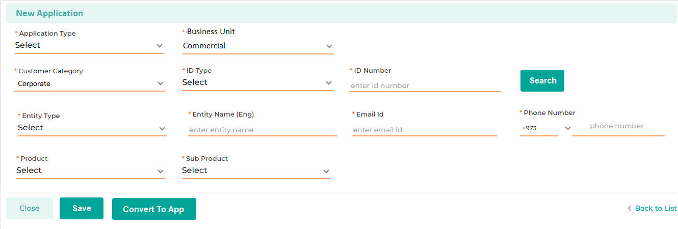
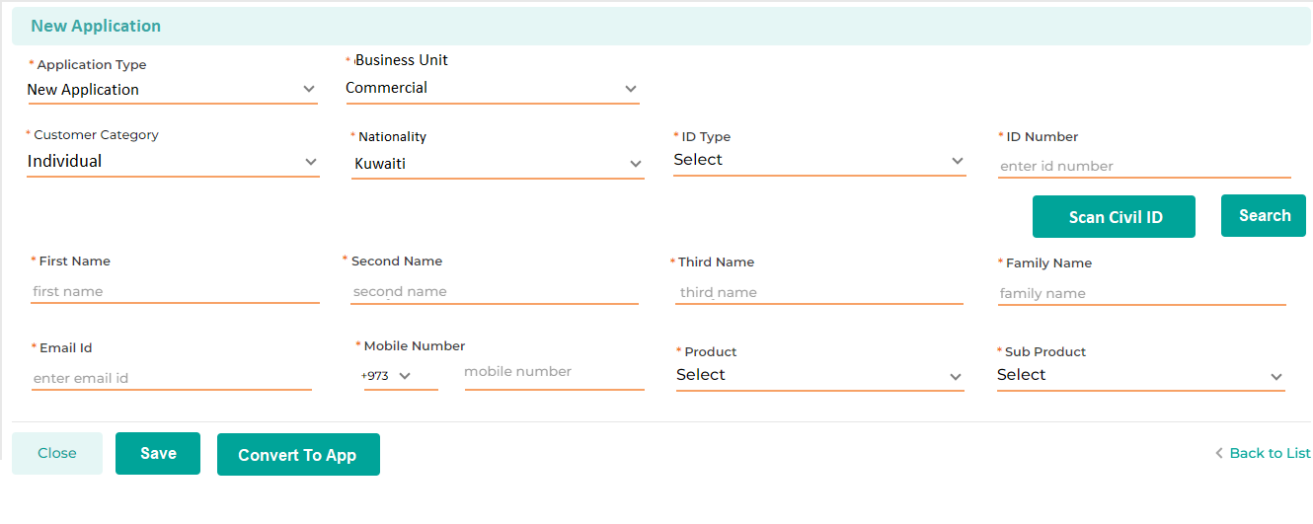
Field Name | Field Type | Data Type / Length | Mandatory | Look-Up Key/ Master Name | Possible Value | Field Description
 |  |  |  |  |  | Remarks / Validation
Application Type | LOV Dropdown | VARCHAR | Yes | NA | - New Application  - Loan Transfer  - Loan Renewal  - Loan Reschedule  - Loan Rearrangement  - Credit Limit Creation  - Credit Limit Utilization | The user will select the application type for which the customer onboarding is to be initiated as per customer’s request.
Business Unit | Read Only | VARCHAR | Yes | NA | - Retail  - Commercial | Business Unit will be auto populated as the Business unit defined for the specific user role who will be initiating the application.
Customer Category | Dropdown | Varchar | Yes | CUSTTYPE | Individual | Will be dependent on the Business Unit
 |  |  |  |  | Company | For the Retail business unit, the customer category will be set to "Individual" by default. However, for the Commercial business unit, the user will have the option to select the customer category as either "Individual" or "Company."  Based on the selected Customer Category, the following related fields, and lists of values (LOVs) should be displayed to capture the details of the prospective customer:
ID Type | Master Dropdown | VARCHAR | Yes | IDTYPEs | CR No | The user will select the ID Type from the dropdown values such as CR No
 |  |  |  |  | Civil ID | As the customer category is Company, the dropdown values for the ID type linked to the Customer category should be displayed as mentioned.
ID Number | Text Box | NVARCHAR | Yes | NA | NA | This will let the User enter the applicant’s ID number.
Search | Button | Button | Button | NA | NA | Allow the user to do the Dedupe search basis of the data entered and will let the user know whether the prospect customer is a new or existing to KFIC  Will only enabled once the required data points are captured (ID Type & ID Number) for performing the dedupe search
Entity Type | Text box | VARCHAR | Yes | NA | NA | User will enter the Entity Type else it will be fetched via the interface with MOCI if available.
Name in English | Text box | VARCHAR | Yes | NA | NA | User will enter the Company's name in English else it will be fetched via the interface with MOCI if available.
Email Id | Text box | VARCHAR | Yes | NA | shams@gmail.com | User will enter the customer’s Email Id
Phone No | Numeric | INT | Yes | NA | +965 7384527 | User will enter the customer’s mobile number
Product | Master Dropdown | VARCHAR | Yes | Facility Master | Vehicle Loan | This will let the User select the applicant’s chosen product.
 |  |  |  |  | Cash Loan
 |  |  |  |  |  | If the Business Unit is Commercial, all the Commercial Product to be appear in the dropdown.
Sub Product | Master Dropdown | VARCHAR | Yes | Sub Facility Master | Vehicle Loan New | This will let the User select the applicant’s chosen sub product linked to the product selected.
 |  |  |  |  | Vehicle Loan Used
 |  |  |  |  | Real estate
 |  |  |  |  | Shares
Action Button
Close | Button | Button | Button | NA | NA | The close button will reset the screen by remove any of the prior data entered partially
Save | Button | Button | Button | NA | NA | The save button will let the User save the entered data in the application list, which can further be converted into an application  Clicking the "Save" button will trigger a message to be sent to the prospective customer's mobile number, notifying them about the initiation of the lead and their engagement with KFIC.
Convert To App | Button | Button | Button | NA | NA | New Customer  After the dedupe search, if the prospect customer appears to be the new one then the user will click on "Convert to App" button to convert the prospect customer into an application and further start the loan process.  Existing Customer  After the dedupe search, if the prospect customer appears to be the existing one the user will select the specific search output and click on “Convert To App” which will convert the prospect customer into an application and also fetch the basic customer information to various screens. Also, the system will allow the user to update the data being fetched.  On click of “Convert To App” in case of Existing Customer, customer CIF data will be fetched in the following screens of New Application's Detail Data Entry stage:  Basic Details, Address Details, Contact Details, KYC Documents, and Bank Details.  “Convert To App” button will only be enabled once the user has performed the dedupe customer search by clicking on the “Search” button.

11.3.3 New Application (Credit Limit Creation)
The following screen enables the user to initiate the Credit Limit Creation process for the customer, triggering the workflow that follows all the necessary stages.
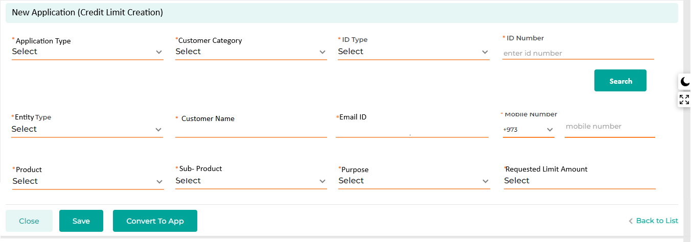

Field Name | Field Type | Data Type / Length | Mandatory | Look-Up Key/ Master Name | Possible Value | Field Description
 |  |  |  |  |  | Remarks / Validation
Application Type | LOV Dropdown | VARCHAR | Yes | NA | - Credit Limit Creation | The user will select the application type as “New Credit Limit Creation” which initiates the workflow for credit limit creation for the customer.
Customer Category | Dropdown | Varchar | Yes | CUSTTYPE | Individual | By default, Corporate
 |  |  |  |  | Company | Based on the selected Customer Type, the following related fields, and lists of values (LOVs) should be displayed to capture the details of the prospective customer:
ID Type | Master Dropdown | VARCHAR | Yes | IDTYPEs | CR No | The user will select the ID Type from the dropdown values such as CR No
 |  |  |  |  | Civil ID | As the customer type is Individual, the dropdown values for the ID type linked to the Customer Type should be displayed as mentioned.
ID Number | Text Box | NVARCHAR | Yes | NA | NA | This will let the U ser enter the applicant’s ID number.
Search | Button | Button | Button | NA | NA | Allow the user to do the Dedupe search basis of the data entered and will let the user know whether the prospect customer is a new or existing to KFIC  Will only enabled once the required data points are captured for performing the dedupe search
Entity Type | Text box | VARCHAR | Yes | NA | NA | User will enter the Entity Type else it will be fetched via the interface with MOCI if available.
Customer Name | Text box | VARCHAR | Yes | NA | NA | User will enter the Company's name in English else it will be fetched via the interface with MOCI if available.
Email Id | Text box | VARCHAR | Yes | NA | shams@gmail.com | User will enter the customer’s Email Id
Phone No | Numeric | INT | Yes | NA | +965 7384527 | User will enter the customer’s mobile number
Product | Master Dropdown | VARCHAR | Yes | Facility Master | Vehicle Loan | This will let the User select the applicant’s chosen product.
 |  |  |  |  | Cash Loan
 |  |  |  |  |  | If the Customer type is selected as Corporate, all the Commercial Product to be appear in the dropdown.
Sub Product | Master Dropdown | VARCHAR | Yes | Sub Facility Master | Vehicle Loan New | This will let the User select the applicant’s chosen sub product linked to the product selected.
 |  |  |  |  | Vehicle Loan Used
 |  |  |  |  | Real estate
 |  |  |  |  | Shares
Purpose | Multi select LOV Dropdown | VARCHAR | Yes |  | - Financial  - Trade and Trading in Business  - Other Business  - Services  - Real Estate  - Construction  - Industries  - Personal  - Shares & Bonds. | The user will select multiples purposes b selecting the checkbox for which the customer is requesting the limit.
Requested Limit Amount | Text Box | VARCHAR | Yes |  | 100,000
Action Button
Close | Button | Button | Button | NA | NA | The close button will reset the screen by remove any of the prior data entered partially
Save | Button | Button | Button | NA | NA | The save button will let the User save the entered data in the application list, which can further be converted into an application
Convert To App | Button | Button | Button | NA | NA | New Customer  After the dedupe search, if the prospect customer appears to be the new one then the user will click on "Convert to App" button to convert the prospect customer into an application and further start the loan process.  Existing Customer  After the dedupe search, if the prospect customer appears to be the existing one the user will select the specific search output and click on “Convert To App” which will convert the prospect customer into an application and also fetch the basic customer information to various screens. Also, the system will allow the user to update the data being fetched.  On click of “Convert To App” in case of Existing Customer, customer CIF data will be fetched in the following screens of New Application's Detail Data Entry stage:  Basic Details, Address Details, Contact Details, KYC Documents, and Bank Details.  “Convert To App” button will only be enabled once the user has performed the dedupe customer search by clicking on the “Search” button.

11.3.4 New Application (Credit Limit Utilization)
The following screen enables the user to start the Credit Limit Utilization process whenever a customer requests a withdrawal from their approved limit. Based on the selected customer, the system will display a list of their approved limits with the detail information, from which the user can choose any to proceed.
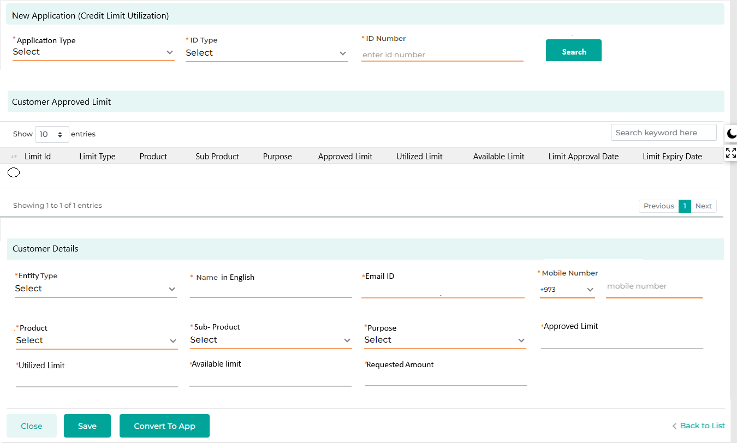

Field Name | Field Type | Data Type / Length | Mandatory | Look-Up Key/ Master Name | Possible Value | Field Description
 |  |  |  |  |  | Remarks / Validation
Application Type | LOV Dropdown | VARCHAR | Yes | NA | - Credit Limit Utilization | The user will select the application type as “New Credit Limit Creation” which initiates the workflow for credit limit creation for the customer.
ID Type | Master Dropdown | VARCHAR | Yes | IDTYPEs | CR No | Will be auto populated based on the CIF ID entered.
ID Number | Text Box | NVARCHAR | Yes | NA | NA | Will be auto populated based on the CIF ID entered.
Search | Button | Button | Button | NA | NA | Allow the user to do the Dedupe search basis of the data entered and will let the user know whether the prospect customer is a new or existing to KFIC  Will only enabled once the required data points are captured for performing the dedupe search
Customer Approved Limit
Radio Button | Radio Button | Button | Yes | NA |  | The user will select the limit which the customer is requested to withdraw.
Limit Id | Read Only | VARCHAR | Yes | NA |  | Unique ID for each limit will be displayed in the grid list.
Limit Type | Read Only | VARCHAR | Yes | NA |  | The details will be displayed in the grid list as per the approved limit.
Product | Read Only | VARCHAR | Yes | NA |  | The details will be displayed in the grid list as per the approved limit.
Sub Product | Read Only | VARCHAR | Yes | NA |  | The details will be displayed in the grid list as per the approved limit.
Purpose | Read Only | VARCHAR | Yes | NA |  | The details will be displayed in the grid list as per the approved limit.
Approved Limit | Read Only | VARCHAR | Yes | NA |  | The details will be displayed in the grid list as per the approved limit.
Utilized Limit | Read Only | VARCHAR | Yes | NA |  | The details will be displayed in the grid list as per the approved limit.
Available Limit | Read Only | VARCHAR | Yes | NA |  | The details will be displayed in the grid list as per the approved limit.
Limit Approval Date | Read Only | VARCHAR | Yes | NA |  | The details will be displayed in the grid list as per the approved limit.
Limit Expiry Date | Read Only | VARCHAR | Yes | NA |  | The details will be displayed in the grid list as per the approved limit.
Customer Details
Entity Type | Text box | VARCHAR | Yes | NA | NA | Will be auto populated based on the CIF ID entered.
Customer Name | Text box | VARCHAR | Yes | NA | NA | Will be auto populated based on the CIF ID entered.
Email Id | Text box | VARCHAR | Yes | NA | shams@gmail.com | Will be auto populated based on the CIF ID entered.
Phone No | Numeric | INT | Yes | NA | +965 7384527 | Will be auto populated based on the CIF ID entered.
Product | Master Dropdown | VARCHAR | Yes | Facility Master | Vehicle Loan | Will be auto populated based on the CIF ID entered.
 |  |  |  |  | Cash Loan | Will be auto populated based on the CIF ID entered.
Sub Product | Master Dropdown | VARCHAR | Yes | Sub Facility Master | Vehicle Loan New | Will be auto populated based on the CIF ID entered.
 |  |  |  |  | Vehicle Loan Used | Will be auto populated based on the CIF ID entered.
 |  |  |  |  | Real estate | Will be auto populated based on the CIF ID entered.
 |  |  |  |  | Shares | Will be auto populated based on the CIF ID entered.
Purpose | Multi select LOV Dropdown | VARCHAR | Yes |  | - Financial  - Trade and Trading in Business  - Other Business  - Services  - Real Estate  - Construction  - Industries  - Personal  - Shares & Bonds. | Will be auto populated based on the limit type selected.
Approved Limit | Read Only | VARCHAR | Yes |  | 200,000 | Will be auto populated based on the limit type selected.
Utilized Limit | Read Only | VARCHAR | Yes |  | 50,000 | Will be auto populated based on the limit type selected
Available Limit | Read Only | VARCHAR | Yes |  | 150,000 | Will be auto populated based on the limit type selected
Requested Amount | Text Box | VARCHAR | Yes |  | 50,000 | The user will enter the limit amount the customer is requesting to withdraw from the approved limit.  The request amount should always be less than the Available Limit.
Action Button
Close | Button | Button | Button | NA | NA | The close button will reset the screen by remove any of the prior data entered partially
Save | Button | Button | Button | NA | NA | The save button will let the User save the entered data in the application list, which can further be converted into an application
Convert To App | Button | Button | Button | NA | NA | The user will click on "Convert to App" button to convert the prospect customer into an application and further start the Credit limit utilization process.  “Convert To App” button will only be enabled once the user has performed the dedupe customer search by clicking on the “Search” button.

11.3.5 New Application – Loan Renewal
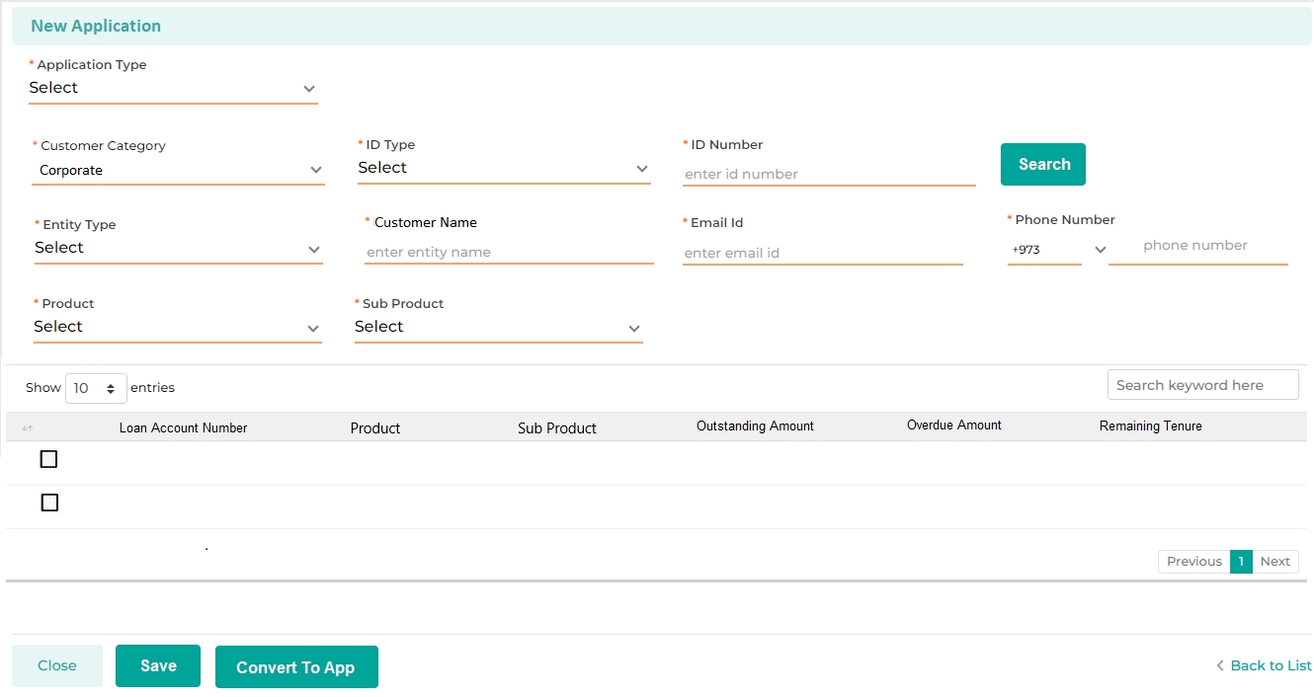

11.3.6 New Application - Loan Reschedule
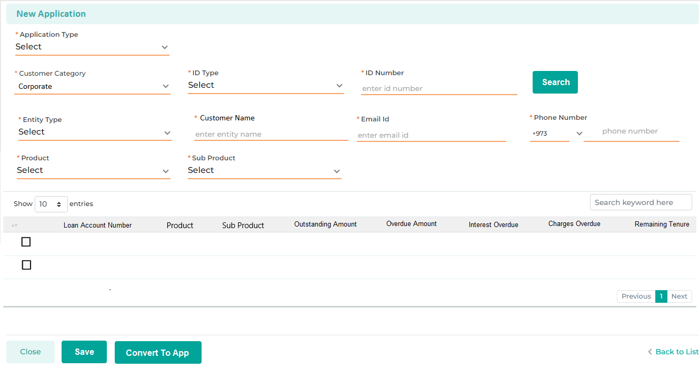

11.3.7 New Application – Loan Rearrangement
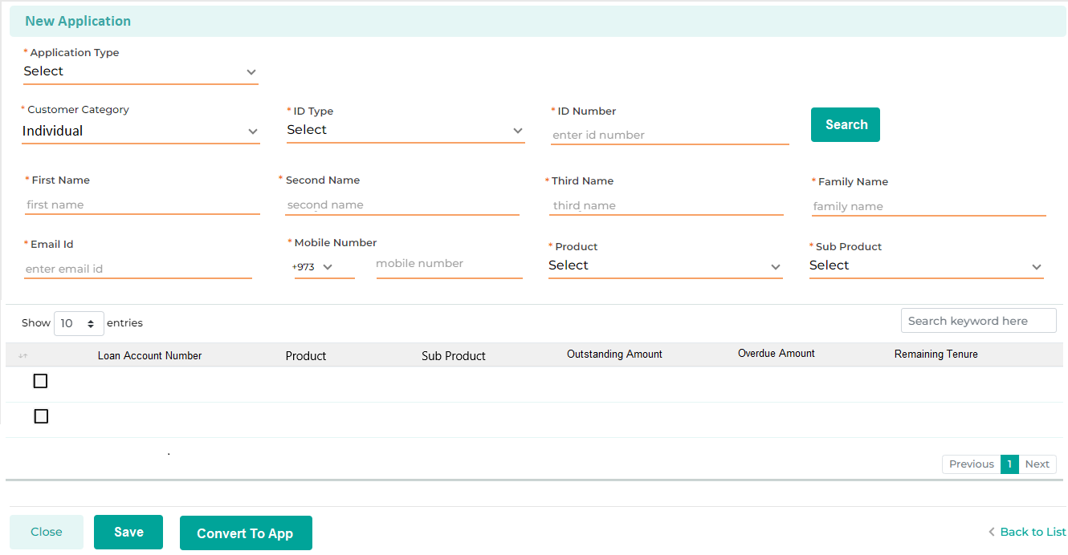

11.3.8 New Application – Loan Transfer
- Individual – Loan Transfer
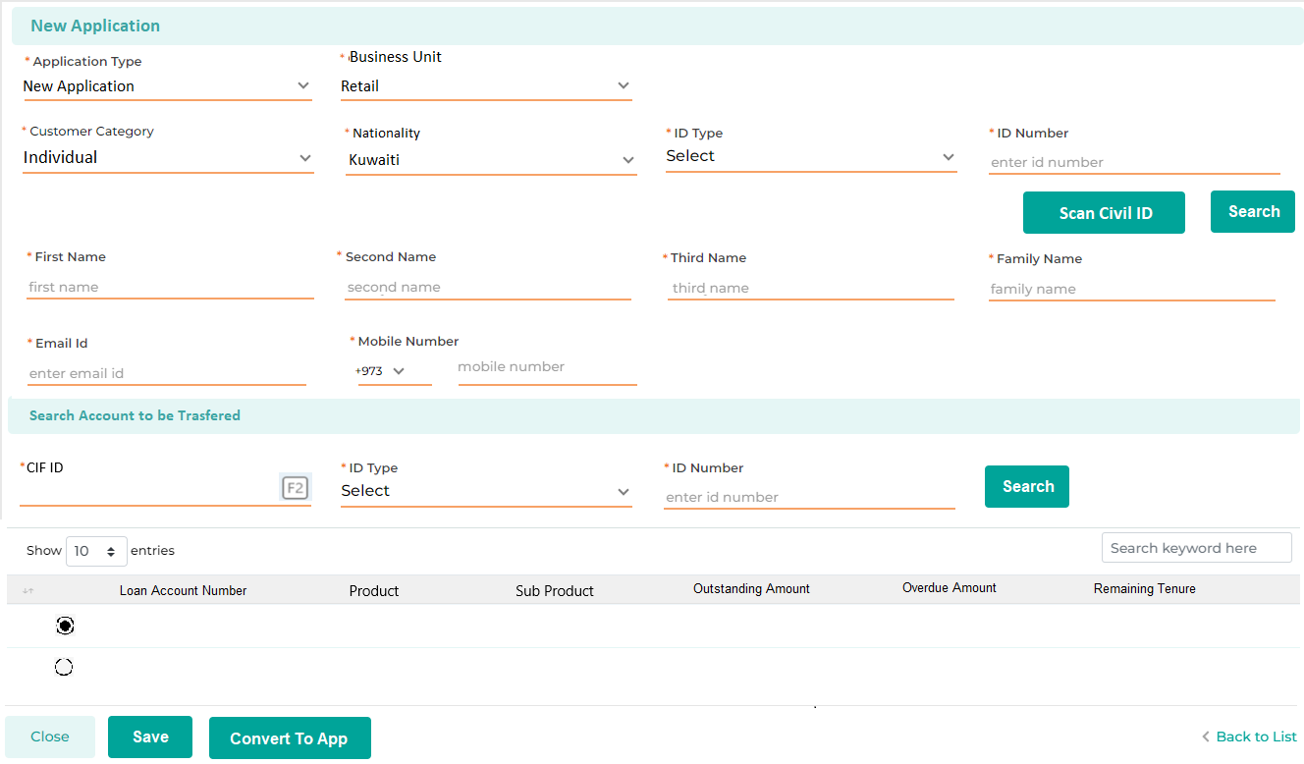

- Commercial – Loan Transfer
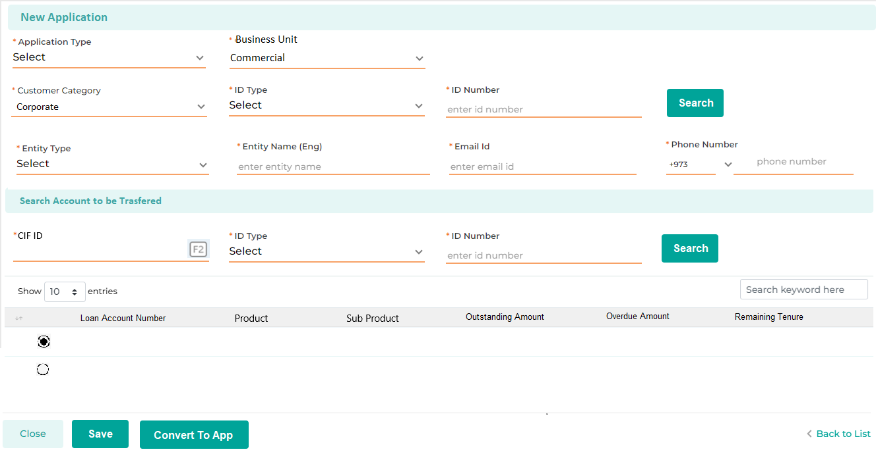

11.3.9 New Application – Staff Loan – KFIC Finance
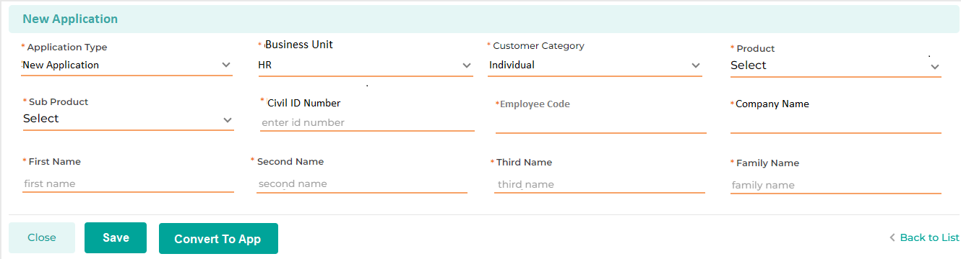

Customer Dedupe Search
The deduplication search functionality during the New Application Creation, enables the user to prevent redundancy in the application process. Based on the parameters entered into the New Application screen, the system will conduct a deduplication search. The results will indicate whether the prospective customer is new or existing. If the customer is existing, the system will display their current exposure with KFIC bringing all the data from the LMS & core system.
Additionally, the search results will display any ongoing or pending leads or applications at various stages and branches, helping to prevent duplication at the initial stage of the process. If a user attempts to process a duplicate lead, a notification will be sent to both the users and the supervisor.
Validation measures on the New Application screen prevent the user from proceeding with application conversion without first completing the deduplication search. If the customer is new to KFIC, the system will display a message stating "No Record Found Meeting Search Criteria”
Furthermore, the View Exposure link will always be accessible under the Overview section, remaining consistent across all stages for all users.
Process for Dedupe Customer Search:
- The user will first select the Application Type and then enter the ID Type and ID Number.
- The user will click the "Search" button to proceed.
- If the customer is new to KFIC, a message will appear on a pop-up screen saying, "No data found." The user will then capture the customer’s Name, Contact Number, Email ID, and the Product and Sub-product the customer is interested in applying for and click on Save, which will save the data of the prospective customer under the application list queue.
- If the customer is an existing KFIC customer, the pop-up screen will display a record matching the entered ID Type and ID Number, along with the following details: CIF ID, Customer Name, ID Type, ID Number, Blacklist Status (Y/N), Sales Officer, Application Stage and a link to view the customer’s 360 Exposure.
- The user can then select the relevant entry, which will automatically populate the customer’s Name, Contact Number, and Email ID fields. The user will then select the Product and Sub-product the customer is interested in applying for.
- Once all the details are confirmed, the user will click the "Convert to App" button.
- For New Customers: Clicking "Convert to App" will convert the prospect into a loan application, starting the loan process.
- For Existing Customers: Clicking "Convert to App" will:
- Convert the prospect into a loan application.
- Fetch the customer's basic information from their CIF record to populate various screens in the Data Entry Stage, including:
  - Basic Details
  - Address Details
  - Contact Details
  - KYC Documents
  - Bank Details
- The system will allow the user to update any data fetched from the customer's CIF.

- New Customer
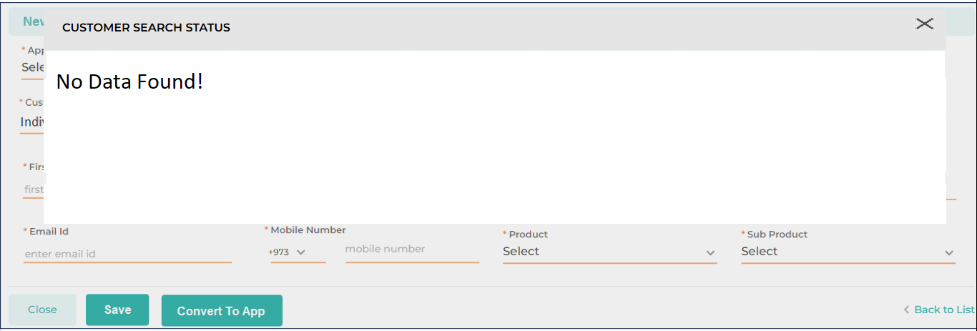

- Existing Customer
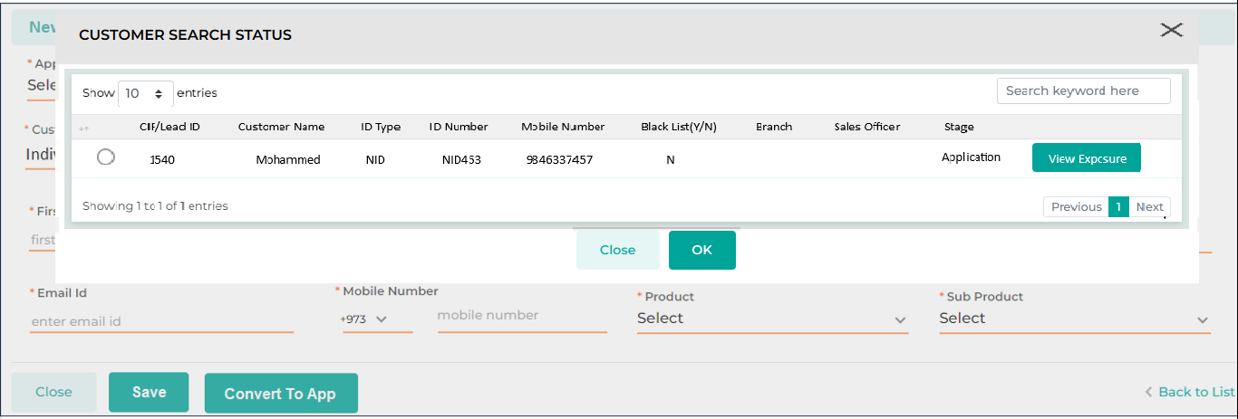

Field Name | Field Type | Data Type / Length | Mandatory (Yes/No) | Look Up Key / Master Name | Possible Value | Field Description
 |  |  |  |  |  | Remarks / Validation
CIF/ Lead ID | List View | List View | NA | NA | NA | The system will display the customer’s name if it’s an existing customer or Lead ID if it’s in the lead stage.
Customer Name | List View | List View | NA | NA | NA | The system will display the customer’s name.
ID Type | List View | List View | NA | NA | NA | The system will display the customer’s ID type.
ID Number | List View | List View | NA | NA | NA | The system will display the customer’s ID Number.
Mobile Number | List View | List View | NA | NA | NA | The system will display the customers’ mobile number.
Blacklist (Y/N) | List View | List View | NA | NA | NA | The system will display the customer’s blacklist flagging
Branch | List View | List View | NA | NA | NA | The system will display from which branch the lead was initiated.
Sales Officer | List View | List View | NA | NA | NA | The system will display the name of the sales officer working on the application if the application is in the processing stage.
Stage | List View | List View | NA | NA | NA | The system will display the stage at which the application is currently pending at if the application is in processing stage.
View Exposure (Customer 360) | Button | Button | NA | NA | NA | To see the overall exposure of the existing customer.

In case of existing customers of KFIC, an alert notification pop-up will be displayed at the time of converting it into an application to inform the user of any outstanding amounts that need to be paid by the customer and guarantors for other existing loans.
Alert message will be as follows “The prospective customer is an existing KFIC client with an outstanding balance. Please ensure the outstanding amount is cleared before proceeding. Click "Customer 360" to view more details.”
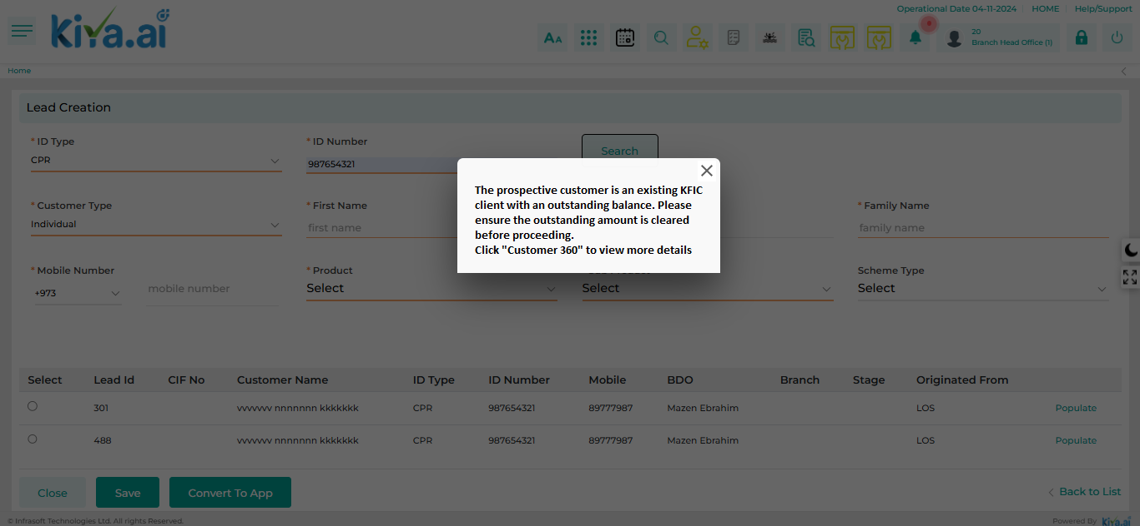

View Exposure (Customer 360)
The View Exposure feature provides a comprehensive 360-degree overview of a customer's basic details, identification details, and contact details. This feature also includes detailed loan information, such as basic loan details, installment information, collateral, and insurance details. Additionally, it showcases various transaction details, including disbursement, repayment, rescheduling, bulk payments, and foreclosure details.

11.5.1 Summary Details
This screen displays key customer information, including Customer ID, Customer Name, and Date of Birth (DOB). It also outlines the residential status, credit score, and credit risk rating, along with the customer's address and email ID. This comprehensive overview helps users quickly assess customer’s overall profile.

Navigation: Customer360 Information → Summary
Following screen will be displayed once the user clicks on Customer360 Information:
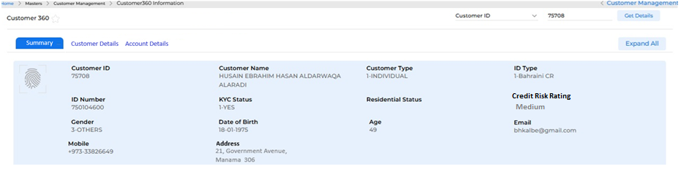

Below mentioned are the details specific to the information being displayed above:
Field Name | Field Type | Mandatory Y/N | Data Type / Length | Lookup Key / Master Name | Possible Values | Field Description
 |  |  |  |  |  | Remarks/ Validation
Customer ID | Read Only | NA | INT | NA | NA | System will display the CIF Id of Client
 |  |  |  |  |  | Auto populated from Loan origination system
Customer Name | Read Only | NA | VARCHAR | NA | NA | System will display the name of the customer
 |  |  |  |  |  | Auto populated from Loan origination system
Customer Type | Read Only | NA | VARCHAR | NA | 1. Individual  2. Non-Individual | System will display the type of customer as captured in loan origination module
 |  |  |  |  |  | Auto populated
ID Type | Read Only | NA | VARCHAR | NA | NA | System will display the ID type of the customer captured during Loan origination process
 |  |  |  |  |  | Auto populated
ID Number | Read Only | NA | VARCHAR | NA | NA | System will display the ID Number of the customer
 |  |  |  |  |  | Auto populated
KYC Status | Read Only | NA | VARCHAR | NA | 1. Pending  2. Updated  3. Expired  4. Under Review | System will display the status of the customer's KYC process.
 |  |  |  |  |  | Auto populated
Residential Status | Read Only | NA | VARCHAR | NA | 1. Owned  2. Tenant | System will display the residential status of the customer
 |  |  |  |  |  | Auto populated from Loan Origination System
Credit Risk Rating | Read Only | NA | VARCHAR | NA | High  Medium  Low | System displays the credit risk rating of the customer done as a part of AML Screening process at the time of loan onboarding
 |  |  |  |  |  | Auto populated
Gender | Read Only | NA | VARCHAR | NA | 1. Male  2. Female  3. Others | System will display the gender of the customer
 |  |  |  |  |  | Auto populated
Date of Birth | Read Only | NA | DATETIME | NA | NA | System will display the date of birth of the customer
 |  |  |  |  |  | Auto populated
Age | Read Only | NA | INT | NA | NA | System will display the age of the customer
 |  |  |  |  |  | Auto populated
Email | Read Only | NA | NVARCHAR | NA | NA | System will display the email ID of the customer
 |  |  |  |  |  | Auto populated
Mobile | Read Only | NA | INT | NA | NA | System will display the mobile number of the customer
 |  |  |  |  |  | Auto populated
Address | Read Only | NA | NVARCHAR | NA | NA | System will display the customer's address
 |  |  |  |  |  | Auto populated
Action Buttons
Customer ID | Drop Down | Y | VARCHAR | NA | 1. Customer ID  2. Mobile Number  3. National ID  4. Account ID | The user will select a parameter from the dropdown list to retrieve detailed information about the customer
Get Details | Button | Y | Button | NA | NA | The system automatically retrieves the customer's information based on the selected parameter type

11.5.2 Customer Details
This screen allows the user to view the customer’s personal details, which means it provides more detailed information about the customer as compared to the summary screen. This screen shows a list of all the documents submitted by the customer, address details, employment details, income details and contact details.

Navigation: Main Menu à Masters à Customer Management à Customer360 Information à Customer Details

Following screen will be displayed once the user clicks on Customer Details:
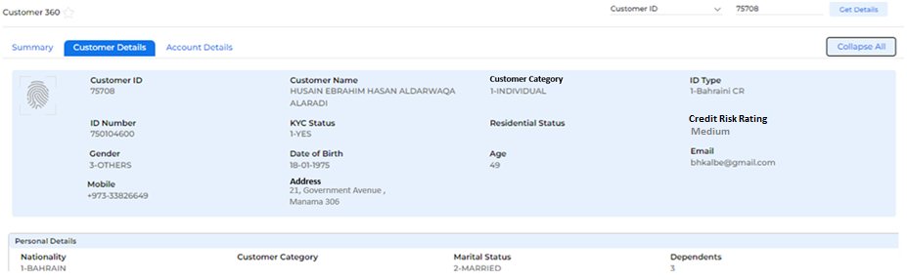

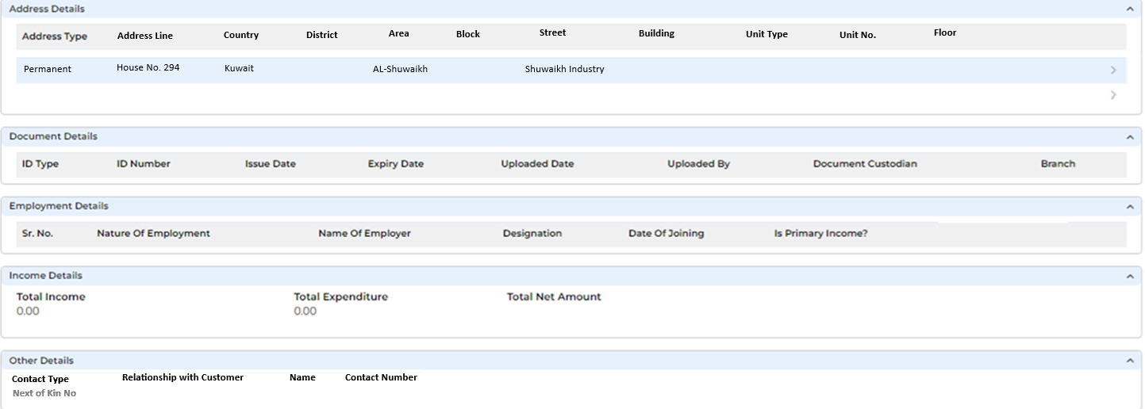

Below mentioned are the details specific to the information being displayed above:
Field Name | Field Type | Mandatory Y/N | Data Type / Length | Lookup Key / Master Name | Possible Values | Field Description
 |  |  |  |  |  | Remarks/ Validation
Personal Details
Nationality | Read Only | NA | VARCHAR | NA | NA | System will display the nationality of the customer
 |  |  |  |  |  | Auto populated
Customer Category | Read Only | NA | VARCHAR | NA | Individual  Corporate | System will display customer Type
 |  |  |  |  |  | Auto populated
Marital Status | Read Only | NA | VARCHAR | NA | NA | System will display the Marital Status of the customer
Dependents | Read Only | NA | INT | NA | NA | System will show the total number of dependents linked to the customer
 |  |  |  |  |  | Auto Populated
Relationship Manager | Read Only | NA | VARCHAR | NA | NA | System will display the name of customer’s relationship manager
 |  |  |  |  |  | Auto Populated
Customer Status | Read Only | NA | VARCHAR | NA | Live  Bankrupt  Fraud  Deceased | System will display customer’s status
 |  |  |  |  |  | Auto Populated
Address Details
Address Type | Read Only | NA | VARCHAR | NA | Residential | System will display the address type
 |  |  |  |  | Permanent | System will display the address type
 |  |  |  |  | Temporary | Auto populated
Address Line | Read Only | NA | NVARCHAR | NA | NA | System will display the address line of the customer
 |  |  |  |  |  | Auto populated
Country | Read Only | NA | NVARCHAR | NA | NA | System will display the name of the country where customer resides
 |  |  |  |  |  | Auto populated
District | Read Only | NA | VARCHAR | NA | NA | System will display the name of the district where customer resides
 |  |  |  |  |  | Auto populated
Area | Read Only | NA | VARCHAR | NA | NA | System will display the area name where customer resides
 |  |  |  |  |  | Auto populated
Block | Read Only | NA | VARCHAR | NA | NA | System will display the block details associated with the customer’s address
 |  |  |  |  |  | Auto populated
Street | Read Only | NA | VARCHAR | NA | NA | System will display the street details associated with the customer’s address
Building | Read Only | NA | VARCHAR | NA | NA | System will display the building details associated with the customer’s address
Unit Type | Read Only | NA | VARCHAR | NA | NA | System will display the unit type associated with the customer’s address
Unit No. | Read Only | NA | VARCHAR | NA | NA | System will display the unit No. associated with the customer’s address
Floor | Read Only | NA | VARCHAR | NA | NA | System will display the floor details associated with the customer’s address
Documents
ID Type | Read Only | NA | VARCHAR | NA | NA | System will display the document ID type
 |  |  |  |  |  | Auto populated
ID Number | Read Only | NA | VARCHAR | NA | NA | System will display the document ID number
 |  |  |  |  |  | Auto populated
Issue Date | Read Only | NA | DATETIME | NA | NA | System will display the document issue date
 |  |  |  |  |  | Auto populated
Expiry Date | Read Only | NA | DATETIME | NA | NA | System will display the document expiry date
 |  |  |  |  |  | Auto populated
Uploaded Date | Read Only | NA | DATETIME | NA | NA | System will display the document upload date
 |  |  |  |  |  | Auto populated
Uploaded By | Read Only | NA | VARCHAR | NA | NA | System will display the details of the user who uploaded the document
 |  |  |  |  |  | Auto populated
Document Custodian | Read Only | NA | VARCHAR | NA | NA | System will display the name of the document custodian
 |  |  |  |  |  | Auto populated
Branch | Read Only | NA | VARCHAR | NA | NA | System will display the name of the branch where the documents are maintained
 |  |  |  |  |  | Auto populated
Employment Details
S. No. | Read Only | NA | INT | NA | NA | System will display the serial number for each customer record
 |  |  |  |  | NA | Auto Populated. There can be more than one customer record
Nature of Employment | Read Only | NA | VARCHAR |  | Salaried | System will display the type of employment held by the customer
 |  |  |  | NA | Non-Salaried | Auto Populated
Name of Employer | Read Only | NA | VARCHAR | NA | NA | System will display the name of the customer's employer.
 |  |  |  |  |  | Auto Populated
Designation | Read Only | NA | VARCHAR | NA | NA | System will display the customer's job role within the organization
Date of Joining | Read Only | NA | DATETIME | NA | NA | System will display the customer’s date of joining in the organization
 |  |  |  |  |  | Auto Populated
Monthly Income | Read Only | NA | FLOAT | NA | NA | System will display customer’s monthly income in their current organization
 |  |  |  |  |  | Auto Populated
Is Primary Income | Read Only | NA | VARCHAR | NA | Yes | System will indicate whether the income from employment is customer’s primary source of income
 |  |  |  |  | No | Auto Populated
Income Details
Total Income | Read Only | NA | FLOAT | NA | NA | System will display the customer's total income from all sources.
 |  |  |  |  |  | Auto Populated
Total Expenditure | Read Only | NA | FLOAT | NA | NA | System will display the customer's total monthly expenditure
 |  |  |  |  |  | Auto Populated
Total Net Amount | Read Only | NA | FLOAT | NA | NA | System will display the total net amount after deducting expenditures and debts from their total income
 |  |  |  |  |  | Auto Populated. (Net Amount = Total Income - Total Exp - Total debts)
Other Details
Contact Type | Read Only | NA | VARCHAR | NA | - Mobile No.  - Telephone No  - Next of Kin No. | System will display the contact type as captured during loan onboarding
 |  |  |  |  |  | Auto populated
Relationship with customer | Read Only | NA | VARCHAR | NA | NA | System will display the relationship of the person with the customer
 |  |  |  |  |  | Only applicable if Contact Type is selected as “Next Of Kin”
Name | Read Only | NA | VARCHAR | NA | NA | The system will display the name
Contact Number | Read Only | NA | VARCHAR | NA | NA | System will display the contact No.

11.5.3 Account Details
The account detail screen displays all the existing exposure of the customer at KFIC. By selecting each loan account number, users can delve deeper into the specifics of that loan and view detailed loan and transaction information.
- If customer A is a Main Applicant in a loan then only one record will be displayed in View Exposure
- If customer A is a Main Applicant in a Loan and a Guarantor in other loan(s) then 2/more records will be displayed in View Exposure
- If customer A is not a Main Applicant in a loan, however, is a Guarantor in another loan then system will display the record for this loan also
Navigation: Customer360 > Accounts Details

The following screen will be displayed once the user clicks on Account Details. The user must select an account from the list to view its details.
No information will be displayed until an account is chosen.
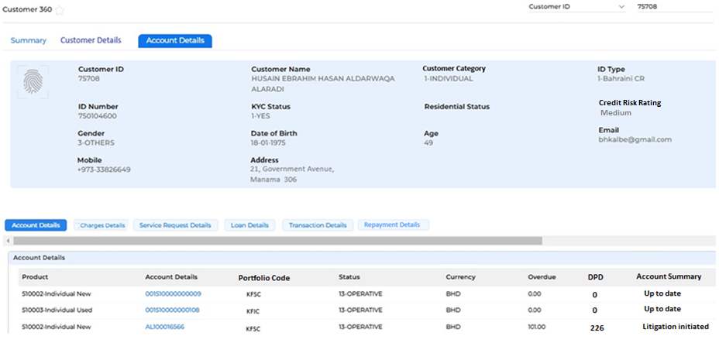

Below mentioned are the details specific to the information being displayed above:
Field Name | Field Type | Mandatory Y/N | Data Type / Length | Lookup Key / Master Name | Possible Values | Field Description
 |  |  |  |  |  | Remarks/ Validation
Product | Read Only | NA | VARCHAR | NA | NA | System will display the Product associated with the Loan account
 |  |  |  |  |  | Auto populated
Account Detail | Read Only | NA | VARCHAR | NA | NA | System will display the account No. of the customer
 |  |  |  |  |  | Auto populated
Portfolio Code | Read Only | NA | VARCHAR | NA | KFIC  KFSC  ABK  EBK | System will Display the company/Portfolio code of the customer to identify the accounts belonging to KFIC and white label Portfolio
Status | Read Only | NA | VARCHAR | Operative  Non-Operative | NA | The code as KFIC will be displayed for all the new customers as well as for the migrated data customers. KFSC will be displayed only for the migrated data customers.
 |  |  |  |  |  | Auto populated
Currency | Read Only | NA | VARCHAR | KD  USD | NA | System will display the currency used for transaction in customer’s account
 |  |  |  |  |  | Auto populated
Overdue | Read Only | NA | Float | NA | NA | System will display the amount that is past due for payment
 |  |  |  |  |  | Auto populated
DPD | Read Only | NA | INT | NA | NA | System will display the total No. of DPD in an overdue instalment
Account Summary | Read Only | NA | VARCHAR | NA | 1.Up to date  2.Under litigation | System will display the account summary

11.5.5 Loan Details
By selecting each loan account number, users can delve deeper into the specifics of that loan and view detailed loan and transaction information.
- If customer A is a Main Applicant in a loan then only one record will be displayed in View Exposure
- If customer A is a Main Applicant in a Loan and a Guarantor in other loan(s) then 2/more records will be displayed in View Exposure
- If customer A is not a Main Applicant in a loan, however, is a Guarantor in another loan then system will display the record for this loan also

Navigation: Customer360 Information à Accounts à Loan Details

Following screen will be displayed once the user clicks on loan details:
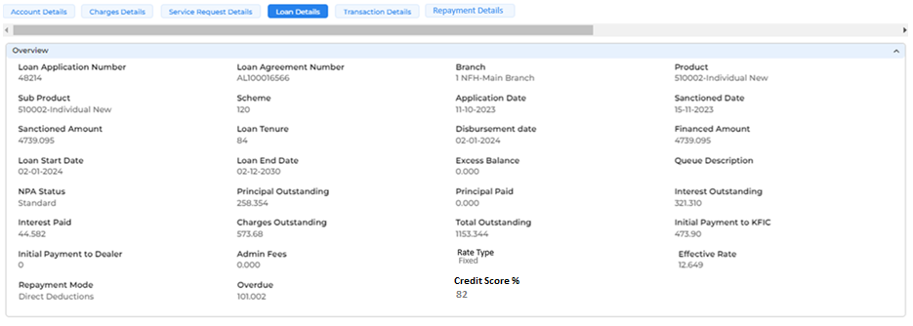

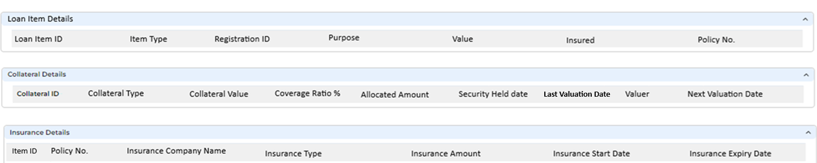

Below mentioned are the details specific to the information being displayed above:
Overview
Loan Application Number | Read Only | NA | VARCHAR | NA | NA | System will display the loan application No. associated with the loan account selected by the user on the account details screen.
 |  |  |  |  |  | Auto populated
Loan Agreement Number | Read Only | NA | VARCHAR | NA | NA | System will display the loan agreement No. associated with the loan account selected by the user on the account details screen.
 |  |  |  |  |  | Auto populated
Branch | Read Only | NA | VARCHAR | NA | NA | System will show the name of the branch associated with the loan account.
 |  |  |  |  |  | Auto populated
Product | Read Only | NA | VARCHAR | NA | NA | System will display the product associated with the loan account.
 |  |  |  |  |  | Auto populated
Sub Product | Read Only | NA | VARCHAR | NA | NA | System will display the Sub product associated with the loan account.
 |  |  |  |  |  | Auto Populated
Scheme | Read Only | NA | VARCHAR | NA | NA | System will display the scheme associated with the loan account.
 |  |  |  |  |  | Auto Populated
Application Date | Read Only | NA | DATETIME | NA | NA | System will display the date of loan application
 |  |  |  |  |  | Auto Populated
Sanctioned Date | Read Only | NA | DATETIME | NA | NA | System will display the date on which the loan was sanctioned
 |  |  |  |  |  | Auto Populated
Sanctioned Amount | Read Only | NA | FLOAT | NA | NA | System will display the sanctioned/approved amount
 |  |  |  |  |  | Auto Populated
Loan Tenure | Read Only | NA | INT | NA | NA | System will display the loan tenure for which the customer has availed the loan.
 |  |  |  |  |  | Auto Populated
Disbursement Date | Read Only | NA | DATETIME | NA | NA | System will display the date of loan disbursement
 |  |  |  |  |  | Auto Populated
Financed Amount | Read Only | NA | FLOAT | NA | NA | System will display the actual amount financed to the customer
 |  |  |  |  |  | Auto Populated
Loan Start Date | Read Only | NA | DATETIME | NA | NA | System will display the loan start date
 |  |  |  |  |  | Auto Populated
Loan End Date | Read Only | NA | DATETIME | NA | NA | System will display the loan end date
 |  |  |  |  |  | Auto Populated
Excess Balance | Read Only | NA | FLOAT | NA | NA | System will display any surplus amount available in customer’s account
 |  |  |  |  |  | Auto Populated. This will be auto calculated based on the loan details and the payments made
Deal Status | Read Only | NA | VARCHAR | NA | Approved  Pending  Rejected | System will display status of the loan deal
 |  |  |  |  |  | Auto Populated
Days Past Due | Read Only | NA | INT | NA | NA | System will display the number of days since the payment was due
 |  |  |  |  |  | Auto Populated. It should be automatically calculated based on current date and due date
Queue Description | Read Only | NA | NVARCHAR | NA | NA | System will display the DPD queue associated with any outstanding installment.  For Example:  0-30 Days: If DPD is between 0 -30 days  31-60 Days: If DPD is between 31-60 days  61-90 Days: If DPD is between 61-90 days
 |  |  |  |  |  | Auto Populated
NPA Status | Read Only | NA | VARCAHAR | NA | 1.Standard  2. Sub Standard  3. Doubtful | System will display the NPA status of a loan account
Auto Populated. It Should automatically updated based on payment history
For Example:
1.If Payment is regular- Standard
2.If Payment is overdue for 30-90 days - Sub Standard
3.If Payment is overdue for 91-180 days - Doubtful
4. If Payment is overdue for more 180 days - NPA
Principal Outstanding | Read Only | NA | FLOAT | NA | NA | System will display the outstanding principal amount for a loan installment
 |  |  |  |  |  | Auto Populated. It should be automatically updated based on payments made toward the principal component
Principal Paid | Read Only | NA | FLOAT | NA | NA | System will display the amount of principal that has been paid for a loan installment
 |  |  |  |  |  | Auto Populated
Interest Outstanding | Read Only | NA | FLOAT | NA | NA | System will display the overdue Interest amount for a loan installment
 |  |  |  |  |  | Auto Populated. It should be automatically updated based on payments made toward the Interest component
Interest Paid | Read Only | NA | FLOAT | NA | NA | System will display the amount of interest that has been paid for a loan installment
 |  |  |  |  |  | Auto Populated
Charges Outstanding | Read Only | NA | FLOAT | NA | NA | System will display the total amount of outstanding charges (fees and penalties) that are due for payment
 |  |  |  |  |  | Auto Populated
Total Outstanding | Read Only | NA | FLOAT | NA | NA | System will display the total o/s amount that is due for payment
 |  |  |  |  |  | Auto Populated. Outstanding amount will include the principal, interest, and any charges
Initial Payment to Company | Read Only | NA | FLOAT | NA | NA | System will display the down payment amount (Own Contribution) paid by the customer to company
 |  |  |  |  |  | Customers can pay the full down payment amount either to the Company or the Dealer, or they can split the payment by paying part to the Company and part to the Dealer.
Initial Payment to Dealer | Read Only | NA | FLOAT | NA | NA | System will display the down payment amount (Own Contribution) paid by the customer to dealer
Admin Fees | Read Only | NA | FLOAT | NA | NA | system will display the admin fees paid by the customer for loan disbursement, If any
 |  |  |  |  |  | Auto Populated
Rate Type | Read Only | NA | VARCHAR | NA | Fixed  Floating | The system will display the rate type
 |  |  |  |  |  | Auto Populated
Effective Rate | Read Only | NA | NVARCHAR | NA | NA | System will display the actual effective rate applicable to the customer
 |  |  |  |  |  | Auto Populated
Repayment Mode | Read Only | NA | VARCHAR | NA | NA | System will display the repayment mode selected by the customer for installment payments
 |  |  |  |  |  | Auto Populated
Overdue | Read Only | NA | FLOAT | NA | NA | System will display the total overdue amount that the customer needs to pay
 |  |  |  |  |  | Auto Populated
Credit Score | Read Only | NA | FLOAT | NA | NA | System will display the customer's most recent credit score as recorded in the Loan Origination system
 |  |  |  |  |  | Auto Populated
Collateral Details
Collateral ID | Read Only | NA | VARCHAR | NA | NA | System will display a unique ID for the collateral associated with the loan
 |  |  |  |  |  | Auto Populated
Collateral Type | Read Only | NA | VARCHAR | NA | NA | System will display the type of security mortgaged as a collateral for the loan
 |  |  |  |  |  | Auto Populated
Collateral Value | Read Only | NA | FLOAT | NA | NA | System will display the Market Value or appraised value of the collateral mortgaged against the loan.
 |  |  |  |  |  | Auto Populated
Coverage Ratio % | Read Only | NA | FLOAT | NA | NA | System will display the ratio of collateral value to the loan amount
 |  |  |  |  |  | Auto Populated
Allocated amount | Read Only | NA | FLOAT | NA | NA | System will display the collateral coverage amount that is being used to secure a loan or obligation
 |  |  |  |  |  | Auto Populated
Security Held Date | Read Only | NA | DATETIME | NA | NA | System will display the date on which security was mortgaged/hypothecated against the loan
 |  |  |  |  |  | Auto Populated
Last Valuation Date | Read Only | NA | DATETIME | NA | NA | System will display the date on which the last valuation of the collateral was done
 |  |  |  |  |  | Auto Populated.
Valuer | Read Only | NA | VARCHAR | NA | NA | system will display the name of the valuer who performed the valuation of the collateral
 |  |  |  |  |  | Auto Populated
 |  |  |  |  |  | Auto Populated
Policy No. | Read Only | NA | VARCHAR | NA | NA | System will display the Insurance Policy Number for the collateral
 |  |  |  |  |  | Auto Populated. This will be displayed only if the collateral is insured.
Next Valuation Date | Read Only | NA | DATETIME | NA | NA | System will display the scheduled date for the next valuation of the collateral
Loan Item Details
Loan Item ID | Read Only | NA | VARCHAR | NA | NA | Auto populated from LOS
Item Type | Read Only | NA | VARCHAR | NA | 1.Vehicle  2.Real Estate  3.Stocks | System will display the item type
 |  |  |  |  |  | Auto populated from LOS
Registration ID | Read Only | NA | VARCHAR | NA | NA | System will display the Registration ID of the collateral selected in the above field
 |  |  |  |  |  | Auto populated from LOS
Purpose | Read Only | NA | VARCHAR | NA | 1.Vehicle  2.Renovation  3.Medical Treatment  4.Education | System will display the purpose of the loan
 |  |  |  |  |  | Auto Populated
Value | Read Only | NA | FLOAT | NA | NA | System will display the market value of the chosen loan item
 |  |  |  |  |  | Auto Populated
Insured | Read Only | NA | VARCHAR | NA | Yes  No | System will display whether the loan item has insurance covered or not
 |  |  |  |  |  | Auto Populated
Policy No | Read Only | NA | VARCHAR | NA | NA | System will display the insurance policy No.
Insurance Details
Policy No | Read Only | NA | VARCHAR | NA | NA | System will display the insurance policy No.
Insurance Company Name | Read Only | NA | VARCHAR | NA | NA | System will display the name of insurance company
Insurance Type | Read Only | NA | VARCHAR | NA | 1.Full Insurance  2.Life Insurance  3.Liability Insurance | System will display the nature of insurance
 |  |  |  |  |  | Auto Populated.
Insurance Amount | Read Only | NA | FLOAT | NA | NA | System will display the insurance premium amount
 |  |  |  |  |  | Auto Populated
Insurance Start Date | Read Only | NA | DATETIME | NA | NA | System will display the date on which the insurance policy was issued.
 |  |  |  |  |  | Auto Populated
Insurance Expiry Date | Read Only | NA | DATETIME | NA | NA | System will display the date on which the insurance policy will expire
 |  |  |  |  |  | Auto Populated

11.5.6 Transaction Details
The user will click on the Transaction Details, which lets the user view the disbursement details, repayment details, transaction summary, & the customer ledger. In the Transaction summary, users can see a summary of customer transactions, such as the last 10 transactions. The customer ledger offers a detailed view of all customer transactions.
Following screen will be displayed once the user clicks on loan details:
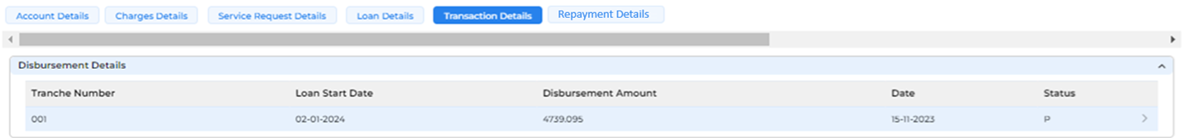

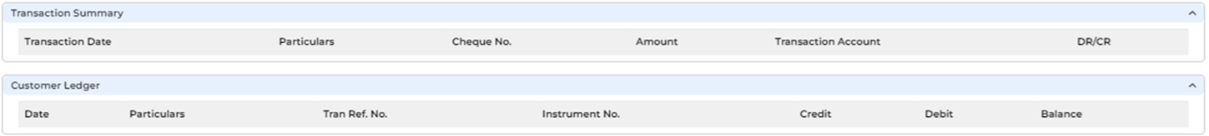

Below mentioned are the details specific to the information being displayed above:
Field Name | Field Type | Mandatory Y/N | Data Type / Length | Lookup Key / Master Name | Possible Values | Field Description
 |  |  |  |  |  | Remarks/ Validation
Disbursement Details
Tranche Number | Read Only | NA | VARCHAR | NA | 001  002 | System will display the number of the tranche associated with the loan disbursement
 |  |  |  |  |  | Auto populated. Multiple tranches may be available for a single loan disbursement
Loan Start Date | Read Only | NA | DATETIME | NA | NA | System will display the loan start date
 |  |  |  |  |  | Auto populated.
Disbursement Amount | Read Only | NA | FLOAT | NA | NA | System will display the amount of disbursement of the loan
 |  |  |  |  |  | Auto populated.
Date | Read Only | NA | DATETIME | NA | NA | System will display the loan disbursement date
 |  |  |  |  |  | Auto populated. In the case of multiple tranches, the loan start date will remain the same; only the disbursement dates will vary, reflecting the actual dates when each tranche is disbursed
Status | Read Only | NA | VARHAR | NA | Active  Closed | System will display the status of the loan
 |  |  |  |  |  | Auto populated
Transaction Summary
Transaction Date | Read Only | NA | DATETIME | NA |  | System will display the date when the transaction is processed
 |  |  |  |  |  | Auto Populated. It will be in dd-mm-yyyy format
Particulars | Read Only | NA | VARCHAR | NA |  | System will display detailed information about the transaction
 |  |  |  |  |  | Auto Populated. It should adhere to predefined character limit and should not contain any special character
Cheque No. | Read Only | NA | VARCHAR | NA |  | System will display the cheque No. associated with the transaction
 |  |  |  |  |  | Auto Populated. This field will be displayed if transaction mode is cheque. It will be in a specific format
Amount | Read Only | NA | FLOAT | NA |  | System will display the transaction amount
 |  |  |  |  |  | Auto Populated
Transaction Account | Read Only | NA | VARCHAR | NA |  | System will display the account no. associated with the transaction
 |  |  |  |  |  | Auto Populated
DR/CR | Read Only | NA | VARCHAR | NA |  | System will display the nature of the transaction. Whether the transaction is Debit (Expenses) or Credit (Income)
 |  |  |  |  |  | Auto Populated
Customer Ledger
Date | Read Only | NA | DATETIME | NA |  | System will display the date of transaction
 |  |  |  |  |  | Auto Populated
Particulars | Read Only | NA | VARCHAR | NA |  | System will display the detailed information about the transaction
 |  |  |  |  |  | Auto Populated
Tran Ref. No. | Read Only | NA | VARCHAR | NA |  | System will display the Transaction Reference No. associated with the transaction
 |  |  |  |  |  | Auto Populated
Instrument No. | Read Only | NA | VARCHAR | NA |  | System will display the instrument No. associated with the transaction
 |  |  |  |  |  | Auto Populated
Credit | Read Only | NA | FLOAT | NA |  | System will display the amount credited for that transaction
 |  |  |  |  |  | Auto Populated
Debit | Read Only | NA | FLOAT | NA |  | System will display the amount debited for that transaction
 |  |  |  |  |  | Auto Populated
Balance | Read Only | NA | FLOAT | NA |  | System will display the balance of customers account after adjustment of the latest transaction
 |  |  |  |  |  | Auto Populated

11.5.7 Repayment Details
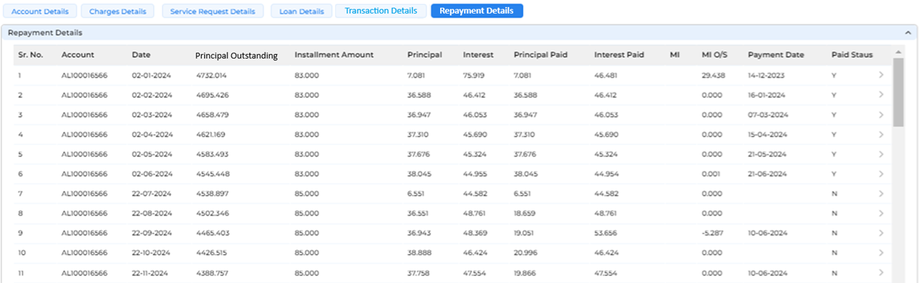

Field Name | Field Type | Mandatory Y/N | Data Type / Length | Lookup Key / Master Name | Possible Values | Field Description
 |  |  |  |  |  | Remarks/ Validation
Repayment Details
Sr. No. | Read Only | NA | INT | NA |  | System will display the serial No. for each record
Account | Read Only | NA | VARCHAR | NA |  | System will display the Account No. associated with the loan repayment
 |  |  |  |  |  | Auto Populated
Date | Read Only | NA | DATETIME | NA |  | System will display the date on which the loan installment is due for payment
 |  |  |  |  |  | Auto Populated
Principal Outstanding | Read Only | NA | FLOAT | NA |  | The system will display the principal outstanding amount
Installment Amount | Read Only | NA | FLOAT | NA |  | System will display the amount to be paid for each loan instalment
 |  |  |  |  |  | Auto Populated
Principal | Read Only | NA | FLOAT | NA |  | System will display the principal component of the total installment amount
 |  |  |  |  |  | Auto Populated
Interest | Read Only | NA | FLOAT | NA |  | System will display the Interest component of the total installment amount
 |  |  |  |  |  | Auto Populated
Principal Paid | Read Only | NA | FLOAT | NA |  | System will display the amount of the principal component paid on the due date
 |  |  |  |  |  | Auto Populated
Interest Paid | Read Only | NA | FLOAT | NA |  | System will display the amount of the Interest component paid on the due date
 |  |  |  |  |  | Auto Populated
MI | Read Only | NA | FLOAT | NA |  | System will display the interest amount accrued during the moratorium period
 |  |  |  |  |  | Auto Populated. This will be displayed in the event of skip payment
MI O/S | Read Only | NA | FLOAT | NA |  | System will display the o/s accrued interest amount incurred during moratorium period that is yet to be paid
 |  |  |  |  |  | Auto Populated
Payment date | Read Only | NA | DATETIME | NA |  | System will display the date on which the installment was paid.
 |  |  |  |  |  | Auto Populated
Paid status | Read Only | NA | VARCHAR | NA |  | System will display the payment status of the installment
 |  |  |  |  |  | Auto Populated
 |  |  |  |  |  | Auto Populated

11.5.8 Charges Details
Following screen will be displayed once the user clicks on Charges Details:
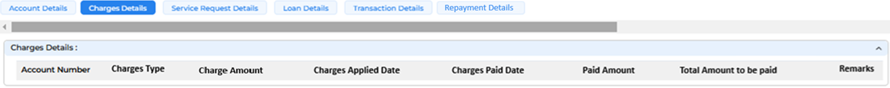

Below mentioned are the details specific to the information being displayed above:
Field Name | Field Type | Mandatory Y/N | Data Type / Length | Lookup Key / Master Name | Possible Values | Field Description
 |  |  |  |  |  | Remarks/ Validation
Account Number | Read Only | NA | VARCHAR | NA | NA | System will display the account No. of the customer which has been selected to view the details
 |  |  |  |  |  | Auto Populated
Charges Type | Read Only | NA | VARCHAR | NA | NA | System will display the type of charge that has been levied on customer’s account
 |  |  |  |  |  | Auto Populated
Charge Amount | Read Only | NA | FLOAT | NA | NA | System will display the charges amount that has been paid out of the total due by the customer
Charges Applied Date | Read Only | NA | DATETIME | NA | NA | System will display the date on which charges has been applied to the customer
 |  |  |  |  |  | Auto populated
Charge Paid Date | Read Only | NA | DATETIME | NA | NA | System will display the date of which charges has been paid by the customer
 |  |  |  |  |  | Auto populated
Total Amount to be Paid | Read Only | NA | FLOAT | NA | NA | System will display the charges amount that is pending to be paid out of the total due by the customer
 |  |  |  |  |  | Auto populated.
Remarks | Read Only | NA | VARCHAR | NA | NA | System will display the remarks, if any.
 |  |  |  |  |  | Auto populated

11.5.9 Service Request details
This screen presents an overview of all service requests raised for the selected loan account. It includes information such as the Service ID, request type, user details etc.

Navigation: Customer360 Information à Accounts à Service Request Details

Following screen will be displayed once the user clicks on Service Request Details:
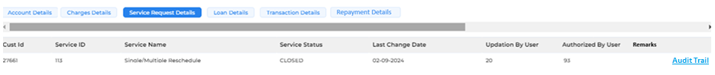

Below mentioned are the details specific to the information being displayed above:
Field Name | Field Type | Mandatory Y/N | Data Type / Length | Lookup Key / Master Name | Possible Values | Field Description
 |  |  |  |  |  | Remarks/ Validation
Cust ID | Read Only | NA | VARCHAR | NA | NA | System will display customer ID
 |  |  |  |  |  | Auto populated from service request module
Service ID | Read Only | NA | VARCHAR | NA | NA | System will display the unique identifier assigned to the service request.
 |  |  |  |  |  | Auto populated from service request module. This will be auto generated when a service request is created
Service Name | Read Only | NA | VARCHAR | NA | NA | System will display the name of the service associated with the service request.
 |  |  |  |  |  | Auto populated from service request module
Service Status | Read Only | NA | VARCHAR | NA | Open  Closed | System will display the status of the service request.
Auto populated from service request module.
Open - indicates if request is still pending to be authorized
Closed - indicates if request has been authorized
Last Change Date | Read Only | NA | DATETIME | NA | NA | System will display the date of the most recent update made to the service request.
 |  |  |  |  |  | Auto populated. This will be auto generated based on the last change made
Updation By user | Read Only | NA | VARCHAR | NA | NA | System will display the name of the user who made the most recent update to the service request.
 |  |  |  |  |  | Auto populated.
Authorized By user | Read Only | NA | VARCHAR | NA | NA | System will display the name of the user who has authorized the service request.
 |  |  |  |  |  | Auto populated
Remarks | Read Only | NA | VARCHAR | NA | NA | System will display the additional remarks, if any.
 |  |  |  |  |  | Auto Populated
Audit Trail | Hyperlink | NA | Hyperlink | NA | NA | On clicking the hyperlink, the user can view a detailed record of changes made for a selected service request
 |  |  |  |  |  | Changes will be maintained with id and timestamp of users logged in the system

Initiating Loan Origination
Once the application has been successfully converted from the New Application screen, the application will further move into the inbox of the same user under the detail data entry stage of the defined workflow being mapped to the product and the sub product. The supervisor user will have view-only access to all the applications of the users mapped under his/her hierarchy through “Team Inbox” queue.
Scenario:
When user "A" enters the prospect customer details and converts them into an application from the “New Application” screen, the converted application will appear in user "A"'s inbox. By double-clicking the application number, user "A" can initiate the Detail Data Entry stage. Additionally, the application converted by user "A" will be visible to user "A"'s manager in view-only mode within “Team Inbox” queue.

Navigation:
Sales à General à App Tracker
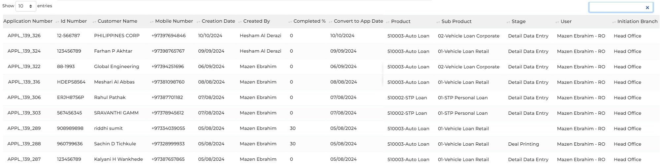

Below are the details specific to the information being displayed above.
Field Name | Field Type | Data Type / Length | Mandatory (Yes/No) | Look Up Value/ Master Name | Possible Value | Field Description
 |  |  |  |  |  | Remarks / Validation
Application Number | List View | List View | NA | NA | NA | The system will display the Loan Application number generated at the time of converting an application from the New Application scree.
Id Number | List View | List View | NA | NA | NA | The system will display the ID Number captured at the time of the Application stage
Customer Name | List View | List View | NA | NA | NA | The system will display Customer Name.
Mobile Number |  |  |  |  |  | The system will display the primary contact number captured at the time of application creation
Creation Date | List View | List View | NA | NA | NA | The system will display the creation date of the lead creation.
Created By | List View | List View | NA | NA | NA | The system will display the name of the user who has initiated the loan application
Application Type | List View | List View | NA | NA | - New Application  - Loan Transfer  - Loan Rearrangement  - Loan Reschedule  - Loan Renewal  - Credit Limit Creation  - Credit Limit Utilization | The system will display the type of application basis what was selected at the time of Application Creation.
Completed % | List View | List View | NA | NA | NA | The system will display the completion percentage of the loan application process
Convert To Application Date | List View | List View | NA | NA | NA | The system will display the creation date of the loan application converted.
Product | List View | List View | NA | NA | NA | The system will display the facility, or the product chosen by the applicant.
Sub Product | List View | List View | NA | NA | NA | The system will display the sub facility chosen by the applicant.
Stage | List View | List View | NA | NA | NA | The system will display the current stage of the application.
Current User | List View | List View | NA | NA | NA | The system will display the Username and Id.
Initiation Branch | List View | List View | NA | NA | NA | The system will display the branch from which the application was initiated.

12.1 Overview
The user will double-click on the Application ID they need to work on. Upon doing so, a screen will display all the details collected during the application creation stage, as well as the subsequent stages leading to disbursement. The user can track the application status, its current stage, estimated completion date, and the user assigned to the next stage.
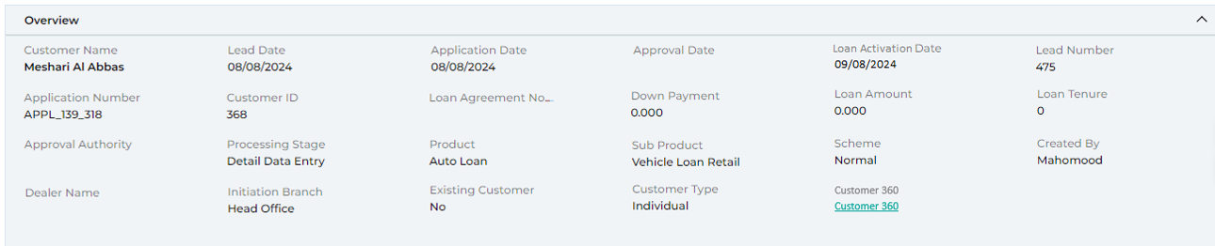
Below are the details specific to the information being displayed above.
Field Name | Field Type | Data Type / Length | Mandatory (Yes/No) | Look Up Value/ Master Name | Possible Value | Field Description
 |  |  |  |  |  | Remarks / Validation
Customer Name | Read Only | List View | NA | NA | NA | The system will display the customer’s name
Lead Date | Read Only | List View | NA | NA | NA | The system will display the date when lead was created.
Application Date | Read Only | List View | NA | NA | NA | The system will display the date on which the application was created.
Approval Date | Read Only | List View | NA | NA | NA | The system will display the date on which the loan application was approved.
Loan Activation Date | Read Only | List View | NA | NA | NA | The system will display the date on which the loan application was activated.
Lead Number | Read Only | List View | NA | NA | NA | The system will display the Lead number.
Application Number | Read Only | List View | NA | NA | NA | The system will display the application number.
Customer ID | Read Only | List View | NA | NA | NA | The system will display the customer’s Id.
Loan Agreement No | Read Only | List View | NA | NA | NA | The system will display the loan agreement number
Down Payment | Read Only | List View | NA | NA | NA | The system will display the downpayment customers agree to pay.
Loan Amount | Read Only | List View | NA | NA | NA | The system will display the total loan amount required by the customer.
Loan Tenure | Read Only | List View | NA | NA | NA | The system will display the approved tenure.
Approval Authority | Read Only | List View | NA | NA | NA | The system will display the sanctioned authority.
Processing Stage | Read Only | List View | NA | NA | NA | The system will display the processing stage.
Product | Read Only | List View | NA | NA | NA | The system will display the product.
Sub Product | Read Only | List View | NA | NA | NA | The system will display the sub product.
Scheme | Read Only | List View | NA | NA | NA | The system will display the scheme selected.
Created By | Read Only | List View | NA | NA | NA | The system will display the Username who created the loan application.
Dealer Name | Read Only | List View | NA | NA | NA | The system will display the Dealer name.
Initiation Branch | Read Only | List View | NA | NA | NA | The system will display the initiation branch.
Existing Customer | Read Only | List View | NA | NA | NA | In case of existing customer, the system will display the flagging as Yes else it will be shown as No
Customer Category | Read Only | List View | NA | NA | NA | The system will display the customer category whether Individual or Company
Customer 360 | Read Only | Hyperlink | NA | NA | NA | The User will click on this hyperlink to view the overall history of the customer in case if the customer is existing
 |  |  |  |  |  | Customer 360 is applicable only in the case of existing customers, and the required data will be getting in fetch via the LMS

12.2 Progress of Application
The progress bar enables the user to monitor the overall status and advancement based on the product workflow timeline. It allows the user to see the Application status and monitor the TAT for individual applications and it highlights the following fields (different stages, start date, end date, TAT for the stage, user allocated to, and status).
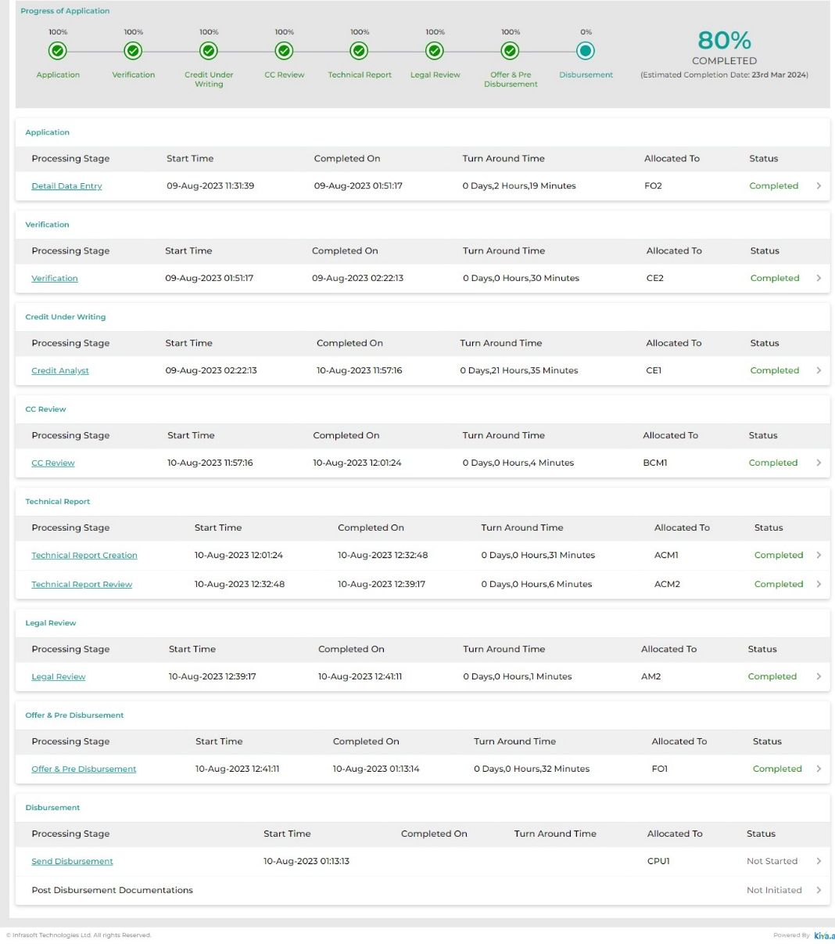

12.3 Team Inbox
The Team Inbox queue is designed for supervisor users, allowing them to view applications that their team is currently working on in a read-only mode. Supervisors can filter applications by team member name and double-click on an application to access detailed information in view-only mode.

Field Name | Field Type | Data Type / Length | Mandatory (Yes/No) | Look Up Value/ Master Name | Possible Value | Field Description
 |  |  |  |  |  | Remarks / Validation
Application Number | List View | List View | NA | NA | NA | The system will display the Loan Application number generated at the time of converting an application from the New Application scree.
Id Number | List View | List View | NA | NA | NA | The system will display the ID Number captured at the time of the Application stage
Customer Name | List View | List View | NA | NA | NA | The system will display Customer Name.
Mobile Number |  |  |  |  |  | The system will display the primary contact number captured at the time of application creation
Creation Date | List View | List View | NA | NA | NA | The system will display the creation date of the lead creation.
Created By | List View | List View | NA | NA | NA | The system will display the name of the user who has initiated the loan application
Completed % | List View | List View | NA | NA | NA | The system will display the completion percentage of the loan application process
Convert To Application Date | List View | List View | NA | NA | NA | The system will display the creation date of the loan application converted.
Product | List View | List View | NA | NA | NA | The system will display the facility, or the product chosen by the applicant.
Sub Product | List View | List View | NA | NA | NA | The system will display the sub facility chosen by the applicant.
Stage | List View | List View | NA | NA | NA | The system will display the current stage of the application.
Current User | List View | List View | NA | NA | NA | The system will display the Username and Id.
Initiation Branch | List View | List View | NA | NA | NA | The system will display the branch from which the application was initiated.

Detail Data Entry Stage

Access Right Metrics
Access rights metrics display the configuration of screens within each respective stage and tab, indicating the available access rights for users to Add, View, Edit, or data. A "✔" icon signifies the access rights granted for each screen at that stage. Conversely, if all four access rights options are blank and lack an icon, it means that the screen is not applicable for that stage.
Tab Name | Screen Name | Add | View | Edit | Delete
Application | Application Summary |  | ü
KYC | Basic Details | ü | ü | ü | ü
KYC | Address Details | ü | ü | ü | ü
KYC | Identification Details | ü | ü | ü | ü
KYC | Business Details | ü | ü | ü | ü
KYC | Relationship Segment | ü | ü | ü | ü
KYC | Employment Details | ü | ü | ü | ü
KYC | Bank Details | ü | ü | ü | ü
KYC | Repayment Details | ü | ü | ü | ü
KYC | Insurance Details | ü | ü | ü | ü
KYC | Contact Details | ü | ü | ü | ü
Product Details | Collateral Search | ü | ü | ü | ü
Product Details | Collateral Details | ü | ü | ü | ü
Product Details | Valuation | ü | ü | ü | ü
Product Details | Loan Item Details | ü | ü | ü | ü
Product Details | Loan Details | ü | ü | ü | ü
Product Details | Charges | ü | ü | ü | ü
Income & Expense | Income | ü | ü | ü | ü
Income & Expense | Expense | ü | ü | ü | ü
Income & Expense | Credit Bureau Exposure Check | ü | ü | ü | ü
Income & Expense | Repayment Ratios | ü | ü | ü | ü
Document | Document Checklist | ü | ü | ü | ü
Document | Document Verification
Document | Loan Kit | ü | ü | ü | ü
Financials | PNW Statement | ü | ü | ü | ü
Financials | Balance Sheet | ü | ü | ü | ü
Financials | Income Statement | ü | ü | ü | ü
Financials | Financial Ratios | ü | ü | ü | ü
Financials | Cash Flow Statement | ü | ü | ü | ü
Financials | Z-Score Analysis | ü | ü | ü | ü
Financials | Qualitative - Quantitative Scoring | ü | ü | ü | ü
Policy Review | Policy Check | ü | ü | ü | ü
Policy Review | Credit Score Card | ü | ü | ü | ü
Policy Review | Exception Details | ü | ü | ü | ü
Collection Review | Collection Review
Checklist | Legal Opinion Checklist
Checklist | Credit Concentration Review
Checklist | Risk Opinion Checklist
AML Check | Risk Assessment Checklist
AML Check | Customer Risk Rating
Credit Approval | Recommendation
Credit Approval | Recommendation History
Credit Approval | Committee Approval
Disbursement | Disbursement Details
Registration | Registration Details
Document Archive | Document Archive

Business Logic
The Detail Data Entry stage in a loan application involves collecting detailed information from the applicant by the retail/commercial sales officer. Key details include KYC details, employment history, business details, financial information, income details, credit history, loan specific details, and the submission of necessary documents. This stage will be the source of information for the rest of the stages and will also be used for the computation of the policy check, internal scoring along with the customer risk.
Additionally, it enables the user to fetch data via the integration of Smart Card Reader/MID for a smooth onboarding process of individuals. Moreover, the system can trigger the Ci-Net (Credit Bureau) to retrieve exposure details of the customer, aiding in computing eligibility and assessing associated risks.
Once the due diligence has been done and all related data points are captured, sales user will move the application to the next stage which will be the Verification stage. The application will get assigned to the retail/commercial manager for the verification of the details & documents captured for further processing.

13.2.1 Application Summary
The application summary screen is a read-only display that provides a high-level overview of the loan and customer details captured across various screens, including KYC, employment, business, income, expenses, collateral, existing exposure, and loan specifics. It also presents computations based on defined logic, assisting underwriters and decision-makers in evaluating the application without needing to navigate through different screens. The data fields shown on the application summary will vary by business line; for instance, the fields for retail customers will differ from those for commercial customers.

13.2.1.1 Application Summary – Retail Customer
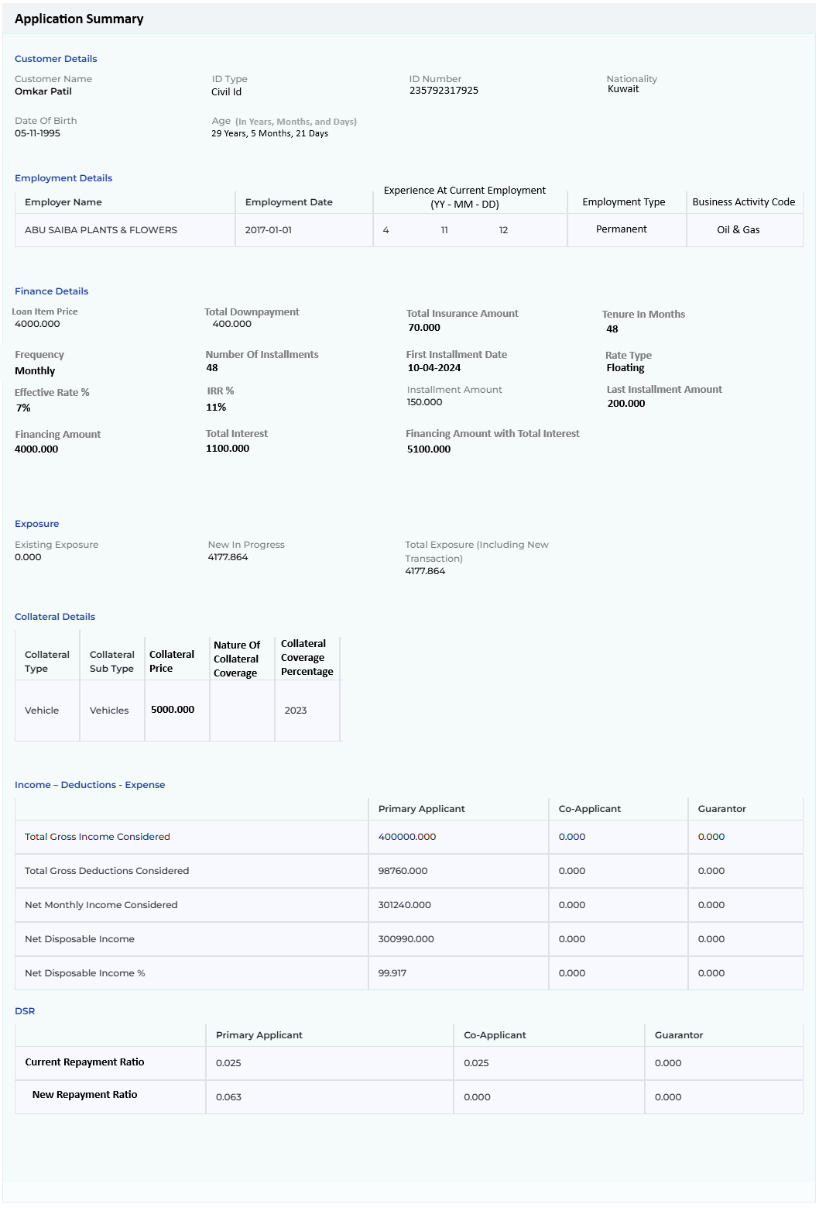
Field Name | Field Type | Data Type / Length | Mandatory (Yes/No) | Look Up Key / Master Name | Possible Value | Field Description
 |  |  |  |  |  | Remarks / Validation
Customer Details
Customer Name | Read Only |  |  |  | Abbas Al Meshari | The system will display the customer’s name  From the Basic Details screen
ID Type | Read Only |  |  |  | Civil Id | System will display the ID Type provided such as Civil Id, CR, etc.  From the Basic Details screen
ID Number | Read Only |  |  |  | 236518239163 | System will display the ID Number of the selected ID Type  From the Basic Details screen
Nationality | Read Only |  |  |  | Kuwait | System will display the customer’s nationality  From the Basic Details screen
Date Of Birth | Read Only |  |  |  | 05-11-1995 | System will display the  Customer’s Date of Birth  From the Basic Details screen
Age (In Years, Months, and Days) | Read Only |  |  |  | 29 Years, 5 Months, 21 Days | System will display the customer’s Age in years & months  From the Basic Details screen
Employment Details
Employer Name | Read Only |  |  |  |  | System will display the employer’s name  From the Employment Details screen
Employment Date | Read Only |  |  |  |  | System will display the employment date  From the Employment Details screen
Experience at Current Employment  (YY – MM- DD) | Read Only |  |  |  |  | The system will display the service tenure in years and months  From the Employment Details screen
Employment Type | Read Only |  |  |  |  | System will display the employment type  From the Employment Details screen
Business Activity Code | Read Only |  |  |  |  | System will display the business activity code.  From the Employment Details screen
Loan Details
Loan Item Price | Read Only |  |  |  | 4000.000 | The system will display the loan item price  From the Loan Details screen
Total Downpayment | Read Only |  |  |  | 400.000 | System will display the total downpayment amount.  From the Loan Details screen
Total Insurance Amount | Read Only |  |  |  | 70.000 | The system will display the total insurance amount  From the Loan Details screen
Tenure in Months | Read Only |  |  |  | 48 | System will display the tenure in months  From the Loan Details screen
Frequency | Read Only |  |  |  | Monthly | The system will display the loan frequency  From the Loan Details screen
Number Of Installments | Read Only |  |  |  | 48 | System will display the total number of loan installments  From the Loan Details screen
First Installment Date | Read Only |  |  |  | 10-04-2024 | System will display the first date of loan installment  From the Loan Details screen
Rate Type | Read Only |  |  |  | Floating | System will display the rate type  From the Loan Details screen
Effective Rate | Read Only |  |  |  | 7% | The system will display the effective rate of interest in percentage.  From the Loan Details screen
IRR% | Read Only |  |  |  | 11% | System will display the IRR rate percentage.  From the Loan Details screen
Instalment Amount | Read Only |  |  |  | 150.000 | System will display the installment amount  From the Loan Details screen
Last Instalment Amount | Read Only |  |  |  | 200.000 | System will display the last installment amount  From the Loan Details screen
Financing Amount | Read Only |  |  |  | 4000.000 | System will display the financing amount  From the Loan Details screen
Total Interest | Read Only |  |  |  | 1100.000 | The system will display the total interest to be paid.  From the Loan Details screen
Financing Amount with Total Interest | Read Only |  |  |  | 5100.000 | The system will display the total amount to be paid including interest  From the Loan Details screen
Exposure
Existing Exposure | Read Only |  |  |  |  | System to display existing exposure  From the Credit Bureau Exposure Details screen
New In Progress | Read Only |  |  |  |  | System to display new exposure which will be equals to the financing amount  From the Loan Details screen
Total Exposure (Including Net Transaction) | Read Only |  |  |  |  | System to display total exposure including the applied new transaction  From the Credit Bureau Exposure Details & Loan Details screen
Collateral
Collateral Type | Read Only |  |  |  |  | System to display Collateral Type  From the Collateral Details screen
Collateral Sub Type | Read Only |  |  |  |  | System to display Collateral Sub Type  From the Collateral Details screen
Collateral Price | Read Only |  |  |  |  | System to display Collateral price  From the Collateral Details screen
Nature of Collateral Coverage | Read Only |  |  |  |  | System to display Nature of Collateral Coverage  From the Collateral Details screen
Collateral Coverage Percentage | Read Only |  |  |  |  | System to display Collateral Coverage Percentage  From the Collateral Details screen
Income – Deductions - Expense
Total Gross Income Considered | Read Only |  |  |  |  | To be computed for Main Applicant, Joint Applicant, Guarantor  From the Ratios screen
Total Gross Deduction Considered | Read Only |  |  |  |  | To be computed for Main Applicant, Joint Applicant, Guarantor  From the Ratios screen
Net Monthly Income Considered | Read Only |  |  |  |  | To be computed for Main Applicant, Joint Applicant, Guarantor  From the Ratios screen
Net Disposable Income | Read Only |  |  |  |  | To be computed for Main Applicant, Joint Applicant, Guarantor  From the Ratios screen
Net Disposable Income % | Read Only |  |  |  |  | To be computed for Main Applicant, Joint Applicant, Guarantor  From the Ratios screen
Repayment Ratio
Current Repayment Ratio | Read Only |  |  |  |  | To be computed for Main Applicant, Joint Applicant, Guarantor  From the Ratios screen
New Repayment Ratio | Read Only |  |  |  |  | To be computed for Main Applicant, Joint Applicant, Guarantor  From the Ratios screen

13.2.1.2 Application Summary – Commercial Customer
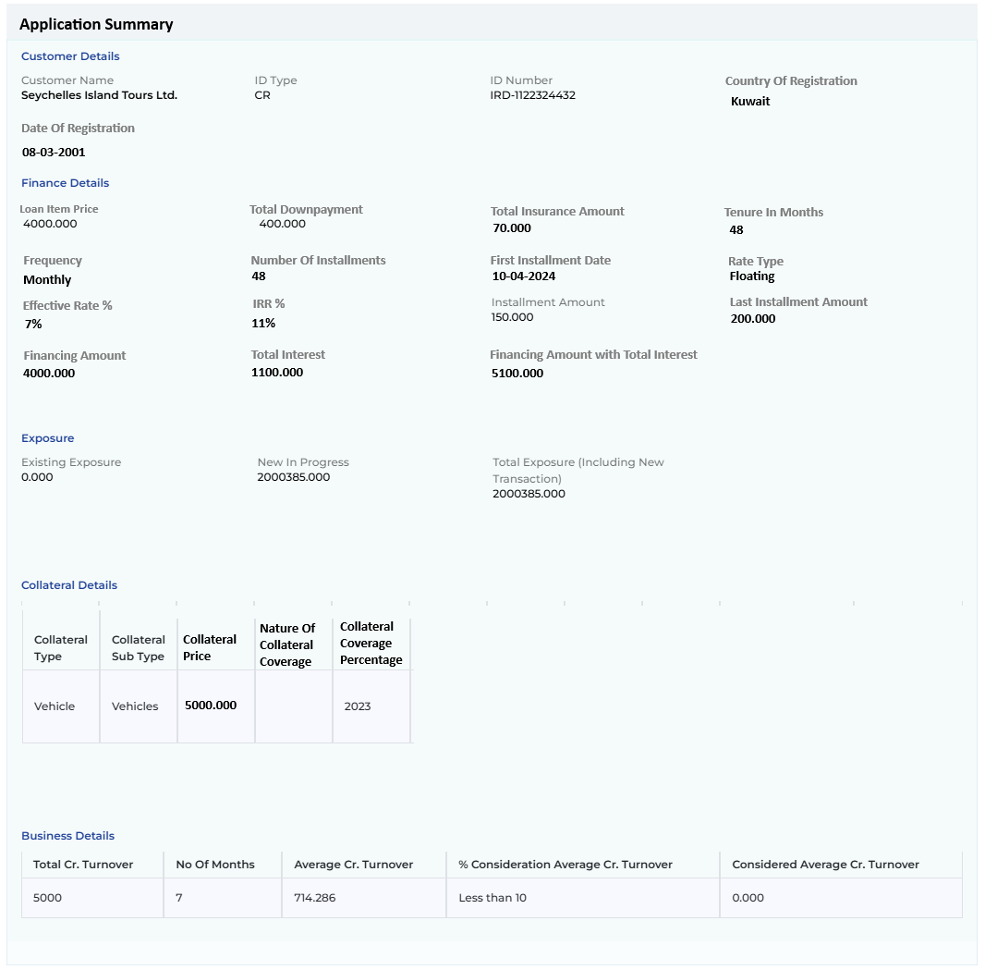
Field Name | Field Type | Data Type / Length | Mandatory (Yes/No) | Look Up Key / Master Name | Possible Value | Field Description
 |  |  |  |  |  | Remarks / Validation
Customer Details
Customer Name | Read Only |  |  |  | Micro Tech Enterprises | System will display the customer name  From the Basic Details screen
ID Type | Read Only |  |  |  | CR | System will display the ID Type provided  From the Basic Details screen
ID Number | Read Only |  |  |  | 2346578980 | System will display the ID Number of the selected ID Type  From the Basic Details screen
Country Of Registration | Read Only |  |  |  |  | The system will display the company’s country of registration  From the Basic Details screen
Date Of Registration | Read Only |  |  |  |  | The system will display the company’s Date of Registration  From the Basic Details screen
Finance Details
Loan Item Price | Read Only |  |  |  | 4000.000 | The system will display the loan item price  From the Loan Details screen
Total Downpayment | Read Only |  |  |  | 400.000 | System will display the total downpayment amount.  From the Loan Details screen
Total Insurance Amount | Read Only |  |  |  | 70.000 | The system will display the total insurance amount  From the Loan Details screen
Tenure in Months | Read Only |  |  |  | 48 | System will display the tenure in months  From the Loan Details screen
Frequency | Read Only |  |  |  | Monthly | The system will display the loan frequency  From the Loan Details screen
Number Of Installments | Read Only |  |  |  | 48 | System will display the total number of loan installments  From the Loan Details screen
First Installment Date | Read Only |  |  |  | 10-04-2024 | System will display the first date of loan installment  From the Loan Details screen
Rate Type | Read Only |  |  |  | Floating | System will display the rate type  From the Loan Details screen
Effective Rate | Read Only |  |  |  | 7% | The system will display the effective rate of interest in percentage.  From the Loan Details screen
IRR% | Read Only |  |  |  | 11% | System will display the IRR rate percentage.  From the Loan Details screen
Instalment Amount | Read Only |  |  |  | 150.000 | System will display the installment amount  From the Loan Details screen
Last Instalment Amount | Read Only |  |  |  | 200.000 | System will display the last installment amount  From the Loan Details screen
Financing Amount | Read Only |  |  |  | 4000.000 | System will display the financing amount  From the Loan Details screen
Total Interest | Read Only |  |  |  | 1100.000 | The system will display the total interest to be paid.  From the Loan Details screen
Financing Amount with Total Interest | Read Only |  |  |  | 5100.000 | The system will display the total amount to be paid including interest  From the Loan Details screen
Exposure
Existing Exposure | Read Only |  |  |  |  | System to display existing exposure  From the Credit Bureau Exposure Details screen
New In Progress | Read Only |  |  |  |  | System to display new exposure if any in progress  From the Credit Bureau Exposure Details screen
Total Exposure (Including New Transaction) | Read Only |  |  |  |  | System to display total exposure including the applied new transaction  From the Credit Bureau Exposure Details screen
Collateral
Collateral Type | Read Only |  |  |  |  | System to display Collateral Type  From the Collateral Details screen
Collateral Sub Type | Read Only |  |  |  |  | System to display Collateral Sub Type  From the Collateral Details screen
Collateral Price | Read Only |  |  |  |  | System to display Collateral price  From the Collateral Details screen
Nature of Collateral Coverage | Read Only |  |  |  |  | System to display Nature of Collateral Coverage  From the Collateral Details screen
Collateral Coverage Percentage | Read Only |  |  |  |  | System to display Collateral Coverage Percentage  From the Collateral Details screen
Business Details
Total Cr. Turnover |  |  |  |  |  | The system will display the first total Credit Turnover
 |  |  |  |  |  | Summation of multiple bank Credit Turnover captured in the Business Details screen will be displayed over here.
No Of Months |  |  |  |  |  | System will display the number of months for the highest Total Cr Turnover captured on the Business Details screen
Average Cr. Turnover |  |  |  |  |  | System will display the summation of the average credit turnover for those computed on the Business Details screen
% Consideration Average Cr. Turnover |  |  |  |  |  | System will display the % consideration for average credit turnover for those months computed on the Business Details screen, it will display the highest percentage considered
Considered Average Cr. Turnover |  |  |  |  |  | System will display the sum of considered average credit turnover as per the % defined computed on the Business Details screen

13.2.2 KYC
The KYC tab includes several screens that enable sales users to capture the necessary KYC details for Main Applicant & guarantors in case of Retail Loan and in case of Commercial Loan for Main Applicant, Guarantor, Partner, & beneficiary of the company. Users can input essential information such as the borrowers' basic details, various addresses, employment information for salaried individuals, business details for companies, member information related to the company along with their shareholding, bank details, repayment mode, contact information, and insurance details.

13.2.2.1 Basic Details

The Basic Detail screen enables the user to record essential information for both individual and corporate customers, including the applicant's name, contact number, identification details, and nationality which are the crucial data points for due diligence and customer onboarding. The customer details captured during application creation will automatically be considered as the main applicant. Whereas the Fetch functionality applicable for the Individual customer allows the integration with smart card reader to fetch details directly, reducing manual data entry time. Additionally, the Basic Details screen allows for the entry of Joint Applicant and guarantor information. When onboarding a Joint Applicant or guarantor, the system performs due diligence and retrieves data through integration with the Civil ID smart card, just as it does for the main applicant.
If fetch rights are not granted, users can enter the required details manually for all the borrowers.
The following data points to be fetched from the Civil Id interface on the click of Fetch button and will be stored and utilized during the detail data entry stage.
- Name - English and Arabic
- Civil ID Number
- Gender - English and Arabic
- Nationality - English and Arabic
- Birth Date - YYYY-MM-DD
- Issue Date - YYYY-MM-DD
- Expiry Date - YYYY-MM-DD']
- District
- Block
- Street
- Building No
- Unit Type
- Unit No
- Floor
- Blood Type

Navigation:
Detail Data Entry à KYC à Basic Details
The following screen will be displayed once the User clicks on Basic Details:

13.2.2.1.1 Basic Details – Retail Customer

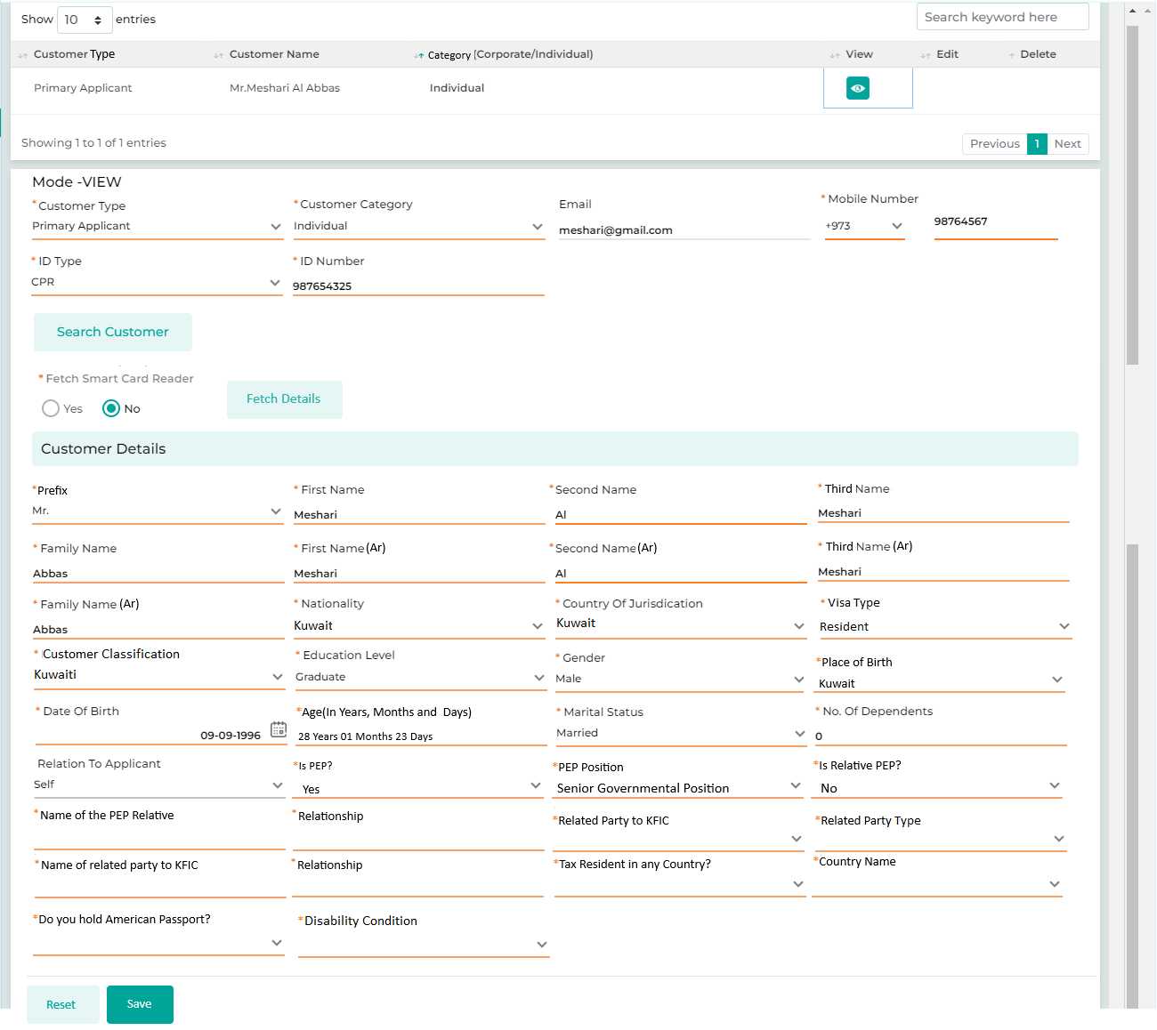
Below are the details specific to the information being displayed above.
Field Name | Field Type | Data Type / Length | Mandatory (Yes/No) | Look Up Key / Master Name | Possible Value | Field Description
 |  |  |  |  |  | Remarks / Validation
Customer Type | LOV Dropdown | VARCHAR | Yes | 4034 | - Main Applicant  - Joint Applicant  - Guarantor | The User will select the Customer type from the drop-down values for capturing the basic details for the selected entity.  The customer details captured during application creation will automatically be considered as the Main Applicant, with data retrieved via the Civil ID smart card reader or MID auto-populated across respective fields.
Customer Category | LOV Dropdown | VARCHAR | Yes | 1120 | - Individual  - Company | The User will select the Customer category from the drop-down values.  When "Individual" is selected as the customer category, the fields specific to individual customers will be displayed. Conversely, when "Company" is selected, the fields relevant to commercial customers will appear for the user to fill out.
Applicant Type | LOV Dropdown | VARCHAR | Yes |  | Individual  Technical non-complaint  PEP | The User will select the Applicant type from the drop-down values.  Fields available for regulatory reporting in base product
Email | Text box | VARCHAR | No | NA | NA | The User will enter the customer’s email-id.
 |  |  |  |  |  | Can be fetched via Civil ID smart card reader integration
Mobile Number | Text Box | VARCHAR | Yes | NA | NA | The User will enter the customer’s mobile number.  Mobile Number pattern will be as follow:  Code +965  Followed by 8 digits
 |  |  |  |  |  | Can be fetched via Civil ID smart card reader integration
ID Type | Master Dropdown | VARCHAR | NA | POITYPE_IND | Civil ID  Passport  MOCI Registration No  (Refer LOV Sheet for the complete list of LOVS) | The User will select the identity document from the drop-down values.
ID Number | Text box | NVARCHAR | Yes | NA | NA | The User will enter the ID Number of the selected POI Type.
Search | Button | Button | Yes | NA | NA | When onboarding other customer types such as Joint Applicant or Guarantor, using the ID number entered the search functionality enables the user to identify if they are existing customers in the KFIC system. If they are, the search results will display their details, allowing the user to click on the result and automatically populate the information on the screen instead of entering it manually.
Fetch Smart Card Reader | Button | Radio Button | Yes | NA | Yes  No | If "No" is selected, the user can manually enter the details. If "Yes" is selected, the smart card reader will be activated, allowing the user to insert the Civil ID. This will initiate the fetch process, which will automatically populate the details on the screen.
Fetch Details | Button | Button | NA | NA | NA | Regarding the option to fetch details from the smart card reader, once the Civil ID is inserted, the user will click on "Fetch Details" button to initiate the process.
Customer Details
Title | LOV Dropdown | VARCHAR | Yes | TITLE | - MS  - MR  - MRS | The User will select the customer’s title from the drop-down values.
 |  |  |  |  |  | Can be fetched via Civil ID smart card reader integration
Prefix | LOV Dropdown | VARCHAR | Yes | TITLE | - MS  - MR  - MRS | The User will select the customer’s prefix from the drop-down values.
 |  |  |  |  |  | Can be fetched via Civil ID smart card reader integration
First Name | Text box | VARCHAR | Yes | NA | NA | The User will enter the customer’s first name in the text box.
 |  |  |  |  |  | Can be fetched via Civil ID smart card reader integration
Second Name | Text Box | VARCHAR | Yes | NA | NA | The User will enter the customer’s middle/second name in the text box.
 |  |  |  |  |  | Can be fetched via Civil ID smart card reader integration
Third Name | Text Box | VARCHAR | Yes | NA | NA | The User will enter the customer’s Third name in the text box.
 |  |  |  |  |  | Can be fetched via Civil ID smart card reader integration
Family Name | Text box | VARCHAR | Yes | NA | NA | The User will enter the customer’s family name in the text box.  Can be fetched via Civil ID smart card reader integration
First Name (Arabic) | Text box | VARCHAR | Yes | NA | NA | The User will enter the customer’s first name in the text box in Arabic
 |  |  |  |  |  | Can be fetched via Civil ID smart card reader integration
Second Name (Arabic) | Text Box | VARCHAR | Yes | NA | NA | The User will enter the customer’s middle/second name in the text box in Arabic
 |  |  |  |  |  | Can be fetched via Civil ID smart card reader integration
Third Name (Arabic) | Text Box | VARCHAR | Yes | NA | NA | The User will enter the customer’s Third name in the text box in Arabic
 |  |  |  |  |  | Can be fetched via Civil ID smart card reader integration
Family Name (Arabic) | Text box | VARCHAR | Yes | NA | NA | The User will enter the customer’s family name in the text box in Arabic
Name As Per ID | Read Only | NVARCHAR | No | NA | NA | Upon fetching the details of the customer through the provided POI and ID number, it will display the Name of the customer as per the official records.
 |  |  |  |  |  | Names as per the ID type which is fetched via the interface should have validation to match with the name entered, else it should give a system alert before moving ahead.
Nationality | LOV Dropdown | VARCHAR | Yes | NA | Kuwait  KSA  UAE  Egypt  India | The User will select the nationality of the customer.
 |  |  |  |  |  | Can be fetched via Civil ID smart card reader integration
Country Of Jurisdiction | LOV Dropdown | VARCHAR | Yes | NA | Kuwait | The system will display the country of jurisdiction depending upon the nationality selected  By default, it will be Kuwait  Can be fetched via Civil ID smart card reader integration
Visa Type | LOV Dropdown | VARHAR | Yes | NA | Resident | Will be fetched via Civil ID smart card reader integration
Customer Classification | LOV Dropdown | VARCHAR | Yes | NA | Kuwaiti  Expatriate  Bedouin | If the Nationality is Kuwaiti, the user has the option to select the customer classification as Kuwaiti or Bedouin.  Whereas if the Nationality is other than Kuwaiti, by default the system will populate the Customer Classification as Expatriates.  Required for Lending Criteria Policy
Education Level | LOV Dropdown | VARCHAR | Yes | EDULVL | 001  School Completed  002 Undergraduate  003 Masters  004 Doctorate  005 None  006 Not Available | The User will select the qualification of the customer.  Can be fetched via Civil ID smart card reader integration  Mandatory field required for CiNet reporting
Gender | LOV Dropdown | VARCHAR | Yes | 54 | - Male  - Female  - Others | The User will select the gender of the customer.
 |  |  |  |  |  | Can be fetched via Civil ID smart card reader integration
Place Of Birth | LOV Dropdown | VARCHAR | Yes |  | Kuwait | The user will select the place of birth from the list of values, by default it will be Kuwait.  Can be fetched via Civil ID smart card reader integration  Mandatory field required for CiNet reporting
Date Of Birth | Calendar | DATETIME | Yes | NA | 09-09-1996 | The User will select the DOB of the customer from the Calendar.
 |  |  |  |  |  | Can be fetched via Civil ID smart card reader integration
Age (In Years, Months, & Days) | Read Only | Integer | Yes | NA | 28 Years 01 Months 23 Days | Comparing the difference between the date of data entry and the date of birth of the customer the system will compute the age in years months and days.
Marital Status | LOV Dropdown | VARCHAR | Yes | MARITALSTATUS | 001 Single  002 Widowed  003 Divorced  004 Married  005 Separated  006 Not Available | The User will select the marital status of the customer from the drop-down.
 |  |  |  |  |  | Mandatory field required for CiNet reporting
No. Of Dependents | Text Box | VARCHAR | Yes | NA | NA | The User will enter the no. of member dependent on the customer in the text box.
Relationship To Applicant | LOV Dropdown | VARCHAR | Yes |  | Brother  Sister  Father  Mother  Daughter  Son | The following field is applicable only when onboarding the Joint Applicant or Guarantor, where the user will select the relationship type between the Joint Applicant or Guarantor and the main applicant.
Is PEP? | LOV Dropdown | VARCHAR | Yes | NA | Yes  No | The user will select whether the customer is listed under the PEP list. If the customer is available in the PEP list the user will select “Yes” else will select “No”
PEP position | LOV Dropdown | VARCHAR | Yes | NA | - Senior Governmental Position  - Member of ruling family  - Member of parliament /national assembly  - High military rank  - Diplomat / Ambassador/ Consul/ Secretary  - Judge/ counsel / chief justice / prosecutor  - Prominent political party official  - Executive officer /board member of international organization | If selected PEP as “Yes” the user will select the position under the PEP from the dropdown list.  The filed will be dependent to the selection for the filed “Is PEP?” is selected as Yes
Is Relative PEP? | LOV Dropdown | VARCHAR | Yes | NA | Yes  No | The user will select whether any of the customer’s relative is listed under the PEP list by selecting “Yes” or “No”
Name of the PEP relative | Text Box | VARCHAR | Yes | NA |  | If selected “Yes” the user will enter the name of the relative who comes under the PEP list  The filed will be dependent to the selection for the filed “Is Relative PEP?” is selected as Yes
Relationship | Text Box | VARCHAR | Yes | NA |  | If selected “Yes” the user will enter the relationship with the relative who come under the PEP list  The filed will be dependent to the selection for the filed “Is Relative PEP?” is selected as Yes
Related Party To KFIC | LOV Dropdown | VARCHAR | Yes | RELATED PARTY TO KFIC MASTER | Yes  No | Basis of the Civil ID or the ID type entered, the system should check from the related party master list and populate as Yes.
Related party Type | Read Only | VARCHAR | Yes | NA | CEO  Executive Management  Board Of Directors  Shareholders  Lawyers  Auditors  (Refer LOV sheet for the detailed list) | The filed will be dependent to the selection for the filed “Related Party to KFIC” is Yes.  Basis the Civil Id check from the Related party to the KFIC master, the system will display the type of the relation with KFIC.
Name of Related Party | Read Only | VARCHAR | Yes | NA |  | The filed will be dependent to the selection for the filed “Related Party to KFIC” is Yes.  Basis the Civil Id check from the Related party to the KFIC master, the system will display the name of the related party.
Relationship | Text Box | VARCHAR | Yes | NA |  | If selected “Yes” the user will enter the relationship with the related party individual  The filed will be dependent to the selection for the filed “Related Party to KFIC “is selected any value other than “Yes”
Tax Resident in any Country? | LOV Dropdown | VARCHAR | Yes | NA | Yes  No | The user will select whether the customer is Taxpayer in any country by selecting “Yes” or “No” from the dropdown
Country Name | LOV Dropdown | VARCHAR | Yes | NA | India | If selected “Yes” under the filed “Tax Resident in any Country” the user will select the country name from the list of values  The filed will be dependent basis on the selection of the “Tax Resident in any Country” as Yes
Do you hold American Passport? | LOV Dropdown | VARCHAR | Yes | NA | Yes  No | The user will select whether the customer is the US passport holder by selecting “Yes” or “No” from the dropdown
Disability Condition | LOV Dropdown | VARCHAR | Yes | NA | Yes  No | The user will select whether the customer is disabled by selecting “Yes” or “No” from the dropdown  Required for Lending Criteria Policy
Category Of Client | LOV Dropdown |  |  |  |  | Fields available for regulatory reporting in base product
Auto Blacklisted | LOV Dropdown |  |  |  |  | The system will automatically flag the customer as blacklisted as per the internal blacklist database.
UN Blacklist Validated | LOV Dropdown |  |  |  |  | As per the search in the UN list, the user will select Yes or No
Blacklist Reason | LOV Dropdown |  |  |  |  | The system will display the blacklist reason
Returned Cheques | LOV Dropdown |  |  |  |  | In case of existing loan of the customer, the system will display whether there were any returned cheques.
Cheque Abuser List | LOV Dropdown |  |  |  |  | In case of existing loan of the customer, the system will display whether the customer was in the cheque abuser list in case of any bounce.
Action Buttons
Reset | Button | Button | NA | NA | NA | The User will click on the button to clear the entered data.
Save | Button | Button | NA | NA | NA | The User will click on the button to save the entered data.

13.2.2.1.2 Basic Details – Commercial Customer
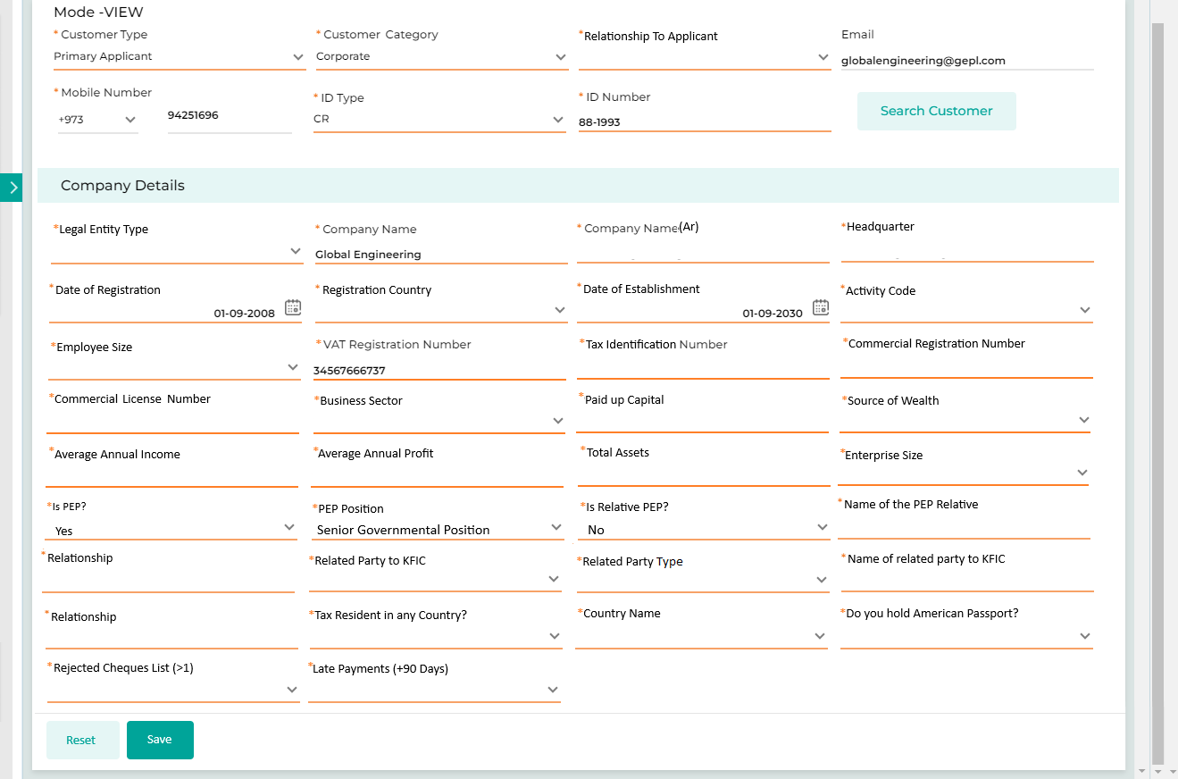
Below are the details specific to the information being displayed above.
Field Name | Field Type | Data Type / Length | Mandatory  (Yes/No) | Look Up Key / Master Name | Possible Value | Field Description
 |  |  |  |  |  | Remarks / Validation
Customer Type | LOV Dropdown | VARCHAR | Yes | 4034 | Main Applicant  Joint Applicant  Guarantor  Partner | The User will select the Customer type from the drop-down values for capturing the basic details for the selected entity.  The customer details captured during application creation will automatically be considered as the Main Applicant.
Customer Category | LOV Dropdown | VARCHAR | Yes | 1120 | Individual  Company | The User will select the Customer category from the drop-down values.  When "Individual" is selected as the customer category, the fields specific to individual customers will be displayed. Conversely, when "Company" is selected, the fields relevant to commercial customers will appear for the user to fill out.
Relationship To Applicant | LOV Dropdown | VARCHAR | Yes |  | Proprietor  Partner-General Partnership  Limited Partner  Shareholder  Board of Director  Chairman  Vice Chairman  Key Decision Maker  Partner-Limited Partnership  Parent Company  Subsidiary  Associates  Sister Company  Auditors (of the lender)  Others  Single Person Company  (Refer LOV Sheet for the complete list of LOVS) | The following field is applicable only when onboarding the Joint Applicant or Guarantor, where the user will select the relationship type between the Joint Applicant or Guarantor and the main applicant.
Applicant Type | LOV Dropdown | VARCHAR | Yes |  | Individual  Technical non-complaint  PEP | The User will select the Applicant type from the drop-down values.  Fields available for regulatory reporting in base product
Email | Text box | VARCHAR | No | NA | NA | The User will enter the customer’s email-id.
Mobile Number | Text Box | VARCHAR | Yes | NA | NA | The User will enter the customer’s mobile number.
Mobile Number pattern will be as follow:
Code +965
Followed by 8 digits
ID Type | Master Dropdown | VARCHAR | NA | POITYPE_IND | Civil ID  Passport  MOCI Registration No  (Refer LOV Sheet for the complete list of LOVS) | The User will select the identity document from the drop-down values.
ID Number | Text box | NVARCHAR | Yes | NA | NA | The User will enter the ID Number of the selected POI Type.
Search | Button | Button | Yes | NA | NA | When onboarding other customer types such as Joint Applicant or Guarantor, using the ID number entered the search functionality enables the user to identify if they are existing customers in the KFIC system. If they are, the search results will display their details, allowing the user to click on the result and automatically populate the information on the screen instead of entering it manually.
Customer Details
Legal Entity Type | LOV Dropdown | VARCHAR | Yes | NA | General Partnership Company  Limited Partnership Company  Partnership limited by shares  Joint Venture Company  Shareholding Company  (Refer LOV Sheet for the complete list of LOVS) | The user will select the company’s legal type of the customer as an entity who is applying for the loan  Mandatory field required for CiNet reporting
Company Name | Text box | VARCHAR | Yes | NA | Al Mishra | The user will enter the name of the company in English
Company Name (Arabic) | Text box | VARCHAR | Yes | NA | المشراق | The user will enter the name of the company in Arabic
Headquarter | Text box | VARCHAR | Yes | NA | Kuwait | The user will enter the location of the company’s headquarter by default it should be Kuwait
Date Of Registration | Calendar | Date | Yes | NA | NA | The user will enter the date of establishment from the calendar  Mandatory field required for CiNet reporting
Registration Country | LOV Dropdown | VARCHAR | Yes | NA | Kuwait | The user will select the country in which the company is registered.  Mandatory field required for CiNet reporting
Expiration Date | Calendar | Date | Yes | NA | NA | Details will be fetched via the interface whereas it will also allow the user to capture the details.
Date Of Commencement | Calendar | Date | Yes | NA | NA | Details will be fetched via the interface whereas it will also allow the user to capture the details.
Date Of Incorporation | Calendar | Date | Yes | NA | NA | Details will be fetched via the interface whereas it will also allow the user to capture the details.
Place Of Establishment | Text Box |  |  |  |  | Details will be fetched via the interface whereas it will also allow the user to capture the details.
Date Of Establishment | Calendar | Date | Yes | NA | NA | The user will enter the date of establishment from the calendar
Activity Code | LOV Dropdown | VARCHAR | Yes | NA | Government - Ministry of Finance  Government - Other Government Institutions  Oil Industry - Oil Exploration  Oil Industry - Drilling Oil Wells  Oil Industry - Production  Oil Industry – Others  (Refer LOV Sheet for the complete list of LOVS) | The user will select the Activity Code from the list of values  Mandatory field required for CiNet reporting
Employee Size | LOV Dropdown | Integer | Yes | NA | 01 to 50  51 to 150  150 above | The user will select the range of number of employees associated with the company  Range as per CiNet manual
VAT Registered? | LOV Dropdown | VARCHARs | Yes | NA | NA | The user will select whether the VAT is registered Yes or No
VAT Registration Number | Text Box | VARCHAR | Yes | NA | NA | The User will enter the VAT registration Number
 |  |  |  |  |  | If Vat Registered is selected as Yes
Tax Identification Number | Text Box | VARCHAR | Yes | NA | NA | The user will enter the tax identification number of the entity
Commercial Registration Number | Text Box | VARCHAR | Yes | NA | NA | The user will enter the Commercial registration number of the entity
Commercial License Number | Text Box | VARCHAR | Yes | NA | NA | The user will enter the Commercial license number of the entity
VAT Registration Date | Calendar |  |  |  |  | The User will enter the VAT registration date
 |  |  |  |  |  | If Vat Registered is selected as Yes
Industry | LOV Dropdown | VARCHAR | Yes |  |  | The User will select the industry type of the company from the drop-down values.
Business Sector | LOV Dropdown | VARCHAR | Yes |  | Traditional Commercial Banks  Islamic Commercial Banks  Specialized Banks  Traditional Investment Companies  Islamic Investment Companies  Finance Companies  Other Financial Institutions  Government *  Government Institutions with Independent Budgets **  Non-Financial Units with a Government Share of 50% or More of the capital ***  Private Sector (Private Non-Financial Institutions) Not Applicable  (Refer LOV Sheet for the complete list of LOVS) | The User will select the sector type of the company from the drop-down values.  Mandatory field required for CiNet reporting
Paid up Capital | Text Box | Float | Yes | NA | NA | The user will enter the detail
Source Of Wealth | LOV Dropdown | VARCHAR | Yes | NA | Earnings  Business activities  Investment Retunes  Rents  Other (Dependent field in case of selected Other) | The user will select the primary source of wealth
Avg Annual Income | Text Box | Float | Yes | NA | NA | The user will enter the detail
Avg Annual Profit | Text Box | Float | Yes | NA | NA | The user will enter the detail
Total Assets | Text Box | Float | Yes | NA | NA | The user will enter the detail
Enterprise Size | LOV Dropdown | VARCHAR | Yes | NA | Small enterprise  Medium enterprise  Large enterprise  Not Applicable  (Refer LOV Sheet for the complete list of LOVS) | The User will select the size of the company from the drop-down values.  Mandatory field required for CiNet reporting
Is PEP? | LOV Dropdown | VARCHAR | Yes | NA | Yes  No | The user will select whether the customer is listed under the PEP list. If the customer is available in the PEP list the user will select “Yes” else will select “No”
PEP position | LOV Dropdown | VARCHAR | Yes | NA | - Senior Governmental Position  - Member of ruling family  - Member of parliament /national assembly  - High military rank  - Diplomat / Ambassador/ Consul/ Secretary  - Judge/ counsel / chief justice / prosecutor  - Prominent political party official  - Executive officer /board member of international organization | If selected PEP as “Yes” the user will select the position under the PEP from the dropdown list.  The filed will be dependent to the selection for the filed “Is PEP?” is selected as Yes
Is Relative PEP? | LOV Dropdown | VARCHAR | Yes | NA | Yes  No | The user will select whether any of the customer’s relative is listed under the PEP list by selecting “Yes” or “No”
Name of the PEP relative | Text Box | VARCHAR | Yes | NA |  | If selected “Yes” the user will enter the name of the relative who comes under the PEP list  The filed will be dependent to the selection for the filed “Is Relative PEP?” is selected as Yes
Relationship | Text Box | VARCHAR | Yes | NA |  | If selected “Yes” the user will enter the relationship with the relative who come under the PEP list  The filed will be dependent to the selection for the filed “Is Relative PEP?” is selected as Yes
Related Party To KFIC | LOV Dropdown | VARCHAR | Yes | RELATED PARTY TO KFIC MASTER | Yes  No | Basis of the Civil ID or the ID type entered, the system should check from the related party master list and populate as Yes.
Related party Type | Read Only | VARCHAR | Yes | NA | CEO  Executive Management  Board Of Directors  Shareholders  Lawyers  Auditors  (Refer LOV sheet for the detailed list) | The filed will be dependent to the selection for the filed “Related Party to KFIC” is Yes.  Basis the Civil Id check from the Related party to the KFIC master, the system will display the type of the relation with KFIC.
Name of Related Party to KFIC | Read Only | VARCHAR | Yes | NA |  | The filed will be dependent to the selection for the filed “Related Party to KFIC” is Yes.  Basis the Civil Id check from the Related party to the KFIC master, the system will display the name of the related party.
Relationship | Text Box | VARCHAR | Yes | NA |  | If selected “Yes” the user will enter the relationship with the related party individual  The filed will be dependent to the selection for the filed “Related Party to KFIC “is selected any value other than “Yes”
Tax Resident in any Country? | LOV Dropdown | VARCHAR | Yes | NA | Yes  No | The user will select whether the customer is Taxpayer in any country by selecting “Yes” or “No” from the dropdown
Country Name | LOV Dropdown | VARCHAR | Yes | NA | India | If selected “Yes” under the filed “Tax Resident in any Country” the user will select the country name from the list of values  The filed will be dependent basis on the selection of the “Tax Resident in any Country” as Yes
Do you hold American Passport? | LOV Dropdown | VARCHAR | Yes | NA | Yes  No | The user will select whether the customer is the US passport holder by selecting “Yes” or “No” from the dropdown
Rejected Cheques List (>1) | LOV Dropdown | VACHAR | Yes | NA | Yes  No | Applicable only in the case of an existing customer.  The user will select No if the customer is not available in the rejected cheques list for more than 1 case within the last year.  Mandatory field required for Policy check
Late Payment (+ 90 Dyas) | LOV Dropdown | VACHAR | Yes | NA | Yes  No | Applicable only in the case of an existing customer.  The user will select No if the customer’s late payment didn’t exceed 90 days within the last year.  Mandatory field required for Policy check
Action Buttons
Reset | Button | Button | NA | NA | NA | The User will click on the button to clear the entered data.
Save | Button | Button | NA | NA | NA | The User will click on the button to save the entered data.

13.2.2.2 Address Details
The user will capture the address details of the applicant along with the address details of the Joint Applicant and guarantor, if applicable. If the Civil ID data fetch is initiated, the address details will be fetched on the screen via the interfaces.
Navigation:
Detail Data Entry à KYC à Address Details
The following screen will be displayed once the User clicks on Address Details:
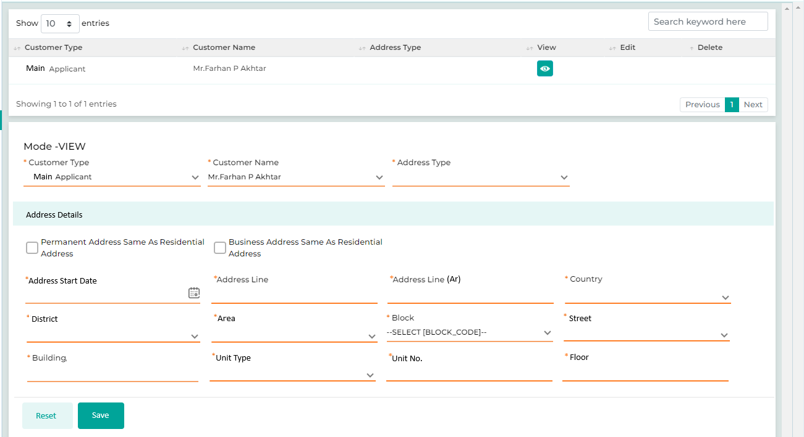
Below are the details specific to the information being displayed above.
Field Name | Field Type | Data Type/  Length | Mandatory  (Yes / No) | LookUp Key / Master Name | Possible Value | Field Description
 |  |  |  |  |  | Remark / Validation
Customer Type | LOV Dropdown | VARCHAR | Yes | 4034 | - Main Applicant  - Joint Applicant  - Guarantor  - Partner | The User will select the customer type from the drop-down values.
Customer Name | Master Dropdown | VARCHAR | Yes | NA | NA | Customer’s name will be visible in the Dropdown values as per the customer type selected
Address Type | LOV Dropdown | VARCHAR | Yes | 42046 | - Residential  - Permanent  - Business  - Postal  - P.O Box | The User will select the type of address from the Dropdown values.
 |  |  |  |  |  | Mandatory field required for CiNet reporting
Address Details
Permanent Address Same As Residential Address | Checkbox | Checkbox | NA | NA | NA | The user will select this button if the applicant’s permanent address is same as the residential address.
Business Address Same As Residential Address | Checkbox | Checkbox | NA | NA | NA | The user will select this button if the applicant’s business address is same as the residential address.
Address Start Date | Calendar | Date | NA | NA | 01-01-2001 | The user will select the date since when the customer is living at the mentioned address.
Address Line | Text Box | NVARCHAR | Yes | NA | NA | If Civil ID integration is triggered, it will be fetched via the interface else the system will allow the user to enter the details  Full address will be displayed English
Address Line (Arabic) | Text Box | NVARCHAR | Yes | NA | NA | If Civil ID integration is triggered, it will be fetched via the interface else the system will allow the user to enter the details  Full address will be displayed Arabic
Country | LOV Dropdown | VARCHAR | Yes | COUNTRY | NA | If Civil ID integration is triggered, it will be fetched via the interface else the system will allow the user to enter the details
District | LOV Dropdown | VARCHAR | Yes | DISTRICT | NA | If Civil ID integration is triggered, it will be fetched via the interface else the system will allow the user to enter the details
Area | LOV Dropdown | VARCHAR | Yes | AREA | NA | If Civil ID integration is triggered, it will be fetched via the interface else the system will allow the user to enter the details
Block | LOV Dropdown | VARCHAR | Yes | BLOCK | NA | If Civil ID integration is triggered, it will be fetched via the interface else the system will allow the user to enter the details
Street | LOV Dropdown | VARCHAR | Yes | STREET | NA | If Civil ID integration is triggered, it will be fetched via the interface else the system will allow the user to enter the details
Building | Text Box | VARCHAR | Yes | NA | NA | If Civil ID integration is triggered, it will be fetched via the interface else the system will allow the user to enter the details
Unit Type | LOV Dropdown | VARCHAR | Yes | NA | Apartment  Villa | If Civil ID integration is triggered, it will be fetched via the interface else the system will allow the user to enter the details
Unit No | Text Box | VARCHAR | Yes | NA | NA | If Civil ID integration is triggered, it will be fetched via the interface else the system will allow the user to enter the details
Floor | Text Box | VARCHAR | Yes | NA | NA | If Civil ID integration is triggered, it will be fetched via the interface else the system will allow the user to enter the details
Action Buttons
Reset | Button | Button | NA | NA | NA | The User will click on the button to clear the entered data.
Save | Button | Button | NA | NA | NA | The User will click on the button to save the entered data.

13.2.2.3 Identification Details

Identification details screen allows the user to capture the Identification details of the Main Applicant, Joint Applicant & Guarantor along with their validity credentials which further used for checking the validations at the time of customer Re-KYC and review. Apart from the ID type captured at the initial stage, the user can also capture another identification related details on this screen.
Navigation:
Detail Data Entry à KYC à Identification Details
The following screen will be displayed once the User clicks on Identification Details

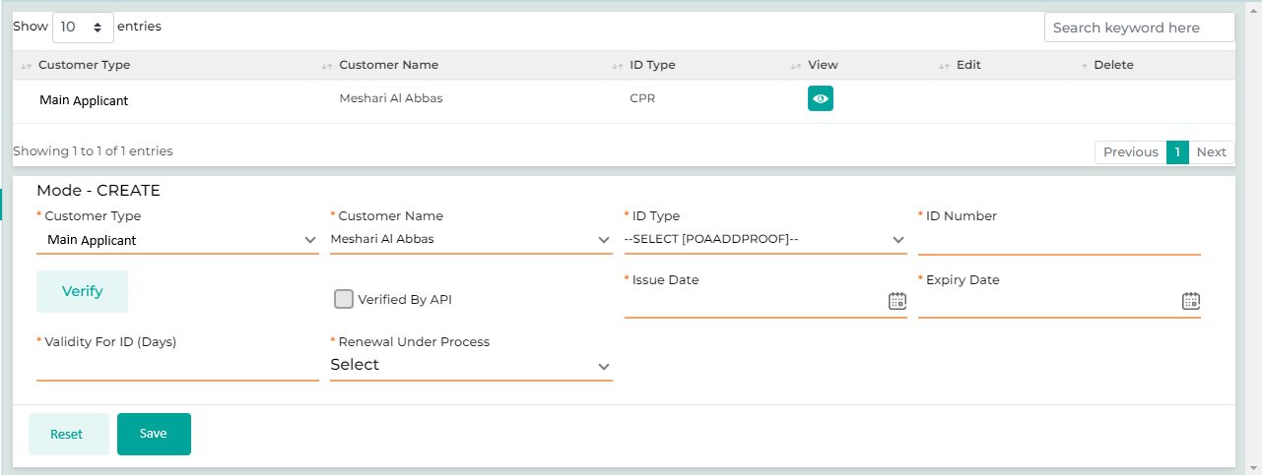

Below are the details specific to the information being displayed above.

Field Name | Field Type | Data Type/ Length | Mandatory (Yes / No) | LookUp Key/Master Name | Possible Value | Field Description
 |  |  |  |  |  | Remarks / Validation
Customer Type | List View | VARCHAR | Yes | NA | Main Applicant  Joint Applicant  Guarantor  Partner | Displays the Customer Type for whom the KYC document is to be captured.
Customer Name | List View | VARCHAR | Yes | NA | NA | Displays the Customer Name for whom the KYC document is being captured.
ID Type | List View | VARCHAR | Yes | NA | NA | Displays the id type.
Mode - Create
Customer Type | LOV Dropdown | VARCHAR | Yes | 4034 | - Main Applicant  - Joint Applicant  - Guarantor | The User will select the customer type from the drop-down values
Customer Name | Master Dropdown | VARCHAR | Yes | NA | NA | The User will select the customer’s name from the dropdown.
ID Type | LOV Dropdown | VARCHAR | Yes | POAADDPROOF | Civil ID  Passport  MOCI Registration No  (Refer LOV Sheet for the complete list of LOVS) | The User will select the ID Type.
ID Number | Text Box | NVARCHAR | Yes | NA | NA | The User will enter the ID Number of the applicant.
Verify | Button | Button | NA | NA | NA | The User will click on this button to verify the ID.
Verified By API | Checkbox | Checkbox | NA | NA | NA
Issue Date | Calendar | Date | Yes |  | 14-10-2013 | In case of integration is triggered, it will be fetched via the interface else the system will allow the user to enter the details
Expiry Date | Calendar | Date | Yes |  | 01-05-2023 | In case of integration is triggered, it will be fetched via the interface else the system will allow the user to enter the details
Validity for ID(In Days) | Read Only | INT |  |  | 525 | Auto-computed basis on the Issue date & Expiry Date
Is Renewal Under Process? | LOV Dropdown | VARCHAR | Yes | NA | Yes  No | This filed will be applicable only if the id is expired, where the user will select that as the ID is expired it is under the renewal process by the customer.
Action Buttons
Reset | Button | Button | NA | NA | NA | The User will click on this button to clear the data that has been captured.
Save | Button | Button | NA | NA | NA | The User will click on this button to save the entered data.

13.2.2.4 Business Details
This screen is specific for the commercial customer, it allows the user to capture the overall business details including business operational, shareholder, financial, demographics & contact details.
Navigation:
Detail Data Entry à KYC àBusiness Details
The following screen will be displayed once the User clicks on Business Details:
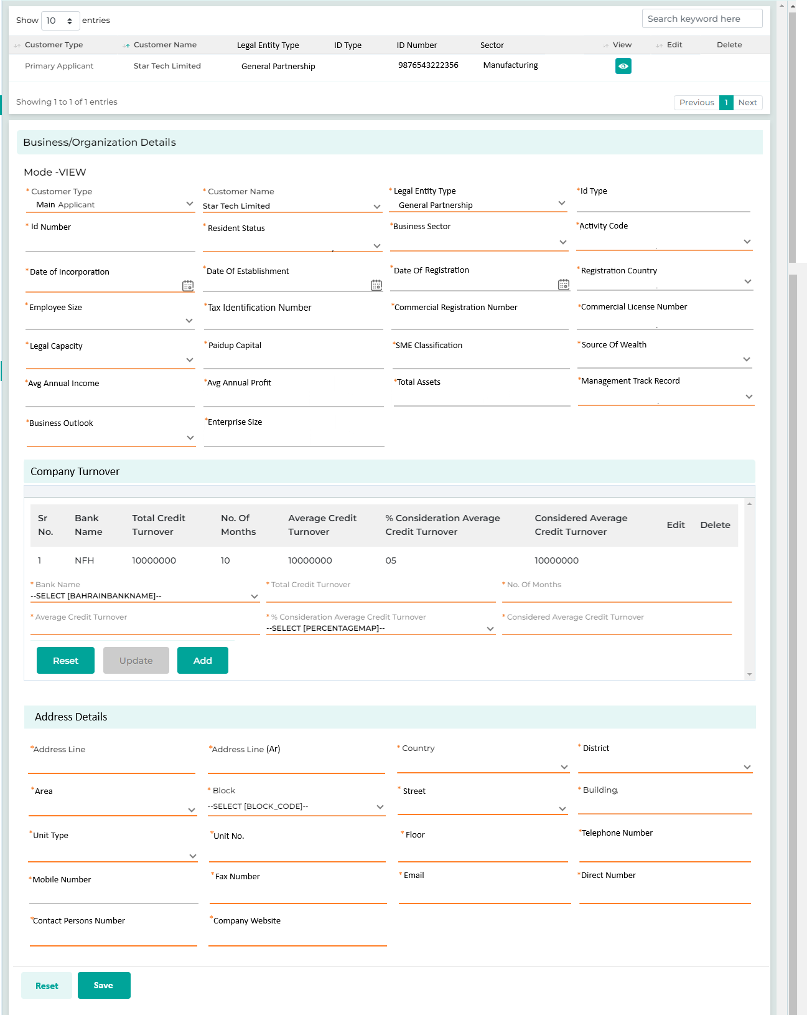

The following screen will be displayed once the User clicks on Business Details:
Field Name | Field Type | Data Type/ Length | Mandatory (Yes / No) | LookUp Key  /Master Name | Possible Value | Field Description
 |  |  |  |  |  | Remarks / Validation
Customer Type | List View | VARCHAR | Yes | NA | NA | Displays the Customer Type for whom the business details are being captured.
Customer Name | List View | VARCHAR | Yes | NA | NA | Displays the Customer Name for whom the business details are being captured.
Legal Entity Type | List View | VARCHAR | Yes | NA | NA | Displays which form of Company it is
ID Type | List View | VARCHAR | Yes | NA | MOCI Registration No | Displays the ID Type.
ID Number | List View | VARCHAR | Yes | NA | 9876543222356 | Displays the ID Number.
Sector | List View | VARCHAR | Yes | NA | Manufacturing | Displays the Sector Type.
Business /Organization Details
Customer Type | LOV Dropdown | VARCHAR | Yes | 4034 | Main Applicant  Joint Applicant  Guarantor  Partner | The User will select the customer type from the drop-down values
Customer Name | Master Dropdown | VARCHAR | Yes | NA | - NA | Customer’s name will be visible in the Dropdown values.
Legal Entity Type | LOV Dropdown | VARCHAR | Yes | NA | General Partnership Company  Limited Partnership Company  Partnership limited by shares  Joint Venture Company  Shareholding Company  (Refer LOV Sheet for the complete list of LOVS) | The data in this field will be auto populated from the Basic Details screen  Mandatory field required for CiNet reporting
ID Type | Read Only | VARCHAR | Yes | NA | MOCI Registration No | The data in this field will be auto populated from the Basic Details screen
ID Number | Read Only | VARCHAR | Yes | NA | 9876543222356 | The data in this field will be auto populated from the Basic Details screen
Residence Status | LOV Dropdown | VARCHAR | Yes | NA | 003 Domestic Commercial Entity  004 Foreign Commercial Entity | The user will select the Residence Status  Mandatory field required for CiNet reporting
Business Sector | LOV Dropdown | VARCHAR | Yes |  | Traditional Commercial Banks  Islamic Commercial Banks  Specialized Banks  Traditional Investment Companies  Islamic Investment Companies  Finance Companies  Other Financial Institutions  Government *  Government Institutions with Independent Budgets **  Non-Financial Units with a Government Share of 50% or More of the capital ***  Private Sector (Private Non-Financial Institutions) Not Applicable  (Refer LOV Sheet for the complete list of LOVS) | The data in this field will be auto populated from the Basic Details screen  Mandatory field required for CiNet reporting
Activity Code | LOV Dropdown | VARCHAR | Yes | NA | Government - Ministry of Finance  Government - Other Government Institutions  Oil Industry - Oil Exploration  Oil Industry - Drilling Oil Wells  Oil Industry - Production  Oil Industry – Others  (Refer LOV Sheet for the complete list of LOVS) | The data in this field will be auto populated from the Basic Details screen  Mandatory field required for CiNet reporting
Date Of Incorporation | Calendar | DATETIME | Yes | NA | NA | The User will select the date when the company was established.
Date Of Establishment | Calendar | Date | Yes | NA | NA | The data in this field will be auto populated from the Basic Details screen
Date Of Registration | Calendar | Date | Yes | NA | NA | The data in this field will be auto populated from the Basic Details screen
Registration Country | LOV Dropdown | VARCHAR | Yes | NA | Kuwait | The data in this field will be auto populated from the Basic Details screen
Employee Size | LOV Dropdown | INT | Yes | NA | 01 to 50  51 to 150  150 above | The data in this field will be auto populated from the Basic Details screen  Range as per CiNet manual
Tax Identification Number | Text Box | VARCHAR | Yes | NA | NA | The data in this field will be auto populated from the Basic Details screen
Commercial Registration Number | Text Box | VARCHAR | Yes | NA | NA | The data in this field will be auto populated from the Basic Details screen
Commercial License Number | Text Box | VARCHAR | Yes | NA | NA | The data in this field will be auto populated from the Basic Details screen
Legal Capacity | LOV Dropdown | VARCHAR | Yes | NA | 001 Adult  002 Minor  003 Guardian  004 Legal Person  005 Entity | The user will select the Legal Capacity type as “Entity”  Mandatory field required for CiNet reporting
Auto Blacklisted | LOV Dropdown |  | Yes |  |  | The system will automatically flag the customer as blacklisted as per the internal blacklist database; it will also allow the user to select the blacklist status. If the status is modified, it will highlight at the time of verification and policy check.
UN List Link | Button |  | Yes |  |  | Link to access the UN List website to be provided
UN Blacklist Validated | LOV Dropdown |  | Yes |  |  | As per the search in the UN list, the user will select Yes or No
Blacklist Reason | LOV Dropdown |  | Yes |  |  | The system will display the blacklist reason
Does the customer have US Indica? | LOV Dropdown |  | Yes
Does the customer have US Passport | LOV Dropdown |  | Yes
SSN Number | Text Box |  | Yes
W9 Expiry Date | Calendar |  | Yes
Diversification Of Business Stream | LOV Dropdown | VARCHAR | Yes |  | Highly concentrated  Moderate  Concentration  Diversified | The user will select the list of values describing the engagement of business customers.
Cheque Abuser within 1 past year | LOV Dropdown | VARCHAR | Yes |  | Yes  No | As per the internal cheque abuser list, the user will select whether the customer is available in the list or not.
Paid up Capital | Text Box | Float | Yes | NA | NA | The data in this field will be auto populated from the Basic Details screen
SME Classification | Read Only | VARCHAR | Yes | NA | - Small  - Medium  - Large | The system will compute based on the following logic of Paid-up Capital  Less than KD 250,000 = Small  Between KD 250,000 to KD 750,000 = Medium  Greater Than KD 750,000 = Large
Source Of Wealth | LOV Dropdown | VARCHAR | Yes | NA | Earnings  Business activities  Investment Retunes  Rents  Other (Dependent field in case of selected Other) | The data in this field will be auto populated from the Basic Details screen
Avg Annual Income | Text Box | Float | Yes | NA | NA | The data in this field will be auto populated from the Basic Details screen
Avg Annual Profit | Text Box | Float | Yes | NA | NA | The data in this field will be auto populated from the Basic Details screen
Total Assets | Text Box | Float | Yes | NA | NA | The data in this field will be auto populated from the Basic Details screen
Management Track Record | LOV Dropdown | VARCHAR | Yes | NA | - Distinguished & long successful experience in the same industry (10+) with an excellent track record and well-defined organizational structure/hierarchy  - Long successful experience & track record (7+ years), with above-average decision-making compared to peers  - Average management quality with moderate experience and track record (5+)  - No or marginally successful experience (0-5 years) of management  - Unsuccessful track record or lack of management commitment/involvement | The user will select from the list of values  Mandatory field for internal score card.
Business Outlook | LOV Dropdown | VARCHAR | Yes | NA | Positive  Negative  Stable | The user will select from the list of values  Mandatory field for internal score card.
Enterprise Size | LOV Dropdown | VARCHAR | Yes | NA | Small enterprise  Medium enterprise  Large enterprise  Not Applicable  (Refer LOV Sheet for the complete list of LOVS) | The data in this field will be auto populated from the Basic Details screen  Mandatory field required for CiNet reporting
Company Turnover
Bank Name | LOV Dropdown | NVARCHAR | Yes | NA
Total Credit Turnover | Text Box |  | Yes |  |  | Allows the users to enter the Total Turnover for the selected bank statement
 |  |  |  |  |  | User can add multiple turnovers.
No Of Months |  |  |  |  |  | Allows the user to input the duration, in months, for which the credit turnover is being recorded.
Average Cr. Turnover | Text Box |  | Yes |  |  | The system will computes this value based on the total credit turnover captured and the number of months specified.
 |  |  |  |  |  | Dividing Total Credit Turnover with No of Months
% Consideration Average Cr. Turnover |  |  |  |  | 10%  15%  20% | Users will select from a dropdown menu (containing options such as 10%, 15%, 20%) to determine the percentage to be considered for computation.
Considered Average Cr. Turnover | Text Box |  | Yes |  |  | The system computes percentage value from the Average Credit Turnover, based on the selected Percentage Consideration.
Address Details
Address Line | Text Box | NVARCHAR | Yes | NA | NA | If Civil ID integration is triggered, it will be fetched via the interface else the system will allow the user to enter the details  Full address will be displayed English
Address Line (Arabic) | Text Box | NVARCHAR | Yes | NA | NA | If Civil ID integration is triggered, it will be fetched via the interface else the system will allow the user to enter the details  Full address will be displayed Arabic
Country | LOV Dropdown | VARCHAR | Yes | COUNTRY | NA | If Civil ID integration is triggered, it will be fetched via the interface else the system will allow the user to enter the details
District | LOV Dropdown | VARCHAR | Yes | DISTRICT | NA | If Civil ID integration is triggered, it will be fetched via the interface else the system will allow the user to enter the details
Arera | LOV Dropdown | VARCHAR | Yes | AREA | NA | If Civil ID integration is triggered, it will be fetched via the interface else the system will allow the user to enter the details
Block | LOV Dropdown | VARCHAR | Yes | BLOCK | NA | If Civil ID integration is triggered, it will be fetched via the interface else the system will allow the user to enter the details
Street | LOV Dropdown | VARCHAR | Yes | STREET | NA | If Civil ID integration is triggered, it will be fetched via the interface else the system will allow the user to enter the details
Building | Text Box | VARCHAR | Yes | NA | NA | If Civil ID integration is triggered, it will be fetched via the interface else the system will allow the user to enter the details
Unit Type | LOV Dropdown | VARCHAR | Yes | NA | Apartment  Villa | If Civil ID integration is triggered, it will be fetched via the interface else the system will allow the user to enter the details
Unit No | Text Box | VARCHAR | Yes | NA | NA | If Civil ID integration is triggered, it will be fetched via the interface else the system will allow the user to enter the details
Floor | Text Box | VARCHAR | Yes | NA | NA | If Civil ID integration is triggered, it will be fetched via the interface else the system will allow the user to enter the details
Telephone Number | Text Box | INT | Yes | NA | NA | The User will enter the telephone number of the ompany.
Mobile Number | Text Box | VARCHAR | Yes | NA | NA | The data in this field will be auto populated from the Basic Details screen
Mobile Number pattern will be as follow:
Code +965
Followed by 8 digits
Fax No. | Text Box | VARCHAR | No | NA | NA | The User will enter the fax number of the company.
Email | Text Box | VARCHAR | Yes | NA | NA | The User will enter the email id of the company.
Direct Number | Text Box | VARCHAR | Yes | NA | NA | The User will enter the direct contact number of the company.
Contact Person’s Name | Text Box | VARCHAR | Yes | NA | NA | The User will enter the contact person’s name
Company Website | Text Box | VARCHAR | Yes | NA | NA | The User will enter the company’s website.
Action Buttons
Reset | Button | Button | NA | NA | NA | The User will click on the reset button to clear the fields.
Save | Button | Button | NA | NA | NA | The User will click on the save button to record the entered data.

13.2.2.5 Relationship Segment

Relationship segment screen will be applicable for the commercial loan only allowing the commercial sales user to capture the details information of the related parties to the customer like partners, shareholders, board members, subsidiaries, & beneficiary with their key details such as identification number, % of shareholding, & nationality.

Navigation:
Detail Data Entry à KYC à Relationship Segment
The following screen will be displayed once the User clicks on Relationship Segment:
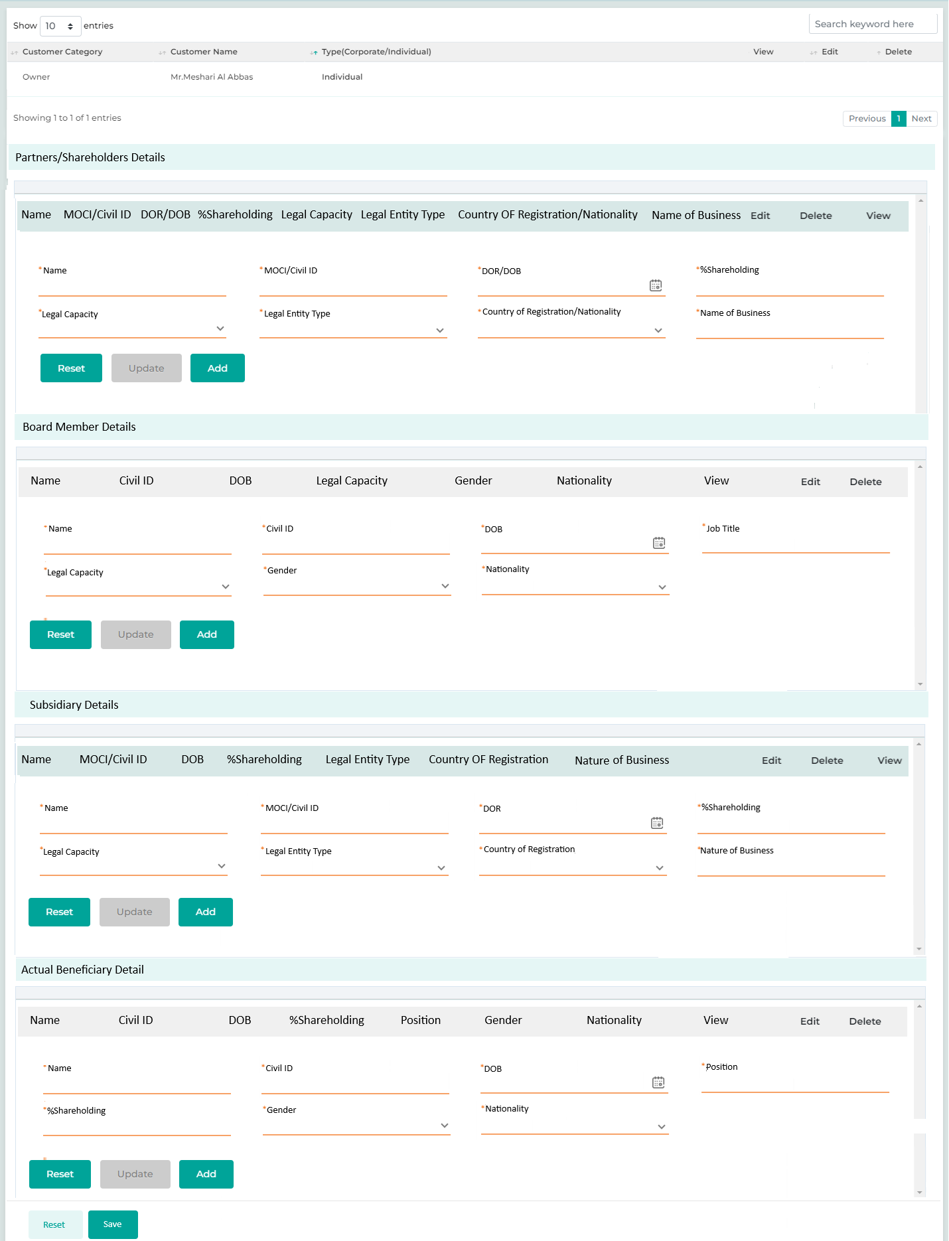

Field Name | Field Type | Data Type/ Length | Mandatory (Yes / No) | LookUp Key  /Master Name | Possible Value | Field Description
 |  |  |  |  |  | Remarks / Validation
Partners/Shareholders Details
Name  MOCI/Civil ID  DOR/DOB  % Share Holding  Legal Capacity  Legal Entity Type  Country Of Registration/Nationality  Name of Business | List View | NVARCHAR | Yes | NA | NA | Displaying the data points specific to the section as per multiple entry in the grid list view
Name | Text Box | NVARCHAR | Yes | NA | NA | The user will enter the name of the partner/shareholder in english which can be an individual or a company.
MOCI/Civil ID | Text Box | VARCHAR | Yes | NA | NA | In case of individual as a partner/shareholder civil ID will be entered and in case of the entity as a partner then MOCI number will be entered by the user.
DOR/DOB | Calendar | Date | Yes | NA | NA | The user will enter the date of birth in case of individual as a partner of date of registration in case of company.
% Share Holding | Text Box | Float | Yes | NA | NA | The user will enter the person shareholding by the partner/shareholder.
Legal Capacity | LOV Dropdown | VARCHAR | Yes | Individual  Company | NA | The user will select the legal capacity type of the partner/ shareholder.
Legal Entity Type | LOV Dropdown | VARCHAR | Yes | Private Company  LLP | NA | Displays which form of Company it is
Country Of Registration/Nationality | LOV Dropdown show | VARCHAR | Yes | NA | Kuwait | Displays the ID Type.
Name of Business | Text Box | VARCHAR | Yes | NA | Al Mashriq | Displays the ID Number.
Board Member Details
Name  Civil ID  DOB  Job Title  Legal Capacity  Gender  Nationality | List View | NVARCHAR | Yes | NA | NA | Displaying the data points specific to the section as per multiple entry in the grid list view
Name | Text Box | NVARCHAR | Yes | NA | NA | The user will enter the name of the board member in english.
Civil ID | Text Box | VARCHAR | Yes | NA | NA | The user will enter the civil ID of the board member
DOB | Calendar | Date | Yes | NA | NA | The user will enter the DOB of the board member.
Job Title | Text Box | VARCHAR | Yes | NA | Sales  Operations  Management | The user will enter the job title for the respective board member
Legal Capacity | LOV Dropdown | VARCHAR | Yes | NA | Chariman  CEO  Deputy CEO  Executive Director  Board Member | The user will select the legal capacity of the respective board member
Gender | LOV Dropdown | VARCHAR | Yes | NA | Male  Female  Other | The user will select the gender of the respective board member
Nationality | LOV Dropdown | VARCHAR | Yes | NA | Kuwait | The user will select the nationality of the board member from the list of values by default it will be Kuwait
Subsidiary Details
Name  MOCI  DOR  % Share Holding  Legal Entity Type  Country Of Registration  Nature Of Business | List View | NVARCHAR | Yes | NA | NA | Displaying the data points specific to the section as per multiple entry in the grid list view
Name | Text Box | NVARCHAR | Yes | NA | NA | The user will enter the name of the subsidiary company in english.
MOCI | Text Box | VARCHAR | Yes | NA | NA | The user will enter the MOCI of the subsidiary company.
DOR | Calendar | Date | Yes | NA | NA | The user will enter the Dat Of Registraion of the subsidiary company.
% Share Holding | Text Box | Float | Yes | NA | NA | The user will enter the person shareholding by the subsidiary company.
Legal Entity Type | LOV Dropdown | VARCHAR | Yes | Private Company  LLP | NA | Displays which form of Company it is
Country Of Registration | LOV Dropdown | VARCHAR | Yes | NA | Kuwait | The user will select the country of registration of the subsidiary company from the list of values by default it will be Kuwait
Nature Of Business | Text Box | VARCHAR | Yes | NA | NA | The user will enter the nature of business
Actual Beneficiary Detail
Name  Civil ID  DOB  Position  % Share Holding  Gender  Nationality | List View | NVARCHAR | Yes | NA | NA | Displaying the data points specific to the section as per multiple entry in the grid list view
Name | Text Box | NVARCHAR | Yes | NA | NA | The user will enter the name of the respective beneficiary.in english.
Civil ID | Text Box | VARCHAR | Yes | NA | NA | The user will enterthe Ciovil ID of the respective beneficiary.
DOB | Calendar | Date | Yes | NA | NA | The user will enter the date of birth for the respective beneficiary.
Position | Text Box | Float | Yes | NA | NA | The user will enter the position for the respective beneficiary.
% Share Holding | Text Box | Float | Yes | NA | NA | The user will enter the person shareholding by the respective beneficiary.
Gender | LOV Dropdown | VARCHAR | Yes | NA | Male  Female  Other | The user will select the gender of the respective beneficiary
Nationality | LOV Dropdown | VARCHAR | Yes | NA | Kuwait | The user will select the nationality of the respective beneficiary from the list of values by default it will be Kuwait
Action Button
Reset | Button | Button | NA | NA | NA | The User will click on the reset button to clear the fields.
Save | Button | Button | NA | NA | NA | The User will click on the save button to record the entered data.

13.2.2.6 Employment Details

The employment details screen is designed for retail salaried customers, enabling retail sales users to input employment-related information, including employer details, income from employment, and monthly deductions made by the employer.
If a customer has multiple employers or if the user wants to record details of previous employment along with the current one, the employment details screen will accommodate this.
For existing customers of KFIC, the employment related details captured in the previous loan application should be populated too on the screen in read only mode and if there are changes to the employment data points for a new application, a notification should be issued during the Credit Administration stage.
For example, if a customer’s salary was KD 300 at the time of their first loan application and is KD 600 at the time of their second loan application, a notification should alert the credit control team about this change in salary during their review.
Navigation:
Detail Data Entry à KYC à Employment Details
The following screen will be displayed once the User clicks on Employment Details:

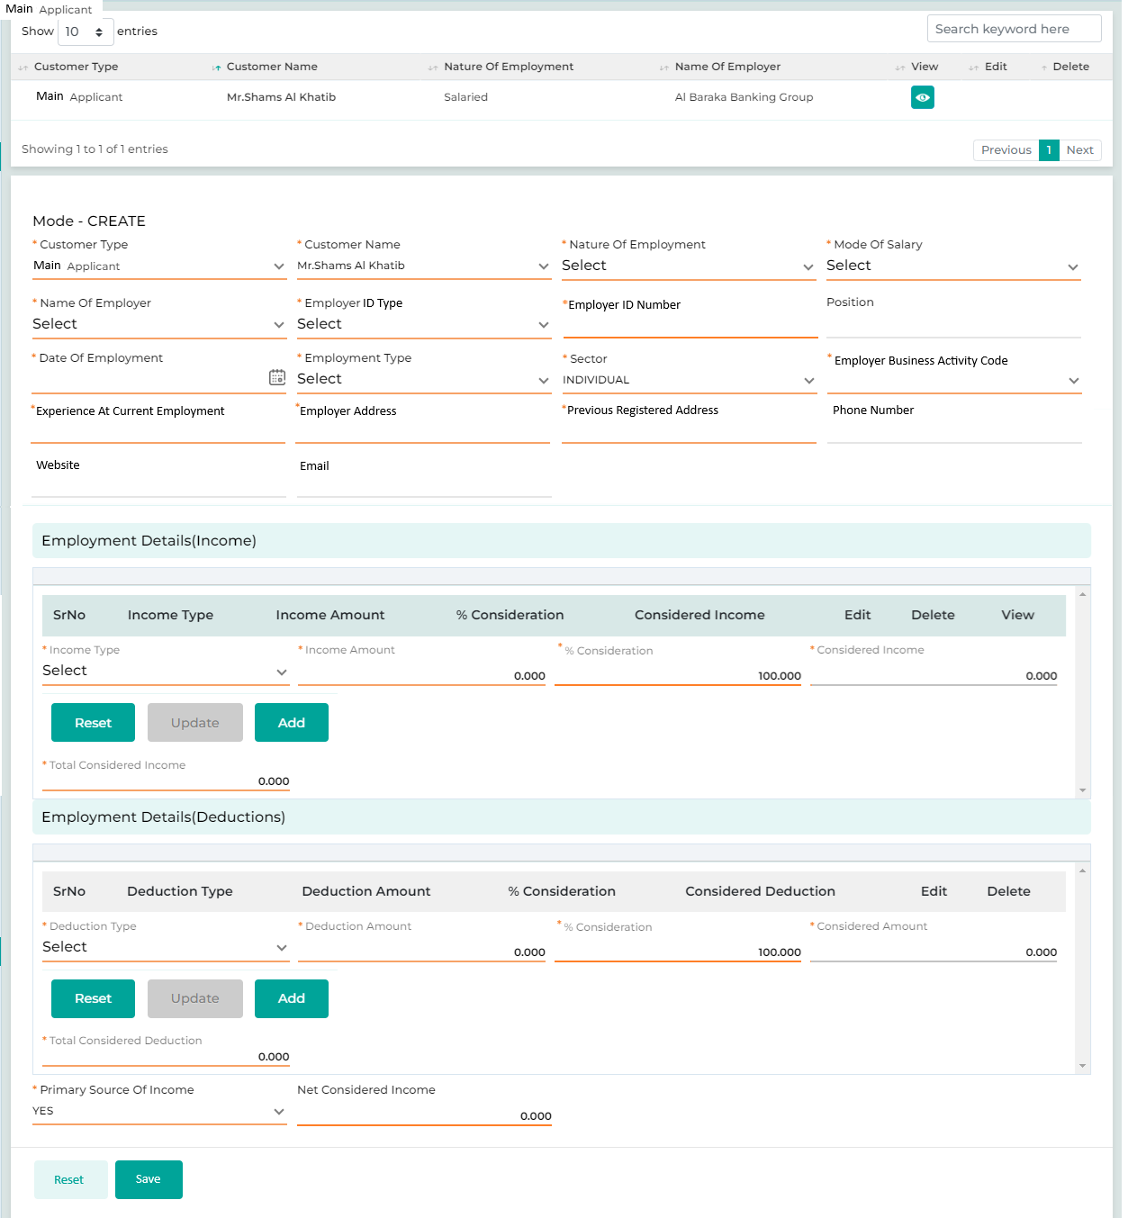

Below are the details specific to the information being displayed above.

Field Name | Field Type | Data Type/ Length | Mandatory (Yes / No) | LookUp Key/  Master Name | Possible Value |  | Field Description
 |  |  |  |  |  |  | Remarks / Validation
Customer Type | List View | VARCHAR | Yes | NA | Main Applicant  Joint Applicant  Guarantor |  | Displays the Customer type for whom the employment details are being captured.
Customer Name | List View | VARCHAR | Yes | NA | NA |  | Displays the Customer name for whom the employment details are being captured.
Nature Of Employment | List View | VARCHAR | Yes | NA | NA |  | Displays the the Nature Of Employment
Name Of Employer | List View | VARCHAR | Yes | NA | NA |  | Displays the name of the customer’s employer which can be one or more than.
Employment Details
Customer Type | LOV Dropdown | VARCHAR | Yes | 4034 | - Main Applicant  - Co-Borrower  - Guarantor | The User will select the customer type from the Dropdown values.
Customer Name | Master Dropdown | VARCHAR | Yes | NA | NA | The customer’s name is displayed in the Dropdown values upon selection of the customer type.
Nature Of Employment | LOV Dropdown |  | Yes |  | Salaried  Self Employed  Retired | The user will select the employment nature, such as Salaried or Self-Employed
Mode Of Salary | LOV Dropdown |  | Yes |  | Cash  Transfer | The user will select the mode of salary through which the customer receives the salary like Cash or Bank transfer.
Employer Name | Text Box | VARCHAR | Yes | NA | Al Mashriq | The user will select the name of the employer  Mandatory field for CiNet
Employer ID Type | LOV Dropdown | VARCHAR | Yes | NA | MOCI  Civil Id – Commercial  Civil Id – Individual  Public Sector | The user will select the ID type for the respective employer  Basis the Employer Name selected the ID type will be p
Employer ID Number | Textbox | VARCHAR | Yes | NA | 98765432235 | For the selected employer ID type the user will enter the ID number.
Employer Class |  |  |  |  | Class A  Class B  Class Others | System will compute the employer class automatically based on the employment details
Position | Text box | VARCHAR | No | NA | Managing Director  Cashier official  Store Manager  Executive director  Assistant Inspector  Air Services  Geography teacher  X-Ray technician  (Refer LOV Sheet for the complete list of LOVS) | the user will select the position of the customer with the employer for the respective employment.
Date Of Employment | Calendar | DATETIME | Yes | NA | NA | The User will select the date of employment from the Calendar.
Employment Type | LOV Dropdown | VARCHAR | Yes | NA | Contract  Permanenet | The user will select the employment type whether the employment is Contractual or Permanent position
Sector | LOV Dropdown | VARCHAR | Yes | NA | Traditional Commercial Banks  Islamic Commercial Banks  Specialized Banks  Traditional Investment Companies  Islamic Investment Companies  Finance Companies  Other Financial Institutions  Government *  Government Institutions with Independent Budgets **  Non-Financial Units with a Government Share of 50% or More of the capital ***  Private Sector (Private Non-Financial Institutions) Not Applicable  (Refer LOV Sheet for the complete list of LOVS) | The user will select the sector of the employer’s company
Employer Business Activity Code | LOV Dropdown | VARCHAR | Yes | NA | Government - Ministry of Finance  Government - Other Government Institutions  Oil Industry - Oil Exploration  Oil Industry - Drilling Oil Wells  Oil Industry - Production  Oil Industry – Others  (Refer LOV Sheet for the complete list of LOVS) | The user will select the Activity Code from the list of values  Mandatory field required for CiNet reporting
Industry | LOV Dropdown |  | Yes
Experience At Current Employment | Text Box | INT | Yes | NA | NA | The system will compute the Experience in YY-MM-DD from data of employment and current date
Empoloyer Address | Text Box | NVARCHAR | Yes | NA | NA | The user will enter the entire address of the employer.  Mandatory field for CiNet
Previous Registered Address | Text Box | NVARCHAR | Yes | NA | NA | The user will enter the previous address of the employer.  Mandatory field for CiNet
Phone Number | Text Box | VARCHAR | No | NA | NA |  | The User will enter the phone number of the applicant in the text box.
Website | Text Box | VARCHAR | No | NA | NA |  | The User will enter the website details of the customer’s company in the text box provided.
E-mail | Text Box | VARCHAR | No | NA | NA |  | The User will enter the customer’s email id.
Employment Details (Income)
Income Type | Dropdown | LOV | Yes | NA | -Basic Salary  - Government Allowance |  | The Income Type field will allow the user to select the different types of income such as Basic Income & Government Allowance.  All income types will be recorded only once for each employer.  For example, the basic salary will be captured only once for a specific employer. When attempting to add the same income type for that employer again, the system will validate and prevent this action.  Government Allowance is only applicable only for Kuwaiti customer, to be validate as per the nationlality mentioned in the basic details screen.
Selecting Basic Income or Government Allowance as income type, will allow the user to enter Income Amount & the % Consideration (By default will be 100% with the provision for the user to change it) depending on which Considered Amount will be computed.
Amount will be computed.
Income Amount | Text Box |  | Yes | NA | 1000 |  | User will enter the amount for each income type selected
% Consideration | Text Box |  | Yes | NA | 80% |  | Percentage of the income to be considerd
Considered Amount | Readonly |  | Yes | NA | 800 |  | Amount after computing respect to the % consideration
Add | Button |  | Yes | NA | NA |  | Button to add multiple Income for the same employer.
Total Considered Income | Readonly |  | Yes | NA | 3000 |  | The Total Considered Amount will be the summation of Considered Income for all the income types captured.
Employment Details (Deductions)
Deduction Type | Dropdown | LOV | Yes | NA | - Savings  - Advance Salary  - Other deduction |  | The user will select the type of deduction for the specific employer.  Employer deduction is only applicable for Kuwaiti customer, to be validate as per the nationlality mentioned in the basic details screen.
Deduction Amount | Text Box |  | Yes | NA | 200 |  | User will enter the amount for each deduction type selected
% Consideration | Text Box |  | Yes | NA | 100 % |  | Percentage of the deduction to be considerd
Considered Amount | Readonly |  | Yes | NA | 200 |  | Amount after computing respect to the % consideration
Add | Button |  | Yes | NA | - NA |  | Button to add multiple Deduction
Total Considered Deduction | Readonly |  | Yes | NA | 1000 |  | The Total Considered Amount will be the summation of Considered deduction for all the deduction types captured.
Primary Source of Income | LOV Dropdown | VARCHAR | Yes | 51 | Yes  No |  | The User will select from the Dropdown value if this is the primary source of income of the customer.
Net Considered Income | Text Box | INT | Yes |  | 2000 |  | Auto computed by subtracting Total Considered Deduction from Total Considered Income for each employment.
Action Buttons
Add | LOV | Button | NA | NA | NA |  | The user can add multiple income and deduction for multiple employers considered.
Reset | Button | Button | NA | NA | NA |  | The User will click on this button to clear the entered data.
Save | Button | Button | NA | NA | NA |  | The User will click on this button to save the entered data.

13.2.2.7 Bank Details

The Bank Details screen enables users to enter a customer's banking information. If the customer has multiple bank accounts, details for all accounts—including the bank name, branch name, account number, IBAN, and currency—will be collected. These bank details will serve as the primary reference for linking to loan repayments and during disbursement.
Navigation:
Detail Data Entry à KYC à Bank Details
The following screen will be displayed once the User clicks on Bank Details:

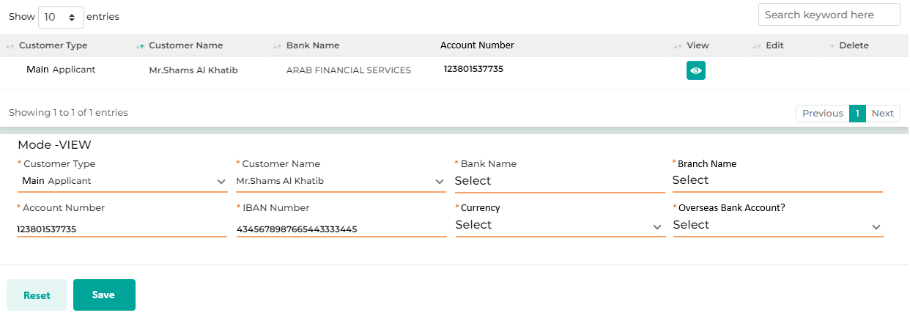

Below are the details specific to the information being displayed above.

Field Name | Field Type | Data Type / Length | Mandatory (Yes / No) | LookUp Key / Master Name | Possible Values | Field Description
 |  |  |  |  |  | Remarks / Validation
Customer Type  Customer Name  Bank Name  Account Number | List View | Grid | NA | NA | NA | Display the multiple bank details captured by the user in a grid for different customer type linked to the loan application.
Customer Type | LOV Dropdown | VARCHAR | Yes | 4034 | - Main Applicant  - Guarantor  - Partner | The User will select the customer type.
Customer Name | Master Dropdown | VARCHAR | Yes | NA | NA | The User will select the customer’s name.
Bank Name | Text Box | VARCHAR | No | NA | NBK | The User will enter the bank name.
Branch Name | Text Box | NVARCHAR | Yes | NA | Sharq | The User will enter the branch name.
Account Number | Text Box | NVARCHAR | Yes | NA | 0000 0000 0000 1234 5601 01 | The User will enter the account number.
IBAN Number | Text Box | NVARCHAR | Yes | NA | KW16 NBOK 0000 0000 0000 1234 5601 01 | The User will enter the IBAN.
Currency | LOV Dropdown | NVARCHAR | Yes | NA | KD | The User will enter the currenc linked to the account.
Overseas Bank Account? | LOV Dropdown | NVARCHAR | Yes | NA | Yes  No | The user will select whether the bank account mention is an overseas bank account or not
Action Buttons
Reset | Button | Button | NA | NA | NA | The User will click on this button to clear the entered data.
Save | Button | Button | NA | NA | NA | The User will click on this button to save the entered data.

13.2.2.8 Repayment Details
The Repayment details screen will be capturing the mode of repayment such as Cash, Cheque, or BSI. Along with that if the mode of payment is other than cash, the bank related details for the specific instrument wil be captured.
Navigation:
Detail Data Entry à KYC à Repayment Details
The following screen will be displayed once the User clicks on Repayment Details:
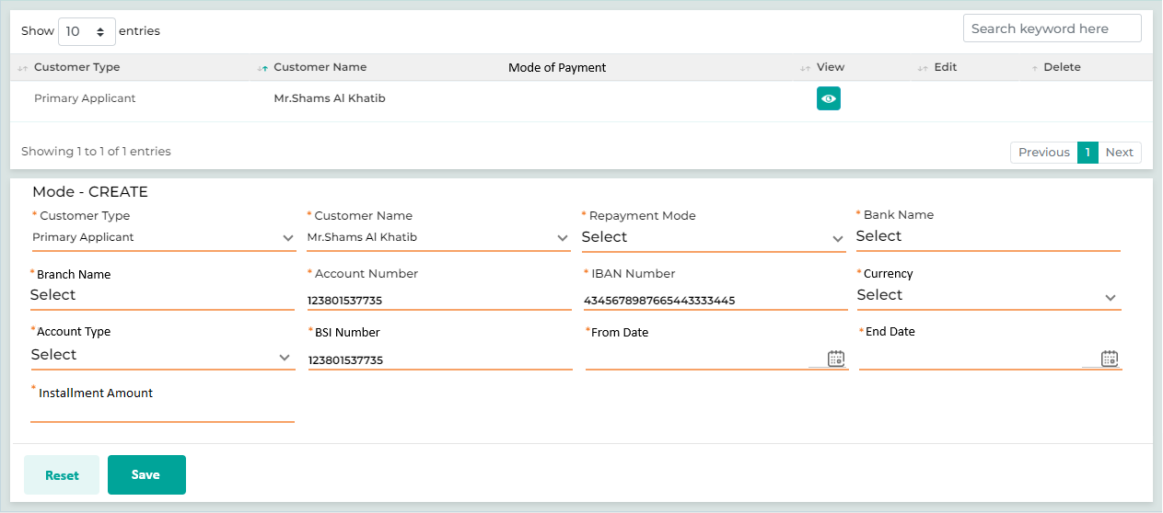

Below are the details specific to the information being displayed above.

Field Name | Field Type | Data Type / Length | Mandatory (Yes / No) | LookUp Key / Master Name | Possible Values | Field Description
 |  |  |  |  |  | Remarks / Validation
Customer Type | List View | VARCHAR | Yes | NA | NA | Displays the applicant type.
Customer Name | List View | VARCHAR | Yes | NA | NA | Displays the applicant name.
Mode Of Payment | List View | VARCHAR | Yes | NA | NA | Displays the mode of payment
Repayment Details
Customer Type | LOV Dropdown | VARCHAR | Yes | 4034 | Main Applicant  Guarantor  Joint Applicant | The User will select the applicant type from the drop-down values.
Customer Name | Master Dropdown | VARCHAR | Yes | NA | NA | The customer’s name is displayed in the Dropdown values upon selection of the customer type.
Repayment Mode | LOV Dropdown |  | Yes |  | - Cash  - BSI  - Salary Deduction
If the repayment mode selected as Cash, the remaining fields will either be hidden or set to read-only. However, if a repayment mode is selected as BSI, the system will allow the user to input the relevant details.

Salary Deduction will only be applicable for Staff Loan as a product
Bank Name | Text Box | VARCHAR | Yes | NA | - HDFC  - SBI  - Kotak | The user will select the Bank Name from the list of values fetched from Bank Details screen as per the Customer Type & Name selected
 |  |  |  |  |  | Only applicanle if the mode of payment is BSI
Branch Name | Text Box | NVARCHAR | Yes | NA | Sharq | The user will select the Branch Name from the list of values fetched from Bank Details screen as per the Customer Type, Customer Name & the Bank Name is selected  Only applicanle if the mode of payment is BSI
Account Number | Text Box | NVARCHAR | Yes | NA | NA | The user will select the Account Number from the list of values fetched from Bank Details screen as per the Customer Type, Customer Name & the Bank Name is selected
 |  |  |  |  |  | Only applicanle if the mode of payment is BSI
IBAN Number | Text Box | NVARCHAR | Yes | NA | NA | Will be fetched from Bank Details screen
 |  |  |  |  |  | Only applicanle if the mode of payment is BSI
Currency | Text Box | NVARCHAR | Yes | NA | NA | Will be fetched from Bank Details screen  Only applicanle if the mode of payment is BSI
Account Type | LOV Dropdown | VARCHAR | Yes | Account Type | - Savings A/C  - Current A/C | The User will select the account type of the customer from the drop-down values.
 |  |  |  |  |  | Only applicanle if the mode of payment is BSI
BSI Number | Text Box | NVARCHAR | Yes | NA | NA | The user will enter the BSI unique number
 |  |  |  |  |  | Only applicanle if the mode of payment is BSI
From Date | Calendar | DATETIME | Yes | NA | NA | The user will enter the start date for the BSI
 |  |  |  |  |  | Only applicanle if the mode of payment is BSI
End Date | Calendar | DATETIME | Yes | NA | NA | Auto computed as last istallment date
 |  |  |  |  |  | Only applicanle if the mode of payment is BSI
Installment Amount | Text Box | INT | Yes | NA | NA | Will be auto popultaed from the loan details screen and will be equals to the installment.
 |  |  |  |  |  | Only applicanle if the mode of payment is BSI
Action Buttons
Reset | Button | Button | NA | NA | NA | The User will click on this button to clear the entered data.
Save | Button | Button | NA | NA | NA | The User will click on this button to save the entered data.

13.2.2.9 Contact Details
The contact Details screen allows the user to capture various contact details of the customer such mobile number, home telephone, office number, etc. Contact details of the mail applicant fetched via the integration will be auto populated on the screen.
This screen will also allow to capture the details of the reference personnel who will be contacted in case the customer is not reachable.
Navigation:
Detail Data Entry à KYC à Reference Details
The following screen will be displayed once the User clicks on Reference Details:
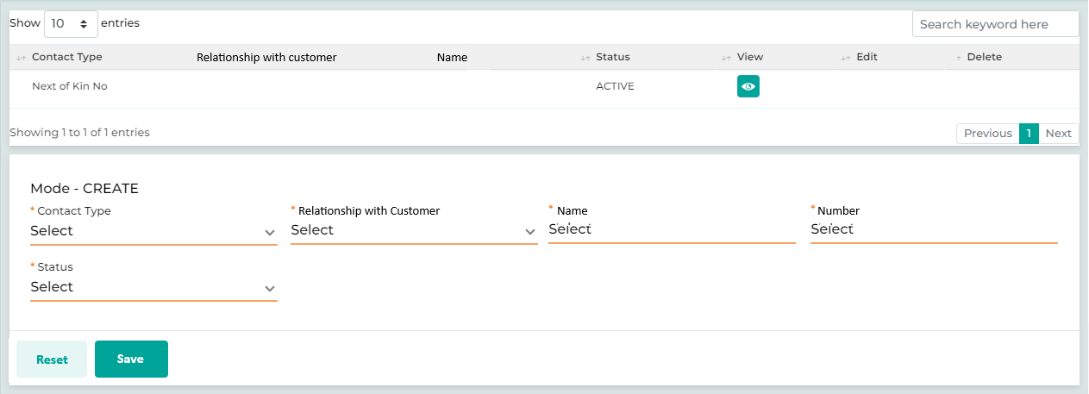

Below are the details specific to the information being displayed above.
Field Name | Field Type | Data Type / Length | Mandatory (Yes / No) | LookUp Key/Master Name | Possible Values | Field Description
 |  |  |  |  |  | Remarks / Validation
- Contact Type  - Relationship with customer*  - Name*  - Status | List View | Grid | NA | NA | NA | Displays the data captured on the screen in the grid list.
Contact Type | Dropdown | VARCHAR | Yes | NA | - Mobile No.  - Emergency Number  - Work Number  - Telephone No  - Next of Kin No.  - Email ID | The user will select the contact type need to be captured.
Relationship With Customer | LOV Dropdown | VARCHAR | No | NA | - NA | Only applicable if Contact Type is selected as “Next Of Kin”  The user will select the relationship of the person with the customer.
Name | Text Box | VARCHAR | No | NA | NA | Only applicable if Contact Type is selected as “Next Of Kin”  Where the user will enter the name of the next of kin person.
Number | Text Box | VARCHAR | Yes | NA | NA | The user will enter the detail.
Status | Dropdown | VARCHAR | Yes | NA | Active  Inactive | This field is only applicable in case of capturing the primary mobile or telephone number.
Action Buttons
Reset | Button | Button | NA | NA | NA | The User will click on this button to clear the entered data.
Save | Button | Button | NA | NA | NA | The User will click on this button to save the data.

13.2.3 Collateral & Loan Details

13.2.3.1 Collateral Search

This screen allows the user to conduct a collateral search using a collateral type, a unique collateral ID, or a customer ID. It will inform the user whether the collateral is new to KFIC or if it already exists in the system. If the collateral is already existing to KFIC, the screen will display the associated loan account and the coverage utilization for that loan. This information will help the user determine whether to link the collateral to a new loan.

Scenario:
The user will first select a Collateral Type from the list of options. If "Vehicle" is chosen, the user will enter the chassis number in the Collateral ID field and then click on "Search." Based on this search, the system will return results if the collateral is existing to the KFIC, highlighting the loan accounts linked to the specified collateral, along with the coverage ratio for each account the user can click on the radio button across the search result and later click on “Proceed” to populate the collateral related data in the collateral screen automatically. The user will also have the option to view the collateral documents and if the collateral is not an existing one with KFIC the system will return the message as “No Collateral Result Found”

Navigation:
Detail Data Entry à Collateral & Loan Details à Collateral Search
The following screen will be displayed once the User clicks on Collateral Search:
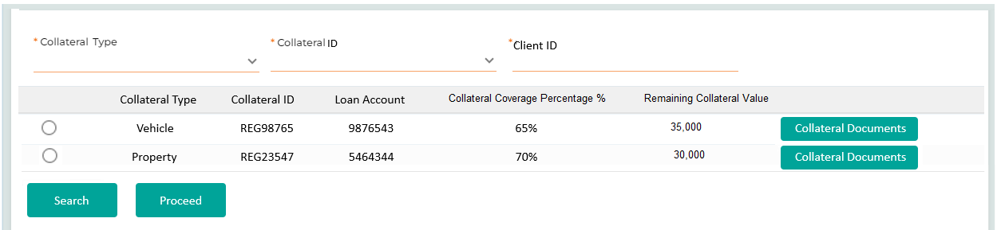

Below are the details specific to the information being displayed above.

Field Name | Field Type | Data Type / Length | Mandatory (Yes / No) | LookUp Key/Master Name | Possible Values | Field Description
 |  |  |  |  |  | Remarks / Validation
Collateral Type | Master Dropdown | VARCHAR | Yes | INSTALLMENTRECTYPE | - Vehicle  - Reaslestate  - Shares  - Bank Guarantee | The User will select the collateral type for which the search operation is to be performed
Registration Number | Text Box | NVARCHAR | Yes | NA | NA | The User will enter the registration number.
Collateral ID | LOV Dropdown | VARCHAR | Yes |  | - Ownership Deed No  - Chasis Number  - Portfolio Number  - Bill Reference Number (BG) | Depending upon the Collateral Type, the user will select the Collateral ID which is unique to each individual collateral in order to perform the search.
Client ID | Text Box | NVARCHAR | Yes | NA |  | The user can also search for any of the collateral using the customer id linkage with collateral.
Collateral Search Result
Collateral Type | List View | Grid List | NA | NA | Vehicle | The system will display collateral type basis on the search result  Multiple entries can be displayed if one collateral is liked to more than one loan
Collateral Id | List View | Grid List | NA | NA | REG98765 | The system will display collateral Id basis on the search result  Multiple entries can be displayed if one collateral is liked to more than one loan
Loan Account | List View | Grid List | NA | NA | 9876543 | The system will display loan account basis on the search result  Multiple entries can be displayed if one collateral is liked to more than one loan
Collateral Coverage Percentage % | List View | Grid List | NA | NA | 60% | The system will display the percentage of the searched collateral that has already been marked as a lien on other loan accounts.  If the Collateral Coverage Percentage is 100%, the system will not allow the user to proceed with the same collateral for a new loan application. Show an alert message as  "This collateral is fully utilized (100%) in existing loans and cannot be used for new applications."
Remaining Collateral Value | List View | Grid List | NA | NA | 40,000 | The system will display the remaining collateral value for the searched collateral and will be calculated as follows:  (Coverage Rate % × Final Valuation Amount, if available; otherwise, Collateral Amount) - Sum of Existing Pledge Amount for the same collateral in other loans.  Multiple entries can be displayed if one collateral is liked to more than one loan
Collateral Documents | Button | Button | NA | NA |  | The user can click on the button to see the collateral related documents all together.  Multiple entries can be displayed if one collateral is liked to more than one loan
Action Buttons
Search | Button | Button | NA | NA | NA | The User will click on this button to search for the collateral details provided.
Proceed | Button | Button | NA | NA | NA | The User will click on this button to proceed with the collateral search.
Only enabled if there’s a search result related to the collateral and the user has clicked on the radio button across the search result

This will populate the data of the exiting collateral on the collateral screen.

13.2.3.2 Collateral Details

The collateral details screen enables the user to enter information for various types of collateral, including vehicle, real estate, and shares, to link them to a loan application. It also displays the coverage ratio based on the loan type and the amount requested by the customer. This serves as a validation tool for the user, allowing them to initiate an exceptional approval from an authorized user if the coverage ratio does not meet the required standards for different product types.

- For shares as Collateral
For shares used as collateral, the system will validate the coverage ratio based on the types of shares selected by the user and highlight this information.
Following type of shares will not be consider as collateral, volatile stocks, unlisted stocks.
For example, if the requested loan amount is KD 1,000 and the customer is providing shares classified as "Stable Stock," they must provide shares with a total value of KD 1,750 to meet the criteria. Conversely, if the customer offers shares worth KD 1,750 in the "Stable Stocks" category, they will be eligible for the KD 1,000 loan.
Category | Classification | Coverage Rate (%) | Maximum Ratio
Leading Stocks | - Profitability and high net profit  - Return on equity above 10% (average of the last three years)  - Sustainable and consistent dividends | 150 | 125
Stable Stocks | - Stable profitability and net profit (over the past year)  - Return on equity above 20% (average of the last three years)  - Positive outlook and growth opportunities  - Low payment ratio  - Mid-Size Shares | 175 | 150
Growth Stocks | - Inconsistent profitability (wide fluctuations in profits over the past 4-5 years)  - Low return on equity  - Low net profit  - Low liquidity  - Inconsistent dividend payments | 200 | 175

- For property as Collateral
For property used as collateral, the system will validate the coverage ratio based on the category selected by the user and alert them if there is a breach of coverage.
Category | Coverage Rate (%)
Income-generating building | 150%
Non-revenue building or wasteland | 200%

Navigation:
Detail Data Entry à Collateral & Loan Details à Collateral Details
The following screen will be displayed once the User clicks on Collateral Details:

- Collateral Details – Vehicle
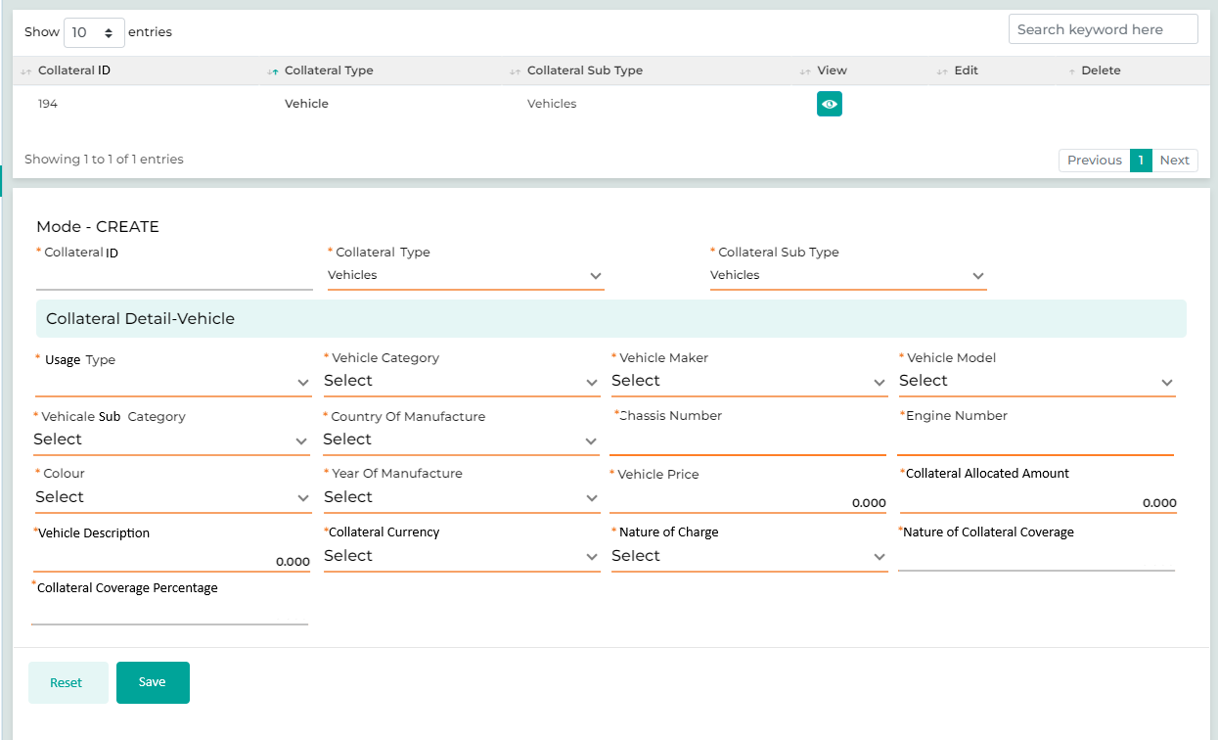
- Collateral Details – Property
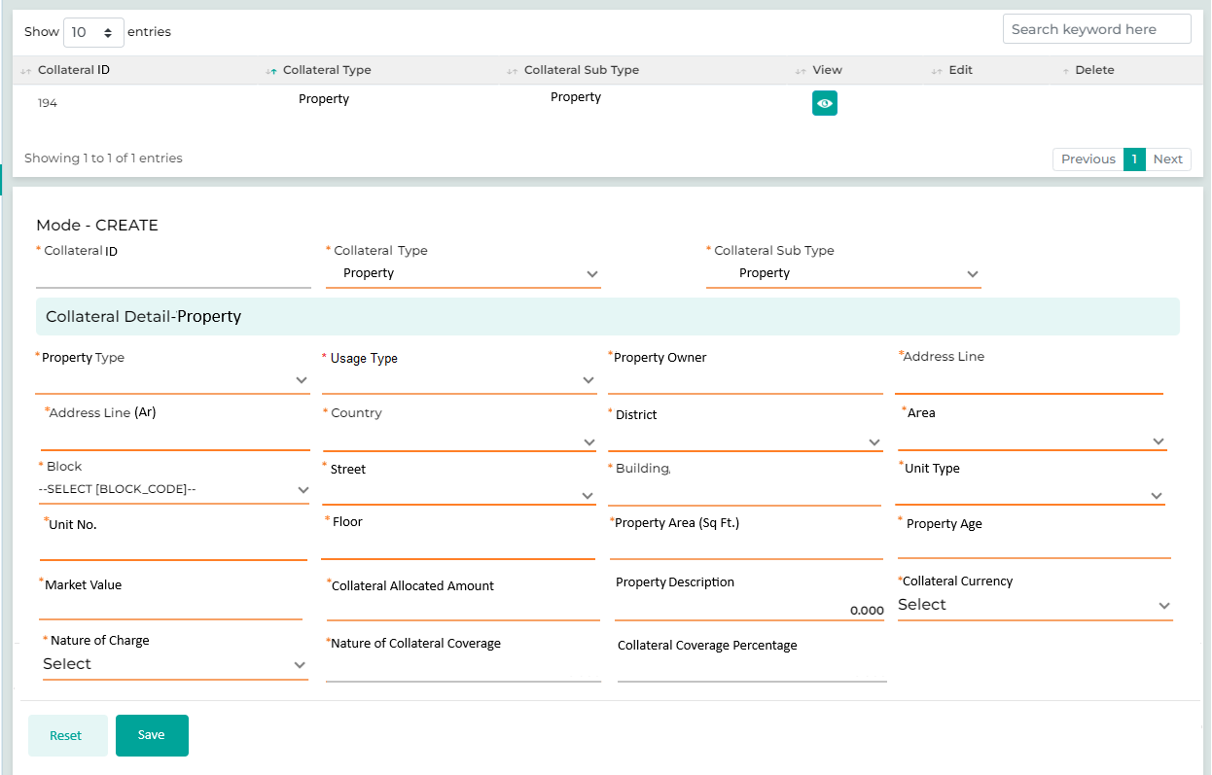
- Collateral Details – Stocks

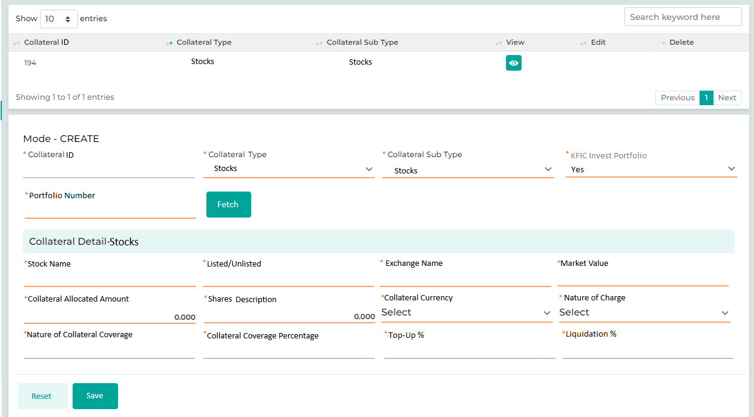

- Collateral Details – Bank Guarantee
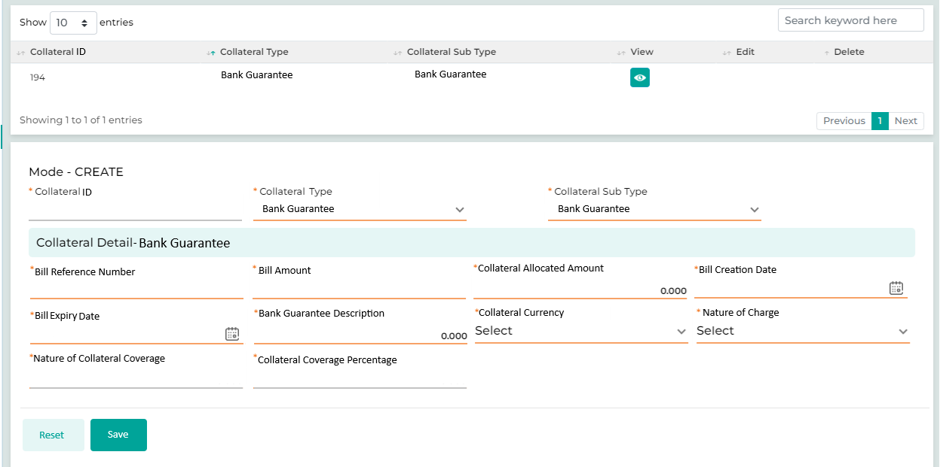

Below are the details specific to the information being displayed above.

Field Name | Field Type | Data Type / Length | Mandatory (Yes / No) | Lookup Key / Master Name | Possible Values | Field Description
 |  |  |  |  |  | Remarks/ Validation
- Collateral Id  - Collateral Type  - Sub Collateral Type | List View | Grid Liat |  |  |  | List view in the grid to highlight the number of collaterals added with the action buttons such as View, Edit, & Delete.
Collateral Id | Read Only | INT | Yes |  | 10001 | Auto generated basis on the number of collaterals added, will be the unique ID of each collateral across the system.
Collateral Type | LOV Drop Down | VARCHAR | Yes |  | - Real Estate  - Vehicle  - Stocks  - Bank Guarantee | User selects the collateral type
Sub Collateral Type | LOV Drop Down | VARCHAR | Yes |  | - Income Generating  - Non-Income Generating  - Car  3.1 Leading Stocks  3.2 Stable Stocks  3.3 Growth Stocks  3.4 Listed International Stocks  4.1 Bank Guarantee | User selects the sub collateral type
 |  |  |  |  |  | Dependent LOV basis of the Collateral Type
KFIC Invest Portfolio? | LOV Drop Down | VARCHAR | Yes |  | Yes  No | Only applicable if the Collateral Type is Stocks  The user should select “Yes” if the portfolio available with KFIC Invest is to be used as collateral, by retrieving the data from the PMS integration.  The user should select “No” if the portfolio to be pledged is not held with KFIC Invest.
Portfolio Number | Text Box | VARCHAR | Yes |  | 802 | Only applicable in Collateral Type as Stocks and KFIC Invest Portfolio is “Yes”.  The user will enter the Portfolio Number referring to what is available with KFIC Invest.
Fetch | Button | Button | Yes |  |  | Only applicable in Collateral Type as Stock, KFIC Invest Portfolio is “Yes”, and Portfolio Number I entered.  On click of Fetch button, the data will be fetched from the PMS of KFIC invest.
Property (Dependent Section basis of the Collateral & Sub Collateral Type selection)
Property Type | LOV Drop Down | VARCHAR | Yes | NA | Land  Building | The user will enter the property type whether it’s land, building, others.
Usage Type | LOV Drop Down | VARCHAR | Yes | NA | Residential  Commercial | The user will enter the usage type whether residential or commercial
Property Owner Name | Text Box | VARCHAR | Yes | NA | NA | The user will enter the property owner name
Address Line | Text Box | VARCHAR | Yes | NA | NA | Address line in English will be captured
Address Line (Arabic) | Text Box | NVARCHAR | Yes | NA | NA | Address line in Arabic will be captured
Country | LOV Dropdown | VARCHAR | Yes | COUNTRY | Kuwait | The user will enter the details
District | LOV Dropdown | VARCHAR | Yes | DISTRICT | NA | The user will enter the details
Area | LOV Dropdown | VARCHAR | Yes | AREA | NA | The user will enter the details
Block | LOV Dropdown | VARCHAR | Yes | BLOCK | NA | The user will enter the details
Street | LOV Dropdown | VARCHAR | Yes | STREET | NA | The user will enter the details
Building | Text Box | VARCHAR | Yes | NA | NA | The user will enter the details
Unit Type | LOV Dropdown | VARCHAR | Yes | NA | Apartment  Villa | The user will enter the details
Unit No | Text Box | VARCHAR | Yes | NA | NA | The user will enter the details
Floor | Text Box | VARCHAR | Yes | NA | NA | The user will enter the details
Property Area (Sq. Ft) | Text Box | VARCHAR | Yes | NA | NA | The user will enter the details
Property Age | Text Box | VARCHAR | Yes | NA | NA | The user will enter the details
Market Value | Text Box | VARCHAR | Yes | NA | 100000 | The user will enter the details, on basis of the valuation done from both the bank & the valuation agency the lowest among them will be considered.  Mandatory field as per CiNet (Latest of Collateral)
Collateral Allocated Amount | Textbox | VARCHAR | Yes | NA | 80000 | The user will enter the collateral allocated amount at the account level. For new collateral in KFIC, this amount will be set to the lowest valuation amount. For collateral already linked to a loan account in KFIC as result obtained via the Collateral Search screen, the remaining available collateral amount will be used.  Mandatory field as per CiNet (Collateral Allocated Amount)  Following will be the validation referring to the “Collateral Coverage Percentage” field  Let us assume a case where the current value of collateral is 75,000 KWD and If the same collateral is given to three loan accounts, then the ‘Collateral Coverage Percentage’ should be computed as 33.33 %and the ‘Latest Value of the Collateral’ should be reported as 25,000 KWD for this Account.
Description Of Property | Text Box | VARCHAR | Yes | NA | NA | The user will enter the details  Mandatory field as per CiNet (Description of Collateral)
Vehicle (Dependent Section basis of the Collateral & Sub Collateral Type selection)
Usage Type | LOV Dropdown | VARCHAR | Yes | NA | New  Used  Used with No Plate | The user will enter the details
Vehicle Category | Dropdown | VARCHAR | Yes | NA | Motor Vehicle  Electric Vehicle | The user will enter the details
Vehicle maker | Dropdown | VARCHAR | Yes | NA | Toyota | User will select the Vehicle maker which is the brand name
Vehicle Model | Textbox | VARCHAR | Yes | NA | Corolla | Vehicle Model depended upon the maker selected
Vehicle Subcategory | LOV Dropdown | VARCHAR | Yes | NA | SUV  Sedan  Saloon | The vehicle Subcategory is dependent upon the Model selected
Country of Manufacture | LOV Dropdown | VARCHAR | Yes | NA | Japan | The country of Manufacture is dependent upon the maker selected
Chassis Number | Text Box | VARCHAR | Yes | NA | 643246890 | The user will enter the details
Engine Number | Text Box | VARCHAR | Yes | NA | ENG889754543 | The user will enter the details
Colour | LOV Dropdown | VARCHAR | Yes | NA | White | The user will enter the details
Year Of Manufacture | Text Box | VARCHAR | Yes | NA | 2018 | The user will enter the details
Vehicle Price | Textbox | VARCHAR | Yes | NA | 10000 | The user will enter the details, in case of used vehicle from Agency the value from the quotation will be considered where in case of used vehicle from individual the market price will be considered.  Mandatory field as per CiNet (Latest of Collateral)
Collateral Allocated Amount | Textbox | VARCHAR | Yes | NA | 8000 | The user will enter the allocated amount for the collateral to be considered.  Mandatory field as per CiNet (Collateral Allocated Amount)  Following will be the validation referring to the “Collateral Coverage Percentage” field  Let us assume a case where the current value of collateral is 75,000 KWD and If the same collateral is given to three loan accounts, then the ‘Collateral Coverage Percentage’ should be computed as 33.33 %and the ‘Latest Value of the Collateral’ should be reported as 25,000 KWD for this Account.
Vehicle Description | Textbox | VARCHAR | Yes | NA | NA | The user will enter the details  Mandatory field as per CiNet (Description of Collateral)
Stocks (Dependent Section basis of the Collateral & Sub Collateral Type selection)
Stock Name | Textbox | VARCHAR | Yes | NA | Polo Engineering | The user will enter the details  The data will be fetched from the PMS of KFIC invest if the client’s portfolio is available with the KFIC invest.
Listed/Unlisted | Dropdown | VARCHAR | Yes | NA | Listed  Unlisted | The user will enter the details  The data will be fetched from the PMS of KFIC invest if the client’s portfolio is available with the KFIC invest.
Exchange Name | Textbox | VARCHAR | Yes | NA | KSE | The user will enter the details  The data will be fetched from the PMS of KFIC invest if the client’s portfolio is available with the KFIC invest.
Market Value | Textbox | VARCHAR | Yes | NA | 100 | Mandatory field as per CiNet (Latest of Collateral)  Following will be the validation referring to the “Collateral Coverage Percentage” field  Let us assume a case where the current value of collateral is 75,000 KWD and If the same collateral is given to three loan accounts, then the ‘Collateral Coverage Percentage’ should be computed as 33.33 %and the ‘Latest Value of the Collateral’ should be reported as 25,000 KWD for this Account.  The data will be fetched from the PMS of KFIC invest if the client’s portfolio is available with the KFIC invest.
Collateral Allocated Amount | Textbox | VARCHAR | Yes | NA | 80 | The user will enter the details, it will be equals to the lowest valuation amount.  The user will enter the details based on the valuation report received from the external agency or if integrated with the KFIC invest market value will be fetched in automatically.  Mandatory field as per CiNet (Collateral Allocated Amount)  The data will be fetched from the PMS of KFIC invest if the client’s portfolio is available with the KFIC invest.
Shares Description | Textbox | VARCHAR | Yes | NA | NA | The user will enter the details  Mandatory field as per CiNet (Description of Collateral)
Top-Up% | Textbox | VARCHAR | Yes | NA | NA | The user will enter the Top-Up % required in case if the pledged amount falls below the coverage percentage. Where in case the customer will be asked to provide more collateral or pay upfront cash.
Liquidation % | Textbox | VARCHAR | Yes | NA | NA | The user will enter % consider for liquidation in case the market value in gradually decreasing, allowing the rights sell the % amount to balance the risk.
Bank Guarantee (Dependent Section basis of the Collateral & Sub Collateral Type selection)
Bill Reference Number | Textbox | VARCHAR | Yes | NA | 9876441 | The user will enter the details
Bill Amount | Textbox | VARCHAR | Yes | NA | 100000 | The user will enter the allocated amount for the collateral to be considered.  Mandatory field as per CiNet (Latest of Collateral)  Following will be the validation referring to the “Collateral Coverage Percentage” field  Let us assume a case where the current value of collateral is 75,000 KWD and If the same collateral is given to three loan accounts, then the ‘Collateral Coverage Percentage’ should be computed as 33.33 %and the ‘Latest Value of the Collateral’ should be reported as 25,000 KWD for this Account.
Collateral Allocated Amount | Textbox | VARCHAR | Yes | NA | 80000 | The user will enter the details, it will be equals to the lowest valuation amount.  Mandatory field as per CiNet (Collateral Allocated Amount)
Bill Creation Date | Textbox | VARCHAR | Yes | NA | 20-10-2024 | The user will enter the details
Bill Expiry Date | Textbox | VARCHAR | Yes | NA | 12-10-2027 | The user will enter the details
Bank Guarantee Description | Textbox | VARCHAR | Yes | NA | NA | The user will enter the details  Mandatory field as per CiNet (Description of Collateral)
Common fields for all collateral type
Collateral Currency | LOV Dropdown | VARCHAR | Yes |  | KWD  USD  GBP  EUR | The user will select the collateral currency  Mandatory field as per CiNet (Collateral Currency)
Nature of Charge | LOV Dropdown | VARCHAR | Yes |  | 001 1st degree mortgage  002 2nd degree mortgage  003 3rd degree mortgage  004 Pari-Passu  005 Lien for Cash / Deposit  006 Assignment  007 Others | The user will select the Nature of Charge from the list of values.  Mandatory field as per CiNet (Nature of Charge)
Nature of Collateral Coverage | Read Only | VARCHAR | Yes |  | 001 Cover Other Accounts  002 Cover only this account | Mandatory field as per CiNet (Nature Collateral Coverage)  In case of collateral is found to be existing to KFIC during the collateral search and being linked to other accounts too, “Cover Other Accounts” will automatically be selected whereas if it is the new collateral and only covering this account “Cover only this account” will be selected automatically.
Collateral Coverage Percentage | Read Only | VARCHAR | Yes |  | 25,000 | Mandatory field as per CiNet (Collateral Coverage Percentage)  In case of collateral is found to be existing to KFIC during the collateral search and being linked to other accounts too then an only the value will be computed automatically in this field.  Let us assume a case where the current value of collateral is 75,000 KWD and If the same collateral is given to three loan accounts, then the ‘Collateral Coverage Percentage’ should be computed as 33.33 %and the ‘Latest Value of the Collateral’ should be reported as 25,000 KWD for this Account.
Action Buttons
Reset | Button | Button | NA | NA | NA | The User will click on this button to clear the entered data.
Save | Button | Button | NA | NA | NA | The User will click on this button to save the entered data.

13.2.3.3 Loan Item Details

The Loan Item details screen enables the user to capture specific information about the item and the purpose for which the customer is applying for the loan. It also allows for the addition of multiple loan items, particularly in the case of commercial loans, by defining the count for items with the same parameters.
For Vehicle Loan items involving a dealer, the system provides functionality to check the dealer's exposure—either as an individual or entity—using the Civil ID or MOCI. This feature helps the user determine if the dealer is an existing client. If the dealer is indeed an existing client, the system will display their current exposure with KFIC through the customer 360 module.
The system will automatically set the collateral coverage for loan Item to 100%. This ensures they cannot be added as collateral for other loans in future.
Specific for the Commercial loans, the system also enables the users to efficiently enter data for Loan Item types, in case of Vehicles, where multiple loan items are linked to a single loan account. Users can click the "Upload" button to upload a standard Excel template filled with the required details. Once uploaded successfully, the details will appear in the grid. If needed, users can edit any loan item entry by clicking the "Edit" button, making the necessary changes, and saving the updated information.
Navigation:
Detail Data Entry à Collateral & Loan Details à Loan Item Details
The following screen will be displayed once the User clicks on Loan Item Details:

- Loan Item Details – Vehicle
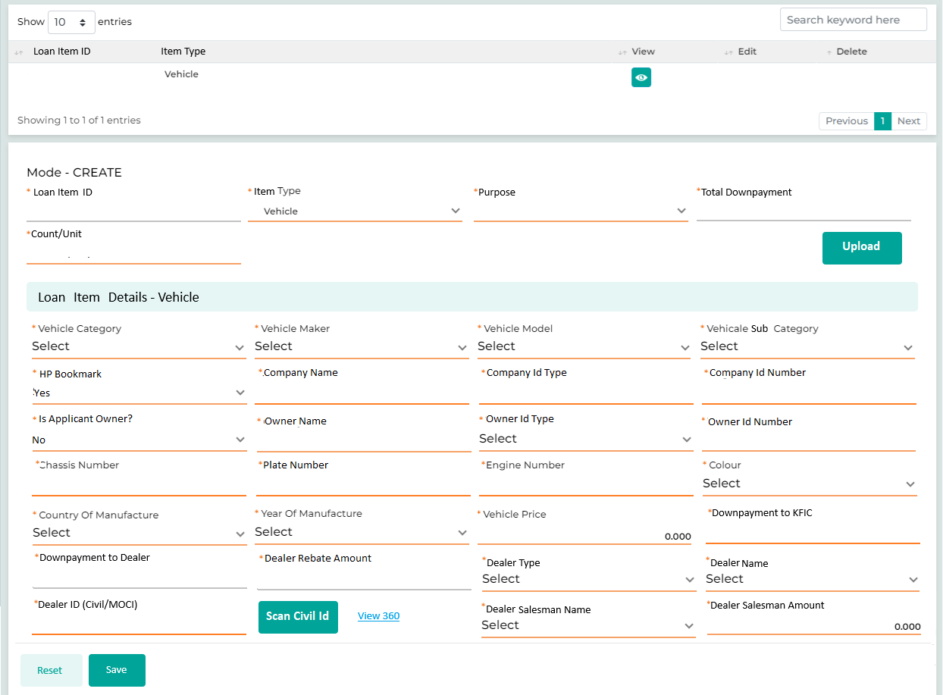
- Loan Item Details – Property
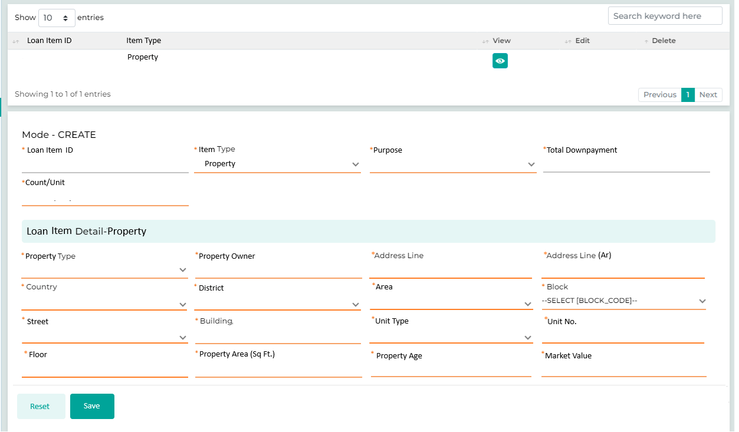

- Loan Item Details – Stocks
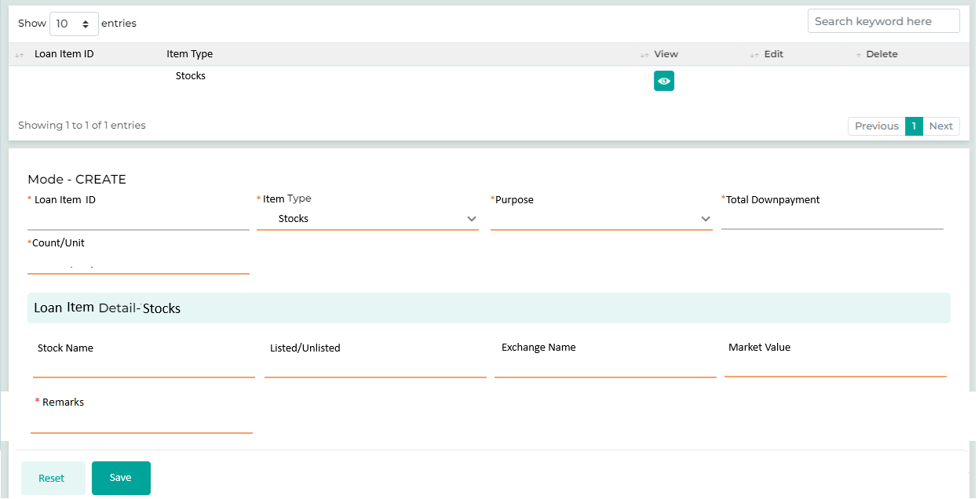

Field Name | Field Type | Data Type / Length | Mandatory (Yes / No) | Lookup Key / Master Name | Possible Values | Field Description
 |  |  |  |  |  | Remarks/ Validation
- Loan Item Id  - Item Type | List View | Grid Liat |  |  |  | List view in the grid to highlight the number of loan item added with the action buttons such as View, Edit, & Delete.
Loan Item Id | Read Only | INT | Yes |  |  | Auto generated basis on the number of loan item added, will be the unique ID for each loan item across the system.
Item Type | LOV Drop Down | VARCHAR | Yes |  | - Vehicle  - Real Estate  - Stocks | User selects the loan item type
Purpose | LOV Drop Down | VARCHAR | Yes |  | - Vehicle  - Renovation  - Construction  - Medical Treatment  - Education | User selects the loan purpose
Total Downpayment | Read Only | VARCHAR | Yes |  | 200 | System will compute the downpayment amount which should be configurable.  Example, for vehicle loan downpayment should be 10% of the loan item amount
Count/Unit | Text Box | VARCHAR | Yes |  | 3 | When capturing the loan item, the user will specify the number of identical loan items to be entered.  For example, if there are three vehicles with the same parameters, the user will input a count of three and provide the necessary details. The system will then clone these details and display three entries in the grid. The user will also have the option to click the edit action button for any individual loan item if they wish to update specific parameters.
Upload | Button | Button | Yes |  |  | Applicable only if the user has selected the item type as “Vehicle” and “Count/Unit” is more than 1.  The system enables users to efficiently enter data for Loan Item types, such as Vehicles, where multiple loan items are linked to a single loan account. Users can click the "Upload" button to upload a standard Excel template filled with the required details related to the Loan Item (Vehicle) & insurance details. Once uploaded successfully, the details will appear in the grid on Loan Item details and will also appear automatically on the Insurance Screen grid linking the insurance with the respective loan items. If needed, users can edit any entry from loan item detail or Insurance details screen by clicking the "Edit" button, making the necessary changes, and saving the updated information.
Property (Dependent Section basis of the loan item selection)
Property Type | LOV Drop Down | VARCHAR | Yes | NA | Residential  Commercial | The user will enter the property type whether residential or commercial
Property Owner Name | Text Box | VARCHAR | Yes | NA | NA | The user will enter the property owner name
Address Line | Text Box | VARCHAR | Yes | NA | NA | Address line in English will be captured
Address Line (Arabic) | Text Box | NVARCHAR | Yes | NA | NA | Address line in Arabic will be captured
Country | LOV Dropdown | VARCHAR | Yes | COUNTRY | Kuwait | The user will enter the details
District | LOV Dropdown | VARCHAR | Yes | DISTRICT | NA | The user will enter the details
Area | LOV Dropdown | VARCHAR | Yes | AREA | NA | The user will enter the details
Block | LOV Dropdown | VARCHAR | Yes | BLOCK | NA | The user will enter the details
Street | LOV Dropdown | VARCHAR | Yes | STREET | NA | The user will enter the details
Building | Text Box | VARCHAR | Yes | NA | NA | The user will enter the details
Unit Type | LOV Dropdown | VARCHAR | Yes | NA | Apartment  Villa | The user will enter the details
Unit No | Text Box | VARCHAR | Yes | NA | NA | The user will enter the details
Floor | Text Box | VARCHAR | Yes | NA | NA | The user will enter the details
Property Area (Sq. Ft) | Text Box | VARCHAR | Yes | NA | NA | The user will enter the details
Property Age | Text Box | VARCHAR | Yes | NA | NA | The user will enter the details
Market Value | Text Box | VARCHAR | Yes | NA | 100000 | The user will enter the details
Vehicle (Dependent Section basis of the loan item selection)
Vehicle Category | Dropdown | VARCHAR | Yes | NA | Motor Vehicle  Electric Vehicle | The user will enter the details
Vehicle maker | Dropdown | VARCHAR | Yes | NA | Toyota | User will select the Vehicle maker which is the brand name
Vehicle Model | Textbox | VARCHAR | Yes | NA | Corolla | Vehicle Model depended upon the maker selected
Vehicle Subcategory | LOV Dropdown | VARCHAR | Yes | NA | SUV  Sedan  Saloon | The vehicle Subcategory is dependent upon the Model selected
HP Bookmark | LOV Dropdown | VARCHAR | Yes | NA | Yes  No | The user will select whether the loan item to be marked under Hypothecation or not.
Company Name | Master Dropdown | VARCHAR | Yes | NA | - KFIC Finance  - KFIC Car | Dependent filed if the HP Bookmark is selected as Yes.  The user will select the Company Name whether KFIC Finance or KFIC Car under name the HP will be marked.
Company Id Type | Master Dropdown | VARCHAR | Yes | NA | CR | Dependent filed if the HP Bookmark is selected as Yes.  The ID Type will be populated based on the company name selected.
Company Id Number | Master Dropdown | VARCHAR | Yes | NA | 235467890 | Dependent filed if the HP Bookmark is selected as Yes.  The ID Number will be populated based on the company name selected.
Is Applicant Owner? | LOV Dropdown | VARCHAR | Yes | NA | Yes  No | Dependent filed if the HP Bookmark is selected as No.
Owner Name | Text Box | VARCHAR | Yes | NA | Abu Huzaifa Shamsi | Dependent filed if the “Is Applicant Owner?” is selected as No.  The user will enter the name of the beneficiary.
Owner Id Type | LOV Dropdown | VARCHAR | Yes | NA | Civil Id | Dependent filed if the “Is Applicant Owner?” is selected as No.  The user will select the ID Type of the beneficiary.
Owner Id Number | Text Box | VARCHAR | Yes | NA | 2346579653214 | Dependent filed if the “Is Applicant Owner?” is selected as No.  The user will enter the ID number of the beneficiary.
Chassis Number | Text Box | VARCHAR | Yes | NA | 643246890 | The user will enter the chassis number for the vehicle as a Loan Item  Once the user enters the Chassis Number and Plate Number, the system will check if the vehicle is already registered as a loan item with KFIC. If no matching data is found, a message stating "No data found" will be displayed. If the vehicle is already registered, the system will automatically flag the policy referring to the existing loan item with the same details as "failed" on the Policy Check screen. The user will then need to initiate exceptional approval for that policy. Once the approval is granted by the authorized user, only then will the user be able to proceed the application to the next stage.
Plate Number | Text Box | VARCHAR | Yes | NA | MIG 876 | The user will enter the plate number for the vehicle as a Loan Item  Once the user enters the Chassis Number and Plate Number, the system will check if the vehicle is already registered as a loan item with KFIC. If no matching data is found, a message stating "No data found" will be displayed. If the vehicle is already registered, the system will automatically flag the policy referring to the existing loan item with the same details as "failed" on the Policy Check screen. The user will then need to initiate exceptional approval for that policy. Once the approval is granted by the authorized user, only then will the user be able to proceed the application to the next stage.
Engine Number | Text Box | VARCHAR | Yes | NA | ENG889754543 | The user will enter the engine number for the vehicle as a Loan Item
Colour | LOV Dropdown | VARCHAR | Yes | NA | White | The user will enter the details
Country of Manufacture | LOV Dropdown | VARCHAR | Yes | NA | Japan | The country of Manufacture is dependent upon the maker selected
Year Of Manufacture | Text Box | VARCHAR | Yes | NA | 2018 | The user will enter the details
Vehicle Price | Textbox | VARCHAR | Yes | NA | 10000 | The user will enter the details
Downpayment to KFIC | Text Box | VARCHAR | Yes |  | 50 | Only applicable if Loan item type is Vehicle. The user will enter the amount lower than the Total Downpayment amount
Downpayment to Dealer | Read Only | VARCHAR | Yes |  | 150 | Only applicable if Loan item type is Vehicle. The system will display the amount which is to be paid to the dealer.  If the vehicle price is KD 2000, the total down payment will be automatically calculated as 10%, which amounts to KD 200. If the user inputs KD 50 as the down payment made to KFIC, the system will then automatically calculate the remaining amount to be paid to the dealer.
Dealer Rebate Amount | Text Box | INT | Yes |  | 10.000 | The user will enter the dealer rebate amount for each of the loan item.  Rebate amount will be considered as part of finance.
Dealer Type | LOV Dropdown | VARCHAR | Yes |  | Company  Agency  Individual | The user will select the dealer type from the list of values.
Dealer Name | LOV Dropdown – Company/Agency Dealer  Read Only – Individual Dealer | VARCHAR | Yes |  | Amazing Motors | In case of Company & Agency as the Dealer Type the user will select the dealer’s name from the list of values  Dealer Name in case of Dealer Type as Individual will be fetched via the Civil ID scan functionality.
Dealer Id (Civil/MOCI) | Read Only | VARCHAR | Yes |  | 223456128459 | Basis the civil ID(Individual) or MOCI (Agency & Company) of the dealer, which will trigger an exposure check by the system to determine whether the dealer is an existing customer of KFIC.  Civil Id Number in case of Dealer Type as Individual will be fetched via the Civil ID scan functionality.
Scan Civil Id | Button | BUTTON | Yes |  |  | Scan Civil ID button will only be enabled if the user has selected the Dealer Type as Individual. The user will scan the Civil Id of the Individual basis of which the Dealer Name & Civil ID Number will be populated on the respective field “Dealer Name” & “Dealer ID (Civil/MOCI)”
View 360 | Hyperlink | BUTTON | Yes |  |  | Th user will click on View 360 and if the dealer is an existing customer (Main Applicant or Guarantor), the system will display the exposure information through the 360 views. If there are any pending dues, the user will be prompted to ask the dealer to settle those dues before proceeding further.
Dealer Salesman Name | LOV Dropdown | VARCHAR | Yes |  | Ibrahim Urooj  Not Applicable | This field is applicable only if the Dealer Type is selected as Agency or Company.  Based on the selected dealer, a list of salesmen mapped to that specific dealer will be displayed. The user can then choose the desired salesman’s name from this list of values the user also has an option to select the option as Not Applicable.
Dealer Salesman Amount | Text Box | INT | Yes |  | 10 | The user will manually enter the amount to be paid to the dealer salesman.  Validation: The Dealer Salesman Amount should not be greater than the admin fees  If Dealer Salesman Name is selected as Not Applicable, the “Dealer Salesman Amount” field will be disabled.
Stocks (Dependent Section basis of the loan item selection)
Stock Name | Textbox | VARCHAR | No | NA | Polo Engineering | The user will enter the details
Listed/Unlisted | Dropdown | VARCHAR | No | NA | Listed  Unlisted | The user will enter the details
Exchange Name | Textbox | VARCHAR | No | NA | KSE | The user will enter the details
Market Value | Textbox | VARCHAR | No | NA | 100 | The user will enter the details
Remarks | Textbox | VARCHAR | Yes | NA |  | The user will enter the details
Action Buttons
Reset | Button | Button | NA | NA | NA | The User will click on this button to clear the entered data.
Save | Button | Button | NA | NA | NA | The User will click on this button to save the entered data.

13.2.3.4 Insurance Details

This screen will let the user capture the insurance details for the various insurance type including Full Insurance, Life Insurance, and Liability Insurance which will be kept on adding in the grid above. Users will need to provide details such as the name of the insurance company, type of insurance, policy number, coverage type, and effective dates. Additionally, users must upload the insurance policy document provided by the customer to verify coverage details for accurate record-keeping within the system. Customer also has an option to include the insurance amount in finance, where the Full Insurance and Life Insurance can be included in the finance, whereas Liability Insurance will not.
Life insurance is applicable to all loan products, while full insurance and liability insurance will be applicable for Vehicle loan.
All insurance-related details will be captured, except for the policy number and the actual policy document, which will be uploaded once the loan is approved and activated at a later stage and the PO will be generated for the respective insurance company.
Full Insurance and Liability Insurance can be associated with a Loan Item by selecting the corresponding Loan Item ID. If multiple loan items are included in a loan, multiple insurance policies can be linked to each item. For instance, in the case of a commercial vehicle loan with more than one vehicle, separate insurance policies will be linked to each vehicle.
Navigation:
Detail Data Entry à KYC à Reference Details
The following screen will be displayed once the User clicks on Reference Details:
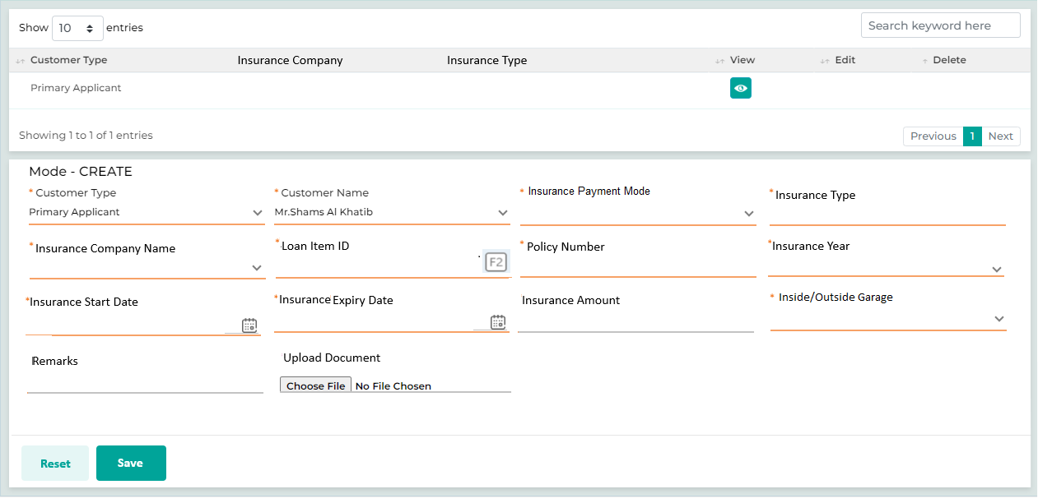

Following screen will be displayed on click on F2 search, which will display all the loan items captured on the Loan Item Details screen, each with a unique Loan Item ID. The user can then select the appropriate Loan Item ID to link the insurance to the corresponding loan item.
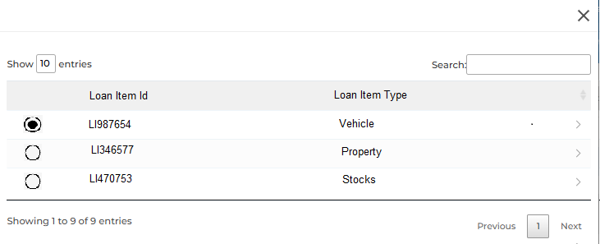

Field Name | Field Type | Data Type / Length | Mandatory (Yes/ No) | LookUp Key/Master Name | Possible Values | Field Description
 |  |  |  |  |  | Remarks / Validation
- Customer Type  - Insurance Company  - Insurance Type | List View | NA | NA | NA |  | The system will display the list of the different insurance added.
Customer Type | LOV Dropdown | VARCHAR | Yes | 4034 | - Main Applicant  - Joint Applicant  - Guarantor | The User will select the customer type from the Dropdown values.
Customer Name | Master Dropdown | VARCHAR | Yes | NA | NA | The User will select the customer’s name from the Dropdown values.
Insurance Payment Mode | LOV Dropdown |  | Yes |  | - Amortized  - Included in Finance | The user will select, whether the insurance amount is to be included in finance or to be amortized.
 |  |  |  |  |  | Full Insurance and Life Insurance can be included in the finance, whereas Liability Insurance will be amortized
Insurance Type | LOV Dropdown | VARCHAR | Yes | INSURANCETYPEC | Full Insurance  Life Insurance  Liability Insurance  Replacement Car  CPM Insurance | The User will select the insurance type.
Insurance Company Name | LOV Dropdown | VARCHAR | Yes | InsuranceName | - Gulf Insurance | The User will select the insurance company name from the dropdown.
Coverage Type | LOV Dropdown | VARCHAR | Yes | CoverageType | - Full Coverage  - Third party | The User will select the coverage type of the insurance.
Collateral | LOV Dropdown | VARCHAR | Yes |  | - Vehicle  - Land & Property | If the insurance type is selected as Collateral, the user will select the collateral type.
Loan Item Id | LOV Dropdown | VARCHAR | Yes |  |  | “Loan Item Id” is a dependent filed only beapplicable if the Insurance Type is selected as Full Insurance or Liability Insurance. And the same won’t be applicable if the insurance type is selcted as Life Insurance.  The user will click the F2 search button, which will display all the loan items captured on the Loan Item Details screen, each with a unique Loan Item ID. The user can then select the appropriate Loan Item ID to link the insurance to the corresponding loan item.
Policy Number | Text Box | VARCHAR | Yes | NA | NA | At the detail data entry stage, policy number field is non-mandatory where as it will be captured by the user once the loan is approved and activated at a later stage and also the PO will be generated for the respective insurance company.
Insurance Year | LOV Dropdown | VARCHAR | Yes |  | 1 year  2 year  3 year | The user will select the number of year as per cleint requirement
Insurance Start Date | Calendar | DATETIME | Yes | NA | NA | Insurance start date will be same as the PO (Purchase Order) date
Insurance Expiry Date | Calendar | DATETIME | Yes | NA | NA | Insurance end date will basis of th start date & the number of years selected by the user.
Premium Amount | Text Box | VARCHAR | No | NA | 100 | The User will enter the insurance premium amount.
Insurance Amount | Text Box | VARCHAR | No | NA | 100 | The User will enter the insurance amount for full & liability insurance, where as for life insurance it will be automatically computed as per the matrix defined in the master.
Sum Insured | Read only | VARCHAR | No | NA |  | Sum Insured will be auto-populated equals to the asset price.
Inside/Outside Garage | LOV Dropdown | VARCHAR | Yes | NA | Inside Garage  Outside Garage | Applicable only if the Insurance Type is selected as “Full Insurance”  The user will select whether the insurance covers the mainatinance of the car inside or outside garage.
Remarks | Text Box | VARCHAR | No | NA |  | The user will capture the remarks related to the insurance
Upload Document | Button | VARCHAR | No | NA |  | The user will be upload the insurance policy document once the loan is approved and activated at a later stage and also the PO will be generated for the respective insurance company.
Action Button
Reset | Button | Button | NA | NA | NA | The User will click on this button to clear the entered data.
Save | Button | Button | NA | NA | NA | The User will click on this button to save the entered data.

13.2.3.5 Valuation

The Valuation screen enables the user to capture detailed information from valuation reports provided by valuation agencies for properties offered as collateral. These reports can either be submitted by the client or initiated by the sales officer.
In accordance with internal policy requirements, valuation reports must be obtained from two valuators: one from Kuwait Finance House and the other from a valuation company. The lowest value from these reports will be used for calculations and will be automatically populated in the "Market Value" field on the collateral detail screen. Valuation reports are valid for one year.
Navigation:
Detail Data Entry à Collateral & Loan Details à Valuation
The following screen will be displayed once the User clicks on Loan Item Details:

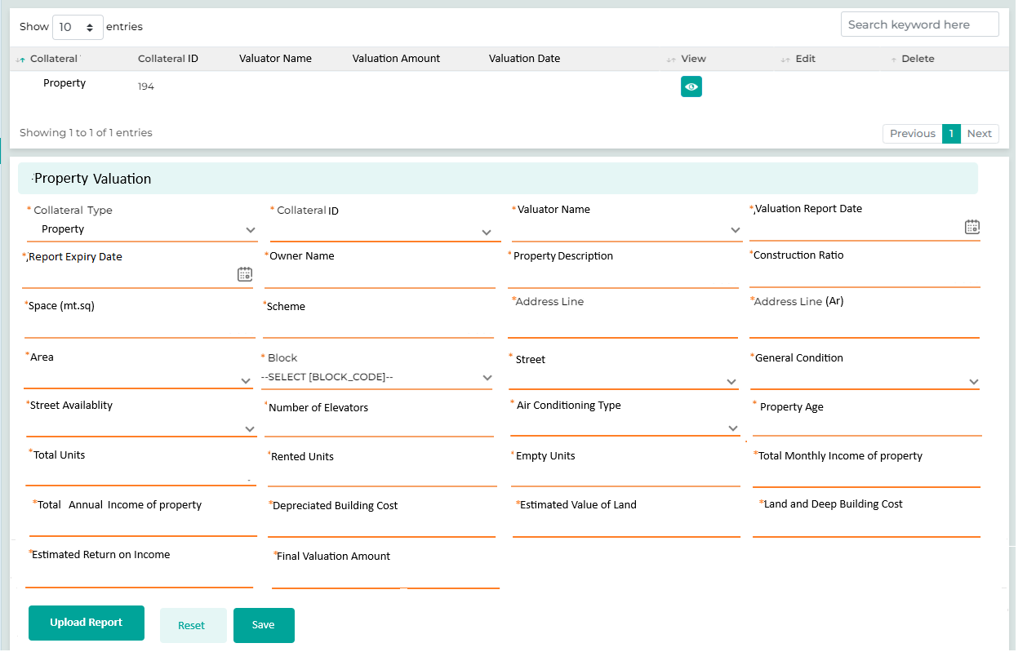

Field Name | Field Type | Data Type / Length | Mandatory (Yes / No) | Lookup Key/Master Name | Possible Values | Field Description
 |  |  |  |  |  | Remarks / Validation
Collateral | List View | VARCHAR | NA | NA | NA | Collateral type will be displayed
Collateral Id | List View | VARCHAR | NA | NA | NA | Collateral Id for which the Valuation is done
Valuator Name | List View | VARCHAR | NA | NA | NA | Valuation agency name will be displayed
Valuation Amount | List View | INT | NA | NA | NA | Valuation amount provided by the valuator name will be displayed
Valuation Date | List View |  | NA | NA | NA | Date on which the valuation was happedn will be displayed
Property Valuation
Collateral | Text Box | VARCHAR | NA | NA | - Real Estate  - Vehicle  - Stocks  - Bank Guarantee | The user will selct the collateral Type
Collateral Id | LOV Dropdown | VARCHAR | NA | NA |  | Based on the collateral type, the Collateral ID maintained on the Collateral Details screen will be displayed in a dropdown menu. The user will select the appropriate Collateral ID for which the valuation data needs to be captured.
Valuator Name | Dropdown | VARCHAR | Yes | AGENCY MASTER | - National Finance House  - Kuwait Real Estate Investment Consortium | The user will select the name of the Valuator agency/s from the multi select dropdown for which the valuation data needs to be captured refering the valuation report.
Valuation Report Date | Calendar | DATE | Yes | NA | 01-02-2024 | The user will enter the details as per the valuation report received from the bank and the valuation agency.
Report Expiry Date | Calendar | DATE | Yes | NA | 08-09-2024 | The user will enter the details as per the valuation report received from the bank and the valuation agency.
Owner Name | Text Box | VARCHAR | Yes | NA | Al Falah International | The user will enter the details as per the valuation report received from the bank and the valuation agency.
Property Description | Text Box | VARCHAR | Yes | NA | Established | The user will enter the details as per the valuation report received from the bank and the valuation agency.
Construction Ratio | Text Box | VARCHAR | Yes | NA | 250% | The user will enter the details as per the valuation report received from the bank and the valuation agency.
Space (mt.sq) | Text Box | VARCHAR | Yes | NA | 858 | The user will enter the details as per the valuation report received from the bank and the valuation agency.
Scheme | Text Box | VARCHAR | Yes | NA | 21656/m | The user will enter the details as per the valuation report received from the bank and the valuation agency.
Address Line | Text Box | VARCHAR | Yes | NA | NA | The user will enter the details as per the valuation report received from the bank and the valuation agency.
Address Line (Arabic) | Text Box | NVARCHAR | Yes | NA | NA | The user will enter the details as per the valuation report received from the bank and the valuation agency.
Area | Text Box | VARCHAR | Yes | NA | Farwaniya | The user will enter the details as per the valuation report received from the bank and the valuation agency.
Block | LOV Dropdown | VARCHAR | Yes | BLOCK | NA | The user will enter the details as per the valuation report received from the bank and the valuation agency.
Street | LOV Dropdown | VARCHAR | Yes | STREET | NA | The user will enter the details as per the valuation report received from the bank and the valuation agency.
General Condition | LOV Dropdown | VARCHAR | Yes | NA | Good  Bad  Average | The user will enter the details as per the valuation report received from the bank and the valuation agency.
Street Availability | LOV Dropdown | VARCHAR | Yes | NA | Yes  No | The user will enter the details as per the valuation report received from the bank and the valuation agency.
Number Of Elevators | Text Box | VARCHAR | Yes | NA | 2 | The user will enter the details as per the valuation report received from the bank and the valuation agency.
Air Conditioning Type | LOV Dropdown | VARCHAR | Yes | NA | Central | The user will enter the details as per the valuation report received from the bank and the valuation agency.
Property Age | Text Box | VARCHAR | Yes | NA | NA | The user will enter the details as per the valuation report received from the bank and the valuation agency.
Total Units | Text Box | INT | Yes | NA | 50 | The user will enter the details as per the valuation report received from the bank and the valuation agency.
Rented Units | Text Box | INT | Yes | NA | 45 | The user will enter the details as per the valuation report received from the bank and the valuation agency.
Empty Units | Text Box | INT | Yes | NA | 5 | The user will enter the details as per the valuation report received from the bank and the valuation agency.
Total Monthly Income of Property | Text Box | INT | Yes | NA | 10,380 | The user will enter the details as per the valuation report received from the bank and the valuation agency.
Total Annual Income of Property | Text Box | INT | Yes | NA | 124,560 | The user will enter the details as per the valuation report received from the bank and the valuation agency.
Depreciated Building Cost | Text Box | INT | Yes | NA | 351,090 | The user will enter the details as per the valuation report received from the bank and the valuation agency.
Estimated value of land | Text Box | INT | Yes | NA | 1,225,000 | The user will enter the details as per the valuation report received from the bank and the valuation agency.
Land & Dep Building Cost | Text Box | INT | Yes | NA | 1,576,090 | The user will enter the details as per the valuation report received from the bank and the valuation agency.
Estimated Return on Income | Text Box | INT | Yes | NA | 7.33% | The user will enter the details as per the valuation report received from the bank and the valuation agency.
Final Valuation Amount | Text Box | INT | Yes | NA | 1,700,000 | The user will enter the details as per the valuation report received from the bank and the valuation agency.
Upload Report | Button | NA | NA | NA | NA | The user will upload the report received from the Valuation Agency.
Action Buttons
Reset | Button | Button | NA | NA | NA | The User will click on this button to clear the entered data.
Save | Button | Button | NA | NA | NA | The User will click on this button to save the entered data.

13.2.3.6 Loan Details
This screen displays the summarize view of the loan details and the loan calculation along with the repayment schedule. It retrieves the loan requirement details, including loan item value and the downpayment to be made by the customer to KFIC or the dealer. Additionally, it computes parameters such as the requested loan amount, interest rate, IRR, and instalment amount.
Navigation:
Detail Data Entry à Collateral & Loan Details à Loan Details
The following screen will be displayed once the User clicks on Loan Details:
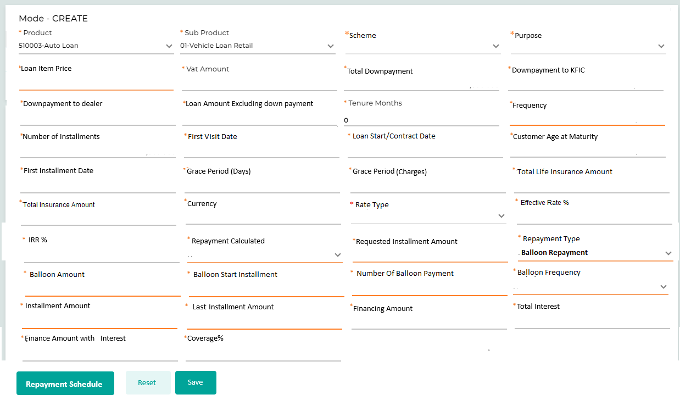

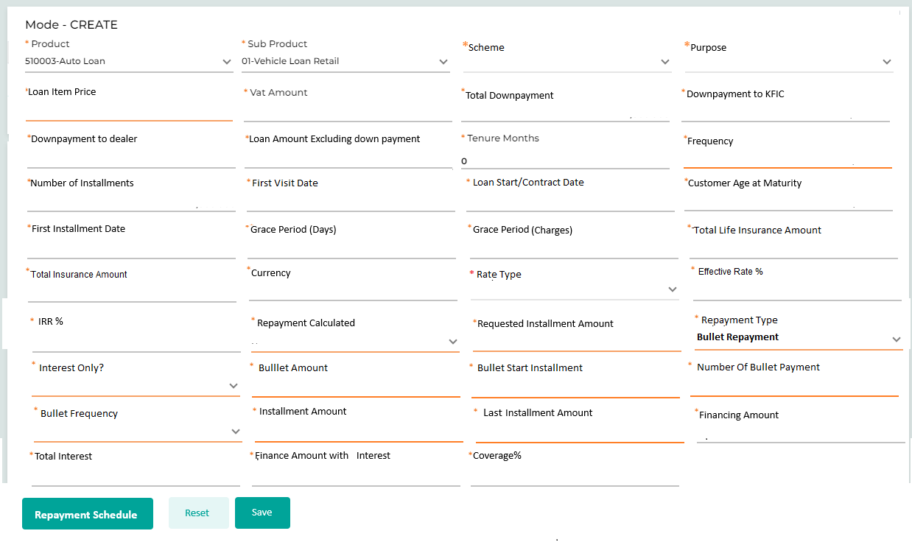

Below are the details specific to the information being displayed above.
Field Name | Field Type | Data Type / Length | Mandatory (Yes / No) | LookUp Key/Master Name | Possible Values | Field Description
 |  |  |  |  |  | Remarks / Validation
Product | Read Only | VARCHAR | Yes | NA | - Vehicle Loan  - Personal Loan  - Cash Loan | The system will display this field based on the data captured during the application creation
Sub Product | Read Only | VARCHAR | Yes | NA | - Vehicle Loan New  - Vehicle Loan Used (Agency)  - Vehicle Loan Used (Other)  - Housing Loan  - Consumer Loan  - Realestate  - Sares | The system will display this field based on the data captured during the application creation
Scheme | Master Dropdown | Varchar | Yes | Scheme Master | MotoCorp Dealer Campaign | The user will select the scheme
Purpose | Read Only | VARCHAR | Yes | NA | - Vehicle  - Renovation  - Medical Treatment  - Education | The system will display the purpose basis of the data captured in the loan item details screen.
Loan Item Price | Read Only | VARCHAR | Yes | NA | 5000 | It will be the summation of the price of all the loan item mention in the Loan Item detail screen.
VAT Amount | Read Only | VARCHAR | Yes | NA | 0 | Based on the configuration, the VAT amount will be considered accordingly. If there is currently no VAT applicable, the VAT percentage will be set to 0%, resulting in a VAT amount of zero.  For example, if the Loan Item Price is KD 1000 and the VAT is configured at 10% of the loan item price, the VAT amount will be calculated as KD 100.
Total Downpayment | Read Only | VARCHAR | Yes | NA | 200 | It will be the summation of the total downpayment amount of all the loan item mention in the Loan Item detail screen.
Downpayment to KFIC | Read Only | VARCHAR | Yes | NA | 100 | Applicable only for Vehicle.  It will be the summation of the downpayment amount to KFIC of all the loan items mention in the Loan Item detail screen.
Downpayment to Dealer | Read Only | VARCHAR | Yes | NA | 100 | Applicable only for Vehicle.  It will be the summation of the downpayment amount to dealer of all the loan items mention in the Loan Item detail screen.
Loan Amount Excluding Downpayment | Read Only | FLOAT | Yes | NA | 4,800 | Computed as following  Loam Amount Excluding Downpayment =  Loan Item Price – Total Downpayment
Tenure in Months | Read Only | VARCHAR | Yes | NA | 36 Months | The system will display the tenure configired at product & sub product level.  Retail – Vehicle Loan = 5 Years  Retail – Personal – Consumer Loan = 5 Years  Retail – Personal – Consumer Loan = 15 Years
Frequency | LOV Dropdown | VARCHAR | Yes | NA | - Monthly  - Quartelry | The user will selct the loan frequency
Number Of Installments | Read Only | VARCHAR | Yes | NA | 36 | The system will display the Number of installments basis of the tenure & frequency select.  If the tenure is 36 months and the frequency is selected as Monthly, then the Number of Installments to be computed as 36
First Visit Date | Read Only | VARCHAR | Yes | NA | 1-10-2024 | The system will display the date on which the application was converted from the New Application screen.
Loan Start/Contract Date | Read Only | VARCHAR | Yes | NA | 12-10-2024 | When creating the application, the default date will be set to the date of application. However, once the loan is approved and activated, the date of activation will be populated over here.
Customer Age at Maturity | Read Only | VARCHAR | Yes | NA | YY:MM:DD | Auto computed based on DOB/DOR and the tenure will be as follows if the DOB/DOR is 09-09-1996 and the loan maturity date is 12-10-2027  The Customer Age at maturity should be displayed as 31 Years 1 Months 3 days
First Istallment Date | Read Only | DATE | Yes | NA | 30-09-202 | The user will select the first date of installment as per the customer’s requiremet.  The date of the first installment is determined according to the date of submitting the application, if the application is submitted before the 15th of the month, the date of the first installment is calculated in the same month, and if the application is submitted after the 15th of the month, the date of the first installment is calculated at the end of the next month
Grace Period (Days) | Read Only | VARCHAR | Yes | NA | 0 | Auto compute as per current date & due date
Grace Period (Charges) | Read Only |  | Yes | NA | 0 | Charges will be computed based on the grace period days
Total Life Insurance Amount | Read Only | Int | Yes | NA | 350 | Summation of the Life Insurance component from the repayment schedule.
Total Insurance Amount | Read Only | VARCHAR | Yes | NA | 215 | It will be the summation of amount of all the insurances for different type captured on the insurance details screen.
Currency | Read Only | VARCHAR | Yes | NA | KWD | The system will display the currency linked to the Product & Sub Product
Rate Type | Read Only | VARCHAR | Yes | NA | Flat  Fixed | The system will display the rate type either fixed or floating linked to the Product & Sub Product
Effective Rate% | Read Only | VARCHAR | Yes | NA | 3.853% | The system will display the interest rate linked to the Product & Sub Product
IRR % | Read Only | VARCHAR | Yes | NA | 7.250% | The system will compute the IRR% basis of the loan amount and the tenure.
Repayment Calculated | Dropdown | VARCHAR | Yes |  | 1. Tenure  2. Installment | By defaul Tenure, if selected Installment then field “Requested Installment Amount” to be appeared for the user to enter the requested Installment  In the following scenario, if the system computes the installment amount as KD 180 based on the tenure and frequency, but the customer indicates they can only pay a maximum of KD 160, the user can select “Repayment Calculated” by “Installment.” This action will generate a new repayment schedule based on the customer's requested installment amount.
Requested Installment Amount | Textbox | VARCHAR | Yes | NA | NA | Applicable only if the user has selected “Repayment Calculated’ as Installment.  User will enter the requested installment amount
Repayment Type | LOV Dropdown | VARCHAR | Yes | NA | - Balloon Repayment  - Bullet Repayment | The user will select the Repayment Type, whether Balloon or Bullet Repayment type
Interest Only | LOV Dropdown | VARCHAR | Yes | NA | - Yes  - No | Applicable only if repayment type selected as Bullet, where the user will select wether Interest is to be considered in monthly installment or both Principal and Interest to be considered.
Balloon Amount | Textbox | VARCHAR | Yes | NA | 200000 | Applicable only if repayment type selected as Balloon, The user will enter the amount to be considered in each Balloon installment.
Balloon Start Installment | Textbox | VARCHAR | Yes | NA | 3rd | Applicable only if repayment type selected as Balloon.  The user will select the installment number from when the balloon installment will be applicable.
Number Of Balloon Payment | Textbox | VARCHAR | Yes | NA | 2 | Applicable only if repayment type selected as Balloon.  The user will enter the number of balloon payment installment across the repayment tenure.
Balloon Frquency | LOV Dropdown | VARCHAR | Yes | NA | - Monthly  - Quarterly  - Yearly | Applicable only if repayment type selected as Balloon.  The user will select the frequency application of the Balloon Installment
Interest Only | LOV Dropdown | VARCHAR | Yes | NA | - Yes  - No | Applicable only if repayment type selected as Bullet, where the user will select wether Interest is to be considered in monthly installment or both Principal and Interest to be considered.
Bullet Amount | Textbox | VARCHAR | Yes | NA | 200000 | Applicable only if repayment type selected as Bullet, The user will enter the amount to be considered in each Bullet installment.
Bullet Start Installment | Textbox | VARCHAR | Yes | NA | 12th | Applicable only if repayment type selected as Bullet.  The user will select the installment number from when the Bullet installment will be applicable.
Number Of Bullet Payment | Textbox | VARCHAR | Yes | NA | 3 | The user will enter the number/s of Bullet payment installment across the repayment tenure.
Bullet Frquency | LOV Dropdown | VARCHAR | Yes | NA | - Monthly  - Quarterly  - Yearly | Applicable only if repayment type selected as Bullet.  The user will select the frequency application of the Bullet Installment
Installment Amount | Textbox | VARCHAR | Yes | NA | 156 | The system will display the computed installment amount.
Last Installment Amount | Read Only | VARCHAR | Yes | NA | 133 | The system will display the last installament amount as generated in the repayment schedule.
Financing Amount | Read Only | VARCHAR | Yes | NA | 5,015 | Finance amount will be computed as  Loam Amount Excluding Downpayment + grace period charges + Total insurance amount (full, life , liability; where the Insurance Payment Mode is selected as “Included in Finance” in the Insurance details screen) + Dealer Rebate Amount (From Loan Item Details screen)
Total Interest | Read Only | VARCHAR | Yes | NA | 578 | The system will display the total interest to be earned for this finance
Finance Amount with Interest | Read Only | VARCHAR | Yes | NA | 5,593 | The system will display the finace amount including the total interest earned from the customer.
Coverage % | Read Only | VARCHAR | Yes | NA | 130% | The system will compute basis on the Financed Amount & the Collateral provided.  The Coverage % will be calculated as the Total Collateral Value divided by the Financed Amount.  For example, if the collateral value is KD 6,500 and the required financed amount is KD 5,015, the Coverage % is computed as 6,500/5,015 * 100 thus computing the Coverage% equals to 130%  This percentage should be validated against the Collateral Coverage metrics outlined in the Collateral Details section.
Repayment Schedule | Button | VARCHAR | Yes | NA | NA | Clicking the “Repayment Schedule” button a pop-up screen will appear showcasing the detail repayment schedule.
Action Buttons
Reset | Button | Button | NA | NA | NA | The User will click on this button to clear the entered data.
Save | Button | Button | NA | NA | NA | The User will click on this button to save the entered data.

13.2.3.7 Credit Limit Details
The Credit Limit Details screen will be available when the application type “Credit Limit Creation” is selected from the New Application screen, triggering the workflow to establish limits for the customer across different products and sub-products. This screen allows the user to select the relevant products and sub-products to be included under the approved limit, enter the desired amounts for each product and sub-product, and specify the validity period in days for the limit. Users can create limits for multiple product and sub-product types, linking them to the overall customer credit limit. The data will then be submitted for further approval and will be used when the customer requests withdrawals in tranches from the approved limit.
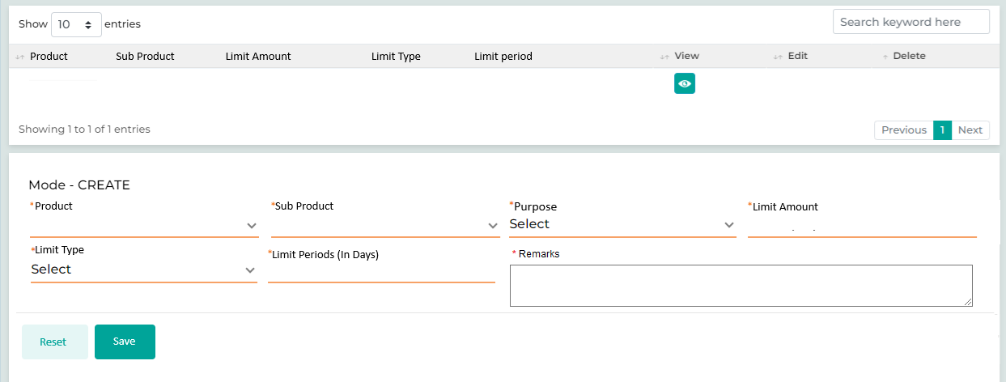

Field Name | Field Type | Data Type / Length | Mandatory (Yes / No) | Look Up Key/Master Name | Possible Values | Field Description
 |  |  |  |  |  | Remarks / Validation
- Product  - Sub Product  - Limit Amount  - Interest Rate  - Limit Type  - Limit Period | List View | NA | NA | NA | NA | List view will be displayed the overview of the credit limit defined.
Product | LOV Dropdown | Varchar | Yes | NA | - Vehicle Loan  - Personal Loan  - Cash Loan | The user will select the Loan Product which is to be added to the credit limit being defined to the customer
Sub Product | Lov Dropdown | Varchar | Yes | NA | - Vehicle Loan New  - Vehicle Loan Used (Agency)  - Vehicle Loan Used (Other)  - Housing Loan  - Consumer Loan  - Realestate  Sares | The user will select the sub product linked to the product selected.
Purpose | LOV Dropdown | VARCHAR | Yes | NA | - Financial  - Trade and Trading in Business  - Other Business  - Services  - Real Estate  - Construction  - Industries  - Personal  - Shares & Bonds. | The user will select the Purpose from the list of values.
Limit Amount | Text Box | INT | Yes | NA |  | The Desired amount for the defined limit will be entered.
Limit Type | Lov Dropdown | Varchar | Yes | NA | 1. Revolving Limit  2. Non-Revolving Limit | The user will select if the credit limit type whether revolving or a non-revolving.
Limit Period  (In Days) | Text Box | Varchar | Yes | NA | NA | The user will enter the number of days the limit to be valid after the approval.
Remarks | Text Box | Varchar | No | NA |  | The user will enter the remarks if any.
Action Buttons
Reset | Button | Button | NA | NA | NA | The User will click on this button to clear the entered data.
Save | Button | Button | NA | NA | NA | The User will click on this button to save the entered data.

13.2.3.8 Charges
Charges screen will display all the charges configured to the product along with the downpayment which is to be paid at KFIC. The user will be allowed to decrease the charges by waiving the amount. Whereas the user cannot decrease the downpayment amount to be collected. Apart from the charges being charges being configured; the user also has the provision to capture any Ad-Hoc charges during the loan processing.
All charges configured at different stages will be available in the user’s list, with the charge amounts displayed as the total to be collected. Users will have the option to waive a specific charge by entering the waived amount on the screen. If a waived amount is entered, the system will prompt for CEO approval. To initiate the approval process, the user should click the “Send for Approval” button, which will submit the request to the CEO and will be displayed under the Charges Waiver Approval list. Once the CEO approves the waiver, the “Approval Status” will be marked as accepted. Only after this status is accepted will the system allow the user to collect the associated charges through the specified payment method. The users can progress the application up to the Offer stage without collecting fees; however, at the Offer stage, it is mandatory to collect all required charges before proceeding.
Scenario 1:
Consider a case where the Ci-Net fee is set at KD 10, which will be displayed on the screen. The user enters a waived amount of KD 2, resulting in a total payable amount of KD 8. Since a waiver has been applied, the system prompts the user to click the “Send for Approval” button to initiate the approval process. Once the CEO’s approval is received and will be displayed under the Charges Waiver Approval list and the CEO will Approve which will mark the status as Approved on the Charges screen, the user will then check the box for the respective Ci-Net charge. Next, they will select the payment method from the available options and click the “Send” button to start the charges collection process.
Scenario 2:
Consider a case where the Ci-Net fee is configured at KD 10, which is displayed on the screen. The user enters a waived amount of KD 0, resulting in a total payable amount of KD 10. Since no waiver has been provided, there is no need to send the request for approval. The user will then check the box for the respective Ci-Net charge, select the payment method from the available options, and click the “Send” button to initiate the charges collection process.

- Payment Mode
The fees & downpayment can be collected via different mode such as KNet- Kiosk, KNet – Web, or Cash.
KNet-Kiosk: In the case of payment mode as KNet – Kiosk, the request will be sent to the LMS, where the charges will appear in the transaction queue for the cashier. The customer will make the payment at the KNet-Kiosk and receive a generated receipt, which must then be submitted to the cashier. Upon receiving the receipt, the cashier will confirm the payment and update in the LMS, the status will then be updated to "Paid" back on this screen in LOS via the interface.
Cash: In the case of payment mode as Cash, the request will be sent to the LMS, where these charges will appear in the transaction queue for the cashier. Once collected, the status will be updated to "Paid" on this screen via the LMS interface.

KNet-Web: For payment mode as KNet – Web, a link will be sent to the customer's registered number. Once the customer completes the payment, the status will be updated to "Paid" on this screen via the KNet interface.

- Fees Collection Status
The system will display the status of fees and down payment collection based on the response received from the LMS/KNET once the fees are collected.

Not Initiated: This status indicates that the user has not yet initiated the fees/down payment collection request, meaning they have not clicked the “Send” button.

Pending: This status is shown when a fees/down payment collection request has been made, but action is still pending either from the Cashier or the KNet interface.

Paid: This status indicates that the fees/down payment has been successfully collected via the Cashier (for Cash and KNet Kiosk) or through the KNet interface (for KNet-Web).

Declined: This status appears if the fees/down payment collection request has been declined for any reason.
Configuration: During the charge’s configuration, there will be an option whether to waiver functionality is to be made applicable for the following kind of charges or not. Charges will be configured as per the following document. (Click Here)
Navigation:
Detail Data Entry à Collateral & Loan Details à Charges
The following screen will be displayed once the user clicks on Charges:

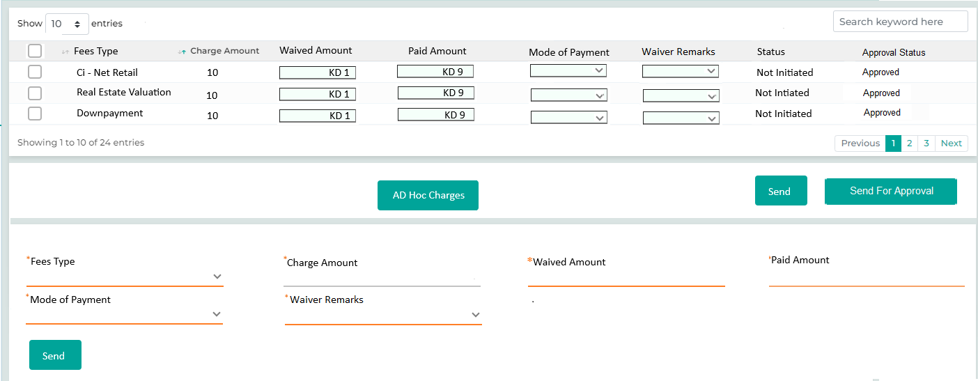

Below are the details specific to the information being displayed above.

Field Name | Field Type | Data Type / Length | Mandatory (Yes / No) | LookUp Key/Master Name | Possible Values | Field Description
 |  |  |  |  |  | Remarks / Validation
Fees Type | Read Only | VARCHAR | Yes | CHARGES MASTER | - Ci-Net (Retail)  - Ci-Net (Commercial)  - BSI  - Real Estate Valuation  - MOJ – Contract Attestation  - Downpayment  - Promotional/Ad-Hoc Charges | The user will see the list of fees along the downpayment configured to be collected at the stage level.  Promotional/Ad-Hoc Charges added by the user won’t affect the finance nor collected upfront, it will only be used for accounting as an expense to the company.
Charge Amount | Read Only | VARCHAR | Yes | NA | KD 10 | The charges amount will be displayed as configured in the cahrges master.  In case of Downpayment, the value will be auto populated from the “Total Downpayment” field of Loan Details screen
Waived Amount | Text Box | VARCHAR | Yes | NA | KD 1 | The user will enter the amount which is to be waived from the caharges being configured.  Not applicable if fees type selected as “Downpayment”
Paid Amount | Text Box | VARCHAR | Yes | NA | KD 9 | Will be computed as the difference between the Charge Amount & the Waived Amount
Mode Of Payment | LOV Dropdown | VARCHAR | Yes | NA | KNet – Kiosk  KNet – Web  Cash | The user will select the mode of payment through which the customer is paying the fees.
Waiver Remarks | LOV Dropdown | VARCHAR | Yes | NA |  | The field will be enabled only if the waiver amount is enterd by the user, the user will select the Waiver remarks from the list of values.
Status | Read Only | VARCHAR | Yes | NA | Not Initiated  Pending  Paid  Declined | The system will display the status of fees and down payment collection based on the response received from the LMS/KNET once the fees are collected.  Not Initiated: This status indicates that the user has not yet initiated the fees/down payment collection request, meaning they have not clicked the “Send” button.  Pending: This status is shown when a fees/down payment collection request has been made, but action is still pending either from the Cashier or the KNet interface.  Paid: This status indicates that the fees/down payment has been successfully collected via the Cashier (for Cash and KNet Kiosk) or through the KNet interface (for KNet-Web).  Declined: This status appears if the fees/down payment collection request has been declined for any reason.
Waiver Approval Status | Read Only | VARCHAR | Yes | NA | Approved  Rejected  Pending | If a waived amount is entered and the waiver approval proces is initiated.  Pending: The request is initiated and pending for approval.  Approved: The CEO approves the waiver request.  Rejected: The CEO rejected the waiver request.
Ad-Hoc Charges
Ad-Hoc Charges | Button | VARCHAR | Yes |  |  | The user will clcik on the “Ad-Hoc” charges button” in order to capture any charges apart from the configured chargse.
Fees Type | Master Dropdown | VARCHAR | Yes | CHARGES MASTER |  | The user will select the charges from the list of values, or click “Others” an type the charge name in the dependent field.
Charge Amount | Read Only | VARCHAR | Yes | NA |  | User will enter the cahrge amount for the respective charge type.
Waived Amount | Text Box | VARCHAR | Yes | NA |  | The user will enter the waived amount in case of waiver to be provided.
Paid Amount | Text Box | VARCHAR | Yes | NA |  | Will be computed as the difference between the Charge Amount & the Waived Amount
Mode Of Payment | LOV Dropdown | VARCHAR | Yes | NA |  | The user will select the mode of payment.
Waiver Remarks | LOV Dropdown | VARCHAR | Yes | NA |  | The field will be enabled only if the waiver amount is enterd by the user, the user will select the Waiver remarks from the list of values.
Action Button
Send | Button | Button | NA | NA |  | The user will click on the checkbox across each of the fees type and then click on Send button.  The "Send" button will be disabled until all required details are entered in the respective fields.  In the case of payment mode as Cash & KNet – Kiosk, the request will be sent to the LMS, where these charges will appear in the transaction queue for the cashier. Once collected, the status will be updated to "Paid" on this screen via the LMS interface.  For payment mode as KNet – Web, a link will be sent to the customer's registered number. Once the customer completes the payment, the status will be updated to "Paid" on this screen via the KNet interface.
Send For Approval | Button | Button | NA | NA |  | The user will click on “Send for Approval” to initiate the waiver approval request. For all charges where the waived amount is greater than zero, all waived charges will be compiled and sent to the CEO via the Waiver Approval service request screen for approval.

13.2.4 Income & Expense
This section will allow the user to capture the income and expenses for the individual applicant and the guarantor, along with their overall existing exposure with KFIC or any other financial institution. By fetching data via CiNet and consolidating this information, it will also assist in computing the customer's Repayment Ratio.

13.2.4.1 Income
This screen allows the user to input the income details of the applicant. Users can specify income from various sources such as rental income, self-employed, alumni income, etc. Additionally, users can configure the percentage allocation across each income category and based on the defined percentage allocation, the system consider the net value for each income category.
Income earned from employment will also be included here. By considering all different types of income, the system calculates the Total Gross Income considered.
If the customer is an existing customer, the income related data captured during the previous loan application should also be highlight in the read only mode.

Navigation:
Detail Data Entry à Income & Expense à Income
The following screen will be displayed once the User clicks on Income:

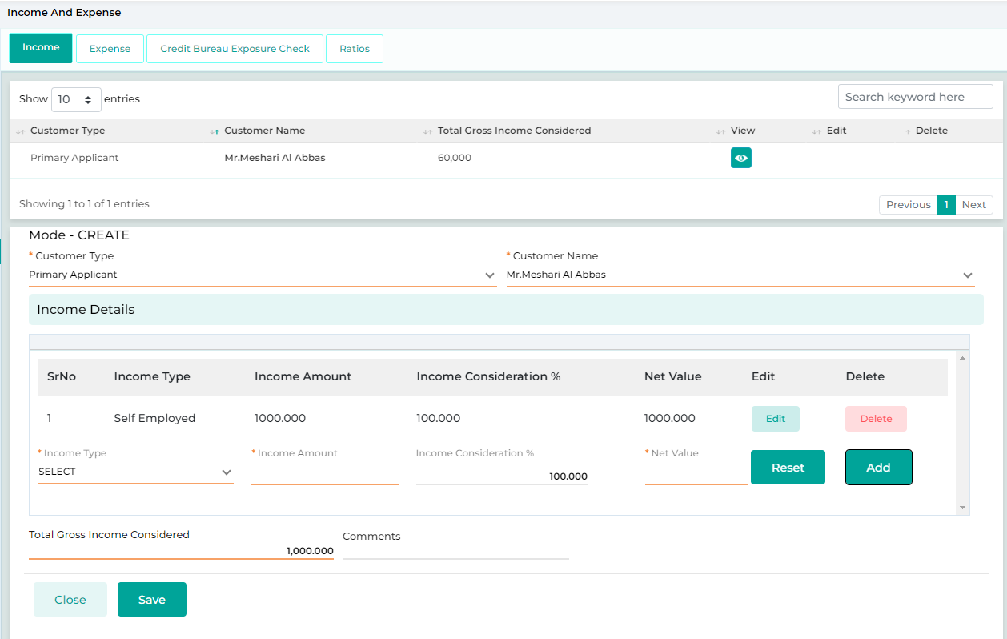

Below are the details specific to the information being displayed above.
Field Name | Field Type | Data Type / Length | Mandatory (Yes / No) | LookUp Key/Master Name | Possible Values | Field Description
 |  |  |  |  |  | Remarks / Validation
- Customer Type  - Customer Name  - Total Gross Income Considered | List View | Parent Grid | NA | NA | NA | List view displaying the customer type and their income captured along with the access right to edit, view, delete.
Customer Type | LOV Dropdown | VARCHAR | Yes | 4034 | - Main Applicant  - Joint Applicant  - Guarantor | The User will select the customer type from the Dropdown values. For which the income details is to be captured.
Customer Name | LOV Dropdown | VARCHAR | Yes | NA | NA | Basis of the customer type selected, the customer name will be displayed in this field.
- Income Type  - Income Amount  - Income Consideration  - Net Value | List View | Child Grid | NA | NA | NA | List view displaying the the various income type camtured along with the access right to edit, view, delete.
Income Type | Dropdown | Yes | NA | NA | -Self Employed  -Government Labor Support  - Alumni income  - Rental Income | The user will selecte the income type from the list of values
Income Amount | Text Box | Yes | NA | NA | NA | The user will enter the Income Amount across each income type selected.
Income Consideration% | Text Box | Yes | NA | NA | NA | Percent consideration for each of the income type can be configured via the master.
 |  |  |  |  |  | Bydefault it will be considerd as 100%, where as the user has the rights to change it as required.
Net Value | Read Only | Yes | NA | NA | NA | Net value is computed as the % consideration of the income amount entered
Total Gross Income Considered | Read Only | Yes | Yes | NA | NA | Will be computed as the summation of the Net Value for all the income type selected and added along with the income from employment which was captured in the employment details screen.
Comments | Textbox |  | Yes | NA | NA | The user will capture the comments and remarks
Action Buttons
Add | Button | Button | NA | NA | NA | Add button for the child grid, in order to capture the different income type.
Reset | Button | Button | NA | NA | NA | The User will click on this button to clear the entered data.
Save | Button | Button | NA | NA | NA | The User will click on this button to save the entered data.

13.2.4.2 Expense

The Expense Details screen will record the monthly expenses of the customer, including deductions related to their employment as documented in the employment details screen. If the customer has multiple employments recorded, there will be multiple entries for employment deductions. The user has the option to specify the percentage consideration for total expenses prior to the deductions at employment, based on which the Total Deduction Considered will be calculated.
If the customer is an existing customer, the expense related data captured during the previous loan application should also be showcase in the read only mode.

Navigation:
Detail Data Entry à Income & Expense à Expense
The following screen will be displayed once the User clicks on Expenditure Details:
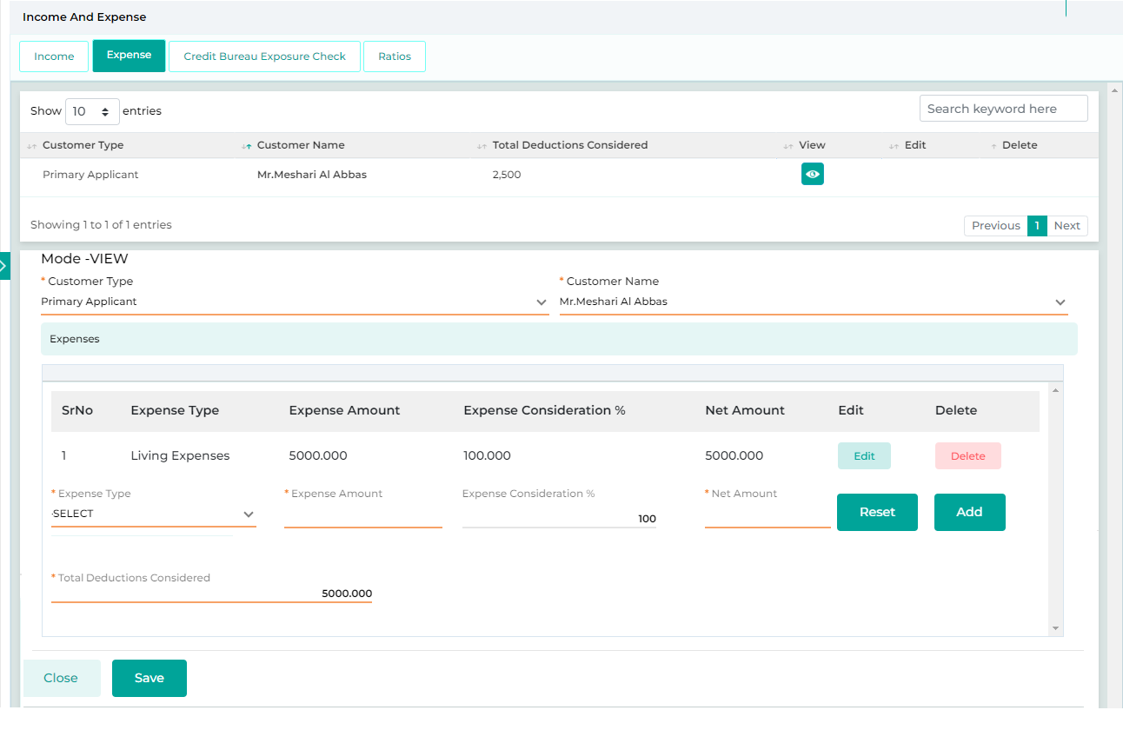
Field Name | Field Type | Data Type / Length | Mandatory (Yes / No) | LookUp Key/Master Name | Possible Values | Field Description
 |  |  |  |  |  | Remarks / Validation
- Customer Type  - Customer Name  - Total Deductions Considered | List View | Parent Grid | NA | NA | NA | List view displaying the customer type and their expenses captured along with the access right to edit, view, delete.
Customer Type | LOV Dropdown | VARCHAR | Yes | 4034 | 1.Main Applicant  2.Guarantor  3.Joint Applicant | The User will select the customer type from the Dropdown values.
Customer Name | LOV Dropdown | VARCHAR | Yes |  | NA | The User will select the customer’s name from the Dropdown values.
- Expense Type  - Expense Amount  - Expense Consideration  - Net Value | List View | Child Grid | NA | NA | NA | List view displaying the the various expense type captured along with the access right to edit, view,.
Expense Type | LOV  Dropdown | LOV | Yes | NA | - Living Expenses  - Rental Expenses  - Telecommunication Expenses  - Light & Water Expenses | The user will select the type of expense
Expense Amount | Read Only |  | Yes | NA | NA | Total expenses amount will be computed by summing up the value of various expense type selected.
Expense Consideration% | Textbox |  | Yes | NA | NA | Percent consideration for each of the expense type can be configured via the master.  By default it will be 100%, will allow the user to change as required.
Net Value | Read Only |  | Yes | NA | NA | Net Value will be computed as per the percentage defined.
Total Deductions Considered | Textbox |  | Yes | NA | NA | Will be computed as the summation of the Net Value for all the expense type selected and added along with the deductions from employment which was captured in the employment details screen.
Action Buttons
Add | Button | Button | NA | NA | NA | Add button for the child grid, in order to capture the different expense type.
Reset | Button | Button | NA | NA | NA | The User will click on this button to clear the entered data.
Save | Button | Button | NA | NA | NA | The User will click on this button to save the entered data.

13.2.4.3 Credit Bureau Exposure

The Credit Bureau Exposure screen allows the user to retrieve the Ci-Net Credit Bureau report within the system through interface for all the customer type i.e. Main Applicant, Guarantor. The external exposure retrieved from Ci-Net via the interface will be shown on this screen in read-only mode (cannot be deleted or modified by the user), the external exposure of the customer with the “Account Status” as Open will automatically be included in the customer’s current liabilities for repayment ratio computation. Along with the data fetch for it also allows the user to download the CiNet report in the pdf format by clicking on the “View Ci-Net” button.
When the “Fetch Ci-Net” button is clicked, it will be disabled until a response is received. It will only be enabled again after the response from Ci-Net arrives. If a user attempts to request Ci-Net again before receiving the initial response, the system will display a confirmation message: "Do you want to trigger Ci-Net again?" The default selection will be ‘No,’ but the user can choose either ‘Yes’ or ‘No.’ If the user selects ‘No,’ the alert will close. If ‘Yes’ is clicked, a new request will be initiated, and the response received will overwrite the auto-populated data in the Credit Bureau Exposure screen.
If, for any reason, the user is unable to generate the Ci-Net report from the system, they can create the report externally and manually enter the details on the designated screen. A Stage Completion Rule will be triggered if the Ci-Net data is entered manually, and the PDF report is not uploaded in the system from the document upload screen. In this scenario, the user will not be permitted to submit the application to the next stage.
If the user has already fetched the Ci-Net report for a customer and the report is still valid, the system will display the following message: “The Ci-Net report for the customer (CIF ID: 987654) is up to date; kindly consider using this report.” The validity period for the Ci-Net report is 7 days, and this duration should be configurable. Additionally, if the duration between the date of fetching the information from the Ci-Net and the evaluation exceeds 7 days, it is mandatory for the user to fetch a fresh report to proceed with the decision-making process.
The user can directly fetch the Ci-Net report without completing the entire data entry for the application. If the user is not satisfy with the credit history of the customer after the report assessment, the user will not proceed with the detailed data entry and may request exceptional approval instead.
If the Ci-Net report is retrieved through the interface, the user must generate the Ci-Net consent from the document checklist screen, obtain the customer's signature, and upload it back (within 24 hours) using the document upload screen. This consent will be required for the Ci-Net reporting process.
Navigation:
Detail Data Entry à Income & Expense à Existing Exposure Check
- Credit Bureau Exposure - Consumer
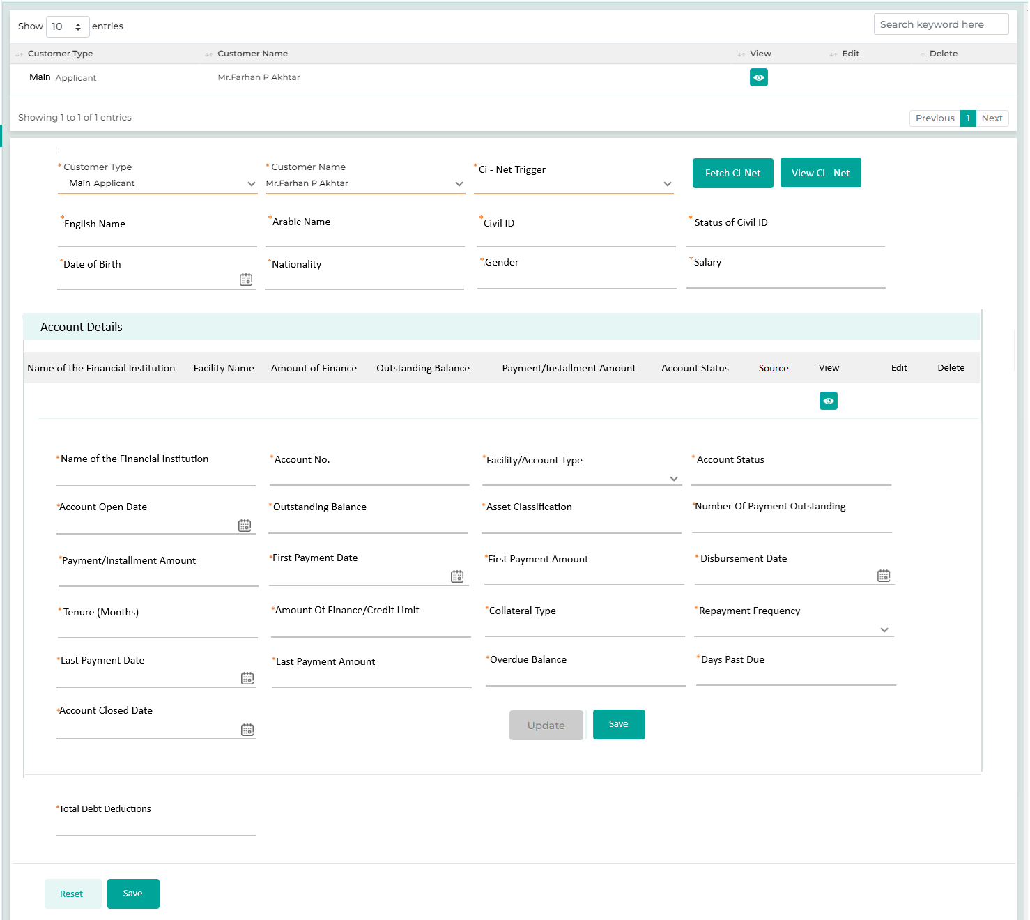

- Credit Bureau Exposure – Commercial
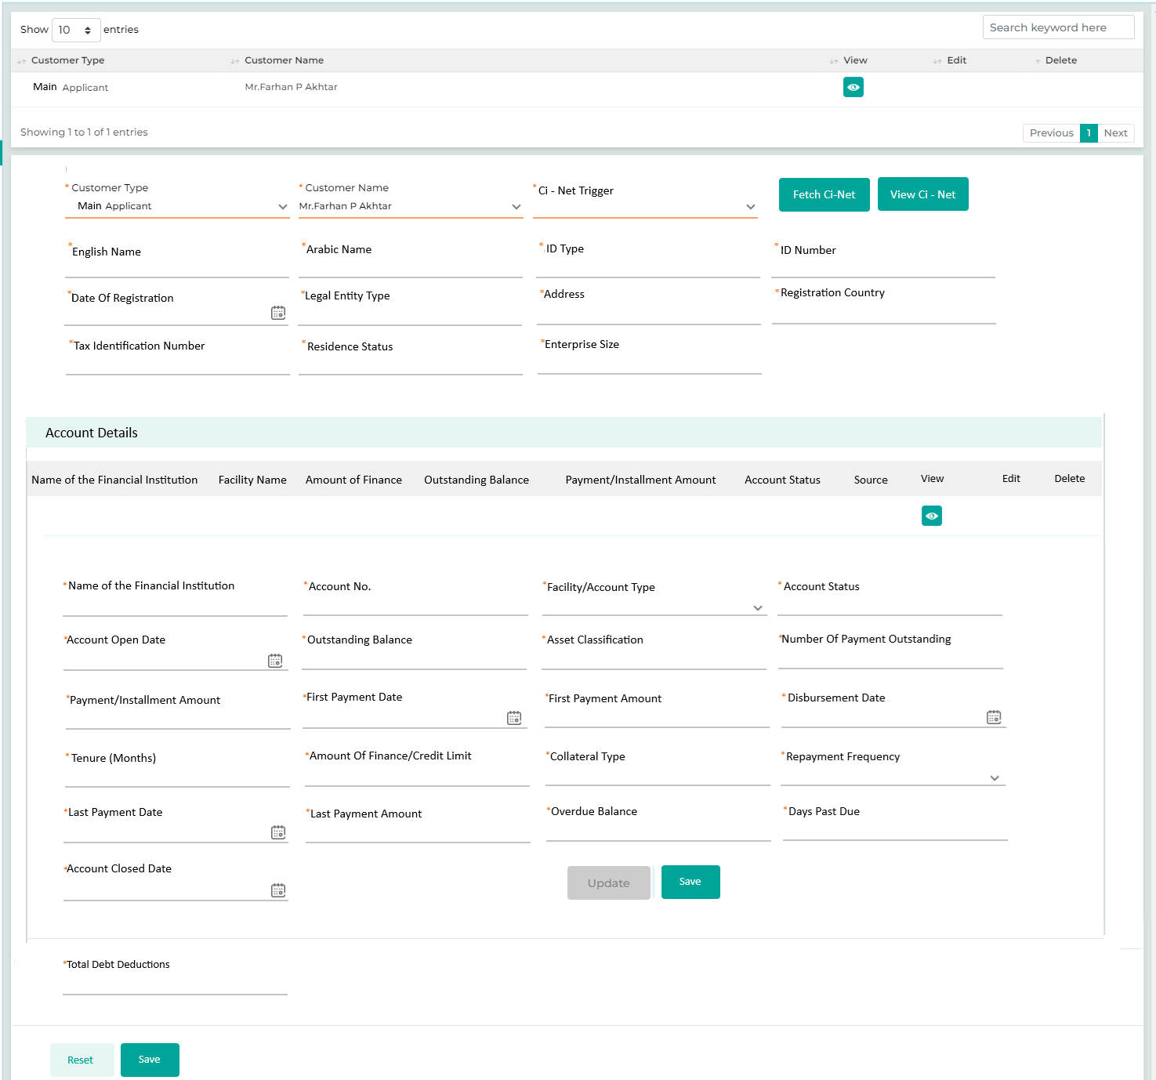
If the user has already fetched the Ci-Net report for a customer and the report is still valid, the system will display the following message: “The Ci-Net report for the customer (CIF ID: 987654) is up to date; kindly consider using this report.”
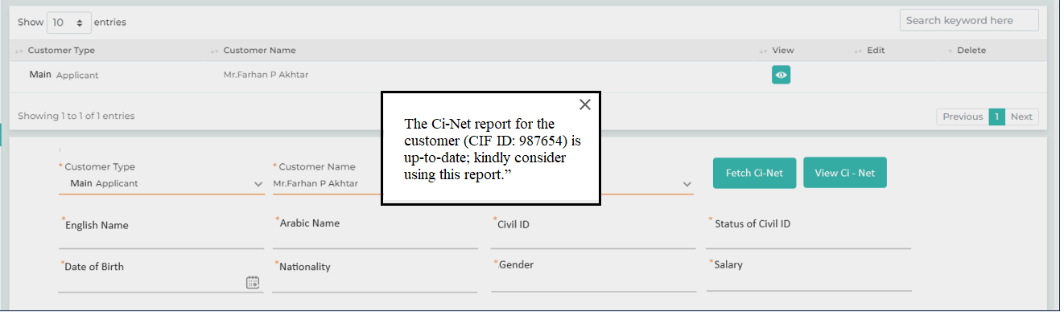

Below are the details specific to the information being displayed above.
Field Name | Field Type | Data Type / Length | Mandatory (Yes / No) | LookUp Key/Master Name | Possible Values | Field Description
 |  |  |  |  |  | Remarks / Validation
Customer Type | List View | VARCHAR | Yes | 4034 | - Main Applicant  - Joint Applicant  - Guarantor | Displays the customer type
Customer Name | List View | VARCHAR | Yes |  | NA | Displays the customer Name
Cinet Trigger
Customer Type | Master Dropdown | VARCHAR | Yes | 4034 | - Main Applicant  - Joint Applicant  - Guarantor | The User will select the customer type from the Dropdown values for which the Ci-Net is to be triggered or the data is to be captured.
Customer Name | Master Dropdown | VARCHAR | Yes |  | NA | The system will display the customer name basis of the customer type selected.
Ci-Net Trigger? | LOV Drop Down | VARCHAR | Yes |  | Yes  No | The user should select "Yes" to proceed with the Ci-Net fetch. If the Ci-Net interface is unavailable, the user can click "No" and manually enter the data by referencing the Ci-Net report generated outside the system.
Fetch Ci-Net | Button | NA | Yes | NA | NA | The user will click on Fetch Ci-Net button in order to fetch the data from the Ci-Net interface.  Only be accessible if Ci-Net Trigger is selected as Yes.
View Ci-Net | Button | NA | Yes | NA | NA | The user will click on View Ci-Net button in order to view & download the Ci-Net report pdf.  Only be enabled if Ci-Net interface has been triggered.
Cutomer Details – Consumer (Following fields applicable only for Consumer Customer)
English Name | Text Box | VARCHAR | NA | NA | NA | When the Ci-Net interface is triggered, the data will be retrieved and displayed in read-only mode. If the fetched data from Ci-Net matches the information entered on the basic details screen, the corresponding fields will be highlighted in green and if didn’t matches it will be highlighted in Red.  If "No" is selected for the Ci-Net Trigger, the following fields will not be displayed for data capturing.
Arabic Name | Text Box | VARCHAR | NA | NA | NA | When the Ci-Net interface is triggered, the data will be retrieved and displayed in read-only mode. If the fetched data from Ci-Net matches the information entered on the basic details screen, the corresponding fields will be highlighted in green and if didn’t matches it will be highlighted in Red.  If "No" is selected for the Ci-Net Trigger, the following fields will not be displayed for data capturing.
Civil Id | Text Box | VARCHAR | NA | NA | NA | When the Ci-Net interface is triggered, the data will be retrieved and displayed in read-only mode. If the fetched data from Ci-Net matches the information entered on the basic details screen, the corresponding fields will be highlighted in green and if didn’t matches it will be highlighted in Red.  If "No" is selected for the Ci-Net Trigger, the following fields will not be displayed for data capturing.
Status Of Civil Id | Text Box | VARCHAR | NA | NA | NA | When the Ci-Net interface is triggered, the data will be retrieved and displayed in read-only mode. If the fetched data from Ci-Net matches the information entered on the basic details screen, the corresponding fields will be highlighted in green and if didn’t matches it will be highlighted in Red.  If "No" is selected for the Ci-Net Trigger, the following fields will not be displayed for data capturing.
Date Of Birth | Calendar | VARCHAR | NA | NA | NA | When the Ci-Net interface is triggered, the data will be retrieved and displayed in read-only mode. If the fetched data from Ci-Net matches the information entered on the basic details screen, the corresponding fields will be highlighted in green and if didn’t matches it will be highlighted in Red.  If "No" is selected for the Ci-Net Trigger, the following fields will not be displayed for data capturing.
Nationality | Text Box | VARCHAR | NA | NA | NA | When the Ci-Net interface is triggered, the data will be retrieved and displayed in read-only mode. If the fetched data from Ci-Net matches the information entered on the basic details screen, the corresponding fields will be highlighted in green and if didn’t matches it will be highlighted in Red.  If "No" is selected for the Ci-Net Trigger, the following fields will not be displayed for data capturing.
Gender | Text Box | VARCHAR | NA | NA | NA | When the Ci-Net interface is triggered, the data will be retrieved and displayed in read-only mode. If the fetched data from Ci-Net matches the information entered on the basic details screen, the corresponding fields will be highlighted in green and if didn’t matches it will be highlighted in Red.  If "No" is selected for the Ci-Net Trigger, the following fields will not be displayed for data capturing.
Salary | Text Box | VARCHAR | NA | NA | NA | When the Ci-Net interface is triggered, the data will be retrieved and displayed in read-only mode. If the fetched data from Ci-Net matches the information entered on the basic details screen, the corresponding fields will be highlighted in green and if didn’t matches it will be highlighted in Red.  If "No" is selected for the Ci-Net Trigger, the following fields will not be displayed for data capturing.
Cutomer Details (Commercial)
English Name | Text Box | VARCHAR | NA | NA | NA | When the Ci-Net interface is triggered, the data will be retrieved and displayed in read-only mode. If the fetched data from Ci-Net matches the information entered on the basic details screen, the corresponding fields will be highlighted in green and if didn’t matches it will be highlighted in Red.  If "No" is selected for the Ci-Net Trigger, the following fields will not be displayed for data capturing.
Arabic Name | Text Box | VARCHAR | NA | NA | NA | When the Ci-Net interface is triggered, the data will be retrieved and displayed in read-only mode. If the fetched data from Ci-Net matches the information entered on the basic details screen, the corresponding fields will be highlighted in green and if didn’t matches it will be highlighted in Red.  If "No" is selected for the Ci-Net Trigger, the following fields will not be displayed for data capturing.
ID Type | Text Box | VARCHAR | NA | NA | NA | When the Ci-Net interface is triggered, the data will be retrieved and displayed in read-only mode. If the fetched data from Ci-Net matches the information entered on the basic details screen, the corresponding fields will be highlighted in green and if didn’t matches it will be highlighted in Red.  If "No" is selected for the Ci-Net Trigger, the following fields will not be displayed for data capturing.
ID Number | Text Box | VARCHAR | NA | NA | NA | When the Ci-Net interface is triggered, the data will be retrieved and displayed in read-only mode. If the fetched data from Ci-Net matches the information entered on the basic details screen, the corresponding fields will be highlighted in green and if didn’t matches it will be highlighted in Red.  If "No" is selected for the Ci-Net Trigger, the following fields will not be displayed for data capturing.
Date Of Registration | Calendar | VARCHAR | NA | NA | NA | When the Ci-Net interface is triggered, the data will be retrieved and displayed in read-only mode. If the fetched data from Ci-Net matches the information entered on the basic details screen, the corresponding fields will be highlighted in green and if didn’t matches it will be highlighted in Red.  If "No" is selected for the Ci-Net Trigger, the following fields will not be displayed for data capturing.
Legal Entity Type | Text Box | VARCHAR | NA | NA | NA | When the Ci-Net interface is triggered, the data will be retrieved and displayed in read-only mode. If the fetched data from Ci-Net matches the information entered on the basic details screen, the corresponding fields will be highlighted in green and if didn’t matches it will be highlighted in Red.  If "No" is selected for the Ci-Net Trigger, the following fields will not be displayed for data capturing.
Address | Text Box | VARCHAR | NA | NA | NA | When the Ci-Net interface is triggered, the data will be retrieved and displayed in read-only mode. If the fetched data from Ci-Net matches the information entered on the basic details screen, the corresponding fields will be highlighted in green and if didn’t matches it will be highlighted in Red.  If "No" is selected for the Ci-Net Trigger, the following fields will not be displayed for data capturing.
Registration Country | Text Box | VARCHAR | NA | NA | NA | When the Ci-Net interface is triggered, the data will be retrieved and displayed in read-only mode. If the fetched data from Ci-Net matches the information entered on the basic details screen, the corresponding fields will be highlighted in green and if didn’t matches it will be highlighted in Red.  If "No" is selected for the Ci-Net Trigger, the following fields will not be displayed for data capturing.
Tax Identification Number | Text Box | VARCHAR | NA | NA | NA | When the Ci-Net interface is triggered, the data will be retrieved and displayed in read-only mode. If the fetched data from Ci-Net matches the information entered on the basic details screen, the corresponding fields will be highlighted in green and if didn’t matches it will be highlighted in Red.  If "No" is selected for the Ci-Net Trigger, the following fields will not be displayed for data capturing.
Residence Status | Text Box | VARCHAR | NA | NA | NA | When the Ci-Net interface is triggered, the data will be retrieved and displayed in read-only mode. If the fetched data from Ci-Net matches the information entered on the basic details screen, the corresponding fields will be highlighted in green and if didn’t matches it will be highlighted in Red.  If "No" is selected for the Ci-Net Trigger, the following fields will not be displayed for data capturing.
Enterprise Size | Text Box | VARCHAR | NA | NA | NA | When the Ci-Net interface is triggered, the data will be retrieved and displayed in read-only mode. If the fetched data from Ci-Net matches the information entered on the basic details screen, the corresponding fields will be highlighted in green and if didn’t matches it will be highlighted in Red.  If "No" is selected for the Ci-Net Trigger, the following fields will not be displayed for data capturing.
Account Details (Open, Closed Accounts & Inquiry)
Name of the Financial Institution | List View | VARCHAR | Yes | NA | KFIC  Others | Displays the name of the institution from which the financing has been obtained
Facility Name | List View | VARCHAR | Yes |  |  | Displays the name of the facility
Amount of Finance/Credit Limit | List View | VARCHAR | Yes | NA | NA | Displays the amount of finance or the credit limit
Outstanding Balance | List View | VARCHAR | Yes | NA | NA | Displays the outstanding balance
Payment/nstallment Amount | List View | VARCHAR | Yes | NA | NA | Displays the insallment amount
Account Status | List View | VARCHAR | Yes | NA | Open  Closed  Inquiry | Displays the insallment amount
Source | List View | VARCHAR | Yes |  | - Ci-Net  - Manual | If the data is fetched via Ci-Net interface, then the source will be Benefit.  If captured manually by the user, then the source will be Manual
(Following data to be displayed if clicked on View for each entry fetched from Ci-Net)
Name of the Financial Institution | Text Box | VARCHAR | NA | NA | NA | When the Ci-Net interface is triggered, the data will be retrieved and displayed in read-only mode.  If "No" is selected for the Ci-Net Trigger, the data will b captured by the user refering to the Ci-Net report generated out of the system.
Account No. | Text Box | VARCHAR | NA | NA | NA | When the Ci-Net interface is triggered, the data will be retrieved and displayed in read-only mode.  If "No" is selected for the Ci-Net Trigger, the data will b captured by the user refering to the Ci-Net report generated out of the system.
Facility/Account Type | LOV Dropdown | VARCHAR | NA | NA | - Secured Loan  - Consumer Finance  - Housing Finance  - Staff Loan - Consumer  - Staff Loan - Installment  - Government Fund Loan  - Credit Card  - Charge Card  - Overdraft  - Lease – Lease to own consumer  - Lease – Lease to own instalments  - Rent – Operational Lease  - Current Account  - Telecommunications Account  - Standing Instruction  - Family Fund Loan  - Letter of Guarantee - Consumer  - Letter of Guarantee - Housing | When the Ci-Net interface is triggered, the data will be retrieved and displayed in read-only mode.  If "No" is selected for the Ci-Net Trigger, the data will b captured by the user refering to the Ci-Net report generated out of the system.
Account Status | Text Box | VARCHAR | NA | NA | Open  Closed  Inquiry | When the Ci-Net interface is triggered, the data will be retrieved and displayed in read-only mode.  If "No" is selected for the Ci-Net Trigger, the data will b captured by the user refering to the Ci-Net report generated out of the system.
Account Open Date | Calendar | VARCHAR | NA | NA | NA | When the Ci-Net interface is triggered, the data will be retrieved and displayed in read-only mode.  If "No" is selected for the Ci-Net Trigger, the data will b captured by the user refering to the Ci-Net report generated out of the system.
Outstanding Balance | Text Box | VARCHAR | NA | NA | NA | When the Ci-Net interface is triggered, the data will be retrieved and displayed in read-only mode.  If "No" is selected for the Ci-Net Trigger, the data will b captured by the user refering to the Ci-Net report generated out of the system.
Asset Classification | Text Box | VARCHAR | NA | NA | NA | When the Ci-Net interface is triggered, the data will be retrieved and displayed in read-only mode.  If "No" is selected for the Ci-Net Trigger, the data will b captured by the user refering to the Ci-Net report generated out of the system.
Number Of Payment Outstanding | Text Box | VARCHAR | NA | NA | NA | When the Ci-Net interface is triggered, the data will be retrieved and displayed in read-only mode.  If "No" is selected for the Ci-Net Trigger, the data will b captured by the user refering to the Ci-Net report generated out of the system.
Payment/Installment Amount | Text Box | VARCHAR | NA | NA | NA | When the Ci-Net interface is triggered, the data will be retrieved and displayed in read-only mode.  If "No" is selected for the Ci-Net Trigger, the data will b captured by the user refering to the Ci-Net report generated out of the system.
First Payment Date | Calendar | VARCHAR | NA | NA | NA | When the Ci-Net interface is triggered, the data will be retrieved and displayed in read-only mode.  If "No" is selected for the Ci-Net Trigger, the data will b captured by the user refering to the Ci-Net report generated out of the system.
First Payment Amount | Text Box | VARCHAR | NA | NA | NA | When the Ci-Net interface is triggered, the data will be retrieved and displayed in read-only mode.  If "No" is selected for the Ci-Net Trigger, the data will b captured by the user refering to the Ci-Net report generated out of the system.
Disbursement Date | Calendar | VARCHAR | NA | NA | NA | When the Ci-Net interface is triggered, the data will be retrieved and displayed in read-only mode.  If "No" is selected for the Ci-Net Trigger, the data will b captured by the user refering to the Ci-Net report generated out of the system.
Tenure (Months) | Text Box | VARCHAR | NA | NA | NA | When the Ci-Net interface is triggered, the data will be retrieved and displayed in read-only mode.  If "No" is selected for the Ci-Net Trigger, the data will b captured by the user refering to the Ci-Net report generated out of the system.
Amount Of Finance/Credit Limit | Text Box | VARCHAR | NA | NA | NA | When the Ci-Net interface is triggered, the data will be retrieved and displayed in read-only mode.  If "No" is selected for the Ci-Net Trigger, the data will b captured by the user refering to the Ci-Net report generated out of the system.
Collateral Type | Text Box | VARCHAR | NA | NA | NA | When the Ci-Net interface is triggered, the data will be retrieved and displayed in read-only mode.  If "No" is selected for the Ci-Net Trigger, the data will b captured by the user refering to the Ci-Net report generated out of the system.
Repaymnt Frequency | LOV Dropdown | VARCHAR | NA | NA | - Weekly  - Monthly  - 2 monthly (bimonthly)  - 3 monthly (quarterly)  - 4 monthly  - 6 monthly  - Annually  - Variable | When the Ci-Net interface is triggered, the data will be retrieved and displayed in read-only mode.  If "No" is selected for the Ci-Net Trigger, the data will b captured by the user refering to the Ci-Net report generated out of the system.
Last Payment Date | Calendar | VARCHAR | NA | NA | NA | When the Ci-Net interface is triggered, the data will be retrieved and displayed in read-only mode.  If "No" is selected for the Ci-Net Trigger, the data will b captured by the user refering to the Ci-Net report generated out of the system.
Last Payment Amount | Text Box | VARCHAR | NA | NA | NA | When the Ci-Net interface is triggered, the data will be retrieved and displayed in read-only mode.  If "No" is selected for the Ci-Net Trigger, the data will b captured by the user refering to the Ci-Net report generated out of the system.
Overdue Balance | Text Box | VARCHAR | NA | NA | NA | When the Ci-Net interface is triggered, the data will be retrieved and displayed in read-only mode.  If "No" is selected for the Ci-Net Trigger, the data will b captured by the user refering to the Ci-Net report generated out of the system.
Days Past Due | Text Box | VARCHAR | NA | NA | NA | When the Ci-Net interface is triggered, the data will be retrieved and displayed in read-only mode.  If "No" is selected for the Ci-Net Trigger, the data will b captured by the user refering to the Ci-Net report generated out of the system.
Account Closed Date | Calendar | VARCHAR | NA | NA | NA | When the Ci-Net interface is triggered, the data will be retrieved and displayed in read-only mode.  If "No" is selected for the Ci-Net Trigger, the data will b captured by the user refering to the Ci-Net report generated out of the system.
Total Debt Deductions | Read Only |  |  | NA | NA | Summation of overall exposure (Monthly Installment) capture via Ci-Net Interface along with the one captured by the user manually with the account Status marked as “Open”
Action Buttons
Reset | Button | Button | NA | NA | NA | The User will click on this button to clear the entered data.

13.2.4.4 Repayment Ratio
Repayment Ratio screen allows the user to know the ability of the individual customer to repay the loan by considering the income, expenses, deductions, and exposures captured in the respective screens. The derived the repayment ratio for main applicant, guarantor/s, and provide the user with combined repayment ratio. If there are multiple joint applicants or guarantors and their financial details have been captured, the repayment ratio for each of them will be displayed here.
Guarantors with a repayment ratio exceeding 65% will not be considered for the application. Similarly, a repayment ratio above 30% will disqualify a retired customer, and a ratio above 40% will disqualify a working customer. In such cases, an alert notification will be raised to inform the user.
Navigation: Detail Data Entry à Income & Expense àRatios
The following screen will be displayed once the User clicks on Ratios:
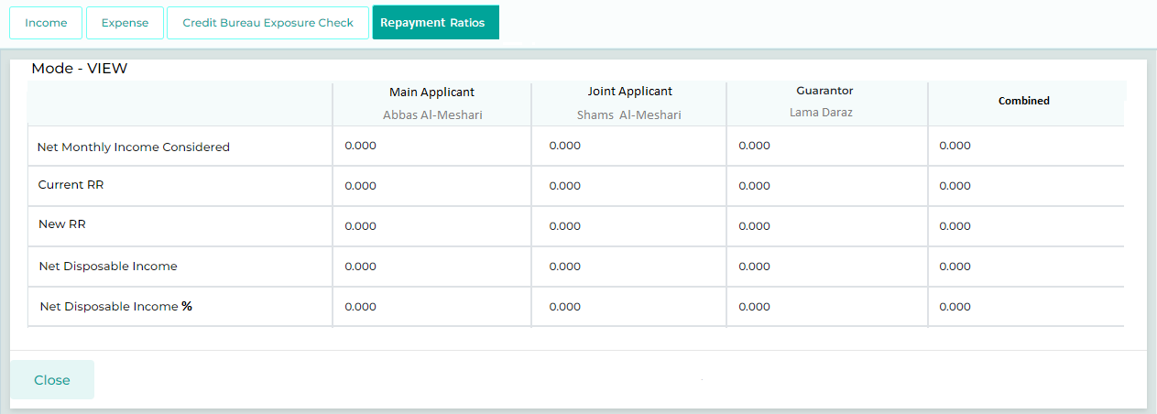

Field Name | Field Type | Data Type / Length | Mandatory (Yes / No) | LookUp Key/Master Name | Possible Values | Field Description
 |  |  |  |  |  | Remarks / Validation
Main Applicant  Joint Applicant  Guarantor  Combined (Main, Joint & Guarantor) | Read Only | Grid List | NA | NA | NA | The user will be able to see the Current & New Repayment Ratio, Net Disposable Income, & Net Disposable Income % for all the customer type as mentioned in the gridd view.
Net Monthly Income Considered | Read Only | FLOAT | NA | NA | NA | Substracting "Total Deductions Considered" from "Total Gross Income Considered"
Current Repayment Ratio | Read Only | FLOAT | NA | NA | NA | "Total Debt Deductions" divided by "Total Gross Income Considered"
New Repayment Ratio | Read Only | FLOAT | NA | NA | NA | (Total Debt Deductions + New Installment with KFIC) divided by "Total Gross Income Considered"
Net Disposable Income | Read Only | FLOAT | NA | NA | NA | Net Monthly Income Considered - (Total Debt Deductions + New Installment with KFIC)
Net Disposable Income% | Read Only | FLOAT | NA | NA | NA | "Net Disposable Income" divided by "Net Monthly Income Considered"
Action Button
Save | Button | Button | NA | NA | NA
Cancel | Button | Button | NA | NA | NA

13.2.5 Document
The document tab will allow the User to upload the documents provided by the applicant for verification purpose. The list of documents being displayed here are driven from the Document Checklist master.

13.2.5.1 Document Checklist
This screen presents all the documents that a user needs to capture at the current stage. All documents listed are configured at the stage and product level for different customer types. Additionally, it allows the user to capture any other documents apart from the defined checklist.
It also allows the user to upload the document either directly from the user’s system or get it uploaded by scanning it from the scanner. The user will simply need to click the upload button corresponding to each document in the document checklist which will give two options to the user such as “Upload” or “Scan. On click of Upload, it will allow the user to upload the document available as a softcopy in the system and on clicking of Scan, in connection with the scanner it will allow the user to scan the document and upload it.
This screen also enables the user to view all uploaded documents in a single PDF.
If the Ci-Net is not triggered, a validation message will notify the user to upload the Ci-Net report generated out of the system.
Additionally, based on the insurance details captured on the insurance details screen, a validation will be implemented to prompt the user to upload the Insurance Policy documents at a later stage.
Refer Required Document Checklist

Navigation:
Detail Data Entry à Document à Document Checklist
The following screen will be displayed once the User clicks on Document Checklist:
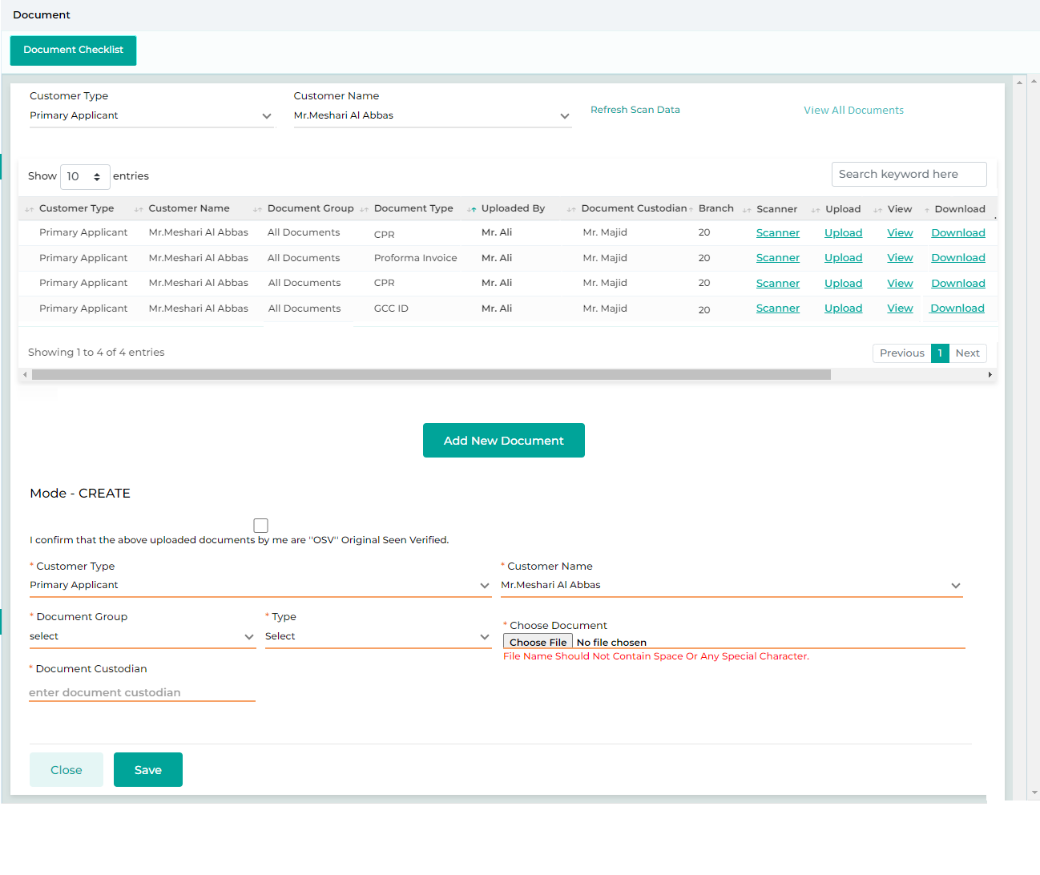
Below are the details specific to the information being displayed above.

Field Name | Field Type | Data Type / Length | Mandatory (Yes / No) | LookUp Key/Master Name | Possible Values | Field Description
 |  |  |  |  |  | Remarks / Validation
List View
Customer Type | List View | Read Only | NA | Document Checklist | Main Applicant | The system will display the customer Type.
Customer Name | List View | Read Only | NA | Document Checklist | Abdullah | The system will display the customer name.
Document Group | List View | Read Only | NA | Document Checklist | Financials | The system will display the document group.
Document Type | List View | Read Only | NA | Document Checklist | Bank Statement | The system will display the document type.
Uploaded By | List View | Read Only | NA | Document Checklist | Nabil | The system will display the uploaded by.
Document Custodian | List View | Read Only | NA | Document Checklist | Nabil | The system will display the document custodian.
Branch | List View | Read Only | NA | NA | Kuwait City | The system will display the branch.
Document Upload
Customer Type | Dropdown |  | Yes | NA | Main Applicant  Guarantor  Joint Applicant  Partner | The user will select the customer type
Customer Name | Dropdown |  | Yes | NA |  | The system will displays the Customer Name basis on the customer type selected
Document Group | Dropdown |  | Yes | NA | - Finacials  - Address  - Employment  - Others | The system will display the group of the document under which the document is mapped.
Type | Dropdown |  | Yes | NA | - Civil Id  - Passport  - Bank Statement  - MOA  - AOA  - MOCI  - Salary Certificate | The system will display the the document name which the user will upload.
Choose Document | Text Box | Button | Yes | NA |  | The User will upload a document.
Document Custodian | Text Box | VARCHAR | Yes | NA |  | The User will select the document custodian in case of physical document is kept with KFIC.
Action Buttons
View All | Button | Button | NA | NA | NA | Allows the user to view all documents uploaded in a single pdf format.
Upload | Button | Button | NA | NA | NA | The User will click on this button to upload any new document.
Download | Button | Button | NA | NA | NA | The User will click on this button to download and view any document.
Delete | Button | Button | NA | NA | NA | The User will click on this button to delete any document.
Reset | Button | Button | NA | NA | NA | The User will click on this button to clear the entered data.
Save | Button | Button | NA | NA | NA | The User will click on this button to save the entered data.

13.2.5.2 Loan Kit
The loan kit screen maintains records of all system-generated templates needed at various stages, including loan contracts, consent forms, and more. The users can generate these templates from this screen to obtain customer acceptance either via physical signature or send them to customers via mail integration.
If the user needs to obtain a physical signature on a document, they can click the "Generate" button to download the template designed and configured for the specific customer and stage. This downloaded template will already have the customer-related details populated throughout the document. Once the customer has signed the document, the user can click the "Upload" button to upload the signed copy back into the system.
If the user wishes to customize the standard document template before getting it signed by the customer, they can click the "Customize" button. This will open the document in an editing mode, allowing the user to make updates. Once the changes are made, the user can click "Save and Generate" to finalize the document.
If the user wants to send the document the customer, they can select the checkbox for each document type that needs to be shared. After making their selections, the user clicks the "Send to Customer" button, which will trigger an email to be sent to the customer's registered email address.
Once the document is uploaded from the Loan Kit screen, it will be accessible in the Document Verification screen for verification users and other authorized personnel to review during the subsequent stages of the loan process. At the approval stage, users are required to go through each document in the document verification screen, referencing the Loan Kit and verify them before proceeding to the next stage after approval.
Navigation:
Offer & Pre-disbursement à Loan Documentation à Loan Kit
Below screen will be displayed once the User clicks on Loan Kit.

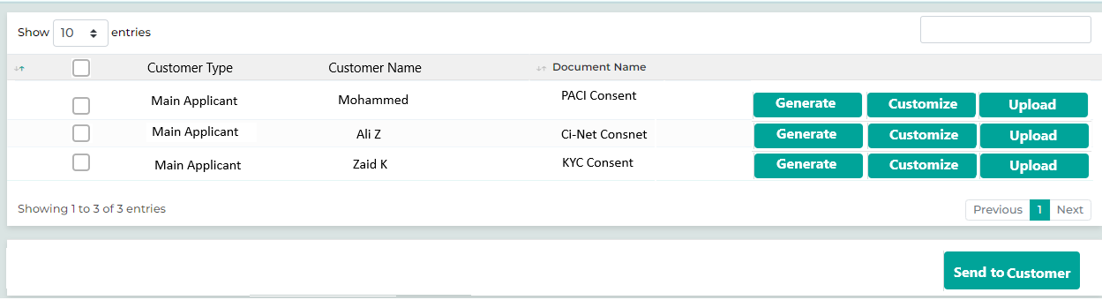

Below are the details specific to the information being displayed above.
Field Name | Field Type | Data Type / Length | Mandatory (Yes/No) | LookUp Key/Master Name | Possible Value | Field Description
 |  |  |  |  |  | Remarks / Validation
List View
Check box | Button | Button | Yes |  | NA | Checkbox across each document type and select all checkbox at the grid to select all the documents all together.
Customer Type | List View |  | Yes |  | NA | The system will display the type of the customer across each Document for which the document is mapped.
Customer Name | List View |  | Yes |  | NA | The system will display the customer’s name across each Document for which the document is mapped.
Document Name | List View |  | Yes |  | - PACI Consent  - Ci-Net Consent  - KYC Consent  - Life Insurance Declaration  - Health Declaration  - Disclosure Declaration  - Loan Contract  - Risk Opinion | The system will display the for the documents configured as per customer and stage.
Action Button
Generate | Button | Button | NA | NA |  | The user clicks the "Generate" button to download the template that has been designed and configured in the system for the specific document type, customer, and stage.
Customize | Button | Button | NA | NA |  | If the user wishes to customize the standard document template, they can click the "Customize" button. This will open the document in an editing mode, allowing the user to make updates. Once the changes are made, the user can click "Save and Generate" to finalize the document.
Upload | Button | Button | NA | NA |  | The user will click the “Upload” button to upload the document back to the system.
Sending To Customer | Button | Button | NA | NA |  | The user selects the document or template to be shared with the customer and clicks the "Send to Customer" button. This action will trigger an email to be sent to the customer's registered email address.

13.2.6 Financials – Corporate Customer

13.2.6.1 PNW Statement

This applies to corporate loan applications where the Personal Net Worth (PNW) of an individual guarantor is required. The user inputs details related to assets, liabilities, expenses, and revenues, which are then considered during the loan application processing.

Navigation:
Detail Data Entry à Financialsà PNW Statement
The following screen will be displayed once the User clicks on PNW Statement:
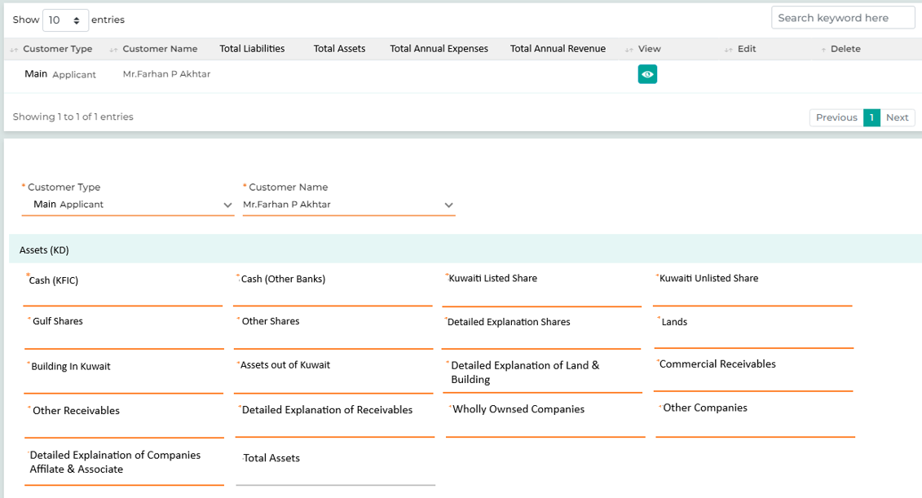
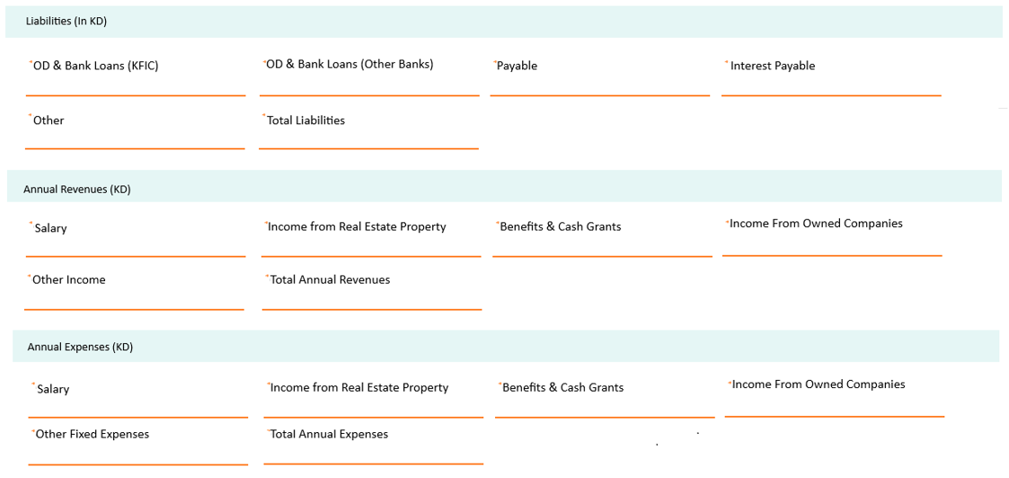
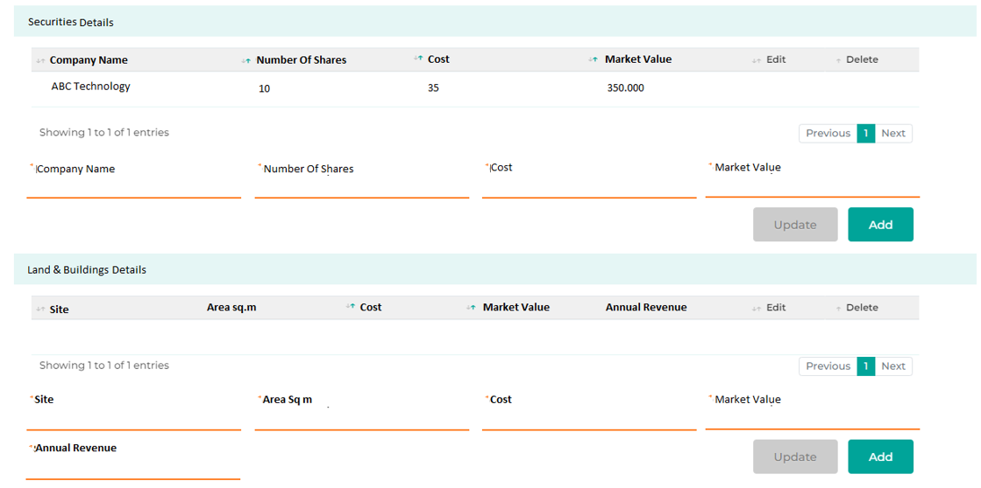
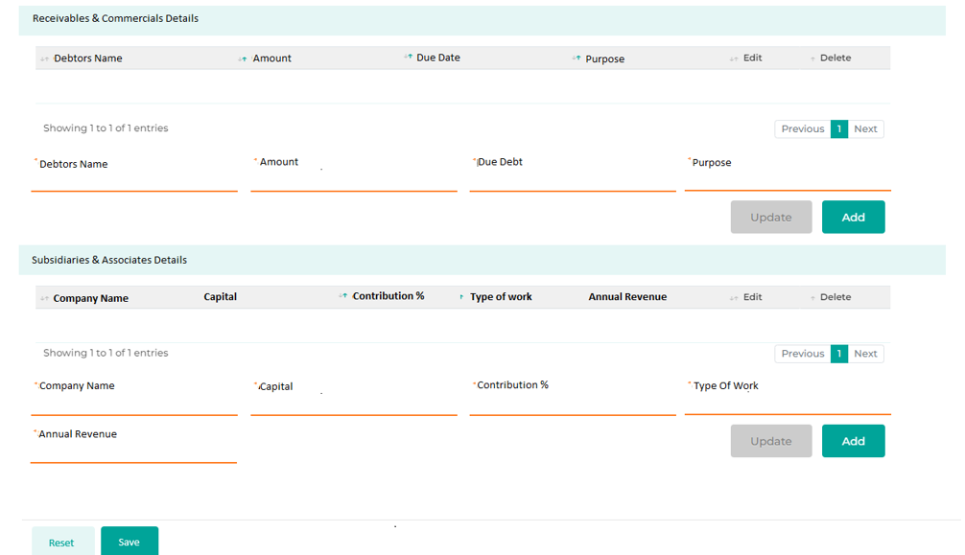

Field Name | Field Type | Data Type / Length | Mandatory (Yes / No) | LookUp Key / Master Name | Possible Values | Field Description
 |  |  |  |  |  | Remarks / Validation
- Customer Type  - Customer Name  - Total Liabilities  - Total Assets  - Total nnual Expenses  - Total Annual Revenue | List View | Grid | NA | NA | NA | Display the multiple risk assessment details captured by the user in a grid for different customer type linked to the loan application.
Customer Type | LOV Dropdown | VARCHAR | Yes | 4034 | Guarantor | Only Applicable for the Guarantor
Customer Name | Master Dropdown | VARCHAR | Yes | NA | NA | The User will select the Guarantor’s name.
Assets (In KD)
Cash (KFIC) | Text Box | VARCHAR | Yes | NA | NA | The user will enter the details referring to the document.
Cash (Other Banks) | Text Box | VARCHAR | Yes | NA | NA | The user will enter the details referring to the document.
Kuwaiti Listed Shared | Text Box | VARCHAR | Yes | NA | NA | The user will enter the details referring to the document.
Kuwaiti Unlisted Shared | Text Box | VARCHAR | Yes | NA | NA | The user will enter the details referring to the document.
Gulf Shares | Text Box | VARCHAR | Yes | NA | NA | The user will enter the details referring to the document.
OIther Shares | Text Box | VARCHAR | Yes | NA | NA | The user will enter the details referring to the document.
Detailed Explaination of Shares | Text Box | VARCHAR | Yes | NA | NA | The user will enter the details referring to the document.
Lands | Text Box | VARCHAR | Yes | NA | NA | The user will enter the details referring to the document.
Building in Kuwait | Text Box | VARCHAR | Yes | NA | NA | The user will enter the details referring to the document.
Assets out of Kuwait | Text Box | VARCHAR | Yes | NA | NA | The user will enter the details referring to the document.
Detailed Explaination of Land & Building | Text Box | VARCHAR | Yes | NA | NA | The user will enter the details referring to the document.
Commercial Receivables | Text Box | VARCHAR | Yes | NA | NA | The user will enter the details referring to the document.
Other Receivables | Text Box | VARCHAR | Yes | NA | NA | The user will enter the details referring to the document.
Detailed Explaination of Receivables | Text Box | VARCHAR | Yes | NA | NA | The user will enter the details referring to the document.
Wholly Ownsed Companies | Text Box | VARCHAR | Yes | NA | NA | The user will enter the details referring to the document.
Other Companies | Text Box | VARCHAR | Yes | NA | NA | The user will enter the details referring to the document.
Detailed Explaination of Companies Affilate & Associate | Text Box | VARCHAR | Yes | NA | NA | The user will enter the details referring to the document.
Total Assets | Read Only | VARCHAR | Yes | NA | NA | The system calculates the Total Asset Value in KD by aggregating the values specified across all categories.
Liabilities (In KD)
OD & Bank Loans (KFIC) | Text Box | VARCHAR | Yes | NA | NA | The user will enter the details referring to the document.
OD & Bank Loans (Other Banks) | Text Box | VARCHAR | Yes | NA | NA | The user will enter the details referring to the document.
Payable | Text Box | VARCHAR | Yes | NA | NA | The user will enter the details referring to the document.
Interest Payable | Text Box | VARCHAR | Yes | NA | NA | The user will enter the details referring to the document.
Other | Text Box | VARCHAR | Yes | NA | NA | The user will enter the details referring to the document.
Total Liabilities | Read Only | VARCHAR | Yes | NA | NA | The system calculates the Total Liability Value in KD by aggregating the values specified across all categories.
Annual Revenues (In KD)
Salary | Text Box | VARCHAR | Yes | NA | NA | The user will enter the details referring to the document.
Income from Real Estate Property | Text Box | VARCHAR | Yes | NA | NA | The user will enter the details referring to the document.
Benefits & Cash Grants | Text Box | VARCHAR | Yes | NA | NA | The user will enter the details referring to the document.
Income From Owned Companies | Text Box | VARCHAR | Yes | NA | NA | The user will enter the details referring to the document.
Other Income | Text Box | VARCHAR | Yes | NA | NA | The user will enter the details referring to the document.
Total Anula Revenues | Read Only | VARCHAR | Yes | NA | NA | The system calculates the Total Annual Revenue in KD by aggregating the values specified across all categories.
Annual Expenses (In KD)
Due To Banks | Text Box | VARCHAR | Yes | NA | NA | The user will enter the details referring to the document.
Accounts Payable | Text Box | VARCHAR | Yes | NA | NA | The user will enter the details referring to the document.
Installments | Text Box | VARCHAR | Yes | NA | NA | The user will enter the details referring to the document.
Interest Payable | Text Box | VARCHAR | Yes | NA | NA | The user will enter the details referring to the document.
Other Fixed Expenses | Text Box | VARCHAR | Yes | NA | NA | The user will enter the details referring to the document.
Total Annual Expenses | Read Only | VARCHAR | Yes | NA | NA | The system calculates the Total Annual Expenses in KD by aggregating the values specified across all categories.
Securities Details
- Company Nmae  - Number Of Shares  - Cost  - Market Value  - Edit  - Delete | Child Grid | VARCHAR | Yes | NA | NA | Multiple entry of the data will be displayed in the grid.
Company Nmae | Text Box | VARCHAR | Yes | NA | NA | The user will enter the details referring to the document.
Number Of Shares | Text Box | INT | Yes | NA | NA | The user will enter the details referring to the document.
Cost | Text Box | INT | Yes | NA | NA | The user will enter the details referring to the document.
Market Value | Text Box | INT | Yes | NA | NA | The user will enter the details referring to the document.
Update | Button | Button | Yes | NA | NA | Once the user has clicked on edit button in the grid and updated the data, the user will clcik on Update button to save the details back.
Add | Button | Button | Yes | NA | NA | The user will clcik on Add button to add the data entered in the fields to the grid.
Land & Buildings Details
- Site  - Area Sq.m  - Cost  - Market Value  - Annual Revenue  - Edit  - Delete | Child Grid | VARCHAR | Yes | NA | NA | Multiple entry of the data will be displayed in the grid.
Site | Text Box | VARCHAR | Yes | NA | NA | The user will enter the details referring to the document.
Area Sq.m | Text Box | INT | Yes | NA | NA | The user will enter the details referring to the document.
Cost | Text Box | INT | Yes | NA | NA | The user will enter the details referring to the document.
Market Value | Text Box | INT | Yes | NA | NA | The user will enter the details referring to the document.
Annual Revenue | Text Box | INT | Yes | NA | NA | The user will enter the details referring to the document.
Update | Button | Button | Yes | NA | NA | Once the user has clicked on edit button in the grid and updated the data, the user will clcik on Update button to save the details back.
Add | Button | Button | Yes | NA | NA | The user will clcik on Add button to add the data entered in the fields to the grid.
Receivables & Commercials Details
- Debtors Name  - Amount  - Due Date  - Purpose  - Edit  - Delete | Child Grid | VARCHAR | Yes | NA | NA | Multiple entry of the data will be displayed in the grid.
Debtors Name | Text Box | VARCHAR | Yes | NA | NA | The user will enter the details referring to the document.
Amount | Text Box | INT | Yes | NA | NA | The user will enter the details referring to the document.
Due Date | Calendar | DATE | Yes | NA | NA | The user will enter the details referring to the document.
Purpose | Text Box | VARCHAR | Yes | NA | NA | The user will enter the details referring to the document.
Update | Button | Button | Yes | NA | NA | Once the user has clicked on edit button in the grid and updated the data, the user will clcik on Update button to save the details back.
Add | Button | Button | Yes | NA | NA | The user will clcik on Add button to add the data entered in the fields to the grid.
Subsidiaries & Associates Details
- Company Name  - Capital  - Contribution %  - Type of Work  - Annual Revenue  - Edit  - Delete | Child Grid | VARCHAR | Yes | NA | NA | Multiple entry of the data will be displayed in the grid.
Company Name | Text Box | VARCHAR | Yes | NA | NA | The user will enter the details referring to the document.
Capital | Text Box | INT | Yes | NA | NA | The user will enter the details referring to the document.
Contribution % | Text Box | INT | Yes | NA | NA | The user will enter the details referring to the document.
Type of Work | Text Box | VARCHAR | Yes | NA | NA | The user will enter the details referring to the document.
Annual Revenue | Text Box | INT | Yes | NA | NA | The user will enter the details referring to the document.
Update | Button | Button | Yes | NA | NA | Once the user has clicked on edit button in the grid and updated the data, the user will clcik on Update button to save the details back.
Add | Button | Button | Yes | NA | NA | The user will clcik on Add button to add the data entered in the fields to the grid.
Action Buttons
Reset | Button | Button | NA | NA | NA | The User will click on this button to clear the entered data.
Save | Button | Button | NA | NA | NA | The User will click on this button to save the entered data.

13.2.6.2 Balance Sheet
The user can select the type of balance sheet, whether audited or in-house. Additionally, the system allows the user to capture the balance sheet for both actual and projected years. Depending on the selected years, the defined years will appear, enabling the user to capture the assets and liabilities within the system. Validation will ensure that a minimum of three years of balance sheet data is captured, enabling the user to record details for the default period.
If the customer is an existing one, the system will automatically populate the balance sheet data for the years previously provided, based on the selected years for the new loan application. For example, if the customer previously submitted balance sheet data for 2023, 2024, and 2025, and is now applying for a new loan where the balance sheet is required for 2024, 2025, and 2026, the system will auto-populate the data for 2024 and 2025. The user will then be prompted to upload the balance sheet data only for the year 2026.
The system will also allow users to upload the balance using an Excel upload feature. Users can enter the data into the standard Excel template, upload it back to the screen, and then click "Save" to store the balance sheet details from the uploaded template.

Navigation:
Detail Data Entry à Financialsà Balance Sheet
The following screen will be displayed once the User clicks on Balance Sheet:

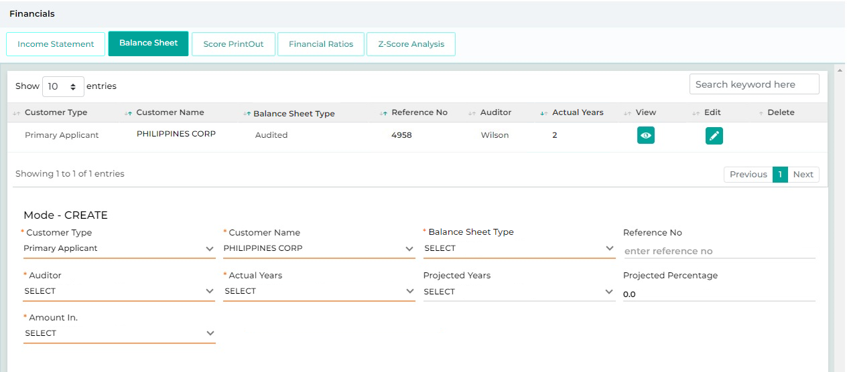
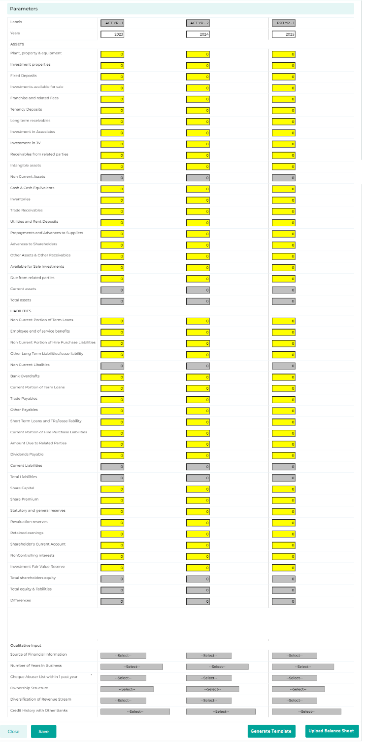

Field Name | Field Type | Data Type / Length | Mandatory (Yes / No) | LookUp Key/Master Name | Possible Values | Field Description
 |  |  |  |  |  | Remarks / Validation
Customer Type | List View | Read Only | NA | Document Checklist | Main Applicant | The system will display the customer Type.
Customer Name | List View | Read Only | NA | Document Checklist | Abdullah | The system will display the customer name.
Balance Sheet Type | List View |  | Yes | NA | AUDITED
Reference No | List View |  | Yes | NA | 1001110
Auditor | List View |  | Yes | NA | Wilson
Actual Years | List View |  | Yes | NA | 1-1
Customer Type | Dropdown |  | Yes | NA | Main Applicant  Guarantor  Joint Applicant | The user will select the customer type
Customer Name | Dropdown |  | Yes | NA |  | The system will displays the Customer Name basis on the customer type selected
Balance Sheet Type | Dropdown |  | Yes | NA | - AUDITED  - NON-AUDITED  - INTERIM
Reference No | Textbox |  | Yes | NA | 1001110
Auditor | Textbox |  | Yes | NA | Wilson
Actual Years | Dropdown |  | Yes | NA | 1-1
Projected Years | Dropdown |  | Yes | NA | 1-1
Projected Percentage | Textbox |  | Yes | NA | 10
Amount In | Dropdown |  | Yes | NA | - Thousand
Parameters
Years | Read-only |  | Yes | NA | NA
Assets
Plant, property & equipment | Numeric |  | Yes | NA | NA
Investment properties | Numeric |  | Yes | NA | NA
Fixed Deposits | Numeric |  | Yes | NA | NA
Investments available for sale | Numeric |  | Yes | NA | NA
Franchise and related Fees | Numeric |  | Yes | NA | NA
Tenancy Deposits | Numeric |  | Yes | NA | NA
Long term receivables | Numeric |  | Yes | NA | NA
Investment in Associates | Numeric |  | Yes | NA | NA
Investment in JV | Numeric |  | Yes | NA | NA
Receivables from related parties | Numeric |  | Yes | NA | NA
Intangible assets | Numeric |  | Yes | NA | NA
Non-Current Assets | Read-only |  | Yes | NA | NA
Cash & Cash Equivalents | Numeric |  | Yes | NA | NA
Inventories | Numeric |  | Yes | NA | NA
Trade Receivables | Numeric |  | Yes | NA | NA
Utilities and Rent Deposits | Numeric |  | Yes | NA | NA
Prepayments and Advances to Suppliers | Numeric |  | Yes | NA | NA
Advances to Shareholders | Numeric |  | Yes | NA | NA
Other Assets & Other Receivables | Numeric |  | Yes | NA | NA
Available for Sale Investments | Numeric |  | Yes | NA | NA
Due from related parties | Numeric |  | Yes | NA | NA
Current assets | Read-only |  | Yes | NA | NA
Total assets | Read Only |  | Yes | NA | NA
Liabilities
Non-Current Portion of Term Loans | Numeric |  | Yes | NA | NA
Employee end of service benefits | Numeric |  | Yes | NA | NA
Non-Current Portion of Hire Purchase Liabilities | Numeric |  | Yes | NA | NA
Other Long-Term Liabilities/lease liability | Numeric |  | Yes | NA | NA
Non-Current Labilities | Numeric |  | Yes | NA | NA
Bank Overdrafts | Numeric |  | Yes | NA | NA
Current Portion of Term Loans | Numeric |  | Yes | NA | NA
Trade Payables | Numeric |  | Yes | NA | NA
Other Payables | Numeric |  | Yes | NA | NA
Short Term Loans and TRs/lease liability | Numeric |  | Yes | NA | NA
Current Portion of Hire Purchase Liabilities | Numeric |  | Yes | NA | NA
Amount Due to Related Parties | Numeric |  | Yes | NA | NA
Dividends Payable | Numeric |  | Yes | NA | NA
Current Liabilities | Read-only |  | Yes | NA | NA
Total Liabilities | Read-only |  | Yes | NA | NA
Share Capital | Numeric |  | Yes | NA | NA
Share Premium | Numeric |  | Yes | NA | NA
Statutory and general reserves | Numeric |  | Yes | NA | NA
Revaluation reserves | Numeric |  | Yes | NA | NA
Retained earnings | Numeric |  | Yes | NA | NA
Shareholder's Current Account | Numeric |  | Yes | NA | NA
Noncontrolling interests | Numeric |  | Yes | NA | NA
Investment Fair Value Reserve | Numeric |  | Yes | NA | NA
Total shareholders’ equity | Read Only |  | Yes | NA | NA
Total equity & liabilities | Readonly |  | Yes | NA | NA
Qualitative Input
Source of Financial Information | Dropdown |  | Yes | NA | NA
Number of Years in Business | Dropdown |  | Yes | NA | NA
Cheque Abuser List within 1 past year | Dropdown |  | Yes | NA | NA
Ownership Structure | Dropdown |  | Yes | NA | NA
Diversification of Revenue Stream | Dropdown |  | Yes | NA | NA
Credit History with Other Banks | Dropdown |  | Yes | NA | NA
Action Button
Reset | Button | Button | NA | NA | NA
Save | Button | Button | NA | NA | NA
Generate Template | Button | Button | NA | NA | NA | The user will clcik on the Generate Template button to download the excel template for the balance sheet.
Upload Balance Sheet | Button | Button | NA | NA | NA | The user will enter the data input in the gnerated template and clcik on the “Upload Balance Sheet” button to upload the balance sheet which then will be reflected on the screen. Later the user will clcik on Save button to save the details.

13.2.6.3 Income Statement

Based on the projected year defined in the balance sheet, the user will capture the income statement for the business, determining all the parameters. Validation will ensure that a minimum of three years of income statement data is captured, enabling the user to record details for the default period.
A standard template will be provided in order capture the data using the excel file upload functionality.
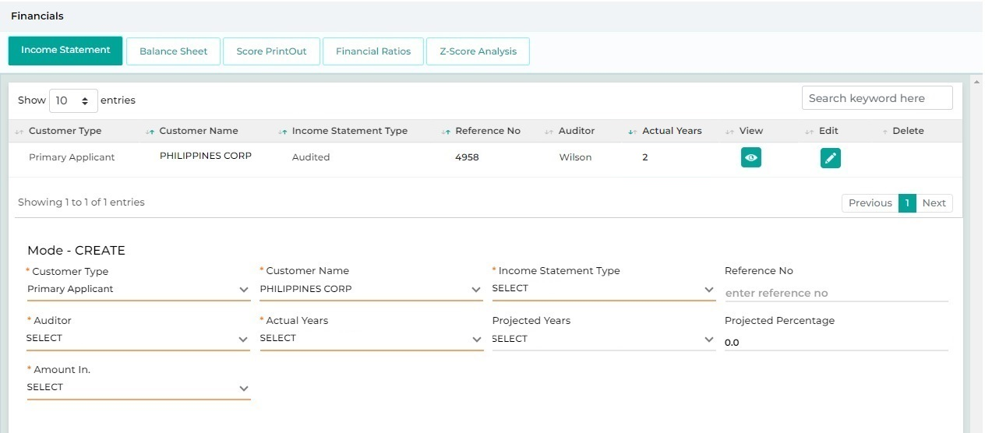
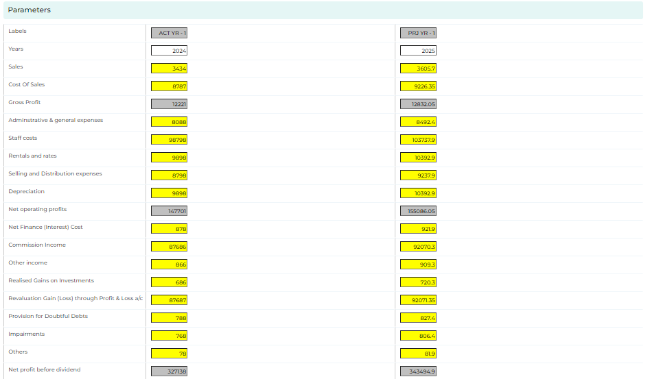

Navigation:
Detail Data Entry à Financialsà Income Statement
The following screen will be displayed once the User clicks on Income Statement:

Field Name | Field Type | Data Type / Length | Mandatory (Yes / No) | LookUp Key/Master Name | Possible Values | Field Description
 |  |  |  |  |  | Remarks / Validation
Customer Type | List View | Read Only | NA | Document Checklist | Main Applicant | The system will display the customer Type.
Customer Name | List View | Read Only | NA | Document Checklist | Abdullah | The system will display the customer name.
Income Statement Type | List View |  | Yes | NA | AUDITED
Reference No | List View |  | Yes | NA | 1001110
Auditor | List View |  | Yes | NA | Wilson
Actual Years | List View |  | Yes | NA | 1-1
Customer Type | Dropdown |  | Yes | NA | Main Applicant  Guarantor  Joint Applicant | The user will select the customer type
Customer Name | Dropdown |  | Yes | NA |  | The system will displays the Customer Name basis on the customer type selected
Income Statement Type | Dropdown |  | Yes | NA | AUDITED
Reference No | Textbox |  | Yes | NA | 1001110
Auditor | Textbox |  | Yes | NA | Wilson
Actual Years | Dropdown |  | Yes | NA | 1-1
Projected Years | Dropdown |  | Yes | NA | 1-1
Projected Percentage | Textbox |  | Yes | NA | 10
Amount In | Dropdown |  | Yes | NA | - Thousand
Parameters
Years | Readonly |  | Yes | NA | 2023
Sales | Numeric |  | Yes | NA | NA
Cost of sales | Numeric |  | Yes | NA | NA
Gross profit | Readonly |  | Yes | NA | NA
Administrative & general expenses | Numeric |  | Yes | NA | NA
Staff costs | Numeric |  | Yes | NA | NA
Rentals and rates | Numeric |  | Yes | NA | NA
Selling and Distribution expenses | Numeric |  | Yes | NA | NA
Depreciation | Numeric |  | Yes | NA | NA
Net operating profits | Readonly |  | Yes | NA | NA
Net Finance (Interest) Cost | Numeric |  | Yes | NA | NA
Commission Income | Numeric |  | Yes | NA | NA
Other income | Numeric |  | Yes | NA | NA
Realised Gains on Investments | Numeric |  | Yes | NA | NA
Revaluation Gain (Loss) through Profit & Loss a/c | Numeric |  | Yes | NA | NA
Provision for Doubtful Debts | Numeric |  | Yes | NA | NA
Impairments | Numeric |  | Yes | NA | NA
Others | Numeric |  | Yes | NA | NA
Commission Income | Numeric |  | Yes | NA | NA
Net profit Before Divident | Readonly |  | Yes | NA | NA
Action Button
Reset | Button | Button | NA | NA | NA
Save | Button | Button | NA | NA | NA

13.2.6.4 Cash Flow Statement
The user will capture the cashflow related parameters. Validation will ensure that a minimum of three years of cashflow statement data is captured, enabling the user to record details for the default period.
A standard template will be provided in order capture the data using the excel file upload functionality.

Navigation:
Detail Data Entry à Financialsà Cash Flow Analysis
The following screen will be displayed once the User clicks on Cash Flow Analysis:
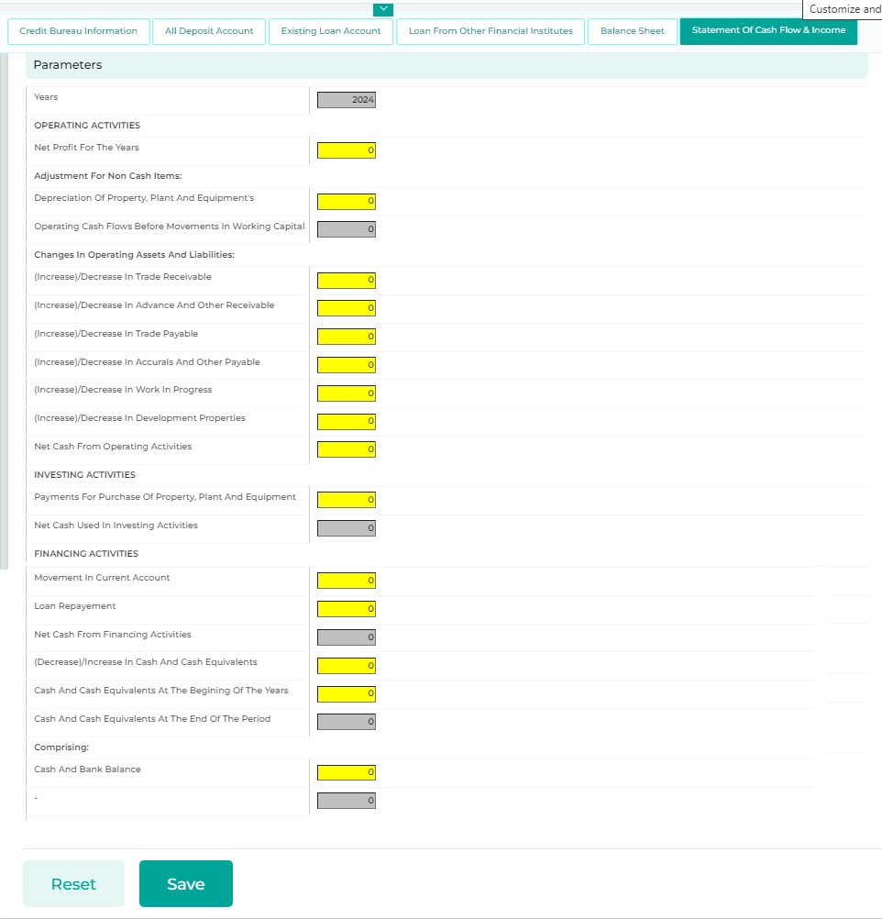

13.2.6.5 Financial Ratios
Basis of the financials captured; the system will compute the Financial Ratios. The user can click on “Print” button to download the ratio computed for the client in an excel format.
Navigation:
Detail Data Entry à Financialsà Financial Ratios
The following screen will be displayed once the User clicks on Financial Ratios:

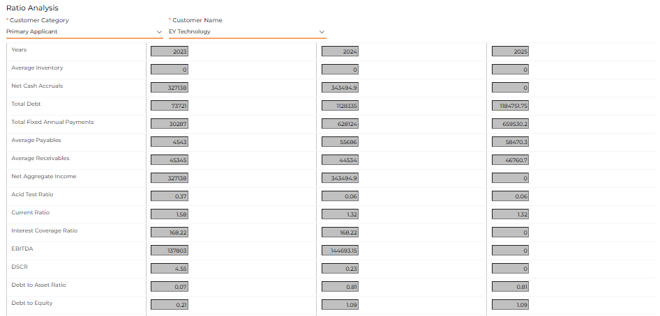
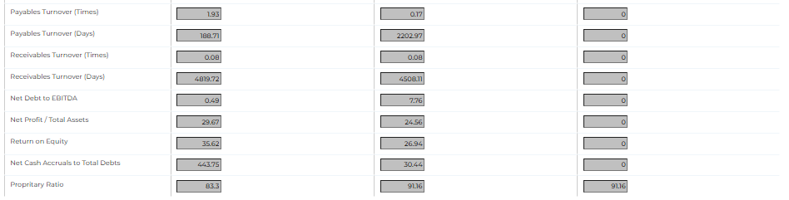

13.2.6.6 Z-Score Analysis
Z-Score Analysis will be conducted based on the financial data collected, which indicates the potential for bankruptcy or insolvency of a company. A Z-score above 3 is considered favourable, suggesting that the company is performing well and is not at risk of bankruptcy. The user can click on “Print” button to download the score computed for the client in an excel format.

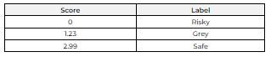
Navigation:
Detail Data Entry à Financialsà Z-Score Analysis
The following screen will be displayed once the User clicks on Z-Score Analysis:

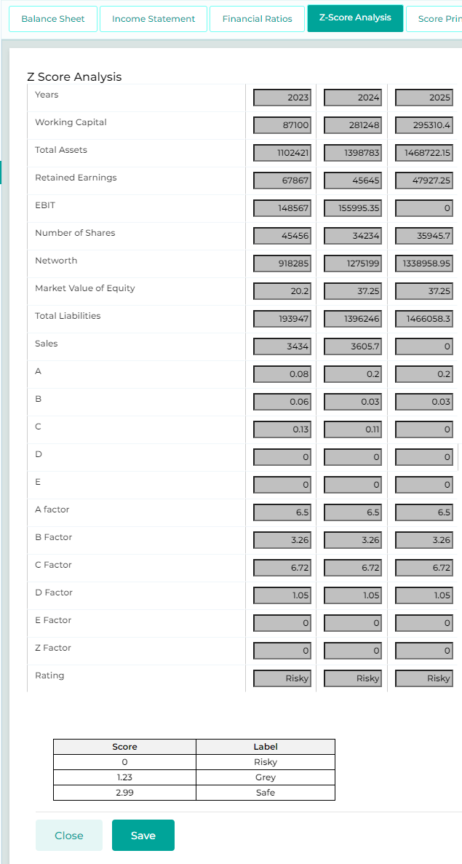

13.2.6.7 Quantitative-Qualitative Scoring
Quantitative and Qualitative Scoring to be computed as per the financials captured to be total of one hundred to derive with the Credit Risk Rating based on Risk Category – please refer to the below extracted sheet from the model in excel sheet provided. The user can click on “Print” button to download the score report for the client in an excel format.

Lower Bound | Upper Bound | Score | Category
0.00 | 5.00 | 7 | Watchlist
5.00 | 17.50 | 6 | Average
17.50 | 37.50 | 5 | Satisfactory
37.50 | 62.50 | 4 | Good
62.50 | 82.50 | 3 | Very Good
82.50 | 95.00 | 2 | Excellent
95.00 | 100.00 | 1 | Prime

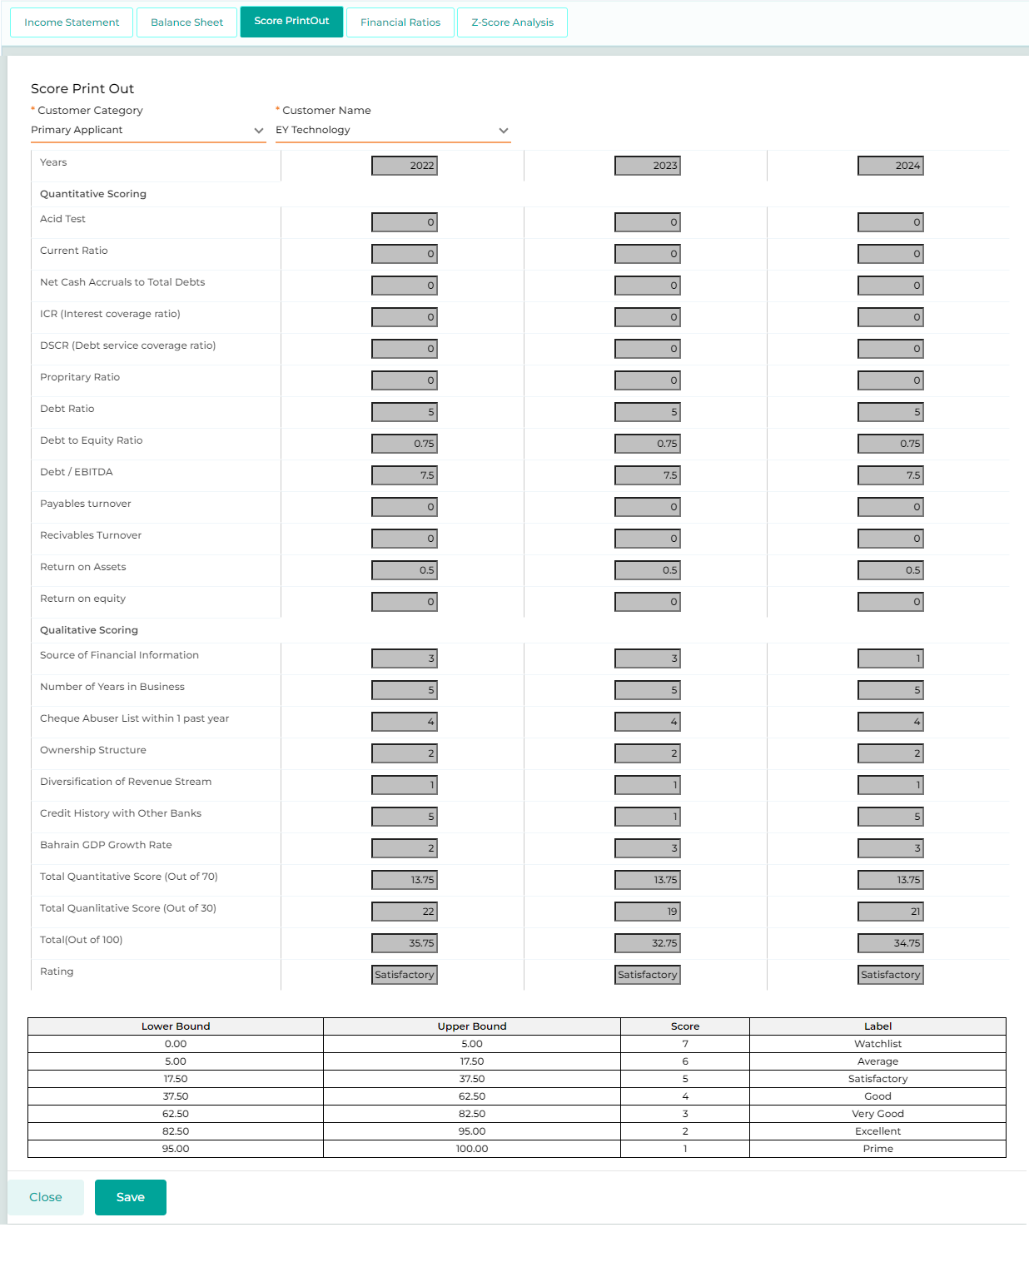

13.2.7 Policy Review
This feature will let the User generate a Basic Health Check (BHC), run an Internal score card and view the credit bureau report of the customer.

13.2.7.1 Policy Check
The Policy Check feature enables users to obtain a snapshot of the loan application's basis of the CBK & Internal policies configured and as per the data captured across the respective screens of detail data entry stage. These policies are configurable at product level & sub-product level within the system, and the system automatically verifies each policy, indicating its status as approved or rejected. If any policy is breached, the user is empowered to initiate the exception. This exceptional approval can be escalated either at the individual user level or collectively at the stage level, adhering to the escalation matrix defined in accordance with KFIC policies.
Once all the data is captured across the respective screens, the user will click the “Policy Check” button. The system will then run the policy check engine and return the status of each policy as either "Pass" or "Fail." If the user wishes to request exceptional approval for any failed policy (only internal policies are applicable for exceptional approval), they can check the box next to the failed policy and click on “Deviate.” Clicking the “Deviate” button will send an exceptional approval request to the authorized user, who will provide approval to proceed with the application processing. Additionally, an entry will be made in the Exception Details screen to record the status of the raised exception for the user to review.
- Detailed Policy Check parameter for Individual & Corporate Customers and the Lending Criteria. Such policies are configurable given they might change from time to time.

Navigation:
Detail Data Entry à Policy Review àCredit Policy Check
The following screen will be displayed once the User clicks on Credit Policy Check:
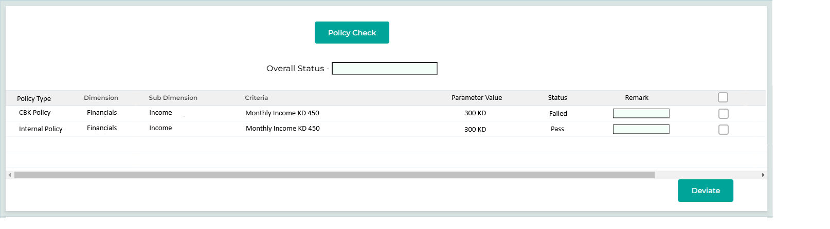
Below are the details specific to the information being displayed above.

Field Name | Field Type | Data Type / Length | Mandatory (Yes / No) | LookUp Key/Master Name | Sample  Data | Field Description
 |  |  |  |  |  | Remarks / Validation
Policy Check | Button | Button | NA | NA | NA | The User will click on this button to generate a policy check about the applicant.
Overall Status | Read Only | VARCHAR | NA | NA | NA | The system will display the status of the applicant based on the documents and info provided by the applicant
List View
Policy Type | List View | List View | NA | NA | - CBK Policy  - Internal Policy | The system will display the category of Policy Type that this policy falls under. Whether it’s a CBK policy or internal policy of the KFIC.
Dimension | List View | List View | NA | NA | Financials | This list view will display the various dimensions on which the policy check will happen
Sub-Dimension | List View | List View | NA | NA | Income | This list view will display the various sub-dimensions on which the policy check will happen
Criteria | List View | List View | NA | NA | Monthly Income KD 450 | This list view will display the various criteria on which the policy check will happen
Parameter Value | List View | VARCHAR | NA | NA | 300 KD | The value which was entered by the user in different screen on which policy is derived will be displayed here
Status | List View | List View | NA | NA | - Failed  - Pass  - Not Initiated | This list view will display the status of the specific dimension and criteria whether its approved or rejected
Remark | Text Box | List View | NA | NA | NA | Allows the user to enter the remarks before initiating the exceptional approval from the repectie authority.  Only accessible in case of Policy Failure
Action | Checkbox |  | NA |  |  | The user will enter the remarks across the failed policy and mark the checkbox and clcik on “Deviate” button.  Applicable only in case of Policy Failure

13.2.7.2 Credit Score Card

This functionality enables users with calculated internal credit scores of the customer by considering various risk parameters and dimensions defined in the configuration. Each risk parameter is assigned a weightage, which, when multiplied by the applicant's score, yields the dimension score. The sum of these dimension scores constitutes the internal overall score of the prospect. The overall risk score will be derived as Low, Medium, or High
The score is classified into the following ranges and scales:
Scale | Score Range
High Risk | 0 - 60
Medium Risk | 61 - 80
Low Risk | 81 - 100

- Detailed Credit Score Card parameters for Individual & Corporate Customers

Navigation:
Detail Data Entry à Policy Review à Credit Score Card
The following screen will be displayed once the User clicks on Credit Score Card:

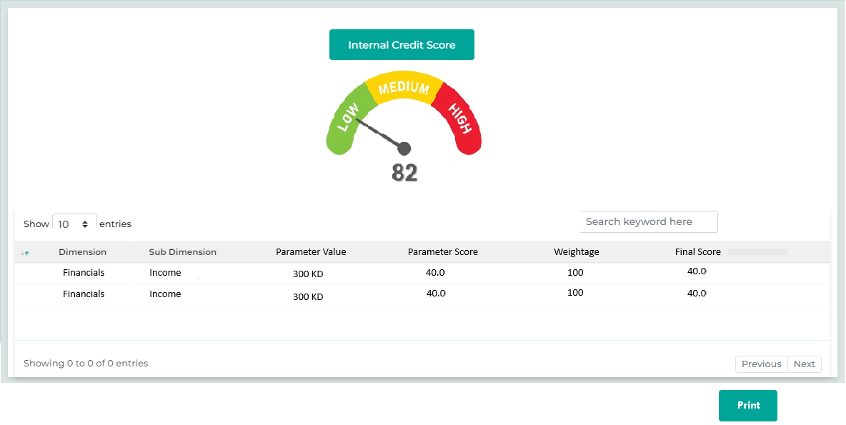

Below are the details specific to the information being displayed above.
Field Name | Field Type | Data Type / Length | Mandatory (Yes / No) | Lookup Key / Master Name | Possible Values | Field Description
 |  |  |  |  |  | Remarks / Validation
Score Indicator | Indicator Widget | NA | NA | NA | Low, Medium, High | The system will compute the Overall Internal Score as the summation of the final score across all the configured parameters and the Score Category as configured.  The Score & the Scaling category will be displayed through an indicator.
Dimension | List View | VARCHAR | NA | NA | NA | The system will display the risk dimension.
Sub Dimension | List View | VARCHAR | NA | NA | NA | The system will display the risk sub dimension.
Parameter Value | List View | VARCHAR | NA | NA | NA | The value which was entered by the user in different screen will be fetched here
Parameter Score | List View | FLOAT | NA | NA | NA | The system will display the configured score for the specific parameter value and sub dimension.
Weightage | List View | FLOAT | NA | NA | NA | The system will display the configured weightage for the specific parameter value and sub dimension.
Final Score | List View | FLOAT | NA | NA | NA | The system will compute the final score of the parameter
Action Button
Internal Credit Score | Button | Button | Yes | NA | NA | The User will click on this button to generate the internal credit score of the prospect. The report should show the legends of the risk category – refer to the attached relevant score card sheet in excel sheet
Print | Button | Button | No | NA | NA | Allows the user to Print the score for the customer in an Excel format.

13.2.7.3 Exception Details
The Exception Details screen allows the user to track and capture actions related to exceptions. Policies that have failed during the Policy Check will be displayed on this screen, enabling the user to see the status of each approval. Additionally, the user can manually raise exceptions from this screen. Any exceptions raised will be sent to the authorized user for approval based on the configured policies and authority levels. The user cannot proceed to the next stage until the approval for the raised exception is received.
There are two processes for handling exceptions by the authorized user:
1. The authorized user can send the application back to the sales officer for amendments before proceeding.
2. Alternatively, the authorized user can choose to proceed with the application for later review. In this case, Credit Control user at the Final Check Credit Control stage will verify whether the conditions that were advanced are met in the system. An alert notification will be sent until those conditions are fulfilled.
Navigation:
Verification à Exception à Deviation Details

The following screen will be displayed once the User clicks on Deviation Details:
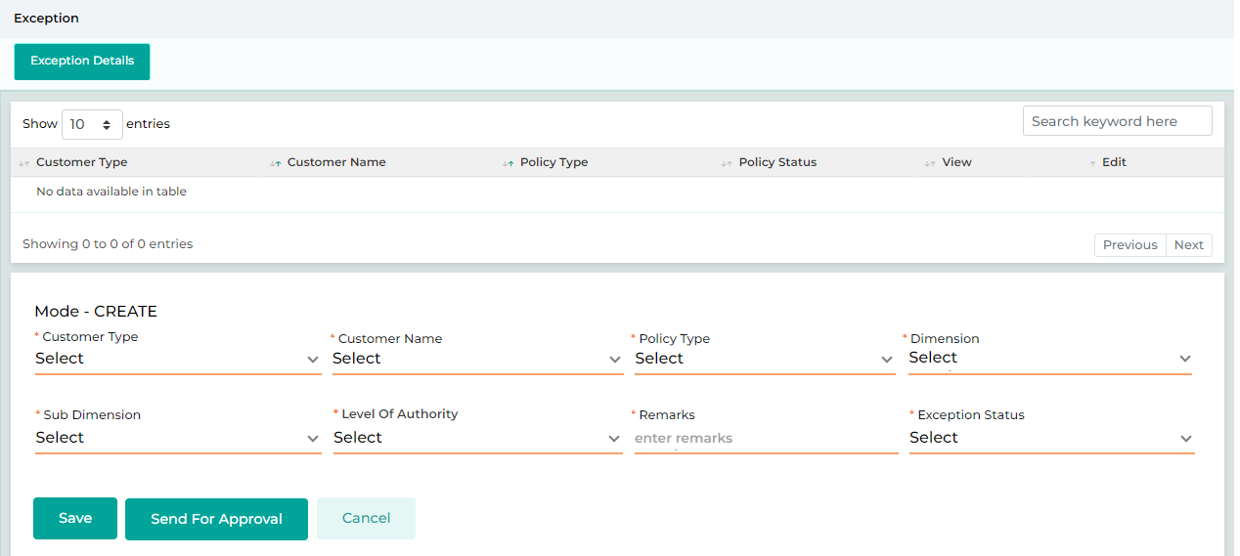

Below are the details specific to the information being displayed above.
Field Name | Field Type | Data Type / Length | Mandatory (Yes / No) | LookUp Key/Master Name | Possible Values | Field Description
 |  |  |  |  |  | Remarks / Validation
- Customer Type  - Customer Name  - Policy Type  - Status | List View | VARCHAR | Yes |  |  | Displays the list of custmer related to which the exception was raised
Customer Type | Master Dropdown | VARCHAR | Yes | 4034 | - Main Applicant  - Guarantor  - Partner | The customer type will be displaed in case if the policy is raised for an exceptional approval from the “Policy Check” screen.
 |  |  |  |  |  | The User will select the customer type for which the exception is to be raised.
Customer Name | Master Dropdown | VARCHAR | Yes | NA | NA | The customer name will be displaed in case if the policy is raised for an exceptional approval from the “Policy Check” screen.
 |  |  |  |  |  | The customer name will be displayed as per the customer type selected.
Policy Type | LOV Dropdown | VARCHAR | Yes | NA | - CBK Policy  - Internal Policy | The Policy Type will be displayed in case if the policy is raised for an exceptional approval from the “Policy Check” screen.  In case of request raised from this screen, the user will select the Policy Type
Dimension | Master Dropdown | VARCHAR | Yes |  | Financial | The Dimension will be displayed in case if the policy is raised for an exceptional approval from the “Policy Check” screen.  In case of request raised from this screen, the user will select the Dimension
Sub Dimension | Master Dropdown | VARCHAR | Yes |  | Income | The Sub Dimension will be displayed in case if the policy is raised for an exceptional approval from the “Policy Check” screen.  In case of request raised from this screen, the user will select the Sub Dimension
Remarks | Text Box | VARCHAR | Yes | NA | NA | The User will enter the remarks if any
Level of Authority | Master Dropdown | VARCHAR | Yes | User Role – User Name | CEO – Mr Hamza Najjar | The user name will be displayed in case if the policy is raised for an exceptional approval from the “Policy Check” screen.  In case of request raised from this screen, the user will select the user name to whom the exceptional approval is to be sent.
Exception Status | Master Dropdown | VARCHAR | Yes | DEVIATIONSTATUS | - Approved  - Rejected  - Pending | Once initiated by the user from the Policy Check screen, the status will be displayed as "Pending."  When a response is received from the authorized user, the status will be updated to either "Approved" or "Rejected," depending on the decision made by the approver.
Action Button
Send for Approval | Button | Button | NA | NA | NA | Applicable only if the exceptional approval raised manually, the user ill click on this button to send the reques for exceptional approval to the authorized user.
Reset | Button | Button | NA | NA | NA | The User will click on this button to clear the entered data.
Save | Button | Button | NA | NA | NA | The User will click on this button to save the entered data.

Stage Completion Rules
Please refer Stage Completion Rules for details about the stage completion rules for this stage.

Interface Touchpoints
Please refer to Interface Touch Points for details about the interface touchpoints required for this stage.

Required Documents
Please refer to Required Document Checklist for details about the documents required at this stage.

Collection Review

Access Rights
Access rights metrics display the configuration of screens within each respective stage and tab, indicating the available access rights for users to Add, View, Edit, or data. A "✔" icon signifies the access rights granted for each screen at that stage. Conversely, if all four access rights options are blank and lack an icon, it means that the screen is not applicable for that stage.
Tab Name | Screen Name | Add | View | Edit | Delete
Application | Application Summary |  | ü
KYC | Basic Details |  | ü
KYC | Address Details |  | ü
KYC | Identification Details |  | ü
KYC | Business Details
KYC | Relationship Segment
KYC | Employment Details
KYC | Bank Details |  | ü
KYC | Repayment Details |  | ü
KYC | Insurance Details
KYC | Contact Details |  | ü
Product Details | Collateral Search |  | ü
Product Details | Collateral Details
Product Details | Valuation
Product Details | Loan Item Details
Product Details | Loan Details
Product Details | Charges
Income & Expense | Income
Income & Expense | Expense
Income & Expense | Credit Bureau Exposure Check |  | ü
Income & Expense | Repayment Ratios
Document | Document Checklist | ü | ü | ü | ü
Document | Document Verification |  | ü
Document | Loan Kit |  | ü
Financials | PNW Checklist
Financials | Balance Sheet
Financials | Income Statement
Financials | Financial Ratios
Financials | Cash Flow Analysis
Financials | Z-Score Analysis
Financials | Qualitative - Quantitative Scoring
Policy Review | Policy Check
Policy Review | Credit Score Card
Policy Review | Exception Details
Collection Review | Collection Review | ü | ü | ü | ü
Checklist | Legal Opinion Checklist
Checklist | Credit Concentration Review
Checklist | Risk Opinion Checklist
AML Check | Risk Assessment Checklist
AML Check | Customer Risk Rating
Credit Approval | Recommendation
Credit Approval | Recommendation History
Credit Approval | Credit Committee Approval
Disbursement | Disbursement Details
Registration | Registration Details
Document Archive | Document Archive

Business Logic
The Collection Review stage is specific to retail loans and is applicable only if the customer or guarantor has a history with KFIC Finance, including any active or settled loans. This stage will be triggered if the customer or guarantor has delayed a maximum of three payments based on their past history with KFIC.
Once the retail sales officer completes the detailed data entry and proceeds to the next stage, the system will first check if the customer or guarantor is existing. If so, it will verify whether there have been any delayed payments on past or active loans. If there are more than equals to three delayed payments, instead of moving the application from the detail data entry stage to the verification stage, the system will assign it to a collection officer for to provide his/her opinion.
The application will appear in the collection officer's inbox queue, where they will review the Customer 360 for customer & guarantor and provide their recommendations by capturing remarks in the Collection Review screen. The collection officer will then click "Approve" to move the application to the next stage.
The condition to trigger this stage should be parametrized and configurable by the system.

Note: All screens marked with a “ü” in the access rights matrix will be available to the user at this stage, according to the access rights granted.
The screens are configurable and can be arranged along with their required access rights at different stages

14.2.1 Collection Review
The Collection Review screen will be used by the collection officer to provide remarks and recommendations based on the past history of the customer or guarantor.
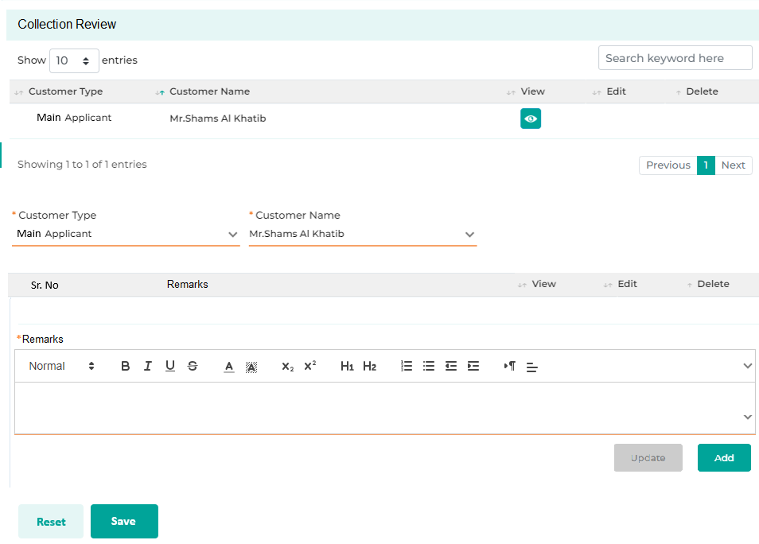

Field Name | Field Type | Data Type / Length | Mandatory (Yes / No) | LookUp Key/Master Name | Possible Values | Field Description
 |  |  |  |  |  | Remarks / Validation
- Customer Type  - Customer Name | List View | NA | NA | NA | NA | The system will display the list view in the grid for different customer type
Customer Type | LOV Dropdown | VARCHAR | Yes | 4034 | - Main Applicant  - sJoint Applicant  - Guarantor | The user will select the customer type for which the remarks need to be captured.
Customer Name | Master Dropdown | VARCHAR | Yes | NA | NA | The system will display the customer name associated with the customer type selected.
Remarks Section
- Sr No  - Remarks  - View  - Edit  - Delete | List View | VARCHAR | Yes | NA | NA | Display the details captured in the grid list.
Remarks | Rich Text | NVARCHAR | Yse | NA | NA | The user will enter the details related to the collection history of the applicant/guarantor and keep on adding the details in the grid by clicking the Add button.
Add | Button | Button | NA | NA | NA | The user will enter the remarks and click on Add button to add multiple remarks.
Action Button
Reset | Button | Button | NA | NA | NA | The reset button will help the User clear contents from the fields and start capturing the document again.
Save | Button | Button | NA | NA | NA | The save button will let the User save the captured information.

Stage Completion Rules
Please refer Stage Completion Rules for details about the stage completion rules for this stage.

Interface Touchpoints
Please refer to Interface Touch Points for details about the interface touchpoints required for this stage.

Required Documents
Please refer to Required Document Checklist for details about the documents required at this stage.

Verification

Access Right Metrics
Access rights metrics display the configuration of screens within each respective stage and tab, indicating the available access rights for users to Add, View, Edit, or data. A "✔" icon signifies the access rights granted for each screen at that stage. Conversely, if all four access rights options are blank and lack an icon, it means that the screen is not applicable for that stage.
Tab Name | Screen Name | Add | View | Edit | Delete
Application | Application Summary |  | ü
KYC | Basic Details |  | ü
KYC | Address Details |  | ü
KYC | Identification Details |  | ü
KYC | Business Details |  | ü
KYC | Relationship Segment |  | ü
KYC | Employment Details |  | ü
KYC | Bank Details |  | ü
KYC | Repayment Details |  | ü
KYC | Insurance Details |  | ü
KYC | Contact Details |  | ü
Product Details | Collateral Search |  | ü
Product Details | Collateral Details |  | ü
Product Details | Valuation |  | ü
Product Details | Loan Item Details |  | ü
Product Details | Loan Details |  | ü
Product Details | Charges |  | ü
Income & Expense | Income |  | ü
Income & Expense | Expense |  | ü
Income & Expense | Credit Bureau Exposure Check |  | ü
Income & Expense | Repayment Ratios |  | ü
Document | Document Checklist |  | ü
Document | Document Verification
Document | Loan Kit |  | ü
Financials | PNW Checklist |  | ü
Financials | Balance Sheet |  | ü
Financials | Income Statement |  | ü
Financials | Financial Ratios |  | ü
Financials | Cash Flow Analysis |  | ü
Financials | Z-Score Analysis |  | ü
Financials | Qualitative - Quantitative Scoring |  | ü
Policy Review | Policy Check |  | ü
Policy Review | Credit Score Card |  | ü
Policy Review | Exception Details |  | ü
Collection Review | Collection Review
Checklist | Legal Opinion Checklist
Checklist | Credit Concentration Review
Checklist | Risk Opinion Checklist
AML Check | Risk Assessment Checklist
AML Check | Customer Risk Rating
Credit Approval | Recommendation
Credit Approval | Recommendation History
Credit Approval | Credit Committee Approval
Disbursement | Disbursement Details
Registration | Registration Details
Document Archive | Document Archive

Business Logic
The Retail/Commercial Sales Manager will verify the details captured and the documents provided by the customer during the Detail Data Entry stage. This verification stage ensures that all necessary information is thoroughly checked, enabling the underwriter to make informed decisions.
All customer information from the Detail Data Entry stage will be accessible to the Retail/Commercial Sales Manager in read-only mode. If all details are accurate and the correct documents are provided, the manager will accept and mark the documents as verified enter the remarks, moving them to the next stage of loan processing. However, if the verification user identifies any incorrect data or documents, they can return the application to the previous sales user along with their remarks using the return functionality.

Note: All screens marked with a “ü” in the access rights matrix will be available to the user at this stage, according to the access rights granted.
The screens are configurable and can be arranged along with their required access rights at different stages

15.2.1 Verification

15.2.1.1 Document Verification

At the document verification screen, the sales manager can view the list of all documents uploaded from the Document Checklist Screen or generated and uploaded from Loan Kit screen. The system enables the user to view each document and take necessary actions such as marking it Approved or Rejected. If the submitted documents meet the requirements, the user marks them as Verified; otherwise, they are marked as Rejected. The user can also raise a query if there is a discrepancy in the document or if it is improper. In such cases, the document is sent back to the sales officer for re-upload to fulfil verification requirements.
If the user wishes to view all documents together, they can click on the "View All Documents" button. This action displays all documents merged into a single document format, which the user can also download.
Navigation:
Verification à Document à Document Verification
The following screen will be displayed once the User clicks on Document Verification:

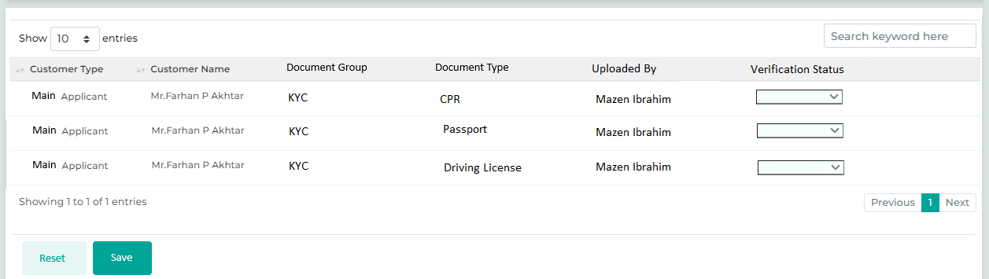
Below are the details specific to the information being displayed above.
Field Name | Field Type | Data Type / Length | Mandatory (Yes / No) | LookUp Key/Master Name | Possible Values | Field Description
 |  |  |  |  |  | Remarks / Validation
- Customer Type  - Customer Name  - Document Group  - Document Type  - Status | List View | NA | NA | NA | NA | The system will display the list view of all the doucments uploaded from the Document Checklist & the Loan Kit screen.
Customer Type | List View | NA | NA | NA | Main Applicant  Joint Applicant  Guarantor  Partner | The system will display the customer type associated with the uploaded document.
Customer Name | List View | NA | NA | NA | NA | The system will display the customer name associated with the uploaded document.
Document Group | List View | NA | NA | NA | - Finacials  - Address  - Employment  - Others | The system will display the document group associated with the uploaded document.  For the document coming in from the Loan Kit screen, the Document Group to be displayed as “Loan Kit”
Type | List View | NA | NA | NA | - Civil Id  - Passport  - Bank Statement  - MOA  - AOA  - MOCI  - Salary Certificate | The system will display the document name
Uploaded By | List View | NA | NA | NA | - Field Officer 1  - Field Officer 2  - Field Officer 3 | The system will display the user name who has uploaded document.
Verification Status | Dropdown |  | Yes | NA | Approved  Rejected | If the user is satisfied with the document, they will click "Approved." If they are dissatisfied, they will click "Rejected."
Action Buttons
Reset | Button | Button | NA | NA | NA | The reset button will help the User clear contents from the fields and start capturing the document again.
Save | Button | Button | NA | NA | NA | The save button will let the User save the captured information.

Stage Completion Rules
Please refer Stage Completion Rules for details about the stage completion rules for this stage.

Interface Touchpoints
Please refer to Interface Touch Points for details about the interface touchpoints required for this stage.

Required Documents
Please refer to Required Document Checklist for details about the documents required at this stage.

Legal Review

Access Right Metrics
Access rights metrics display the configuration of screens within each respective stage and tab, indicating the available access rights for users to Add, View, Edit, or data. A "✔" icon signifies the access rights granted for each screen at that stage. Conversely, if all four access rights options are blank and lack an icon, it means that the screen is not applicable for that stage.
Tab Name | Screen Name | Add | View | Edit | Delete
Application | Application Summary |  | ü
KYC | Basic Details
KYC | Address Details
KYC | Identification Details |  | ü
KYC | Business Details |  | ü
KYC | Relationship Segment |  | ü
KYC | Employment Details
KYC | Bank Details
KYC | Repayment Details
KYC | Insurance Details
KYC | Contact Details
Product Details | Collateral Search
Product Details | Collateral Details
Product Details | Valuation
Product Details | Loan Item Details
Product Details | Loan Details
Product Details | Charges
Income & Expense | Income
Income & Expense | Expense
Income & Expense | Credit Bureau Exposure Check
Income & Expense | Repayment Ratios
Document | Document Checklist
Document | Document Verification |  | ü
Document | Loan Kit |  | ü
Financials | PNW Checklist
Financials | Balance Sheet
Financials | Income Statement
Financials | Financial Ratios
Financials | Cash Flow Analysis
Financials | Z-Score Analysis
Financials | Qualitative - Quantitative Scoring
Policy Review | Policy Check
Policy Review | Credit Score Card
Policy Review | Exception Details
Collection Review | Collection Review
Checklist | Legal Opinion Checklist | ü | ü | ü | ü
Checklist | Credit Concentration Review
Checklist | Risk Opinion Checklist
AML Check | Risk Assessment Checklist
AML Check | Customer Risk Rating
Credit Approval | Recommendation
Credit Approval | Recommendation History
Credit Approval | Credit Committee Approval
Disbursement | Disbursement Details
Registration | Registration Details
Document Archive | Document Archive

Business Logic
The Legal Review stage applies to all commercial loans, during which the legal officer reviews documents such as the Commercial License, MOA, CR, Civil ID, and passports of the guarantors and beneficiaries. Once these documents are verified, the legal officer will consult the legal checklist generated by the system and provide appropriate remarks. If all documents and details are correct, the user will advance the application to the next stage with their review remarks. However, if amendments are needed, the legal officer will return the application to the Detail Data Entry stage for the sales user, along with their remarks using the return functionality.
The application processed from the legal review stage will be allocated to both the Credit Control and Finance Control departments for their respective reviews. This process will occur in parallel. Once both departments have completed their evaluations, the application will then move to the next stage.
Note: All screens marked with a “ü” in the access rights matrix will be available to the user at this stage, according to the access rights granted.
The screens are configurable and can be arranged along with their required access rights at different stages

16.2.1 Legal Opinion Checklist
The Legal Opinion Checklist applies to commercial loans, where the legal officer provides remarks based on the review conducted at the application level and verifies the legal documents uploaded during the detailed data entry stage. The user will review the uploaded legal documents through the document verification screen, and the legal opinion checklist will be auto generated based on data captured in earlier stages. Based on this information, the legal officer will provide justification and proceed with the application to the next stage.
The checklist is configurable within the system using the questionnaire master, allowing admin users to define, edit, or delete checklist parameters in response to any future changes.

Navigation:
Legal Review à Legal Opinion Checklist
The following screen will be displayed once the User clicks on Legal Opinion Checklist:
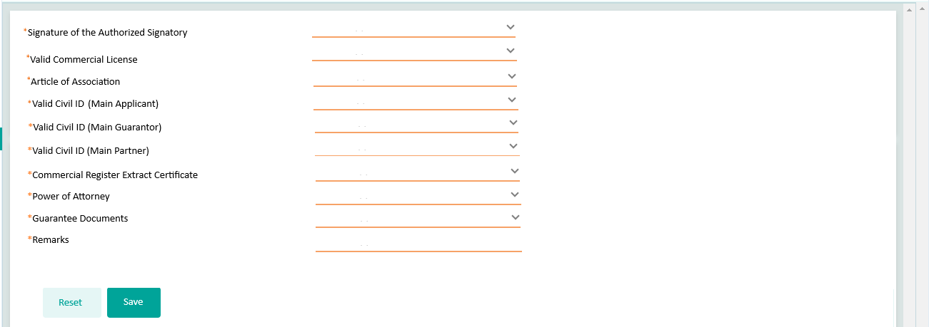

Field Name | Field Type | Data Type / Length | Mandatory (Yes / No) | LookUp Key / Master Name | Possible Values | Field Description
 |  |  |  |  |  | Remarks / Validation
Signature of the Authorized Signatory | LOV Dropdown | VARCHAR | Yes |  | Yes  No | It will be automatically populated as “Yes” if the specific uploaded document is marked as Verified by the sales manager in the Document Verification screen during the verification stage.
Valid Commercial License | LOV Dropdown | VARCHAR | Yes |  | Yes  No | It will be automatically populated as “Yes” if the specific document details captured at the Identification screen are valid.
Article Of Association | LOV Dropdown | VARCHAR | Yes |  | Yes  No | It will be automatically populated as “Yes” if the specific uploaded document is marked as Verified by the sales manager in the Document Verification screen during the verification stage.
Valid Civil Id Main Applicant | LOV Dropdown | VARCHAR | Yes |  | Yes  No | It will be automatically populated as “Yes” if the specific document details captured at the Identification screen are valid.
Valid Civil Id Main Guarantors | LOV Dropdown | VARCHAR | Yes |  | Yes  No | It will be automatically populated as “Yes” if the specific document details captured at the Identification screen are valid.
Valid Civil Id Main Partners | LOV Dropdown | VARCHAR | Yes |  | Yes  No | It will be automatically populated as “Yes” if the specific document details captured at the Identification screen are valid.
Commercial Register Extract Certificate | LOV Dropdown | VARCHAR | Yes |  | Yes  No | It will be automatically populated as “Yes” if the specific uploaded document is marked as Verified by the sales manager in the Document Verification screen during the verification stage.
Power Of Attorney | LOV Dropdown | VARCHAR | Yes |  | Yes  No | It will be automatically populated as “Yes” if the specific uploaded document is marked as Verified by the sales manager in the Document Verification screen during the verification stage.
Guarantee Docments | LOV Dropdown | VARCHAR | Yes |  | Yes  No | It will be automatically populated as “Yes” if the specific uploaded document is marked as Verified by the sales manager in the Document Verification screen during the verification stage.
Remarks | LOV Dropdown | VARCHAR | Yes |  | Yes  No | The user will enter the Remarks.
Action Buttons
Reset | Button | Button | NA | NA | NA | The User will click on this button to clear the entered data.
Save | Button | Button | NA | NA | NA | The User will click on this button to save the entered data.

Stage Completion Rules
Please refer Stage Completion Rules for details about the stage completion rules for this stage.

Interface Touchpoints
Please refer to Interface Touch Points for details about the interface touchpoints required for this stage.

Required Documents
Please refer to Required Document Checklist for details about the documents required at this stage.

Credit Control Review

Access Right Metrics
Access rights metrics display the configuration of screens within each respective stage and tab, indicating the available access rights for users to Add, View, Edit, or data. A "✔" icon signifies the access rights granted for each screen at that stage. Conversely, if all four access rights options are blank and lack an icon, it means that the screen is not applicable for that stage.
Tab Name | Screen Name | Add | View | Edit | Delete
Application | Application Summary |  | ü
KYC | Basic Details |  | ü
KYC | Address Details |  | ü
KYC | Identification Details |  | ü
KYC | Business Details |  | ü
KYC | Relationship Segment |  | ü
KYC | Employment Details
KYC | Bank Details |  | ü
KYC | Repayment Details |  | ü
KYC | Insurance Details |  | ü
KYC | Contact Details |  | ü
Product Details | Collateral Search |  | ü
Product Details | Collateral Details |  | ü
Product Details | Valuation |  | ü
Product Details | Loan Item Details |  | ü
Product Details | Loan Details |  | ü
Product Details | Charges |  | ü
Income & Expense | Income
Income & Expense | Expense
Income & Expense | Credit Bureau Exposure Check |  | ü
Income & Expense | Repayment Ratios
Document | Document Checklist
Document | Document Verification |  | ü
Document | Loan Kit |  | ü
Financials | PNW Checklist |  | ü
Financials | Balance Sheet |  | ü
Financials | Income Statement |  | ü
Financials | Financial Ratios |  | ü
Financials | Cash Flow Analysis |  | ü
Financials | Z-Score Analysis |  | ü
Financials | Qualitative - Quantitative Scoring |  | ü
Policy Review | Policy Check |  | ü
Policy Review | Credit Score Card |  | ü
Policy Review | Exception Details |  | ü
Collection Review | Collection Review
Checklist | Legal Opinion Checklist |  | ü
Checklist | Credit Concentration Review
Checklist | Risk Opinion Checklist
AML Check | Risk Assessment Checklist
AML Check | Customer Risk Rating
Credit Approval | Recommendation
Credit Approval | Recommendation History
Credit Approval | Credit Committee Approval
Disbursement | Disbursement Details
Registration | Registration Details
Document Archive | Document Archive

Business Logic
The Credit Control review process, prior to credit approval, is specific to commercial loans. During this stage, a member of the credit control team reviews the loan application based on the parameters set by CBK guidelines and internal company policies. All screens related to access metrics will be configured for this user in view-only mode, allowing the credit control officer to review detailed information and proceed to the next stage. If any changes are needed, the officer can return the loan application to the appropriate previous stage.
Note: All screens marked with a “ü” in the access rights matrix will be available to the user at this stage, according to the access rights granted.
The screens are configurable and can be arranged along with their required access rights at different stages

Stage Completion Rules
Please refer Stage Completion Rules for details about the stage completion rules for this stage.

Interface Touchpoints
Please refer to Interface Touch Points for details about the interface touchpoints required for this stage.

Required Documents
Please refer to Required Document Checklist for details about the documents required at this stage.

Credit Concentration Check

Access Right Metrics
Access rights metrics display the configuration of screens within each respective stage and tab, indicating the available access rights for users to Add, View, Edit, or data. A "✔" icon signifies the access rights granted for each screen at that stage. Conversely, if all four access rights options are blank and lack an icon, it means that the screen is not applicable for that stage.
Tab Name | Screen Name | Add | View | Edit | Delete
Application | Application Summary |  | ü
KYC | Basic Details
KYC | Address Details
KYC | Identification Details
KYC | Business Details
KYC | Relationship Segment
KYC | Employment Details
KYC | Bank Details
KYC | Repayment Details
KYC | Insurance Details
KYC | Contact Details
Product Details | Collateral Search
Product Details | Collateral Details
Product Details | Valuation
Product Details | Loan Item Details
Product Details | Loan Details |  | ü
Product Details | Charges
Income & Expense | Income
Income & Expense | Expense
Income & Expense | Credit Bureau Exposure Check |  | ü
Income & Expense | Repayment Ratios
Document | Document Checklist |  | ü
Document | Document Verification
Document | Loan Kit |  | ü
Financials | PNW Checklist |  | ü
Financials | Balance Sheet |  | ü
Financials | Income Statement |  | ü
Financials | Financial Ratios |  | ü
Financials | Cash Flow Analysis |  | ü
Financials | Z-Score Analysis |  | ü
Financials | Qualitative - Quantitative Scoring |  | ü
Policy Review | Policy Check |  | ü
Policy Review | Credit Score Card |  | ü
Policy Review | Exception Details |  | ü
Collection Review | Collection Review
Checklist | Legal Opinion Checklist
Checklist | Credit Concentration Review | ü | ü | ü | ü
Checklist | Risk Opinion Checklist
AML Check | Risk Assessment Checklist
AML Check | Customer Risk Rating
Credit Approval | Recommendation
Credit Approval | Recommendation History
Credit Approval | Credit Committee Approval
Disbursement | Disbursement Details
Registration | Registration Details
Document Archive | Document Archive

Business Logic
Note: All screens marked with a “ü” in the access rights matrix will be available to the user at this stage, according to the access rights granted.
The screens are configurable and can be arranged along with their required access rights at different stages

18.2.1 Credit Concentration Review
The Credit Concentration Review applies to commercial loans, where a user from the Finance Control Division assesses the overall customer loan request, including related parties, provided collateral, and the exposure of both the customer and related parties. They verify these details against CBK guidelines and applicable rules, providing input for each rule under the “Inquiry Credit Facility (KD)” and “Required/Utilized Limit” columns.
All rules are configurable within the system using the questionnaire master, allowing admin users to define, edit, or delete any rule parameters in response to changes in CBK guidelines or internal policies.
Navigation:
Credit Concentration Check à Credit Concentration Review
The following screen will be displayed once the User clicks on Credit Concentration Review:
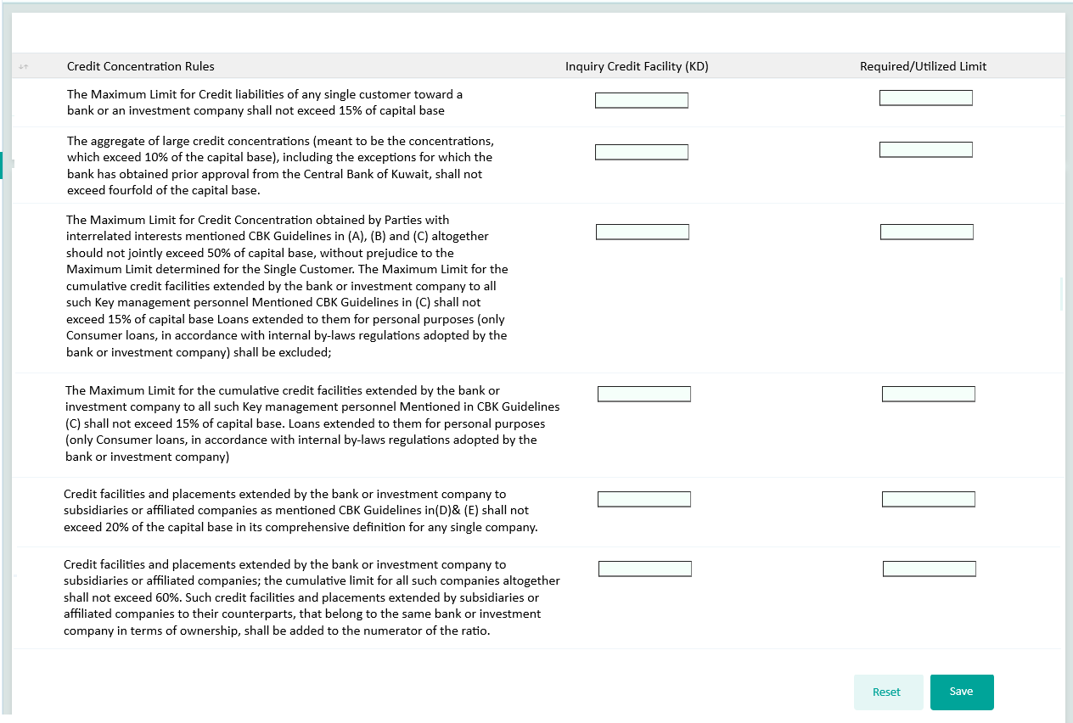

Field Name | Field Type | Data Type / Length | Mandatory (Yes / No) | LookUp Key / Master Name | Possible Values | Field Description
 |  |  |  |  |  | Remarks / Validation
- Credit Consentration Rules  - Inquiry Credit Facility (KD)  - Rquired/Utilized Limit | List View | Grid | NA | NA |  | List view showcasing rules and allowing the user to capture the values across the Inquiry Credit Facility (KD) and Rquired/Utilized Limit column
The Maximum Limit for Credit liabilities of any single customer toward a bank or an investment company shall not exceed 15% of capital base | Parameter | VARCHAR | Yes | NA | NA | The User will enter the value across each rule under the Inquiry Credit Facility (KD) and Rquired/Utilized Limit column
The aggregate of large credit concentrations (meant to be the concentrations, which exceed 10% of the capital base), including the exceptions for which the bank has obtained prior approval from the Central Bank of Kuwait, shall not exceed fourfold of the capital base. | Parameter | VARCHAR | Yes | NA | NA | The User will enter the value across each rule under the Inquiry Credit Facility (KD) and Rquired/Utilized Limit column
The Maximum Limit for Credit Concentration obtained by Parties with interrelated interests mentioned CBK Guidelines in (A), (B) and (C) altogether should not jointly exceed 50% of capital base, without prejudice to the Maximum Limit determined for the Single Customer. The Maximum Limit for the cumulative credit facilities extended by the bank or investment company to all such Key management personnel Mentioned CBK Guidelines in (C) shall not exceed 15% of capital base Loans extended to them for personal purposes (only Consumer loans, in accordance with internal by-laws regulations adopted by the bank or investment company) shall be excluded; | Parameter | VARCHAR | Yes | NA | NA | The User will enter the value across each rule under the Inquiry Credit Facility (KD) and Rquired/Utilized Limit column
The Maximum Limit for the cumulative credit facilities extended by the bank or investment company to all such Key management personnel Mentioned in CBK Guidelines (C) shall not exceed 15% of capital base. Loans extended to them for personal purposes (only Consumer loans, in accordance with internal by-laws regulations adopted by the bank or investment company) | Parameter | VARCHAR | Yes | NA | NA | The User will enter the value across each rule under the Inquiry Credit Facility (KD) and Rquired/Utilized Limit column
Credit facilities and placements extended by the bank or investment company to subsidiaries or affiliated companies as mentioned CBK Guidelines in(D)& (E) shall not exceed 20% of the capital base in its comprehensive definition for any single company. | Parameter | VARCHAR | Yes | NA | NA | The User will enter the value across each rule under the Inquiry Credit Facility (KD) and Rquired/Utilized Limit column
Credit facilities and placements extended by the bank or investment company to subsidiaries or affiliated companies; the cumulative limit for all such companies altogether shall not exceed 60%. Such credit facilities and placements extended by subsidiaries or affiliated companies to their counterparts, that belong to the same bank or investment company in terms of ownership, shall be added to the numerator of the ratio. | Parameter | VARCHAR | Yes | NA | NA | The User will enter the value across each rule under the Inquiry Credit Facility (KD) and Rquired/Utilized Limit column
Action Buttons
Reset | Button | Button | NA | NA | NA | The User will click on this button to clear the entered data.
Save | Button | Button | NA | NA | NA | The User will click on this button to save the entered data.

Stage Completion Rules
Please refer Stage Completion Rules for details about the stage completion rules for this stage.

Interface Touchpoints
Please refer to Interface Touch Points for details about the interface touchpoints required for this stage.

Required Documents
Please refer to Required Document Checklist for details about the documents required at this stage.

AML Screening & Approval

Access Right Metrics
Access rights metrics display the configuration of screens within each respective stage and tab, indicating the available access rights for users to Add, View, Edit, or data. A "✔" icon signifies the access rights granted for each screen at that stage. Conversely, if all four access rights options are blank and lack an icon, it means that the screen is not applicable for that stage.
Tab Name | Screen Name | Add | View | Edit | Delete
Application | Application Summary |  | ü
KYC | Basic Details |  | ü
KYC | Address Details |  | ü
KYC | Identification Details |  | ü
KYC | Business Details |  | ü
KYC | Relationship Segment |  | ü
KYC | Employment Details |  | ü
KYC | Bank Details
KYC | Repayment Details
KYC | Insurance Details
KYC | Contact Details
Product Details | Collateral Search
Product Details | Collateral Details
Product Details | Valuation
Product Details | Loan Item Details |  | ü
Product Details | Loan Details |  | ü
Product Details | Charges
Income & Expense | Income
Income & Expense | Expense
Income & Expense | Credit Bureau Exposure Check |  | ü
Income & Expense | Repayment Ratios |  | ü
Document | Document Checklist |  | ü
Document | Document Verification
Document | Loan Kit |  | ü
Financials | PNW Checklist
Financials | Balance Sheet
Financials | Income Statement
Financials | Financial Ratios |  | ü
Financials | Cash Flow Analysis |  | ü
Financials | Z-Score Analysis |  | ü
Financials | Qualitative - Quantitative Scoring |  | ü
Policy Review | Policy Check |  | ü
Policy Review | Credit Score Card |  | ü
Policy Review | Exception Details |  | ü
Collection Review | Collection Review
Checklist | Legal Opinion Checklist
Checklist | Credit Concentration Review
Checklist | Risk Opinion Checklist
AML Check | Risk Assessment Checklist | ü | ü | ü | ü
AML Check | Customer Risk Rating | ü | ü | ü | ü
Credit Approval | Recommendation
Credit Approval | Recommendation History
Credit Approval | Credit Committee Approval
Disbursement | Disbursement Details
Registration | Registration Details
Document Archive | Document Archive

Business Logic
The AML Screening and Approval stage plays a crucial role in assessing and computing the risk associated with each customer. This process allows business users to gain a clear understanding of potential risks by analysing various factors. Enhancing overall risk management strategies, allowing for more informed decision-making regarding customer relationships.
Note: All screens marked with a “ü” in the access rights matrix will be available to the user at this stage, according to the access rights granted.
The screens are configurable and can be arranged along with their required access rights at different stages

19.2.1 Risk Assessment Checklist
Enables the AML compliance team to capture risk assessment parameters related to the customer and the guarantor by referencing documents provided by the sales team and the screening report generated from the Refinitiv LSEG portal, which assists in determining the customer's risk rating.
Navigation:
AML Screening & Approval à Risk Assessment Checklist
The following screen will be displayed once the User clicks on Risk Assessment Checklist:
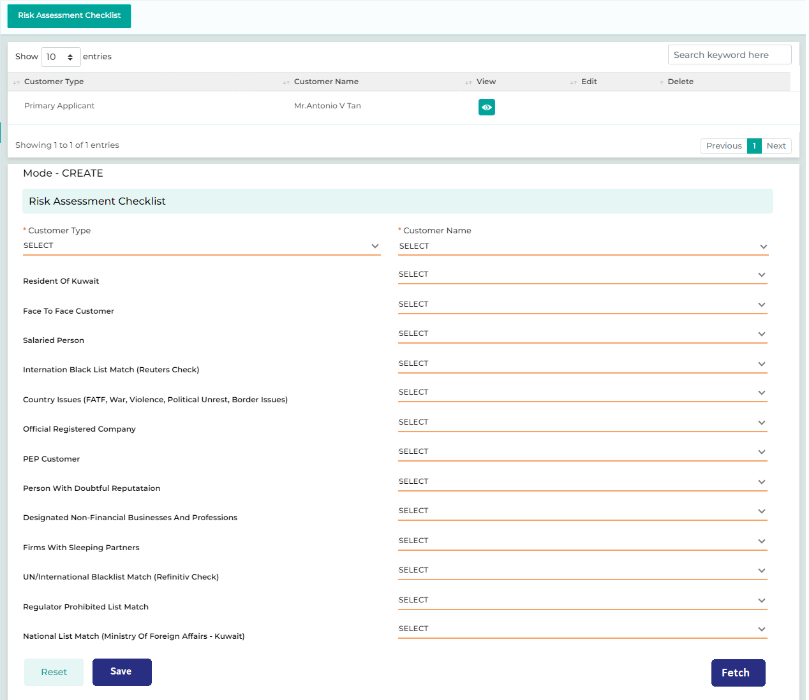
Field Name | Field Type | Data Type / Length | Mandatory (Yes / No) | LookUp Key / Master Name | Possible Values | Field Description
 |  |  |  |  |  | Remarks / Validation
- Customer Type  - Customer Name | List View | Grid | NA | NA | NA | Display the multiple risk assessment details captured by the user in a grid for different customer type linked to the loan application.
Customer Type | LOV Dropdown | VARCHAR | Yes | 4034 | - Main Applicant  - Guarantor | The User will select the customer type.
Customer Name | Master Dropdown | VARCHAR | Yes | NA | NA | The User will select the customer’s name.
Resident of Kuwait | LOV Dropdown | VARCHAR | Yes |  | Yes  No | Will be auto-populated basis of the data captured on the basic details screen for the following customer
Face to Face Customer | LOV Dropdown | VARCHAR | Yes |  | Yes  No | Will be auto-populated basis of the mode of customer onboarding for the folloing customer.  Yes: If customer walk-in to the branch and application was initiated by the slaes user using the LOS  No: If the application was created via the digital channel.
Salaried Person | LOV Dropdown | VARCHAR | Yes |  | Yes  No | Will be auto-populated basis of the data captured on the ployment details screen for the following customer
Internation Blacklist Match (Reuters Check) | LOV Dropdown | VARCHAR | Yes |  | Yes  No | The user can select "Yes" or "No" from the provided list.  Alternatively, the data can be fetched via the WorldCheck One interface.
Country issues (FATF, War, Violence, political unrest, border issues) | LOV Dropdown | VARCHAR | Yes |  | Yes  No | The user can select "Yes" or "No" from the provided list. Alternatively, the information can be populated by maintaining a master list and checking the customer against that list.
Official Registered Company | LOV Dropdown | VARCHAR | Yes |  | Yes  No | The user will select basis of the documents available
PEP Customer | LOV Dropdown | VARCHAR | Yes |  | Yes  No | Will be auto-populated basis of the data captured on the basic details screen for the following customer
Person with doubtful reputation | LOV Dropdown | VARCHAR | Yes |  | Yes  No | The user will select basis of the documents available
Designated Non-Financial Businesses and Professions | LOV Dropdown | VARCHAR | Yes |  | Yes  No | The user will select basis of the documents available
Firms with sleeping Partners | LOV Dropdown | VARCHAR | Yes |  | Yes  No | The user will select basis of the documents available
UN/International Blacklist Match (Refinitiv Check) | LOV Dropdown | VARCHAR | Yes |  | Yes  No | The user can select "Yes" or "No" from the provided list.  Alternatively, the data can be fetched via the WorldCheck One interface.
Regulator Prohibited List Match | LOV Dropdown | VARCHAR | Yes |  | Yes  No | The user can select "Yes" or "No" from the provided list. Alternatively, the information can be populated by maintaining a master list and checking the customer against that list.
National List Match (Ministry of Foreign Affairs - Kuwait) | LOV Dropdown | VARCHAR | Yes |  | Yes  No | The user can select "Yes" or "No" from the provided list. Alternatively, the information can be populated by maintaining a master list and checking the customer against that list.
Action Buttons
Reset | Button | Button | NA | NA | NA | The User will click on this button to clear the entered data.
Save | Button | Button | NA | NA | NA | The User will click on this button to save the entered data.
Fetch | Button | Button | NA | NA | NA | The user will click on fetch button to trigger the interface for WorldCheck One fetching the details related to the UN & International blacklist.

19.2.2 Customer Risk Rating
The Customer Risk Rating provides the approver users with insights into the risks associated with a customer based on data gathered during KYC due diligence and risk assessments conducted by the AML compliance team. The risk score is categorized into four levels: Low, Medium, High, and Rejected.
If the risk rating is High, the application will be forwarded to the CEO or other authorized user for approval before proceeding to the next stage. If the authorized user declines the application, it will be marked as rejected and moved to the rejection queue and if accepted the application will be processed to the next stage.

- Detailed document to be referred to for Customer Risk Rating
Navigation:
AML Screening & Approval à Customer Risk Rating
The following screen will be displayed once the User clicks on Customer Risk Rating:
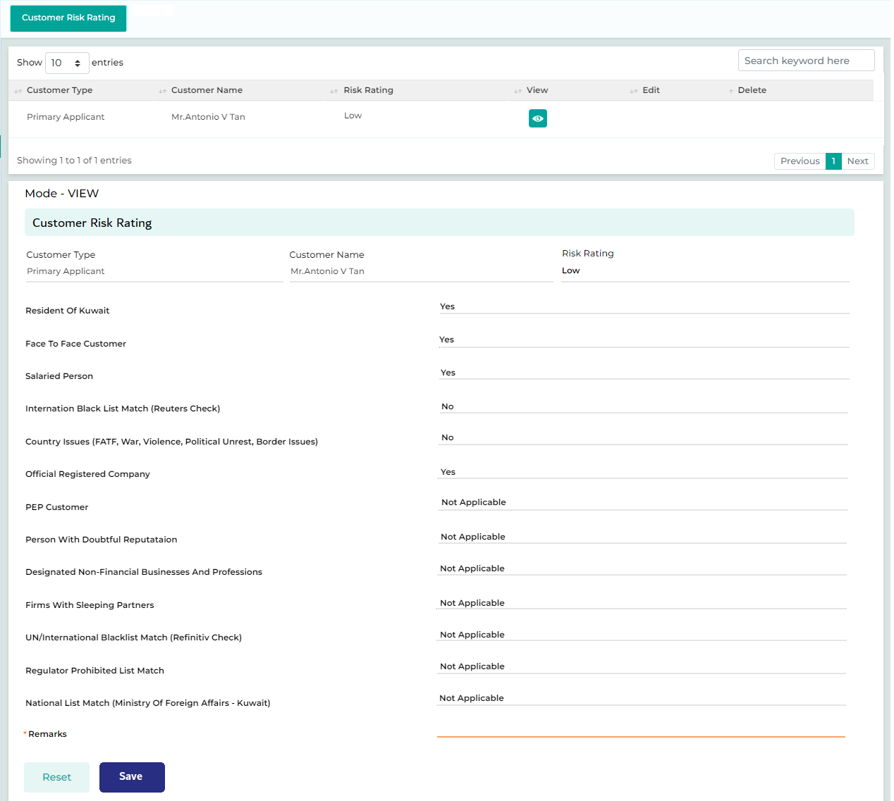
Below are the details specific to the information being displayed above.

Field Name | Field Type | Data Type / Length | Mandatory (Yes / No) | LookUp Key / Master Name | Possible Values | Field Description
 |  |  |  |  |  | Remarks / Validation
- Customer Type  - Customer Name  - Risk Rating  - View | List View | Grid | NA | NA | NA | Display the multiple risk assessment details captured by the user in a grid for different customer type from the Risk Assessment Screen.
Customer Type | Read Only | VARCHAR | Yes | 4034 | - Main Applicant  - Guarantor | The system will displays the customer type
Customer Name | Read Only | VARCHAR | Yes | NA | NA | The system will displays the customer name
Risk Rating | Read Only | VARCHAR | Yes | NA | - Low  - Medium  - High  - Rejected | Th system will automatically computes the Risk rating based on the parameters configured.  Refer the attachedment “Customer Risk Rating” for the configuration.
Resident of Kuwait | Read Only | VARCHAR | Yes |  | Yes  No | The system will display the details captured in the risk assesment checklist screen.
Face to Face Customer | Read Only | VARCHAR | Yes |  | Yes  No | The system will display the details captured in the risk assesment checklist screen.
Salaried Person | Read Only | VARCHAR | Yes |  | Yes  No | The system will display the details captured in the risk assesment checklist screen.
Internation Blacklist Match (Reuters Check) | Read Only | VARCHAR | Yes |  | Yes  No | The system will display the details captured in the risk assesment checklist screen.
Country issues (FATF, War, Violence, political unrest, border issues) | Read Only | VARCHAR | Yes |  | Yes  No | The system will display the details captured in the risk assesment checklist screen.
Official Registered Company | Read Only | VARCHAR | Yes |  | Yes  No | The system will display the details captured in the risk assesment checklist screen.
PEP Customer | Read Only | VARCHAR | Yes |  | Yes  No | The system will display the details captured in the risk assesment checklist screen.
Person with doubtful reputation | Read Only | VARCHAR | Yes |  | Yes  No | The system will display the details captured in the risk assesment checklist screen.
Designated Non-Financial Businesses and Professions | Read Only | VARCHAR | Yes |  | Yes  No | The system will display the details captured in the risk assesment checklist screen.
Firms with sleeping Partners | Read Only | VARCHAR | Yes |  | Yes  No | The system will display the details captured in the risk assesment checklist screen.
UN/International Blacklist Match (Refinitiv Check) | Read Only | VARCHAR | Yes |  | Yes  No | The system will display the details captured in the risk assesment checklist screen.
Regulator Prohibited List Match | Read Only | VARCHAR | Yes |  | Yes  No | The system will display the details captured in the risk assesment checklist screen.
National List Match (Ministry of Foreign Affairs - Kuwait) | Read Only | VARCHAR | Yes |  | Yes  No | The system will display the details captured in the risk assesment checklist screen.
Remarks | Text Box | NVARCHAR | Yes |  | NA | The user will enter the remarks and justification if any.
Action Buttons
Reset | Button | Button | NA | NA | NA | The User will click on this button to clear the entered data.
Save | Button | Button | NA | NA | NA | The User will click on this button to save the entered data.

Stage Completion Rules
Please refer Stage Completion Rules for details about the stage completion rules for this stage.

Interface Touchpoints
Please refer to Interface Touch Points for details about the interface touchpoints required for this stage.

Required Documents
Please refer to Required Document Checklist for details about the documents required at this stage.

Risk Opinion

Access Right Metrics
Access rights metrics display the configuration of screens within each respective stage and tab, indicating the available access rights for users to Add, View, Edit, or data. A "✔" icon signifies the access rights granted for each screen at that stage. Conversely, if all four access rights options are blank and lack an icon, it means that the screen is not applicable for that stage.
Tab Name | Screen Name | Add | View | Edit | Delete
Application | Application Summary |  | ü
KYC | Basic Details |  | ü
KYC | Address Details
KYC | Identification Details |  | ü
KYC | Business Details |  | ü
KYC | Relationship Segment |  | ü
KYC | Employment Details
KYC | Bank Details
KYC | Repayment Details
KYC | Insurance Details
KYC | Contact Details
Product Details | Collateral Search
Product Details | Collateral Details |  | ü
Product Details | Valuation
Product Details | Loan Item Details |  | ü
Product Details | Loan Details |  | ü
Product Details | Charges
Income & Expense | Income
Income & Expense | Expense
Income & Expense | Credit Bureau Exposure Check |  | ü
Income & Expense | Repayment Ratios
Document | Document Checklist
Document | Document Verification |  | ü
Document | Loan Kit |  | ü
Financials | PNW Checklist |  | ü
Financials | Balance Sheet |  | ü
Financials | Income Statement |  | ü
Financials | Financial Ratios |  | ü
Financials | Cash Flow Analysis |  | ü
Financials | Z-Score Analysis |  | ü
Financials | Qualitative - Quantitative Scoring |  | ü
Policy Review | Policy Check |  | ü
Policy Review | Credit Score Card |  | ü
Policy Review | Exception Details
Collection Review | Collection Review
Checklist | Legal Opinion Checklist
Checklist | Credit Concentration Review
Checklist | Risk Opinion Checklist | ü | ü | ü | ü
AML Check | Risk Assessment Checklist
AML Check | Customer Risk Rating
Credit Approval | Recommendation
Credit Approval | Recommendation History
Credit Approval | Credit Committee Approval
Disbursement | Disbursement Details
Registration | Registration Details
Document Archive | Document Archive

Business Logic
The Risk Opinion stage applies only to commercial loans, and the application will be assigned to this stage following the completion of the AML screening. This process follows a maker-checker system, where a maker from the Risk Management Division captures data points in the Risk Opinion Checklist screen, along with recommendations. This information is used to generate the Risk Opinion report for the loan application. The report is then submitted to the Executive Director of the Risk Management Division for approval, allowing the application to move to the next stage.
Note: All screens marked with a “ü” in the access rights matrix will be available to the user at this stage, according to the access rights granted.
The screens are configurable and can be arranged along with their required access rights at different stages.

20.2.1 Risk Opinion Checklist
The Risk Opinion Checklist enables the user to capture detailed information about the overall customer background, the loan proposal being applied for, and data points from the commercial Ci-net credit bureau report. It also includes the financial information of the customer and details about any guarantors. In addition to capturing this comprehensive information, the checklist allows for the generation of a Risk Opinion report, which can be utilized in the loan processing workflow.
Navigation:
Risk Opinion à Risk Opinion à Risk Opinion Checklist

The following screen will be displayed once the user clicks on Risk Opinion Checklist:
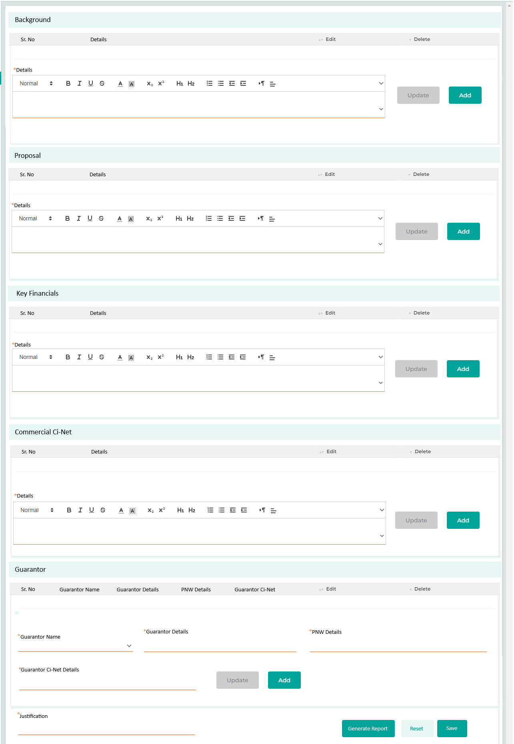
Field Name | Field Type | Data Type / Length | Mandatory (Yes / No) | LookUp Key/Master Name | Possible Values | Field Description
 |  |  |  |  |  | Remarks / Validation
Background
Sr No  Details  Edit  Delete | List View | VARCHAR | Yes | NA | NA | Display the details captured in the grid list.
Details | Rich Text | NVARCHAR | Yse | NA | NA | The user will enter the details related to the Background of the customers and keep on adding the details in the grid by clicking the Add button.
Proposal
Sr No  Details  Edit  Delete | List View | VARCHAR | Yes | NA | NA | Display the details captured in the grid list.
Details | Rich Text | NVARCHAR | Yse | NA | NA | The user will enter the details related to the Loan Proposal and keep on adding the details in the grid by clicking the Add button.
Key Financials
Sr No  Details  Edit  Delete | List View | VARCHAR | Yes | NA | NA | Display the details captured in the grid list.
Details | Rich Text | NVARCHAR | Yse | NA | NA | The user will enter the details related to the Finacials of the customer and keep on adding the details in the grid by clicking the Add button.
Commercial Ci-Net
Sr No  Details  Edit  Delete | List View | VARCHAR | Yes | NA | NA | Display the details captured in the grid list.
Details | Rich Text | NVARCHAR | Yse | NA | NA | The user will enter the details related to the company’s Ci-Net and keep on adding the details in the grid by clicking the Add button.
Guarantor
Sr No  Guarantor Name  Guarantor Details  PNW Details  Guarantor Ci-Net Details  Edit  Delete | List View | VARCHAR | Yes | NA | NA | Display the details captured in the grid list.
Guarantor Name | LOV Dropdown | VARCHAR | Yse | NA | NA | The user will select the guarantor name from the dropdown.
Guarantor Details | Rich Text | NVARCHAR | Yse | NA | NA | The user will enter the details related to the guarantor such as nationality and age, keep on adding the details in the grid by clicking the Add button
PNW Details | Rich Text | NVARCHAR | Yse | NA | NA | The user will enter the details related to the guarantor PNW and keep on adding the details in the grid by clicking the Add button
Guarantor Ci-Net Details | Rich Text | NVARCHAR | Yse | NA | NA | The user will enter the details related to the guarantor Ci-Net details and keep on adding the details in the grid by clicking the Add button
Update | Button | NA | NA | NA | NA | Update button will be applicable only if te user has clicked on the Edit button from the grid of each section.
Add | Button | NA | NA | NA | NA | Add button will be availble under each section Backgroud, Proposal, Key Financial, Commercial Ci-Net & Guarantor Details to keep on adding multiple records.
Justification | Rich Text | NVARCHAR | Yse | NA | NA | The user will add any remarks or justification in brief regarding the overall analysis done on the application.
Action Buttons
Generate Report | Button | Button | NA | NA | NA | The user will click the "Generate Report" button to create the Risk Opinion report, which incorporates all the detailed information captured across the various sections of the screen.
Reset | Button | Button | NA | NA | NA | The reset button will help the User clear contents from the fields and start capturing the document again.
Save | Button | Button | NA | NA | NA | The save button will let the User save the captured information.

20.2.2 Risk Opinion Approval
Risk Opinion Approval is a sub-stage within the Risk Opinion stage where the report generated from the details captured in the Risk Opinion Checklist is reviewed by the Executive Director of the Risk Management Division. The Executive Director's approval is necessary to proceed with the application to the next stage.
Risk Opinion checklist will be applicable in a read only mode along with the previously mapped screens.

Stage Completion Rules
Please refer Stage Completion Rules for details about the stage completion rules for this stage.

Interface Touchpoints
Please refer to Interface Touch Points for details about the interface touchpoints required for this stage.

Required Documents
Please refer to Required Document Checklist for details about the documents required at this stage.

Credit Approval

Access Right Metrics
Access rights metrics display the configuration of screens within each respective stage and tab, indicating the available access rights for users to Add, View, Edit, or data. A "✔" icon signifies the access rights granted for each screen at that stage. Conversely, if all four access rights options are blank and lack an icon, it means that the screen is not applicable for that stage.
Tab Name | Screen Name | Add | View | Edit | Delete
Application | Application Summary |  | ü
KYC | Basic Details |  | ü
KYC | Address Details
KYC | Identification Details
KYC | Business Details |  | ü
KYC | Relationship Segment |  | ü
KYC | Employment Details
KYC | Bank Details
KYC | Repayment Details
KYC | Insurance Details |  | ü
KYC | Contact Details
Product Details | Collateral Search
Product Details | Collateral Details |  | ü
Product Details | Valuation |  | ü
Product Details | Loan Item Details |  | ü
Product Details | Loan Details |  | ü
Product Details | Charges
Income & Expense | Income |  | ü
Income & Expense | Expense |  | ü
Income & Expense | Credit Bureau Exposure Check |  | ü
Income & Expense | Repayment Ratios |  | ü
Document | Document Checklist
Document | Document Verification |  | ü
Document | Loan Kit |  | ü
Financials | PNW Checklist |  | ü
Financials | Balance Sheet |  | ü
Financials | Income Statement |  | ü
Financials | Financial Ratios |  | ü
Financials | Cash Flow Analysis |  | ü
Financials | Z-Score Analysis |  | ü
Financials | Qualitative - Quantitative Scoring |  | ü
Policy Review | Policy Check |  | ü
Policy Review | Credit Score Card |  | ü
Policy Review | Exception Details
Collection Review | Collection Review
Checklist | Legal Opinion Checklist |  | ü
Checklist | Credit Concentration Review |  | ü
Checklist | Risk Opinion Checklist |  | ü
AML Check | Risk Assessment Checklist |  | ü
AML Check | Customer Risk Rating |  | ü
Credit Approval | Recommendation | ü | ü | ü | ü
Credit Approval | Recommendation History | ü | ü | ü | ü
Credit Approval | Credit Committee Approval | ü | ü | ü | ü
Disbursement | Disbursement Details
Registration | Registration Details
Document Archive | Document Archive

Business Logic
The credit approval process is managed by lending authorities assigned at various committee levels. The allocation of loan applications to specific credit committees is based on the customer’s total exposure, which includes both the principal balance amount, and the amount of new financing required. Each credit committee consists of several members who provide recommendations and approvals. The application will be marked as either recommended, approved, or rejected based on predefined criteria.
According to the lending authority rules defined in the system, the software identifies the appropriate approvers and recommenders within a hierarchical structure. Users responsible for recommending the application will see a "Recommend" button, while approvers will have access to an "Approve" button as configured.
The committee responsible for the initial assessment provides recommendations by clicking the "Recommend" button, which advances the application through successive levels of authority. This process continues until it reaches the designated individual or joint approver, who has the final authority to approve the loan. Once at this stage, the approver will provide their input and click the "Approve" button.
The digital stamp and signature of each approver will be stored in image format within the system in the user master. When a voting member provides their approval and moves the application to the next stage, their stamp and signature will be imprinted in the designated location on the document. The member at the next stage will be able to generate a document that includes the previous user's stamp and signature, emphasizing the authenticity of the approval. Later, this document can be generated and shared with the customer, featuring the signatures of all approvers to confirm their acceptance.
Validation will be enforced so that the maker of a loan application cannot be part of the approval committee for retail loans. However, for commercial loans, the maker of the loan application may be included in the approval committee.
- Detailed Credit Approval Level & Lending authority
Note: All screens marked with a “ü” in the access rights matrix will be available to the user at this stage, according to the access rights granted.
The screens are configurable and can be arranged along with their required access rights at different stages.

Scenario 1: Let us consider a customer applying for a retail loan of KD 25,000. The customer currently has an existing exposure of KD 10,000, bringing the total exposure to KD 35,000. According to the credit approval metrics, this application falls under the "Executive Retail Credit Committee," which has an approval limit ranging from KD 25,000 to KD 95,000.
1. Initially, the recommendation will be provided by the Non-Voting Members by providing their input on the Recommendation screen:
- Executive Director - Risk, Compliance, and AML: This member evaluates the application based on factors such as the customer’s credit history, financial stability, and the purpose of the loan.
- Financial Manager: This member analyses the financial implications and provides recommendations.
2. If all Non-Voting Members agree that the application meets the necessary criteria, they will recommend it for approval.
3. The application will then be reviewed by the Voting Members of the committee, who will consider recommendations from the Recommendation History screen and provide their own assessment Recommendation screen:
- Voting Members include the CEO, Directors of Financial Services, Manager of Financial Services, Manager of Commercial Finance, and Assistant of Commercial Finance.
4. If all Voting Members reach a consensus, the application is approved.
5. If any Voting Member disagrees and withholds approval, the application is rejected.

Scenario 2: Let us consider a customer applying for a commercial loan of KD 20,000. The customer currently has an existing exposure of KD 5,000, bringing the total exposure to KD 25,000. According to the credit approval metrics, this application falls under the "Commercial Credit Committee," which has an approval limit ranging up to KD 25,000.
1. Initially, the recommendation will be provided by the Non-Voting Members by providing their input on the Recommendation screen:
- Executive Director - Risk, Compliance, and AML: This member evaluates the application based on factors such as the customer’s credit history, financial stability, and the purpose of the loan.

2. If all Non-Voting Members agree that the application meets the necessary criteria, they will recommend it for approval.
3. The application will then be reviewed by the Voting Members of the committee, who will consider recommendations from the Recommendation History screen and provide their own assessment Recommendation screen:
- Voting Members include the CEO, Manager of Commercial Finance, and Assistant Manager of Commercial Finance or any user authorized by the CEO
4. If all Voting Members reach a consensus, the application is approved.
5. If any Voting Member disagrees and withholds approval, the application is rejected.
Scenario 3: In all scenarios, applications will be assigned to the appropriate committee based on their approval authority. However, if the overall exposure of the customer falls within the approval limit range of the Executive Committee, the application will first be assigned to the Voting Members of the Executive Credit Committee. Once they provide their approval, the application will then be forwarded to the Voting Members of the Executive Committee for their final approval.
Let us consider a customer applying for a commercial loan with the total exposure between KD 350,000 to KD 500,000. According to the credit approval metrics, this application falls under the "Executive Committee.”
1. Initially, the recommendation will be provided by the Non-Voting Members of the Executive Committee by providing their input on the Recommendation screen:
- Executive Director - Risk, Compliance, and AML: This member evaluates the application based on factors such as the customer’s credit history, financial stability, and the purpose of the loan.
- Financial Manager: This member analyses the financial implications and provides recommendations.

2. If all Non-Voting Members agree that the application meets the necessary criteria, they will recommend it for approval from the Executive Credit Committee
3. The application will then be reviewed by the Voting Members of the Executive Credit Committee, who will consider recommendations from the Recommendation History screen and proceed it ahead after providing their approval.
- Voting Members include the CEO & Chairman of Board of Director
4. The application will then be reviewed by the Voting Members of the Executive Committee, who will consider recommendations from the Recommendation History screen and provide their approval.
- Voting Members include the Chairman of Board of Director and the Board Members
4. If all Voting Members reach a consensus, the application is approved.
5. If any Voting Member disagrees and withholds approval, the application is rejected.

21.2.1 Recommendation
This screen enables the user to input details such as the recommended amount & interest rate to be offered to the customer based on the assessment. If the application falls within the queue of the non-voting members of the specific committee, referring to the lending authority limit, they can recommend it to the voting members by clicking the "Recommend" button to move it forward.
Once assigned to the Voting Members of the respective committee, they will conduct their assessment and can either click "Approve" to accept the application or "Decline" to reject the application.
Navigation:
Credit Analyst à Credit Approval à Recommendation
The following screen will be displayed once the User clicks on Recommendation:
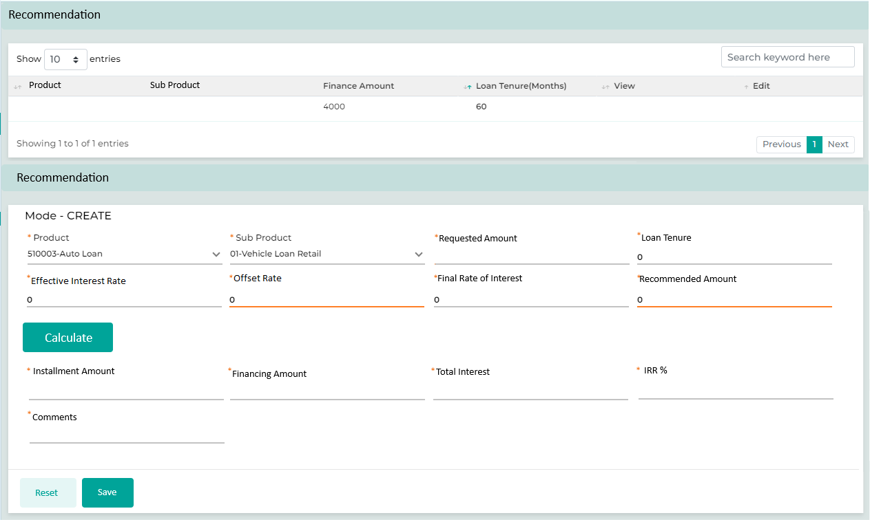

Below are the details specific to the information being displayed above.
Field Name | Field Type | Data Type / Length | Mandatory (Yes / No) | LookUp Key/Master Name | Possible Values | Field Description
 |  |  |  |  |  | Remarks / Validation
Product | List View |  | NA |  |  | The system will display the detail in the grid.
Sub Product | List View |  | NA |  |  | The system will display the detail in the grid.
Finance Amount | List View |  | NA |  |  | The system will display the detail in the grid.
Loan Tenure | List View |  | NA |  |  | The system will display the detail in the grid.
View | Button |  | NA
Edit | Button |  | NA
Recommendation
Product | Read Only |  | NA |  |  | Will be populated from the Loan Details screen
Sub Product | Read Only |  | NA |  |  | Will be populated from the Loan Details screen
Requested Amount | Read Only |  |  |  |  | Will be populated from the Loan Details screen – Loan Item Price
Loan Tenure | Read Only |  | NA |  |  | Will be populated from the Loan Details screen – Tenure in Months
Effective Interest Rate | Read Only |  | NA |  |  | Will be populated from the Loan Details screen – Effective Interest Rate %
Offset Rate | Text Box |  | NA |  |  | The user can enter the percentage offset to be applied to the effective interest rate, along with the appropriate operator. To increase the interest rate, the user should enter a '+' sign followed by the percentage by which the rate should be increased. To decrease the interest rate, the user should enter a '-' sign followed by the percentage by which the rate should be decreased.
Final Rate Of Insterest | Read Only |  | NA |  |  | To be computed as To be computed as  Effective Interest Rate + {(+/- Based on the operator entered) Offset Rate}
Recommended Amount | Text Box |  |  |  |  | The user will enter the recommended amount as per the decision made.
Calculate | Button |  | NA |  |  | The uer will click on calculate button in order to generate the computation.
Installment Amount | Read Only |  | NA |  |  | The system will compute basis of the new recommended amount.
Financing Amount | Read Only |  | NA |  |  | The system will compute basis of the new recommended amount.
Total Interest | Read Only |  | NA |  |  | The system will compute basis of the new recommended amount.
IRR % | Read Only |  | NA |  |  | The system will compute basis of the new recommended amount.
Comments | Read Only |  | NA |  |  | The system will compute basis of the new recommended amount.
Action Buttons
Reset | Button | Button | NA | NA | NA | The User will click on this button to clear the entered data.
Save | Button | Button | NA | NA | NA | The User will click on this button to save the data.

- Recommendation – Credit Limit
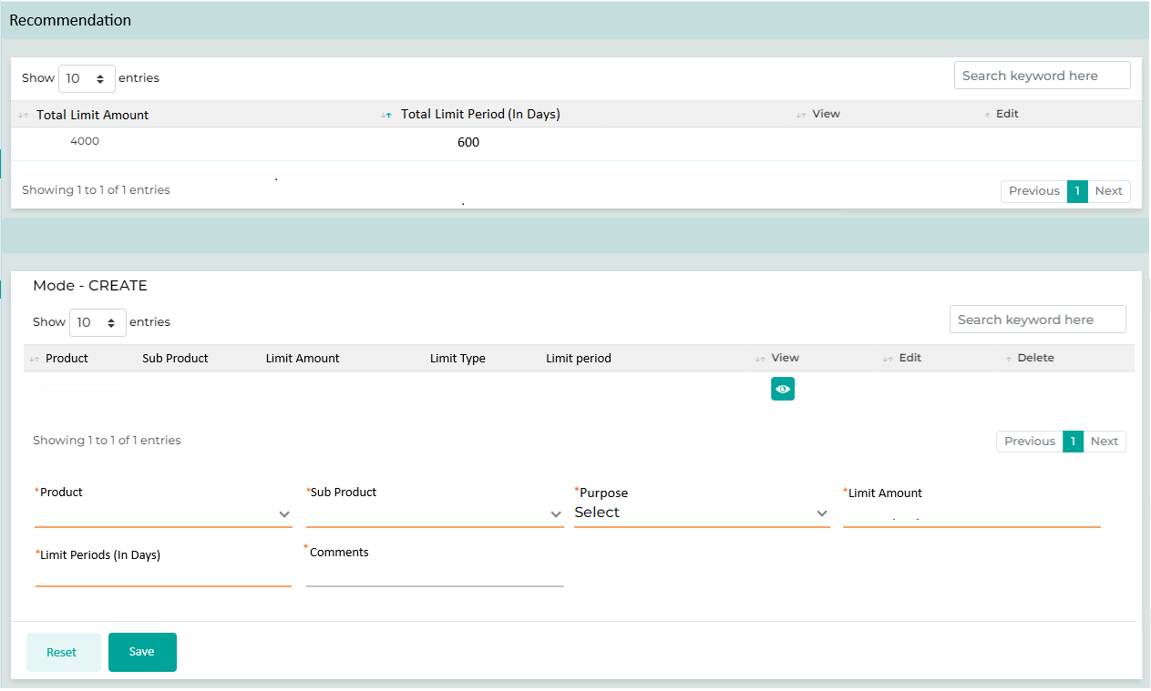

21.2.2 Recommendation History
This screen provides the user with information about the recommendations made at the previous underwriting stages, including their comments and decisions.
Navigation:
Credit Analyst à Credit Approval à Recommendation History
The following screen will be displayed once the User clicks on Recommendation History:

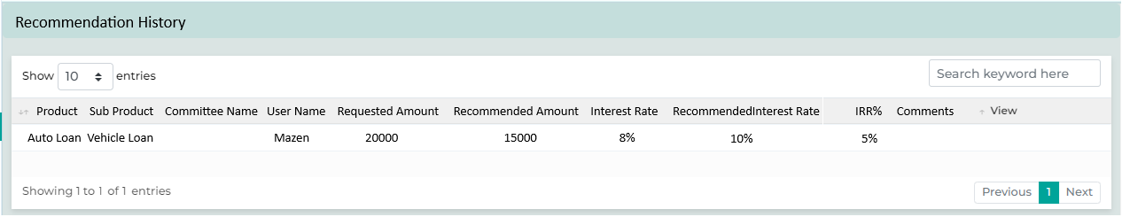

Field Name | Field Type | Data Type / Length | Mandatory (Yes / No) | LookUp Key/Master Name | Possible Values | Field Description
 |  |  |  |  |  | Remarks / Validation
Product | List View |  | NA |  |  | Will be auto-populate basis of the selection done in the Recommedation screen.
Sub Product | List View |  | NA |  |  | Will be auto-populate basis of the selection done in the Recommedation screen.
Committee Name | List View |  | NA |  |  | Will be auto-populate basis of Credit Committie to which the application has sent for approval.
User Name | List View |  | NA |  |  | Will be auto-populate basis of user umndr that particular Credit Committie to which the application has sent for approval.
Requested Amount | List View |  | NA |  |  | Will be auto-populate basis of the selection done in the Recommedation screen – Requested Amount
Recommended Amount | List View |  | NA |  |  | Will be auto-populate basis of the selection done in the Recommedation screen – Recommednded Amount
Interest Rate | List View |  | NA |  |  | Will be auto-populate basis of the selection done in the Recommedation screen – Interest Rate
Recommeded Interest Rate | List View |  | NA |  |  | Will be auto-populate basis of the selection done in the Recommedation screen – Final Rate of Interest
IRR % | List View |  | NA |  |  | Will be auto-populate basis of the selection done in the Recommedation screen.
Comments | List View |  | NA |  |  | Will be auto-populate basis of the selection done in the Recommedation screen.
View | Button |  | NA |  |  | On clcik of view, what all data points available at the recommendtion screen will be available in read only mode.

- Recommendation History – Credit Limit

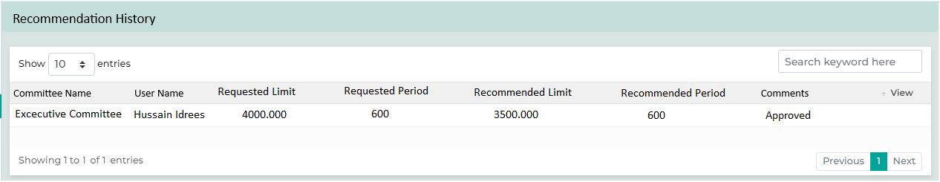

21.2.3 Committee Approval
The Committee Approval functionality is designed to record approvals from the Chairman or Board Members for loan applications processed outside the system, typically via email. This feature allows the Committee Coordinator (Company Secretary) to log forward decisions and comments from each committee member received through various external channels.
The Committee Coordinator will also track the attendance of each member during the decision-making process, along with their remarks and decisions. Based on the established logic reflecting individual committee members' decisions, the system will calculate the Overall Decision. Additionally, the Committee Coordinator can input overall remarks as necessary.

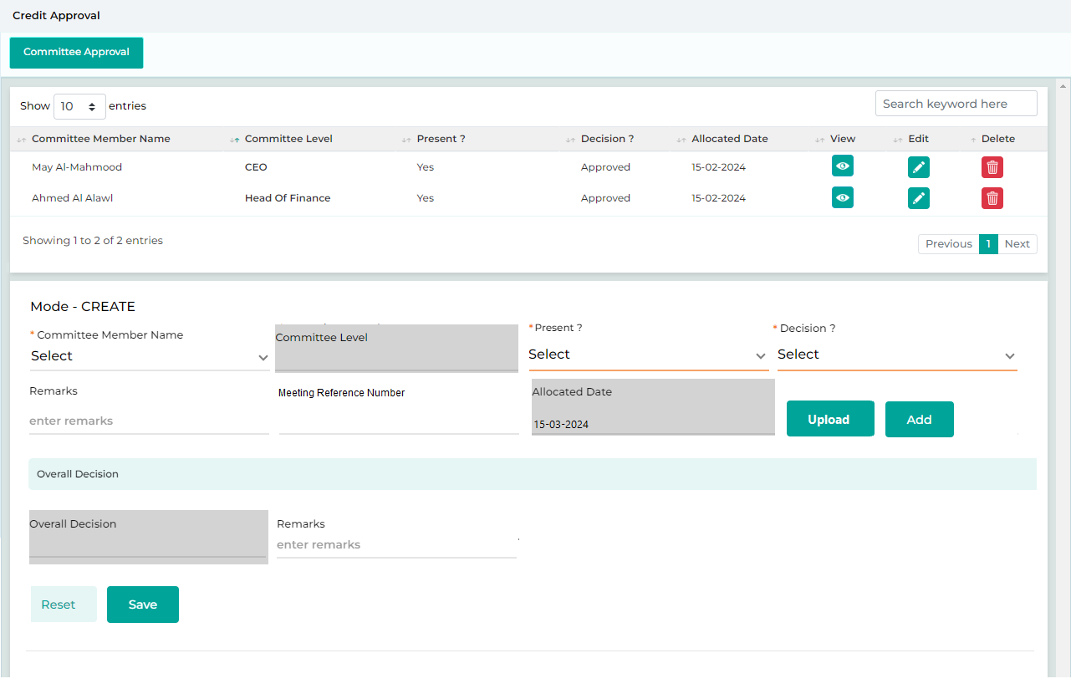

Field Name | Field Type | Data Type / Length | Mandatory (Yes / No) | Lookup Key/Master Name | Possible Values | Field Description
 |  |  |  |  |  | Remarks / Validation
Committee Member Name | List View | VARCHAR | Yes | NA | NA | Displays the Committee member name for which the decision has been captured.
Committee Level | List View | VARCHAR | Yes | NA | NA | Displays the Committee member level for the respective committee member.
Present? | List View | VARCHAR | Yes | NA | NA | Displays the Committee member attendance whether Present Yes or No
Decision? | List View | VARCHAR | Yes | NA | NA | Displays the Committee member decision whether Approved or Rejected
Allocated Date | List View | VARCHAR | Yes | NA | NA | Displays the date on which the application was allocated to the Committee member for approval.
Committee Approval Details
Committee Member Name | Master Dropdown | VARCHAR | Yes | User Master | Mahdi Murad | The Committee Coordinator will select the member’s name for which the decision is to be captured.
 |  |  |  |  |  | The name of the member for which the decision has been captured already that member name system will not allow to capture the remarks again for the same user.
Committee Level | Read Only | VARCHAR | Yes | User Master | Head Of Risk | As per the member’s name selected, the level will be fetched automatically which will the user role
Present? | LOV Dropdown | VARCHAR | Yes |  | Yes  No | The user will select whether the member was present or absent at the time of the decisioning
Decision? | LOV Dropdown | VARCHAR | Yes |  | Approve  Decline | The user will select whether the member’s decision whether Approved or Rejected
Remarks | Textbox | NARCHAR | Yes |  |  | The user will enter the remarks shared by the respective member
Meeting Reference Number | Textbox | NARCHAR | Yes |  |  | The user will enter the meeting reference number
Allocated Date | Calendar |  | Yes |  |  | System will capture the date on which the application was allocated to the member for approval
Upload | Button |  |  |  |  | Allows the user to upload the attachments (Such as mail copy) related to the approval received from the committee member.  Document uploaded from this screen will make an entry on the document verification screen for the other user to view or download.
Add | Button |  |  |  |  | To add approval from multiple committee members.
Overall Decision
Overall Decision | Read Only | Varchar | Yes |  | Approved  Rejected | Based on the logic defined, the system will compute the overall decision as Approved or Rejected
 |  |  |  |  |  | Refer excel file (Credit Underwriter Lending Authority) attached under Credit Underwriting
Remarks | Textbox | Narhari | Yes |  |  | Committee Coordinator will capture the remarks overall consolidated remarks if any.
Action Buttons
Reset | Button | Button | NA | NA | NA | The User will click on this button to clear the entered data.
Save | Button | Button | NA | NA | NA | The User will click on this button to save the entered data.

Stage Completion Rules
Please refer Stage Completion Rules for details about the stage completion rules for this stage.

Interface Touchpoints
Please refer to Interface Touch Points for details about the interface touchpoints required for this stage.

Required Documents
Please refer to Required Document Checklist for details about the documents required at this stage.

Credit Administration (Post Approval - Applicable for Retails Loans))

Access Right Metrics
Access rights metrics display the configuration of screens within each respective stage and tab, indicating the available access rights for users to Add, View, Edit, or data. A "✔" icon signifies the access rights granted for each screen at that stage. Conversely, if all four access rights options are blank and lack an icon, it means that the screen is not applicable for that stage.
Tab Name | Screen Name | Add | View | Edit | Delete
Application | Application Summary |  | ü
KYC | Basic Details |  | ü
KYC | Address Details
KYC | Identification Details |  | ü
KYC | Business Details
KYC | Relationship Segment
KYC | Employment Details
KYC | Bank Details
KYC | Repayment Details
KYC | Insurance Details |  | ü
KYC | Contact Details
Product Details | Collateral Search
Product Details | Collateral Details |  | ü
Product Details | Valuation |  | ü
Product Details | Loan Item Details |  | ü
Product Details | Loan Details |  | ü
Product Details | Charges
Income & Expense | Income |  | ü
Income & Expense | Expense |  | ü
Income & Expense | Credit Bureau Exposure Check |  | ü
Income & Expense | Repayment Ratios |  | ü
Document | Document Checklist
Document | Document Verification |  | ü
Document | Loan Kit |  | ü
Financials | PNW Checklist
Financials | Balance Sheet
Financials | Income Statement
Financials | Financial Ratios
Financials | Cash Flow Analysis
Financials | Z-Score Analysis
Financials | Qualitative - Quantitative Scoring
Policy Review | Policy Check |  | ü
Policy Review | Credit Score Card |  | ü
Policy Review | Exception Details |  | ü
Collection Review | Collection Review
Checklist | Legal Opinion Checklist
Checklist | Credit Concentration Review
Checklist | Risk Opinion Checklist
AML Check | Risk Assessment Checklist |  | ü
AML Check | Customer Risk Rating |  | ü
Credit Approval | Recommendation |  | ü
Credit Approval | Recommendation History |  | ü
Credit Approval | Credit Committee Approval |  | ü
Disbursement | Disbursement Details
Registration | Registration Details
Document Archive | Document Archive

Business Logic
The Credit Administration process, post credit approval stage, is specific to retail loans. During this stage, a member of the credit control team will scrutinize the application referring the process was inline within the approving and CBK guidelines and will also check if there are any missing documents. All screens related to access metrics will be configured for this user in view-only mode, allowing the credit control officer to review detailed information and proceed to the next stage. If there is any discrepancy, it will be sent back to the retail user for correction. Additionally, if any documents are required, the customer will be notified accordingly.
Note: All screens marked with a “ü” in the access rights matrix will be available to the user at this stage, according to the access rights granted.
The screens are configurable and can be arranged along with their required access rights at different stages

Stage Completion Rules
Please refer Stage Completion Rules for details about the stage completion rules for this stage.

Interface Touchpoints
Please refer to Interface Touch Points for details about the interface touchpoints required for this stage.

Required Documents
Please refer to Required Document Checklist for details about the documents required at this stage.

Legal Review & MOJ process

Access Right Metrics
Access rights metrics display the configuration of screens within each respective stage and tab, indicating the available access rights for users to Add, View, Edit, or data. A "✔" icon signifies the access rights granted for each screen at that stage. Conversely, if all four access rights options are blank and lack an icon, it means that the screen is not applicable for that stage.
Tab Name | Screen Name | Add | View | Edit | Delete
Application | Application Summary |  | ü
KYC | Basic Details |  | ü
KYC | Address Details |  | ü
KYC | Identification Details |  | ü
KYC | Business Details |  | ü
KYC | Relationship Segment |  | ü
KYC | Employment Details
KYC | Bank Details
KYC | Repayment Details
KYC | Insurance Details
KYC | Contact Details
Product Details | Collateral Search
Product Details | Collateral Details |  | ü
Product Details | Valuation
Product Details | Loan Item Details |  | ü
Product Details | Loan Details |  | ü
Product Details | Charges | ü | ü | ü | ü
Income & Expense | Income
Income & Expense | Expense
Income & Expense | Credit Bureau Exposure Check |  | ü
Income & Expense | Repayment Ratios
Document | Document Checklist | ü | ü | ü | ü
Document | Document Verification
Document | Loan Kit |  | ü
Financials | PNW Checklist
Financials | Balance Sheet
Financials | Income Statement
Financials | Financial Ratios
Financials | Cash Flow Analysis
Financials | Z-Score Analysis
Financials | Qualitative - Quantitative Scoring
Policy Review | Policy Check |  | ü
Policy Review | Credit Score Card |  | ü
Policy Review | Exception Details | ü | ü | ü | ü
Collection Review | Collection Review
Checklist | Legal Opinion Checklist |  | ü
Checklist | Credit Concentration Review |  | ü
Checklist | Risk Opinion Checklist |  | ü
AML Check | Risk Assessment Checklist |  | ü
AML Check | Customer Risk Rating |  | ü
Credit Approval | Recommendation |  | ü
Credit Approval | Recommendation History |  | ü
Disbursement | Disbursement Details
Registration | Registration Details

Business Logic
The final legal review and MOJ process applies exclusively to commercial loans, where the final offer is generated for customer acceptance.
- The user will first create the offer to be shared with the customer, which includes documents such as the final contract, promissory note, disclosure of related parties, and an advisory study from the Loan Kit screen mapped at this stage, all containing the customer's details. If any document is customized from the Loan Kit, it should require approval from the Legal Manager before proceeding to the next stage of offer creation. The user will need to click "Move to Next" and manually allocate it to the Legal Manager for approval.
- Once the customer accepts the offer, fees and the down payment will be collected from the Charges screen mapped at this stage.
- Meanwhile, the legal officer will schedule an appointment with the MOJ.
- After the MOJ process, the accepted contract will be notarized and attested by the MOJ.
- The user will upload the document back to the system via the Document Checklist screen.

In certain cases, the Legal Officer can request exceptional approval to present the MOJ contract at a later date or request a waiver for the MOJ contract. If approval is granted to present the contract on a later date, the Legal Officer will continue with the MOJ appointment and further processing. On the scheduled date, if the MOJ contract has not been received, the Legal Officer can submit a request for a waiver. If approval for the waiver is granted, the MOJ contract will not be prepared by the legal team.

Note: All screens marked with a “ü” in the access rights matrix will be available to the user at this stage, according to the access rights granted.
The screens are configurable and can be arranged along with their required access rights at different stages

Stage Completion Rules
Please refer Stage Completion Rules for details about the stage completion rules for this stage.

Interface Touchpoints
Please refer to Interface Touch Points for details about the interface touchpoints required for this stage.

Required Documents
Please refer to Required Document Checklist for details about the documents required at this stage.

Deal Printing and Offer Acceptance

Access Right Metrics
Access rights metrics display the configuration of screens within each respective stage and tab, indicating the available access rights for users to Add, View, Edit, or data. A "✔" icon signifies the access rights granted for each screen at that stage. Conversely, if all four access rights options are blank and lack an icon, it means that the screen is not applicable for that stage.
Tab Name | Screen Name | Add | View | Edit | Delete
Application | Application Summary
KYC | Basic Details
KYC | Address Details
KYC | Identification Details
KYC | Business Details
KYC | Relationship Segment
KYC | Employment Details
KYC | Bank Details
KYC | Repayment Details
KYC | Insurance Details
KYC | Contact Details
Product Details | Collateral Search |  | ü
Product Details | Collateral Details |  | ü
Product Details | Valuation |  | ü
Product Details | Loan Item Details |  | ü
Product Details | Loan Details |  | ü
Product Details | Charges |  | ü
Income & Expense | Income
Income & Expense | Expense
Income & Expense | Credit Bureau Exposure Check
Income & Expense | Repayment Ratios
Document | Document Checklist | ü | ü | ü | ü
Document | Document Verification
Document | Loan Kit | ü | ü | ü | ü
Financials | PNW Checklist
Financials | Balance Sheet
Financials | Income Statement
Financials | Financial Ratios
Financials | Cash Flow Analysis
Financials | Z-Score Analysis
Financials | Qualitative - Quantitative Scoring
Policy Review | Policy Check
Policy Review | Credit Score Card
Policy Review | Exception Details
Collection Review | Collection Review
Checklist | Legal Opinion Checklist
Checklist | Credit Concentration Review
Checklist | Risk Opinion Checklist
AML Check | Risk Assessment Checklist
AML Check | Customer Risk Rating
Credit Approval | Recommendation
Credit Approval | Recommendation History |  | ü
Credit Approval | Credit Committee Approval
Disbursement | Disbursement Details
Registration | Registration Details
Document Archive | Document Archive

Business Logic
The following stage is applicable only for retail loans, as the offer acceptance process for commercial loans occurs during the "Legal Review & MOJ Process" stage. In this stage, based on the outcome of the credit approval, a final contract will be generated the TAT for the final contract generation is 2 days from the credit approval process.
The customer can choose to accept, decline, or appeal the offer.
- If the customer rejects the offer, the application will move into the rejected application queue.
- If the customer appeals, the offer will be returned to the credit approval stage for reconsideration, and a revised offer will be generated based on that decision.
- If the customer accepts the offer, the final contract will be generated from the Loan Kit screen, and fees and down payments will be collected from the Charges screens mapped to this stage.
Referring to screen that will be mapped at the Offer & Deal Printing stage too, validation to be mentioned not allowing the user to proceed to next stage unless all the charges and downpayment status are marked as received.
Regarding the Charges screen, which will also be configured at the Deal Printing & Offer Acceptance stages, there should be a validation in place to prevent the user from proceeding to the next stage unless all charges and down payment statuses are marked as received.
Note: All screens marked with a “ü” in the access rights matrix will be available to the user at this stage, according to the access rights granted.
The screens are configurable and can be arranged along with their required access rights at different stages

Stage Completion Rules
Please refer Stage Completion Rules for details about the stage completion rules for this stage.

Interface Touchpoints
Please refer to Interface Touch Points for details about the interface touchpoints required for this stage.

Required Documents
Please refer to Required Document Checklist for details about the documents required at this stage.

Final Check Credit Control

Access Right Metrics
Access rights metrics display the configuration of screens within each respective stage and tab, indicating the available access rights for users to Add, View, Edit, or data. A "✔" icon signifies the access rights granted for each screen at that stage. Conversely, if all four access rights options are blank and lack an icon, it means that the screen is not applicable for that stage.
Tab Name | Screen Name | Add | View | Edit | Delete
Application | Application Summary |  | ü
KYC | Basic Details
KYC | Address Details
KYC | Identification Details
KYC | Business Details
KYC | Relationship Segment
KYC | Employment Details
KYC | Bank Details
KYC | Repayment Details
KYC | Insurance Details
KYC | Contact Details
Product Details | Collateral Search
Product Details | Collateral Details
Product Details | Valuation
Product Details | Loan Item Details
Product Details | Loan Details
Product Details | Charges
Income & Expense | Income
Income & Expense | Expense
Income & Expense | Credit Bureau Exposure Check
Income & Expense | Repayment Ratios
Document | Document Checklist
Document | Document Verification
Document | Loan Kit
Financials | PNW Checklist
Financials | Balance Sheet
Financials | Income Statement
Financials | Financial Ratios
Financials | Cash Flow Analysis
Financials | Z-Score Analysis
Financials | Qualitative - Quantitative Scoring
Policy Review | Policy Check
Policy Review | Credit Score Card
Policy Review | Exception Details
Collection Review | Collection Review
Checklist | Legal Opinion Checklist |  | ü
Checklist | Credit Concentration Review |  | ü
Checklist | Risk Opinion Checklist |  | ü
AML Check | Risk Assessment Checklist |  | ü
AML Check | Customer Risk Rating |  | ü
Credit Approval | Recommendation
Credit Approval | Recommendation History |  | ü
Credit Approval | Credit Committee Approval
Disbursement | Disbursement Details
Registration | Registration Details
Document Archive | Document Archive

Business Logic
This stage follows a maker-checker system. The "maker," a credit control officer, will review the offer accepted by the customer and send the physical file for archival. The "checker," a manager from the credit control department, will cross-check the details verified by the previous officer and provide acceptance for the further processing of the application.
Note: All screens marked with a “ü” in the access rights matrix will be available to the user at this stage, according to the access rights granted.
The screens are configurable and can be arranged along with their required access rights at different stages

Stage Completion Rules
Please refer Stage Completion Rules for details about the stage completion rules for this stage.

Interface Touchpoints
Please refer to Interface Touch Points for details about the interface touchpoints required for this stage.

Required Documents
Please refer to Required Document Checklist for details about the documents required at this stage.

Purchase Order Generation

Access Right Metrics
Access rights metrics display the configuration of screens within each respective stage and tab, indicating the available access rights for users to Add, View, Edit, or data. A "✔" icon signifies the access rights granted for each screen at that stage. Conversely, if all four access rights options are blank and lack an icon, it means that the screen is not applicable for that stage.
Tab Name | Screen Name | Add | View | Edit | Delete
Application | Application Summary |  | ü
KYC | Basic Details
KYC | Address Details
KYC | Identification Details
KYC | Business Details
KYC | Relationship Segment
KYC | Employment Details
KYC | Bank Details
KYC | Repayment Details
KYC | Insurance Details
KYC | Contact Details
Product Details | Collateral Search
Product Details | Collateral Details
Product Details | Valuation |  | ü
Product Details | Loan Item Details |  | ü
Product Details | Loan Details |  | ü
Product Details | Charges
Income & Expense | Income
Income & Expense | Expense
Income & Expense | Credit Bureau Exposure Check
Income & Expense | Repayment Ratios
Document | Document Checklist | ü | ü | ü | ü
Document | Document Verification
Document | Loan Kit | ü | ü | ü | ü
Financials | PNW Checklist
Financials | Balance Sheet
Financials | Income Statement
Financials | Financial Ratios
Financials | Cash Flow Analysis
Financials | Z-Score Analysis
Financials | Qualitative - Quantitative Scoring
Policy Review | Policy Check
Policy Review | Credit Score Card
Policy Review | Exception Details
Collection Review | Collection Review
Checklist | Legal Opinion Checklist
Checklist | Credit Concentration Review
Checklist | Risk Opinion Checklist
AML Check | Risk Assessment Checklist
AML Check | Customer Risk Rating
Credit Approval | Recommendation
Credit Approval | Recommendation History |  | ü
Disbursement | Disbursement Details
Registration | Registration Details

Business Logic
The Purchase Order generation stage applies only to vehicle loans (both retail and commercial). During this stage, the Purchase Order will be generated in the name of the Vehicle Agency and the Insurance Company (only for full insurance), incorporating all necessary details.
The user will generate the Purchase Order from the Loan Kit screen. The first Purchase Order created will be considered the original, while any subsequent attempts to generate a Purchase Order will include a watermark indicating "COPY" for identification purposes.
For the Retail Loan subproduct classified as a Used Vehicle Loan, the system will permit purchase order (PO) generation only if the user has uploaded the vehicle image from the Document Checklist screen.
Note: All screens marked with a “ü” in the access rights matrix will be available to the user at this stage, according to the access rights granted.
The screens are configurable and can be arranged along with their required access rights at different stages

Stage Completion Rules
Please refer Stage Completion Rules for details about the stage completion rules for this stage.

Interface Touchpoints
Please refer to Interface Touch Points for details about the interface touchpoints required for this stage.

Required Documents
Please refer to Required Document Checklist for details about the documents required at this stage.

Loan Activation

Access Right Metrics
Access rights metrics display the configuration of screens within each respective stage and tab, indicating the available access rights for users to Add, View, Edit, or data. A "✔" icon signifies the access rights granted for each screen at that stage. Conversely, if all four access rights options are blank and lack an icon, it means that the screen is not applicable for that stage.
Tab Name | Screen Name | Add | View | Edit | Delete
Application | Application Summary |  | ü
KYC | Basic Details
KYC | Address Details
KYC | Identification Details
KYC | Business Details
KYC | Relationship Segment
KYC | Employment Details
KYC | Bank Details
KYC | Repayment Details
KYC | Insurance Details
KYC | Contact Details
Product Details | Collateral Search
Product Details | Collateral Details
Product Details | Valuation
Product Details | Loan Item Details
Product Details | Loan Details | ü | ü | ü | ü
Product Details | Charges | ü | ü | ü | ü
Income & Expense | Income
Income & Expense | Expense
Income & Expense | Credit Bureau Exposure Check
Income & Expense | Repayment Ratios
Document | Document Checklist | ü | ü | ü | ü
Document | Document Verification
Document | Loan Kit | ü | ü | ü | ü
Financials | PNW Checklist
Financials | Balance Sheet
Financials | Income Statement
Financials | Financial Ratios
Financials | Cash Flow Analysis
Financials | Z-Score Analysis
Financials | Qualitative - Quantitative Scoring
Policy Review | Policy Check
Policy Review | Credit Score Card
Policy Review | Exception Details
Collection Review | Collection Review
Checklist | Legal Opinion Checklist
Checklist | Credit Concentration Review
Checklist | Risk Opinion Checklist
AML Check | Risk Assessment Checklist
AML Check | Customer Risk Rating
Credit Approval | Recommendation
Credit Approval | Recommendation History
Credit Approval | Credit Committee Approval
Disbursement | Disbursement Details | ü | ü | ü | ü
Registration | Registration Details
Document Archive | Document Archive

Business Logic
A user from the Finance Control department will initiate the loan activation process, transferring data to the LMS for actual disbursement. Before initiating the request, the user will review all fees and down payments associated with the application to ensure they are collected. If certain fees, such as the Ci-Net fee, have not been collected, the user can address this using the charges screen mapped at this stage.
Note: All screens marked with a “ü” in the access rights matrix will be available to the user at this stage, according to the access rights granted.
The screens are configurable and can be arranged along with their required access rights at different stages

Disbursement Details
Disbursement Initiation Stage allows Finance Control Division users to initiate the payment request which then will be sent to the LMS for actual transaction.
For the disbursement initiation the following activities will be performed at this stage,
- Tranche Definition: It also supports tranche/slab-based disbursement initiation, whereas all the loans are dealt in single disbursement,
- Payment Request Verification
- Disbursement Trigger: Once a disbursement has been triggered the system will further display the API calls status along with the failure reasons, If any
LMS will be triggered whenever a disbursement is initiated, and the following action will be performed in the LMS
a) Customer Creation
b) Loan Account Creation
c) Loan Basic Details
d) Loan Limit Details

This process will create an entry in the transaction queue for the checker in the Finance Control Department (FCD) to approve the transaction, enabling disbursement into the beneficiary's account. Alternatively, a cheque will be issued and delivered to the customer, typically in the case of retail loans (housing and consumer) as well as for commercial loans (stocks and real estate).

Once the actual disbursement is initiated, the loan will be marked as activated. After loan activation, the loan will be reported to the Ci-Net under the customer’s name and CBK reporting will also be done.
Navigation:
Initiate Disbursement à Disbursement à Disbursement Details
The following screen will be displayed once the User clicks on Disbursement Details:
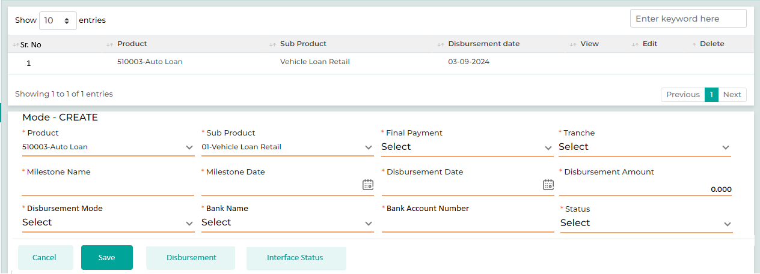

Below are the details specific to the information being displayed above.
Field Name | Field Type | Data Type / Length | Mandatory (Yes / No) | LookUp Key/Master Name | Possible Values | Field Description
 |  |  |  |  |  | Remarks / Validation
Sr. No | List view |  | No | NA | 1
Product | List view |  | No | NA | Partner-Partner
Sub Product | List view |  | No | NA | 0
Disbursement Date | List view |  | No | NA | 1660156200000
Product | LOV Dropdown | VARCHAR | No | NA | NA | The system will display te details on click of View.
Sub Product | LOV Dropdown | VARCHAR | No | NA | NA | The system will display te details on click of View.
Fnal Payment | LOV Dropdown | VARCHAR | No | NA | Yes  No | The user will select the Yes in order to proceed ahead with the full disbursement.
Tranche | LOV Dropdown | VARCHAR | No | NA | Single  Tranche | The user will select whether Single or Tranche based loan.  Following field will only be applicable for the loan products, where the “Tranche Disbursement” is selected as “Yes” in the Sub-Product Master.  Wher as for other loans, following field will be disabeled.
Milestone Name | Text Box | VARCHAR | Yes | NA | AAA | The User will give the name for the milestone
 |  |  |  |  |  | Only applicable if Tranche is selected
Milestone Date | Calendar | DATETIME | Yes | NA |  | The User will select the tranche date
 |  |  |  |  |  | Dependednt field, only be available for the loan other than Auto Loan and Equipment Loan.
Disbursement Date | Calendar | DATETIME | Yes | NA | NA | Only applicable if Tranche is selected
Disbursement Amount | Text Box | INT | Yes | NA | NA | Total disbursement amount to be will be displayed.
Disbursement Mode | LOV Dropdown | VARCHAR | Ye | NA | Cheque  Bank Transfer | The user will select the mode through which the amount to be disbursed to the customer account.
Bank Name | Read Only | VARCHAR | No | NA | NBK | Only applicable if the “Disbursement Mode” is selected as Cheque  Name of the bank associated with KFIC from where the amount will be disbursed will be auto-populated.
Bank Account Number | Read Only | VARCHAR | No | NA | 24354657687989 | Only applicable if the “Disbursement Mode” is selected as Cheque  Bank Account number will be auto-populated as configured.
Status | LOV Dropdown | VARCHAR |  |  | Disbursee  Pending | Status will be displayed whther Disbursed or Pending
Action Buttons
Cancel | Button | Button | NA | NA | NA | The User will click on this button to clear the entered data.
Save | Button | Buttton | NA | NA | NA
Disbursement | Button | Button | NA | NA | NA | The User will click on this button to initiate disbursement.
Interface Status | Button | Button | NA | NA | NA | The User will click on this button to view the interface status of the application.

Stage Completion Rules
Please refer Stage Completion Rules for details about the stage completion rules for this stage.

Interface Touchpoints
Please refer to Interface Touch Points for details about the interface touchpoints required for this stage.

Required Documents
Please refer to Required Document Checklist for details about the documents required at this stage.

Post Loan Activation

Access Right Metrics
Access rights metrics display the configuration of screens within each respective stage and tab, indicating the available access rights for users to Add, View, Edit, or data. A "✔" icon signifies the access rights granted for each screen at that stage. Conversely, if all four access rights options are blank and lack an icon, it means that the screen is not applicable for that stage.
Tab Name | Screen Name | Add | View | Edit | Delete
Application | Application Summary |  | ü
KYC | Basic Details |  | ü
KYC | Address Details
KYC | Identification Details
KYC | Business Details
KYC | Relationship Segment
KYC | Employment Details
KYC | Bank Details
KYC | Repayment Details
KYC | Insurance Details | ü | ü
KYC | Contact Details
Product Details | Collateral Search
Product Details | Collateral Details
Product Details | Valuation |  | ü
Product Details | Loan Item Details |  | ü
Product Details | Loan Details |  | ü
Product Details | Charges
Income & Expense | Income
Income & Expense | Expense
Income & Expense | Credit Bureau Exposure Check
Income & Expense | Repayment Ratios
Document | Document Checklist |  | ü
Document | Document Verification |  | ü
Document | Loan Kit |  | ü
Financials | PNW Checklist
Financials | Balance Sheet
Financials | Income Statement
Financials | Financial Ratios
Financials | Cash Flow Analysis
Financials | Z-Score Analysis
Financials | Qualitative - Quantitative Scoring
Policy Review | Policy Check
Policy Review | Credit Score Card
Policy Review | Exception Details
Collection Review | Collection Review
Checklist | Legal Opinion Checklist
Checklist | Credit Concentration Review
Checklist | Risk Opinion Checklist
AML Check | Risk Assessment Checklist
AML Check | Customer Risk Rating
Credit Approval | Recommendation
Credit Approval | Recommendation History
Credit Approval | Credit Committee Approval
Disbursement | Disbursement Details
Registration | Registration Details | ü | ü | ü | ü
Document Archive | Document Archive

Business Logic
Note: All screens marked with a “ü” in the access rights matrix will be available to the user at this stage, according to the access rights granted.
The screens are configurable and can be arranged along with their required access rights at different stages

Registration Details
The Registration Details screen is applicable only for Vehicle Loans. The number of vehicles added in the loan item details screen will be displayed on the registration details screen. The commercial sales user will generate and share the necessary documents with the traffic department, and once confirmed, the user will receive the Car Book and invoice for the vehicles.
The user can click the edit button within the registration details screen grid, where all data captured in the loan item details screen will be displayed across the respective screens. The user will enter the registration number from the Car Book received and upload the Car Book to the system. Additionally, the user will capture the insurance policy number in the Insurance Details screen. The same process will be followed if there are multiple item details.
Once all details are captured and the required documents are uploaded by the commercial sales user, the user will move the application to the sub-stage within the Post Loan Activation stage for approval from the commercial sales manager.
The following process should be considered if there are changes to vehicle parameters, such as the engine number or chassis number, at the time of registration due to the unavailability of the vehicle or other conditions. A sub-workflow will be initiated, sending the application back to the Retail Credit Committee for approval. Once approved, the application will move to the Credit Administration process. After this, the final contract will be generated with the updated loan item parameters and shared with the customer for acceptance. A new purchase order will then be created, allowing for the loan activation and registration to proceed.
Navigation:
Post Disbursement à Registration Details
The following screen will be displayed once the User clicks on Registration Details:
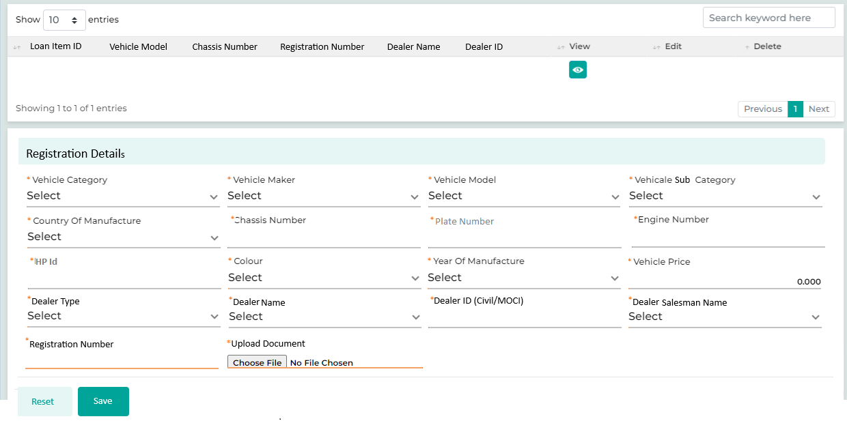

Below are the details specific to the information being displayed above.
Field Name | Field Type | Data Type / Length | Mandatory (Yes / No) | LookUp Key/Master Name | Possible Values | Field Description
 |  |  |  |  |  | Remarks / Validation
Loan Item Id | List view |  | Yes | NA |  | The details will be displayed as pr the loan item details captured on the loan item details screen
Vehicle Model | List view |  | Yes | NA |  | The details will be displayed as pr the loan item details captured on the loan item details screen
Chasis Number | List view |  | Yes | NA |  | The details will be displayed as pr the loan item details captured on the loan item details screen
Registrtion Number | List view |  | Yes | NA |  | The details will be displayed as pr the loan item details captured on the loan item details screen
Dealer Name | List view |  | Yes | NA |  | The details will be displayed as pr the loan item details captured on the loan item details screen
Dealer ID | List view |  | Yes | NA |  | The details will be displayed as pr the loan item details captured on the loan item details screen
Registeration Details
Vehicle Category | Read Only | VARCHAR | Yes | NA | Motor Vehicle | The data will be auto populated from the Loan Item details screen
Vehicle maker | Read Only | VARCHAR | Yes | NA | Toyota | The data will be auto populated from the Loan Item details screen
Vehicle Model | Read Only | VARCHAR | Yes | NA | Corolla | The data will be auto populated from the Loan Item details screen
Vehicle Subcategory | Read Only | VARCHAR | Yes | NA | Sedan | The data will be auto populated from the Loan Item details screen
Country of Manufacture | Read Only | VARCHAR | Yes | NA | Japan | The data will be auto populated from the Loan Item details screen
Chassis Number | Read Only | VARCHAR | Yes | NA | 643246890 | The data will be auto populated from the Loan Item details screen
Plate Number | Read Only | VARCHAR | Yes | NA | 643246890 | The data will be auto populated from the Loan Item details screen
Engine Number | Read Only | VARCHAR | Yes | NA | ENG889754543 | The data will be auto populated from the Loan Item details screen
HP Id | Text Box | VARCHAR | Yes | NA | ENG889754543 | Only applicable in case of Hypothecation. The user will enter the HP Id obtained referring to the Car Book.  The system will validate against the HP Id of the KFIC configured in the system.
Colour | Read Only | VARCHAR | Yes | NA | White | The data will be auto populated from the Loan Item details screen
Year Of Manufacture | Read Only | VARCHAR | Yes | NA | 2018 | The data will be auto populated from the Loan Item details screen
Vehicle Price | Read Only | VARCHAR | Yes | NA | 10000 | The data will be auto populated from the Loan Item details screen
Dealer Type | Read Only | VARCHAR | Yes |  | Company  Agency  Individual | The data will be auto populated from the Loan Item details screen
Dealer Name | Read Only | VARCHAR | Yes |  | Amazing Motors | The data will be auto populated from the Loan Item details screen
Dealer Id (Civil/MOCI) | Read Only | VARCHAR | Yes |  | 223456128459 | The data will be auto populated from the Loan Item details screen
Dealer Salesman Name | Read Only | VARCHAR | Yes |  | Ibrahim Urooj | The data will be auto populated from the Loan Item details screen
Registration Number | Text Box | VARCHAR | Yes | NA | REG9876554 | The user will enter the Registration number obtained.
Upload Document | Button | NA | NA | N |  | The user will click on upload and can upload the document related to the vehicle registration such as Car Book.
Action Button
Reset | Button | Button | NA | NA | NA
Save | Button | Button | NA | NA | NA

Registration Details Approval
The details and the documents captured at the previous substage will appear at the “Registration Details Approval” stage for approval from the commercial sales manager. The commercial sales manager will review the details and documents and proceed the loan application to the next stage.

Stage Completion Rules
Please refer Stage Completion Rules for details about the stage completion rules for this stage.

Interface Touchpoints
Please refer to Interface Touch Points for details about the interface touchpoints required for this stage.

Required Documents
Please refer to Required Document Checklist for details about the documents required at this stage.

Document Archive

Access Right Metrics
Access rights metrics display the configuration of screens within each respective stage and tab, indicating the available access rights for users to Add, View, Edit, or data. A "✔" icon signifies the access rights granted for each screen at that stage. Conversely, if all four access rights options are blank and lack an icon, it means that the screen is not applicable for that stage.
Tab Name | Screen Name | Add | View | Edit | Delete
Application | Application Summary |  | ü
KYC | Basic Details |  | ü
KYC | Address Details
KYC | Identification Details
KYC | Business Details
KYC | Relationship Segment
KYC | Employment Details
KYC | Bank Details
KYC | Repayment Details
KYC | Insurance Details
KYC | Contact Details
Product Details | Collateral Search
Product Details | Collateral Details
Product Details | Valuation
Product Details | Loan Item Details
Product Details | Loan Details
Product Details | Charges
Income & Expense | Income
Income & Expense | Expense
Income & Expense | Credit Bureau Exposure Check
Income & Expense | Repayment Ratios
Document | Document Checklist | ü | ü | ü | ü
Document | Document Verification
Document | Loan Kit | ü | ü | ü | ü
Financials | PNW Checklist
Financials | Balance Sheet
Financials | Income Statement
Financials | Financial Ratios
Financials | Cash Flow Analysis
Financials | Z-Score Analysis
Financials | Qualitative - Quantitative Scoring
Policy Review | Policy Check
Policy Review | Credit Score Card
Policy Review | Exception Details
Collection Review | Collection Review
Checklist | Legal Opinion Checklist
Checklist | Credit Concentration Review
Checklist | Risk Opinion Checklist
AML Check | Risk Assessment Checklist
AML Check | Customer Risk Rating
Credit Approval | Recommendation
Credit Approval | Recommendation History
Credit Approval | Credit Committee Approval
Disbursement | Disbursement Details
Registration | Registration Details
Document Archive | Document Archive | ü | ü | ü | ü

Business Logic

29.2.1 Document Archive
The document archival process occurs after loan activation, during which physical documents are collected and securely stored by the custodian. The following screen enables the user to maintain a record of the documents' location and custody, facilitating easy tracking whenever needed.
Navigation:
Document Archive à Document Archive
The following screen will be displayed once the User clicks on Document Verification:
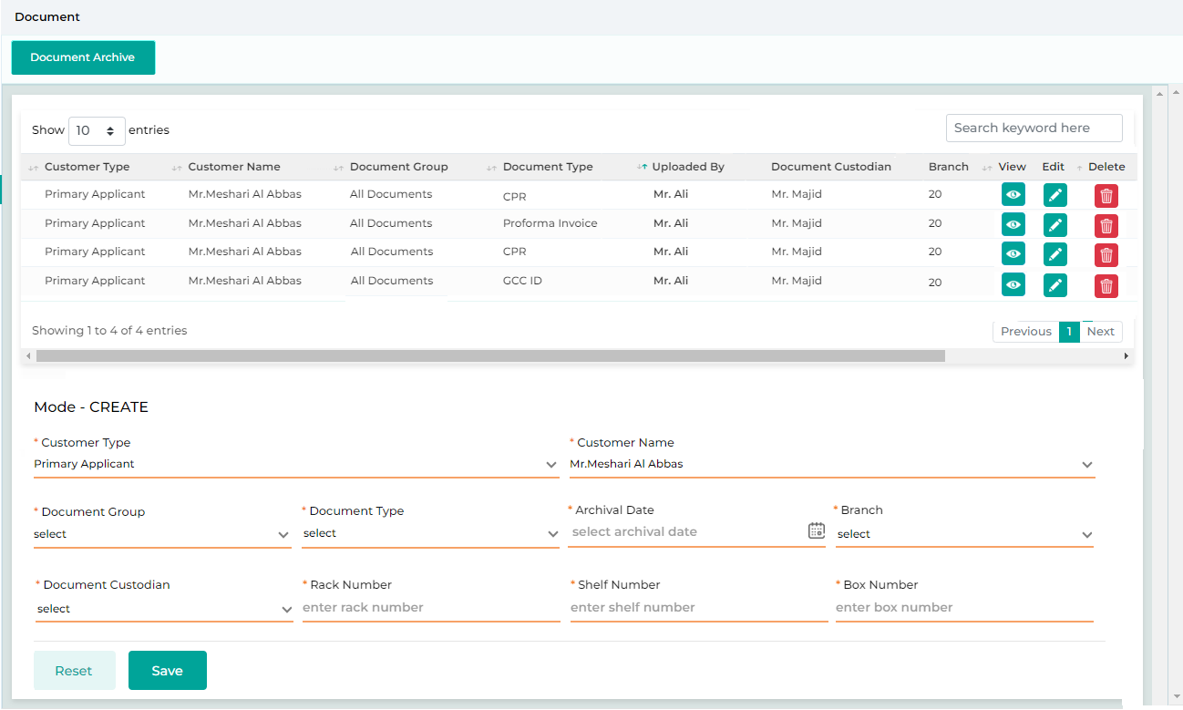

Below are the details specific to the information being displayed above.
Field Name | Field Type | Data Type / Length | Mandatory (Yes / No) | LookUp Key/Master Name | Possible Values | Field Description
 |  |  |  |  |  | Remarks / Validation
- Customer Type  - Customer Name  - Document Group  - Document Type  - Branch  - Custodian | List View | NA | NA | NA | NA | The system will display the list view of all the doucments being archived
Customer Type | LOV Dropdown | VARCHAR | Yes | 4034 | Main Applicant  Joint Applicant  Guarantor | The user will select the customer type associated with the document to be archived.
Customer Name | Master Dropdown | VARCHAR | Yes | NA | NA | The user will select the customer name associated with the document to be archived.
Document Group | LOV Dropdown | VARCHAR | Yes | DOCUMENTGROUP |  | The user will select the document group for the document to be archived.
Document Type | LOV Dropdown | VARCHAR | Yes | DOCUMENTTYPE |  | The user will select the document to be archived.
Archival Date | Calendar | Date | Yes |  | 12-03-2024 | The user will select the date of archival
Branch | LOV Dropdown | VARCHAR | Yes |  | Kuwait | The user will select the branch where the phsical document are kept.
Document Custodian | LOV Dropdown | VARCHAR | Yes |  | User A  User B | The user will select the custodian at the specific brach who holds the phsical document.
Rack Number | Text Box | VARCHAR | Yes |  | 202 | The user will enter the rack number where the physical copy of the documents are kept
Shelf Number | Text Box | VARCHAR | Yes |  | 01 | The user will enter the shelf number where the physical copy of the documents are kept
Box Number | Text Box | VARCHAR | Yes |  | 20 | The user will enter the box number where the physical copy of the documents are kept
Action Buttons
Reset | Button | Button | NA | NA | NA | The reset button will help the User clear contents from the fields and start capturing the document again.
Save | Button | Button | NA | NA | NA | The save button will let the User save the captured information.

Stage Completion Rules
Please refer Stage Completion Rules for details about the stage completion rules for this stage.

Interface Touchpoints
Please refer to Interface Touch Points for details about the interface touchpoints required for this stage.

Required Documents
Please refer to Required Document Checklist for details about the documents required at this stage.

Miscellaneous

Loan Transfer
Loan Transfer process is applicable for the Retail Loans - Vehicle (New & Used) & Commercial Loans where the loan will be transferred from one customer to the another marking the existing loan as transferred and activating the new loan for other customer., request for the loan transfer will be treated as a new application which will be initiated from the “New Application-Loan Transfer” screen
The following process will be followed in order to process the request for Loan Transfer:
- Application Creation:
The user will initiate the request for the loan which has to be transferred from Customer A to Customer B from the “New Application-Loan Transfer” screen by selecting the application type as “Loan Transfer.”
The user will perform the Customer Dedupe Search twice, one for the customer who’s account is to be transferred and the other for the customer to whom it will be transferred by entering the Category, ID Type & ID Number and then click on “Search”.
Once the user has searched for and selected a customer during the customer dedupe search of the customer who’s account is to be transferred, all the loan accounts associated with that customer will appear in the list below, as shown in the New Application-Loan Transfer screen. The user can then select the specific loan account to transfer. Afterward, the user will enter the details of the new customer to whom the loan is being transferred. To initiate the loan transfer process, the user can click the "Convert To App" button on the application creation screen. Once converted, the loan application processing workflow for the respective selected product will be triggered and application will be available in the Inbox of the user.

- Individual – Loan Transfer

- Commercial – Loan Transfer

To initiate the Loan Transfer process, the customer must clear all overdue payments and outstanding interest. If there are any overdue amounts or interest due, the system will display a pop-up message as “The selected account has overdue payment and outstanding. Please request the customer to settle the amount or click “Yes” to proceed ahead with the Loan Transfer process” prompting the customer to settle these amounts before proceeding with the Loan Transfer. However, the user can still advance the application to the Detail Data Entry stage. Approval for the outstanding amounts will be required from an authorized user at a later stage in the loan processing.
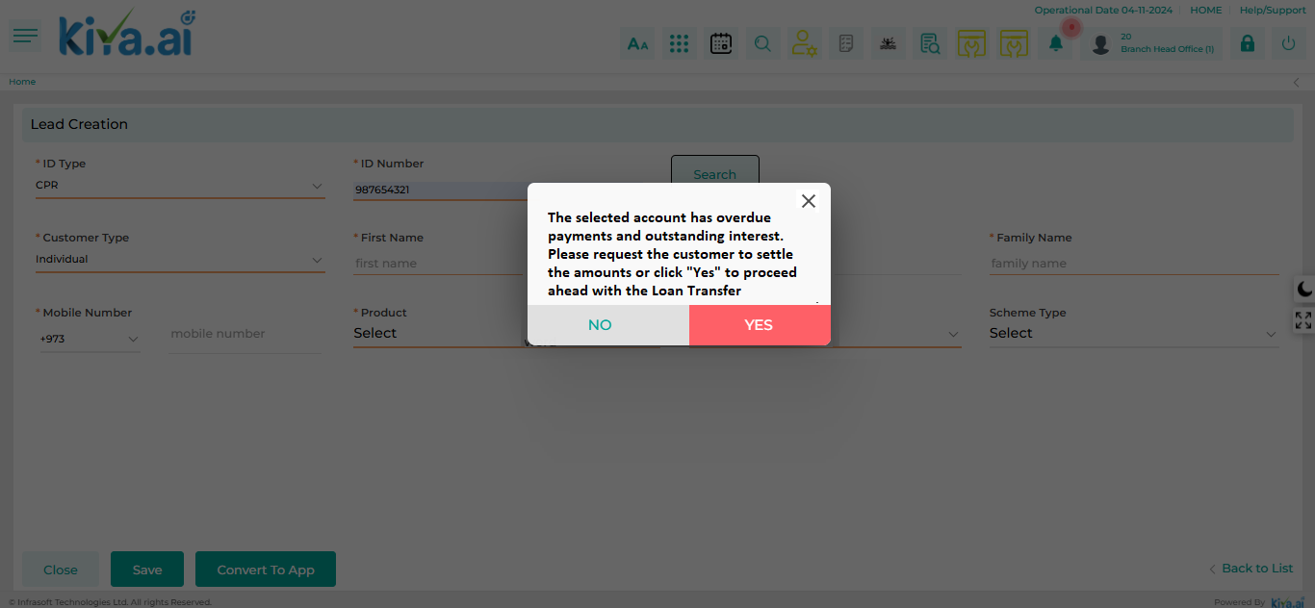

- Detail Data Entry:
- Once the application is converted it will be applicable in the Inbox of the sales user to perform the detail data entry of the customer.
- Principal O/S and remaining tenure of the loan account which is to be transferred will be auto populated on the Loan Detail screen.
- However, since no Dealer will be applicable in Loan Transfer case, Loan Transfer process would not have dealer related parameters associated with the application. If the customer wishes, they can make a payment towards a downpayment, which will reduce the overall amount to be financed. The user will capture this downpayment amount on the Loan Detail screen which will be collected before the loan activation stage.
- There will not be any change in the Repayment Schedule and the customer has the option to include Life Insurance & Full Insurance in the loan amount.
- Any fees applicable to a new application will also apply to the account specific to the loan transfer.
- The user also has an option to add the guarantor related details in the stage.
- If the overdue payment and any outstanding amount are not settled, but the user still initiates the loan transfer process, exceptional approval from an authorized user will be required. There are two scenarios based on which the loan amount for the transferred loan will be determined:
Scenario 1: The overdue interest and charges will be added to the principal amount, and the total will be considered as the financed amount.
(Principal Outstanding + Interest overdue + Charges) of Old Loan + Life & Full Insurance (If included in Finance) + Fees (If Any)
Scenario 2: The overdue interest and charges will not be included, and only the principal amount from the old loan will be considered as the financed amount.
Principal Outstanding of Old Loan + Life & Full Insurance (If included in Finance) + Fees (If Any)

- Linked Loans: The Linked Loans screen allows the user to view basic details of the loan that was transferred, helping them identify the connection between the old loan and the new application. If the user wishes to see more detailed information about the loan, they can access a comprehensive view through Customer 360.
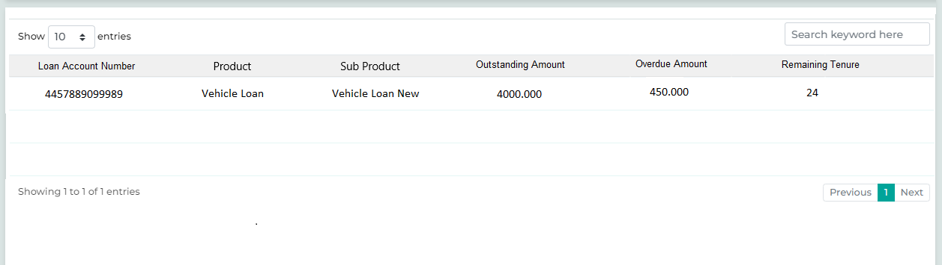

- Verification: The verification process will remain the same as applicable for New Application.
- AML Screening & Approval: The AML Screening & Approval process will remain the same as applicable for New Application
- Credit Approval: The Credit Approval process will remain the same as applicable for New Application. Where based on the limit and the credit approval authority, the system will automatically assign the application to the respective committee for approval. In case of application rejection then application for the Loan Transfer will be declined.
Additionally, the approval committee may request a down payment for loan transfers on a case-by-case basis. This payment will be made to KFIC at cashier, as there will be no vendor involved in the loan transfer process and the status of the will be reflected on the Charges screen.
- Credit Control Review: The Credit Control Review process will remain the same as applicable for New Application.
- Deal Printing & Offer Acceptance: The Deal Printing & Offer Acceptance process will remain the same as applicable for New Application.
- Final Check Credit Control: The Final Check Credit Control process will remain the same as applicable for New Application.
- Purchase Order Generation: PO will not be generated for the Dealer as there is no dealer involved in the Loan Transfer process. Whereas PO will be generated for the insurance company.
- Loan Activation: During the Loan Activation Process, the system will allocate the principal outstanding amount from the loan account which is to be transferred to the Excess Account (GL). Subsequently, this amount will be used to close the existing loan account. The existing loan account will be marked as “Paid Off” and the Sub Status will be updated as Transferred. Since there will not be any disbursement in the case of Loan Transfer, cheque issuance will not be required.
Date of Loan Transfer activation will be same as the date of settlement of the old loan.
- Post Loan Activation: The new loan will remain pending activation until the car book is provided by the customer. Once the car book is received and uploaded to the system, the loan will proceed as outlined in the Post Loan Activation stage and will be activated.
The Car Book, showcasing the vehicle transferred to the new customer, must be presented within 1 month from the date of contract signing. If not, the Loan Transfer request will be rejected, and the old loan will continue with the same customer. After the one-month period, if the user attempts to process the application for activation, a validation message will prompt the user to cancel the current request and re-initiate a new Loan Transfer application.
- Document Archive: On Submit from Post Loan Activation & Approved by the Finance team from the LMS, application will directly be available in Document Archive stage. On submitting from this stage, the Loan Origination Process will be completed. However, application will be available in LO in Read Only through Application Summary.

Loan Rearrangement
Loan Rearrangement is applicable only for the Retail Loans and can be occurred on a one-to-one basis (from one account to a new loan account) or on a many-to-one basis (multiple loan accounts consolidated into one new loan account). In the latter case, the products for all loan accounts must be the same. A loan arrangement can include an enhancement over the existing loan principal outstanding. In the case of an enhancement, the difference amount will be disbursed to the customer’s account. To qualify for a new loan arrangement with an increased amount, the customer must have paid at least 30% of the number of instalments for existing loan contract.
The following process will be followed in order to process the request for Loan Rearrangement:
- Application Creation:
The user will initiate the request for the loan which has to be rearranged from Customer from the “New Application – Loan Rearrangement” screen by selecting the application type as “Loan Rearrangement”
The user will perform the Customer Dedupe Search for the Customer who is requesting for the loan rearrangement by entering the Category, ID Type & ID Number and then click on “Search”.
Once the user has searched for and selected a customer from the customer dedupe search output, all the loan accounts associated with that customer will appear in the list below, as shown in the New Application – Loan Rearrangement screen. The user can then choose one or more loan accounts to be rearranged into a new loan. Additionally, the customer's details will automatically populate on the screen based on the selected customer.
To initiate the loan rearrangement process, the user should click the "Convert To App" button on the application creation screen. Once converted, the loan application processing workflow for the respective selected product will be triggered and application will be available in the Inbox of the user.

If more than one loan account is selected, the system will verify that all selected accounts have the same Product and Sub-Product. If there are discrepancies, the system will display an alert message: "The selected accounts have different Product & Sub-Product. Please select accounts with the same Product & Sub-Product before proceeding with the Loan Rearrangement Process."
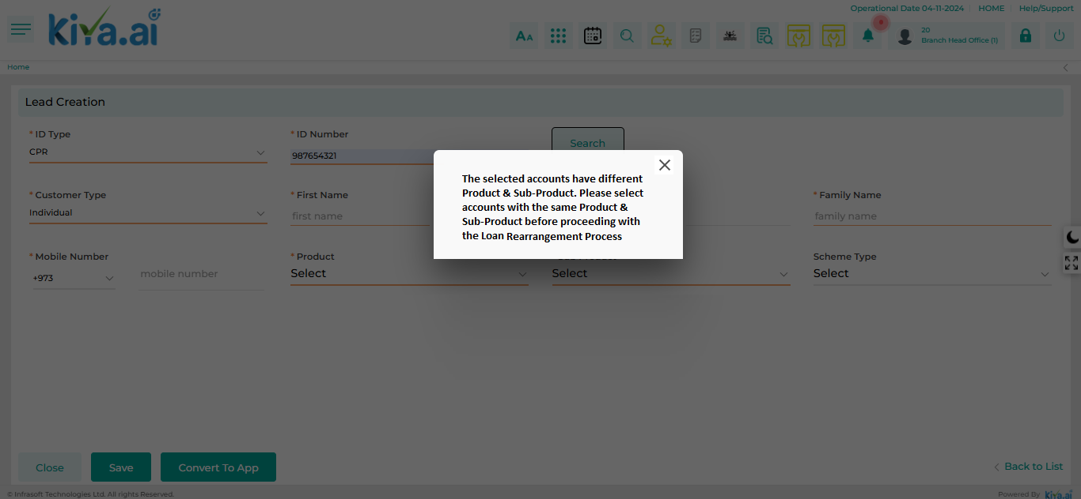

To initiate the Loan Rearrangement process, the customer must clear all overdue payments and outstanding interest. If there are any overdue amounts or interest due, the system will display a pop-up message as The selected account/s {Loan Account Number/s} has overdue payment and outstanding. Please request the customer to settle the amount or click “Yes” to proceed ahead with the Loan Rearrangement process prompting the customer to settle these amounts before proceeding with the Loan Rearrangement. However, the user can still advance the application to the Detail Data Entry stage. Approval for the outstanding amounts will be required from an authorized user at a later stage in the loan processing.

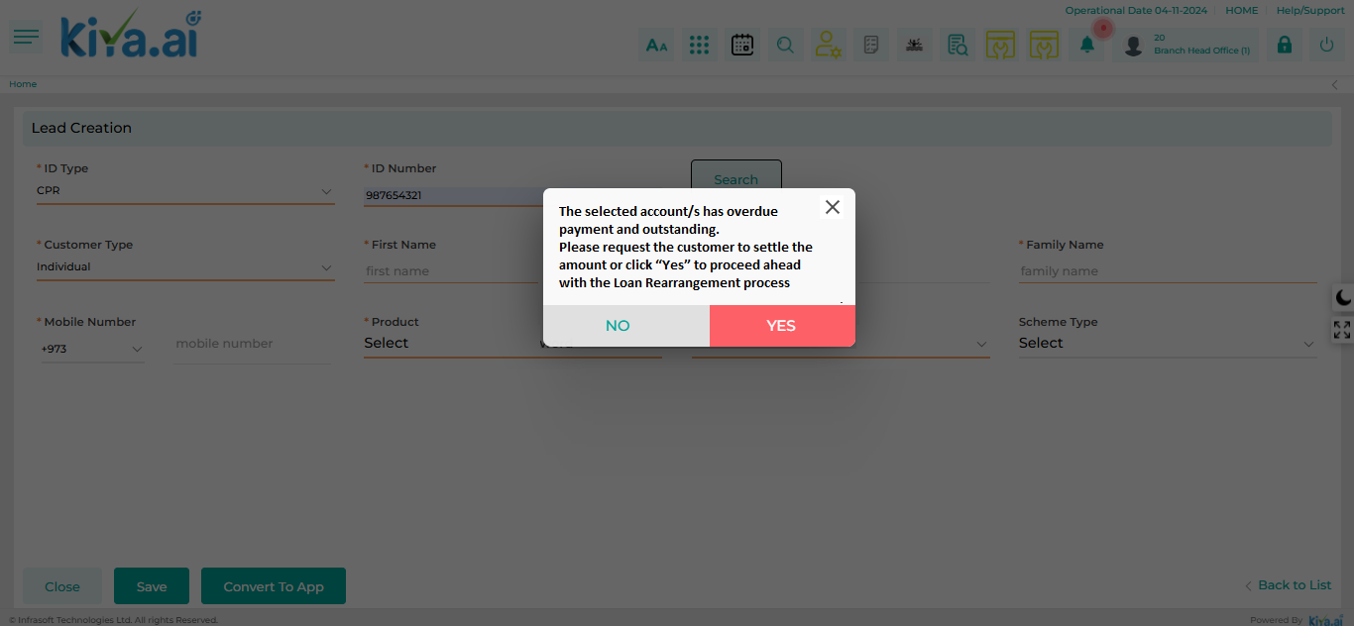

- Detail Data Entry:
- Once the application is converted it will be applicable in the Inbox of the sales user with all the data populated on all the respective screen of the Detail Entry Stage from the existing loan account whereas the user can upload the updated financials of the customer.
- Valid insurance (Full & Liability) from the old loans will be taken into consideration and carry forward to the new loan.
- Any fees applicable to a new application will also apply to the account specific to the loan rearrangement.
- The existing collaterals associated with the current loan accounts will be auto-populated over to the new loan account and will be reflected on the Collateral Detail screen.
- Since loan rearrangement is treated as a new loan, if a loan account has multiple items and some have been released, only the available loan items should be included when filling out the loan item details in the new loan application. For example, if loan account has four loan items and one is released, the new application should only consider the three remaining items on the Loan Item Detail screen.
- If the overdue payment and any outstanding amount are not settled, but the user still initiates the loan rearrangement process, exceptional approval from an authorized user will be required. There are two scenarios based on which the loan amount for the new loan will be determined:
Scenario 1: The overdue interest and charges will be added to the principal amount, and the total will be considered as the financed amount.
(Principal Outstanding + Interest overdue + Charges) of Old Loan + Life & Full Insurance (If included in Finance) + Fees (If Any)
Scenario 2: The overdue interest and charges will not be included, and only the principal amount from the old loan will be considered as the financed amount.
Principal Outstanding of Old Loan + Life & Full Insurance (If included in Finance) + Fees (If Any)
- The Top-Up amount/enhancement can also be provided in the case of loan rearrangement.

- Linked Loans: The Linked Loans screen allows the user to view basic details of all the loan accounts that were merged, helping them identify the connection between the old loan and the new application. If the user wishes to see more detailed information about the loan, they can access a comprehensive view through Customer 360.

- Verification: The verification process will remain the same as applicable for New Application.
- AML Screening & Approval: The AML Screening & Approval process will remain the same as applicable for New Application
- Credit Approval: The Credit Approval process will remain the same as applicable for New Application. Where based on the limit and the credit approval authority, the system will automatically assign the application to the respective committee for approval. In case of application rejection then application for the Loan rearrangement will be declined.
- Credit Control Review: The Credit Control Review process will remain the same as applicable for New Application.
- Deal Printing & Offer Acceptance: The Deal Printing & Offer Acceptance process will remain the same as applicable for New Application.
- Final Check Credit Control: The Final Check Credit Control process will remain the same as applicable for New Application.
- Purchase Order Generation: PO will not be generated for the Dealer as there is no dealer involved in the Loan Transfer process. Whereas PO will be generated for the insurance company.
- Loan Activation: The existing loan account/s will be marked as “Closed” and the Sub Status will be updated as Loan rearrangement and the New Loan Account will be activated. Since there will not be any disbursement in the case of Loan Rearrangement, cheque issuance will not be required.
The Top-Up amount in case of “Personal Loan” t be disbursed in the new loan account.
- Post Loan Activation: Not Applicable
- Document Archive: On Submit from Post Loan Activation & Approved by the Finance team from the LMS, application will directly be available in Document Archive stage. On submitting from this stage, the Loan Origination Process will be completed. However, application will be available in LO in Read Only through Application Summary.

Loan Renewal
Loan Renewal process is applicable only for the Commercial Loans where loan renewals can occur on a one-to-one basis (from one account to a new loan account) or on a many-to-one basis (multiple loan accounts consolidated into one new loan account). In the latter case, the products for all loan accounts being renewed must be the same. The renewal process is applicable to current loan accounts where the customer has no overdue amounts.
The following process will be followed in order to process the request for Loan Renewal:
- Application Creation:
The user will initiate the request for the loans which is to be renewed from the “New Application – Loan Renewal” screen by selecting the application type as “Loan Renewal.”
The user will perform the Customer Dedupe Search for the Customer who is requesting for the loan renewal by entering the Category, ID Type & ID Number and then click on “Search”.
Once the user searches for and selects a customer from the search output, all the loan accounts associated with that customer will be displayed in the list below, as shown on the "New Application – Loan Renewal " screen. The user can then choose one or more loan accounts to be renewed into a new loan. Additionally, the customer's details will automatically populate on the screen based on the selected customer.
To initiate the loan renewal process, the user should click the "Convert To App" button on the application creation screen. Once converted, the loan application processing workflow for the respective selected product will be triggered and application will be available in the Inbox of the user.

If more than one loan account is selected, the system will verify that all selected accounts have the same Product and Sub-Product. If there are discrepancies, the system will display an alert message:
"The selected accounts have different Product & Sub-Product. Please select accounts with the same Product & Sub-Product before proceeding with the Loan Renewal process."
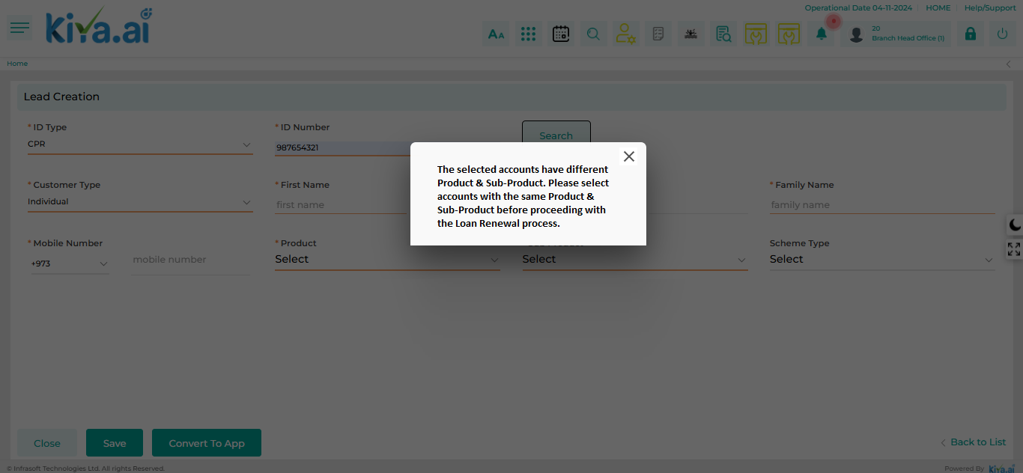

To initiate the Loan Renewal process, the customer must clear all overdue payments and outstanding interest. If there are any overdue amounts or interest due, the system will display a pop-up message as The selected account/s {Loan Account Number/s} has overdue payment and outstanding. Please request the customer to settle the amount or click “Yes” to proceed ahead with the Loan Renewal process prompting the customer to settle these amounts before proceeding with the Loan Renewal. However, the user can still advance the application to the Detail Data Entry stage. Approval for the outstanding amounts will be required from an authorized user at a later stage in the loan processing.

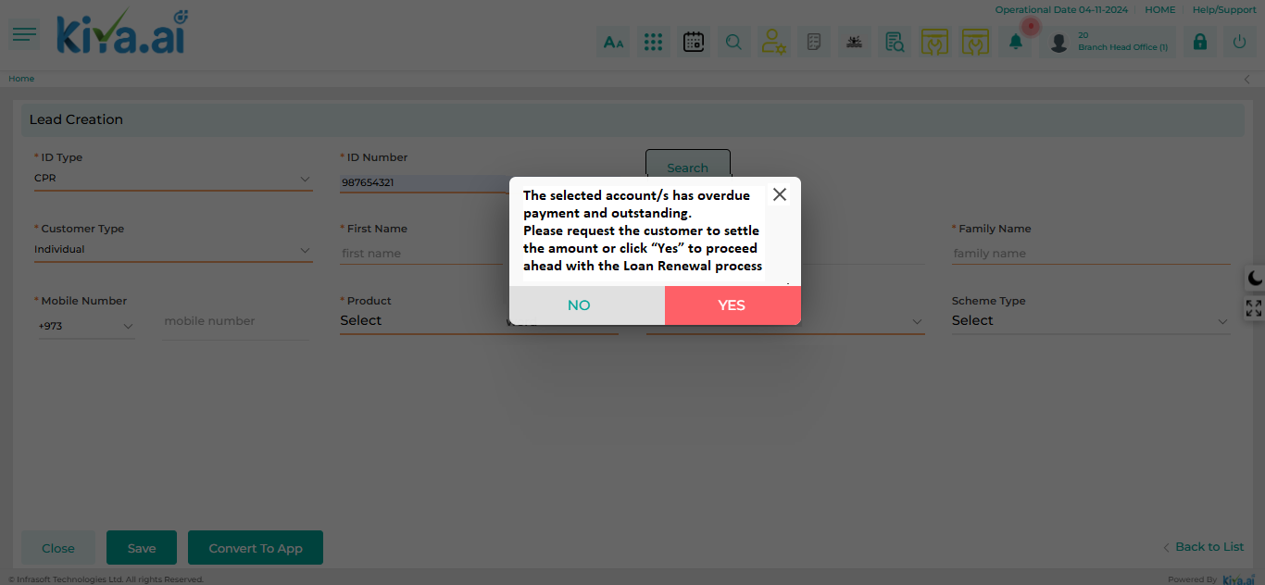
- Detail Data Entry:
- Once the application is converted it will be applicable in the Inbox of the sales user with all the data populated on all the respective screen of the Detail Entry Stage from the existing loan account whereas the user can upload the updated financials of the customer.
- Valid insurance (Full & Liability) from the old loans will be taken into consideration and carry forward to the new loan.
- Any fees applicable to a new application will also apply to the account specific to the loan renewal.
- The existing collaterals associated with the current loan accounts will be auto-populated over to the new loan account and will be reflected on the Collateral Detail screen. Whereas it will also allow the user to add additional collateral if required.
- Since loan renewal is treated as a new loan, if a loan account has multiple items and some have been released, only the available loan items should be included when filling out the loan item details in the new loan application. For example, if loan account has four loan items and one is released, the new application should only consider the three remaining items on the Loan Item Detail screen.
- The user also has an option to linked additional guarantor details in the stage.
- If the overdue payment and any outstanding amount are not settled, but the user still initiates the loan renewal process, exceptional approval from an authorized user will be required. There are two scenarios based on which the loan amount for the new loan will be determined:
Scenario 1: The overdue interest and charges will be added to the principal amount, and the total will be considered as the financed amount.
(Principal Outstanding + Interest overdue + Charges) of Old Loan + Life & Full Insurance (If included in Finance) + Fees (If Any)
Scenario 2: The overdue interest and charges will not be included, and only the principal amount from the old loan will be considered as the financed amount.
Principal Outstanding of Old Loan + Life & Full Insurance (If included in Finance) + Fees (If Any)

- Linked Loans: The Linked Loans screen allows the user to view basic details of all the loan accounts that were merged, helping them identify the connection between the old loan and the new application. If the user wishes to see more detailed information about the loan, they can access a comprehensive view through Customer 360.

- Verification: The verification process will remain the same as applicable for New Application.
- Legal Review: The Legal Review process will remain the same as applicable for New Application.
- Credit Control Review: The Credit Control Review process will remain the same as applicable for New Application.
- Credit Concentration Check: The Credit Concentration Check process will remain the same as applicable for New Application.
- AML Screening & Approval: The AML Screening & Approval process will remain the same as applicable for New Application
- Risk Opinion: The Risk Opinion process will remain the same as applicable for New Application.
- Credit Approval: The Credit Approval process will remain the same as applicable for New Application. Where based on the limit and the credit approval authority for Loan Renewal matrix provided under Credit Approval stage, the system will automatically assign the application to the respective committee for approval. In case of application rejection then application for the Loan Renewal will be declined.
- Legal Review & MOJ Process: The Legal Review & MOJ Process will remain the same as applicable for New Application.
- Deal Printing & Offer Acceptance: The Deal Printing & Offer Acceptance process will remain the same as applicable for New Application.
- Final Check Credit Control: The Final Check Credit Control process will remain the same as applicable for New Application.
- Purchase Order Generation: PO will not be generated for the Dealer as there is no dealer involved in the Loan Transfer process. Whereas PO will be generated for the insurance company.
- Loan Activation: The existing loan account/s will be marked as “Closed” and the Sub Status will be updated as Loan Renewal and the New Loan Account will be activated. Since there will not be any disbursement in the case of Loan Renewal, cheque issuance will not be required.
- Post Loan Activation: Not applicable for Loan Renewal
- Document Archive: Once New Loan is activated, application will directly be available in Document Archive stage. On submitting from this stage, the Loan Origination Process will be completed. However, application will be available in LO in Read Only through Application Summary.

Loan Reschedule
The Loan Reschedule process is applicable for both Retail & Commercial Loans and is specifically available for customers who have defaulted on their payments but can also be initiated for normal customers too who are requesting for reschedule. The Loan Reschedule can occur on a one-to-one basis (from one account to a new loan account) or on a many-to-one basis (multiple loan accounts consolidated into one new loan account). In the latter case, the products for all loan accounts being reschedule must be the same.
The repayment period, including any rescheduling, shall not exceed 1 year in addition to the original repayment period for the consumer loan, which has a maximum term of 5 years. Therefore, the total repayment period, including rescheduling, may not exceed 6 years.
The repayment period, including any rescheduling, shall not exceed 3 years in addition to the original repayment period for the housing loan, which has a maximum term of 15 years. Therefore, the total repayment period, including rescheduling, may not exceed 18 years.
The following process will be followed in order to process the request for Loan Reschedule:
- Application Creation:
The user will initiate the request for the loans which is to be reschedule from the “New Application – Loan Reschedule” screen by selecting the application type as “Loan Reschedule”
The user will perform the Customer Dedupe Search for the Customer who is requesting for the loan reschedule by entering the Category, ID Type & ID Number and then click on “Search”.
Once the user searches for and selects a customer, all the loan accounts associated with that customer will be displayed in the list below, as shown on the "New Application – Loan Reschedule" screen. The user can then choose one or more loan accounts to be reschedule into a new loan. Additionally, the customer's details will automatically populate on the screen based on the selected customer.
To initiate the loan, reschedule process, the user should click the "Convert To App" button on the application creation screen. Once converted, the loan application processing workflow for the respective selected product will be triggered and application will be available in the Inbox of the user.

If more than one loan account is selected, the system will verify that all selected accounts have the same Product and Sub-Product. If there are discrepancies, the system will display an alert message:
"The selected accounts have different Product & Sub-Product. Please select accounts with the same Product & Sub-Product before proceeding with the Loan Reschedule process."
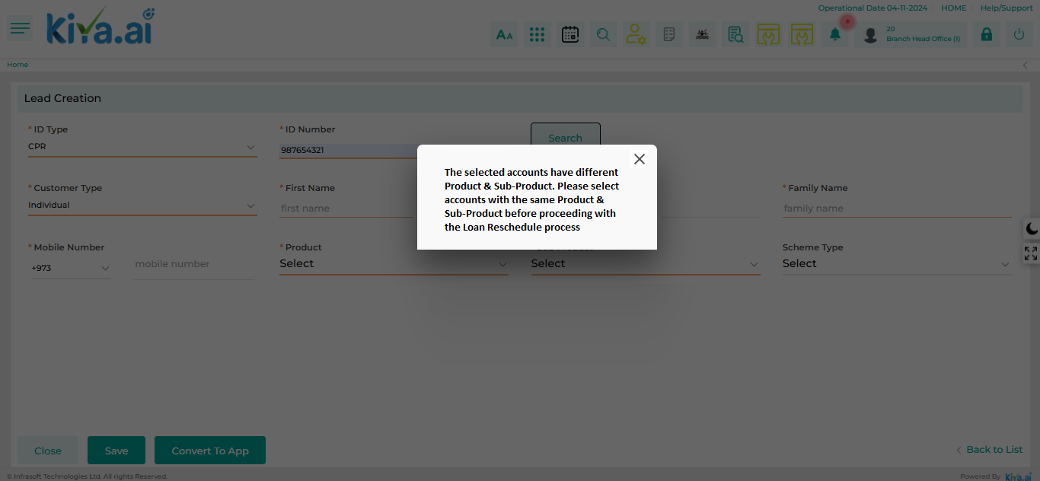

To initiate the Loan Reschedule process, the customer must clear up all overdue payments and outstanding interest. If there are any overdue amounts or interest due, the system will display a pop-up message as The selected account/s {Loan Account Number/s} has overdue payment and outstanding. Please request the customer to settle the amount or click “Yes” to proceed ahead with the Loan Reschedule process prompting the customer to settle these amounts before proceeding with the Loan Reschedule. However, the user can still advance the application to the Detail Data Entry stage. Approval of the outstanding amounts will be required from an authorized user at a later stage in the loan processing.

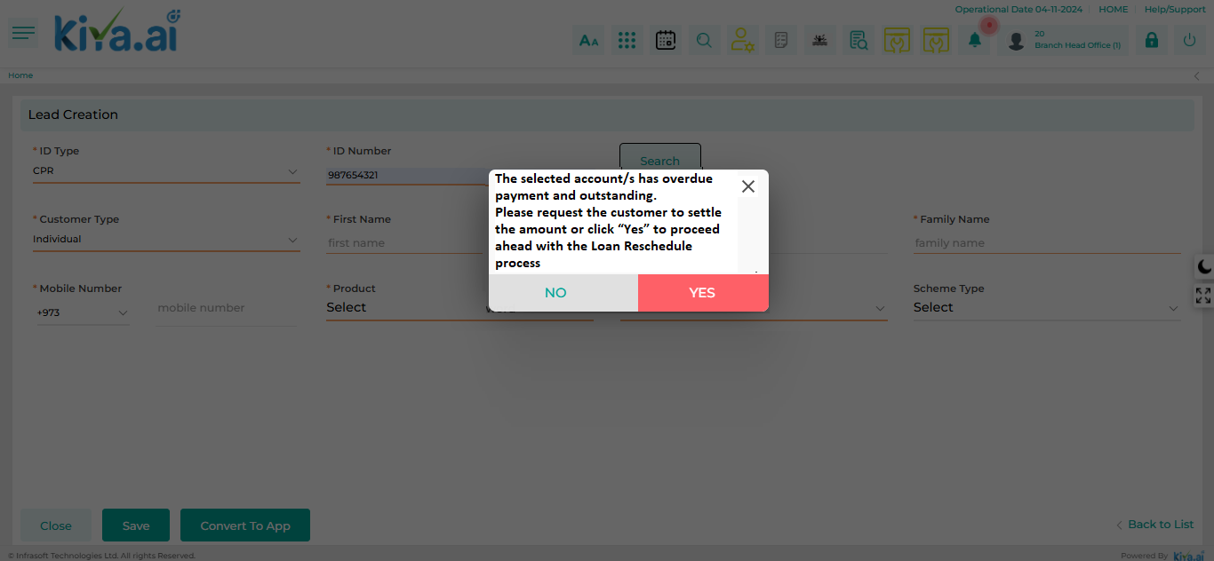

- Detail Data Entry:
- Once the application is converted it will be applicable in the Inbox of the sales user with all the data populated on all the respective screen of the Detail Entry Stage from the existing loan account whereas the user can upload the updated financials of the customer.
- Valid insurance (Full & Liability) from the old loans will be taken into consideration and carry forward to the new loan.
- Charges associated with the loan rescheduling service along with the other fees as applicable for new loan will be added to the loan amount or waived based on managerial approval using the Charges screen.
- The existing collaterals associated with the current loan accounts will be auto-populated over to the new loan account and will be reflected on the Collateral Detail screen. Whereas it will also allow the user to add additional collateral if required.
- Since loan reschedule is treated as a new loan, if a loan account has multiple items and some have been released, only the available loan items should be included when filling out the loan item details in the new loan application. For example, if loan account has four loan items and one is released, the new application should only consider the three remaining items on the Loan Item Detail screen.
- Customers must pay at least 30% of the total number of installments on their due dates to be eligible for the loan rescheduling service.
- If the customer wishes, they can make a payment towards a downpayment, which will reduce the overall amount to be financed. The user will capture this downpayment amount on the Loan Detail screen which will be collected before the loan activation stage.
- The user also has an option to linked additional guarantor details in the stage.
- If the overdue payment and any outstanding amount are not settled, but the user still initiates the loan reschedule process, exceptional approval from an authorized user will be required. There are two scenarios based on which the loan amount for the new loan will be determined:
Scenario 1: The overdue interest and charges will be added to the principal amount, and the total will be considered as the financed amount.
(Principal Outstanding + Interest overdue + Charges) of Old Loan + Life & Full Insurance (If included in Finance) + Fees (If Any)
Scenario 2: The overdue interest and charges will not be included, and only the principal amount from the old loan will be considered as the financed amount.
Principal Outstanding of Old Loan + Life & Full Insurance (If included in Finance) + Fees (If Any)
- Linked Loans: The Linked Loans screen allows the user to view basic details of all the loan accounts that were merged, helping them identify the connection between the old loan and the new application. If the user wishes to see more detailed information about the loan, they can access a comprehensive view through Customer 360.
- Verification: The verification process will remain the same as applicable for New Application.
- Legal Review: The Legal Review process will remain the same as applicable for New Application.
- Credit Control Review: The Credit Control Review process will remain the same as applicable for New Application.
- Credit Concentration Check: The Credit Concentration Check process will remain the same as applicable for New Application.
- AML Screening & Approval: The AML Screening & Approval process will remain the same as applicable for New Application
- Risk Opinion: The Risk Opinion process will remain the same as applicable for New Application.
- Credit Approval: The Credit Approval process will remain the same as applicable for New Application. Where based on the limit and the credit approval authority for Loan Reschedule matrix provided under Credit Approval stage, the system will automatically assign the application to the respective committees for approval. In case of application rejection then application for the Loan Reschedule will be declined. If necessary, a partial settlement may also be requested from the customer to proceed with the loan rescheduling.
- Legal Review & MOJ Process: The Legal Review & MOJ Process will remain the same as applicable for New Application.
- Deal Printing & Offer Acceptance: The Deal Printing & Offer Acceptance process will remain the same as applicable for New Application.
- Final Check Credit Control: The Final Check Credit Control process will remain the same as applicable for New Application.
- Purchase Order Generation: PO will not be generated for the Dealer as there is no dealer involved in the Loan Transfer process. Whereas PO will be generated for the insurance company.
- Loan Activation: The existing loan account/s will be marked as “Closed” and the Sub Status will be updated as Loan Reschedule, and the New Loan Account will be activated. Since there will not be any disbursement in the case of Loan Reschedule, cheque issuance will not be required.
- Post Loan Activation: Not applicable for Loan Reschedule.
- Document Archive: Once New Loan is activated, application will directly be available in Document Archive stage. On submitting from this stage, the Loan Origination Process will be completed. However, application will be available in LO in Read Only through Application Summary.

Credit Limit Creation
The creation of a credit limit applies to commercial loans, where the revolving or non-revolving credit limit type can be established and approved for the commercial customer at both the product and sub-product levels (Purpose). This credit limit creation will follow the same process as the corresponding commercial loan, extending only to the credit approval stage without activation of the loan, meaning it will not be reported to the CBK. When the customer decides to withdraw funds from the approved limit, each amount disbursed will be treated as a new loan contract, at which point reporting to the CBK will occur.
The purpose for the Credit Limit should be as follows: Financial, Trade and Trading in Business, Other Business, Services, Real Estate, Construction, Industries, Personal, and Shares & Bonds.
Refer Stage Role Mapping & Screen Mapping sheet for the detail stage & screens required for Credit Limit Creation.
Sr. No. | Process | Description
1 | Application Creation | The user will initiate a request to create the credit limit for the customer by selecting “Credit Limit Creation” as the application type from the New Application (Credit Limit Creation) screen and entering the basis details.  Upon selecting the Credit Limit Creation, a workflow associated with the relevant application type will be triggered. The application will then be available in the user's inbox, allowing them to proceed to the detailed data entry stage.
2 | Detail Data Entry | The entire detail data entry process will remain the same as with a normal loan application, where the user captures details such as:  KYC Details, Financials, Bank & Repayment Mod details, Collateral Details, Internal scoring, Ci-Net fetch, legal review, credit concentration review, Risk opinion, risk assessment checklist and the required documents.  Additionally, the user will enter details for the various products and sub-products, including the limit for each, within the Credit Limit Details screen. This will create multiple credit lines specific to the selected products for the customer.
3 | Verification | Verifying the details captured by the commercial officer
4 | Legal Review | Legal Document will be checked & opinion will be provided
5 | Credit Control Review | Initial credit control review
6 | Credit Concentration Check | Credit concentration check basis the loan purpose and the budget defined for the same at the quarter level
7 | AML Screening & Approval | AML screening and classification basis the AML rating
8 | Risk Opinion - Maker | Risk Opinion Maker - Officer
9 | Risk Opinion - Checker | Risk Opinion Checker - Manager
10 | Credit Approval | Based on the limit and the credit approval authority, the system will automatically assign the application to the respective committee for approval. In case of application rejection then the user will have to Decline the request.  Once the limit is approved, the customer and the credit limit will be automatically created in the LMS through the interfaces. This information will then be retrieved in the LOS when the customer applies for loan basis of the approved credit limit.

Credit Limit Utilization
Credit Utilization is the process by which a customer applies to withdraw a loan based on the credit limit approved at different product levels. The customer cannot withdraw an amount exceeding the approved limit for a specific product line. The workflow for credit limit utilization does not include a credit approval stage as the limit is already approved during the credit limit creation process; instead, the application will be sent to the CEO for approval following the Risk Opinion recommendation. Once approved, the workflow will proceed as it does for a standard application.
Scenario: The credit limit utilization process can include the following scenarios
1) If the client requests a withdrawal within one month of the credit limit approval date referring to the Credit Limit Creation process, no updated information to be added at the time of detail data entry stage as all the data captured during the limit creation will be considered for processing. The user can proceed with the loan application by adding the loan item details and continue with the further stages till loan activation.
2) If the client requests a withdrawal after one month from the credit limit approval date, a list of details as mentioned below in the Detail Data Entry stage will be required from the client, and CEO approval will be needed to proceed with releasing the tranche.

Refer Stage Role Mapping & Screen Mapping sheet for the detail stage & the screen applicable for Credit Limit Utilization.
Sr. No. | Process | Description
1 | Application Creation | The user will initiate a request for the credit limit utilization as requested by the customer by selecting “Credit Limit Utilization” as the application type from the New Application (Credit Limit Utilization) screen prompting a dependent field to appear for entering the CIF ID.  Upon entering the customer ID, the system will display the multiple limits assigned to the customer at the product level, including details such as the total approved limit, the utilized amount, and the available limit. The user can then select a specific limit for which the customer has made a request.  Upon selecting the requested product & the limit, a workflow associated to the product & sub product will be triggered. The application will then be available in the user's inbox, allowing them to proceed to the detailed data entry stage.
2 | Detail Data Entry | The data captured in the Detail Data Entry stage at the time of credit limit creation process will be auto populated, where the user will capture the updated details such as:  - Ci-Net of Customer & Guarantors  - Internal Scoring  - Bank Statement  - Collateral Detail (Only in case of shares, updated portfolio value)  - Audited Financials  - Commercial License Extract  - Legal Clearance Document  Additionally, the user will also capture the Insurance Details, Loan Item Details, Loan Details, and the Charges.
3 | Verification | Verifying the details captured by the commercial officer
4 | Credit Concentration Check | Credit concentration check basis the loan purpose and the budget defined for the same at the quarter level
5 | AML Screening & Approval | AML screening and classification basis the AML rating
6 | Risk Opinion - Maker | Recommendation from Risk Officer
7 | Risk Opinion - Checker | Recommendation from Executive Director Risk
8 | CEO Approval | Approval from CEO as Accepted or Rejected
9 | Legal Review & MOJ Process | Contract Notarization at MOJ & acceptance by the customer
10 | Deal Printing & Offer Acceptance | Offer Acceptance, Rejection or Appeal by the customer
11 | Final Check Credit Control - L1 | First level final check by the officer
12 | Final Check Credit Control - L2 | Review & Final check by the manager
13 | Purchase Order Generation | Purchase order will be generated
14 | Loan Activation | During the loan activation process, there will be a validation check to determine whether the limit is active or expired. If the limit has expired, the process will not proceed else the loan will be activated.
15 | Post Loan Activation | Capturing Vehicle registration details, insurance details, & document upload
16 | Cheque Issuance | Issuance & Delivery of Cheque
17 | Document Archive | Archiving of the physical documents

Staff Loan – KFIC Finance
The staff loan process applies to KFIC employees who meet the criteria outlined in the HR policies. The process will be initiated through the HR system (MenaME) and subsequently transferred to the lending system for further processing and disbursement.
Staff loans are of two types:
- Advance Salary
In this type, the employee is granted their salary in advance for one month without any interest.
- Only one month of salary can be provided in advance.
- The loan amount can be up to the employee's full monthly salary or 10% of the monthly salary but cannot exceed the amount of one month's salary.
- A maximum of 10 installments are allowed for repayment.
- The advance salary can only be requested at the start of the month and not in the middle of the month.
- Employees can request only one advance salary at a time. However, they may avail themselves of an Interest-Free Loan even if they have an active Advance Salary loan.
- Interest-Free Loan
In this type, the loan amount is calculated based on a defined percentage of the employee's accumulated End of Service Benefit (ESB) as of the loan request date.
- The loan amount can be up to 60% (configurable) of the total ESB amount.
- The loan amount cannot exceed KD 15,000.
- The loan amount cannot be more than six times the employee's monthly salary.
- A maximum tenure of 5 years is allowed for repayment.
- Employees can only have one Interest-Free Loan at a time. However, they may apply for an Advance Salary Loan even if they currently have an active Interest-Free Loan.
- Employees requesting an Interest-Free Loan must submit proof of how the loan amount is utilized within three months from the loan activation date. Acceptable forms of proof include vendor invoices.

- Stage – Screen Mapping
Access rights metrics display the configuration of screens within each respective stage and tab, indicating the available access rights for users to Add, View, Edit, or Delete. A "✔" icon signifies the access rights granted for each screen at that stage. Conversely, if all four access rights options are blank and lack an icon, it means that the screen is not applicable for that stage.
Stage | Screen | Add | View | Edit | Delete
Detail Data Entry | Application Summary |  | ü
Detail Data Entry | Basic Details | ü | ü | ü | ü
Detail Data Entry | Address Details | ü | ü | ü | ü
Detail Data Entry | Employment Details | ü | ü | ü | ü
Detail Data Entry | Bank Details | ü | ü | ü | ü
Detail Data Entry | Repayment Details | ü | ü | ü | ü
Detail Data Entry | Loan Details | ü | ü | ü | ü
Detail Data Entry | Document Checklist | ü | ü | ü | ü
Detail Data Entry | Loan Kit | ü | ü | ü | ü
Detail Data Entry | Policy Check | ü | ü | ü | ü
Manager Approval | Application Summary |  | ü
Manager Approval | Basic Details |  | ü
Manager Approval | Address Details |  | ü
Manager Approval | Employment Details |  | ü
Manager Approval | Bank Details |  | ü
Manager Approval | Repayment Details |  | ü
Manager Approval | Loan Details |  | ü
Manager Approval | Policy Check |  | ü
Manager Approval | Exception Details |  | ü
Manager Approval | Document Verification |  | ü
Manager Approval | Recommendation | ü | ü | ü | ü
Manager Approval | Recommendation History |  | ü
Head Approval | Application Summary |  | ü
Head Approval | Basic Details |  | ü
Head Approval | Address Details |  | ü
Head Approval | Employment Details |  | ü
Head Approval | Bank Details |  | ü
Head Approval | Repayment Details |  | ü
Head Approval | Loan Details |  | ü
Head Approval | Policy Check |  | ü
Head Approval | Exception Details |  | ü
Head Approval | Document Verification |  | ü
Head Approval | Recommendation | ü | ü | ü | ü
Head Approval | Recommendation History |  | ü
Head Approval | Disbursement Details | ü | ü | ü | ü
Post Loan Activation  (Only for Interest Free Loan) | Document Checklist | ü | ü | ü | ü

- Scenario 1: The following process will be followed in order to process the request from HR System (MenaMe) and create the loan into the KiyaAi’s lending system automatically.

- The staff loan request process will be initiated by the employee through the HR system (MenaME)
- The HR Officer reviews the application in accordance with established policies and criteria, providing feedback, as necessary.
- The HR Manager grants approval for the request.
- The employee’s Direct Manager also approves the loan request.
- The CEO provides final approval, after which the application is automatically transferred to the Lending system in the Inbox of HR officer for processing through integration between the HR system and Kiya.ai Lending system.
- A limited-stage workflow will be provided in the LO to generate and share the contract letter and loan documents with the customer through various channels, such as email and SMS. It will also allow the user to activate the loan, pushing it to the Loan Management System after review by the HR officer.
- Further the accounts team will disburse the loan amount to the employee through the requested mode of transfer.

- Scenario 2: The following process will be followed in order to process the request for Staff Loan from Loan Origination System (LOS):

- Application Creation:
The HR Officer will begin the process of requesting a Staff Loan by navigating to the “New Application -Staff Loan – KFIC Finance” screen. Here, they will select “New Application” as the Application Type and “HR” as the Business Unit.
Next, the HR Officer will choose the Product as “Staff Loan” and select the appropriate Sub-Product, either “Advance Salary” or “Interest-Free Loan.” The employee's details will then be retrieved by entering the Civil Id Number & the Employee Code, which will auto-populate the employee's name and company name based on the information stored in the employee master. Employee master will be maintained for all the subsidiary companies within the system.
To proceed with the loan application, the HR Officer will click the “Convert to App” button, triggering the workflow for further processing of the staff loan.
During this conversion, the system will validate the request by checking for any active staff loans associated with the employee. According to policy, an employee cannot have multiple active loans of the same type at the same time. For example, an employee is not allowed to have two “Advance Salary” loans concurrently; they must first settle one loan before applying for another. However, the employee can hold different types of Staff Loans simultaneously, such as an “Interest-Free Loan” in addition to an “Advance Salary” loan. If there is an active loan that conflicts with the request, the system will display a message as "An active loan of the same type already exists. Please settle the current loan before applying for another.” notifying the user and prevent further processing of the application.

- Detail Data Entry:
Once the loan is converted into an application, it will appear in the HR Officer's Inbox for further data entry. Based on the entered civil Id & employee code, the relevant details will be populated on the respective screens—such as Basic Details, Address Details, Employment Details, and Bank Details in integration to the HR system. The HR Officer can make any necessary changes or add additional information on these screens before proceeding to the next stage. The HR officer will also capture the repayment details on the Repayment Details screen, defining the mode of repayment such as Cash, Salary Deduction, or BSI by default it will be deduction from Salary.
The loan amount requested by the employee will be entered on the Loan Details – Staff Loan screen. Whereas the Tenure will auto-populated based on the product parameters configured with Frequency by default as Monthly and the Installment related details will be populated automatically, and Repayment schedule will be generated.
The HR Officer will initiate the Policy Check to verify if the staff loan application meets the required criteria and policies. If the application fails to meet any of the criteria, the HR Officer has the option to raise a deviation request to an authorized user for further review.
The user will upload the required document through the Document Checklist screen which is to be linked to the application.
Once the user completes the detailed data entry, they can see the necessary documents, such as the Contract Letter and Declaration Form on Loan Kit screen. These documents will then be sent to the employee via email, with the HR Group copied on the same email. This process will be facilitated through email integration with the lending system. And the user will move the application to the next stage for further processing.
CiNet won’t be fetched in case of Staff loan, thus existing exposure of the employee won’t be considered while granting loan.
- Loan Details – Staff Loan
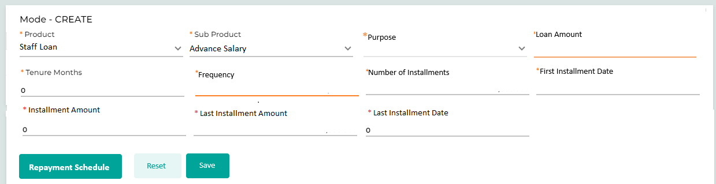
Field Name | Field Type | Data Type / Length | Mandatory (Yes / No) | LookUp Key/Master Name | Possible Values | Field Description
 |  |  |  |  |  | Remarks / Validation
Product | Read Only | VARCHAR | Yes | NA | Staff Loan | The system will display this field based on the data captured during the application creation
Sub Product | Read Only | VARCHAR | Yes | NA | - Advance Salary  - Interest Free Loan | The system will display this field based on the data captured during the application creation
Purpose | LOV Dropdown | VARCHAR | Yes | NA |  | Only applicable in case of Sub Product as “Interest Free Loan” where the user can select the purpose for which the employee is availing te loan.
Loan Amount | Text Box | INT | Yes | NA |  | The user will enter the Loan Amount, will be checked referring to the validation mention for each staff loan type.  Advance Salary: Equals to 1 month slarary or 10% of monthly slaary, cannot be more than one month salary.  Interest Free Loan:  - Upto 60% of the ESB, cannot be more than that.  - Shouldn’t exceed KD 15,000  - Should be max upto 6 times the monthly salary.
Tenure | Text Box | INT | Yes | NA |  | Tenure will be displayed based on the product parameter configured.
Frequency | LOV Dropdown | VARCHAR | Yes | NA | Monthly  Quarterly  Yearly | By default it will be monthly
Number of Installments | Text Box | INT | Yes | NA |  | System will compute the Number of installments
First Installment Date | Calendar | DATE | Yes | NA |  | The user will enter the 1st installment date
Installment Amount | Read Only | INT | Yes | NA |  | System will compute the Installment Amount
Last Installment Amount | Read Only | INT | Yes | NA |  | System will compute the Last Installment Amount
Last Installment Date | Read Only | DATE | Yes | NA |  | System will compute the Last Installment Date
Action Buttons
Repayment Schedule | Button | VARCHAR | Yes | NA | NA | Clicking the “Repayment Schedule” button a pop-up screen will appear showcasing the detail repayment schedule.
Reset | Button | Button | NA | NA | NA | The User will click on this button to clear the entered data.
Save | Button | Button | NA | NA | NA | The User will click on this button to save the entered data.

- HR Manager Approval
Once the HR Officer completes the application data entry and customer acceptance document upload and proceeds to the next stage, the application will be available in the HR Manager's inbox for approval.
The HR Manager will review the data and documents to verify their accuracy using the Document Verification screen. If any criteria from the Policy Check have failed, the HR Manager can provide exceptional approval through the Exceptional Approval screen.
If everything is in order, the HR Manager will recommend the application using the Recommendation screen and approve it, moving it to the next stage. However, if any discrepancies are found or changes are required, the HR Manager can return the application to the HR Officer for further review and corrections.

- HR Head Approval
Finally, the HR Head will approve the loan application after reviewing it and submitting the recommendation via the Recommendation screen. The user will review the beneficiary related details from the Disbursement Details screen and click on “Disbursement” button which will activate the loan and transfer the data to the LMS, where the accounts team will disburse the loan amount to the employee through the requested mode of transfer.

- Post Loan Activation
The Post Loan Activation stage is applicable only for the Staff Loan – Interest Free Loan and not for the Staff Loan – Advance Salary. During this stage, the HR officer will upload the loan utilization proof, such as the invoice from the vendor shared by the employee. The employee must provide the loan utilization proof within 3 months from the date of loan activation. The document can be uploaded by the user via the Document Checklist screen.

Rejection Queue
The Rejection Queue feature displays all the leads that have been rejected by the User due to inaccurate or insufficient details. Herein, the User has the chance to review the lead and edit its status once again.
Navigation:
- Go to the Hamburger Menu
- Click Sales à General à Rejection Queue

The following screen will be displayed once the User clicks on Rejected Leads:

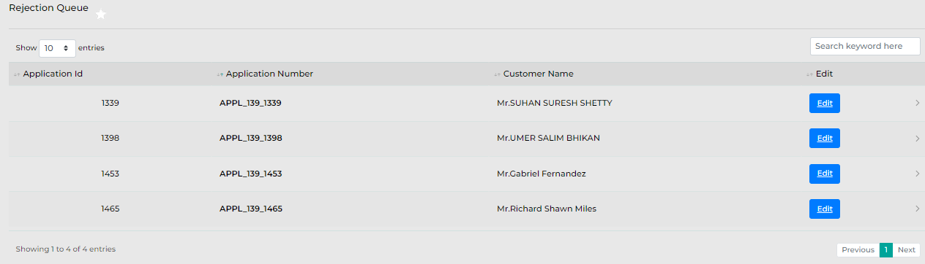

Below are the details specific to the information being displayed above.

Field Name | Field Type | Data Type / Length | Mandatory (Yes/No) | Look Up Value/ Master Name | Possible Value | Field Description
 |  |  |  |  |  | Remarks / Validation
Application ID | List View | NVarchar | NA | NA | NA | The system will display the Application ID assigned to each loan application.
Application Number | List View | NVarchar | NA | NA | NA | The system will display the application number assigned to the loan application.
Customer Name | List View | Varchar | NA | NA | NA | The system will display the Customer name of the loan application.
Edit | Button | Button | NA | NA | NA | Edit button will let the User take actions on the application along with their responses.

Once the User clicks on “Edit,” the following fields will be displayed wherein the User will need to select the actions along with the responses and save the details as shown below.

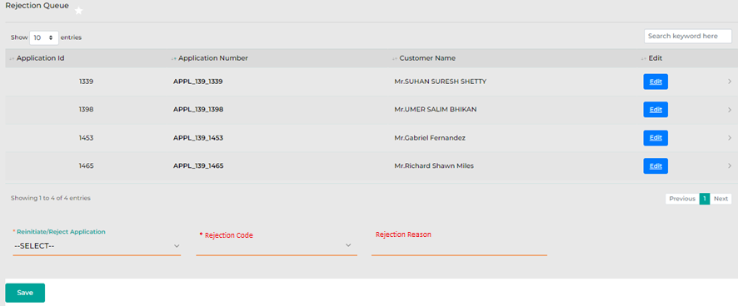
Below are the details specific to the information being displayed above.

Field Name | Field Type | Data Type / Length | Mandatory (Yes/No) | Look Up Value/ Master Name | Possible Value | Field Description
 |  |  |  |  |  | Remarks / Validation
Reinitiate/Reject Application | System Dropdown | Varchar | Yes | NA | -Reject  -Reinitiate | Users will need to select the action against the rejected application.
Rejection Code | Dropdown | VARCHAR | Yes | NA | -Customer Decline  -Internal Decline | The user will select the rejection code from the dropdown values.
 |  |  |  |  |  | If selected Reject under “Reinitiate/Reject Application”
Rejection Reason | Text Box | NVarchar | Yes | NA | NA | The user will capture the reason for rejection
 |  |  |  |  |  | If selected Reject under “Reinitiate/Reject Application”
Save | Button | Button | NA | NA | NA | User will need to click on Save once the action and response have been taken against the selected rejected application.
In the case of Reinitiate Application, the system will move the application to the initial stage of the product workflow.

In case of Reject, the respective application will move out from the rejection queue.

Manual Reallocation
Manual Reallocation is a feature which lets the Supervisor/Manager reallocate the cases which has been assigned to a particular User earlier to another User due to various instances like employee availability, workload distribution, skillset match, priority changes, employee request and more’s
User will need to initially select the Group Code and the corresponding Current User whose case needs to be reassigned and click on “Get Details.” Post this, system will display all the cases that has been assigned to the User along with few details of the same. The User will then need to click on “Edit” to reallocate the case to the desired User.
Navigation:
Sales à General à Manual Reallocation
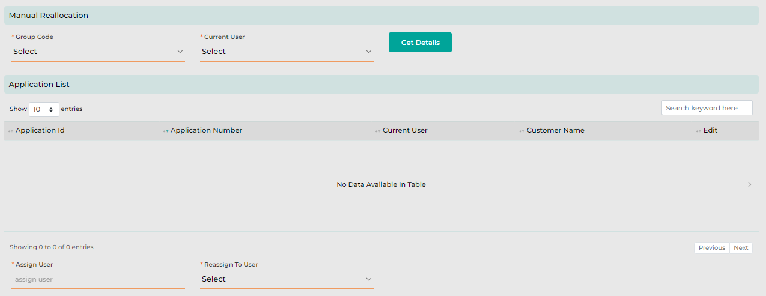
The following screen will be displayed once the User clicks on Manual Reallocation.
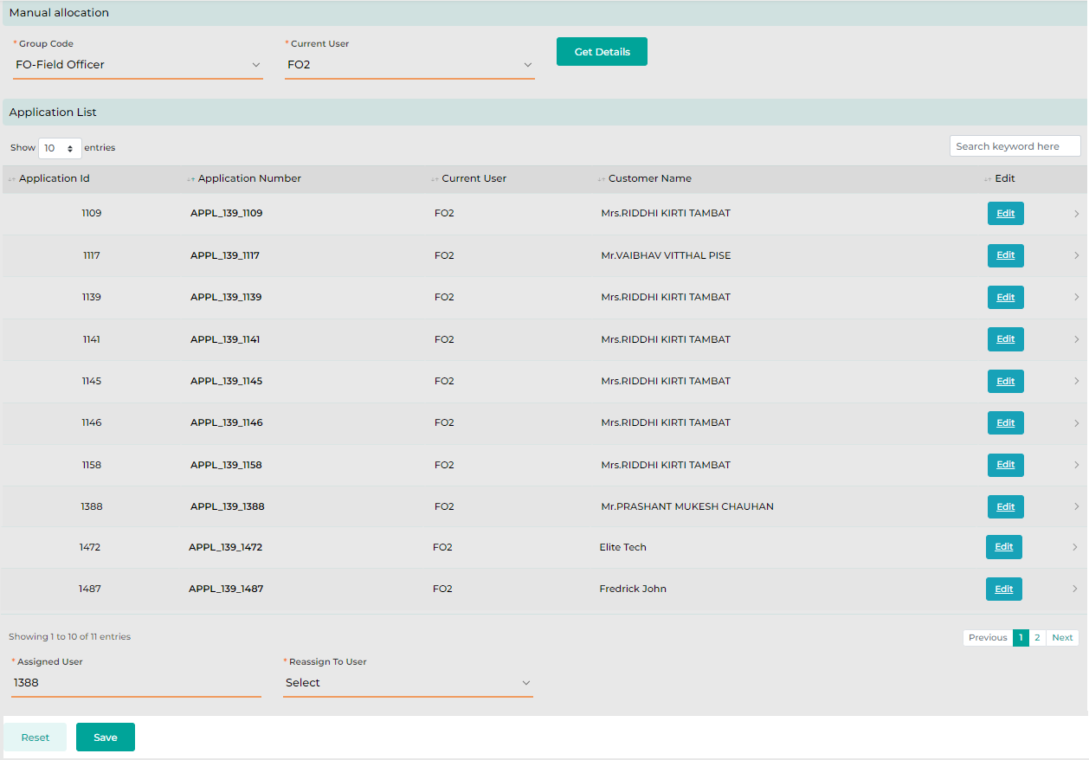
The User will then need to select the Group Code followed by the corresponding Current User, whose case(s) needs to be manually reallocated to another User. By clicking on “Get Details,” system will display an application list which will show all the cases assigned to the selected User.
Once the application list is displayed, the User will need to click on Edit against the required application and the system will display the Reassign to User field wherein the User will need to select the desired User to whom the application needs to be reassigned.

Below are the details specific to the information being displayed above.

Field Name | Field Type | Data Type / Length | Mandatory (Yes/No) | LookUp Key/Master Name | Possible Value | Field Description
 |  |  |  |  |  | Remarks / Validation
Group Code | Master Dropdown | Varchar | Yes | User Role | NA | User will need to select the group code.
Current User | Master Dropdown | Varchar | Yes | User Master | NA | User will need to select the Current User from whom the application needs to be reallocated.
 |  |  |  |  |  | Current User will be displayed on the basis of the Group Code selected.
Application List
Application ID | List View | Varchar | NA | NA | NA | The system will display the application Id of the loan application.
Application Number | List View | NVarchar | NA | NA | NA | The system will display the Loan Application number.
Current User | List View | Varchar | NA | NA | NA | The system will display the Current User.
Customer Name | List View | Varchar | NA | NA | NA | The system will display Customer Name.
Edit | Button | Button | NA | NA | NA | User will need to click on edit if the application needs to be allocated to desired User.
Assign User | Read Only | Varchar | NA | NA | NA | User will display the name of the User to whom the case has been allocated currently.
Reassigned To User | Master Dropdown | Varchar | NA | User Master |  | User will need to select the name of the User belonging to the same group code, to whom the application needs to be reallocated.
Reset | Button | Button | NA | NA | NA | Reset button will let the User reset the information captured.
Save | Button | Button | NA | NA | NA | Save button will let the User save the changes made and will further reallocate the case to assigned User.

Charges Wavier Approval
The Charges Waiver approval queue will be accessible to authorized users, such as the CEO, who can approve or reject charge waiver requested from the Charges Screen across various stages of the loan processing. The authorized user will be able to view waiver requests categorized in different queues, such as Pending, Approved, or Rejected. Waiver requests raised by different users will initially appear in the Pending queue. Once the CEO approves a waiver, the request will move to the Approved queue, and its status will be updated to 'Approved' on the Charges screen. If the request is rejected, it will be moved to the Rejected queue, and the status will be updated to 'Rejected' on the Charges screen

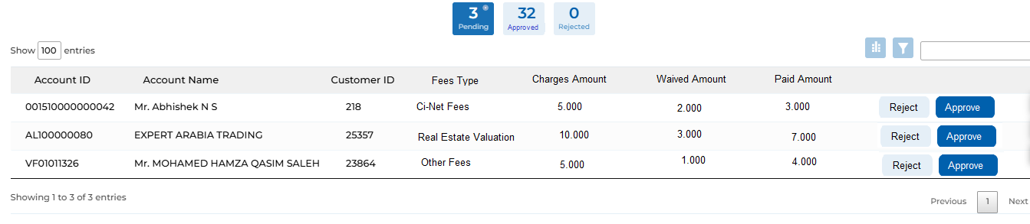

Master & Configuration - Requirements
- Digital Stamp & Sign of user: Digital Stamp & Signature to be maintained for each user by uploading the bitmap image for the same via user master.
- Delegate: A field labelled "Delegative" will be included in the user master, allowing for the assignment of a delegate for each individual user. In the absence of a user, new tasks will automatically be assigned to their respective delegate.
- Stage Completion Rule Master: Stage completion rules maintained under the section 35. Stage Completion Rules should be made configurable within the system.
- CBK & KFIC Rate: Interest rate under the Product & Sub Product master to be defined into two filed as CBS base rate & KFIC rate, e.g.: CBK rate is 4.25 whereas KFIC rate is +3 consolidation both result as 7.25 overall interest rate for the sub product.
- Ci-Net Code mapping: Ci-Net Code field to be provided to map Ci-Net to Product & Sub Product master
Business Unit | Product | Purpose | Ci-Net Code
Retail | Vehicle (Consumer) | Vehicle | Consumer - Consumer
Retail | Consumer | Education | Consumer - Consumer
Retail | Consumer | Medical | Consumer - Consumer
Retail | Consumer | Furniture | Consumer - Consumer
Retail | Housing | Restoration | Consumer - Housing
Retail | Housing | Land Purchase | Consumer - Housing
Retail | Housing | House Purchase | Consumer - Housing
Commercial | Cash Loan | Shares | Commercial - Term Loans
Commercial | Cash Loan | Real estate | Commercial - Term Loans
Commercial | Vehicle | Vehicle | Commercial - Fleet Car Loans

- Business Line: Business Line/Unit as a field to be provided in Product & Sub Product Master in order to map the product with the business line.
- Account Type: Account Type field to be provided in Product & Sub Product Master in order to map the product with the account type required for Ci-Net reporting – Commercial (Refer Lookups sheet for the full list of Account Type)

- Impact of Decrease in Interest Rate due to CBK:
- All loans pending for final contract signing will be marked as closed, and new applications will be created for those loans.
- For loans where the final contract has already been signed and accepted by the customer, the loans will remain unchanged with the original interest rate.
- Impact of Increase in Interest Rate due to CBK:
- All new loans will have the updated interest rate.
- For loans pending final contract signing, customers will be given 2 days to accept the contract. If not accepted within this timeframe, the loan will be marked as closed, and a new application can be created.
- In the event of a rejection due to an interest rate change requiring a new application, the detailed data entry for the new application will be automated by auto-populating the relevant data points on the respective screen. This can be accomplished using the "Reinitiate" functionality available under the rejected queue screen.
- Collection Review: The condition to trigger the Collection Review stage is set to be three or more delayed payments in the past history with KFIC for both the applicant and the guarantor. These criteria should be parameterized within the workflow definition master.
- Related Part to KFIC master: In the "Related Party to KFIC" master, maintain the details of the external auditor, including the start and expiry dates of their engagement. The master record should also include a flag to indicate whether a loan should be granted ("Grant Loan" - Yes or No). This flag will determine whether a loan can be extended to anyone related to the auditor. If configured as "No," the application will prevent proceeding with the loan approval. To update the related party information in the KFIC master, users will have the option to perform a bulk upload of the updated data using a standard template. This upload will overwrite any existing data that has already been mapped in the master.
- Employee Master: Additionally, customers employed by any of the external auditor should not be eligible for a loan. Whereas the employee from the KFIC group company other than KFIC finance are eligible for all kind of Retail loans.
- Auto Lead Rejection: Leads generated by sales users, which accumulate in the application list, should be automatically rejected after a defined period from the creation date. This rejection period should be configurable within the system. For example, if the lead creation date is January 1, 2024, and the rejection period is set to 6 months, the lead should move from the application list to the rejected lead list on July 1, 2024.
- Charges Master: When configuring charges through the Charges Master, there will be a field labelled "Waiver (Yes/No)" with dropdown options of "Yes" and "No." This allows the user to specify whether the particular fee type can be waived.
- Blacklist Master: The Blacklist Master will be made available, enabling the operations team to perform bulk uploads of the list periodically and maintain it in the master. This list will then be used on the screen during the Detail Data Entry stage.
- Hypothecation Bookmark: HP Bookmark should be handled at the product & Sub Product level configuration, where the admin user can define the product & sub product can be hypothecated Yes & No. Basis on the configuration the same to be auto reflected on the Loan Item detail screen.
- Recovery Type: Recovery type consist of Finance (part of finance), Upfront (paid by the customer upfront), & Cashback (treatment will be same as Finance).
The Recovery Type will be linked to the Charges (from charges master) & Insurance (from Insurance Master) basis on which the recovery type is to be considered for computation of Repayment Schedule and the finance amount.

Permission Grid
LOS transaction screens are expected to provide set of action buttons for different stages for Users to quickly take actions on the applications assigned to them. These action buttons would vary from stages to stages depending on the product type.
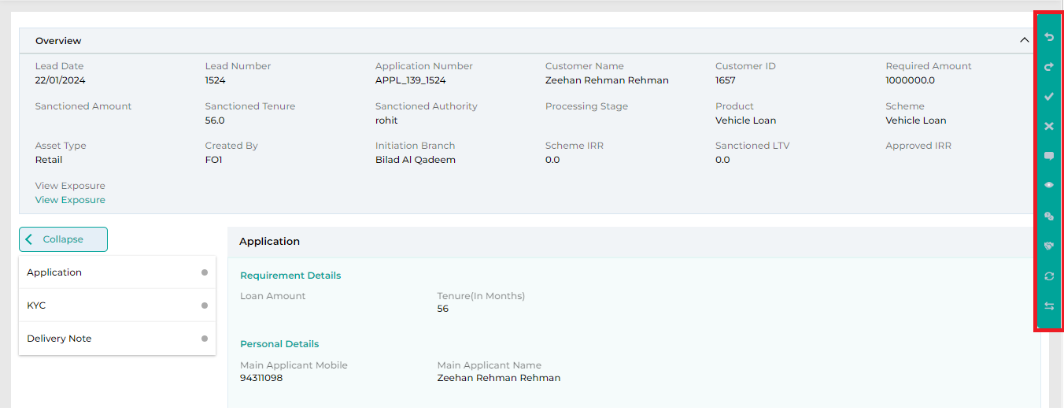
Below mentioned are the action buttons that would be required for different product workflows.
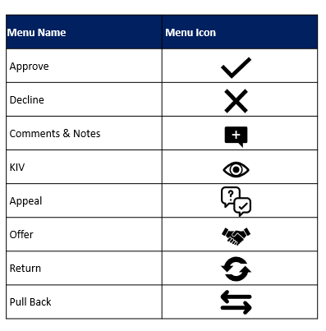

Approved
Approve action will approve the application from the current stage and eventually will move the application to the next User of the following stage as per the defined allocation logic.

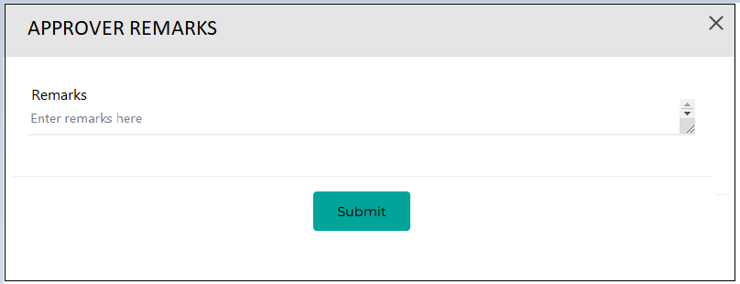

Decline
Decline action will be used to decline the application from the stage. This decline can be a decline made by the User or a decline requested by Customer. Once declined, the application will move to Decline Queue along with the decline type and remark post which User will finally choose whether to reject the application or re-initiate the application. On click of this Decline button, the User must enter the reason for declining the application in the modal screen.

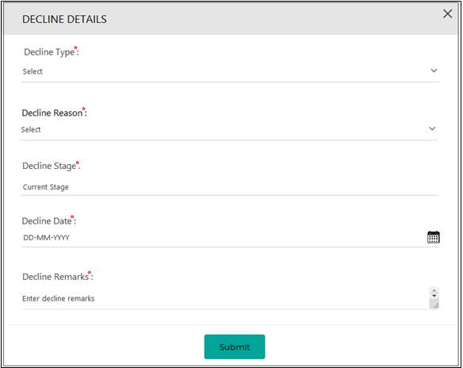

Below are the details specific to the information being displayed above.
Field Name | Field Type | Mandatory (Yes/No) | Field Description | Remarks / Validation
Decline Type | Dropdown | Yes | To select the decline type. The dropdown will have values as follows:  - Customer Decline  - Reject | System will display a validation message if Decline Type is not selected
Decline Reason | LO | Yes | To capture the decline reason. It will be a lookup whose values can be configured from Lookup Management.  The dropdown will have values as follows:  - Customer Declined Due to Better Offer  - Duplicate Application | System will display a validation message if Decline Reason is not selected
Decline Stage | Text Box | Yes | To display the stage from which the application/lead is getting declined and should be in read-only.
Decline Date | Date | Yes | To display the date when the decline is being initiated.  It must be in DD-MM-YYYY format and should be in read-only.
Decline Remarks | Text Area | Yes | To capture additional Remarks for decline. | System will display a validation message if Decline Remarks is not entered.

Comments and Notes
Comments & Notes action will be used capture any additional comments/note against the application. These would be saved and can also be viewed by the subsequent Users of the application.
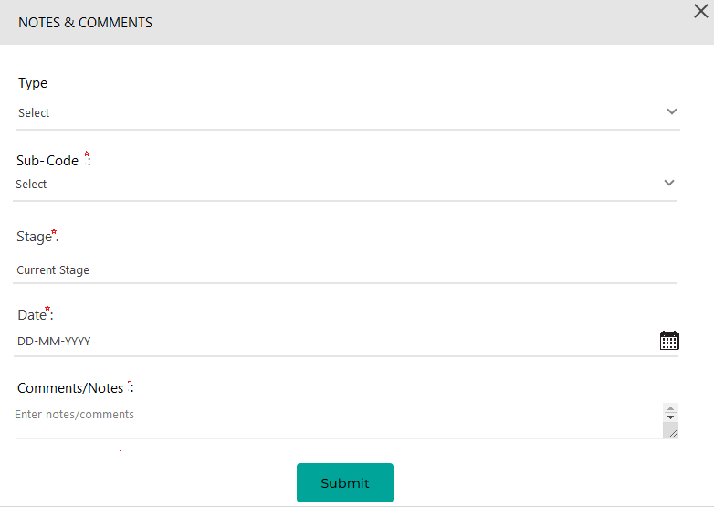
Below are the details specific to the information being displayed above.
Field Name | Field Type | Mandatory (Yes/No) | Field Description | Remarks / Validation
Type | Dropdown | Yes | To select the Type whether note or comment needs to be added. | System will display a validation message if Type is not selected
Sub-Code | Dropdown | Yes | To select the appropriate Sub-Code:  Internal  External | System will display a validation message if Sub-Type is not selected
Stage | Text Box | Yes | To display the stage from where should be in read-only.
Date | Date | Yes | To display the date when the comments/notes have been added.  It must be in DD-MM-YYYY format and should be in read-only.
Comments/Notes | Text Area | Yes | To capture the comments/notes. | System will display a validation message if comment/note is not entered.
Comments/Notes History
Date | List View | NA | Date of the comment should be displayed
Stage | List View | NA | Stage of the comment should be displayed
Username | List View | NA | Name of the user who have captured the comment at this stage
Comments/Notes | List View | NA | Detailed comment across each stage should be displayed

KIV
User can click on KIV to raise query on the application to employee of previous stage in case of which button Pullback will be enabled, else button KIV will be displayed. The list of values under the Query Type will be configurable based on the Product & the Stage from where the KIV will be requested.
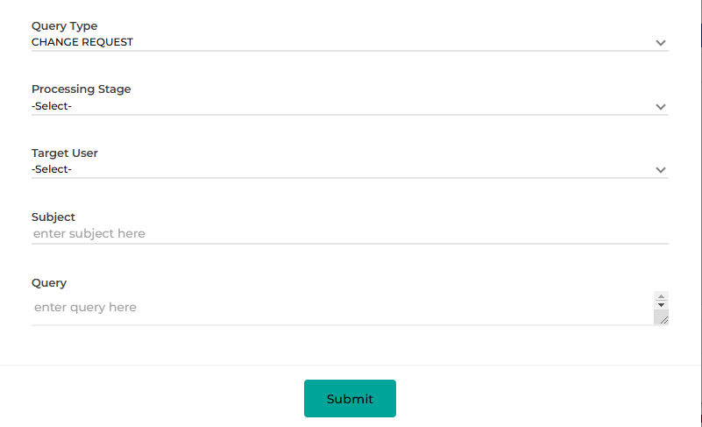

Field Name | Field Type | Mandatory (Yes/No) | Field Description | Remarks / Validation
Query Type | Dropdown | Yes | To select the appeal type.  - Change Request  - Reinitiate Application | The list of values under the Query Type will be configurable based on the Product & the Stage from where the KIV will be requested.
Processing Stage | Date | Yes | The user will select the stage to which the KIV request is to be requested.
Target User | Text Box | Conditionally Mandatory | The user will select the username under the selected stage to whom the request is to be raised.
Subject | Text Box | Conditionally Mandatory | The user will enter the subject for the query.
Query | Rich Text | Conditionally Mandatory | The user will enter the detailed query.
Submit | Butto | Button | The user will click on Submit button which then will send the KIV request to the selected user.

Appeal
This includes request for amount, tenure, or both, indicating Customer has appealed for betterment in offered amount/tenure/Interest rate/down payment/document and click on appeal, whereby case moves back to Underwriting stage.
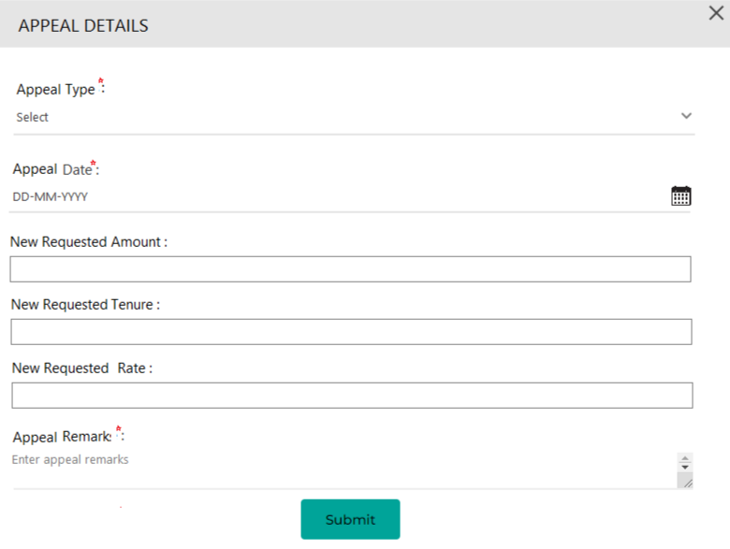
Below are the details specific to the information being displayed above.
Field Name | Field Type | Mandatory (Yes/No) | Field Description | Remarks / Validation
Appeal Type | Dropdown | Yes | To select the appeal type.  - Tenure Change Request  - Interest Rate Change Request  -Downpayment  -Document  - Amount Change Request  - Amount & Tenure Change | System will display a validation message if Appeal Type is not selected
Appeal Date | Date | Yes | To display the date when appeal request has been created.  It must be in DD-MM-YYYY format and should be in read-only.
New Requested Amount | Text Box | Conditionally Mandatory | To enter the new amount as requested by the customer. | System will display a validation if type is selected as Amount Change Request or Amount & Tenure Change
New Requested Tenure | Text Box | Conditionally Mandatory | To enter the new tenure as requested by the customer. | System will display a validation if type is selected as Tenure Change Request or Amount & Tenure Change
New Requested Rate | Text Box | Conditionally Mandatory | To enter the new rate as requested by the customer. | System will display a validation if type is selected as Rate Change Request
Appeal Remark | Text Area | Yes | To capture appeal Remarks. | System will display a validation message if appeal remark is not entered.

Return
Return feature would be used to send back the application to any of previous stage along with the reason & remarks for the return. A grid should be maintained to display both the changes requested by the user and the modifications made by other users. This will help the requesting user easily identify all the changes that have been made. The grid should display the name of the user who returned the application, the reason for the return, the changes made by the user who received the request along with their name, and the date and time for both the request and resolution.
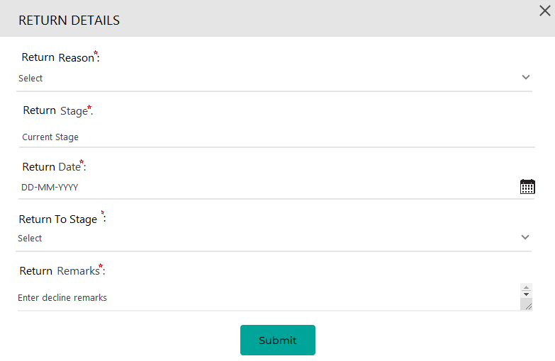

Below are the details specific to the information being displayed above.
Field Name | Field Type | Mandatory | Field Description | Remarks / Validation
Return Reason | Dropdown | Yes | To select the appeal type. | System will display a validation message if Appeal Type is not selected
Return Stage | Text Box | Yes | To display the stage from where the return action is being initiated.
Return Date | Date | Yes | To display the date when return has been created.  It must be in DD-MM-YYYY format and should be in read-only.
Return to Stage | Dropdown | Yes | To select the stage to which the application needs to be returned.  All the previous stages that the application has been through needs to be display | System will display a validation message if the data for  Return to Stage is not selected.
Return Remarks | Text area | Yes | To capture return Remarks. | System will display a validation message if return remarks is not entered.

Pull Back
User would be able to use Pullback option only when the KIV has been initiated against the application. This feature will let the User to cancel the KIV and process the application further to the next stage,

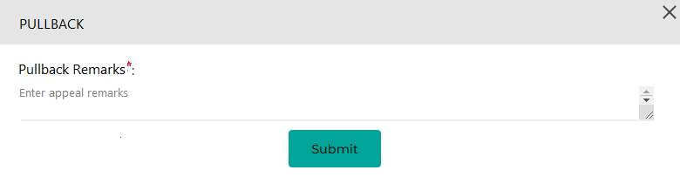

Move To Next
The "Move to Next" button allows the user to progress the application to the next stage once the current processing is complete. When clicked, the system automatically assigns the application to the next configured stage. Additionally, the user can manually select the stage and the individuals within that stage.
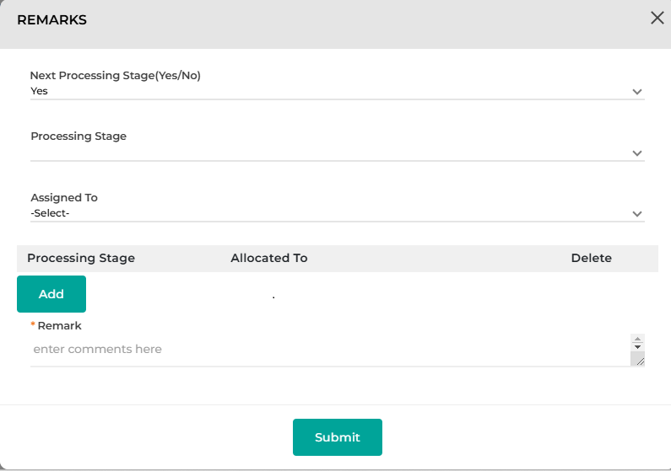

Field Name | Field Type | Mandatory | Field Description | Remarks / Validation
Next Processing Stage (Yes/No) | Dropdown | Yes | The user will select, whether wants to proceed with the stage configured within the system or not. | If selected “Yes”, the user will just enter the Remarks and click on Submit to proceed the application to the next stage automatically as configured within the system.
Processing Stage | Dropdown | Yes | The user will select the next processing stage the user want’s the application to be proceeded. | Only be application if “Next Processing Stage (Yes/No)” is selected as “NO”
Assigned To | Dropdown | Yes | The user will select the username from the selected processing stage. | Only be application if “Next Processing Stage (Yes/No)” is selected as “NO”
Grid
- Next Processing Stage (Yes/No)  - Processing Stage  - Assigned To | List View | Yes |  | Only be application if “Next Processing Stage (Yes/No)” is selected as “NO”
Add | Button | Yes | The user can add multiple Stage & User to whom the application is to be proceeded by selecting and adding in the grid. | Only be application if “Next Processing Stage (Yes/No)” is selected as “NO”
Remarks | Button | Yes | The user will click on submit button to proceed the application to the next/desired stage.
Submit

Reports
Report Specification Document (RSD) for standard reports is provided, while the final list of reports will be finalized after the report session with the business users.

Charges

Required Document Checklist

Stage Completion Rules

Interface Touchpoints

Lookups & Master

