BRACT’s
Vishwakarma Institute of Technology, Pune
Practical Implementation Sheet
Department: CSE-AI Semester: 5 Academic Year: 2026-27
Division: C Batch: 3 Practical No: 1
Roll no: 68 PRN No: 12415154 Name of Student: Kalpesh Patil
Subject Name: Deep Learning
Problem Statement:
Design and implement a Multilayer Perceptron (MLP) for classification of the Iris or Wine dataset, and evaluate its performance using accuracy and a confusion matrix.
Algorithm:
Multilayer Perceptron (MLP) for Iris/Wine Dataset Classification
- Import the required libraries.
- Load the Iris (or Wine) dataset.
- Split the dataset into training and testing sets.
- Create an MLP classifier by specifying:
  - Hidden layers
  - Activation function (ReLU)
  - Optimizer (Adam)
  - Number of iterations
- Train the MLP model using the training data.
- Predict the class labels for the test data.
- Calculate the accuracy of the model using the predicted and actual labels.
- Generate the confusion matrix to compare actual and predicted classes.
- Display the accuracy, confusion matrix, and classification report.
- Analyse the performance of the MLP classifier.
Code:
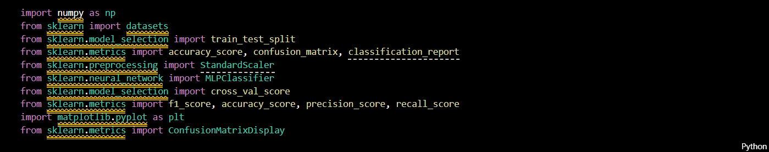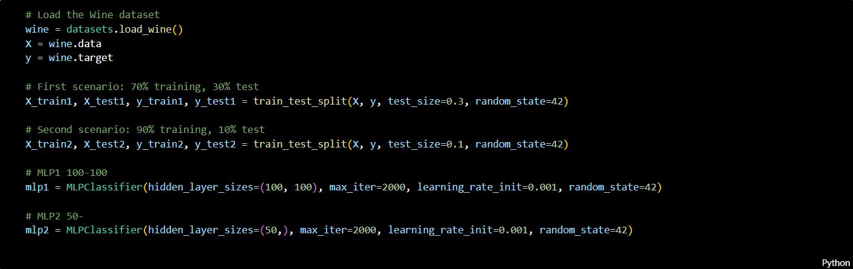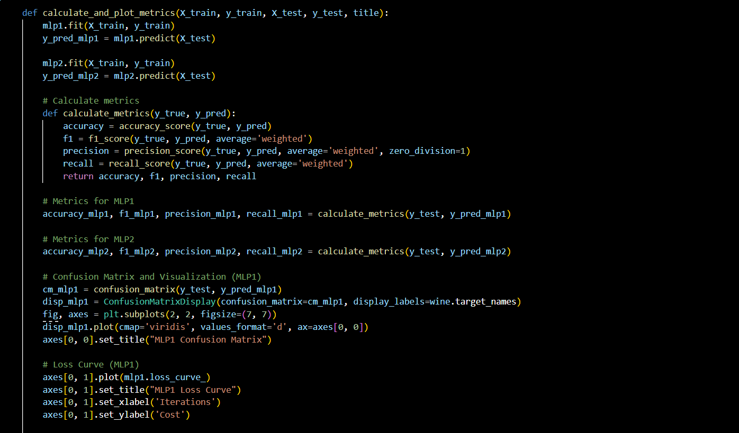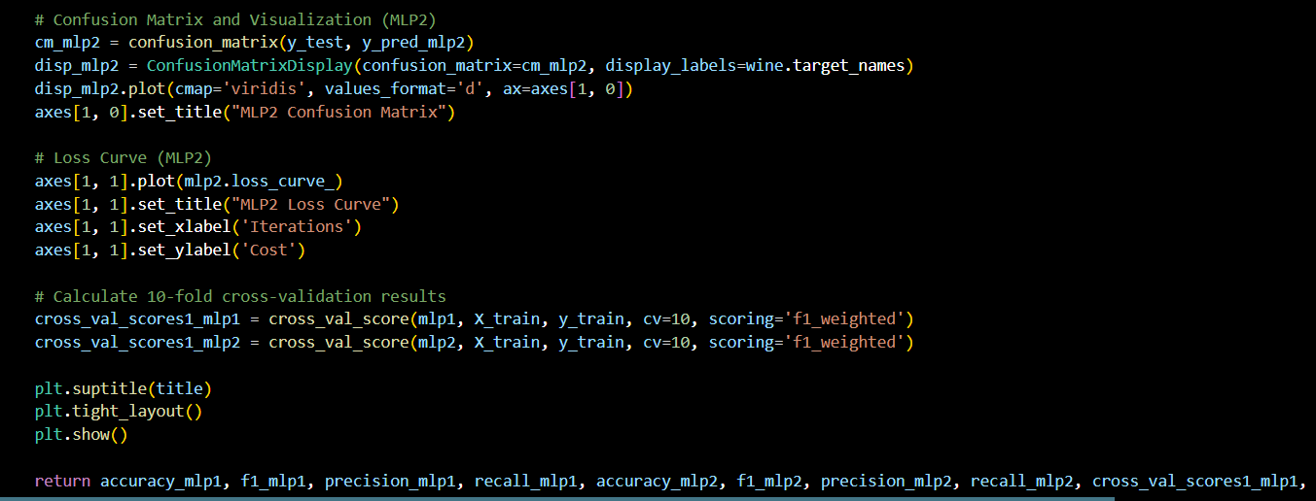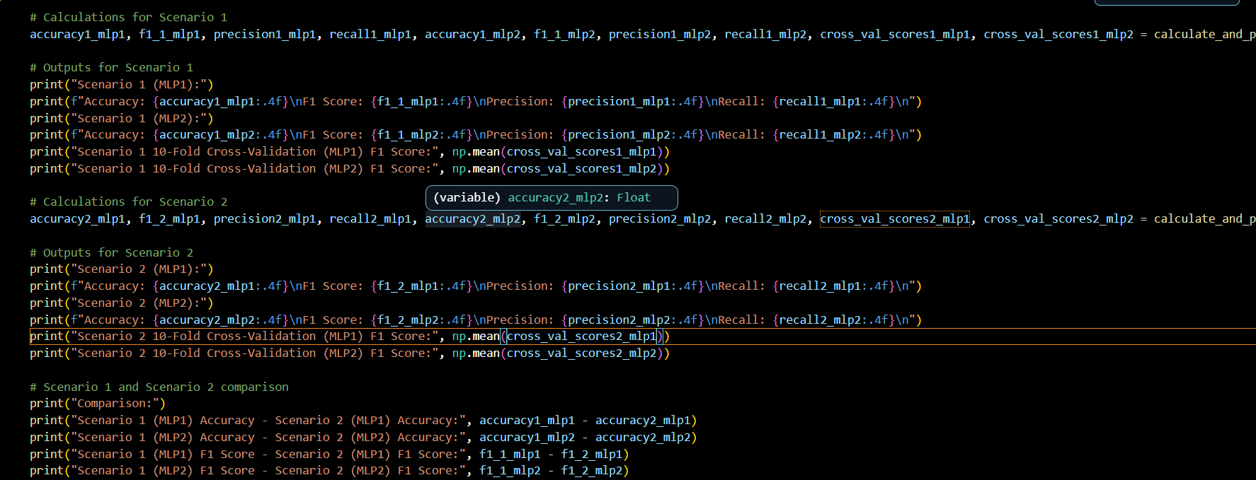

Output:
