BRACT’s
Vishwakarma Institute of Technology, Pune
Practical Implementation Sheet
Department: CSE-AI Semester: 5 Academic Year: 2026-27
Division: C Batch: 3 Practical No: 6
Roll no: 68 PRN No: 12415154 Name of Student: Kalpesh Patil
Subject Name : Deep Learning

Problem Statement: Design and implement a Convolutional Neural Network (CNN) for image classification using the Tomato or Soybean disease dataset.

Algorithm:
- Start by importing the required libraries for dataset loading, image processing, CNN implementation, visualization, and performance evaluation. Set the image size to 128 × 128 pixels, batch size to 64, number of epochs to 8, learning rate to 0.001, and random seed to 42 for reproducible results.
- Load the Tomato Leaf Disease dataset directly from Hugging Face using the load_dataset() function. Retrieve the available class names and verify the number of disease categories present in the dataset.
- Shuffle the complete dataset using the fixed random seed and select 10,000 images for the experiment. Divide these images into 7,000 training images, 1,500 validation images, and 1,500 testing images so that the test data remains separate from model training.
- Convert every image into RGB format, resize it to 128 × 128 pixels, convert the image into a numerical array, and normalize its pixel values from the range 0–255 to the range 0–1. Convert the processed images and their corresponding labels into TensorFlow datasets and divide them into batches of 64 images.
- Display sample tomato leaf images along with their corresponding disease labels and visualize the class distribution of the training dataset to verify the input data.
- Create a CNN model consisting of convolutional layers for extracting image features, max-pooling layers for reducing the spatial dimensions, a flattening layer for converting extracted features into a one-dimensional representation, dense layers for classification, dropout for reducing overfitting, and a final softmax layer for predicting the ten disease classes.
- Compile the CNN using the Adam optimizer with a learning rate of 0.001 and use sparse categorical cross-entropy as the loss function. Use accuracy as the primary training metric.
- Train the CNN for 8 epochs using the training dataset while using the validation dataset to monitor the model's performance after every epoch. Record the training and validation accuracy and loss throughout the training process.
- Evaluate the trained CNN on the separate test dataset and calculate the final test loss and test accuracy. Generate predictions for all test images and compare the predicted labels with their actual labels.
- Calculate accuracy, precision, recall, and F1-score from the test predictions to evaluate the classification performance of the CNN.
- Generate a confusion matrix to visualize the number of correct and incorrect predictions for every tomato disease class and display the classification report containing precision, recall, F1-score, and support for each class.
- Calculate the classification accuracy separately for each disease class and display it using a bar graph. Display the training and validation accuracy and loss curves to analyze the learning behavior of the CNN.
- Finally, display sample predictions with the actual class, predicted class, and prediction confidence, visualize some incorrectly classified images, and print the final training accuracy, validation accuracy, test accuracy, precision, recall, F1-score, training time, number of parameters, and dataset sizes.

Code:
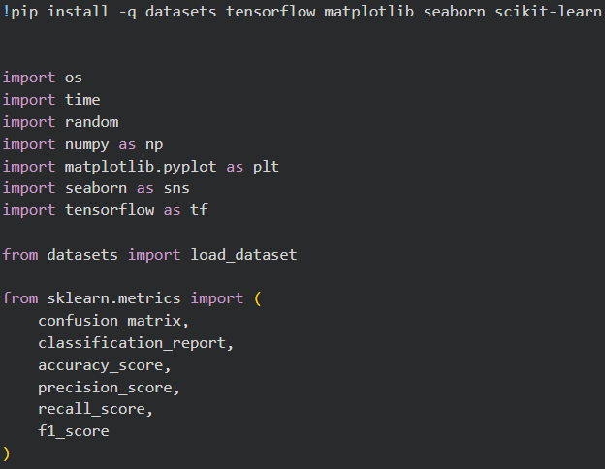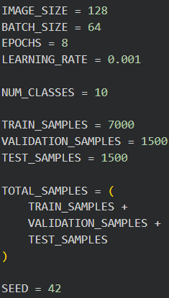
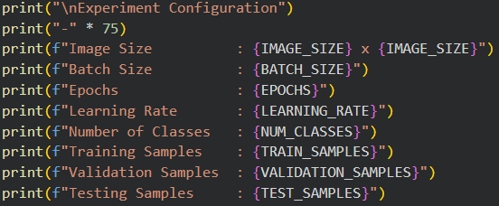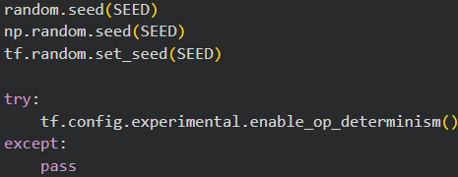
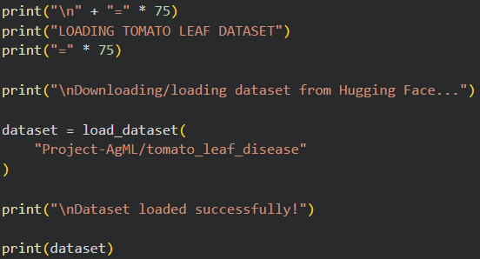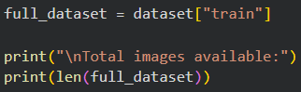
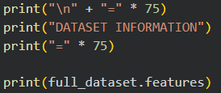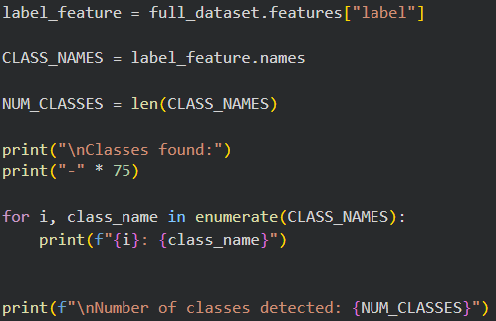
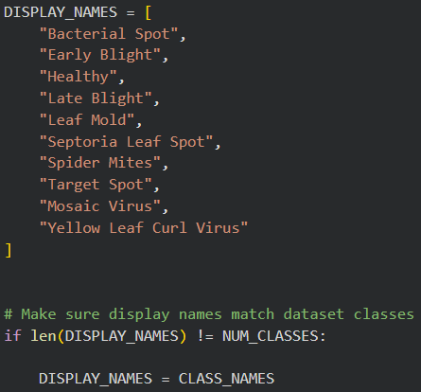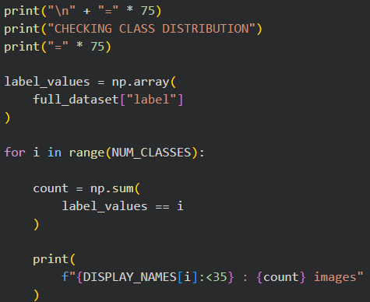
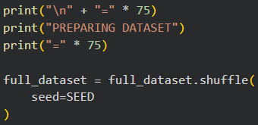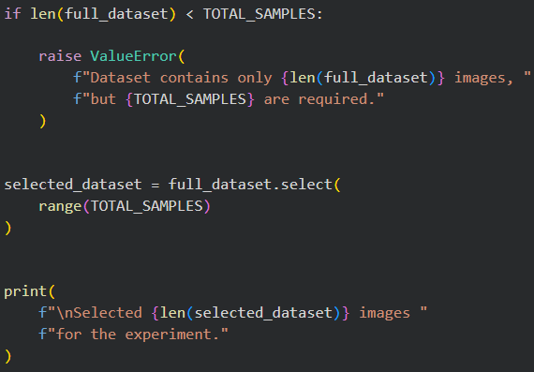
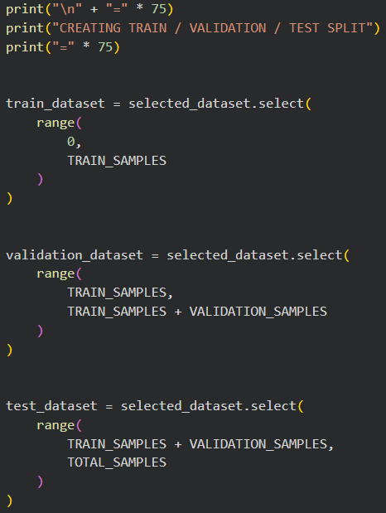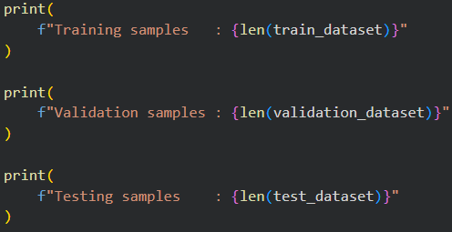
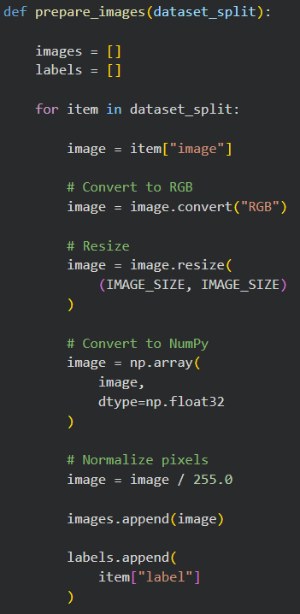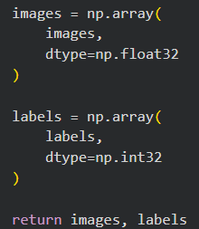
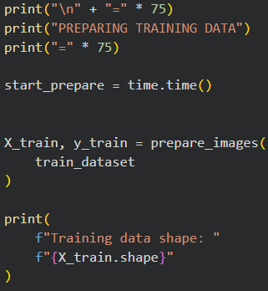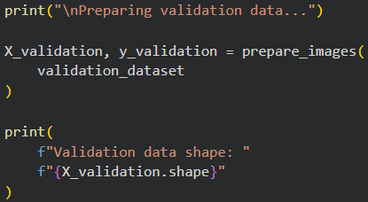
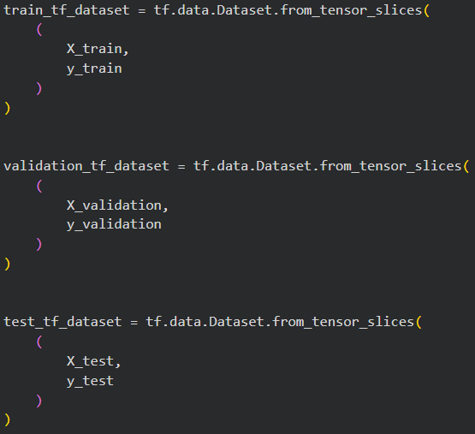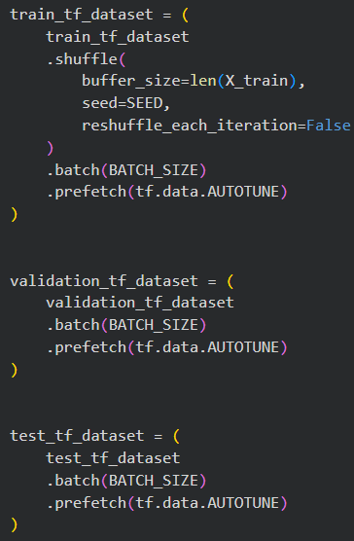
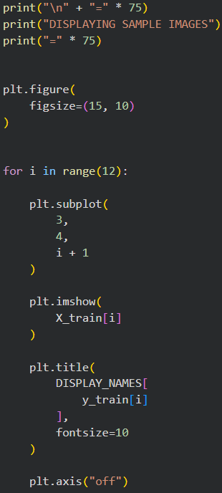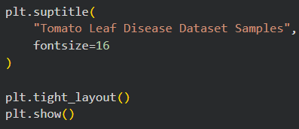
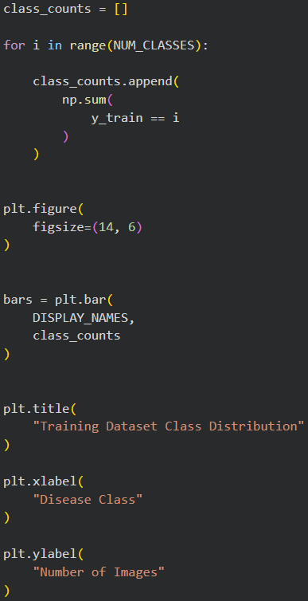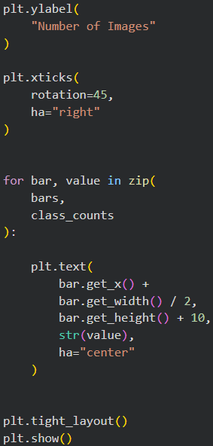
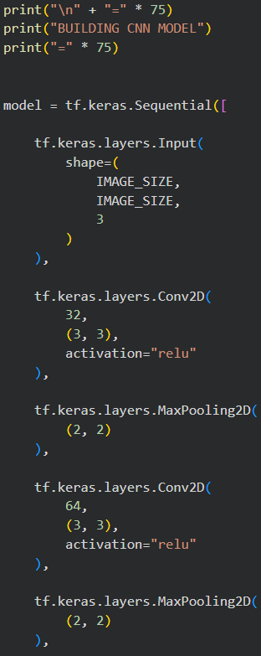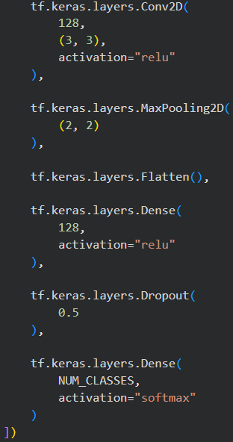
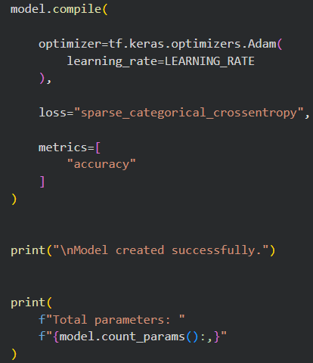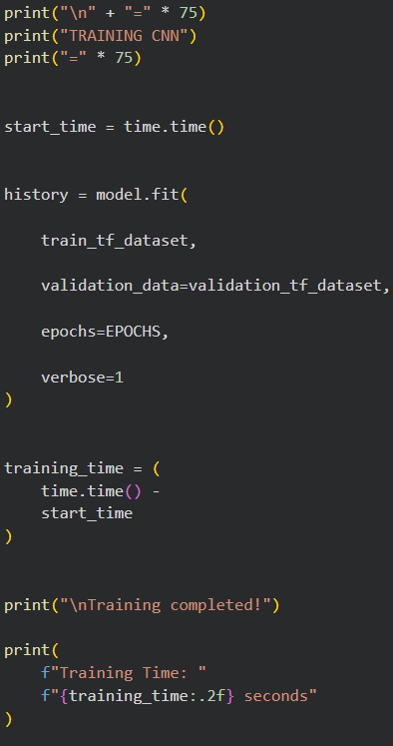
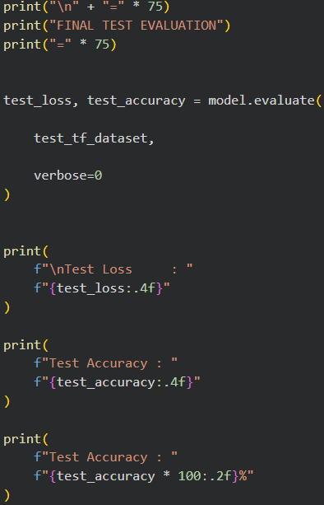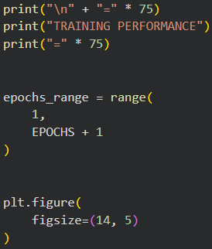
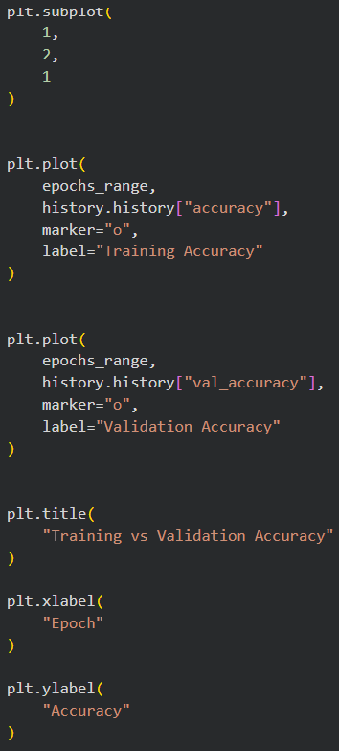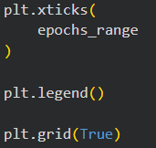
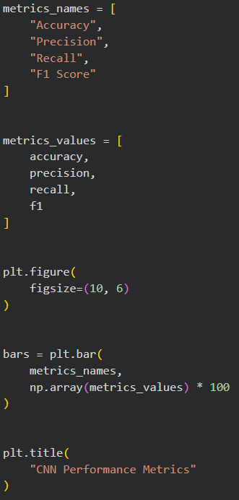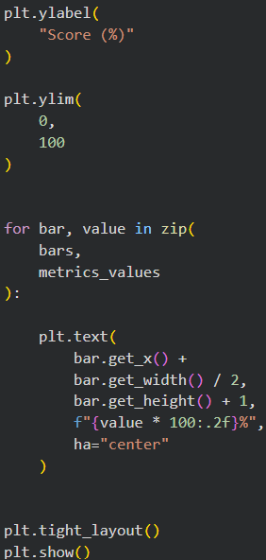
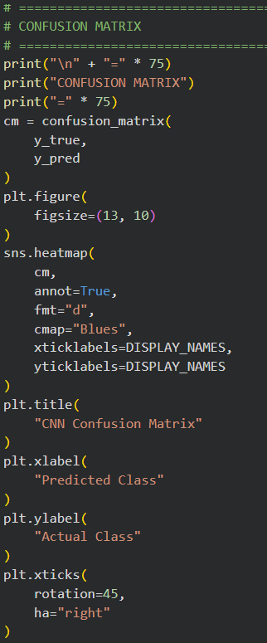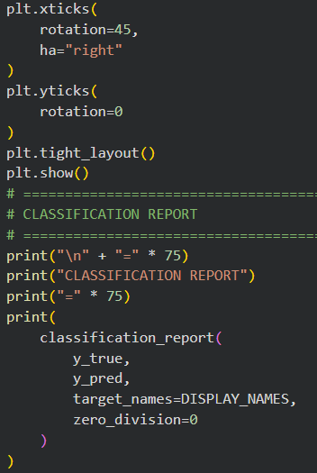
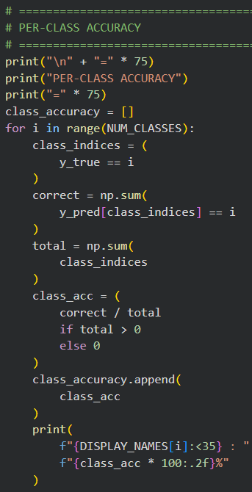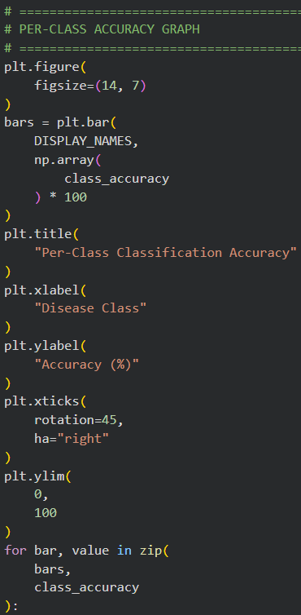
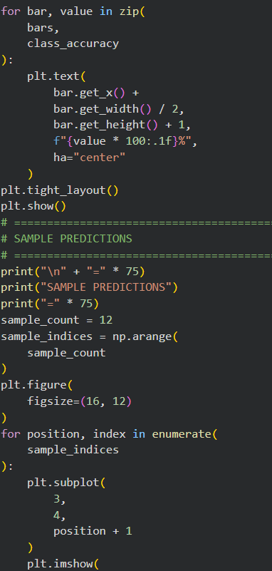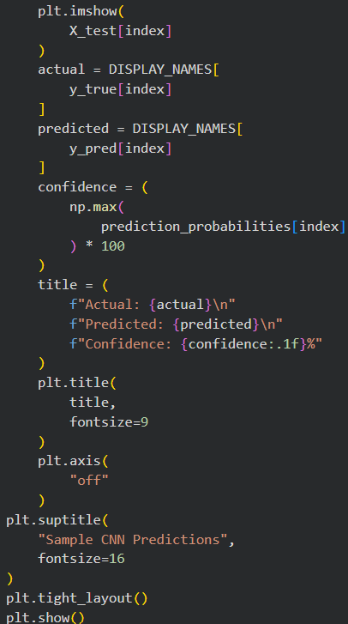
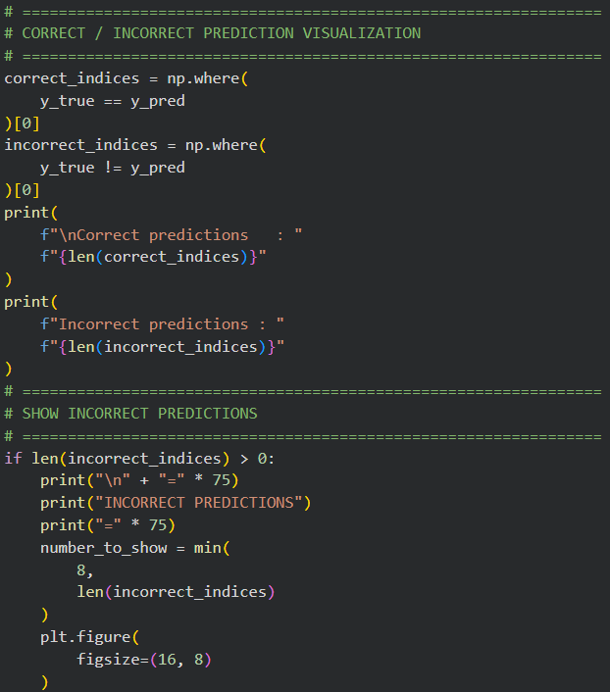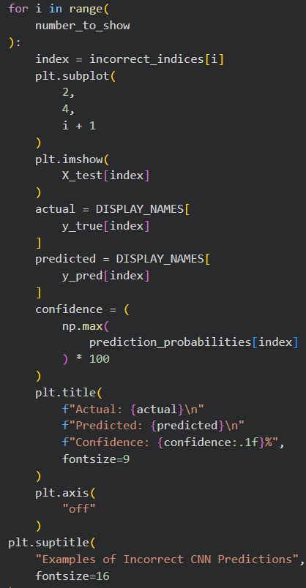
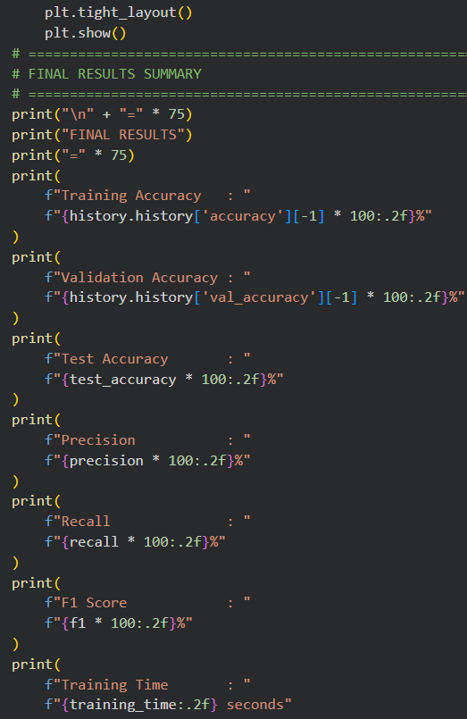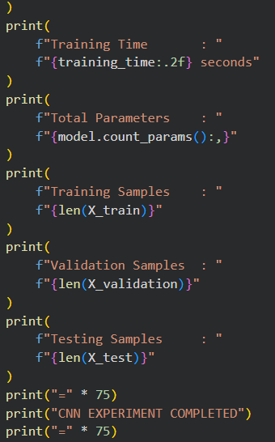
Output:
